+ Epiphany and Baptism of our Lord
January 7th, 2024
10:00 a.m.

St. Andrew Lutheran Church
304 Morewood Ave.
Pittsburgh, PA 15213
412.682.3342
St_andrewELCA@verizon.net
www.standrewpittsburgh.org

+ Epiphany and Baptism of our Lord
Order for Worship

The feast of Epiphany (“manifestation”) concludes the Christmas season with a celebration of God’s glory revealed in the person of Jesus Christ. In Isaiah, that glory is proclaimed for all nations and people. Like the light of the star that guided the magi to Jesus, the light of Christ reveals who we are: children of God, claimed and washed in the waters of Baptism.
As the Spirit moved over the waters in Genesis and descended upon Jesus at his Baptism,
the Spirit has come to us, as well. As baptized followers of Christ, we are sent to share in Jesus’ mission: to bear the light of God’s love to all people, and to re-create the world
in the image of God’s justice and peace.

Welcome to St. Andrew!
- St. Andrew Lutheran congregation welcomes all who are seeking a place of healing and wholeness – a nurturing, faith-forming spiritual home. Our community embraces people of all ages, ethnicities, cultures, abilities, sexual orientations, gender identities and expressions, and family constellations. Come and See!
- Worship Services are live streamed to multiple online platforms. By attending worship, you agree that your image and voice may be broadcast.
- Everyone is invited to make a nametag at the black bookcase in the back of the worship space if they would like. There are stickers indicating pronouns on the bookcase if you would like to include them on your name tag.
- Children are invited to attend Little Church – Big Faith, a Bible lesson and activity, during worship (after the Prayer of the Day). The group returns to the worship space for the liturgy of Holy Communion.
- Worship “toolkits” to help children engage with the service, along with “busy bags” for younger children, are available in the bookcase at the back of the sanctuary. Please feel free to take one to use with/for your children.
- Holy Communion is served with bread (gluten-free available) and wine or grape juice. The presiding minister will distribute the bread (host). Please consume this and then pick up an empty glass from the tray. The Communion Assistant will pour wine or grape juice into your glass. Please step to the side to consume the wine or grape juice. Feel free to kneel at the altar for prayer and reflection. As you return to your pew, glasses may be returned to the empty trays on either side of the center section.
- A restroom is available on the main level of the church, through the doors to the Social Hall and to the right in the main office.

Abbreviations

P: Pastor/Presiding Minister ELW: Evangelical Lutheran Worship hymnal
A: Assisting Minister ACS: All Creation Sings hymnal
L: Lector
C: Congregation

Welcome

Prelude Gesú Bambino Arr. P. Yon

Gathering
The Holy Spirit calls us together as the people of God

The Epiphany of our Lord

Please rise as you are able. All may make the sign of the cross,
the sign that is marked at Baptism, as the presiding minister begins.

P: Blessed be the holy Trinity, ☩ one God,
creator of darkness and light, the Word made flesh,
our life and our salvation.
C: Amen.

Reading – Isaiah 60: 1-6

¹Arise, shine; for your light has come,
and the glory of the Lord has risen upon you.
²For darkness shall cover the earth,
and thick darkness the peoples;
but the Lord will arise upon you,
and the Lord’s glory will appear over you.
³Nations shall come to your light,
and kings to the brightness of your dawn.
⁴Lift up your eyes and look around;
they all gather together, they come to you;
your sons shall come from far away,
and your daughters shall be carried on their nurses’ arms.
⁵Then you shall see and be radiant;
your heart shall thrill and rejoice,
because the abundance of the sea shall be brought to you,
the wealth of the nations shall come to you.
⁶A multitude of camels shall cover you,
the young camels of Midian and Ephah;
all those from Sheba shall come.
They shall bring gold and frankincense,
and shall proclaim the praise of the Lord.

P: Word of God, word of life.
C: Thanks be to God.

Gathering Hymn Arise, Your Light Has Come! ELW 314

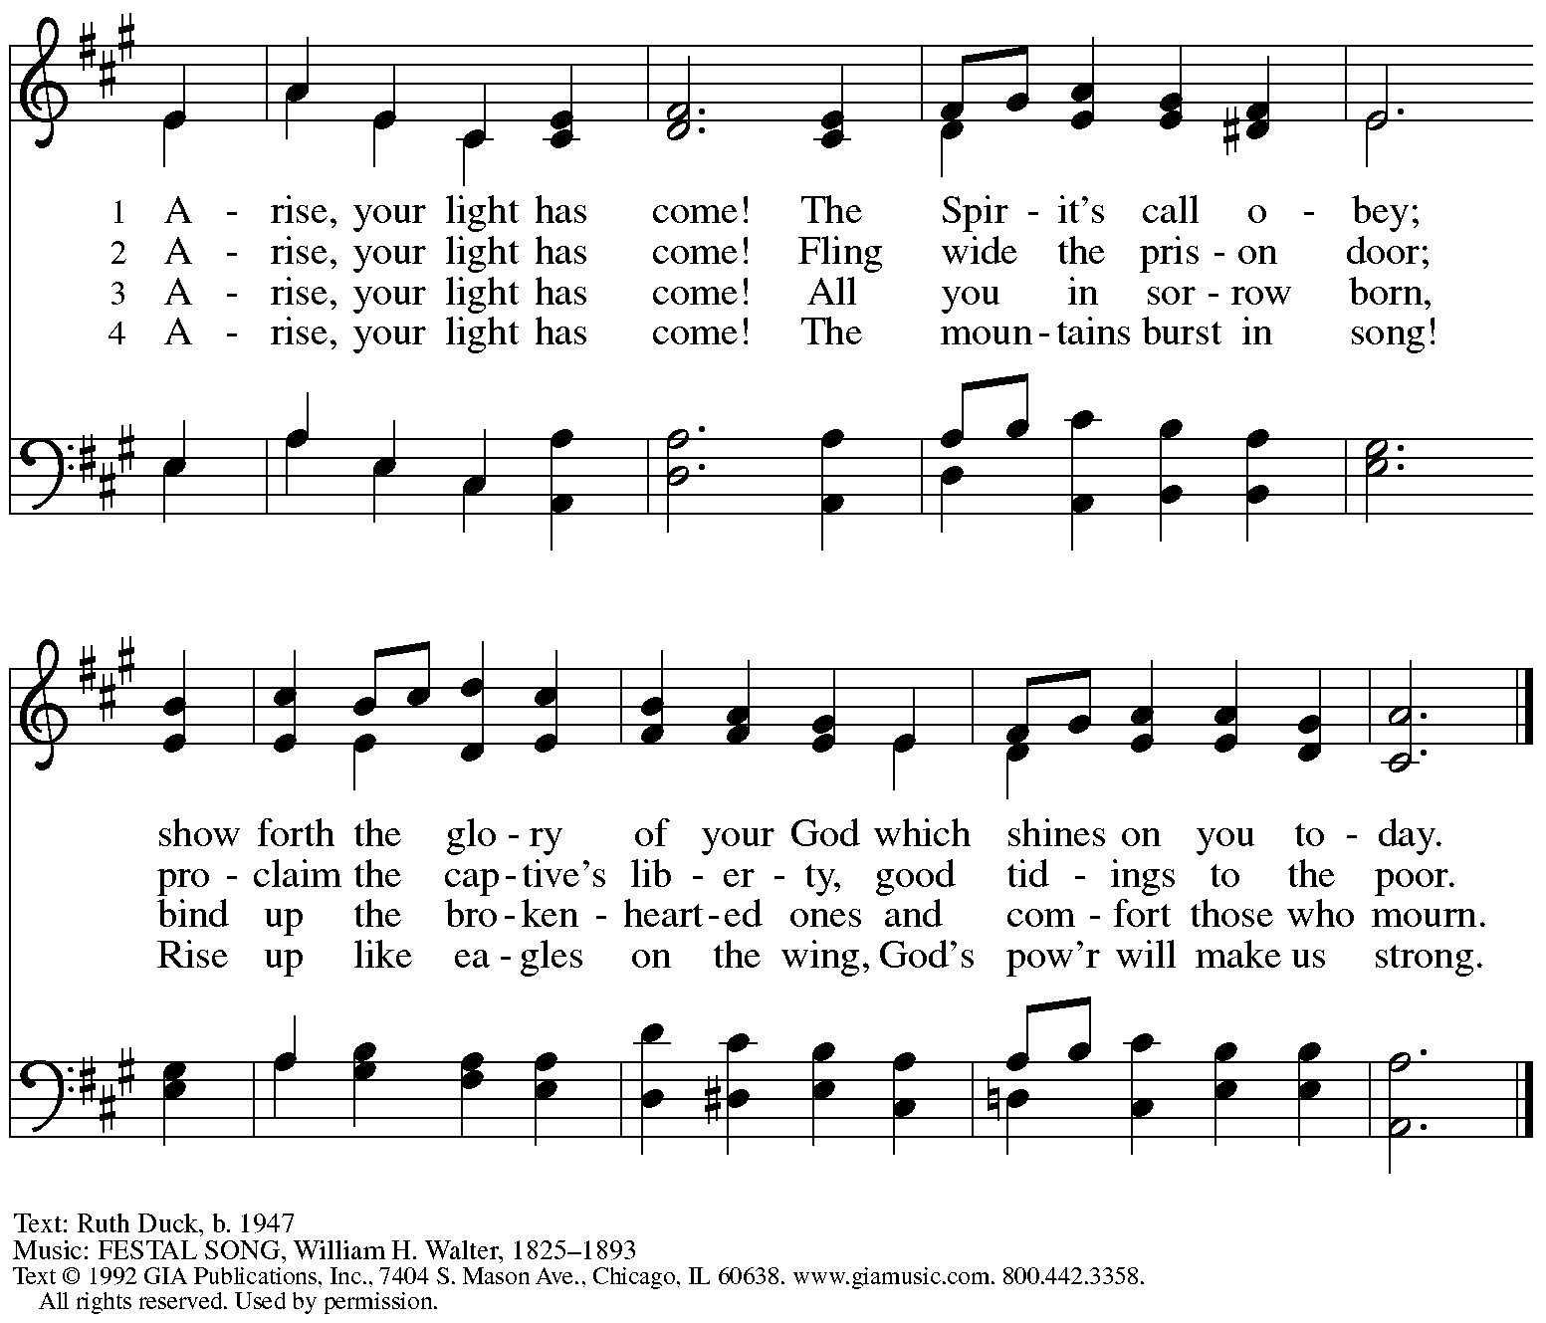
Reprinted with permission under OneLicense.net # A-722139.

Gospel

P: The holy Gospel according to St. Matthew.
C: Glory to you, O Lord.

¹In the time of King Herod, after Jesus was born in Bethlehem of Judea, magi from the East came to Jerusalem, ²asking, “Where is the child who has been born king of the Jews? For we observed his star at its rising, and have come to pay him homage.” ³When King Herod heard this, he was frightened, and all Jerusalem with him; ⁴and calling together all the chief priests and scribes of the people, he inquired of them where the Messiah was to be born. ⁵They told him, “In Bethlehem of Judea; for so it has been written by the prophet:
⁶‘And you, Bethlehem, in the land of Judah,
are by no means least among the rulers of Judah;
for from you shall come a ruler
who is to shepherd my people Israel.’ ”
⁷Then Herod secretly called for the magi and learned from them the exact time when the star had appeared. ⁸Then he sent them to Bethlehem, saying, “Go and search diligently for the child; and when you have found him, bring me word so that I may also go and pay him homage.”
⁹When they had heard the king, they set out; and there, ahead of them, went the star that they had seen at its rising, until it stopped over the place where the child was. ¹⁰When they saw that the star had stopped, they were overwhelmed with joy. ¹¹On entering the house, they saw the child with Mary his mother; and they knelt down and paid him homage. Then, opening their treasure chests, they offered him gifts of gold, frankincense, and myrrh. ¹²And having been warned in a dream not to return to Herod, they left for their own country by another road.

P: The Gospel of the Lord.
C: Praise to you, O Christ.

Epiphany Hymn As with Joy ELW 302
v. 1-3

1 As with joy magi of old
did the guiding star behold;
as with joy they hailed its light,
leading onward, beaming bright;
so, most gracious Lord, may we
evermore be led by thee.

2 As with joyful steps they sped,
Savior, to thy lowly bed,
there to bend the knee before
thee, whom heav'n and earth adore;
so may we with willing feet
ever seek thy mercy seat.

3 As they offered gifts most rare
at thy cradle, rude and bare,
so may we with holy joy,
pure and free from sin's alloy,
all our costliest treasures bring,
Christ, to thee, our heav'nly king.

Text: William C. Dix, 1837-1898, alt. Music: DIX, Conrad Kocher, 1786-1872.

Greeting

P: The grace of our Lord Jesus Christ, the love of God,
and the communion of the Holy Spirit be with you all.
C: And also with you.

Prayer of the Day

P: Let us pray.
O God, in the Epiphany you revealed your Son to the nations by the leading of a star.
Lead us now by faith to know your presence in our lives. Immerse us in your grace and transform us by your Spirit, that we may follow in the way of your Son, Jesus Christ,
our Savior and Lord, who lives and reigns with you and the Holy Spirit,
one God, now and forever.
C: Amen.

Please be seated.
Children are invited to join the adult leaders at the door and move to the office for Little Church – Big Faith. We ask that one additional adult from the congregation attend with the children.

Word
God speaks to us in Scripture reading, preaching, and song

First Reading – Genesis 1: 1-5

¹In the beginning when God created the heavens and the earth, ²the earth was a formless void and darkness covered the face of the deep, while a wind from God swept over the face of the waters.
³Then God said, “Let there be light”; and there was light. ⁴And God saw that the light was good; and God separated the light from the darkness. ⁵God called the light Day, and the darkness God called Night. And there was evening and there was morning, the first day.

L: Word of God, word of life.
C: Thanks be to God.

Psalm 29

Psalm tone

Psalm refrain

¹Ascribe to the | Lord, you gods,
ascribe to the Lord glo- | ry and strength.
²Ascribe to the Lord the glory | due God’s name;
worship the Lord in the beau- | ty of holiness.
³The voice of the Lord is upon the waters; the God of | glory thunders;
the Lord is upon the | mighty waters.
⁴The voice of the Lord is a pow- | erful voice;
the voice of the Lord is a | voice of splendor. R
⁵The voice of the Lord breaks the | cedar trees;
the Lord breaks the ce- | dars of Lebanon;
⁶the Lord makes Lebanon skip | like a calf,
and Mount Hermon like a | young wild ox.
⁷The voice | of the Lord
bursts forth in | lightning flashes.
⁸The voice of the Lord | shakes the wilderness;
the Lord shakes the wilder- | ness of Kadesh. R
⁹The voice of the Lord makes the oak trees writhe and strips the | forests bare.
And in the temple of the Lord all are | crying, “Glory!”
¹⁰The Lord sits enthroned a- | bove the flood;
the Lord sits enthroned as king for- | evermore.
¹¹O Lord, give strength | to your people;
give them, O Lord, the bless- | ings of peace. R

Second Reading – Acts 19: 1-7

¹While Apollos was in Corinth, Paul passed through the interior regions and came to Ephesus, where he found some disciples. ²He said to them, “Did you receive the Holy Spirit when you became believers?” They replied, “No, we have not even heard that there is a Holy Spirit.” ³Then he said, “Into what then were you baptized?” They answered, “Into John’s baptism.” ⁴Paul said, “John baptized with the baptism of repentance, telling the people to believe in the one who was to come after him, that is, in Jesus.” ⁵On hearing this, they were baptized in the name of the Lord Jesus. ⁶When Paul had laid his hands on them, the Holy Spirit came upon them, and they spoke in tongues and prophesied—⁷altogether there were about twelve of them.

L: Word of God, word of life.
C: Thanks be to God.

Please rise as you are able.

Gospel Acclamation Alleluia ELW p. 151

Gospel – Mark 1: 4-11

P: The holy Gospel according to St. Mark.
C: Glory to you, O Lord.

⁴John the baptizer appeared in the wilderness, proclaiming a baptism of repentance for the forgiveness of sins. ⁵And people from the whole Judean countryside and all the people of Jerusalem were going out to him, and were baptized by him in the river Jordan, confessing their sins. ⁶Now John was clothed with camel’s hair, with a leather belt around his waist, and he ate locusts and wild honey. ⁷He proclaimed, “The one who is more powerful than I is coming after me; I am not worthy to stoop down and untie the thong of his sandals. ⁸I have baptized you with water; but he will baptize you with the Holy Spirit.”

⁹In those days Jesus came from Nazareth of Galilee and was baptized by John in the Jordan. ¹⁰And just as he was coming up out of the water, he saw the heavens torn apart and the Spirit descending like a dove on him. ¹¹And a voice came from heaven, “You are my Son, the Beloved; with you I am well pleased.

P: The Gospel of the Lord.
C: Praise to you, O Christ.

Please be seated.
Sermon

A time of silence for prayer and reflection follows the sermon.
As the hymn of the day begins, please rise as you are able.

Hymn of the Day Down Galilee’s Slow Roadways ACS 916

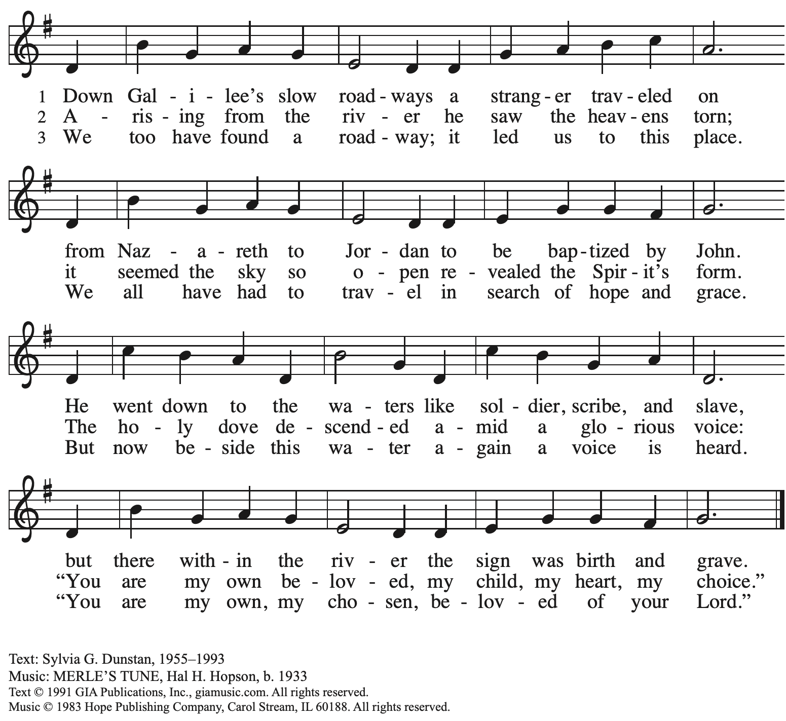
Reprinted with permission under OneLicense.net # A-722139.

Affirmation of Baptism by the Assembly

P: Beloved in Christ, as we remember the Baptism of our Lord Jesus today, we are invited to recall and be renewed in the gifts and promises of our own Baptism. Please join in making affirmation of God’s covenant of Baptism.

P: I ask you to profess your faith in Christ Jesus, reject sin,
and confess the faith of the church.

P: Do you renounce the devil and all the forces that defy God?
Response: I renounce them.

P: Do you renounce the powers of this world that rebel against God?
Response: I renounce them.

P: Do you renounce the ways of sin that draw you from God?
Response:
I renounce them.

P: Do you believe in God the Father?
C: I believe in God, the Father almighty,
creator of heaven and earth.

P: Do you believe in Jesus Christ, the Son of God?
C: I believe in Jesus Christ, God’s only Son, our Lord,
who was conceived by the Holy Spirit,
born of the virgin Mary,
suffered under Pontius Pilate,
was crucified, died, and was buried;
he descended to the dead.*
On the third day he rose again;
he ascended into heaven,
he is seated at the right hand of the Father,
and he will come to judge the living and the dead.

P: Do you believe in God the Holy Spirit?
I believe in the Holy Spirit,
the holy catholic church,
the communion of saints,
the forgiveness of sins,
the resurrection of the body,
and the life everlasting. Amen.

*Or, “he descended into hell,” another translation of this text in widespread use.

Affirmation by the Assembly

P: You have made public profession of your faith.
Do you intend to continue in the covenant God made with you in Holy Baptism:
to live among God’s faithful people,
to hear the word of God and share in the Lord’s supper,
to proclaim the good news of God in Christ through word and deed,
to serve all people, following the example of Jesus,
and to strive for justice and peace in all the earth?
The assembly makes affirmation:
C: I do, and I ask God to help and guide me.

P: People of God, do you promise to support and pray for one another in your life in Christ?
C: We do, and we ask God to help and guide us.

P: Let us pray.
We give you thanks, O God, that through water and the Holy Spirit you give us new birth, cleanse us from sin, and raise us to eternal life. Stir up in your people the gift of your Holy Spirit: the spirit of wisdom and understanding, the spirit of counsel and might, the spirit of knowledge and the fear of the Lord, the spirit of joy in your presence, both now and forever.
C: Amen.

Congregational Refrain

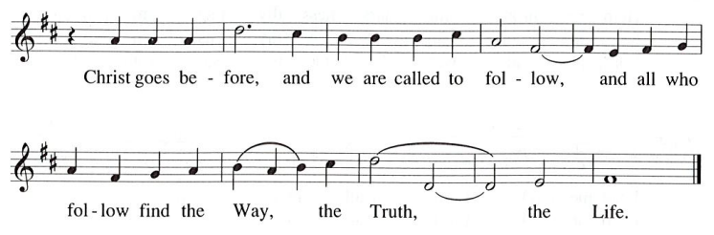

The service continues with the prayers of intercession.

Prayers of the People

A: As we celebrate Christ’s incarnation and revelation, we pray for the church, the world,
and all who are in need.

After each petition
A: God of grace,
C: receive our prayer.

The presiding minister concludes the prayers
P: Knowing that the Holy Spirit intercedes for us, we offer these prayers and the silent prayers of our hearts to you, O God, through Jesus Christ, our Savior.
C: Amen.

Peace

The presiding minister and the assembly greet one another in the peace of the risen Christ.
P: The peace of Christ be with you always.
C: And also with you.

The people may greet those around them with a sign of Christ’s peace and may say
Peace be with you or similar words. Please be mindful that not everyone will be comfortable with sharing the peace, so please seek consent before shaking hands or hugging. Other possible ways to share the peace include a simple bow with the verbal greeting of peace, or simply a verbal expression of peace.

When the greetings of peace have concluded, please be seated.

Meal
God feeds us with the presence of Jesus Christ

Offering

We offer ourselves, our gifts, and our faithful service to God.
As the offering is gathered for the mission of the church, including the care of those in need,
the table is set for Holy Communion.

Reparations Offering

On the first Sunday of each month, St. Andrew invites people of the congregation to consider a donation to a second collection for a reparations fund in acknowledgement of St. Andrew’s use of African American spiritual songs in our worship services. Please see the note in the announcements for more information.

Choir Music during the Offering
In the Bleak Midwinter Arr. J. Wagner

As the gifts are brought forward for presentation, please rise as you are able.

Offertory Song What Child Is This ELW 296
v. 1, 3

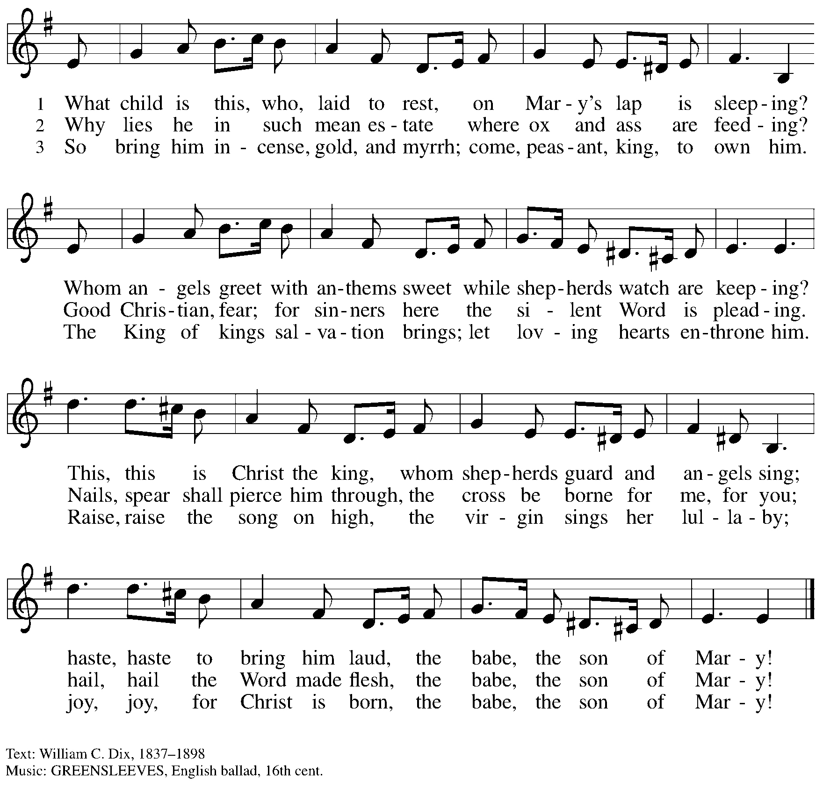

Offertory Prayer

A: Let us pray.
Blessed are you,
C: O God, maker of all things.
Through your goodness you have blessed us with these gifts:
our selves, our time, and our possessions. Work through us and what we have gathered
to feed the world with your love, through the one who gave himself for us,
Jesus Christ, our Savior and Lord. Amen.

Dialogue ELW p. 152

Preface (Sung)

P: It is indeed right, our duty and our joy …
… we praise your name and join their unending hymn:

Sanctus ELW p. 153

Eucharistic Prayer

P: Holy one, the beginning and the end, the giver of life, …
… Do this for the remembrance of me.

Let us proclaim the mystery of faith.
C: Christ has died. Christ is risen. Christ will come again.

P: With this bread and cup …
… We look with hope for his coming.
C: Come, Lord Jesus.

P: Holy God, we long for your Spirit …
… Bring the gift of peace on earth.
C: Come, Holy Spirit.

P: All praise and glory are yours …
… one God, now and forever.
C: Amen.

Lord’s Prayer

P: Gathered as one by the Holy Spirit, let us pray as Jesus taught us.
C: Our Father in heaven,
hallowed be your name,
your kingdom come,
your will be done,
on earth as in heaven.
Give us today our daily bread.
Forgive us our sins
as we forgive those
who sin against us.
Save us from the time of trial
and deliver us from evil.
For the kingdom, the power,
and the glory are yours,
now and forever. Amen.

Fraction and Invitation

P: Glory to God in the highest!
Come to the table of peace.

Agnus Dei / Lamb of God ELW p. 154

Please be seated.

Holy Communion
- All who seek God and desire a deeper and stronger life in Christ are welcome to receive Holy Communion.
- Worshipers from the pulpit side will proceed forward first, followed by the center section, and then the lectern side.
- Please inform an usher if you would like the ministers to bring Communion to you.
- Holy Communion will be served with bread and wine/grape juice.
- The presiding minister will first distribute the bread (host) to each communicant. Please indicate if you require a gluten-free host.
- Once you have consumed the bread, please pick up an empty glass from the tray next to the presiding minister. The Communion Assistant will pour wine from the chalice or grape juice from the cruet into your glass.
- Please step to the side to consume the wine or grape juice.
- Feel free to kneel at the altar rail for prayer after receiving the sacrament.
- As you return to your pew, glasses may be returned to the empty trays on either side of the center section.
- A blessing will be provided for anyone who does not yet receive the sacrament.
- All are invited to join in singing the hymns during Holy Communion.

Hymns during Holy Communion
Come, Beloved of the Maker ELW 306

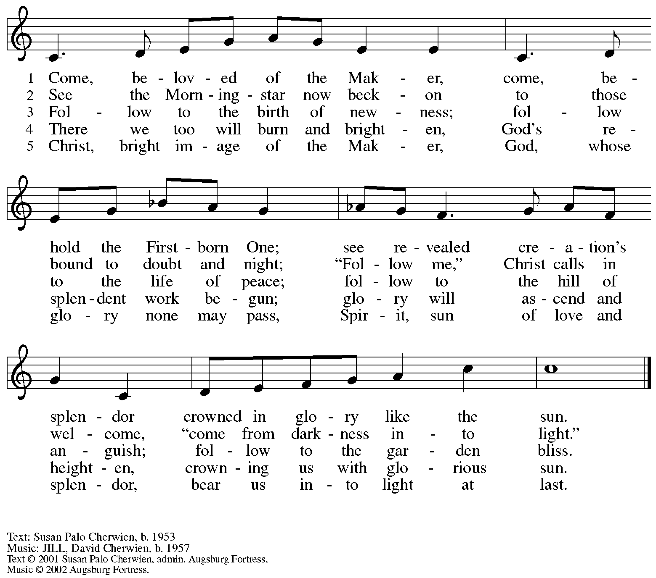
All rights reserved. Reprinted with permission under OneLicense.net # A-722139.

Hymns during Holy Communion
Hail to the Lord’s Anointed ELW 311

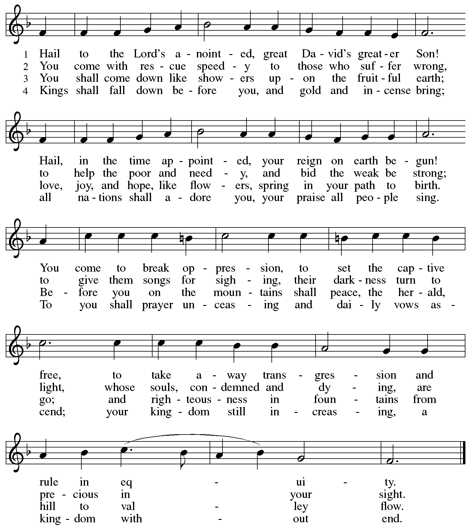

Text: James Montgomery, 1771-1854, alt.
Music: FREUT EUCH, IHR LIEBEN, Leonhart Schröter, 1540-1602.

Hymns during Holy Communion
To Christ Belong, in Christ Behold ACS 958

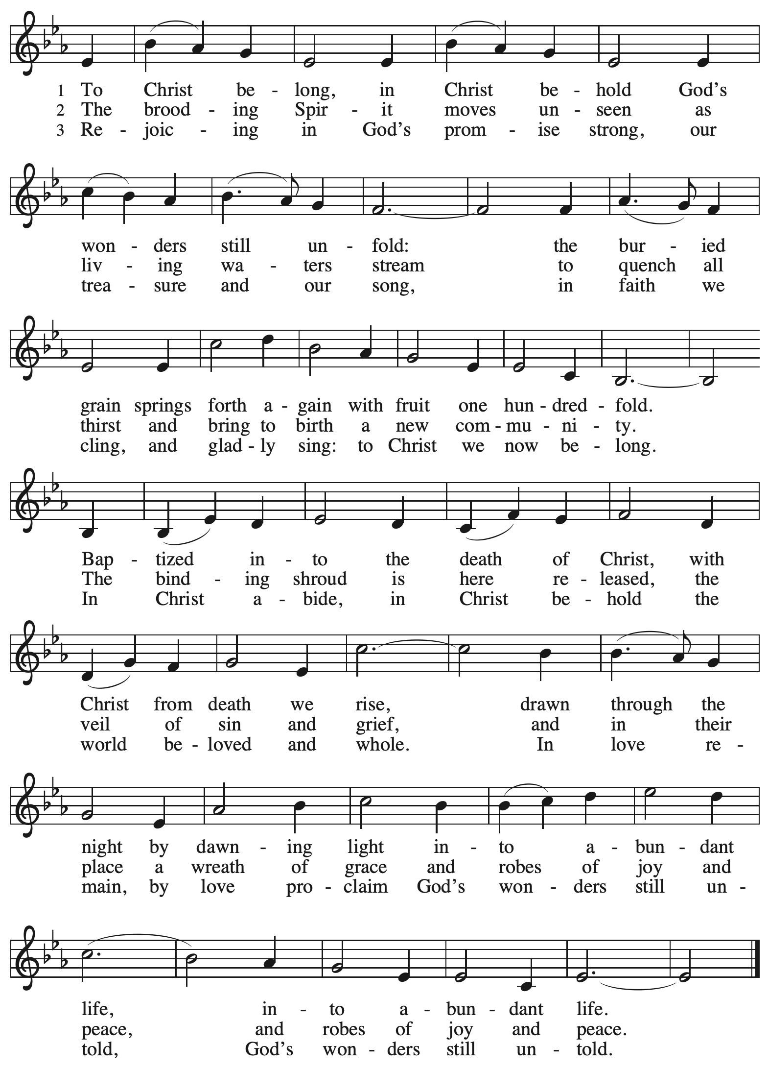

When all have returned to their places, please rise as you are able.

Blessing

P: The body and blood of our Lord Jesus Christ strengthen you and keep you in his grace.
C: Amen.

Prayer

A: Let us pray.
God of abundance, with this bread of life and cup of salvation you have united us with Christ, making us one with all your people. Now send us forth in the power of your Spirit,
that we may proclaim your redeeming love to the world
and continue forever in the risen life of Jesus Christ, our Lord.
C: Amen.

Please be seated.

Sending
God blesses us and sends us in mission to the world

Announcements

Please rise as you are able.

Benediction

P: God who names you,
Christ who claims you,
and the Holy Spirit who dwells in you,
☩ bless you now and forever.
C: Amen.

Sending Hymn Songs of Thankfulness and Praise Following page

Dismissal

A: Go in peace. Share the good news!
C: Thanks be to God!

Postlude O Morning Star, How Fair and Bright Arr. Raabe

Sending Hymn Songs of Thankfulness and Praise ELW 310

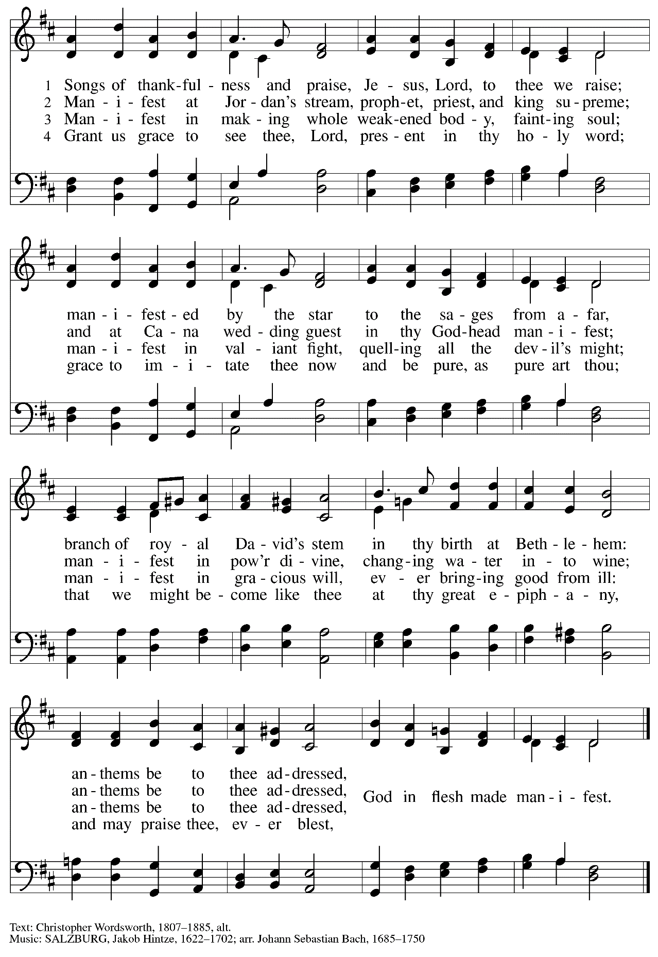

Those serving in worship

Altar Care Janet Grzegorczyk
Assisting Minister Colleen Cooke
Audio-Visual Minister Kristen Asplin
Cantor Joseph Paetz
Clarinet on Prelude Maria Mangano
Euphonium on Prelude David Rollinson
Lector Alda Maria Gonzaga
Little Church – Big Faith Teacher Emily Duque
Minister of Music Laura Reynolds
Presiding and Preaching Minister The Rev. Ross I. Carmichael

Liturgy and Hymnody Acknowledgements

From SundaysandSeasons.com. Copyright © 2024 Augsburg Fortress. All rights reserved. Reprinted under OneLicense.net # A-722139.
Used by permission of Augsburg Fortress.

To Christ Belong, in Christ Behold – Text: Susan R. Briehl, b. 1952. Music: WONDERS, Robert Buckley Farlee, b. 1950.
Text © 2011 Susan R. Briehl, admin. Augsburg Fortress. Music © 2011 Robert Buckley Farlee, admin. Augsburg Fortress.
All rights reserved. Reprinted with permission under OneLicense.net # A-722139.

Please use the QR code below to link to St. Andrew’s Announcements online!

St. Andrew Lutheran Church Announcements
January 7th, 2024

- Welcome to worship at St. Andrew as We Celebrate Epiphany and the Baptism of our Lord, January 7th, 2024 – We are so glad you are here, and we offer a special welcome to all guests who are gathered at the church or online! Children are invited to participate in Little Church – Big Faith, a Bible lesson and activity, after the prayer of the day. There are worship “toolkits” to help children engage with worship and “busy bags” for younger children available in the bookcase at the back of the sanctuary. Please feel free to take one to use with/for your children.
- Monthly Reparations Offering Today during Worship – Jesus’ parable from Luke's Gospel about a compassionate Samaritan provides an example of how God's people are called to work for healing and repair for our neighbors, independent of who or what caused harm. In light of this, St. Andrew has made a commitment to reparations in regard to African American spiritual songs used in our worship. The text and music of most hymns is attributed to specific authors, with copyrights in place, usage reported, and royalties paid to those whose works are featured in worship. With African American spirituals, this is not possible. In response to many years of such uncredited use, St. Andrew invites the congregation to give to a reparations offering. Funds received in worship will be donated to our siblings at Bethel AME Church, whose land and building were taken from them in the 1950s, to fund their development in the lower Hill District.
- Hearts and Hands Meeting on First Sunday of the Month, Starting Today, January 7th, 2024, after Worship – Hearts and Hands, St. Andrew’s crocheting and knitting ministry group, plans to gather each month on the first Sunday after worship, beginning on January 7th. The leaders will teach anyone who would like to learn to crochet and have yarn and hooks to help get you started! We are currently in need of knitted or crocheted shawls, afghans, and stoles to replenish the congregation’s supply. Anyone is welcome to make something and drop it off even if they are not available or choose not to come to a meeting.
- Online Event – An Evening with The Rev. Dr. Mitri Raheb, Lutheran Pastor and Founder of Dar Al-Kalima University in Bethlehem, Palestine – Monday, January 15th, 5:00-7:00 p.m. – The Rev. Dr. Mitri Raheb, a Lutheran Pastor, will be speaking at Lutheran Church of the Redeemer in Atlanta on Monday, January 15th, from 5:00-7:00 p.m. He will share updates on Dar Al-Kalima University, Palestine, and Lutheran Christians work in the Holy Land. The event will be livestreamed at https://www.redeemer.org/.
- Shelter Dinner at East End Cooperative Ministry – Thursday, January 18th, 6:30 p.m. – Each month, people of St. Andrew provide and serve a meal for the guests of the shelter at East End Cooperative Ministry (EECM), 6140 Station St., 15206. Anyone can sign up to prepare or purchase a portion of the meal to bring to EECM at 6:00 p.m. that day, or just come to help serve the meal at 6:30 p.m. If you would like to contribute, please sign up at: https://www.signupgenius.com/go/5080544AAAC22A1F58-46992157-jan.
- “Noisy Offering” to Return Sunday, January 21st – In the past, the children and youth of St. Andrew would lead the congregation in a “noisy offering” once a month. People of the congregation would bring loose change to worship to throw into metal buckets that the children brought around the church during the offering. All offerings went to support a local charitable organization on an occasional basis. St. Andrew would like to return to the Noisy Offering on the third Sunday of each month, beginning January 21st – Please save your change!
- Save the Date – Service of Prayer and Lament for the Holy Land – Saturday, January 27th at St. Andrew. Meal and Presentation – 5:00 p.m., Service – 6:00 p.m.
- Christ in Our Home Devotional Booklets for January - March Available at Church Entrances – This resource offers a daily Bible reading with a short reflection and prayer, along with additional readings and prayer topics for those who would like to expand their devotional practices. We encourage people of the congregation to take one for yourself, your family unit, or others!

