+ First Sunday in Lent
February 18th, 2024
10:00 a.m.

St. Andrew Lutheran Church
304 Morewood Ave.
Pittsburgh, PA 15213
412.682.3342
St_andrewELCA@verizon.net
www.standrewpittsburgh.org

+ First Sunday in Lent
Order for Worship

On Ash Wednesday the church began its journey toward baptismal immersion in the death and resurrection of Christ. This year, the Sundays in Lent lead us to focus on five covenants God makes in the Hebrew Scriptures and to use them as lenses through which to view baptism.
First Peter connects the way God saved Noah’s family in the flood with the way God saves us through the waters of baptism. The baptismal covenant is made with us individually, but the new life we are given in baptism is for the sake of the whole world.

Welcome to St. Andrew!
- St. Andrew Lutheran congregation welcomes all who are seeking a place of healing and wholeness – a nurturing, faith-forming spiritual home. Our community embraces people of all ages, ethnicities, cultures, abilities, sexual orientations, gender identities and expressions, and family constellations. Come and See!
- Worship Services are live streamed to multiple online platforms. By attending worship, you agree that your image and voice may be broadcast.
- Everyone is invited to make a nametag at the black bookcase in the back of the worship space if they would like. There are stickers indicating pronouns on the bookcase if you would like to include them on your name tag.
- Children are invited to attend Little Church – Big Faith, a Bible lesson and activity, during worship (after the Prayer of the Day). The group returns to the worship space for the liturgy of Holy Communion.
- Worship “toolkits” to help children engage with the service, along with “busy bags” for younger children, are available in the bookcase at the back of the sanctuary. Please feel free to take one to use with/for your children.
- Holy Communion is served with bread (gluten-free available) and wine or grape juice. The presiding minister will distribute the bread (host). Please consume this and then pick up an empty glass from the tray. The Communion Assistant will pour wine or grape juice into your glass. Please step to the side to consume the wine or grape juice. Feel free to kneel at the altar for prayer and reflection. As you return to your pew, glasses may be returned to the empty trays on either side of the center section.
- A restroom is available on the main level of the church, through the doors to the Social Hall and to the right in the main office.

Abbreviations

P: Pastor/Presiding Minister ELW: Evangelical Lutheran Worship hymnal
A: Assisting Minister ACS: All Creation Sings hymnal
L: Lector
C: Congregation

Prelude Prelude #1 H. Villa-Lobos

Welcome

Gathering
The Holy Spirit calls us together as the people of God

Centering Music Return to God ACS 921

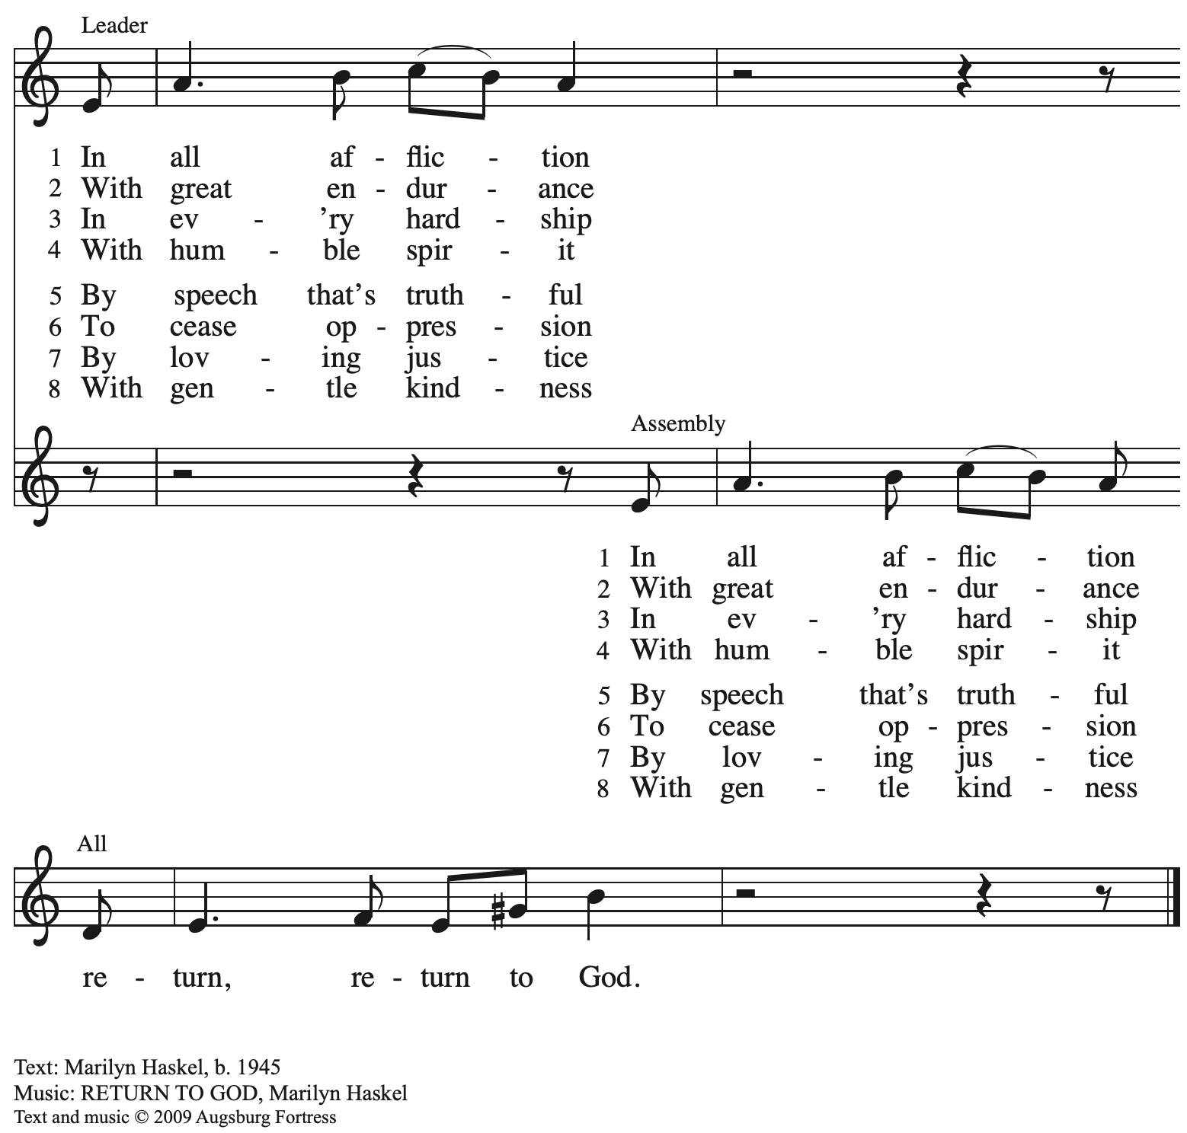
All rights reserved. Reprinted with permission under OneLicense.net # A-722139.

Confession and Forgiveness

Please rise as you are able. All may make the sign of the cross,
the sign that is marked at Baptism, as the presiding minister begins.

P: Blessed be the holy Trinity, ☩ one God,
who looks upon us in compassion,
forgives our sin,
and heals our wounds.
C: Amen.

P: Let us confess our sin in the presence of God and of one another.

Silence is kept for reflection.

P: Have mercy, O God,
C: for we have sinned
against you and our neighbors,
by what we have done
and by what we have failed to do.
In your compassion,
cleanse us from our sin
and take away our guilt.
Create in us a new heart
and give us a steadfast spirit.
Do not cast us away,
but fill us with your Holy Spirit
and restore your joy within us.
Amen.

P: As far as the highest mountain is to the lowest ocean floor,
so deep is God’s compassion for you.
As high as heaven is above earth,
so vast is God’s love for you.
As far as east is from west,
so far God removes your sin from you,
renewing your life through Jesus Christ.
Blessed be God who crowns us with mercy and love.
C: Blessed be God forever. Amen.

Gathering Hymn Bless Now, O God, the Journey ELW 326

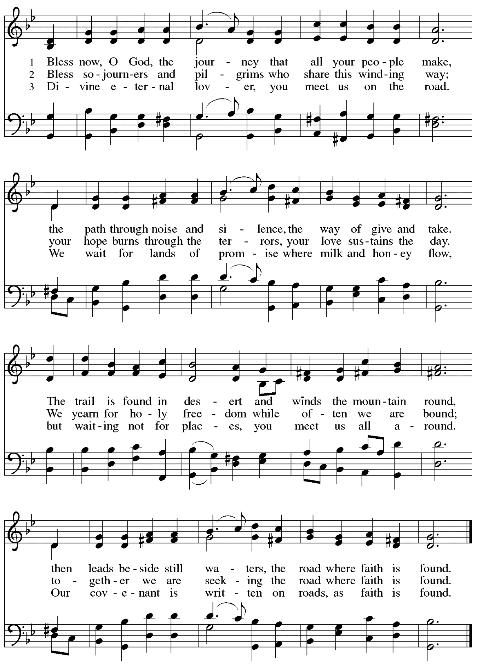

Greeting

P: The grace of our Lord Jesus Christ, the love of God,
and the communion of the Holy Spirit be with you all.
C: And also with you.

Kyrie ACS p. 31

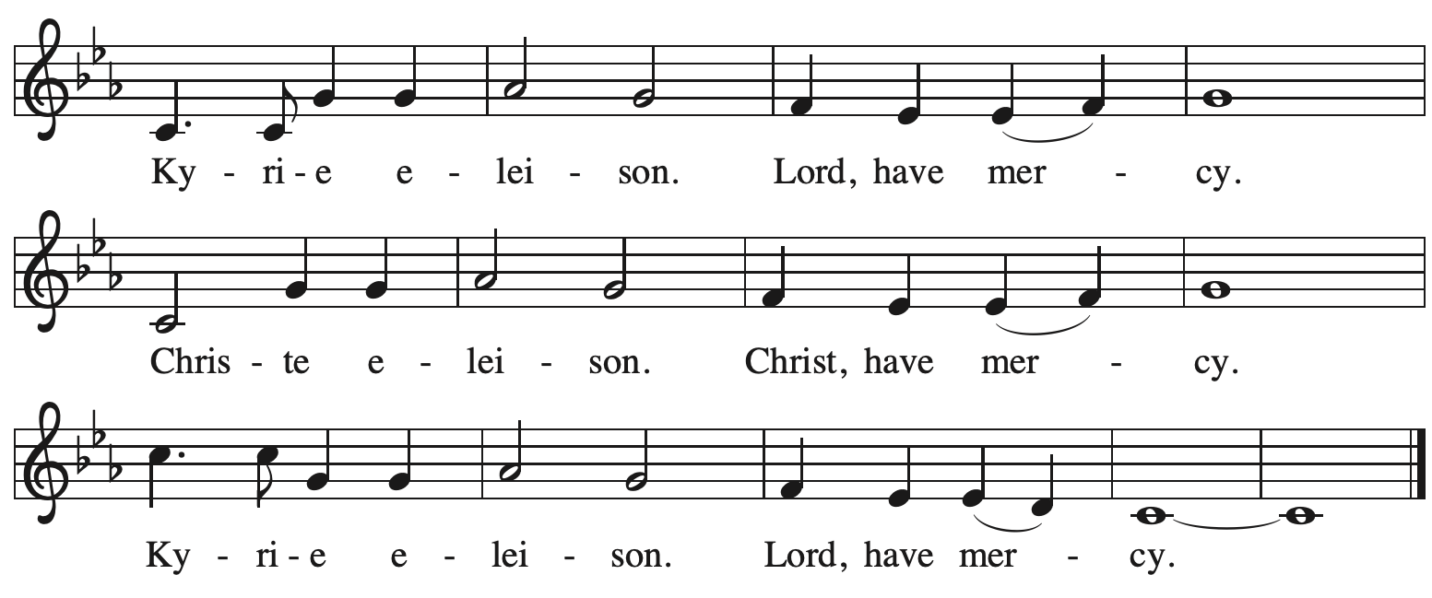

Prayer of the Day

P: Let us pray.
Holy God, heavenly Father, in the waters of the flood you saved the chosen,
and in the wilderness of temptation you protected your Son from sin.
Renew us in the gift of baptism. May your holy angels be with us,
that the wicked foe may have no power over us, through Jesus Christ, our Savior and Lord,
who lives and reigns with you and the Holy Spirit, one God, now and forever.
C: Amen.

Please be seated.
Children are invited to join the adult leaders at the door and move to the office for Little Church – Big Faith. We ask that one additional adult from the congregation attend with the children.

Word
God speaks to us in Scripture reading, preaching, and song

First Reading – Genesis 9: 8-17

⁸God said to Noah and to his sons with him, ⁹“As for me, I am establishing my covenant with you and your descendants after you, ¹⁰and with every living creature that is with you, the birds, the domestic animals, and every animal of the earth with you, as many as came out of the ark. ¹¹I establish my covenant with you, that never again shall all flesh be cut off by the waters of a flood, and never again shall there be a flood to destroy the earth.” ¹²God said, “This is the sign of the covenant that I make between me and you and every living creature that is with you, for all future generations: ¹³I have set my bow in the clouds, and it shall be a sign of the covenant between me and the earth. ¹⁴When I bring clouds over the earth and the bow is seen in the clouds, ¹⁵I will remember my covenant that is between me and you and every living creature of all flesh; and the waters shall never again become a flood to destroy all flesh. ¹⁶When the bow is in the clouds, I will see it and remember the everlasting covenant between God and every living creature of all flesh that is on the earth.” ¹⁷God said to Noah, “This is the sign of the covenant that I have established between me and all flesh that is on the earth.”

L: Word of God, word of life.
C: Thanks be to God.

Psalm 25: 1-10

Psalm tone

Psalm refrain

¹To | you, O Lord,
I lift | up my soul.
²My God, I put my trust in you; let me not be | put to shame,
nor let my enemies triumph | over me.
³Let none who look to you be | put to shame;
rather let those be put to shame | who are treacherous.
⁴Show me your | ways, O Lord,
and teach | me your paths. R
⁵Lead me in your | truth and teach me,
for you are the God of my salvation; in you have I trusted all | the day long.
⁶Remember, O Lord, your compas- | sion and love,
for they are from | everlasting.
⁷Remember not the sins of my youth and | my transgressions;
remember me according to your steadfast love and for the sake of your good- | ness, O Lord.
⁸You are gracious and up- | right, O Lord;
therefore you teach sinners | in your way. R
⁹You lead the low- | ly in justice
and teach the low- | ly your way.
¹⁰All your paths, O Lord, are steadfast | love and faithfulness
to those who keep your covenant and your | testimonies. R

Second Reading – 1 Peter 3: 18-22

¹⁸Christ also suffered for sins once for all, the righteous for the unrighteous, in order to bring you to God. Christ was put to death in the flesh, but made alive in the spirit, ¹⁹in which also he went and made a proclamation to the spirits in prison, ²⁰who in former times did not obey, when God waited patiently in the days of Noah, during the building of the ark, in which a few, that is, eight persons, were saved through water. ²¹And baptism, which this prefigured, now saves you—not as a removal of dirt from the body, but as an appeal to God for a good conscience, through the resurrection of Jesus Christ, ²²who has gone into heaven and is at the right hand of God, with angels, authorities, and powers made subject to him.

L: Word of God, word of life.
C: Thanks be to God.

Please rise as you are able.

Gospel Acclamation ACS p. 34

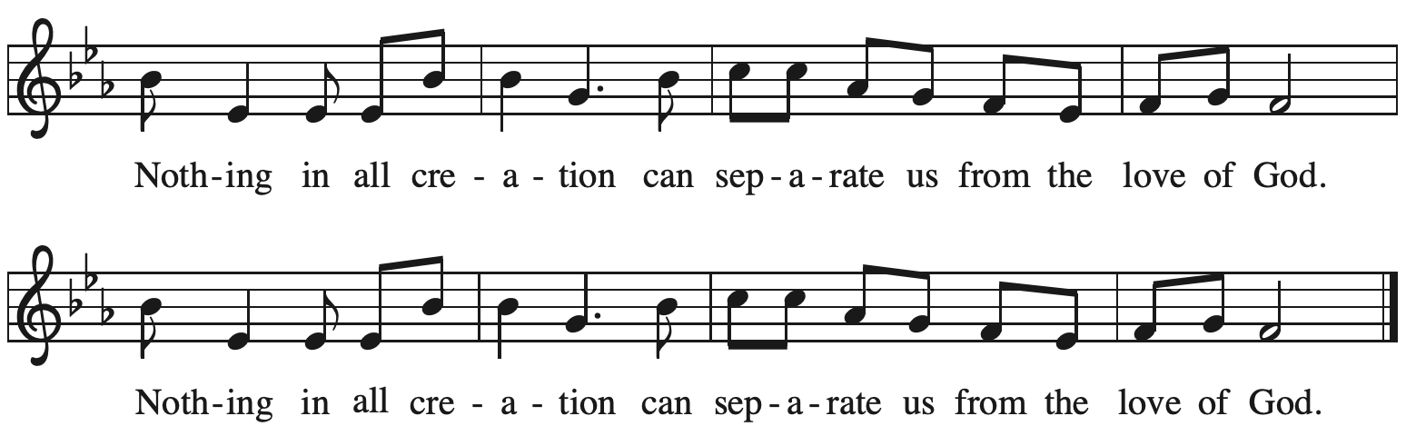

Gospel – Mark 1: 9-15

P: The holy Gospel according to St. Mark.
C: Glory to you, O Lord.

⁹In those days Jesus came from Nazareth of Galilee and was baptized by John in the Jordan.
¹⁰And just as he was coming up out of the water, he saw the heavens torn apart and the Spirit descending like a dove on him. ¹¹And a voice came from heaven, “You are my Son, the Beloved; with you I am well pleased.”
¹²And the Spirit immediately drove him out into the wilderness. ¹³He was in the wilderness forty days, tempted by Satan; and he was with the wild beasts; and the angels waited on him.
¹⁴Now after John was arrested, Jesus came to Galilee, proclaiming the good news of God, ¹⁵and saying, “The time is fulfilled, and the kingdom of God has come near; repent, and believe in the good news.”

P: The Gospel of the Lord.
C: Praise to you, O Christ.

Please be seated.

Sermon

A time of silence for prayer and reflection follows the sermon.
As the hymn of the day begins, please rise as you are able.

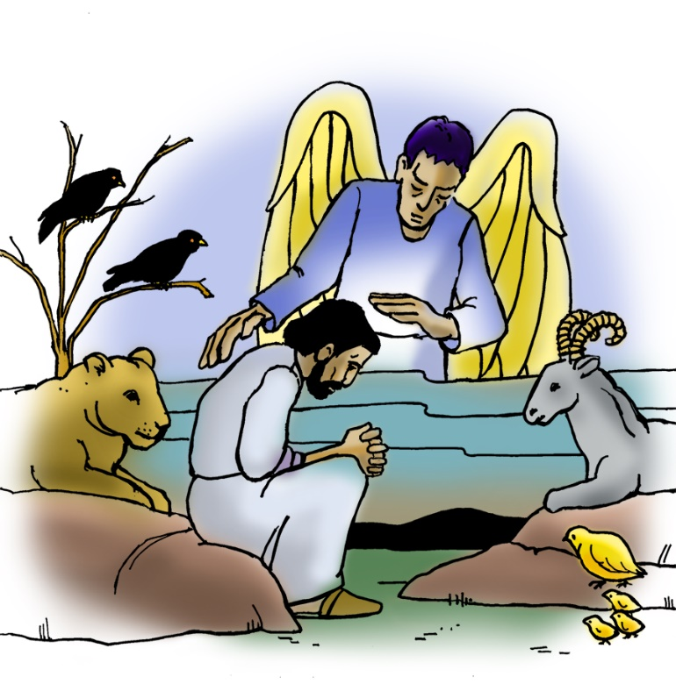

Hymn of the Day As Your Spirit in the Desert ACS 923

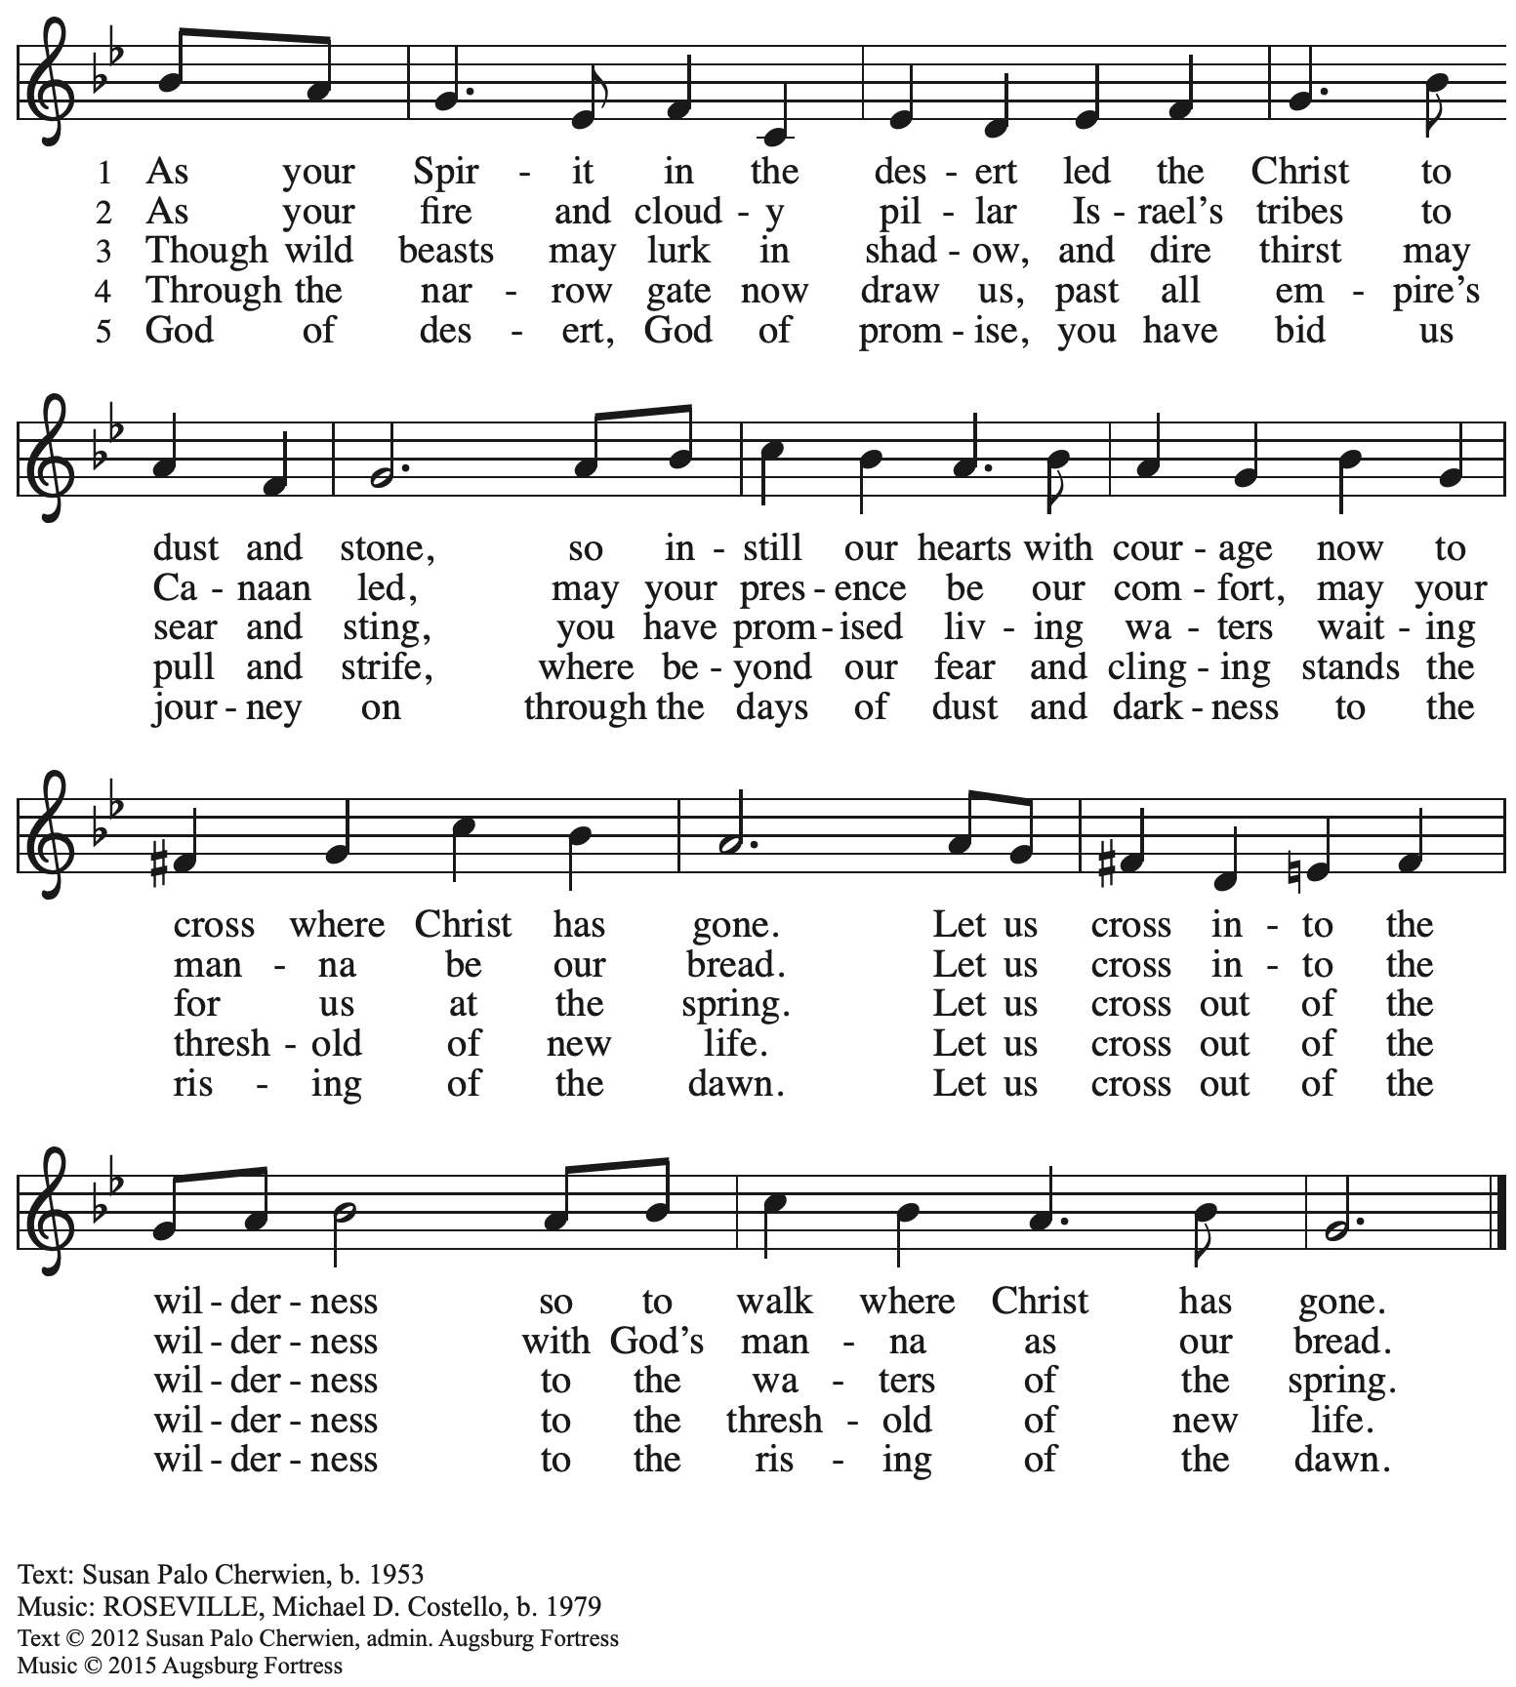
All rights reserved. Reprinted with permission under OneLicense.net # A-722139.

Apostles Creed

P: Trusting in God’s mercy, we confess our faith.
C: I believe in God, the Father almighty,
creator of heaven and earth.

I believe in Jesus Christ, God’s only Son, our Lord,
who was conceived by the Holy Spirit,
born of the virgin Mary,
suffered under Pontius Pilate,
was crucified, died, and was buried;
he descended to the dead.*
On the third day he rose again;
he ascended into heaven,
he is seated at the right hand of the Father,
and he will come to judge the living and the dead.

I believe in the Holy Spirit,
the holy catholic church,
the communion of saints,
the forgiveness of sins,
the resurrection of the body,
and the life everlasting. Amen.

*Or, “he descended into hell,” another translation of this text in widespread use.

Prayers of the People

A: Trusting in God’s promise to reconcile all things, let us pray for the church,
the well-being of creation, and all who are in need.

After each petition
A: Merciful God,
C: receive our prayer.

The presiding minister concludes the prayers
P: Accompany us on our journey through this season, O God of grace,
and receive the prayers of our hearts, through Jesus Christ, our Savior.
C: Amen.

Peace

The presiding minister and the assembly greet one another in the peace of the risen Christ.
P: The peace of Christ be with you always.
C: And also with you.

The people may greet those around them with a sign of Christ’s peace and may say
Peace be with you or similar words. Please be mindful that not everyone will be comfortable with sharing the peace, so please seek consent before shaking hands or hugging. Other possible ways to share the peace include a simple bow with the verbal greeting of peace, or simply a verbal expression of peace. When the greetings of peace have concluded, please be seated.
Meal
God feeds us with the presence of Jesus Christ

Offering

We offer ourselves, our gifts, and our faithful service to God.
As the offering is gathered for the mission of the church, including the care of those in need,
the table is set for Holy Communion.

“Quiet” Offering

As children of the congregation carry metal buckets around the sanctuary (with towels on the bottom during the season of Lent, people of the congregation are invited to throw in their change as an offering which will benefit local organization Casa San Jose.

Music during the Offering Old Rugged Cross G. Bennard

As the gifts are brought forward for presentation, please rise as you are able.

Offertory Song Create in Me a Clean Heart ELW 188

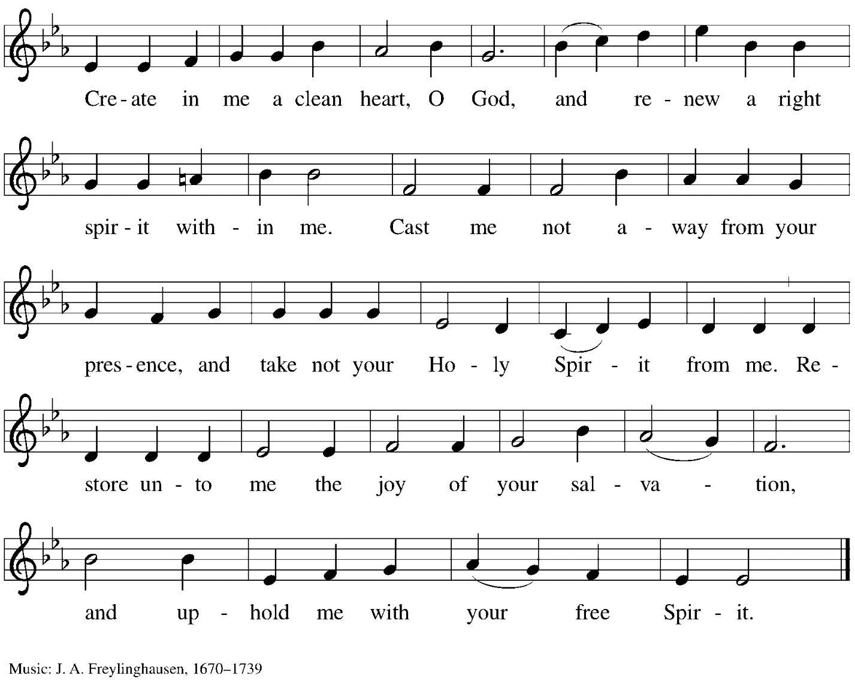

Offertory Prayer

A: Let us pray.
God our provider,
C: you have not fed us with bread alone,
but with words of grace and life.
Bless us and these your gifts,
which we receive from your bounty,
through Jesus Christ our Lord.
Amen.

Dialogue

P: The Lord be with you.
C: And also with you.

P: Lift up your hearts.
C: We lift them to the Lord.

P: Let us give thanks to the Lord our God.
C: It is right to give our thanks and praise.

Preface

P: It is indeed right, our duty and our joy,
that we should at all times and in all places
give thanks and praise to you, almighty and merciful God,
through our Savior Jesus Christ.
You call your people to cleanse their hearts
and prepare with joy for the paschal feast,
that, renewed in the gift of baptism,
we may come to the fullness of your grace.
And so, with all the choirs of angels,
with the church on earth and the hosts of heaven,
we praise your name and join their unending hymn:

Sanctus ACS p. 36

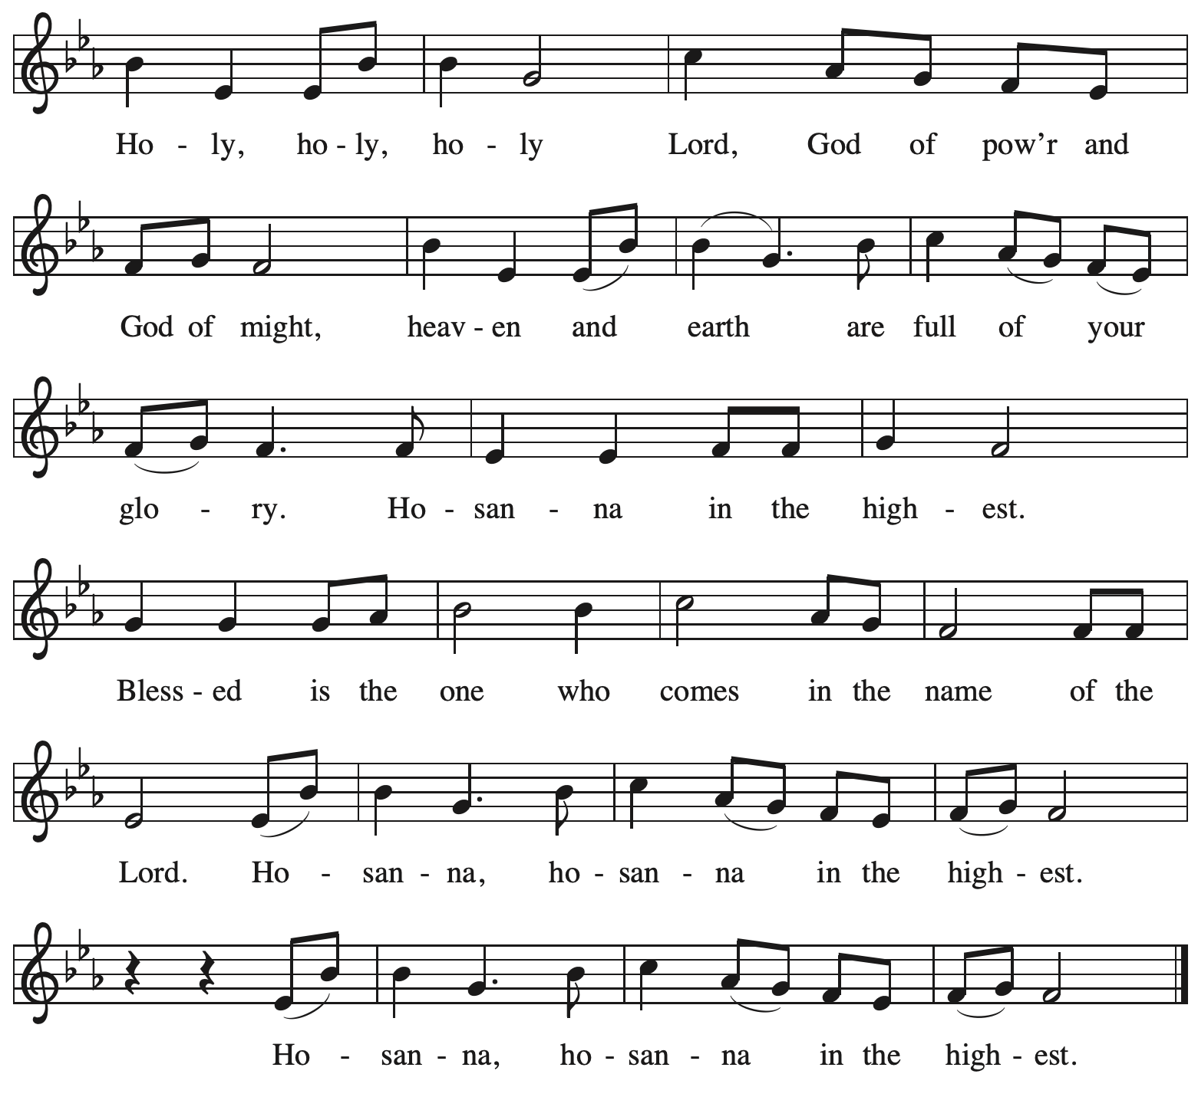

Eucharistic Prayer

P: Blessed are you, O God of the universe
Your mercy is everlasting
and your faithfulness endures from age to age.

Praise to you for creating the heavens and the earth.
Praise to you for saving the earth from the waters of the flood.
Praise to you for bringing the Israelites safely through the sea.
Praise to you for leading your people through the wilderness
to the land of milk and honey.

P: Praise to you for the words and deeds of Jesus, your anointed one.
Praise to you for the death and resurrection of Christ.
Praise to you for your Spirit poured out on all nations.

In the night in which he was betrayed,
our Lord Jesus took bread, and gave thanks;
broke it, and gave it to his disciples, saying:
Take and eat; this is my body, given for you.
Do this for the remembrance of me.

Again, after supper, he took the cup, gave thanks,
and gave it for all to drink, saying:
This cup is the new covenant in my blood,
shed for you and for all people for the forgiveness of sin
Do this for the remembrance of me.

With this bread and cup
we remember our Lord’s passover from death to life
as we proclaim the mystery of faith:
C: Christ has died.
Christ is risen.
Christ will come again.

P: O God of resurrection and new life:
Pour out your Holy Spirit on us
and on these gifts of bread and wine.
Bless this feast.
Grace our table with your presence.
C: Come, Holy Spirit.

P: Reveal yourself to us in the breaking of the bread.
Raise us up as the body of Christ for the world.
Breathe new life into us.
Send us forth,
burning with justice, peace, and love.
C: Come, Holy Spirit.

P: With your holy ones of all times and places,
with the earth and all its creatures,
with sun and moon and stars,
we praise you, O God,
blessed and holy Trinity,
now and forever.
C: Amen.

Lord’s Prayer (Sung)

P: Gathered as one by the Holy Spirit, let us pray as Jesus taught us.
C:
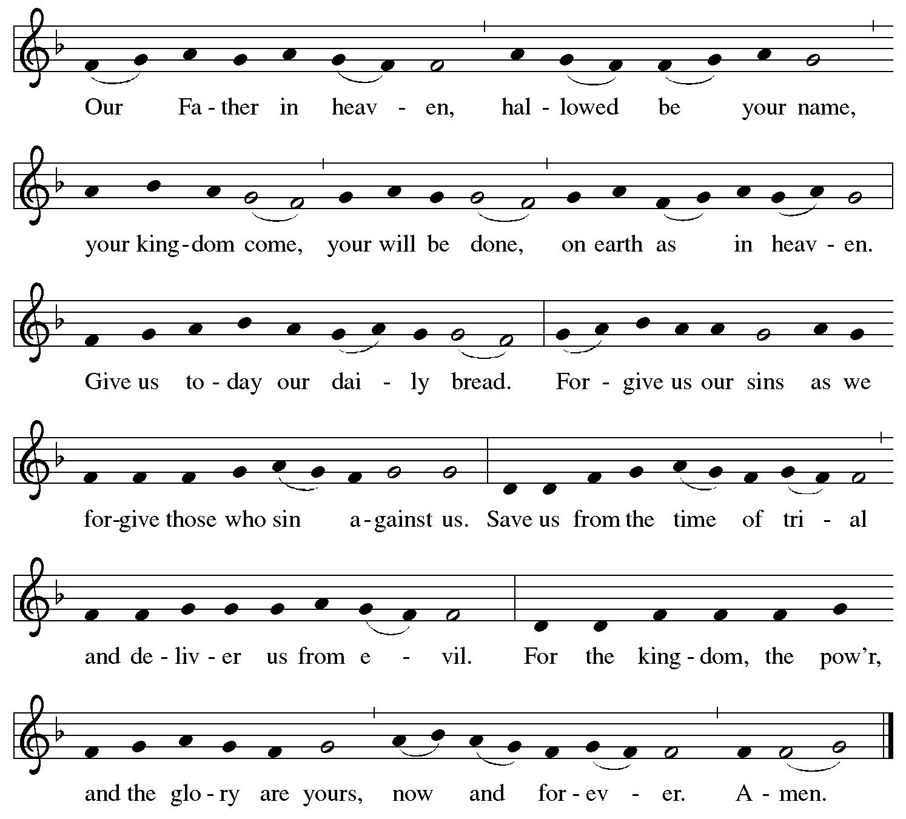

Fraction and Invitation

P: Come to the table of mercy.
Receive God’s gifts of grace.

Agnus Dei / Lamb of God ACS p. 40

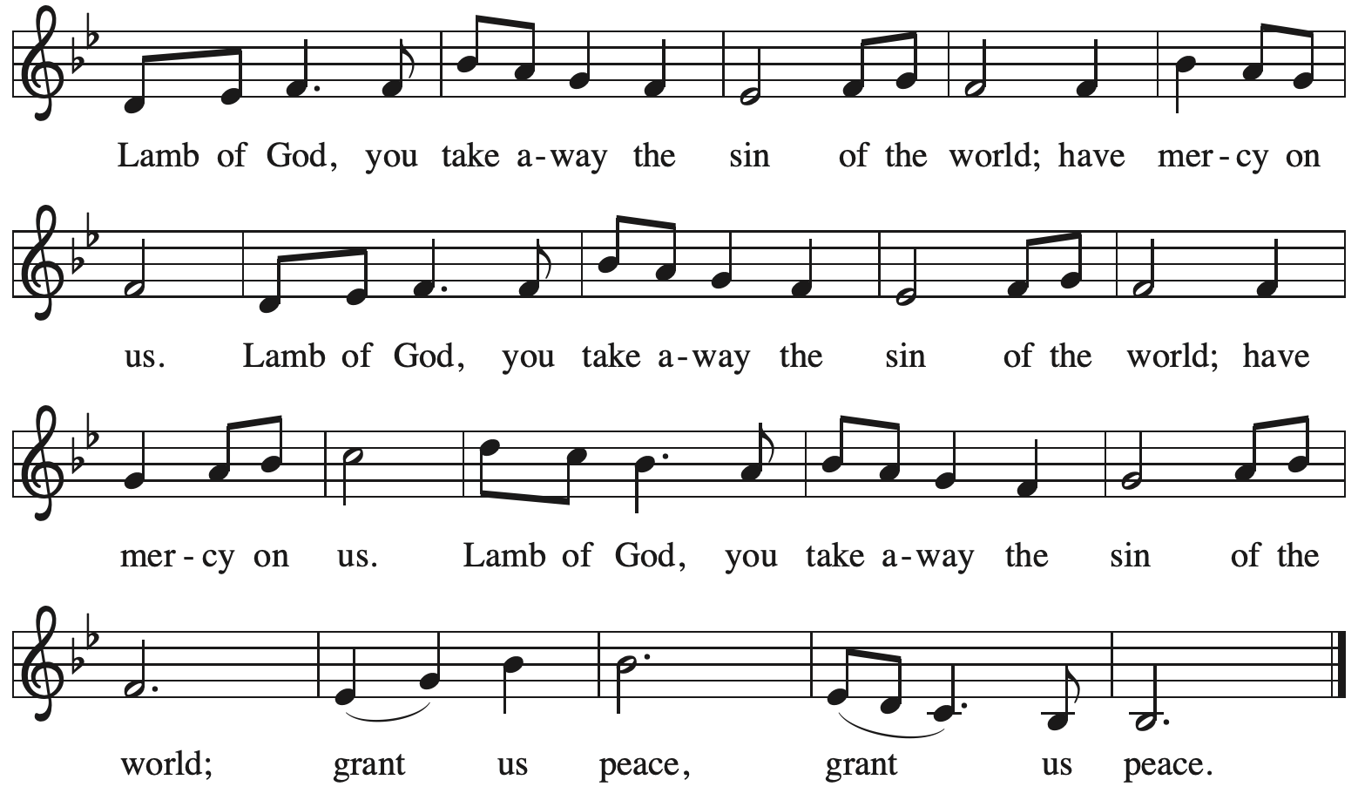

Please be seated.

Holy Communion
- All who seek God and desire a deeper and stronger life in Christ are welcome to receive Holy Communion.
- Worshipers from the pulpit side will proceed forward first, followed by the center section, and then the lectern side.
- Please inform an usher if you would like the ministers to bring Communion to you.
- Holy Communion will be served with bread and wine/grape juice.
- The presiding minister will first distribute the bread (host) to each communicant. Please indicate if you require a gluten-free host.
- Once you have consumed the bread, please pick up an empty glass from the tray next to the presiding minister. The Communion Assistant will pour wine from the chalice or grape juice from the cruet into your glass.
- Please step to the side to consume the wine or grape juice.
- Feel free to kneel at the altar rail for prayer after receiving the sacrament.
- As you return to your pew, glasses may be returned to the empty trays on either side of the center section.
- A blessing will be provided for anyone who does not yet receive the sacrament.
- All are invited to join in singing the hymns during Holy Communion.

Hymns during Holy Communion
We Place upon Your Table, Lord ELW 467

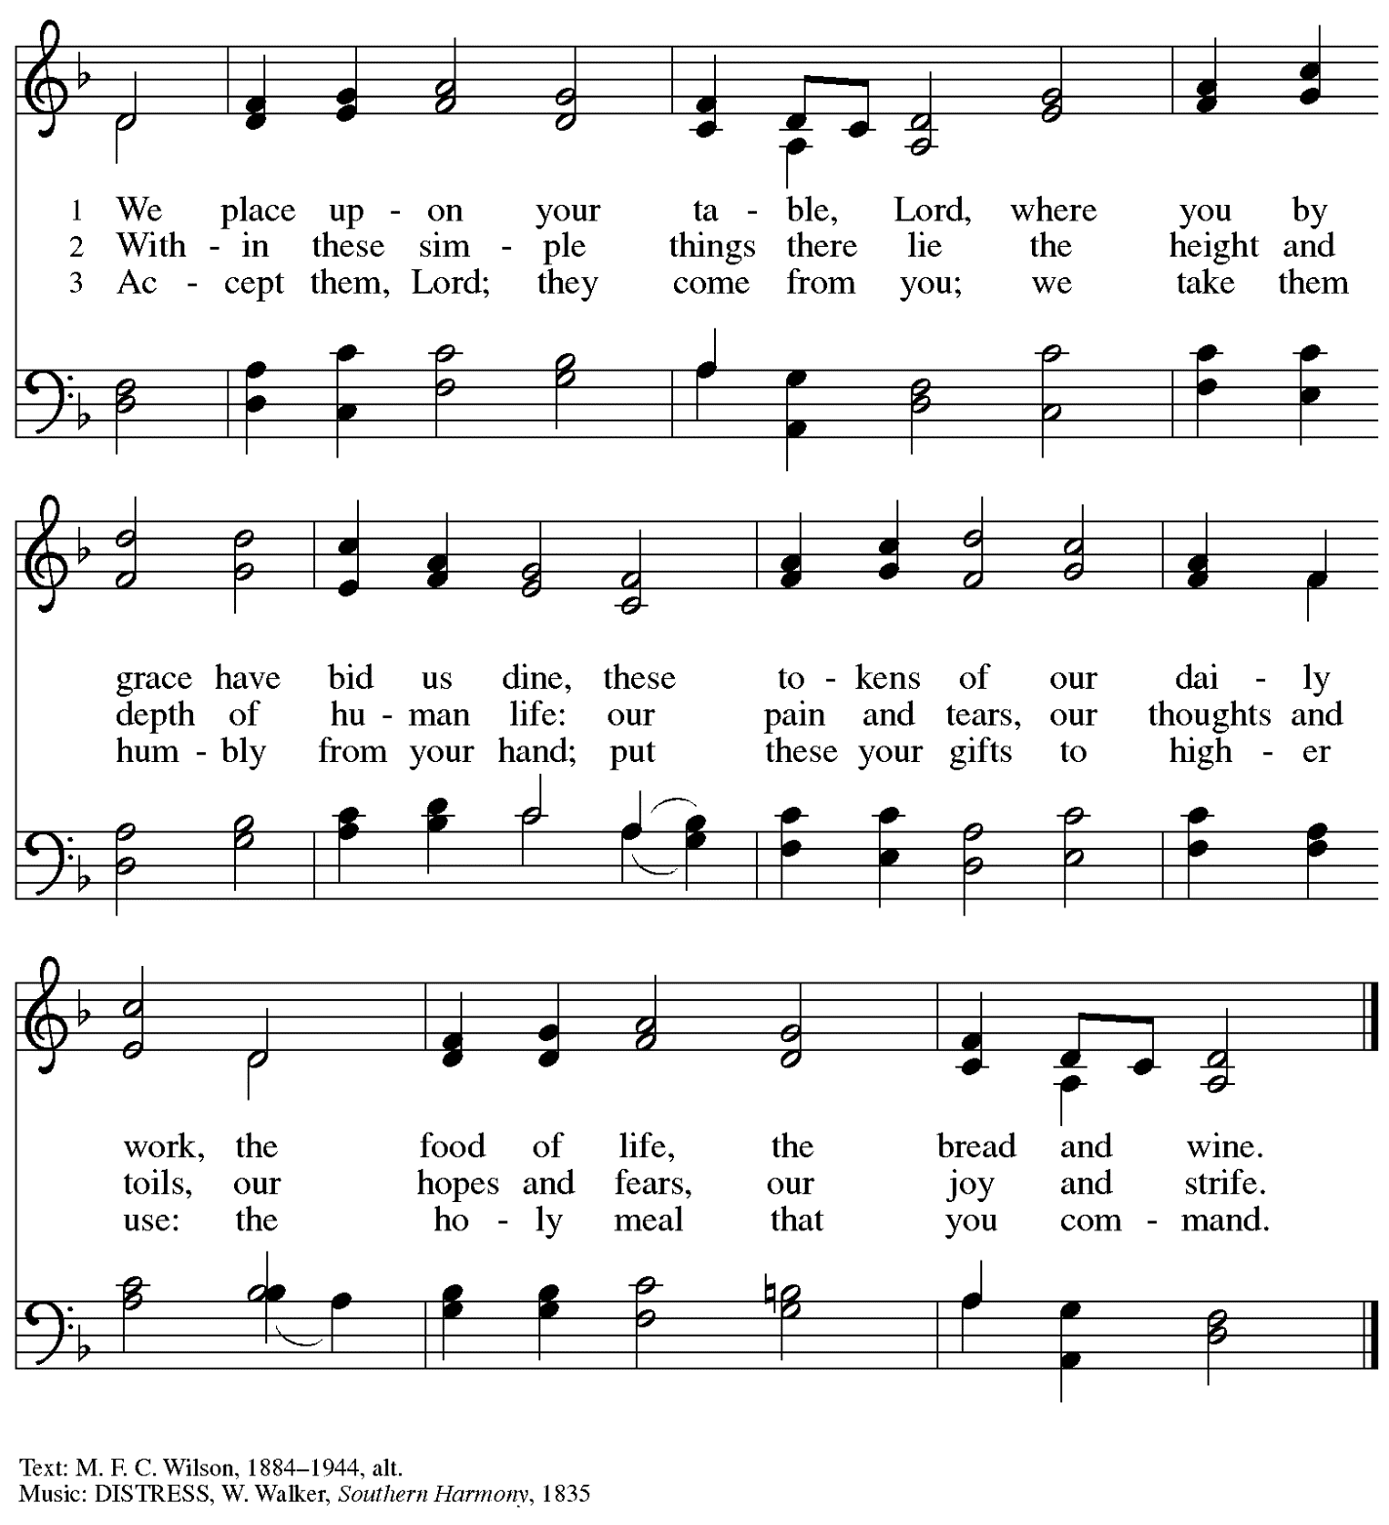

Hymns during Holy Communion
Lord, Keep Us Steadfast in Your Word ELW 517

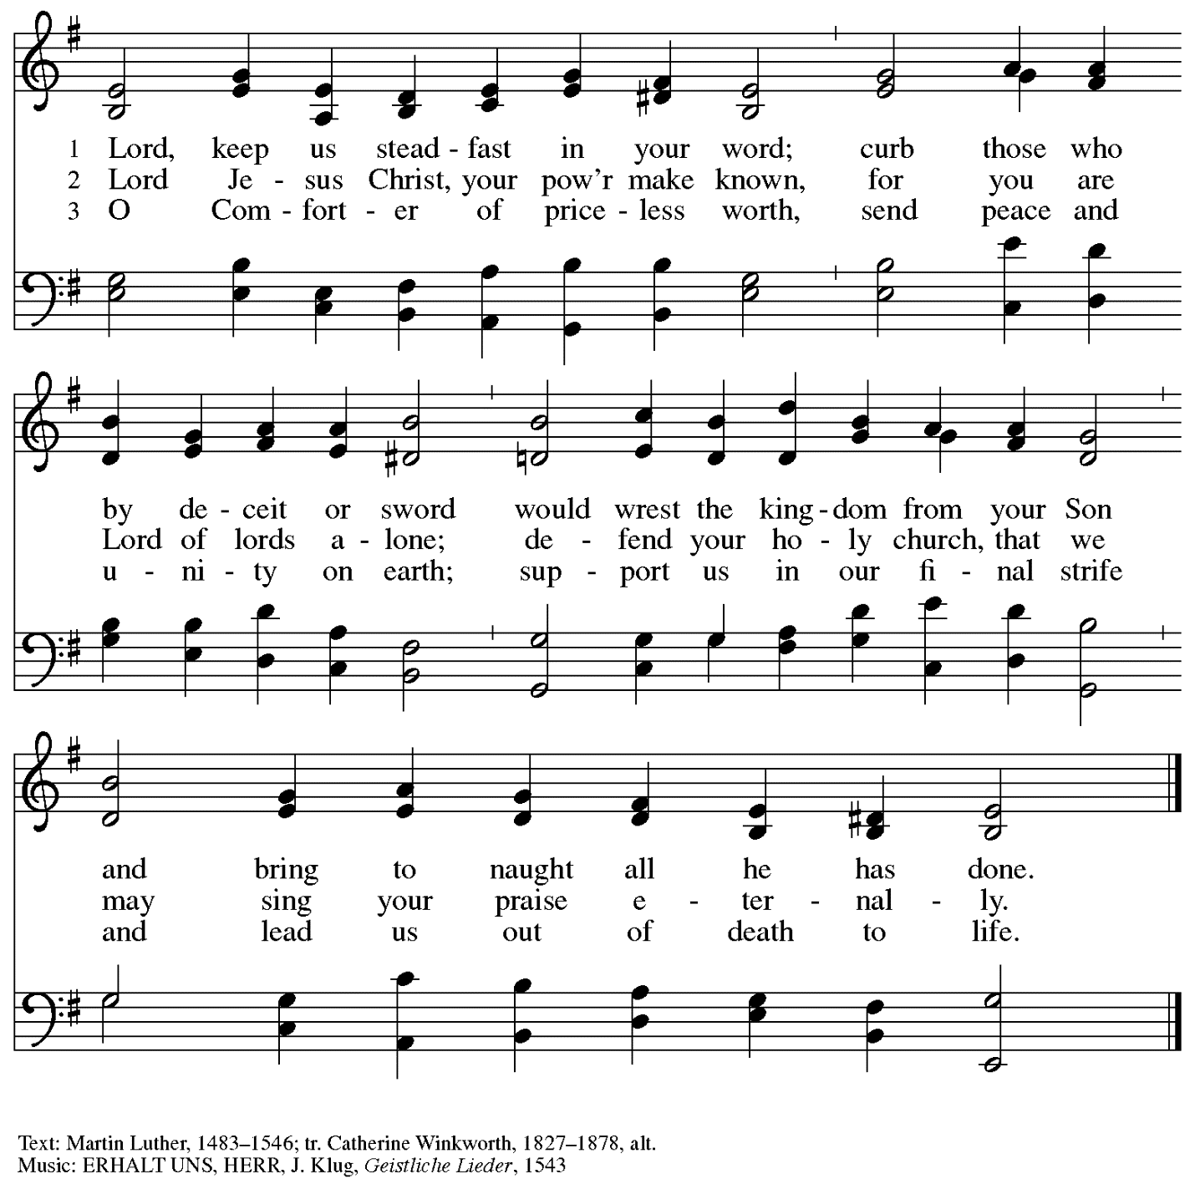
.

Hymns during Holy Communion
When We Are Tested ACS 922

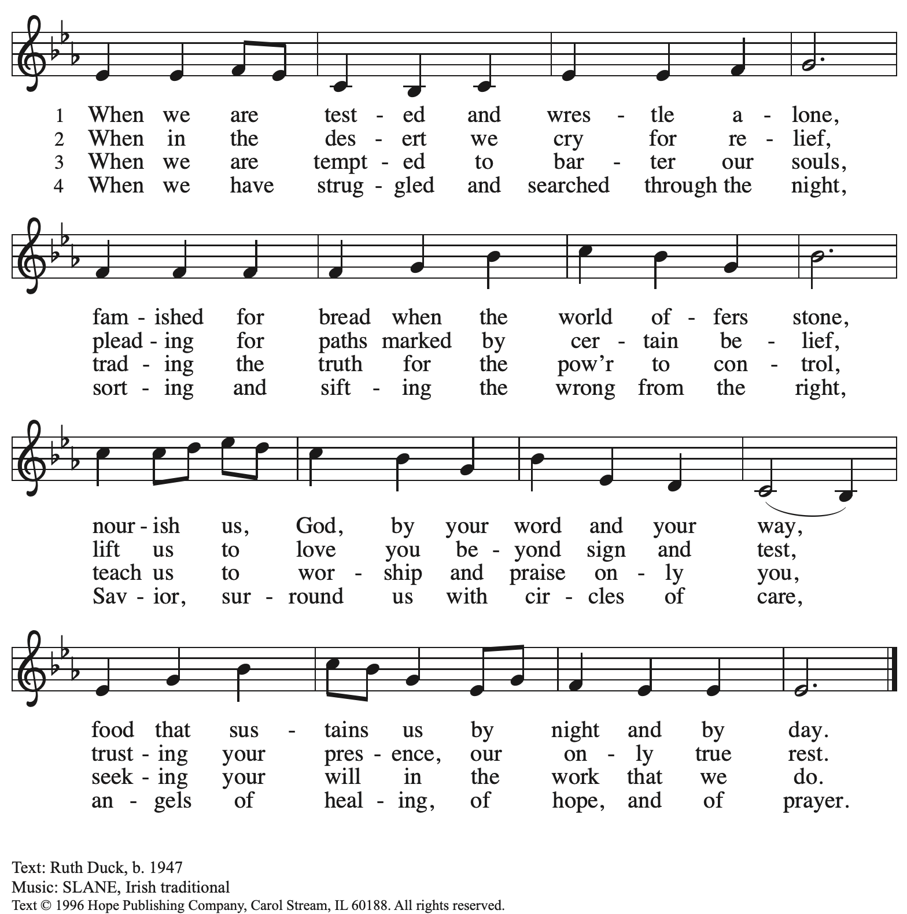
Reprinted with permission under OneLicense.net # A-722139.

When all have returned to their places, please rise as you are able.

Blessing

P: The body and blood of our Lord Jesus Christ strengthen you and keep you in his grace.
C: Amen.

Prayer

A: Let us pray.
Compassionate God, you have fed us with the bread of heaven.
Sustain us in our Lenten pilgrimage:
may our fasting be hunger for justice;
our alms, a making of peace;
and our prayer, the song of grateful hearts,
through Jesus Christ, our Savior and Lord.
C: Amen.

Please be seated.

Sending
God blesses us and sends us in mission to the world

Announcements

Please rise as you are able.

Benediction

P: The peace of God,
which surpasses all understanding,
keep your hearts and your minds
in ☩ Christ Jesus.
C: Amen.

Sending Hymn Jesus, Still Lead On Following page

Dismissal

A: Go in peace. Christ is with you.
C: Thanks be to God!

Postlude Larghetto K.34 D. Scarlatti

Sending Hymn Jesus, Still Lead On ELW 624

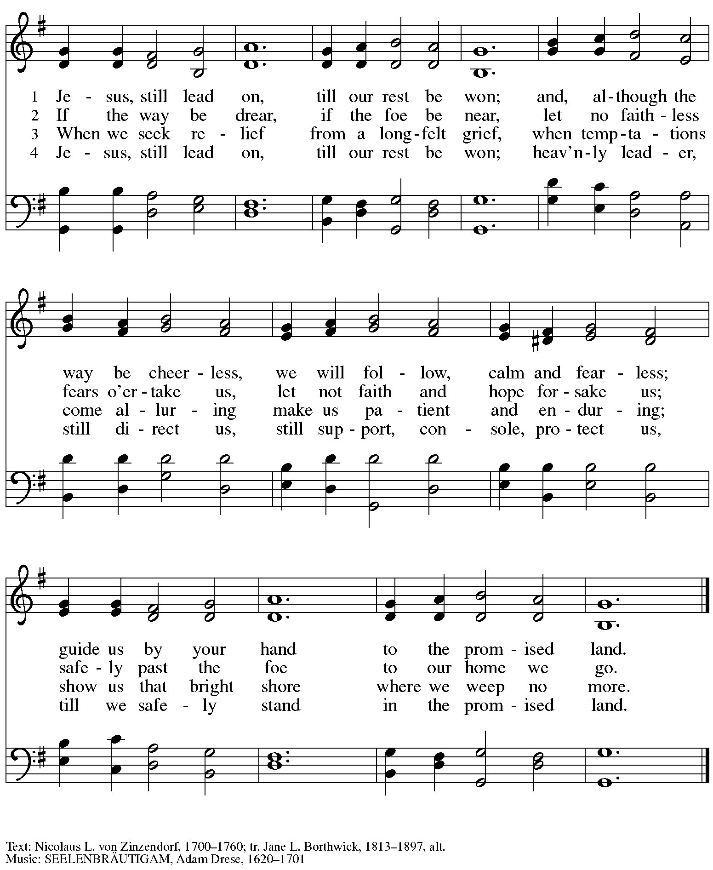

Those serving in worship

Altar Care Beverley Chapman
Assisting Minister Colleen Cooke
Audio-Visual Ministers Kristen Asplin
Joseph Paetz
Tyler Rietze
Cantor Maria Mangano
Classical Guitar Jered Stratton
Coffee Hour Lindsay Baxter
Lector Michael Chapman
Little Church – Big Faith Teacher Sue Gaugler
Minister of Music Laura Reynolds
Presiding and Preaching Minister The Rev. Ross I. Carmichael

Liturgy and Hymnody Acknowledgements

From SundaysandSeasons.com. Copyright © 2024 Augsburg Fortress. All rights reserved. Reprinted under OneLicense.net # A-722139.
Used by permission of Augsburg Fortress.

Bless Now, O God, the Journey – Text: Sylvia G. Dunstan, 1955-1993. Music: LLANGLOFFAN, Welsh tune, 19th cent. Text © 1991 GIA Publications, Inc., 7404 S. Mason Ave., Chicago, IL 60638. www.giamusic.com. 800.442.3358. All rights reserved. Reprinted with permission under OneLicense.net # A-722139.

.

Please use the QR code below to link to St. Andrew’s Announcements online!

St. Andrew Lutheran Church Announcements
February 18th, 2024

- Welcome to worship at St. Andrew on the First Sunday in Lent, February 18th, 2024 – We are so glad you are here, and we offer a special welcome to all visitors and guests who are gathered at the church or online! Children are invited to participate in Little Church – Big Faith, a Bible lesson and activity, after the prayer of the day. There are worship “toolkits” to help children engage with worship and “busy bags” for younger children available in the bookcase at the back of the sanctuary. Please feel free to take one to use with/for your children. We invite everyone to gather in the social hall (through the door on the left side of the worship space) for coffee and conversation after worship!
- “Quiet” (Noisy) Offering during Worship Today – On the third Sunday of each month, St. Andrew invites the children of the congregation to lead us in a “noisy” offering during Lent. Children carry buckets around the congregation and people are invited to throw in their change. Because the church has entered the more subdued season of Lent, this month’s noisy offering will be a “Quiet” offering, and will benefit Casa San Jose, a member of Pittsburgh’s ISAC (Immigrant Services and Connections) network, providing various resources to immigrants new to Pittsburgh.
Growing in Faith Together – Gatherings for People New to St. Andrew Begin Today, February 18th, after Worship – Over the past year, St. Andrew has been blessed by the presence of many people new to the community of faith! We are offering small group gatherings to help people get to know one another, share in conversation and faith stories based on the weekly readings, and to pray for one another. These gatherings will be on the Sundays in Lent after worship, beginning today, February 18th. The group will continue to meet on February 25th, March 3rd, March 10th (Congregational Meeting), March 17th, and March 24th. If you are interested in participating or have any questions, please speak with Pastor Ross or contact Jeff at jdenlinger26@icloud.com.
- Gathered into One: Devotions for Lent 2024 Still Available at Church Entrances – The Christian church’s season of Lent, from a word that meant “springtime,” began this past week on Ash Wednesday. During Lent, many practice some form of spiritual discipline, with prayer, fasting, or charitable giving. Gathering into One offers a brief reading, prayer, and reflection for each day of the Lenten season. We invite everyone to take one for yourself and/or others from the church entrances.
- Choir Rehearsal Sunday, February 25th, after Worship – Anyone who would like to sing on a choir Prelude on Sunday, March 3rd is encouraged to attend a rehearsal after worship next Sunday, February 25th. There will also be a rehearsal at 9:00 a.m. on Sunday, March 3rd. If you have any questions, please contact Laura Reynolds at ministerofmusic@standrewpittsburgh.org.
- Service of Prayer and Lament for the Holy Land – Saturday, March 2nd, 6:00 p.m. – As the crisis in the Holy Land continues, St. Andrew will once again offer a service of prayer and lament for the Holy Land on Saturday, March 2nd.
- Meeting of the Congregation – Sunday, March 10th, after Worship – Each year in the winter/spring, St. Andrew gathers for a congregational meeting to review financial figures for the previous year, report of our various ministries, and update the congregation on upcoming developments and initiatives. Please put this date on your calendars!
- Support Abuelas Responden – Grannies Respond with Donations of Used Winter Clothing Items – Abuelas Responden - Grannies Respond is a local organization that supports traveling asylum seekers as they come through Pittsburgh. The group goes to the downtown bus station to meet those who have been released from the Moshannon Valley detention center and supply them with much needed items as they travel to join family or friends in other cities. The primary need is for warm winter clothing. A bin will be set up in the social hall to receive these items. Right now the most needed items are:
- Men’s warm (but not too bulky) coats, jackets, fleece hoodies - People need to be able to fit everything in bags so there is no space for a heavy coat.
- Men’s Pants and Shoes (Please no sweatpants - this is what the people receive in detention, so we want to avoid outfitting anyone with something that looks like prisoners’ clothes.
- Men’s gloves
- Inviting Coffee Hour Signups for Upcoming Sundays – One way that we at St. Andrew build community is by sharing conversation over food and drinks at coffee hour after worship on Sundays. We invite people of the congregation to serve by getting the coffee brewing, setting out cups, napkins, food items, and cold drinks, and cleaning up afterward. Everything needed is at St. Andrew and instructions are available. If you would be willing to set up coffee hour on any of the upcoming Sundays, please sign up here:
https://www.signupgenius.com/go/5080B4AAFAF2CABF85-47069030-coffee.
Thank you for your consideration!
- Call for Parishioners to Serve in Worship Roles – St. Andrew's worship is made possible by many people who serve in various roles – Some people prepare the altar and setup Communion, some run the sound/streaming system, while others teacher Little Church – Big Faith for the children, serve as ushers, wash communion cups, count the offering, and more. It is not just roles like Cantor and Lector that involve being up in front of the congregation! If you are interested in getting more involved in worship, talk to Pastor Ross or Joseph Paetz. Most positions serve once a month or less!
- Compline Prayer Service, a Ministry of Lutheran Campus Ministry in Greater Pittsburgh, Sundays at 8:00 p.m. at Heinz Chapel – Compline was traditionally a monastic prayer service, and the Pittsburgh Compline Choir sings a choral version of compline rooted in this thousand-year-old tradition of scripture, song, and silence. This service also streams on Facebook (Pittsburgh Compline Choir) and YouTube (The Pittsburgh Compline Choir). Heinz Chapel is located off of S. Bellefield Ave. in Oakland.
- Christ in Our Home Devotional Booklets for January - March Available at Church Entrances – This resource offers a daily Bible reading with a short reflection and prayer, along with additional readings and prayer topics for those who would like to expand their devotional practices. We encourage people of the congregation to take one for yourself, your family unit, or others!

