+ Transfiguration of our Lord
February 11th, 2024
10:00 a.m.

St. Andrew Lutheran Church
304 Morewood Ave.
Pittsburgh, PA 15213
412.682.3342
St_andrewELCA@verizon.net
www.standrewpittsburgh.org

+ Transfiguration of our Lord
Order for Worship

The Sundays after Epiphany began with Jesus’ baptism and conclude with three disciples’ vision of his transfiguration. In Mark’s story of Jesus’ baptism, only Jesus sees the Spirit descending and hears the words from heaven. But now Jesus’ friends hear the same words naming him God’s Beloved. As believers, Paul writes, we are enabled to see the God-light in Jesus’ face, because the same God who created light in the first place has shone in our hearts to give us that vision. The light of God’s glory in Jesus has enlightened us through Holy Baptism and shines in us also for others to see.

Welcome to St. Andrew!
- St. Andrew Lutheran congregation welcomes all who are seeking a place of healing and wholeness – a nurturing, faith-forming spiritual home. Our community embraces people of all ages, ethnicities, cultures, abilities, sexual orientations, gender identities and expressions, and family constellations. Come and See!
- Worship Services are live streamed to multiple online platforms. By attending worship, you agree that your image and voice may be broadcast.
- Everyone is invited to make a nametag at the black bookcase in the back of the worship space if they would like. There are stickers indicating pronouns on the bookcase if you would like to include them on your name tag.
- Children are invited to attend Little Church – Big Faith, a Bible lesson and activity, during worship (after the Prayer of the Day). The group returns to the worship space for the liturgy of Holy Communion.
- Worship “toolkits” to help children engage with the service, along with “busy bags” for younger children, are available in the bookcase at the back of the sanctuary. Please feel free to take one to use with/for your children.
- Holy Communion is served with bread (gluten-free available) and wine or grape juice. The presiding minister will distribute the bread (host). Please consume this and then pick up an empty glass from the tray. The Communion Assistant will pour wine or grape juice into your glass. Please step to the side to consume the wine or grape juice. Feel free to kneel at the altar for prayer and reflection. As you return to your pew, glasses may be returned to the empty trays on either side of the center section.
- A restroom is available on the main level of the church, through the doors to the Social Hall and to the right in the main office.

Abbreviations

P: Pastor/Presiding Minister ELW: Evangelical Lutheran Worship hymnal
A: Assisting Minister ACS: All Creation Sings hymnal
L: Lector
C: Congregation
Welcome

Prelude Beautiful Savior arr. Raabe

Gathering
The Holy Spirit calls us together as the people of God

Confession and Forgiveness

Please rise as you are able. All may make the sign of the cross,
the sign that is marked at Baptism, as the presiding minister begins.

P: Blessed be the holy Trinity, ☩ one God,
creator of darkness and light, word of truth,
our life and our salvation.
C: Amen.

P: Let us confess our sin in the presence of God and of one another.

Silence is kept for reflection.

P: God, our rock and refuge,
C: We confess that we have sinned against you
and wounded one another.
We have not loved you and our neighbors as you have loved us.
We have not always recognized the Holy Spirit dwelling in each of us.
Remember your covenant.
Renew your creation.
Restore us,
that we might proclaim your good news to all.
Amen.

P: The voice of the Lord is upon the waters.
God has spoken: The time of grace is now.
In Jesus, the reign of God has come near.
By the authority of ☩ Jesus Christ, your sins are forgiven.
You are God’s beloved.
C: Amen.

Gathering Hymn Love Divine, All Loves Excelling ELW 631

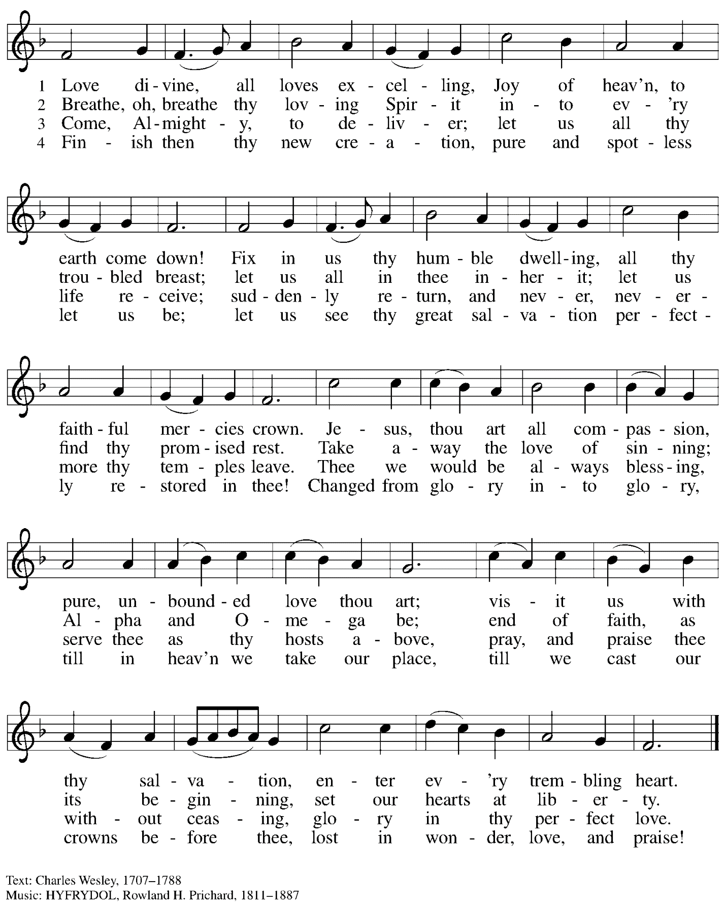

Greeting

P: The grace of our Lord Jesus Christ, the love of God,
and the communion of the Holy Spirit be with you all.
C: And also with you.

Hymn of Praise ACS p. 31

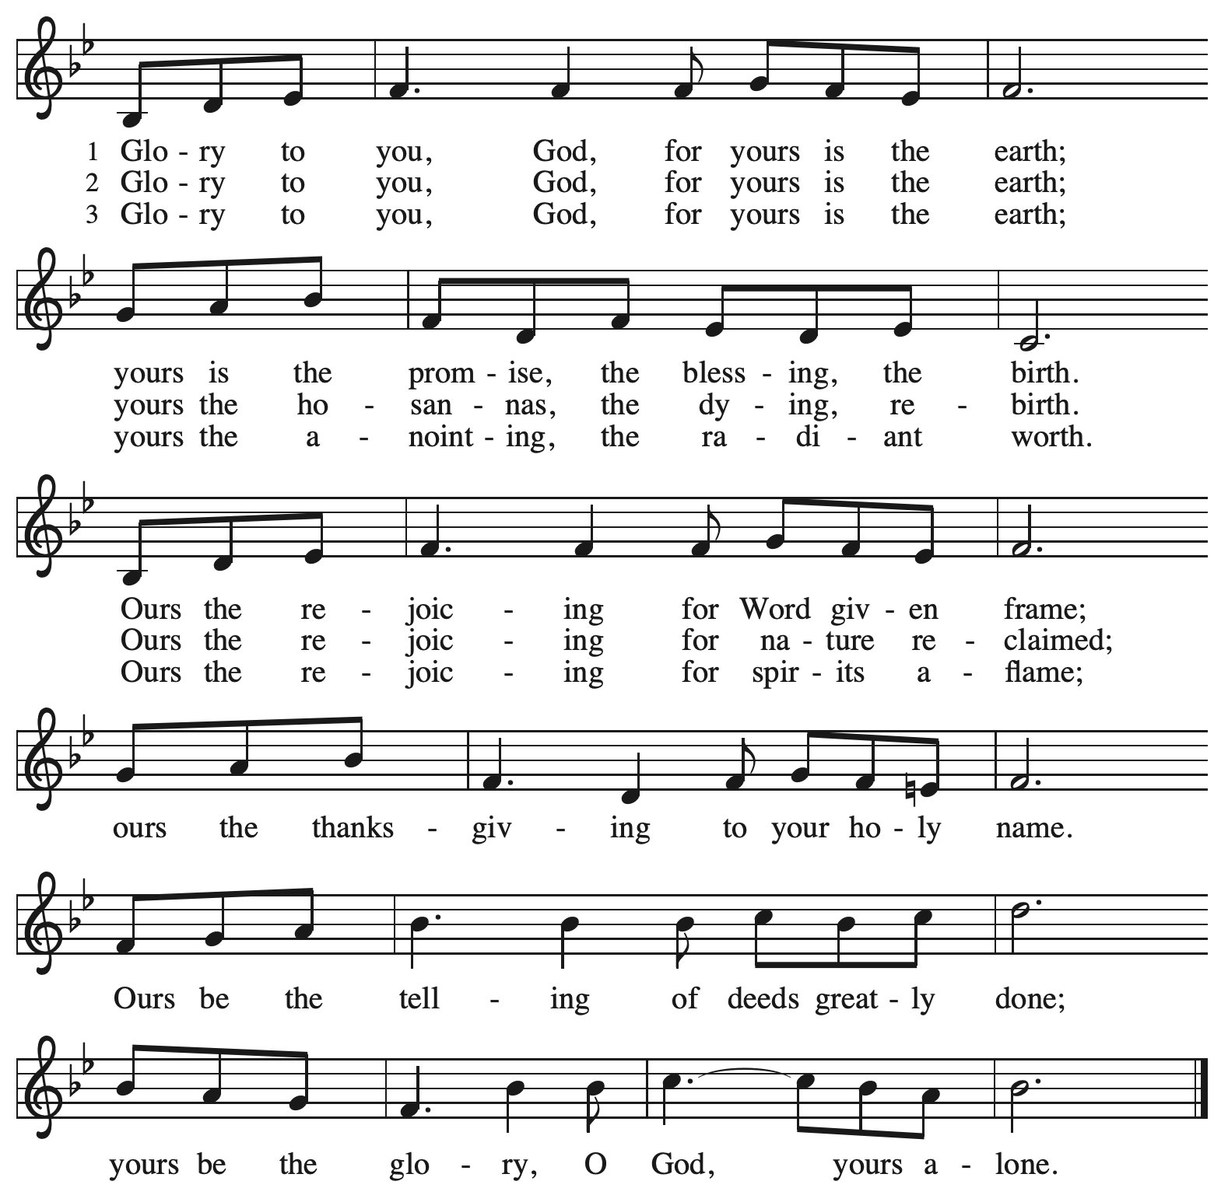

Prayer of the Day

P: Let us pray.
Almighty God, the resplendent light of your truth shines from the mountaintop into our hearts. Transform us by the experience of your beloved Son, and illumine the world with your image,
through Jesus Christ, our Savior and Lord, who lives and reigns with you and the Holy Spirit,
one God, now and forever.
C: Amen.

Please be seated.
Children are invited to join the adult leaders at the door and move to the office for Little Church – Big Faith. We ask that one additional adult from the congregation attend with the children.

Word
God speaks to us in Scripture reading, preaching, and song

First Reading – 2 Kings 2: 1-12

¹Now when the Lord was about to take Elijah up to heaven by a whirlwind, Elijah and Elisha were on their way from Gilgal. ²Elijah said to Elisha, “Stay here; for the Lord has sent me as far as Bethel.” But Elisha said, “As the Lord lives, and as you yourself live, I will not leave you.” So they went down to Bethel. ³The company of prophets who were in Bethel came out to Elisha, and said to him, “Do you know that today the Lord will take your master away from you?” And he said, “Yes, I know; keep silent.”
⁴Elijah said to him, “Elisha, stay here; for the Lord has sent me to Jericho.” But he said, “As the Lord lives, and as you yourself live, I will not leave you.” So they came to Jericho. ⁵The company of prophets who were at Jericho drew near to Elisha, and said to him, “Do you know that today the Lord will take your master away from you?” And he answered, “Yes, I know; be silent.”
⁶Then Elijah said to him, “Stay here; for the Lord has sent me to the Jordan.” But he said, “As the Lord lives, and as you yourself live, I will not leave you.” So the two of them went on. ⁷Fifty men of the company of prophets also went, and stood at some distance from them, as they both were standing by the Jordan. ⁸Then Elijah took his mantle and rolled it up, and struck the water; the water was parted to the one side and to the other, until the two of them crossed on dry ground.
⁹When they had crossed, Elijah said to Elisha, “Tell me what I may do for you, before I am taken from you.” Elisha said, “Please let me inherit a double share of your spirit.” ¹⁰He responded, “You have asked a hard thing; yet, if you see me as I am being taken from you, it will be granted you; if not, it will not.” ¹¹As they continued walking and talking, a chariot of fire and horses of fire separated the two of them, and Elijah ascended in a whirlwind into heaven. ¹²Elisha kept watching and crying out, “Father, father! The chariots of Israel and its horsemen!” But when he could no longer see him, he grasped his own clothes and tore them in two pieces.

L: Word of God, word of life.
C: Thanks be to God.

Psalm 50: 1-6

Psalm tone

Psalm refrain

¹The mighty one, God the | Lord, has spoken;
calling the earth from the rising of the sun | to its setting.
²Out of Zion, perfect | in its beauty,
God shines | forth in glory. R
³Our God will come and will | not keep silence;
with a consuming flame before, and round about a | raging storm.
⁴God calls the heavens and the earth | from above
to witness the judgment | of the people.
⁵“Gather before me my | loyal followers,
those who have made a covenant with me and sealed | it with sacrifice.”
⁶The heavens declare the rightness | of God’s cause,
for it is God | who is judge. R

Second Reading – 2 Corinthians 4: 3-6

³Even if our gospel is veiled, it is veiled to those who are perishing. ⁴In their case the god of this world has blinded the minds of the unbelievers, to keep them from seeing the light of the gospel of the glory of Christ, who is the image of God. ⁵For we do not proclaim ourselves; we proclaim Jesus Christ as Lord and ourselves as your slaves for Jesus’ sake. ⁶For it is the God who said, “Let light shine out of darkness,” who has shone in our hearts to give the light of the knowledge of the glory of God in the face of Jesus Christ.

L: Word of God, word of life.
C: Thanks be to God.

Please rise as you are able.

Gospel Acclamation Alleluia ACS p. 33

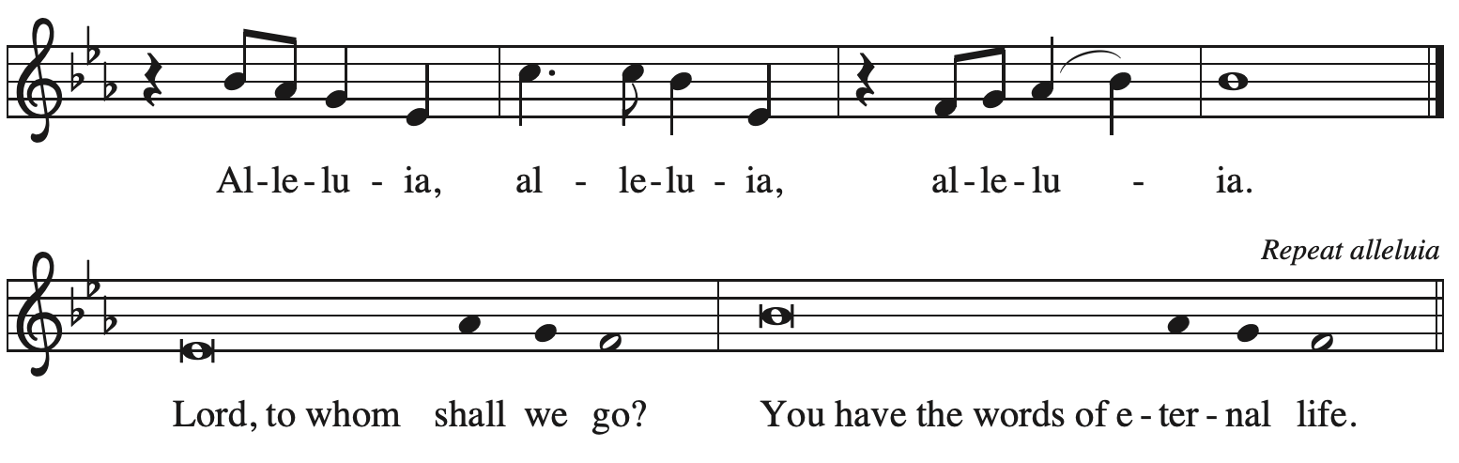

Gospel – Mark 9: 2-9

P: The holy Gospel according to St. Mark.
C: Glory to you, O Lord.

Six days later, Jesus took with him Peter and James and John, and led them up a high mountain apart, by themselves. And he was transfigured before them, ³and his clothes became dazzling white, such as no one on earth could bleach them. ⁴And there appeared to them Elijah with Moses, who were talking with Jesus. ⁵Then Peter said to Jesus, “Rabbi, it is good for us to be here; let us make three dwellings, one for you, one for Moses, and one for Elijah.” ⁶He did not know what to say, for they were terrified. ⁷Then a cloud overshadowed them, and from the cloud there came a voice, “This is my Son, the Beloved; listen to him!” ⁸Suddenly when they looked around, they saw no one with them any more, but only Jesus.

⁹As they were coming down the mountain, he ordered them to tell no one about what they had seen, until after the Son of Humanity had risen from the dead.

P: The Gospel of the Lord.
C: Praise to you, O Christ.

Please be seated.

Sermon

A time of silence for prayer and reflection follows the sermon.
As the hymn of the day begins, please rise as you are able.

Hymn of the Day Jesus on the Mountain Peak ELW 317

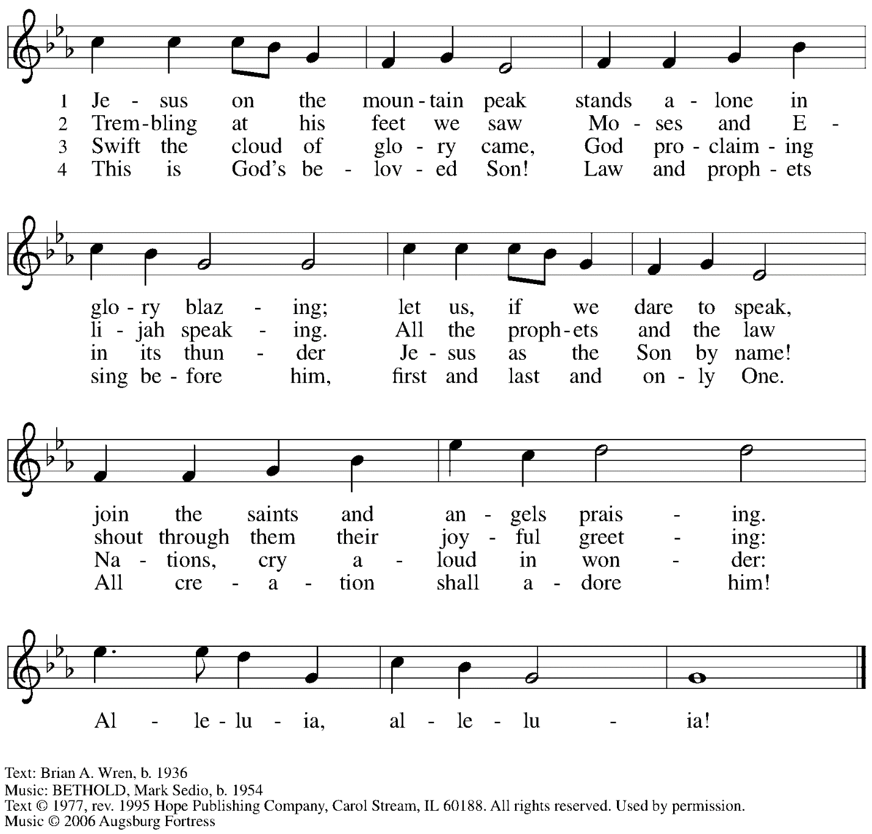
Reprinted with permission under OneLicense.net # A-722139.

Apostles Creed

P: With the whole church, we confess our faith.
C: I believe in God, the Father almighty,
creator of heaven and earth.

I believe in Jesus Christ, God’s only Son, our Lord,
who was conceived by the Holy Spirit,
born of the virgin Mary,
suffered under Pontius Pilate,
was crucified, died, and was buried;
he descended to the dead.*
On the third day he rose again;
he ascended into heaven,
he is seated at the right hand of the Father,
and he will come to judge the living and the dead.

I believe in the Holy Spirit,
the holy catholic church,
the communion of saints,
the forgiveness of sins,
the resurrection of the body,
and the life everlasting. Amen.

*Or, “he descended into hell,” another translation of this text in widespread use.

Prayers of the People

A: Called together to follow Jesus, let us pray for the church, the world,
and all who are in need.

After each petition
A: God of grace,
C: receive our prayer.

The presiding minister concludes the prayers
P: Knowing that the Holy Spirit intercedes for us,
we offer these prayers
and the silent prayers of our hearts to you, O God,
through Jesus Christ, our Savior.
C: Amen.

Peace

The presiding minister and the assembly greet one another in the peace of the risen Christ.
P: The peace of Christ be with you always.
C: And also with you.

The people may greet those around them with a sign of Christ’s peace and may say
Peace be with you or similar words. Please be mindful that not everyone will be comfortable with sharing the peace, so please seek consent before shaking hands or hugging. Other possible ways to share the peace include a simple bow with the verbal greeting of peace, or simply a verbal expression of peace.

When the greetings of peace have concluded, please be seated.

Meal
God feeds us with the presence of Jesus Christ

Offering

We offer ourselves, our gifts, and our faithful service to God.
As the offering is gathered for the mission of the church, including the care of those in need,
the table is set for Holy Communion.

Music during the Offering
When Morning Gilds the Skies arr. Berry

As the gifts are brought forward for presentation, please rise as you are able.

Offertory Song God of the Fertile Fields ACS 1063
v. 2-4

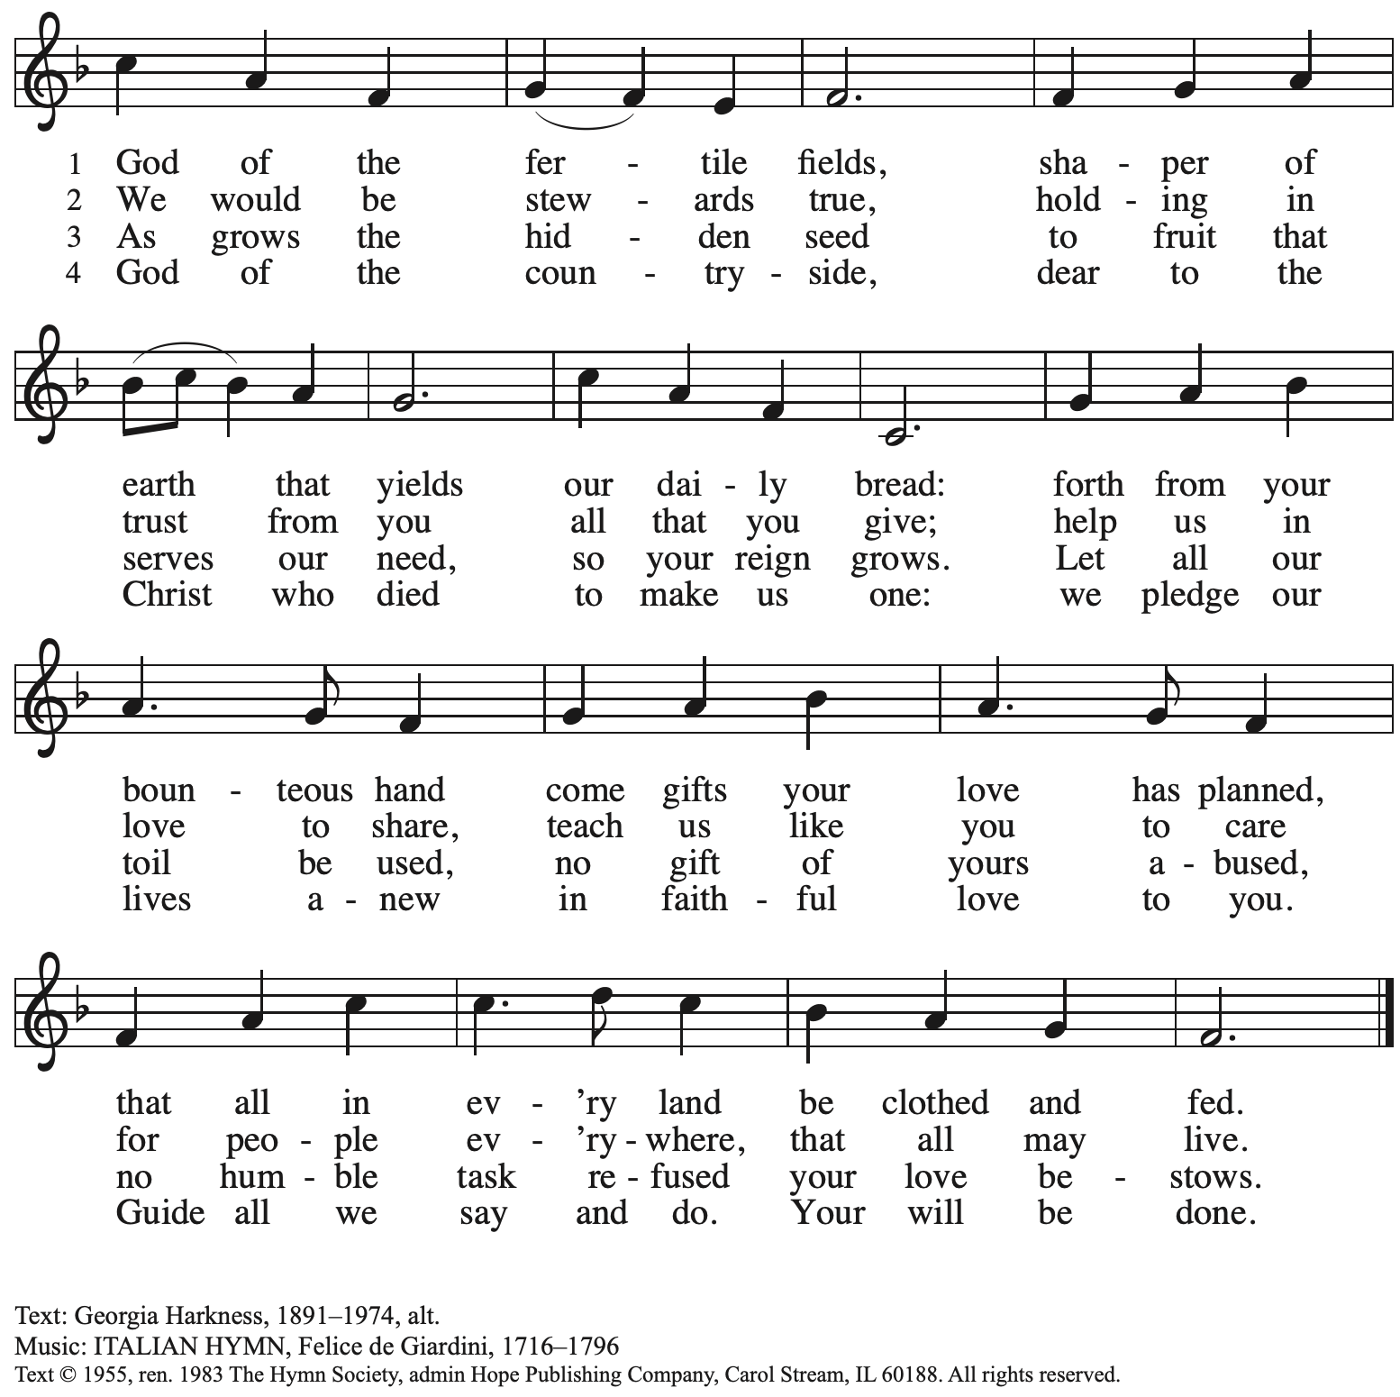
Reprinted with permission under OneLicense.net # A-722139.

Offertory Prayer

A: Let us pray.
Blessed are you,
C: O God, maker of all things.
Through your goodness you have blessed us with these gifts:
our selves, our time, and our possessions.
Work through us and what we have gathered
to feed the world with your love, through the one who gave himself for us,
Jesus Christ, our Savior and Lord. Amen.

Dialogue

P: The Lord be with you.
C: And also with you.

P: Lift up your hearts.
C: We lift them to the Lord.

P: Let us give thanks to the Lord our God.
C: It is right to give our thanks and praise.

Preface

P: It is indeed right, our duty and our joy,
that we should at all times and in all places
give thanks and praise to you, almighty and merciful God,
through our Savior Jesus Christ;
who on this day overcame death and the grave,
and by his glorious resurrection opened to us the way of everlasting life.
And so, with all the choirs of angels,
with the church on earth and the hosts of heaven,
we praise your name and join their unending hymn:

Sanctus ACS p. 36

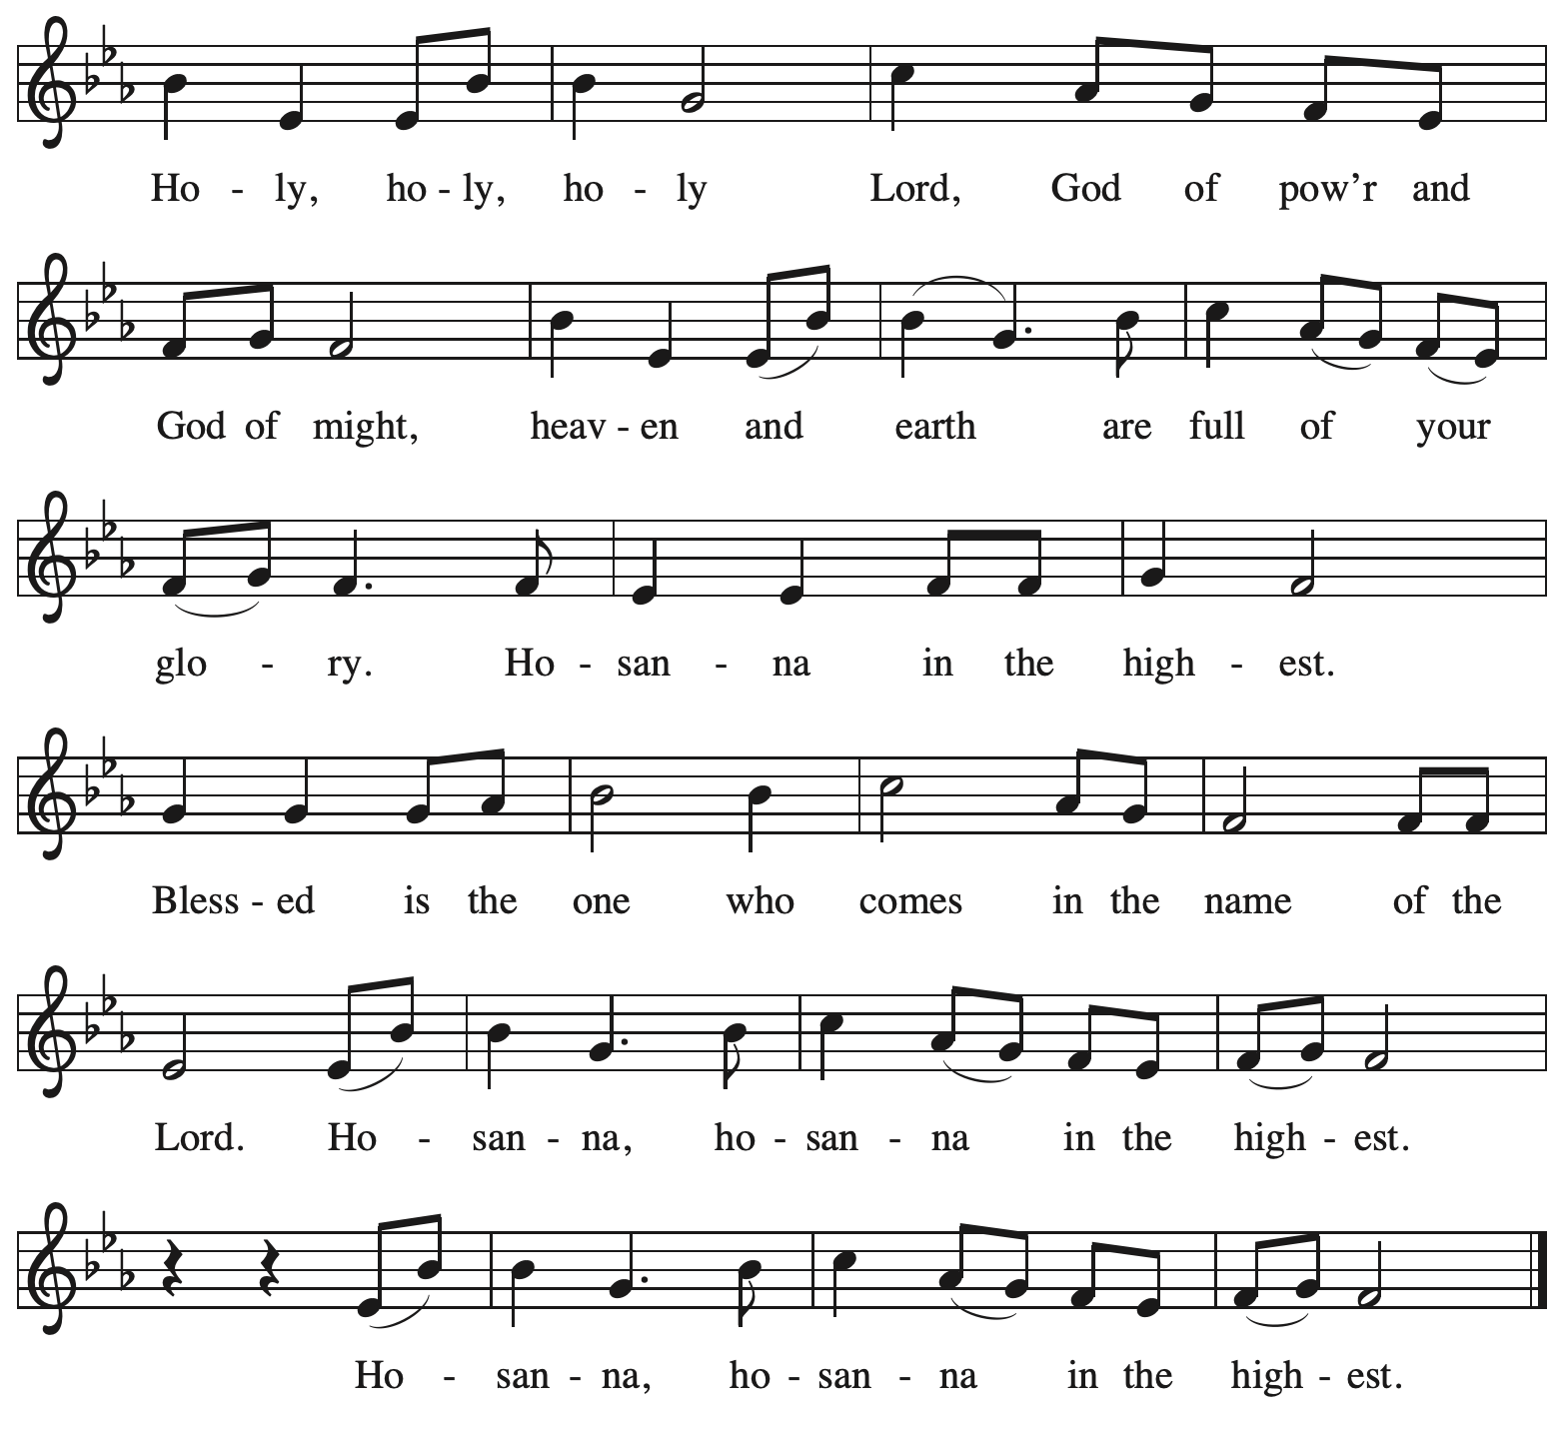

Eucharistic Prayer

P: Holy God, holy and merciful, your people praise you, saying:
Your mercy endures forever.
C: Your mercy endures forever.

P: By your promise you bound yourself to earth and all its creatures, granting them life
and calling them to flourish, setting the sign of the bow in the clouds, the colors of your love
and faithfulness. Your mercy endures forever.
C: Your mercy endures forever.

P: By your promise you bound yourself to your people of old,
blessing them with family outnumbering the stars and calling them to be a blessing to others,
showing them steadfast love in every generation and calling them to be a light to the nations.
Your mercy endures forever.
C: Your mercy endures forever.

P: By your promise you joined us to Jesus, your Beloved …
… Do this for the remembrance of me.

With this bread and cup
we remember his life laid down and lifted up
as we proclaim the mystery of faith.
C: Christ has died. Christ is risen. Christ will come again.

P: Send your Holy Spirit upon us …
… in your Spirit, now and forever.
C: Amen.

Lord’s Prayer

P: Gathered as one by the Holy Spirit, let us pray as Jesus taught us.
C: Our Father in heaven,
hallowed be your name,
your kingdom come,
your will be done,
on earth as in heaven.
Give us today our daily bread.
Forgive us our sins
as we forgive those
who sin against us.
Save us from the time of trial
and deliver us from evil.
For the kingdom, the power,
and the glory are yours,
now and forever. Amen.

Fraction and Invitation

P: At Christ’s table,
heaven and earth are joined as one.
Come and see.

Agnus Dei / Lamb of God ACS p. 40

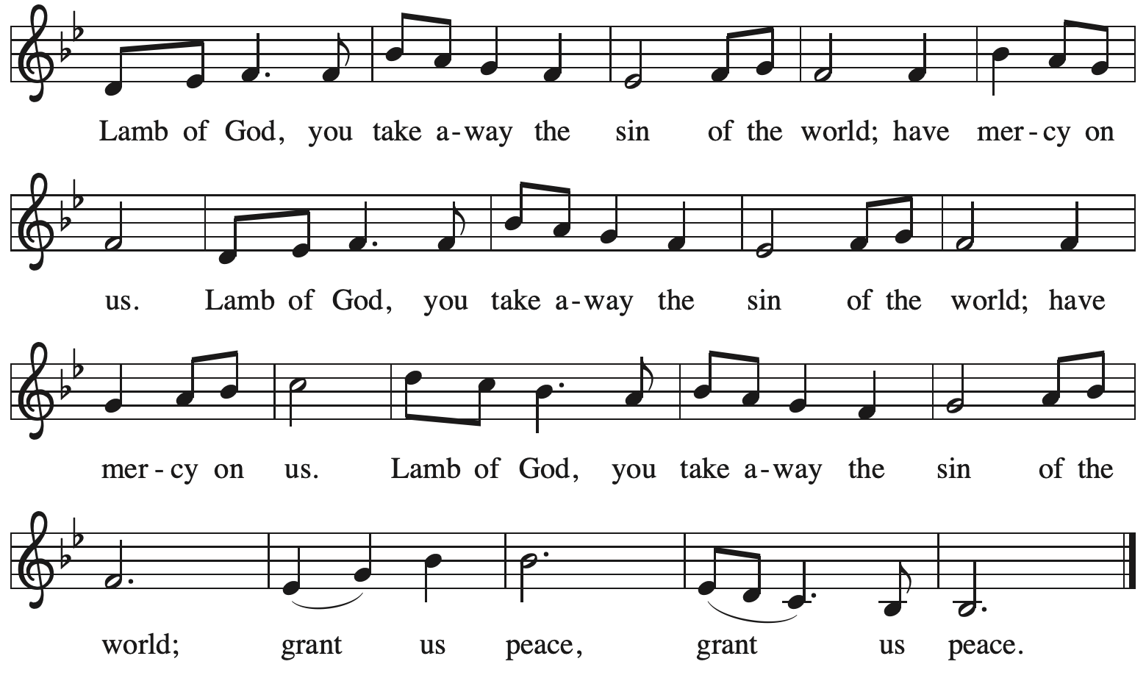

Please be seated.

Holy Communion
- All who seek God and desire a deeper and stronger life in Christ are welcome to receive Holy Communion.
- Worshipers from the pulpit side will proceed forward first, followed by the center section, and then the lectern side.
- Please inform an usher if you would like the ministers to bring Communion to you.
- Holy Communion will be served with bread and wine/grape juice.
- The presiding minister will first distribute the bread (host) to each communicant. Please indicate if you require a gluten-free host.
- Once you have consumed the bread, please pick up an empty glass from the tray next to the presiding minister. The Communion Assistant will pour wine from the chalice or grape juice from the cruet into your glass.
- Please step to the side to consume the wine or grape juice.
- Feel free to kneel at the altar rail for prayer after receiving the sacrament.
- As you return to your pew, glasses may be returned to the empty trays on either side of the center section.
- A blessing will be provided for anyone who does not yet receive the sacrament.
- All are invited to join in singing the hymns during Holy Communion.

Hymns during Holy Communion
Light Shone in Darkness ELW 307

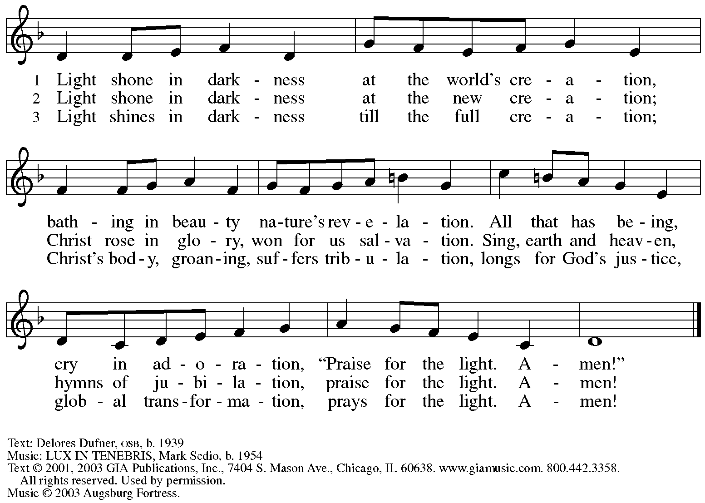
Reprinted with permission under OneLicense.net # A-722139.

Hymns during Holy Communion
O Beauty, Ever Ancient ACS 1100

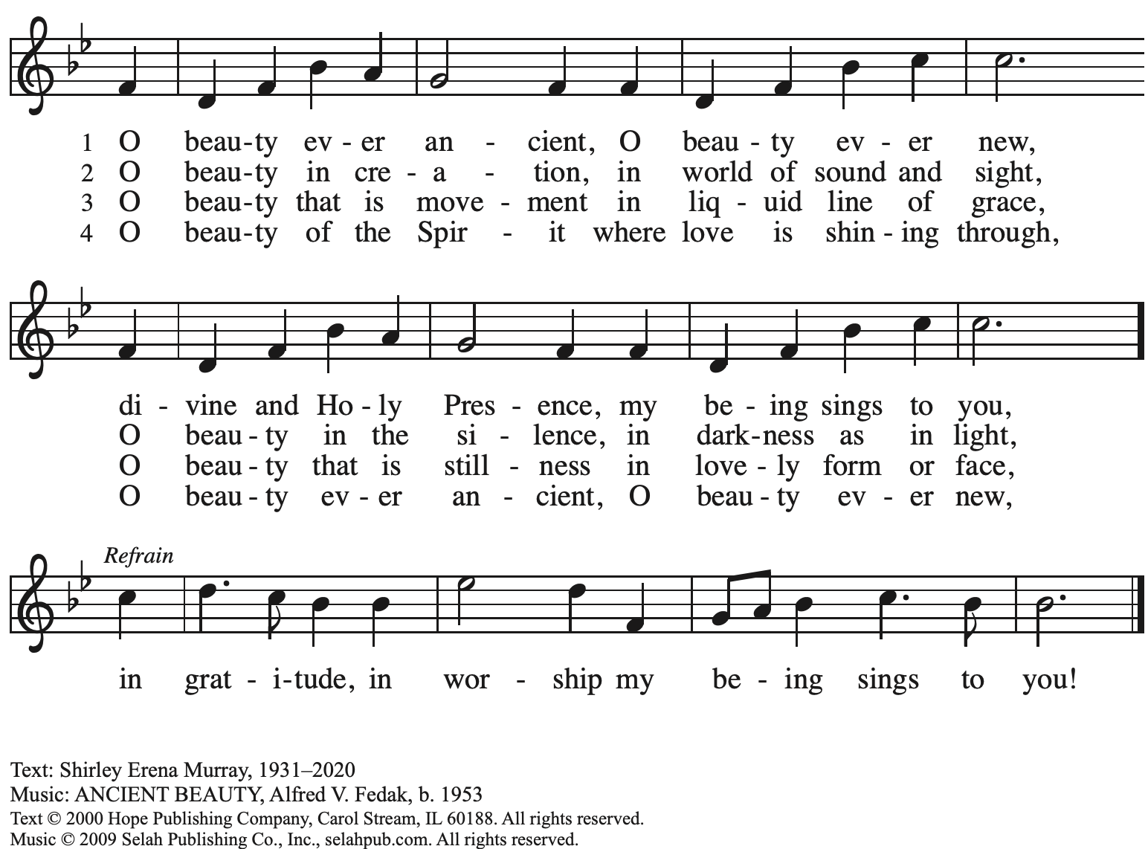
Reprinted with permission under OneLicense.net # A-722139.

Hymns during Holy Communion
Beautiful Savior ELW 838

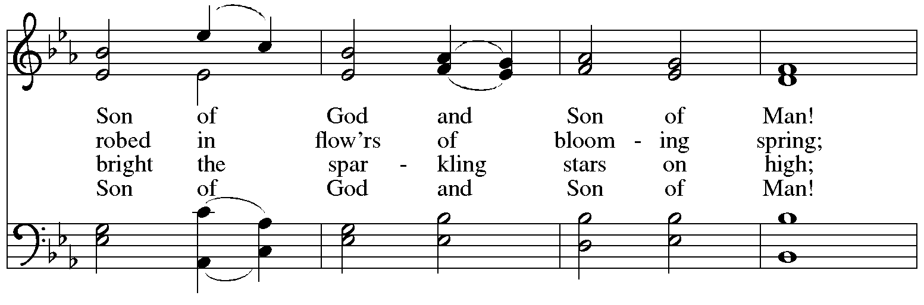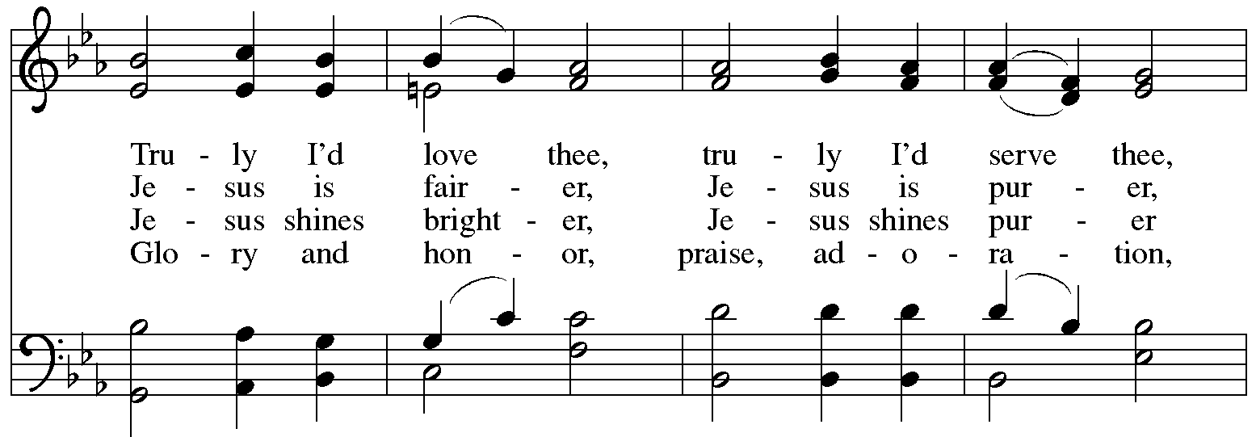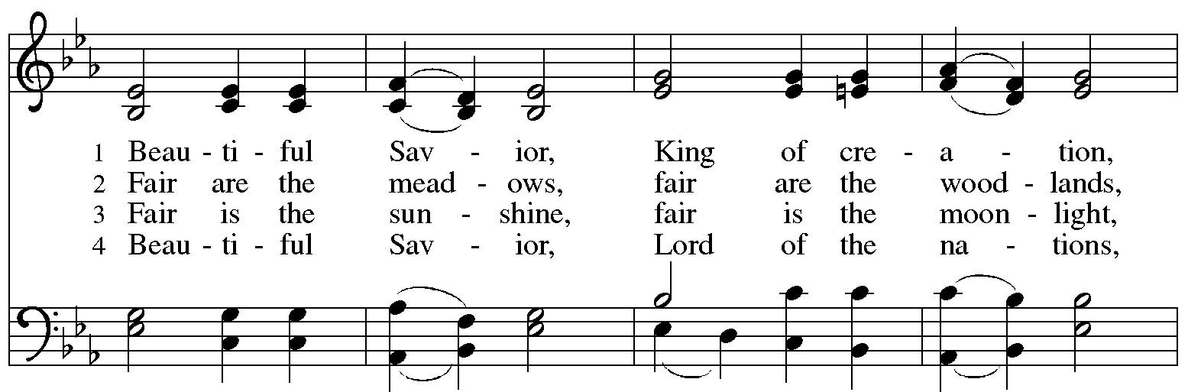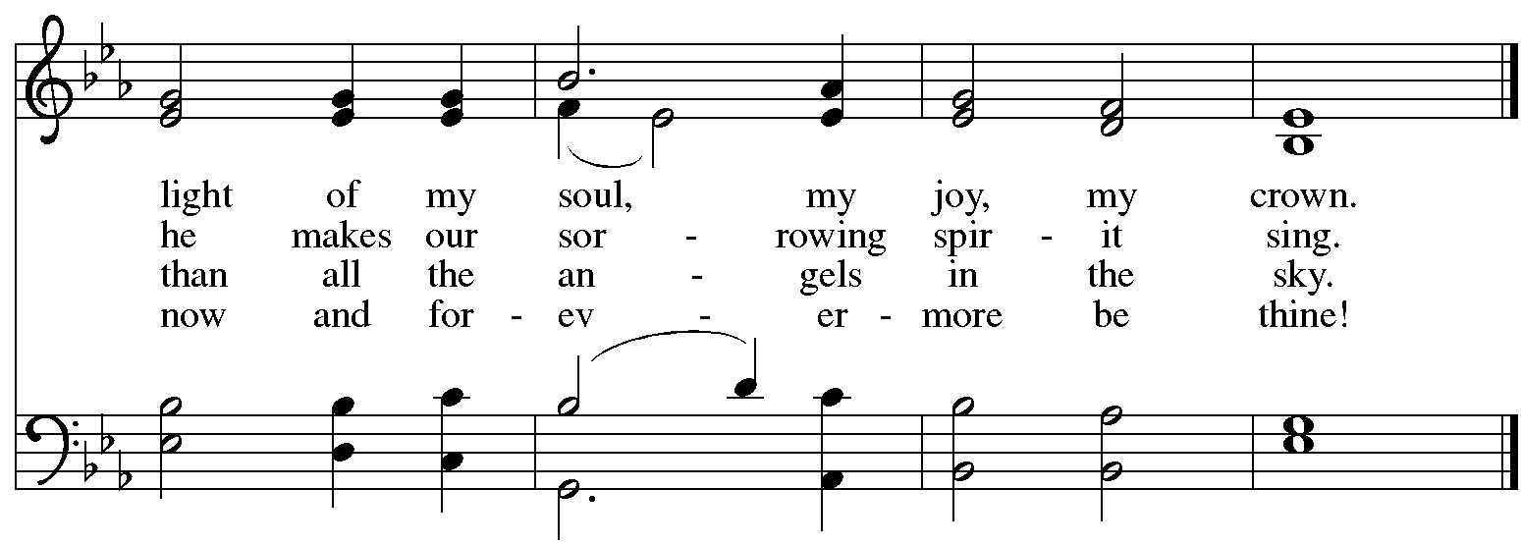

When all have returned to their places, please rise as you are able.

Blessing

P: The body and blood of our Lord Jesus Christ strengthen you and keep you in his grace.
C: Amen.

Prayer

A: Let us pray.
God of abundance, with this bread of life and cup of salvation you have united us with Christ, making us one with all your people. Now send us forth in the power of your Spirit,
that we may proclaim your redeeming love to the world
and continue forever in the risen life of Jesus Christ, our Lord.
C: Amen.

Please be seated.

Sending
God blesses us and sends us in mission to the world

Announcements

Please rise as you are able.

Benediction

P: God who names you,
Christ who claims you,
and the Holy Spirit who dwells in you,
☩ bless you now and forever.
C: Amen.

Sending Hymn Alleluia, Song of Gladness Following page

Dismissal

A: Go in peace. You are beloved.
C: Thanks be to God!

Postlude

Sending Hymn Alleluia, Song of Gladness ELW 318

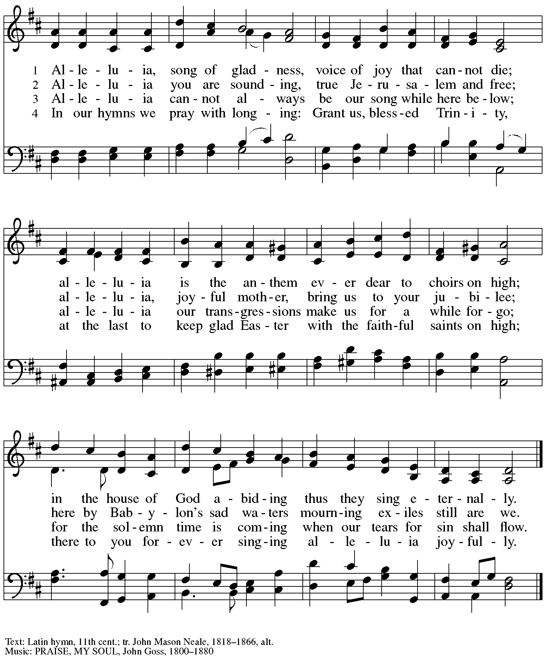

The congregation is invited to proceed to the ramp and yard behind the church building immediately after worship for the Burial of the Alleluia and Burning of Palms as we prepare for Ash Wednesday and Lent.
Those serving in worship

Altar Care Christy Ruhe
Assisting Minister Jeff Denlinger
Audio-Visual Ministers Sarita
Joseph Paetz
Cantor The Rev. Erin Jones
Coffee Hour Kristen Asplin
Lector Colleen Cooke
Little Church – Big Faith Teacher Emily Duque
Minister of Music Laura Reynolds
Organ and Burning of Palms Jimmi Kocher-Hillmer
Presiding and Preaching Minister The Rev. Ross I. Carmichael

Liturgy and Hymnody Acknowledgements

From SundaysandSeasons.com. Copyright © 2024 Augsburg Fortress. All rights reserved. Reprinted under OneLicense.net # A-722139.
Used by permission of Augsburg Fortress.

Beautiful Savior – Text: Gesangbuch, Münster, 1677; tr. Joseph A. Seiss, 1823-1904. Music: SCHÖNSTER HERR JESU, Silesian folk tune, 19th cent.

.
Please use the QR code below to link to St. Andrew’s Announcements online!

St. Andrew Lutheran Church Announcements
February 11th, 2024

- Welcome to worship at St. Andrew on the Transfiguration of our Lord, February 11th, 2024 – We are so glad you are here, and we offer a special welcome to all guests who are gathered at the church or online! Children are invited to participate in Little Church – Big Faith, a Bible lesson and activity, after the prayer of the day. There are worship “toolkits” to help children engage with worship and “busy bags” for younger children available in the bookcase at the back of the sanctuary. Please feel free to take one to use with/for your children. Coffee and conversation in the social hall will follow the burning of palms and burial of the alleluia (see note below).
- Brief Liturgy for Burial of Alleluia and Burning of Palms Immediately after Worship Behind the Church – The season of Lent is approaching with Ash Wednesday this week, and the church prepares by putting aside or “burying,” the celebratory word “Alleluia” for the season and by burning the palm branches from the previous Palm Sunday to make ashes for Ash Wednesday. These actions are often accompanied by a brief liturgy. As the Sending Hymn and Dismissal conclude the Transfiguration service, we invite the congregation to proceed to the back of the church to the yard, ramp, and walkway to take part in this liturgy as we turn our focus toward Lent.
- Pick Up Gathered into One: Devotions for Lent 2024 at Church Entrances – The Christian church’s season of Lent, from a word that meant “springtime,” begins with Ash Wednesday on February 14th. Many during Lent practice some form of spiritual discipline, with prayer, fasting, or charitable giving. Gathering into One offers a brief reading, prayer, and reflection for each day of the Lenten season. We invite everyone to take one for yourself and/or others from the church entrances.
- Ash Wednesday Worship with Imposition of Ashes and Holy Communion – February 14th, 7:00 p.m. – Ash Wednesday begins the season of Lent on February 14th this year. This is a day of worship that often includes Imposition of Ashes, an ancient sign of mourning and repentance. On this day, we receive the call to confess our sins and return to God, acknowledging our human vulnerability and dependence on God. Worship with Imposition of Ashes and Holy Communion will be held at 7:00 p.m.
- Shelter Dinner at East End Cooperative Ministry – Thursday, February 15th, Arrival 6:00 p.m., Dinner 6:30 p.m. – Each month, on the third Thursday, people of St. Andrew provide and serve a meal for the guests of the shelter at East End Cooperative Ministry (EECM), 6140 Station St., 15206. Anyone can sign up to prepare or purchase a portion of the meal to bring to EECM at 6:00 p.m. that day, or just come to help serve the meal at 6:30 p.m. If you would like to contribute, please sign up at: https://www.signupgenius.com/go/5080544AAAC22A1F58-47342991-shelter.
- Ukrainian Egg Workshop – A Focused Spiritual Meditation for Lent, Saturday, February 17th, 1:00-4:30 p.m. – Jimmi and Timothy Kocher Hillmer will lead a workshop on the tradition of Ukrainian egg decoration as a spiritual discipline for the season of Lent. Pysanky, the Ukrainian name for the tradition, comes from the word “write,” similar to the spiritual practice of “writing” icons, and the process involves both writing on and dyeing the eggs. Due to safety considerations (open flame, hot wax) this workshop is recommended for people 6th grade and up. To ensure ample space and supplies, registration will be limited to 20 participants. If you would like to participate, please sign up at https://www.signupgenius.com/go/5080B4AAFAF2CABF85-47277468-ukrainian by the end of today. If you have questions, please contact Jimmi at jimotha@yahoo.com. Please bring an old dish towel on which to work.
- Growing in Faith Together – Gatherings for People New to St. Andrew on the Sundays in Lent – Over the past year, St. Andrew has been blessed by the presence of many people new to the community of faith! In the past, we have offered small group gatherings to help people get to know one another, share in conversation and faith stories based on the weekly readings, and to pray for one another. Our next gatherings, led by St. Andrew member Jeff Denlinger, will be on Sundays, February 18th, 25th, March 3rd, March 10th (Congregational Meeting), March 17th, and March 24th. If you are interested in participating or have any questions, please speak with Pastor Ross or contact Jeff at jdenlinger26@icloud.com.
- Meeting of the Congregation – Sunday, March 10th, after Worship – Each year in the winter/spring, St. Andrew gathers for a congregational meeting to review financial figures for the previous year, report of our various ministries, and update the congregation on upcoming developments and initiatives. Please put this date on your calendars!
- Support Abuelas Responden – Grannies Respond with Donations of Used Winter Clothing Items – Abuelas Responden - Grannies Respond is a local organization that supports traveling asylum seekers as they come through Pittsburgh. The group goes to the downtown bus station to meet those who have been released from the Moshannon Valley detention center and supply them with much needed items as they travel to join family or friends in other cities. The primary need is for warm winter clothing. A bin will be set up in the social hall to receive these items. Right now the most needed items are:
- Men’s warm (but not too bulky) coats, jackets, fleece hoodies - People need to be able to fit everything in bags so there is no space for a heavy coat.
- Men’s Pants and Shoes (Please no sweatpants - this is what the people receive in detention, so we want to avoid outfitting anyone with something that looks like prisoners’ clothes.
- Men’s gloves
- Inviting Coffee Hour Signups for Upcoming Sundays – One way that we at St. Andrew build community is by sharing conversation over food and drinks at coffee hour after worship on Sundays. We invite people of the congregation to serve by getting the coffee brewing, setting out cups, napkins, food items, and cold drinks, and cleaning up afterward. Everything needed is at St. Andrew and instructions are available. If you would be willing to set up coffee hour on any of the upcoming Sundays, please sign up here:
https://www.signupgenius.com/go/5080B4AAFAF2CABF85-47069030-coffee.
Thank you for your consideration!
- Call for Parishioners to Serve in Worship Roles – St. Andrew's worship is made possible by many people who serve in various roles – Some people prepare the altar and setup Communion, some run the sound/streaming system, while others teacher Little Church – Big Faith for the children, serve as ushers, wash communion cups, count the offering, and more. It is not just roles like Cantor and Lector that involve being up in front of the congregation! If you are interested in getting more involved in worship, talk to Pastor Ross or Joseph Paetz. Most positions serve once a month or less!
- Compline Prayer Service, a Ministry of Lutheran Campus Ministry in Greater Pittsburgh, Sundays at 8:00 p.m. at Heinz Chapel – Compline was traditionally a monastic prayer service, and the Pittsburgh Compline Choir sings a choral version of compline rooted in this thousand-year-old tradition of scripture, song, and silence. This service also streams on Facebook (Pittsburgh Compline Choir) and YouTube (The Pittsburgh Compline Choir). Heinz Chapel is located off of S. Bellefield Ave. in Oakland.
- Christ in Our Home Devotional Booklets for January - March Available at Church Entrances – This resource offers a daily Bible reading with a short reflection and prayer, along with additional readings and prayer topics for those who would like to expand their devotional practices. We encourage people of the congregation to take one for yourself, your family unit, or others!

