+ Fifth Sunday in Lent
March 17th, 2024
10:00 a.m.

St. Andrew Lutheran Church
304 Morewood Ave.
Pittsburgh, PA 15213
412.682.3342
St_andrewELCA@verizon.net
www.standrewpittsburgh.org

+ Fifth Sunday in Lent
Order for Worship

God promises Jeremiah that a “new covenant” will be made in the future: a covenant that will allow all the people to know God by heart. The church sees this promise fulfilled in Christ, who draws all people to himself when he is lifted up on the cross. Our baptismal covenant draws us to God’s heart through Christ and draws God’s love and truth into our hearts. We join together in worship, sharing in word, song, and meal, and leave strengthened to share God’s love with all the world.

Welcome to St. Andrew!
- St. Andrew Lutheran congregation welcomes all who are seeking a place of healing and wholeness – a nurturing, faith-forming spiritual home. Our community embraces people of all ages, ethnicities, cultures, abilities, sexual orientations, gender identities and expressions, and family constellations. Come and See!
- Worship Services are live streamed to multiple online platforms. By attending worship, you agree that your image and voice may be broadcast.
- Everyone is invited to make a nametag at the black bookcase in the back of the worship space if they would like. There are stickers indicating pronouns on the bookcase if you would like to include them on your name tag.
- Children are invited to attend Little Church – Big Faith, a Bible lesson and activity, during worship (after the Prayer of the Day). The group returns to the worship space for the liturgy of Holy Communion.
- Worship “toolkits” to help children engage with the service, along with “busy bags” for younger children, are available in the bookcase at the back of the sanctuary. Please feel free to take one to use with/for your children.
- Holy Communion is served with bread (gluten-free available) and wine or grape juice. The presiding minister will distribute the bread (host). Please consume this and then pick up an empty glass from the tray. The Communion Assistant will pour wine or grape juice into your glass. Please step to the side to consume the wine or grape juice. Feel free to kneel at the altar for prayer and reflection. As you return to your pew, glasses may be returned to the empty trays on either side of the center section.
- A restroom is available on the main level of the church, through the doors to the Social Hall and to the right in the main office.

Abbreviations

P: Pastor/Presiding Minister ELW: Evangelical Lutheran Worship hymnal
A: Assisting Minister ACS: All Creation Sings hymnal
L: Lector
C: Congregation

Prelude My Song Is Love Unknown arr. T. Kocher-Hillmer

Welcome

Gathering
The Holy Spirit calls us together as the people of God

Centering Music Return to God ACS 921

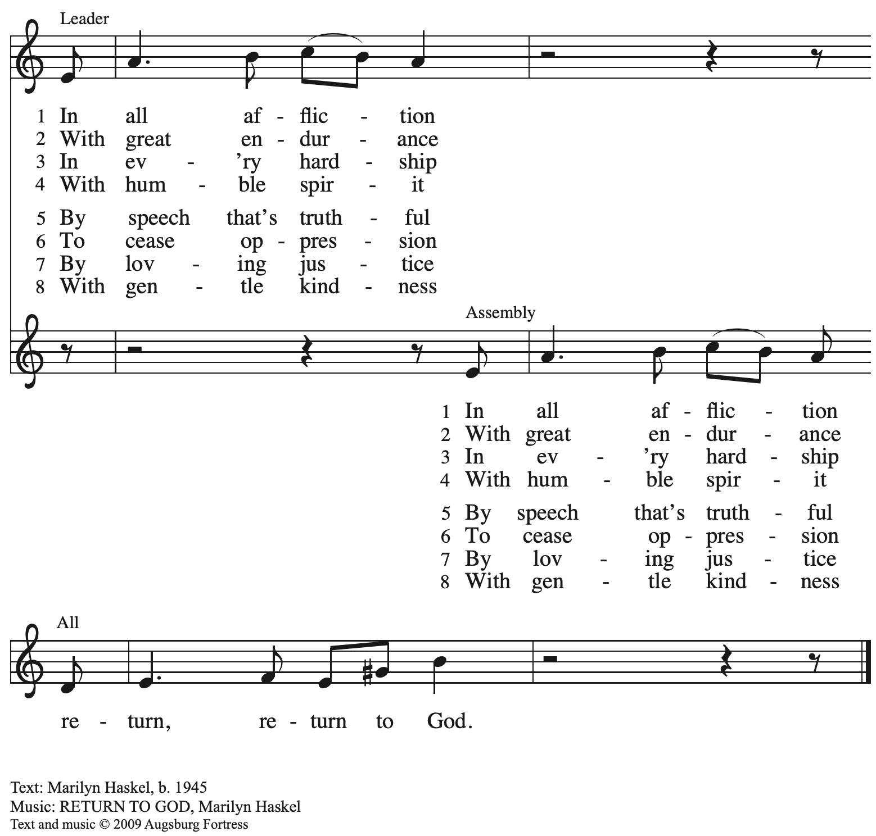
All rights reserved. Reprinted with permission under OneLicense.net # A-722139.

Confession and Forgiveness

Please rise as you are able. All may make the sign of the cross,
the sign that is marked at Baptism, as the presiding minister begins.

P: Blessed be the holy Trinity, ☩ one God,
who looks upon us in compassion,
forgives our sin,
and heals our wounds.
C: Amen.

P: Let us confess our sin in the presence of God and of one another.

Silence is kept for reflection.

P: Have mercy, O God,
C: for we have sinned
against you and our neighbors,
by what we have done
and by what we have failed to do.
In your compassion,
cleanse us from our sin
and take away our guilt.
Create in us a new heart
and give us a steadfast spirit.
Do not cast us away,
but fill us with your Holy Spirit
and restore your joy within us.
Amen.

P: As far as the highest mountain is to the lowest ocean floor,
so deep is God’s compassion for you.
As high as heaven is above earth,
so vast is God’s love for you.
As far as east is from west,
so far God removes your sin from you,
renewing your life through Jesus Christ.
Blessed be God who crowns us with mercy and love.
C: Blessed be God forever. Amen.

Gathering Hymn As the Winter Days Grow Longer ACS 924

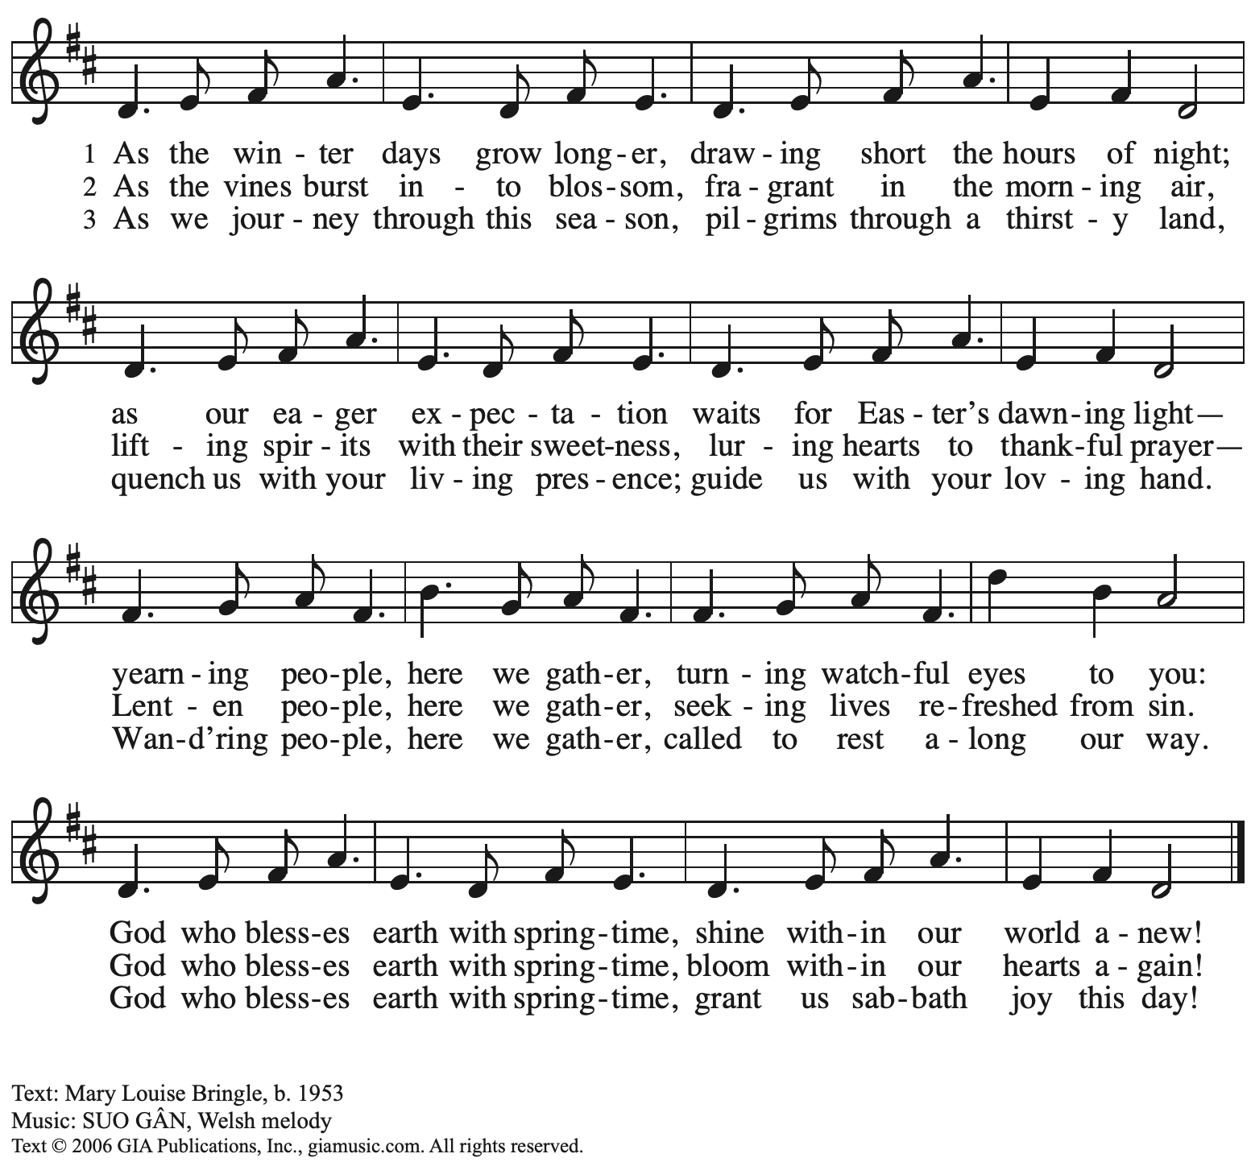
Reprinted with permission under OneLiucense.net # A-722139.

Greeting

P: The grace of our Lord Jesus Christ, the love of God,
and the communion of the Holy Spirit be with you all.
C: And also with you.

Kyrie ACS p. 31

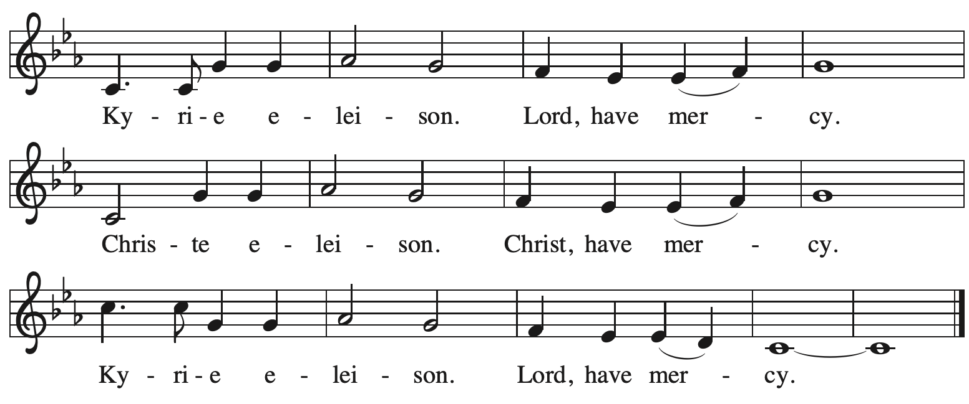

Prayer of the Day

P: Let us pray.
O God, with steadfast love you draw us to yourself, and in mercy you receive our prayers. Strengthen us to bring forth the fruits of the Spirit, that through life and death we may live in your Son, Jesus Christ, our Savior and Lord, who lives and reigns with you and the Holy Spirit, one God, now and forever.
C: Amen.

Please be seated.
Children are invited to join the adult leaders at the door and move to the office for Little Church – Big Faith. We ask that one additional adult from the congregation attend with the children.

Word
God speaks to us in Scripture reading, preaching, and song

First Reading – Jeremiah 31: 31-34

³¹The days are surely coming, says the Lord, when I will make a new covenant with the house of Israel and the house of Judah. ³²It will not be like the covenant that I made with their ancestors when I took them by the hand to bring them out of the land of Egypt—a covenant that they broke, though I was their husband, says the Lord. ³³But this is the covenant that I will make with the house of Israel after those days, says the Lord: I will put my law within them, and I will write it on their hearts; and I will be their God, and they shall be my people. ³⁴No longer shall they teach one another, or say to each other, “Know the Lord,” for they shall all know me, from the least of them to the greatest, says the Lord; for I will forgive their iniquity, and remember their sin no more.

L: Word of God, word of life.
C: Thanks be to God.

Psalm 51: 1-12

Psalm tone

Psalm refrain

¹Have mercy on me, O God, according to your | steadfast love;
in your great compassion blot out | my offenses.
²Wash me through and through | from my wickedness,
and cleanse me | from my sin.
³For I know | my offenses,
and my sin is ev- | er before me.
⁴Against you only have I sinned and done what is evil | in your sight;
so you are justified when you speak and right | in your judgment. R
⁵Indeed, I was born | steeped in wickedness,
a sinner from my | mother’s womb.
⁶Indeed, you delight in truth | deep within me,
and would have me know wisdom | deep within.
⁷Remove my sins with hyssop, and I | shall be clean;
wash me, and I shall be pur- | er than snow.
⁸Let me hear | joy and gladness;
that the body you have broken | may rejoice. R
⁹Hide your face | from my sins,
and blot out | all my wickedness.
¹⁰Create in me a clean | heart, O God,
and renew a right spir- | it within me.
¹¹Cast me not away | from your presence,
and take not your Holy Spir- | it from me.
¹²Restore to me the joy of | your salvation
and sustain me with your boun- | tiful Spirit. R

Second Reading – Hebrews 5: 5-10

⁵Christ did not glorify himself in becoming a high priest, but was appointed by the one who said to him,
“You are my Son,
today I have begotten you”;
⁶as God says also in another place,
“You are a priest forever,
according to the order of Melchizedek.”
⁷In the days of his flesh, Jesus offered up prayers and supplications, with loud cries and tears, to the one who was able to save him from death, and he was heard because of his reverent submission. ⁸Although he was a Son, he learned obedience through what he suffered; ⁹and having been made perfect, he became the source of eternal salvation for all who obey him,
¹⁰having been designated by God a high priest according to the order of Melchizedek.

L: Word of God, word of life.
C: Thanks be to God.

Please rise as you are able.

Gospel Acclamation ACS p. 34

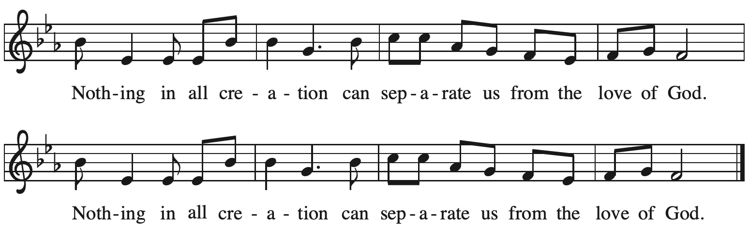

Gospel – John 12: 20-33

P: The holy Gospel according to St. John.
C: Glory to you, O Lord.

²⁰Now among those who went up to worship at the festival were some Greeks. ²¹They came to Philip, who was from Bethsaida in Galilee, and said to him, “Sir, we wish to see Jesus.” ²²Philip went and told Andrew; then Andrew and Philip went and told Jesus.
²³Jesus answered them, “The hour has come for the Son of Humanity to be glorified. ²⁴Very truly, I tell you, unless a grain of wheat falls into the earth and dies, it remains just a single grain; but if it dies, it bears much fruit. ²⁵Those who love their life lose it, and those who hate their life in this world will keep it for eternal life. ²⁶Whoever serves me must follow me, and where I am, there will my servant be also. Whoever serves me, the Father will honor.
²⁷“Now my soul is troubled. And what should I say—‘Father, save me from this hour’? No, it is for this reason that I have come to this hour. ²⁸Father, glorify your name.” Then a voice came from heaven, “I have glorified it, and I will glorify it again.” ²⁹The crowd standing there heard it and said that it was thunder. Others said, “An angel has spoken to him.” ³⁰Jesus answered, “This voice has come for your sake, not for mine. ³¹Now is the judgment of this world; now the ruler of this world will be driven out. ³²And I, when I am lifted up from the earth, will draw all people to myself.” ³³He said this to indicate the kind of death he was to die.

P: The Gospel of the Lord.
C: Praise to you, O Christ.

Please be seated.

Sermon

A time of silence for prayer and reflection follows the sermon.
As the hymn of the day begins, please rise as you are able.

Hymn of the Day The Word of God Is Source and Seed ELW 506

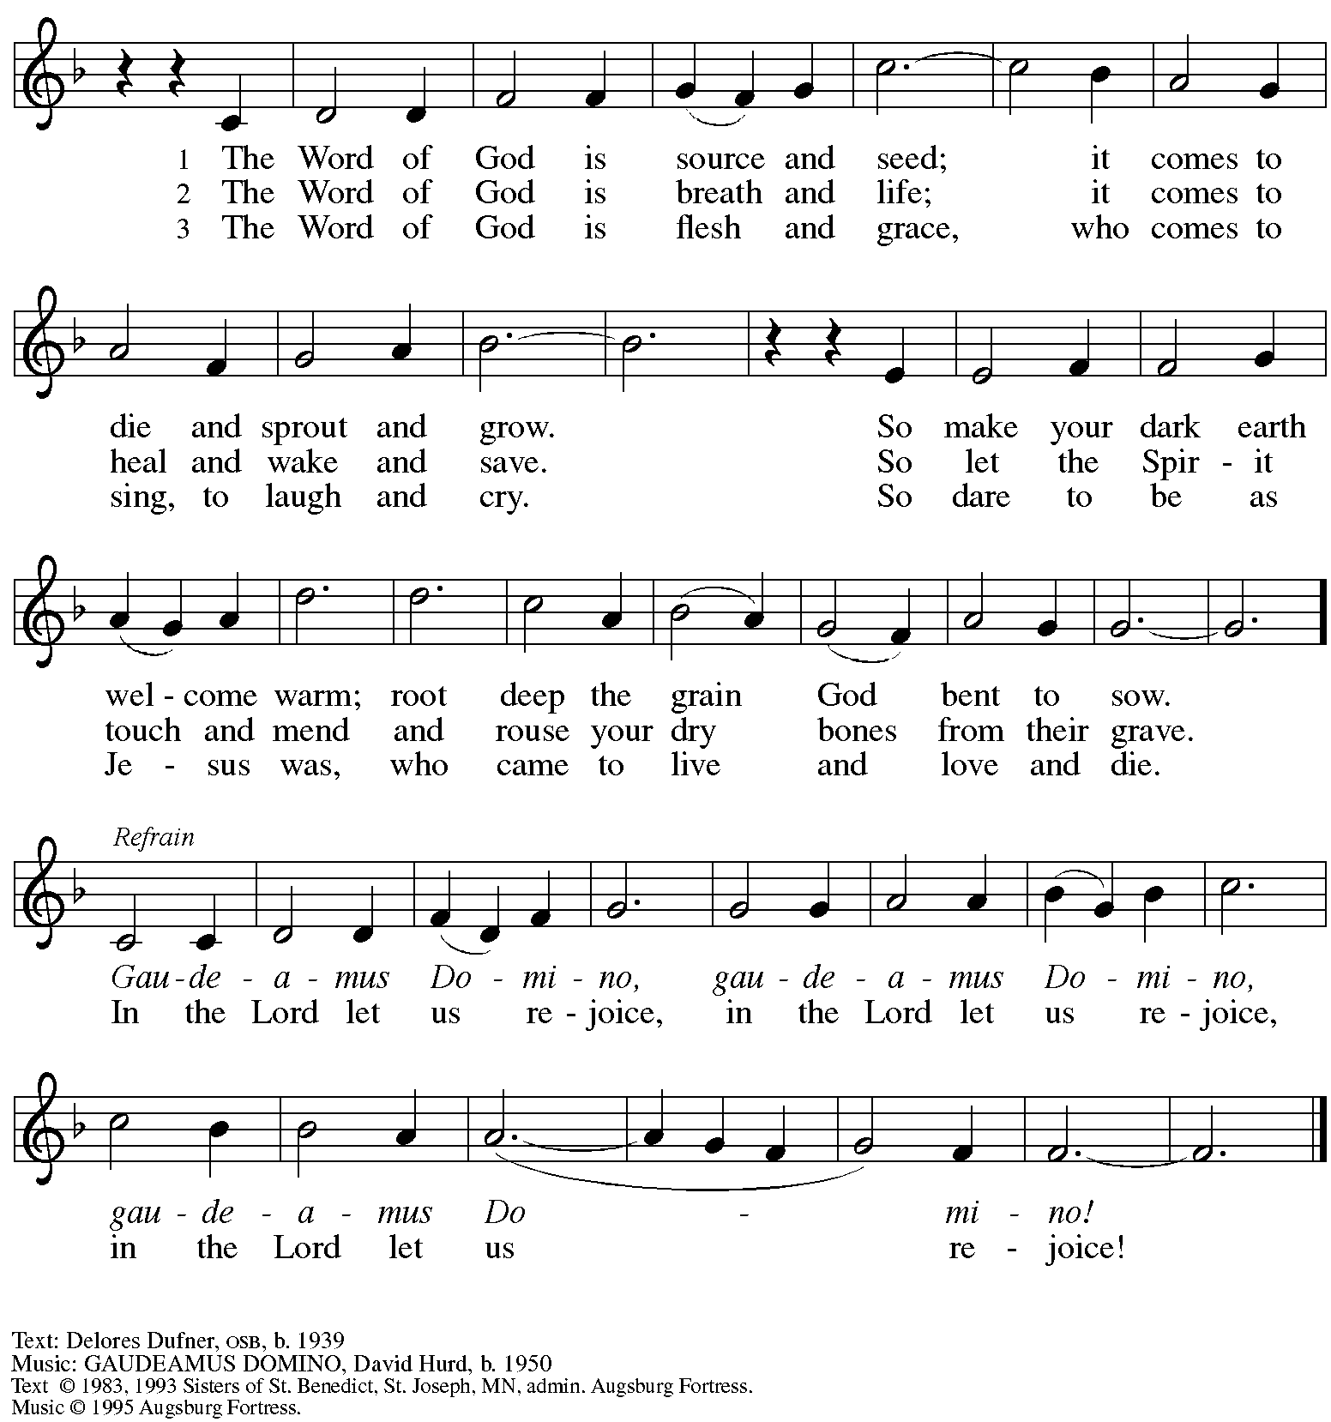
All rights reserved. Reprinted with permission under OneLicense.net # A-722139.

Apostles Creed

P: Trusting in God’s mercy, we confess our faith.
C: I believe in God, the Father almighty,
creator of heaven and earth.

C: I believe in Jesus Christ, God’s only Son, our Lord,
who was conceived by the Holy Spirit,
born of the virgin Mary,
suffered under Pontius Pilate,
was crucified, died, and was buried;
he descended to the dead.*
On the third day he rose again;
he ascended into heaven,
he is seated at the right hand of the Father,
and he will come to judge the living and the dead.

I believe in the Holy Spirit,
the holy catholic church,
the communion of saints,
the forgiveness of sins,
the resurrection of the body,
and the life everlasting. Amen.

*Or, “he descended into hell,” another translation of this text in widespread use.

Prayers of the People

A: Trusting in God’s promise to reconcile all things, let us pray for the church,
the well-being of creation, and all who are in need.

After each petition
A: Merciful God,
C: receive our prayer.

The presiding minister concludes the prayers
P: Accompany us on our journey through this season, O God of grace,
and receive the prayers of our hearts, through Jesus Christ, our Savior.
C: Amen.

Peace

The presiding minister and the assembly greet one another in the peace of the risen Christ.
P: The peace of Christ be with you always.
C: And also with you.

The people may greet those around them with a sign of Christ’s peace and may say
Peace be with you or similar words. Please be mindful that not everyone will be comfortable with sharing the peace, so please seek consent before shaking hands or hugging. Other possible ways to share the peace include a simple bow with the verbal greeting of peace, or simply a verbal expression of peace.

When the greetings of peace have concluded, please be seated.

Meal
God feeds us with the presence of Jesus Christ

Offering

We offer ourselves, our gifts, and our faithful service to God.
As the offering is gathered for the mission of the church, including the care of those in need,
the table is set for Holy Communion.

“Quiet” Offering

As children of the congregation carry metal buckets around the sanctuary (with towels on the bottom during the subdued season of Lent), people of the congregation are invited to throw in their change as an offering which will benefit our local partner in ministry, Lutheran Campus Ministry in Greater Pittsburgh.

Music during the Offering
Bring Peace to Earth Again arr. Raabe

As the gifts are brought forward for presentation, please rise as you are able.
Offertory Song Create in Me a Clean Heart ELW 188

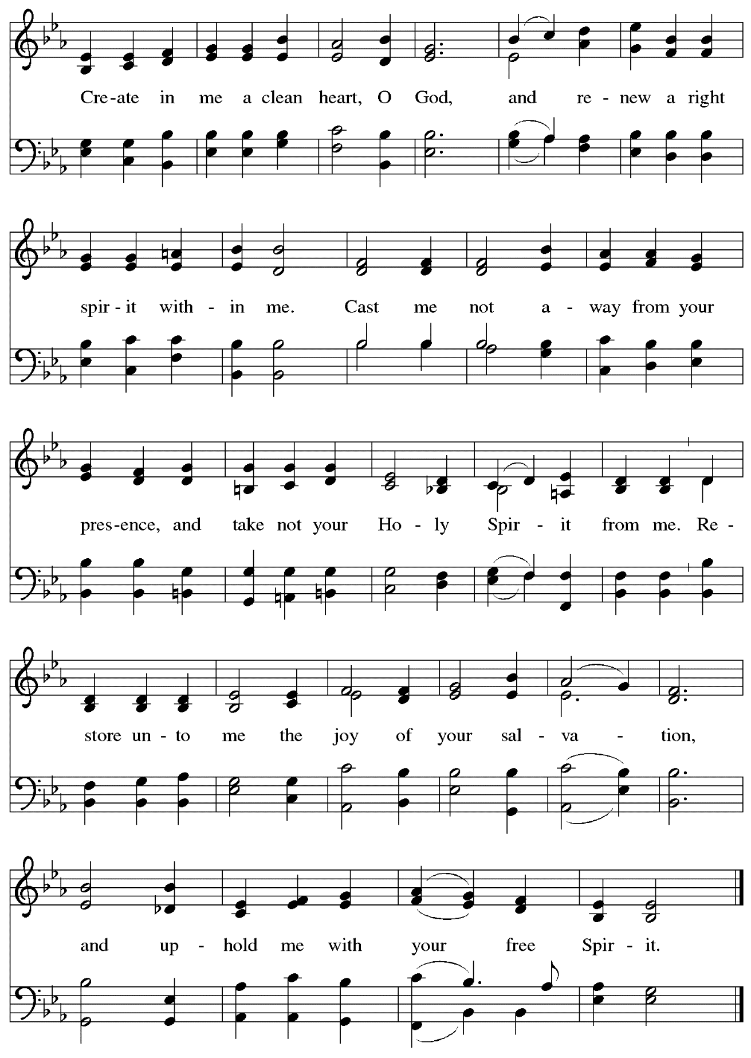
Music: J.A. Freylinghausen, 1670-1739.

Offertory Prayer

A: Let us pray.
God our provider,
C: you have not fed us with bread alone,
but with words of grace and life.
Bless us and these your gifts,
which we receive from your bounty,
through Jesus Christ our Lord.
Amen.

Dialogue

P: The Lord be with you.
C: And also with you.

P: Lift up your hearts.
C: We lift them to the Lord.

P: Let us give thanks to the Lord our God.
C: It is right to give our thanks and praise.

Preface

P: It is indeed right, our duty and our joy,
that we should at all times and in all places
give thanks and praise to you, almighty and merciful God,
through our Savior Jesus Christ.
You call your people to cleanse their hearts
and prepare with joy for the paschal feast,
that, renewed in the gift of baptism,
we may come to the fullness of your grace.
And so, with all the choirs of angels,
with the church on earth and the hosts of heaven,
we praise your name and join their unending hymn:

Sanctus ACS p. 36

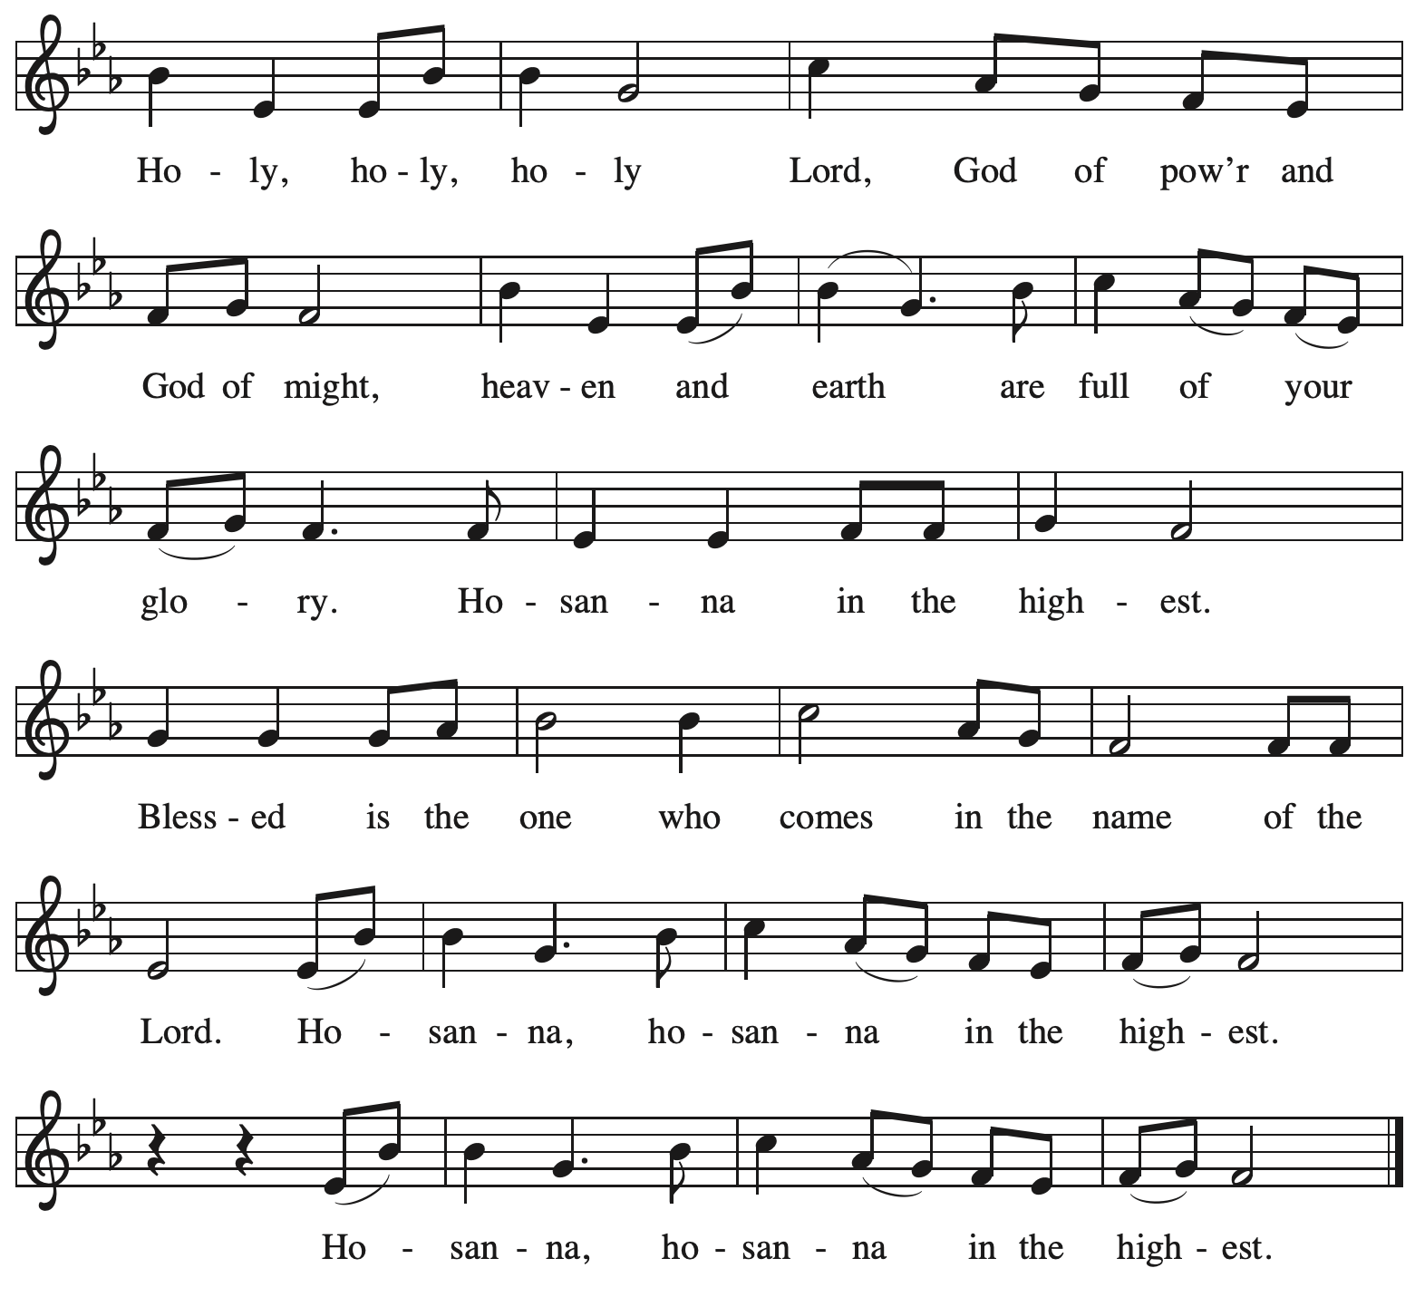

Eucharistic Prayer

P: Blessed are you, O God of the universe
Your mercy is everlasting
and your faithfulness endures from age to age.

Praise to you for creating the heavens and the earth.
Praise to you for saving the earth from the waters of the flood.
Praise to you for bringing the Israelites safely through the sea.
Praise to you for leading your people through the wilderness
to the land of milk and honey.

P: Praise to you for the words and deeds of Jesus, your anointed one.
Praise to you for the death and resurrection of Christ.
Praise to you for your Spirit poured out on all nations.

In the night in which he was betrayed,
our Lord Jesus took bread, and gave thanks;
broke it, and gave it to his disciples, saying:
Take and eat; this is my body, given for you.
Do this for the remembrance of me.

Again, after supper, he took the cup, gave thanks,
and gave it for all to drink, saying:
This cup is the new covenant in my blood,
shed for you and for all people for the forgiveness of sin
Do this for the remembrance of me.

With this bread and cup
we remember our Lord’s passover from death to life
as we proclaim the mystery of faith:
C: Christ has died.
Christ is risen.
Christ will come again.

P: O God of resurrection and new life:
Pour out your Holy Spirit on us
and on these gifts of bread and wine.
Bless this feast.
Grace our table with your presence.
C: Come, Holy Spirit.

P: Reveal yourself to us in the breaking of the bread.
Raise us up as the body of Christ for the world.
Breathe new life into us.
Send us forth,
burning with justice, peace, and love.
C: Come, Holy Spirit.

P: With your holy ones of all times and places,
with the earth and all its creatures,
with sun and moon and stars,
we praise you, O God,
blessed and holy Trinity,
now and forever.
C: Amen.

Lord’s Prayer (Sung)

P: Gathered as one by the Holy Spirit, let us pray as Jesus taught us.
C:
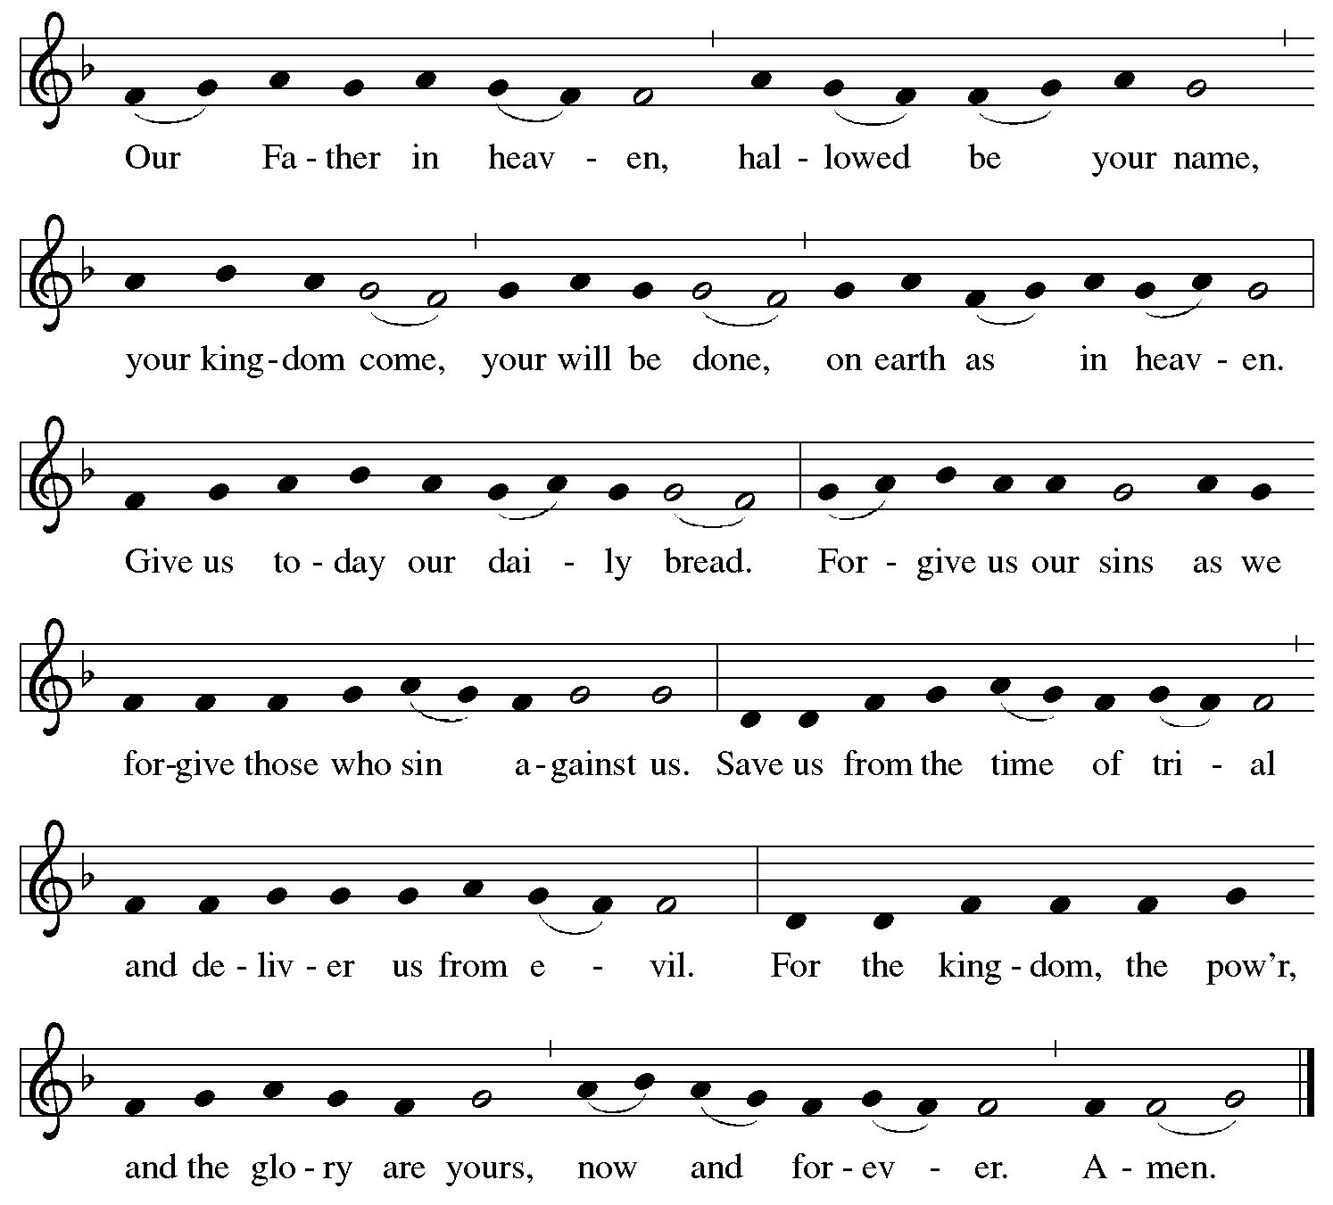

Fraction and Invitation

P: Come to the table of mercy.
Receive God’s gifts of grace.

Agnus Dei / Lamb of God ACS p. 40

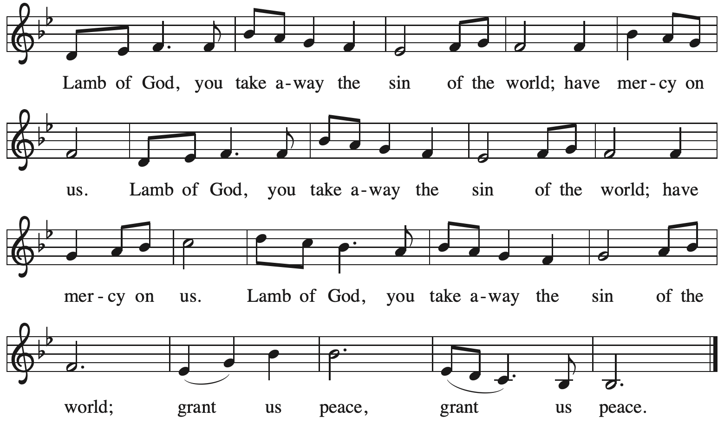

Please be seated.

Holy Communion
- All who seek God and desire a deeper and stronger life in Christ are welcome to receive Holy Communion.
- Worshipers from the pulpit side will proceed forward first, followed by the center section, and then the lectern side.
- Please inform an usher if you would like the ministers to bring Communion to you.
- Holy Communion will be served with bread and wine/grape juice.
- The presiding minister will first distribute the bread (host) to each communicant. Please indicate if you require a gluten-free host.
- Once you have consumed the bread, please pick up an empty glass from the tray next to the presiding minister. The Communion Assistant will pour wine from the chalice or grape juice from the cruet into your glass.
- Please step to the side to consume the wine or grape juice.
- Feel free to kneel at the altar rail for prayer after receiving the sacrament.
- As you return to your pew, glasses may be returned to the empty trays on either side of the center section.
- A blessing will be provided for anyone who does not yet receive the sacrament.
- All are invited to join in singing the hymns during Holy Communion.

Hymns during Holy Communion
To Christ Belong, in Christ Behold ACS 958

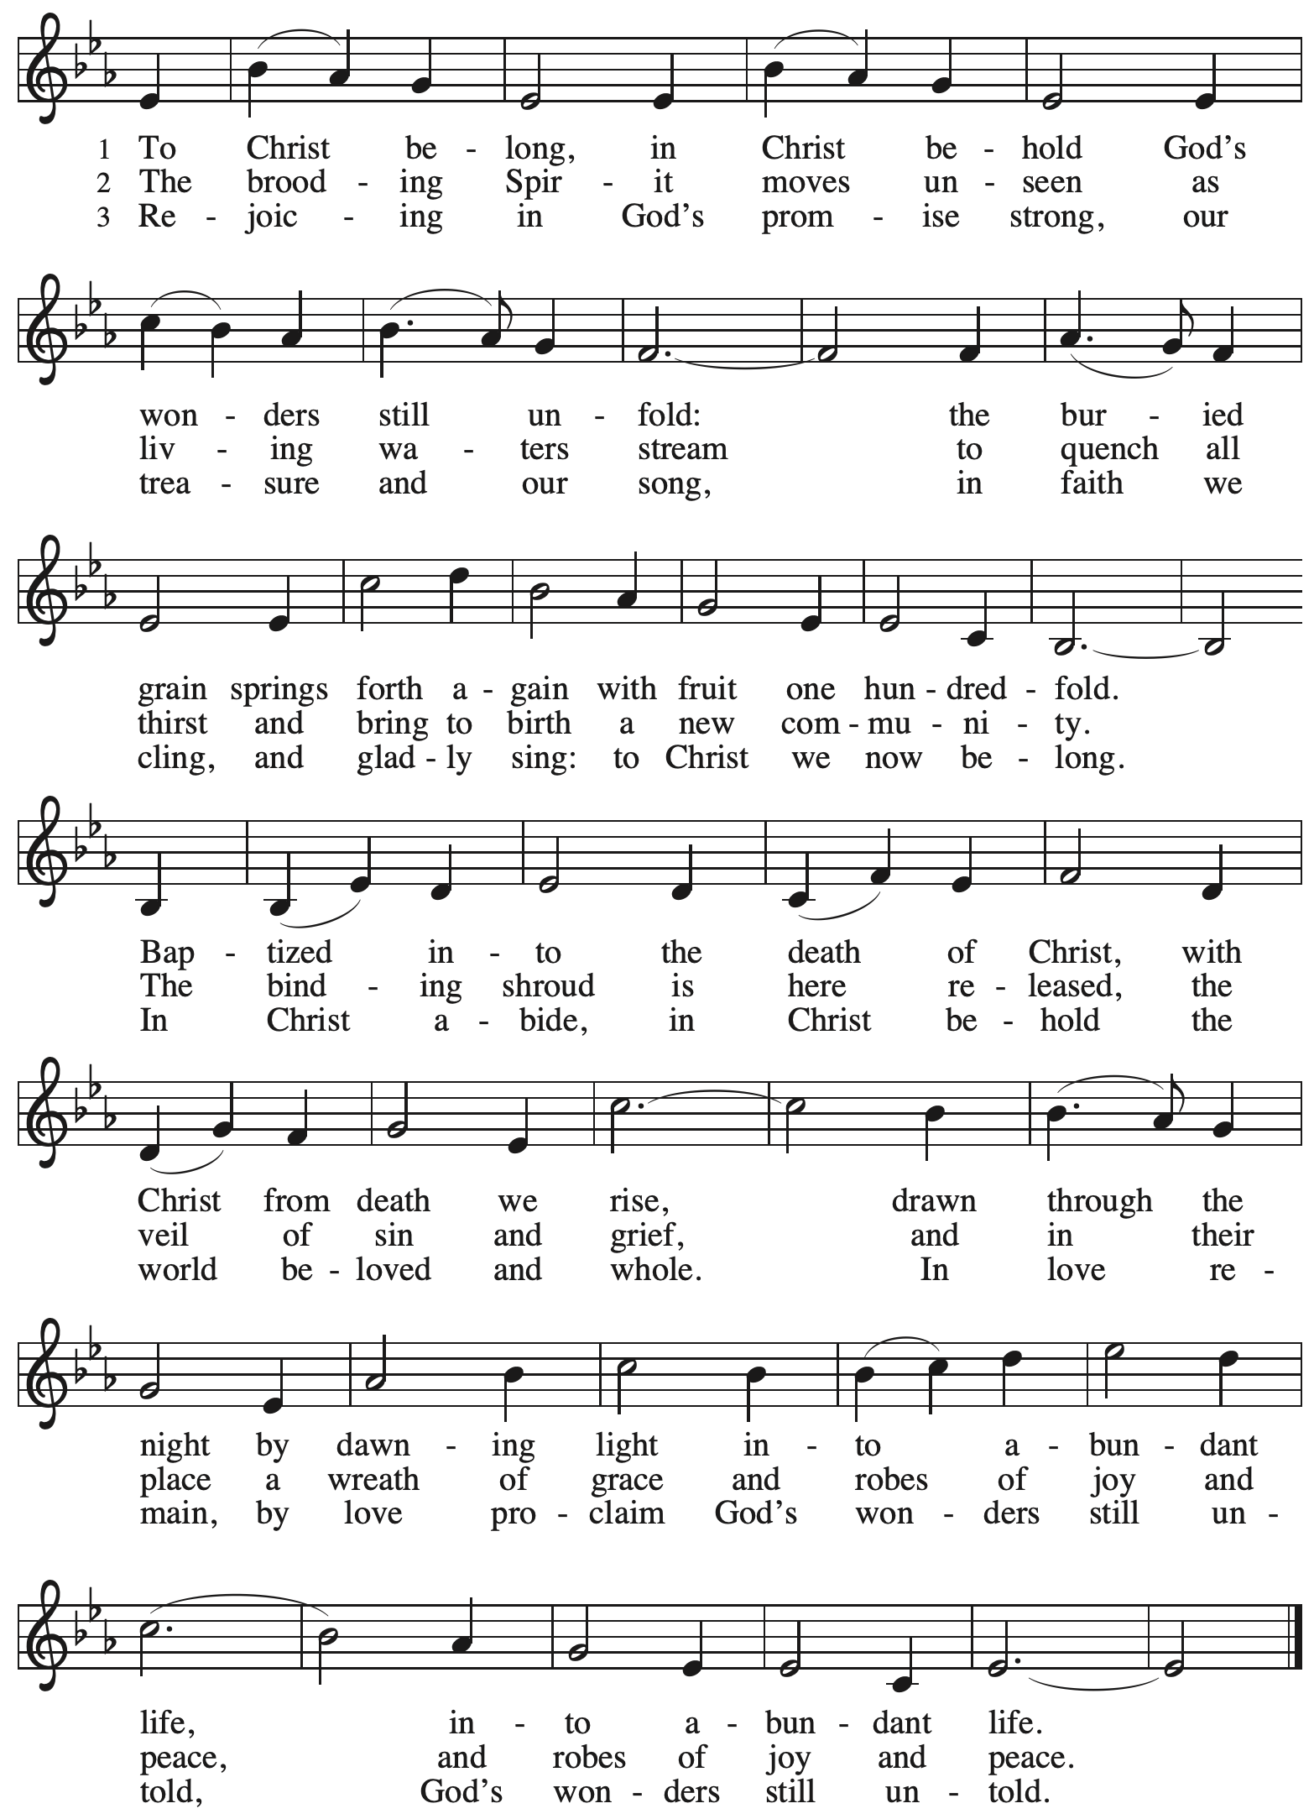

Hymns during Holy Communion
As the Grains of Wheat ELW 465

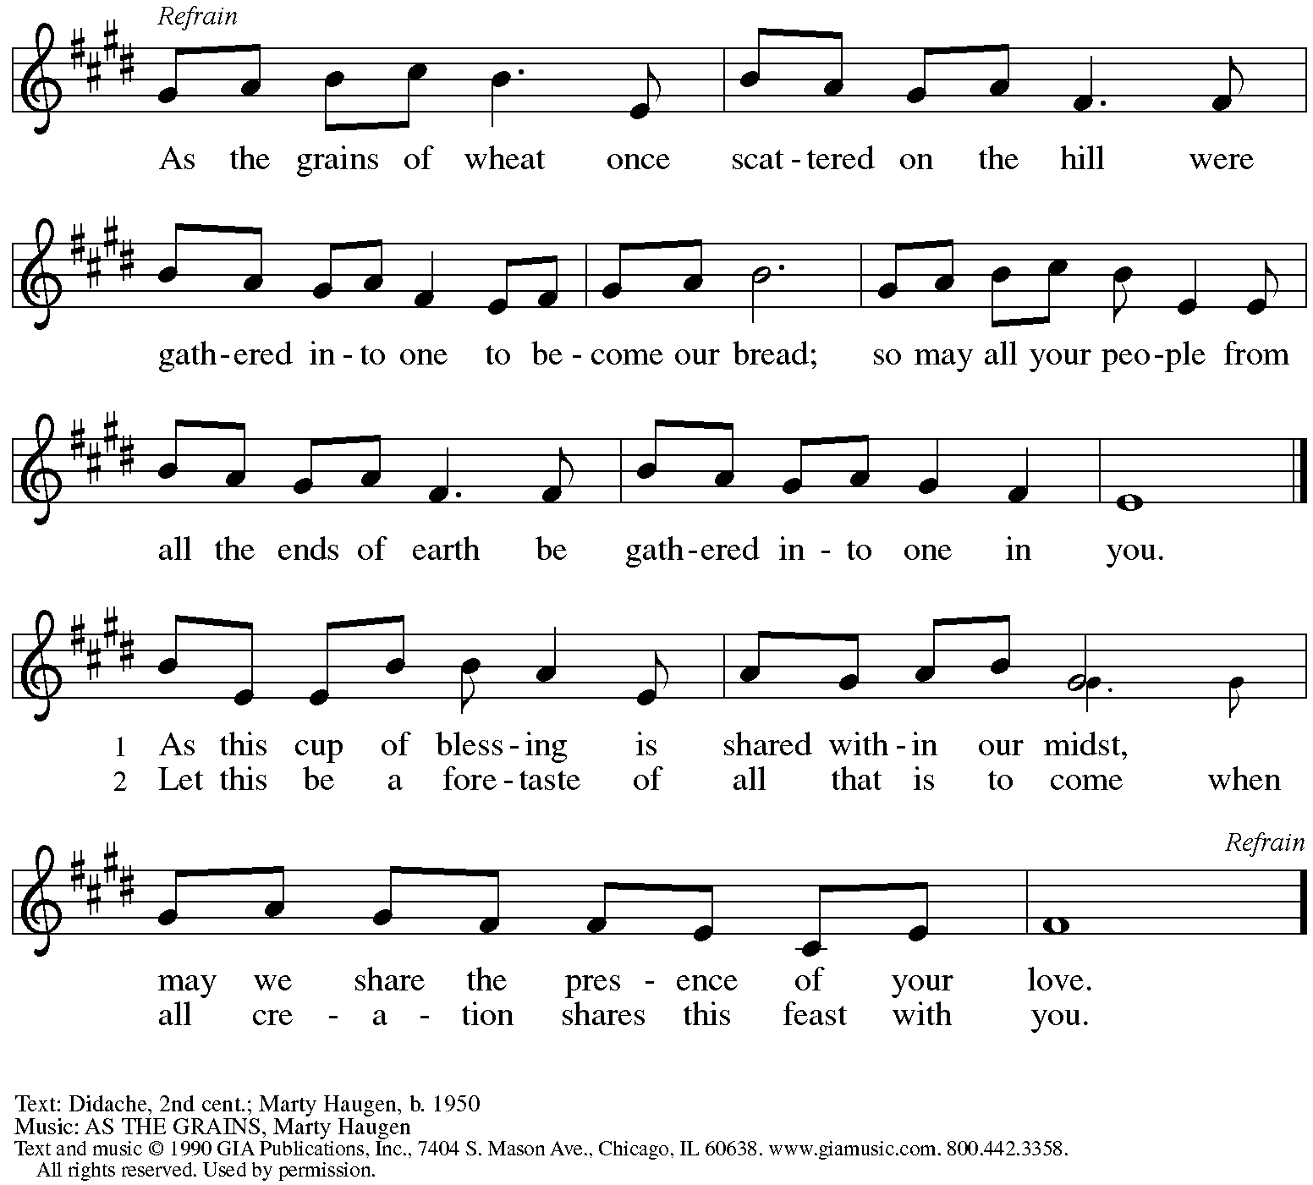
Reprinted under OneLicense.net # A-72219.

Hymns during Holy Communion
Spirit, Open My Heart ACS 1043

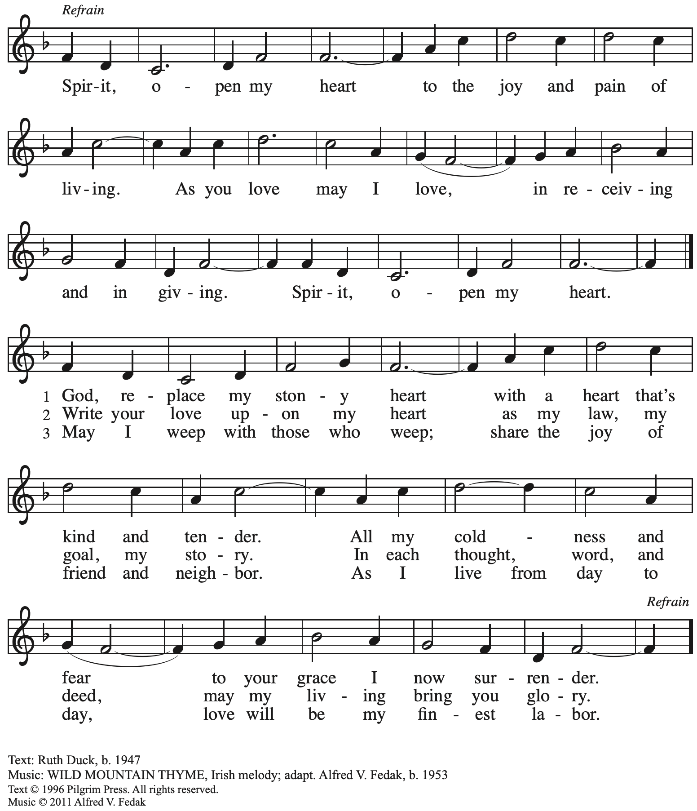
All rights reserved. Reprinted with permission under OneLicense.net # A-722139.

When all have returned to their places, please rise as you are able.

Blessing

P: The body and blood of our Lord Jesus Christ strengthen you and keep you in his grace.
C: Amen.

Prayer

A: Let us pray.
Compassionate God, you have fed us with the bread of heaven.
Sustain us in our Lenten pilgrimage:
may our fasting be hunger for justice;
our alms, a making of peace;
and our prayer, the song of grateful hearts,
through Jesus Christ, our Savior and Lord.
C: Amen.

Please be seated.

Sending
God blesses us and sends us in mission to the world

Announcements

Please rise as you are able.

Benediction

P: The peace of God,
which surpasses all understanding,
keep your hearts and your minds
in ☩ Christ Jesus.
C: Amen.

Sending Hymn Lord, Dismiss Us with Your Blessing Following page

Dismissal

A: Go in peace. Christ is with you.
C: Thanks be to God!

Postlude Abba, Abba, Hear Us arr. B. Moore

Sending Hymn Lord, Dismiss Us with Your Blessing ELW 545

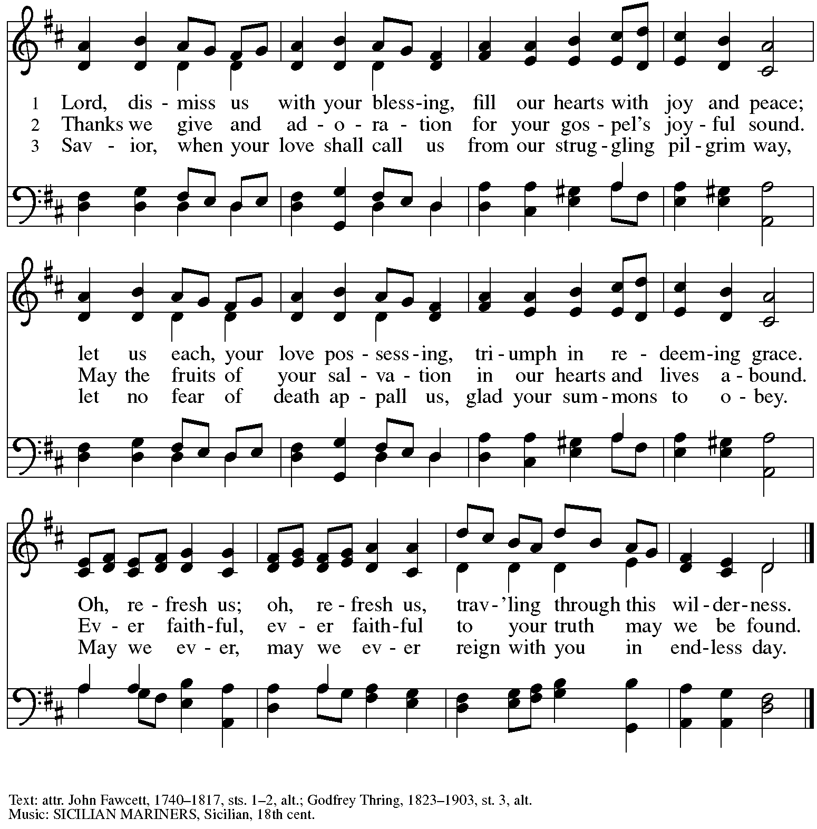

Those serving in worship

Altar Care Beverley Chapman
Assisting Minister Jeff Denlinger
Audio-Visual Ministers Jason Galyardt
David Rollinson
Cantor Joy Givens
Coffee Hour Kristen Asplin
Lector Kelly Spanninger
Little Church – Big Faith Teacher Sue Gaugler
Recorder Timothy Kocher-Hillmer
Minister of Music Laura Reynolds
Presiding and Preaching Minister The Rev. Ross I. Carmichael

Liturgy and Hymnody Acknowledgements

From SundaysandSeasons.com. Copyright © 2024 Augsburg Fortress. All rights reserved. Reprinted under OneLicense.net # A-722139.
Used by permission of Augsburg Fortress.

To Christ Belong, in Christ Behold – Text: Susan R. Briehl, b. 1952. Music: WONDERS, Robert Buckley Farlee, b. 1950. Text © 2011 Susan R. Briehl, admin. Augsburg Fortress. Music © 2011 Robert Buckley Farlee, admin. Augsburg Fortress. All rights reserved. Reprinted with permission under OneLicense.net # A-722139.

Please use the QR code below to link to St. Andrew’s Announcements online!

St. Andrew Lutheran Church Announcements
March 17th, 2024

- Welcome to Worship at St. Andrew on the Fifth Sunday in Lent, March 17th, 2024 – We are so glad you are here, and we offer a special welcome to all visitors and guests who are gathered at the church or online! Children are invited to participate in Little Church – Big Faith, a Bible lesson and activity, after the prayer of the day. There are worship “toolkits” to help children engage with worship and “busy bags” for younger children available in the bookcase at the back of the sanctuary. Please feel free to take one to use with/for your children. We invite everyone to gather in the social hall (through the door on the left side of the worship space) for coffee and conversation after worship!
- “Quiet” (Noisy) Offering during Worship Today – On the third Sunday of each month, St. Andrew invites the children of the congregation to lead us in a “noisy” offering during Lent. Children carry buckets around the congregation and people are invited to throw in their change. Because the church has entered the more subdued season of Lent, this month’s noisy offering will be a “Quiet” offering, benefitting Lutheran Campus Ministry in Greater Pittsburgh.
- Growing in Faith Together – Gather for the Congregational Meeting Today after Worship –St. Andrew’s small group gatherings to help people get to know one another, to share in conversation and faith stories based on the weekly readings, and to pray for one another continue on the Sundays in Lent after worship, today and next Sunday, March 24th. If you are interested in participating or have any questions, please speak with Pastor Ross or contact Jeff at jdenlinger26@icloud.com.
- Shelter Dinner at East End Cooperative Ministry – Thursday, March 21st, Arrival 6:00 p.m., Dinner 6:30 p.m. – Each month, on the third Thursday, people of St. Andrew provide and serve a meal for the guests of the shelter at East End Cooperative Ministry (EECM), 6140 Station St., 15206. Anyone can sign up to prepare or purchase a portion of the meal to bring to EECM at 6:00 p.m. that day, or just come to help serve the meal at 6:30 p.m. If you would like to contribute, please sign up at:
https://www.signupgenius.com/go/5080544AAAC22A1F58-48072861-march.
- New Signup Form for Worship Roles – St. Andrew's worship is made possible by many people who serve in various roles – Some people prepare the altar and setup Communion, some run the sound/streaming system, while others teacher Little Church – Big Faith for the children, serve as ushers, wash communion cups, count the offering, and more. It is not just roles like Cantor and Lector that involve being up in front of the congregation! If you are interested in getting more involved in worship, talk to Pastor Ross or Joseph Paetz. Most positions serve once a month or less. We have created a new form for those wishing to express interest in service for any of the roles – please access it here https://forms.gle/qfeJvbFR6V8DtTsz7 and someone will be in touch soon!
- Inviting Coffee Hour Signups for Upcoming Sundays – One way that we at St. Andrew build community is by sharing conversation over food and drinks at coffee hour after worship on Sundays. We invite people of the congregation to serve by getting the coffee brewing, setting out cups, napkins, food items, and cold drinks, and cleaning up afterward. Everything needed is at St. Andrew and instructions are available. If you would be willing to set up coffee hour on any of the upcoming Sundays, please sign up here:
https://www.signupgenius.com/go/5080B4AAFAF2CABF85-47069030-coffee.
Thank you for your consideration!
- Worship Schedule for Holy Week – With today’s service, the church enters into the contemplation of the passion, death, and resurrection of our Savior Jesus Christ. Our primary means for this reflection is through the service of the Triduum – the Great Three Days of Holy Week – one service that unfolds in three parts: Maundy Thursday, Good Friday, and the Vigil of Easter. The service schedule for the upcoming week is:
  - Triduum – Maundy Thursday, March 28th, 7:00 p.m. – The Church concludes the season of Lent with Confession and Forgiveness, receives Jesus’ command to love one another, remembers Christ’s example of such love in the washing of feet, and takes part in the sacrament of Holy Communion.
  - Triduum – Good Friday, March 29th, 7:00 p.m. – Service of Shadows and Stones – In relative darkness, we hear Gospel accounts of the crucifixion, sing prayerful, meditative hymns, and leave stones at the foot of the cross as we honor our crucified Savior.
  - Triduum – The Vigil of Easter, March 30th, 5:00 p.m. – The church tells God’s story of salvation through worship, word, sacrament, and song as we gather around a fire, hear stories of God’s faithfulness throughout the ages, give thanks for the gift of Baptism, and move into the celebration of the resurrection with Holy Communion.
  - The Resurrection of our Lord – Easter Sunday, March 31st, 10:00 a.m. – Worship with Holy Communion – We join the church throughout the world in proclaiming the good news of Christ’s resurrection!
- Monthly Produce Distribution – Tuesday, April 2nd, 5:30-7:00 p.m. – St. Andrew’s monthly distribution of fresh produce (in partnership with Greater Pittsburgh Community Food Bank) will be Tuesday, April 2nd, from 5:30-7:00 p.m. We would also appreciate help with unloading and setup earlier in the day, usually sometime between 10:30 a.m. and 1:00 p.m.
- Empty Bowls Dinner Benefitting Greater Pittsburgh Community Food Bank – Sunday, April 7th, at Rodef Shalom Congregation – This annual event will be hosted by our neighbors at Rodef Shalom congregation at 4905 Fifth Ave. Oakland 15213. There will be three seatings: from 1:00-3:00 p.m., 3:30-5:30 p.m., and 6:00-8:00 p.m. A Soup and Bowl takeout option is also available. Cost is $25 for presale and $30 at the door. Tickets and information can be found at pittsburghfoodbank.org/emptybowls.
- Compline Prayer Service, a Ministry of Lutheran Campus Ministry in Greater Pittsburgh, Sundays at 8:00 p.m. at Heinz Chapel – Compline was traditionally a monastic prayer service, and the Pittsburgh Compline Choir sings a choral version of compline rooted in this thousand-year-old tradition of scripture, song, and silence. This service also streams on Facebook (Pittsburgh Compline Choir) and YouTube (The Pittsburgh Compline Choir). Heinz Chapel is located off of S. Bellefield Ave. in Oakland.
- New Christ in Our Home Devotional Booklets for April - June Available at Church Entrances – This resource offers a daily Bible reading with a short reflection and prayer, along with additional readings and prayer topics for those who would like to expand their devotional practices. We encourage people of the congregation to take one for yourself, your family unit, or others! There are still a few books left for the remainder of March if anyone is interested in picking one up.

Flowers for Easter

St. Andrew will be ordering Lilies (6 inch, five bloom - $8.00 each)
Tulips (8 inch - $9.00 each))
Daffodils (6 inch - $5.25 each)
to decorate the worship space for Easter Sunday, March 31st,
and the Easter season.
If you would like to sponsor and dedicate flowers, please order using this form.
Order by: Sunday, March 24th

Orders may be submitted at the desk in the main office
or through the Sunday offering plates.
Please submit payment with order - Checks may be made payable to:
St. Andrew Lutheran Church

Name __________________________________________
In Honor of __________________________________________
In Memory of __________________________________________
In Appreciation/Love for __________________________________________

Number of Lilies ________
Number of Tulips ________
Number of Daffodils ________

