+ The Resurrection of our Lord
Easter Sunday
March 31, 2024
St. Andrew Lutheran Church
304 Morewood Ave.
Pittsburgh, PA 15213
St_andrewELCA@verizon.net
www.standrewpittsburgh.org

+ The Resurrection of our Lord – Easter Sunday
Order for Worship

Christ is risen! Jesus is alive, and God has swallowed up death forever. With Mary Magdalene, Mary the mother of James, and Salome, we may feel astonished and confused, unsure of what to make of the empty tomb. But this is why we gather: to proclaim, witness, praise, and affirm the liberating reality of Christ’s death and resurrection. In word and feast, we celebrate God’s unending love, and depart to share this good news with all the world. Alleluia!

Welcome to St. Andrew!
- St. Andrew Lutheran congregation welcomes all who are seeking a place of healing and wholeness – a nurturing, faith-forming spiritual home. Our community embraces people of all ages, ethnicities, cultures, abilities, sexual orientations, gender identities and expressions, and family constellations. Come and See!
- Worship Services are live streamed to multiple online platforms. By attending worship, you agree that your image and voice may be broadcast.
- Everyone is invited to make a nametag at the black bookcase in the back of the worship space if they would like. There are stickers indicating pronouns on the bookcase if you would like to include them on your name tag.
- The nursery is available through the doors at the left side of the sanctuary and across from the doorway to the Social Hall. It is a purple room.
- Children are invited to attend Little Church – Big Faith, a Bible lesson and activity, during worship (after the Prayer of the Day). The group returns to the worship space for the liturgy of Holy Communion.
- Worship “toolkits” to help children engage with the service, along with “busy bags” for younger children, are available in the bookcase at the back of the sanctuary. Please feel free to take one to use with/for your children.
- The nursery is available through the doors at the left side of the sanctuary and across from the doorway to the Social Hall. It is a purple room.
- Holy Communion is served with bread (gluten-free available) and wine or grape juice. The presiding minister will distribute the bread (host). Please consume this and then pick up an empty glass from the tray. The Communion Assistant will pour wine or grape juice into your glass. Please step to the side to consume the wine or grape juice. Feel free to kneel at the altar for prayer and reflection. As you return to your pew, glasses may be returned to the empty trays on either side of the center section.
- A restroom is available on the main level of the church, through the doors to the Social Hall and to the right in the main office.

Abbreviations
P: Pastor/Presiding Minister ELW: Evangelical Lutheran Worship hymnal
A: Assisting Minister ACS: All Creation Sings hymnal
L: Lector
C: Congregation

Pre-Service Music

Welcome

Gathering
The Holy Spirit calls us together as the people of God.

Children are invited to gather at the front of the worship space as the service begins,
as we welcome back the “Alleluia,” the Church’s song of Easter joy!

Raising the Alleluia

Once the Alleluias have been brought out, the presiding minister and congregation proclaim:
P: Alleluia! Christ is risen!
C: Christ is risen indeed! Alleluia! Alleluia!

Choir Anthem Hallelujah Chorus G.F. Handel
arr. Podd

Please rise as you are able and face the cross as the Processional Hymn begins.

Processional Hymn Jesus Christ Is Risen Today ELW 365

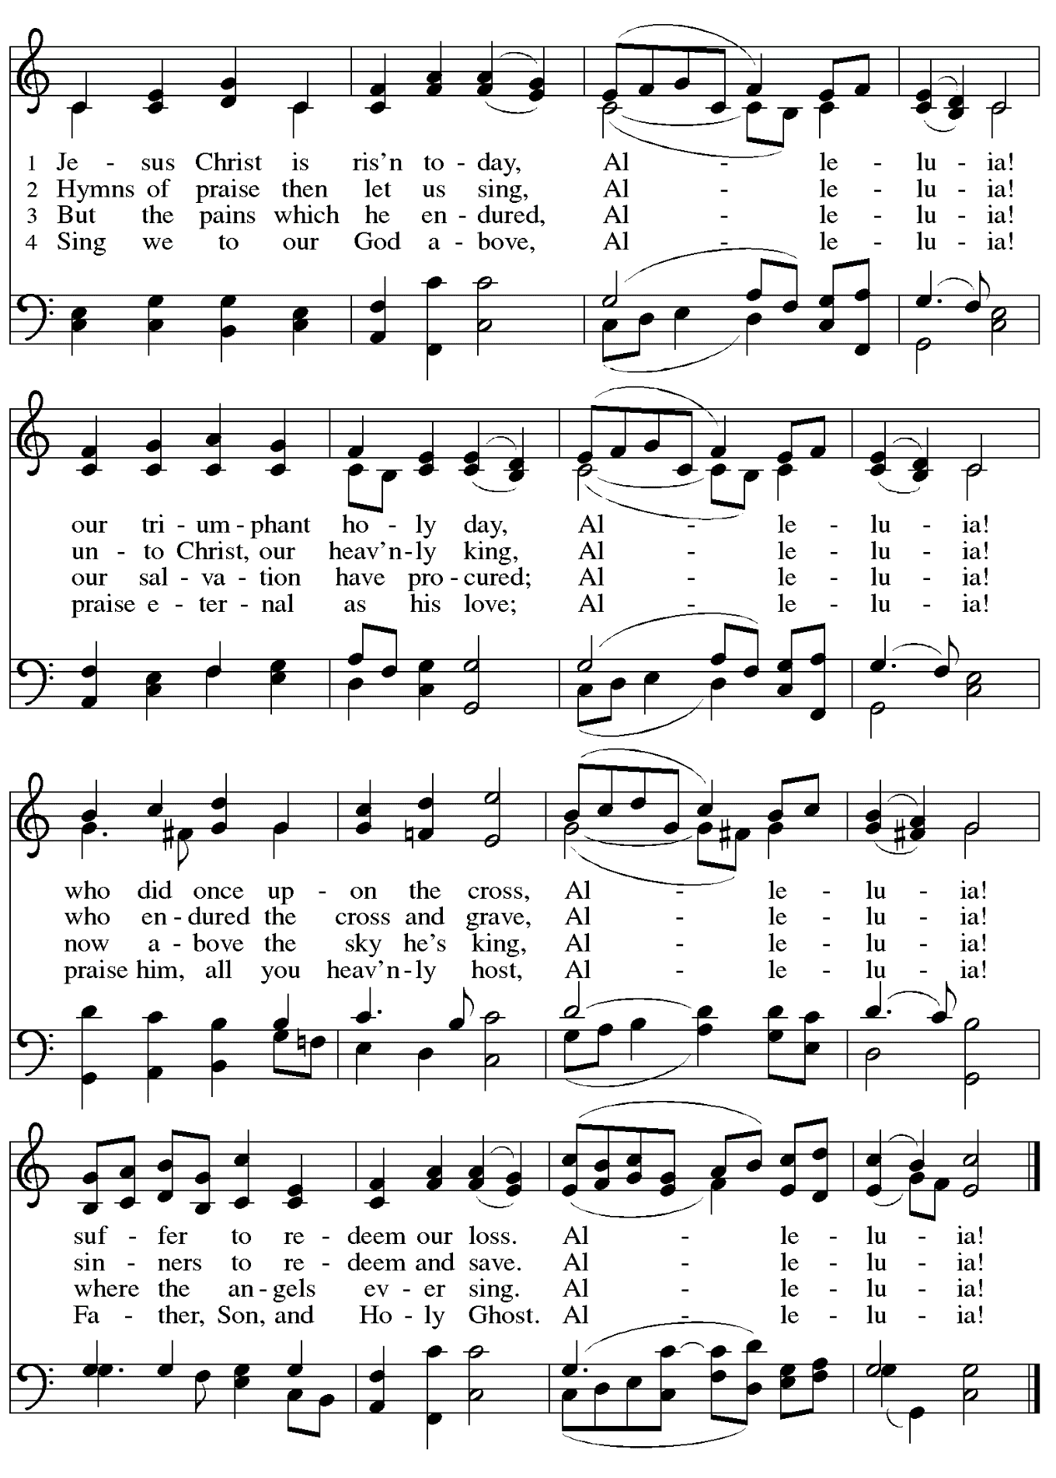

Greeting

P: The grace of our Lord Jesus Christ, the love of God,
and the communion of the Holy Spirit be with you all.
C: And also with you.

Hymn of Praise This Is the Feast ELW p. 149-150

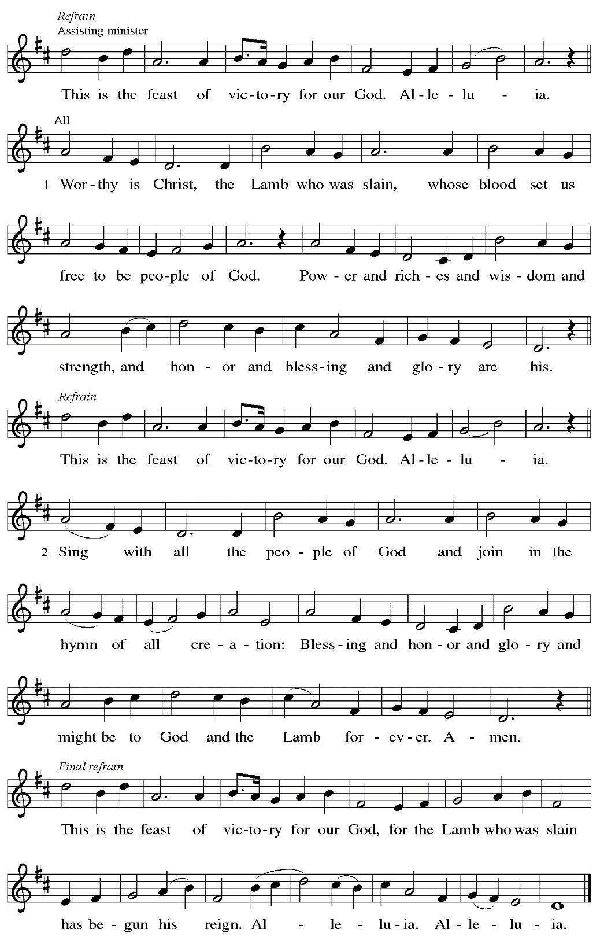

Prayer of the Day

P: The Lord be with you.
C: And also with you.

P: Let us pray.
O God, you gave your only Son to suffer death on the cross for our redemption,
and by his glorious resurrection you delivered us from the power of death.
Make us die every day to sin, that we may live with him forever in the joy of the resurrection, through your Son, Jesus Christ our Lord, who lives and reigns with you and the Holy Spirit,
one God, now and forever.
C: Amen.

Please be seated.

Word
God speaks to us in Scripture reading, preaching, and song

First Reading – Acts 10: 34-43

³⁴Peter began to speak to [the people]: “I truly understand that God shows no partiality, ³⁵but in every nation anyone who fears God and does what is right is acceptable to God. ³⁶You know the message God sent to the people of Israel, preaching peace by Jesus Christ—he is Lord of all. ³⁷That message spread throughout Judea, beginning in Galilee after the baptism that John announced: ³⁸how God anointed Jesus of Nazareth with the Holy Spirit and with power; how he went about doing good and healing all who were oppressed by the devil, for God was with him. ³⁹We are witnesses to all that he did both in Judea and in Jerusalem. They put him to death by hanging him on a tree; ⁴⁰but God raised him on the third day and allowed him to appear, ⁴¹not to all the people but to us who were chosen by God as witnesses, and who ate and drank with him after he rose from the dead. ⁴²He commanded us to preach to the people and to testify that he is the one ordained by God as judge of the living and the dead. ⁴³All the prophets testify about him that everyone who believes in him receives forgiveness of sins through his name.”

L: Word of God, word of life.
C: Thanks be to God.

Psalm 118: 1-12, 14-24

The psalm will be sung responsively, led by the cantor,
with the congregation responding with the bold verses and refrain.

Psalm tone

Psalm refrain

¹Give thanks to the Lord, for the | Lord is good;
God’s mercy en- | dures forever.
²Let Israel | now declare,
“God’s mercy en- | dures forever.”
¹⁴The Lord is my strength | and my song,
and has become | my salvation.
¹⁵Shouts of rejoicing and salvation echo in the tents | of the righteous:
“The right hand of the | Lord acts valiantly!
¹⁶The right hand of the Lord| is exalted!
The right hand of the | Lord acts valiantly!”
¹⁷I shall not | die, but live,
and declare the works | of the Lord. R
¹⁸The Lord indeed pun- | ished me sorely,
but did not hand me o- | ver to death.
¹⁹Open for me the | gates of righteousness;
I will enter them and give thanks | to the Lord.
²⁰“This is the gate | of the Lord;
here the righ- | teous may enter.”
²¹I give thanks to you, for you have | answered me
and you have become | my salvation. R
²²The stone that the build- | ers rejected
has become the chief | cornerstone.
²³By the Lord has | this been done;
it is marvelous | in our eyes.
²⁴This is the day that the | Lord has made;
let us rejoice and be | glad in it. R

Second Reading – 1 Corinthians 15: 1-11

¹Now I would remind you, kindred, of the good news that I proclaimed to you, which you in turn received, in which also you stand, ²through which also you are being saved, if you hold firmly to the message that I proclaimed to you—unless you have come to believe in vain.
³For I handed on to you as of first importance what I in turn had received: that Christ died for our sins in accordance with the scriptures, ⁴and that he was buried, and that he was raised on the third day in accordance with the scriptures, ⁵and that he appeared to Cephas, then to the twelve.
⁶Then he appeared to more than five hundred siblings at one time, most of whom are still alive, though some have died. ⁷Then he appeared to James, then to all the apostles. ⁸Last of all, as to one untimely born, he appeared also to me. ⁹For I am the least of the apostles, unfit to be called an apostle, because I persecuted the church of God. ¹⁰But by the grace of God I am what I am, and God’s grace toward me has not been in vain. On the contrary, I worked harder than any of them—though it was not I, but the grace of God that is with me. ¹¹Whether then it was I or they, so we proclaim and so you have come to believe.

L: Word of God, word of life.
C: Thanks be to God.

Please rise as you are able.

Gospel Acclamation ELW p. 151

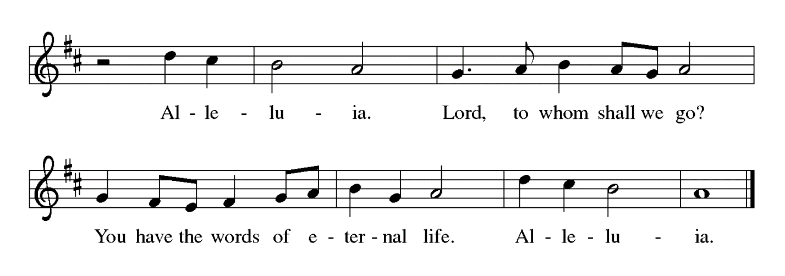

Gospel – Mark 16: 1-8

P: The holy Gospel according to St. Mark.
C: Glory to you, O Lord.

¹When the sabbath was over, Mary Magdalene, and Mary the mother of James, and Salome bought spices, so that they might go and anoint [Jesus’ body]. ²And very early on the first day of the week, when the sun had risen, they went to the tomb. ³They had been saying to one another, “Who will roll away the stone for us from the entrance to the tomb?” ⁴When they looked up, they saw that the stone, which was very large, had already been rolled back. ⁵As they entered the tomb, they saw a young man, dressed in a white robe, sitting on the right side; and they were alarmed. ⁶But he said to them, “Do not be alarmed; you are looking for Jesus of Nazareth, who was crucified. He has been raised; he is not here. Look, there is the place they laid him. ⁷But go, tell his disciples and Peter that he is going ahead of you to Galilee; there you will see him, just as he told you.” ⁸So they went out and fled from the tomb, for terror and amazement had seized them; and they said nothing to anyone, for they were afraid.

P: The Gospel of the Lord.
C: Praise to you, O Christ.

Please be seated.

Sermon

A time of silence for prayer and reflection follows the sermon.
When the hymn of the day begins, please rise as you are able.

Hymn of the Day Christ Is Alive! Let Christians Sing Following page

Hymn of the Day Christ Is Alive! Let Christians Sing ELW 389

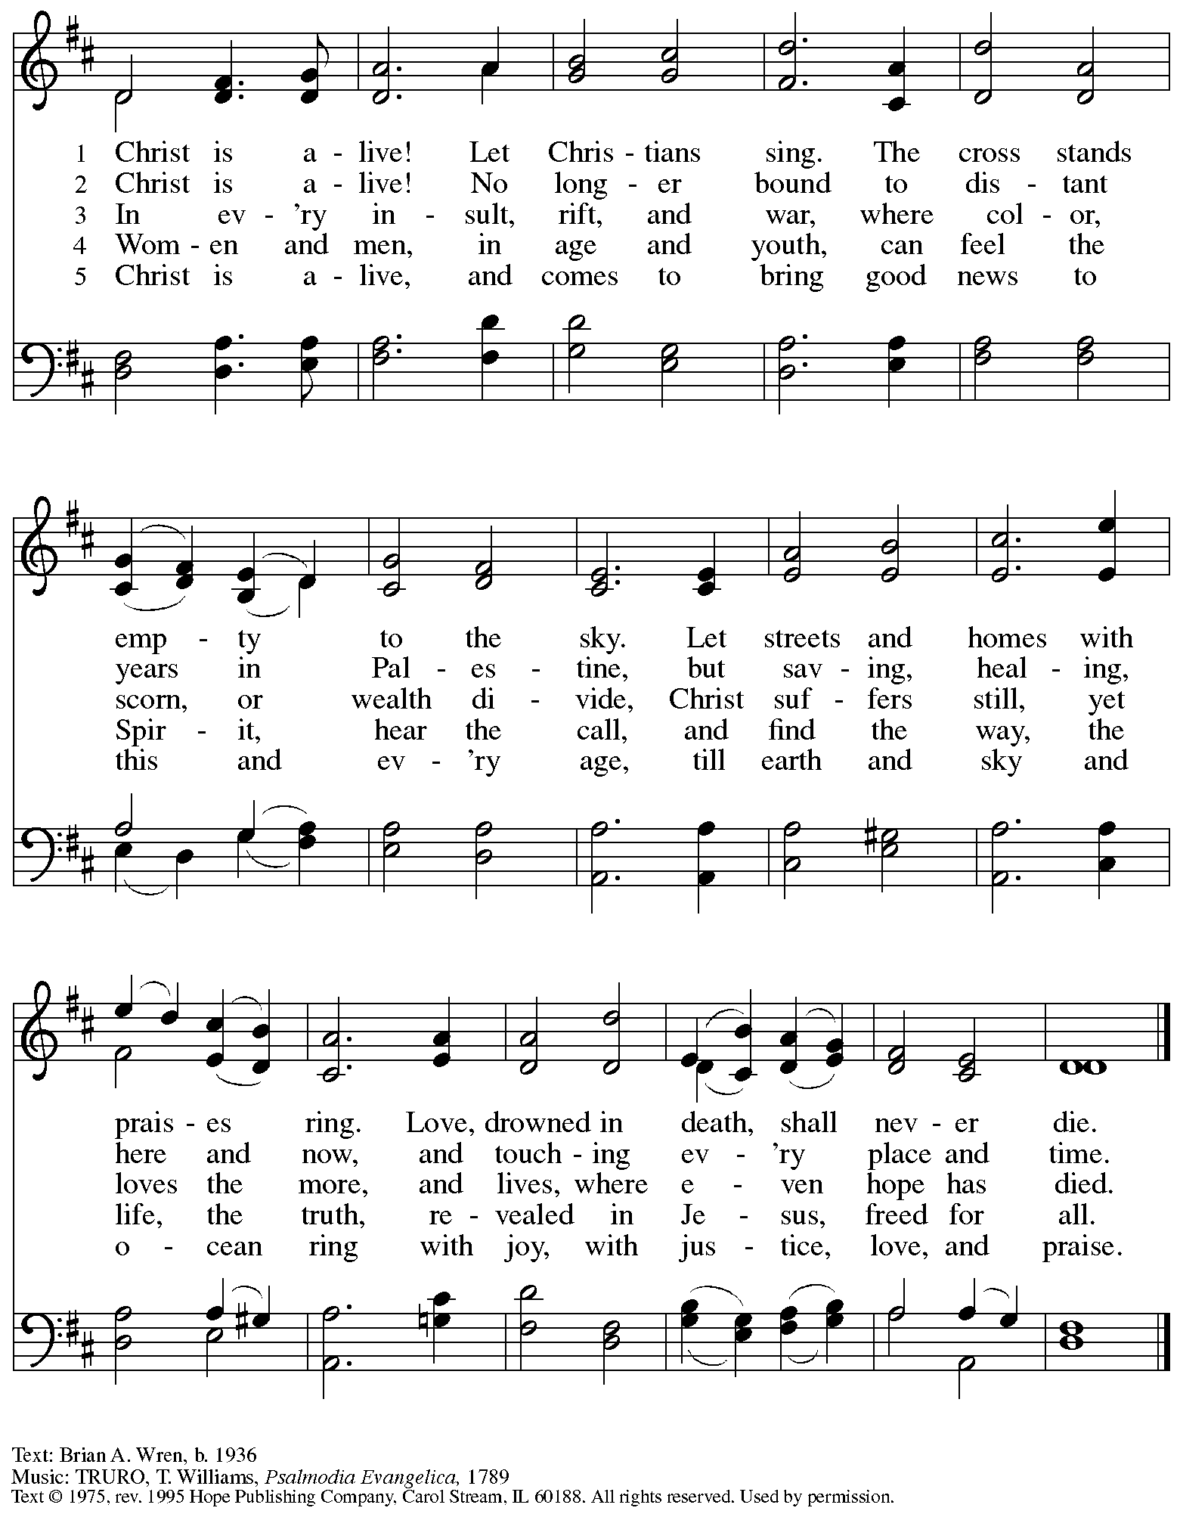
Reprinted with permission under OneLicense.net # A-722139.
Nicene Creed

C: We believe in one God,
the Father, the Almighty,
maker of heaven and earth,
of all that is, seen and unseen.

We believe in one Lord, Jesus Christ,
the only Son of God,
eternally begotten of the Father,
God from God, Light from Light,
true God from true God,
begotten, not made,
of one Being with the Father;
through him all things were made.
For us and for our salvation
he came down from heaven,
was incarnate of the Holy Spirit and the virgin Mary
and became truly human.
For our sake he was crucified under Pontius Pilate;
he suffered death and was buried.
On the third day he rose again
in accordance with the scriptures;
he ascended into heaven
and is seated at the right hand of the Father.
He will come again in glory to judge the living and the dead,
and his kingdom will have no end.

We believe in the Holy Spirit, the Lord, the giver of life,
who proceeds from the Father and the Son,*
who with the Father and the Son is worshiped and glorified,
who has spoken through the prophets.
We believe in one holy catholic and apostolic church.
We acknowledge one baptism for the forgiveness of sins.
We look for the resurrection of the dead,
and the life of the world to come. Amen.

*Or, “who proceeds from the Father.” The phrase “and the Son” is a later addition to the creed.

Prayers of the People

A: United in the joy and hope of the resurrection, let us pray for the church, the world,
and all who are in need.

After each petition
A: Gracious God,
C: receive our prayer.

P: We lift these prayers to you O God, trusting in your abundant mercy,
through Jesus Christ our risen Savior.
C: Amen.

Peace

The presiding minister and the assembly greet one another in the peace of the risen Christ.
P: The peace of Christ be with you always.
C: And also with you.

The people may greet those around them with a sign of Christ’s peace and may say
Peace be with you or similar words. Please be mindful that not everyone will be comfortable with sharing the peace, so please seek consent before shaking hands or hugging. Other possible ways to share the peace include a simple bow with the verbal greeting of peace, or simply a verbal expression of peace.

When the greetings of peace have concluded, please be seated.

Meal

Offering

We offer ourselves, our gifts, and our faithful service to God.
As the offering is gathered for the mission of the church, including the care of those in need,
the table is set for Holy Communion.

Musical Offering Easter Medley arr. Oines

As the gifts are brought forward for presentation, please rise as you are able.

Offertory Song Let the Vineyards ELW 184

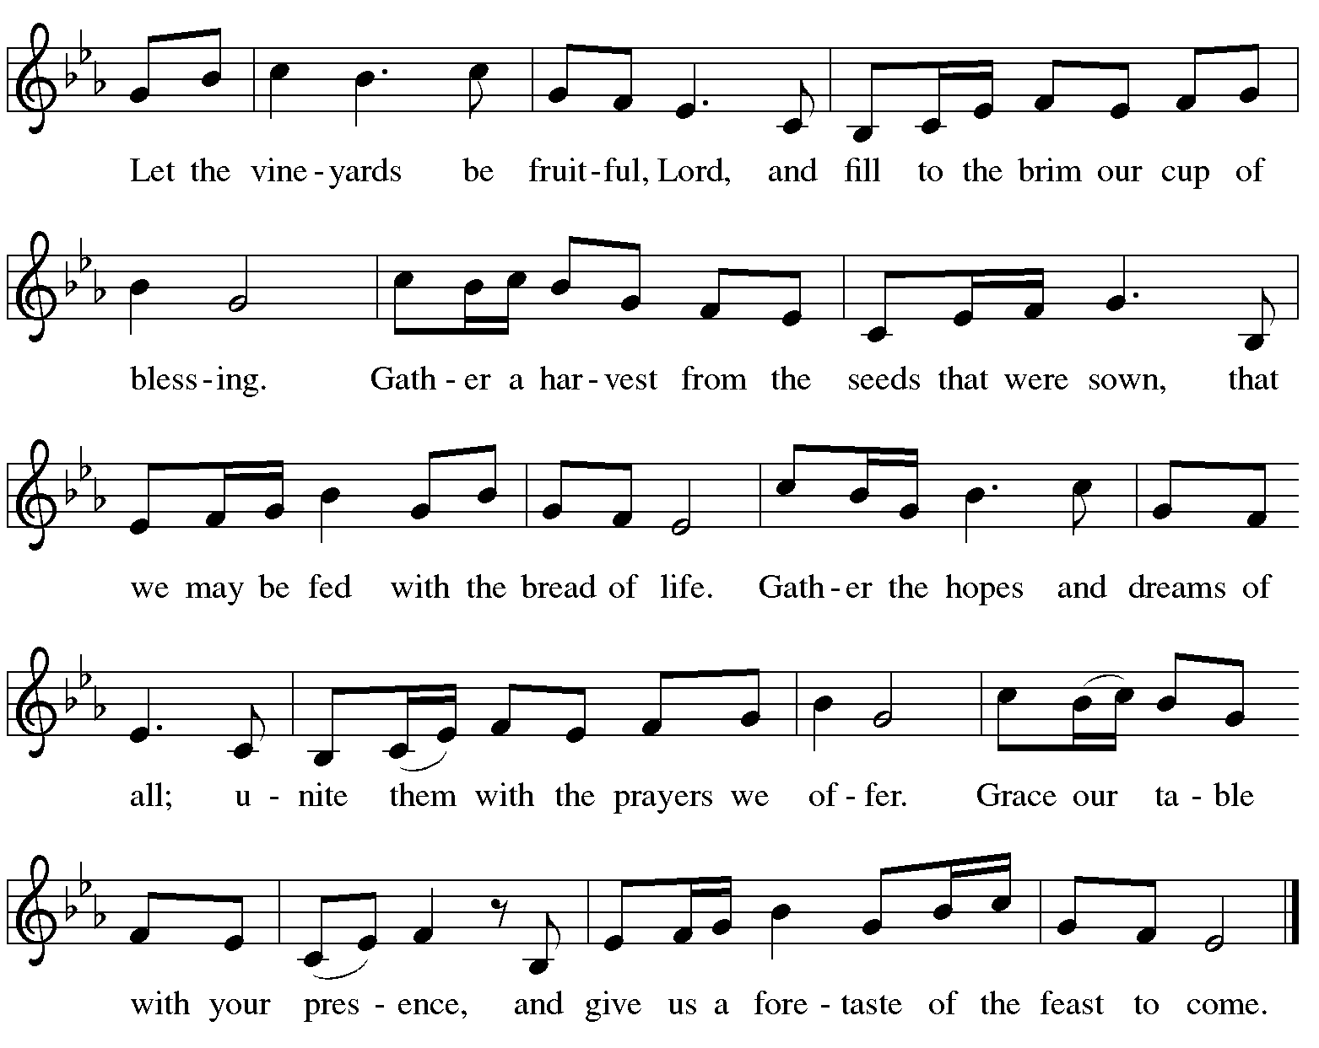

Offertory Prayer

A: Let us pray.
Blessed are you, O God,
C: ruler of heaven and earth.
Day by day you shower us with blessings.
As you have raised us to new life in Christ,
give us glad and generous hearts,
ready to praise you and to respond to those in need,
through Jesus Christ, our Savior and Lord.
Amen.

Dialogue ELW p. 152

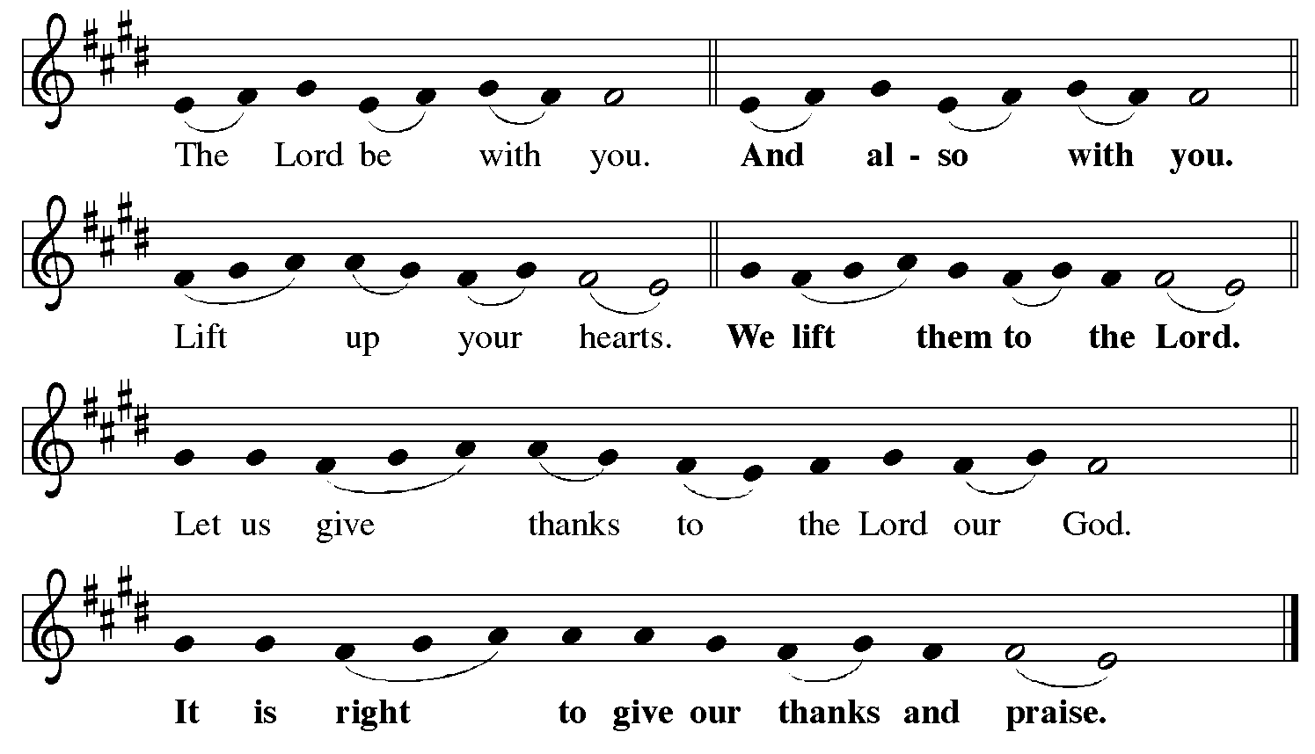

Preface (Sung by the presiding minister)

P: It is indeed right, our duty and our joy,
that we should at all times and in all places
give thanks and praise to you, almighty and merciful God,
for the glorious resurrection of our Savior Jesus Christ,
the true Paschal Lamb who gave himself to take away our sin;
who in dying has destroyed death,
and in rising has brought us to eternal life.
And so, with Mary Magdalene and Peter
and all the witnesses of the resurrection,
with earth and sea and all their creatures,
and with angels and archangels, cherubim and seraphim,
we praise your name and join their unending hymn:

Sanctus ELW p. 153

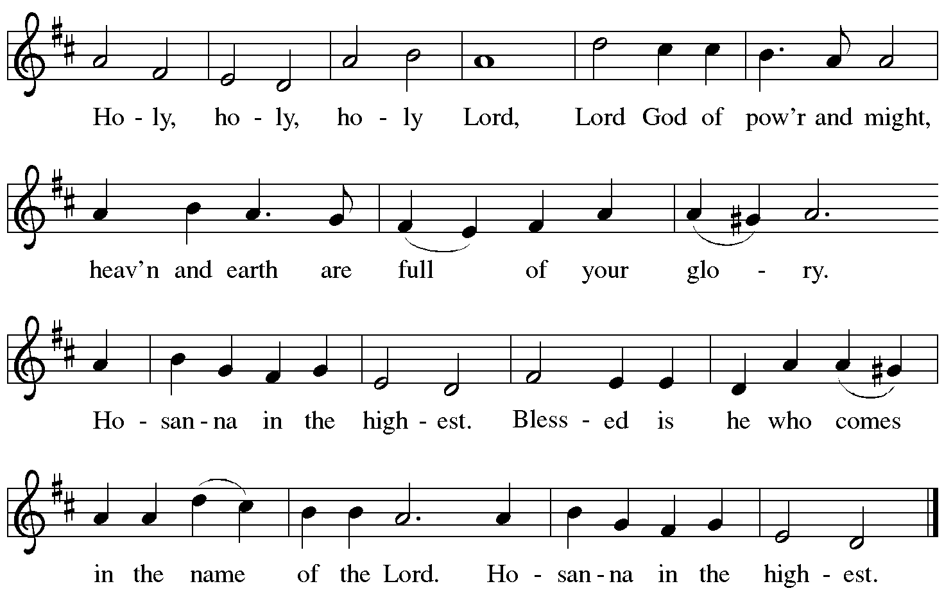

Eucharistic Prayer

P: Blessed are you, O God of the universe …
For Christ is risen:
C: Christ is risen indeed!

P: This is the day on which you gave light to the earth …
and that light is Christ:
C: Thanks be to God.

P: This is the day on which you broke the chains of death …
For Christ is risen:
C: Christ is risen indeed!

P: In the night in which he was betrayed …
… Do this for the remembrance of me.

Let us proclaim the mystery of faith.
C: Christ has died. Christ is risen. Christ will come again.

P: On this day send us the power of your Holy Spirit …
For that light is Christ:
C: Thanks be to God.

P: All holy and mighty and glorious God …
… for Christ is risen:
C: Christ is risen indeed!

P: Amen and Amen!
C: Amen and Amen!

Lord’s Prayer

P: Gathered as one by the Holy Spirit, let us pray as Jesus taught us.
C: Our Father in heaven,
hallowed be your name,
your kingdom come,
your will be done,
on earth as in heaven.
Give us today our daily bread.
Forgive us our sins
as we forgive those
who sin against us.
Save us from the time of trial
and deliver us from evil.
For the kingdom, the power,
and the glory are yours,
now and forever. Amen.

Fraction and Invitation

P: Alleluia! Christ is risen!
C: Christ is risen indeed! Alleluia! Alleluia!

P: This is the feast of victory for our God. Alleluia! Alleluia!
Come, share the feast.

Agnus Dei / Lamb of God Following Page

Agnus Dei / Lamb of God ELW p. 154

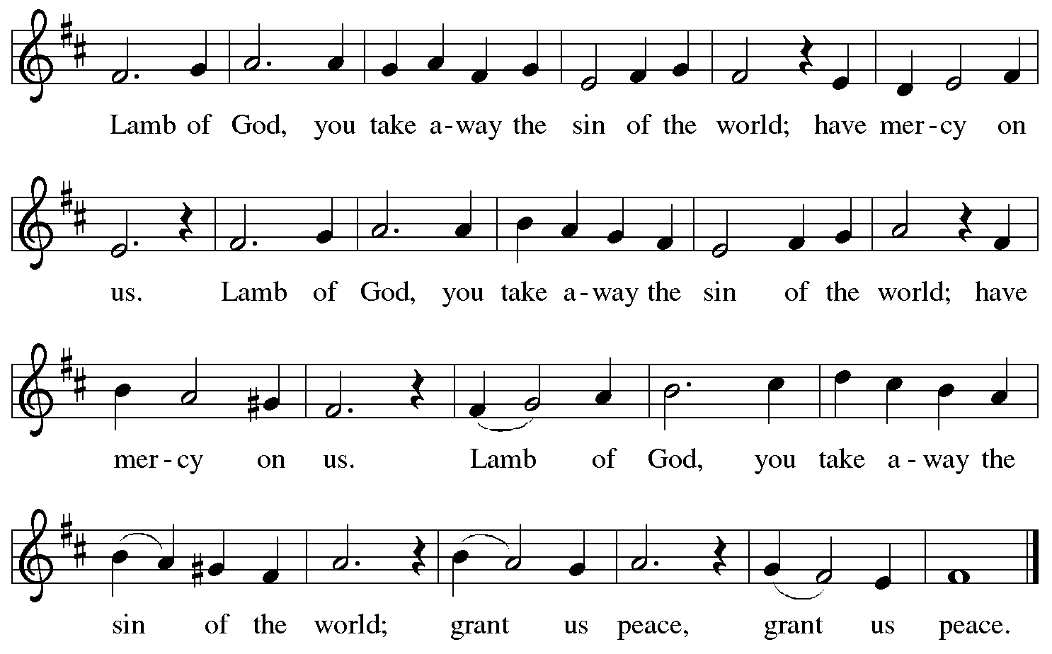

Please be seated.

Holy Communion
- All who seek God and desire a deeper and stronger life in Christ are welcome to receive Holy Communion.
- Worshipers from the pulpit side will proceed forward first, followed by the center section, and then the lectern side.
- Please inform an usher if you would like the ministers to bring Communion to you.
- Holy Communion will be served with bread and wine/grape juice.
- The presiding minister will first distribute the bread (host) to each communicant. Please indicate if you require a gluten-free host.
- Once you have consumed the bread, please pick up an empty glass from the tray next to the presiding minister. The Communion Assistant will pour wine from the chalice or grape juice from the cruet into your glass.
- Please step to the side to consume the wine or grape juice.
- Feel free to kneel at the altar rail for prayer after receiving the sacrament.
- As you return to your pew, glasses may be returned to the empty trays on either side of the center aisle.
- A blessing will be provided for anyone who does not yet receive the sacrament.
- All are invited to join in singing the hymns during Holy Communion.
Hymn during Holy Communion
At the Lamb’s High Feast We Sing ELW 362

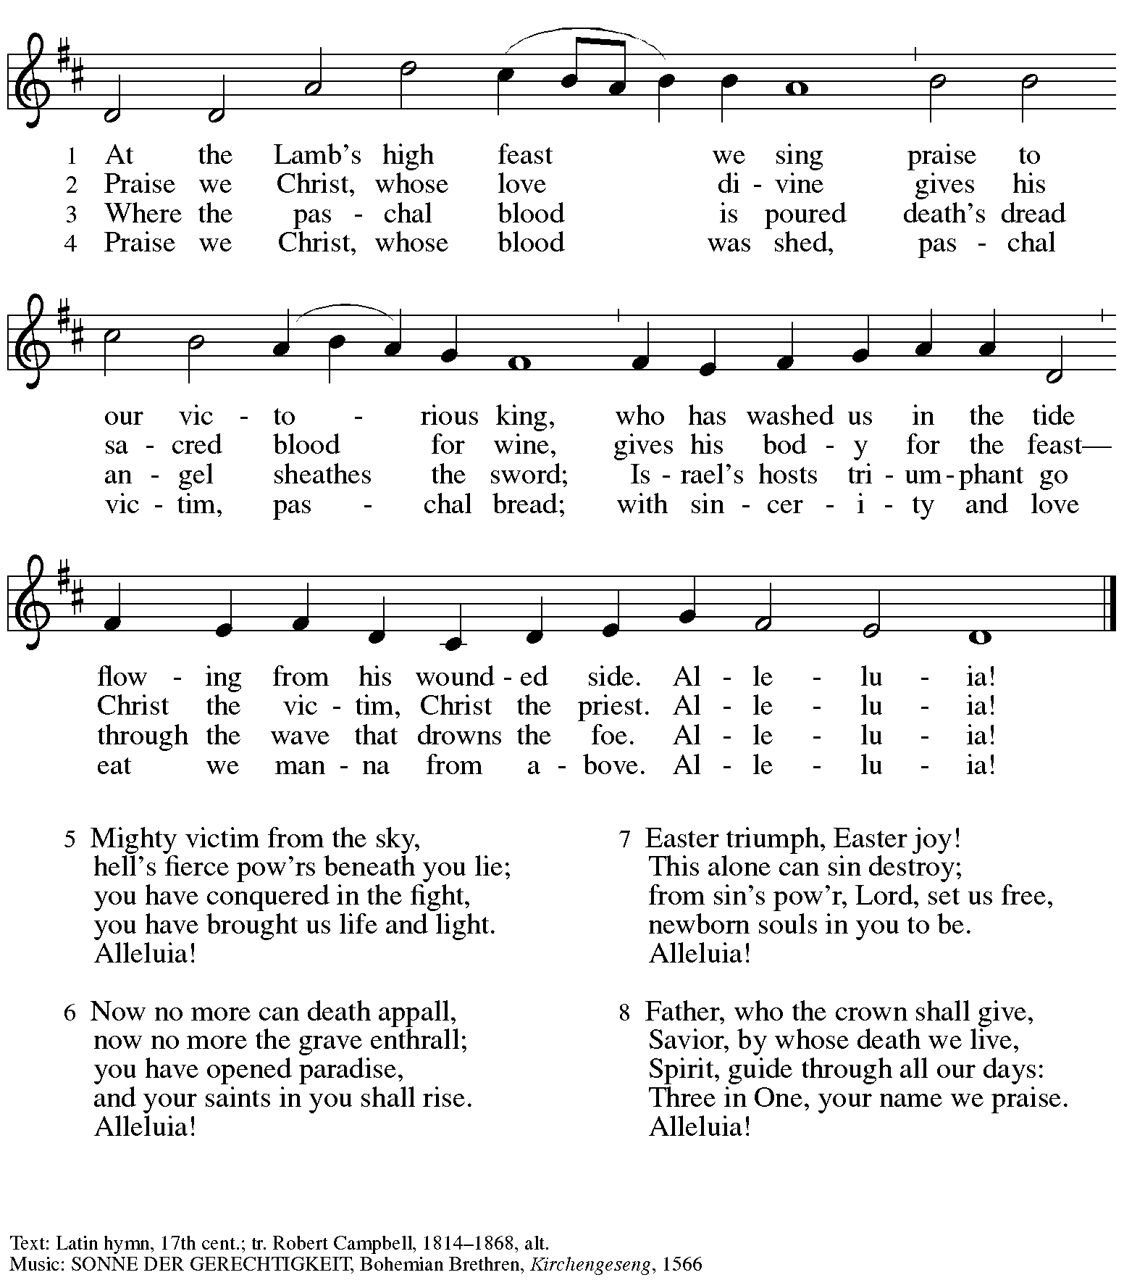

Hymn during Holy Communion
The Day of Resurrection! ELW 361

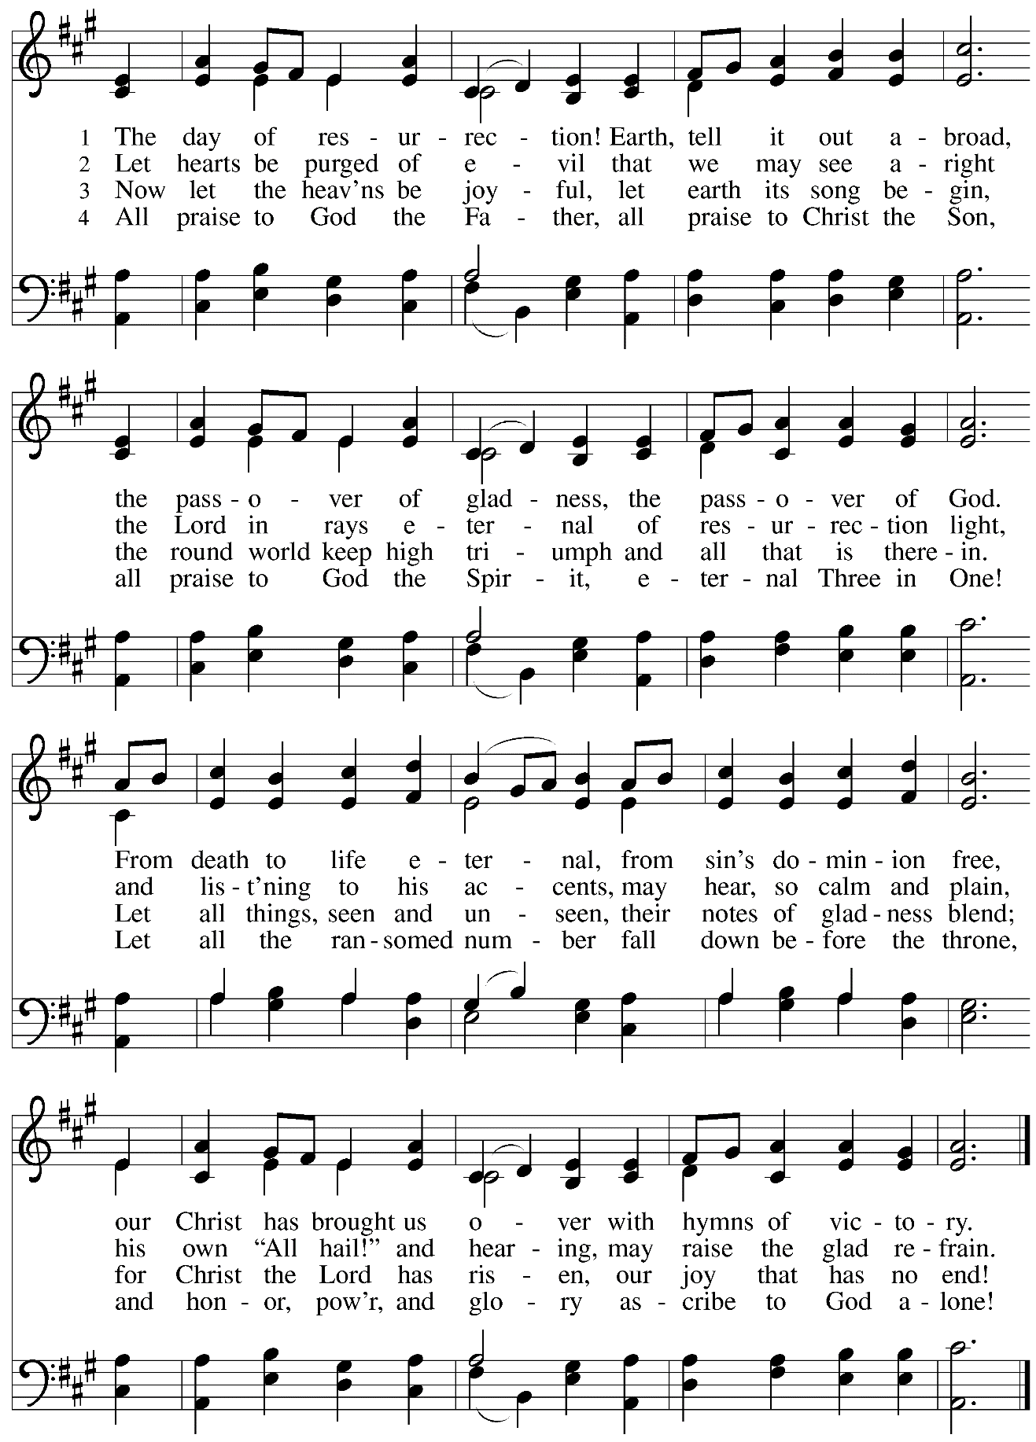
Hymn during Holy Communion
This Joyful Eastertide ELW 391

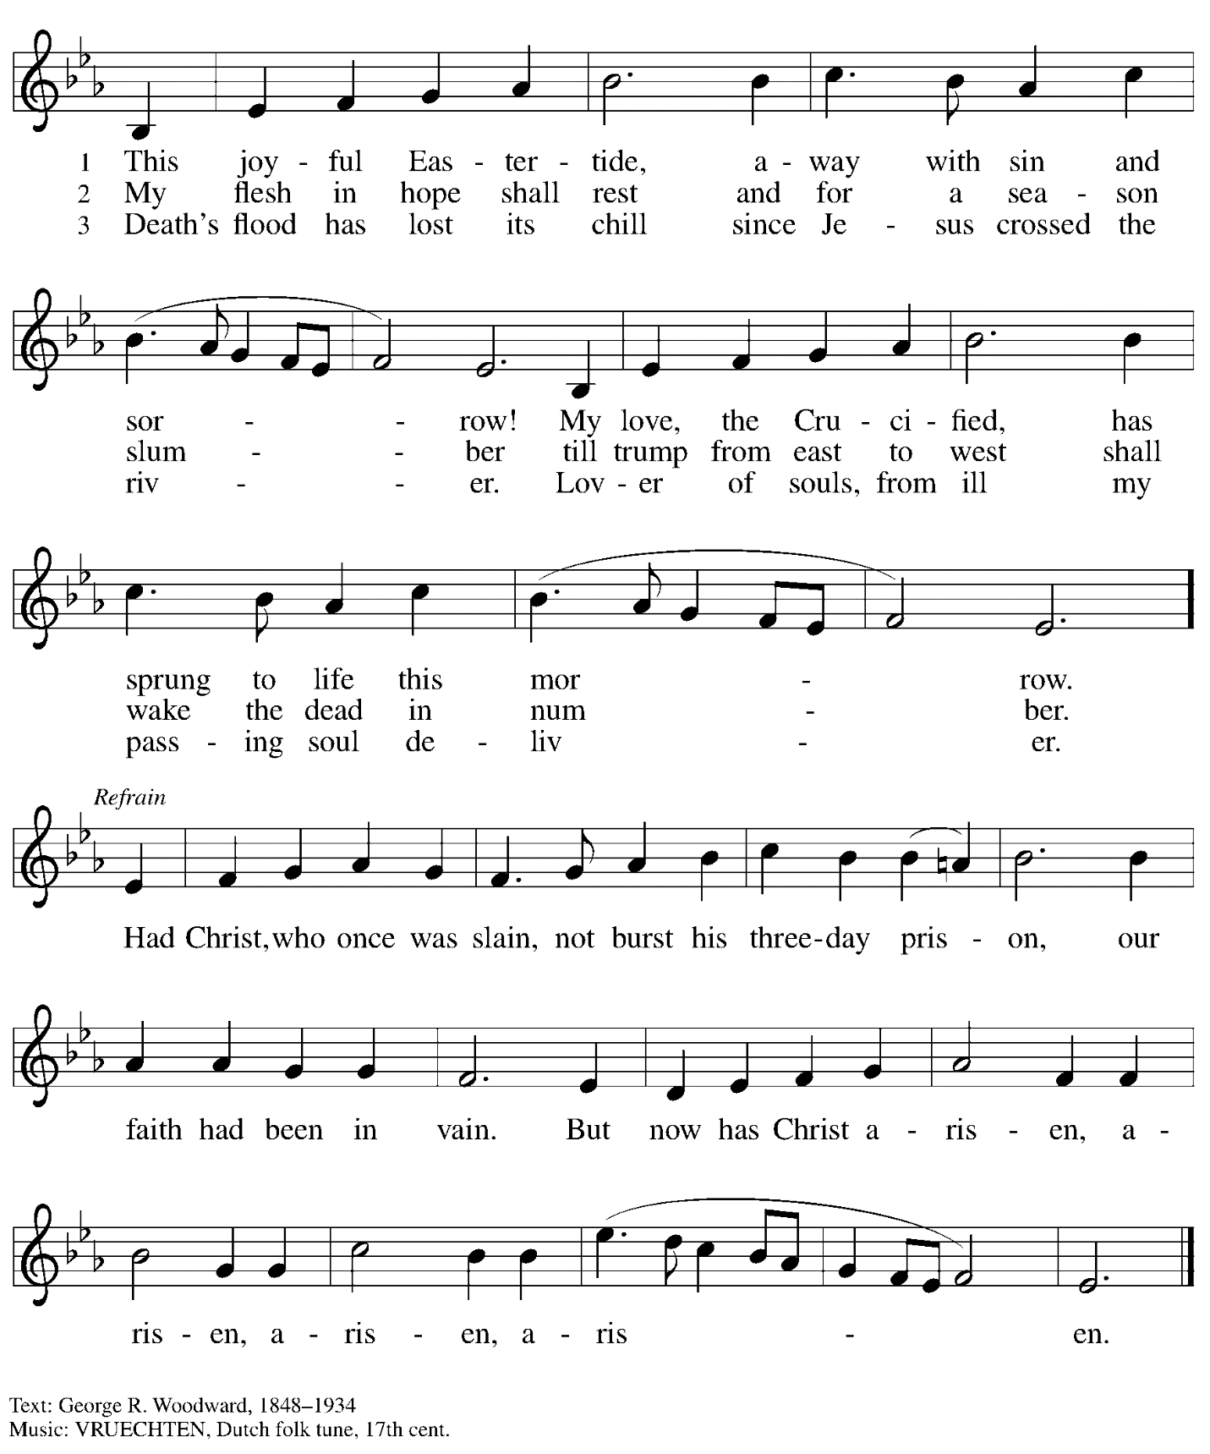

Hymn during Holy Communion
Christ Is Risen! Alleluia! ELW 382

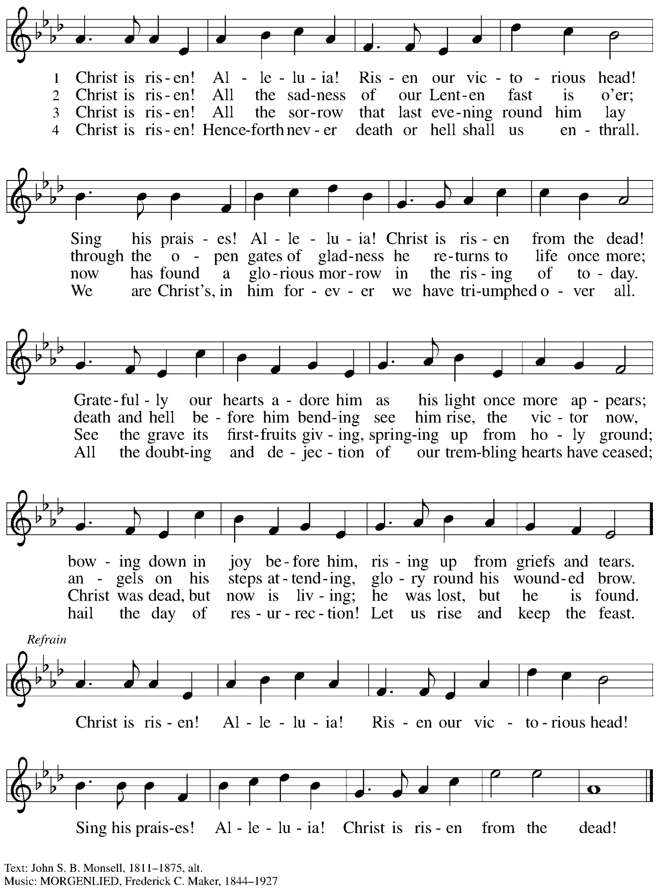
Hymn during Holy Communion
Now All the Vault of Heaven Resounds ELW 367

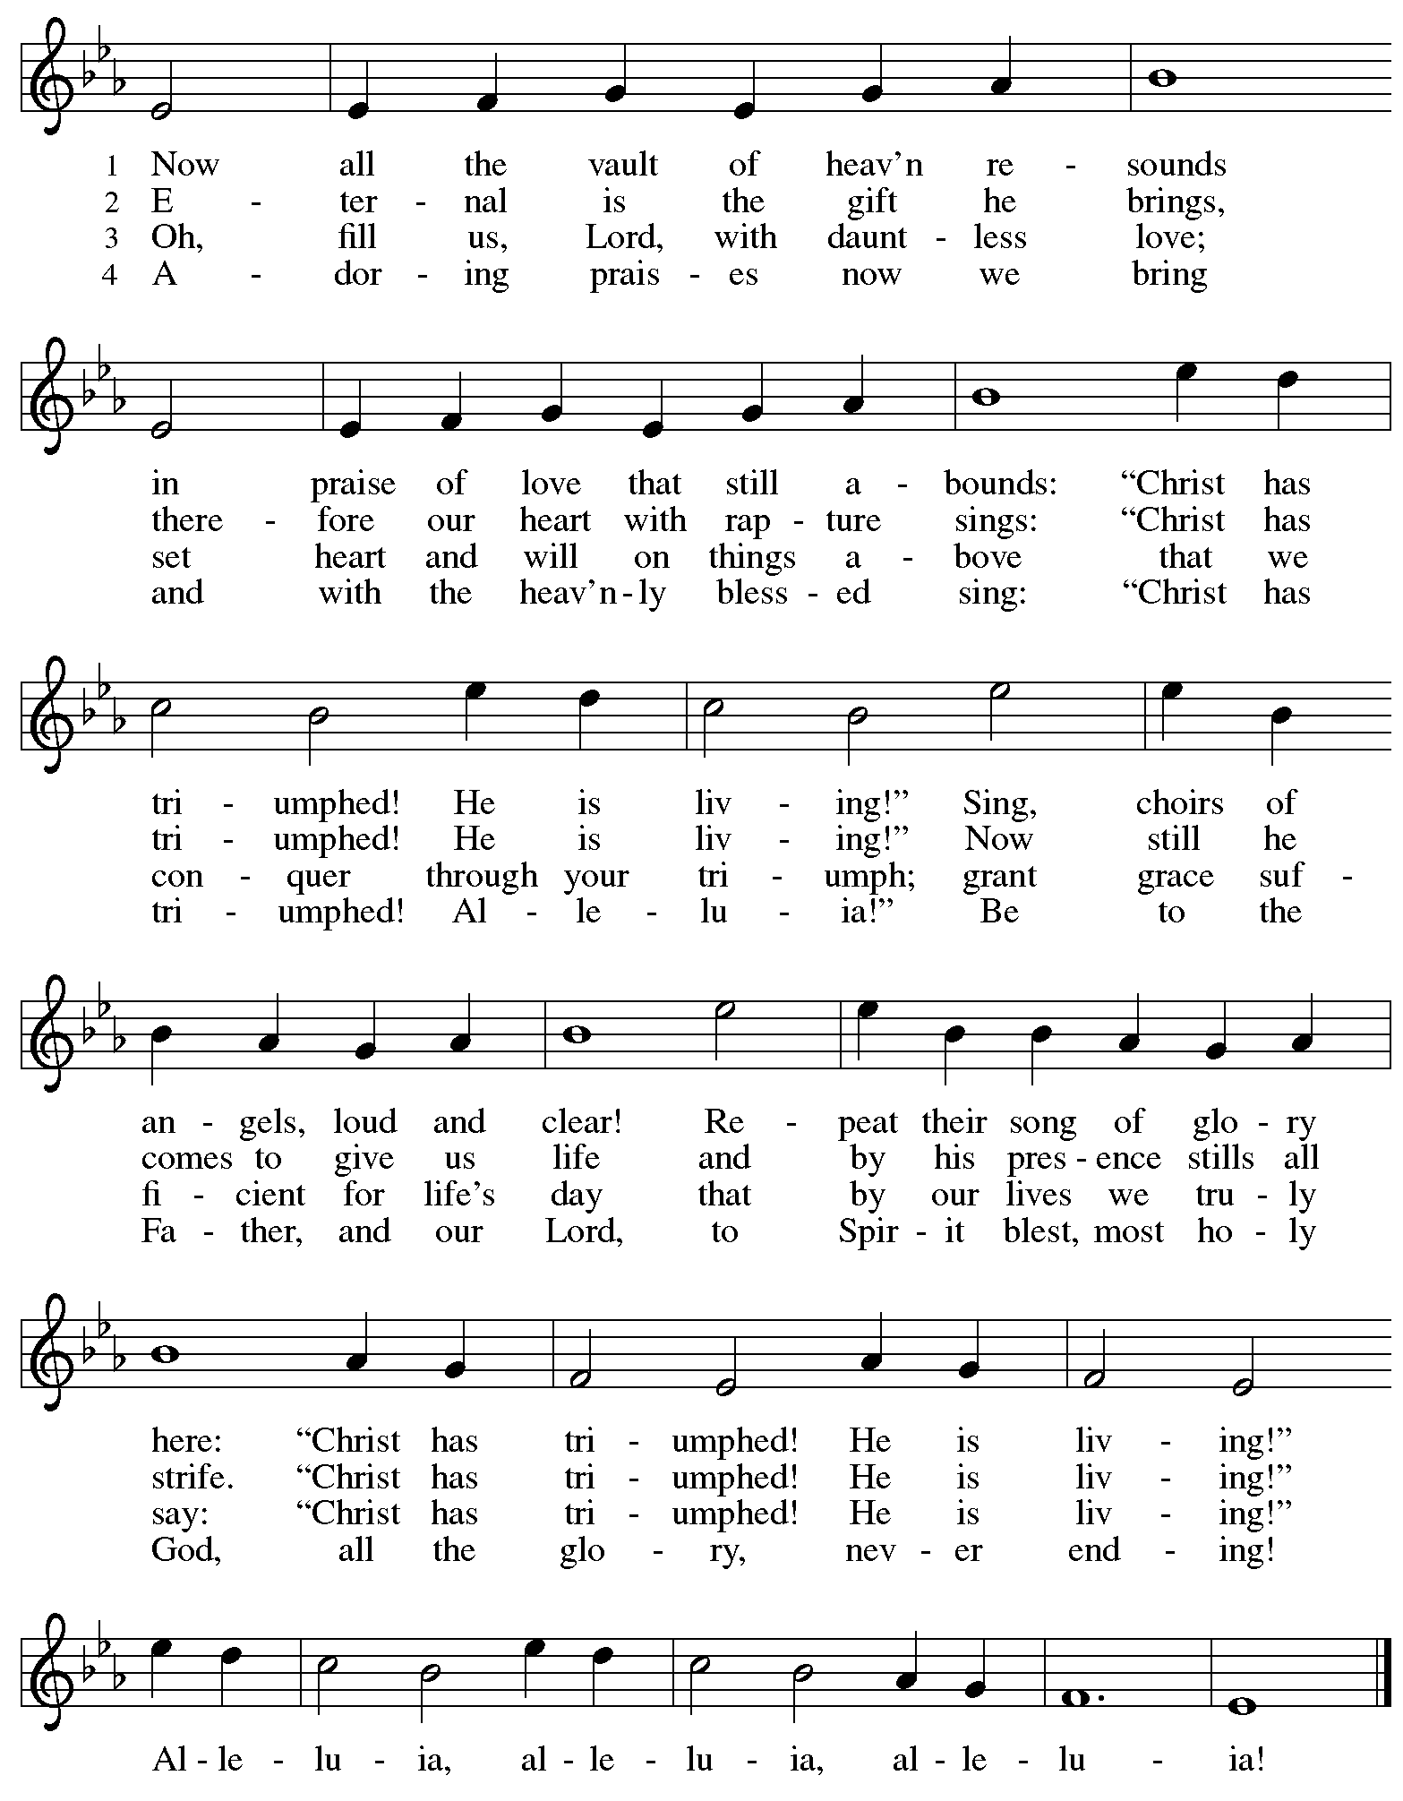

When all have returned to their places, please rise as you are able.

Blessing

P: The body and blood of our Lord Jesus Christ strengthen you and keep you in his grace.
C: Amen.

Prayer

A: Let us pray.
Life-giving God,
in the mystery of Christ’s resurrection, you send light to conquer darkness,
water to give new life, and the bread of life to nourish your people.
Send us forth as witnesses to your Son’s resurrection,
that we may show your glory to all the world,
through Jesus Christ, our risen Lord.
C: Amen.

Sending

Benediction

P: May our glorious God grant you a spirit of wisdom
to know and love the risen Christ.

Almighty God, holy One, ☩ holy Three,
bless you now and forever.
C: Amen.

Recessional Hymn Thine Is the Glory Following page

Dismissal

A: Alleluia! Christ is risen!
C: Christ is risen indeed! Alleluia! Alleluia!

A: Go in peace. Share the good news!
C: Thanks be to God!

Postlude Phantasiestücke Op. 73 R. Schumann
III. Rasch und mit Feuer

Recessional Hymn Thine Is the Glory ELW 376

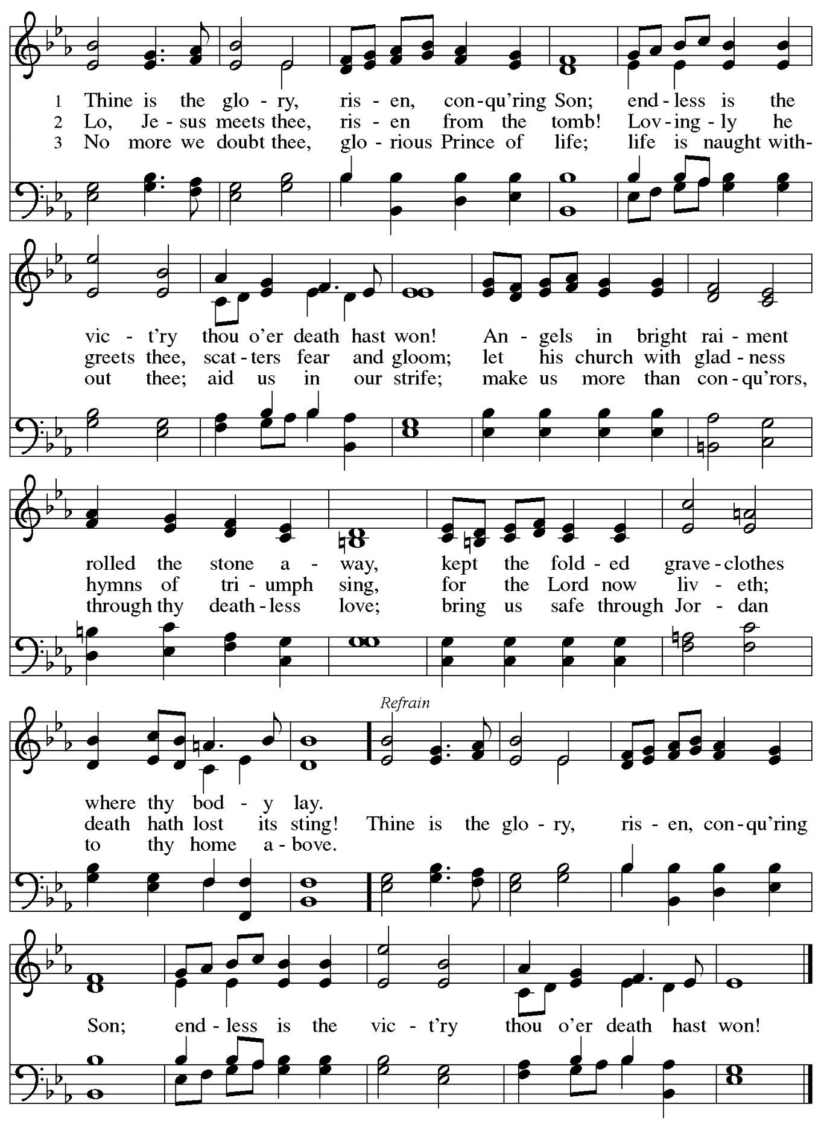
Those serving in worship today

Altar Care Jodie Minor
Assisting Minister Colleen Cooke
Audio-Visual Ministers Kristen Asplin
Joseph Paetz
Tyler Rietze
Cantor Miriam Bohlmann Kunz
Clarinet Maria Mangano
Euphonium David Rollinson
Flute Lindsay Baxter
French Horn Emily Duque
Lector Lester Prince
Little Church – Big Faith Leader Sue Gaugler
Minister of Music Laura Reynolds
Organ Jimmi Kocher-Hillmer
Presiding Minister Pastor Ross I. Carmichael

Liturgy and Hymnody Acknowledgements

From SundaysandSeasons.com. Copyright © 2024 Augsburg Fortress. All rights reserved. Reprinted under OneLicense.net # A-722139.
Used by permission of Augsburg Fortress.

Jesus Christ Is Risen Today –Text: Latin carol, 14th cent., sts. 1-3; tr. J. Walsh, Lyra Davidica, 1708, alt.; Charles Wesley, 1707-1788, st. 4. Music: EASTER HYMN, J. Walsh, Lyra Davidica, 1708.

Christ Is Risen! Alleluia! – Text: John S. B. Monsell, 1811-1875, alt. Music: MORGANLIED, Frederick C. Maker, 1844-1927.

Let the Vineyards – Text: John W. Arthur, 1922-1980. Music: Ronald A. Nelson, b. 1927. Text and Music © 1978 Lutheran Book of Worship, admin. Augsburg Fortress.

Eucharistic Prayer, For the Resurrection of our Lord: Easter Day – Adapted from Pray, Praise, and Give Thanks: A Collection of Litanies, Laments, and Thanksgivings at Font and Table by Gail Ramshaw, copyright © 2017 Augsburg Fortress. All rights reserved. Reprinted with permission.

The Day of Resurrection! – Text: John of Damascus, c. 696 – c. 754; tr. John Mason Neale, 1818-1866, alt. Music: ELLACOMBE, German melody, 18th cent.; adapt. X.L. Hartig, Melodien zum Mainzer Gesangbuche, 1833.

Now All the Vault of Heaven Resounds – Text: Paul Z. Strodach, 1876-1947, alt. Music: LASST UNS ERFREUEN, Geistliche Kirchengesänge, Köln, 1623. Text © 1958 Service Book and Hymnal, admin. Augsburg Fortress. All rights reserved. Reprinted with permission under OneLicense.net # A-722139.

Thine Is the Glory – Text: Edmund Budry, 1854-1932; tr. R Birch Hoyle, 1875-1939. Music: JUDAS MACCABEUS, George Frideric Handel, 1685-1759.

Please use the QR code below to link to St. Andrew’s Announcements online!

St. Andrew Lutheran Church Announcements
March 31st, 2023

- Happy Easter! Welcome to Worship at St. Andrew on March 31st, 2024 as We Celebrate + The Resurrection of our Lord! – We are so glad you are here to share in this festive day, and we offer a special welcome to all visitors and guests who are here for the first time! Children are invited to participate in Little Church – Big Faith, a Bible lesson and activity, after the prayer of the day. There are worship “toolkits” to help children engage with worship and “busy bags” for younger children available in the bookcase at the back of the sanctuary. Please feel free to take one to use with/for your children. A nursery is available through the door to the left of the worship space and across the social hall (it is a purple room). We pray that everyone has a blessed Easter season!
- Donors Please Remember to Take Home Easter Flowers! – We are grateful for everyone who contributed to beautifying the church with flowers this Easter! We encourage those who have dedicated flowers to please take them with you so they do not go to waste. If you choose not to take them, please let Pastor Ross know so that others may enjoy them!
- Monthly Produce Distribution – Tuesday, April 2nd, 5:30-7:00 p.m. – St. Andrew’s monthly distribution of fresh produce (in partnership with Greater Pittsburgh Community Food Bank) will be Tuesday, April 2nd, from 5:30-7:00 p.m. We would also appreciate help with unloading and setup earlier in the day, usually sometime between 10:30 a.m. and 1:00 p.m.
- Shelter Dinner at East End Cooperative Ministry – Thursday, April 20th, 6:30 p.m. – Each month, people of St. Andrew provide dinner for guests of East End Cooperative Ministry, 6140 Station St. (East Liberty), 15206. We invite you to prepare or purchase one menu item and bring it to the shelter by 6:00 p.m., or just come to help serve at 6:30 p.m. If you would like to participate, please sign up here:
https://www.signupgenius.com/go/5080544AAAC22A1F58-48748236-shelter.

Easter Flowers Decorating the Chancel Have Been Given

by Leanne and Jonathan Paetz

In Appreciation / Love for
The Congregation of St. Andrew by Ginny and Tom Leech
Family and Friends by Christy Ruhe
The Holy Spirit in this Place
by Jimmi and Timothy Kocher-Hillmer
Pastor Ross and Laura by Michael Smolleck
St. Andrew’s Music Ministry by Pastor Peter and Kristen Asplin
Rachel Schuldt and Megan Elk by Cynthia Holden
John and Dixie Tymitz by Arnie Rowlands

In Honor of Janet and Delbert Fisher by Joy Givens
Ginny Nestor by Joy Givens
My Parents by Lindsay Baxter
Tyler Christian Shively by Joy Givens

In Memory of Sharon Andino by Christy Ruhe
John and Sandy Bowen by Kathy Hays
Ada Charlson by Lindsay Baxter
Ron Finke by Adi Oehman and Tyler Rietze
Jack and Shirley Hays by Kathy Hays
Edith and Regis Holden by Cynthia Holden
Our Grandparents by Adi Oehman and Tyler Rietze
Our Mothers by Joyce Compton and Kelly Spanninger
Our Parents by Scott and Sue Gaugler
Pops by Audrey Gaugler
Pops by Lily Gaugler
Ruth Rollinson by Dave Rollinson and Maria Mangano
Sally and Arnold Rowlands by Arnie Rowlands
Rose and Joe Smolleck by Michael Smolleck
Teddy by Adi Oehman and Tyler Rietze
Priscilla VanTassel by Christy Ruhe
Sherri Wilcox by Hal Wilcox

In Thanksgiving for
Pastor and Laura by Sharon Koch

