+ Second Sunday of Easter
April 7, 2024
St. Andrew Lutheran Church
304 Morewood Ave.
Pittsburgh, PA 15213
St_andrewELCA@verizon.net
www.standrewpittsburgh.org

+ Second Sunday of Easter
Order for Worship

The Easter season is a week of weeks, seven Sundays on which we explore
the mystery of Christ’s presence, mostly through the glorious Gospel of John.
Today we gather with the disciples on the first Easter, and Jesus breathes the Spirit on us.
With Thomas we ask for a sign, and Jesus offers us his wounded self in the broken bread.
From frightened individuals we are transformed into a community of open doors, peace, forgiveness, and material sharing such that no one among us is in need.

Welcome to St. Andrew!
- St. Andrew Lutheran congregation welcomes all who are seeking a place of healing and wholeness – a nurturing, faith-forming spiritual home. Our community embraces people of all ages, ethnicities, cultures, abilities, sexual orientations, gender identities and expressions, and family constellations. Come and See!
- Worship Services are live streamed to multiple online platforms. By attending worship, you agree that your image and voice may be broadcast.
- Everyone is invited to make a nametag at the black bookcase in the back of the worship space if they would like. There are stickers indicating pronouns on the bookcase if you would like to include them on your name tag.
- The nursery is available through the doors at the left side of the sanctuary and across from the doorway to the Social Hall. It is a purple room.
- Children are invited to attend Little Church – Big Faith, a Bible lesson and activity, during worship (after the Prayer of the Day). The group returns to the worship space for the liturgy of Holy Communion.
- Worship “toolkits” to help children engage with the service, along with “busy bags” for younger children, are available in the bookcase at the back of the sanctuary. Please feel free to take one to use with/for your children.
- A nursery is available through the doors at the left side of the sanctuary and across from the doorway to the Social Hall. It is a purple room.
- Holy Communion is served with bread (gluten-free available) and wine or grape juice. The presiding minister will distribute the bread (host). Please consume this and then pick up an empty glass from the tray. The Communion Assistant will pour wine or grape juice into your glass. Please step to the side to consume the wine or grape juice. Feel free to kneel at the altar for prayer and reflection. As you return to your pew, glasses may be returned to the empty trays on either side of the center section.
- A restroom is available on the main level of the church, through the doors to the Social Hall and to the right in the main office.

Abbreviations
P: Pastor/Presiding Minister ELW: Evangelical Lutheran Worship hymnal
A: Assisting Minister ACS: All Creation Sings hymnal
L: Lector
C: Congregation
Pre-Service Music

Welcome

Gathering
The Holy Spirit calls us together as the people of God.

Please rise as you are able. All may make the sign of the cross,
the sign that is marked at Baptism, as the presiding minister begins.

Confession and Forgiveness

P: Blessed be the holy Trinity, ☩ one God,
who creates, redeems, and sustains us and all of creation.
C: Amen.

P: Let us confess our sin in the presence of God and one another.

Silence is kept for reflection.

P: Most merciful God,
we confess that we are captive to sin and cannot free ourselves.
We have sinned against you in thought, word, and deed,
by what we have done and by what we have left undone.
We have not loved you with our whole heart;
we have not loved our neighbors as ourselves.
For the sake of your Son, Jesus Christ, have mercy on us.
Forgive us, renew us, and lead us,
so that we may delight in your will
and follow in your ways,
to the glory of your holy name.
Amen.

P: By water and the Holy Spirit God gives you a new birth,
and through the death and resurrection of ☩ Jesus Christ,
God forgives you all your sins.
The God of mercy and might strengthen you in all goodness
and keep you in eternal life.
C: Amen.

Gathering Hymn Christ the Lord Is Risen Today; Alleluia! ELW 369

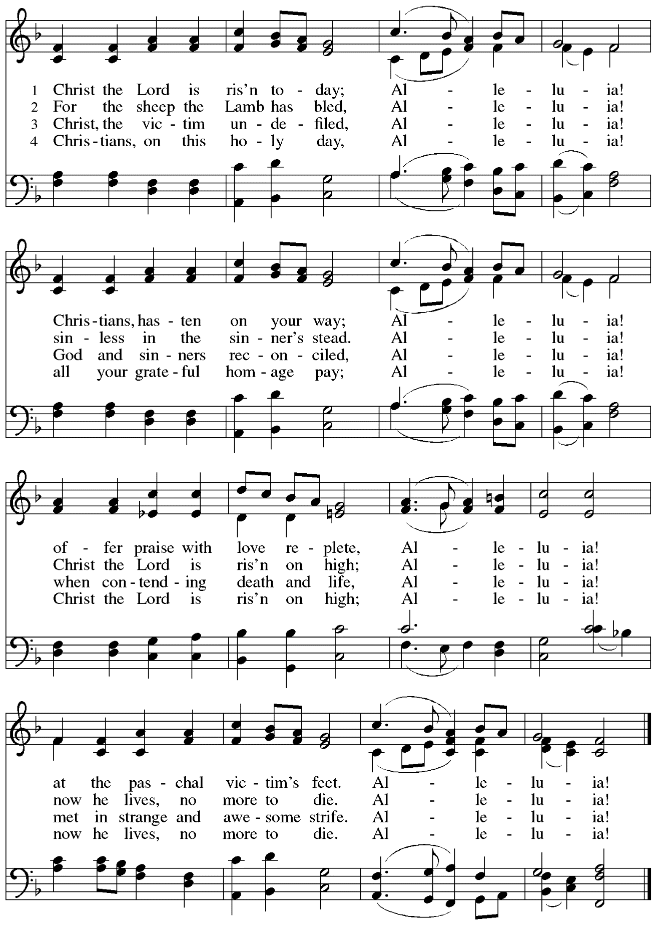

Greeting

P: The grace of our Lord Jesus Christ, the love of God,
and the communion of the Holy Spirit be with you all.
C: And also with you.

Hymn of Praise This Is the Feast ELW p. 149-150

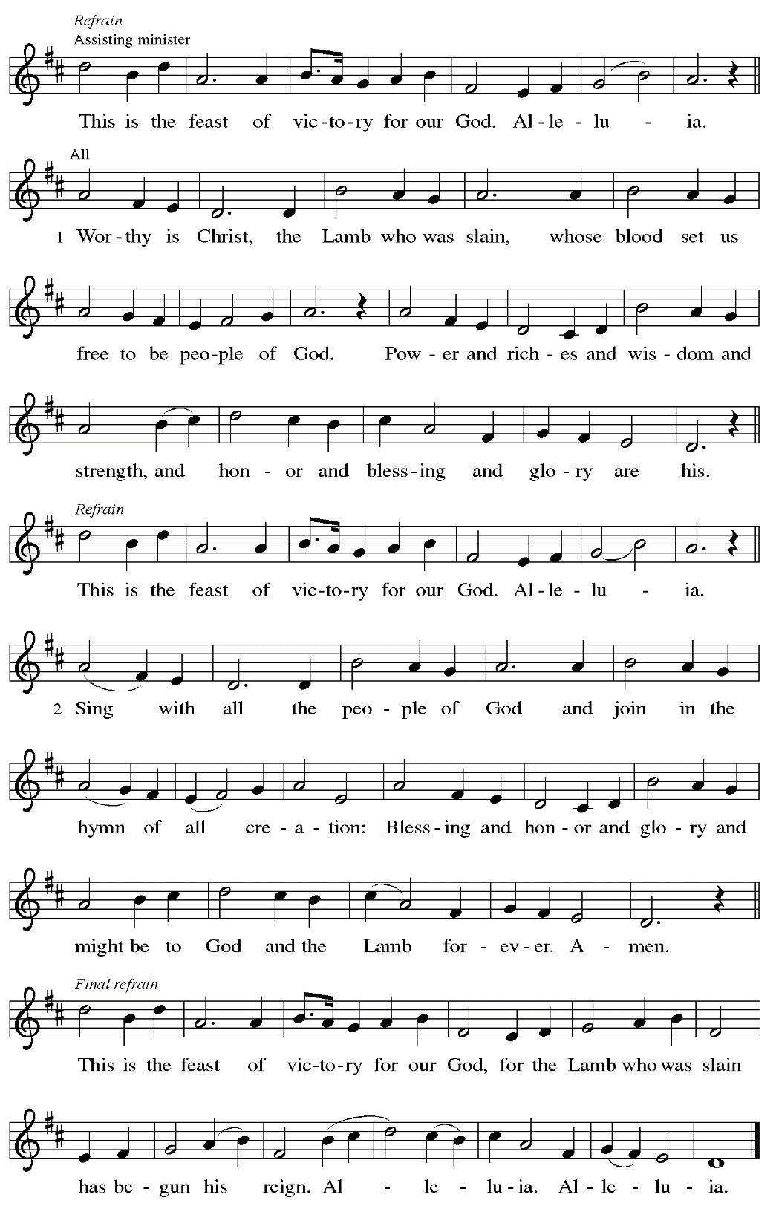

Prayer of the Day

P: The Lord be with you.
C: And also with you.

P: Let us pray. Almighty God, with joy we celebrate the day of our Lord’s resurrection.
By the grace of Christ among us, enable us to show the power of the resurrection
in all that we say and do, through Jesus Christ, our Savior and Lord,
who lives and reigns with you and the Holy Spirit, one God, now and forever.
C: Amen.

Please be seated.

Word
God speaks to us in Scripture reading, preaching, and song

First Reading – Acts 4: 32-35

³²Now the whole group of those who believed were of one heart and soul, and no one claimed private ownership of any possessions, but everything they owned was held in common. ³³With great power the apostles gave their testimony to the resurrection of the Lord Jesus, and great grace was upon them all. ³⁴There was not a needy person among them, for as many as owned lands or houses sold them and brought the proceeds of what was sold. ³⁵They laid it at the apostles’ feet, and it was distributed to each as any had need.

L: Word of God, word of life.
C: Thanks be to God.

Psalm 133 Miren que bueno – Behold, How Pleasant Following page

In place of the regular chanted psalm, the congregation will sing this hymn based on Psalm 133, the appointed psalm for the day.

Psalm 133 Miren que bueno – Behold, How Pleasant ELW 649

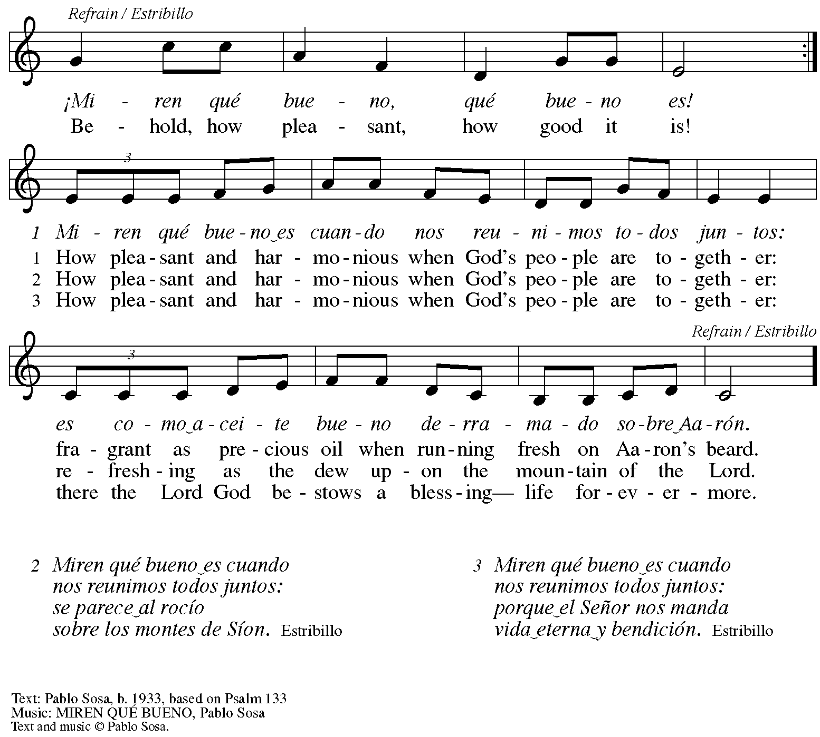
All rights reserved. Reprinted with permission under OneLicense.net #A-722139.

Second Reading – 1 John 1: 1 – 2: 2

¹We declare to you what was from the beginning, what we have heard, what we have seen with our eyes, what we have looked at and touched with our hands, concerning the word of life—²this life was revealed, and we have seen it and testify to it, and declare to you the eternal life that was with the Father and was revealed to us—³we declare to you what we have seen and heard so that you also may have fellowship with us; and truly our fellowship is with the Father and with his Son Jesus Christ. ⁴We are writing these things so that our joy may be complete.
⁵This is the message we have heard from God and proclaim to you, that God is light and in God there is no darkness at all. ⁶If we say that we have fellowship with God while we are walking in darkness, we lie and do not do what is true; ⁷but if we walk in the light
as God himself is in the light, we have fellowship with one another, and the blood of Jesus, God’s Son, cleanses us from all sin. ⁸If we say that we have no sin, we deceive ourselves, and the truth is not in us. ⁹If we confess our sins, God who is faithful and just will forgive us our sins and cleanse us from all unrighteousness. ¹⁰If we say that we have not sinned, we make God a liar, and God’s word is not in us.

^{2:1}My little children, I am writing these things to you so that you may not sin. But if anyone does sin, we have an advocate with the Father, Jesus Christ the righteous; ²and he is the atoning sacrifice for our sins, and not for ours only but also for the sins of the whole world.

L: Word of God, word of life.
C: Thanks be to God.

Please rise as you are able.

Gospel Acclamation ELW p. 151

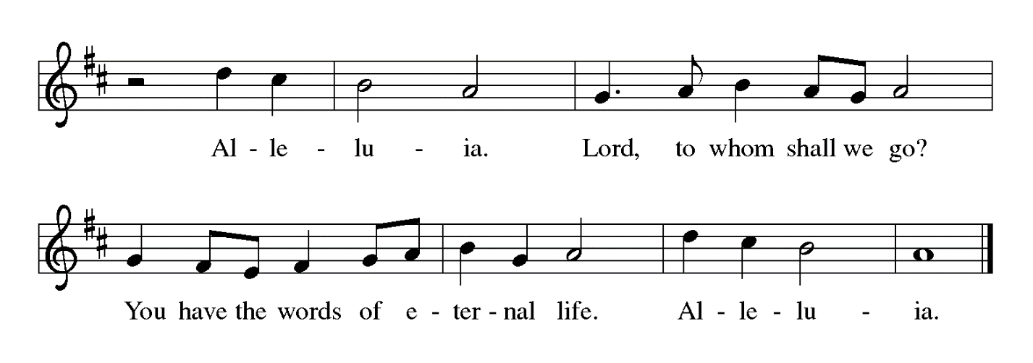

Gospel – John 20: 19-31

P: The holy Gospel according to St. John.
C: Glory to you, O Lord.

¹⁹When it was evening on that day, the first day of the week, and the doors of the house where the disciples had met were locked for fear of Jesus’ opponents among the Jewish leaders, Jesus came and stood among them and said, “Peace be with you.” ²⁰After he said this, he showed them his hands and his side. Then the disciples rejoiced when they saw the Lord. ²¹Jesus said to them again, “Peace be with you. As the Father has sent me, so I send you.” ²²When he had said this, he breathed on them and said to them, “Receive the Holy Spirit. ²³If you forgive the sins of any, they are forgiven them; if you retain the sins of any, they are retained.”
²⁴But Thomas (who was called the Twin), one of the twelve, was not with them when Jesus came. ²⁵So the other disciples told him, “We have seen the Lord.” But he said to them,
“Unless I see the mark of the nails in his hands, and put my finger in the mark of the nails and my hand in his side, I will not believe.”
²⁶A week later his disciples were again in the house, and Thomas was with them. Although the doors were shut, Jesus came and stood among them and said, “Peace be with you.” ²⁷Then he said to Thomas, “Put your finger here and see my hands. Reach out your hand and put it in my side. Do not doubt but believe.” ²⁸Thomas answered him, “My Lord and my God!” ²⁹Jesus said to him, “Have you believed because you have seen me? Blessed are those who have not seen and yet have come to believe.”

³⁰Now Jesus did many other signs in the presence of his disciples, which are not written in this book. ³¹But these are written so that you may come to believe that Jesus is the Messiah, the Son of God, and that through believing you may have life in his name.

P: The Gospel of the Lord.
C: Praise to you, O Christ.

Please be seated.

Sermon

A time of silence for prayer and reflection follows the sermon.
When the hymn of the day begins, please rise as you are able.

Hymn of the Day We Walk by Faith and Not by Sight WOV 675

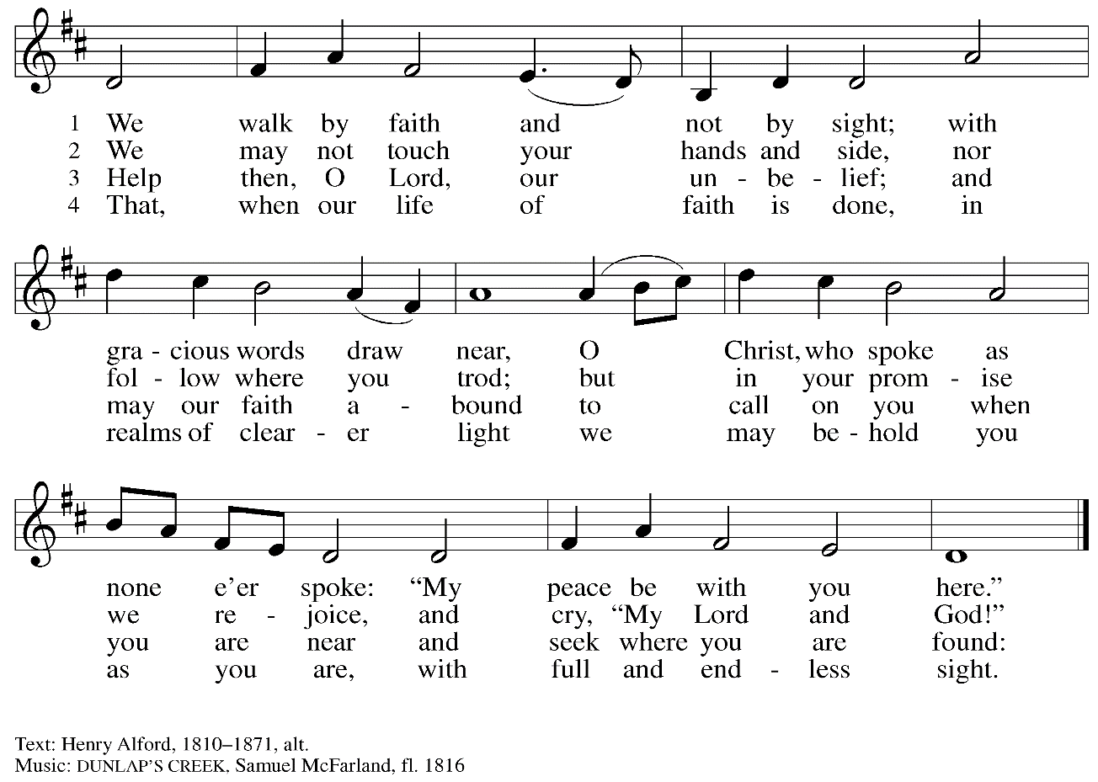

Nicene Creed

P: Together, in the joy of the resurrection, we profess our faith:
C: We believe in one God,
the Father, the Almighty,
maker of heaven and earth,
of all that is, seen and unseen.

We believe in one Lord, Jesus Christ,
the only Son of God,
eternally begotten of the Father,
God from God, Light from Light,
true God from true God,
begotten, not made,
of one Being with the Father;
through him all things were made.
For us and for our salvation
he came down from heaven,
was incarnate of the Holy Spirit and the virgin Mary
and became truly human.
For our sake he was crucified under Pontius Pilate;
he suffered death and was buried.
On the third day he rose again
in accordance with the scriptures;
he ascended into heaven
and is seated at the right hand of the Father.
He will come again in glory to judge the living and the dead,
and his kingdom will have no end.

We believe in the Holy Spirit, the Lord, the giver of life,
who proceeds from the Father and the Son,*
who with the Father and the Son is worshiped and glorified,
who has spoken through the prophets.
We believe in one holy catholic and apostolic church.
We acknowledge one baptism for the forgiveness of sins.
We look for the resurrection of the dead,
and the life of the world to come. Amen.

*Or, “who proceeds from the Father.” The phrase “and the Son” is a later addition to the creed.

Prayers of the People

A: United in the joy and hope of the resurrection, let us pray for the church, the world,
and all who are in need.

After each petition
A: Gracious God,
C: receive our prayer.

P: We lift these prayers to you most merciful God, trusting in your abiding love;
through Jesus Christ, our risen and living Savior.
C: Amen.

Peace

The presiding minister and the assembly greet one another in the peace of the risen Christ.
P: The peace of Christ be with you always.
C: And also with you.

The people may greet those around them with a sign of Christ’s peace and may say
Peace be with you or similar words. Please be mindful that not everyone will be comfortable with sharing the peace, so please seek consent before shaking hands or hugging. Other possible ways to share the peace include a simple bow with the verbal greeting of peace, or simply a verbal expression of peace.

When the greetings of peace have concluded, please be seated.

Meal

Offering

We offer ourselves, our gifts, and our faithful service to God.
As the offering is gathered for the mission of the church, including the care of those in need,
the table is set for Holy Communion.

Reparations Offering

On the first Sunday of each month, St. Andrew invites people of the congregation to consider a donation to a second collection for a reparations fund in acknowledgement of St. Andrew’s use of African American spiritual songs in our worship services. Please see the note in the announcements for more information.

Musical Offering

As the gifts are brought forward for presentation, please rise as you are able.

Offertory Song Let the Vineyards ELW 184

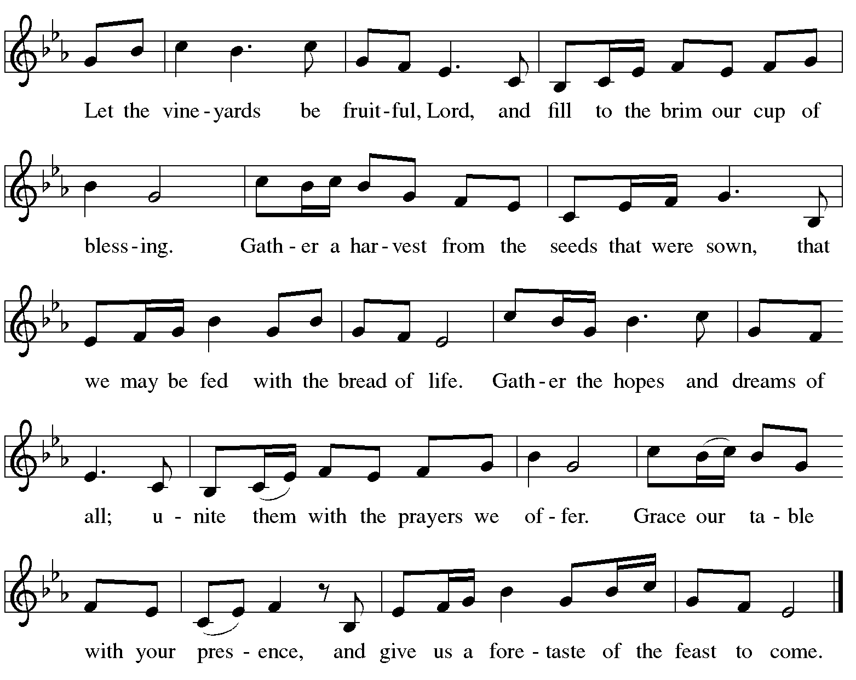

Offertory Prayer

A: Let us pray.
Blessed are you, O God,
C: ruler of heaven and earth.
Day by day you shower us with blessings.
As you have raised us to new life in Christ,
give us glad and generous hearts,
ready to praise you and to respond to those in need,
through Jesus Christ, our Savior and Lord.
Amen.

Dialogue ELW p. 152

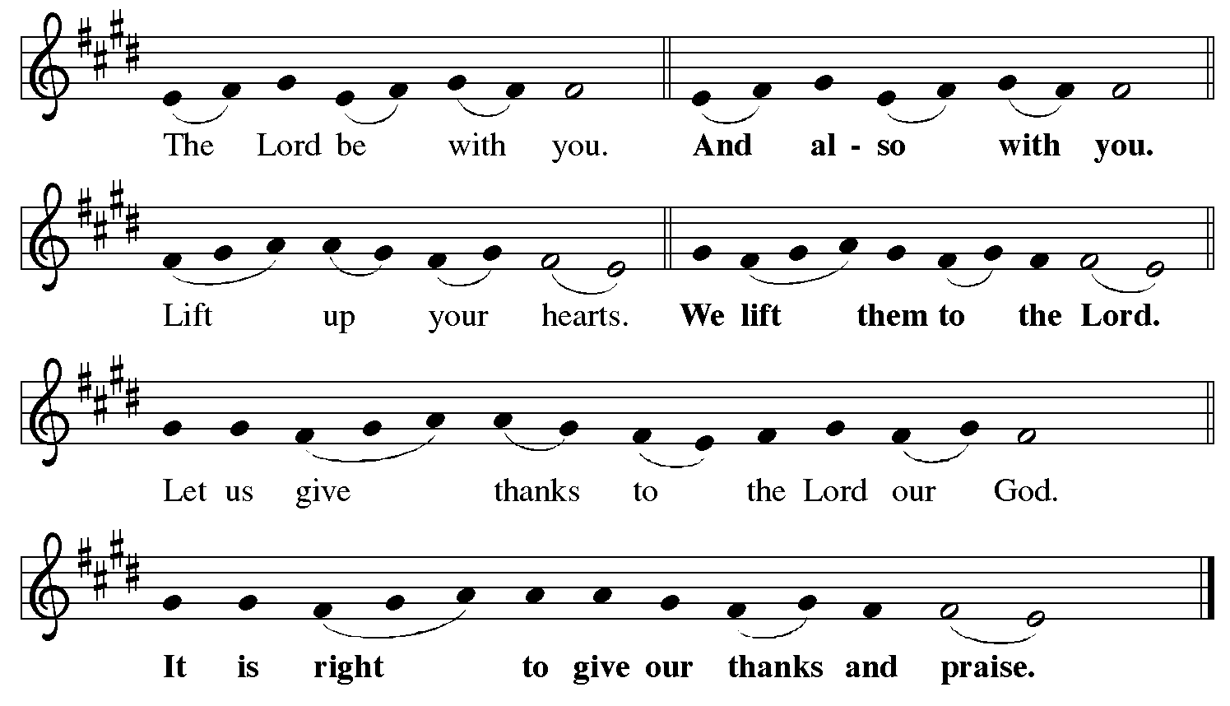

Preface (Sung by the presiding minister)

P: It is indeed right, our duty and our joy,
that we should at all times and in all places
give thanks and praise to you, almighty and merciful God,
for the glorious resurrection of our Savior Jesus Christ,
the true Paschal Lamb who gave himself to take away our sin;
who in dying has destroyed death,
and in rising has brought us to eternal life.
And so, with Mary Magdalene and Peter
and all the witnesses of the resurrection,
with earth and sea and all their creatures,
and with angels and archangels, cherubim and seraphim,
we praise your name and join their unending hymn:

Sanctus ELW p. 153

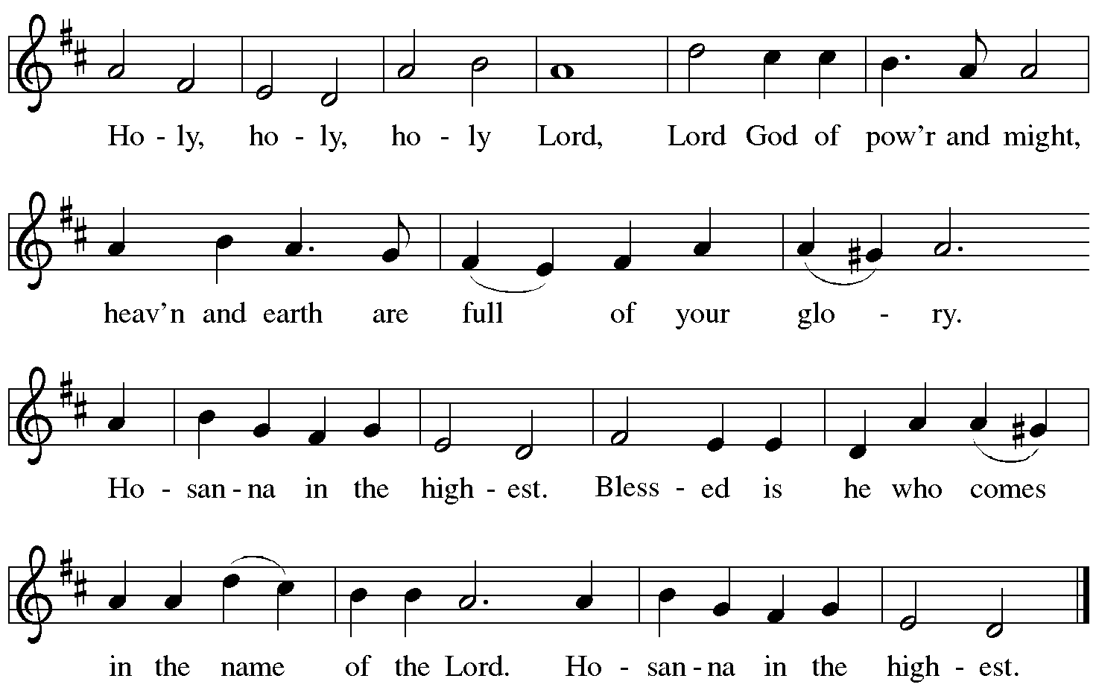

Eucharistic Prayer

P: Blessed are you, O God of the universe …
Do this for the remembrance of me.

With this bread and cup,
we remember our Lord’s passover from death to life
as we proclaim the mystery of faith:
C: Christ has died. Christ is risen. Christ will come again.

P: O God of resurrection and new life …
Grace our table with your presence.
C: Come, Holy Spirit.

P: Reveal yourself to us in the breaking of the bread …
Send us forth, burning with justice, peace, and love.
C: Come, Holy Spirit.

P: With your holy ones of all times and places,
with the earth and all its creatures,
with sun and moon and stars,
we praise you, O God,
blessed and holy Trinity,
now and forever.
C: Amen.

Lord’s Prayer

P: Gathered as one by the Holy Spirit, let us pray as Jesus taught us.
C: Our Father in heaven,
hallowed be your name,
your kingdom come,
your will be done,
on earth as in heaven.
Give us today our daily bread.
Forgive us our sins
as we forgive those
who sin against us.
Save us from the time of trial
and deliver us from evil.
For the kingdom, the power,
and the glory are yours,
now and forever. Amen.

Fraction and Invitation

P: Alleluia! Christ is risen!
C: Christ is risen indeed! Alleluia! Alleluia!

P: This is the feast of victory for our God. Alleluia! Alleluia!
Come, share the feast.

Agnus Dei / Lamb of God Following Page

Agnus Dei / Lamb of God ELW p. 154

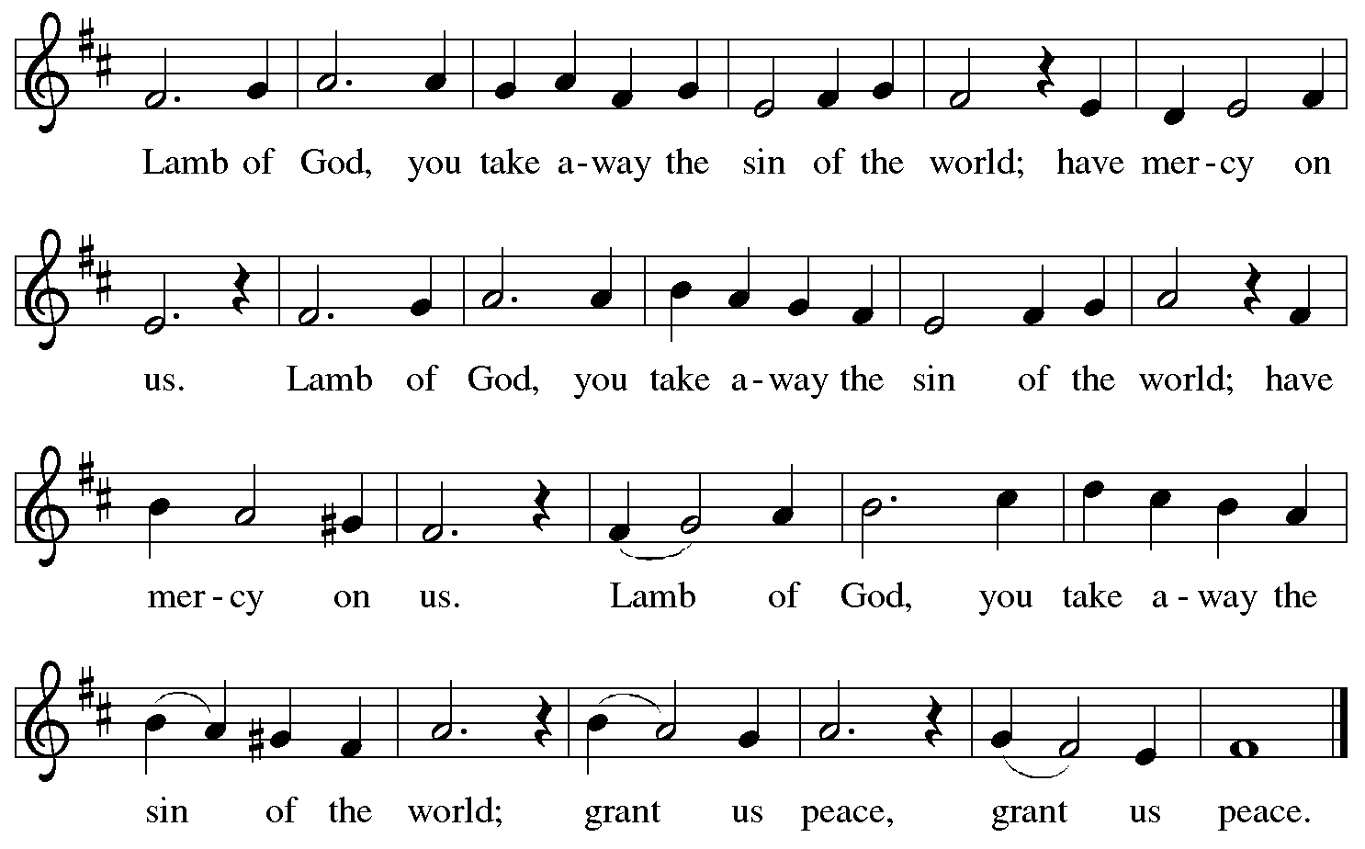

Please be seated.

Holy Communion
- All who seek God and desire a deeper and stronger life in Christ are welcome to receive Holy Communion.
- Worshipers from the pulpit side will proceed forward first, followed by the center section, and then the lectern side.
- Please inform an usher if you would like the ministers to bring Communion to you.
- Holy Communion will be served with bread and wine/grape juice.
- The presiding minister will first distribute the bread (host) to each communicant. Please indicate if you require a gluten-free host.
- Once you have consumed the bread, please pick up an empty glass from the tray next to the presiding minister. The Communion Assistant will pour wine from the chalice or grape juice from the cruet into your glass.
- Please step to the side to consume the wine or grape juice.
- Feel free to kneel at the altar rail for prayer after receiving the sacrament.
- As you return to your pew, glasses may be returned to the empty trays on either side of the center aisle.
- A blessing will be provided for anyone who does not yet receive the sacrament.
- All are invited to join in singing the hymns during Holy Communion.
Hymn during Holy Communion
Now We Join in Celebration ELW 462

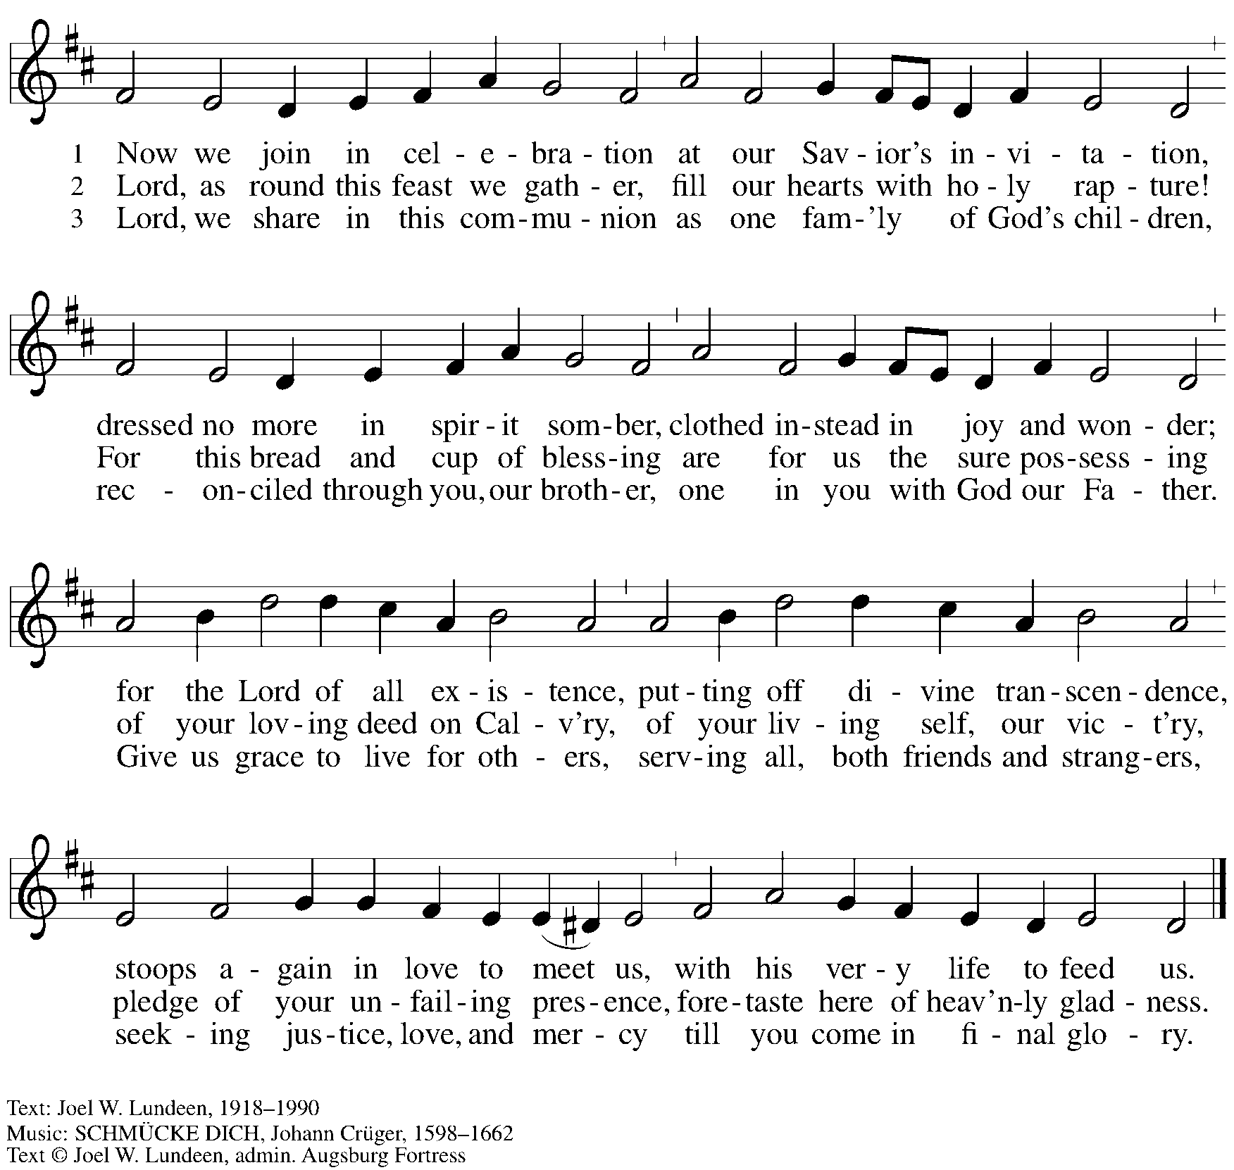
All rights reserved. Reprinted with permission under OneLicense.net # A-722139.

Hymn during Holy Communion
Cristo vive – Christ Is Living ACS 934

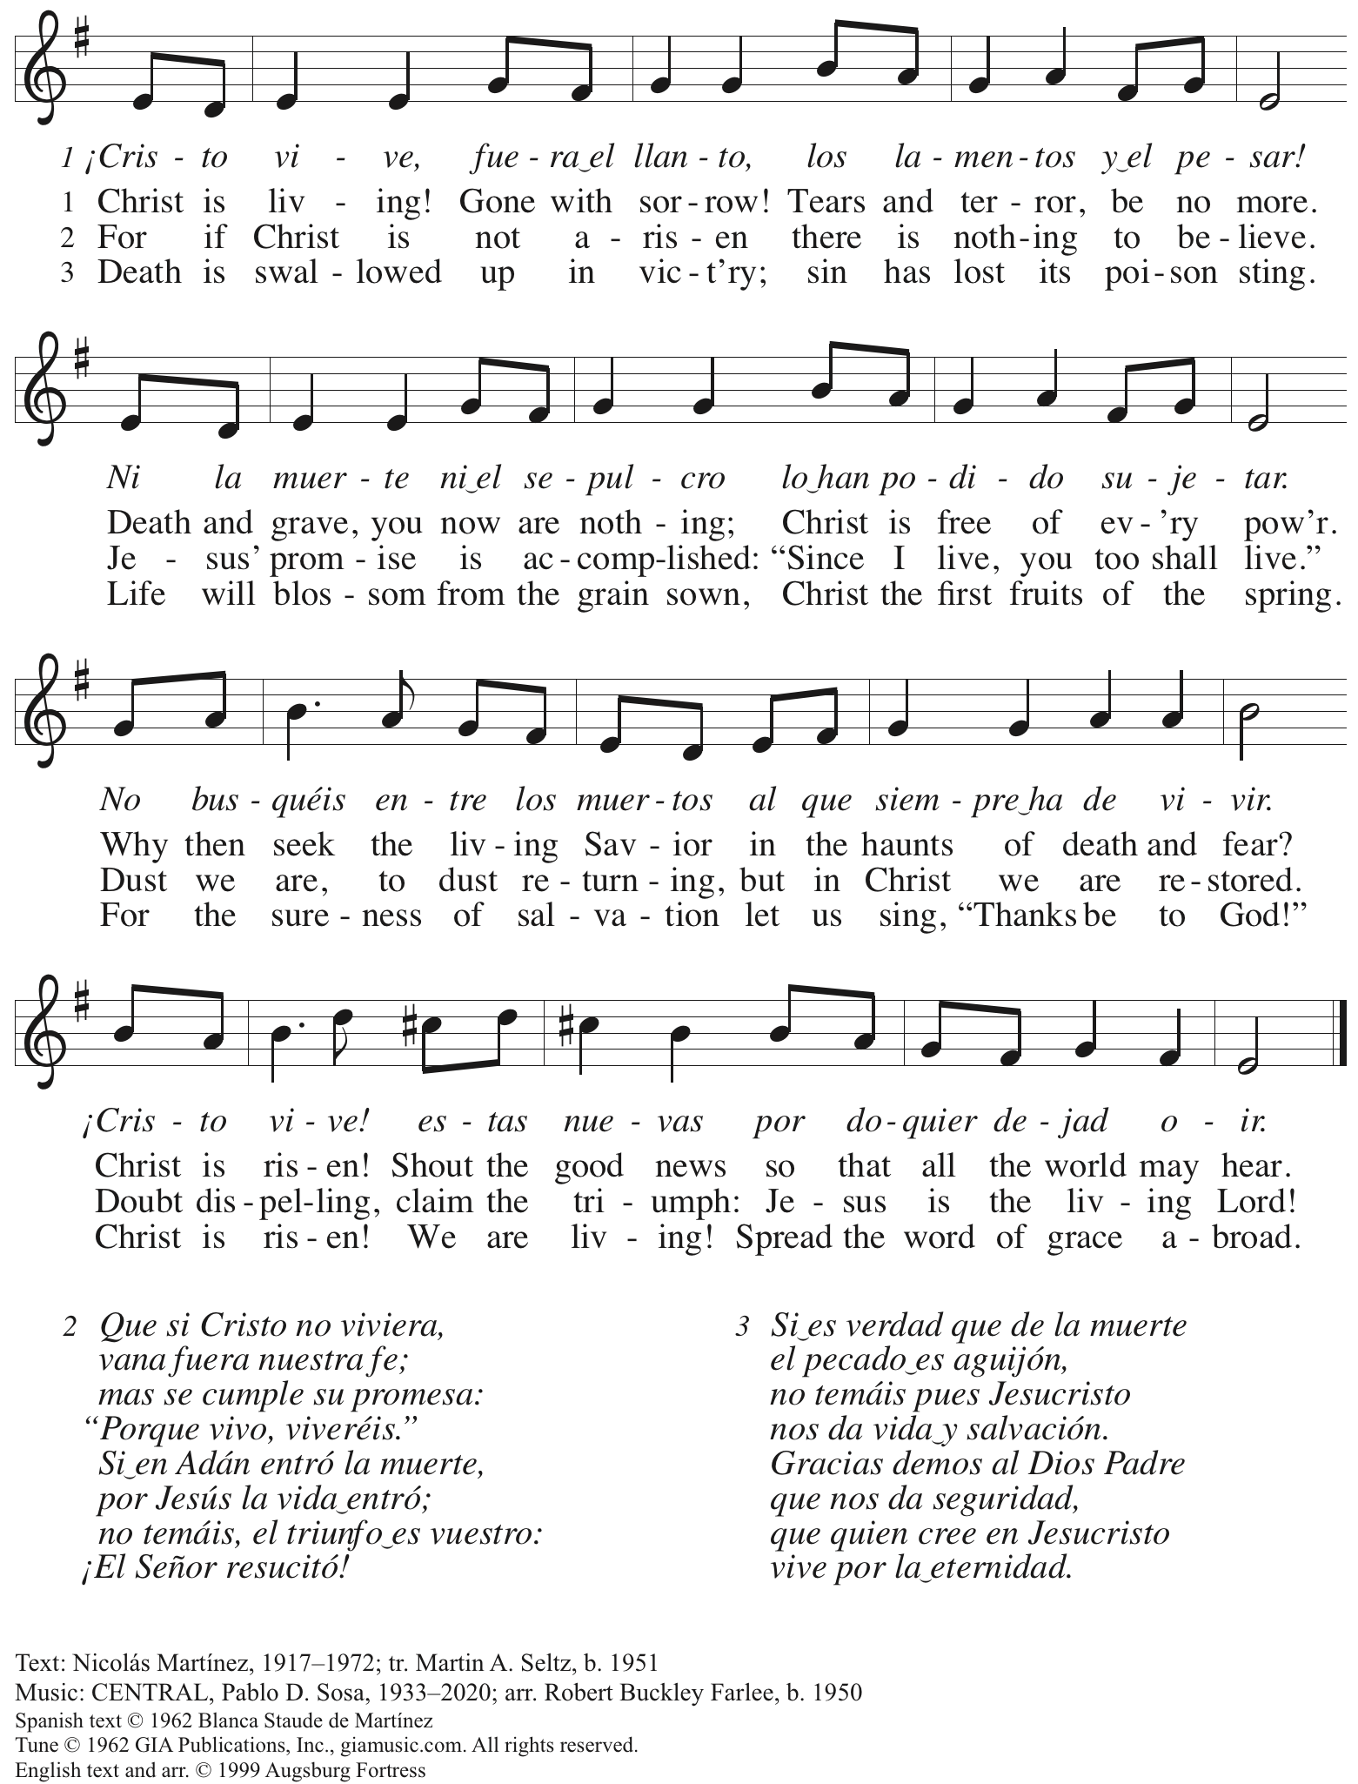
Reprinted with permission under OneLicense.net # A-722139.

Hymn during Holy Communion
Breathe on Us, Breath of God ACS 941

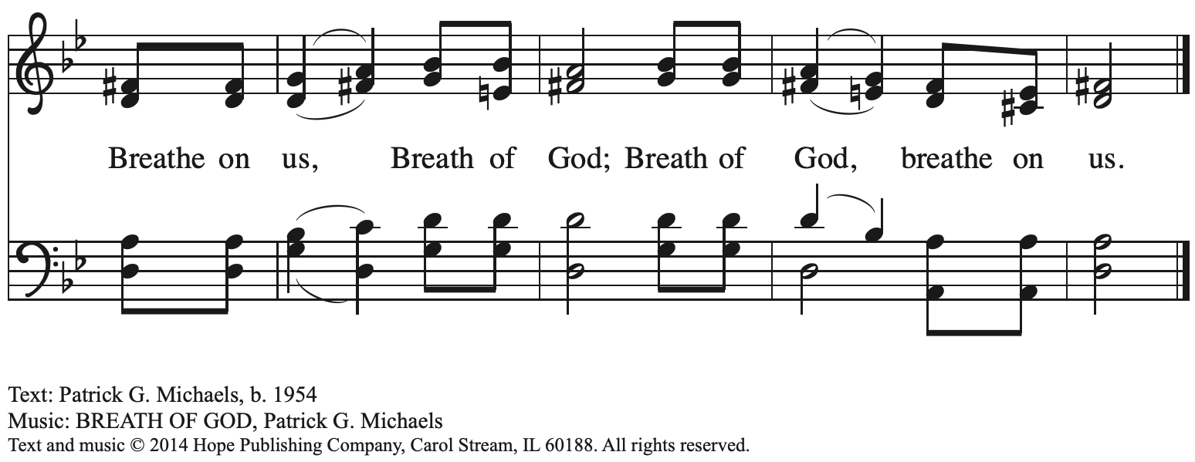
Reprinted with permission under OneLicense.net # A-722139.

When all have returned to their places, please rise as you are able.

Blessing

P: The body and blood of our Lord Jesus Christ strengthen you and keep you in his grace.
C: Amen.

Prayer

A: Let us pray. Life-giving God,
in the mystery of Christ’s resurrection, you send light to conquer darkness,
water to give new life, and the bread of life to nourish your people.
Send us forth as witnesses to your Son’s resurrection,
that we may show your glory to all the world,
through Jesus Christ, our risen Lord.
C: Amen.

Sending

Benediction

P: May our glorious God grant you a spirit of wisdom
to know and love the risen Christ.

Almighty God, holy One, ☩ holy Three,
bless you now and forever.
C: Amen.

Sending Hymn Rise, O Church, Like Christ Arisen ELW 548

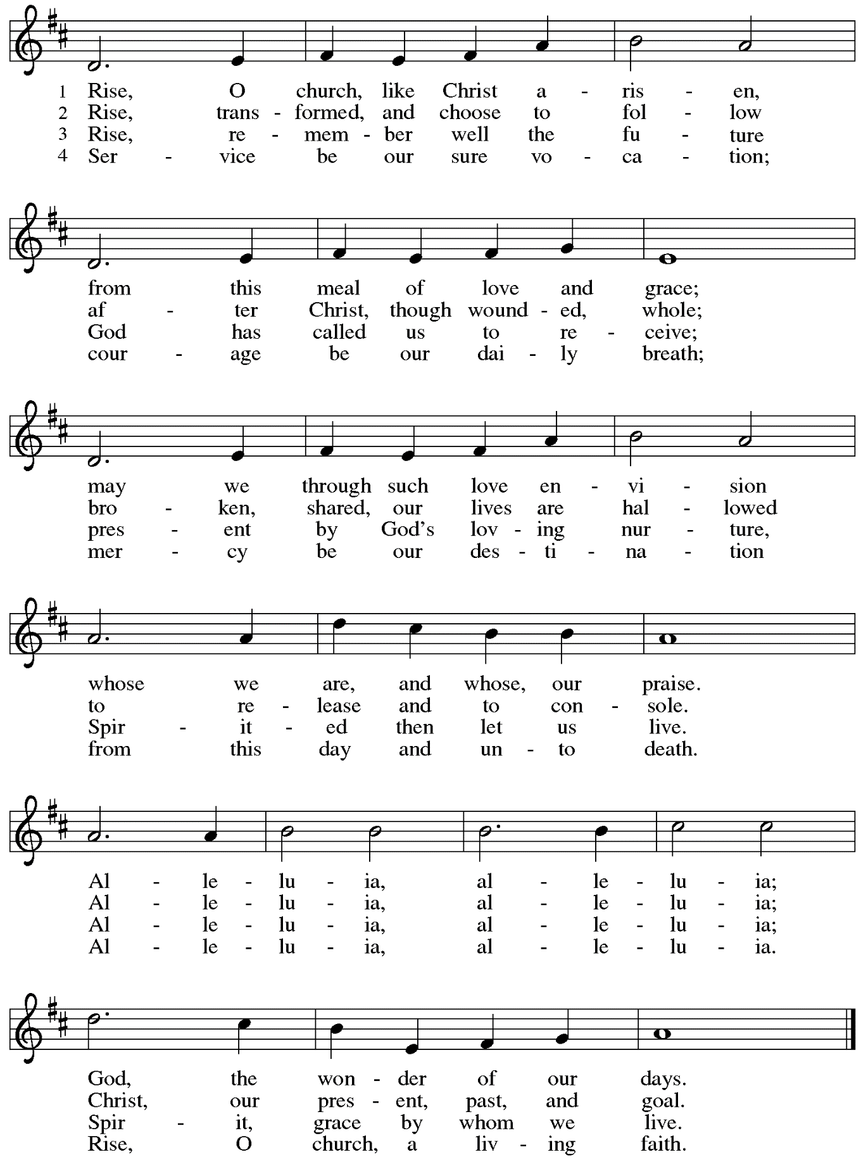

Dismissal

A: Alleluia! Christ is risen!
C: Christ is risen indeed! Alleluia! Alleluia!

A: Go in peace. Share the good news!
C: Thanks be to God!

Postlude

Those serving in worship today

Altar Care Janet Grzegorczyk
Assisting Minister Jeff Denlinger
Audio-Visual Ministers Joseph Paetz
Sarita
Cantor Maria Mangano
Lector Colleen Cooke
Little Church – Big Faith Leader Ty Best
Minister of Music Laura Reynolds
Presiding Minister Pastor Ross I. Carmichael

Liturgy and Hymnody Acknowledgements

From SundaysandSeasons.com. Copyright © 2024 Augsburg Fortress. All rights reserved. Reprinted under OneLicense.net # A-722139.
Used by permission of Augsburg Fortress.

Christ the Lord Is Risen Today; Alleluia! –Text: att. Wipo of Burgundy, d. c. 1050; tr. Jane E. Leeson, 1807-1882, alt. Music: LLANFAIR, Robert Williams, 1781-1821.

Let the Vineyards – Text: John W. Arthur, 1922-1980. Music: Ronald A. Nelson, b. 1927. Text and Music © 1978 Lutheran Book of Worship, admin. Augsburg Fortress.

Rise, O Church, Like Christ Arisen – Text: Susan Palo Cherwien, b. 1953. Music: SURGE ECCLESIA, Timothy J. Strand, b. 1958. Text © 1997 Susan Palo Cherwien, admin. Augsburg Fortress. Music © 1997 Augsburg Fortress. All rights reserved. Reprinted with permission under OneLicense.net # A-722139.

Please use the QR code below to link to St. Andrew’s Announcements online!

St. Andrew Lutheran Church Announcements
April 7th, 2024

- Happy Easter Season! Welcome to Worship at St. Andrew on April 7th, 2024, the + Second Sunday of Easter! – We are so glad you are here, and we offer a special welcome to all visitors and guests who are here for the first time! Children are invited to participate in Little Church – Big Faith, a Bible lesson and activity, after the prayer of the day. There are worship “toolkits” to help children engage with worship and “busy bags” for younger children available in the bookcase at the back of the sanctuary. Please feel free to take one to use with/for your children. A nursery is available through the door to the left of the worship space and across the social hall (it is a purple room). We pray that everyone has a blessed Easter season!
- Monthly Reparations Offering Today during Worship – Jesus’ parable from Luke’s Gospel about a compassionate Samaritan provides an example of how God's people are called to work for healing and repair for our neighbors, independent of who or what caused harm. In light of this, St. Andrew has made a commitment to reparations in regard to African American spiritual songs used in our worship. The text and music of most hymns is attributed to specific authors, with copyrights in place, usage reported, and royalties paid to those whose works are featured in worship. With African American spirituals, this is not possible. In response to many years of such uncredited use, St. Andrew invites the congregation to give a reparations offering. Funds received in worship will be donated to our siblings at Bethel AME Church, whose land and building were taken from them in the 1950s, to fund their development in the lower Hill District.
- Bible Book Club Invites Participants – Wednesdays at 7:00 p.m. beginning April 10th – During the pandemic, a small group from St. Andrew gathered weekly online to "Read the Bible in a Year." That group has continued meeting as a Bible Book Club, reading works from authors such as Rachel Held Evans, Nadia Bolz-Weber, Barbara Brown Taylor, Dietrich Bonhoeffer, and Henri Nouwen. The group would like to invite new participants as we begin discussion of a new book on Wednesday, April 10th, at 7:00 p.m. via Zoom. The next book will be The Bible Tells Me So: How Defending Scripture Has Made Us Unable to Read It by Peter Enns. Please contact Pastor Ross at PastorRCarmichael@gmail.com for the Zoom link or if you need assistance accessing the book.
- Shelter Dinner at East End Cooperative Ministry – Thursday, April 20th, 6:30 p.m. – Each month, people of St. Andrew provide dinner for guests of East End Cooperative Ministry, 6140 Station St. (East Liberty), 15206. We invite you to prepare or purchase one menu item and bring it to the shelter by 6:00 p.m., or just come to help serve at 6:30 p.m. If you would like to participate, please sign up here:
https://www.signupgenius.com/go/5080544AAAC22A1F58-48748236-shelter
- Compline Prayer Service, a Ministry of Lutheran Campus Ministry in Greater Pittsburgh, Sundays at 8:00 p.m. at Heinz Chapel – Compline was traditionally a monastic prayer service, and the Pittsburgh Compline Choir sings a choral version of compline rooted in this thousand-year-old tradition of scripture, song, and silence. This service also streams on Facebook (Pittsburgh Compline Choir) and YouTube (The Pittsburgh Compline Choir). Heinz Chapel is located off of S. Bellefield Ave. in Oakland.

