+ Third Sunday of Easter
April 14, 2024
St. Andrew Lutheran Church
304 Morewood Ave.
Pittsburgh, PA 15213
St_andrewELCA@verizon.net
www.standrewpittsburgh.org

+ Third Sunday of Easter
Order for Worship

The Gospel for the third Sunday of Easter is always one in which the risen Christ shares food with his disciples. These meals are the Easter template for the meal of Holy Communion that we share each Sunday. In today’s Gospel, Jesus both shares the disciples’ food and through the scriptures shows them the meaning of his suffering, death, and resurrection, essentially the two main elements of our Sunday worship.

Welcome to St. Andrew!
- St. Andrew Lutheran congregation welcomes all who are seeking a place of healing and wholeness – a nurturing, faith-forming spiritual home. Our community embraces people of all ages, ethnicities, cultures, abilities, sexual orientations, gender identities and expressions, and family constellations. Come and See!
- Worship Services are live streamed to multiple online platforms. By attending worship, you agree that your image and voice may be broadcast.
- Everyone is invited to make a name tag at the black bookcase in the back of the worship space if they would like. There are stickers indicating pronouns on the bookcase if you would like to include them on your name tag.
- The nursery is available through the doors at the left side of the sanctuary and across from the doorway to the Social Hall. It is a purple room.
- Children are invited to attend Little Church – Big Faith, a Bible lesson and activity, during worship (after the Prayer of the Day). The group returns to the worship space for the liturgy of Holy Communion.
- Worship “toolkits” to help children engage with the service, along with “busy bags” for younger children, are available in the bookcase at the back of the sanctuary. Please feel free to take one to use with/for your children.
- A nursery is available through the doors at the left side of the sanctuary and across from the doorway to the Social Hall. It is a purple room.
- Holy Communion is served with bread (gluten-free available) and wine or grape juice. The presiding minister will distribute the bread (host). Please consume this and then pick up an empty glass from the tray. The Communion Assistant will pour wine or grape juice into your glass. Please step to the side to consume the wine or grape juice. Feel free to kneel at the altar for prayer and reflection. As you return to your pew, glasses may be returned to the empty trays on either side of the center section.
- A restroom is available on the main level of the church, through the doors to the Social Hall and to the right in the main office.

Abbreviations
P: Pastor/Presiding Minister ELW: Evangelical Lutheran Worship hymnal
A: Assisting Minister ACS: All Creation Sings hymnal
L: Lector
C: Congregation
Pre-Service Music

Welcome

Prelude Amazing Grace (My Chains Are Gone) arr. Raney

Gathering
The Holy Spirit calls us together as the people of God

Please rise as you are able. All may make the sign of the cross,
the sign that is marked at Baptism, as the presiding minister begins.

Confession and Forgiveness

P: Blessed be the holy Trinity, ☩ one God,
who creates, redeems, and sustains us and all of creation.
C: Amen.

P: Let us confess our sin in the presence of God and one another.

Silence is kept for reflection.

P: Most merciful God,
we confess that we are captive to sin and cannot free ourselves.
We have sinned against you in thought, word, and deed,
by what we have done and by what we have left undone.
We have not loved you with our whole heart;
we have not loved our neighbors as ourselves.
For the sake of your Son, Jesus Christ, have mercy on us.
Forgive us, renew us, and lead us,
so that we may delight in your will
and follow in your ways,
to the glory of your holy name.
Amen.

P: By water and the Holy Spirit God gives you a new birth,
and through the death and resurrection of ☩ Jesus Christ,
God forgives you all your sins.
The God of mercy and might strengthen you in all goodness
and keep you in eternal life.
C: Amen.

Gathering Hymn That Easter Day with Joy Was Bright ELW 384

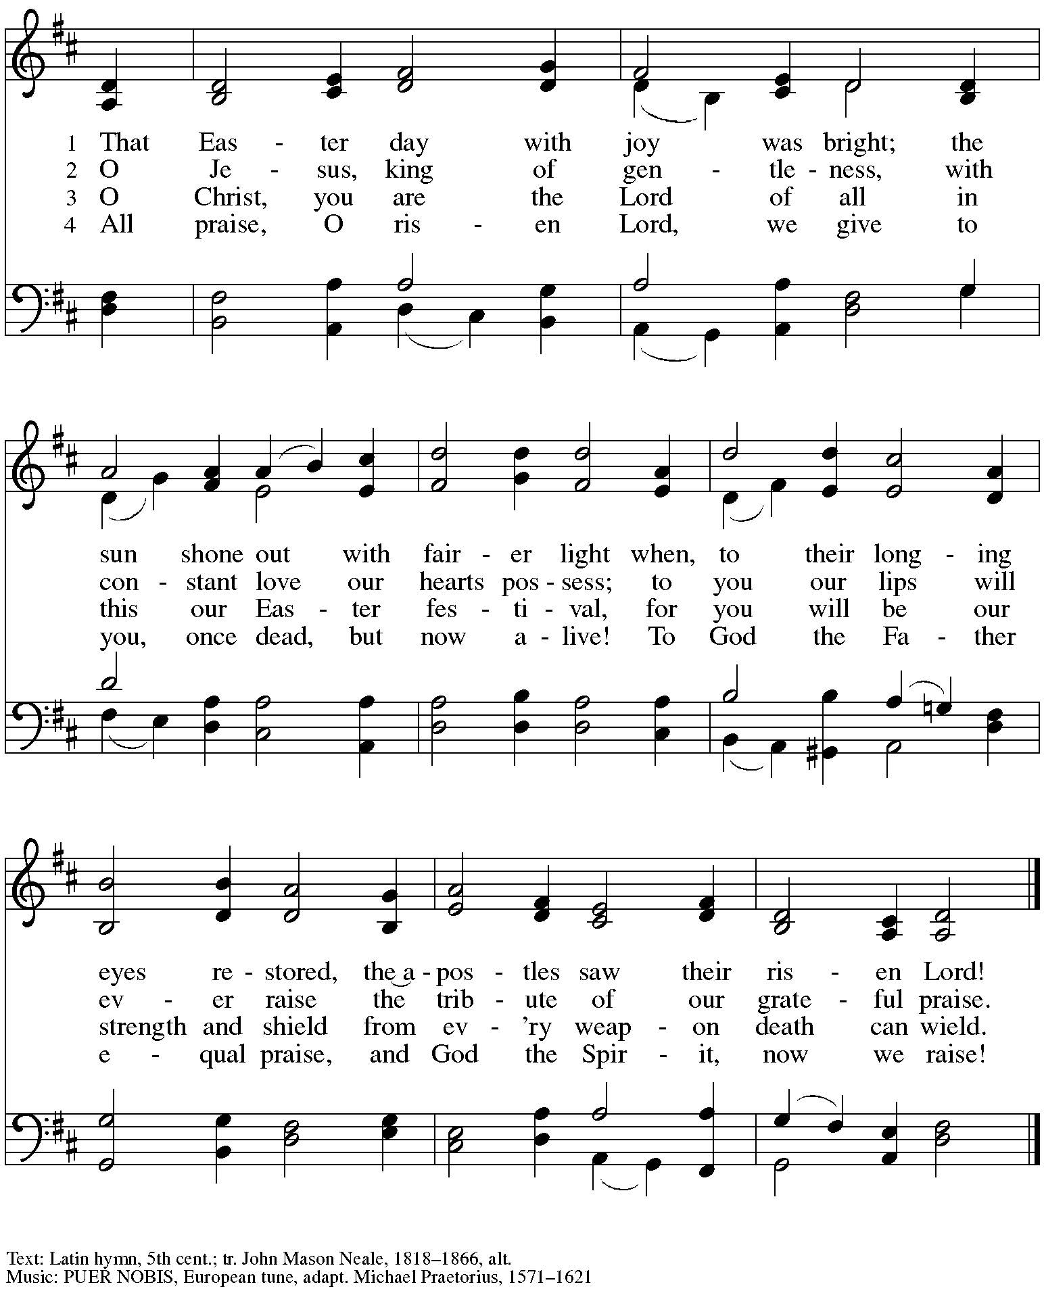

Greeting

P: The grace of our Lord Jesus Christ, the love of God,
and the communion of the Holy Spirit be with you all.
C: And also with you.

Hymn of Praise This Is the Feast ELW p. 149-150

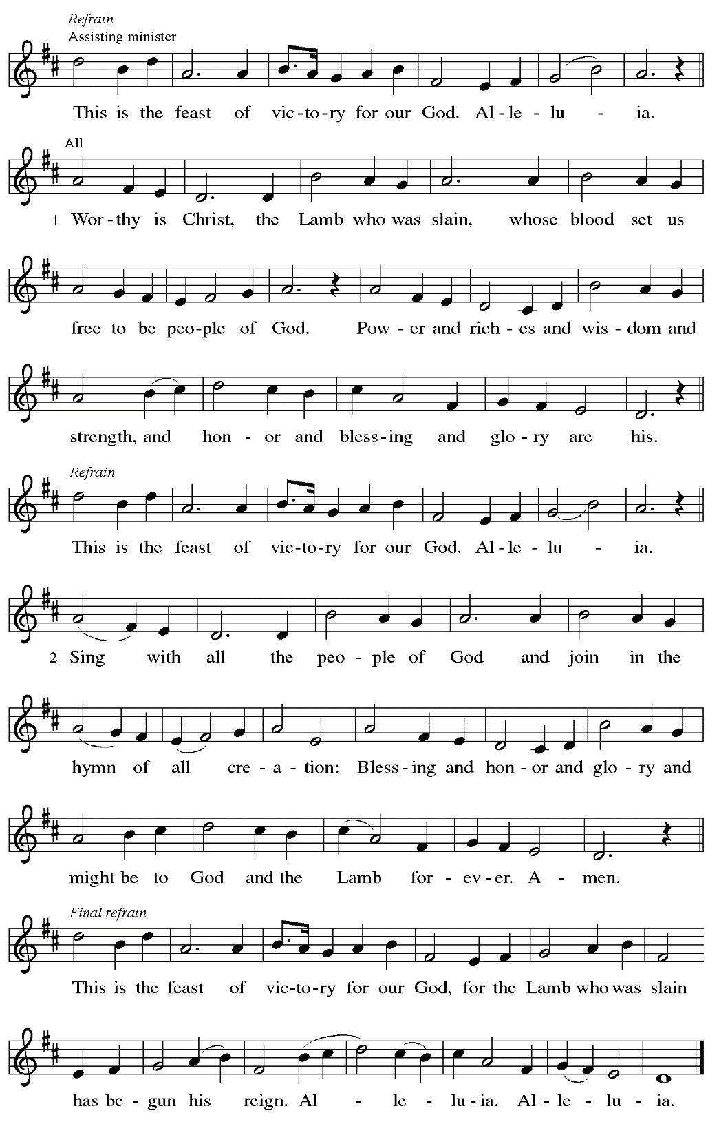

Prayer of the Day

P: The Lord be with you.
C: And also with you.

P: Let us pray.
Holy and righteous God, you are the author of life,
and we give thanks that in love you have called us your children.
Fill us with your words of life, that we may live as witnesses to the resurrection of your Son, Jesus Christ, our Savior and Lord, who lives and reigns with you and the Holy Spirit,
one God, now and forever.
C: Amen.

Please be seated.

Word
God speaks to us in Scripture reading, preaching, and song

First Reading – Acts 3: 12-19

¹²[Peter] addressed the people, “You Israelites, why do you wonder at this, or why do you stare at us, as though by our own power or piety we had made him walk? ¹³The God of Abraham, the God of Isaac, and the God of Jacob, the God of our ancestors has glorified God’s servant Jesus, whom you handed over and rejected in the presence of Pilate, though he had decided to release him. ¹⁴But you rejected the Holy and Righteous One and asked to have a murderer given to you,
¹⁵and you killed the Author of life, whom God raised from the dead. To this we are witnesses. ¹⁶And by faith in his name, his name itself has made this man strong, whom you see and know; and the faith that is through Jesus has given him this perfect health in the presence of all of you.
¹⁷“And now, friends, I know that you acted in ignorance, as did also your rulers. ¹⁸In this way God fulfilled what God had foretold through all the prophets, that God’s Messiah would suffer. ¹⁹Repent therefore, and turn to God so that your sins may be wiped out.”

L: Word of God, word of life.
C: Thanks be to God.

Psalm 4

The cantor will lead the singing of the psalm.
The congregation is invited to respond with the alternate verses in bold print,
and to join in singing the refrain.

Psalm tone

Psalm refrain

¹Answer me when I call, O God, defender | of my cause;
you set me free when I was in distress; have mercy on me and | hear my prayer.
²“You mortals, how long will you dishon- | or my glory;
how long will you love illusions and seek | after lies?”
³Know that the Lord does wonders | for the faithful;
the Lord will hear me | when I call.
⁴Tremble, then, and | do not sin;
speak to your heart in silence up- | on your bed. R
⁵Offer the appointed | sacrifices,
and put your trust | in the Lord.
⁶Many are saying, “Who will show us | any good?”
Let the light of your face shine upon | us, O Lord.
⁷You have put gladness | in my heart,
more than when grain and | wine abound.
⁸In peace, I will lie | down and sleep;
for you alone, O Lord, make me | rest secure. R

Second Reading – 1 John 3: 1-7

¹See what love the Father has given us, that we should be called children of God; and that is what we are. The reason the world does not know us is that it did not know God. ²Beloved, we are God’s children now; what we will be has not yet been revealed. What we do know is this: when God is revealed, we will be like God, for we will see God as God is. ³And all who have this hope in God purify themselves, just as God is pure.
⁴Everyone who commits sin is guilty of lawlessness; sin is lawlessness. ⁵You know that God was revealed to take away sins, and in God there is no sin. ⁶No one who abides in God sins;
no one who sins has either seen God or known God. ⁷Little children, let no one deceive you. Everyone who does what is right is righteous, just as God is righteous.

L: Word of God, word of life.
C: Thanks be to God.

Please rise as you are able.

Gospel Acclamation ELW p. 151

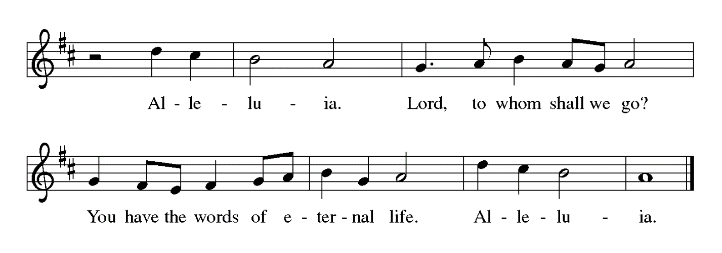

Gospel – Luke 24: 36b-48

P: The holy Gospel according to St. Luke.
C: Glory to you, O Lord.

^{36b}Jesus himself stood among [the disciples] and said to them, “Peace be with you.” ³⁷They were startled and terrified, and thought that they were seeing a ghost. ³⁸He said to them, “Why are you frightened, and why do doubts arise in your hearts? ³⁹Look at my hands and my feet; see that it is I myself. Touch me and see; for a ghost does not have flesh and bones as you see that I have.”
⁴⁰And when he had said this, he showed them his hands and his feet. ⁴¹While in their joy they were disbelieving and still wondering, he said to them, “Have you anything here to eat?” ⁴²They gave him a piece of broiled fish, ⁴³and he took it and ate in their presence.
⁴⁴Then he said to them, “These are my words that I spoke to you while I was still with you—that everything written about me in the law of Moses, the prophets, and the psalms must be fulfilled.” ⁴⁵Then he opened their minds to understand the scriptures, ⁴⁶and he said to them, “Thus it is written, that the Messiah is to suffer and to rise from the dead on the third day, ⁴⁷and that repentance and forgiveness of sins is to be proclaimed in his name to all nations, beginning from Jerusalem. ⁴⁸You are witnesses of these things.”

P: The Gospel of the Lord.
C: Praise to you, O Christ.

Please be seated.

Sermon

A time of silence for prayer and reflection follows the sermon.
When the hymn of the day begins, please rise as you are able.

Hymn of the Day Touch That Soothes and Heals ACS 939

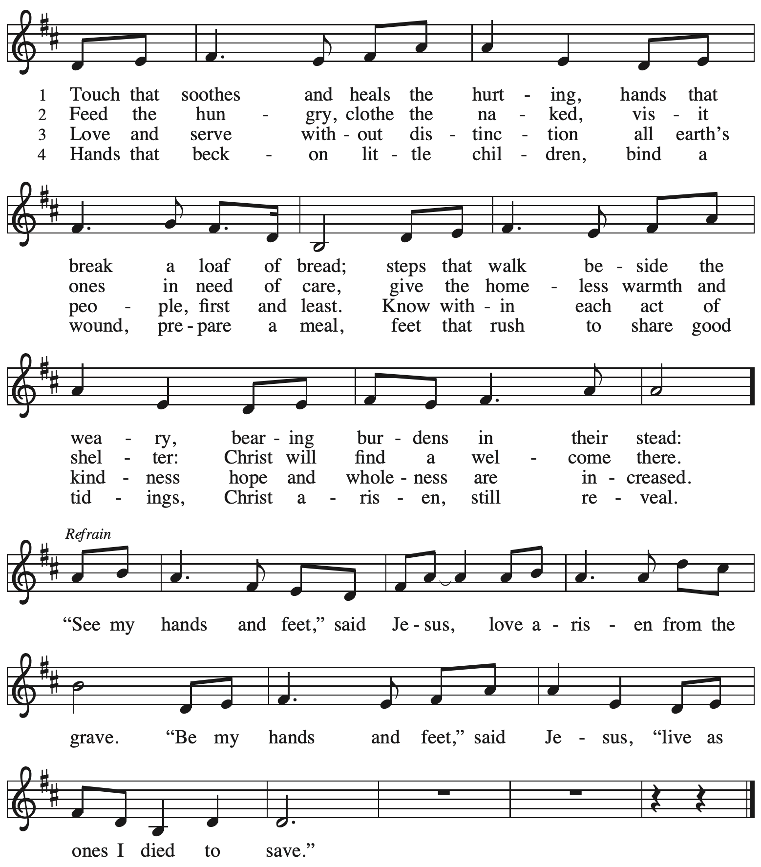

Nicene Creed

P: Together, in the joy of the resurrection, we profess our faith:
C: We believe in one God,
the Father, the Almighty,
maker of heaven and earth,
of all that is, seen and unseen.

We believe in one Lord, Jesus Christ,
the only Son of God,
eternally begotten of the Father,
God from God, Light from Light,
true God from true God,
begotten, not made,
of one Being with the Father;
through him all things were made.
For us and for our salvation
he came down from heaven,
was incarnate of the Holy Spirit and the virgin Mary
and became truly human.
For our sake he was crucified under Pontius Pilate;
he suffered death and was buried.
On the third day he rose again
in accordance with the scriptures;
he ascended into heaven
and is seated at the right hand of the Father.
He will come again in glory to judge the living and the dead,
and his kingdom will have no end.

We believe in the Holy Spirit, the Lord, the giver of life,
who proceeds from the Father and the Son,*
who with the Father and the Son is worshiped and glorified,
who has spoken through the prophets.
We believe in one holy catholic and apostolic church.
We acknowledge one baptism for the forgiveness of sins.
We look for the resurrection of the dead,
and the life of the world to come. Amen.

*Or, “who proceeds from the Father.” The phrase “and the Son” is a later addition to the creed.

Prayers of the People

A: United in the joy and hope of the resurrection, let us pray for the church, the world,
and all who are in need.

After each petition
A: Gracious God,
C: receive our prayer.

The presiding minister concludes the prayers
P: We lift these prayers to you most merciful God, trusting in your abiding love;
through Jesus Christ, our risen and living Savior.
C: Amen.

Peace

The presiding minister and the assembly greet one another in the peace of the risen Christ.
P: The peace of Christ be with you always.
C: And also with you.

The people may greet those around them with a sign of Christ’s peace and may say
Peace be with you or similar words. Please be mindful that not everyone will be comfortable with sharing the peace, so please seek consent before shaking hands or hugging. Other possible ways to share the peace include a simple bow with the verbal greeting of peace, or simply a verbal expression of peace.

When the greetings of peace have concluded, please be seated.

Meal

Offering

We offer ourselves, our gifts, and our faithful service to God.
As the offering is gathered for the mission of the church, including the care of those in need,
the table is set for Holy Communion.

Music during the Offering
Day of Delight and Beauty Unbounded arr. Oines

As the gifts are brought forward for presentation, please rise as you are able.

Offertory Song Let the Vineyards ELW 184

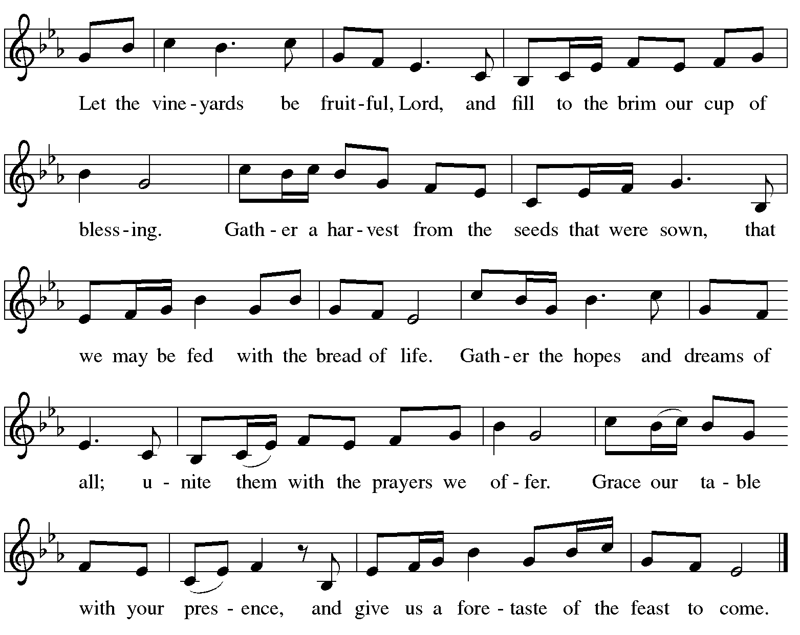

Offertory Prayer

A: Let us pray.
Blessed are you,
C: O God, ruler of heaven and earth.
Day by day you shower us with blessings.
As you have raised us to new life in Christ,
give us glad and generous hearts,
ready to praise you and to respond to those in need,
through Jesus Christ, our Savior and Lord.
Amen.

Dialogue ELW p. 152

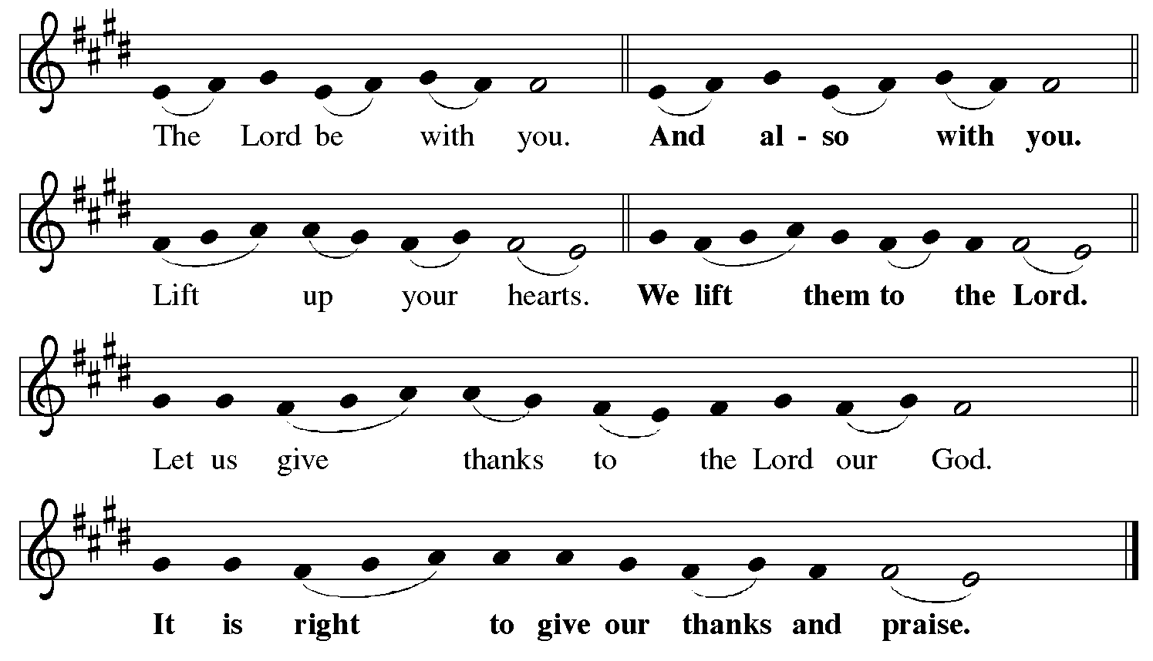

Preface (Sung by the presiding minister)

P: It is indeed right, our duty and our joy,
that we should at all times and in all places
give thanks and praise to you, almighty and merciful God,
for the glorious resurrection of our Savior Jesus Christ,
the true Paschal Lamb who gave himself to take away our sin;
who in dying has destroyed death,
and in rising has brought us to eternal life.
And so, with Mary Magdalene and Peter
and all the witnesses of the resurrection,
with earth and sea and all their creatures,
and with angels and archangels, cherubim and seraphim,
we praise your name and join their unending hymn:

Sanctus ELW p. 153

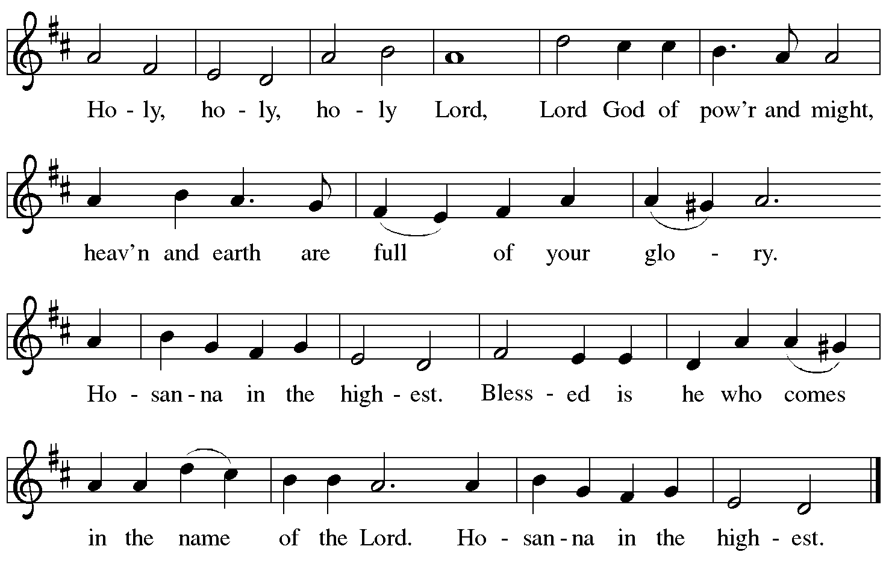

Eucharistic Prayer

P: Blessed are you, O God of the universe …
Do this for the remembrance of me.

With this bread and cup,
we remember our Lord’s passover from death to life
as we proclaim the mystery of faith:
C: Christ has died. Christ is risen. Christ will come again.

P: O God of resurrection and new life …
Grace our table with your presence.
C: Come, Holy Spirit.

P: Reveal yourself to us in the breaking of the bread …
Send us forth, burning with justice, peace, and love.
C: Come, Holy Spirit.

P: With your holy ones of all times and places,
with the earth and all its creatures,
with sun and moon and stars,
we praise you, O God,
blessed and holy Trinity,
now and forever.
C: Amen.

Lord’s Prayer

P: Gathered as one by the Holy Spirit, let us pray as Jesus taught us.
C: Our Father in heaven,
hallowed be your name,
your kingdom come,
your will be done,
on earth as in heaven.
Give us today our daily bread.
Forgive us our sins
as we forgive those
who sin against us.
Save us from the time of trial
and deliver us from evil.
For the kingdom, the power,
and the glory are yours,
now and forever. Amen.

Fraction and Invitation

P: Alleluia! Christ is risen!
C: Christ is risen indeed! Alleluia! Alleluia!

P: This is the feast of victory for our God. Alleluia! Alleluia!
Come, share the feast.

Agnus Dei / Lamb of God Following Page

Agnus Dei / Lamb of God ELW p. 154

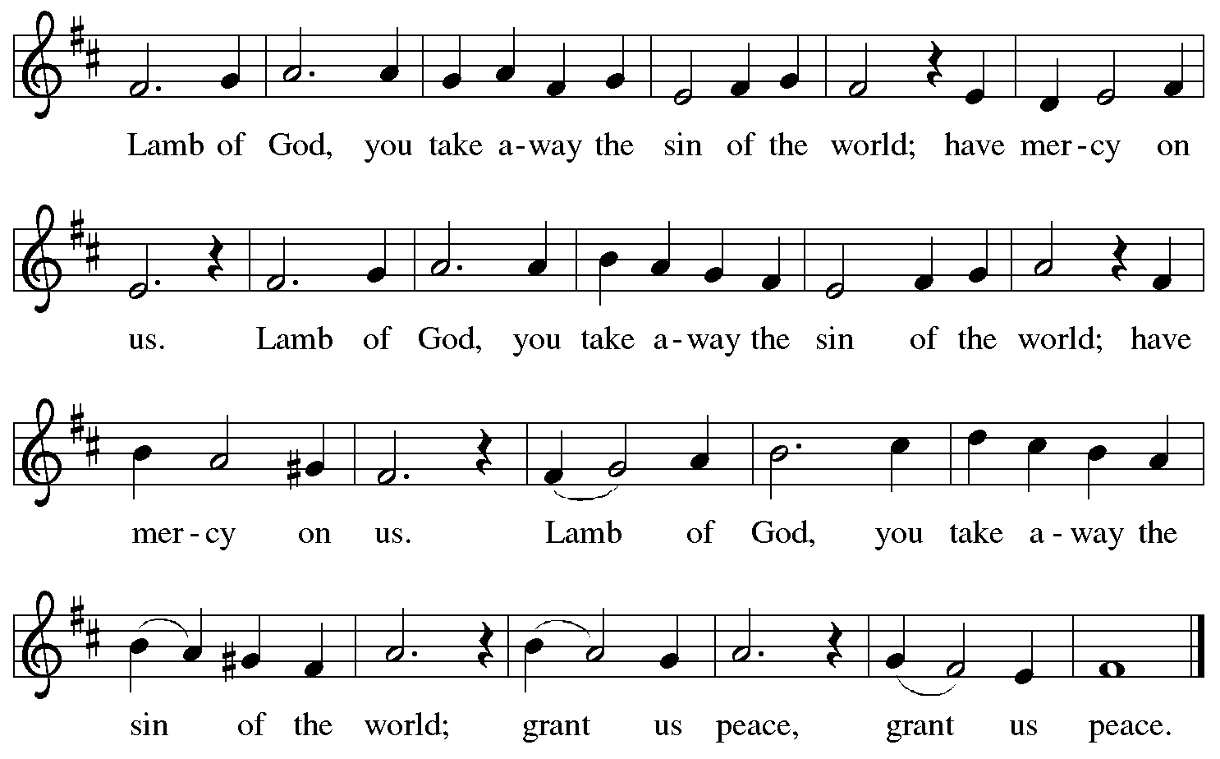

Please be seated.

Holy Communion
- All who seek God and desire a deeper and stronger life in Christ are welcome to receive Holy Communion.
- Worshipers from the pulpit side will proceed forward first, followed by the center section, and then the lectern side.
- Please inform an usher if you would like the ministers to bring Communion to you.
- Holy Communion will be served with bread and wine/grape juice.
- The presiding minister will first distribute the bread (host) to each communicant. Please indicate if you require a gluten-free host.
- Once you have consumed the bread, please pick up an empty glass from the tray next to the presiding minister. The Communion Assistant will pour wine from the chalice or grape juice from the cruet into your glass.
- Please step to the side to consume the wine or grape juice.
- Feel free to kneel at the altar rail for prayer after receiving the sacrament.
- As you return to your pew, glasses may be returned to the empty trays on either side of the center aisle.
- A blessing will be provided for anyone who does not yet receive the sacrament.
- All are invited to join in singing the hymns during Holy Communion.
Hymn during Holy Communion
Come to the Table ELW 481

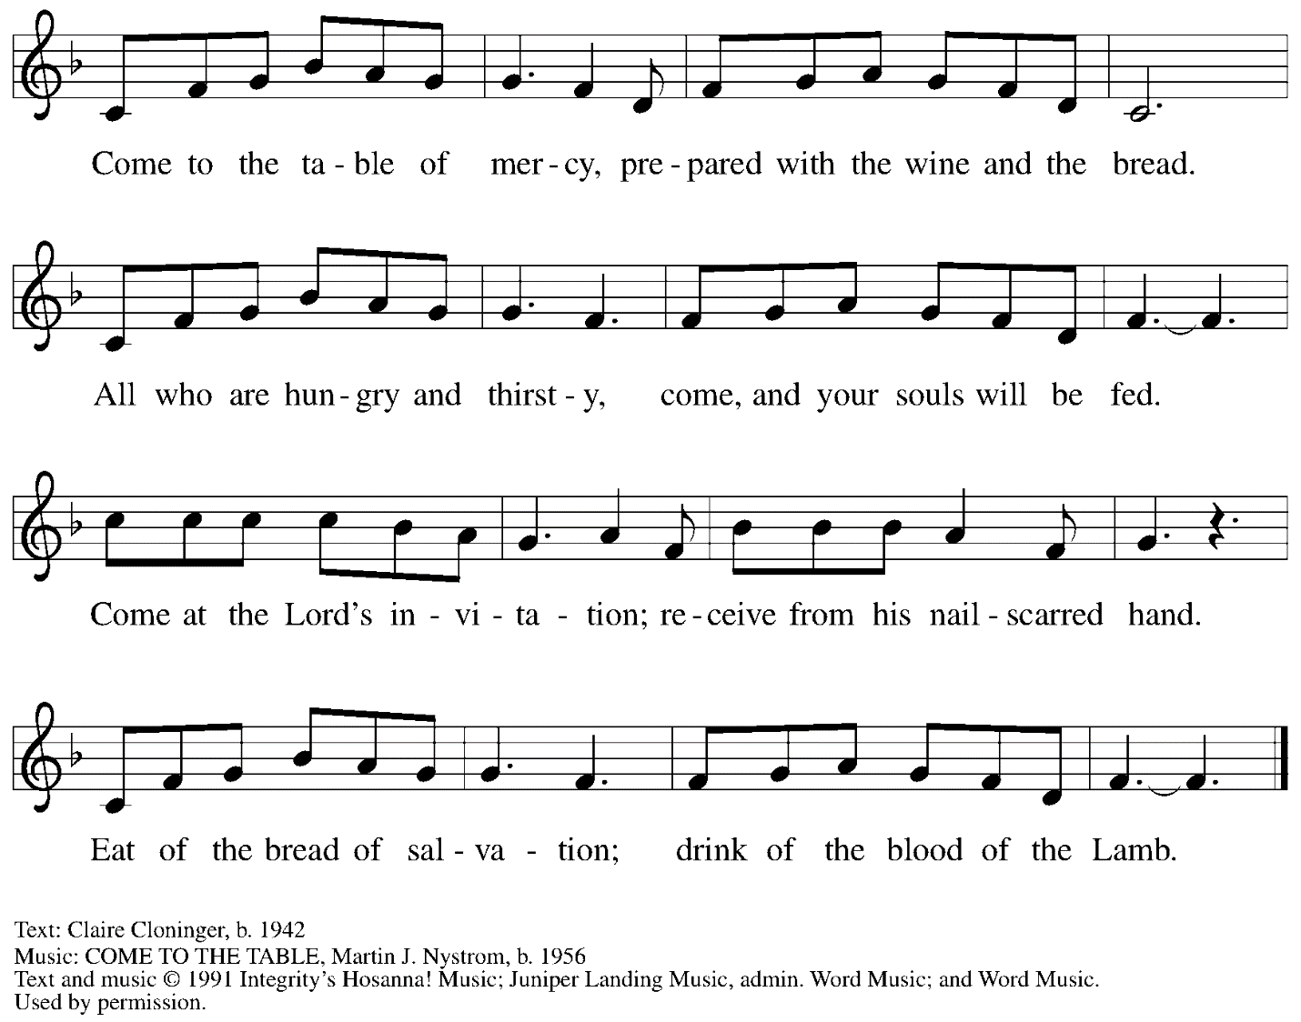
All rights reserved. Reprinted with permission under OneLicense.net # A-722139 and CCLI License # 11561207.

Hymn during Holy Communion
Be Thou My Vision ELW 793

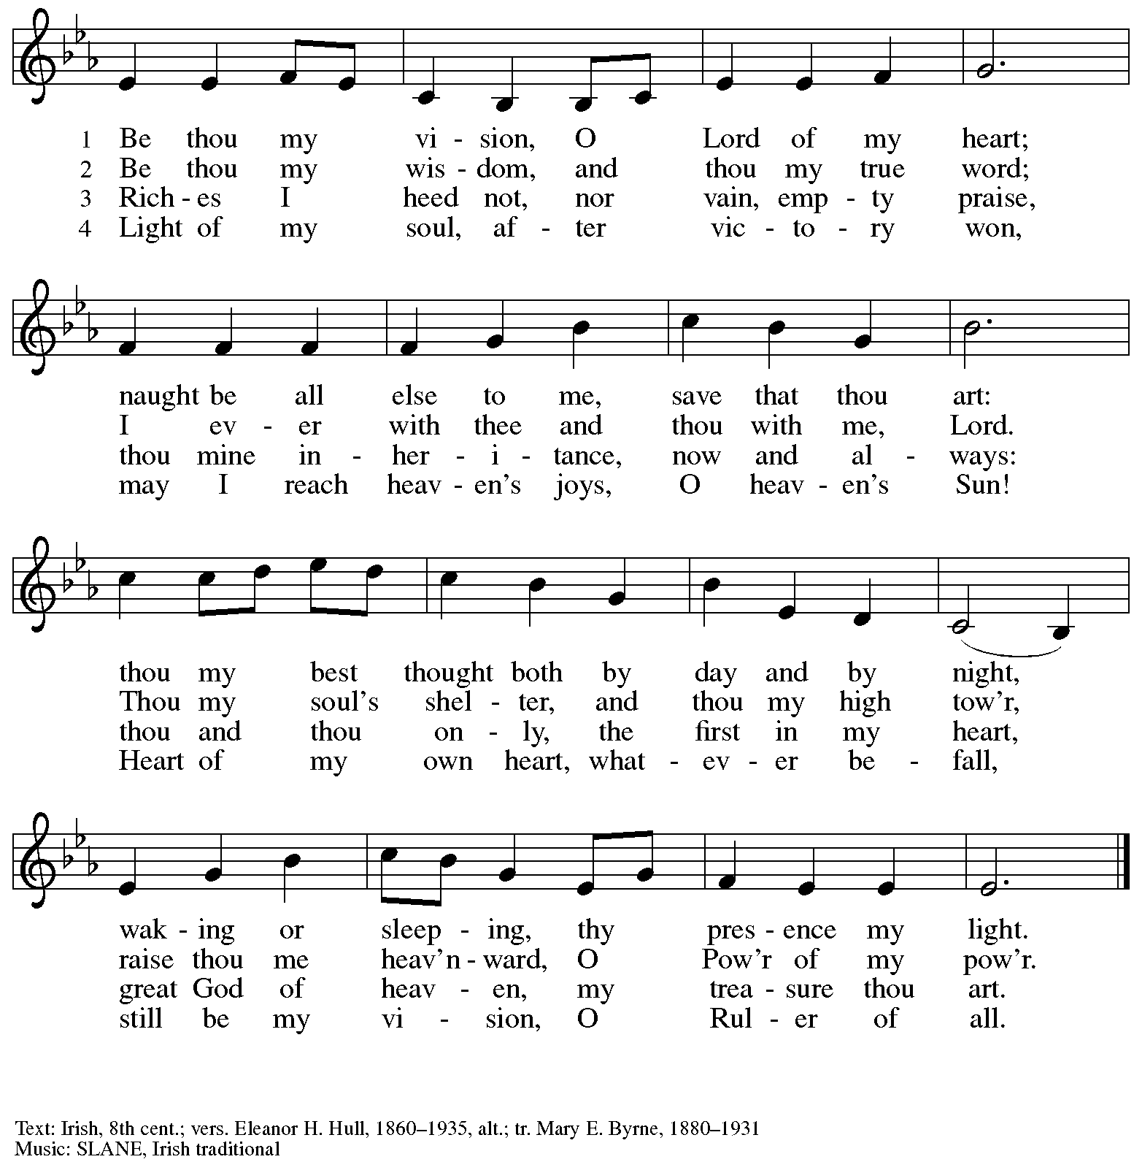

Hymn during Holy Communion
Oh, for a Thousand Tongues to Sing ELW 886
v. 1, 4-6

1 Oh, for a thousand tongues to sing
my great Redeemer's praise,
the glories of my God and King,
the triumphs of his grace!

4 He speaks, and list'ning to his voice,
new life the dead receive;
the mournful, broken hearts rejoice,
the humble poor believe.

5 Look unto him, your Savior own,
O fallen human race!
Look and be saved through faith alone,
be justified by grace!

6 To God all glory, praise, and love
be now and ever giv'n
by saints below and saints above,
the church in earth and heav'n.

Text: Charles Wesley, 1707-1788, alt. Music: AZMON, Carl G. Gläser; arr. Lowell Mason, 1792-1872.

Hymn during Holy Communion
As We Gather at Your Table ELW 522
v. 1-2

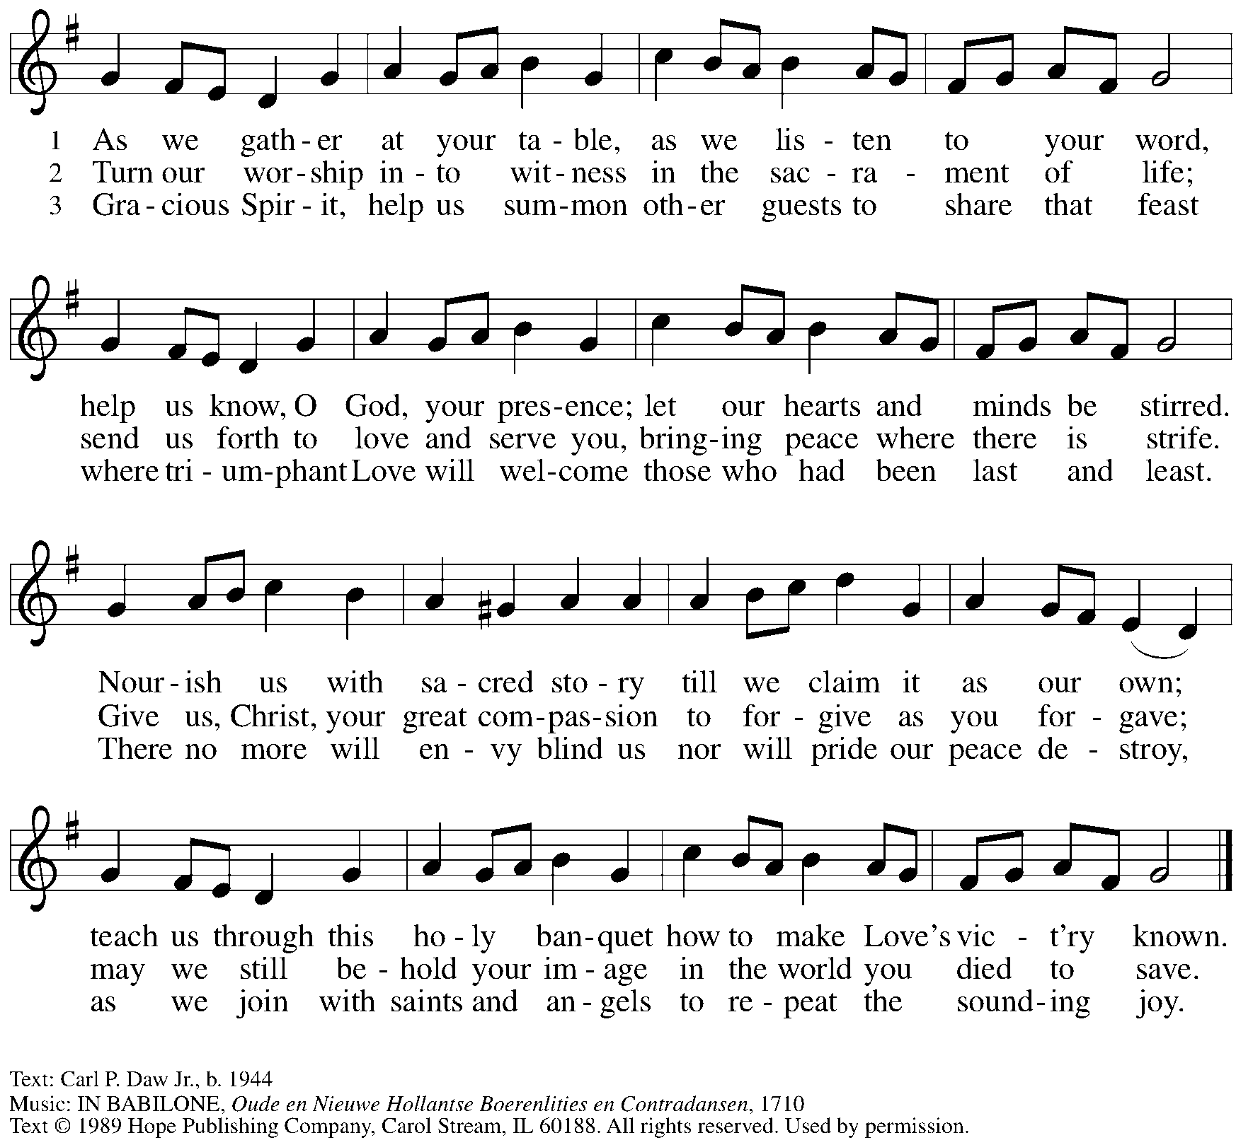
Reprinted with permission under OneLicense.net # A-722139.

When all have returned to their places, please rise as you are able.

Blessing

P: The body and blood of our Lord Jesus Christ strengthen you and keep you in his grace.
C: Amen.

Prayer

A: Let us pray. Life-giving God,
in the mystery of Christ’s resurrection, you send light to conquer darkness,
water to give new life, and the bread of life to nourish your people.
Send us forth as witnesses to your Son’s resurrection,
that we may show your glory to all the world,
through Jesus Christ, our risen Lord.
C: Amen.

Please be seated.

Sending

Announcements

Please rise as you are able.

Benediction

P: May our glorious God grant you a spirit of wisdom
to know and love the risen Christ.

Almighty God, holy One, ☩ holy Three,
bless you now and forever.
C: Amen.

Sending Hymn Go, My Children, with My Blessing Following page

Dismissal

A: Alleluia! Christ is risen!
C: Christ is risen indeed! Alleluia! Alleluia!

A: Go in peace. Share the good news!
C: Thanks be to God!

Postlude O Worship the King arr. Keveren

Sending Hymn Go, My Children, with My Blessing ELW 543

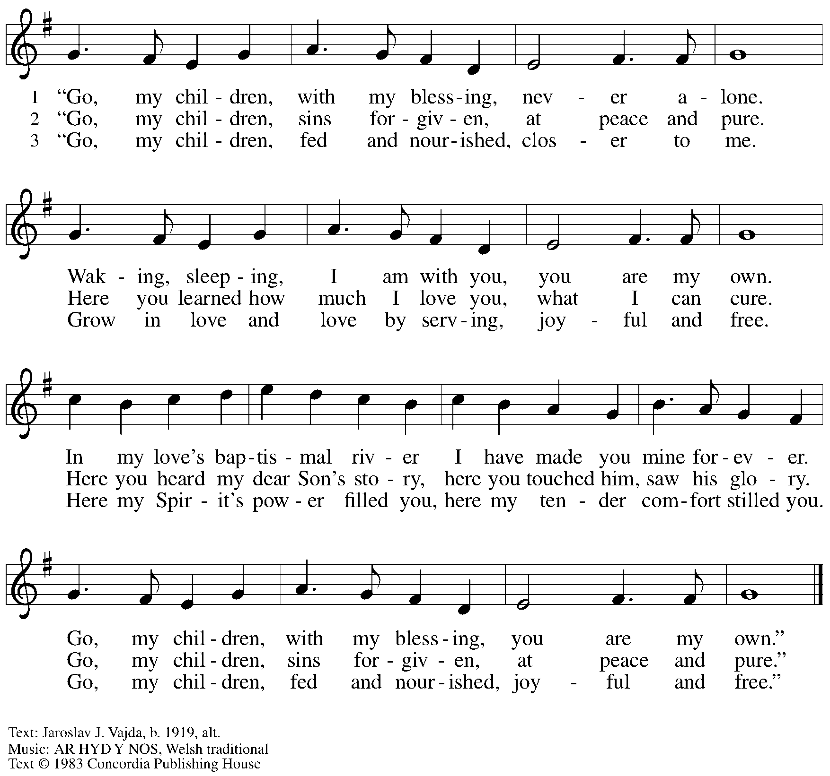
All rights reserved. Reprinted with permission under OneLicense.net # A-722139.

Those serving in worship today

Altar Care Christy Ruhe
Audio-Visual Ministers David Rollinson
Jered Stratton
Cantor Mandy Best
Lector Sue Gaugler
Little Church – Big Faith Leader Maria Mangano
Vocalists Emily Duque
The Rev. Erin Jones
Minister of Music Laura Reynolds
Presiding Minister Pastor Ross I. Carmichael

Liturgy and Hymnody Acknowledgements

From SundaysandSeasons.com. Copyright © 2024 Augsburg Fortress. All rights reserved. Reprinted under OneLicense.net # A-722139.
Used by permission of Augsburg Fortress.

Touch That Soothes and Heals – Text: Mary Louise Bringle, b. 1953. Music: CIVILITY, Gregg DeMey, b. 1972. Text © 2002 Gia Publications, Inc., giamusic.com. All rights reserved. Music © 2008 Re:Create Music, admin. Faith Alive Christian Resources. All rights reserved. Reprinted with permission under OneLicense.net # A-722139.

Let the Vineyards – Text: John W. Arthur, 1922-1980. Music: Ronald A. Nelson, b. 1927. Text and Music © 1978 Lutheran Book of Worship, admin. Augsburg Fortress.

Please use the QR code below to link to St. Andrew’s Announcements online!

St. Andrew Lutheran Church Announcements
April 14th, 2024

- Blessed Easter Season! Welcome to Worship at St. Andrew on April 14th, 2024, the + Third Sunday of Easter! – We are so glad you are here, and we offer a special welcome to all visitors and guests who are here for the first time! Children are invited to participate in Little Church – Big Faith, a Bible lesson and activity, after the prayer of the day. There are worship “toolkits” to help children engage with worship and “busy bags” for younger children available in the bookcase at the back of the sanctuary. Please feel free to take one to use with/for your children. A nursery is available through the door to the left of the worship space and across the social hall (it is a purple room). We pray that everyone has a blessed Easter season!
- Shelter Dinner at East End Cooperative Ministry – Thursday, April 18th, 6:30 p.m. – Several Items Still Needed! – Each month, people of St. Andrew provide dinner for guests of East End Cooperative Ministry, 6140 Station St. (East Liberty), 15206. We invite you to prepare or purchase one menu item and bring it to the shelter by 6:00 p.m., or just come to help serve at 6:30 p.m. This month’s dinner includes several items that require no cooking – just dropping off! If you would like to participate, please sign up here:
https://www.signupgenius.com/go/5080544AAAC22A1F58-48748236-shelter
- Service of Prayer and Lament for the Holy Land – Saturday, April 20th, Meal and Education 5:00 p.m., Service at 6:30 p.m. – As the troubling events in the Holy Land continue, St. Andrew invites people of the congregation to come together once again for a service of prayer and lament. Based on feedback from the first gathering in January, which suggested that the schedule for the meal, education, and the service felt too rushed, we have adjusted the timing to allow 1.5 hours before the service for the meal and educational component.
- A Celebration of Earth Day – Saturday, April 27th at the Church starting at 9:00 a.m. – In connection with Earth Day, we invite you to come to the church starting at 9:00 a.m. on Saturday, April 27th, to plant flowers to decorate our outdoor spaces. Doughnuts, coffee, and necessary supplies will be provided. Gather with us as we make our entrances welcoming with the gifts of God’s natural world.
- Marathon Weekend Worship – Saturday, May 4th, 5:00 p.m. – Dinner, 6:00 p.m. – Worship; Sunday, May 5th, 10:00 a.m. – Worship – The annual Pittsburgh Marathon events are held over the first weekend in May each year. This has often caused issues for St. Andrew and other East End houses of worship that are within the marathon route, especially on Sunday morning. Since some people of St. Andrew live within the route and since there is a way to get to the church by accessing and coming up Bigelow Blvd. St. Andrew still holds worship on that Sunday morning - we will soon post maps to help with this navigation. This year we will also offer an opportunity to gather on Saturday, May 4th, for dinner in the social hall at 5:00 p.m. and hold a worship service at 6:00 p.m. Please watch for more information in the upcoming bulletins and emails.
- Compline Prayer Service, a Ministry of Lutheran Campus Ministry in Greater Pittsburgh, Sundays at 8:00 p.m. at Heinz Chapel – Compline was traditionally a monastic prayer service, and the Pittsburgh Compline Choir sings a choral version of compline rooted in this thousand-year-old tradition of scripture, song, and silence. This service also streams on Facebook (Pittsburgh Compline Choir) and YouTube (The Pittsburgh Compline Choir). Heinz Chapel is located off of S. Bellefield Ave. in Oakland.

