+ Fourth Sunday of Easter
April 21, 2024
St. Andrew Lutheran Church
304 Morewood Ave.
Pittsburgh, PA 15213
St_andrewELCA@verizon.net
www.standrewpittsburgh.org

+ Fourth Sunday of Easter
Order for Worship

The image of the good shepherd shows us how the risen Christ brings us to life. It is the relationship between the shepherd and the sheep, one of mutual knowledge and love, that gives the shepherd authority. The shepherd’s willingness to lay down his life for the sheep shows his love. First John illustrates what it means to lay down our lives for one another by the example of sharing our wealth with any sibling in need.

Welcome to St. Andrew!
- St. Andrew Lutheran congregation welcomes all who are seeking a place of healing and wholeness – a nurturing, faith-forming spiritual home. Our community embraces people of all ages, ethnicities, cultures, abilities, sexual orientations, gender identities and expressions, and family constellations. Come and See!
- Worship Services are live streamed to multiple online platforms. By attending worship, you agree that your image and voice may be broadcast.
- Everyone is invited to make a name tag at the black bookcase in the back of the worship space if they would like. There are stickers indicating pronouns on the bookcase if you would like to include them on your name tag.
- The nursery is available through the doors at the left side of the sanctuary and across from the doorway to the Social Hall. It is a purple room.
- Children are invited to attend Little Church – Big Faith, a Bible lesson and activity, during worship (after the Prayer of the Day). The group returns to the worship space for the liturgy of Holy Communion.
- Worship “toolkits” to help children engage with the service, along with “busy bags” for younger children, are available in the bookcase at the back of the sanctuary. Please feel free to take one to use with/for your children.
- A nursery is available through the doors at the left side of the sanctuary and across from the doorway to the Social Hall. It is a purple room.
- Holy Communion is served with bread (gluten-free available) and wine or grape juice. The presiding minister will distribute the bread (host). Please consume this and then pick up an empty glass from the tray. The Communion Assistant will pour wine or grape juice into your glass. Please step to the side to consume the wine or grape juice. Feel free to kneel at the altar for prayer and reflection. As you return to your pew, glasses may be returned to the empty trays on either side of the center section.
- A restroom is available on the main level of the church, through the doors to the Social Hall and to the right in the main office.

Abbreviations
P: Pastor/Presiding Minister ELW: Evangelical Lutheran Worship hymnal
A: Assisting Minister ACS: All Creation Sings hymnal
L: Lector
C: Congregation
Pre-Service Music

Welcome

Prelude The Lord Is My Shepherd arr. Shackley

Gathering
The Holy Spirit calls us together as the people of God

Please rise as you are able. All may make the sign of the cross,
the sign that is marked at Baptism, as the presiding minister begins.

Confession and Forgiveness

P: Blessed be the holy Trinity, ☩ one God,
who creates, redeems, and sustains us and all of creation.
C: Amen.

P: Let us confess our sin in the presence of God and one another.

Silence is kept for reflection.

P: Most merciful God,
we confess that we are captive to sin and cannot free ourselves.
We have sinned against you in thought, word, and deed,
by what we have done and by what we have left undone.
We have not loved you with our whole heart;
we have not loved our neighbors as ourselves.
For the sake of your Son, Jesus Christ, have mercy on us.
Forgive us, renew us, and lead us,
so that we may delight in your will
and follow in your ways,
to the glory of your holy name.
Amen.

P: By water and the Holy Spirit God gives you a new birth,
and through the death and resurrection of ☩ Jesus Christ,
God forgives you all your sins.
The God of mercy and might strengthen you in all goodness
and keep you in eternal life.
C: Amen.

Gathering Hymn v. 1-3 ELW 364
Mfurahini, haleluya – Christ Has Arisen, Alleluia

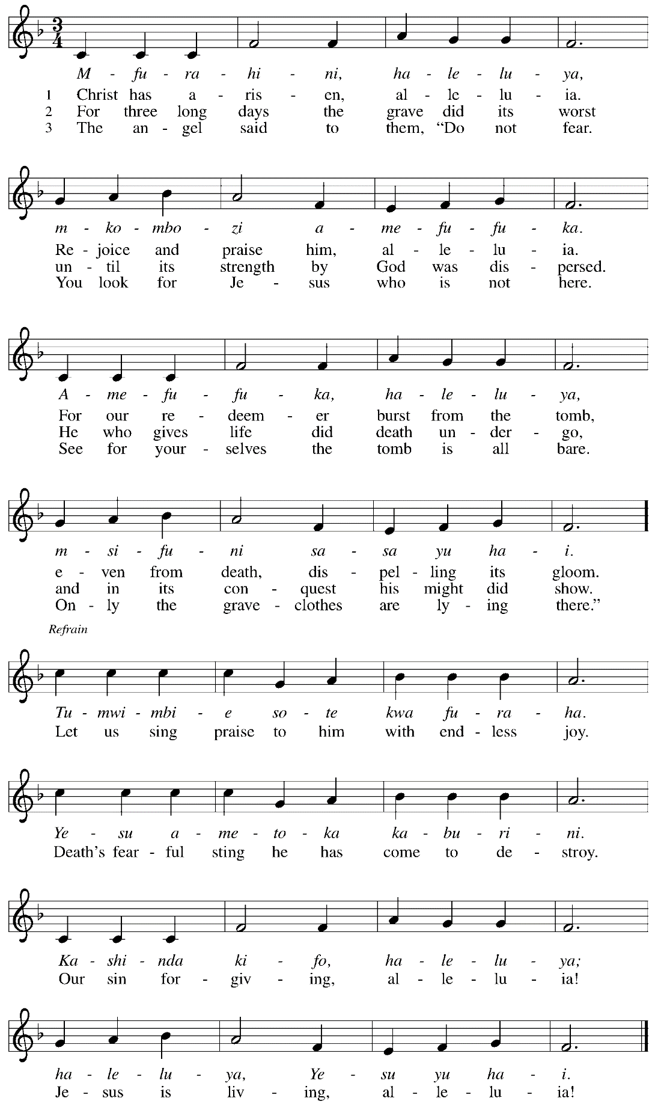
Greeting

P: The grace of our Lord Jesus Christ, the love of God,
and the communion of the Holy Spirit be with you all.
C: And also with you.

Hymn of Praise This Is the Feast ELW p. 149-150

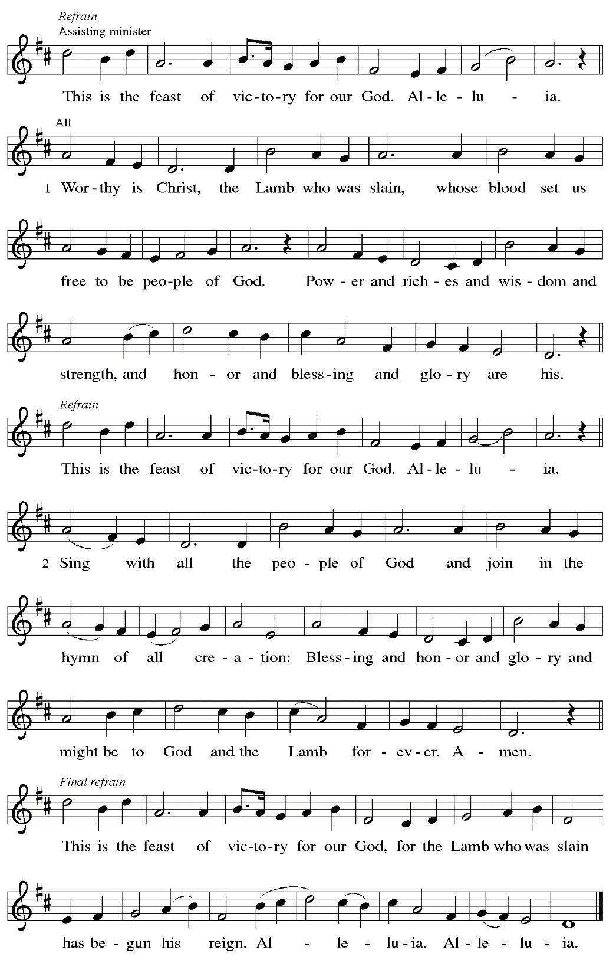

Prayer of the Day

P: The Lord be with you.
C: And also with you.

P: Let us pray.
O Lord Christ, good shepherd of the sheep, you seek the lost and guide us into your fold.
Feed us, and we shall be satisfied; heal us, and we shall be whole.
Make us one with you, for you live and reign with the Father and the Holy Spirit,
one God, now and forever.
C: Amen.

Please be seated.

Word
God speaks to us in Scripture reading, preaching, and song

First Reading – Acts 4: 5-12

⁵The next day [the] rulers, elders, and scribes assembled in Jerusalem, ⁶with Annas the high priest, Caiaphas, John, and Alexander, and all who were of the high-priestly family. ⁷When they had made the prisoners stand in their midst, they inquired, “By what power or by what name did you do this?” ⁸Then Peter, filled with the Holy Spirit, said to them, “Rulers of the people and elders, ⁹if we are questioned today because of a good deed done to someone who was sick and are asked how this man has been healed, ¹⁰let it be known to all of you, and to all the people of Israel, that this man is standing before you in good health by the name of Jesus Christ of Nazareth, whom you crucified, whom God raised from the dead. ¹¹This Jesus is
‘the stone that was rejected by you, the builders;
it has become the cornerstone.’
¹²There is salvation in no one else, for there is no other name under heaven given among mortals by which we must be saved.”

L: Word of God, word of life.
C: Thanks be to God.

Psalm 23 Shepherd Me, O God Following page

In place of the regular chanted psalm,
the congregation will sing this hymn based on Psalm 23,
the appointed psalm for the day.

Psalm 23 Shepherd Me, O God ELW 780

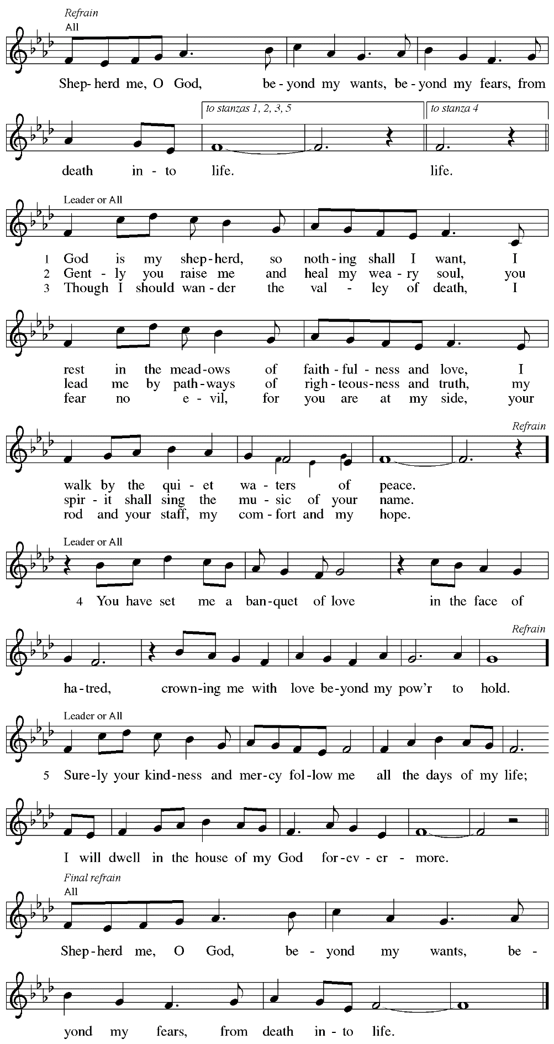
Second Reading – 1 John 3: 16-24

¹⁶We know love by this, that [Jesus Christ] laid down his life for us—and we ought to lay down our lives for one another. ¹⁷How does God’s love abide in anyone who has the world’s goods and sees a sibling in need and yet refuses help?
¹⁸Little children, let us love, not in word or speech, but in truth and action. ¹⁹And by this we will know that we are from the truth and will reassure our hearts before God ²⁰whenever our hearts condemn us; for God is greater than our hearts, and God knows everything. ²¹Beloved, if our hearts do not condemn us, we have boldness before God; ²²and we receive from God whatever we ask, because we obey God’s commandments and do what pleases God.
²³And this is God’s commandment, that we should believe in the name of God’s Son Jesus Christ and love one another, just as Christ has commanded us. ²⁴All who obey his commandments abide in him, and he abides in them. And by this we know that he abides in us, by the Spirit that he has given us.

L: Word of God, word of life.
C: Thanks be to God.

Please rise as you are able.

Gospel Acclamation ELW p. 151

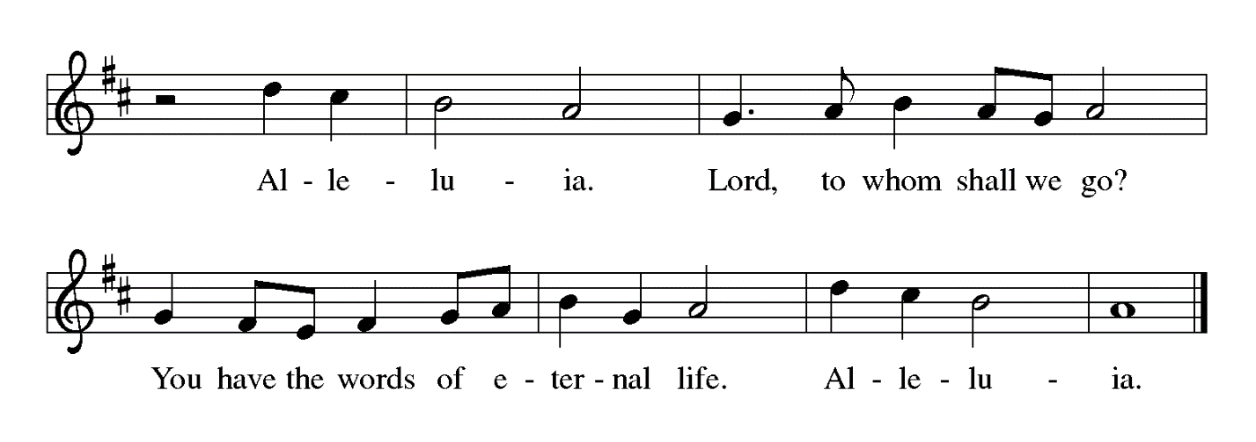

Gospel – John 10: 11-18

P: The holy Gospel according to St. John.
C: Glory to you, O Lord.

[Jesus said:] ¹¹“I am the good shepherd. The good shepherd lays down his life for the sheep.
¹²The hired hand, who is not the shepherd and does not own the sheep, sees the wolf coming and leaves the sheep and runs away—and the wolf snatches them and scatters them. ¹³The hired hand runs away because a hired hand does not care for the sheep. ¹⁴I am the good shepherd. I know my own and my own know me, ¹⁵just as the Father knows me and I know the Father. And I lay down my life for the sheep. ¹⁶I have other sheep that do not belong to this fold. I must bring them also, and they will listen to my voice. So there will be one flock, one shepherd. ¹⁷For this reason the Father loves me, because I lay down my life in order to take it up again. ¹⁸No one takes it from me, but I lay it down of my own accord. I have power to lay it down, and I have power to take it up again. I have received this command from my Father.”

P: The Gospel of the Lord.
C: Praise to you, O Christ.

Please be seated.

Sermon

A time of silence for prayer and reflection follows the sermon.
When the hymn of the day begins, please rise as you are able.

Hymn of the Day You, Lord, Are Both Lamb and Shepherd ACS 954

1 You, Lord, are both Lamb and Shepherd.
You, Lord, came, the world to save.
You, peacemaker and sword-bringer
of the way you took and gave.
You, the everlasting instant;
you, whom we both scorn and crave.

2 Clothed in light upon the mountain,
stripped of might upon the cross,
shining in eternal glory,
beggared by a soldier's toss,
you, the everlasting instant;
you, who are both gift and cost.

3 You, who walk each day beside us,
sit in power at God's side.
You, who preach a way that's narrow,
have a love that reaches wide.
You, the everlasting instant;
you, who are our pilgrim guide.

4 Worthy is our earthly Jesus!
Worthy is our cosmic Christ!
Worthy your defeat and vict'ry;
worthy still your peace and strife.
You, the everlasting instant;
you, who are our death and life.

Text: Sylvia G. Dunstan, 1955–1993. Music: PICARDY, French folk tune, 17th cent. Text © 1991 GIA Publications, Inc., giamusic.com. All rights reserved. Reprinted with permission under OneLicense.net # A-722139.

Nicene Creed

P: Together, in the joy of the resurrection, we profess our faith:
C: We believe in one God,
the Father, the Almighty,
maker of heaven and earth,
of all that is, seen and unseen.

We believe in one Lord, Jesus Christ,
the only Son of God,
eternally begotten of the Father,
God from God, Light from Light,
true God from true God,
begotten, not made,
of one Being with the Father;
through him all things were made.
For us and for our salvation
he came down from heaven,
was incarnate of the Holy Spirit and the virgin Mary
and became truly human.
For our sake he was crucified under Pontius Pilate;
he suffered death and was buried.
On the third day he rose again
in accordance with the scriptures;
he ascended into heaven
and is seated at the right hand of the Father.
He will come again in glory to judge the living and the dead,
and his kingdom will have no end.

We believe in the Holy Spirit, the Lord, the giver of life,
who proceeds from the Father and the Son,*
who with the Father and the Son is worshiped and glorified,
who has spoken through the prophets.
We believe in one holy catholic and apostolic church.
We acknowledge one baptism for the forgiveness of sins.
We look for the resurrection of the dead,
and the life of the world to come. Amen.

*Or, “who proceeds from the Father.” The phrase “and the Son” is a later addition to the creed.

Prayers of the People

A: United in the joy and hope of the resurrection, let us pray for the church, the world,
and all who are in need.

After each petition
A: Gracious God,
C: receive our prayer.

The presiding minister concludes the prayers
P: We lift these prayers to you most merciful God, trusting in your abiding love;
through Jesus Christ, our risen and living Savior.
C: Amen.

Peace

The presiding minister and the assembly greet one another in the peace of the risen Christ.
P: The peace of Christ be with you always.
C: And also with you.

The people may greet those around them with a sign of Christ’s peace and may say
Peace be with you or similar words. Please be mindful that not everyone will be comfortable with sharing the peace, so please seek consent before shaking hands or hugging. Other possible ways to share the peace include a simple bow with the verbal greeting of peace, or simply a verbal expression of peace.

When the greetings of peace have concluded, please be seated.

Meal
God feeds us with the presence of Jesus Christ

Offering

We offer ourselves, our gifts, and our faithful service to God.
As the offering is gathered for the mission of the church, including the care of those in need,
the table is set for Holy Communion.

Noisy Offering

As children of the congregation carry metal buckets around the sanctuary, people of the congregation are invited to throw in their change as an offering. This month, in association with Earth Day, the noisy offering will benefit Clean Air Council.

Musical Offering All Hail the Power of Jesus’ Name Holden

As the gifts are brought forward for presentation, please rise as you are able.

Offertory Song Let the Vineyards ELW 184

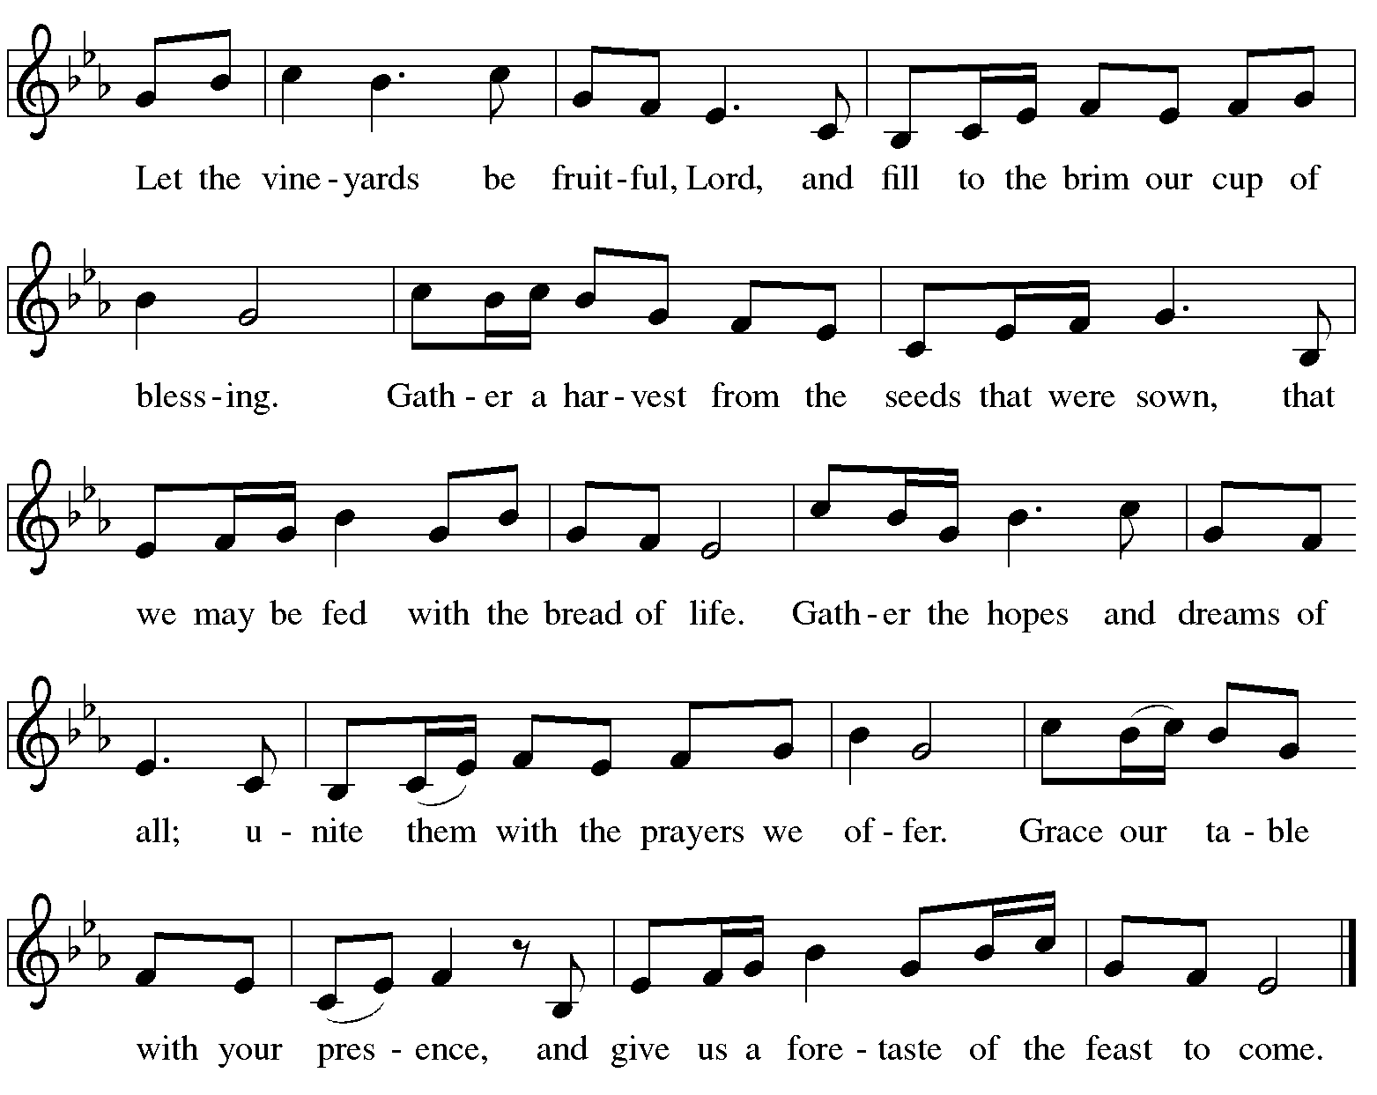

Offertory Prayer

A: Let us pray.
Blessed are you, O God,
C: ruler of heaven and earth.
Day by day you shower us with blessings.
As you have raised us to new life in Christ,
give us glad and generous hearts,
ready to praise you and to respond to those in need,
through Jesus Christ, our Savior and Lord.
Amen.

Dialogue ELW p. 152

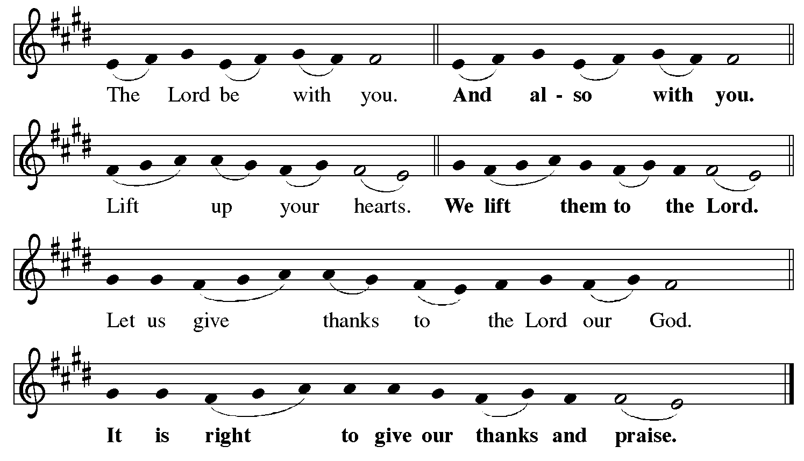

Preface (Sung by the presiding minister)

P: It is indeed right, our duty and our joy,
that we should at all times and in all places
give thanks and praise to you, almighty and merciful God,
for the glorious resurrection of our Savior Jesus Christ,
the true Paschal Lamb who gave himself to take away our sin;
who in dying has destroyed death,
and in rising has brought us to eternal life.
And so, with Mary Magdalene and Peter
and all the witnesses of the resurrection,
with earth and sea and all their creatures,
and with angels and archangels, cherubim and seraphim,
we praise your name and join their unending hymn:

Sanctus ELW p. 153

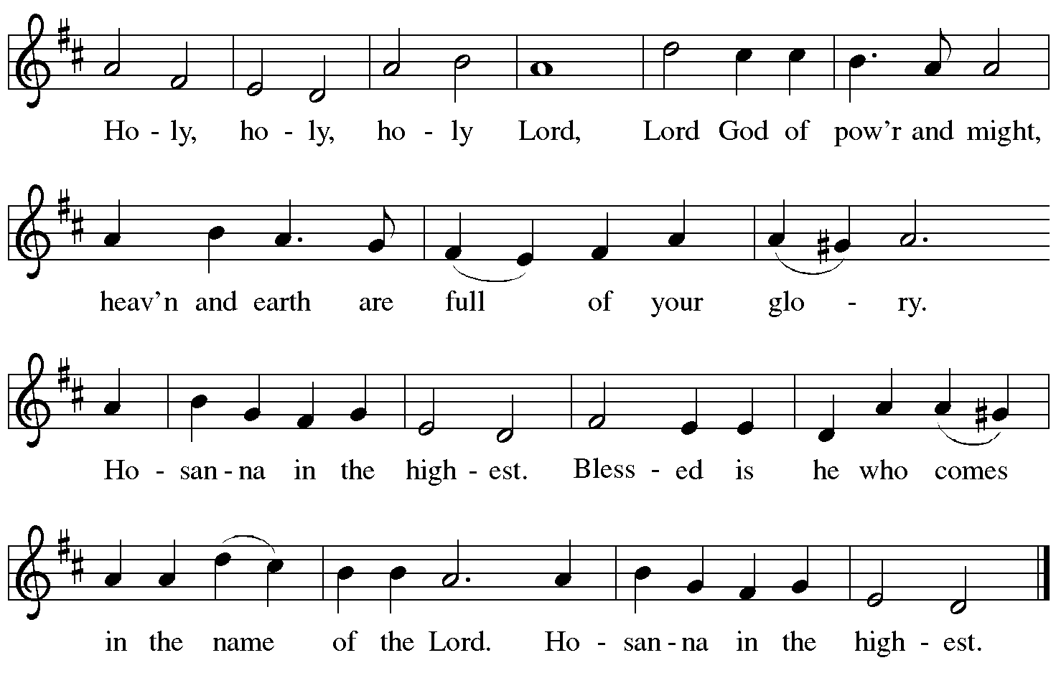

Eucharistic Prayer

P: Blessed are you, O God of the universe …
Do this for the remembrance of me.

With this bread and cup,
we remember our Lord’s passover from death to life
as we proclaim the mystery of faith:
C: Christ has died. Christ is risen. Christ will come again.

P: O God of resurrection and new life …
Grace our table with your presence.
C: Come, Holy Spirit.

P: Reveal yourself to us in the breaking of the bread …
Send us forth, burning with justice, peace, and love.
C: Come, Holy Spirit.

P: With your holy ones of all times and places,
with the earth and all its creatures,
with sun and moon and stars,
we praise you, O God,
blessed and holy Trinity,
now and forever.
C: Amen.

Lord’s Prayer

P: Gathered as one by the Holy Spirit, let us pray as Jesus taught us.
C: Our Father in heaven,
hallowed be your name,
your kingdom come,
your will be done,
on earth as in heaven.
Give us today our daily bread.
Forgive us our sins
as we forgive those
who sin against us.
Save us from the time of trial
and deliver us from evil.
For the kingdom, the power,
and the glory are yours,
now and forever. Amen.

Fraction and Invitation

P: Alleluia! Christ is risen!
C: Christ is risen indeed! Alleluia! Alleluia!

P: This is the feast of victory for our God. Alleluia! Alleluia!
Come, share the feast.

Agnus Dei / Lamb of God Following Page

Agnus Dei / Lamb of God ELW p. 154

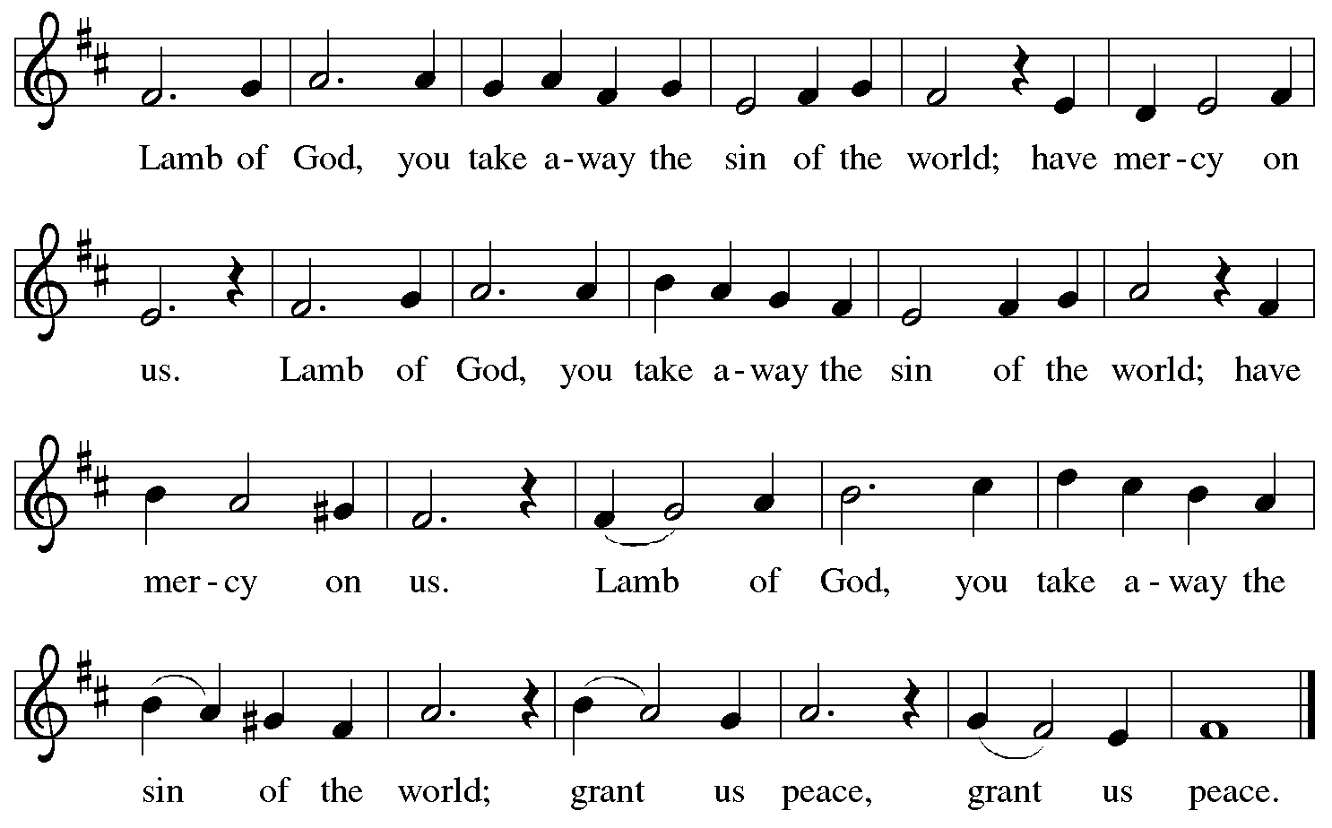

Please be seated.

Holy Communion
- All who seek God and desire a deeper and stronger life in Christ are welcome to receive Holy Communion.
- Worshipers from the pulpit side will proceed forward first, followed by the center section, and then the lectern side.
- Please inform an usher if you would like the ministers to bring Communion to you.
- Holy Communion will be served with bread and wine/grape juice.
- The presiding minister will first distribute the bread (host) to each communicant. Please indicate if you require a gluten-free host.
- Once you have consumed the bread, please pick up an empty glass from the tray next to the presiding minister. The Communion Assistant will pour wine from the chalice or grape juice from the cruet into your glass.
- Please step to the side to consume the wine or grape juice.
- Feel free to kneel at the altar rail for prayer after receiving the sacrament.
- As you return to your pew, glasses may be returned to the empty trays on either side of the center aisle.
- A blessing will be provided for anyone who does not yet receive the sacrament.
- All are invited to join in singing the hymns during Holy Communion.
Hymn during Holy Communion
The King of Love My Shepherd Is ELW 502

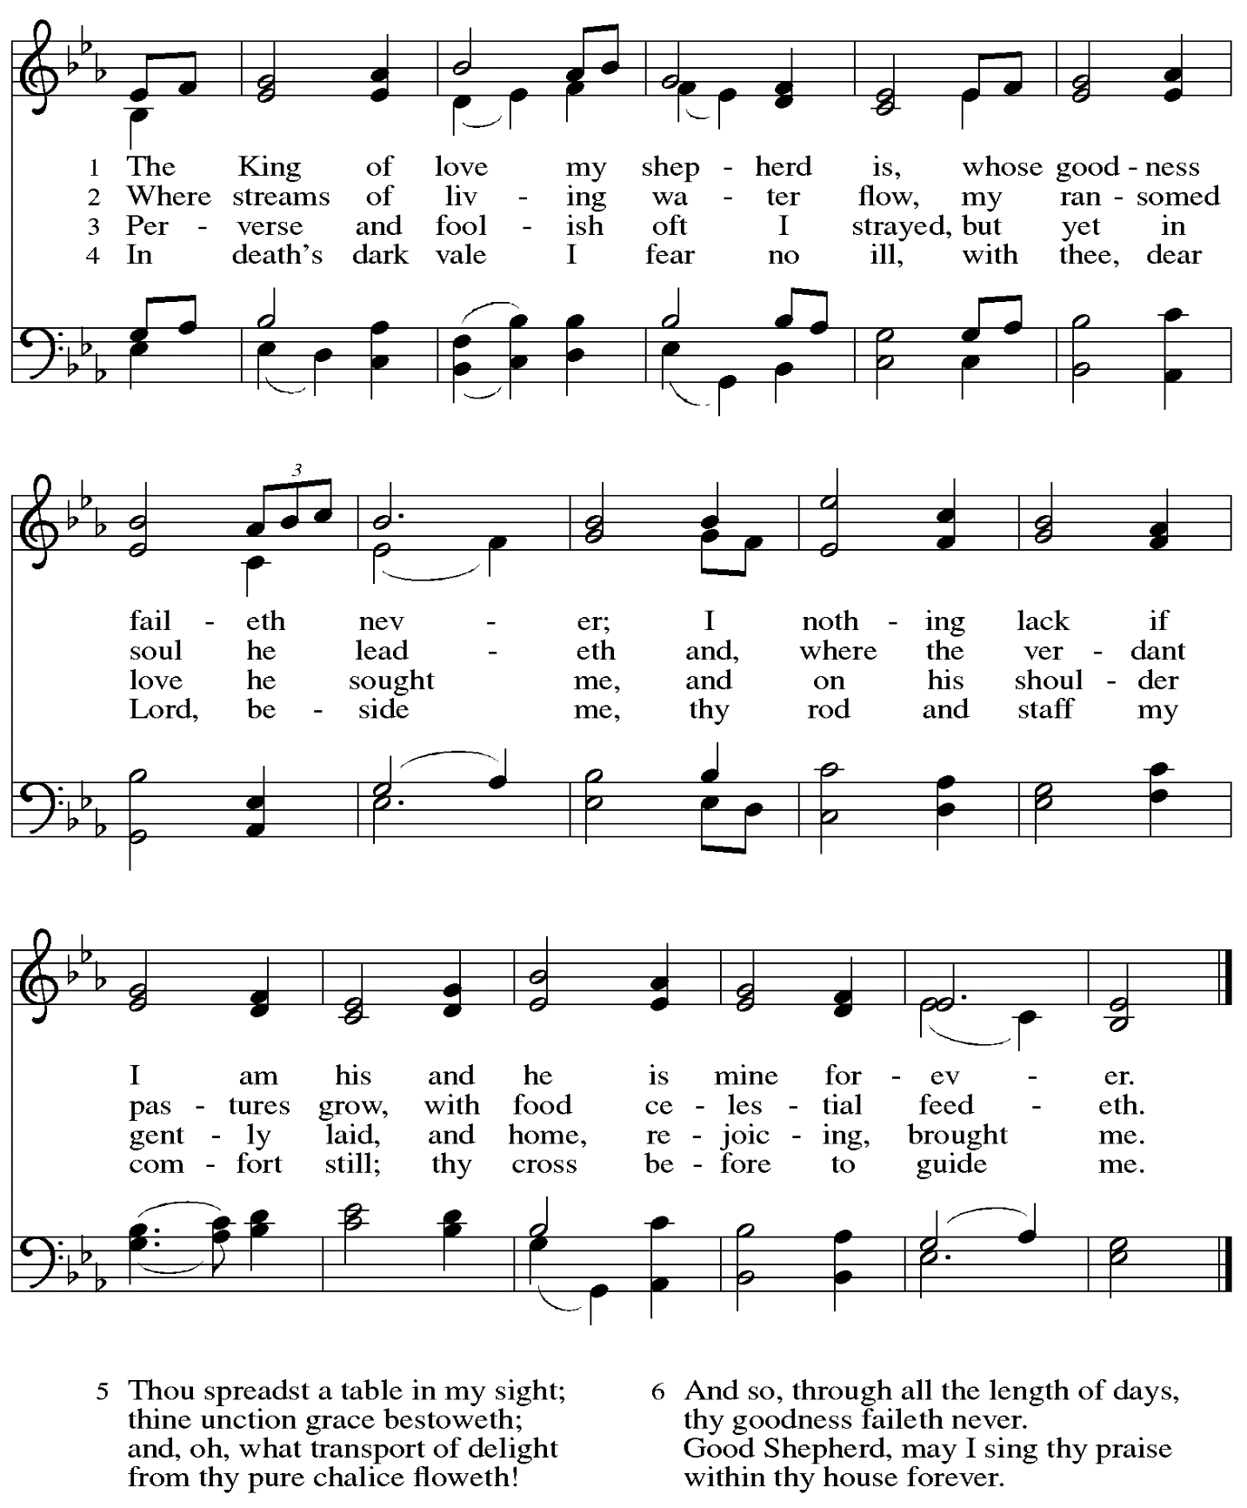

Hymn during Holy Communion
You Satisfy the Hungry Heart ELW 484

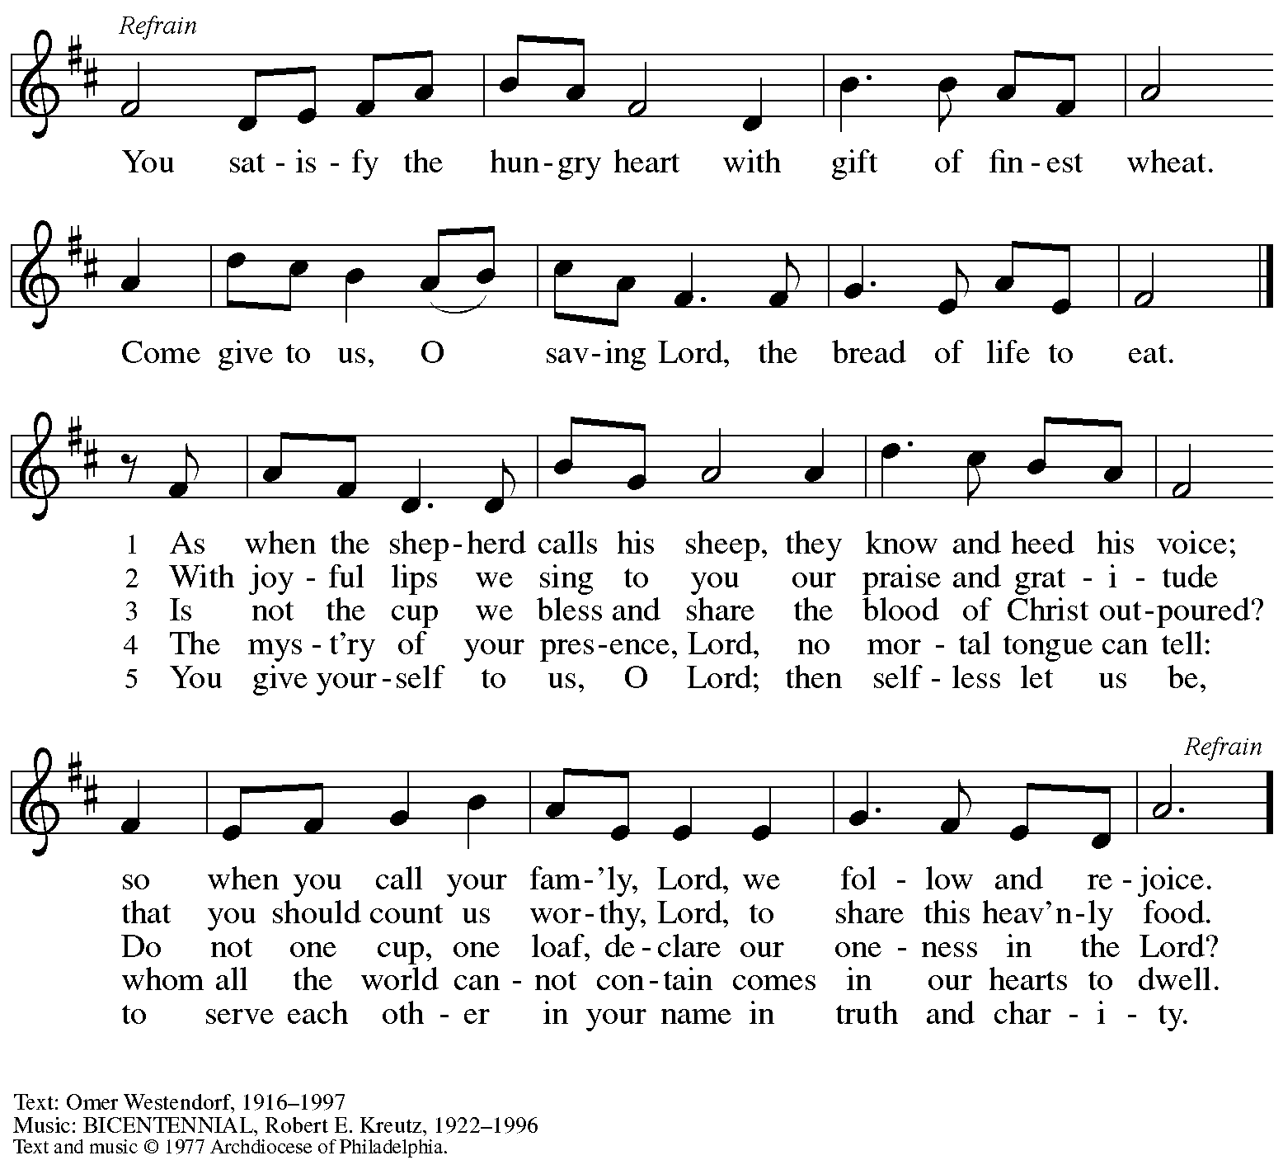
All rights reserved. Reprinted with permission under OneLicense.net # A-722139.

Hymn during Holy Communion
Christ Is Made the Sure Foundation ELW 645

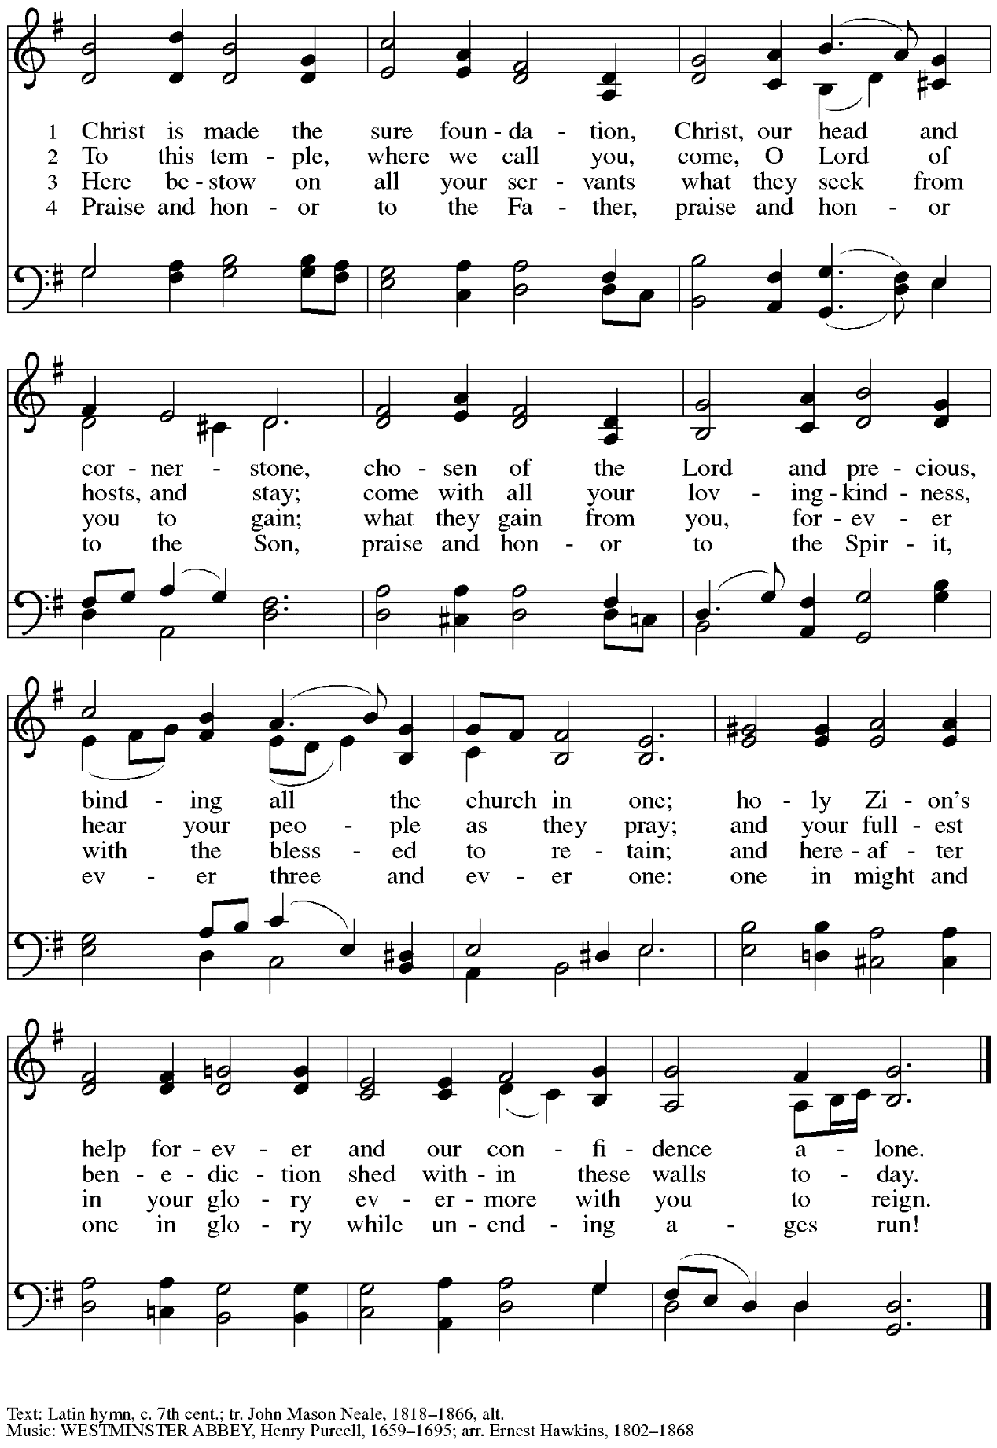

When all have returned to their places, please rise as you are able.

Blessing

P: The body and blood of our Lord Jesus Christ strengthen you and keep you in his grace.
C: Amen.

Prayer

A: Let us pray. Life-giving God,
in the mystery of Christ’s resurrection, you send light to conquer darkness,
water to give new life, and the bread of life to nourish your people.
Send us forth as witnesses to your Son’s resurrection,
that we may show your glory to all the world,
through Jesus Christ, our risen Lord.
C: Amen.

Please be seated.

Sending

Announcements

Please rise as you are able.

Benediction

P: May our glorious God grant you a spirit of wisdom
to know and love the risen Christ.

Almighty God, holy One, ☩ holy Three,
bless you now and forever.
C: Amen.

Sending Hymn Praise the Lord, Rise Up, Rejoicing Following page

Dismissal

A: Alleluia! Christ is risen!
C: Christ is risen indeed! Alleluia! Alleluia!

A: Go in peace. Share the good news!
C: Thanks be to God!

Sending Hymn Praise the Lord, Rise Up, Rejoicing ELW 544

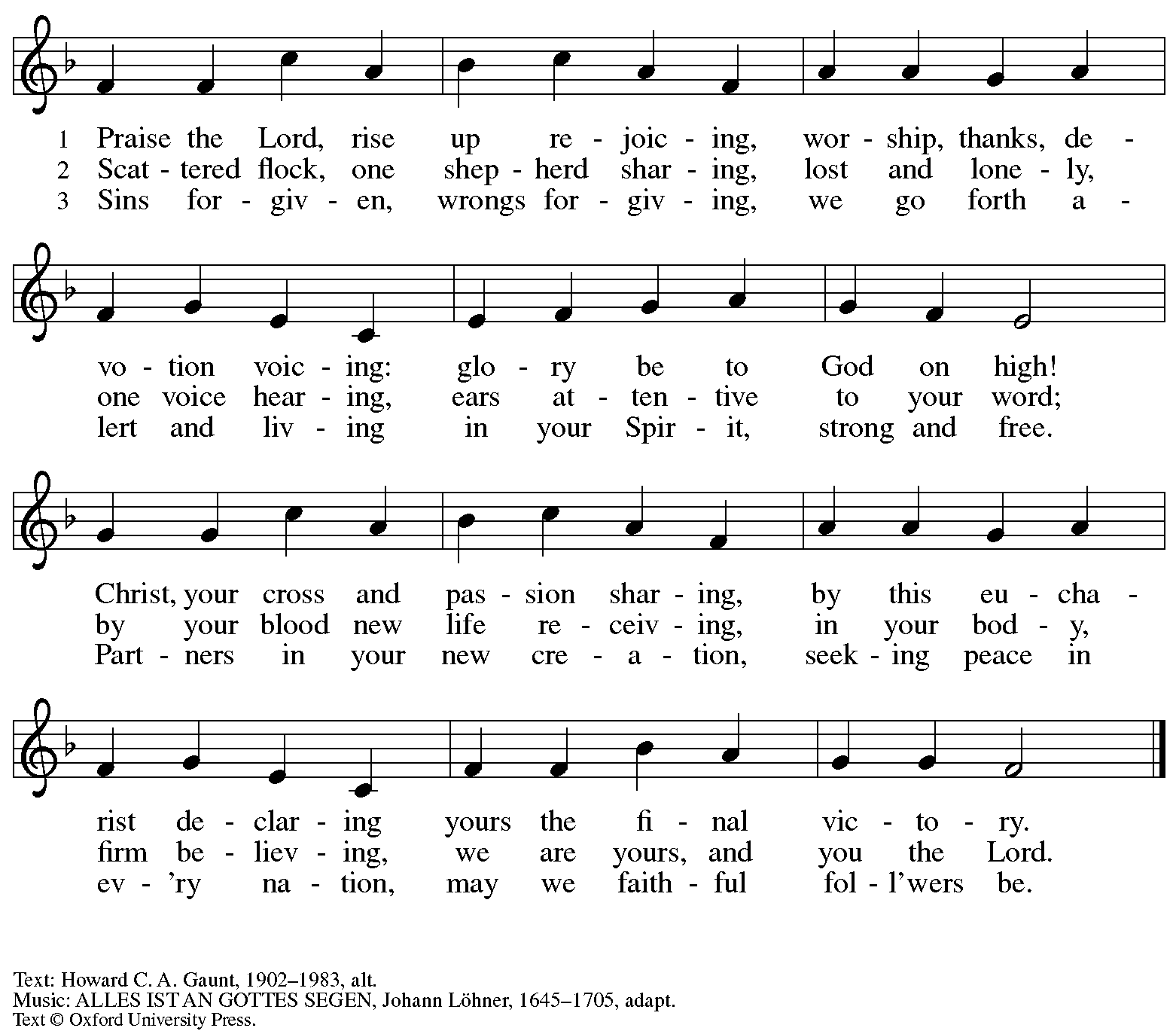
All rights reserved. Reprinted with permission under OneLicense.net # A-722139.

Postlude Celebration Bober

Those serving in worship today

Altar Care Beverley Chapman
Assisting Minister Timothy Kocher-Hillmer
Audio-Visual Ministers Kristen Asplin
Jason Galyardt
Cantor Joy Givens
Lector Michael Chapman
Little Church – Big Faith Leader Emily Duque
Minister of Music Laura Reynolds
Piano on Prelude and Postlude Sarita
Presiding Minister Pastor Ross I. Carmichael

Liturgy and Hymnody Acknowledgements

From SundaysandSeasons.com. Copyright © 2024 Augsburg Fortress. All rights reserved. Reprinted under OneLicense.net # A-722139.
Used by permission of Augsburg Fortress.

Mfurahini, haleluya – Christ Has Arisen, Alleluia – Text: Bernard Kyamanywa, b. 1938; tr. Howard S. Olson, b. 1922.. Music: MFURAHINI, HALELUYA, Tanzanian traditional. Text © 1968 Lutheran Theological College, Makumira, Tanzania, admin. Augsburg Fortress. Tr. © 1977 Howard S. Olson, admin. Augsburg Fortress. All rights reserved. Reprinted with permission under OneLicense.net # A-722139.

Shepherd Me, O God – Text: Marty Haugen, b. 1950, based on Psalm 23. Music: SHEPHERD ME, Marty Haugen. Text and music © 1986 GIA Publications, Inc., 7404 S. Mason Ave., Chicago, IL 60638. www.giamusic.com. 800.442.3358. All rights reserved. Reprinted with permission under OneLicense.net # A-722139.

Let the Vineyards – Text: John W. Arthur, 1922-1980. Music: Ronald A. Nelson, b. 1927. Text and Music © 1978 Lutheran Book of Worship, admin. Augsburg Fortress.

Please use the QR code below to link to St. Andrew’s Announcements online!

St. Andrew Lutheran Church Announcements
April 21st, 2024

- Happy Easter Season! Welcome to Worship at St. Andrew on April 21st, 2024, the Fourth Sunday of Easter! – We are so glad you are here, and we offer a special welcome to all visitors and guests who are here for the first time! Children are invited to participate in Little Church – Big Faith, a Bible lesson and activity, after the prayer of the day. There are worship “toolkits” to help children engage with worship and “busy bags” for younger children available in the bookcase at the back of the sanctuary. Please feel free to take one to use with/for your children. A nursery is available through the door to the left of the worship space and across the social hall (it is a purple-colored room). We pray that everyone has a blessed Easter season!
- “Noisy” Offering during Worship Today – On the third Sunday of each month, St. Andrew invites the children of the congregation to lead us in a “noisy” offering. Children carry buckets around the congregation and people are invited to throw in their change. This month’s noisy offering in association with Earth Day will benefit the Clean Air Council, which seeks to protect everyone’s right to a healthy environment. To learn more about their work please visit https://cleanair.org/.
- A Celebration of Earth Day – Saturday, April 27th at the Church starting at 9:00 a.m. – In connection with Earth Day, we invite you to come to the church starting at 9:00 a.m. on Saturday, April 27th, to plant flowers to decorate our outdoor spaces. Doughnuts, coffee, and necessary supplies will be provided. Gather with us as we make our entrances welcoming with the gifts of God’s natural world.
- Marathon Weekend Worship – Saturday, May 4th, 5:00 p.m., Dinner, 6:00 p.m. Worship; Sunday, May 5th, 10:00 a.m. Worship – The annual Pittsburgh Marathon events are held over the first weekend in May each year. This has often caused issues for St. Andrew and other East End houses of worship that are within the marathon route, especially on Sunday morning. Since some people of St. Andrew live within the route and since there is a way to get to the church by accessing and coming up Bigelow Blvd. St. Andrew still holds worship on that Sunday morning - we will soon post maps to help with this navigation. This year we will also offer an opportunity to gather on Saturday, May 4th, for dinner in the social hall at 5:00 p.m. and hold a worship service at 6:00 p.m. Please watch for more information in the upcoming bulletins and emails.
- Lutheran Day in the Capitol – May 9th – Pastor Martin Rafanan of St. Andrew to Be Honored – Dear Saints of St. Andrew Lutheran Church,
Lutheran Advocacy Ministry in Pennsylvania is pleased to share that the Rev. Dr. Martin Rafanan, will be recognized on May 9th with the "Serve.Pray.Speak." award in recognition of his devotion to service and justice, following the example of Jesus. He
was nominated by Bishop Kusserow of the Southwestern Pennsylvania Synod and will be recognized at our 45th anniversary celebration along with advocates from every synod in Pennsylvania on the evening of our annual Lutheran Day in the Capitol. We invite you to join us in Harrisburg for a day of education, advocacy, and inspiration as we gather as church together for the sake of the world God loves. Register here for the whole day, or join us for the evening celebration. We hope to see you there!
Tracey DePasquale
Director, Lutheran Advocacy Ministry in Pennsylvania
- Bethel AME Church Juneteenth Celebrations – Sunday, June 16th, 11:00 a.m. and 2:00 p.m. – Bethel AME Church in the Hill District (2720 Webster Ave, 15219), with whom the St. Andrew congregation and our Southwestern Pennsylvania (SWPA) Synod have been in relationship with for the past several years, will host Juneteenth celebrations on Sunday, June 16th, with Bishop Kurt F. Kusserow of the SWPA Synod as the speaker at the 11:00 a.m. service and with Bishop Errenous E. McCloud of the AME Church as the speaker at the 2:00 p.m. service. Bethel invites you, your church choir, or your affiliated choir to join in a sing along. Thursdays will be rehearsal days if there are enough singers. Please watch for information on rehearsal times.
- Compline Prayer Service, a Ministry of Lutheran Campus Ministry in Greater Pittsburgh, Sundays at 8:00 p.m. at Heinz Chapel – Compline was traditionally a monastic prayer service, and the Pittsburgh Compline Choir sings a choral version of compline rooted in this thousand-year-old tradition of scripture, song, and silence. This service is also streamed on Facebook (Pittsburgh Compline Choir) and YouTube (The Pittsburgh Compline Choir). Heinz Chapel is located off of S. Bellefield Ave. in Oakland.

