+ Fifth Sunday of Easter
April 28, 2024
St. Andrew Lutheran Church
304 Morewood Ave.
Pittsburgh, PA 15213
St_andrewELCA@verizon.net
www.standrewpittsburgh.org

+ Fifth Sunday of Easter
Order for Worship

This Sunday’s Gospel uses the image of a vine to describe how the risen Christ shares his life with us. Christ the vine and we the branches are alive in each other, in the mystery of mutual abiding described in the gospel and the first letter of John. Baptism makes us a part of Christ’s living and life-giving self and makes us alive with Christ’s life. As the vine brings food to the branches, Christ feeds us at his table. We are sent out to bear fruit for the life of the world.

Welcome to St. Andrew!
- St. Andrew Lutheran congregation welcomes all who are seeking a place of healing and wholeness – a nurturing, faith-forming spiritual home. Our community embraces people of all ages, ethnicities, cultures, abilities, sexual orientations, gender identities and expressions, and family constellations. Come and See!
- Worship Services are live streamed to multiple online platforms. By attending worship, you agree that your image and voice may be broadcast.
- Everyone is invited to make a name tag at the black bookcase in the back of the worship space if they would like. There are stickers indicating pronouns on the bookcase if you would like to include them on your name tag.
- A nursery is available through the doors at the left side of the sanctuary and across from the doorway to the Social Hall. It is a purple-colored room.
- Children are invited to attend Little Church – Big Faith, a Bible lesson and activity, during worship (after the Prayer of the Day). The group returns to the worship space for the liturgy of Holy Communion.
- Worship “toolkits” to help children engage with the service, along with “busy bags” for younger children, are available in the bookcase at the back of the sanctuary. Please feel free to take one to use with/for your children.
- Holy Communion is served with bread (gluten-free available) and wine or grape juice. The presiding minister will distribute the bread (host). Please consume this and then pick up an empty glass from the tray. The Communion Assistant will pour wine or grape juice into your glass. Please step to the side to consume the wine or grape juice. Feel free to kneel at the altar for prayer and reflection. As you return to your pew, glasses may be returned to the empty trays on either side of the center section.
- A restroom is available on the main level of the church, through the doors to the Social Hall and to the right in the main office.

Abbreviations
P: Pastor/Presiding Minister ELW: Evangelical Lutheran Worship hymnal
A: Assisting Minister ACS: All Creation Sings hymnal
L: Lector CBM: Come, Beloved of the Maker hymnal
C: Congregation TFF: This Far by Faith hymnal
HS: Hymnal Supplement (GIA Publications)

Pre-Service Music

Welcome

Prelude Op. 39, No. 15 J. Brahms

Gathering
The Holy Spirit calls us together as the people of God

Please rise as you are able. All may make the sign of the cross,
the sign that is marked at Baptism, as the presiding minister begins.

Confession and Forgiveness

P: Blessed be the holy Trinity, ☩ one God,
who creates, redeems, and sustains us and all of creation.
C: Amen.

P: Let us confess our sin in the presence of God and one another.

Silence is kept for reflection.

P: Most merciful God,
we confess that we are captive to sin and cannot free ourselves.
We have sinned against you in thought, word, and deed,
by what we have done and by what we have left undone.
We have not loved you with our whole heart;
we have not loved our neighbors as ourselves.
For the sake of your Son, Jesus Christ, have mercy on us.
Forgive us, renew us, and lead us,
so that we may delight in your will
and follow in your ways,
to the glory of your holy name.
Amen.

P: By water and the Holy Spirit God gives you a new birth,
and through the death and resurrection of ☩ Jesus Christ,
God forgives you all your sins.
The God of mercy and might strengthen you in all goodness
and keep you in eternal life.
C: Amen.

Gathering Hymn Alleluia! Jesus Is Risen! ELW 377

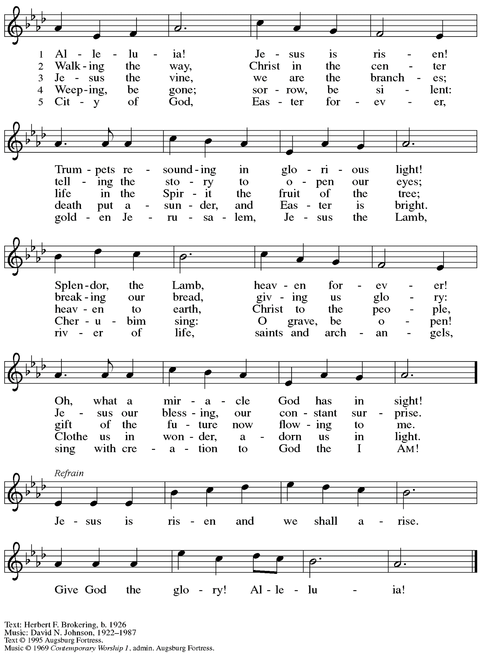
All rights reserved. Reprinted with permission under OneLicense.net # A-722139.
Greeting

P: The grace of our Lord Jesus Christ, the love of God,
and the communion of the Holy Spirit be with you all.
C: And also with you.

Hymn of Praise This Is the Feast ELW p. 149-150

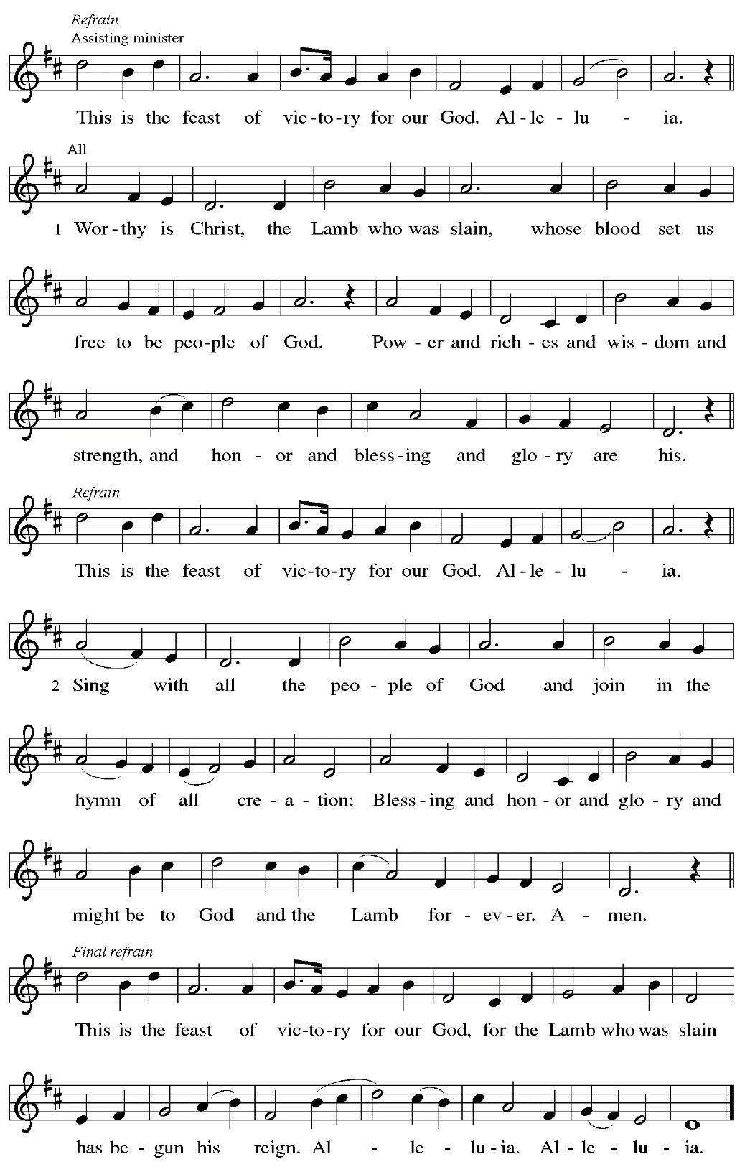

Prayer of the Day

P: The Lord be with you.
C: And also with you.

P: Let us pray.
O God, you give us your Son as the vine apart from whom we cannot live.
Nourish our life in his resurrection, that we may bear the fruit of love
and know the fullness of your joy, through Jesus Christ, our Savior and Lord,
who lives and reigns with you and the Holy Spirit, one God, now and forever.
C: Amen.

Please be seated.

Word
God speaks to us in Scripture reading, preaching, and song

First Reading – Acts 8: 26-40

²⁶An angel of the Lord said to Philip, “Get up and go toward the south to the road that goes down from Jerusalem to Gaza.” (This is a wilderness road.) ²⁷So he got up and went. Now there was an Ethiopian eunuch, a court official of the Candace, queen of the Ethiopians, in charge of her entire treasury. He had come to Jerusalem to worship ²⁸and was returning home; seated in his chariot, he was reading the prophet Isaiah. ²⁹Then the Spirit said to Philip, “Go over to this chariot and join it.” ³⁰So Philip ran up to it and heard him reading the prophet Isaiah. He asked, “Do you understand what you are reading?” ³¹He replied, “How can I, unless someone guides me?” And he invited Philip to get in and sit beside him. ³²Now the passage of the scripture that he was reading was this:
“Like a sheep he was led to the slaughter,
and like a lamb silent before its shearer,
so he does not open his mouth.
³³In his humiliation justice was denied him.
Who can describe his generation?
For his life is taken away from the earth.”
³⁴The eunuch asked Philip, “About whom, may I ask you, does the prophet say this, about himself or about someone else?” ³⁵Then Philip began to speak, and starting with this scripture, he proclaimed to him the good news about Jesus. ³⁶As they were going along the road, they came to some water; and the eunuch said, “Look, here is water! What is to prevent me from being baptized?” ³⁸He commanded the chariot to stop, and both of them, Philip and the eunuch, went down into the water, and Philip baptized him. ³⁹When they came up out of the water, the Spirit of the Lord snatched Philip away; the eunuch saw him no more, and went on his way rejoicing.
⁴⁰But Philip found himself at Azotus, and as he was passing through the region, he proclaimed the good news to all the towns until he came to Caesarea.

L: Word of God, word of life.
C: Thanks be to God.

Psalm 22: 25-31

The cantor will lead the singing of the psalm.
The congregation is invited to respond with the alternate verses in bold print,
and to join in singing the refrain.

Psalm tone

Psalm refrain

²⁵From you comes my praise in the | great assembly;
I will perform my vows in the sight of those who | fear the Lord.
²⁶The poor shall eat | and be satisfied,
Let those who seek the Lord give praise! May your hearts | live forever!
²⁷All the ends of the earth shall remember and turn | to the Lord;
all the families of nations shall bow | before God.
²⁸For dominion belongs | to the Lord,
who rules o- | ver the nations. R
²⁹Indeed, all who sleep in the earth shall bow | down in worship;
all who go down to the dust, though they be dead, shall kneel be- | fore the Lord.
³⁰Their descendants shall | serve the Lord,
whom they shall proclaim to genera- | tions to come.
³¹They shall proclaim God’s deliverance to a people | yet unborn,
saying to them, “The | Lord has acted!” R

Second Reading – 1 John 4: 7-21

⁷Beloved, let us love one another, because love is from God; everyone who loves is born of God and knows God. ⁸Whoever does not love does not know God, for God is love. ⁹God’s love was revealed among us in this way: God sent God’s only Son into the world so that we might live through him. ¹⁰In this is love, not that we loved God but that God loved us and sent God’s Son to be the atoning sacrifice for our sins. ¹¹Beloved, since God loved us so much, we also ought to love one another. ¹²No one has ever seen God; if we love one another, God lives in us, and God’s love is perfected in us.
¹³By this we know that we abide in God and God in us, because God has given us of God’s Spirit. ¹⁴And we have seen and do testify that the Father has sent his Son as the Savior of the world. ¹⁵God abides in those who confess that Jesus is the Son of God, and they abide in God. ¹⁶So we have known and believe the love that God has for us.
God is love, and those who abide in love abide in God, and God abides in them. ¹⁷Love has been perfected among us in this: that we may have boldness on the day of judgment, because as God is, so are we in this world. ¹⁸There is no fear in love, but perfect love casts out fear; for fear has to do with punishment, and whoever fears has not reached perfection in love. ¹⁹We love because God first loved us. ²⁰Those who say, “I love God,” and hate their siblings, are liars; for those who do not love a sibling whom they have seen, cannot love God whom they have not seen. ²¹The commandment we have from God is this: those who love God must love their siblings also.

L: Word of God, word of life.
C: Thanks be to God.

Please rise as you are able.

Gospel Acclamation ELW p. 151

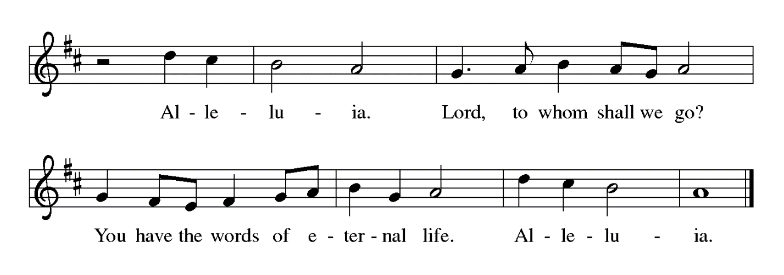

Gospel – John 15: 1-8

P: The holy Gospel according to St. John.
C: Glory to you, O Lord.

[Jesus said:] ¹“I am the true vine, and my Father is the vinegrower. ²He removes every branch in me that bears no fruit. Every branch that bears fruit he prunes to make it bear more fruit. ³You have already been cleansed by the word that I have spoken to you. ⁴Abide in me as I abide in you. Just as the branch cannot bear fruit by itself unless it abides in the vine, neither can you unless you abide in me. ⁵I am the vine, you are the branches. Those who abide in me and I in them bear much fruit, because apart from me you can do nothing. ⁶Whoever does not abide in me is thrown away like a branch and withers; such branches are gathered, thrown into the fire, and burned. ⁷If you abide in me, and my words abide in you, ask for whatever you wish, and it will be done for you. ⁸My Father is glorified by this, that you bear much fruit and become my disciples.

P: The Gospel of the Lord.
C: Praise to you, O Christ.

Please be seated.

Sermon

A time of silence for prayer and reflection follows the sermon.
When the hymn of the day begins, please rise as you are able.

Hymn of the Day Beloved and Most Loving Source Following page

Hymn of the Day Beloved and Most Loving Source CBM 61

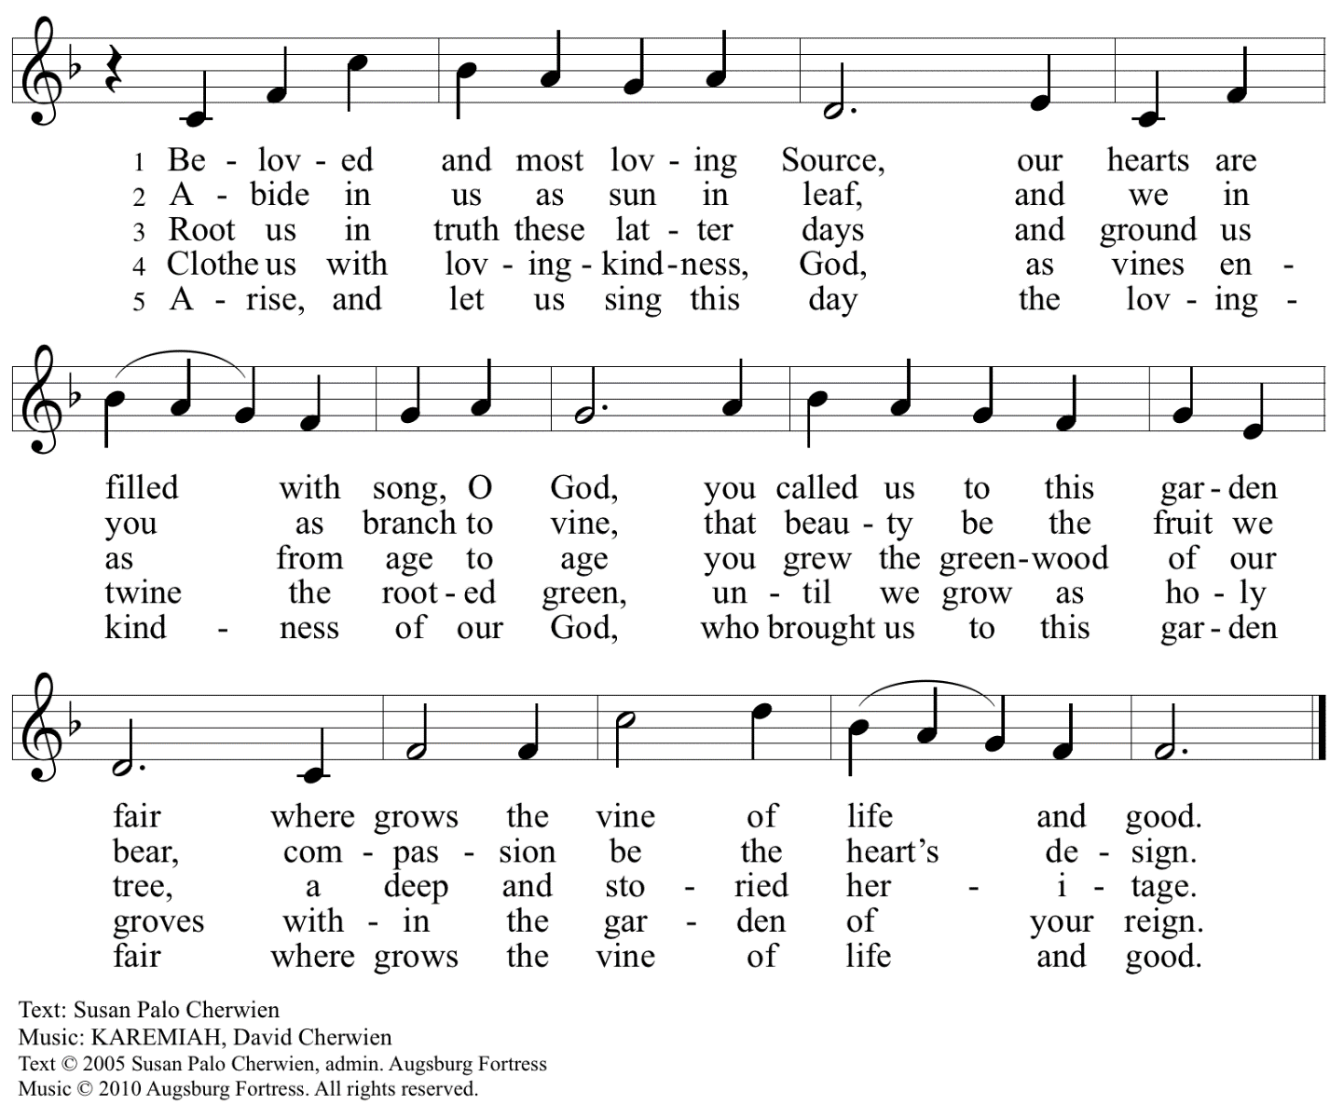
Reprinted with permission under OneLicense.net # A-722139.

Nicene Creed

P: Together, in the joy of the resurrection, we profess our faith:
C: We believe in one God,
the Father, the Almighty,
maker of heaven and earth,
of all that is, seen and unseen.

We believe in one Lord, Jesus Christ,
the only Son of God,
eternally begotten of the Father,
God from God, Light from Light,
true God from true God,
begotten, not made,
of one Being with the Father;
through him all things were made.
For us and for our salvation
he came down from heaven,
was incarnate of the Holy Spirit and the virgin Mary
and became truly human.
For our sake he was crucified under Pontius Pilate;
he suffered death and was buried.
On the third day he rose again
in accordance with the scriptures;
he ascended into heaven
and is seated at the right hand of the Father.
He will come again in glory to judge the living and the dead,
and his kingdom will have no end.

We believe in the Holy Spirit, the Lord, the giver of life,
who proceeds from the Father and the Son,*
who with the Father and the Son is worshiped and glorified,
who has spoken through the prophets.
We believe in one holy catholic and apostolic church.
We acknowledge one baptism for the forgiveness of sins.
We look for the resurrection of the dead,
and the life of the world to come. Amen.

*Or, “who proceeds from the Father.” The phrase “and the Son” is a later addition to the creed.

Prayers of the People

A: United in the joy and hope of the resurrection, let us pray for the church, the world,
and all who are in need.

After each petition
A: Gracious God,
C: receive our prayer.

The presiding minister concludes the prayers
P: We lift these prayers to you most merciful God, trusting in your abiding love;
through Jesus Christ, our risen and living Savior.
C: Amen.

Peace

The presiding minister and the assembly greet one another in the peace of the risen Christ.
P: The peace of Christ be with you always.
C: And also with you.

The people may greet those around them with a sign of Christ’s peace and may say
Peace be with you or similar words. Please be mindful that not everyone will be comfortable with sharing the peace, so please seek consent before shaking hands or hugging. Other possible ways to share the peace include a simple bow with the verbal greeting of peace, or simply a verbal expression of peace.

When the greetings of peace have concluded, please be seated.

Meal

Offering

We offer ourselves, our gifts, and our faithful service to God.
As the offering is gathered for the mission of the church, including the care of those in need,
the table is set for Holy Communion.

Offertory Music Great Is Thy Faithfulness arr. P. Keveren

As the gifts are brought forward for presentation, please rise as you are able.

Offertory Song Let the Vineyards ELW 184

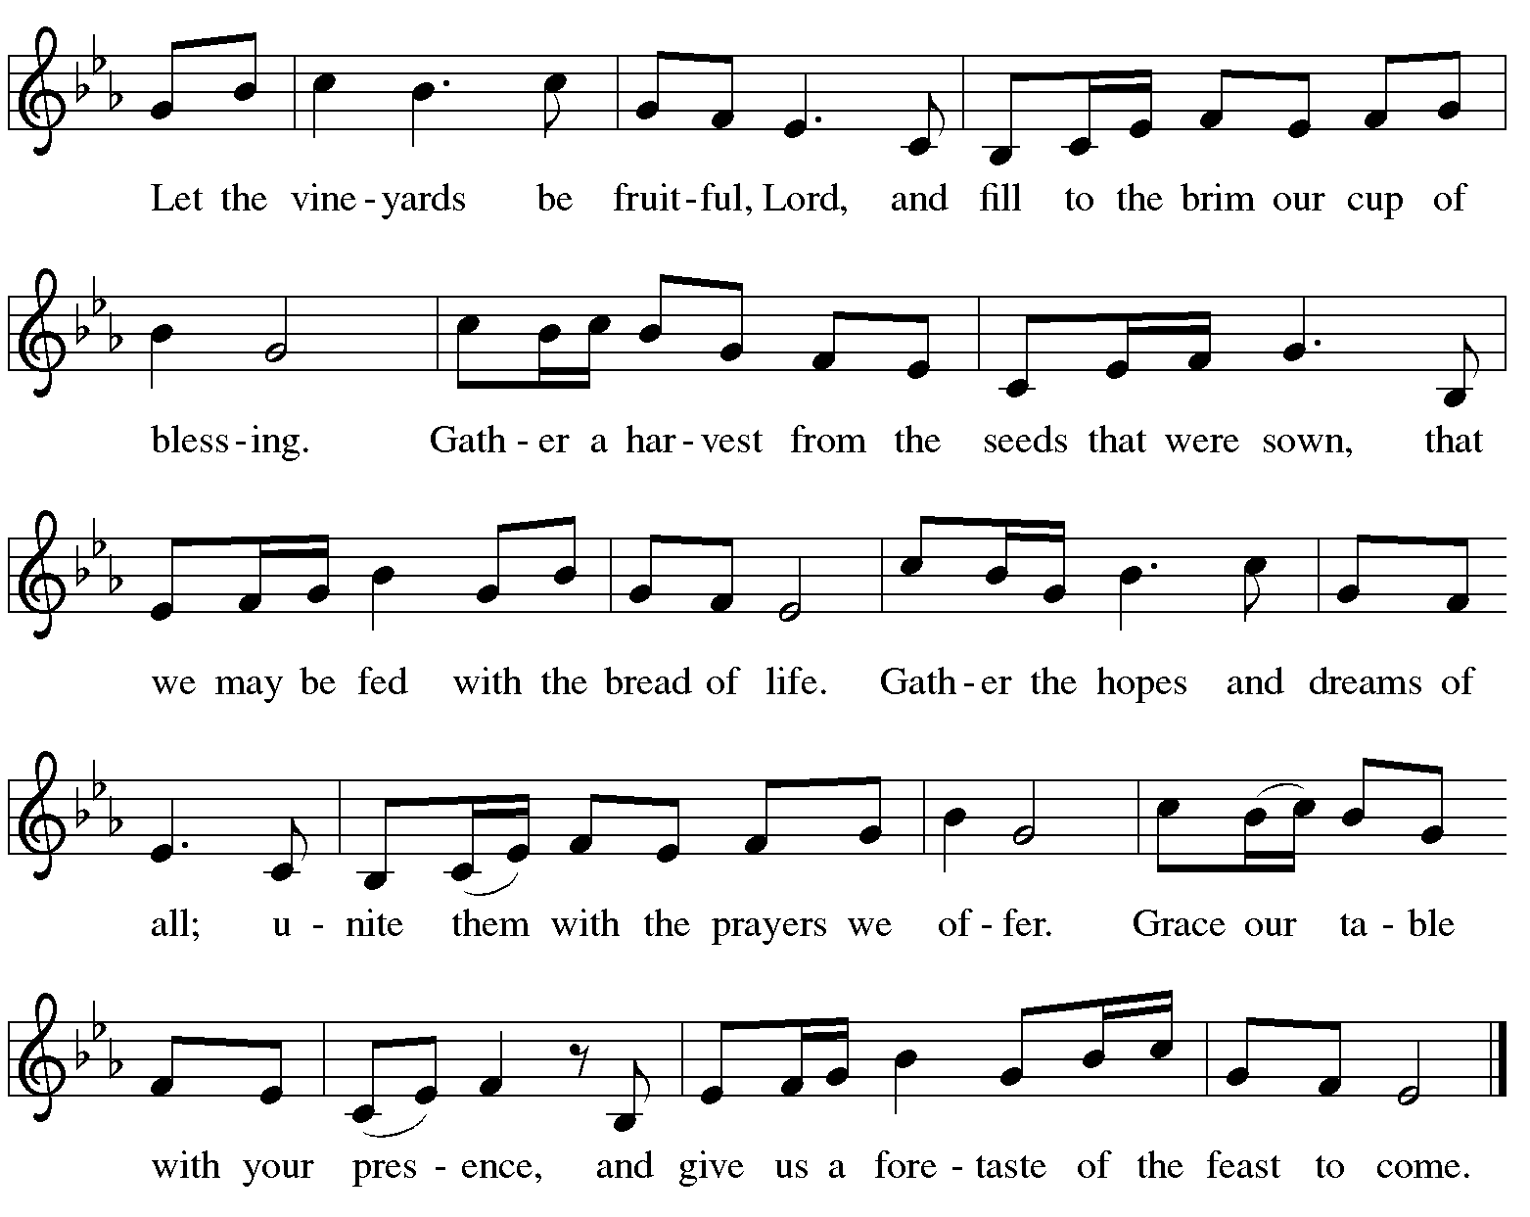

Offertory Prayer

A: Let us pray.
Blessed are you,
C: O God, ruler of heaven and earth.
Day by day you shower us with blessings.
As you have raised us to new life in Christ,
give us glad and generous hearts,
ready to praise you and to respond to those in need,
through Jesus Christ, our Savior and Lord.
Amen.

Dialogue ELW p. 152

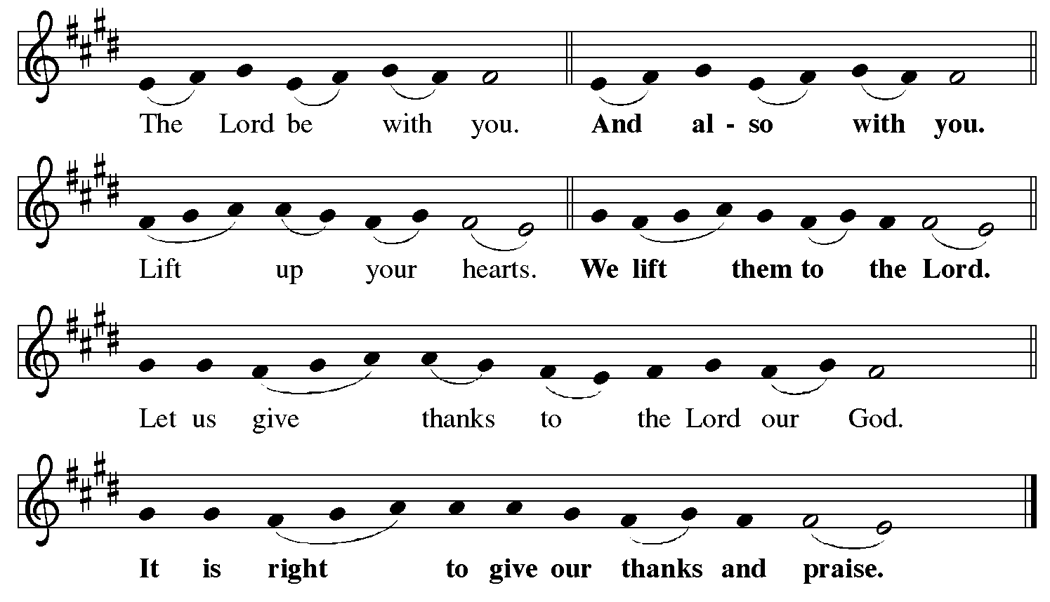

Preface (Sung by the presiding minister)

P: It is indeed right, our duty and our joy,
that we should at all times and in all places
give thanks and praise to you, almighty and merciful God,
for the glorious resurrection of our Savior Jesus Christ,
the true Paschal Lamb who gave himself to take away our sin;
who in dying has destroyed death,
and in rising has brought us to eternal life.
And so, with Mary Magdalene and Peter
and all the witnesses of the resurrection,
with earth and sea and all their creatures,
and with angels and archangels, cherubim and seraphim,
we praise your name and join their unending hymn:

Sanctus ELW p. 153

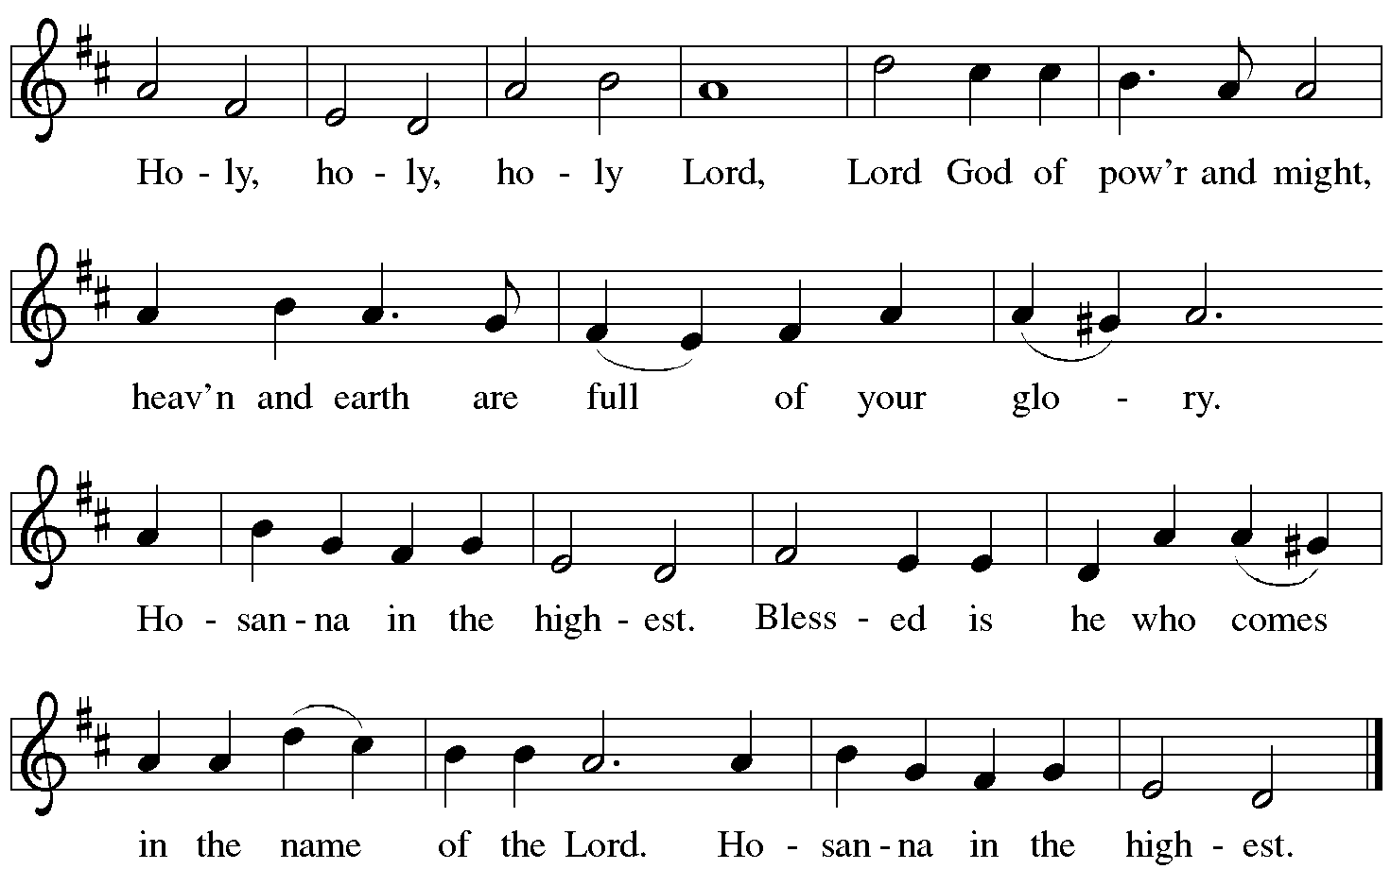

Eucharistic Prayer

P: Blessed are you, O God of the universe …
Do this for the remembrance of me.

With this bread and cup,
we remember our Lord’s passover from death to life
as we proclaim the mystery of faith:
C: Christ has died. Christ is risen. Christ will come again.

P: O God of resurrection and new life …
Grace our table with your presence.
C: Come, Holy Spirit.

P: Reveal yourself to us in the breaking of the bread …
Send us forth, burning with justice, peace, and love.
C: Come, Holy Spirit.

P: With your holy ones of all times and places,
with the earth and all its creatures,
with sun and moon and stars,
we praise you, O God,
blessed and holy Trinity,
now and forever.
C: Amen.

Lord’s Prayer

P: Gathered as one by the Holy Spirit, let us pray as Jesus taught us.
C: Our Father in heaven,
hallowed be your name,
your kingdom come,
your will be done,
on earth as in heaven.
Give us today our daily bread.
Forgive us our sins
as we forgive those
who sin against us.
Save us from the time of trial
and deliver us from evil.
For the kingdom, the power,
and the glory are yours,
now and forever. Amen.

Fraction and Invitation

P: Alleluia! Christ is risen!
C: Christ is risen indeed! Alleluia! Alleluia!

P: This is the feast of victory for our God. Alleluia! Alleluia!
Come, share the feast.

Agnus Dei / Lamb of God Following Page

Agnus Dei / Lamb of God ELW p. 154

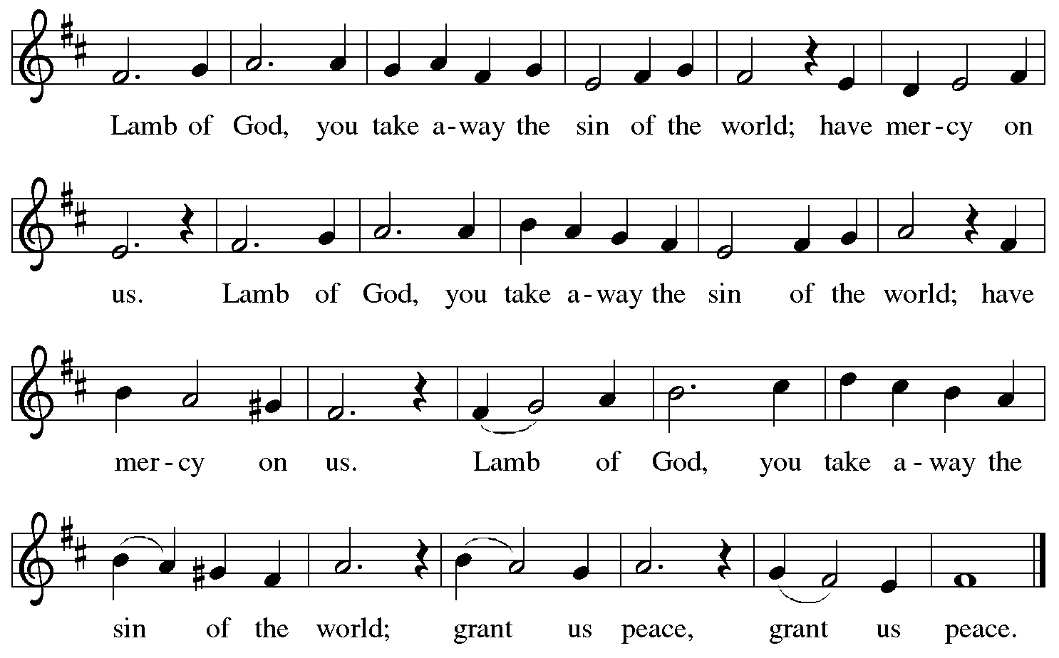

Please be seated.

Holy Communion
- All who seek God and desire a deeper and stronger life in Christ are welcome to receive Holy Communion.
- Worshipers from the pulpit side will proceed forward first, followed by the center section, and then the lectern side.
- Please inform an usher if you would like the ministers to bring Communion to you.
- Holy Communion will be served with bread and wine/grape juice.
- The presiding minister will first distribute the bread (host) to each communicant. Please indicate if you require a gluten-free host.
- Once you have consumed the bread, please pick up an empty glass from the tray next to the presiding minister. The Communion Assistant will pour wine from the chalice or grape juice from the cruet into your glass.
- Please step to the side to consume the wine or grape juice.
- Feel free to kneel at the altar rail for prayer after receiving the sacrament.
- As you return to your pew, glasses may be returned to the empty trays on either side of the center aisle.
- A blessing will be provided for anyone who does not yet receive the sacrament.
- All are invited to join in singing the hymns during Holy Communion.
Hymn during Holy Communion
Lord, I Hear of Showers of Blessings TFF 120

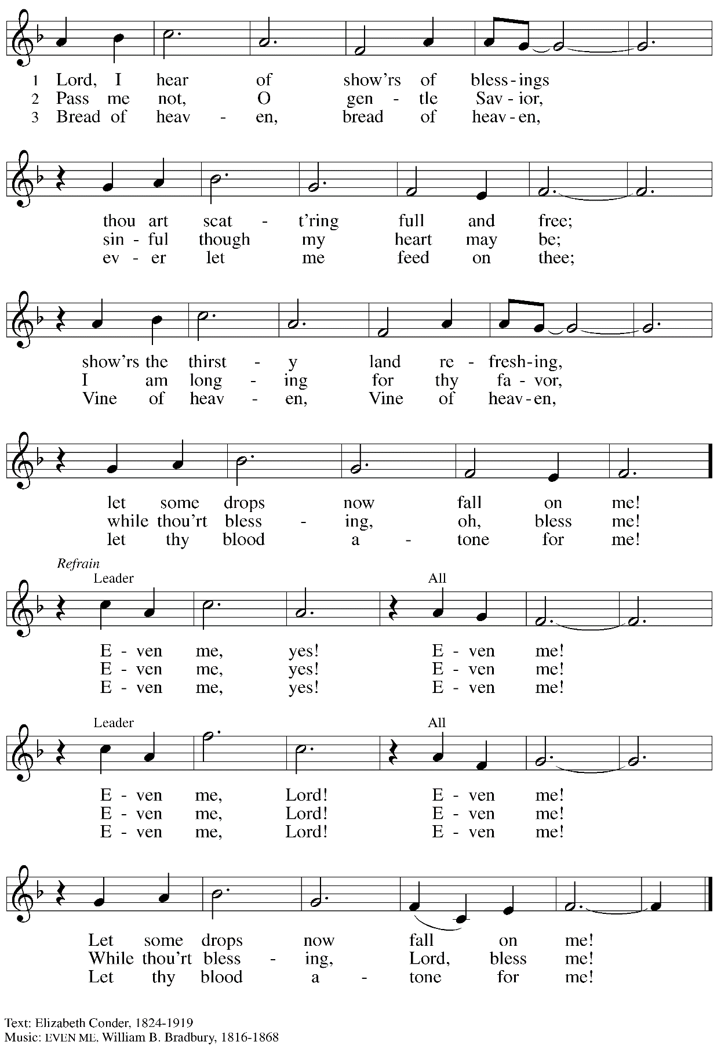

Hymn during Holy Communion
Now the Green Blade Rises ELW 379

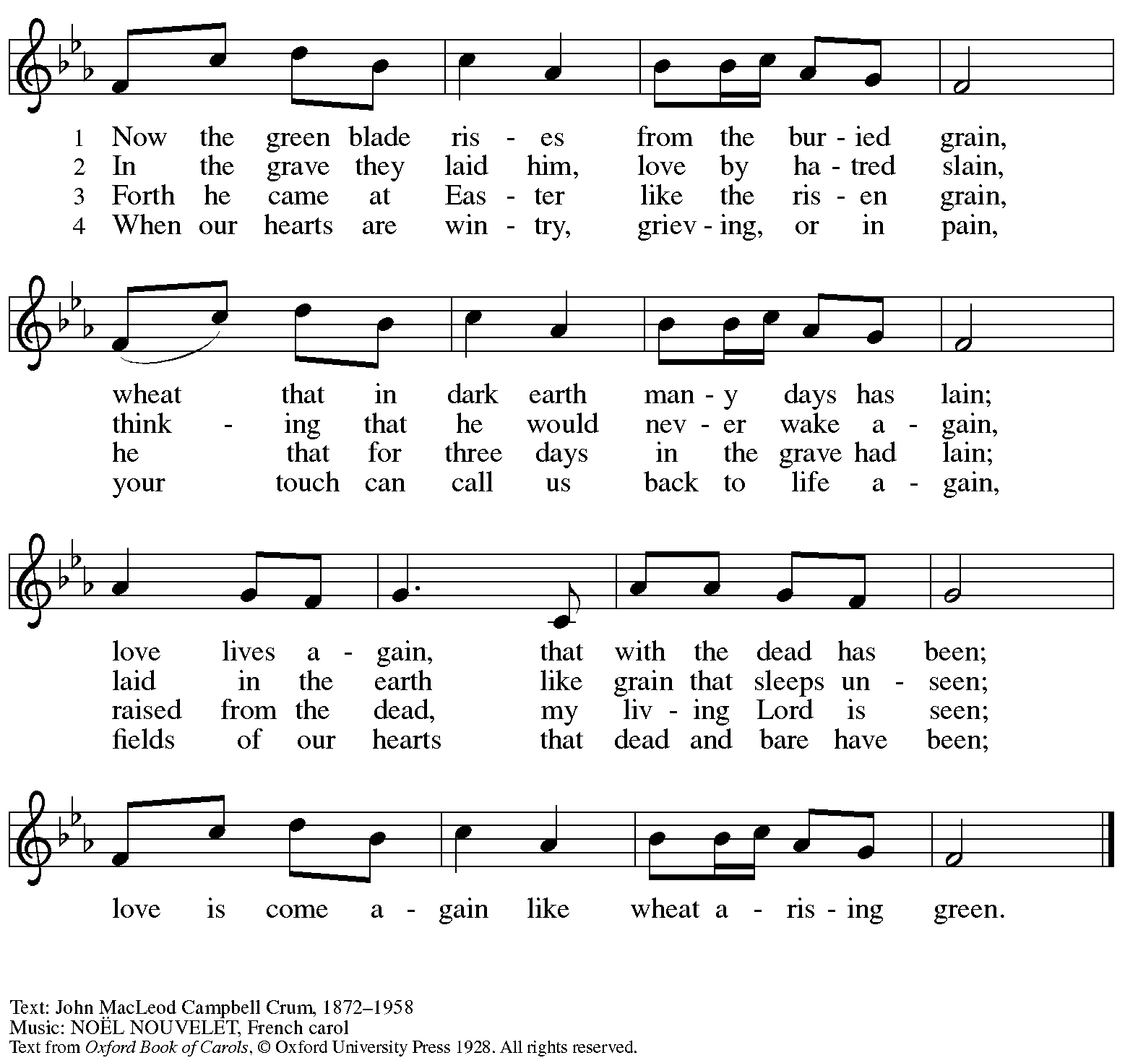
Reprinted with permission under OneLicense.net # A-722139.

Hymn during Holy Communion
Abide with Me ELW 629

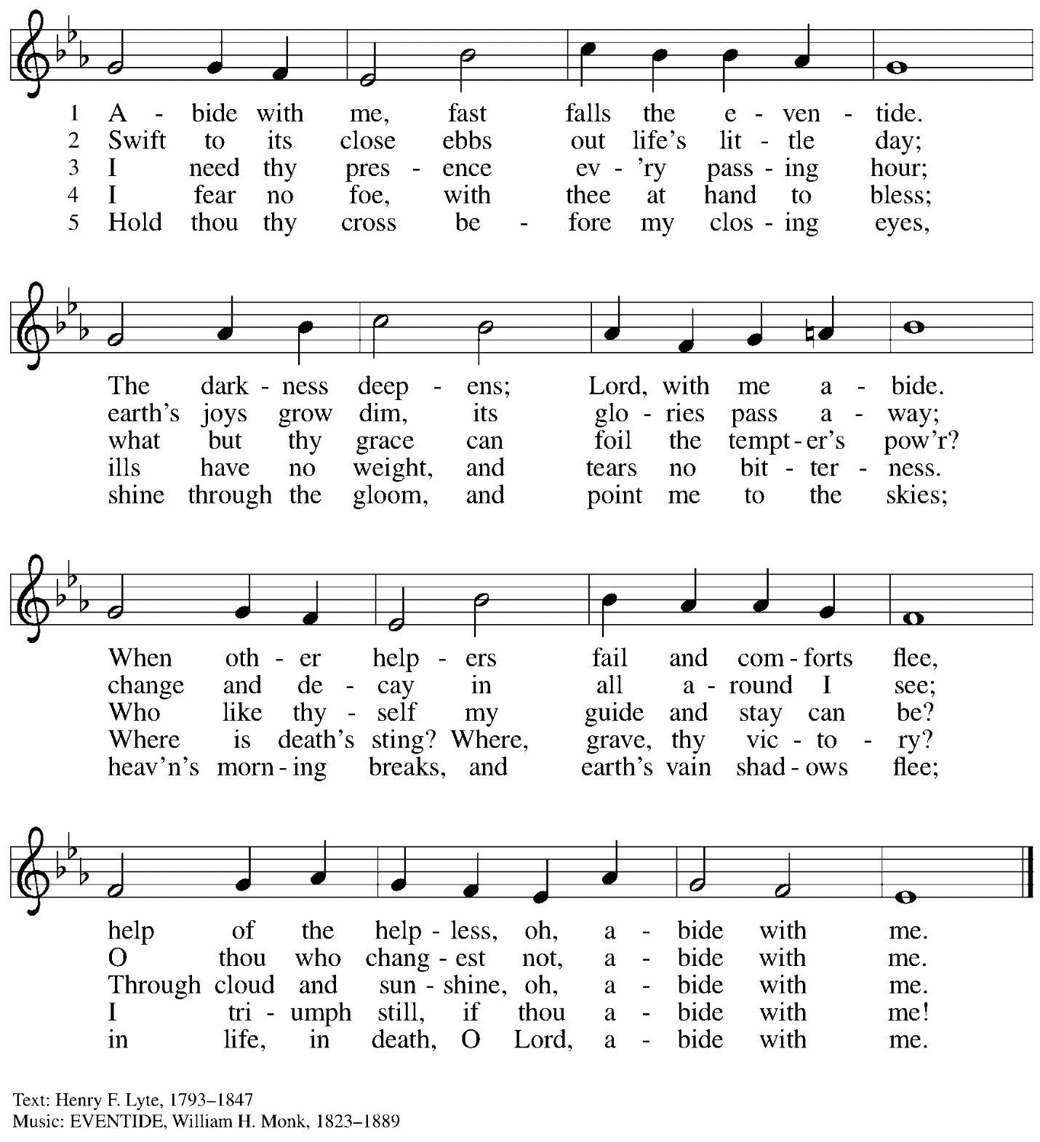

When all have returned to their places, please rise as you are able.

Blessing

P: The body and blood of our Lord Jesus Christ strengthen you and keep you in his grace.
C: Amen.

Prayer

A: Let us pray. Life-giving God,
in the mystery of Christ’s resurrection, you send light to conquer darkness,
water to give new life, and the bread of life to nourish your people.
Send us forth as witnesses to your Son’s resurrection,
that we may show your glory to all the world,
through Jesus Christ, our risen Lord.
C: Amen.

Please be seated.

Sending

Announcements

Please rise as you are able.

Farewell and Godspeed

The congregation is invited to join in signing St. Andrew’s congregational refrain.

Congregational Refrain HS 808

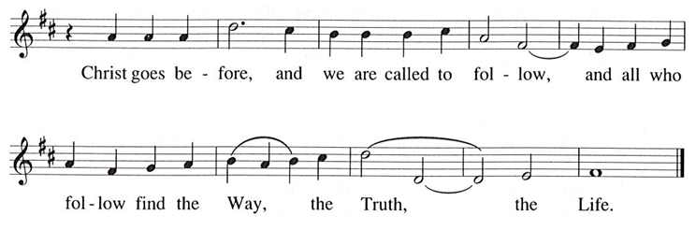

Benediction

P: May our glorious God grant you a spirit of wisdom
to know and love the risen Christ.

Almighty God, holy One, ☩ holy Three,
bless you now and forever.
C: Amen.

Sending Hymn We Know That Christ Is Raised ELW 449

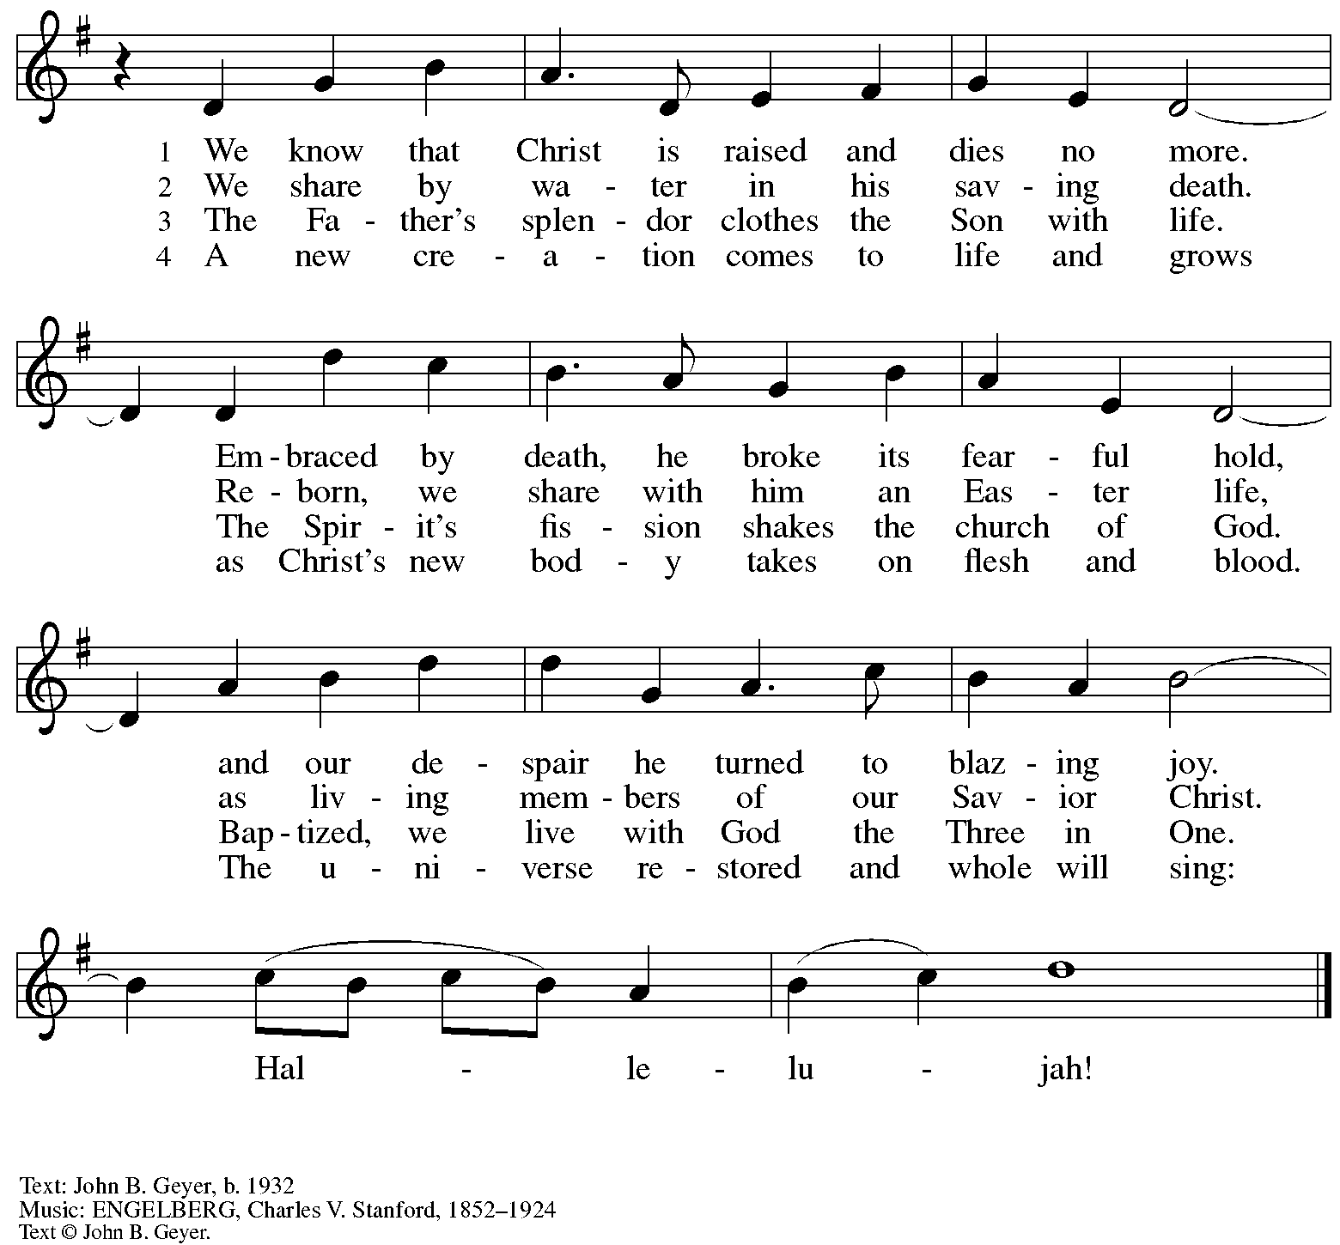
All rights reserved. Reprinted with permission under OneLicense.net # A-722139.

Dismissal

A: Alleluia! Christ is risen!
C: Christ is risen indeed! Alleluia! Alleluia!

A: Go in peace. Share the good news!
C: Thanks be to God!

Postlude With Shouts of Praise J. Krug

Those serving in worship today

Altar Care Jodie Minor
Audio-Visual Ministers Tyler Rietze
Joseph Paetz
Cantor Marit Bakken
Lector Lindsay Baxter
Little Church – Big Faith Leader Emily Duque
Minister of Music Laura Reynolds
Presiding Minister Pastor Ross I. Carmichael

Liturgy and Hymnody Acknowledgements

From SundaysandSeasons.com. Copyright © 2024 Augsburg Fortress. All rights reserved. Reprinted under OneLicense.net # A-722139.
Used by permission of Augsburg Fortress.

Let the Vineyards – Text: John W. Arthur, 1922-1980. Music: Ronald A. Nelson, b. 1927. Text and Music © 1978 Lutheran Book of Worship, admin. Augsburg Fortress.

Please use the QR code below to link to St. Andrew’s Announcements online!

St. Andrew Lutheran Church Announcements
April 28th, 2024

- Happy Easter Season! Welcome to Worship at St. Andrew on April 28th, 2024, the Fifth Sunday of Easter! – We are so glad you are here, and we offer a special welcome to all visitors and guests who are here for the first time! Children are invited to participate in Little Church – Big Faith, a Bible lesson and activity, after the prayer of the day. There are worship “toolkits” to help children engage with worship and “busy bags” for younger children available in the bookcase at the back of the sanctuary. Please feel free to take one to use with/for your children. A nursery is available through the door to the left of the worship space and across the social hall (it is a purple-colored room). All are invited to a time of coffee and conversation in the social hall after worship. We pray that everyone has a blessed Easter season!
- Farewell and Godspeed to Rija and Kikao – Rija and Kikao have been attending St. Andrew for the past few months during Rija’s time as visiting researcher at Duquesne University and they will soon be leaving Pittsburgh. We have appreciated their presence and generosity in their time with St. Andrew, especially for preparing a wonderful meal made up of foods from Madagascar for St. Andrew’s congregational meeting in March. As they move on to new endeavors, we bid them farewell and Godspeed during worship today. We encourage the congregation to stay for coffee hour after worship and take the opportunity to wish them well!
- Donate Geraniums for Pentecost! – On the festival of Pentecost, for which the liturgical color is red, the congregation often decorates the worship space with geraniums. This year, Pentecost is on Sunday, May 19th. St. Andrew will be purchasing geraniums in 4-inch pots for $6.00 each and they can be dedicated “in memory of,” “in honor of,” “in thanks for,” etc. Please submit your orders by Sunday, May 5th, using the following signup link: https://www.signupgenius.com/go/5080B4AAFAF2CABF85-49168876-pentecost. Payments can be made at our website, standrewpittsburgh.org, or through the Sunday offering plates with the label “Pentecost Flowers.”
- Marathon Weekend Worship – Saturday, May 4th, 5:00 p.m. Dinner, 6:00 p.m. Worship; Sunday, May 5th, 10:00 a.m. Worship – The annual Pittsburgh Marathon events are held over the first weekend in May each year. This has often caused issues for St. Andrew and other East End houses of worship that are within the marathon route, especially on Sunday morning. Since some people of St. Andrew live within the route and since there is a way to get to the church by accessing and coming up Bigelow Blvd., St. Andrew still holds worship on that Sunday morning. This year we will also offer an opportunity to gather on Saturday, May 4th, for a potluck dinner in the social hall at 5:00 p.m., with worship following at 6:00 p.m. If you plan to bring a dish for the dinner, please indicate what you are bringing at the signup link so we can ensure we have enough food: https://www.signupgenius.com/go/5080B4AAFAF2CABF85-49169316-marathon.
Please see the map in the Friday email for details on Marathon and travel routes.
- Monthly Produce Distribution – Tuesday, May 7th, 5:30-7:00 p.m. – St. Andrew’s monthly distribution of fresh produce (in partnership with Greater Pittsburgh Community Food Bank) will be Tuesday, May 7th, from 5:30-7:00 p.m. We would also appreciate help with unloading and setup earlier in the day, usually sometime between 10:30 a.m. and 1:00 p.m.
- Lutheran Day in the Capitol – May 9th – Pastor Martin Rafanan of St. Andrew to Be Honored – Dear Saints of St. Andrew Lutheran Church,
Lutheran Advocacy Ministry in Pennsylvania is pleased to share that the Rev. Dr. Martin Rafanan will be recognized on May 9th with the "Serve.Pray.Speak." award in recognition of his devotion to service and justice, following the example of Jesus. He
was nominated by Bishop Kusserow of the Southwestern Pennsylvania Synod and will be recognized at our 45th anniversary celebration along with advocates from every synod in Pennsylvania on the evening of our annual Lutheran Day in the Capitol. We invite you to join us in Harrisburg for a day of education, advocacy, and inspiration as we gather as church together for the sake of the world God loves. Register here for the whole day, or join us for the evening celebration. We hope to see you there!
Tracey DePasquale
Director, Lutheran Advocacy Ministry in Pennsylvania
- Shelter Dinner at East End Cooperative Ministry – Thursday, May 16th, 6:30 p.m. – Each month, people of St. Andrew provide dinner for guests of East End Cooperative Ministry, 6140 Station St. (East Liberty), 15206. This month, Rev. Bob Maravalli, who has catering experience, is planning on supplying many elements of the meal, but there are a few slots for providing dessert and it would be great to have people with shelter dinner experience there to help serve and find everything needed in the kitchen! If you would like to help with dessert or service, please sign up here:
https://www.signupgenius.com/go/5080544AAAC22A1F58-49262661-mayshelter.
- Bethel AME Church Juneteenth Celebrations – Sunday, June 16th, 11:00 a.m. and 2:00 p.m. – Bethel AME Church in the Hill District (2720 Webster Ave, 15219), with whom the St. Andrew congregation and our Southwestern Pennsylvania (SWPA) Synod have been in relationship with for the past several years, will host Juneteenth celebrations on Sunday, June 16th, with Bishop Kurt F. Kusserow of the SWPA Synod as the speaker at the 11:00 a.m. service and with Bishop Errenous E. McCloud of the AME Church as the speaker at the 2:00 p.m. service. Bethel invites you, your church choir, or your affiliated choir to join in a sing along. Thursdays will be rehearsal days if there are enough singers. Please watch for information on rehearsal times.
- Inviting Coffee Hour Signups for Upcoming Sundays – One way that we at St. Andrew build community is by sharing conversation over food and drinks at coffee hour after worship on Sundays. We invite people of the congregation to serve by getting the coffee brewing, setting out cups, napkins, food items, and cold drinks, and cleaning up afterward. Everything needed is at St. Andrew and instructions are available. If you would be willing to set up coffee hour on any of the upcoming Sundays, please sign up here:
https://www.signupgenius.com/go/5080B4AAFAF2CABF85-47069030-coffee.
- New Signup Form for Worship Roles – St. Andrew's worship is made possible by many people who serve in various roles – Some people prepare the altar and setup Communion, some run the sound/streaming system, while others teacher Little Church – Big Faith for the children, serve as ushers, wash communion cups, count the offering, and more. It is not just roles like cantor and lector that involve being up in front of the congregation! If you are interested in getting more involved in worship, talk to Pastor Ross or Joseph Paetz. Most positions serve once a month or less. We have created a new form for those wishing to express interest in service for any of the roles – please access it here https://forms.gle/qfeJvbFR6V8DtTsz7 and someone will be in touch soon!
- Compline Prayer Service, a Ministry of Lutheran Campus Ministry in Greater Pittsburgh, Sundays at 8:00 p.m. at Heinz Chapel – Compline was traditionally a monastic prayer service, and the Pittsburgh Compline Choir sings a choral version of compline rooted in this thousand-year-old tradition of scripture, song, and silence. This service also streams on Facebook (Pittsburgh Compline Choir) and YouTube (The Pittsburgh Compline Choir). Heinz Chapel is located off of S. Bellefield Ave. in Oakland.

Geraniums for Pentecost

St. Andrew will be ordering Geraniums (4-inch pots, $6.00 each)
to decorate the worship space for the festival of Pentecost, Sunday, May 19th
.
If you would like to sponsor or dedicate geraniums, please use this form or the signup link: https://www.signupgenius.com/go/5080B4AAFAF2CABF85-49168876-pentecost to order by Sunday, May 5th

Orders may also be submitted at the desk in the main office
or through the Sunday offering plates.
Please submit payment with order - Checks may be made payable to:
St. Andrew Lutheran Church with the designation “Pentecost Flowers” or through our website at standrewpittsburgh.org.

Name __________________________________________

In Honor of __________________________________________
In Memory of __________________________________________
In Appreciation/Love for __________________________________________

Number of Geraniums ________

