

**+ Reformation Sunday**

**October 27, 2024**



**St. Andrew Lutheran Church**

**304 Morewood Ave.**

**Pittsburgh, PA 15213**

[**St_andrewELCA@verizon.net**](mailto:St_andrewELCA@verizon.net)

[**www.standrewpittsburgh.org**](http://www.standrewpittsburgh.org)

**+ Reformation Sunday**

**Order for Worship**

*Rooted in the past and growing into the future, the church must always be reformed in order to live out the love of Christ in an ever-changing world. We celebrate the good news of God’s grace, that Jesus Christ sets us free every day to do this life-transforming work. Trusting in the freedom given to us in baptism, we pray for the church, that Christians will unite more fully*

*in worship and mission.*

**Welcome to St. Andrew!**

* St. Andrew Lutheran congregation welcomes all who are seeking a place of healing and wholeness – a nurturing, faith-forming spiritual home. Our community embraces people of all ages, ethnicities, cultures, abilities, sexual orientations, gender identities and expressions, and family constellations. Come and See!
* Worship Services are live-streamed to multiple online platforms. By attending worship, you agree that your image and voice may be broadcast.
* Everyone is invited to make a name tag at the black bookcase in the back of the worship space if they would like. There are stickers indicating pronouns on the bookcase if you would like to include them on your name tag.
* Children are invited to attend Little Church – Big Faith, a Bible lesson and activity, during worship (after the Prayer of the Day). The group returns to the worship space for the liturgy of Holy Communion.
* A nursery is available through the doors at the left side of the sanctuary and across from the doorway to the Social Hall. Look for a purple-colored room.
* Worship “toolkits” to help children engage with the service, along with “busy bags” for younger children, are available in the bookcase at the back of the sanctuary. Please feel free to take one to use with/for your children.
* Holy Communion is served with bread (gluten-free available) and wine or grape juice. The presiding minister will distribute the bread (host). Please consume this and then pick up an empty glass from the tray. The Communion Assistant will pour wine or grape juice into your glass. Please step to the side to consume the wine or grape juice. Feel free to kneel at the altar for prayer and reflection. As you return to your pew, glasses may be returned to the empty trays on either side of the center section.
* A restroom is available on the main level of the church, through the doors to the Social Hall and to the right in the main office.

*Abbreviations*

P: Pastor/Presiding Minister ***ELW*: *Evangelical Lutheran Worship* hymnal**

A: Assisting Minister ***ACS*: *All Creation Sings* hymnal**

L: Lector

**C: Congregation**

**Pre-Service Music**

**Welcome**

**Prelude** *Lord, Keep Us Steadfast in Your Word*

arr. D. von Kampen

**Gathering**

*The Holy Spirit calls us together as the people of God*

**Confession and Forgiveness**

*Please rise as you are able. All may make the sign of the cross,*

*the sign that is marked at Baptism, as the presiding minister begins.*

P: Blessed be the holy Trinity, ☩ one God,

who forgives all our sin,

whose mercy endures forever.

**C: Amen.**

P: Let us confess our sin and come to God for healing.

*Silence is kept for reflection*

P: Gracious God,

**C: have mercy on us.**

**We confess that we have honored you with our lips,**

**but our hearts have been far from you.**

**The cravings at war within us cause conflicts and disputes.**

**In our desire to be first**

**we make distinctions among ourselves.**

**We place the needs of the poor and the suffering last.**

**In your great mercy, forgive us our sins.**

**Draw near to us with grace in time of need,**

**and turn us to follow in the way of Jesus Christ,**

**our Savior and Lord. Amen.**

**P:** God promises to forgive our iniquity

and remember our sin no more.

By grace you have been saved.

In the name of ☩ Jesus Christ,

the source of all healing, your sins are forgiven.

**C: Amen.**

**Gathering Hymn The Church’s One Foundation *ELW* 654**

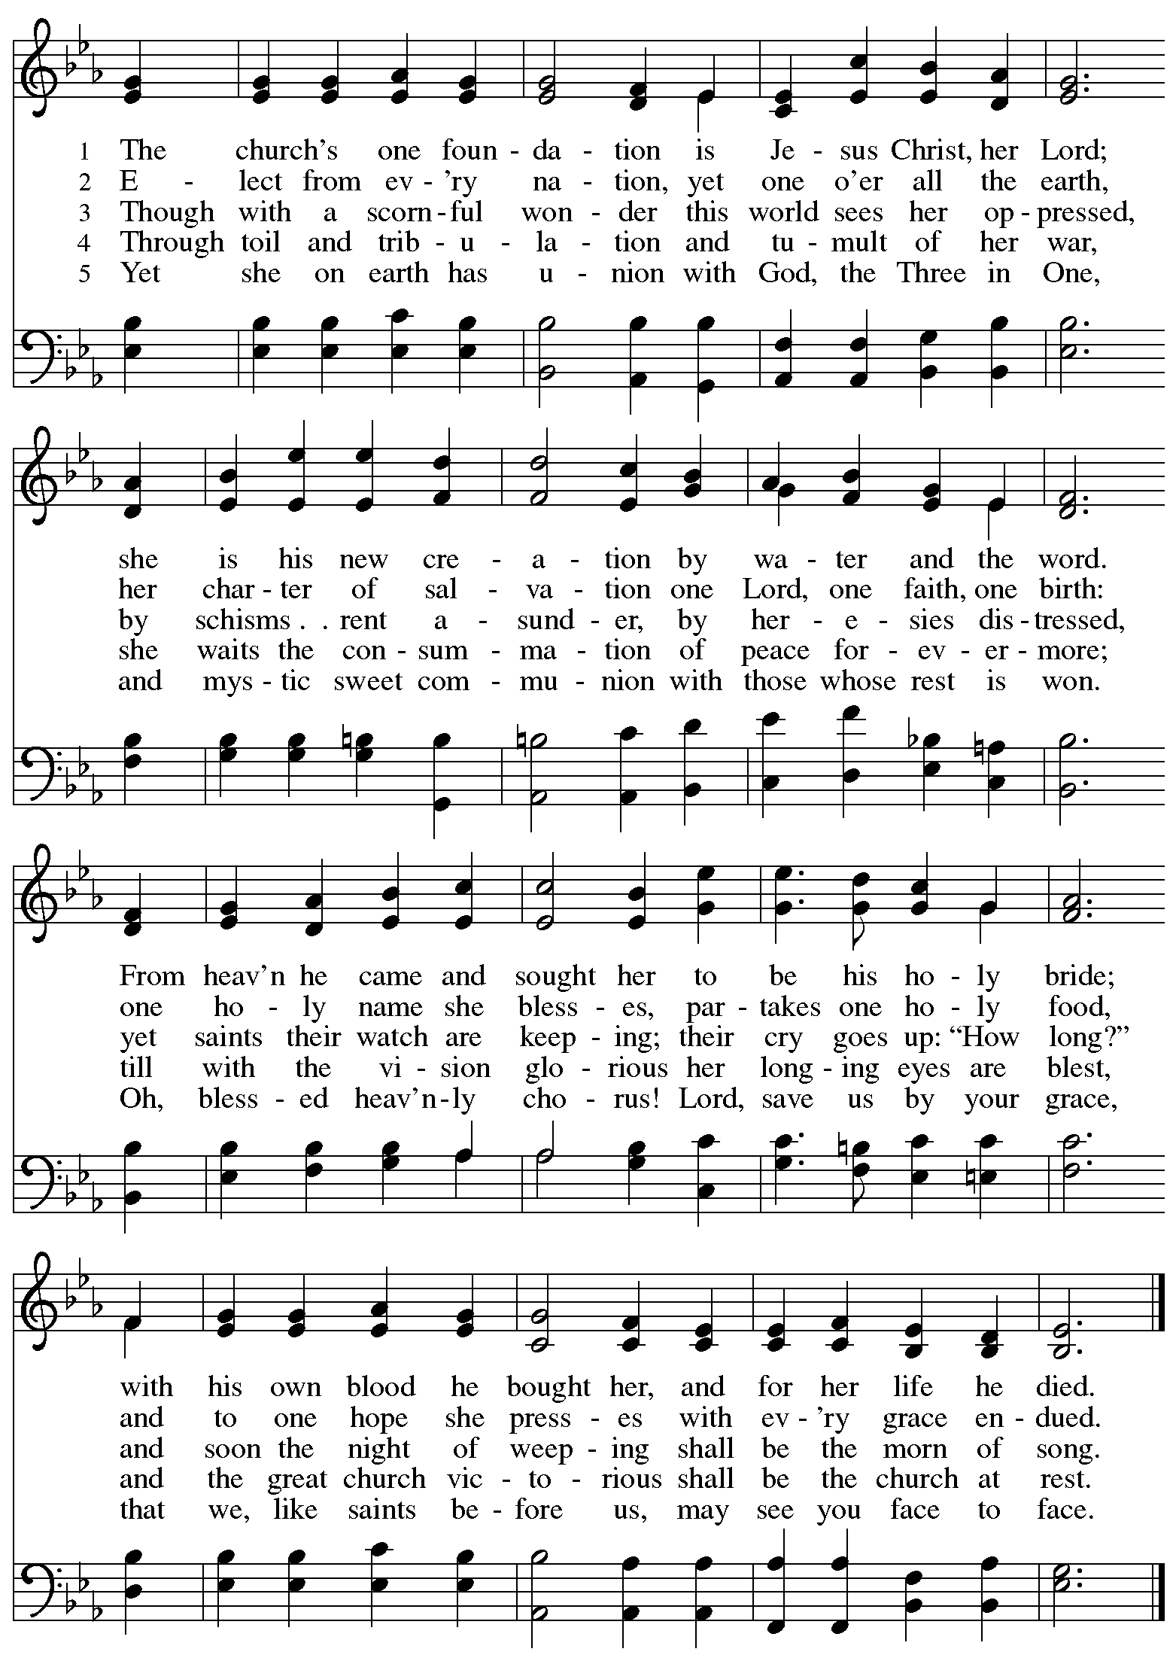

**Greeting**

P: The grace of our Lord Jesus Christ, the love of God,

and the communion of the Holy Spirit be with you all.

**C: And also with you.**

**Hymn of Praise** *ELW* p. 204

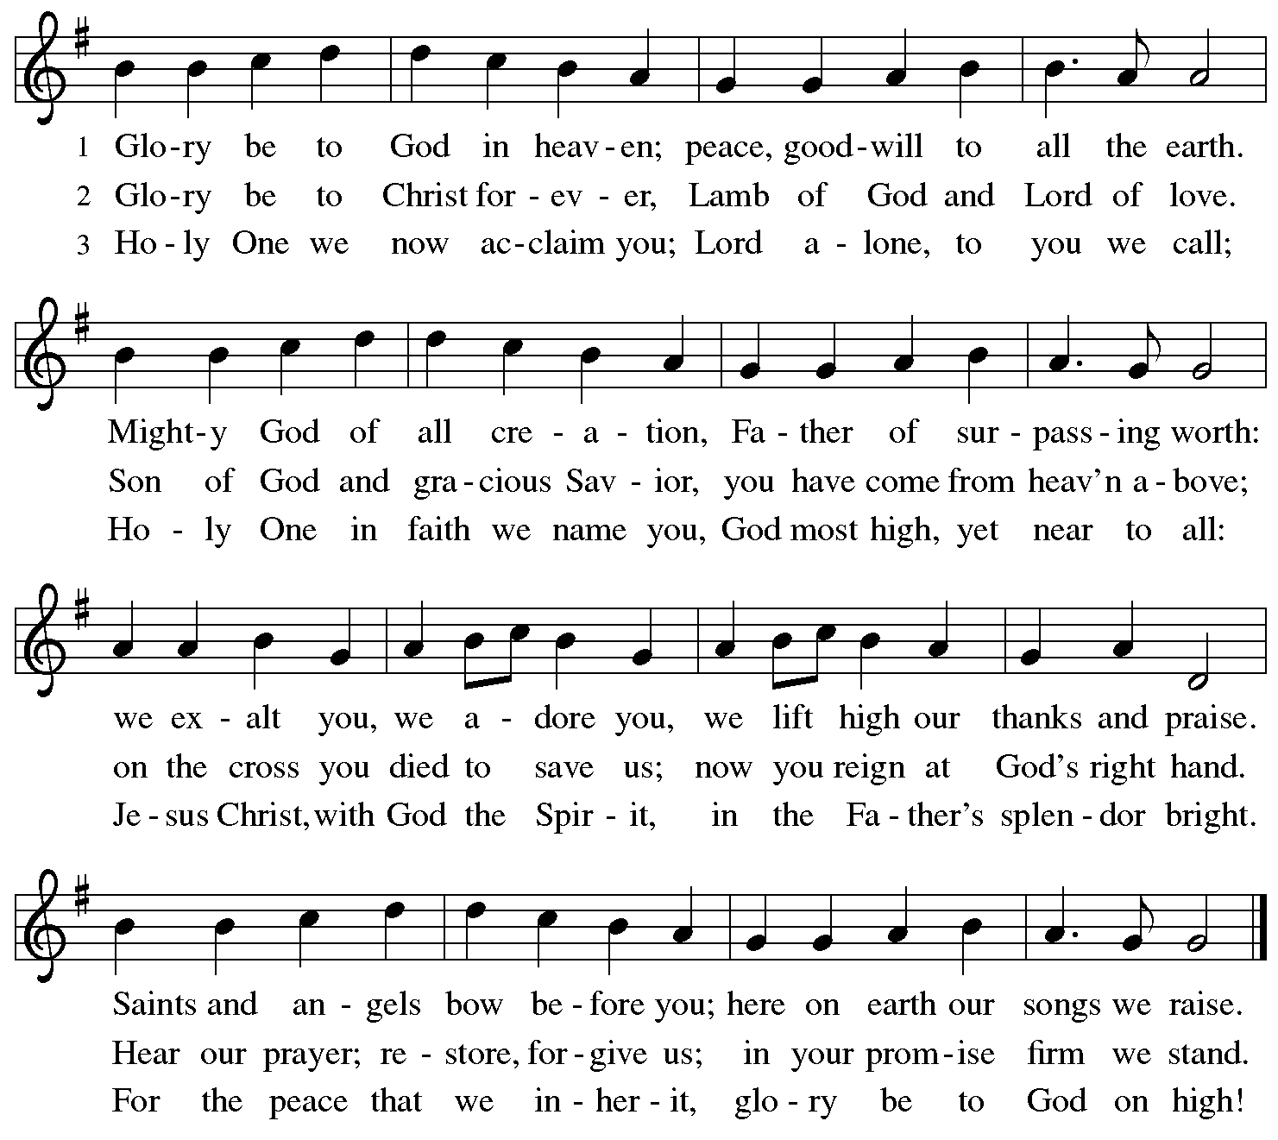

**Prayer of the Day**

P: The Lord be with you.

**C: And also with you.**

P: Let us pray.

Almighty God, gracious Lord, we thank you that your Holy Spirit renews the church in every age. Pour out your Holy Spirit on your faithful people. Keep them steadfast in your word, protect and comfort them in times of trial, defend them against all enemies of the gospel, and bestow on the church your saving peace, through Jesus Christ, our Savior and Lord, who lives and reigns with you and the Holy Spirit, one God, now and forever.

**C: Amen.**

*Please be seated.*

*Children are invited to join the adult leaders at the door and move to the office for Little Church – Big Faith. We ask that one additional adult from the congregation attend with the children.*

**Word**

*God speaks to us in Scripture reading, preaching, and song*

**First Reading** **–** **Jeremiah 31: 31-34**

31The days are surely coming, says the Lord, when I will make a new covenant with the house of Israel and the house of Judah. 32It will not be like the covenant that I made with their ancestors when I took them by the hand to bring them out of the land of Egypt—a covenant that they broke, though I was their husband, says the Lord. 33But this is the covenant that I will make with the house of Israel after those days, says the Lord: I will put my law within them, and I will write it on their hearts; and I will be their God, and they shall be my people. 34No longer shall they teach one another, or say to each other, “Know the Lord,” for they shall all know me, from the least of them to the greatest, says the Lord; for I will forgive their iniquity, and remember their sin no more.

L: Word of God, word of life.

**C: Thanks be to God.**

**Psalm 46**

*In place of today’s psalm, the congregation will sing “A Mighty Fortress Is Our God,”*

*originally written by Martin Luther as a paraphrase of today’s appointed Psalm 46.*



**Psalm 46 A Mighty Fortress Is Our God *ELW* 505**

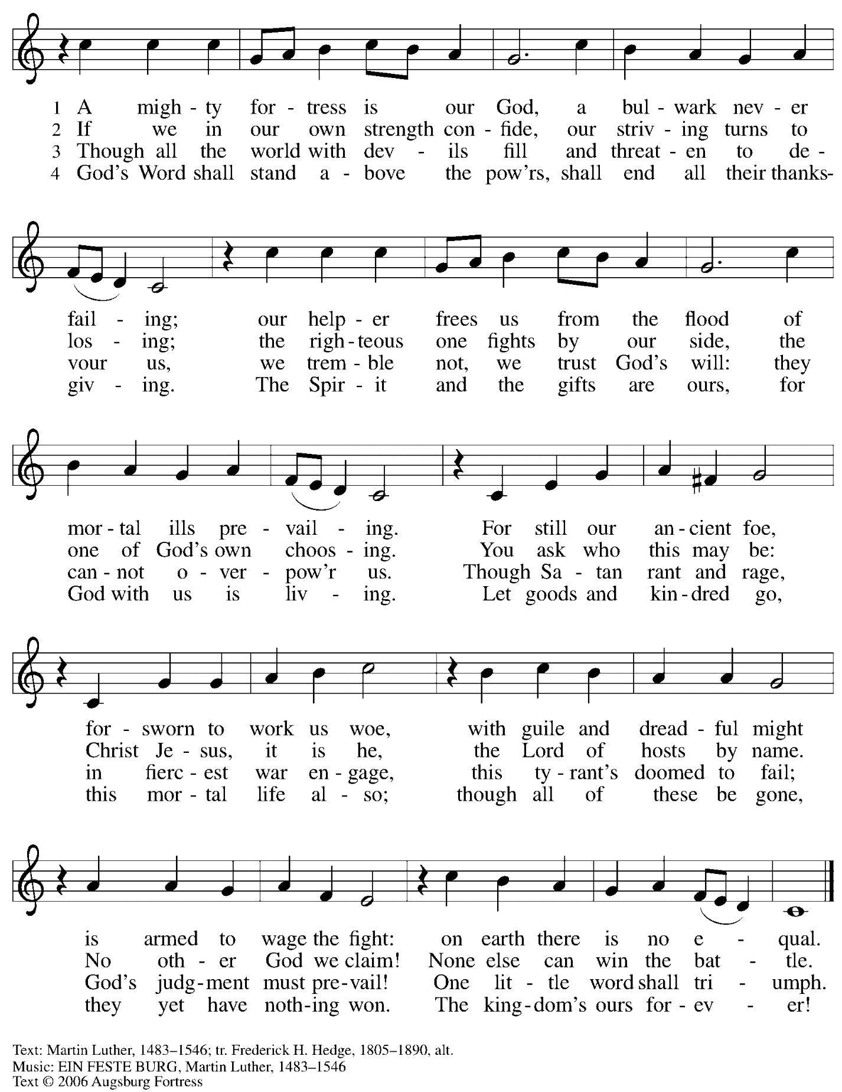

All rights reserved. Reprinted with permission under OneLicemse.net # A-722139.

**Second Reading – Romans 3: 19-28**

19Now we know that whatever the law says, it speaks to those who are under the law, so that every mouth may be silenced, and the whole world may be held accountable to God. 20For “no human being will be justified in God’s sight” by deeds prescribed by the law, for through the law comes the knowledge of sin.  
  
 21But now, apart from law, the righteousness of God has been disclosed, and is attested by the law and the prophets, 22the righteousness of God through faith in Jesus Christ for all who believe. For there is no distinction, 23since all have sinned and fall short of the glory of God; 24they are now justified by God’s grace as a gift, through the redemption that is in Christ Jesus, 25whom God put forward as a sacrifice of atonement by his blood, effective through faith. God did this to show God’s righteousness, because in divine forbearance God had passed over the sins previously committed; 26it was to prove at the present time that God [Godself] is righteous and that God justifies the one who has faith in Jesus.  
 27Then what becomes of boasting? It is excluded. By what law? By that of works? No, but by the law of faith. 28For we hold that a person is justified by faith apart from works prescribed by the law.

L: Word of God, word of life.

**C: Thanks be to God.**

*Please rise as you are able and join in speaking the Gospel Acclamation.*

**Gospel Acclamation** *ELW* p. 205

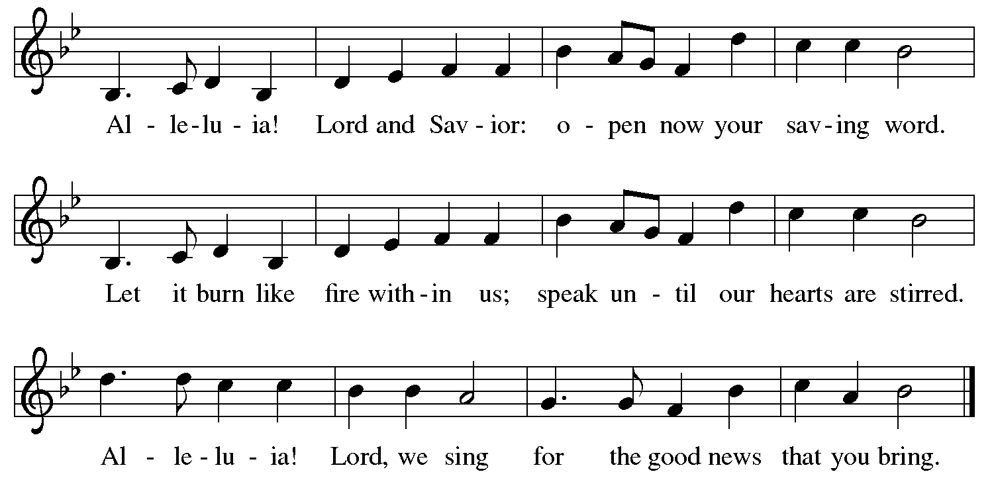

**Gospel – John 8: 31-36**

P: The holy Gospel according to St. John.

**C: Glory to you, O Lord.**

31Jesus said to the Jews who had believed in him, “If you continue in my word, you are truly my disciples; 32and you will know the truth, and the truth will make you free.” 33They answered him, “We are descendants of Abraham and have never been slaves to anyone. What do you mean by saying, ‘You will be made free’?”  
 34Jesus answered them, “Very truly, I tell you, everyone who commits sin is a slave to sin. 35The slave does not have a permanent place in the household; the son has a place there forever. 36So if the Son makes you free, you will be free indeed.”

P: The Gospel of the Lord.

**C: Praise to you, O Christ.**

*Please be seated.*

**Sermon**

*A time of silence for prayer and reflection follows the sermon.*

*When the hymn of the day begins, please rise as you are able.*



**Hymn of the Day By Grace We Have Been Saved *ACS* 1006**

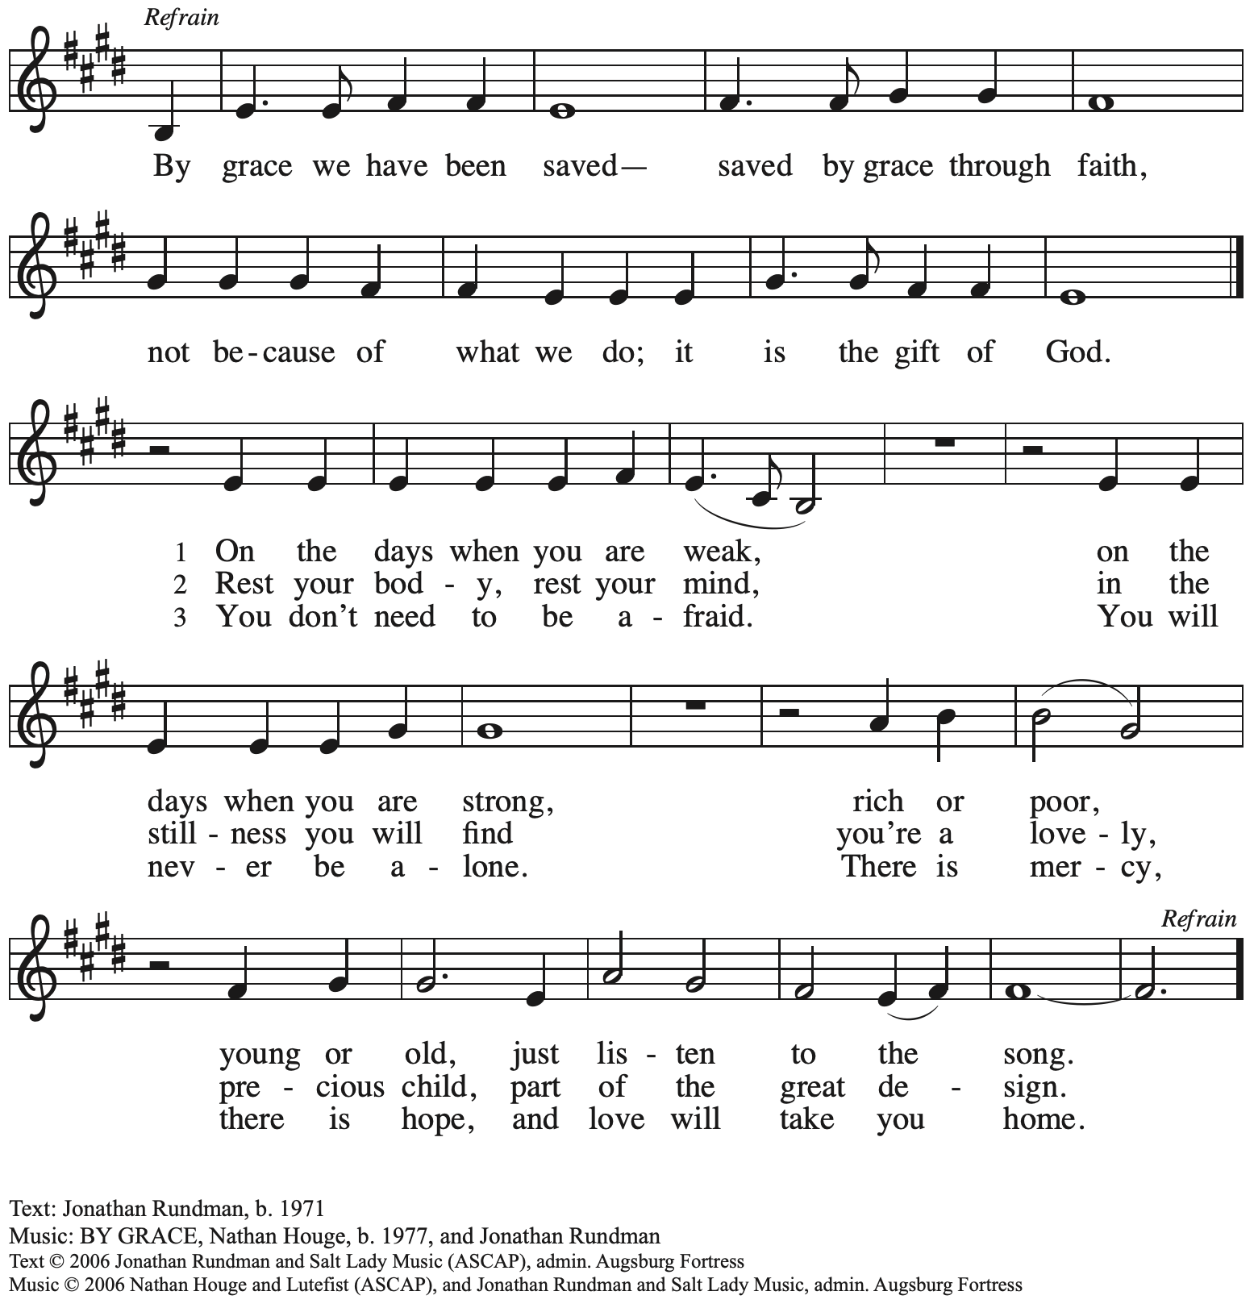

All rights reserved. Reprinted with permission under OneLicense.net # A-722139.

**Apostles’ Creed**

*Profession of our faith using the Apostles’ Creed, one of the Christian Church’s three ecumenical creeds, unites us with siblings in Christ around the world.*

**C: I believe in God, the Father almighty,**

**creator of heaven and earth.**

**C: I believe in Jesus Christ, God’s only Son, our Lord,**

**who was conceived by the Holy Spirit,**

**born of the virgin Mary,**

**suffered under Pontius Pilate,**

**was crucified, died, and was buried;**

**he descended to the dead.\***

**On the third day he rose again;**

**he ascended into heaven,**

**he is seated at the right hand of the Father,**

**and he will come to judge the living and the dead.**

**I believe in the Holy Spirit,**

**the holy catholic church,**

**the communion of saints,**

**the forgiveness of sins,**

**the resurrection of the body,**

**and the life everlasting. Amen.**

*Or, “he descended into hell,” another translation of this text in widespread use.

**Prayers of the People**

A: Drawn together by the power of the Holy Spirit, we pray for the church,

those in need, and all of God’s creation.

*After each petition*

A: Merciful God,

**C: receive our prayer.**

*The presiding minister concludes the prayers*

P: We entrust these and all our prayers to you, holy God,

in the name of your beloved, Jesus Christ, our Savior.

**C: Amen.**

**Peace**

*The presiding minister and the assembly greet one another in the peace of the risen Christ.*

P: The peace of Christ be with you always.

**C: And also with you.**

*The people may greet those around them with a sign of Christ’s peace and may say*

Peace be with you *or similar words. Please be mindful that not everyone will be comfortable with sharing the peace, so please seek consent before shaking hands or hugging. Other possible ways to share the peace include a simple bow with the verbal greeting of peace, or simply a verbal expression of peace.*

*When the greetings of peace have concluded, please be seated.*



**Meal**

*God feeds us with the presence of Jesus Christ*

**Offering**

*We offer ourselves, our gifts and our faithful service to God.*

*As the offering is gathered for the mission of the church, including the care of those in need,*

*the table is set for Holy Communion.*

*There are laminated giving cards in the pew racks that feature a QR code for anyone who would like to give online. Those who give using the QR code, as well as those who give regularly online or through their bank are encouraged to place the laminated card in the plate as an expression of your offering.*

**Music during the Offering**

*A Mighty Fortress Is Our God* arr. Keveren

*As the gifts are brought forward for presentation, please rise as you are able.*

**Offertory Song Accept, O Lord, the Gifts We Bring *ELW* 691**

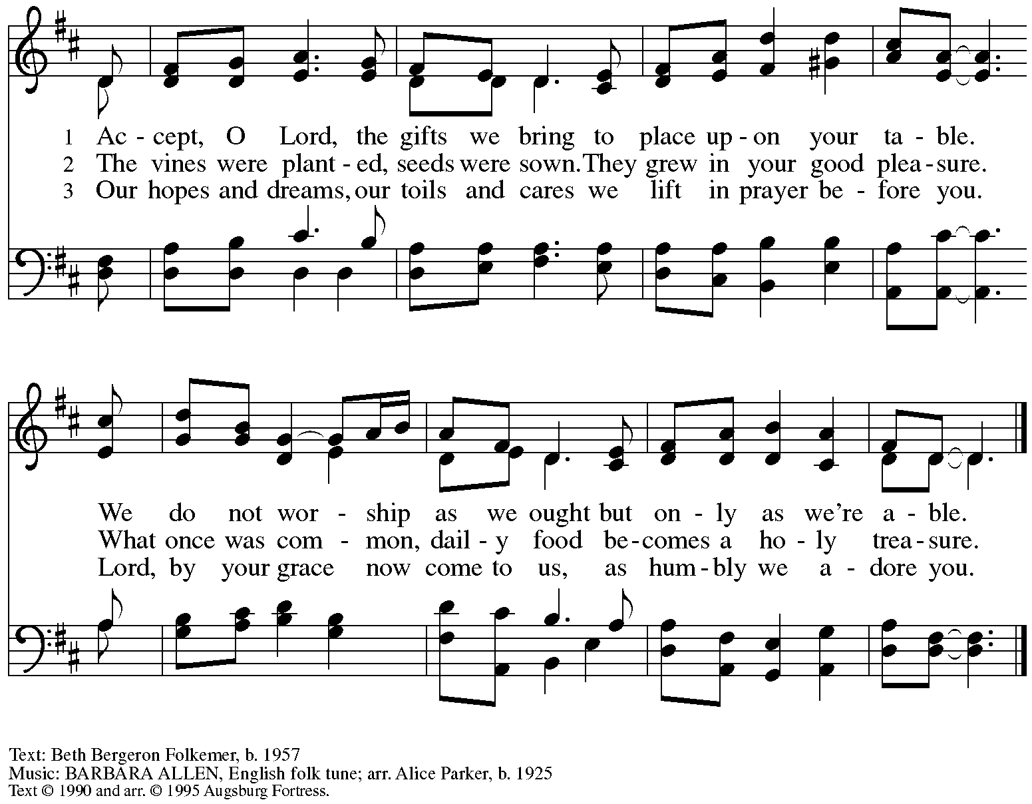

All rights reserved. Reprinted under OneLicense.net # A-722139.

**Offertory Prayer**

A: Let us pray.

Blessed are you,

**C:** **O God, source of all creation.**

**By these gifts and with our lives,**

**help us to serve one another and all in need,**

**through Jesus Christ, our Savior and Lord.**

**Amen.**

**Dialogue**

P: The Lord be with you.

**C: And also with you.**

P: Lift up your hearts.

**C: We lift them to the Lord.**

P: Let us give thanks to the Lord our God.

**C: It is right to give our thanks and praise.**

**Preface**

P: It is indeed right, our duty and our joy …

… we praise your name and join in adoring song:

**Sanctus** *ELW* p. 207

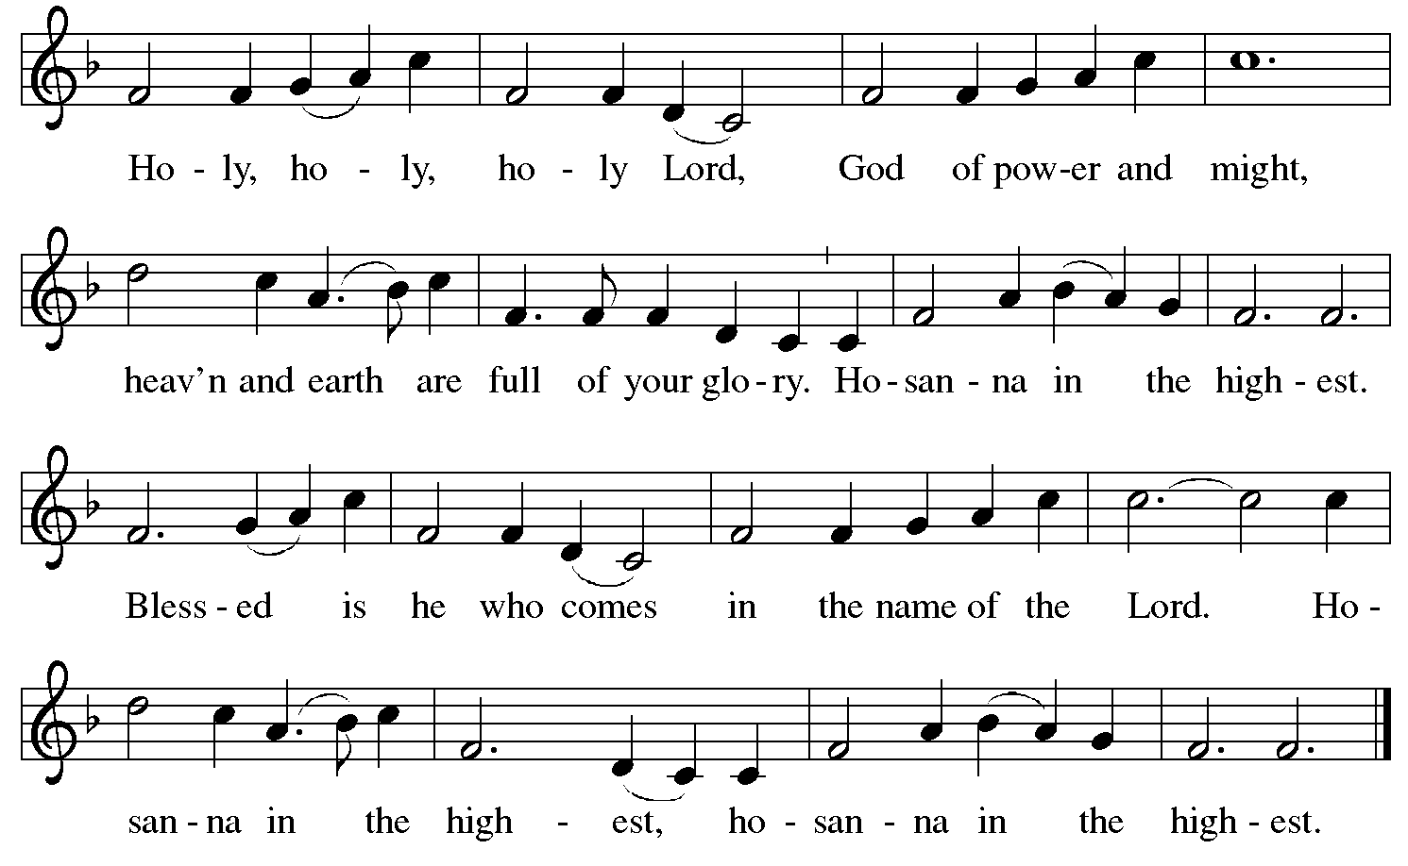

**Eucharistic Prayer**

P: Blessed are you, O God …

… Do this for the remembrance of me.

As often as we eat this bread and drink this cup

we proclaim the Lord’s death until he comes.

**C: Christ has died.**

**Christ is risen.**

**Christ will come again.**

P: Pour out your Holy Spirit …

… power of the Most High, now and forever.

**C: Amen.**

**Lord’s Prayer**

P: Gathered as one by the Holy Spirit, let us pray as Jesus taught us.

**C: Our Father in heaven,**

**hallowed be your name,**

**your kingdom come,**

**your will be done,**

**on earth as in heaven.**

**Give us today our daily bread.**

**Forgive us our sins**

**as we forgive those**

**who sin against us.**

**Save us from the time of trial**

**and deliver us from evil.**

**For the kingdom, the power,**

**and the glory are yours,**

**now and forever. Amen.**

**Fraction and Invitation**

***Agnus Dei /* Lamb of God** *ELW* p. 208

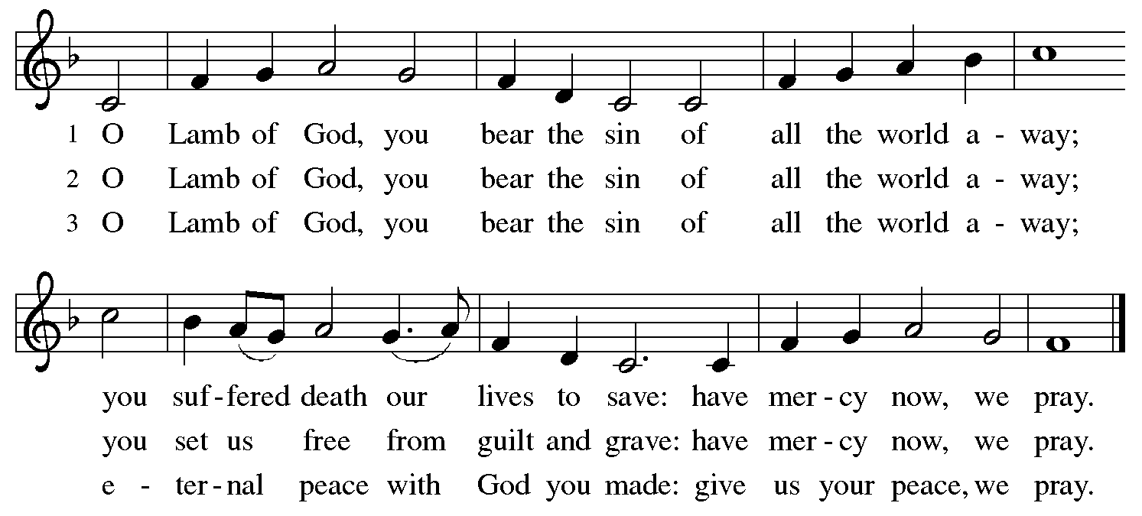

*Please be seated.*

**Holy Communion**

* *All who seek God and desire a deeper and stronger life in Christ are welcome to receive Holy Communion.*
* *Worshipers from the pulpit side will proceed forward first, followed by the center section, and then the lectern side.*
* *Please inform an usher if you would like the ministers to bring Communion to you.*
* *Holy Communion will be served with bread and wine/grape juice.*
* *The presiding minister will first distribute the bread (host) to each communicant. Please indicate if you require a gluten-free host.*
* *Once you have consumed the bread, please pick up an empty glass from the tray next to the presiding minister. The Communion Assistant will pour wine from the chalice or grape juice from the cruet into your glass.*
* *Please step to the side to consume the wine or grape juice.*
* *Feel free to kneel at the altar rail for prayer after receiving the sacrament.*
* *As you return to your pew, glasses may be returned to the empty trays on either side of the center section.*
* *A blessing will be provided for anyone who does not yet receive the sacrament.*
* *All are invited to join in singing the hymns during Holy Communion.*

**Hymns during Holy Communion**

**Ask the Complicated Questions *ACS* 1005**

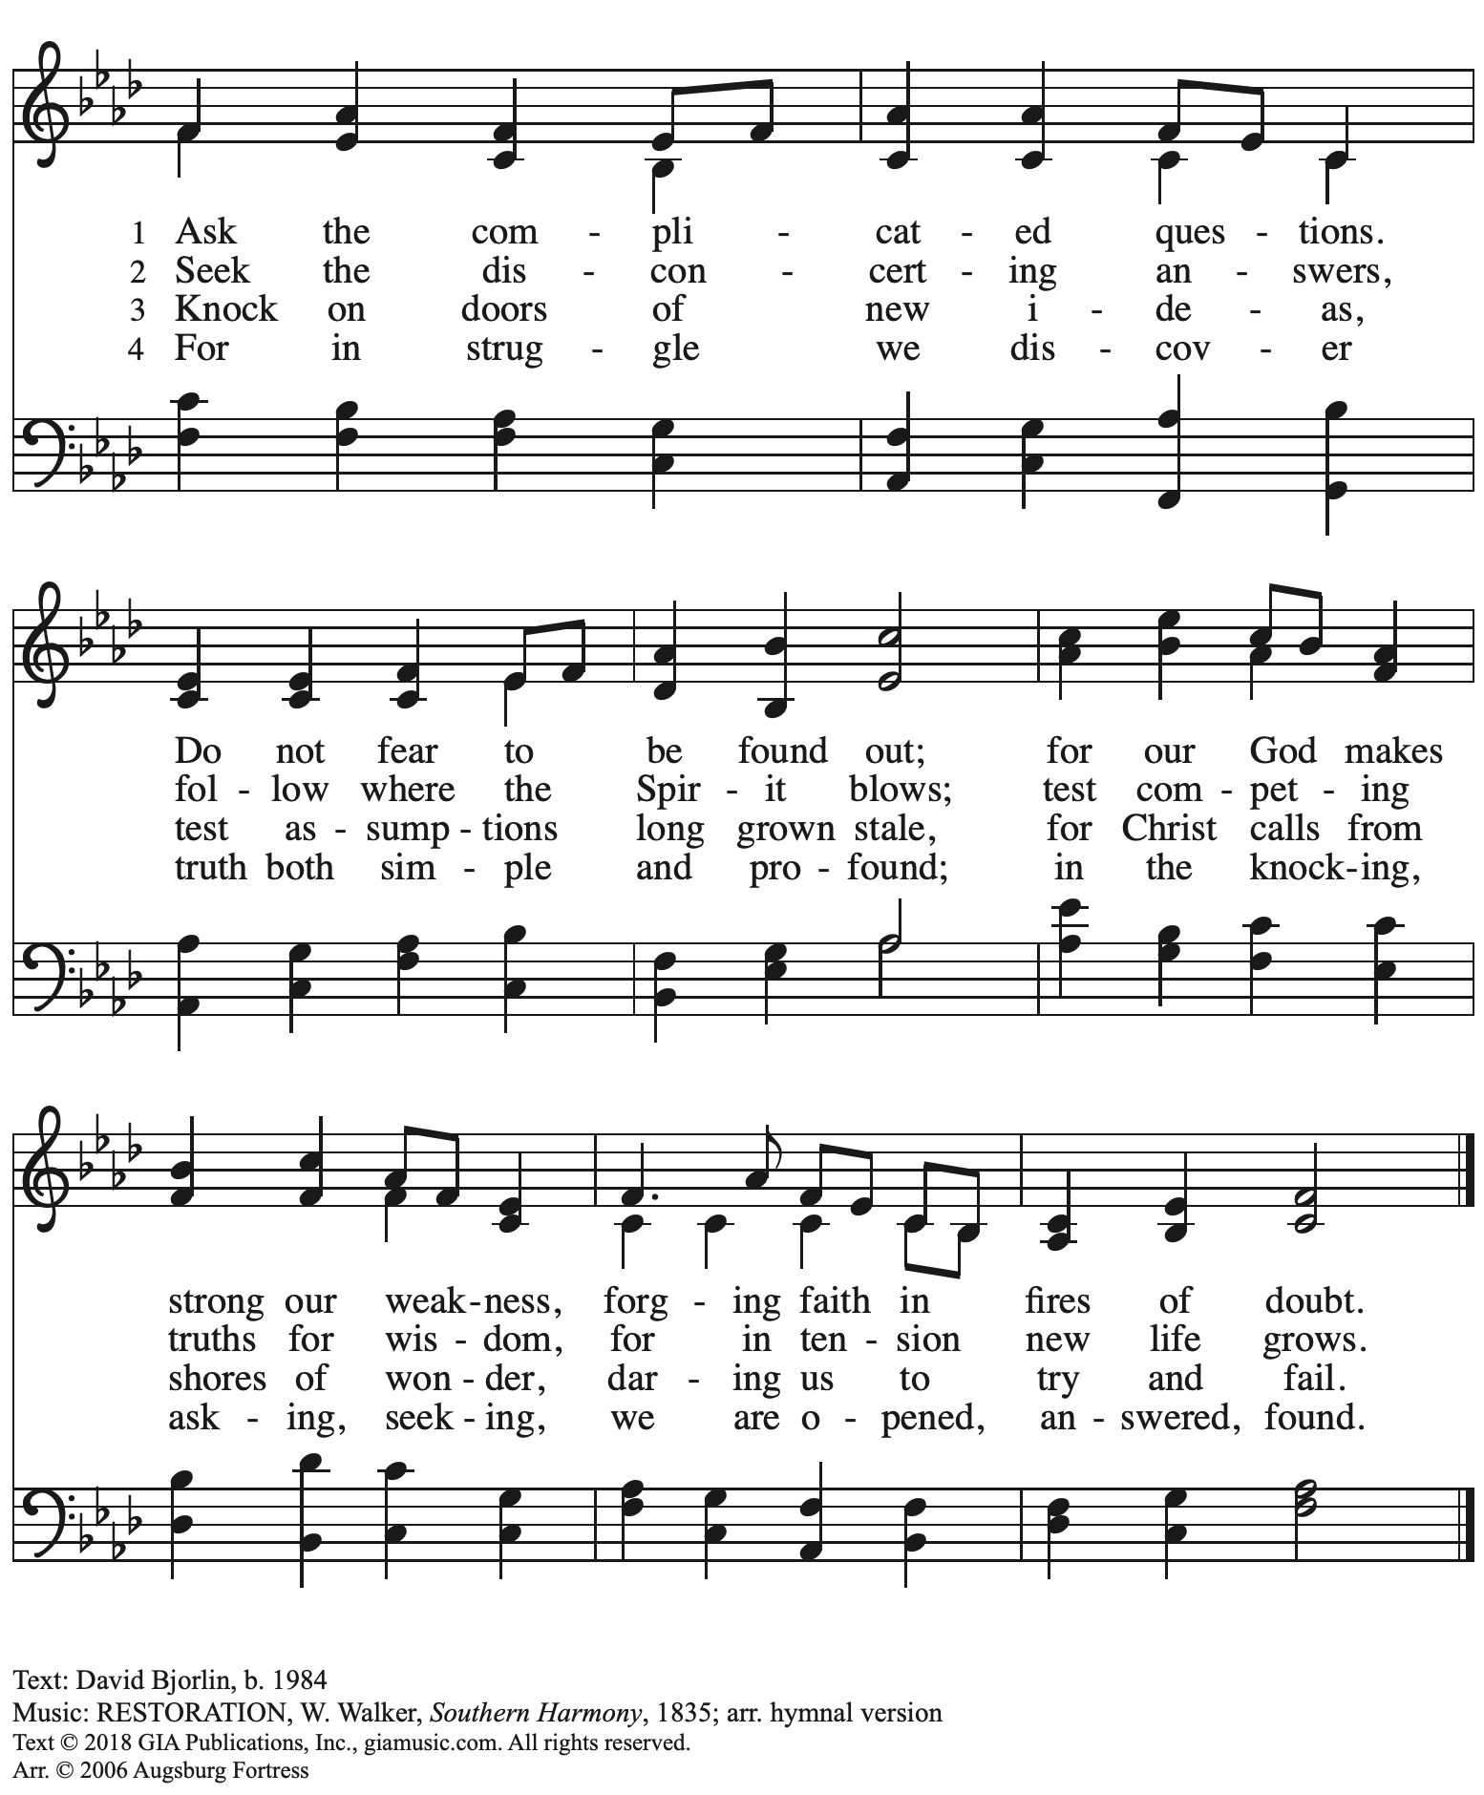

All rights reserved. Reprinted with permission under Onelicense.net # A-722139.

**Hymns during Holy Communion**

**That Priceless Grace *ELW* 591**

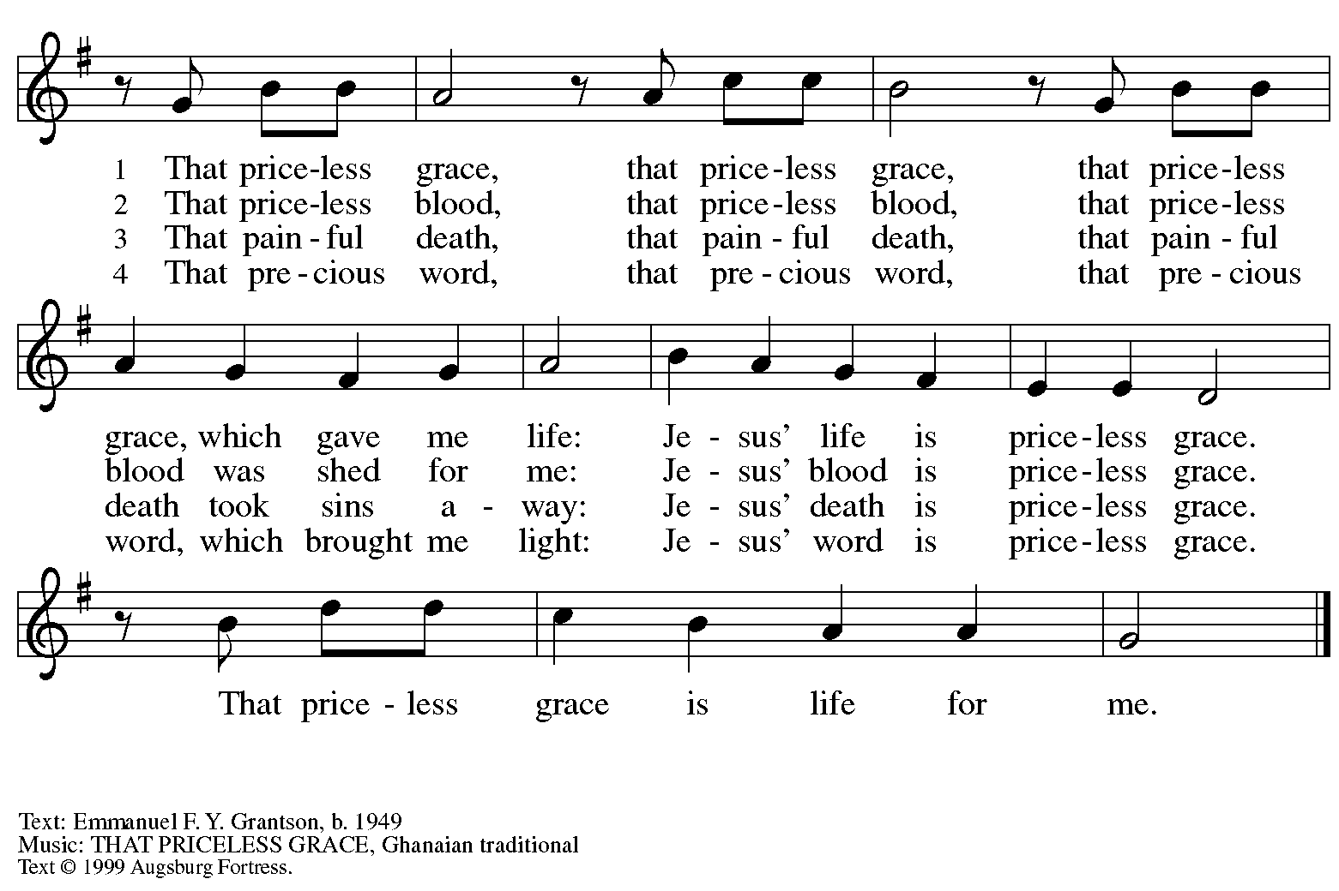

All rights reserved. Reprinted with permission under OneLicense.net # A-722139.

**Hymns during Holy Communion**

**Founded on Faith *ACS* 1048**

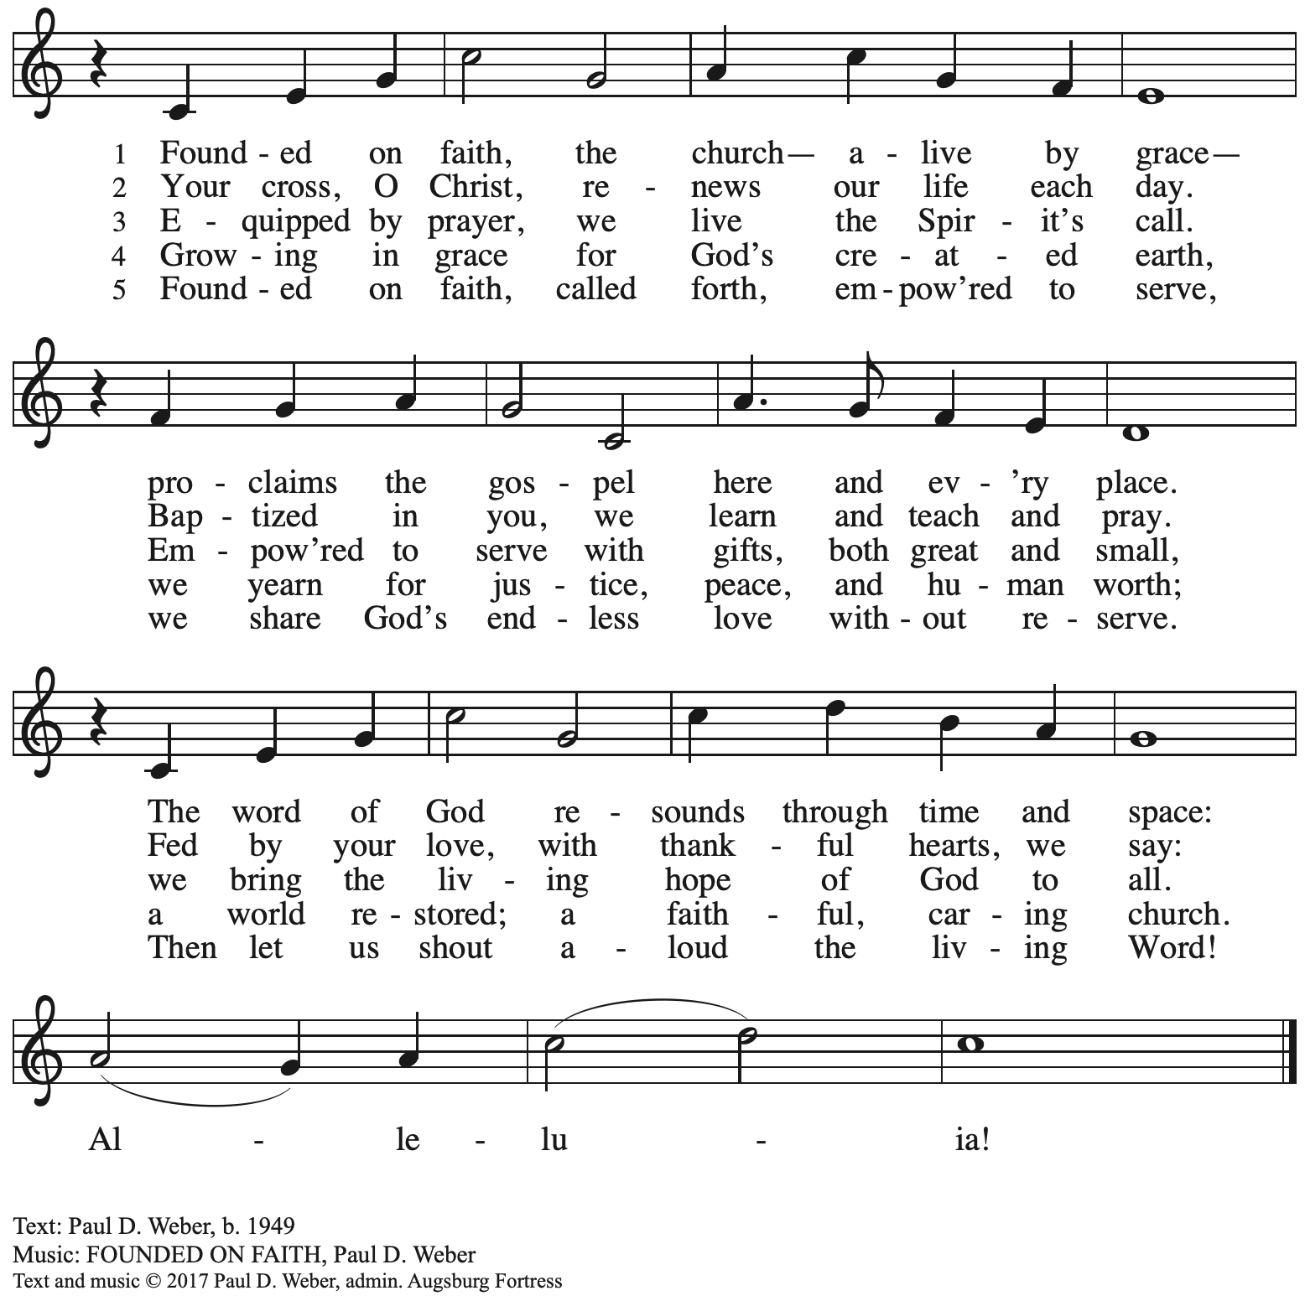

All rights reserved. Reprinted with permission under OneLicense.net # A-722139.

**Hymns during Holy Communion**

**This Is Christ’s Body *ACS* 967**

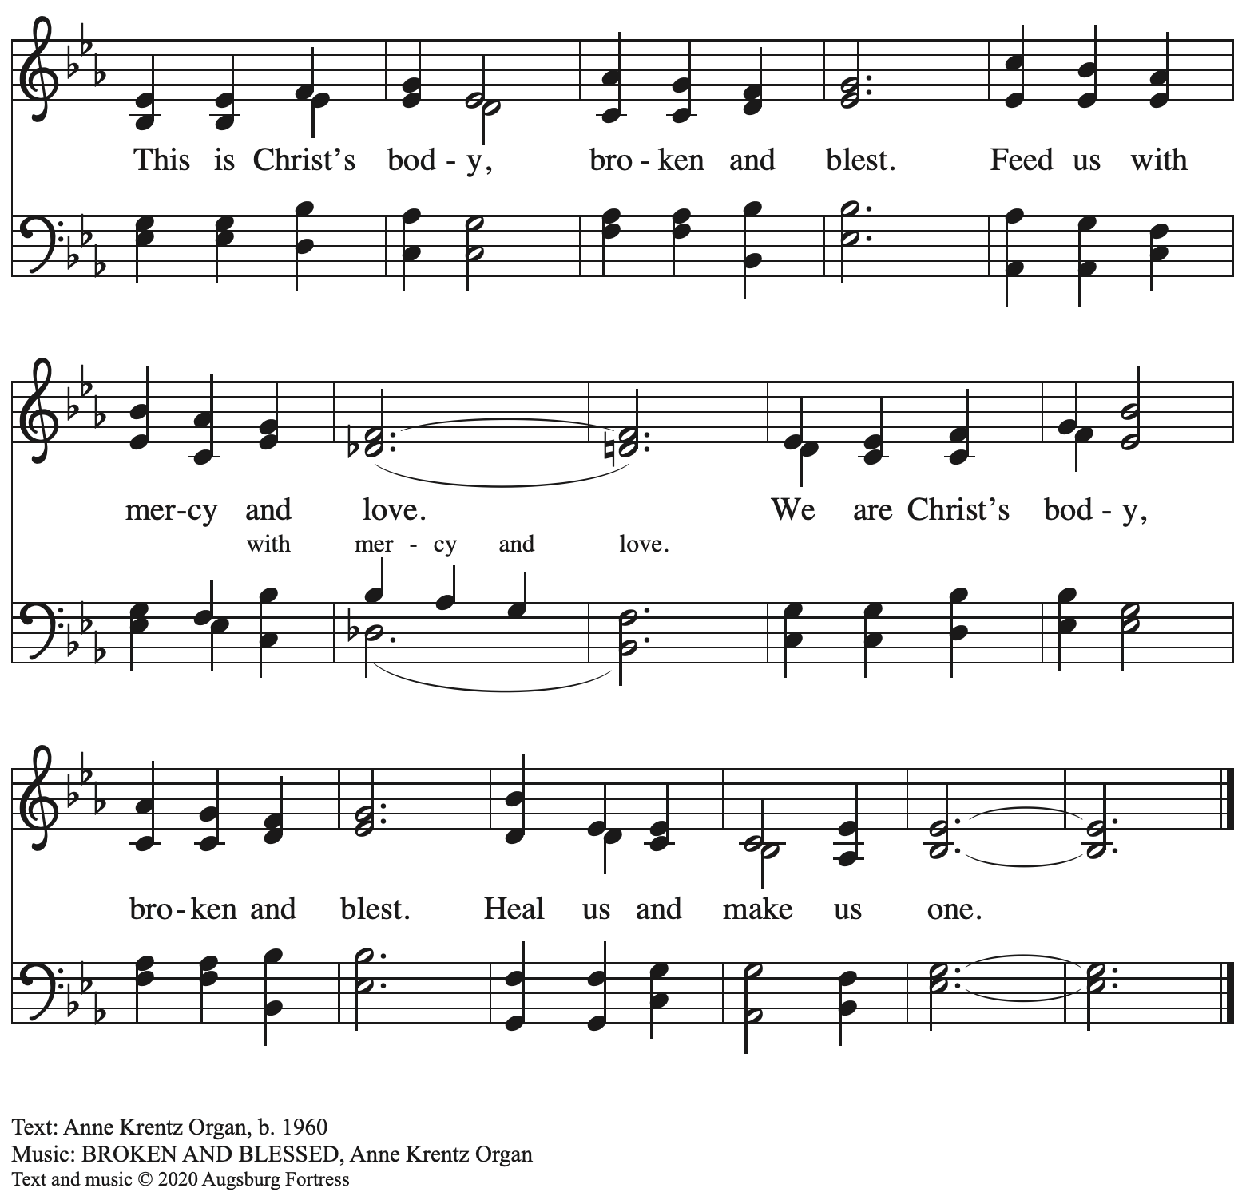

All rights reserved. Reprinted with permission under OneLicense.net # A-722139.

**Hymns during Holy Communion**

**God Alone Be Praised *ACS* 1023**

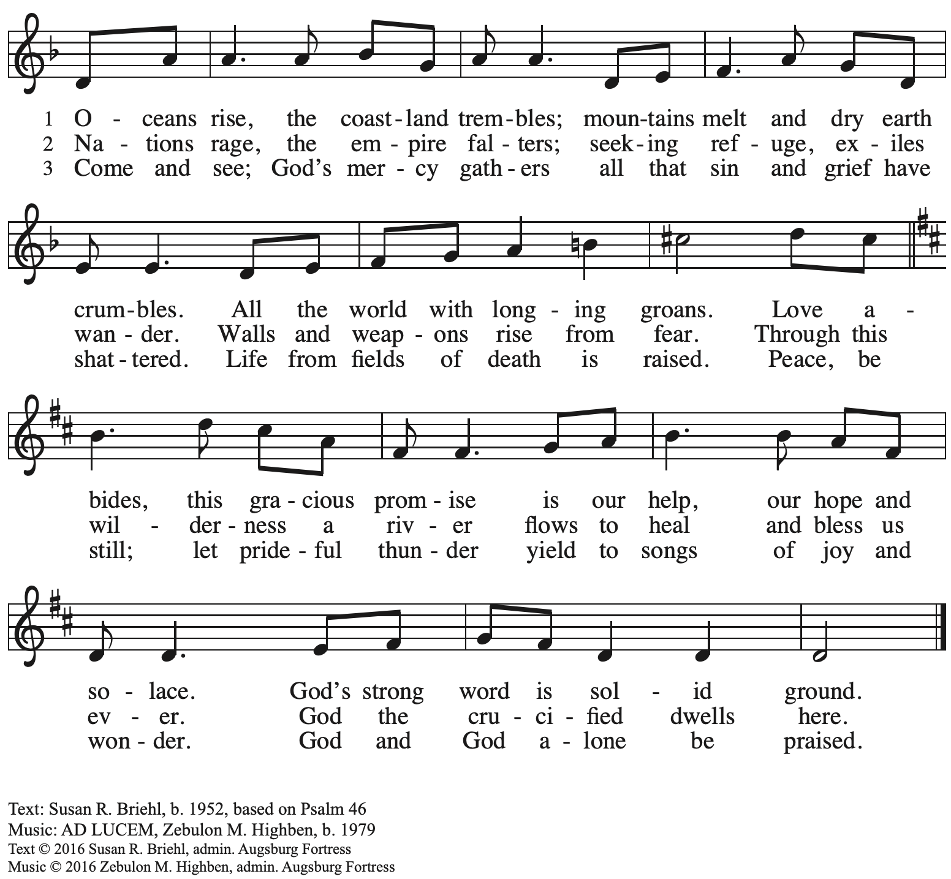

All rights reserved. Reprinted with permission under OneLicense.net # A-722139.

*When all have returned to their places, please rise as you are able.*

**Blessing**

P: The body and blood of our Lord Jesus Christ strengthen you and keep you in his grace.

**C: Amen.**

**Prayer**

A: Let us pray.

Holy God, you have welcomed us to this meal

and fed us at your table with your gifts of grace and life.

Send us now to welcome others and to be at peace with one another,

through Jesus Christ our Lord.

**C: Amen.**

*Please be seated.*

**Sending**

*God blesses us and sends us in mission to the world*

**Announcements**

*Please rise as you are able.*

**Benediction**

P: God almighty,

God most merciful,

☩ bless you, keep you,

and give you peace.

**C: Amen.**

**Sending Hymn** *Following page*

**Dismissal**

A: Go in peace. Serve the Lord.

**C: Thanks be to God.**

**Postlude** *We All Are One in Mission* arr. J. Carter

**Sending Hymn Rise, Shine, You People! *ELW* 665**

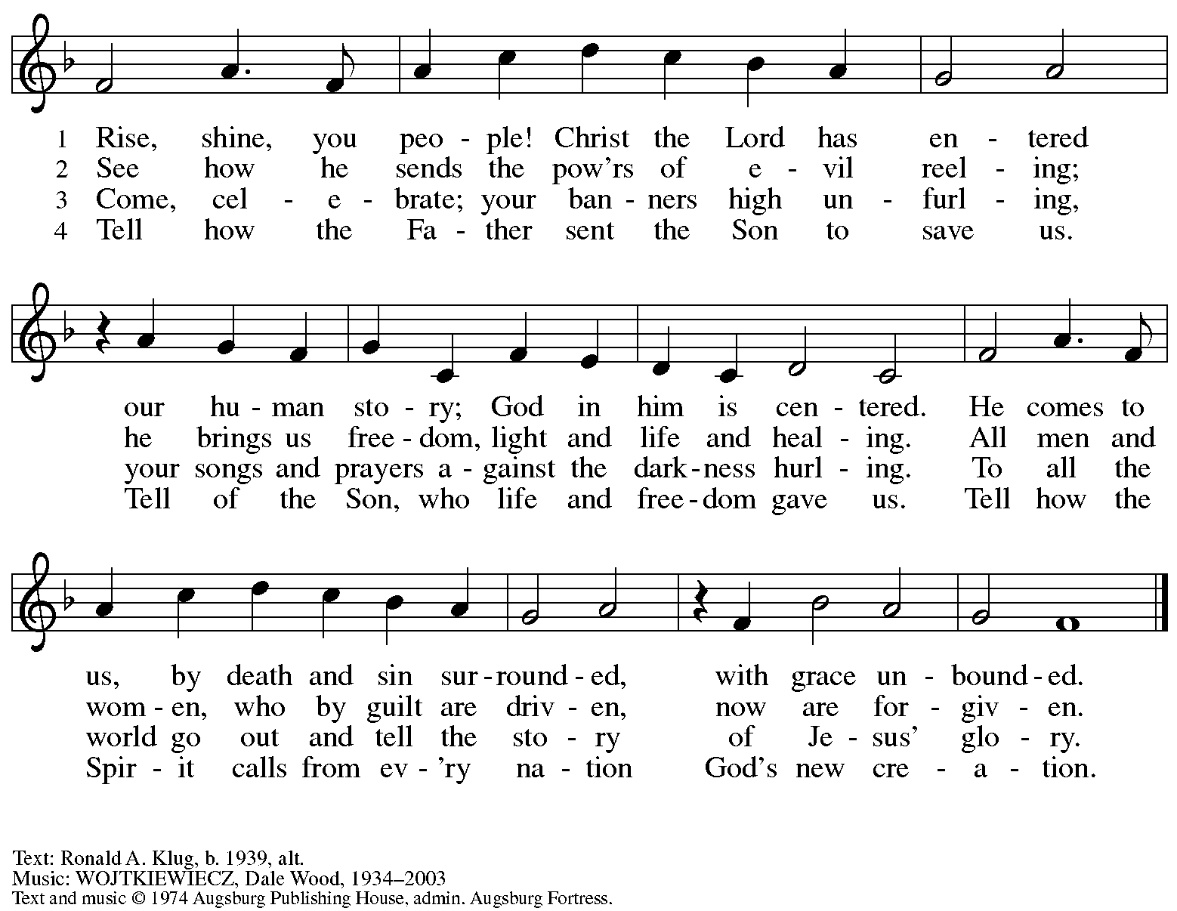

All rights reserved. Reprinted with permission under OneLicense.net # A-722139.

*Those serving in worship today*

Altar Care Jodie Minor

Assisting Minister Jeff Denlinger

Audio-Visual Ministers David Rollinson

Jered Stratton

Cantor Mandy Best

Lector Lindsay Baxter

Little Church – Big Faith Teacher Emily Duque

Prelude Quartet Isabel Barton

Emily Duque Timothy Kocher-Hillmer

Jered Stratton

Minister of Music Laura Reynolds

Preaching and Presiding Minister Pastor Ross Carmichael

*Liturgy and Hymnody Acknowledgements*

From SundaysandSeasons.com. Copyright © 2024 Augsburg Fortress. All rights reserved. Reprinted under OneLicense.net # A-722139.

Used by permission of Augsburg Fortress.

The Scripture readings contained herein are from *New Revised Standard Version* of the Bible © 1989, Division of Christian Education of the National Council of Churches of Christ in the USA. Used by permission. All rights reserved.

**The Church’s One Foundation** – Text: Samuel J. Stone, 1839-1900. Music: AURELIA, Samuel S. Wesley, 1810-1876.

*Please use the QR code below to link to St. Andrew’s announcements online!*



**St. Andrew Lutheran Church Announcements**

**October 27th, 2024**

* **Welcome to Worship at St. Andrew on Reformation Sunday, October 27th, 2024** –We are so glad you are here, and we offer a special welcome to all visitors and guests connecting for the first time! Worship attendees are invited to make a name tag at the back of the worship space. Little Church – Big Faith, a Bible lesson and activity for children, will take place after the prayer of the day. There are also worship “toolkits” to help children engage with worship and “busy bags” for younger children available in the bookcase at the back of the sanctuary. Please feel free to take one to use with/for your children. All are invited to gather for coffee other drinks and food, and conversation in the social hall after worship.
* **Support Days for Girls – Pittsburgh: Today Is the Last Day to Donate Supplies!** – Earlier in the year, St. Andrew shared an opportunity from LAMPa to call for Pennsylvania to provide menstrual hygiene products in public spaces as a crucial step in addressing educational, gender, and economic inequity. As a local follow-up, St. Andrew has connected with Days for Girls – Pittsburgh, which helps to provide education and access to feminine hygiene products for people in need. As an expression of our church’s “God’s Work, Our Hands” commitment, St. Andrew will be collecting items to make Days for Girls’ hygiene kits. We have been collecting women’s underwear (new), sizes medium and large (5, 6, 7), 100% cotton (please avoid white); washcloths, 100% cotton (please avoid white); bar soap (hotel-size); containers of laundry detergent pods (“free and clear” of scents); and packing supplies such as 5/8-inch ribbon and packing tape. Items may be placed in the collection bin located in the social hall.
* **Lessons from Dietrich Bonhoeffer in a House Divided and a World on Fire – Wednesday, October 30th** – Join in the last session on the life and theology of Dietrich Bonhoeffer, and the lessons we can use as we live at the intersection of faith and civic life today. Bonhoeffer was a Lutheran pastor and theologian living in Nazi Germany, who eventually joined the resistance and was arrested and killed before the end of WWII. This curriculum was compiled by Dr. Lori Brandt Hale, an internationally renowned Bonhoeffer scholar. Lutheran Advocacy Ministry in Pennsylvania (LAMPa) is bringing this curriculum to congregations to inspire deeper conversation and discernment about our discipleship. Pastor Erin Jones, staff at LAMPa and member of St. Andrew, leads these sessions. The participant workbook and other materials are available here:

[Bonhoeffer Curriculum Available Now! - LAMPa (lutheranadvocacypa.org)](https://standrewpittsburgh.us20.list-manage.com/track/click?u=08ed12533ff01695f3bedb110&id=b21d27b8d1&e=32a5352e21).

**Zoom Link**: <https://us02web.zoom.us/j/86521390682?pwd=IQUJNKZzWznWObQxrQ3homsZlsLnon.1>

Meeting ID: 865 2139 0682

Passcode: 962169

* **All Saints Sunday – November 3rd – Invitation to Bring in Photos –** The Christian church observes All Saints Day on November 1st, and because this day is not a Sunday this year, we will move the observance to Sunday, November 3rd. On All Saints Sunday, we give thanks for the grace of God that allows all of us to be saints through the righteousness Jesus shares with us. St. Andrew also joins the church throughout the world in giving thanks to God for the saints who have gone before us in faith, all whose lives have been for us a testimony to God's love and grace. On this day, we remember people of the congregation and those we have prayed for who have died since last All Saints Day. We invite the congregation to bring photographs of loved ones you would like to remember on that day, to be placed near the baptismal font as we give thanks for the communion of all the saints who are one with us in the Body of Christ. We will also offer a place in the service when everyone can light candles in remembrance of the saints.
* **November Produce Distribution – First Tuesday of the Month, November 5th, 2024, from 5:30-7:00 p.m. – St. Andrew partners with Greater Pittsburgh Community Food Bank to serve as a distribution site for fresh produce on the first Tuesday of every month. This month’s distribution will be Tuesday, November 5th. We invite people of the congregation to help with the distribution from 5:30-7:00 p.m., help with unloading and setup during the day between 10:00 a.m. and 1:00 p.m.**
* **Shelter Dinner for Guests of East End Cooperative Ministry – Thursday, November 21st, 6:30 p.m. –** Each month, people of St. Andrew provide dinner for guests of East End Cooperative Ministry, 6140 Station St. (East Liberty), 15206. We invite you to prepare or purchase one menu item and bring it to the shelter by 6:00 p.m., or just come to help serve at 6:30 p.m. If you would like to contribute, please sign up here:

<https://www.signupgenius.com/go/5080544AAAC22A1F58-52627894-shelter>.

* **Southwestern Pennsylvania Announces Campaign to Support Bethel AME!** – Our congregation has accompanied the people of Bethel AME in the Hill District as they have sought restorative justice following their displacement in the 1950s. The Southwestern Pennsylvania Synod staff have been part of that process, and this fall the synod has announced an appeal to all congregations and members of the synod to support Bethel AME's pre-development process through the Bethel-Trinity Community Development Corporation. Bethel-Trinity CDC is an organization formed by Bethel AME that will be confronting the systemic racial inequities in the Hill District neighborhood and beyond by developing, managing, and operating real estate projects for the betterment of the community: low- and moderate-income housing, intergenerational housing, revitalization of the Hill District neighborhoods, preschool and primary education, social and human services to individuals and families, economic development programs, individual employment, and youth services. This appeal is exciting news, and we at St. Andrew will continue to support Bethel through our reparations offerings on the first Sunday of every month, as well as any other monetary gifts designated to Bethel. You can also give to Bethel through the synod campaign here: [Bethel-Trinity CDC Appeal (neoncrm.com)](https://swpasynod.app.neoncrm.com/forms/bethel).
* **Coffee Hour Signups Available** –One way that St. Andrew builds community is by sharing conversation over food and drinks at coffee hour after worship on Sundays. We invite people of the congregation to sign up to coordinate coffee hour each week, which includes brewing the coffee; setting out cups, napkins, food items, and cold drinks; and cleaning up afterward. Everything needed is at St. Andrew and instructions are available. Please sign up to host coffee hour here: <https://www.signupgenius.com/go/5080B4AAFAF2CABF85-47069030-coffee>.
* ***Christ in Our Home* Devotional Booklets (October – December) Available at Church Entrances – *Christ in Our Home* is a booklet of devotions that includes Scripture, a brief reflection, and prayer for each day. The new edition for October – December is now available at the various church entrances. Please feel free to take one for yourself or others!**
* **Compline Prayer Service with the Pittsburgh Compline Choir – Sundays at 8:00 p.m. at Heinz Chapel –** Compline was traditionally a monastic prayer service, and the Pittsburgh Compline Choir, a ministry of Lutheran Campus Ministry in Greater Pittsburgh, sings a choral version of compline rooted in this thousand-year-old tradition of scripture, song, and silence each Sunday at Heinz Chapel at 8:00 p.m. This service also streams on Facebook (Pittsburgh Compline Choir) and YouTube (The Pittsburgh Compline Choir). Heinz Chapel is located off of S. Bellefield Ave. in Oakland. For more information, please visit: [Pittsburgh Compline Choir](http://pittsburghcomplinechoir.org/).