

**+ Second Sunday of Easter**

**April 27, 2025**





**St. Andrew Lutheran Church**

**304 Morewood Ave.**

**Pittsburgh, PA 15213**

[**St_andrewELCA@verizon.net**](mailto:St_andrewELCA@verizon.net)

[**www.standrewpittsburgh.org**](http://www.standrewpittsburgh.org)

**+ Second Sunday of Easter**

**Order for Worship**

*Even with all we have heard and all we have seen, it is often hard to believe.*

*Because it is hard to believe, we will invest ourselves in the Easter mystery for fifty days*

*(a week of weeks). Because it is hard to believe, John the evangelist will provide sign after sign celebrating Jesus’ victory over death. Because it is hard to believe, the risen Jesus will return to us again and again in the mystery of Holy Communion, inviting us to touch and receive his presence, and offering us peace.*

**Welcome to St. Andrew!**

* St. Andrew welcomes all who are seeking a place of healing, wholeness, and acceptance in a nurturing and faith-forming spiritual home. We are striving toward racial equity worldwide

and we seek to honor the lived experience of all individuals regardless of background. Our community embraces people of all ages, ethnicities, cultures, abilities, sexual orientations,

gender identities and expressions, and family constellations. Come and See!

* Worship Services are live-streamed to multiple online platforms. By attending worship, you agree that your image and voice may be broadcast.
* Everyone is invited to make a name tag at the black bookcase in the back of the worship space if they would like. There are stickers indicating pronouns on the bookcase if you would like to include them on your name tag.
* Children are invited to attend Little Church – Big Faith, a Bible lesson and activity, during worship (after the Prayer of the Day). The group returns to the worship space for the liturgy of Holy Communion.
* A nursery is available through the doors at the left side of the sanctuary and across from the doorway to the Social Hall. Look for a purple-colored room.
* Worship “toolkits” to help children engage with the service, along with “busy bags” for younger children, are available in the bookcase at the back of the sanctuary. Please feel free to take one to use with/for your children.
* Holy Communion is served with bread (gluten-free available) and wine or grape juice. The presiding minister will distribute the bread (host). Please consume this and then pick up an empty glass from the tray. The Communion Assistant will pour wine or grape juice into your glass. Please step to the side to consume the wine or grape juice. Feel free to kneel at the altar for prayer and reflection. As you return to your pew, glasses may be returned to the empty trays on either side of the center section.
* A restroom is available on the main level of the church, through the doors to the Social Hall and to the right in the main office.

*Abbreviations*

P: Pastor/Presiding Minister ***ELW*: *Evangelical Lutheran Worship* hymnal**

A: Assisting Minister ***ACS*: *All Creation Sings* hymnal**

L: Lector ***WOV*: *With One Voice* hymnal**

**C: Congregation**

**Pre-Service Music**

**Welcome**

**Prelude** *I Love to Tell the Story* arr. Bober

**Gathering**

*The Holy Spirit calls us together as the people of God*

*Please rise as you are able. All may make the sign of the cross, the sign marked at Baptism,*

*as the presiding minister begins.*

**Confession and Forgiveness**

P: Blessed be the holy Trinity, ☩ one God,

who forgives all our sin, whose mercy endures forever.

**C: Amen.**

P: God of all mercy and consolation, come to the help of your people,

turning us from our sin to live for you alone. Give us the power of your Holy Spirit,

that we may confess our sin, receive your forgiveness,

and grow into the fullness of Jesus Christ, our Savior and Lord.

**C: Amen.**

P: Let us confess our sin in the presence of God and of one another.

*Silence is kept for reflection.*

P: Most merciful God,

**we confess that we are captive to sin and cannot free ourselves.**

**We have sinned against you in thought, word, and deed,**

**by what we have done and by what we have left undone.**

**We have not loved you with our whole heart; we have not loved our neighbors as ourselves.**

**For the sake of your Son, Jesus Christ, have mercy on us.**

**Forgive us, renew us, and lead us, so that we may delight in your will**

**and follow in your ways, to the glory of your holy name.** A**men.**

P: God, who is rich in mercy, loved us even when we were dead in sin,

and made us alive together with Christ. By grace you have been saved.

In the name of ☩ Jesus Christ, your sins are forgiven.

Almighty God strengthen you with power through the Holy Spirit,

that Christ may live in your hearts through faith.

**C: Amen.**

**Gathering Hymn *ELW* 369**

**Christ the Lord Is Risen Today; Alleluia!**

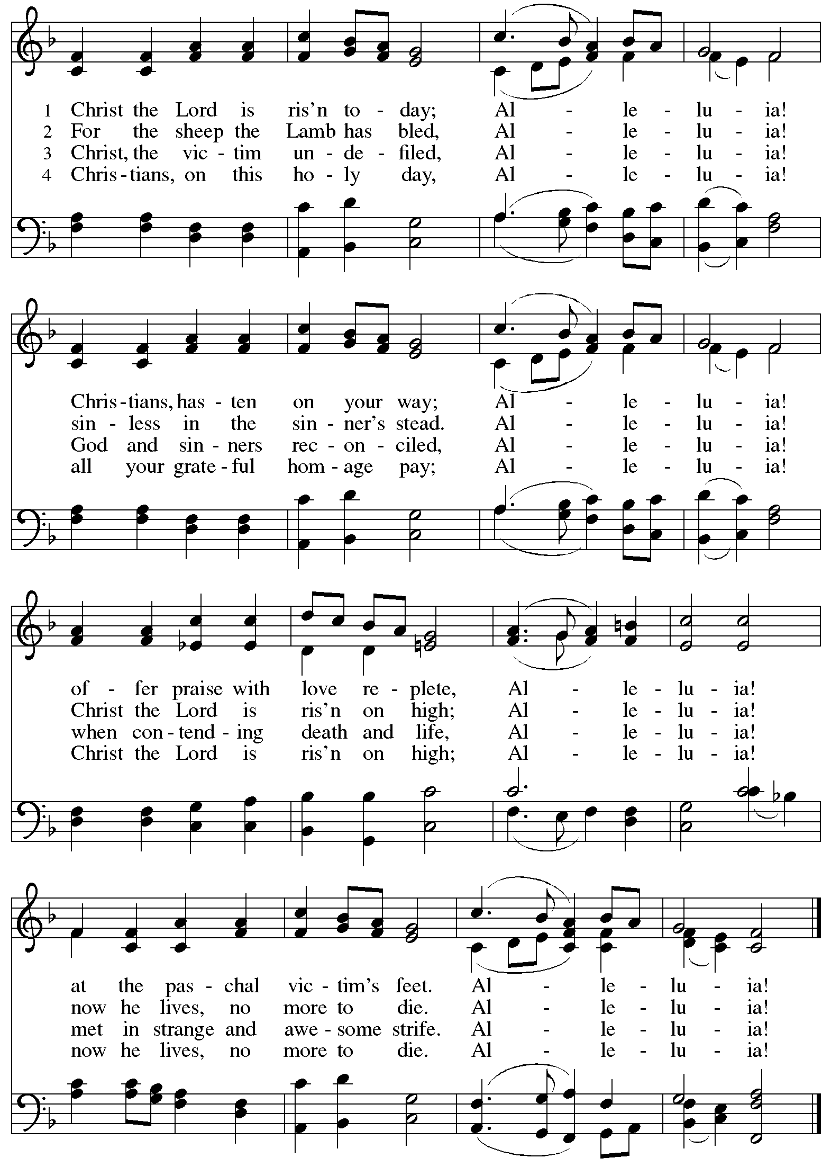

**Greeting**

P: The grace of our Lord Jesus Christ, the love of God,

and the communion of the Holy Spirit be with you all.

**C: And also with you.**

**Hymn of Praise** *This Is the Feast ELW* p. 149-150

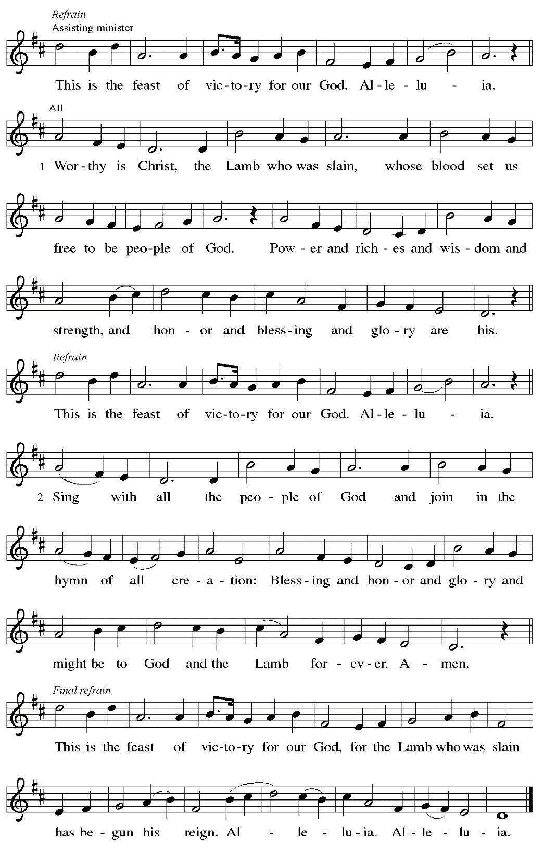

**Prayer of the Day**

P: The Lord be with you.

**C: And also with you.**

P: Let us pray.

O God of life,

you reach out to us amid our fears

with the wounded hands of your risen Son.

By your Spirit’s breath revive our faith in your mercy,

and strengthen us to be the body of your Son,

Jesus Christ, our Savior and Lord,

who lives and reigns with you and the Holy Spirit,

one God, now and forever.

**C: Amen.**

*Please be seated.*

*Children are invited to join the adult leader(s) at the side door for Little Church – Big Faith.*

*We ask that an additional adult from the congregation attend with the children.*

**Word**

*God speaks to us in Scripture reading, preaching, and song*

**First Reading** **– Acts 5: 27-32**

27 When they had brought [the apostles], they had them stand before the council. The high priest questioned them, 28 saying, “We gave you strict orders not to teach in this name, yet here you have filled Jerusalem with your teaching, and you are determined to bring this man’s blood on us.” 29 But Peter and the apostles answered, “We must obey God rather than any human authority. 30 The God of our ancestors raised up Jesus, whom you had killed by hanging him on a tree. 31 God exalted him at God’s right hand as Leader and Savior that he might give repentance to Israel and forgiveness of sins. 32 And we are witnesses to these things, and so is the Holy Spirit whom God has given to those who obey God.”

L: Word of God, word of life.

**C: Thanks be to God.**

**Psalm 118: 14-29**

*The psalm will be sung responsively, led by the cantor,*

*with the congregation responding with the bold verses and refrain.*

*Psalm tone*

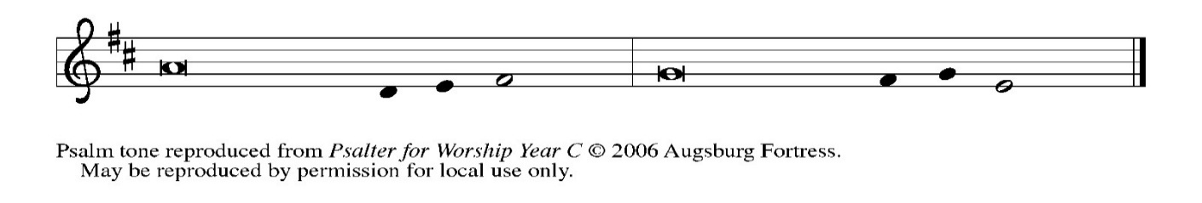

*Psalm refrain*

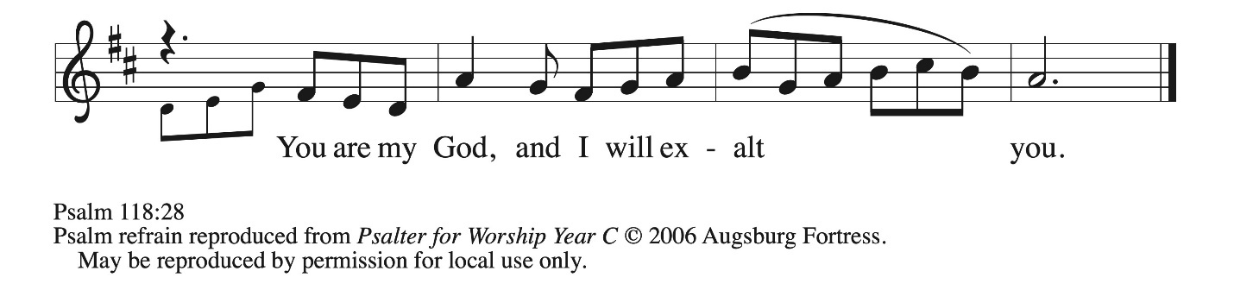

 14The Lord is my strength **|** and my song,  
  and has become **|** my salvation.  
 15**Shouts of rejoicing and salvation echo in the tents | of the righteous:**  
  **“The right hand of the | Lord acts valiantly!**  
 16The right hand of the Lord**|** is exalted!  
  The right hand of the **|** Lord acts valiantly!”  
 17**I shall not | die, but live,**  
  **and declare the works | of the Lord.** R  
 18The Lord indeed pun- **|** ished me sorely,  
  but did not hand me o- **|** ver to death.  
 19**Open for me the | gates of righteousness;**  
  **I will enter them and give thanks | to the Lord.**  
 20“This is the gate **|** of the Lord;  
  here the righ- **|** teous may enter.”  
 21**I give thanks to you, for you have | answered me**  
  **and you have become | my salvation.** R  
 22The stone that the build- **|** ers rejected  
  has become the chief **|** cornerstone.  
 23**By the Lord has | this been done;**  
  **it is marvelous | in our eyes.**  
 24This is the day that the **|** Lord has made;  
  let us rejoice and be **|** glad in it.

25 **Hosanna! | O Lord, save us!**  
  **We pray to you, Lord, pros- | per our days! R**  
 26 Blessed is the one who comes in the name **|** of the Lord;  
  we bless you from the house **|** of the Lord.  
 27 **The Lord is God and has giv- | en us light.**  
  **Form a procession with branches up to the corners | of the altar.**  
 28 You are my God, and **|** I will thank you;  
  you are my God, and I **|** will exalt you.  
 29 **Give thanks to the Lord, for the | Lord is good;**  
  **God’s mercy en- | dures forever. R**

**Second Reading – Revelation 1: 4-8**

4 John to the seven churches that are in Asia:  
  Grace to you and peace from the one who is and who was and who is to come and from the seven spirits who are before God’s throne, 5 and from Jesus Christ, the faithful witness, the firstborn of the dead, and the ruler of the kings of the earth.  
  To him who loves us and freed us from our sins by his blood 6 and made us a kingdom, priests serving his God and Father, to him be glory and dominion forever and ever. Amen.  
 7 Look! He is coming with the clouds;  
  every eye will see him,  
 even those who pierced him,  
  and all the tribes of the earth will wail on account of him.  
So it is to be. Amen.  
  8 “I am the Alpha and the Omega,” says the Lord God, who is and who was and who is to come, the Almighty.

L: Word of God, word of life.

**C: Thanks be to God.**

*Please rise as you are able.*

**Gospel Acclamation** *ELW* p. 151

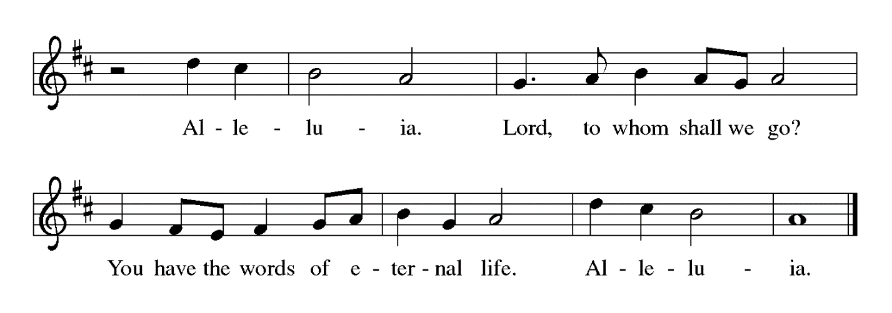

**Gospel – John 20: 19-31**

P: The holy Gospel according to St. John.

**C: Glory to you, O Lord.**

19 When it was evening on that day, the first day of the week, and the doors were locked where the disciples were, for fear of the Jews, Jesus came and stood among them and said, “Peace be with you.” 20 After he said this, he showed them his hands and his side. Then the disciples rejoiced when they saw the Lord. 21 Jesus said to them again, “Peace be with you. As the Father has sent me, so I send you.” 22 When he had said this, he breathed on them and said to them, “Receive the Holy Spirit. 23 If you forgive the sins of any, they are forgiven them; if you retain the sins of any, they are retained.”  
  
  24 But Thomas (who was called the Twin), one of the twelve, was not with them when Jesus came. 25 So the other disciples told him, “We have seen the Lord.” But he said to them, “Unless I see the mark of the nails in his hands and put my finger in the mark of the nails and my hand in his side, I will not believe.”  
  26 A week later his disciples were again in the house, and Thomas was with them. Although the doors were shut, Jesus came and stood among them and said, “Peace be with you.” 27 Then he said to Thomas, “Put your finger here and see my hands. Reach out your hand and put it in my side. Do not doubt but believe.” 28 Thomas answered him, “My Lord and my God!” 29 Jesus said to him, “Have you believed because you have seen me? Blessed are those who have not seen and yet have come to believe.”  
  
  30 Now Jesus did many other signs in the presence of his disciples that are not written in this book. 31 But these are written so that you may continue to believe that Jesus is the Messiah, the Son of God, and that through believing you may have life in his name.

P: The Gospel of the Lord.

**C: Praise to you, O Christ.**

*Please be seated.*

**Sermon**

*A time of silence for prayer and reflection follows the sermon.*



*When the hymn of the day begins, please rise as you are able.*

**Hymn of the Day We Walk by Faith and Not by Sight *WOV* 675**

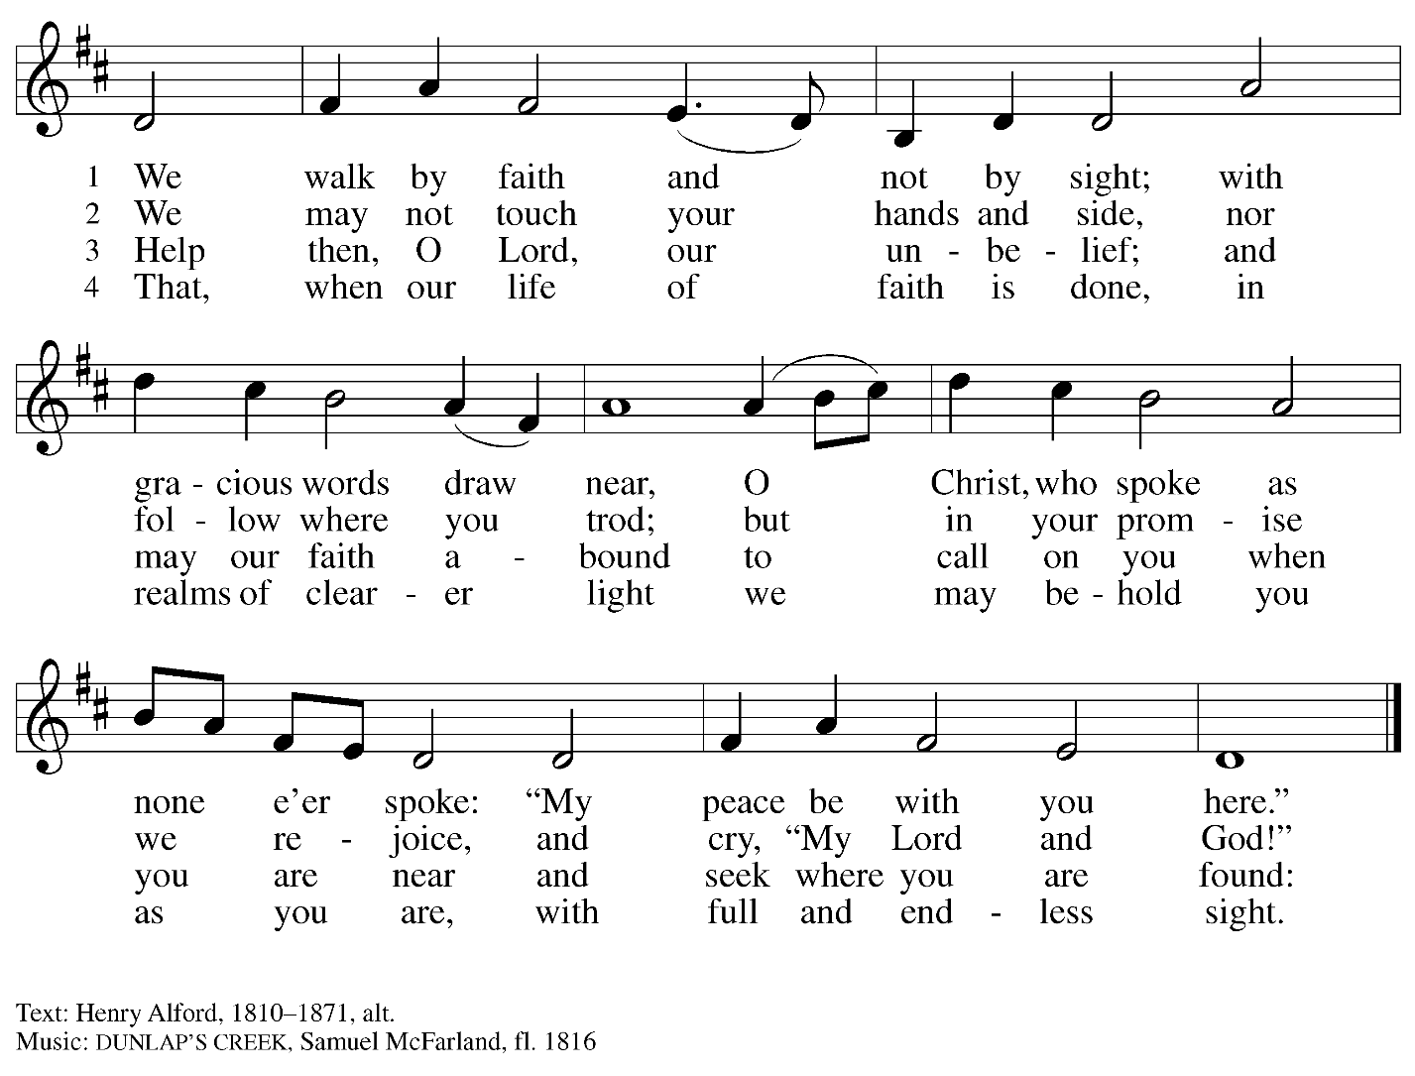

**The Sacrament of Holy Baptism**

*Candidates for baptism, sponsors, and parents gather with the ministers at the font.*

*The assembly is seated.*

**Presentation**

*The presiding minister may address the assembly in these or similar words:*

P: God, who is rich in mercy and love, gives us a new birth into a living hope through the sacrament of Holy Baptism. By water and the Word God delivers us from sin and death and raises us to new life in Jesus Christ. We are united with all the baptized in the one body of Christ, anointed with the gift of the Holy Spirit, and joined in God's mission for the life of the world.

*Sponsors for each candidate, in turn, present the candidates:*

*S*:I present  name  for Baptism.

*The presiding minister addresses parents or others who bring for Baptism*

*children who are not able to answer for themselves:*

P: Called by the Holy Spirit, trusting in the grace and love of God,

do you desire to have your child baptized into Christ?

*Response:* I do.

P: As you bring your child to receive the gift of Baptism, you are entrusted with responsibilities:

to live with them among God's faithful people,

bring them to the word of God and the holy supper,

teach them the Lord's Prayer, the Creed, and the Ten Commandments,

place in their hands the holy scriptures,

and nurture them in faith and prayer,

so that your child may learn to trust God,

proclaim Christ through word and deed,

care for others and the world God made,

and work for justice and peace.

Do you promise to help your child grow in the Christian faith and life?

*Response:* I do.

*The presiding minister addresses sponsors:*

P: Sponsors, do you promise to nurture this personin the Christian faith as you are empowered by God's Spirit, and to help them live in the covenant of Baptism and in communion with the church?

*Response:* I do.

*The presiding minister addresses the assembly:*

P: People of God, do you promise to support name/s and pray for them in their new life in Christ?

**C: We do.**

*People of the assembly please rise as you are able.*

**Profession of Faith**

*The presiding minister addresses candidates for Baptism as well as the parents and sponsors of young children. The assembly may join in the responses.*

P: I ask you to profess your faith in Christ Jesus, reject sin, and confess the faith of the church.

Do you renounce the devil and all the forces that defy God?

*Response:* I renounce them.

P: Do you renounce the powers of this world that rebel against God?

*Response:* I renounce them.

P: Do you renounce the ways of sin that draw you from God?

*Response:* I renounce them.

*The presiding minister addresses the candidates and the assembly.*

P: Do you believe in God the Father?

**C: I believe in God, the Father almighty,**

**creator of heaven and earth.**

P: Do you believe in Jesus Christ, the Son of God?

**C: I believe in Jesus Christ, God’s only Son, our Lord,**

**who was conceived by the Holy Spirit,**

**born of the virgin Mary,**

**suffered under Pontius Pilate,**

**was crucified, died, and was buried;**

**he descended to the dead.\***

**On the third day he rose again;**

**he ascended into heaven,**

**he is seated at the right hand of the Father,**

**and he will come to judge the living and the dead.**

P: Do you believe in God the Holy Spirit?

**C: I believe in the Holy Spirit,**

**the holy catholic church,**

**the communion of saints,**

**the forgiveness of sins,**

**the resurrection of the body,**

**and the life everlasting.**

*Or, “he descended into hell,” another translation of this text in widespread use.

**Thanksgiving at the Font**

*Water may be poured into the font before or during the thanksgiving.*

*At the font, the presiding minister begins the thanksgiving:*

P: The Lord be with you.

**C: And also with you.**

P: Let us give thanks to the Lord our God.

**C: It is right to give our thanks and praise.**

P: We give you thanks, O God, for in the beginning your Spirit moved over the waters and by your Word you created the world, calling forth life in which you took delight.

Through the waters of the flood you delivered Noah and his family, and through the sea you led your people Israel from slavery into freedom. At the river your Son was baptized by John and anointed with the Holy Spirit. By the baptism of Jesus' death and resurrection you set us free from the power of sin and death and raise us up to live in you.

Pour out your Holy Spirit, the power of your living Word, that those who are washed in the waters of baptism may be given new life. To you be given honor and praise through Jesus Christ our Lord, in the unity of the Holy Spirit, now and forever.

**C: Amen.**

*The assembly may be seated.*

**Baptism**

*The presiding minister baptizes the candidate. The candidate is immersed into the water, or water is poured on the candidate's head, as the presiding minister says:*

P:  Name , I baptize you in the name of the Father,*

*The candidate is immersed or water is poured on the candidate's head a second time:*

and of the Son,

*The candidate is immersed or water is poured on the candidate's head a third time:*

and of the Holy Spirit.

**C: Amen.**

*After the Baptism, the assembly sings the acclamation of the congregational refrain,*

*which is sung on special occasions in the life of the congregation.*

**Congregational Refrain *HS* 808**



Text: Jaroslav J. Vajda, b. 1919, © 1987.

Music: RIVERSIDE, Irregular; Carl F. Schalk, b. 1929, © 1987 GIA Publications, Inc.

All rights reserved. Reprinted with permission under OneLicense.net # A-722139.

*The presiding minister continues:*

P: Let us pray.

We give you thanks, O God, that through water and the Holy Spirit you give your children new birth, cleanse them from sin, and raise them to eternal life.

*Laying both hands on the head of the newly baptized, the minister prays:*

P: Sustain name with the gift of your Holy Spirit: the spirit of wisdom and understanding, the spirit of counsel and might, the spirit of knowledge and the fear of the Lord, the spirit of joy in your presence, both now and forever.

**C: Amen.**

*The presiding minister marks the sign of the cross on the forehead of the baptized.*

*Oil prepared for this purpose may be used. As the sign of the cross is made, the minister says:*

P:  Name, child of God, you have been sealed by the Holy Spirit and marked with the cross of Christ forever.

**C: Amen.**

*Or, " Name  is baptized in the name of the Father, . . ."

**Welcome**

*A lighted candle may be given to each of the newly baptized (to a sponsor of a young child)*

*as a representative of the congregation says:*

**A:** Jesus said, I am the light of the world.

Whoever follows me

will have the light of life.

*The ministers and the baptismal group face the assembly.*

*A representative of the congregation leads the assembly in the welcome.*

A: Let us welcome the newly baptized.

**C: We welcome you into the body of Christ and into the mission we share:**

**join us in giving thanks and praise to God**

**and bearing God's creative and redeeming word to all the world.**

*As those who have gathered at the font move through the congregation*

*to introduce our new sibling in Christ,*

*a hymn of blessing is sung by the newly baptized child’s mother.*

*When all have returned to their places, worship continues with the prayers of the people.*

**Prayers of the People**

A: United in the joy and hope of the resurrection, let us pray for the church, the world,

and all who are in need.

*After each petition*

A: Gracious God,

**C: receive our prayer.**

P: We lift these prayers to you O God, trusting in your abundant mercy,

through Jesus Christ our risen Savior.

**C: Amen.**

**Peace**

*The presiding minister and the assembly greet one another in the peace of the risen Christ.*

P: The peace of Christ be with you always.

**C: And also with you.**

*The people may greet those around them with a sign of Christ’s peace and may say*

Peace be with you *or similar words. Please be mindful that not everyone will be comfortable with sharing the peace, so please seek consent before shaking hands or hugging. Other possible ways to share the peace include a simple bow with the verbal greeting of peace, or simply a verbal expression of peace.*

*When the greetings of peace have concluded, please be seated.*

**Meal**

*God feeds us with the presence of Jesus Christ*

**Offering**

*We offer ourselves, our gifts, and our faithful service to God.*

*As the offering is gathered for the mission of the church, including the care of those in need,*

*the table is set for Holy Communion.*

*There are laminated giving cards in the pew racks that feature a QR code for anyone who would like to give online. Those who give using the QR code, as well as those who give regularly online or through their bank are encouraged to place the laminated card in the plate as an expression of your offering.*

**Music during Offering** *Celebration*arr. Bober

*As the gifts are brought forward for presentation, please rise as you are able.*

**Offertory Song Let the Vineyards *ELW* 184**

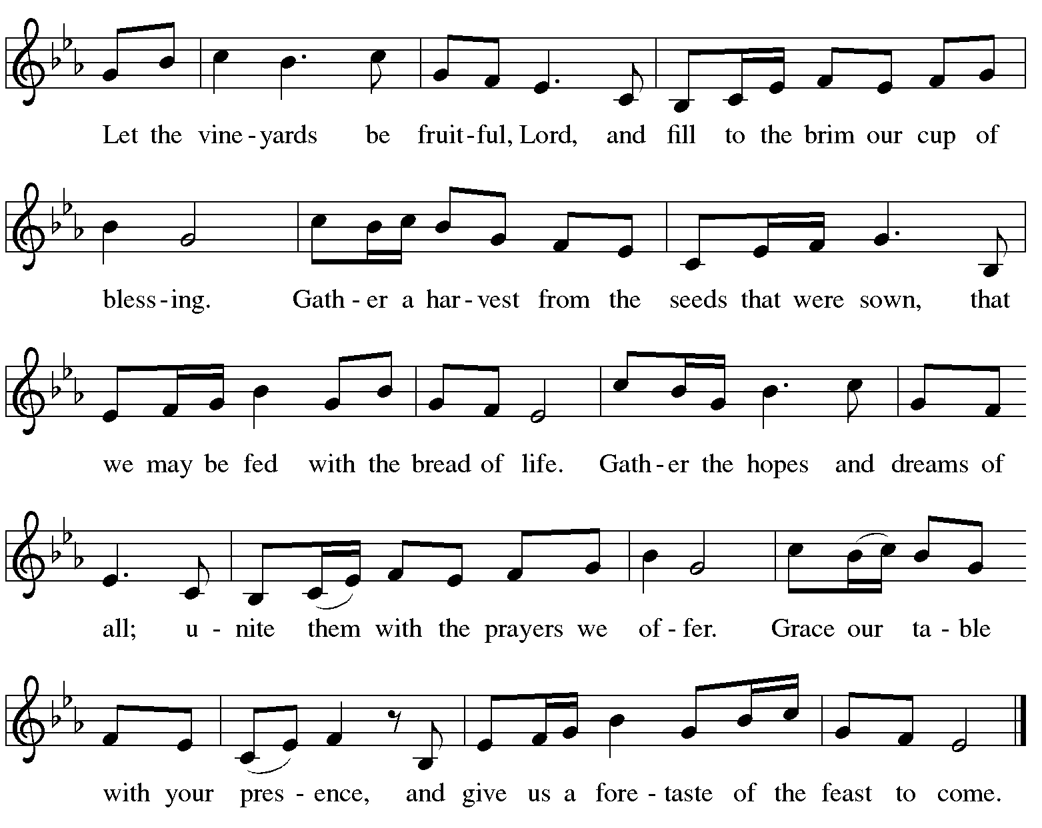

**Offertory Prayer**

A: Let us pray.

Blessed are you, O God,

**C: ruler of heaven and earth.**

**Day by day you shower us with blessings.**

**As you have raised us to new life in Christ,**

**give us glad and generous hearts,**

**ready to praise you and to respond to those in need,**

**through Jesus Christ, our Savior and Lord.**

**Amen.**

**Dialogue** *ELW* p. 152

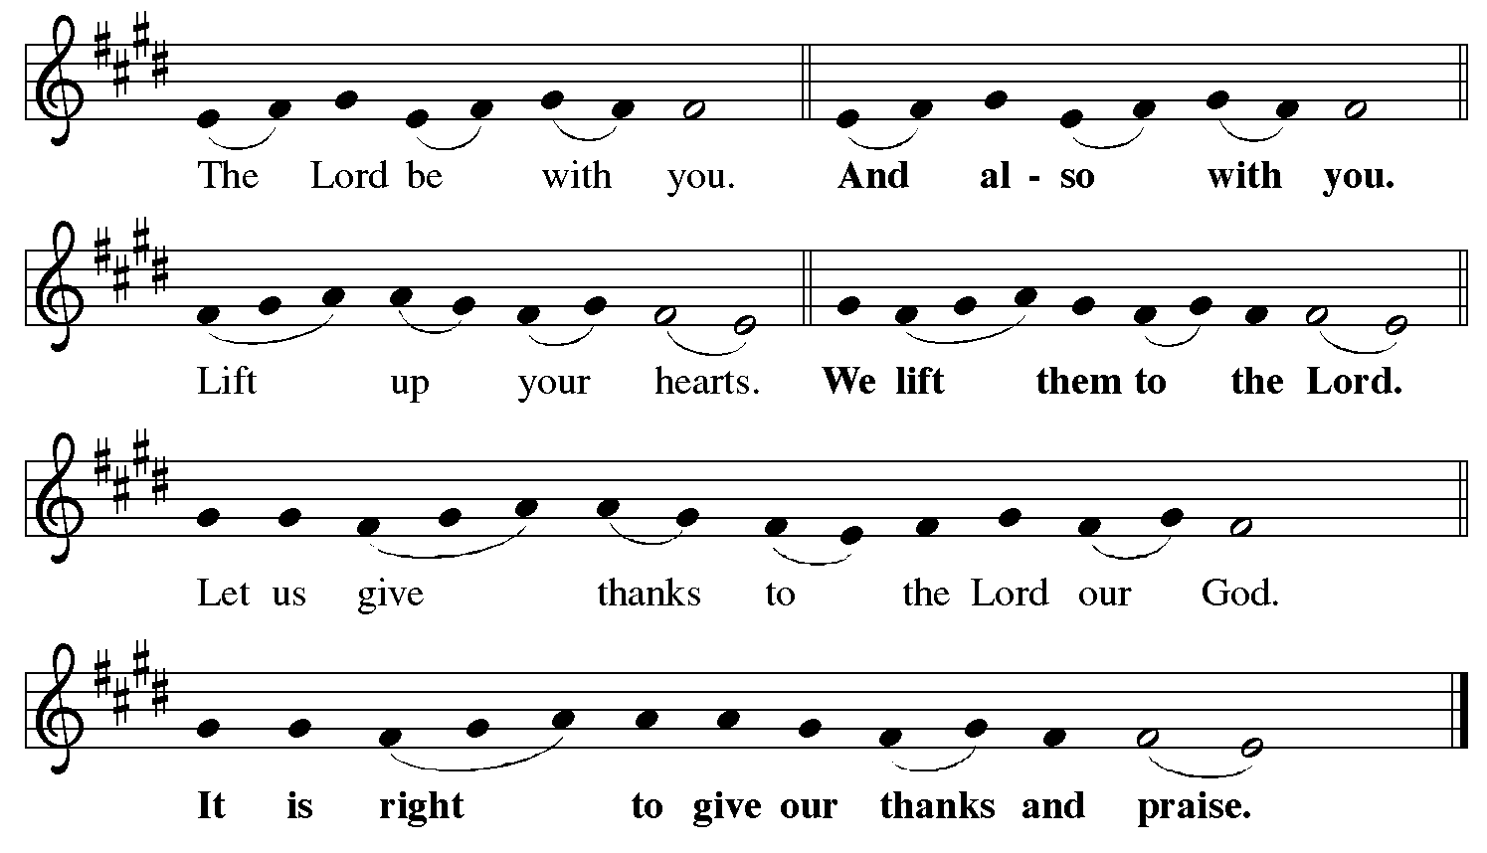

**Preface** *(Sung by the presiding minister)*

P: It is indeed right, our duty and our joy,

that we should at all times and in all places

give thanks and praise to you, almighty and merciful God,

for the glorious resurrection of our Savior Jesus Christ,

the true Paschal Lamb who gave himself to take away our sin;

who in dying has destroyed death,

and in rising has brought us to eternal life.

And so, with Mary Magdalene and Peter

and all the witnesses of the resurrection,

with earth and sea and all their creatures,

and with angels and archangels, cherubim and seraphim,

we praise your name and join their unending hymn:

**Sanctus** *ELW* p. 153

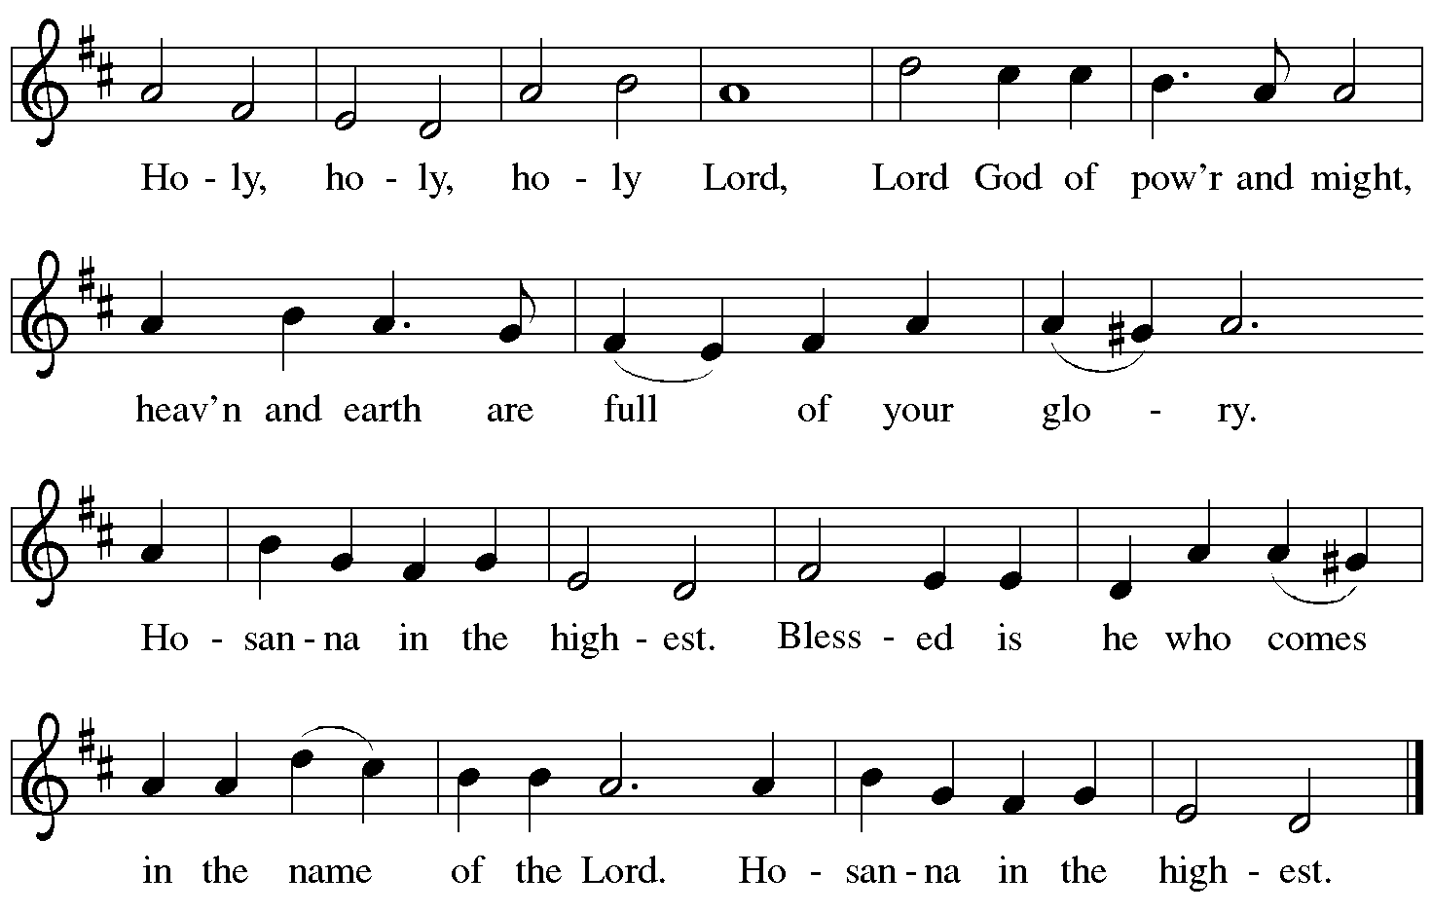

**Eucharistic Prayer**

P: Blessed are you, O God of the universe …

… Do this for the remembrance of me.

With this bread and cup

we proclaim our Lord’s passover from death to life

as we proclaim the mystery of faith:

**C: Christ has died.**

**Christ is risen.**

**Christ will come again.**

P: O God of resurrection and new life …

… Grace our table with your presence.

**C: Come, Holy Spirit.**

P: Reveal yourself to us in the breaking of the bread …

… Send us forth, burning with justice, peace, and love.

**C: Come, Holy Spirit.**

P: With your holy ones of all times and places …

… O God, blessed and holy Trinity,

now and forever.

**C: Amen.**

**Lord’s Prayer**

P: Gathered as one by the Holy Spirit, let us pray as Jesus taught us.

**C: Our Father, who art in heaven,**

**hallowed be thy name,**

**thy kingdom come,**

**thy will be done,**

**on earth as it is in heaven.**

**Give us this day our daily bread;**

**and forgive us our trespasses,**

**as we forgive those**

**who trespass against us;**

**and lead us not into temptation,**

**but deliver us from evil.**

**For thine is the kingdom,**

**and the power, and the glory,**

**forever and ever. Amen.**

**Fraction and Invitation**

P: Alleluia! Christ is risen!

**C: Christ is risen indeed! Alleluia! Alleluia!**

P: This is the feast of victory for our God. Alleluia! Alleluia!

Come, share the feast.



***Agnus Dei /* Lamb of God** *ELW* p. 154

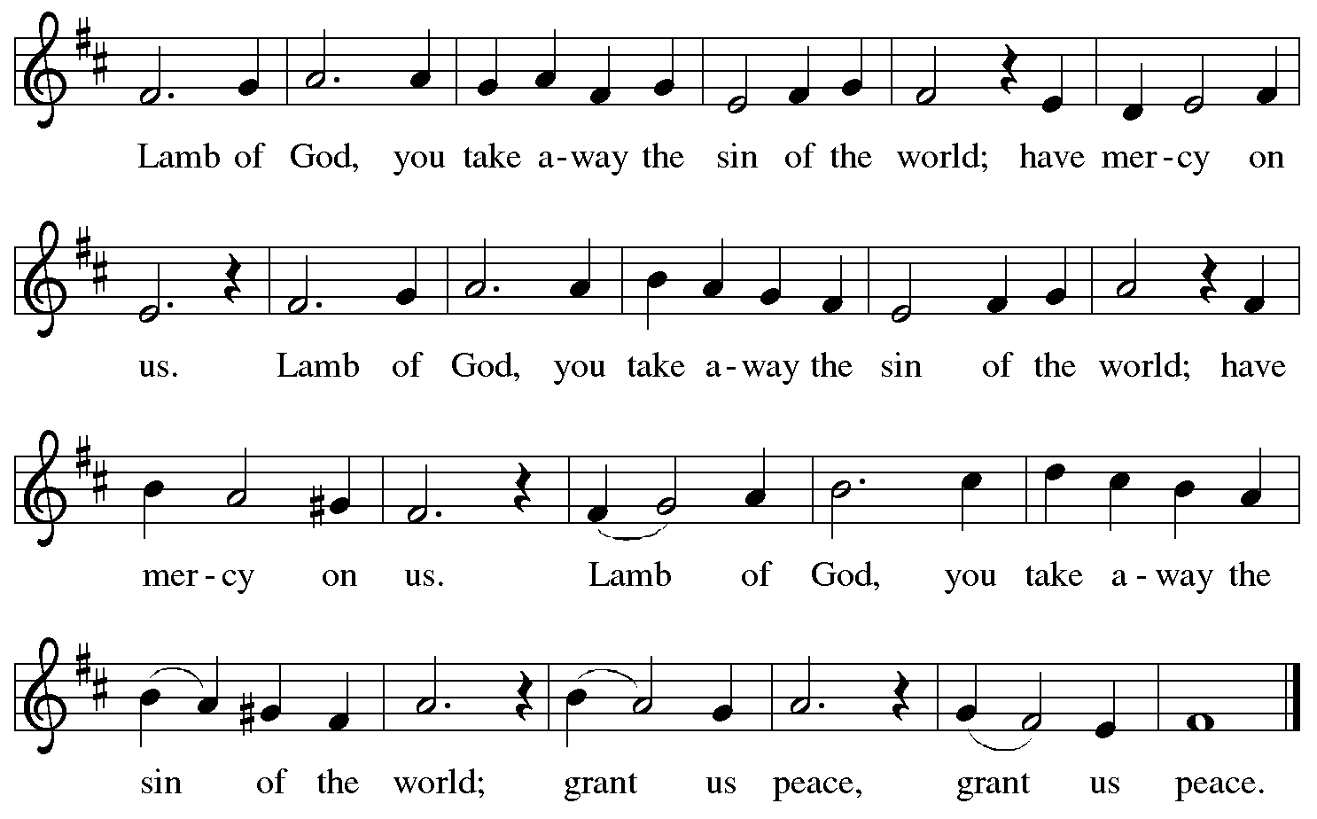

*Please be seated.*

**Holy Communion**

* *All who seek God and desire a deeper and stronger life in Christ are welcome to receive Holy Communion.*
* *Worshipers from the pulpit side will proceed forward first, followed by the center section, and then the lectern side.*
* *Please inform an usher if you would like the ministers to bring Communion to you.*
* *Holy Communion will be served with bread and wine (red) or grape juice (white).*
* *The presiding minister will first distribute the bread (host) to each communicant. Please indicate if you require a gluten-free host.*
* *Once you have consumed the bread, please pick up an empty glass from the tray next to the presiding minister. The Communion Assistant will pour wine or grape juice into your glass.*
* *Please step to the side to consume the wine or grape juice.*
* *Feel free to kneel at the altar rail for prayer after receiving the sacrament.*
* *As you return to your pew, glasses may be returned to the empty tray on the side of the center section.*
* *A blessing will be provided for anyone who does not yet receive the sacrament.*
* *All are invited to join in singing the hymns during Holy Communion.*

**Hymns during Holy Communion**

**Touch That Soothes and Heals  *ACS* 939**

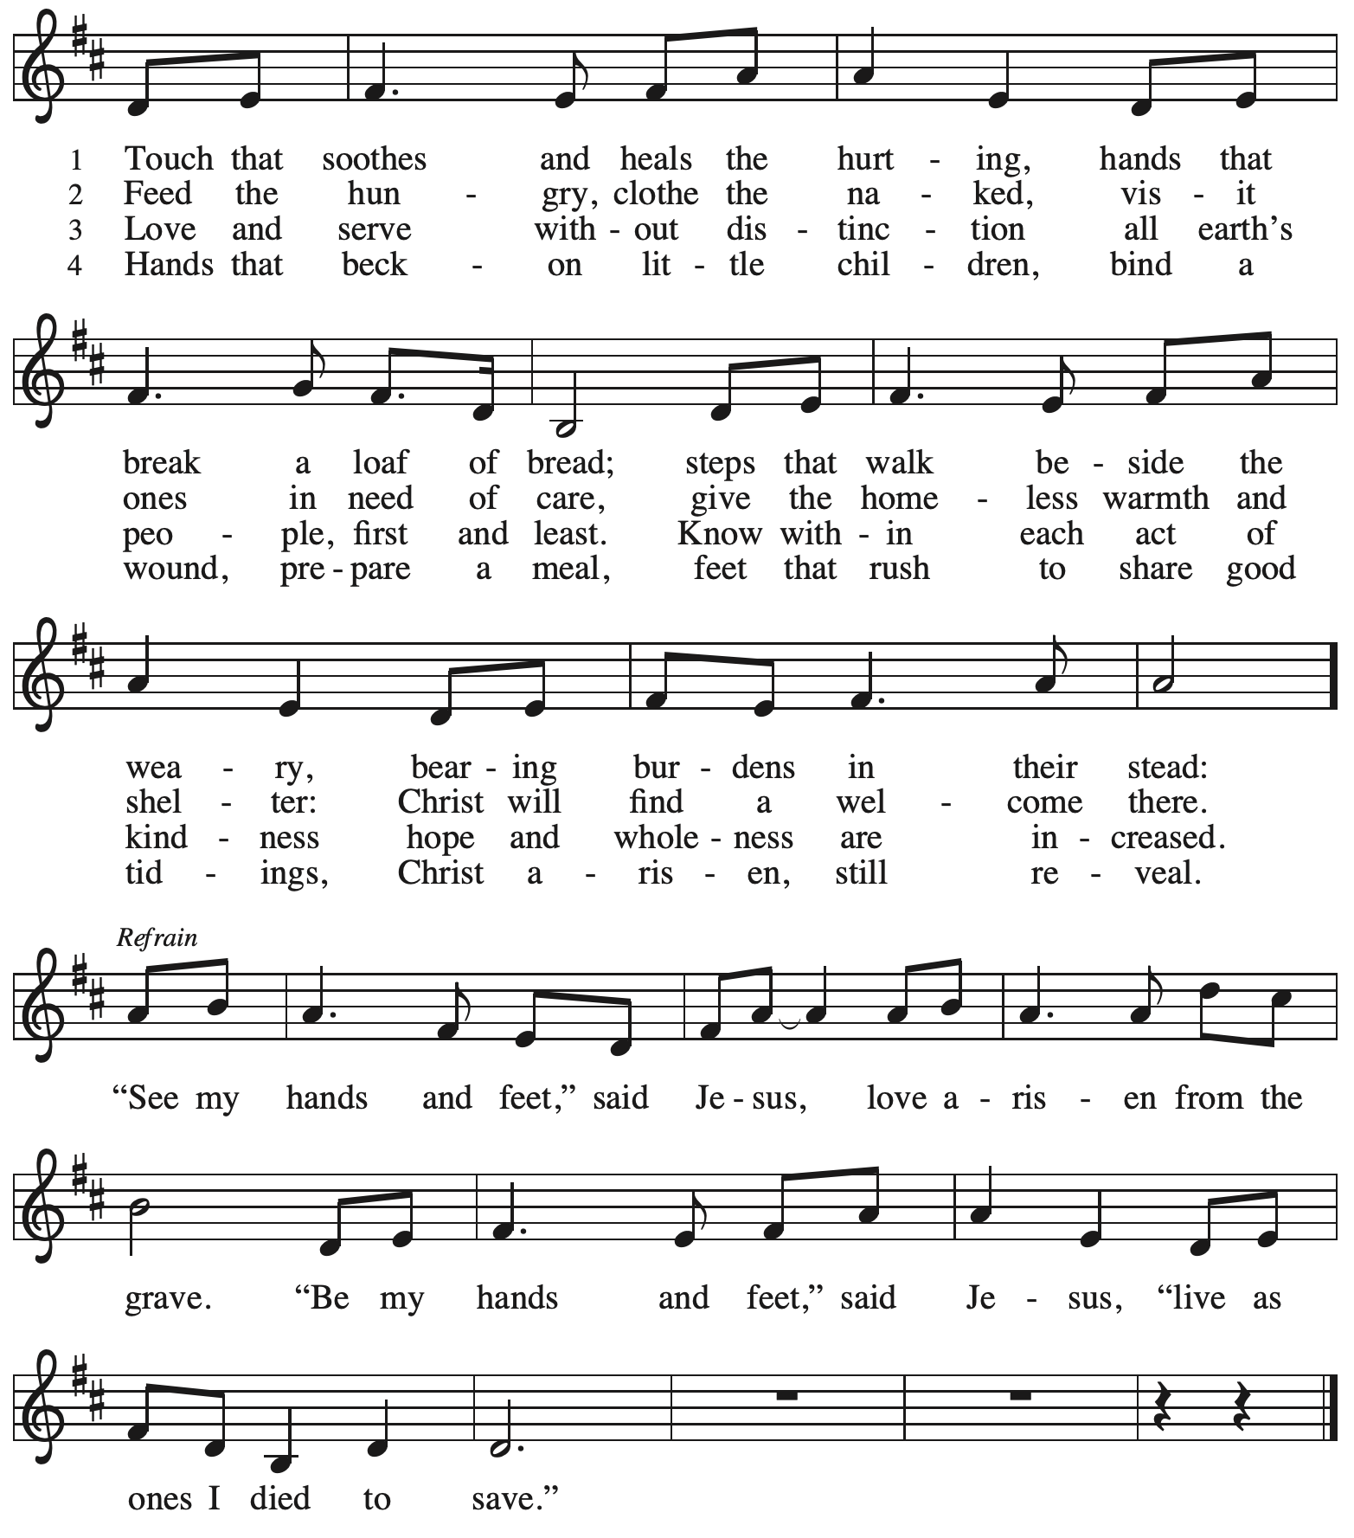

All rights reserved. Reprinted with permission under OneLicense.net # A-722139.

**Hymns during Holy Communion**

**La paz del Señor – The Peace of the Lord *ELW* 646**

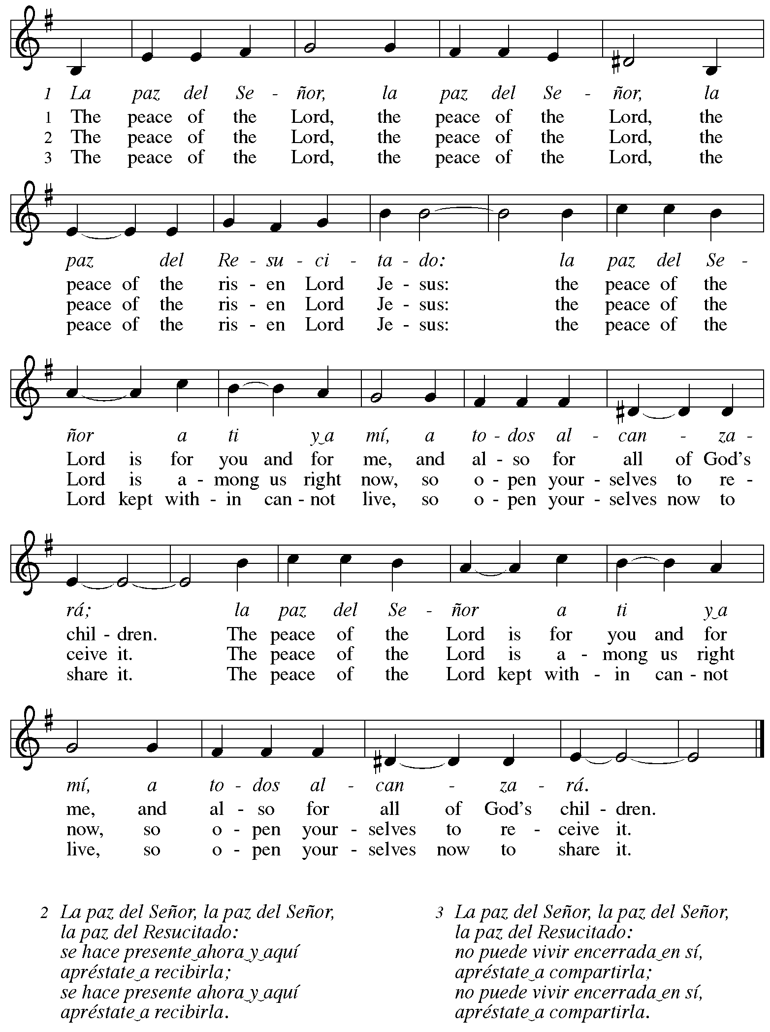

**Hymns during Holy Communion**

**Lord, Enthroned in Heavenly Splendor *ELW* 475**

**v. 1-3**

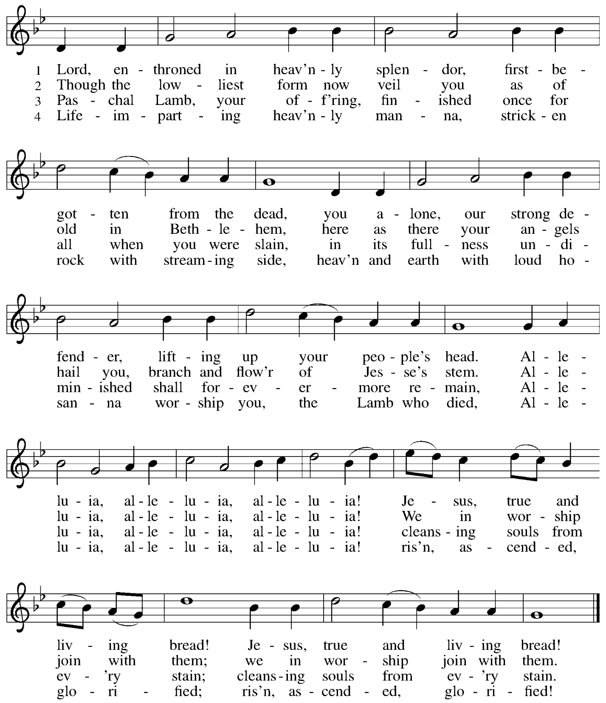

**Hymns during Holy Communion**

**Joyful, Joyful, We Adore Thee *ELW* 836**

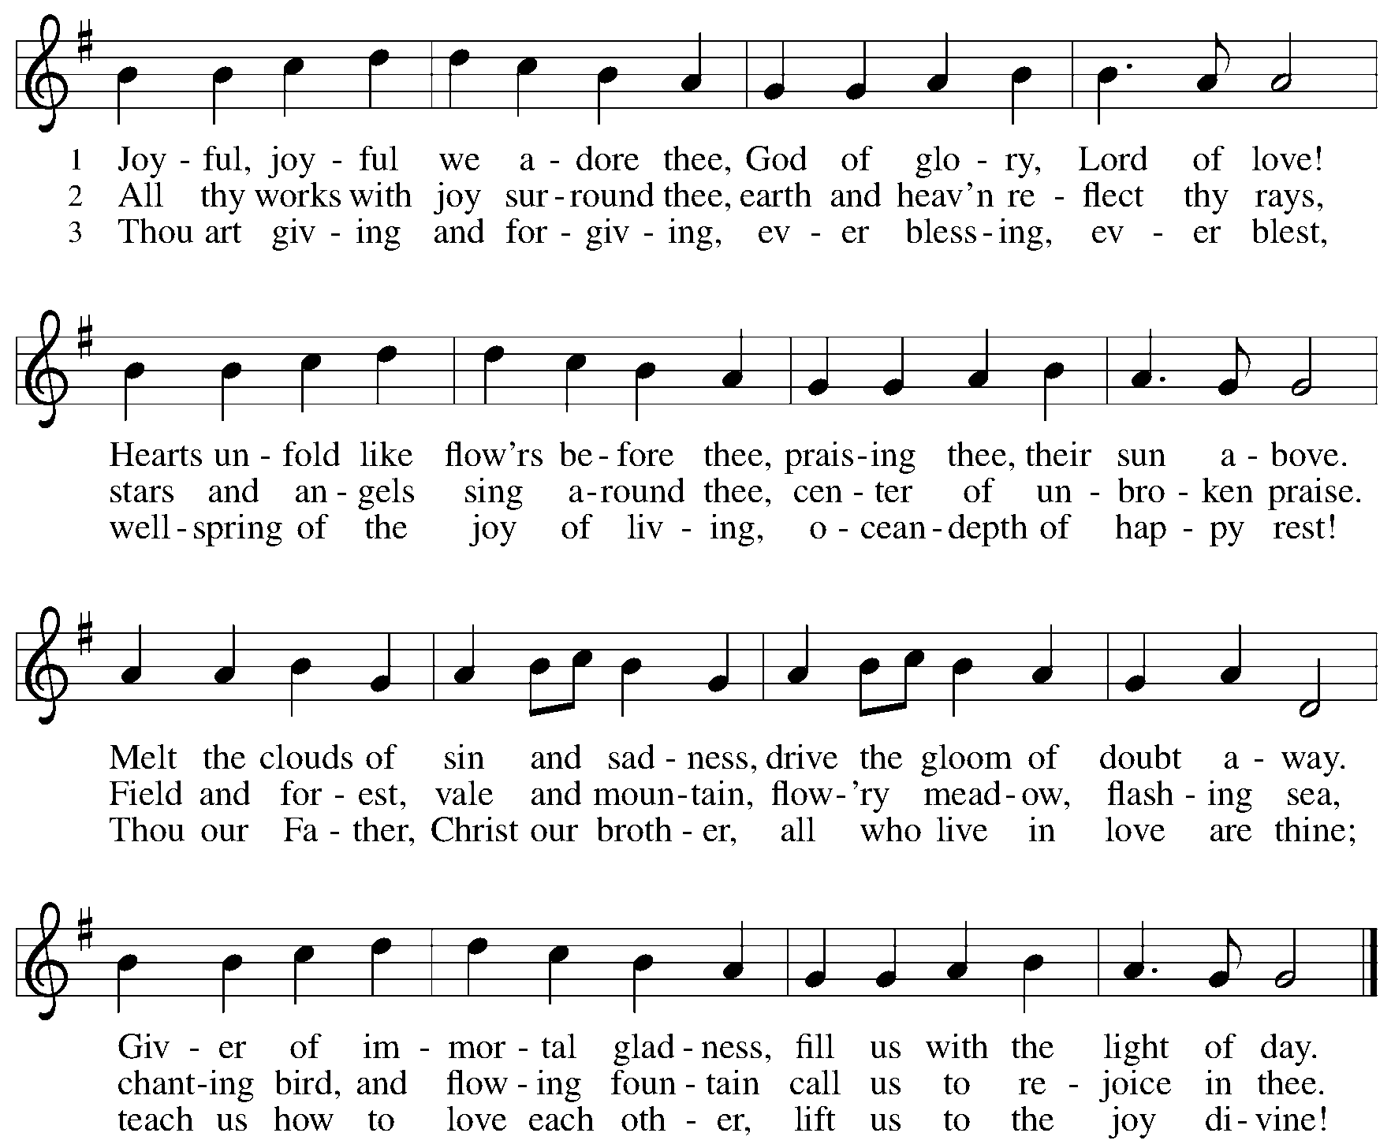



*When all have returned to their places, please rise as you are able.*

**Blessing**

P: The body and blood of our Lord Jesus Christ strengthen you and keep you in his grace.

**C: Amen.**

**Prayer**

A: Let us pray.

Life-giving God,

in the mystery of Christ’s resurrection, you send light to conquer darkness,

water to give new life, and the bread of life to nourish your people.

Send us forth as witnesses to your Son’s resurrection,

that we may show your glory to all the world,

through Jesus Christ, our risen Lord.

**C: Amen.**

**Sending**

*God blesses us and sends us in mission to the world*

**Benediction**

P: May our glorious God grant you a spirit of wisdom

to know and love the risen Christ.

Almighty God, holy One, ☩ holy Three,

bless you now and forever.

**C: Amen.**

**Sending Hymn** *Following page*

**Dismissal**

A: Alleluia! Christ is risen!

**C: Christ is risen indeed! Alleluia! Alleluia!**

A: Go in peace. Share the good news!

**C: Thanks be to God!**

**Postlude**

**Sending Hymn Christ Is Alive! Let Christians Sing *ELW* 389**

**v. 1-2, 5**

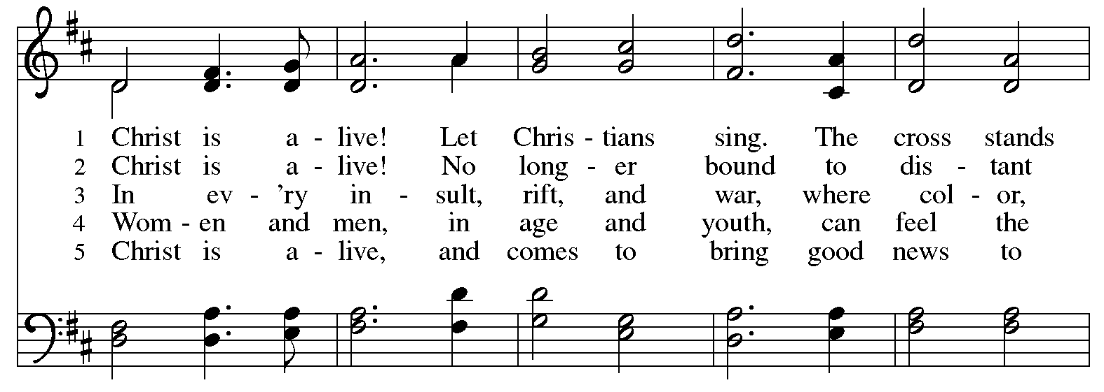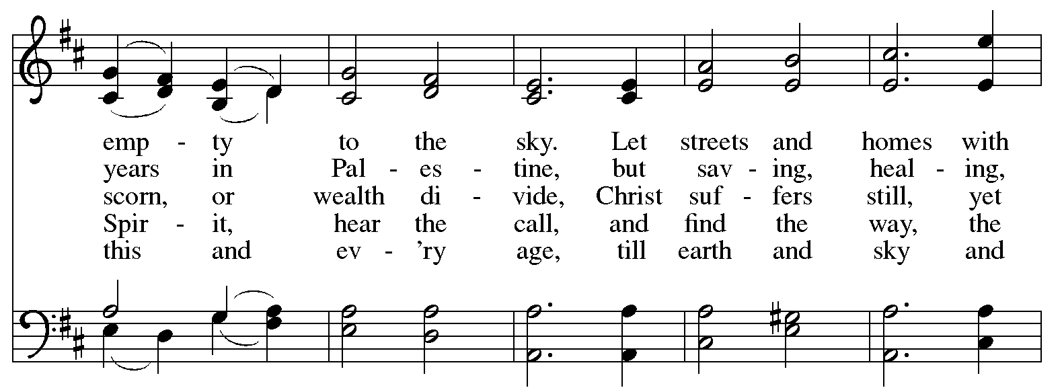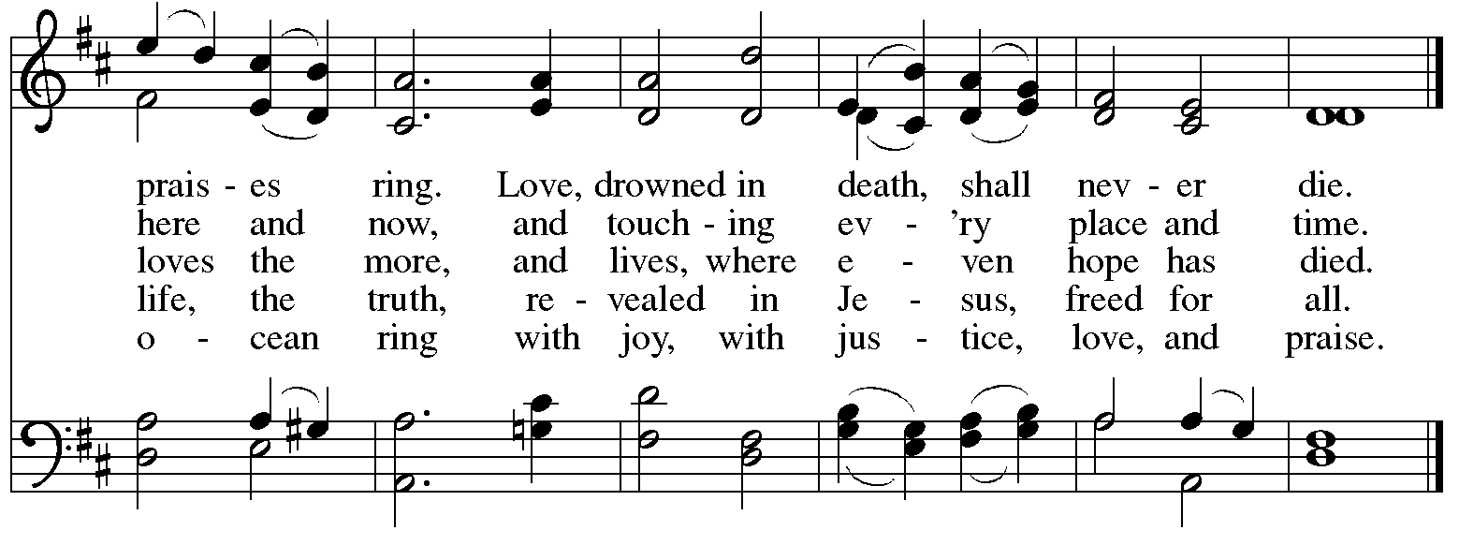

*Serving in worship today*

Altar Care Christy Ruhe

Assisting Minister Kathy Hays

Audio-Visual Ministers Kristen Asplin

Tyler Rietze

Cantor David Rollinson

Lector Sue Gaugler

Little Church – Big Faith Leader Emily Duque

Organ Jimmi Kocher-Hillmer

Prelude and Music during the Offering Sarita

Pre-Service Music Tom Leech

Minister of Music Laura Reynolds

Presiding Minister The Rev. Ross I. Carmichael

*Liturgy and Hymnody Acknowledgements*

From SundaysandSeasons.com. Copyright © 2025 Augsburg Fortress. All rights reserved. Reprinted under OneLicense.net # A-722139.

Used by permission of Augsburg Fortress.

The Scripture readings contained herein are from *New Revised Standard Version Updated Edition* of the Bible © 2021 National Council of Churches of Christ in the United States of America. Used by permission. All rights reserved worldwide.

**Christ the Lord Is Risen Today; Alleluia!** –Text: att. Wipo of Burgundy, d. ca. 1050; tr. Jane E. Leeson, 1807-1882, alt. Music: LLANFAIR, Robert Williams, 1781-1821.

**Let the Vineyards** – Text: John W. Arthur, 1922-1980. Music: Ronald A. Nelson, b. 1927. Text and Music © 1978 *Lutheran Book of Worship*, admin. Augsburg Fortress.

**La paz del Señor** – Text: Anders Ruuth; tr. Gerhard M. Cartford, b. 1923. Music: LAZ PAZ DEL SEÑOR, Anders Ruuth. Spanish text and tune © Anders Ruuth, admin. Augsburg Fortress. English text © Lutheran World Federation. All rights reserved. Reprinted with permission under OneLicense.net # A-722139.

*Please use the QR code below to link to St. Andrew’s Announcements online!*



**St. Andrew Lutheran Church Announcements**

**April 27th, 2025**

* **Happy Easter! Welcome to Worship at St. Andrew on the Second Sunday of Easter, April 27th, 2025!** –We are so glad you are here to share in this festive season, and we offer a special welcome to all visitors and guests who are here for the first time! Children are invited to participate in Little Church – Big Faith, a Bible lesson and activity, after the prayer of the day. There are worship “toolkits” to help children engage with worship and “busy bags” for younger children available in the bookcase at the back of the sanctuary. Please feel free to take one to use with/for your children. A nursery is available through the door to the left of the worship space and across the social hall (look for a purple room). All are invited to stay for coffee, food, and conversation in the social hall after worship. We pray that everyone has a blessed Easter season!
* **Blessings to Edwin Theodore, Receiving the Sacrament of Holy Baptism!** –Today is a day of celebration at St. Andrew not only because the Easter season continues but because during worship, we will welcome our new sibling in Christ, Edwin Theodore, through the Sacrament of Holy Baptism! We invite your prayers for Edwin (Winnie), parents Lindsay and Miriam, godparents, and the whole family as together we give thanks for the gifts of God’s love and grace! Please stay for Coffee hour to continue the celebration with cake!
* **Community Ministry Meeting – Monday, May 5th at 7:00 p.m. on Zoom** – St. **Andrew’s community ministry committee coordinates our local service ministries such as the outdoor Little Library, the pantry, produce distribution, shelter dinner, and various other activities. New participants are always welcome, and the next meeting is Monday, May 5th, at 7:00 p.m. on Zoom. Please contact** [PastorRCarmichael@gmail.com](mailto:PastorRCarmichael@gmail.com) **or** [community@standrewpittsburgh.org](mailto:community@standrewpittsburgh.org) **if you would like the link.**
* **May Produce Distribution – First Tuesday of the Month, May 6th, 5:30-7:00 p.m.** –

St. Andrew partners with Greater Pittsburgh Community Food Bank to serve as a distribution site for fresh produce on the first Tuesday of every month. This month’s distribution will be on Tuesday, May 6th. We invite people of the congregation to help with the distribution from 5:30-7:00 p.m. and/or to help with unloading and setup during the day between 10:00 a.m. and 1:00 p.m.

* **Congregation Council Meeting – Saturday, May 10th, 9:00 a.m.**
* **May Shelter Dinner for Guests of East End Cooperative Ministry – Third Thursday of the Month, May 15th, 6:30 p.m.** – Each month, people of St. Andrew provide dinner for guests of East End Cooperative Ministry (EECM), 6140 Station St. (East Liberty), 15206. This month’s shelter dinner is on Maundy Thursday, when St. Andrew will have worship at 7:00 p.m., so we invite you to prepare or purchase one menu item and bring it to the shelter by 6:00 p.m. If you would like to contribute, please sign up at

[**https://www.signupgenius.com/go/5080544AAAC22A1F58-56438583-mayshelter**](https://www.signupgenius.com/go/5080544AAAC22A1F58-56438583-mayshelter)**.**

* ***Christ in Our Home* Devotional Booklets for April – June Available at Entrances** – This resource offers a daily Bible reading with a short reflection and prayer, along with additional readings and prayer topics for those who would like to expand their devotional practices. We encourage people of the congregation to take one for yourself, your family/household, or others!
* **Prayer Service with the Pittsburgh Compline Choir – Sundays at 8:00 p.m. at Heinz Chapel –** Compline was traditionally a monastic prayer service, and the Pittsburgh Compline Choir, a ministry of Lutheran Campus Ministry in Greater Pittsburgh, sings a choral version of compline rooted in this thousand-year-old tradition of scripture, song, and silence each Sunday at Heinz Chapel at 8:00 p.m. This service also streams on Facebook (Pittsburgh Compline Choir) and YouTube (The Pittsburgh Compline Choir). Heinz Chapel is located off of S. Bellefield Ave. in Oakland. For more information, please visit: [Pittsburgh Compline Choir](http://pittsburghcomplinechoir.org/).