

**+ Fifth Sunday in Lent**

**April 6th, 2025**

**10:00 a.m.**



**St. Andrew Lutheran Church**

**304 Morewood Ave.**

**Pittsburgh, PA 15213**

**412.682.3342**

[**St_andrewELCA@verizon.net**](mailto:St_andrewELCA@verizon.net)

[**www.standrewpittsburgh.org**](http://www.standrewpittsburgh.org)

**+ Fifth Sunday in Lent**

**Order for Worship**

*God makes all things new. In the first reading God promises it. In the gospel, Mary anticipates it, anointing Jesus’ feet with costly perfume in preparation for the day of his burial. In the second reading, Paul recalls his transformation from the persecutor Saul into an apostle. In Baptism, God’s new person (you!) rises daily from the deadly mire of trespasses and sins.*

**Welcome to St. Andrew!**

* St. Andrew welcomes all who are seeking a place of healing, wholeness, and acceptance in a nurturing and faith-forming spiritual home. We are striving toward racial equity worldwide

and we seek to honor the lived experience of all individuals regardless of background. Our community embraces people of all ages, ethnicities, cultures, abilities, sexual orientations,

gender identities and expressions, and family constellations. Come and See!

* Worship Services are live-streamed to multiple online platforms. By attending worship, you agree that your image and voice may be broadcast.
* Everyone is invited to make a name tag at the black bookcase in the back of the worship space if they would like. There are stickers indicating pronouns on the bookcase if you would like to include them on your name tag.
* Children are invited to attend Little Church – Big Faith, a Bible lesson and activity, during worship (after the Prayer of the Day). The group returns to the worship space for the liturgy of Holy Communion.
* A nursery is available through the doors at the left side of the sanctuary and across from the doorway to the Social Hall. Look for a purple-colored room.
* Worship “toolkits” to help children engage with the service, along with “busy bags” for younger children, are available in the bookcase at the back of the sanctuary. Please feel free to take one to use with/for your children.
* Holy Communion is served with bread (gluten-free available) and wine or grape juice. The presiding minister will distribute the bread (host). Please consume this and then pick up an empty glass from the tray. The Communion Assistant will pour wine or grape juice into your glass. Please step to the side to consume the wine or grape juice. Feel free to kneel at the altar for prayer and reflection. As you return to your pew, glasses may be returned to the empty trays on either side of the center section.
* A restroom is available on the main level of the church, through the doors to the Social Hall and to the right in the main office.

*Abbreviations*

P: Pastor/Presiding Minister ***ELW*: *Evangelical Lutheran Worship* hymnal**

A: Assisting Minister ***ACS*: *All Creation Sings* hymnal**

L: Lector ***BB*: *Breaking Bread* hymnal**

**C: Congregation**

**Pre-Service Music** Jimmi Kocher-Hillmer

**Welcome**

**Prelude** *The Wayfaring Stranger* Trad./arr. Paul Smith

**Gathering**

*The Holy Spirit calls us together as the people of God*

**Confession**

*Please rise as you are able. All may make the sign of the cross,*

*the sign that is marked at Baptism, as the presiding minister begins.*

P: Blessed be the holy Trinity, ☩ one God,

who forgives all our sin,

whose mercy endures forever.

**C: Amen.**

P: Let us return to God, confessing our sin in the assurance of God’s abiding love.

*Silence is kept for reflection.*

P: Compassionate One,

**you are slow to anger and abounding in steadfast love,**

**but our lives do not always reflect you** **and your love for the world.**

**We do not show others the tender compassion** **you have shown to us.**

**We do not welcome others with the hospitality** **you grant to all people.**

**We oppress others,** **even though you have set us free again and again.**

**We squander the abundant gifts of the earth.**

**Transform our lives** **and guide us again in the way of the cross.**

**Amen.**

P: Beloved in Christ,

God’s arms are always stretched open wide

to welcome the wandering ones home.

In ☩ Christ your sins are forgiven.

You have a place in God’s house forever.

**C: Amen.**

**Gathering Hymn You Are the Way *ELW* 758**

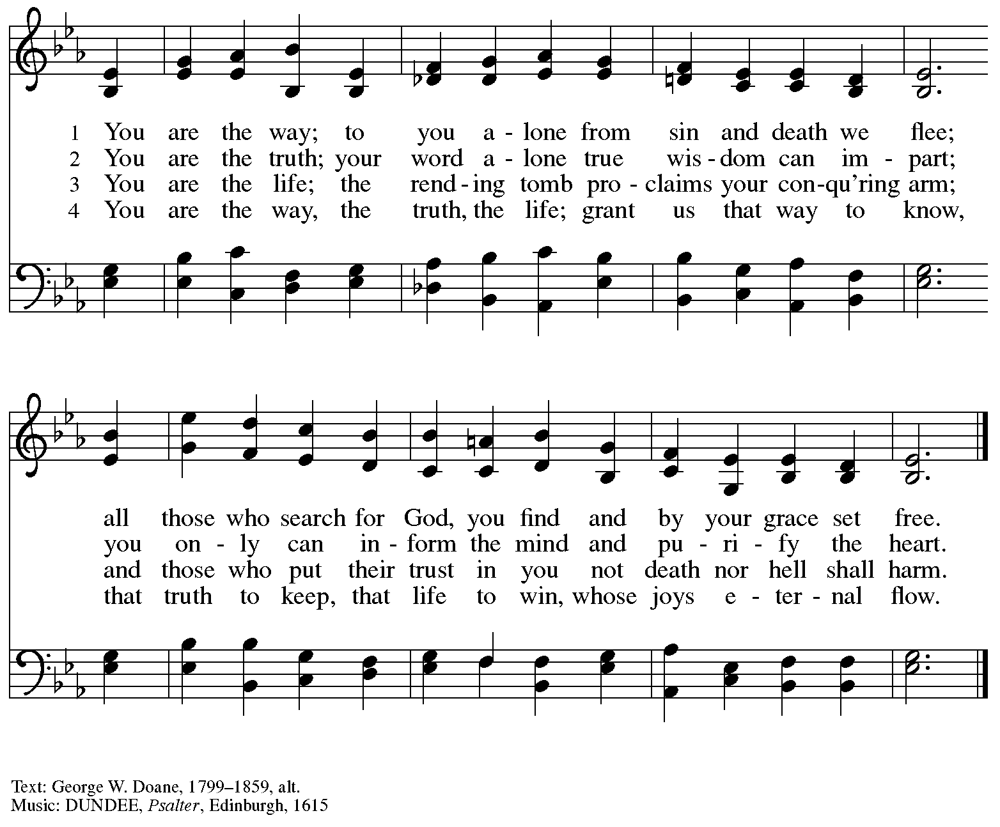

**Greeting**

P: The grace of our Lord Jesus Christ, the love of God,

and the communion of the Holy Spirit be with you all.

**C: And also with you.**

**Kyrie *ELW*** **152**

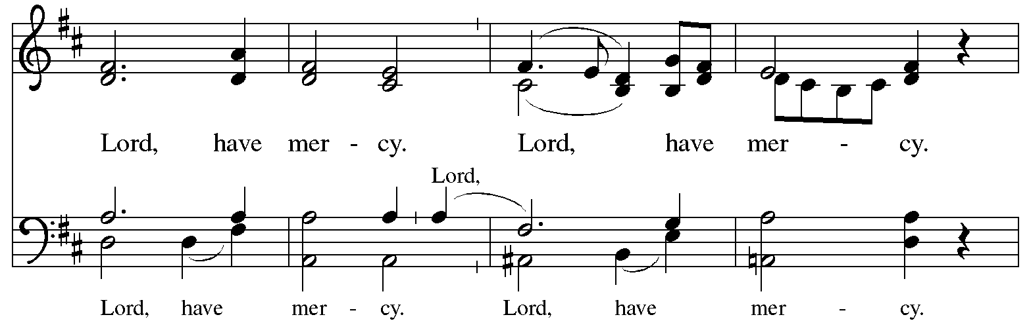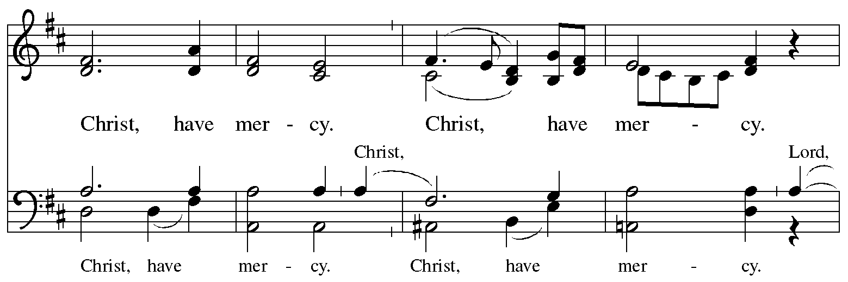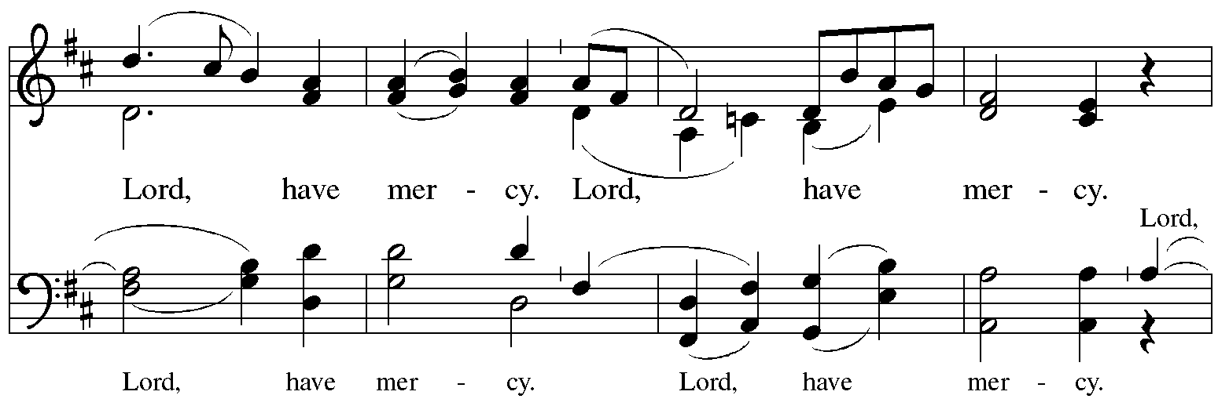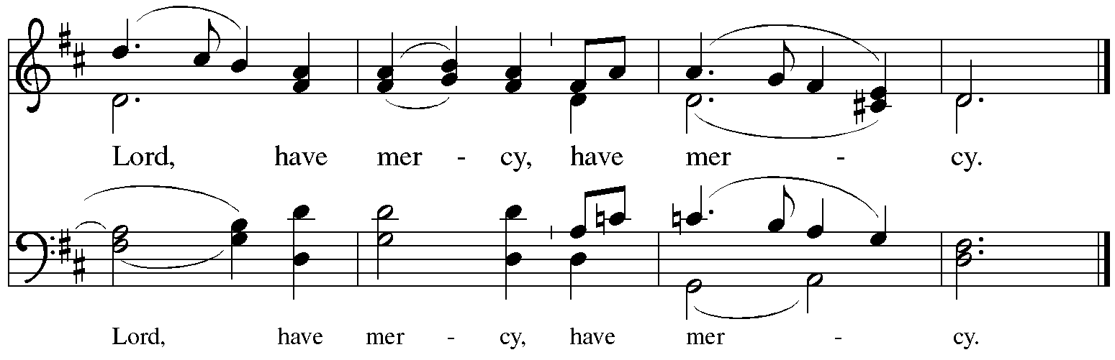

**Prayer of the Day**

P: The Lord be with you.

**C: And also with you.**

P: Let us pray.

Creator God, you prepare a new way in the wilderness, and your grace waters our desert.

Open our hearts to be transformed by the new thing you are doing,

that our lives may proclaim the extravagance of your love given to all

through your Son Jesus Christ, our Savior and Lord,

who lives and reigns with you and the Holy Spirit,

one God, now and forever.

**C: Amen.**

*Please be seated.*

*Children are invited to join the adult leader(s) at the side door for Little Church – Big Faith.*

*We ask that an additional adult from the congregation attend with the children.*

**Word**

*God speaks to us in Scripture reading, preaching, and song*

**First Reading** **– Isaiah 43: 16-21**

16 Thus says the Lord,  
  who makes a way in the sea,  
  a path in the mighty waters,  
 17 who brings out chariot and horse,  
  army and warrior;  
 they lie down; they cannot rise;  
  they are extinguished, quenched like a wick:  
 18 Do not remember the former things,  
  or consider the things of old.  
 19 I am about to do a new thing;  
  now it springs forth; do you not perceive it?  
 I will make a way in the wilderness  
  and rivers in the desert.  
 20 The wild animals will honor me,  
  the jackals and the ostriches;  
 for I give water in the wilderness,  
  rivers in the desert,  
 to give drink to my chosen people,  
  21 the people whom I formed for myself  
 so that they might declare my praise.

L: Word of God, word of life. **C: Thanks be to God.**

**Psalm 126**

*The cantor will lead the singing of the psalm.*

*The congregation is invited to respond with the alternate verses in bold print,*

*and to join in singing the refrain.*

*Psalm Tone*

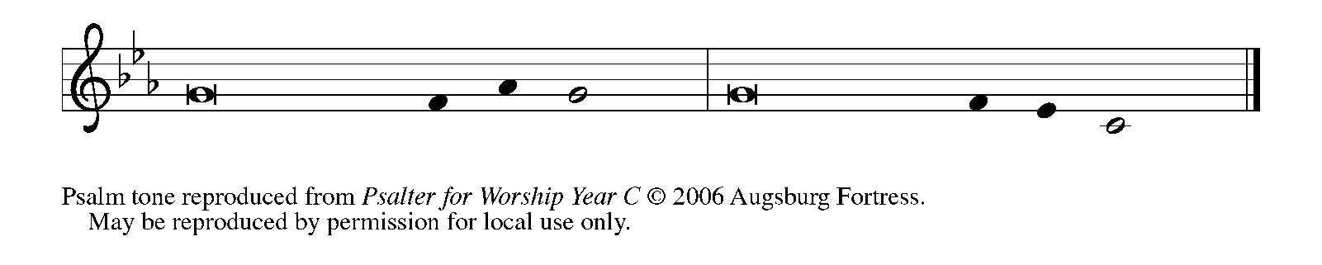

*Psalm Refrain*

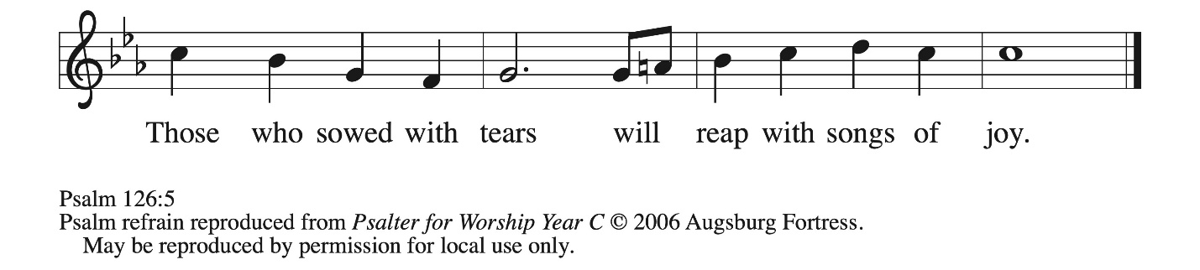

 1 When the Lord restored the for- **|** tunes of Zion,  
  then were we like **|** those who dream.  
 2 **Then was our mouth filled with laughter, and our tongue with | shouts of joy.**  
  **Then they said among the nations, “The Lord has done great | things for them.”**  
 3 The Lord has done great **|** things for us,  
  and we are **|** glad indeed.  
 4 **Restore our for- | tunes, O Lord,**  
  **like the watercourses | of the Negeb. R**  
 5 Those who **|** sowed with tears  
  will reap with **|** songs of joy.  
 6 **Those who go out weeping, carry- | ing the seed,**  
  **will come again with joy, shoulder- | ing their sheaves. R**

**Second Reading – Philippians 3: 4b-14**

[Paul writes:] 4b If anyone else has reason to be confident in the flesh, I have more: 5 circumcised on the eighth day, a member of the people of Israel, of the tribe of Benjamin, a Hebrew born of

Hebrews; as to the law, a Pharisee; 6 as to zeal, a persecutor of the church; as to righteousness under the law, blameless.  
  7 Yet whatever gains I had, these I have come to regard as loss because of Christ. 8 More than that, I regard everything as loss because of the surpassing value of knowing Christ Jesus my Lord. For his sake I have suffered the loss of all things, and I regard them as rubbish, in order that I may gain Christ 9 and be found in him, not having a righteousness of my own that comes from the law but one that comes through faith in Christ, the righteousness from God based on faith. 10 I want to know Christ and the power of his resurrection and the sharing of his sufferings by becoming like him in his death, 11 if somehow I may attain the resurrection from the dead.  
  12 Not that I have already obtained this or have already reached the goal; but I press on to lay hold of that for which Christ has laid hold of me. 13 Beloved, I do not consider that I have laid hold of it, but this one thing I have laid hold of: forgetting what lies behind and straining forward to what lies ahead, 14 I press on toward the goal, toward the prize of the heavenly call of God in Christ Jesus.

L: Word of God, word of life.

**C: Thanks be to God.**

*Please rise as you are able and join in singing the Gospel Acclamation.*

**Gospel Acclamation** *ELW* p. 189

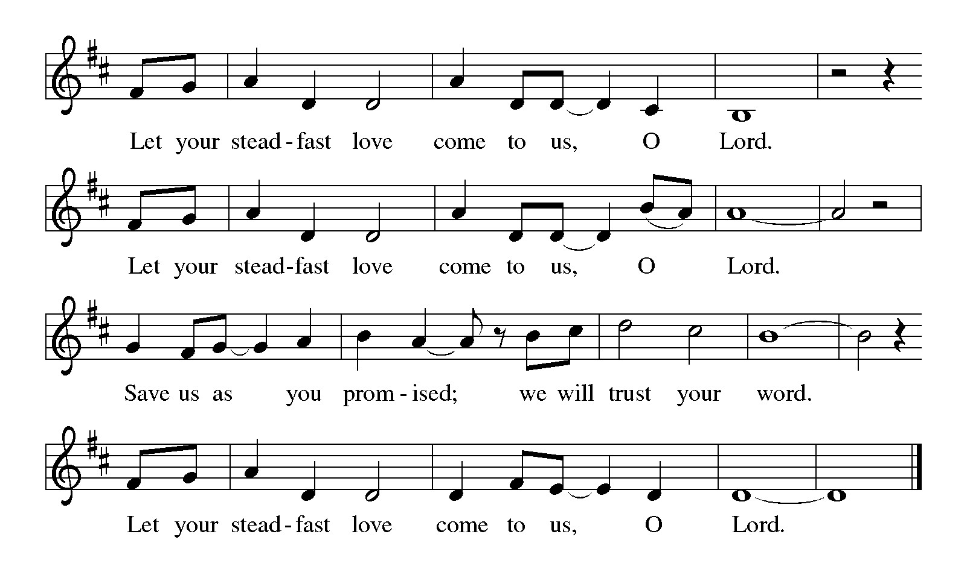

**Gospel – John 12: 1-8**

P: The holy Gospel according to St. John.

**C: Glory to you, O Lord.**

1 Six days before the Passover Jesus came to Bethany, the home of Lazarus, whom he had raised from the dead. 2 There they gave a dinner for him. Martha served, and Lazarus was one of those reclining with him. 3 Mary took a pound of costly perfume made of pure nard, anointed Jesus’ feet, and wiped them with her hair. The house was filled with the fragrance of the perfume. 4 But Judas Iscariot, one of his disciples (the one who was about to betray him), said, 5 “Why was this perfume not sold for three hundred denarii and the money given to the poor?” 6 (He said this not because he cared about the poor but because he was a thief; he kept the common purse and used to steal what was put into it.) 7 Jesus said, “Leave her alone. She bought it so that she might keep it for the day of my burial. 8 You always have the poor with you, but you do not always have me.”

P: The Gospel of the Lord.

**C: Praise to you, O Christ.**

*Please be seated.*

**Sermon**

*A time of silence for prayer and reflection follows the sermon.*

*As the hymn of the day begins, please rise as you are able.*



**Hymn of the Day Holy Woman, Graceful Giver *ACS* 1002**

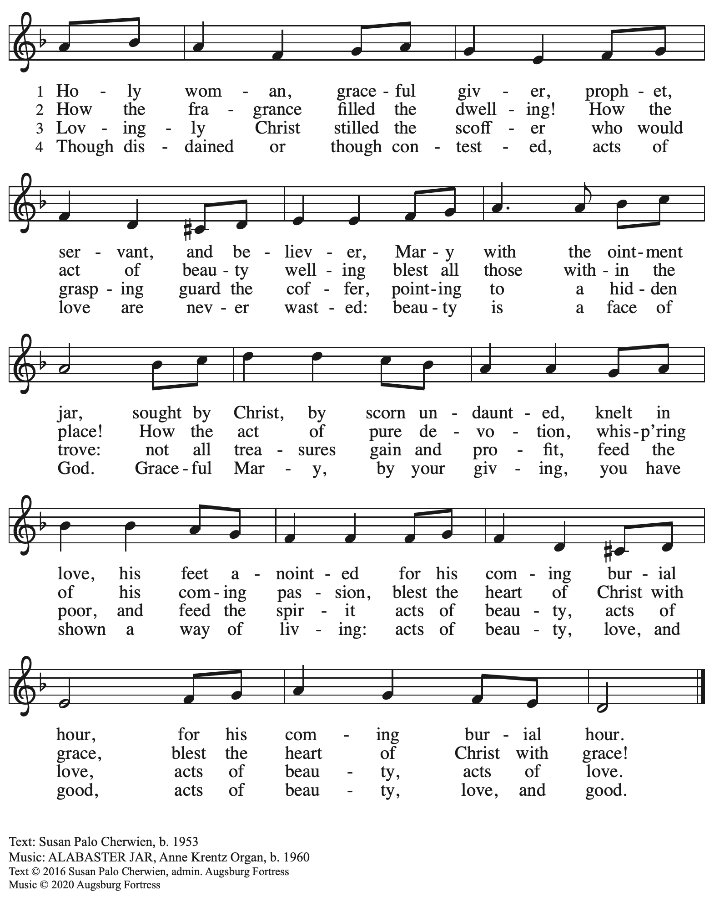

All rights reserved. Reprinted with permission under OneLicense.net # A-722139.

**Apostles’ Creed**

**C: I believe in God, the Father almighty,**

**creator of heaven and earth.**

**I believe in Jesus Christ, God’s only Son, our Lord,**

**who was conceived by the Holy Spirit,**

**born of the virgin Mary,**

**suffered under Pontius Pilate,**

**was crucified, died, and was buried;**

**he descended to the dead.\***

**On the third day he rose again;**

**he ascended into heaven,**

**he is seated at the right hand of the Father,**

**and he will come to judge the living and the dead.**

**I believe in the Holy Spirit,**

**the holy catholic church,**

**the communion of saints,**

**the forgiveness of sins,**

**the resurrection of the body,**

**and the life everlasting. Amen.**

*Or, “he descended into hell,” another translation of this text in widespread use.

**Prayers of the People**

A: Led by the Spirit, let us turn to God in prayer for the church, those in need,

and all God’s creation.

*After each petition*

A: Merciful God,

**C: receive our prayer.**

*The presiding minister concludes the prayers*

P: Receive the prayers of your people, O God, and draw all things together in your love,

in the name of Jesus, who leads us from death to life.

**C: Amen.**

**Peace**

*The presiding minister and the assembly greet one another in the peace of the risen Christ.*

P: The peace of Christ be with you always.

**C: And also with you.**

*The people may greet those around them with a sign of Christ’s peace and may say*

Peace be with you *or similar words. Please be mindful that not everyone will be comfortable with sharing the peace, so please seek consent before shaking hands or hugging. Other possible ways to share the peace include a simple bow with the verbal greeting of peace, or simply a verbal expression of peace. When the greetings of peace have concluded, please be seated.*

**

**Meal**

*God feeds us with the presence of Jesus Christ*

**Offering**

*We offer ourselves, our gifts, and our faithful service to God.*

*As the offering is gathered for the mission of the church, including the care of those in need,*

*the table is set for Holy Communion.*

*There are laminated giving cards in the pew racks that feature a QR code for anyone who would like to give online. Those who give using the QR code, as well as those who give regularly online or through their bank are encouraged to place the laminated card in the plate as an expression of your offering.*

**Reparations Offering**

*On the first Sunday of each month, St. Andrew invites people of the congregation to give a second offering for a reparations fund in acknowledgement of St. Andrew’s use of African American spiritual songs in our worship services. Please see the note in the announcements for more information.*

**Music during the Offering**

*Out of the Depths I Cry to You*

M. Luther / arr. N. Raabe

*As the gifts are brought forward for presentation,* *please rise as you are able.*

**Offertory Song Create in Me a Clean Heart *ELW* 188**

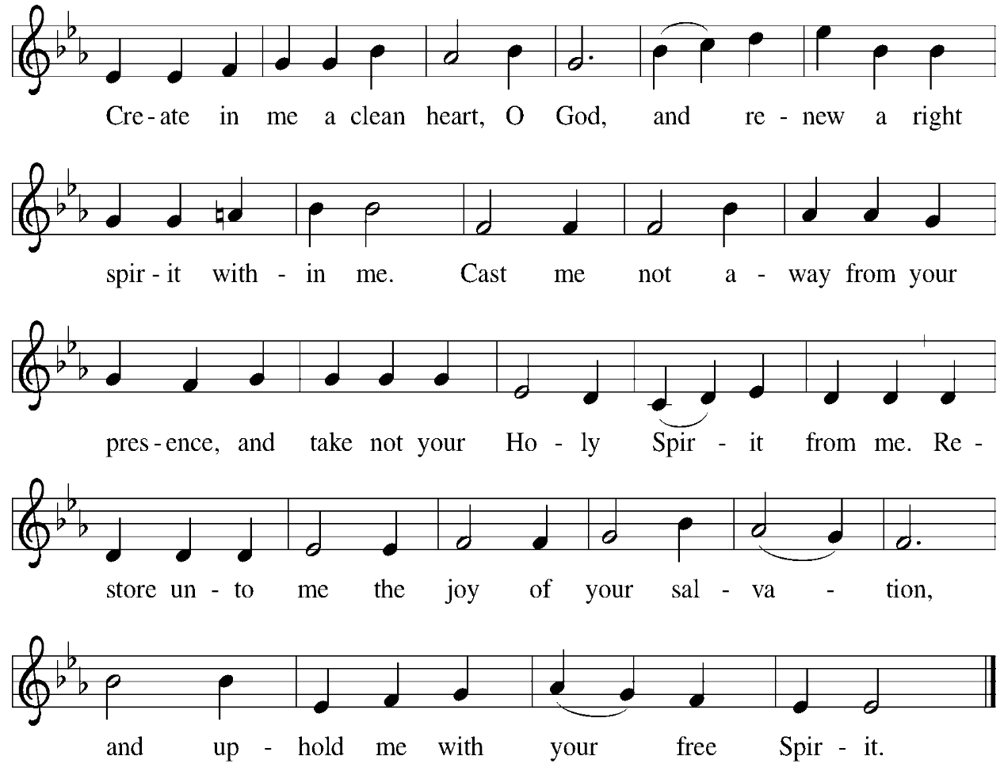

**Offertory Prayer**

A: Let us pray.

God our provider,

**C:** **you have not fed us with bread alone, but with words of grace and life.**

**Bless us and these your gifts, which we receive from your bounty,**

**through Jesus Christ our Lord. Amen.**

**Dialogue**

P: The Lord be with you.

**C: And also with you.**

P: Lift up your hearts.

**C: We lift them to the Lord.**

P: Let us give thanks to the Lord our God.

**C: It is right to give our thanks and praise.**

**Preface**

P: It is indeed right, our duty and our joy,

that we should at all times and in all places

give thanks and praise to you, almighty and merciful God,

through our Savior Jesus Christ;

You call your people to cleanse their hearts

and prepare with joy for the paschal feast,

that, renewed in the gift of baptism,

we may come to the fullness of your grace.

And so, with all the choirs of angels,

with the church on earth and the hosts of heaven,

we praise your name and join their unending hymn:

**Sanctus** *ELW* p. 190

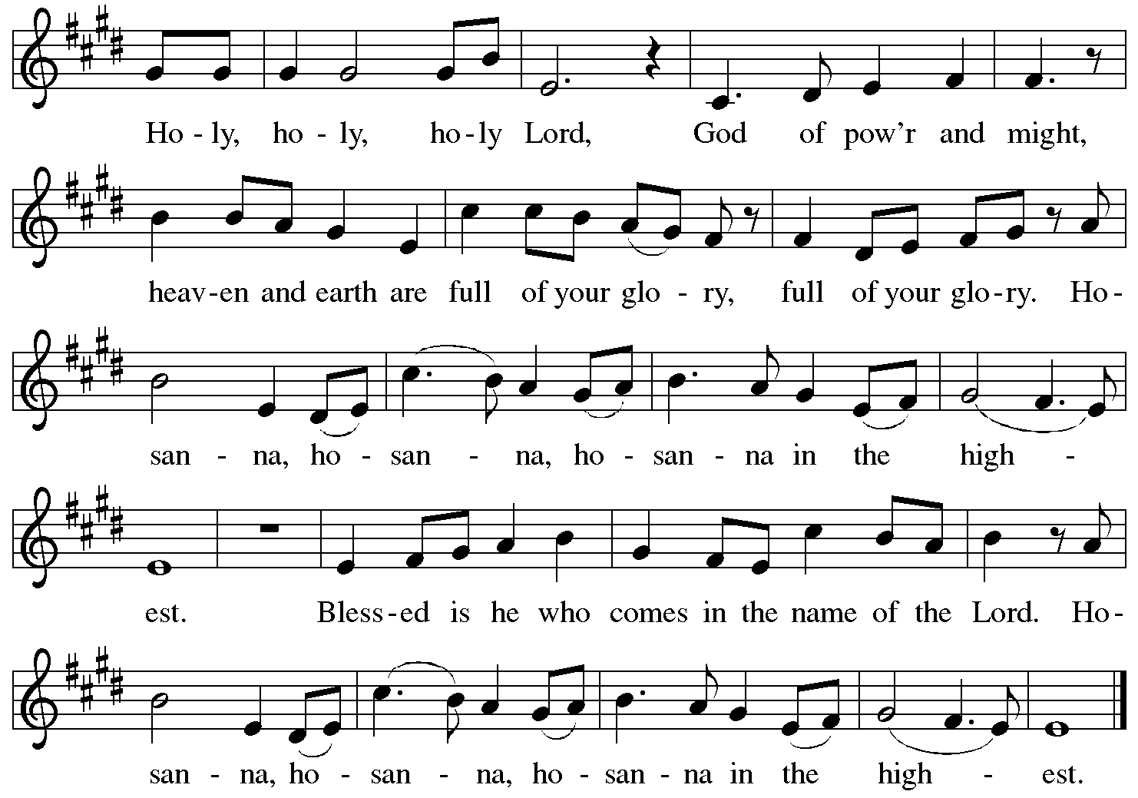

**Eucharistic Prayer**

P: Blessed are you, O God, of the universe … Do this for the remembrance of me.

With this bread and cup we remember our Lord’s Passover from death to life

as we proclaim the mystery of faith:

**C: Christ has died. Christ is risen. Christ will come again.**

P: O God of resurrection and new life … Grace our table with your presence.

**C: Come, Holy Spirit.**

P: Reveal yourself through the breaking of the bread … justice, peace, and love.

**C: Come, Holy Spirit.**

P: With your holy ones of all times and places …

… blessed and Holy Trinity, now and forever.

**C: Amen.**

**Lord’s Prayer**

P: Gathered as one by the Holy Spirit, let us pray as Jesus taught us.

**C: Our Father in heaven,**

**hallowed be your name,**

**your kingdom come,**

**your will be done,**

**on earth as in heaven.**

**Give us today our daily bread.**

**Forgive us our sins**

**as we forgive those**

**who sin against us.**

**Save us from the time of trial**

**and deliver us from evil.**

**For the kingdom, the power,**

**and the glory are yours,**

**now and forever. Amen.**

**Fraction and Invitation**

P: All who are hungry, come.

The feast of grace is ready.

***Agnus Dei /* Lamb of God** *ELW* p. 191

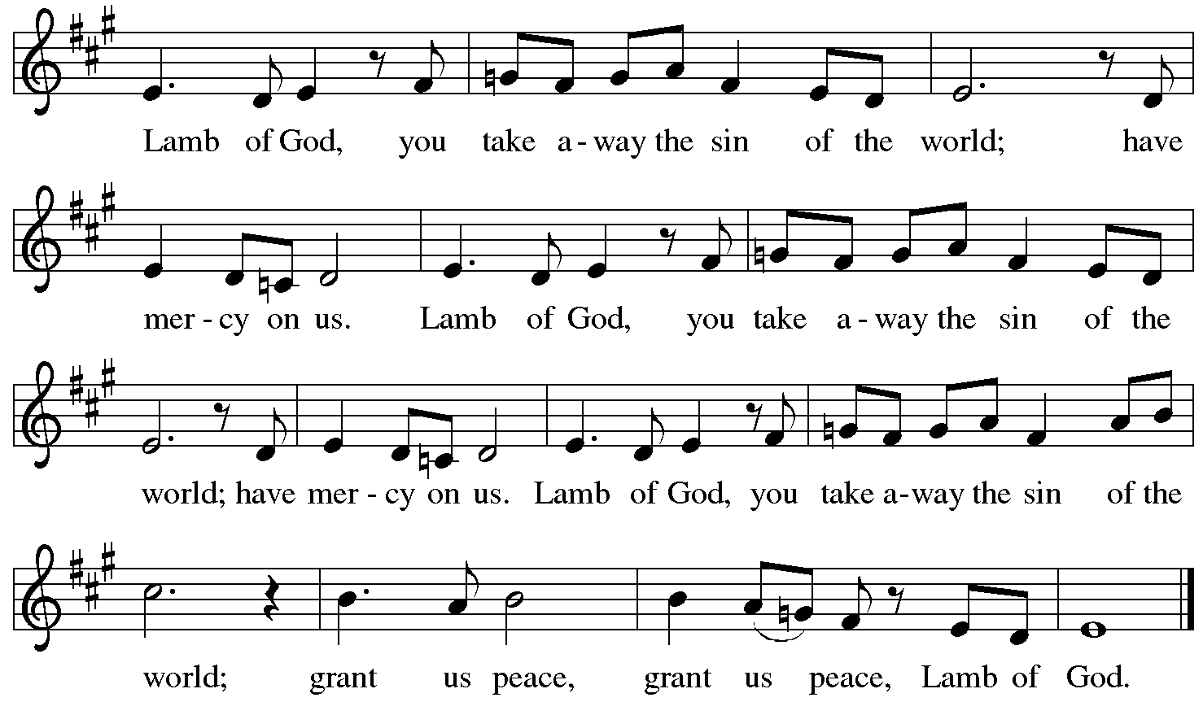

*Please be seated.*

**Holy Communion**

* *All who seek God and desire a deeper and stronger life in Christ are welcome to receive Holy Communion.*
* *Worshipers from the pulpit side will proceed forward first, followed by the center section, and then the lectern side.*
* *Please inform an usher if you would like the ministers to bring Communion to you.*
* *Holy Communion will be served with bread and wine (red) or grape juice (white).*
* *The presiding minister will first distribute the bread (host) to each communicant. Please indicate if you require a gluten-free host.*
* *Once you have consumed the bread, please pick up an empty glass from the tray next to the presiding minister. The Communion Assistant will pour wine from the chalice or grape juice from the cruet into your glass.*
* *Please step to the side to consume the wine or grape juice.*
* *Feel free to kneel at the altar rail for prayer after receiving the sacrament.*
* *As you return to your pew, glasses may be returned to the empty tray on the side of the center section.*
* *A blessing will be provided for anyone who does not yet receive the sacrament.*
* *All are invited to join in singing the hymns during Holy Communion.*

**Hymns during Holy Communion**

**Come, Ye Disconsolate *ELW* 607**

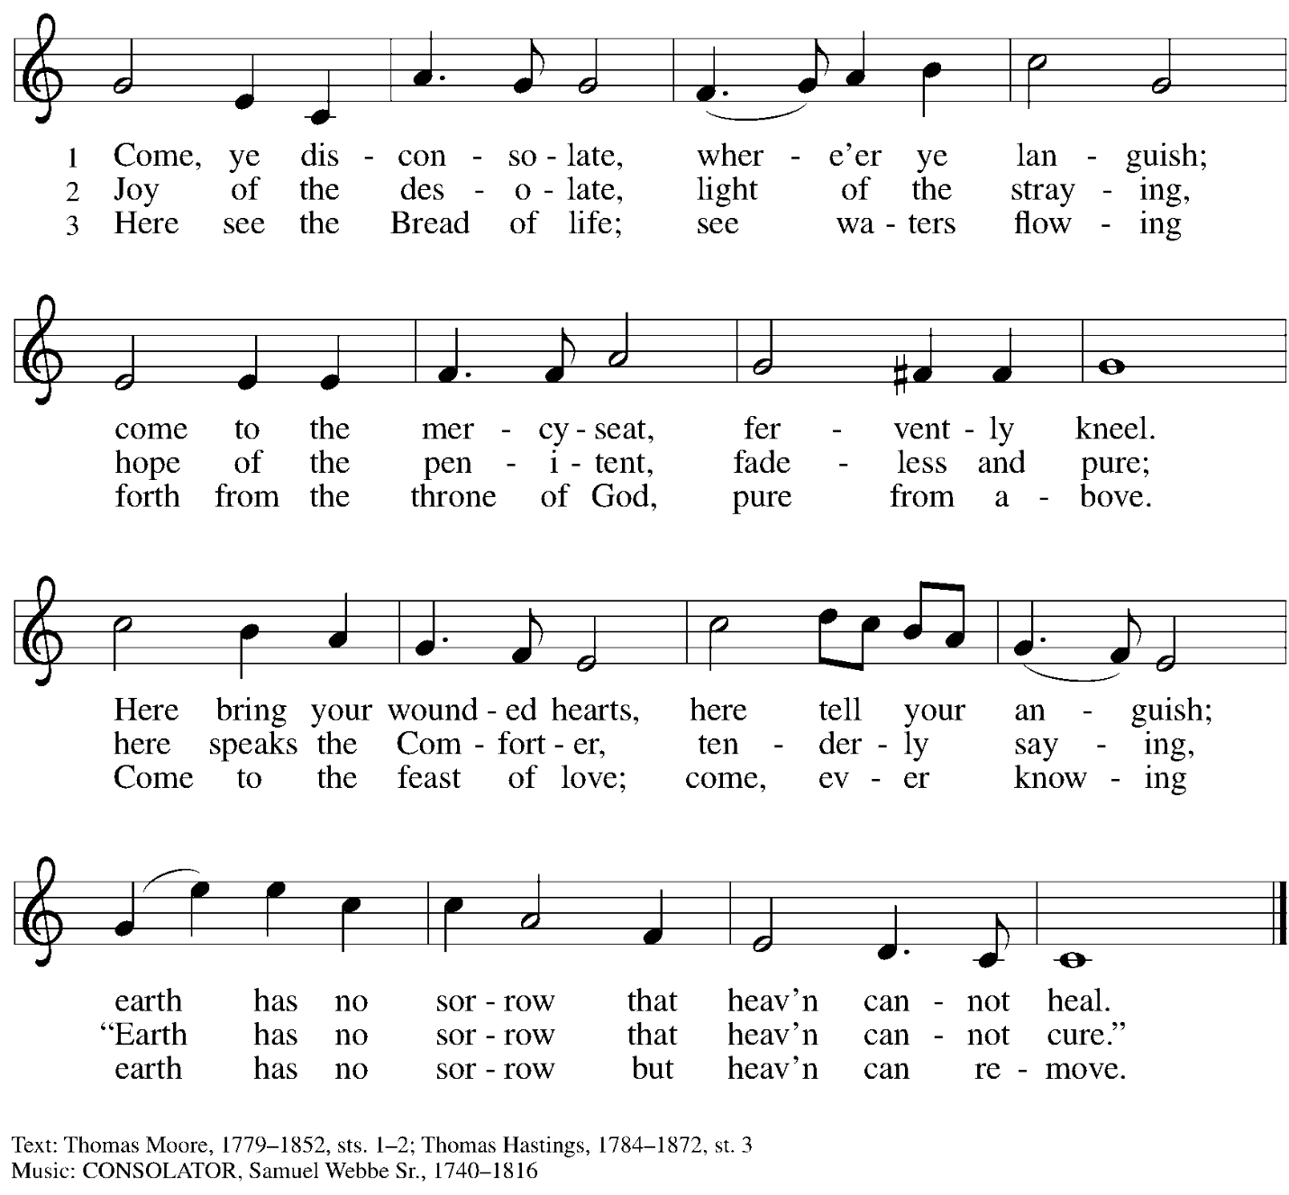

**Hymns during Holy Communion**

**When It Seems the Day Will End *ACS* 1034**

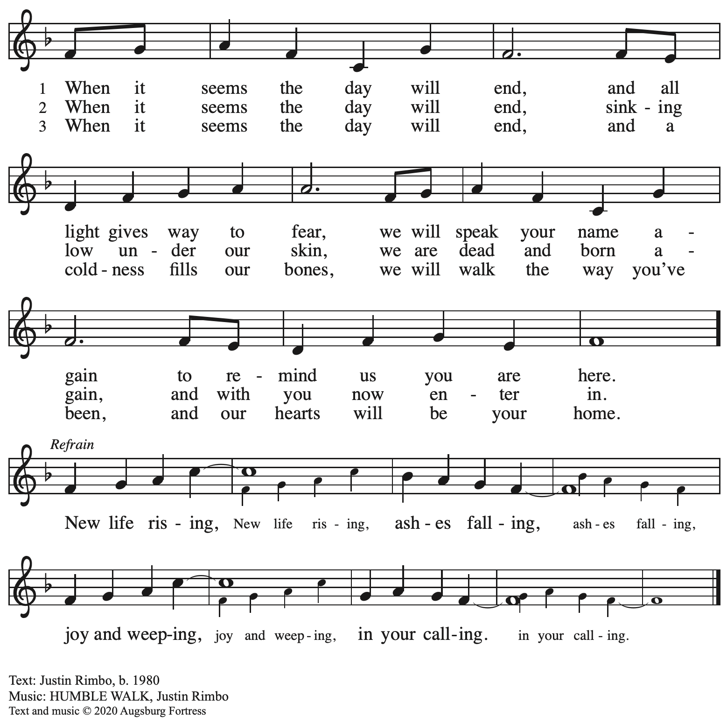

All rights reserved. Reprinted with permission under OneLicense.net #A-722139.

**Hymns during Holy Communion Timothy Kocher-Hillmer**

**You Gave Me Life**

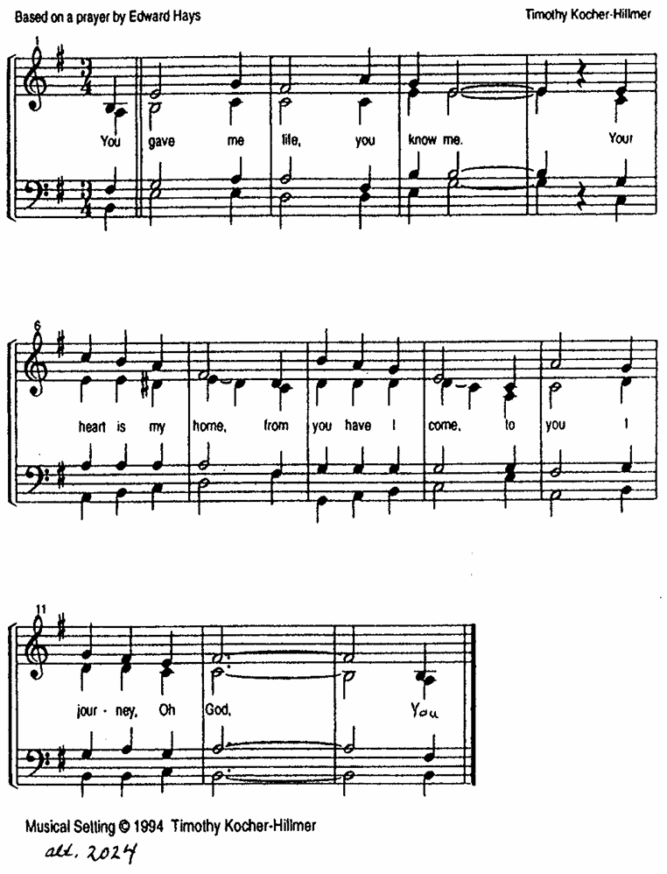

**Hymns during Holy Communion**

**By Gracious Powers *ELW* 626**

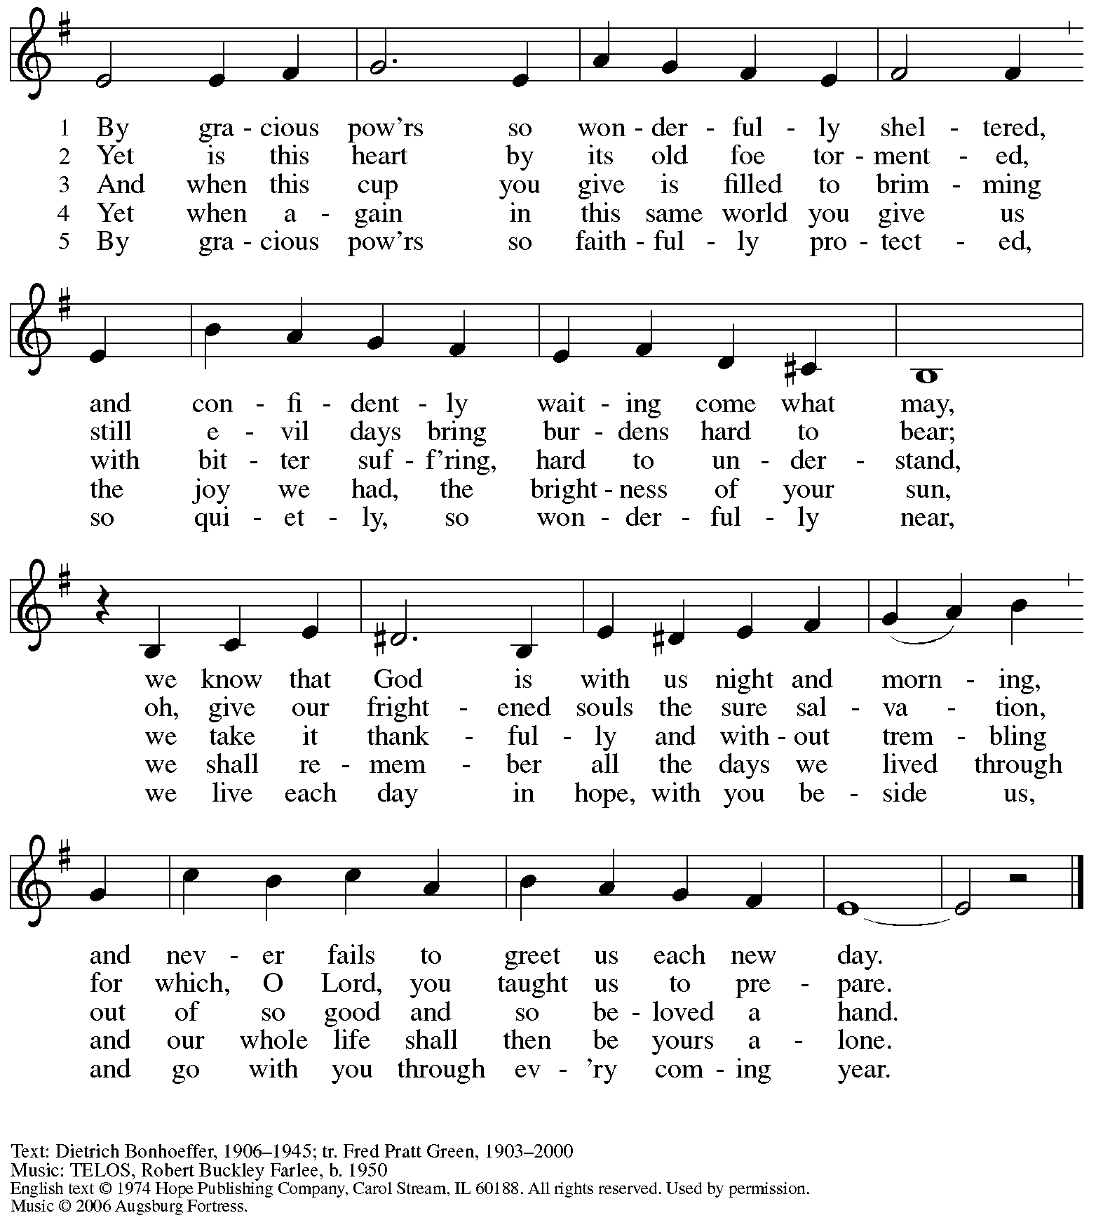

All rights reserved. Reprinted with permission under OneLicense.net # A-722139.

**Hymns during Holy Communion**

**When I Survey the Wondrous Cross *ELW* 803**

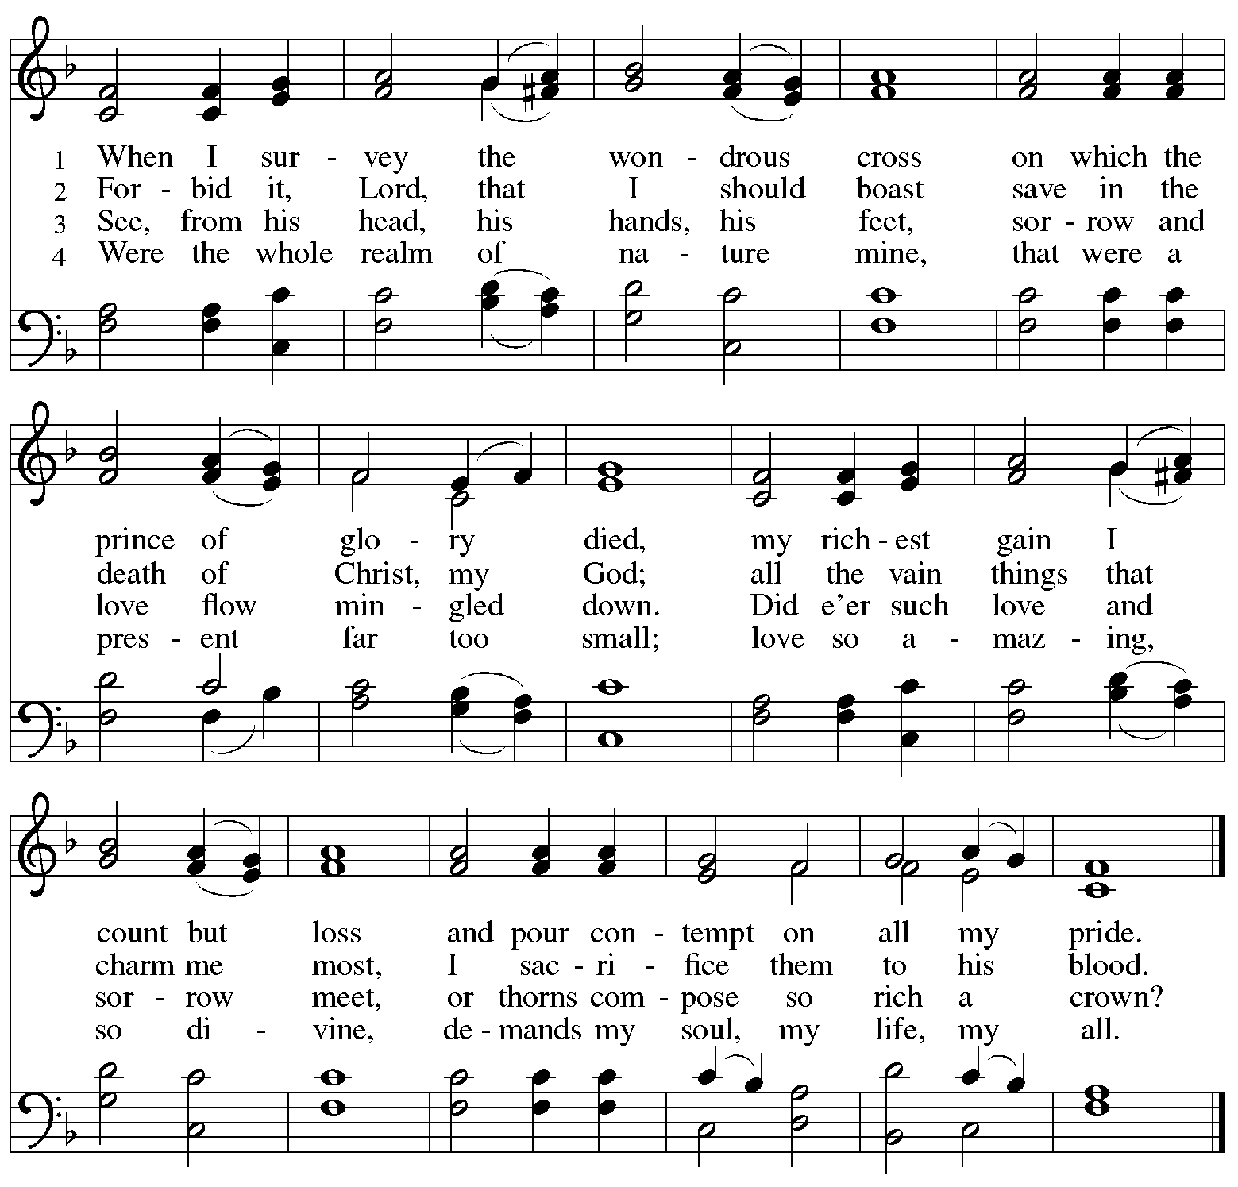

*When all have returned to their places, please rise as you are able.*

**Blessing**

P: The body and blood of our Lord Jesus Christ strengthen you and keep you in his grace.

**C: Amen.**

**Prayer**

A: Let us pray.

Compassionate God, you have fed us with the bread of heaven.

Sustain us in our Lenten pilgrimage:

may our fasting be hunger for justice;

our alms, a making of peace;

and our prayer, the song of grateful hearts,

through Jesus Christ, our Savior and Lord.

**C: Amen.**

*Please be seated.*

**Sending**

*God blesses us and sends us in mission to the world*

**Announcements**

*Please rise as you are able.*

**Benediction**

P: The Lord bless you and keep you.

The Lord’s face shine on you with grace and mercy.

The Lord look upon you with favor and ☩ give you peace.

**C: Amen.**

**Sending Hymn** *Following page*

**Dismissal**

P: Go in peace. Remember those in need.

**C: Thanks be to God!**

**Postlude**

**Sending Hymn Take My Life, That I May Be *ELW* 685**

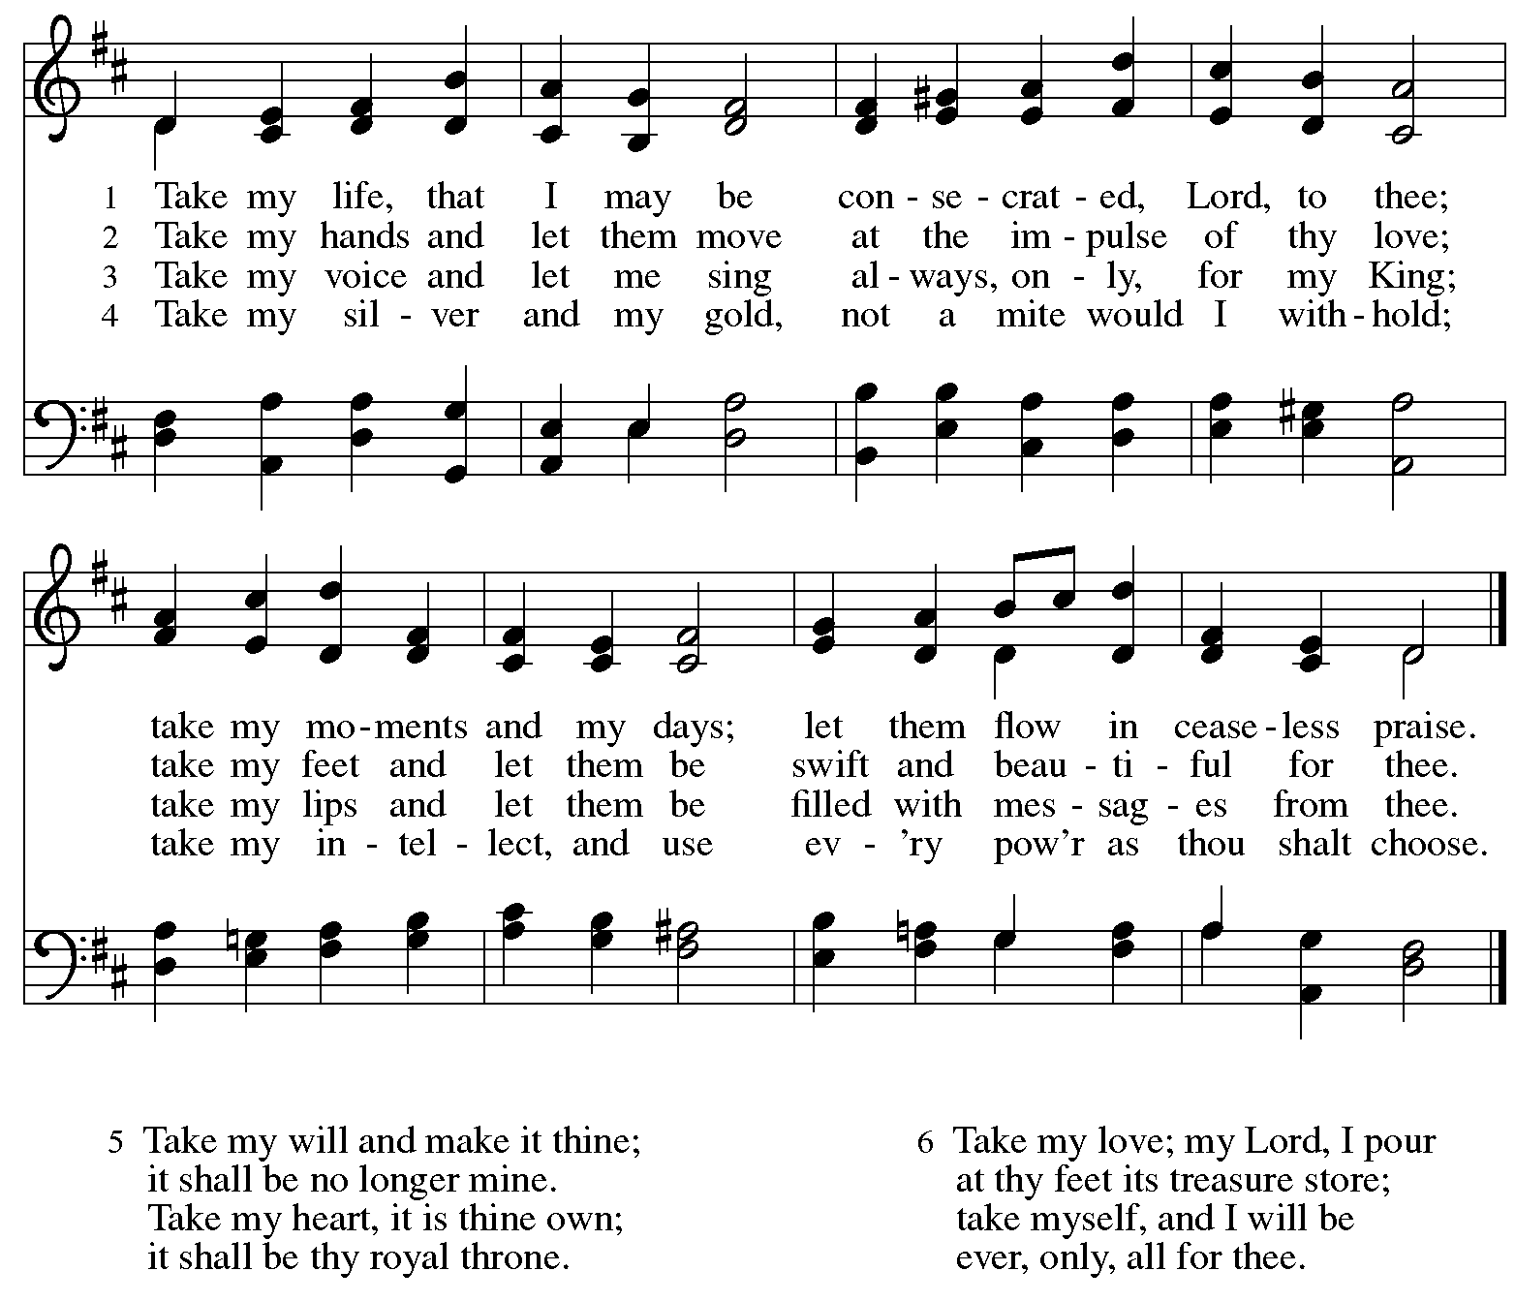

*Those serving in worship*

Altar Care Jodie Minor

Assisting Minister Timothy Kocher-Hillmer

Audio-Visual Ministers Joseph Paetz

Tyler Rietze

Cantor Maria Mangano

Lector Colleen Cooke

Little Church – Big Faith Teacher Emily Duque

Organ on Pre-Service Music Jimmi Kocher-Hillmer

Vocal Quintet Isabel Barton

Timothy Kocher-Hillmer

The Rev. Erin Jones

Jered Stratton

Matthew Tesch

Minister of Music Laura Reynolds

Presiding and Preaching Minister The Rev. Ross I. Carmichael

*Liturgy and Hymnody Acknowledgements*

From SundaysandSeasons.com. Copyright © 2025 Augsburg Fortress. All rights reserved. Reprinted under OneLicense.net # A-722139.

Used by permission of Augsburg Fortress.

The Scripture readings contained herein are from *New Revised Standard Version Updated Edition* of the Bible © 2021 National Council of Churches of Christ in the United States of America. Used by permission. All rights reserved worldwide.

**Kyrie** – Text: *Deutsche Messe* Franz Schubert, 1797-1828; adapt. Richard Proulx, b. 1937. Adapt. © 198, 1989 GIA Publications, Inc. 7404 S. Mason Ave., Chicago, IL 60638. [www.giamusic.com](http://www.giamusic.com). 800.442.3358. All rights reserved. Reprinted with permission under OneLicense.net # A-722139.

**Create in Me a Clean Heart** – Music: J. A. Freylinghausen, 1670-1739.

*Please use the QR code below to link to St. Andrew’s Announcements online!*



**St. Andrew Lutheran Church Announcements**

**April 6th, 2025**

* **Welcome to worship at St. Andrew on the + Fifth Sunday in Lent** –We are so glad you are here, and we offer a special welcome to all visitors and guests who are here for the first time! Worship attendees are invited to make a name tag at the back of the worship space. Little Church – Big Faith, a Bible lesson and activity for children, will take place after the prayer of the day. There are worship “toolkits” to help children engage with worship and “busy bags” for younger children available in the bookcase at the back of the sanctuary. Please feel free to take one to use with/for your children. All are invited to gather for coffee, other drinks, food, and conversation in the social hall after worship.
* **Monthly Reparations Offering Today during Worship** – InLuke’s Gospel, Jesus tells a story about a compassionate Samaritan that suggests God’s people are called to work for healing and restoration for our neighbors, regardless of who or what caused them harm. In light of this, St. Andrew has made a commitment to reparations in regard to African American spiritual songs used in our worship. The text and music of most hymns is attributed to specific authors, with copyrights in place, usage reported, and royalties paid to those whose works are featured in worship. With African American spirituals, this is not possible. In response to many years of such uncredited use, St. Andrew invites the congregation to give a reparations offering. Funds received in worship will be donated to our siblings at Bethel AME Church, whose land and building were taken from them in the 1950s, to fund their development in the Hill District.
* **The Legacy of Dr. Martin Luther King, Jr. – Seeking Justice, Restoring Community Event – Today at St. Andrew, Starting at 3:00 p.m. – Each year, our Southwestern Pennsylvania Synod of the Evangelical Lutheran Church in America (ELCA) has an event honoring the legacy of Dr. Martin Luther King, Jr. We are hosting this year’s Ecumenical Service of Holy Communion and Call to Anti-racist Action this afternoon, beginning at 3:00 p.m. The Rev. Dr. Dale B. Snyder of Bethel A.M.E church will be the guest preacher. We** gather to further God's vision for a just world where all are able to thrive, and honor the legacy of Dr. King's vision for a beloved community. Through education, worship, and conversation, we will learn the harmful legacy of urban renewal in southwestern Pennsylvania and explore how to dismantle harmful assumptions. Together, we will learn how to engage our communities to be rooted in mutuality, repentance, and repair. For more information, visit [**swpasynod.org/calendar/mlk2025**](https://swpasynod.us19.list-manage.com/track/click?u=a23881a5c641ed10cd7f24da0&id=ad79b25734&e=23a8e9845f).
* **Community Ministry Meeting – Monday, April 7th, at 7:00 p.m. on Zoom – St. Andrew’s community ministry committee coordinates our local service ministries such as the outdoor Little Library, the pantry, produce distribution, shelter dinner, and various other activities. New participants are always welcome, and the next meeting is Monday, April 7th, at 7:00 p.m. on Zoom. Please contact** [PastorRCarmichael@gmail.com](mailto:PastorRCarmichael@gmail.com) **or** [community@standrewpittsburgh.org](mailto:community@standrewpittsburgh.org) **if you would like the link.**
* **Next Council Meeting – Saturday, April 12th, at 9:00 a.m. – St. Andrew’s congregation council meets once a month to guide the mission and general operations of the church. It is made up of 13 members of the congregation and the pastor. The next meeting of the council is Saturday, April 12th, at 9:00 a.m. We invite your prayers for St. Andrew’s council leaders!**
* **April Shelter Dinner for Guests of East End Cooperative Ministry – Third Thursday of the Month, April 17th, 6:30 p.m. –** Each month, people of St. Andrew provide dinner for guests of East End Cooperative Ministry (EECM), 6140 Station St. (East Liberty), 15206. This month’s shelter dinner is on Maundy Thursday, when St. Andrew will have worship at 7:00 p.m., so we invite you to prepare or purchase one menu item and bring it to the shelter by 6:00 p.m. If you would like to contribute, please sign up at <https://www.signupgenius.com/go/5080544AAAC22A1F58-55858396-shelter>.
* **The Services of Holy Week: Palm Sunday – Sunday of the Passion, April 13th through Easter Sunday, April 20th – With Palm Sunday, the Church enters into** contemplation of the passion, death, and resurrection of our Savior Jesus Christ. The services of Holy Week then continue with the service of the Triduum – the Great Three Days, one service that unfolds in three parts: Maundy Thursday, Good Friday, and the Vigil of Easter.

**The service schedule for Holy Week is**:

* + **Palm Sunday – Sunday of the Passion, April 13th, 10:00 a.m.** – On this day, worship begins with a procession with palm branches and features the story of Jesus’ passion. This year’s reading comes from Luke’s Gospel.
  + **Triduum – Maundy Thursday, April 17th, 7:00 p.m.** – The Church concludes the season of Lent with Confession and Forgiveness, receives Jesus’ command to love one another, remembers Christ’s example of such love in the washing of feet, and takes part in the sacrament of Holy Communion.
  + **Holy Week Service for Children – Friday, April 18th, 5:30 p.m.** – This service, designed for children up to sixth grade, follows the story of Holy Week with the last supper, Jesus’ washing of his disciples’ feet, his prayer in the garden, and the cross.
  + **Triduum –** **Good Friday, April 18th, 7:00 p.m.** – Service of Shadows and Stones. In relative darkness, we hear Gospel accounts of the crucifixion, sing prayerful, meditative hymns, and leave stones at the foot of the cross as we honor our crucified Savior.
  + **Triduum –** **The Vigil of Easter, April 19th, 5:00 p.m.** – The Vigil of Easter is a special service. Think of it as the people of God gathering around a campfire to tell their family’s stories of faith. The Church follows the history of God’s salvation through worship, word, sacrament, and song as we light the new fire and bless the Paschal candle, tell of God’s faithfulness throughout the ages, give thanks for the gift of Baptism, and move into the celebration of the resurrection with Holy Communion.
* **The Resurrection of our Lord – Easter Sunday, April 20th, 10:00 a.m.** – Worship with Holy Communion – We join the church throughout the world in proclaiming the good news of Christ’s resurrection!
* **Invitation to Pre-Service Music –** The people of St Andrew are gifted in so many ways.  We have much to be grateful for. Come share or experience the musical talents of our family on Sunday mornings. Arrive in-person 10 minutes before the service to rest in the sounds of musical offerings from musicians. If you sing or play an instrument, please consider sharing your gifts. Contact [timothy@touchwholeness.com](mailto:timothy@touchwholeness.com).
* **Lenten Food Drive for St. Andrew’s Pantry** – One of the spiritual disciplines of the season of Lent is almsgiving – generous giving on behalf of neighbors in need. In the spirit of Lent, we are inviting people of the congregation to donate nonperishable food items to help replenish the congregation’s outdoor pantry. **Suggested items include**: Packs of chicken, tuna, or pork (any flavor); cans of Vienna sausage, potted meat, spam; cans of beef stew, beefaroni, ravioli; boxes of macaroni and cheese, stuffing, or mashed potatoes; cups of applesauce – any flavor; granola bars, rice Krispie treat bars; boxes of cookies or crackers; small bags or boxes of cereal – any kind; shelf stable milk; case of water; cans of vegetables and fruits. All canned items must have a pull tab to open.Items may be placed on the donation table in the social hall throughout the season of Lent.
* ***Life Renewed: Devotions for Lent 2025* Available at Church Entrances** – Another of the spiritual disciplines for the season of Lent is prayer, so each year, the worship committee provides copies of a daily devotional booklet. This year’s is titled *Life Renewed*, and it contains a brief scripture reading, reflection/quote, and prayer for each day from Ash Wednesday (March 5th) to the Vigil of Easter (April 19th). They are now available at the entrances to the building – please take one to aid in your devotions this Lent!
* ***Christ in Our Home* Devotional Booklets for April – June Available at Church Entrances** – This resource offers a daily Bible reading with a short reflection and prayer, along with additional readings and prayer topics for those who would like to expand their devotional practices. We encourage people of the congregation to take one for yourself, your family/household, or others!
* **Prayer Service with the Pittsburgh Compline Choir – Sundays at 8:00 p.m. at Heinz Chapel –** Compline was traditionally a monastic prayer service, and the Pittsburgh Compline Choir, a ministry of Lutheran Campus Ministry in Greater Pittsburgh, sings a choral version of compline rooted in this thousand-year-old tradition of scripture, song, and silence each Sunday at Heinz Chapel at 8:00 p.m. This service also streams on Facebook (Pittsburgh Compline Choir) and YouTube (The Pittsburgh Compline Choir). Heinz Chapel is located off of S. Bellefield Ave. in Oakland. For more information, please visit: [Pittsburgh Compline Choir](http://pittsburghcomplinechoir.org/).

**St. Andrew Feasibility Study Ongoing –**

**We Invite Your Input!**

Two weekends ago, consultants from Partners for Sacred Places, a nonprofit based in Philadelphia, were at St. Andrew to conduct interviews and share an update on our ongoing feasibility study to help prepare for a capital campaign.

Partners has also set up a survey in order to gather additional input and perspectives from the congregation, especially from anyone who has not been interviewed. This is an opportunity to share your thoughts and to help St. Andrew prepare for the future! The survey is available using the QR code below and ***it will close in the next few days so please complete it soon!*** Thank you very much for your feedback!



**Flowers for Easter**

*St. Andrew will be ordering Lilies (6 inch, five bloom - $8.00 each)*

*Tulips (8 inch - $9.00 each))*

*Daffodils (6 inch - $5.25 each)*

*to decorate the worship space for Easter Sunday, April 20th,*

*and the Easter season.*

*If you would like to sponsor and dedicate flowers, please order using this form.*

Order by: Sunday, April 13th

*Orders may be submitted at the desk in the main office*

*or through the Sunday offering plates.*

*Please submit payment with order - Checks may be made payable to*:

St. Andrew Lutheran Church

Name __________________________________________

In Honor of __________________________________________

In Memory of __________________________________________

In Appreciation/Love for __________________________________________

Number of Lilies ________

Number of Tulips ________

Number of Daffodils ________