

**+ The Resurrection of our Lord**

**Easter Sunday**

**April 20, 2025**





**St. Andrew Lutheran Church**

**304 Morewood Ave.**

**Pittsburgh, PA 15213**

[**St_andrewELCA@verizon.net**](mailto:St_andrewELCA@verizon.net)

[**www.standrewpittsburgh.org**](http://www.standrewpittsburgh.org)

**+ The Resurrection of our Lord – Easter Sunday**

**Order for Worship**

*“The last enemy to be destroyed is death,” Paul writes. Today Christ is risen, and we gather together with astonishment and joy. Christ is risen, and we have been set free from the bonds of death. Christ is risen, and we are forgiven. Christ is risen, and with the women at the tomb and Peter, we are amazed. Let us rejoice: Christ is risen indeed! Alleluia!*

**Welcome to St. Andrew!**

* St. Andrew welcomes all who are seeking a place of healing, wholeness, and acceptance in a nurturing and faith-forming spiritual home. We are striving toward racial equity worldwide

and we seek to honor the lived experience of all individuals regardless of background. Our community embraces people of all ages, ethnicities, cultures, abilities, sexual orientations,

gender identities and expressions, and family constellations. Come and See!

* Worship Services are live-streamed to multiple online platforms. By attending worship, you agree that your image and voice may be broadcast.
* Everyone is invited to make a name tag at the black bookcase in the back of the worship space if they would like. There are stickers indicating pronouns on the bookcase if you would like to include them on your name tag.
* Little Church – Big Faith, our weekly Bible lesson and activity for children, will not meet during worship this week so the children can fully participate in the celebration of Easter!
* A nursery is available through the doors at the left side of the sanctuary and across from the doorway to the Social Hall. Look for a purple-colored room.
* Worship “toolkits” to help children engage with the service, along with “busy bags” for younger children, are available in the bookcase at the back of the sanctuary. Please feel free to take one to use with/for your children.
* Holy Communion is served with bread (gluten-free available) and wine or grape juice. The presiding minister will distribute the bread (host). Please consume this and then pick up an empty glass from the tray. The Communion Assistant will pour wine or grape juice into your glass. Please step to the side to consume the wine or grape juice. Feel free to kneel at the altar for prayer and reflection. As you return to your pew, glasses may be returned to the empty trays on either side of the center section.
* A restroom is available on the main level of the church, through the doors to the Social Hall and to the right in the main office.

*Abbreviations*

P: Pastor/Presiding Minister ***ELW*: *Evangelical Lutheran Worship* hymnal**

A: Assisting Minister ***ACS*: *All Creation Sings* hymnal**

L: Lector ***W&P*: *Worship & Praise* hymnal**

**C: Congregation**

**Pre-Service Music**

**Welcome**

**Gathering**

*The Holy Spirit calls us together as the people of God*

*Children are invited to gather at the front of the worship space for the beginning of the service,*

*as we welcome back the “Alleluia,” the Church’s song of Easter joy!*

**Raising the Alleluia**

*Once the Alleluias have been brought out, the presiding minister and congregation proclaim:*

P: Alleluia! Christ is risen!

**C: Christ is risen indeed! Alleluia! Alleluia!**



**Choir Anthem** *Hallelujah Chorus* G.F. Handel

arr. Podd

*Please* *rise as you are able and face the cross as the Processional Hymn begins.*

**Processional Hymn Jesus Christ Is Risen Today *ELW* 365**

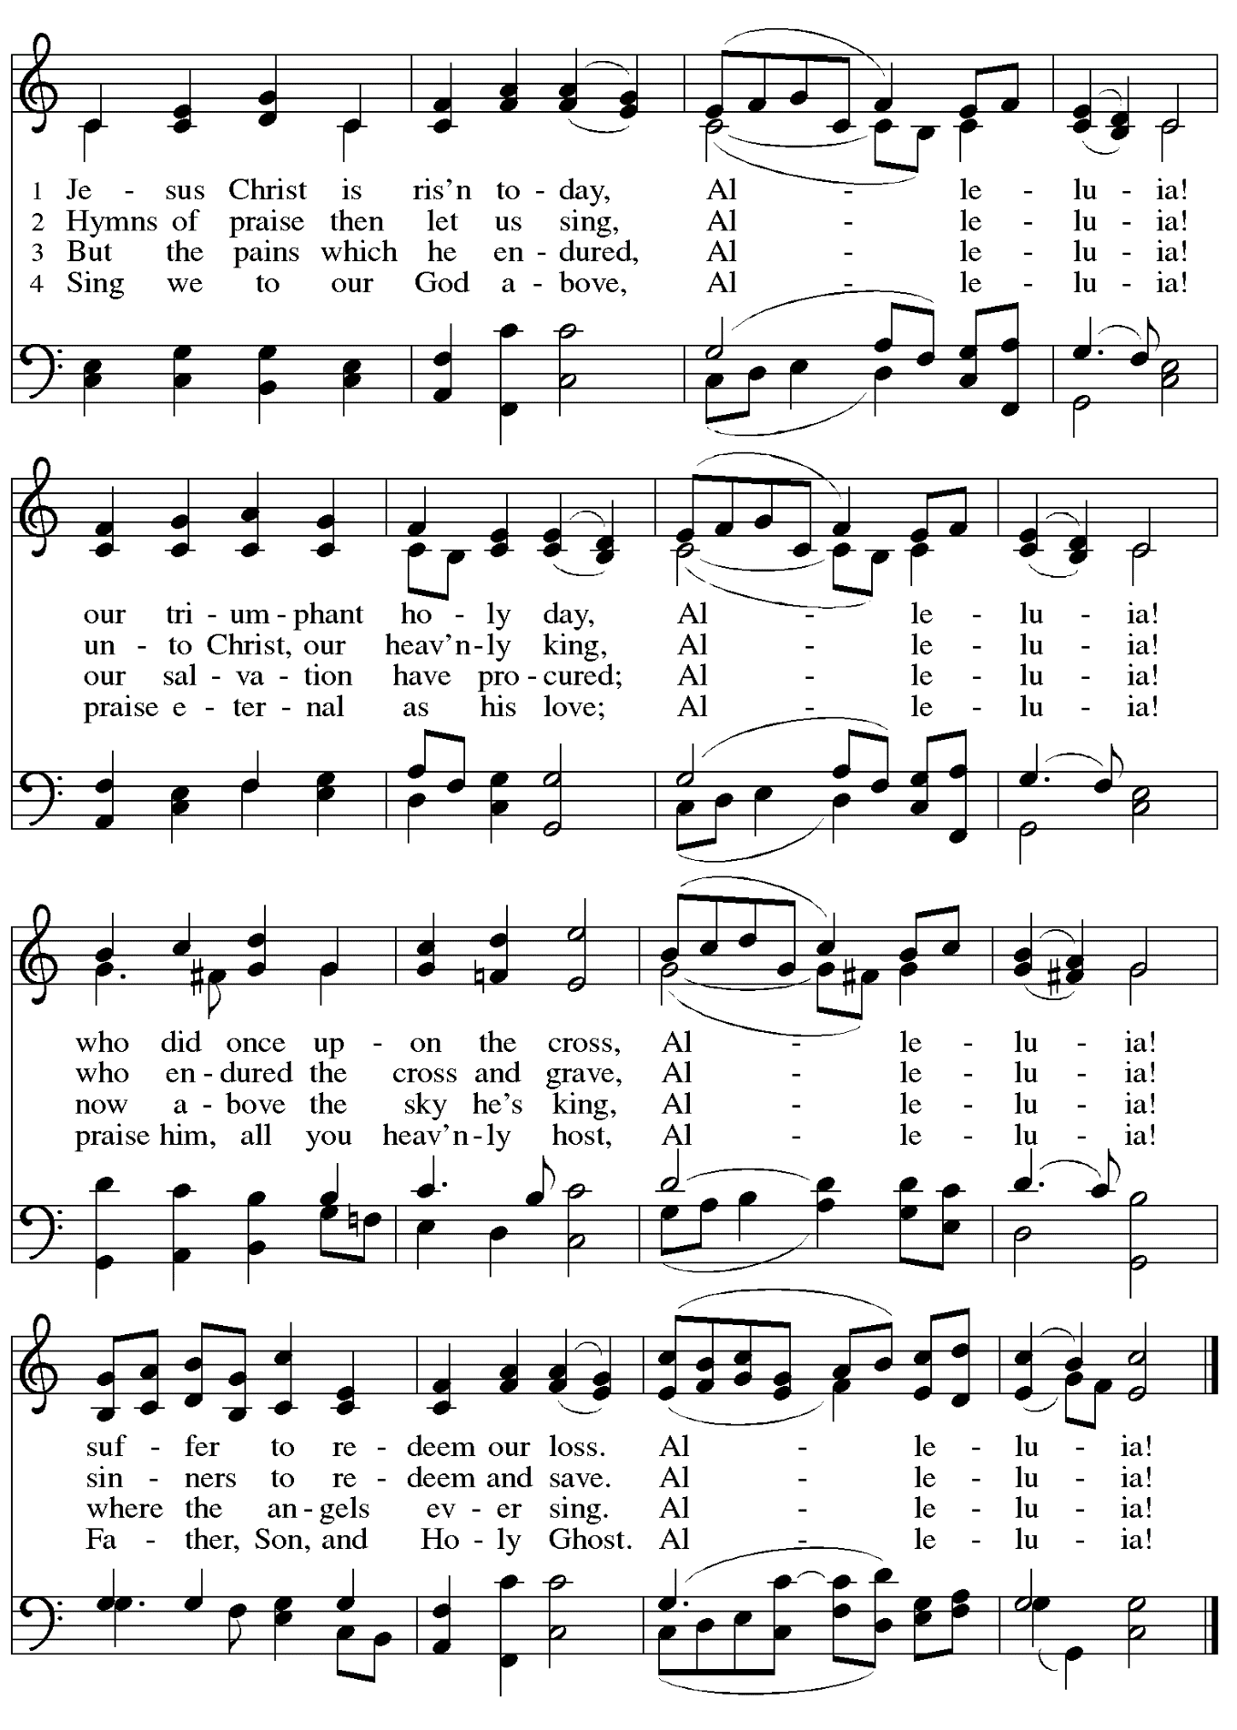

**Greeting**

P: The grace of our Lord Jesus Christ, the love of God,

and the communion of the Holy Spirit be with you all.

**C: And also with you.**

**Hymn of Praise** *This Is the Feast ELW* p. 149-150

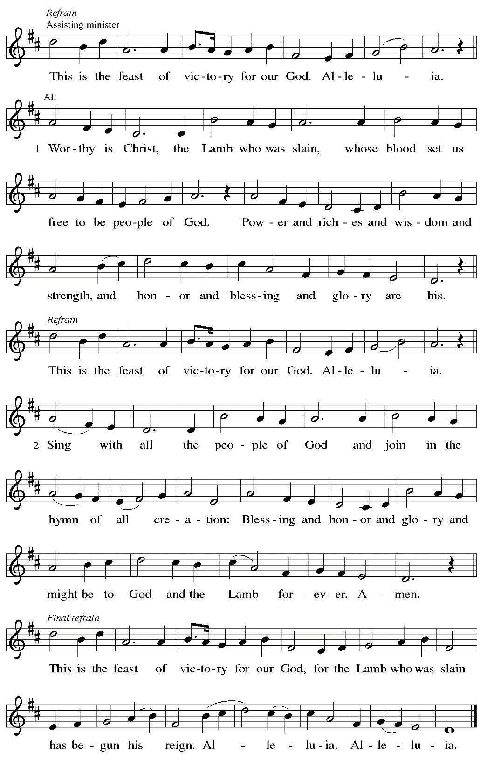

**Prayer of the Day**

P: The Lord be with you.

**C: And also with you.**

P: Let us pray.

O God, you gave your only Son to suffer death on the cross for our redemption,

and by his glorious resurrection you delivered us from the power of death.

Make us die every day to sin, that we may live with him forever in the joy of the resurrection, through your Son, Jesus Christ our Lord, who lives and reigns with you and the Holy Spirit,

one God, now and forever.

**C: Amen.**

*Please be seated.*

**Word**

*God speaks to us in Scripture reading, preaching, and song*

**First Reading** **–** **Acts 10: 34-43**

34 Then Peter began to speak to them: “I truly understand that God shows no partiality, 35 but in every people anyone who fears God and practices righteousness is acceptable to God. 36 You know the message God sent to the people of Israel, preaching peace by Jesus Christ—he is Lord of all. 37 That message spread throughout Judea, beginning in Galilee after the baptism that John announced: 38 how God anointed Jesus of Nazareth with the Holy Spirit and with power; how he went about doing good and healing all who were oppressed by the devil, for God was with him.

39 We are witnesses to all that he did both in Judea and in Jerusalem. They put him to death by hanging him on a tree, 40 but God raised him on the third day and allowed him to appear, 41 not to all the people but to us who were chosen by God as witnesses and who ate and drank with him after he rose from the dead. 42 He commanded us to preach to the people and to testify that he is the one ordained by God as judge of the living and the dead. 43 All the prophets testify about him that everyone who believes in him receives forgiveness of sins through his name.”

L: Word of God, word of life.

**C: Thanks be to God.**

**Psalm 118: 1-12, 14-24**

*The psalm will be sung responsively, led by the cantor,*

*with the congregation responding with the bold verses and refrain.*

*Psalm tone*

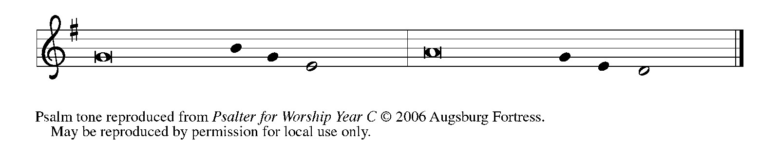

*Psalm refrain*

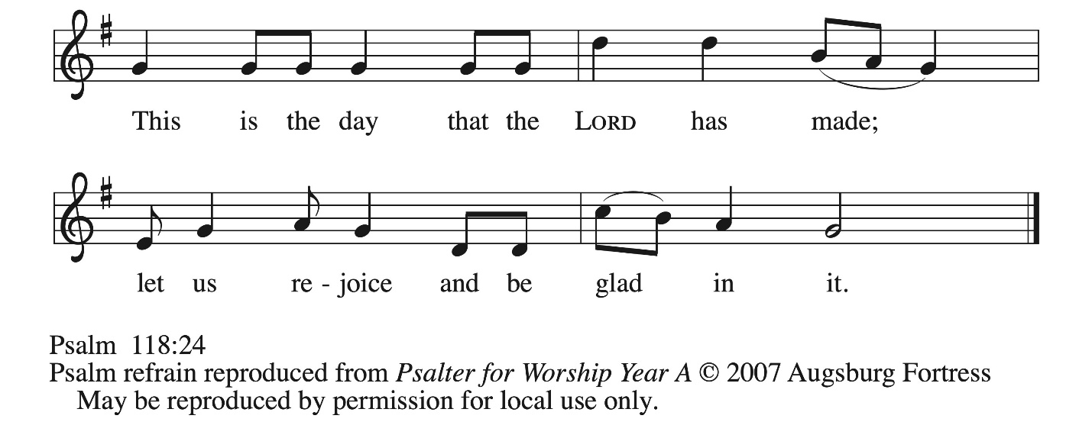

1Give thanks to the Lord, for the **|** Lord is good;  
  God’s mercy en- **|** dures forever.  
 2**Let Israel | now declare,**  
  **“God’s mercy en- | dures forever.”**  
 14The Lord is my strength **|** and my song,  
  and has become **|** my salvation.  
 15**Shouts of rejoicing and salvation echo in the tents | of the righteous:**  
  **“The right hand of the | Lord acts valiantly!**  
 16The right hand of the Lord**|** is exalted!  
  The right hand of the **|** Lord acts valiantly!”  
 17**I shall not | die, but live,**  
  **and declare the works | of the Lord.** R  
 18The Lord indeed pun- **|** ished me sorely,  
  but did not hand me o- **|** ver to death.  
 19**Open for me the | gates of righteousness;**  
  **I will enter them and give thanks | to the Lord.**  
 20“This is the gate **|** of the Lord;  
  here the righ- **|** teous may enter.”

 21**I give thanks to you, for you have | answered me**  
  **and you have become | my salvation.** R  
 22The stone that the build- **|** ers rejected  
  has become the chief **|** cornerstone.  
 23**By the Lord has | this been done;**  
  **it is marvelous | in our eyes.**  
 24This is the day that the **|** Lord has made;  
  let us rejoice and be **|** glad in it. R

**Second Reading – 1 Corinthians 15: 19-26**

19 If for this life only we have hoped in Christ, we are of all people most to be pitied.  
  20 But in fact Christ has been raised from the dead, the first fruits of those who have died. 21 For since death came through a human, the resurrection of the dead has also come through a human, 22 for as all die in Adam, so all will be made alive in Christ. 23 But each in its own order: Christ the first fruits, then at his coming those who belong to Christ. 24 Then comes the end, when he hands over the kingdom to God the Father, after he has destroyed every ruler and every authority and power. 25 For he must reign until he has put all his enemies under his feet. 26 The last enemy to be destroyed is death.

L: Word of God, word of life.

**C: Thanks be to God.**

*Please rise as you are able.*

**Gospel Acclamation** *ELW* p. 151

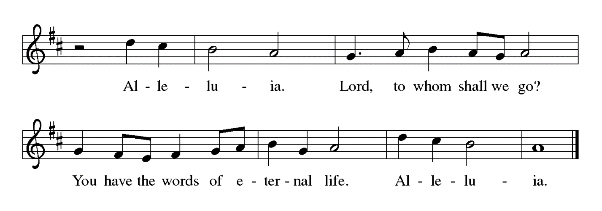

**Gospel – Luke 24: 1-12**

P: The holy Gospel according to St. Luke.

**C: Glory to you, O Lord.**

  1 But on the first day of the week, at early dawn, [the women] went to the tomb, taking the spices that they had prepared. 2 They found the stone rolled away from the tomb, 3 but when they went in they did not find the body. 4 While they were perplexed about this, suddenly two men in dazzling clothes stood beside them. 5 The women were terrified and bowed their faces to the ground, but the men said to them, “Why do you look for the living among the dead? He is not here but has risen. 6 Remember how he told you, while he was still in Galilee, 7 that the Son of Humanity must be handed over to the hands of sinners and be crucified and on the third day rise again.” 8 Then they remembered his words, 9 and returning from the tomb they told all this to the eleven and to all the rest. 10 Now it was Mary Magdalene, Joanna, Mary the mother of James, and the other women with them who told this to the apostles. 11 But these words seemed to them an idle tale, and they did not believe them. 12 But Peter got up and ran to the tomb; stooping and looking in, he saw the linen cloths by themselves; then he went home, amazed at what had happened.

P: The Gospel of the Lord.

**C: Praise to you, O Christ.**

*Please be seated.*

**Sermon**

*A time of silence for prayer and reflection follows the sermon.*

*When the hymn of the day begins, please rise as you are able.*

**Hymn of the Day Alleluia! Jesus Is Risen!** *Following page*



**Hymn of the Day Alleluia! Jesus Is Risen! *ELW* 377**

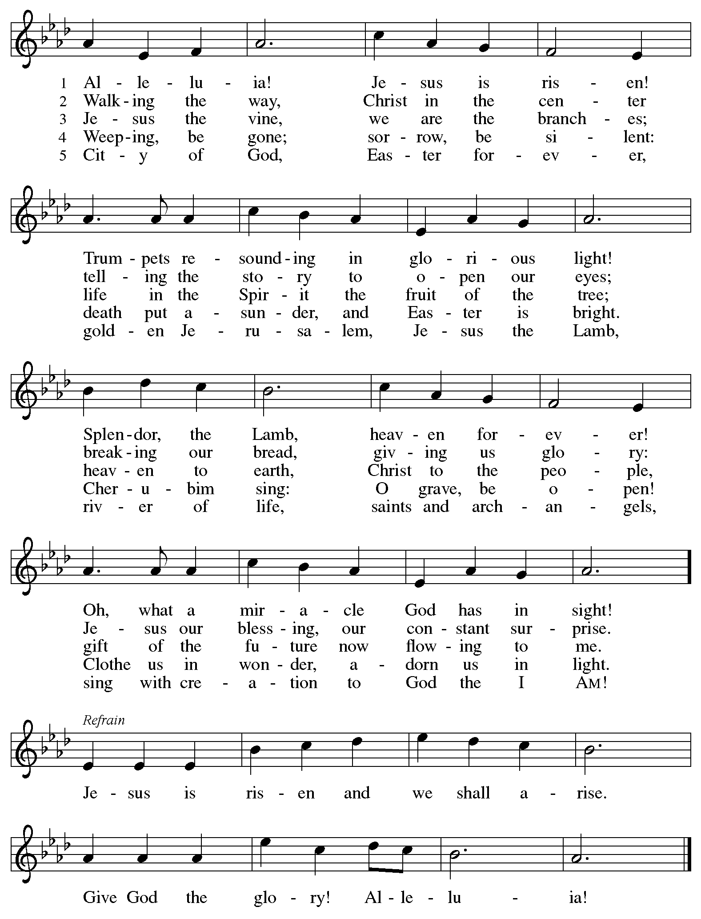

**Nicene Creed**

**C: W****e believe in one God,**

**the Father, the Almighty,**

**maker of heaven and earth,**

**of all that is, seen and unseen.**

**We believe in one Lord, Jesus Christ,**

**the only Son of God,**

**eternally begotten of the Father,**

**God from God, Light from Light,**

**true God from true God,**

**begotten, not made,**

**of one Being with the Father;**

**through him all things were made.**

**For us and for our salvation**

**he came down from heaven,**

**was incarnate of the Holy Spirit and the virgin Mary**

**and became truly human.**

**For our sake he was crucified under Pontius Pilate;**

**he suffered death and was buried.**

**On the third day he rose again**

**in accordance with the scriptures;**

**he ascended into heaven**

**and is seated at the right hand of the Father.**

**He will come again in glory to judge the living and the dead,**

**and his kingdom will have no end.**

**We believe in the Holy Spirit, the Lord, the giver of life,**

**who proceeds from the Father and the Son,\***

**who with the Father and the Son is worshiped and glorified,**

**who has spoken through the prophets.**

**We believe in one holy catholic and apostolic church.**

**We acknowledge one baptism for the forgiveness of sins.**

**We look for the resurrection of the dead,**

**and the life of the world to come. Amen.**

*Or, “who proceeds from the Father.” The phrase “and the Son” is a later addition to the creed.

**Prayers of the People**

A: United in the joy and hope of the resurrection, let us pray for the church, the world,

and all who are in need.

*After each petition*

A: Gracious God,

**C: receive our prayer.**

P: We lift these prayers to you O God, trusting in your abundant mercy,

through Jesus Christ our risen Savior.

**C: Amen.**

**Peace**

*The presiding minister and the assembly greet one another in the peace of the risen Christ.*

P: The peace of Christ be with you always.

**C: And also with you.**

*The people may greet those around them with a sign of Christ’s peace and may say*

Peace be with you *or similar words. Please be mindful that not everyone will be comfortable with sharing the peace, so please seek consent before shaking hands or hugging. Other possible ways to share the peace include a simple bow with the verbal greeting of peace, or simply a verbal expression of peace. When the greetings of peace have concluded, please be seated.*

**Meal**

*God feeds us with the presence of Jesus Christ*

**Offering**

*We offer ourselves, our gifts, and our faithful service to God.*

*As the offering is gathered for the mission of the church, including the care of those in need,*

*the table is set for Holy Communion.*

*There are laminated giving cards in the pew racks that feature a QR code for anyone who would like to give online. Those who give using the QR code, as well as those who give regularly online or through their bank are encouraged to place the laminated card in the plate as an expression of your offering.*

**Noisy Offering**

*As children of the congregation carry buckets around the sanctuary, people of the congregation are invited to throw in their change as an offering. This month’s offering will support Lutheran Disaster Response, a ministry of the Evangelical Lutheran Church in America (ELCA) that provides relief and support to people and areas that have experienced natural disasters, domestically and internationally.*

**Music during the Offering**

*All Hail the Power of Jesus’ Name* arr. Brent Edstrom

*As the gifts are brought forward for presentation, please rise as you are able.*

**Offertory Song Let the Vineyards *ELW* 184**

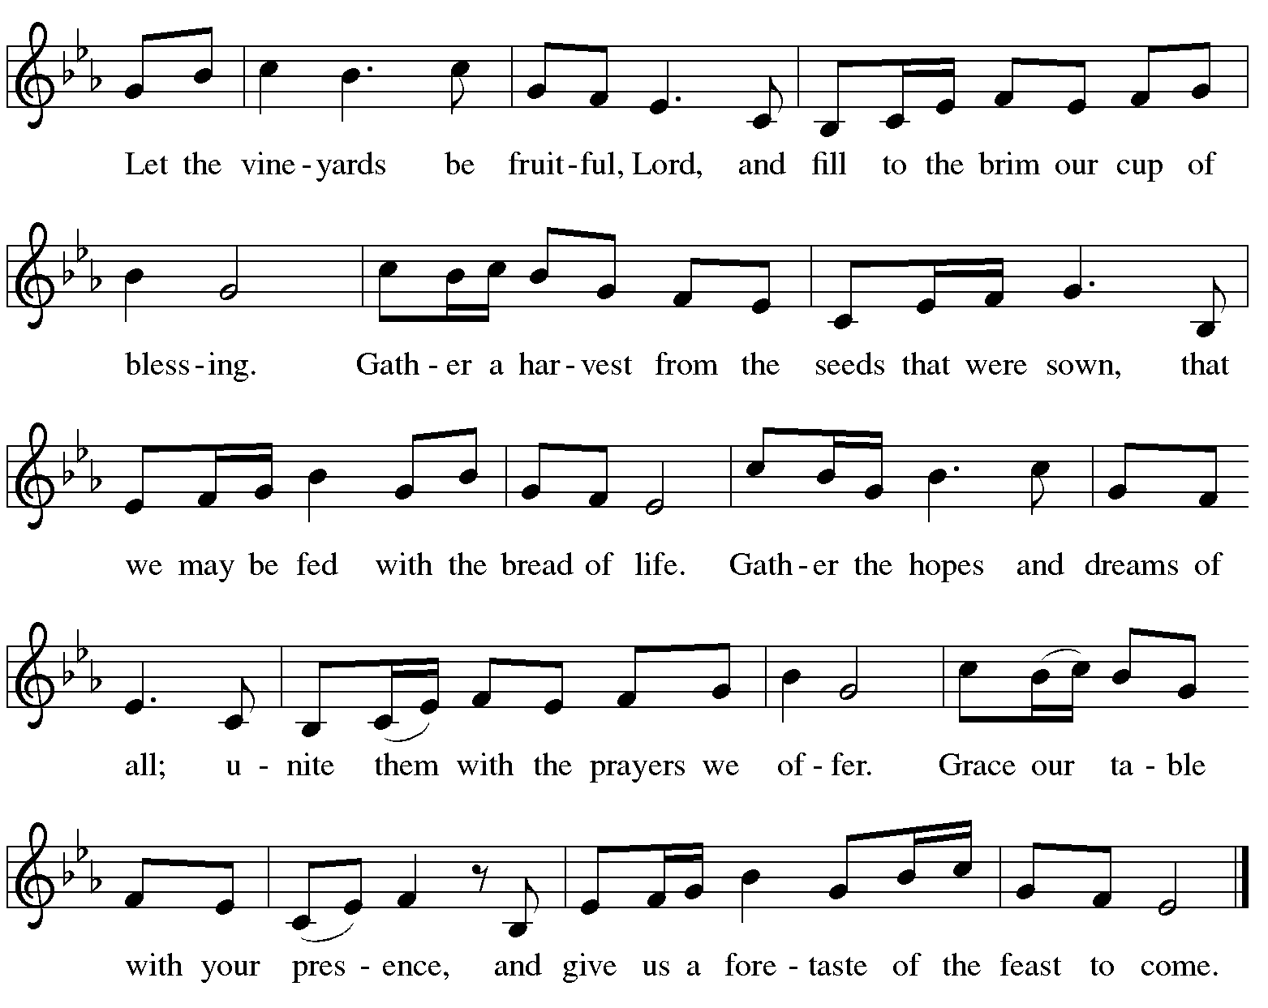

**Offertory Prayer**

A: Let us pray.

Blessed are you, O God,

**C:** **ruler of heaven and earth.**

**Day by day you shower us with blessings.**

**As you have raised us to new life in Christ,**

**give us glad and generous hearts,**

**ready to praise you and to respond to those in need,**

**through Jesus Christ, our Savior and Lord. Amen.**

**Dialogue** *ELW* p. 152

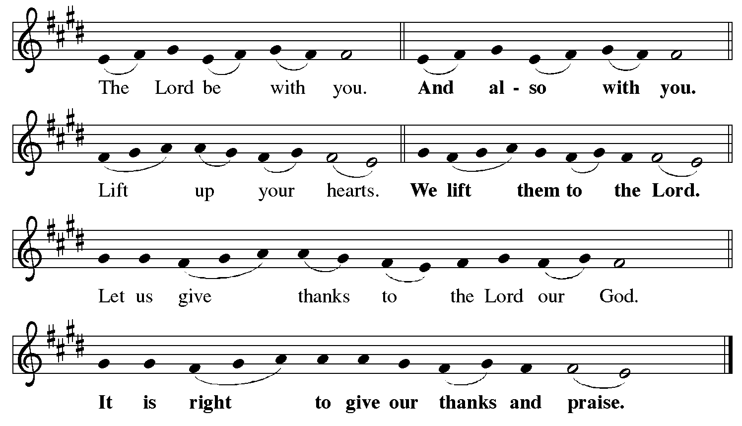

**Preface** *(Sung by the presiding minister)*

P: It is indeed right, our duty and our joy,

that we should at all times and in all places

give thanks and praise to you, almighty and merciful God,

for the glorious resurrection of our Savior Jesus Christ,

the true Paschal Lamb who gave himself to take away our sin;

who in dying has destroyed death,

and in rising has brought us to eternal life.

And so, with Mary Magdalene and Peter

and all the witnesses of the resurrection,

with earth and sea and all their creatures,

and with angels and archangels, cherubim and seraphim,

we praise your name and join their unending hymn:

**Sanctus** *ELW* p. 153

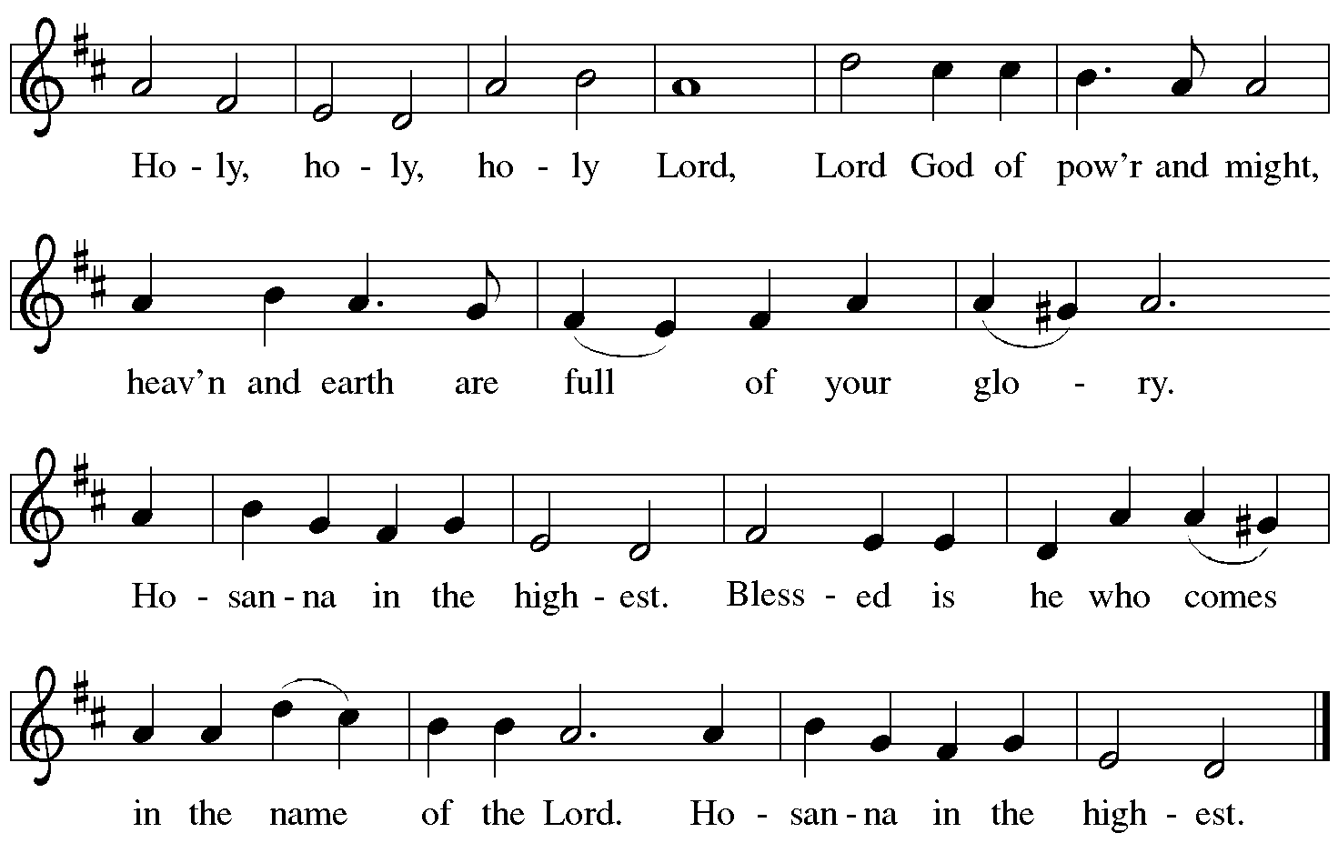

**Eucharistic Prayer**

P: Blessed are you, O God of the universe …

For Christ is risen:

**C: Christ is risen indeed!**

P: This is the day on which you gave light to the earth …

and that light is Christ:

**C: Thanks be to God.**

P: This is the day on which you broke the chains of death …

For Christ is risen:

**C: Christ is risen indeed!**

P: In the night in which he was betrayed …

… Do this for the remembrance of me.

Let us proclaim the mystery of faith.

**C: Christ has died. Christ is risen. Christ will come again.**

P: On this day send us the power of your Holy Spirit …

For that light is Christ:

**C: Thanks be to God.**

P: All holy and mighty and glorious God …

… for Christ is risen:

**C: Christ is risen indeed!**

P: Amen and Amen!

**C: Amen and Amen!**

**Lord’s Prayer**

P: Gathered as one by the Holy Spirit, let us pray as Jesus taught us.

**C: Our Father in heaven,**

**hallowed be your name,**

**your kingdom come,**

**your will be done,**

**on earth as in heaven.**

**Give us today our daily bread.**

**Forgive us our sins**

**as we forgive those**

**who sin against us.**

**Save us from the time of trial**

**and deliver us from evil.**

**For the kingdom, the power,**

**and the glory are yours,**

**now and forever. Amen.**

**Fraction and Invitation**

P: Alleluia! Christ is risen!

**C: Christ is risen indeed! Alleluia! Alleluia!**

P: This is the feast of victory for our God. Alleluia! Alleluia!

Come, share the feast.

***Agnus Dei /* Lamb of God** *Following Page*



***Agnus Dei /* Lamb of God** *ELW* p. 154

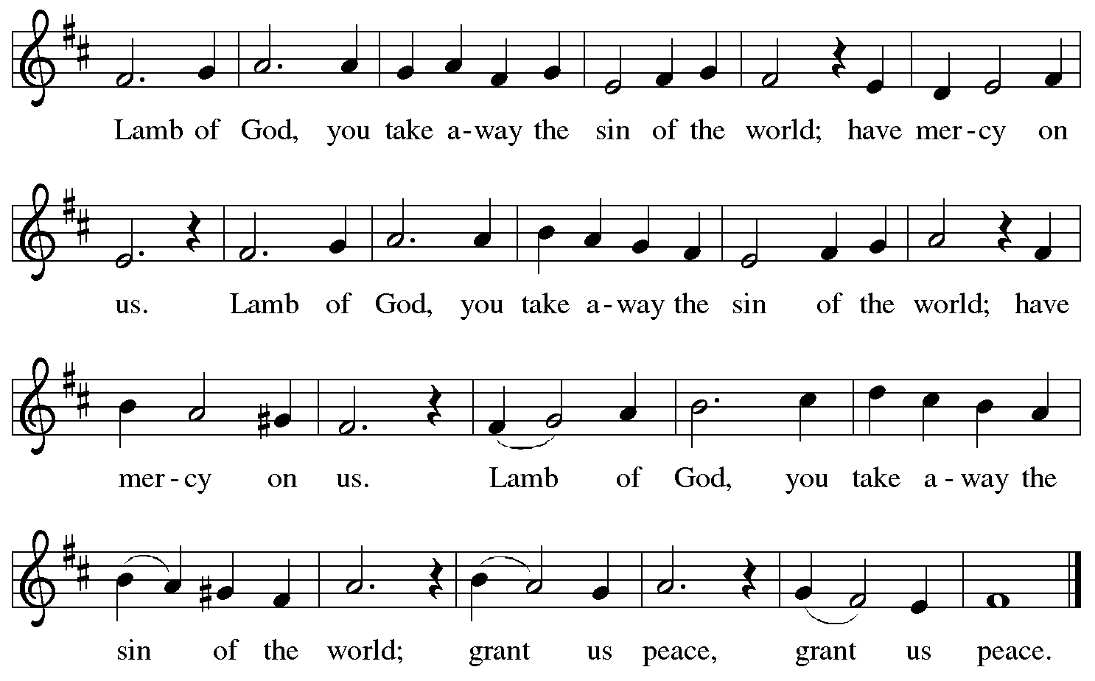

*Please be seated.*

**Holy Communion**

* *All who seek God and desire a deeper and stronger life in Christ are welcome to receive Holy Communion.*
* *Worshipers from the pulpit side will proceed forward first, followed by the center section, and then the lectern side.*
* *Please inform an usher if you would like the ministers to bring Communion to you.*
* *Holy Communion will be served with bread and wine (red) or grape juice (white).*
* *The presiding minister will first distribute the bread (host) to each communicant. Please indicate if you require a gluten-free host.*
* *Once you have consumed the bread, please pick up an empty glass from the tray next to the presiding minister. The Communion Assistant will pour wine from the chalice or grape juice from the cruet into your glass.*
* *Please step to the side to consume the wine or grape juice.*
* *Feel free to kneel at the altar rail for prayer after receiving the sacrament.*
* *As you return to your pew, glasses may be returned to the empty tray on the side of the center section.*
* *A blessing will be provided for anyone who does not yet receive the sacrament.*
* *All are invited to join in singing the hymns during Holy Communion.*

**Hymns during Holy Communion**

**Christ Is Risen! Alleluia! *ELW* 382**

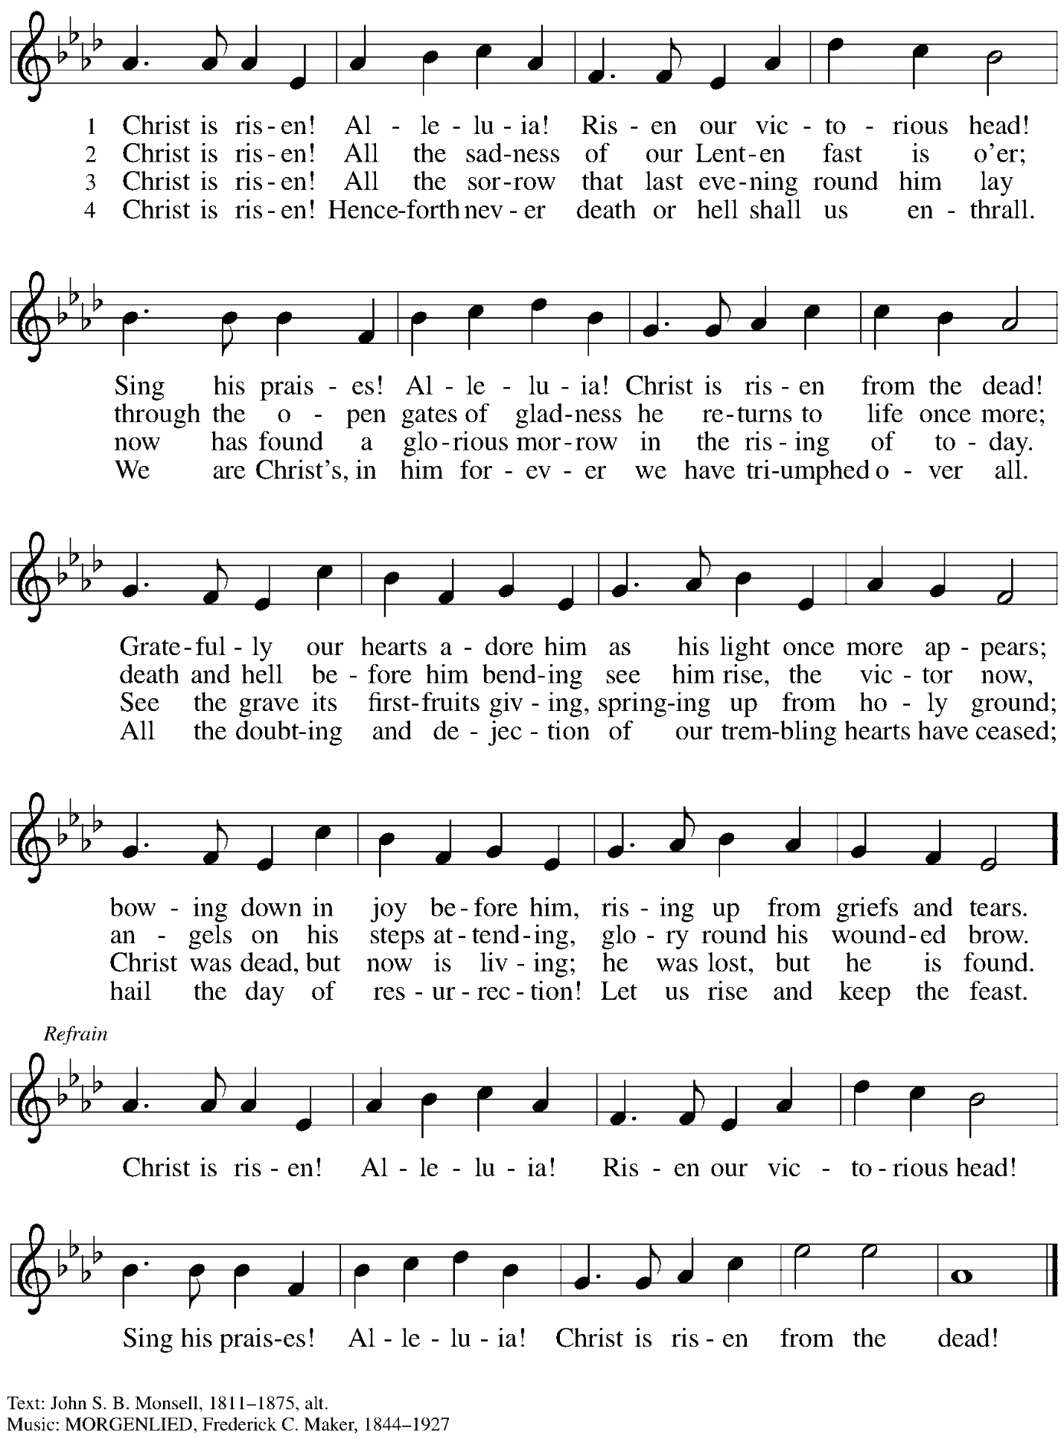

**Hymns during Holy Communion**

**The Day of Resurrection! *ELW* 361**

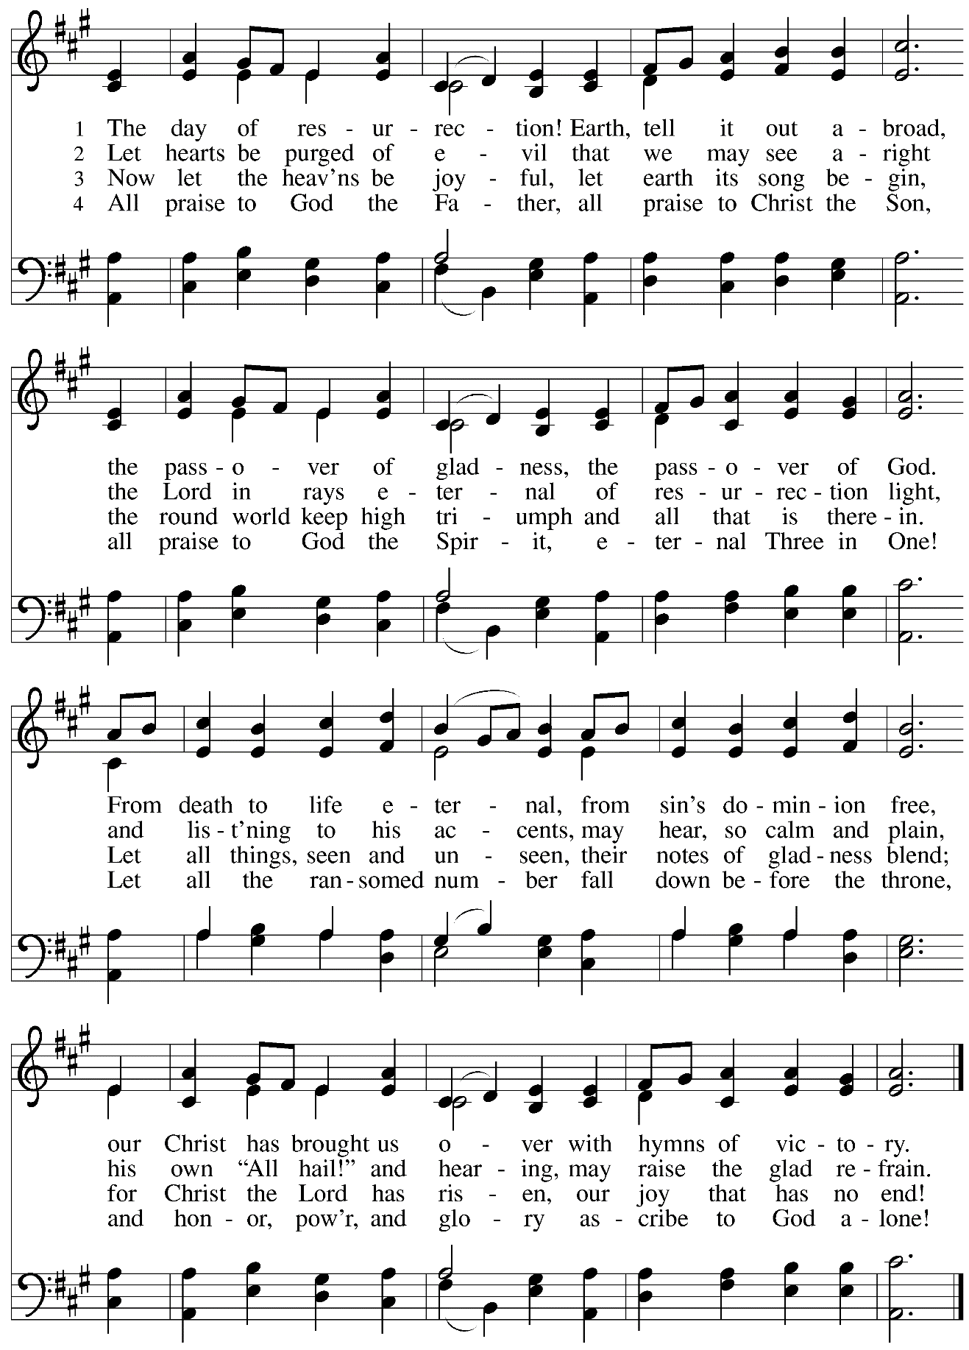

**Hymns during Holy Communion**

**At the Lamb’s High Feast We Sing *ELW* 362**

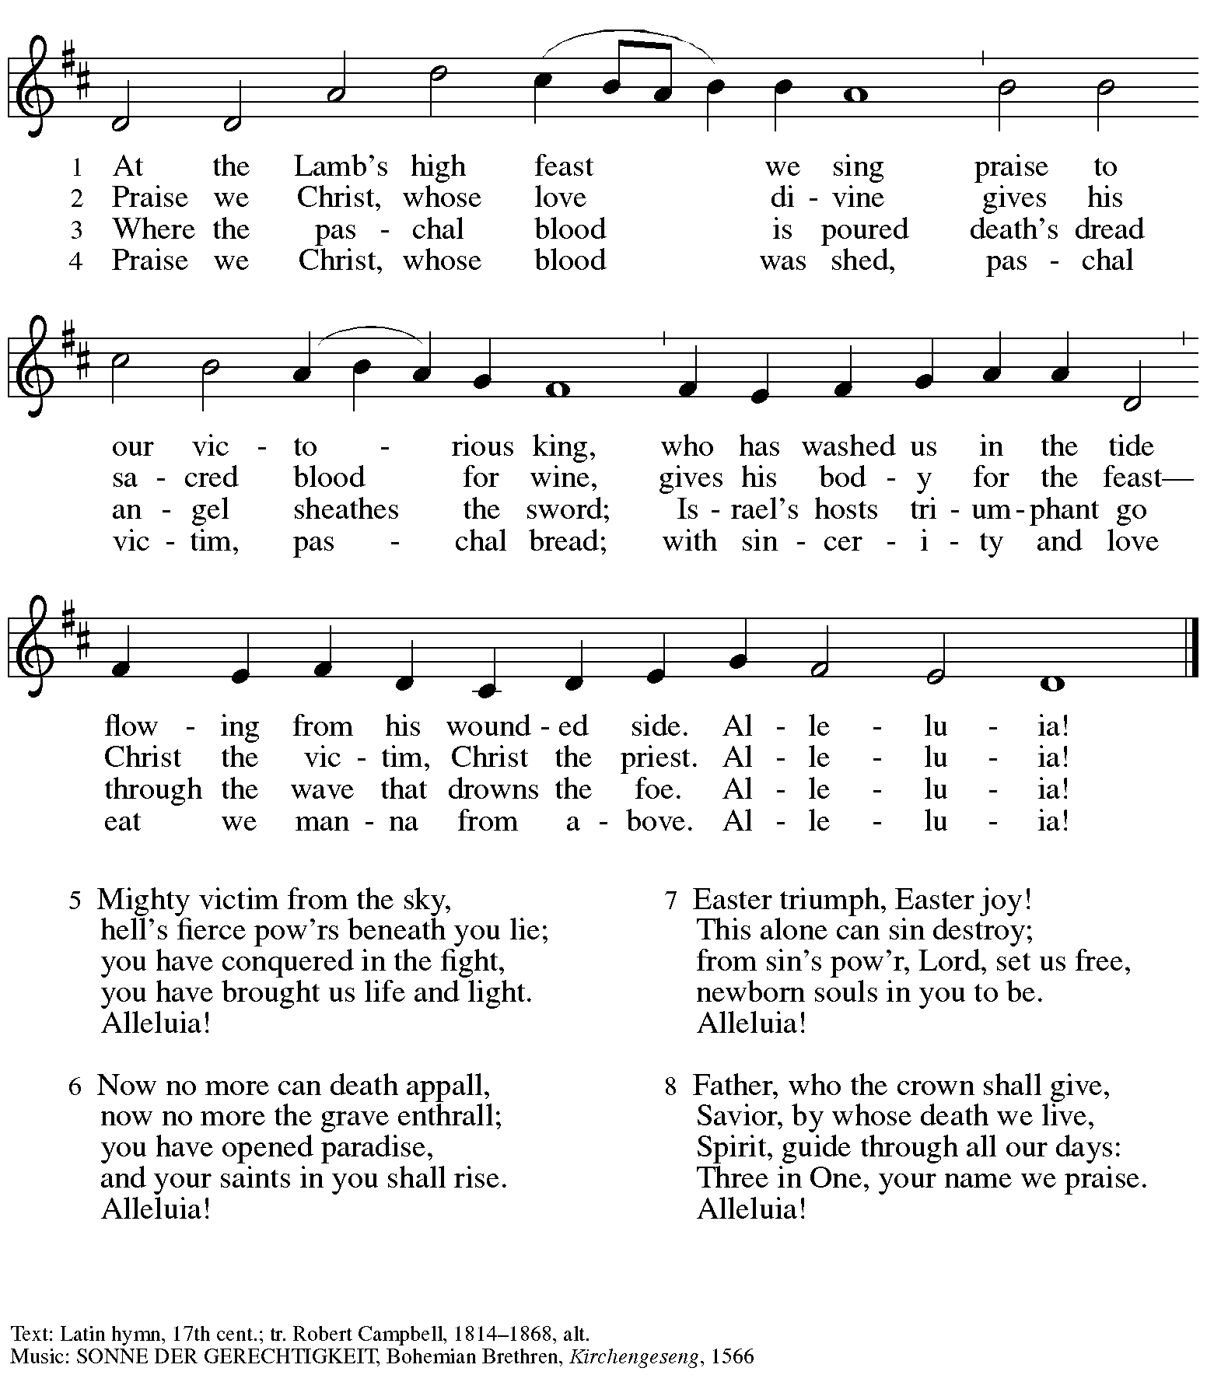

**Hymns during Holy Communion**

**Now the Green Blade Rises *ELW* 379**

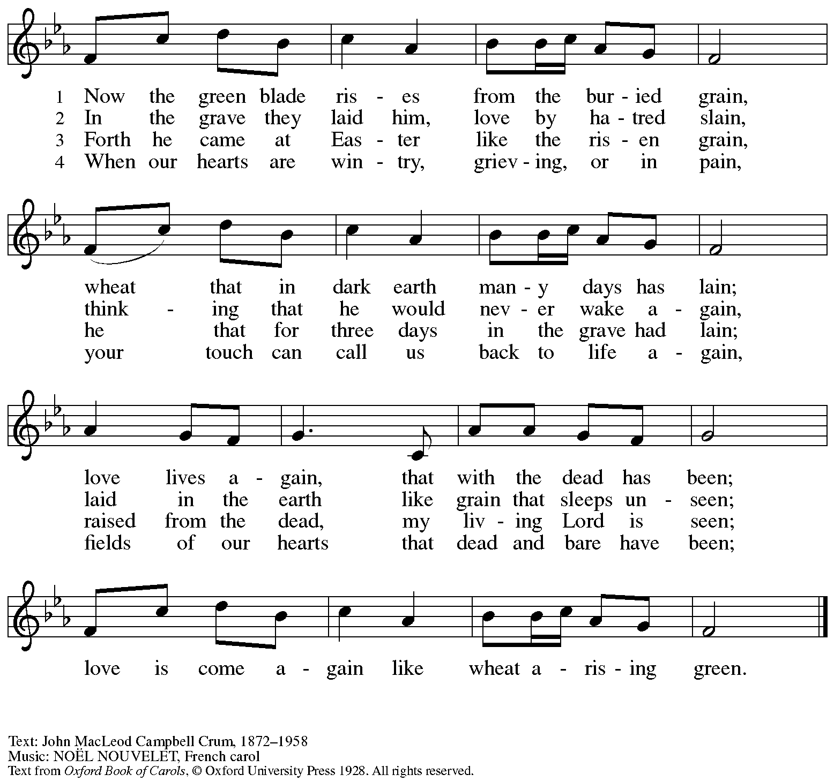

Reprinted with permission under OneLicense.net # A-722139.

**Hymn during Holy Communion**

**This Joyful Eastertide *ELW* 391**

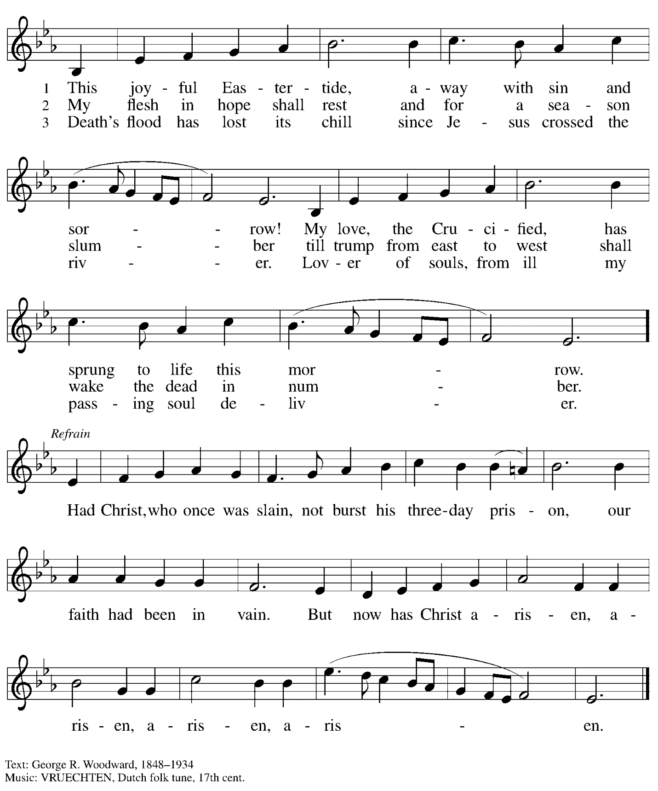

**Hymn during Holy Communion**

**Now All the Vault of Heaven Resounds *ELW* 367**

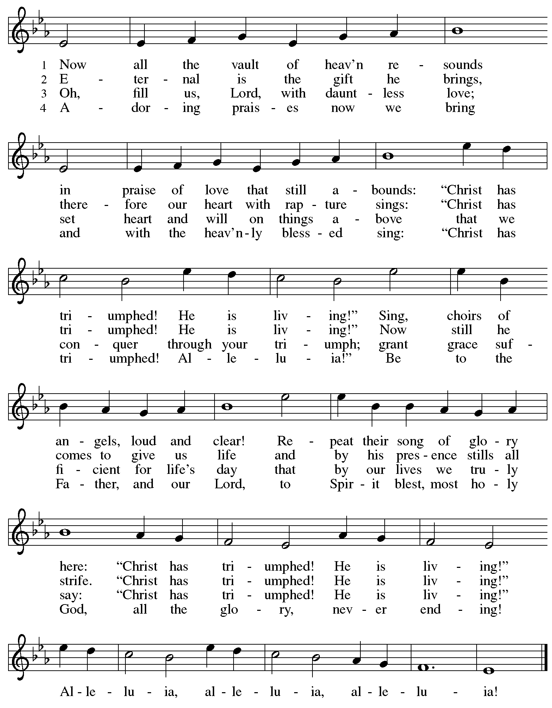

*When all have returned to their places, please rise as you are able.*

**Blessing**

P: The body and blood of our Lord Jesus Christ strengthen you and keep you in his grace.

**C: Amen.**

**Prayer**

A: Let us pray.

Life-giving God,

in the mystery of Christ’s resurrection, you send light to conquer darkness,

water to give new life, and the bread of life to nourish your people.

Send us forth as witnesses to your Son’s resurrection,

that we may show your glory to all the world,

through Jesus Christ, our risen Lord.

**C: Amen.**

**Sending**

*God blesses us and sends us in mission to the world*

**Benediction**

P: May our glorious God grant you a spirit of wisdom

to know and love the risen Christ.

Almighty God, holy One, ☩ holy Three,

bless you now and forever.

**C: Amen.**

**Recessional Hymn Thine Is the Glory** *Following page*

**Dismissal**

A: Alleluia! Christ is risen!

**C: Christ is risen indeed! Alleluia! Alleluia!**

A: Go in peace. Share the good news!

**C: Thanks be to God!**

**Postlude**

**Recessional Hymn Thine Is the Glory *ELW* 376**

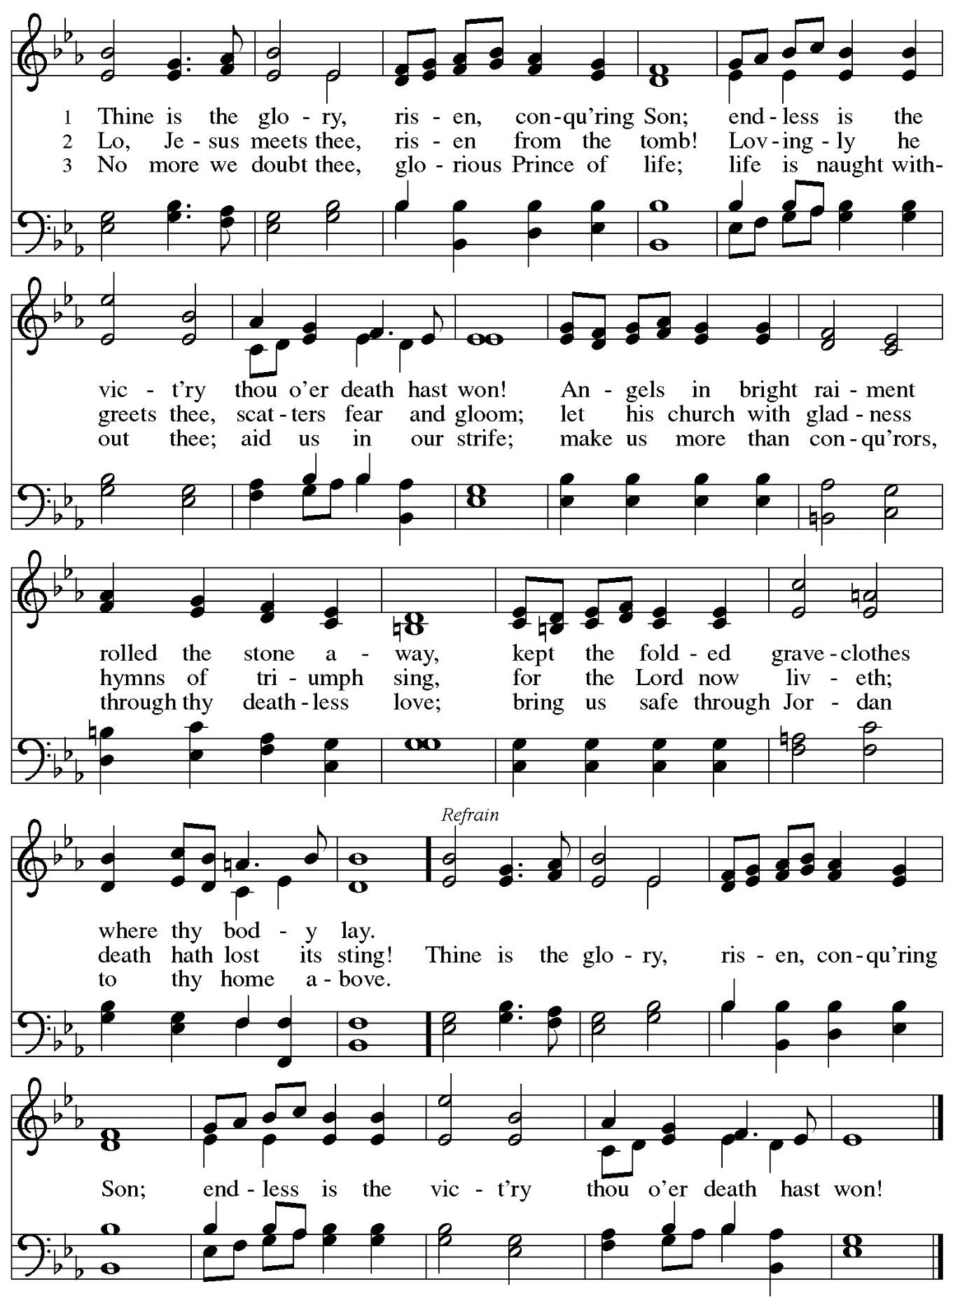

*Those serving in worship today*

Altar Care Jodie Minor

Assisting Minister Timothy Kocher-Hillmer

Audio-Visual Ministers Jason Galyardt

Jered Stratton

Cantor Marit Bakken

Lector Colleen Cooke

Clarinet Maria Mangano

Euphonium David Rollinson

Flute and Bassoon Christine Peterson

French Horn Emily Duque

Trumpet Alex Duque

Minister of Music Laura Reynolds

Presiding Minister The Rev. Ross I. Carmichael

*Liturgy and Hymnody Acknowledgements*

From SundaysandSeasons.com. Copyright © 2025 Augsburg Fortress. All rights reserved. Reprinted under OneLicense.net # A-722139.

Used by permission of Augsburg Fortress.

The Scripture readings contained herein are from *New Revised Standard Version Updated Edition* of the Bible © 2021 National Council of Churches of Christ in the United States of America. Used by permission. All rights reserved worldwide.

**Jesus Christ Is Risen Today** –Text: Latin carol, 14th cent., sts. 1-3; tr. J. Walsh, *Lyra Davidica*, 1708, alt.; Charles Wesley, 1707-1788, st. 4. Music: EASTER HYMN, J. Walsh, *Lyra Davidica*, 1708.

**Alleluia! Jesus Is Risen!** – Text: Herbert Brokering, b. 1926. Music: EARTH AND ALL STARS, David N. Johnson, 1922-1987. Text © 1995 Augsburg Fortress. Music © 1969 *Contemporary Worship 1*, admin. Augsburg Fortress. All rights reserved. Reprinted with permission under OneLicense.net # A-722139.

**Let the Vineyards** – Text: John W. Arthur, 1922-1980. Music: Ronald A. Nelson, b. 1927. Text and Music © 1978 *Lutheran Book of Worship*, admin. Augsburg Fortress.

**Eucharistic Prayer, For the Resurrection of our Lord: Easter Day** – Adapted from *Pray, Praise, and Give Thanks: A Collection of Litanies, Laments, and Thanksgivings at Font and Table* by Gail Ramshaw, copyright © 2017 Augsburg Fortress. All rights reserved. Reprinted with permission.

**Christ Is Risen! Alleluia!** – Text: John S. B. Monsell, 1811-1875, alt. Music: MORGANLIED, Frederick C. Maker, 1844-1927.

**The Day of Resurrection! –** Text: John of Damascus, c. 696 – c. 754; tr. John Mason Neale, 1818-1866, alt. Music: ELLACOMBE, German melody, 18th cent.; adapt. X.L. Hartig, *Melodien zum Mainzer Gesangbuche*, 1833.

**Now All the Vault of Heaven Resounds** – Text: Paul Z. Strodach, 1876-1947, alt. Music: LASST UNS ERFREUEN, *Geistliche Kirchengesänge*, Köln, 1623. Text © 1958 *Service Book and Hymnal*, admin. Augsburg Fortress. All rights reserved. Reprinted with permission under OneLicense.net # A-722139.

**Thine Is the Glory** – Text: Edmund Budry, 1854-1932; tr. R Birch Hoyle, 1875-1939. Music: JUDAS MACCABEUS, George Frideric Handel, 1685-1759.

*Please use the QR code below to link to St. Andrew’s Announcements online!*



**St. Andrew Lutheran Church Announcements**

**April 20th, 2025**

* **Happy Easter! Welcome to Worship at St. Andrew on April 20th, 2025, as We Celebrate + The Resurrection of our Lord!** –We are so glad you are here to share in this festive day, and we offer a special welcome to all visitors and guests who are here for the first time! Little Church – Big Faith will not meet during worship this week so the children can fully participate in the celebration of Easter. There are worship “toolkits” to help children engage with worship and “busy bags” for younger children available in the bookcase at the back of the sanctuary. Please feel free to take one to use with/for your children. A nursery is available through the door to the left of the worship space and across the social hall (look for a purple room). We pray that everyone has a blessed Easter season!
* **Noisy Offering during Worship Today!** – **On the third Sunday of each month, St. Andrew’s children lead the congregation in a “Noisy” Offering, in which people are invited to throw their change into buckets that the children carry around the church and bring forward as an additional offering. Each month’s Noisy Offering supports a local, national, or international church-related or otherwise charitable organization. This month’s Noisy Offering will support Lutheran Disaster Response, a ministry of the Evangelical Lutheran Church in America that provides relief and support to people and areas that have experienced natural disasters, both domestically and internationally. For more information on their work, please visit** <https://www.elca.org/our-work/relief-and-development/lutheran-disaster-response>**.**
* **Flower Donors, Please Remember to Take Home Easter Flowers!** – We are grateful for everyone who contributed to beautifying the church with flowers this Easter! We encourage those who have dedicated flowers to please take them with you so they do not go to waste. If you choose not to take them, please let Pastor Ross know so that others may enjoy them!
* ***Christ in Our Home* Devotional Booklets for April – June Available at Entrances** – This resource offers a daily Bible reading with a short reflection and prayer, along with additional readings and prayer topics for those who would like to expand their devotional practices. We encourage people of the congregation to take one for yourself, your family/household, or others!

**Easter Flowers Decorating the Chancel Have Been Given**

**In Appreciation / Love for**

A Vibrant, Growing Community

by Pastor Peter and Kristen Asplin

Family by the Rev. Dr. Paul and Sharon Koch

My Daughter, Megan Elk, and Her Wife, Rachel Schuldt

by Cynthia Holden

My Sobriety by Colleen Cooke

Pastor Ross and Laura

by Michael Smolleck and Arnie Rowlands

**In Honor of** My Parents, Dan and Ruth Baxter by Lindsay Baxter

The Beautiful Givens Family by Megan Will

Kelly Spanninger by Megan Will

St. Andrew by The Rev. Janet B. and The Rev. Keith E. Grill

The St. Andrew Community by Kelly Spanninger

**In Loving Memory of**

Ada Charlson by Lindsay Baxter

All My Past Pets by Audrey Gaugler

All the Saints in Heaven by Lily Gaugler

Melvin and Dorothy Bohlmann by Miriam Bohlmann Kunz

Joyce Compton by Kelly Spanninger

Joyce Compton by C.E. Pino and Miranda Pino

Esther Hetrick Dugoni and Herbert D. Hetrick

by Deobrah Catanese

Fernando Gonzaga by Alda Maria Gonzaga

Rodrigo Gonzaga by Alda Maria Gonzaga

Grandma Viola by Leanne and Jonathan Paetz

My Grandparents by Alda Maria Gonzaga

Bob and Ruth Kunz by Miriam Bohlmann Kunz

My Mom and My Sisters by Mary Lou Benedetti

My Parents, Regis and Edith Holden by Cynthia Holden

Jack and Katherine Paetz by Leanne and Jonathan Paetz

Our Parents by Victoria Al-Ebrahim and Paul Rehwald

Our Parents by Scott and Sue Gaugler

Sally and Arnold Rowlands

by Arnie Rowlands and Michael Smolleck

**In Loving Memory of**

Rose and Richard Smolleck

by Michael Smolleck and Arnie Rowlands

Mr. George Varghese by Sharon, Sandhya, and Nila

**In Thanksgiving for**

The Bible Book Club by Ginny and Tom Leech

Lily and Audrey by Jon and Becky Gaugler

**To the Glory of God** by Kathy Hays