

**+ Third Sunday of Easter**

**May 4, 2025**





**St. Andrew Lutheran Church**

**304 Morewood Ave.**

**Pittsburgh, PA 15213**

[**St_andrewELCA@verizon.net**](mailto:St_andrewELCA@verizon.net)

[**www.standrewpittsburgh.org**](http://www.standrewpittsburgh.org)

**+ Third Sunday of Easter**

**Order for Worship**

*After the disciples spend a fruitless night fishing and catching nothing, the risen Jesus appears to them, enables an amazing catch, and eats breakfast with them.*

*Wading in the water (remembering Baptism) and eating with Jesus (celebrating Holy Communion) together make up our weekly encounter with the risen Christ.*

*Jesus asks us again and again: Do you love me?*

*And Jesus invites us, again and again, to follow him, bringing the Easter life to others.*

**Welcome to St. Andrew!**

* St. Andrew welcomes all who are seeking a place of healing, wholeness, and acceptance in a nurturing and faith-forming spiritual home. We are striving toward racial equity worldwide

and we seek to honor the lived experience of all individuals regardless of background. Our community embraces people of all ages, ethnicities, cultures, abilities, sexual orientations,

gender identities and expressions, and family constellations. Come and See!

* Worship Services are live-streamed to multiple online platforms. By attending worship, you agree that your image and voice may be broadcast.
* Everyone is invited to make a name tag at the black bookcase in the back of the worship space if they would like. There are stickers indicating pronouns on the bookcase if you would like to include them on your name tag.
* ***Little Church – Big Faith will not meet this Sunday due to the Marathon.***
* A nursery is available through the doors at the left side of the sanctuary and across from the doorway to the Social Hall. Look for a purple-colored room.
* Worship “toolkits” to help children engage with the service, along with “busy bags” for younger children, are available in the bookcase at the back of the sanctuary. Please feel free to take one to use with/for your children.
* Holy Communion is served with bread (gluten-free available) and wine or grape juice. The presiding minister will distribute the bread (host). Please consume this and then pick up an empty glass from the tray. The Communion Assistant will pour wine or grape juice into your glass. Please step to the side to consume the wine or grape juice. Feel free to kneel at the altar for prayer and reflection. As you return to your pew, glasses may be returned to the empty trays on either side of the center section.
* A restroom is available on the main level of the church, through the doors to the Social Hall and to the right in the main office.

*Abbreviations*

P: Pastor/Presiding Minister ***ELW*: *Evangelical Lutheran Worship* hymnal**

A: Assisting Minister ***ACS*: *All Creation Sings* hymnal**

L: Lector

**C: Congregation**

**Pre-Service Music**

**Welcome**

**Prelude**

**Gathering**

*The Holy Spirit calls us together as the people of God*

*Please rise as you are able. All may make the sign of the cross, the sign marked at Baptism,*

*as the presiding minister begins.*

**Confession and Forgiveness**

P: Blessed be the holy Trinity, ☩ one God,

who forgives all our sin, whose mercy endures forever.

**C: Amen.**

P: God of all mercy and consolation, come to the help of your people,

turning us from our sin to live for you alone. Give us the power of your Holy Spirit,

that we may confess our sin, receive your forgiveness,

and grow into the fullness of Jesus Christ, our Savior and Lord.

**C: Amen.**

P: Let us confess our sin in the presence of God and of one another.

*Silence is kept for reflection.*

P: Most merciful God,

**we confess that we are captive to sin and cannot free ourselves.**

**We have sinned against you in thought, word, and deed,**

**by what we have done and by what we have left undone.**

**We have not loved you with our whole heart; we have not loved our neighbors as ourselves.**

**For the sake of your Son, Jesus Christ, have mercy on us.**

**Forgive us, renew us, and lead us, so that we may delight in your will**

**and follow in your ways, to the glory of your holy name.** **Amen.**

P: God, who is rich in mercy, loved us even when we were dead in sin,

and made us alive together with Christ. By grace you have been saved.

In the name of ☩ Jesus Christ, your sins are forgiven.

Almighty God strengthen you with power through the Holy Spirit,

that Christ may live in your hearts through faith.

**C: Amen.**

**Gathering Hymn Now All the Vault of Heaven Resounds *ELW* 367**

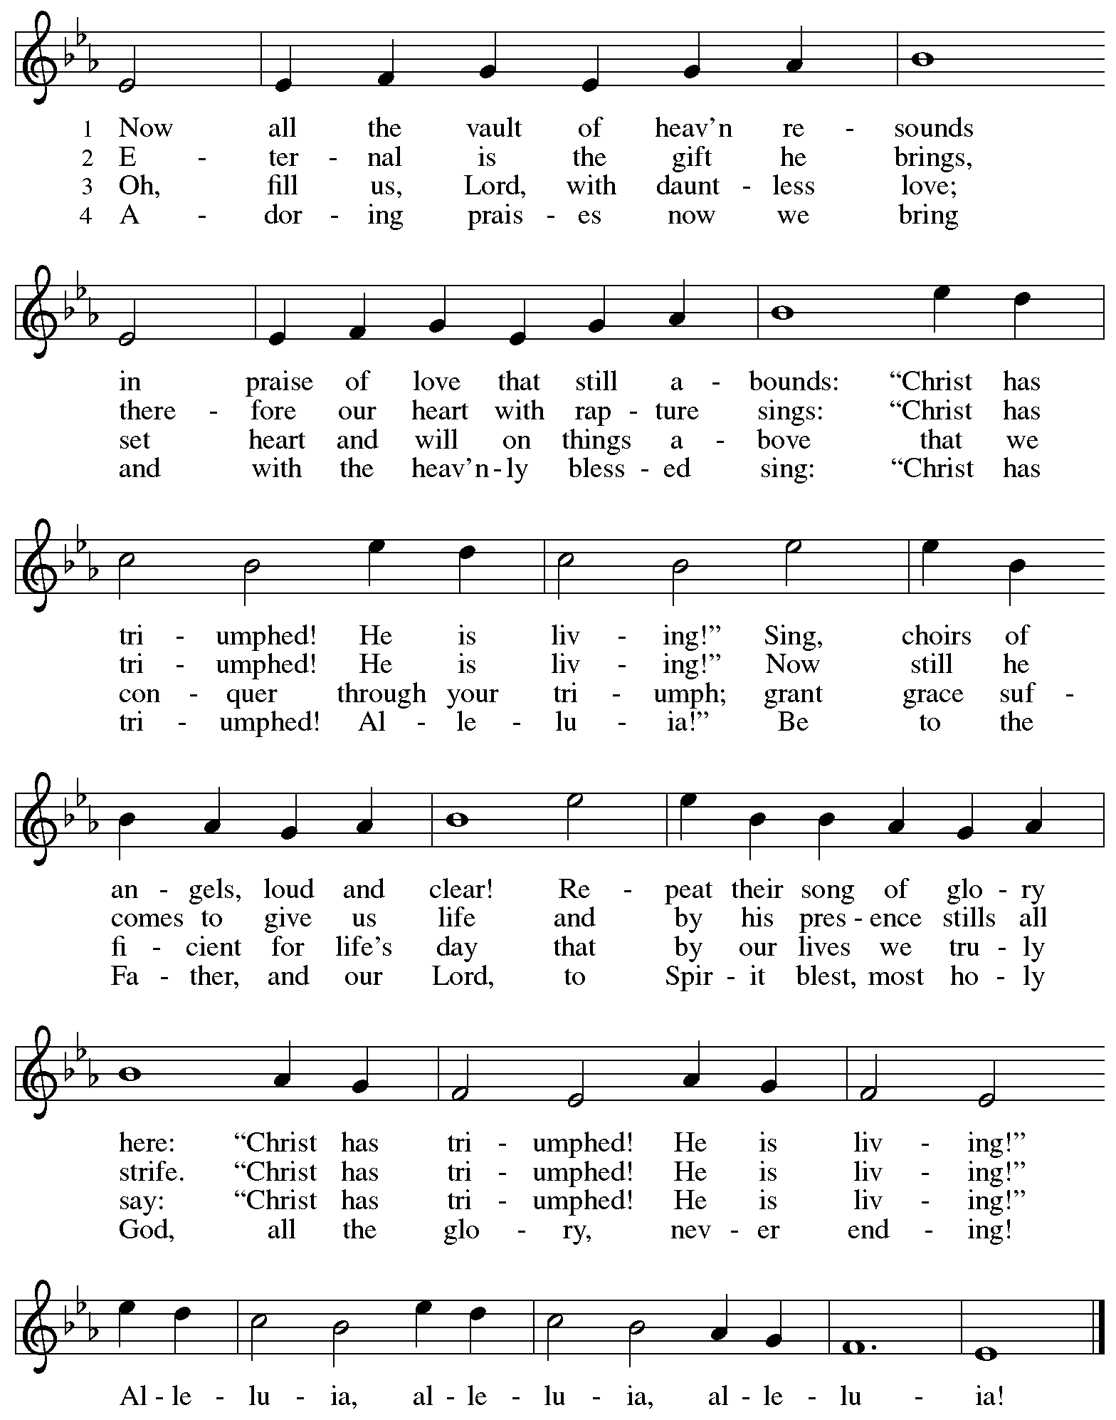

**Greeting**

P: The grace of our Lord Jesus Christ, the love of God,

and the communion of the Holy Spirit be with you all.

**C: And also with you.**

**Hymn of Praise** *This Is the Feast ELW* p. 149-150

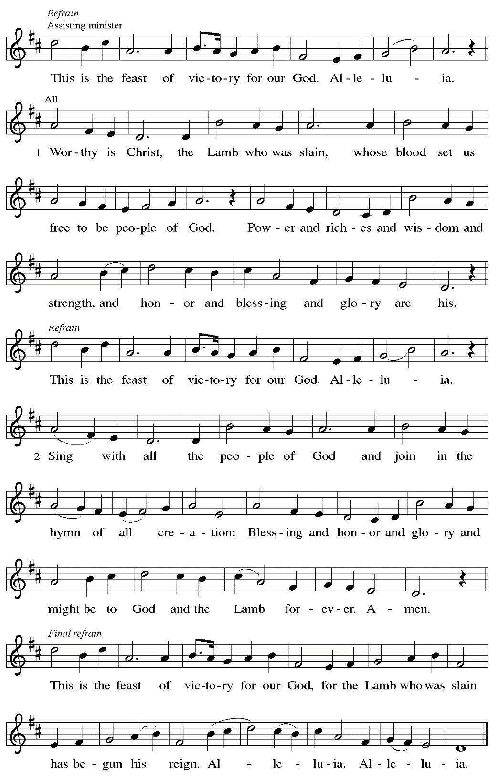

**Prayer of the Day**

P: The Lord be with you.

**C: And also with you.**

P: Let us pray.

Eternal and all-merciful God,

with all the angels and all the saints we laud your majesty and might.

By the resurrection of your Son, show yourself to us and inspire us to follow Jesus Christ,

our Savior and Lord, who lives and reigns with you and the Holy Spirit,

one God, now and forever.

**C: Amen.**

*Please be seated.*

**Word**

*God speaks to us in Scripture reading, preaching, and song*

**First Reading** **– Acts 9: 1-6 [7-20]**

1 Meanwhile Saul, still breathing threats and murder against the disciples of the Lord, went to the high priest 2 and asked him for letters to the synagogues at Damascus, so that if he found any who belonged to the Way, men or women, he might bring them bound to Jerusalem. 3 Now as he was going along and approaching Damascus, suddenly a light from heaven flashed around him.

4 He fell to the ground and heard a voice saying to him, “Saul, Saul, why do you persecute me?”

5 He asked, “Who are you, Lord?” The reply came, “I am Jesus, whom you are persecuting. 6 But get up and enter the city, and you will be told what you are to do.”

[7The men who were traveling with him stood speechless because they heard the voice but saw no one. 8 Saul got up from the ground, and though his eyes were open, he could see nothing; so they led him by the hand and brought him into Damascus. 9 For three days he was without sight and neither ate nor drank.  
  10 Now there was a disciple in Damascus named Ananias. The Lord said to him in a vision, “Ananias.” He answered, “Here I am, Lord.” 11 The Lord said to him, “Get up and go to the street called Straight, and at the house of Judas look for a man of Tarsus named Saul. At this moment he is praying, 12 and he has seen in a vision a man named Ananias come in and lay his hands on him so that he might regain his sight.” 13 But Ananias answered, “Lord, I have heard from many about this man, how much evil he has done to your saints in Jerusalem, 14 and here he has authority from the chief priests to bind all who invoke your name.” 15 But the Lord said to him, “Go, for he is an instrument whom I have chosen to bring my name before gentiles and kings and before the people of Israel; 16 I myself will show him how much he must suffer for the sake of my name.” 17 So Ananias went and entered the house. He laid his hands on Saul and said, “Brother Saul, the Lord Jesus, who appeared to you on your way here, has sent me so that you may regain your sight and be filled with the Holy Spirit.” 18 And immediately something like scales fell from his eyes, and his sight was restored. Then he got up and was baptized, 19 and after taking some food, he regained his strength.  
  
  For several days he was with the disciples in Damascus, 20 and immediately he began to proclaim Jesus in the synagogues, saying, “He is the Son of God.”]

L: Word of God, word of life.

**C: Thanks be to God.**

**Psalm 30**

*The psalm will be sung responsively, led by the cantor,*

*with the congregation responding with the bold verses and refrain.*

*Psalm tone*



*Psalm refrain*



1 I will exalt you, O Lord, because you have lift- **|** ed me up  
  and have not let my enemies triumph **|** over me.  
 2 **O Lord my God, I cried | out to you,**  
  **and you restored | me to health.**  
 3 You brought me up, O Lord, **|** from the dead;  
  you restored my life as I was going down **|** to the grave.  
 4 **Sing praise to the Lord, | all you faithful;**  
  **give thanks in ho- | ly remembrance. R**  
 5 God’s wrath is short; God’s favor **|** lasts a lifetime.  
  Weeping spends the night, but joy comes **|** in the morning.  
 6 **While I felt se- | cure, I said,**  
  **“I shall never | be disturbed.**  
 7 You, Lord, with your favor, made me as strong **|** as the mountains.”  
  Then you hid your face, and I was **|** filled with fear.  
 8 **I cried to | you, O Lord;**  
  **I pleaded with | my Lord, saying,**  
 9 “What profit is there in my blood, if I go down **|** to the pit?  
  Will the dust praise you or de- **|** clare your faithfulness?  
 10 **Hear, O Lord, and have mer- | cy upon me;**  
  **O Lord, | be my helper.” R**  
 11 You have turned my wailing **|** into dancing;  
  you have put off my sackcloth and clothed **|** me with joy.  
 12 **Therefore my heart sings to you | without ceasing;**  
  **O Lord my God, I will give you | thanks forever. R**

**Second Reading – Revelation 5: 11-14**

11 Then I looked, and I heard the voice of many angels surrounding the throne and the living creatures and the elders; they numbered myriads of myriads and thousands of thousands,

12 singing with full voice,  
 “Worthy is the Lamb that was slaughtered  
 to receive power and wealth and wisdom and might  
 and honor and glory and blessing!”  
13 Then I heard every creature in heaven and on earth and under the earth and in the sea and all that is in them, singing,  
 “To the one seated on the throne and to the Lamb  
 be blessing and honor and glory and might  
 forever and ever!”  
14 And the four living creatures said, “Amen!” And the elders fell down and worshiped.

L: Word of God, word of life.

**C: Thanks be to God.**

*Please rise as you are able.*

**Gospel Acclamation** *ELW* p. 151

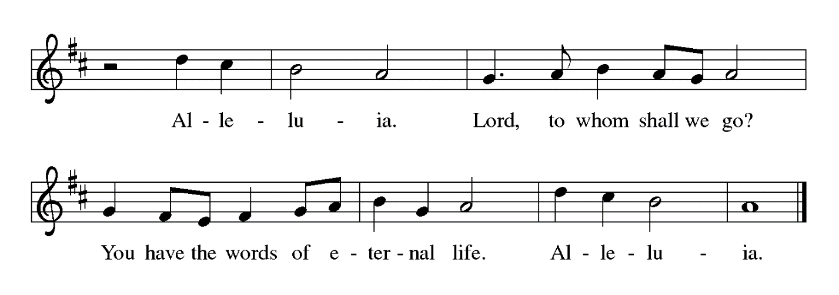

**Gospel – John 21: 1-19**

P: The holy Gospel according to St. John.

**C: Glory to you, O Lord.**

  1 After these things Jesus showed himself again to the disciples by the Sea of Tiberias, and he showed himself in this way. 2 Gathered there together were Simon Peter, Thomas called the Twin, Nathanael of Cana in Galilee, the sons of Zebedee, and two others of his disciples. 3 Simon Peter said to them, “I am going fishing.” They said to him, “We will go with you.” They went out and got into the boat, but that night they caught nothing.  
  4 Just after daybreak, Jesus stood on the beach, but the disciples did not know that it was Jesus. 5 Jesus said to them, “Children, you have no fish, have you?” They answered him, “No.” 6 He said to them, “Cast the net to the right side of the boat, and you will find some.” So they cast it, and now they were not able to haul it in because there were so many fish. 7 That disciple whom Jesus loved said to Peter, “It is the Lord!” When Simon Peter heard that it was the Lord, he put on his outer garment, for he had taken it off, and jumped into the sea. 8 But the other disciples came in the boat, dragging the net full of fish, for they were not far from the land, only about a hundred yards off.  
  9 When they had gone ashore, they saw a charcoal fire there, with fish on it, and bread. 10 Jesus said to them, “Bring some of the fish that you have just caught.” 11 So Simon Peter went aboard and hauled the net ashore, full of large fish, a hundred fifty-three of them, and though there were so many, the net was not torn. 12 Jesus said to them, “Come and have breakfast.” Now none of the disciples dared to ask him, “Who are you?” because they knew it was the Lord. 13 Jesus came and took the bread and gave it to them and did the same with the fish. 14 This was now the third time that Jesus appeared to the disciples after he was raised from the dead.  
  
  15 When they had finished breakfast, Jesus said to Simon Peter, “Simon son of John, do you love me more than these?” He said to him, “Yes, Lord; you know that I love you.” Jesus said to him, “Feed my lambs.” 16 A second time he said to him, “Simon son of John, do you love me?” He said to him, “Yes, Lord; you know that I love you.” Jesus said to him, “Tend my sheep.” 17 He said to him the third time, “Simon son of John, do you love me?” Peter felt hurt because he said to him the third time, “Do you love me?” And he said to him, “Lord, you know everything; you know that I love you.” Jesus said to him, “Feed my sheep. 18 Very truly, I tell you, when you were younger, you used to fasten your own belt and to go wherever you wished. But when you grow old, you will stretch out your hands, and someone else will fasten a belt around you and take you where you do not wish to go.” 19 (He said this to indicate the kind of death by which he would glorify God.) After this he said to him, “Follow me.”

P: The Gospel of the Lord.

**C: Praise to you, O Christ.**

*Please be seated.*

**Sermon**

*A time of silence for prayer and reflection follows the sermon.*

*When the hymn of the day begins, please rise as you are able.*

**Hymn of the Day The Church of Christ, in Every Age *ELW* 729**

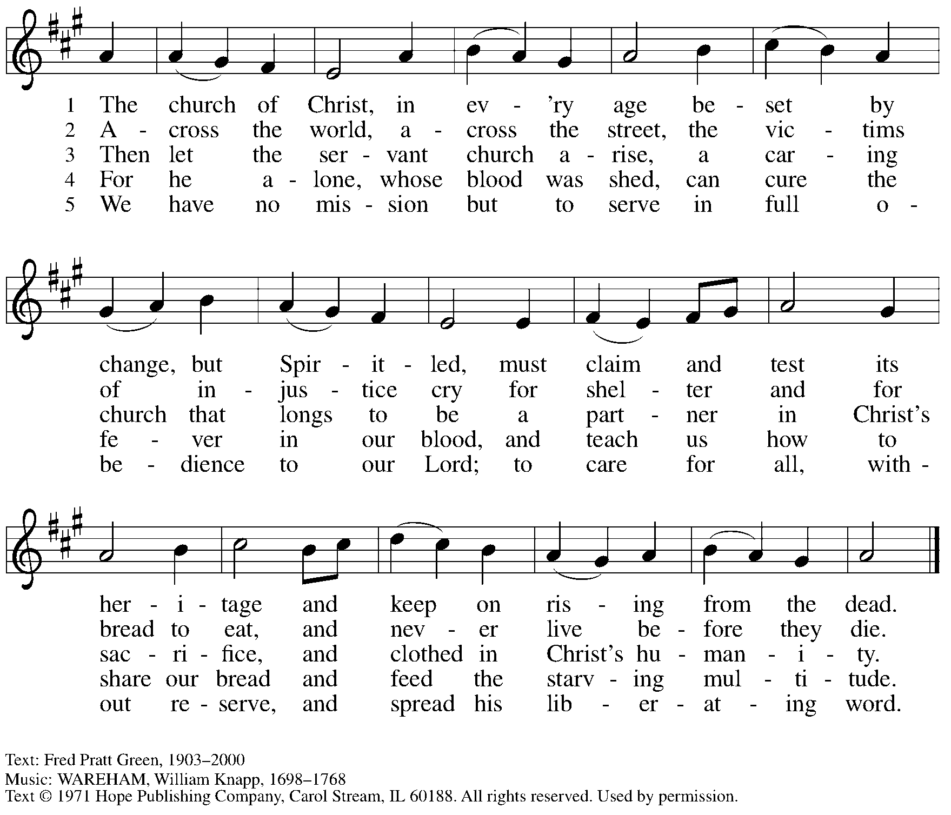

Reprinted under OneLicense.net # A-722139.

**Nicene Creed**

**C: We believe in one God,**

**the Father, the Almighty,**

**maker of heaven and earth,**

**of all that is, seen and unseen.**

**We believe in one Lord, Jesus Christ,**

**the only Son of God,**

**eternally begotten of the Father,**

**God from God, Light from Light,**

**true God from true God,**

**begotten, not made,**

**of one Being with the Father;**

**through him all things were made.**

**For us and for our salvation**

**he came down from heaven,**

**was incarnate of the Holy Spirit and the virgin Mary**

**and became truly human.**

**For our sake he was crucified under Pontius Pilate;**

**he suffered death and was buried.**

**On the third day he rose again**

**in accordance with the scriptures;**

**he ascended into heaven**

**and is seated at the right hand of the Father.**

**He will come again in glory to judge the living and the dead,**

**and his kingdom will have no end.**

**We believe in the Holy Spirit, the Lord, the giver of life,**

**who proceeds from the Father and the Son,\***

**who with the Father and the Son is worshiped and glorified,**

**who has spoken through the prophets.**

**We believe in one holy catholic and apostolic church.**

**We acknowledge one baptism for the forgiveness of sins.**

**We look for the resurrection of the dead,**

**and the life of the world to come. Amen.**

*Or, “who proceeds from the Father.” The phrase “and the Son” is a later addition to the creed.

**Prayers of the People**

A: United in the joy and hope of the resurrection, let us pray for the church, the world,

and all who are in need.

*After each petition*

A: Gracious God,

**C: receive our prayer.**

P: We lift these prayers to you O God, trusting in your abundant mercy,

through Jesus Christ our risen Savior.

**C: Amen.**

**Peace**

*The presiding minister and the assembly greet one another in the peace of the risen Christ.*

P: The peace of Christ be with you always.

**C: And also with you.**

*The people may greet those around them with a sign of Christ’s peace and may say*

Peace be with you *or similar words. Please be mindful that not everyone will be comfortable with sharing the peace, so please seek consent before shaking hands or hugging. Other possible ways to share the peace include a simple bow with the verbal greeting of peace, or simply a verbal expression of peace.*

*When the greetings of peace have concluded, please be seated.*

**Meal**

*God feeds us with the presence of Jesus Christ*

**Offering**

*We offer ourselves, our gifts, and our faithful service to God.*

*As the offering is gathered for the mission of the church, including the care of those in need,*

*the table is set for Holy Communion.*

*There are laminated giving cards in the pew racks that feature a QR code for anyone who would like to give online. Those who give using the QR code, as well as those who give regularly online or through their bank are encouraged to place the laminated card in the plate as an expression of your offering.*

**Reparations Offering**

*On the first Sunday of each month, St. Andrew invites people of the congregation to give a second offering for a reparations fund in acknowledgement of St. Andrew’s use of African American spiritual songs in our worship services. Please see the note in the announcements for more information.*

**Musical Offering**

*As the gifts are brought forward for presentation, please rise as you are able.*

**Offertory Song Let the Vineyards *ELW* 184**

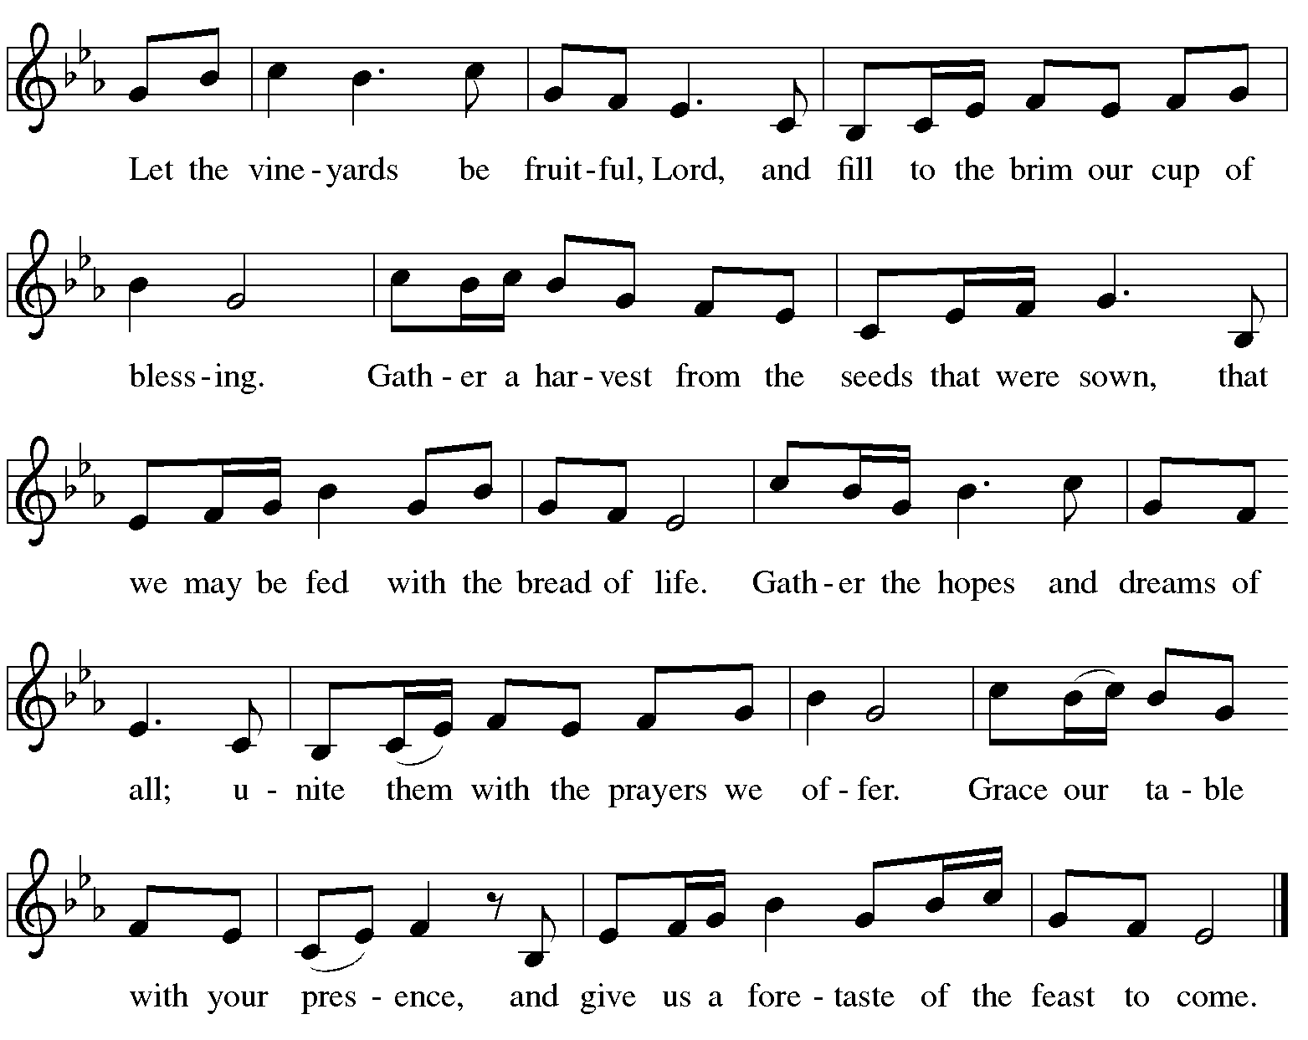

**Offertory Prayer**

A: Let us pray.

Blessed are you, O God,

**C: ruler of heaven and earth.**

**Day by day you shower us with blessings.**

**As you have raised us to new life in Christ,**

**give us glad and generous hearts,**

**ready to praise you and to respond to those in need,**

**through Jesus Christ, our Savior and Lord. Amen.**

**Dialogue** *ELW* p. 152

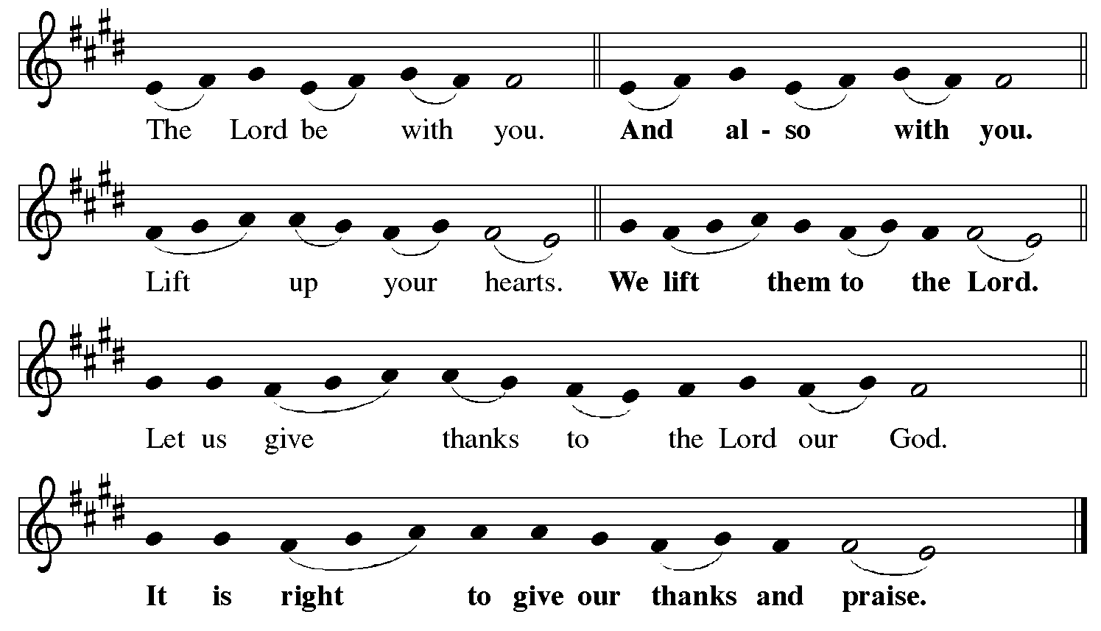

**Preface** *(Sung by the presiding minister)*

P: It is indeed right, our duty and our joy,

that we should at all times and in all places

give thanks and praise to you, almighty and merciful God,

for the glorious resurrection of our Savior Jesus Christ,

the true Paschal Lamb who gave himself to take away our sin;

who in dying has destroyed death,

and in rising has brought us to eternal life.

And so, with Mary Magdalene and Peter

and all the witnesses of the resurrection,

with earth and sea and all their creatures,

and with angels and archangels, cherubim and seraphim,

we praise your name and join their unending hymn:

**Sanctus** *ELW* p. 153

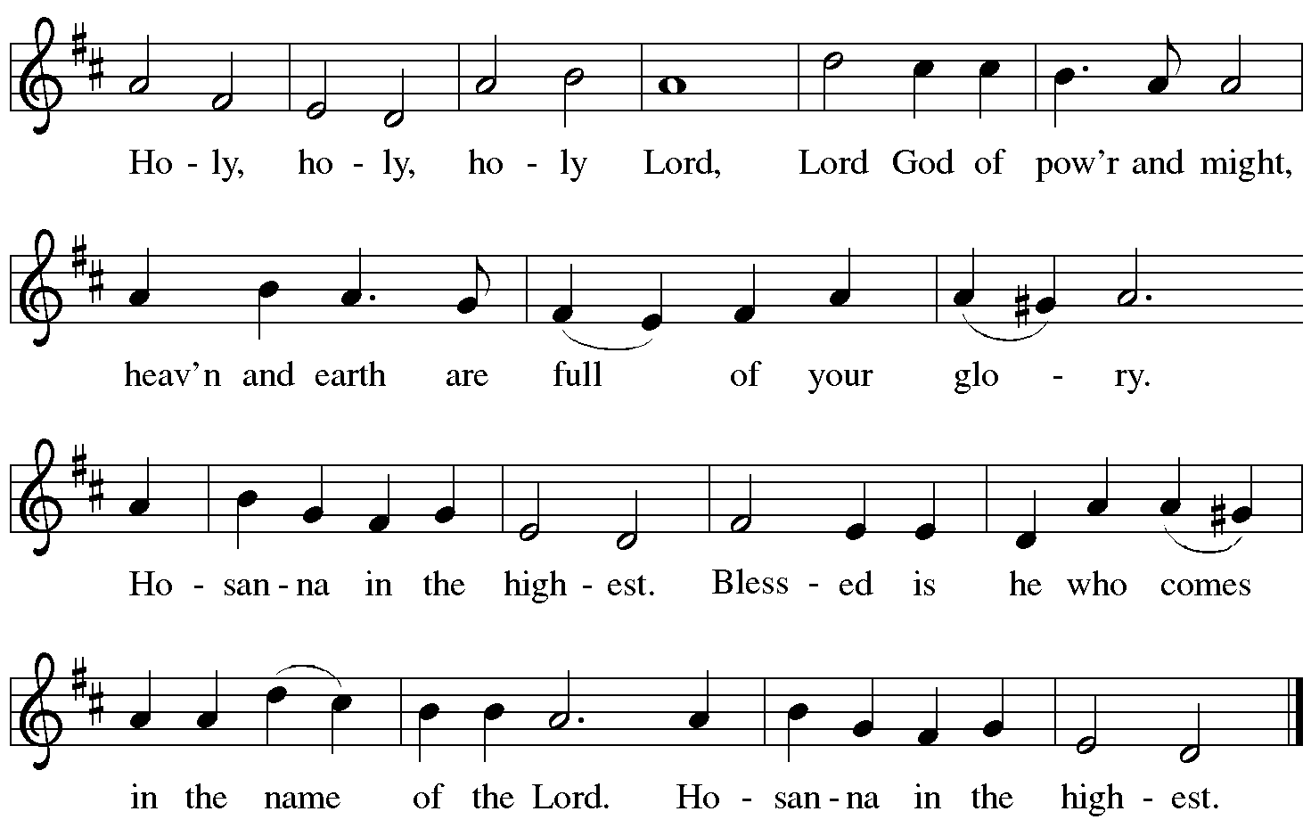

**Eucharistic Prayer**

P: Blessed are you, O God of the universe …

… Do this for the remembrance of me.

With this bread and cup

we proclaim our Lord’s passover from death to life

as we proclaim the mystery of faith:

**C: Christ has died.**

**Christ is risen.**

**Christ will come again.**

P: O God of resurrection and new life …

… Grace our table with your presence.

**C: Come, Holy Spirit.**

P: Reveal yourself to us in the breaking of the bread …

… Send us forth, burning with justice, peace, and love.

**C: Come, Holy Spirit.**

P: With your holy ones of all times and places …

… O God, blessed and holy Trinity,

now and forever.

**C: Amen.**

**Lord’s Prayer**

P: Gathered as one by the Holy Spirit, let us pray as Jesus taught us.

**C: Our Father, who art in heaven,**

**hallowed be thy name,**

**thy kingdom come,**

**thy will be done,**

**on earth as it is in heaven.**

**Give us this day our daily bread;**

**and forgive us our trespasses,**

**as we forgive those**

**who trespass against us;**

**and lead us not into temptation,**

**but deliver us from evil.**

**For thine is the kingdom,**

**and the power, and the glory,**

**forever and ever. Amen.**

**Fraction and Invitation**

P: Alleluia! Christ is risen!

**C: Christ is risen indeed! Alleluia! Alleluia!**

P: This is the feast of victory for our God. Alleluia! Alleluia!

Come, share the feast.



***Agnus Dei /* Lamb of God** *ELW* p. 154

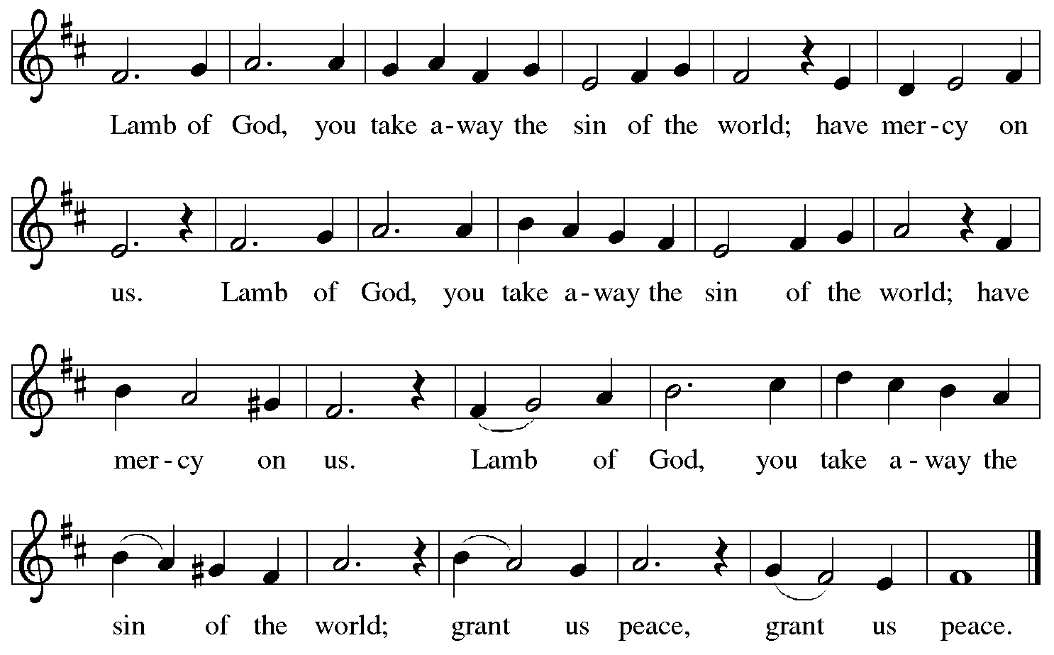

*Please be seated.*

**Holy Communion**

* *All who seek God and desire a deeper and stronger life in Christ are welcome to receive Holy Communion.*
* *Worshipers from the pulpit side will proceed forward first, followed by the center section, and then the lectern side.*
* *Please inform an usher if you would like the ministers to bring Communion to you.*
* *Holy Communion will be served with bread and wine (red) or grape juice (white).*
* *The presiding minister will first distribute the bread (host) to each communicant. Please indicate if you require a gluten-free host.*
* *Once you have consumed the bread, please pick up an empty glass from the tray next to the presiding minister. The Communion Assistant will pour wine from the chalice or grape juice from the cruet into your glass.*
* *Please step to the side to consume the wine or grape juice.*
* *Feel free to kneel at the altar rail for prayer after receiving the sacrament.*
* *As you return to your pew, glasses may be returned to the empty tray on the side of the center section.*
* *A blessing will be provided for anyone who does not yet receive the sacrament.*
* *All are invited to join in singing the hymns during Holy Communion.*

**Hymns during Holy Communion**

**We Who Once Were Dead *ELW* 495**

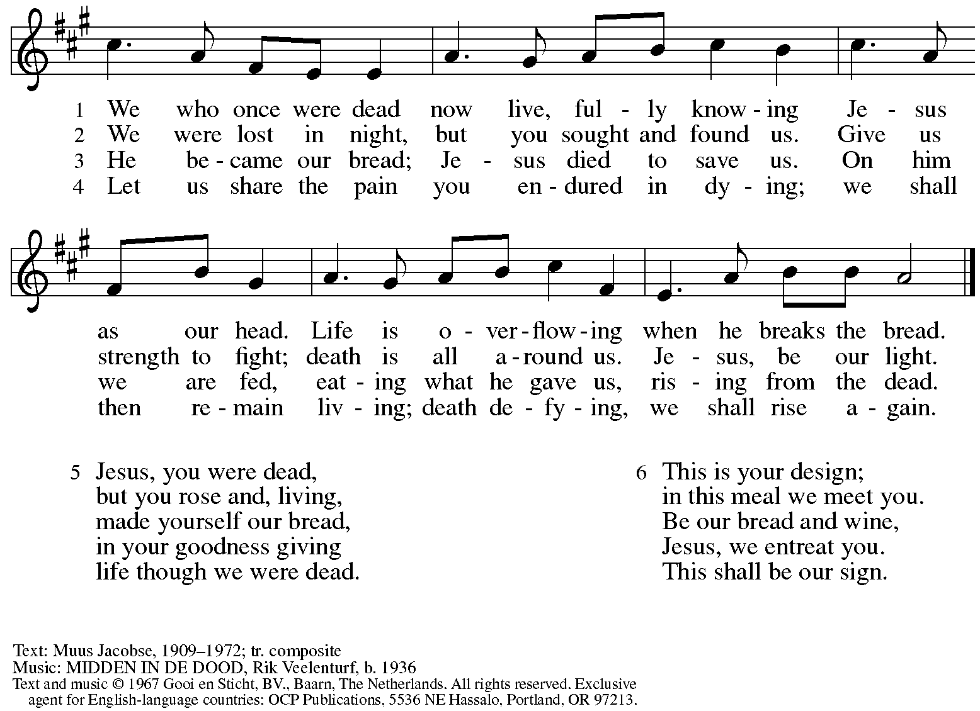

Reprinted with permission under OneLicense.net # A-722139.

**Hymns during Holy Communion**

**Bread of Life from Heaven *ELW* 474**

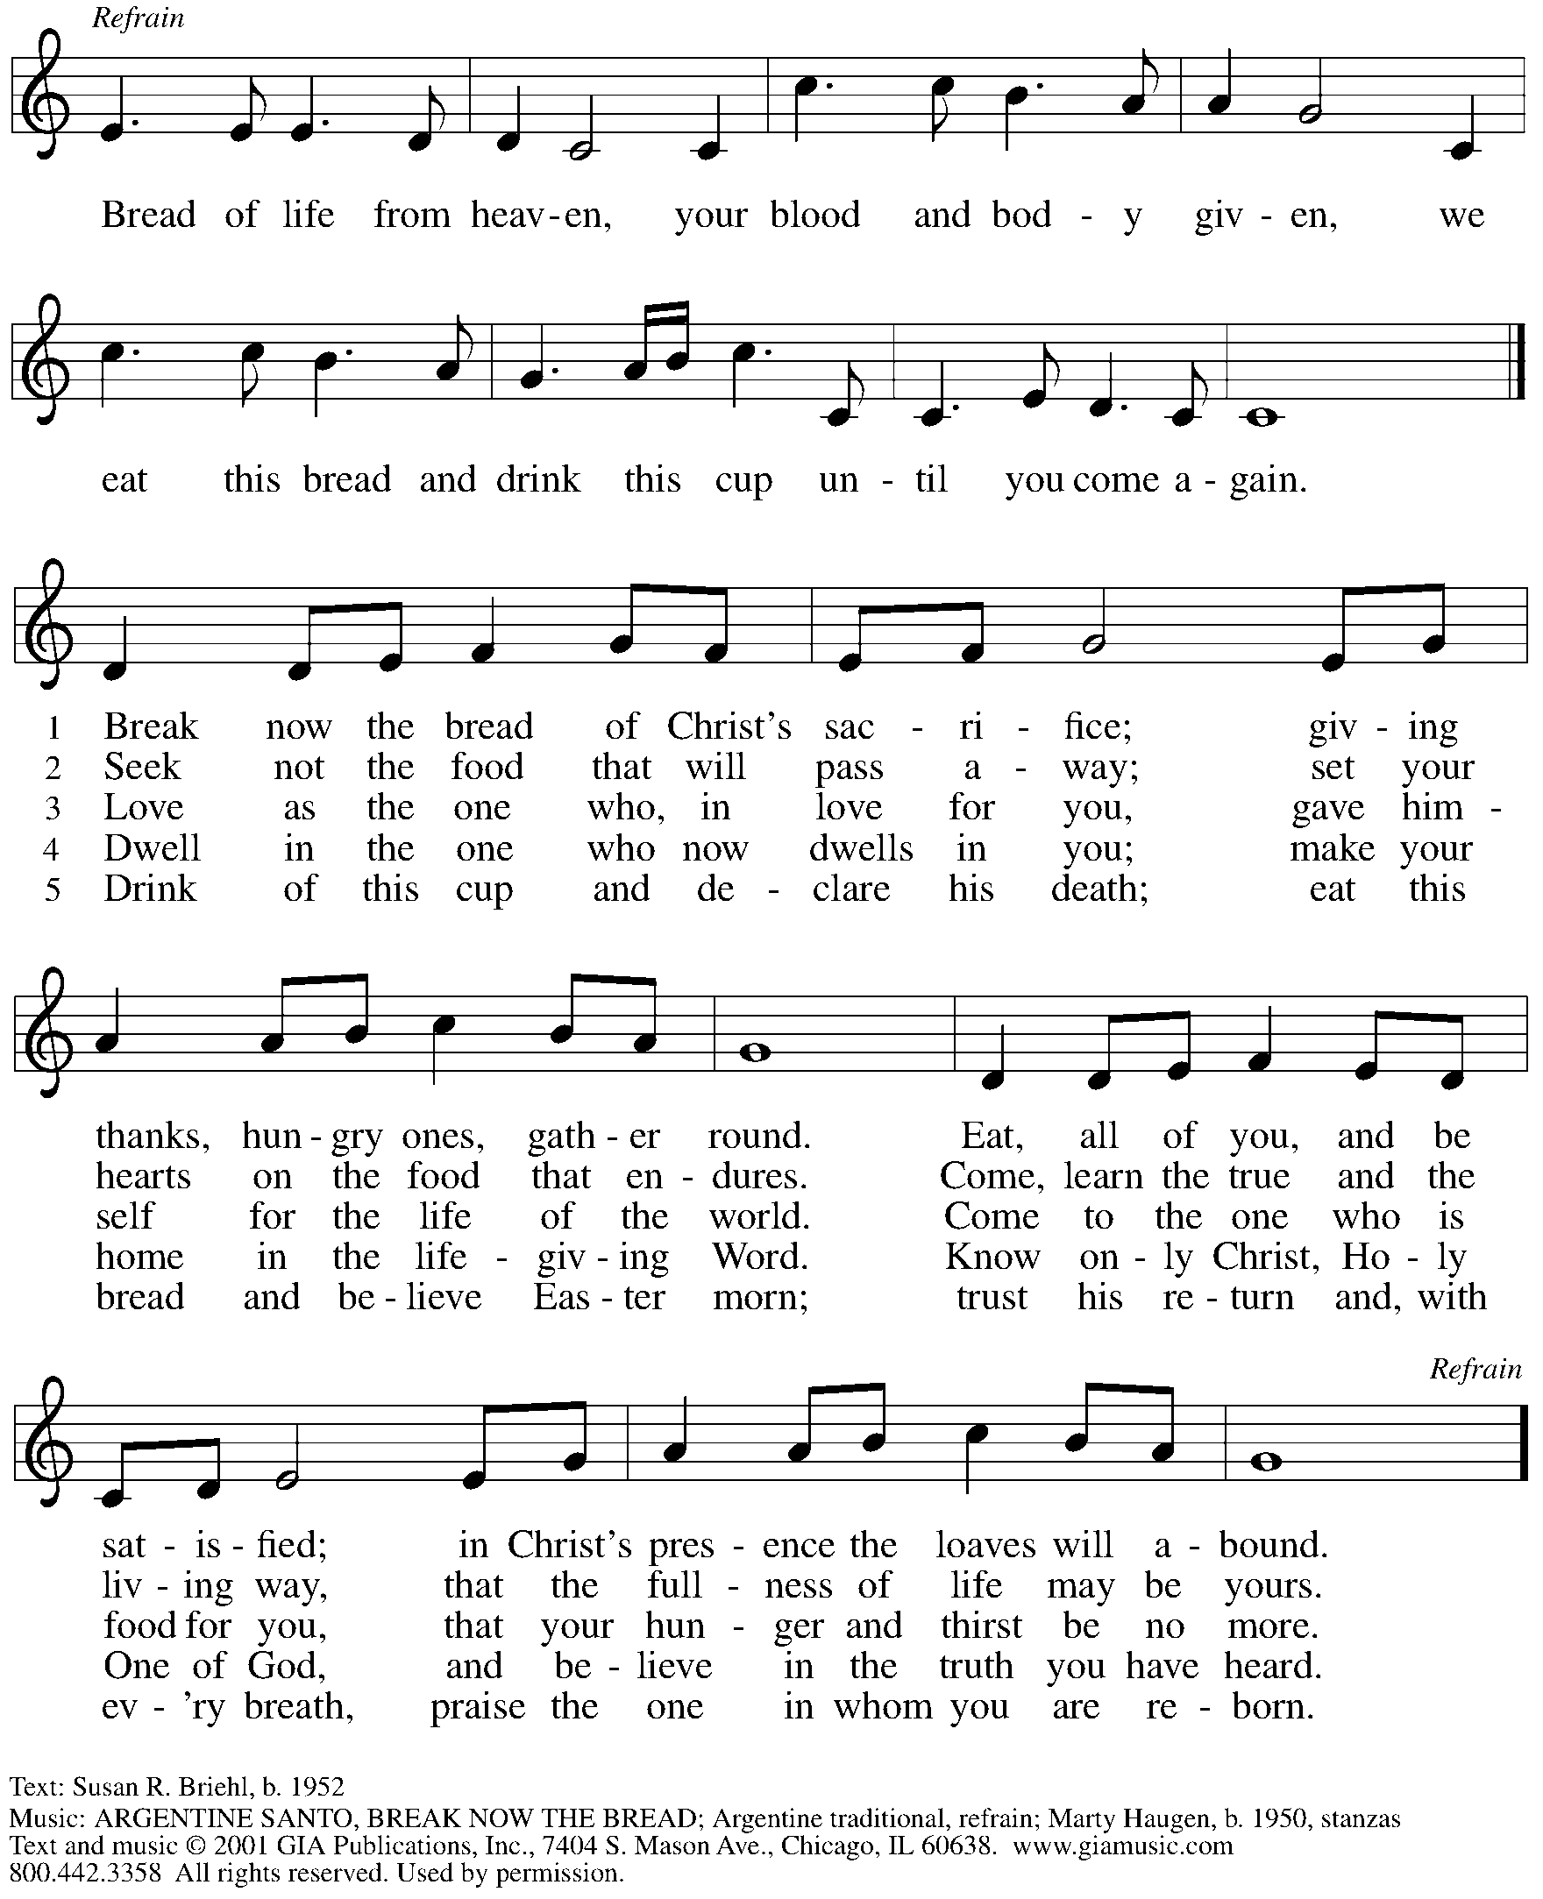

Reprinted under OneLicense.net # A-722139.

**Hymns during Holy Communion**

**Look Who Gathers at Christ’s Table**  ***ACS* 977**

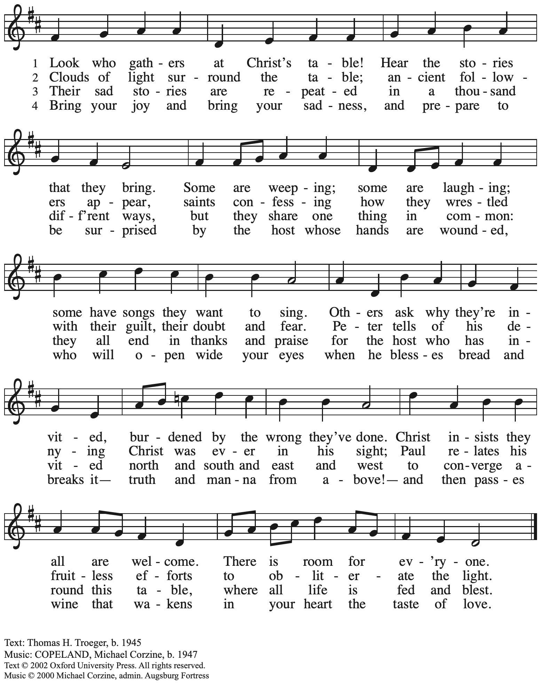

All rights reserved. Reprinted with permission under OneLicense.net # A-722139.

*When all have returned to their places, please rise as you are able.*

**Blessing**

P: The body and blood of our Lord Jesus Christ strengthen you and keep you in his grace.

**C: Amen.**

**Prayer**

A: Let us pray.

Life-giving God,

in the mystery of Christ’s resurrection, you send light to conquer darkness,

water to give new life, and the bread of life to nourish your people.

Send us forth as witnesses to your Son’s resurrection,

that we may show your glory to all the world,

through Jesus Christ, our risen Lord.

**C: Amen.**

**Sending**

*God blesses us and sends us in mission to the world*

**Benediction**

P: May our glorious God grant you a spirit of wisdom

to know and love the risen Christ.

Almighty God, holy One, ☩ holy Three,

bless you now and forever.

**C: Amen.**

**Sending Hymn** *Following page*

**Dismissal**

A: Alleluia! Christ is risen!

**C: Christ is risen indeed! Alleluia! Alleluia!**

A: Go in peace. Share the good news!

**C: Thanks be to God!**

**Postlude**

**Sending Hymn Day of Delight and Beauty Unbounded *ACS* 933**

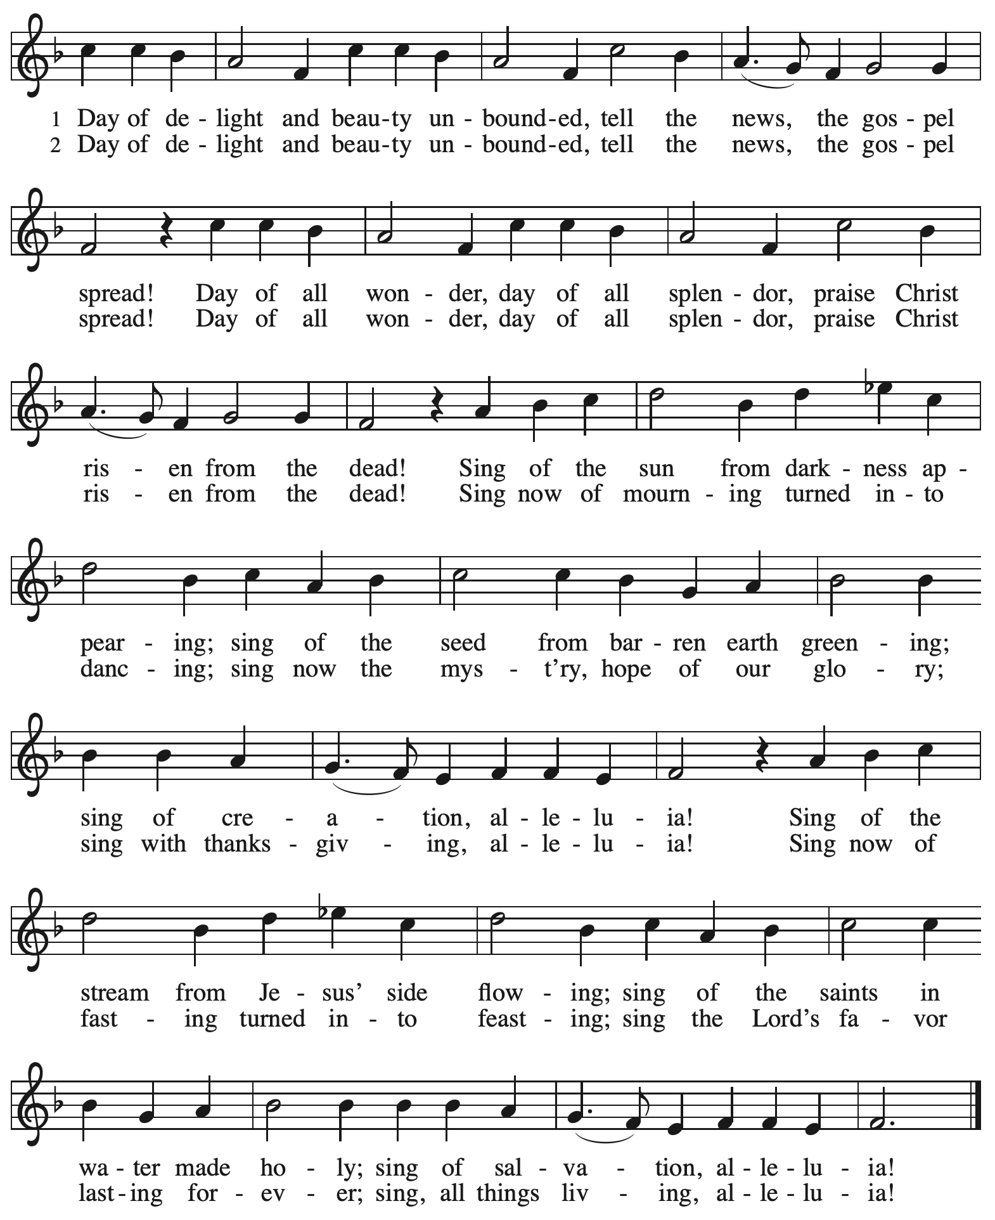

Reprinted with permission under OneLicense.net # A-722139.

*Those serving in worship today*

Altar Care Janet Grzegorczyk

Assisting Minister Jeff Denlinger

Audio-Visual Ministers Joseph Paetz

Sarita

Cantor Mandy Best

Lector Kelly Spanninger

Minister of Music Laura Reynolds

Presiding Minister The Rev. Ross I. Carmichael

*Liturgy and Hymnody Acknowledgements*

From SundaysandSeasons.com. Copyright © 2025 Augsburg Fortress. All rights reserved. Reprinted under OneLicense.net # A-722139.

Used by permission of Augsburg Fortress.

The Scripture readings contained herein are from *New Revised Standard Version Updated Edition* of the Bible © 2021 National Council of Churches of Christ in the United States of America. Used by permission. All rights reserved worldwide.

**Now All the Vault of Heaven Resounds** – Text: Paul Z. Strodach, 1876-1947, alt. Music: LASST UNS ERFREUEN, *Geistliche Kirchengesänge*, Köln, 1623. Text © 1958 *Service Book and Hymnal*, admin. Augsburg Fortress. All rights reserved. Reprinted with permission under OneLicense.net # A-722139.

*Please use the QR code below to link to St. Andrew’s Announcements online!*



**St. Andrew Lutheran Church Announcements**

**May 4th, 2025**

* **Happy Easter! Welcome to Worship at St. Andrew on the Third Sunday of Easter!** –We are so glad you are here to share in this festive season, and we offer a special welcome to all visitors and guests who are here for the first time! Little Church – Big Faith, a Bible lesson and activity for children, will not meet today. There are worship “toolkits” to help children engage with worship and “busy bags” for younger children available in the bookcase at the back of the sanctuary. Please feel free to take one to use with/for your children. A nursery is available through the door to the left of the worship space and across the social hall (look for a purple room). We pray that everyone has a blessed Easter season!
* **Monthly Reparations Offering Today during Worship – In Luke’s Gospel, Jesus tells** a story about a compassionate Samaritan that suggests God’s people are called to work for healing and restoration for our neighbors, regardless of who or what caused them harm. In light of this, St. Andrew has made a commitment to reparations in regard to African American spiritual songs used in our worship. The text and music of most hymns is attributed to specific authors, with copyrights in place, usage reported, and royalties paid to those whose works are featured in worship. With African American spirituals, this is not possible. In response to many years of such uncredited use, St. Andrew invites the congregation to give a reparations offering. Funds received in worship will be donated to our siblings at Bethel AME Church, whose land and building were taken from them in the 1950s, to fund their development in the Hill District.
* **Community Ministry Meeting – Monday, May 5th at 7:00 p.m. on Zoom** – St. **Andrew’s community ministry committee coordinates our local service ministries such as the outdoor Little Library, the pantry, produce distribution, shelter dinner, and various other activities. New participants are always welcome, and the next meeting is Monday, May 5th, at 7:00 p.m. on Zoom. Please contact** [PastorRCarmichael@gmail.com](mailto:PastorRCarmichael@gmail.com) **or** [community@standrewpittsburgh.org](mailto:community@standrewpittsburgh.org) **if you would like the link.**
* **May Produce Distribution – First Tuesday of the Month, May 6th, 5:30-7:00 p.m.** –

St. Andrew partners with Greater Pittsburgh Community Food Bank to serve as a distribution site for fresh produce on the first Tuesday of every month. This month’s distribution will be on Tuesday, May 6th. We invite people of the congregation to help with the distribution from 5:30-7:00 p.m. and/or to help with unloading and setup during the day between 10:00 a.m. and 1:00 p.m.

* **Congregation Council Meeting – Saturday, May 10th, 9:00 a.m.**
* **May Shelter Dinner for Guests of East End Cooperative Ministry – Third Thursday of the Month, May 15th, 6:30 p.m.** – Each month, people of St. Andrew provide dinner for guests of East End Cooperative Ministry (EECM), 6140 Station St. (East Liberty), 15206. We invite you to prepare or purchase one menu item and bring it to the shelter by 6:00 p.m., or just come to help serve at 6:30 p.m. If you would like to contribute, please sign up at

[**https://www.signupgenius.com/go/5080544AAAC22A1F58-56438583-mayshelter**](https://www.signupgenius.com/go/5080544AAAC22A1F58-56438583-mayshelter)**.**

* **St. Andrew Ministry Fair – Sunday, May 18th during Coffee Hour** – St. Andrew strives to make opportunities for ministry and service easily understandable and accessible to everyone in the community, but it is not always easy for someone new to get involved. The council is seeking to share information and make it easier for people to connect by holding a ministry fair after worship on Sunday, May 18th, during Coffee Hour. Council members that work with each ministry area will be available at various places in the social hall to share more about what that ministry team does and how people can get involved. The “committees” or ministry teams are Christian Education, Community ministry, Congregational ministry, Evangelism and Advocacy, Property, Stewardship, and Worship. We will feature brief information about each in the weeks around the 18th.
* **St. Andrew Ministry Area – Christian Education** – This ministry focuses on faith formation for people of all ages, including Little Church – Big Faith education and activities for the youngest children of the community, Confirmation classes, adult studies, both biblical and topical, and Bible Book Club. There are opportunities to help plan, teach, provide classroom assistance, or just to participate! The current council liaison to Christian Education is Ty Best, and he can be reached at [christian.education@standrewpittsburgh.org](mailto:christian.education@standrewpittsburgh.org). Please speak to Ty or watch for more information on May 18th if you are interested in learning more!
* ***Christ in Our Home* Devotional Booklets for April – June Available at Entrances** – This resource offers a daily Bible reading with a short reflection and prayer, along with additional readings and prayer topics for those who would like to expand their devotional practices. We encourage people of the congregation to take one for yourself, your family/household, or others!