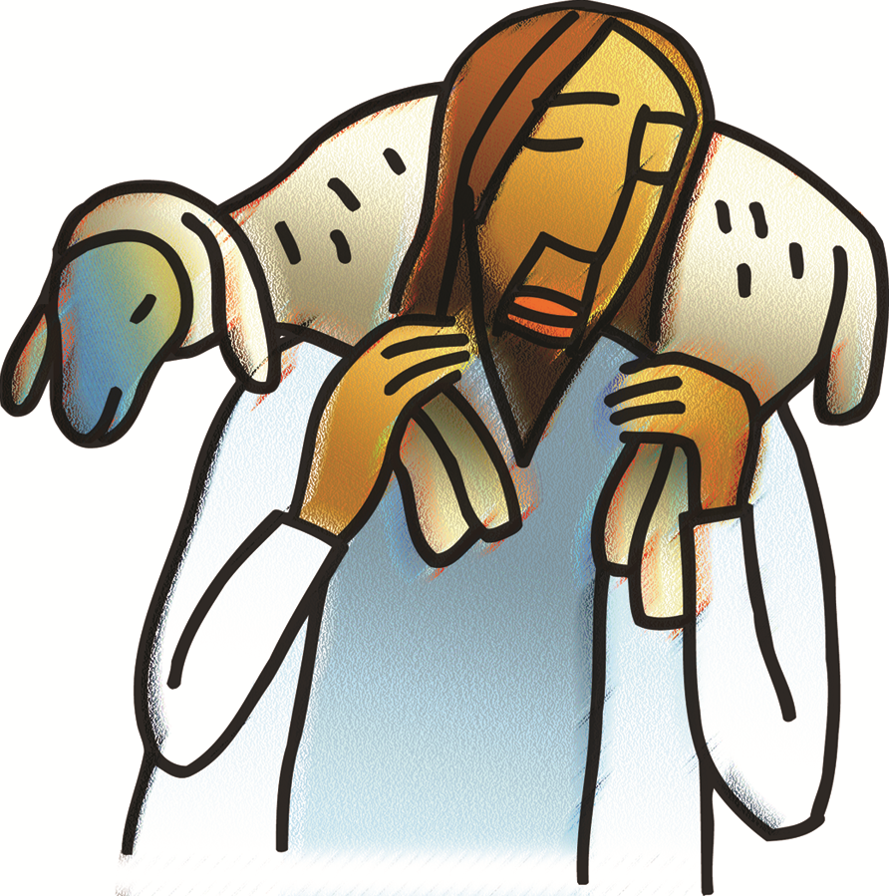

**+ Fourth Sunday of Easter**

**May 11, 2025**





**St. Andrew Lutheran Church**

**304 Morewood Ave.**

**Pittsburgh, PA 15213**

[**St_andrewELCA@verizon.net**](mailto:St_andrewELCA@verizon.net)

[**www.standrewpittsburgh.org**](http://www.standrewpittsburgh.org)

**+ Fourth Sunday of Easter**

**Order for Worship**

*The gift of new life, eternal life, is the gift of the risen Christ. It is the promise of Jesus.*

*It was true for Dorcas in Joppa. It was true for those “who have come out of the great ordeal”*

*in the Revelation vision. It is true for us and for all the baptized: Surely goodness and mercy shall follow me all the days of my life, and I will dwell in the house of the Lord forever.*

**Welcome to St. Andrew!**

* St. Andrew welcomes all who are seeking a place of healing, wholeness, and acceptance in a nurturing and faith-forming spiritual home. We are striving toward racial equity worldwide

and we seek to honor the lived experience of all individuals regardless of background. Our community embraces people of all ages, ethnicities, cultures, abilities, sexual orientations,

gender identities and expressions, and family constellations. Come and See!

* Worship Services are live-streamed to multiple online platforms. By attending worship, you agree that your image and voice may be broadcast.
* Everyone is invited to make a name tag at the black bookcase in the back of the worship space if they would like. There are stickers indicating pronouns on the bookcase if you would like to include them on your name tag.
* Children are invited to attend Little Church – Big Faith, a Bible lesson and activity, during worship (after the Prayer of the Day). The group returns to the worship space for the liturgy of Holy Communion.
* A nursery is available through the doors at the left side of the sanctuary and across from the doorway to the Social Hall. Look for a purple-colored room.
* Worship “toolkits” to help children engage with the service, along with “busy bags” for younger children, are available in the bookcase at the back of the sanctuary. Please feel free to take one to use with/for your children.
* Holy Communion is served with bread (gluten-free available) and wine or grape juice. The presiding minister will distribute the bread (host). Please consume this and then pick up an empty glass from the tray. The Communion Assistant will pour wine or grape juice into your glass. Please step to the side to consume the wine or grape juice. Feel free to kneel at the altar for prayer and reflection. As you return to your pew, glasses may be returned to the empty trays on either side of the center section.
* A restroom is available on the main level of the church, through the doors to the Social Hall and to the right in the main office.

*Abbreviations*

P: Pastor/Presiding Minister ***ELW*: *Evangelical Lutheran Worship* hymnal**

A: Assisting Minister ***ACS*: *All Creation Sings* hymnal**

L: Lector

**C: Congregation**

**Pre-Service Music** Timothy Kocher-Hillmer

**Welcome**

**Prelude** *The Lord’s My Shepherd, I’ll Not Want* Irvine/arr. Keveren

**Gathering**

*The Holy Spirit calls us together as the people of God*

*Please rise as you are able. All may make the sign of the cross, the sign marked at Baptism,*

*as the presiding minister begins.*

**Confession and Forgiveness**

P: Blessed be the holy Trinity, ☩ one God,

who forgives all our sin, whose mercy endures forever.

**C: Amen.**

P: God of all mercy and consolation, come to the help of your people,

turning us from our sin to live for you alone. Give us the power of your Holy Spirit,

that we may confess our sin, receive your forgiveness,

and grow into the fullness of Jesus Christ, our Savior and Lord.

**C: Amen.**

P: Let us confess our sin in the presence of God and of one another.

*Silence is kept for reflection.*

P: Most merciful God,

**we confess that we are captive to sin and cannot free ourselves.**

**We have sinned against you in thought, word, and deed,**

**by what we have done and by what we have left undone.**

**We have not loved you with our whole heart; we have not loved our neighbors as ourselves.**

**For the sake of your Son, Jesus Christ, have mercy on us.**

**Forgive us, renew us, and lead us, so that we may delight in your will**

**and follow in your ways, to the glory of your holy name.** A**men.**

P: God, who is rich in mercy, loved us even when we were dead in sin,

and made us alive together with Christ. By grace you have been saved.

In the name of ☩ Jesus Christ, your sins are forgiven.

Almighty God strengthen you with power through the Holy Spirit,

that Christ may live in your hearts through faith.

**C: Amen.**

**Gathering Hymn That Easter Day with Joy Was Bright *ELW* 384**

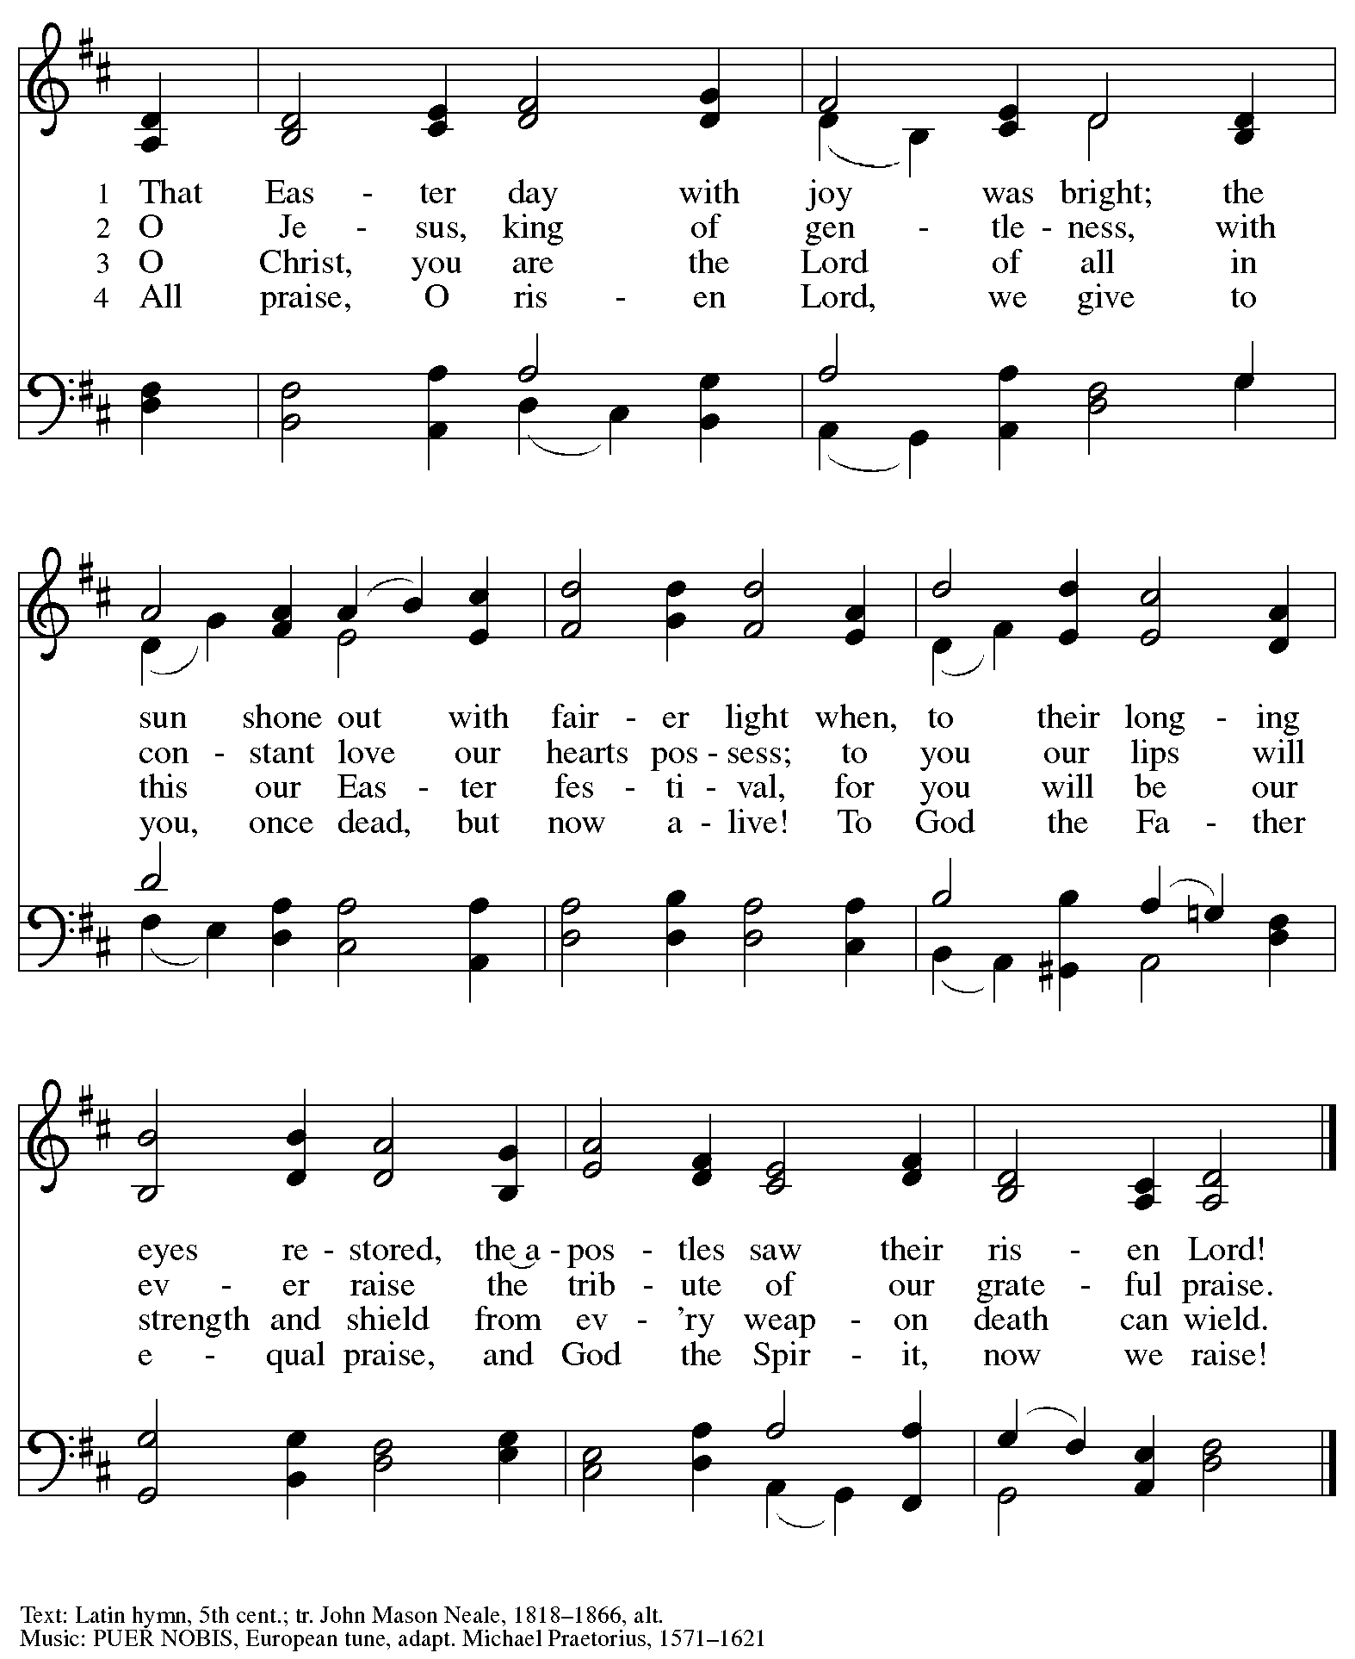

**Greeting**

P: The grace of our Lord Jesus Christ, the love of God,

and the communion of the Holy Spirit be with you all.

**C: And also with you.**

**Hymn of Praise** *This Is the Feast ELW* p. 149-150

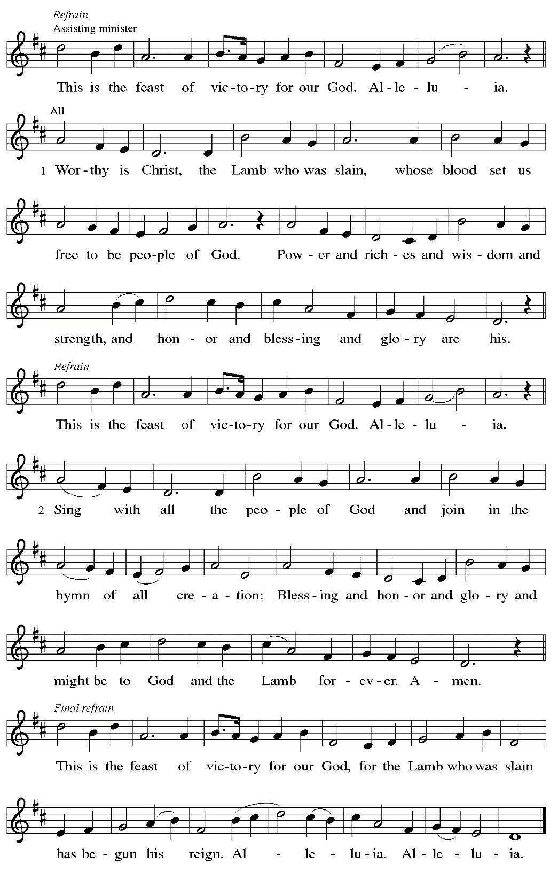

**Prayer of the Day**

P: The Lord be with you.

**C: And also with you.**

P: Let us pray.

O God of peace,

you brought again from the dead our Lord Jesus Christ, the great shepherd of the sheep.

By the blood of your eternal covenant, make us complete in everything good,

that we may do your will, and work among us all that is well-pleasing in your sight,

through Jesus Christ, our Savior and Lord, who lives and reigns with you and the Holy Spirit,

one God, now and forever.

**C: Amen.**

*Please be seated.*

*Children are invited to join the adult leader(s) at the side door for Little Church – Big Faith.*

*We ask that an additional adult from the congregation attend with the children.*

**Word**

*God speaks to us in Scripture reading, preaching, and song*

**First Reading** **–** **Acts 9: 36-43**

  36 Now in Joppa there was a disciple whose name was Tabitha, which in Greek is Dorcas. She was devoted to good works and acts of charity. 37 At that time she became ill and died. When they had washed her, they laid her in a room upstairs. 38 Since Lydda was near Joppa, the disciples, who heard that Peter was there, sent two men to him with the request, “Please come to us without delay.” 39 So Peter got up and went with them, and when he arrived, they took him to the room upstairs. All the widows stood beside him, weeping and showing tunics and other clothing that Dorcas had made while she was with them. 40 Peter put all of them outside, and then he knelt down and prayed. He turned to the body and said, “Tabitha, get up.” Then she opened her eyes, and seeing Peter, she sat up. 41 He gave her his hand and helped her up. Then calling the saints and widows, he showed her to be alive. 42 This became known throughout Joppa, and many believed in the Lord. 43 Meanwhile, he stayed in Joppa for some time with a certain Simon, a tanner.

L: Word of God, word of life.

**C: Thanks be to God.**

**Psalm 23**

*The psalm will be sung responsively, led by the cantor,*

*with the congregation responding with the bold verses and refrain.*

*Psalm tone*

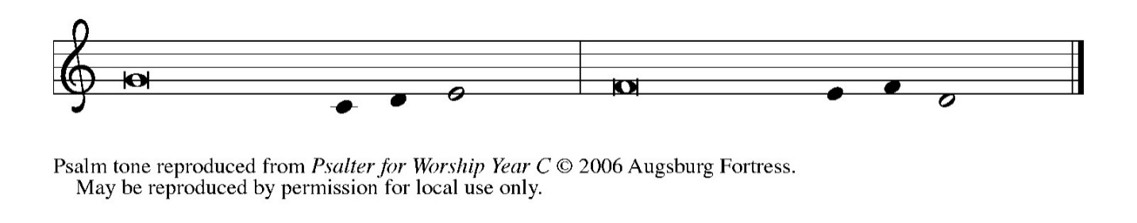

*Psalm refrain*

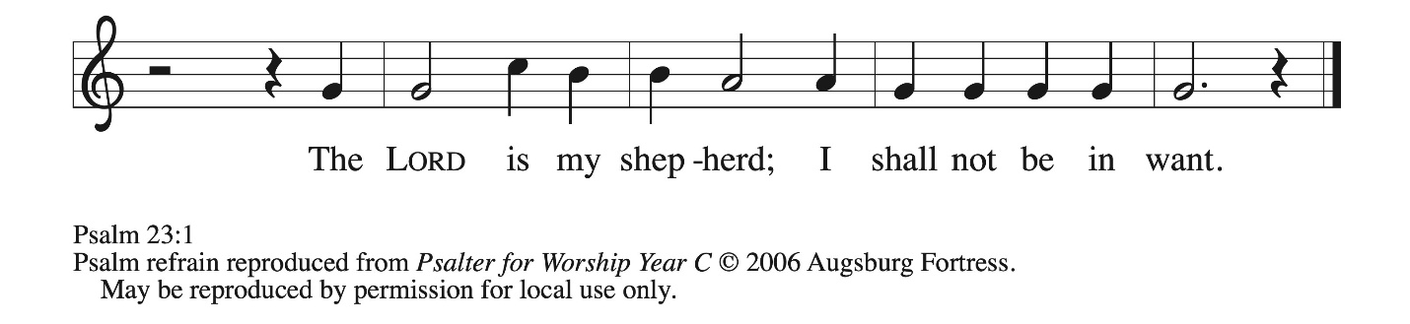

1 The Lord **|** is my shepherd;  
  I shall not **|** be in want.  
 2 **The Lord makes me lie down | in green pastures**  
  **and leads me be- | side still waters.**  
 3 You restore my **|** soul, O Lord,  
  and guide me along right pathways **|** for your name’s sake.  
 4 **Though I walk through the valley of the shadow of death, I shall | fear no evil;**  
  **for you are with me; your rod and your staff, they | comfort me. R**  
 5 You prepare a table before me in the presence **|** of my enemies;  
  you anoint my head with oil, and my cup is **|** running over.  
 6 **Surely goodness and mercy shall follow me all the days | of my life,**  
  **and I will dwell in the house of the | Lord forever. R**

**Second Reading – Revelation 7: 9-17**

9 After this I looked, and there was a great multitude that no one could count, from every nation, from all tribes and peoples and languages, standing before the throne and before the Lamb, robed in white, with palm branches in their hands. 10 They cried out in a loud voice, saying,  
 “Salvation belongs to our God who is seated on the throne and to the Lamb!”  
11 And all the angels stood around the throne and around the elders and the four living creatures, and they fell on their faces before the throne and worshiped God, 12 singing,

 “Amen! Blessing and glory and wisdom  
 and thanksgiving and honor  
 and power and might  
 be to our God forever and ever! Amen.”  
  13 Then one of the elders addressed me, saying, “Who are these, robed in white, and where have they come from?” 14 I said to him, “Sir, you are the one who knows.” Then he said to me, “These are they who have come out of the great ordeal; they have washed their robes and made them white in the blood of the Lamb.  
 15 For this reason they are before the throne of God  
  and worship God day and night within God’s temple,  
  and the one who is seated on the throne will shelter them.  
 16 They will hunger no more and thirst no more;  
  the sun will not strike them,  
  nor any scorching heat,  
 17 for the Lamb at the center of the throne will be their shepherd,  
  and he will guide them to springs of the water of life,  
 and God will wipe away every tear from their eyes.”

L: Word of God, word of life.

**C: Thanks be to God.**

*Please rise as you are able.*

**Gospel Acclamation** *ELW* p. 151

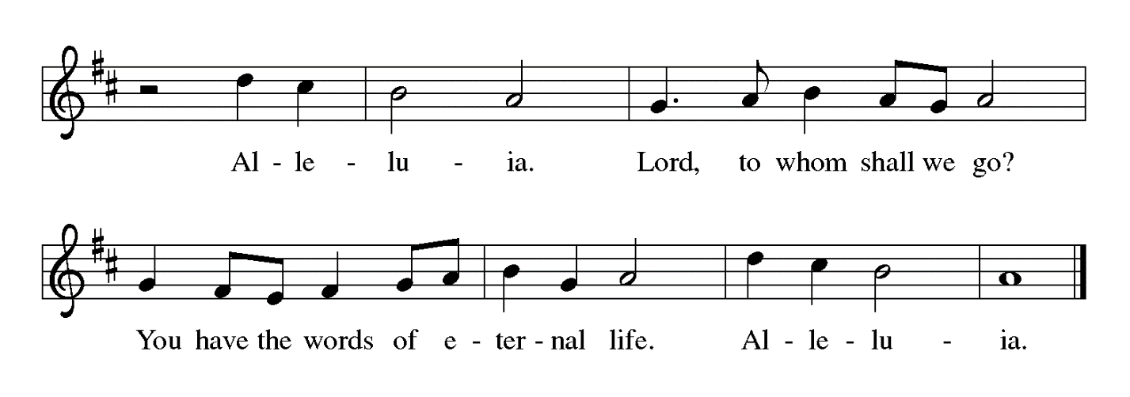

**Gospel – John 10: 22-30**

P: The holy Gospel according to St. John.

**C: Glory to you, O Lord.**

  22 At that time the Festival of the Dedication took place in Jerusalem. It was winter, 23 and Jesus was walking in the temple, in the portico of Solomon. 24 So the Jews gathered around him and said to him, “How long will you keep us in suspense? If you are the Messiah, tell us plainly.” 25 Jesus answered, “I have told you, and you do not believe. The works that I do in my Father’s name testify to me, 26 but you do not believe because you do not belong to my sheep.

27 My sheep hear my voice. I know them, and they follow me. 28 I give them eternal life, and they will never perish. No one will snatch them out of my hand. 29 My Father, in regard to what he has given me, is greater than all, and no one can snatch them out of the Father’s hand. 30 The Father and I are one.”

P: The Gospel of the Lord.

**C: Praise to you, O Christ.**

*Please be seated.*

**Sermon**

*A time of silence for prayer and reflection follows the sermon.*

*When the hymn of the day begins, please rise as you are able.*

**Hymn of the Day** *Following page*

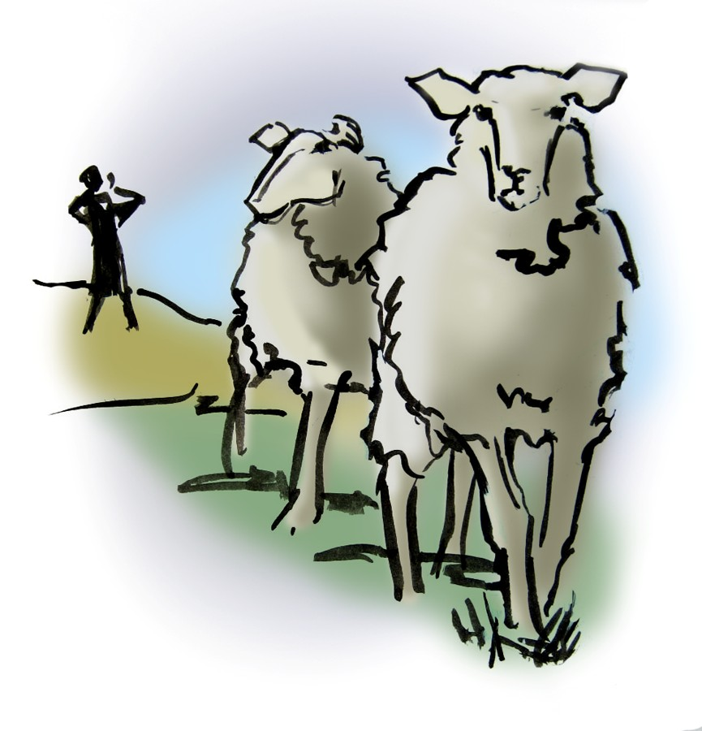

**Hymn of the Day Savior, Like a Shepherd Lead Us *ELW* 789**

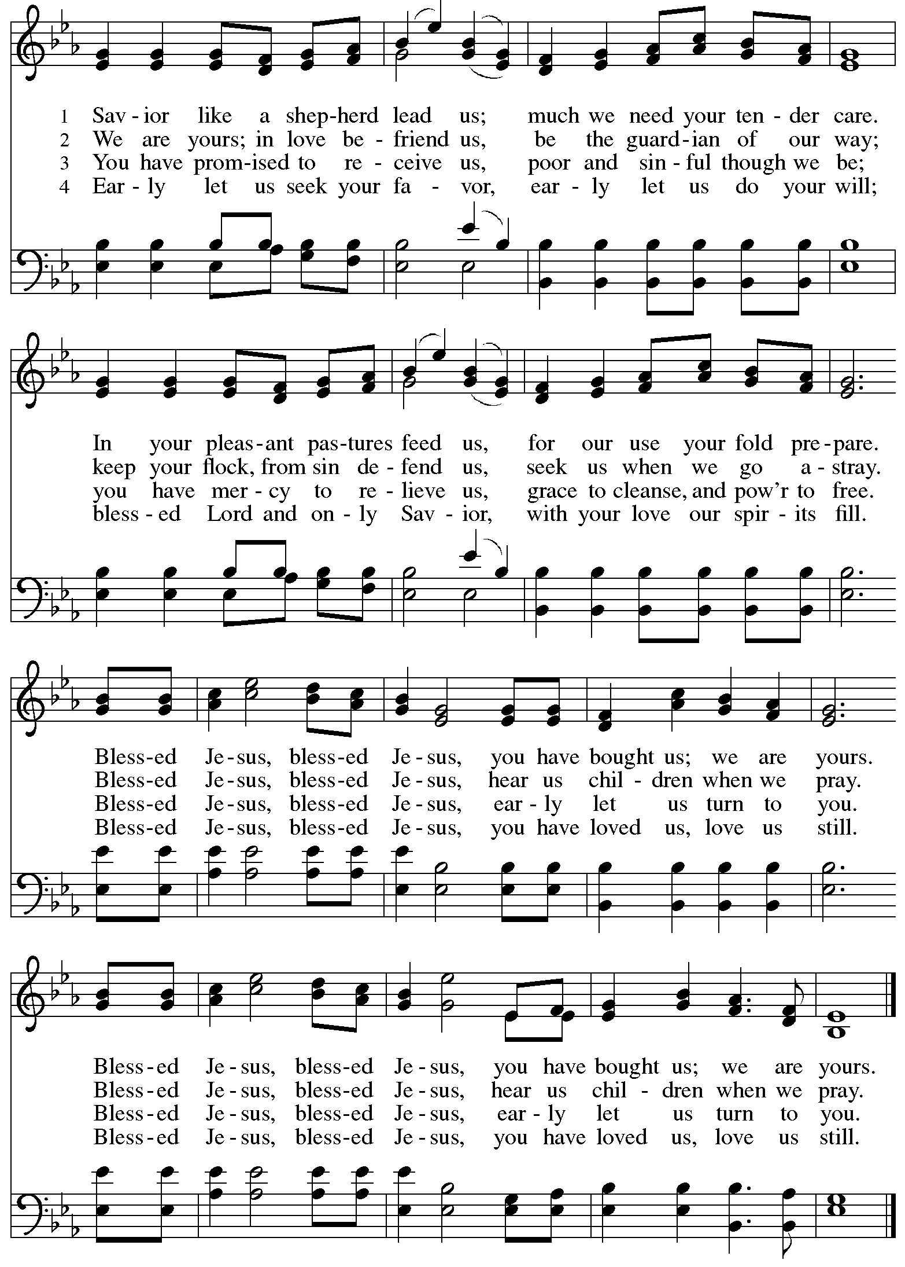

**Nicene Creed**

**C: We believe in one God,**

**the Father, the Almighty,**

**maker of heaven and earth,**

**of all that is, seen and unseen.**

**We believe in one Lord, Jesus Christ,**

**the only Son of God,**

**eternally begotten of the Father,**

**God from God, Light from Light,**

**true God from true God,**

**begotten, not made,**

**of one Being with the Father;**

**through him all things were made.**

**For us and for our salvation**

**he came down from heaven,**

**was incarnate of the Holy Spirit and the virgin Mary**

**and became truly human.**

**For our sake he was crucified under Pontius Pilate;**

**he suffered death and was buried.**

**On the third day he rose again**

**in accordance with the scriptures;**

**he ascended into heaven**

**and is seated at the right hand of the Father.**

**He will come again in glory to judge the living and the dead,**

**and his kingdom will have no end.**

**We believe in the Holy Spirit, the Lord, the giver of life,**

**who proceeds from the Father and the Son,\***

**who with the Father and the Son is worshiped and glorified,**

**who has spoken through the prophets.**

**We believe in one holy catholic and apostolic church.**

**We acknowledge one baptism for the forgiveness of sins.**

**We look for the resurrection of the dead,**

**and the life of the world to come. Amen.**

*Or, “who proceeds from the Father.” The phrase “and the Son” is a later addition to the creed.

**Prayers of the People**

A: United in the joy and hope of the resurrection, let us pray for the church, the world,

and all who are in need.

*After each petition*

A: Gracious God,

**C: receive our prayer.**

P: We lift these prayers to you O God, trusting in your abundant mercy,

through Jesus Christ our risen Savior.

**C: Amen.**

**Peace**

*The presiding minister and the assembly greet one another in the peace of the risen Christ.*

P: The peace of Christ be with you always.

**C: And also with you.**

*The people may greet those around them with a sign of Christ’s peace and may say*

Peace be with you *or similar words. Please be mindful that not everyone will be comfortable with sharing the peace, so please seek consent before shaking hands or hugging. Other possible ways to share the peace include a simple bow with the verbal greeting of peace, or simply a verbal expression of peace.*

*When the greetings of peace have concluded, please be seated.*

**Meal**

*God feeds us with the presence of Jesus Christ*

**Offering**

*We offer ourselves, our gifts, and our faithful service to God.*

*As the offering is gathered for the mission of the church, including the care of those in need,*

*the table is set for Holy Communion.*

*There are laminated giving cards in the pew racks that feature a QR code for anyone who would like to give online. Those who give using the QR code, as well as those who give regularly online or through their bank are encouraged to place the laminated card in the plate as an expression of your offering.*

**Musical Offering** *It Is Enough* Mendelssohn/arr. Castleton

*As the gifts are brought forward for presentation, please rise as you are able.*

**Offertory Song Let the Vineyards *ELW* 184**

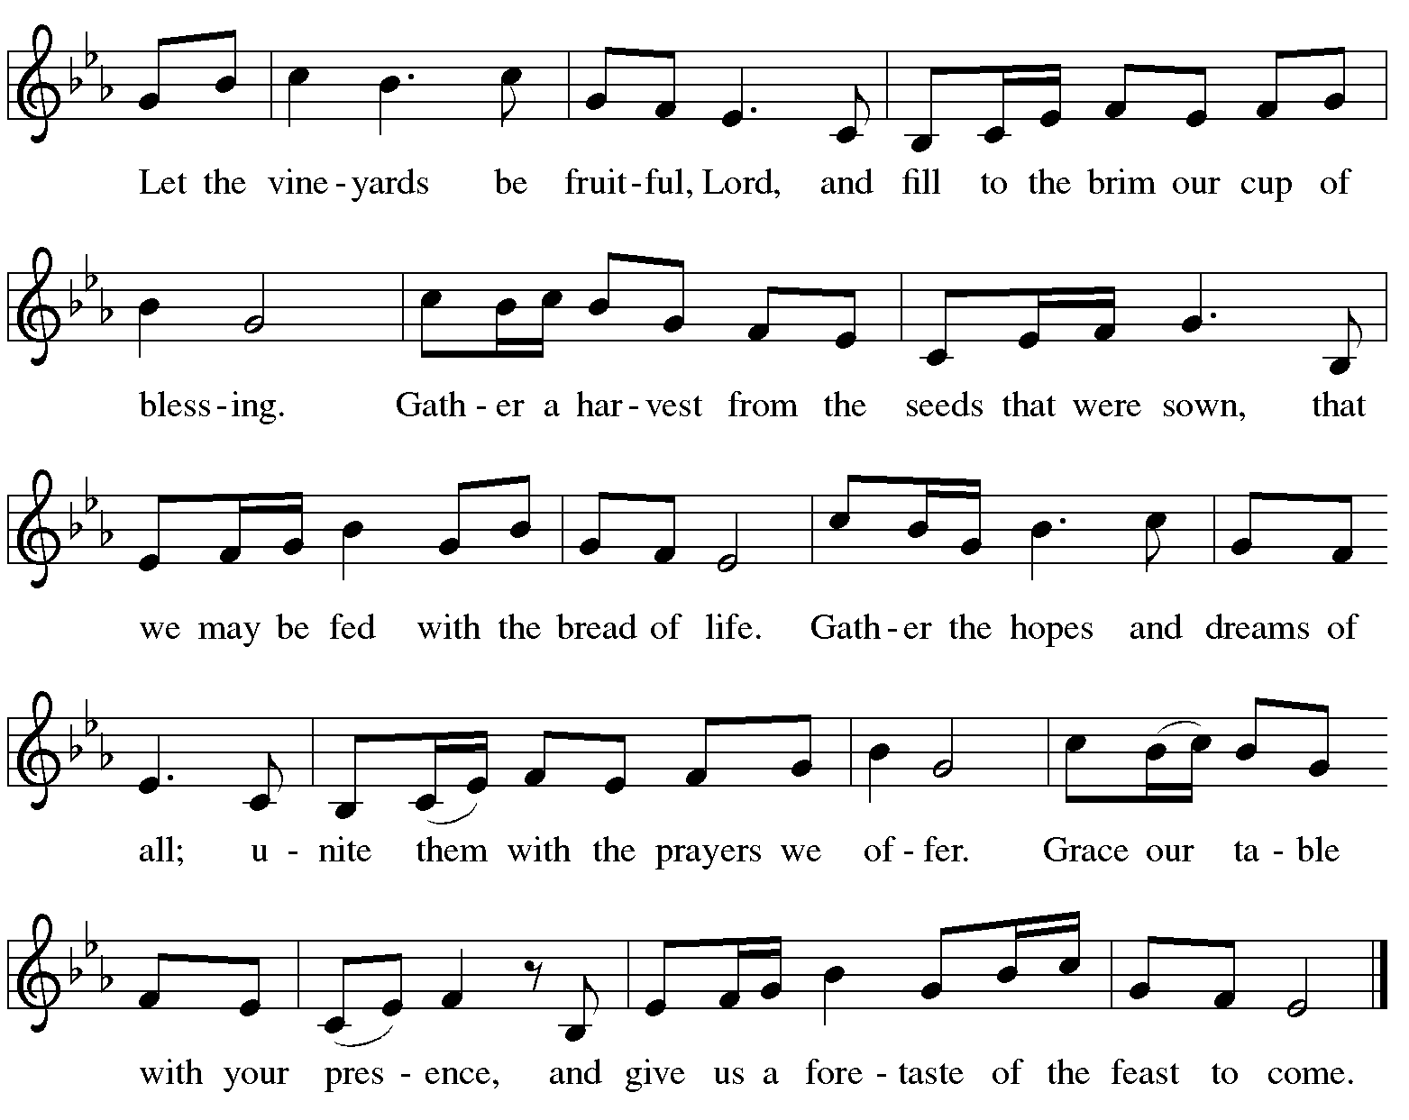

**Offertory Prayer**

A: Let us pray.

Blessed are you, O God,

**C: ruler of heaven and earth.**

**Day by day you shower us with blessings.**

**As you have raised us to new life in Christ,**

**give us glad and generous hearts,**

**ready to praise you and to respond to those in need,**

**through Jesus Christ, our Savior and Lord.**

**Amen.**

**Dialogue** *ELW* p. 152

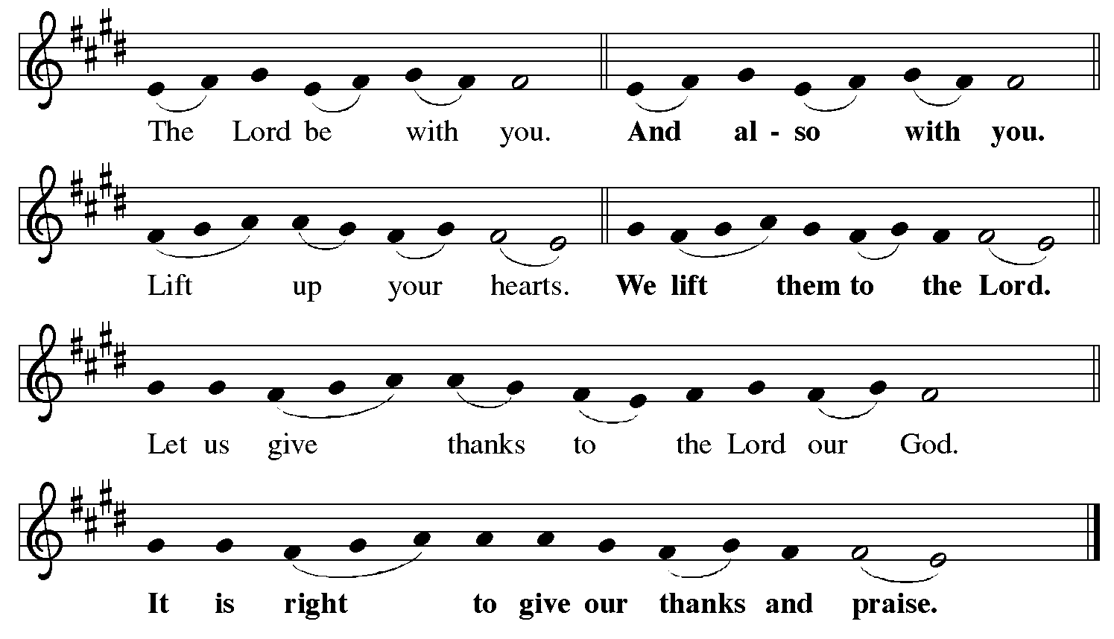

**Preface** *(Sung by the presiding minister)*

P: It is indeed right, our duty and our joy,

that we should at all times and in all places

give thanks and praise to you, almighty and merciful God,

for the glorious resurrection of our Savior Jesus Christ,

the true Paschal Lamb who gave himself to take away our sin;

who in dying has destroyed death,

and in rising has brought us to eternal life.

And so, with Mary Magdalene and Peter

and all the witnesses of the resurrection,

with earth and sea and all their creatures,

and with angels and archangels, cherubim and seraphim,

we praise your name and join their unending hymn:

**Sanctus** *ELW* p. 153

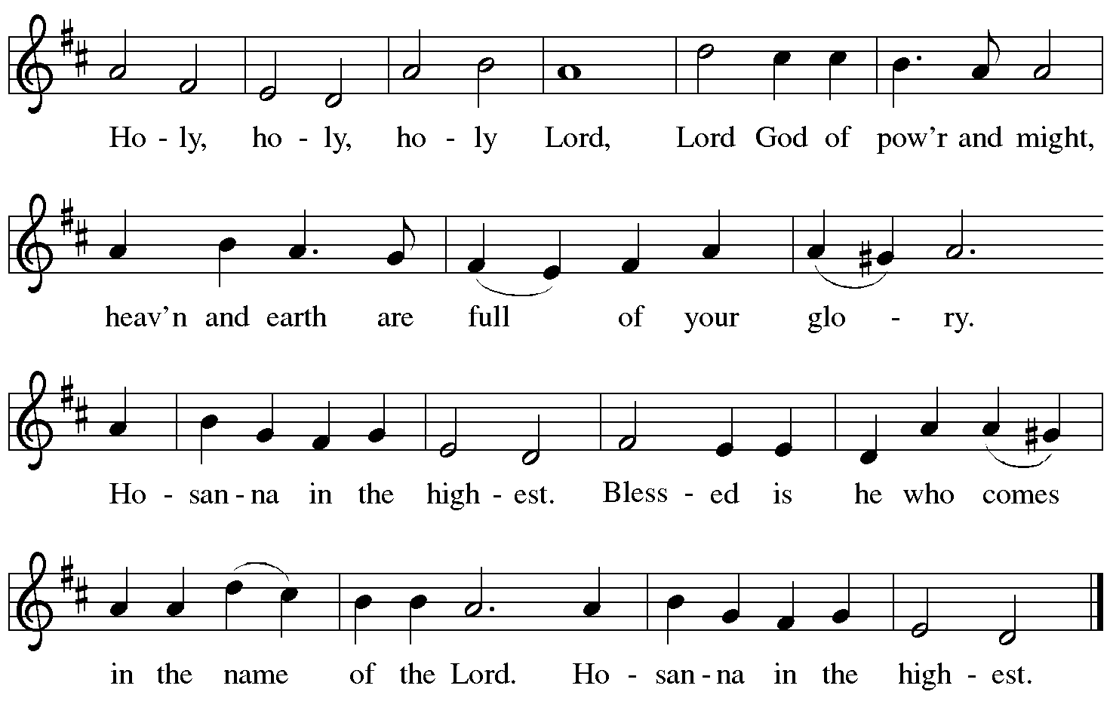

**Eucharistic Prayer**

P: Blessed are you, O God of the universe …

… Do this for the remembrance of me.

With this bread and cup

we proclaim our Lord’s passover from death to life

as we proclaim the mystery of faith:

**C: Christ has died.**

**Christ is risen.**

**Christ will come again.**

P: O God of resurrection and new life …

… Grace our table with your presence.

**C: Come, Holy Spirit.**

P: Reveal yourself to us in the breaking of the bread …

… Send us forth, burning with justice, peace, and love.

**C: Come, Holy Spirit.**

P: With your holy ones of all times and places …

… O God, blessed and holy Trinity,

now and forever.

**C: Amen.**

**Lord’s Prayer**

P: Gathered as one by the Holy Spirit, let us pray as Jesus taught us.

**C: Our Father, who are in heaven,**

**hallowed be thy name,**

**thy kingdom come,**

**thy will be done,**

**on earth as it is in heaven.**

**Give us this day our daily bread;**

**and forgive us our trespasses,**

**as we forgive those**

**who trespass against us;**

**and lead us not into temptation,**

**but deliver us from evil.**

**For thine is the kingdom,**

**and the power, and the glory,**

**forever and ever. Amen.**

**Fraction and Invitation**

P: Alleluia! Christ is risen!

**C: Christ is risen indeed! Alleluia! Alleluia!**

P: This is the feast of victory for our God. Alleluia! Alleluia!

Come, share the feast.



***Agnus Dei /* Lamb of God** *ELW* p. 154

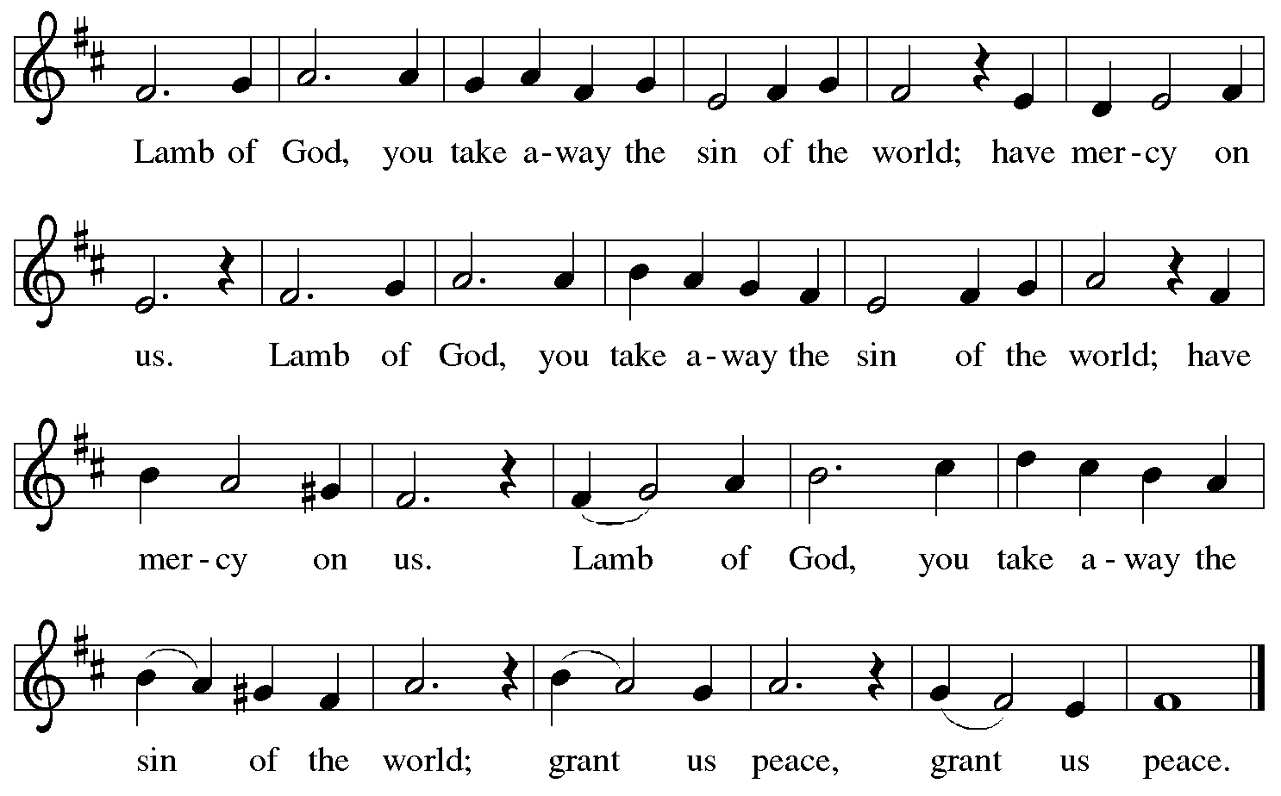

*Please be seated.*

**Holy Communion**

* *All who seek God and desire a deeper and stronger life in Christ are welcome to receive Holy Communion.*
* *Worshipers from the pulpit side will proceed forward first, followed by the center section, and then the lectern side.*
* *Please inform an usher if you would like the ministers to bring Communion to you.*
* *Holy Communion will be served with bread and wine (red) or grape juice (white).*
* *The presiding minister will first distribute the bread (host) to each communicant. Please indicate if you require a gluten-free host.*
* *Once you have consumed the bread, please pick up an empty glass from the tray next to the presiding minister. The Communion Assistant will pour wine or grape juice into your glass.*
* *Please step to the side to consume the wine or grape juice.*
* *Feel free to kneel at the altar rail for prayer after receiving the sacrament.*
* *As you return to your pew, glasses may be returned to the empty tray on the side of the center section.*
* *A blessing will be provided for anyone who does not yet receive the sacrament.*
* *All are invited to join in singing the hymns during Holy Communion.*

**Hymns during Holy Communion**

**You Satisfy the Hungry Heart *ELW* 484**

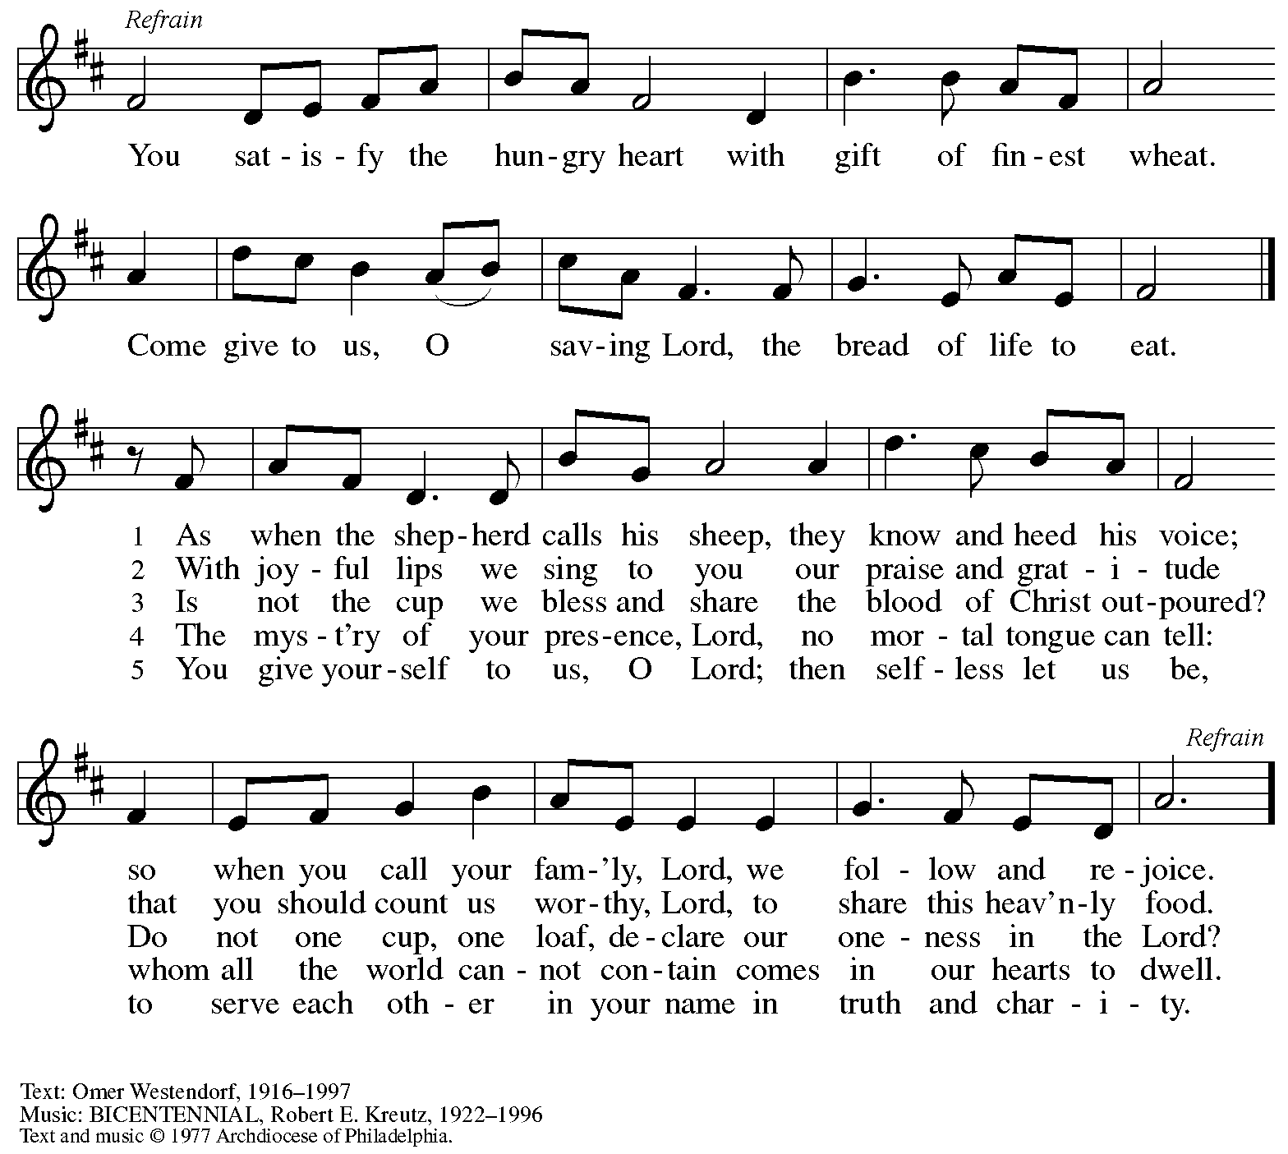

All rights reserved. Reprinted with permission under OneLicense.net # A-722139.

**Hymns during Holy Communion**

**Bring Many Names *ACS* 1094**

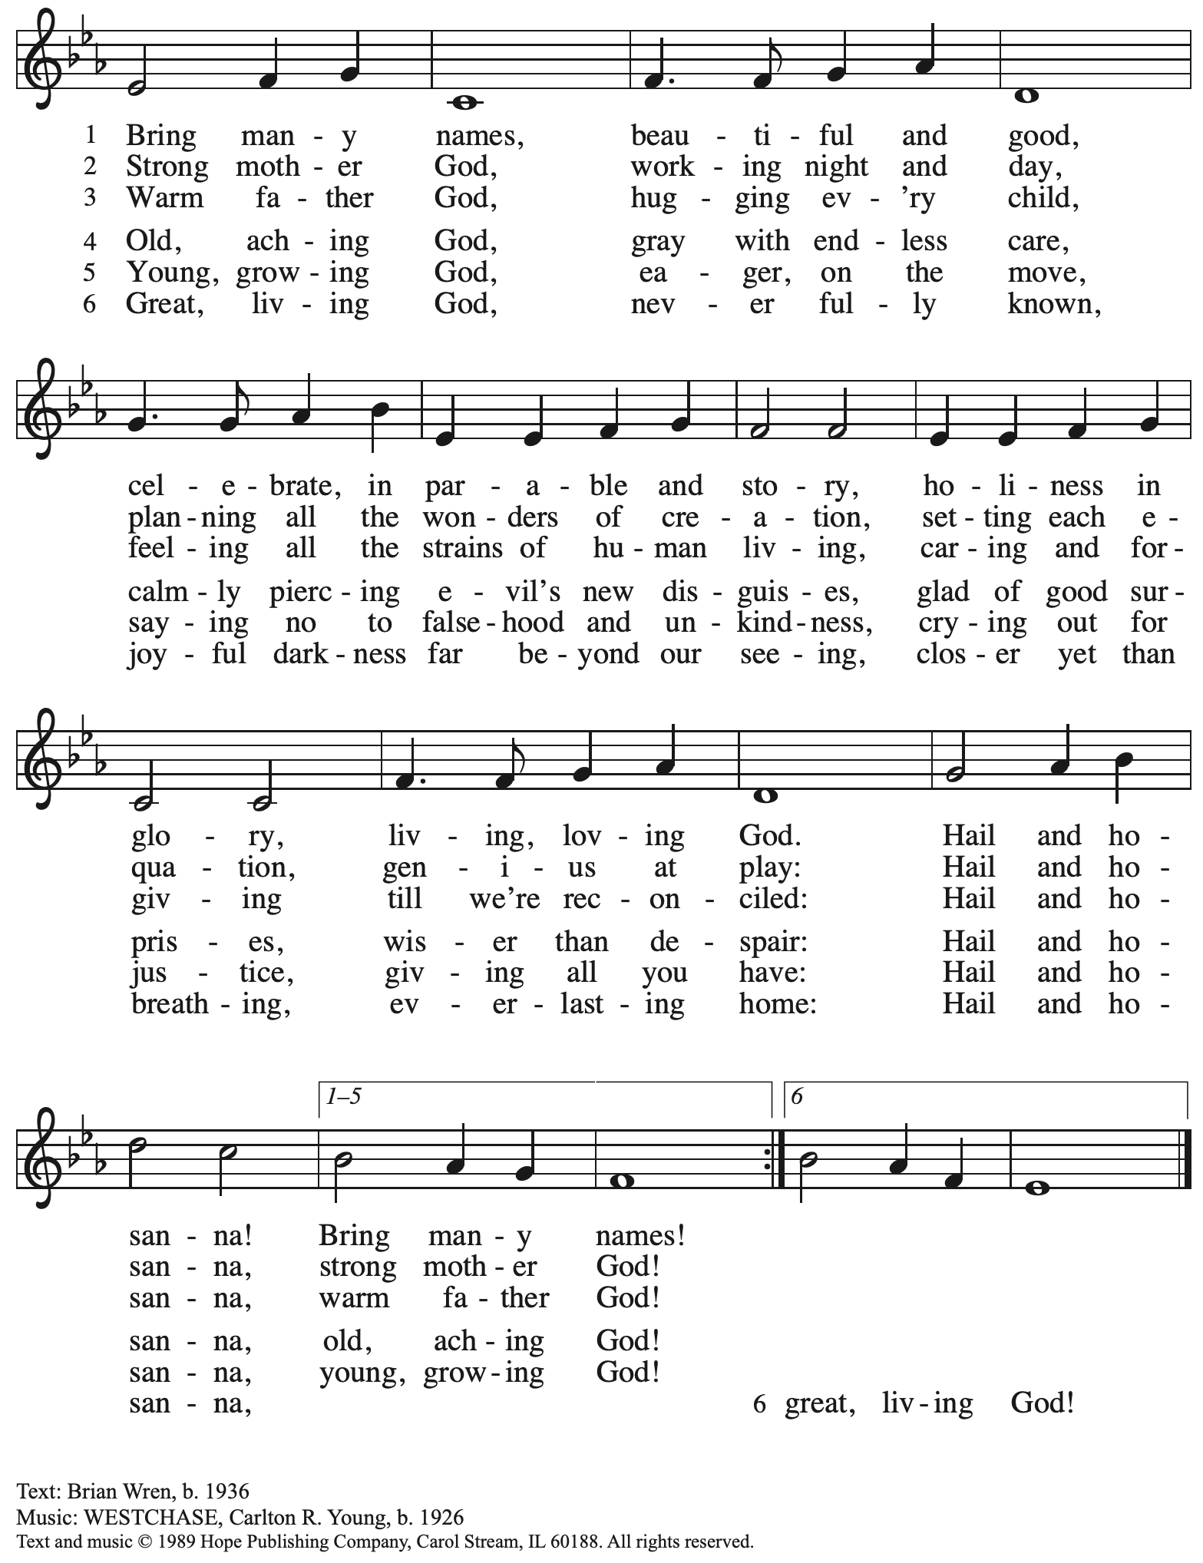

Reprinted with permission under OneLicense.net # A-722139.

**Hymns during Holy Communion**

**The King of Love My Shepherd Is *ELW* 502**

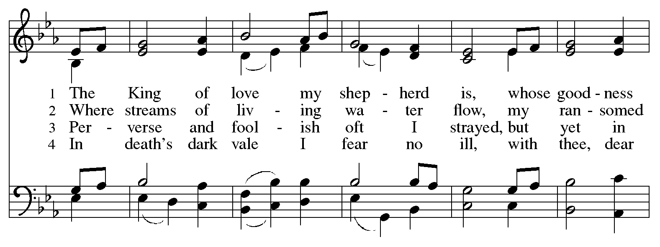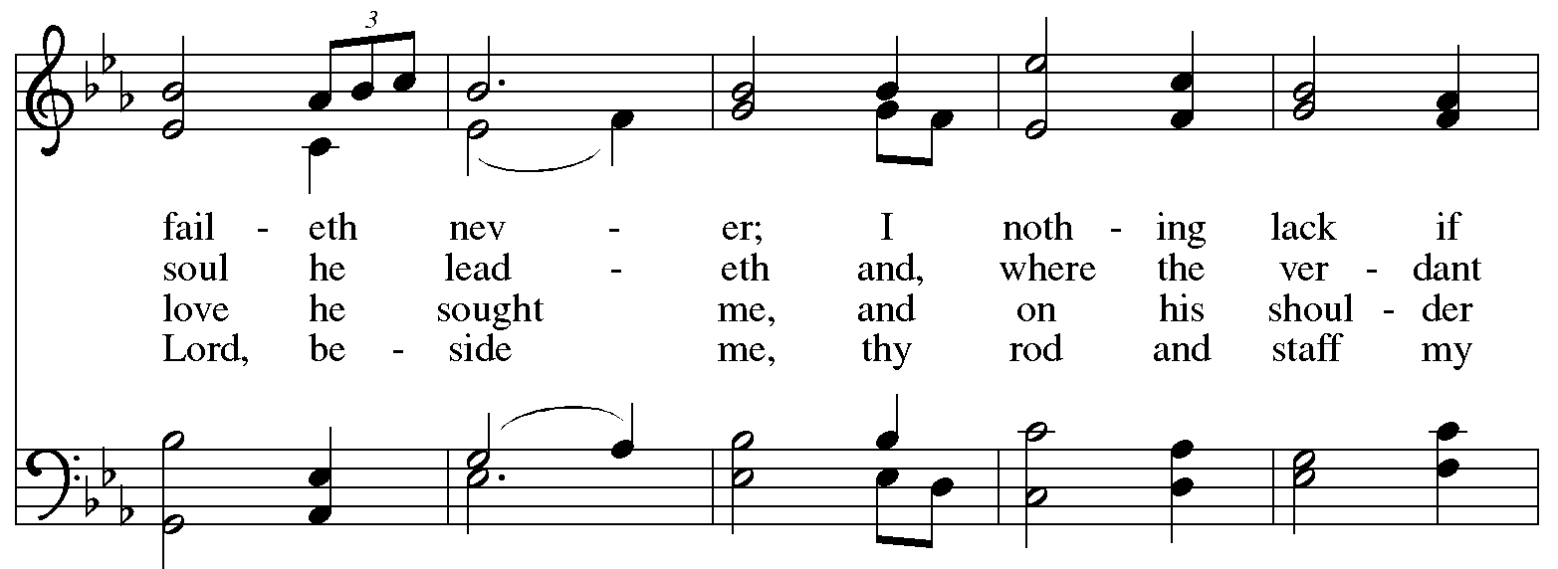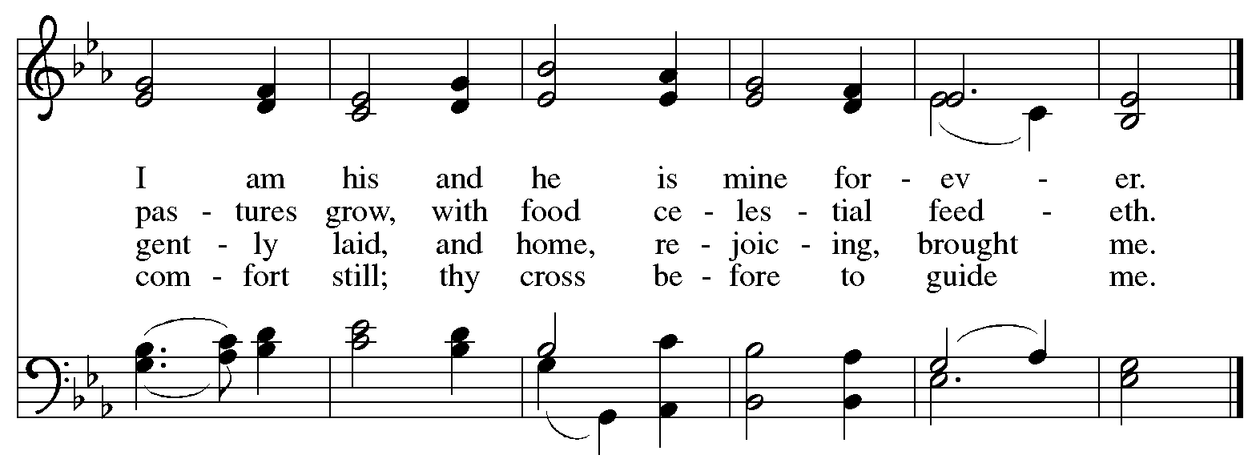

**Hymns during Holy Communion**

**Holy God, We Praise Your Name *ELW* 414**

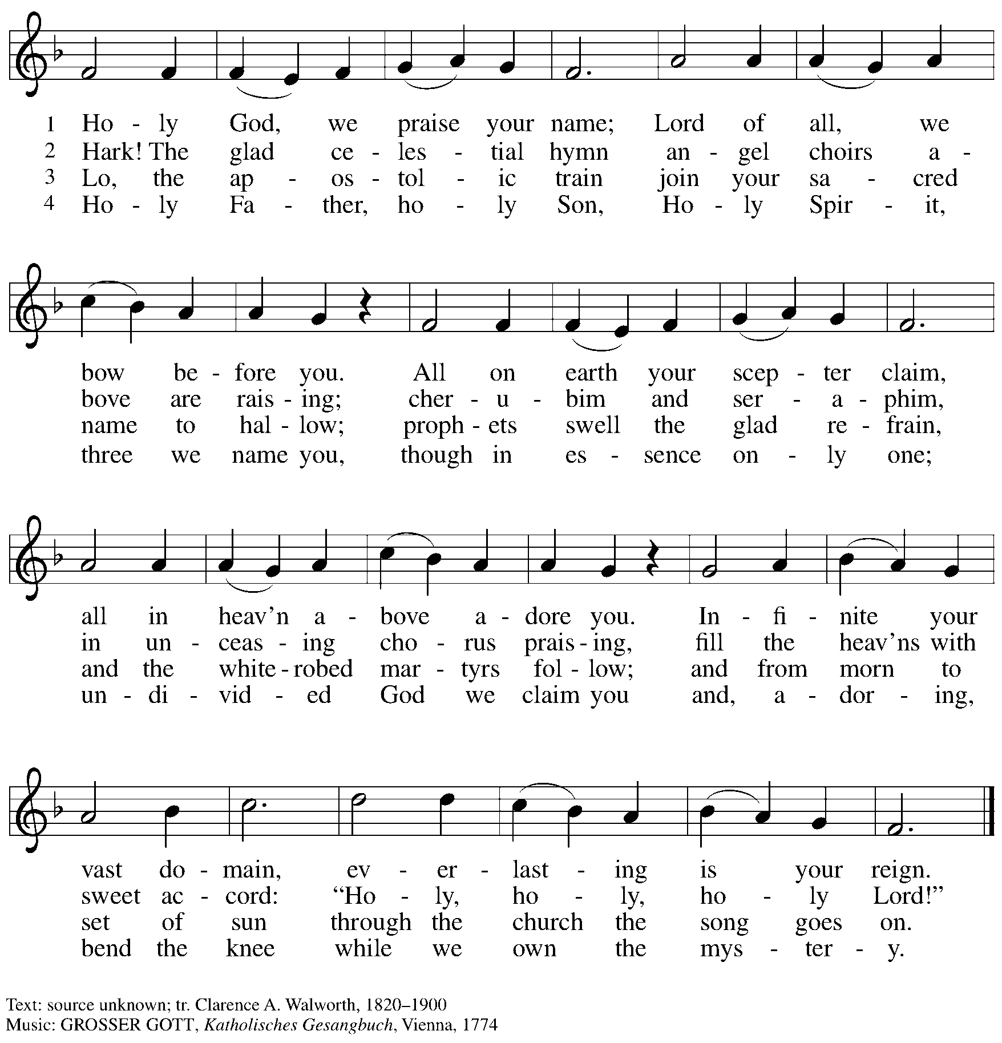

**Hymn during Holy Communion**

**Awake, O Sleeper, Rise from Death**  ***ELW* 452**

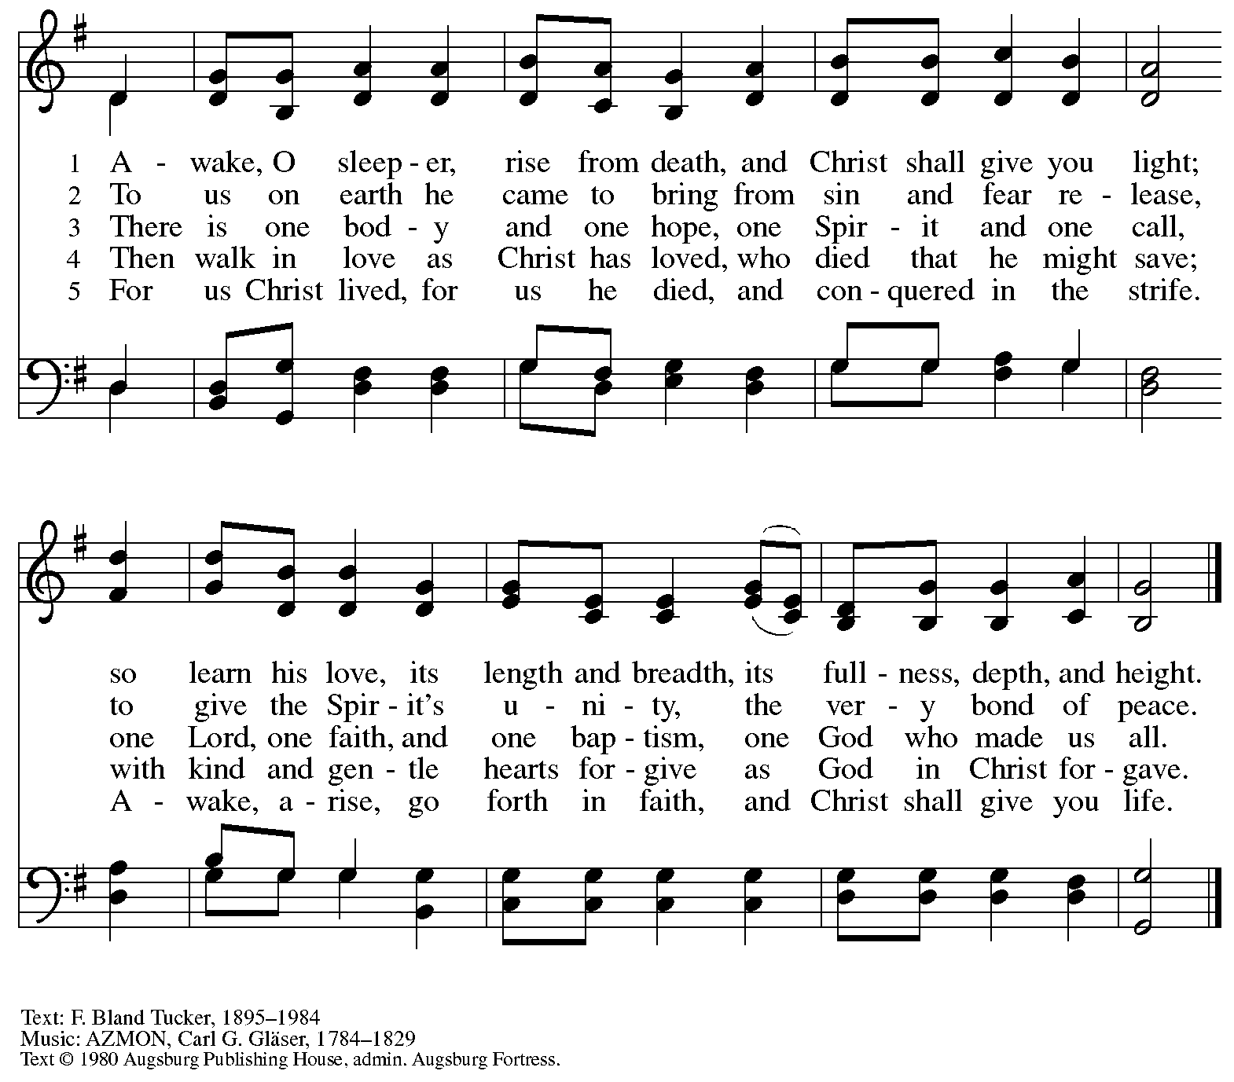

All rights reserved. Reprinted with permission under OneLicense.net # A-722139.

*When all have returned to their places, please rise as you are able.*

**Blessing**

P: The body and blood of our Lord Jesus Christ strengthen you and keep you in his grace.

**C: Amen.**

**Prayer**

A: Let us pray.

Life-giving God,

in the mystery of Christ’s resurrection, you send light to conquer darkness,

water to give new life, and the bread of life to nourish your people.

Send us forth as witnesses to your Son’s resurrection,

that we may show your glory to all the world,

through Jesus Christ, our risen Lord.

**C: Amen.**

*Please be seated.*

**Sending**

*God blesses us and sends us in mission to the world*

*Please rise as you are able.*

**Benediction**

P: May our glorious God grant you a spirit of wisdom

to know and love the risen Christ.

Almighty God, holy One, ☩ holy Three,

bless you now and forever.

**C: Amen.**

**Sending Hymn** *Following page*

**Dismissal**

A: Alleluia! Christ is risen!

**C: Christ is risen indeed! Alleluia! Alleluia!**

A: Go in peace. Share the good news!

**C: Thanks be to God!**

**Postlude**

**Sending Hymn Praise the Lord, Rise Up, Rejoicing *ELW* 544**

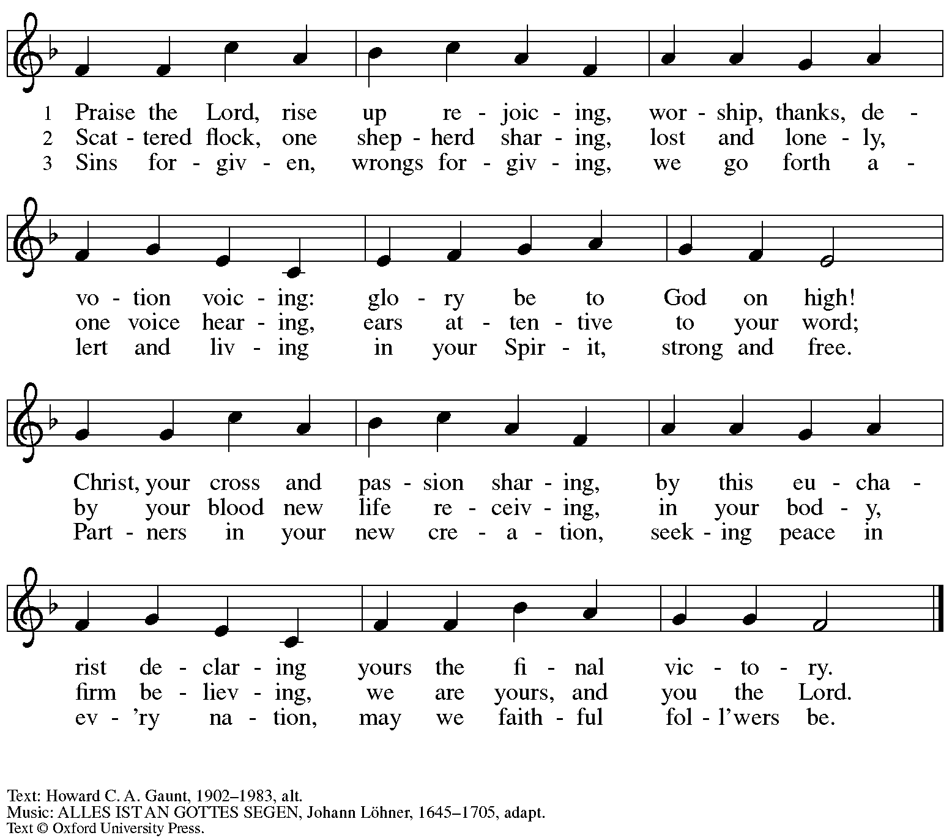

All rights reserved. Reprinted with permission under OneLicense.net # A-722139.

*Those serving in worship*

Altar Care Beverley Chapman

Assisting Minister Jimmi Kocher-Hillmer

Audio-Visual Ministers Jered Stratton

Sarita

Cantor Richard Krug

Euphonium David Rollinson

Lector Michael Chapman

Little Church – Big Faith Leader Ty Best

Pre-Service Music Timothy Kocher-Hillmer

Minister of Music Laura Reynolds

Presiding Minister The Rev. Ross I. Carmichael

*Liturgy and Hymnody Acknowledgements*

From SundaysandSeasons.com. Copyright © 2025 Augsburg Fortress. All rights reserved. Reprinted under OneLicense.net # A-722139.

Used by permission of Augsburg Fortress.

The Scripture readings contained herein are from *New Revised Standard Version Updated Edition* of the Bible © 2021 National Council of Churches of Christ in the United States of America. Used by permission. All rights reserved worldwide.

**Savior, Like a Shepherd Lead Us** Text: attr. Dorothy A. Thrupp, 1779-1847. Music: BRADBURY, William B. Bradbury, 1816-1868.

**Let the Vineyards** – Text: John W. Arthur, 1922-1980. Music: Ronald A. Nelson, b. 1927. Text and Music © 1978 *Lutheran Book of Worship*, admin. Augsburg Fortress.

*Please use the QR code below to link to St. Andrew’s Announcements online!*



**St. Andrew Lutheran Church Announcements**

**May 11th, 2025**

* **Happy Easter! Welcome to Worship at St. Andrew on the Fourth Sunday of Easter!** –We are so glad you are here to share in this festive season, and we offer a special welcome to all visitors and guests who are here for the first time! Children are invited to participate in Little Church – Big Faith, a Bible lesson and activity, after the prayer of the day. There are worship “toolkits” to help children engage with worship and “busy bags” for younger children available in the bookcase at the back of the sanctuary. Please feel free to take one to use with/for your children. A nursery is available through the door to the left of the worship space and across the social hall (look for a purple room). We pray that everyone has a blessed Easter season!
* **May Shelter Dinner for Guests of East End Cooperative Ministry – Third Thursday of the Month, May 15th, 6:30 p.m.** – Each month, people of St. Andrew provide dinner for guests of East End Cooperative Ministry (EECM), 6140 Station St. (East Liberty), 15206. We invite you to prepare or purchase one menu item and bring it to the shelter by 6:00 p.m., or just come to help serve at 6:30 p.m. If you would like to contribute, please sign up at

[**https://www.signupgenius.com/go/5080544AAAC22A1F58-56438583-mayshelter**](https://www.signupgenius.com/go/5080544AAAC22A1F58-56438583-mayshelter)**.**

* **Southwestern Pennsylvania Synod Assembly and Process for Election of New Bishop Begin Next Saturday, May 17th!** – Bishop Kurt Kusserow of our local Southwestern Pennsylvania Synod is concluding his third term in office and will not be seeking reelection. This means that this synod will be electing a new bishop for only third time since the founding of the Evangelical Lutheran Church in America 1988. We invite your prayers for the Church, the ELCA, and the Southwestern Pennsylvania Synod as we discern who will be called as our new bishop. Initial nominations of candidates for bishop will be made on a first ballot on May 17th, and nominees will have one week to remove their names from consideration. The remaining candidates will be on the ballot when synod assembly continues on June 12-14th. St. Andrew will be represented at synod assembly by voting members Kelly Spanninger, Cynthia Holden, and Pastor Ross along with visiting member Colleen Cooke – we invite your prayers for them, also!
* **Noisy Offering Next Sunday, May 18th, during Worship** – **On the third Sunday of each month, St. Andrew’s children lead the congregation in a Noisy Offering, in which people are invited to throw their change into buckets that the children carry around the church and bring forward as an additional offering. Each month’s Noisy Offering supports a local, national, or international church-related or otherwise charitable organization. This month’s offering will benefit ReconcilingWorks: Lutheran for Full Participation, the organization that sponsors St. Andrew’s Reconciling in Christ designation and provides resources for congregations seeking to fully welcome, include, and affirm LGBTQIA+ siblings in the life of the church, congregations, and society. For more information, please visit** [Home - Reconciling Works](https://www.reconcilingworks.org/).
* **St. Andrew Ministry Fair – Sunday, May 18th during Coffee Hour** – St. Andrew strives to make opportunities for ministry and service easily understandable and accessible to everyone in the community, but it is not always easy for someone new to get involved. The council is seeking to share information and make it easier for people to connect by holding a ministry fair after worship on Sunday, May 18th, during Coffee Hour. Council members that work with each ministry area will be available at various places in the social hall to share more about what that ministry team does and how people can get involved. The “committees” or ministry teams are Christian Education, Community ministry, Congregational ministry, Evangelism and Advocacy, Property, Stewardship, and Worship. We will feature brief information about each in the weeks around the 18th.
* **St. Andrew Ministry Area – Community Ministry – St. Andrew’s Community Ministry team focuses on serving people in need in our neighborhoods and building connections and partnerships with other local organizations doing the same. The team coordinates the stocking of the free library and pantry in front of the church, a monthly distribution of fresh produce in partnership with Greater Pittsburgh Community Food Bank, a monthly meal for guests of East End Cooperative Ministry; leads our Reconciling in Christ (LGBTQIA+ affirming) ministries; supports ministries of our friends at Bethel AME Church; and works with local organizations supporting immigrants and refugees. The current council liaison to Community Ministry is Tyler Rietze and he can be reached at** [community@standrewpittsburgh.org](mailto:community@standrewpittsburgh.org)**. Please contact Tyler or connect with him before or on May 18th to learn more about St. Andrew’s community ministries!**
* **Represent St. Andrew at Pittsburgh Pride – Saturday, May 31st, in Two Hour Blocks from 10:00 a.m. – 2:00 p.m. – St. Andrew is a Reconciling in Christ (RIC) congregation, publicly supporting the full welcome, participation, and affirmation of LGBTQIA+ siblings in church and society. As a part of this ministry, we participate in Pittsburgh Pride each year with other RIC congregations in the area. This year’s booth will be at the Pride festival on the North Side on Saturday, May 31st. We are asking people to represent the church – greeting people, sharing conversation and information about the church, and connecting people to resources – in two-hour increments from 10:00 a.m. – 6:00 p.m. If you have any questions, please speak with Kelly Spanninger. Please sign up at:** <https://www.signupgenius.com/go/5080B4AAFAF2CABF85-56727383-pittsburgh>.
* **Coffee Hour Signups Available** –One way that St. Andrew builds community is by sharing conversation over food and drinks at coffee hour after worship on Sundays. We invite people of the congregation to sign up to coordinate coffee hour each week, which includes brewing the coffee; setting out cups, napkins, food items, and cold drinks; and cleaning up afterward. Everything needed is at St. Andrew and instructions are available. Please sign up to host coffee hour here: <https://www.signupgenius.com/go/5080B4AAFAF2CABF85-47069030-coffee>.
* **New *Christ in Our Home* Devotional Booklets for July-September Now Available at Entrances** – This resource offers a daily Bible reading with a short reflection and prayer, along with additional readings and prayer topics for those who would like to expand their devotional practices. We encourage people of the congregation to take one for yourself, your family/household, or others. There are still some copies of the April-June edition available, too!