

**+ Fifth Sunday of Easter**

**May 18, 2025**





**St. Andrew Lutheran Church**

**304 Morewood Ave.**

**Pittsburgh, PA 15213**

[**St_andrewELCA@verizon.net**](mailto:St_andrewELCA@verizon.net)

[**www.standrewpittsburgh.org**](http://www.standrewpittsburgh.org)

**+ Fifth Sunday of Easter**

**Order for Worship**

*Easter initiates a new day. It anticipates a new heaven and a new earth. The risen Christ is making all things new. In the mystery of Holy Baptism God has made new people of us. Today Jesus invites us to see everyone in a new light—through the lens of love.*

**Welcome to St. Andrew!**

* St. Andrew welcomes all who are seeking a place of healing, wholeness, and acceptance in a nurturing and faith-forming spiritual home. We are striving toward racial equity worldwide

and we seek to honor the lived experience of all individuals regardless of background. Our community embraces people of all ages, ethnicities, cultures, abilities, sexual orientations,

gender identities and expressions, and family constellations. Come and See!

* Worship Services are live-streamed to multiple online platforms. By attending worship, you agree that your image and voice may be broadcast.
* Everyone is invited to make a name tag at the black bookcase in the back of the worship space if they would like. There are stickers indicating pronouns on the bookcase if you would like to include them on your name tag.
* Children are invited to attend Little Church – Big Faith, a Bible lesson and activity, during worship (after the Prayer of the Day). The group returns to the worship space for the liturgy of Holy Communion.
* A nursery is available through the doors at the left side of the sanctuary and across from the doorway to the Social Hall. Look for a purple-colored room.
* Worship “toolkits” to help children engage with the service, along with “busy bags” for younger children, are available in the bookcase at the back of the sanctuary. Please feel free to take one to use with/for your children.
* Holy Communion is served with bread (gluten-free available) and wine or grape juice. The presiding minister will distribute the bread (host). Please consume this and then pick up an empty glass from the tray. The Communion Assistant will pour wine or grape juice into your glass. Please step to the side to consume the wine or grape juice. Feel free to kneel at the altar for prayer and reflection. As you return to your pew, glasses may be returned to the empty trays on either side of the center section.
* A restroom is available on the main level of the church, through the doors to the Social Hall and to the right in the main office.

*Abbreviations*

P: Pastor/Presiding Minister ***ELW*: *Evangelical Lutheran Worship* hymnal**

A: Assisting Minister ***ACS*: *All Creation Sings* hymnal**

L: Lector ***MSB1*: *Music Source Book 1***

**C: Congregation *WOV*: *With One Voice* hymnal**

**Pre-Service Music** Matthew Tesch

**Welcome**

**Prelude** *As the Deer* Nystrom / arr. Wagner

**Gathering**

*The Holy Spirit calls us together as the people of God*

*Please rise as you are able. All may make the sign of the cross, the sign marked at Baptism,*

*as the presiding minister begins.*

**Confession and Forgiveness**

P: Blessed be the holy Trinity, ☩ one God,

who forgives all our sin, whose mercy endures forever.

**C: Amen.**

P: God of all mercy and consolation, come to the help of your people,

turning us from our sin to live for you alone. Give us the power of your Holy Spirit,

that we may confess our sin, receive your forgiveness,

and grow into the fullness of Jesus Christ, our Savior and Lord.

**C: Amen.**

P: Let us confess our sin in the presence of God and of one another.

*Silence is kept for reflection.*

P: Most merciful God,

**we confess that we are captive to sin and cannot free ourselves.**

**We have sinned against you in thought, word, and deed,**

**by what we have done and by what we have left undone.**

**We have not loved you with our whole heart; we have not loved our neighbors as ourselves.**

**For the sake of your Son, Jesus Christ, have mercy on us.**

**Forgive us, renew us, and lead us, so that we may delight in your will**

**and follow in your ways, to the glory of your holy name.** A**men.**

P: God, who is rich in mercy, loved us even when we were dead in sin,

and made us alive together with Christ. By grace you have been saved.

In the name of ☩ Jesus Christ, your sins are forgiven.

Almighty God strengthen you with power through the Holy Spirit,

that Christ may live in your hearts through faith.

**C: Amen.**

**Gathering Hymn Now the Green Blade Rises *ELW* 379**

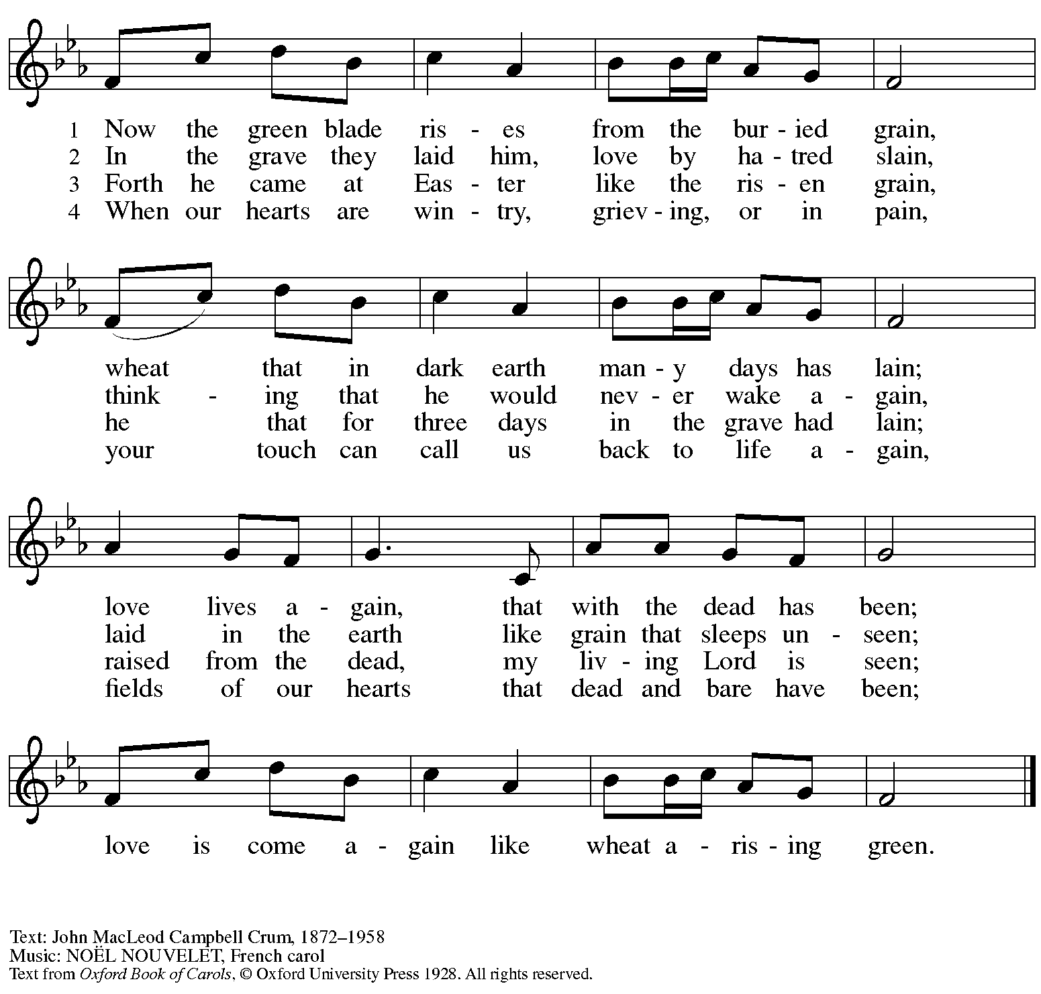

Reprinted with permission under OneLicense.net # A-722139.

**Greeting**

P: The grace of our Lord Jesus Christ, the love of God,

and the communion of the Holy Spirit be with you all.

**C: And also with you.**

**Hymn of Praise** *This Is the Feast ELW* p. 149-150

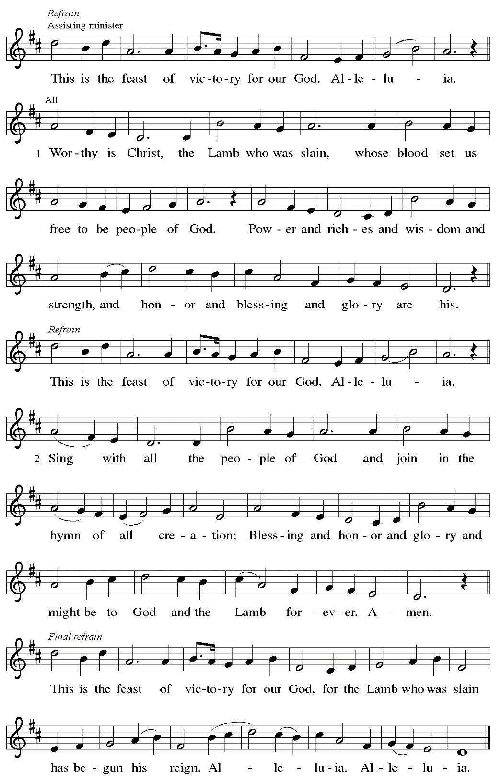

**Prayer of the Day**

P: The Lord be with you.

**C: And also with you.**

P: Let us pray.

O Lord God, you teach us that without love, our actions gain nothing.

Pour into our hearts your most excellent gift of love, that, made alive by your Spirit,

we may know goodness and peace, through your Son, Jesus Christ, our Savior and Lord,

who lives and reigns with you and the Holy Spirit, one God, now and forever.

**C: Amen.**

*Please be seated.*

**Word**

*God speaks to us in Scripture reading, preaching, and song*

**First Reading** **–** **Acts 11: 1-18**

1 Now the apostles and the brothers and sisters who were in Judea heard that the gentiles had also accepted the word of God. 2 So when Peter went up to Jerusalem, the circumcised believers criticized him, 3 saying, “Why did you go to uncircumcised men and eat with them?” 4 Then Peter began to explain it to them, step by step, saying, 5 “I was in the city of Joppa praying, and in a trance I saw a vision. There was something like a large sheet coming down from heaven, being lowered by its four corners, and it came close to me. 6 As I looked at it closely I saw four-footed animals, beasts of prey, reptiles, and birds of the air. 7 I also heard a voice saying to me, ‘Get up, Peter; kill and eat.’ 8 But I replied, ‘By no means, Lord, for nothing profane or unclean has ever entered my mouth.’ 9 But a second time the voice answered from heaven, ‘What God has made clean, you must not call profane.’ 10 This happened three times; then everything was pulled up again to heaven. 11 At that very moment three men, sent to me from Caesarea, arrived at the house where we were. 12 The Spirit told me to go with them and not to make a distinction between them and us. These six brothers also accompanied me, and we entered the man’s house. 13 He told us how he had seen the angel standing in his house and saying, ‘Send to Joppa and bring Simon, who is called Peter; 14 he will give you a message by which you and your entire household will be saved.’ 15 And as I began to speak, the Holy Spirit fell upon them just as it had upon us at the beginning. 16 And I remembered the word of the Lord, how he had said, ‘John baptized with water, but you will be baptized with the Holy Spirit.’ 17 If then God gave them the same gift that God gave us when we believed in the Lord Jesus Christ, who was I that I could hinder God?” 18 When they heard this, they were silenced. And they praised God, saying, “Then God has given even to the gentiles the repentance that leads to life.”

L: Word of God, word of life.

**C: Thanks be to God.**

**Psalm 148**

*The psalm will be sung responsively, led by the cantor,*

*with the congregation responding with the bold verses and refrain.*

*Psalm tone*

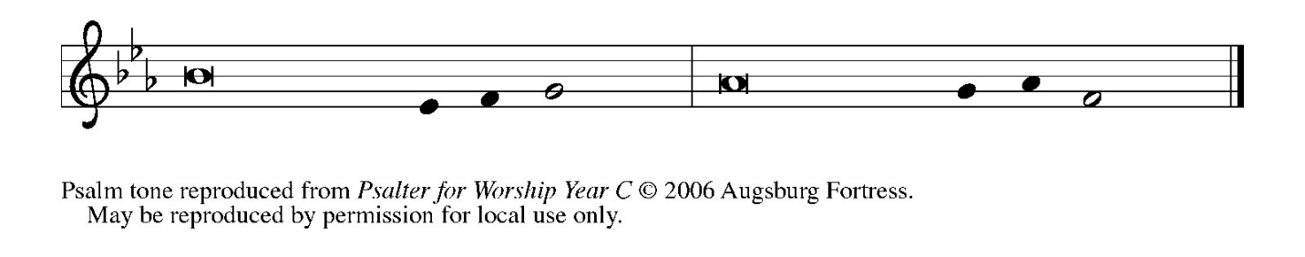

*Psalm refrain*

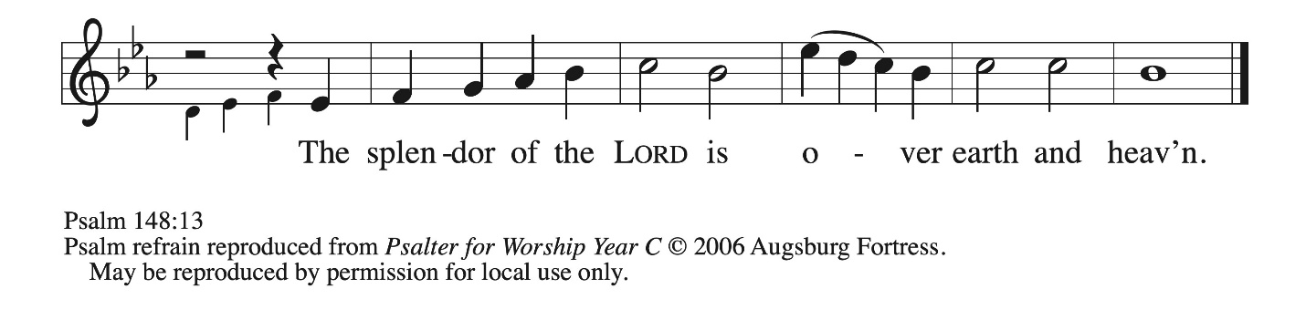

1 Hallelujah! Praise the Lord **|** from the heavens;  
  praise God **|** in the heights.  
 2 **Praise the Lord, | all you angels;**  
  **sing praise, all you | hosts of heaven.**  
 3 Praise the Lord, **|** sun and moon;  
  sing praise, all you **|** shining stars.  
 4 **Praise the Lord, heav- | en of heavens,**  
  **and you waters a- | bove the heavens.**  
 5 Let them praise the name **|** of the Lord,  
  who commanded, and they **|** were created,  
 6 **who made them stand fast forev- | er and ever,**  
  **giving them a law that shall not | pass away. R**  
 7 Praise the Lord **|** from the earth,  
  you sea monsters **|** and all deeps;  
 8 **fire and hail, | snow and fog,**  
  **tempestuous wind, do- | ing God’s will;**  
 9 mountains **|** and all hills,  
  fruit trees **|** and all cedars;  
 10 **wild beasts | and all cattle,**  
  **creeping things and | flying birds;**  
 11 sovereigns of the earth **|** and all peoples,  
  princes and all rulers **|** of the world;  
 12 **young | men and maidens,**  
  **old and | young together. R**  
 13 Let them praise the name **|** of the Lord,  
  whose name only is exalted, whose splendor is over **|** earth and heaven.  
 14 **The Lord has raised up strength for the people and praise for all | faithful servants,**  
  **the children of Israel, a people who are near the Lord. | Hallelujah! R**

**Second Reading – Revelation 21: 1-6**

  1 Then I saw a new heaven and a new earth, for the first heaven and the first earth had passed away, and the sea was no more. 2 And I saw the holy city, the new Jerusalem, coming down out of heaven from God, prepared as a bride adorned for her husband. 3 And I heard a loud voice from the throne saying,  
 “See, the home of God is among mortals.  
 God will dwell with them;  
 they will be God’s peoples,  
 and God Godself will be with them and be their God;  
 4 God will wipe every tear from their eyes.  
 Death will be no more;  
 mourning and crying and pain will be no more,  
 for the first things have passed away.”  
  5 And the one who was seated on the throne said, “See, I am making all things new.” Also he said, “Write this, for these words are trustworthy and true.” 6 Then he said to me, “It is done! I am the Alpha and the Omega, the Beginning and the End. To the thirsty I will give water as a gift from the spring of the water of life.”

L: Word of God, word of life.

**C: Thanks be to God.**

*Please rise as you are able.*

**Gospel Acclamation *MSB1*****S441**

*Cantor*: I give you a | new commandment, that you love one another just as I | have loved you.

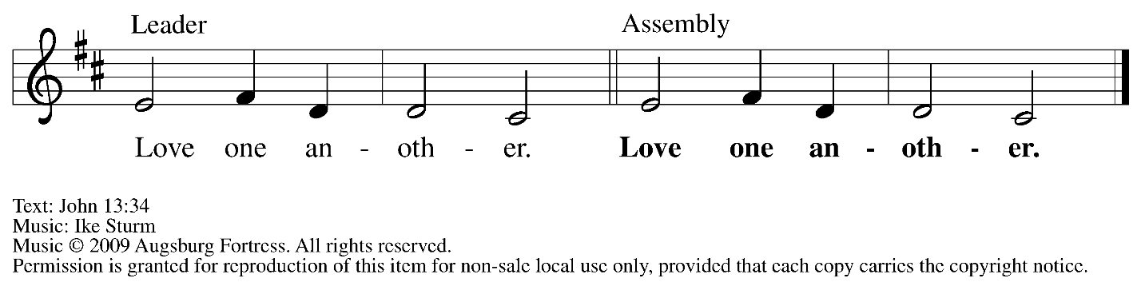

**Gospel – John 13: 31-35**

P: The holy Gospel according to St. John.

**C: Glory to you, O Lord.**

31 When he had gone out, Jesus said, “Now the Son of Humanity has been glorified, and God has been glorified in him. 32 If God has been glorified in him, God will also glorify him in Godself and will glorify him at once. 33 Little children, I am with you only a little longer. You will look for me, and as I said to the Jews so now I say to you, ‘Where I am going, you cannot come.’ 34 I give you a new commandment, that you love one another. Just as I have loved you, you also should love one another. 35 By this everyone will know that you are my disciples, if you have love for one another.”

P: The Gospel of the Lord.

**C: Praise to you, O Christ.**

*Please be seated.*

**Sermon**

*A time of silence for prayer and reflection follows the sermon.*

*When the hymn of the day begins, please rise as you are able.*

**Hymn of the Day** *Following page*



**Hymn of the Day Love Divine, All Loves Excelling *ELW* 631**

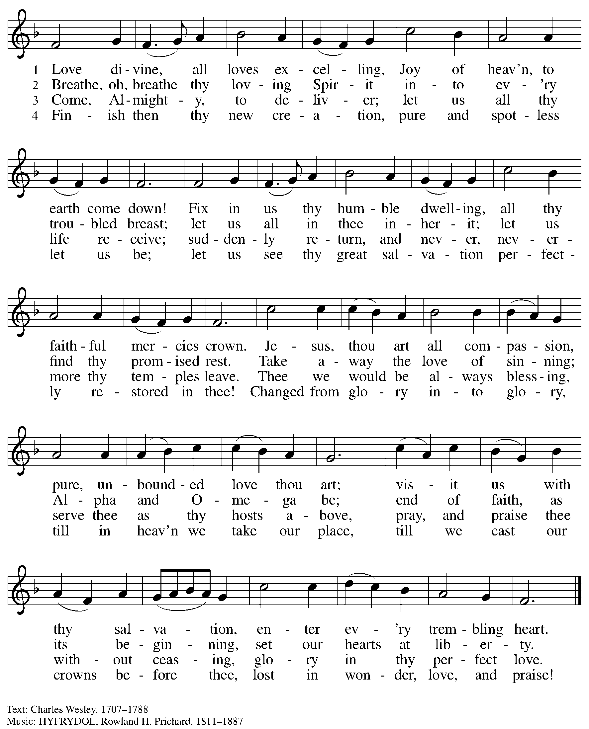

**Nicene Creed**

**C: We believe in one God,**

**the Father, the Almighty,**

**maker of heaven and earth,**

**of all that is, seen and unseen.**

**We believe in one Lord, Jesus Christ,**

**the only Son of God,**

**eternally begotten of the Father,**

**God from God, Light from Light,**

**true God from true God,**

**begotten, not made,**

**of one Being with the Father;**

**through him all things were made.**

**For us and for our salvation**

**he came down from heaven,**

**was incarnate of the Holy Spirit and the virgin Mary**

**and became truly human.**

**For our sake he was crucified under Pontius Pilate;**

**he suffered death and was buried.**

**On the third day he rose again**

**in accordance with the scriptures;**

**he ascended into heaven**

**and is seated at the right hand of the Father.**

**He will come again in glory to judge the living and the dead,**

**and his kingdom will have no end.**

**We believe in the Holy Spirit, the Lord, the giver of life,**

**who proceeds from the Father and the Son,\***

**who with the Father and the Son is worshiped and glorified,**

**who has spoken through the prophets.**

**We believe in one holy catholic and apostolic church.**

**We acknowledge one baptism for the forgiveness of sins.**

**We look for the resurrection of the dead,**

**and the life of the world to come. Amen.**

*Or, “who proceeds from the Father.” The phrase “and the Son” is a later addition to the creed.

**Prayers of the People**

A: United in the joy and hope of the resurrection, let us pray for the church, the world,

and all who are in need.

*After each petition*

A: Gracious God,

**C: receive our prayer.**

P: We lift these prayers to you O God, trusting in your abundant mercy,

through Jesus Christ our risen Savior.

**C: Amen.**

**Peace**

*The presiding minister and the assembly greet one another in the peace of the risen Christ.*

P: The peace of Christ be with you always.

**C: And also with you.**

*The people may greet those around them with a sign of Christ’s peace and may say*

Peace be with you *or similar words. Please be mindful that not everyone will be comfortable with sharing the peace, so please seek consent before shaking hands or hugging. Other possible ways to share the peace include a simple bow with the verbal greeting of peace, or simply a verbal expression of peace.*

*When the greetings of peace have concluded, please be seated.*

**Meal**

*God feeds us with the presence of Jesus Christ*

**Offering**

*We offer ourselves, our gifts, and our faithful service to God.*

*As the offering is gathered for the mission of the church, including the care of those in need,*

*the table is set for Holy Communion.*

*There are laminated giving cards in the pew racks that feature a QR code for anyone who would like to give online. Those who give using the QR code, as well as those who give regularly online or through their bank are encouraged to place the laminated card in the plate as an expression of your offering.*

**Noisy Offering**

*As children of the congregation carry buckets around the sanctuary, people of the congregation are invited to throw in their change as an offering. This month’s offering will support ReconcilingWorks: Lutherans for Full Participation.*

**Offertory Music** *He’s Got the Whole World in His Hands*arr. B. Edstrom

*As the gifts are brought forward for presentation, please rise as you are able.*

**Offertory Song Let the Vineyards *ELW* 184**

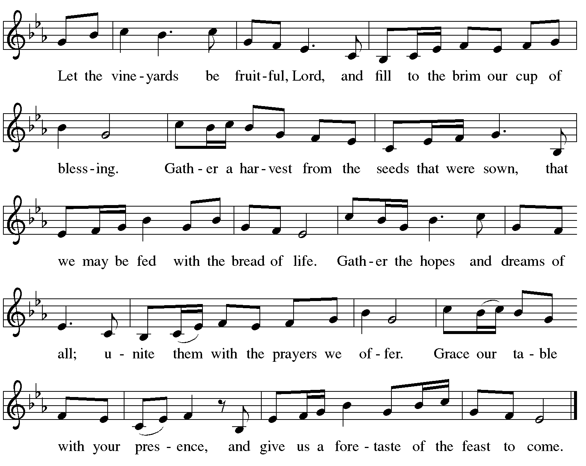

**Offertory Prayer**

A: Let us pray.

Blessed are you, O God,

**C: ruler of heaven and earth.**

**Day by day you shower us with blessings.**

**As you have raised us to new life in Christ,**

**give us glad and generous hearts,**

**ready to praise you and to respond to those in need,**

**through Jesus Christ, our Savior and Lord. Amen.**

**Dialogue** *ELW* p. 152

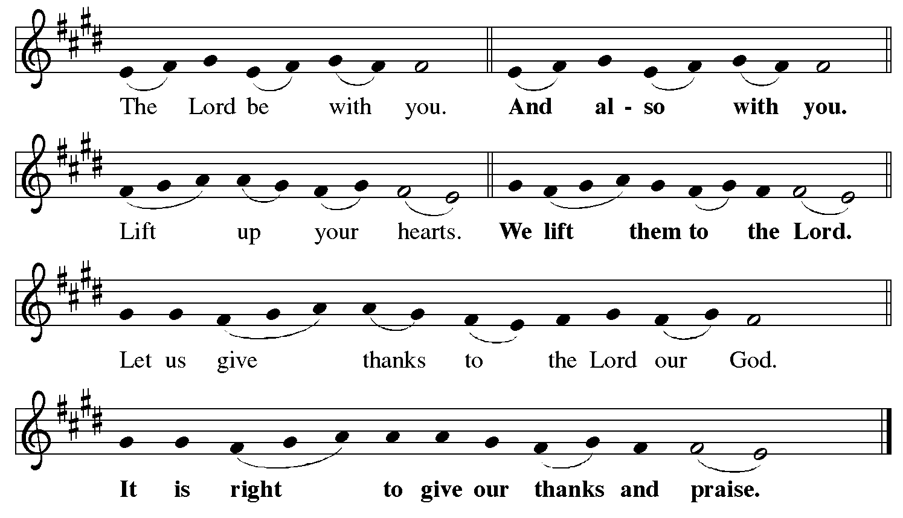

**Preface** *(Sung by the presiding minister)*

P: It is indeed right, our duty and our joy,

that we should at all times and in all places

give thanks and praise to you, almighty and merciful God,

for the glorious resurrection of our Savior Jesus Christ,

the true Paschal Lamb who gave himself to take away our sin;

who in dying has destroyed death,

and in rising has brought us to eternal life.

And so, with Mary Magdalene and Peter

and all the witnesses of the resurrection,

with earth and sea and all their creatures,

and with angels and archangels, cherubim and seraphim,

we praise your name and join their unending hymn:

**Sanctus** *ELW* p. 153

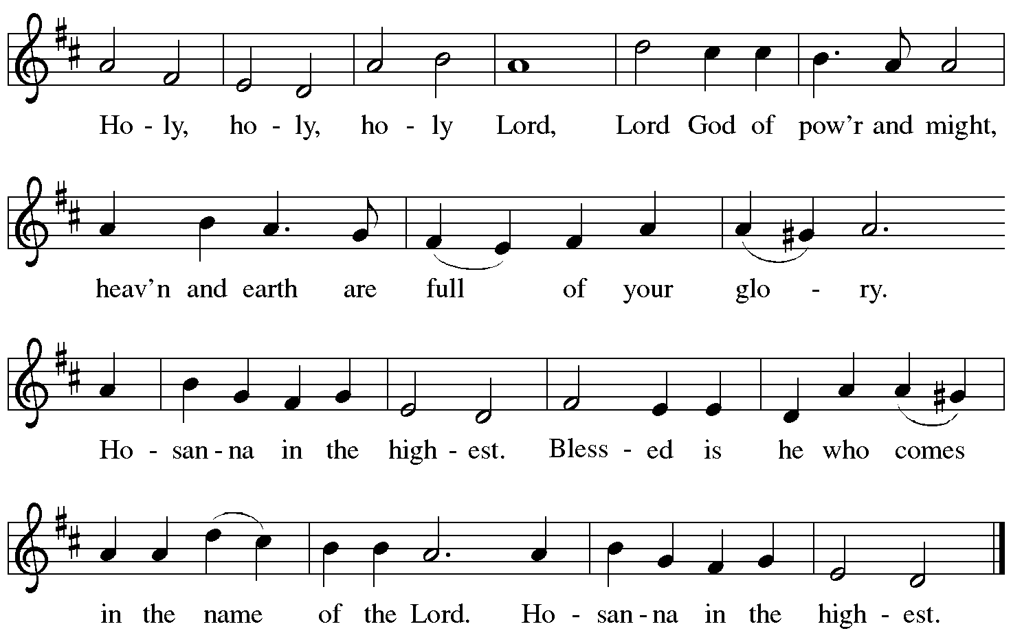

**Eucharistic Prayer**

P: Blessed are you, O God of the universe …

… Do this for the remembrance of me.

With this bread and cup

we proclaim our Lord’s passover from death to life

as we proclaim the mystery of faith:

**C: Christ has died.**

**Christ is risen.**

**Christ will come again.**

P: O God of resurrection and new life …

… Grace our table with your presence.

**C: Come, Holy Spirit.**

P: Reveal yourself to us in the breaking of the bread …

… Send us forth, burning with justice, peace, and love.

**C: Come, Holy Spirit.**

P: With your holy ones of all times and places …

… O God, blessed and holy Trinity,

now and forever.

**C: Amen.**

**Lord’s Prayer**

P: Gathered as one by the Holy Spirit, let us pray as Jesus taught us.

**C: Our Father, who art in heaven,**

**hallowed be thy name,**

**thy kingdom come,**

**thy will be done,**

**on earth as it is in heaven.**

**Give us this day our daily bread;**

**and forgive us our trespasses,**

**as we forgive those**

**who trespass against us;**

**and lead us not into temptation,**

**but deliver us from evil.**

**For thine is the kingdom,**

**and the power, and the glory,**

**forever and ever. Amen.**

**Fraction and Invitation**

P: Alleluia! Christ is risen!

**C: Christ is risen indeed! Alleluia! Alleluia!**

P: This is the feast of victory for our God. Alleluia! Alleluia!

Come, share the feast.



***Agnus Dei /* Lamb of God** *ELW* p. 154

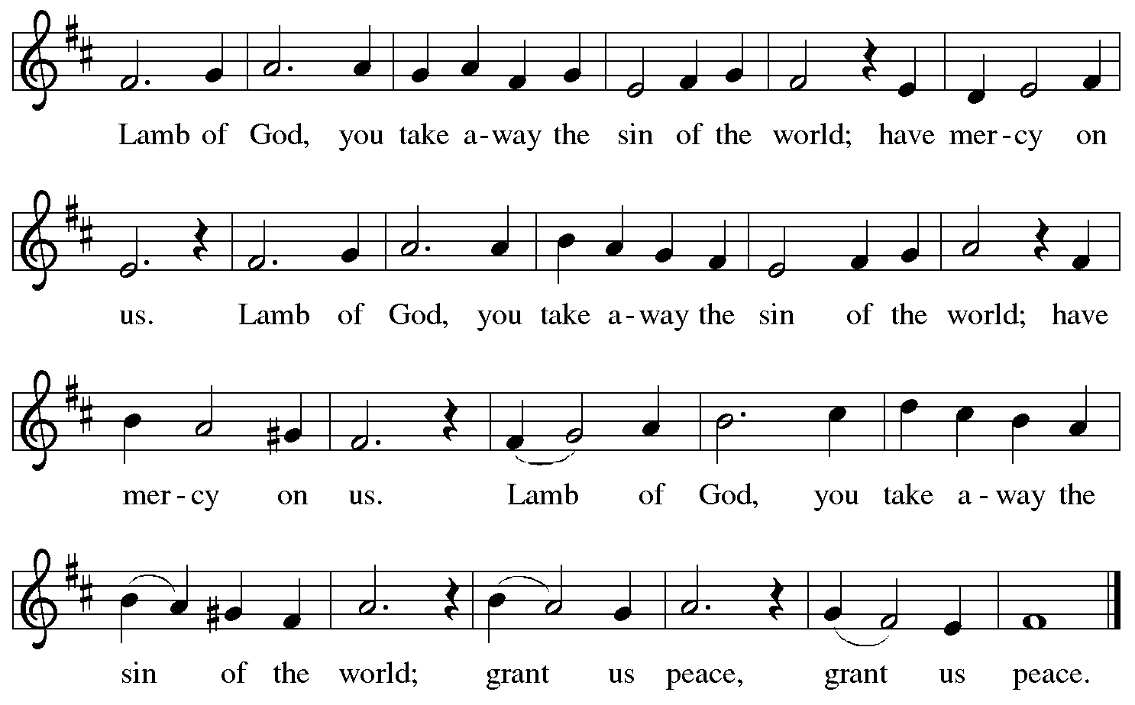

*Please be seated.*

**Holy Communion**

* *All who seek God and desire a deeper and stronger life in Christ are welcome to receive Holy Communion.*
* *Worshipers from the pulpit side will proceed forward first, followed by the center section, and then the lectern side.*
* *Please inform an usher if you would like the ministers to bring Communion to you.*
* *Holy Communion will be served with bread and wine (red) or grape juice (white).*
* *The presiding minister will first distribute the bread (host) to each communicant. Please indicate if you require a gluten-free host.*
* *Once you have consumed the bread, please pick up an empty glass from the tray next to the presiding minister. The Communion Assistant will pour wine or grape juice into your glass.*
* *Please step to the side to consume the wine or grape juice.*
* *Feel free to kneel at the altar rail for prayer after receiving the sacrament.*
* *As you return to your pew, glasses may be returned to the empty tray on the side of the center section.*
* *A blessing will be provided for anyone who does not yet receive the sacrament.*
* *All are invited to join in singing the hymns during Holy Communion.*

**Hymns during Holy Communion**

**A New Commandment *WOV* 644**

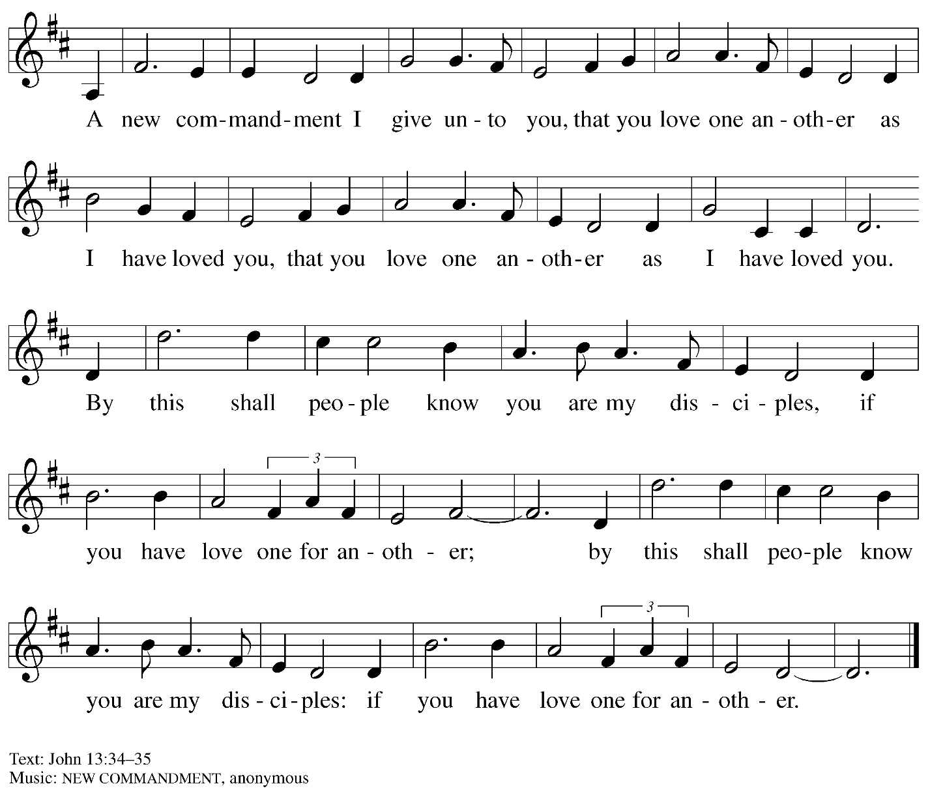

**Hymns during Holy Communion**

**In This Feast of Love *ACS* 962**

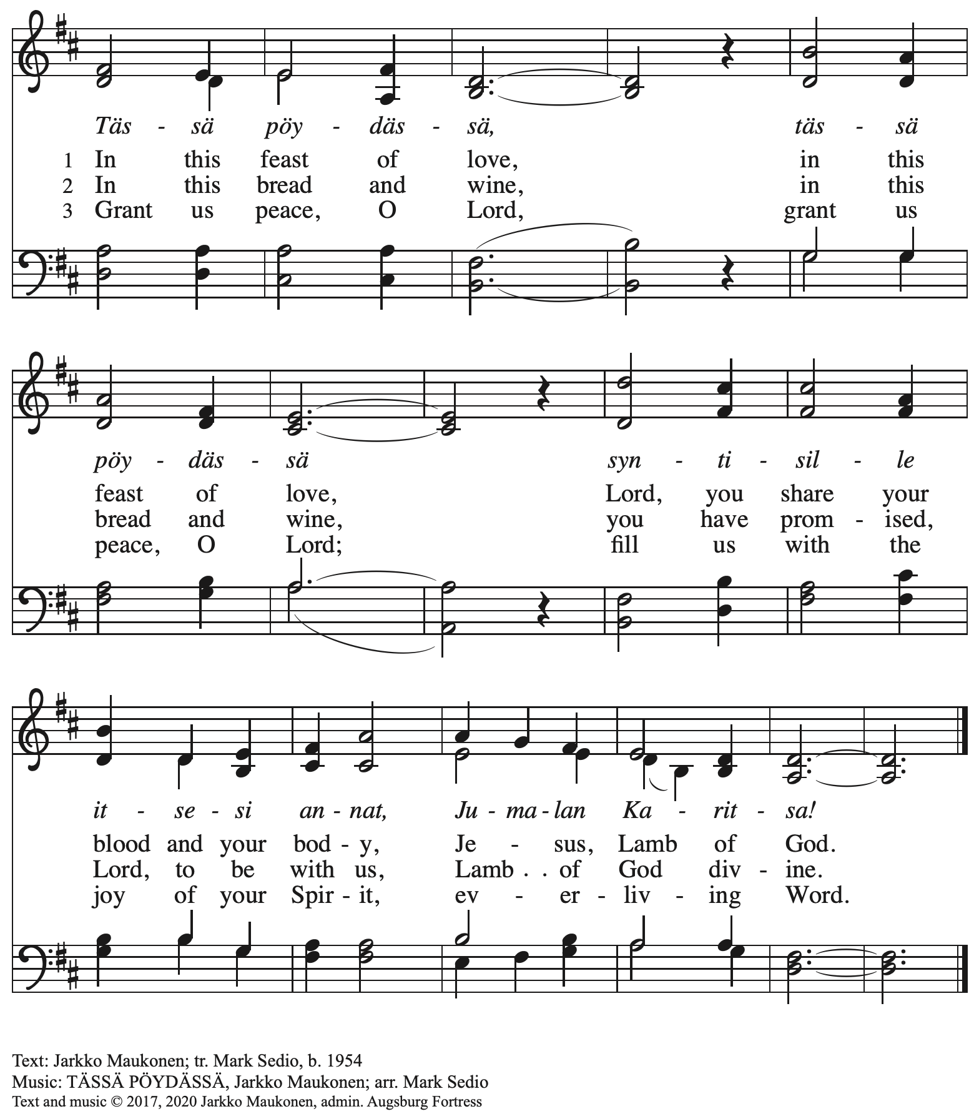

All rights reserved. Reprinted under OneLicense.net #A-722139.

**Hymns during Holy Communion *ACS* 931**

**Donde hay caridad – Where Charity and Love Are Shown**

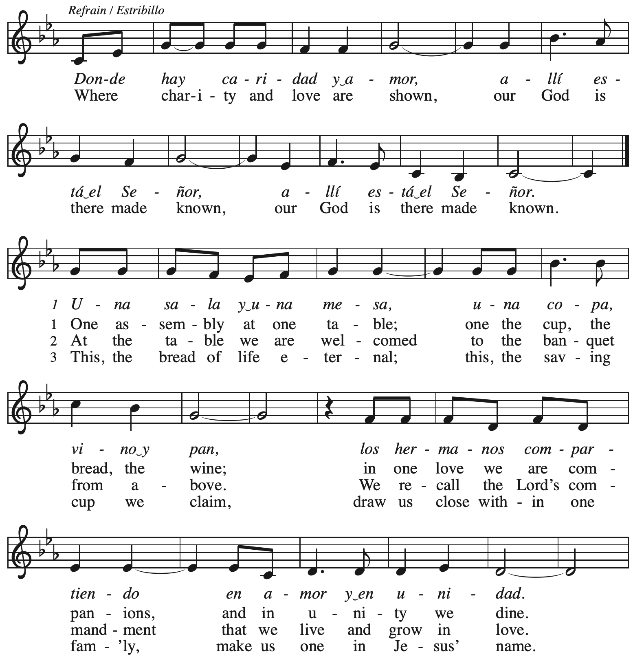

*Continued*

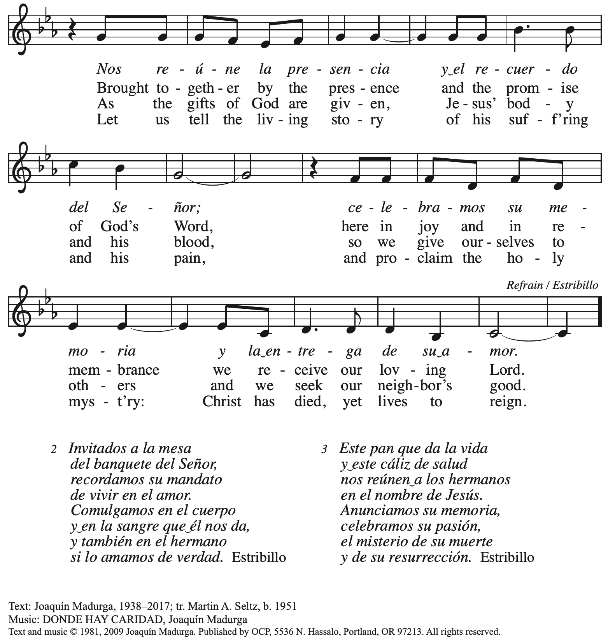

Reprinted with permission under OneLicense.net # A-722139.

**Hymns during Holy Communion**

**Jesu, Jesu, Fill Us with Your Love *ELW* 708**

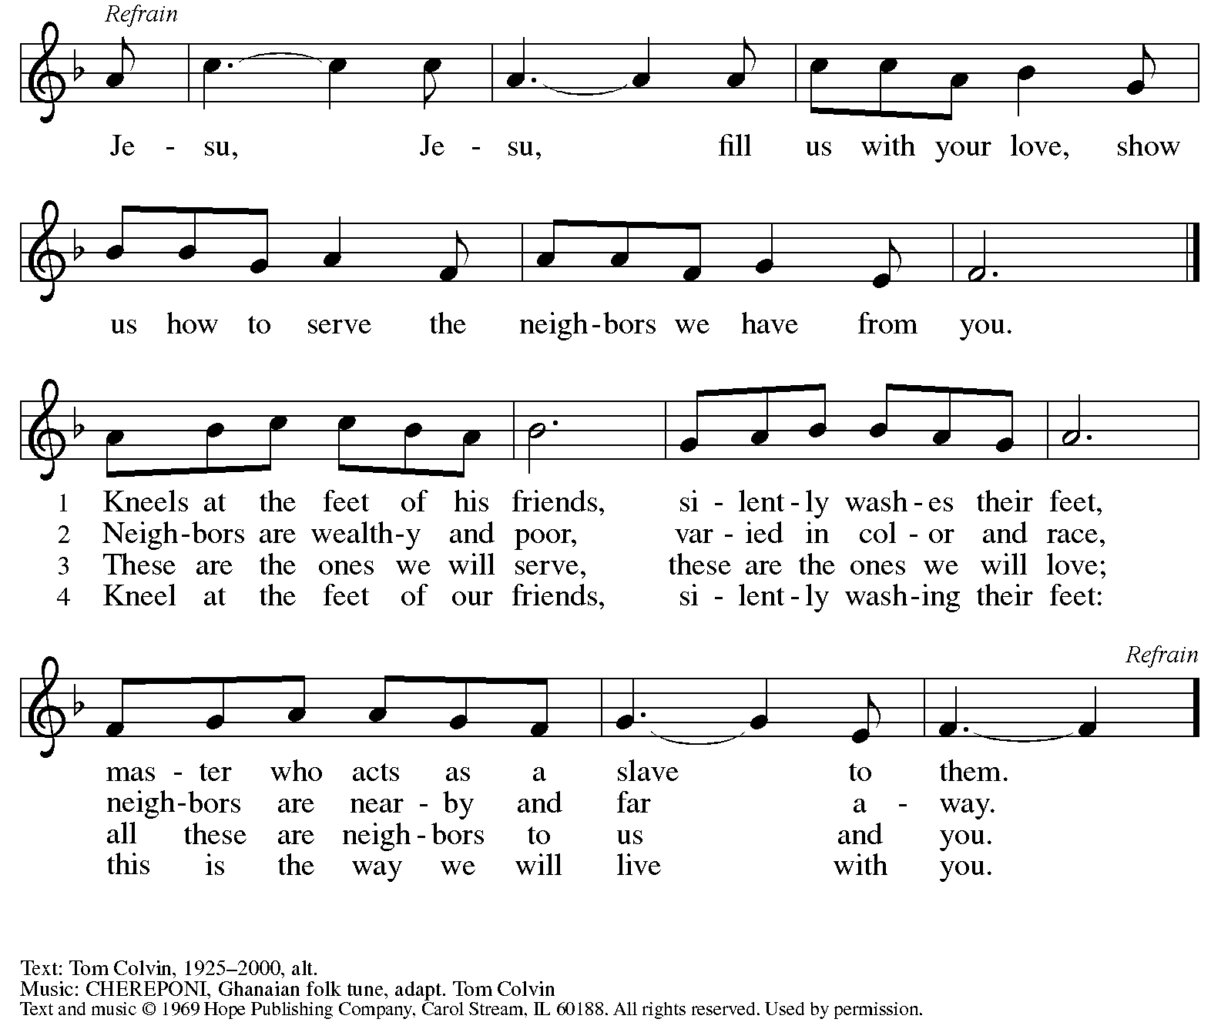

Reprinted under OneLicense.net # A-772139.

**Hymn during Holy Communion**

**Jesus Loves Me! *ELW* 595**

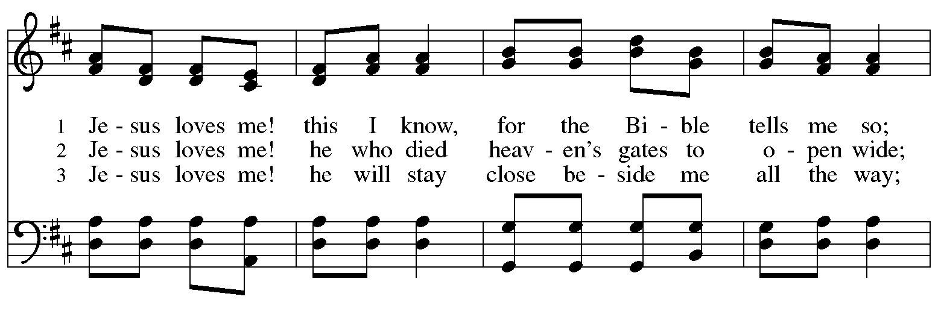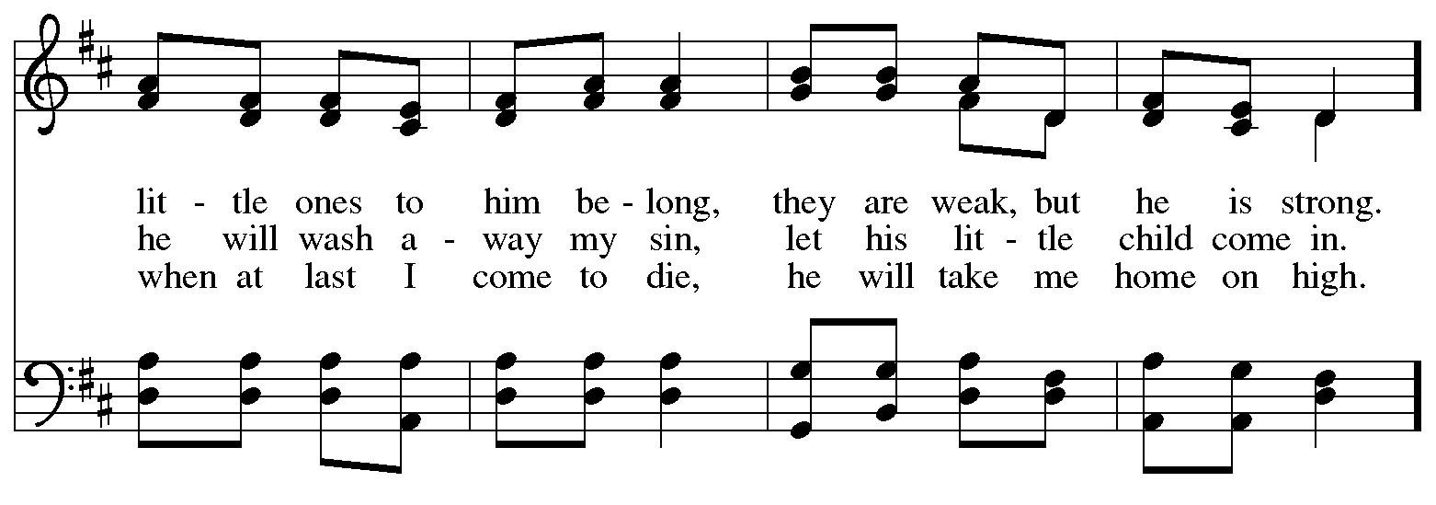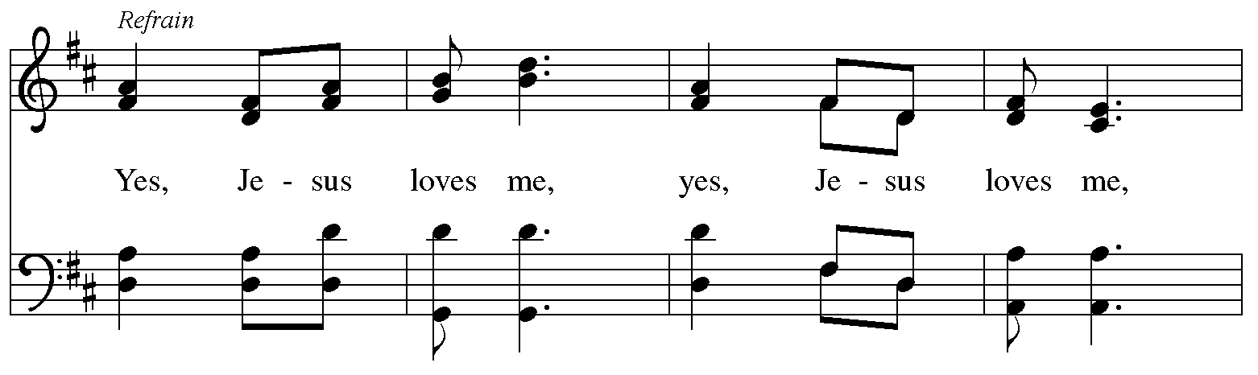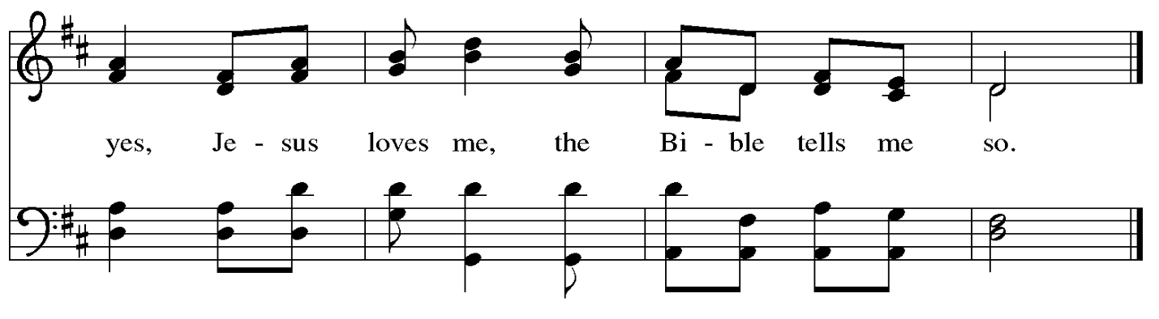

*When all have returned to their places, please rise as you are able.*

**Blessing**

P: The body and blood of our Lord Jesus Christ strengthen you and keep you in his grace.

**C: Amen.**

**Prayer**

A: Let us pray.

Life-giving God,

in the mystery of Christ’s resurrection, you send light to conquer darkness,

water to give new life, and the bread of life to nourish your people.

Send us forth as witnesses to your Son’s resurrection,

that we may show your glory to all the world,

through Jesus Christ, our risen Lord.

**C: Amen.**

**Sending**

*God blesses us and sends us in mission to the world*

**Farewell and Godspeed**

**Benediction**

P: May our glorious God grant you a spirit of wisdom

to know and love the risen Christ.

Almighty God, holy One, ☩ holy Three,

bless you now and forever.

**C: Amen.**

**Sending Hymn** *Following page*

**Dismissal**

A: Alleluia! Christ is risen!

**C: Christ is risen indeed! Alleluia! Alleluia!**

A: Go in peace. Share the good news!

**C: Thanks be to God!**

**Postlude**

**Sending Hymn On Our Way Rejoicing *ELW* 537**

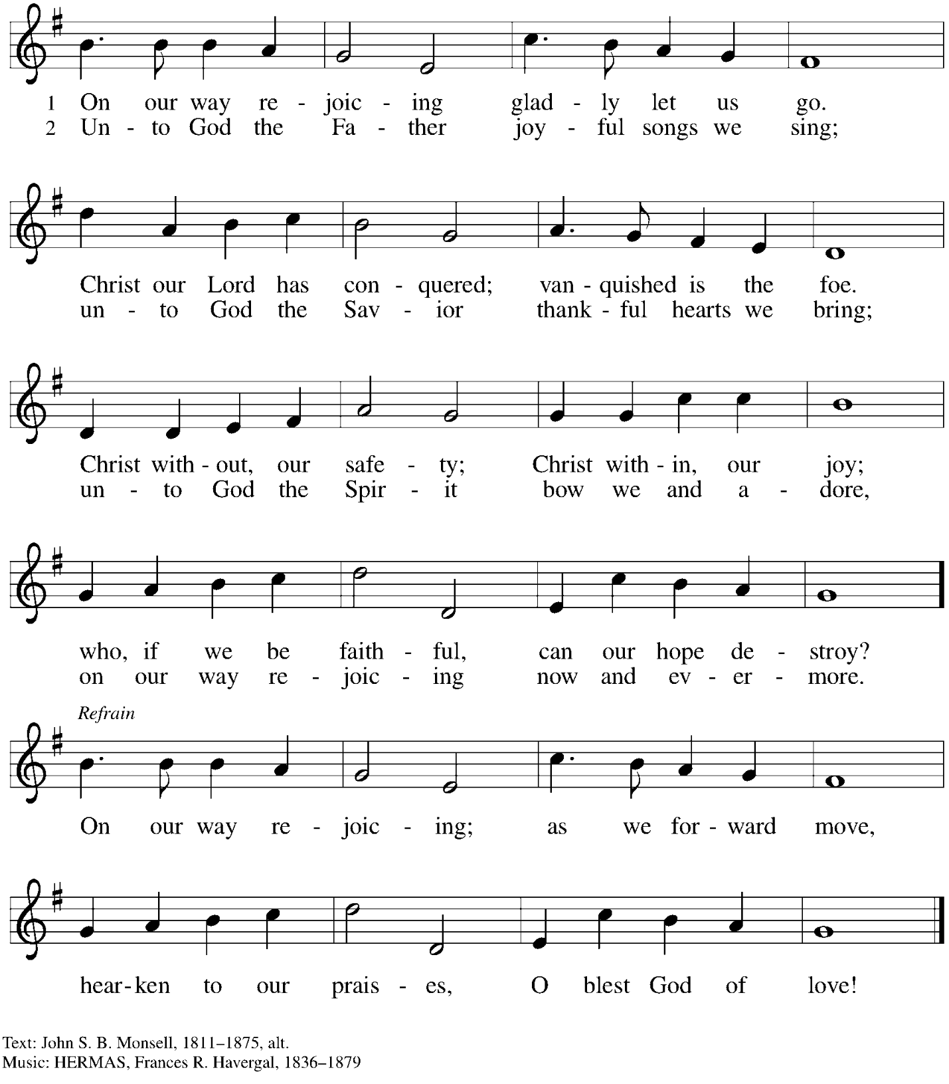

*Those serving in worship today*

Altar Care Jodie Minor

Assisting Minister Timothy Kocher-Hillmer

Audio-Visual Ministers Jason Galyardt

Jered Stratton

Cantor Marit Bakken

Lector Colleen Cooke

Little Church – Big Faith Leader Emily Duque

Trombone – Pre-Service Music Matthew Tesch

Minister of Music Laura Reynolds

Presiding Minister The Rev. Ross I. Carmichael

*Liturgy and Hymnody Acknowledgements*

From SundaysandSeasons.com. Copyright © 2025 Augsburg Fortress. All rights reserved. Reprinted under OneLicense.net # A-722139.

Used by permission of Augsburg Fortress.

The Scripture readings contained herein are from *New Revised Standard Version Updated Edition* of the Bible © 2021 National Council of Churches of Christ in the United States of America. Used by permission. All rights reserved worldwide.

**Let the Vineyards** – Text: John W. Arthur, 1922-1980. Music: Ronald A. Nelson, b. 1927. Text and Music © 1978 *Lutheran Book of Worship*, admin. Augsburg Fortress.

*Please use the QR code below to link to St. Andrew’s Announcements online!*



**St. Andrew Lutheran Church Announcements**

**May 18th, 2025**

* **Happy Easter! Welcome to Worship at St. Andrew on the Fifth Sunday of Easter!** –We are so glad you are here to share in this festive season, and we offer a special welcome to all visitors and guests who are here for the first time! Children are invited to participate in Little Church – Big Faith, a Bible lesson and activity, after the prayer of the day. There are worship “toolkits” to help children engage with worship and “busy bags” for younger children available in the bookcase at the back of the sanctuary. Please feel free to take one to use with/for your children. A nursery is available through the door to the left of the worship space and across the social hall (look for a purple room). We pray that everyone has a blessed Easter season!
* **Noisy Offering Today during Worship – On the third Sunday of each month, St. Andrew’s children lead the congregation in a Noisy Offering, in which people are invited to throw their change into buckets that the children carry around the church and bring forward as an additional offering. Each month’s Noisy Offering supports a local, national, or international church-related or otherwise charitable organization. This month’s offering will benefit ReconcilingWorks: Lutherans for Full Participation, the organization that sponsors St. Andrew’s Reconciling in Christ designation and provides resources for congregations seeking to fully welcome, include, and affirm LGBTQIA+ siblings in the life of the church, congregations, and society. For more information, please visit** [Home - Reconciling Works](https://www.reconcilingworks.org/).
* **Farewell and Godspeed to Rija and Kikao, Isabel and Tate – We at St**. Andrew have been blessed by the presence of Isabel and Tate as they finished their education at Duquesne University and of Rija and Kikao during Rija’s time as visiting scholar at Robert Morris University. This Sunday will be their last service with the congregation, and on such occasions we offer blessings of farewell and Godspeed during worship. Please pray for Rija and Kikao, Isabel and Tate as they move on to serve God and neighbor in other places!
* **St. Andrew Ministry Fair – Today after Worship during Coffee Hour –** St. Andrew strives to make opportunities for ministry and service easily understandable and accessible to everyone in the community, but it is not always easy for someone new to get involved. The council is seeking to share information and make it easier for people to connect by holding a ministry fair after worship today during Coffee Hour. Council members that work with each ministry area will be available at various places in the social hall to share more about what that ministry team does and how people can get involved. The “committees” or ministry teams are Christian Education, Community ministry, Congregational ministry, Evangelism and Advocacy, Property, Stewardship, and Worship.
* **St. Andrew Ministry Area – Congregational Ministry – St. Andrew’s Congregational Ministry team coordinates and provides hospitality for coffee hour and other events, arranges meals for people after a surgery, birth, or other life transition, and generally facilitates meeting the needs of people in the congregation. The current liaison to council is Pat Lutz and she can be reached at** [congregation@standrewpittsburgh.org](mailto:congregation@standrewpittsburgh.org)**. Please speak with Pat to learn more about our ministries of care for people of the congregation!**
* **Represent St. Andrew at Pittsburgh Pride – Saturday, May 31st, in Two Hour Blocks from 10:00 a.m. – 2:00 p.m. – St. Andrew is a Reconciling in Christ (RIC) congregation, publicly supporting the full welcome, participation, and affirmation of LGBTQIA+ siblings in church and society. As a part of this ministry, we participate in Pittsburgh Pride each year with other RIC congregations in the area. This year’s booth will be at the Pride festival on the North Side on Saturday, May 31st. We are asking people to represent the church – greeting people, sharing conversation and information about the church, and connecting people to resources – in two-hour increments from 10:00 a.m. – 6:00 p.m. If you have any questions, please speak with Kelly Spanninger. Please sign up at:** <https://www.signupgenius.com/go/5080B4AAFAF2CABF85-56727383-pittsburgh>.
* **Welcoming Congregations and Sanctuary – What Does This Mean? – Several years ago, the Evangelical Lutheran Church in America (ELCA), of which St. Andrew is a member, started a new initiative called AMMPARO, based on the Spanish word for “refuge” or “protection.” AMMPARO is an acronym for Accompanying Migrant Minors with Protection, Advocacy, Representation, and Opportunities. The initiative was a response to the great needs of unaccompanied minors who were coming to the U.S., and ELCA churches were invited to support the work. St. Andrew became an AMMPARO Welcoming Congregation, committing to accompany and minister to migrants, to pray for migrants, and to advocate for just public policy regarding immigration. In 2019, at the ELCA Churchwide Assembly, our church identified itself as a “Sanctuary Denomination,” which prompted much discussion of how we interpret the word “sanctuary” (See local Bishop Kurt Kusserow’s letter encouraging this discernment, “Sanctuary Church: Being our Best Selves,” here:** <https://gallery.mailchimp.com/a23881a5c641ed10cd7f24da0/files/5cdaff5f-e065-4b01-bfe2-f7abda5a6057/Sanctuary_Church_KusserowMessage.pdf> **) We are inviting people of St. Andrew to gather after worship on Sunday, June 1st, for a discussion of our AMMPARO Welcoming Congregation designation and what Sanctuary means to us at St. Andrew in 2025. Please speak with Pastor Ross if you have questions.**
* **Bethel AME Church Juneteenth Celebrations – Sunday, June 22nd, 11:00 a.m. and 2:00 p.m. –** Friends at Bethel AME Church have invited St. Andrew to join in their events on Sunday, June 22nd in celebration of Juneteenth. Morning worship will be at 11:00 a.m., with Bishop Stafford J.N. Wicker, Presiding Bishop of the Third Episcopal District of the AME Church, preaching. A fellowship meal will follow the service. Afternoon worship will be at 2:00 p.m. with Bishop Kurt Kusserow of our Southwestern Pennsylvania Synod of the Evangelical Lutheran Church in America, preaching.

Musicians, choir members, and soloists are invited to help lead worship. Please contact Minister of Music Laura Reynolds at ministerofmusic@standrewpittsburgh.org if you would like to participate and she will coordinate with Minister Holt of Bethel.

* **Renaissance City Choir “This Is Me” 2025 Pride and 40th Anniversary Concerts – Friday, June 27th and Saturday, June 28th, 7:30 p.m. – Renaissance City Choir, Western Pennsylvania’s LGBTQIA+ choir, is presenting “This Is Me,” its 2025 Pride concert as the choir celebrates its 40th anniversary. The concerts will be Friday, June 27th and Saturday, June 28th at 7:30 p.m. at Point Park University Pittsburgh Playhouse, 350 Forbes Ave. In-person tickets may be purchased at** [RCC 2025 #THIS IS ME Pride Concert in Pittsburgh - Checkout](https://www.ticketleap.events/tickets/rccpittsburgh/rcc-2025-pride-concerts) and tickets for the live-stream can be purchased here: [#This is Me LIVE-STREAM TICKETS ONLY in Pittsburgh - Checkout](https://www.ticketleap.events/tickets/rccpittsburgh/this-is-me-live-stream-tickets-only). Accessibility questions may be directed to [accessibility@rccpittsburgh.com](mailto:accessibility@rccpittsburgh.com). An ASL interpreter will be present on both dates.
* **Coffee Hour Signups Available** –One way that St. Andrew builds community is by sharing conversation over food and drinks at coffee hour after worship on Sundays. We invite people of the congregation to sign up to coordinate coffee hour each week, which includes brewing the coffee; setting out cups, napkins, food items, and cold drinks; and cleaning up afterward. Everything needed is at St. Andrew and instructions are available. Please sign up to host coffee hour here: <https://www.signupgenius.com/go/5080B4AAFAF2CABF85-47069030-coffee>.
* **New *Christ in Our Home* Devotional Booklets for July-September Now Available at Entrances** – This resource offers a daily Bible reading with a short reflection and prayer, along with additional readings and prayer topics for those who would like to expand their devotional practices. We encourage people of the congregation to take one for yourself, your family/household, or others. There are still some copies of the April-June edition available, too!