

**+ The Holy Trinity**

**June 15, 2025**



****St. Andrew Lutheran Church**

**304 Morewood Ave.**

**Pittsburgh, PA 15213**

[**St_andrewELCA@verizon.net**](mailto:St_andrewELCA@verizon.net)

[**www.standrewpittsburgh.org**](http://www.standrewpittsburgh.org)

**+ The Holy Trinity**

**Order for Worship**

*“O Lord our Lord, how majestic is your name in all the earth!”*

*Today we celebrate the Holy Trinity. Paul writes that through Jesus we have peace with God, whose love pours into our hearts through the Holy Spirit, giving us lasting hope.*

*We celebrate the gracious One-in-Three, eternal Three-in-One, as we worship in community;*

*as we share water and word, bread and wine;*

*and as we bring God’s love and hope to our neighbors.*

**Welcome to St. Andrew!**

* St. Andrew welcomes all who are seeking a place of healing, wholeness, and acceptance in a nurturing and faith-forming spiritual home. We are striving toward racial equity worldwide

and we seek to honor the lived experience of all individuals regardless of background. Our community embraces people of all ages, ethnicities, cultures, abilities, sexual orientations,

gender identities and expressions, and family constellations. Come and See!

* Worship Services are live-streamed to multiple online platforms. By attending worship, you agree that your image and voice may be broadcast.
* Everyone is invited to make a name tag at the black bookcase in the back of the worship space if they would like. There are stickers indicating pronouns on the bookcase if you would like to include them on your name tag.
* A nursery is available through the doors at the left side of the sanctuary and across from the doorway to the Social Hall. Look for a purple-colored room.
* Worship “toolkits” to help children engage with the service, along with “busy bags” for younger children, are available in the bookcase at the back of the sanctuary. Please feel free to take one to use with/for your children.
* Holy Communion is served with bread (gluten-free available) and wine or grape juice. The presiding minister will distribute the bread (host). Please consume this and then pick up an empty glass from the tray. The Communion Assistant will pour wine or grape juice into your glass. Please step to the side to consume the wine or grape juice. Feel free to kneel at the altar for prayer and reflection. As you return to your pew, glasses may be returned to the empty trays on either side of the center section.
* A restroom is available on the main level of the church, through the doors to the Social Hall and to the right in the main office.

*Abbreviations*

P: Pastor/Presiding Minister ***ELW*: *Evangelical Lutheran Worship* hymnal**

A: Assisting Minister ***ACS*: *All Creation Sings* hymnal**

L: Lector

**C: Congregation**

**June 17th – Emanuel Nine, Martyrs, 2015**

On June 17th, 2015, Clementa C. Pinckney, Cynthia Marie Graham Hurd, Susie Jackson, Ethel Lee Lance, DePayne Middleton-Doctor, Tywanza Sanders, Daniel Lee Simmons, Sharonda Coleman-Singleton, and Myra Thompson were murdered by a self-professed white supremacist while they were gathered for Bible study and prayer at the Emanuel African Methodist Episcopal Church (often referred to as Mother Emanuel) in Charleston, South Carolina. Pastors Pinckney and Simmons were both graduates of the Lutheran Theological Southern Seminary. A resolution to commemorate June 17th as a day of repentance for the martyrdom of the Emanuel Nine was adopted by the Churchwide Assembly of the Evangelical Lutheran Church in America on August 8th, 2019. Congregations of the ELCA are encouraged to reaffirm their commitment to repenting of the sins of racism and white supremacy which continue to plague this church, to venerate the martyrdom of the Emanuel Nine, and to mark a day of penitence with study and prayer.

**June 19th – Juneteenth, 1865**

Juneteenth is a holiday that commemorates the end of slavery in the United States. It recalls how the states of Louisiana and Texas heard the news that President Abraham Lincoln had signed the Emancipation Proclamation on January 1, 1863. Slavery continued in those two states for more than two years after the proclamation was signed because the word had yet to travel there. Texas and Louisiana finally got the good news on June 19, 1865. Formerly enslaved people broke out in spontaneous celebration. These were dangerous times. Even in the face of resistance and threat, the formerly enslaved Africans found ways to give voice to the wide range of thoughts and emotions at the announcement of the end of legalized slavery in the United States of America.*Please consider joining our* *siblings in Christ at Bethel AME Church next Sunday, June 22nd, for their worship services, celebratory meal, and commemoration of Juneteenth.*

**Pre-Service Music**

**Welcome**

**Prelude**

**Gathering**

*The Holy Spirit calls us together as the people of God*

*Please rise as you are able.*

**Invocation**

P: Blessed be the holy Trinity, ☩ one God,

whose mercy endures forever.

**C: Amen.**

**Commemoration of the Emanuel Nine**

Today we join with Mother Emanuel Methodist Episcopal Church in Charleston, South Carolina and our siblings in Christ across the AME Church in remembering the Emanuel Nine.

The Emanuel Nine, of blessed and eternal memory, were gifted, loving, and faithful people who spent their lives striving for excellence, connection, and the presence of God, and their last moments in the study of God’s word. They leave a legacy of grace, resistance, family, and faith.

We remember:

The Rev. Clementa C. Pinckney

Cynthia Marie Graham Hurd

The Rev. Daniel Lee Simmons

The Rev. DePayne Middleton-Doctor

Ethel Lee Lance

The Rev. Myra Singleton Quarles Thompson

The Rev. Sharonda Coleman-Singleton

Susie Jackson

Tywanza Kibwe Diop Sanders

In faithfulness and dedication, your beloved lived by your promises, sharing their gifts with their families and communities. Ensure, gracious God, that in remembering their lives and witness, the world comes to know of your love and your Spirit at work in and through them.

We ask this in the name of Jesus.

**C: Amen.**

**Confessing Racism: A Lament for the Church**

P: The sin of racism hurts communities of color, fractures human relationships, and denies God’s good creation. To lament is a way for us to recognize the harm caused by racism.

P: Nothing can separate us from the love of God in Christ Jesus (Romans 8:35-39). God’s grace in Christ frees us for the difficult work of recognizing and lamenting racism.

We are all part of one body in Christ, called to act with equity, fairness, and justice. God’s saving love creates grace-filled spaces within us and within our relationships. God’s saving love calls and leads us toward rooting out the racism that continues to harm the body. Remembering the lives and witness of the Emanuel Nine, let us join the whole church in confession and lament.

P: Within the human family, people of color have experienced both interpersonal aggression and structural oppression instead of abundant life. We recognize and lament the harm racism has caused to African Descent communities; American Indian and Alaska Native communities; Indigenous Peoples within Canada; Arab and Middle Eastern communities; Asian and Pacific Islander communities; and Latinx communities. We cry out to you,

**C: Lord, have mercy,**

P: We have assigned the notion of race to human beings created in God’s own divine image. We have judged God’s beautiful diversity by our flawed and artificial standards. We cry out to you, **C: Lord, have mercy.**

P: We have used language and images in ways that equate black and dark with stain and sin, and that fail to welcome the treasures of darkness in God’s good creation. We cry out to you,

**C: Lord, have mercy.**

P: We have accepted practices in our churches and in our society that privilege whiteness over diversity and equity. We have been complicit in how racism continues to exclude and harm people of color. We cry out to you,

**C: Lord, have mercy.**

P: When one part of the body of Christ suffers, the whole body suffers.

As we listen to people who are harmed by racism, we call to you,

**C: open our hearts, O God.**

P: As we reflect on our daily interactions with people and communities of color, we call to you, **C: open our hearts, O God.**

P: As we reconsider what we have been taught about race and racism, we call to you,

**C: open our hearts, O God.**

P: As we contemplate what we have done and what we have left undone, we call to you,

**C: open our hearts, O God.**

P: As we work to cultivate loving and safe communities for our siblings of color and all people, we call to you,

**C: open our hearts, O God.**

P: Holy, merciful and living God, we commit ourselves anew to the work of loving one another as you have loved us. Unite us as members of your body, connected to one another and empowered for the work you call us to do, in the name of Jesus and by the power of your renewing Spirit.

**C: Amen.**

**Hymn When Our World Is Rent by Violence *ACS* 1052**

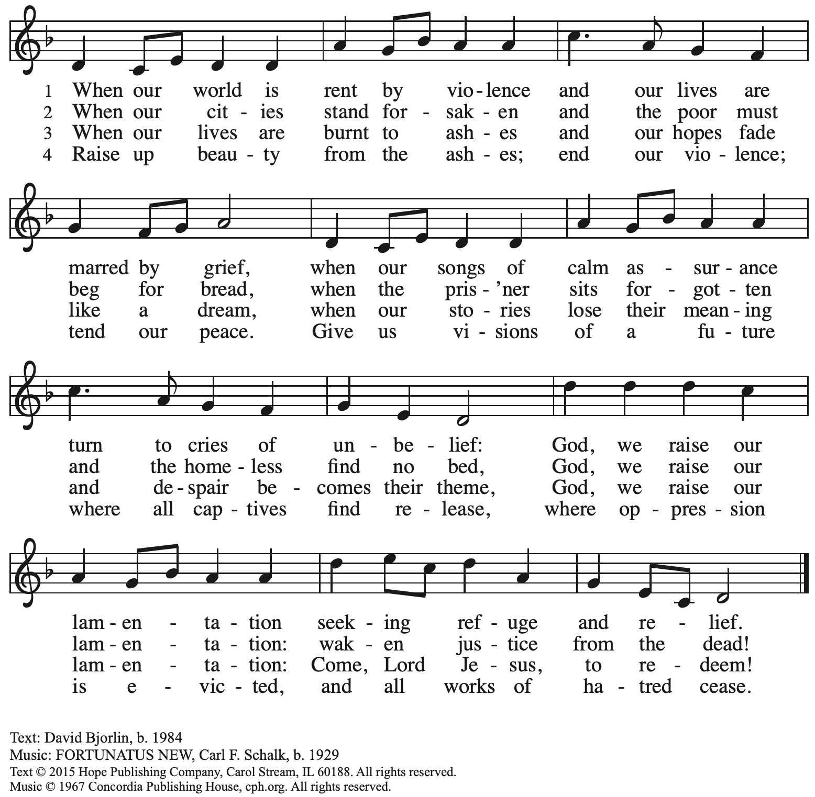

**Greeting**

P: The grace of our Lord Jesus Christ, the love of God,

and the communion of the Holy Spirit be with you all.

**C: And also with you.**

**Hymn of Praise**  *ELW* p. 204

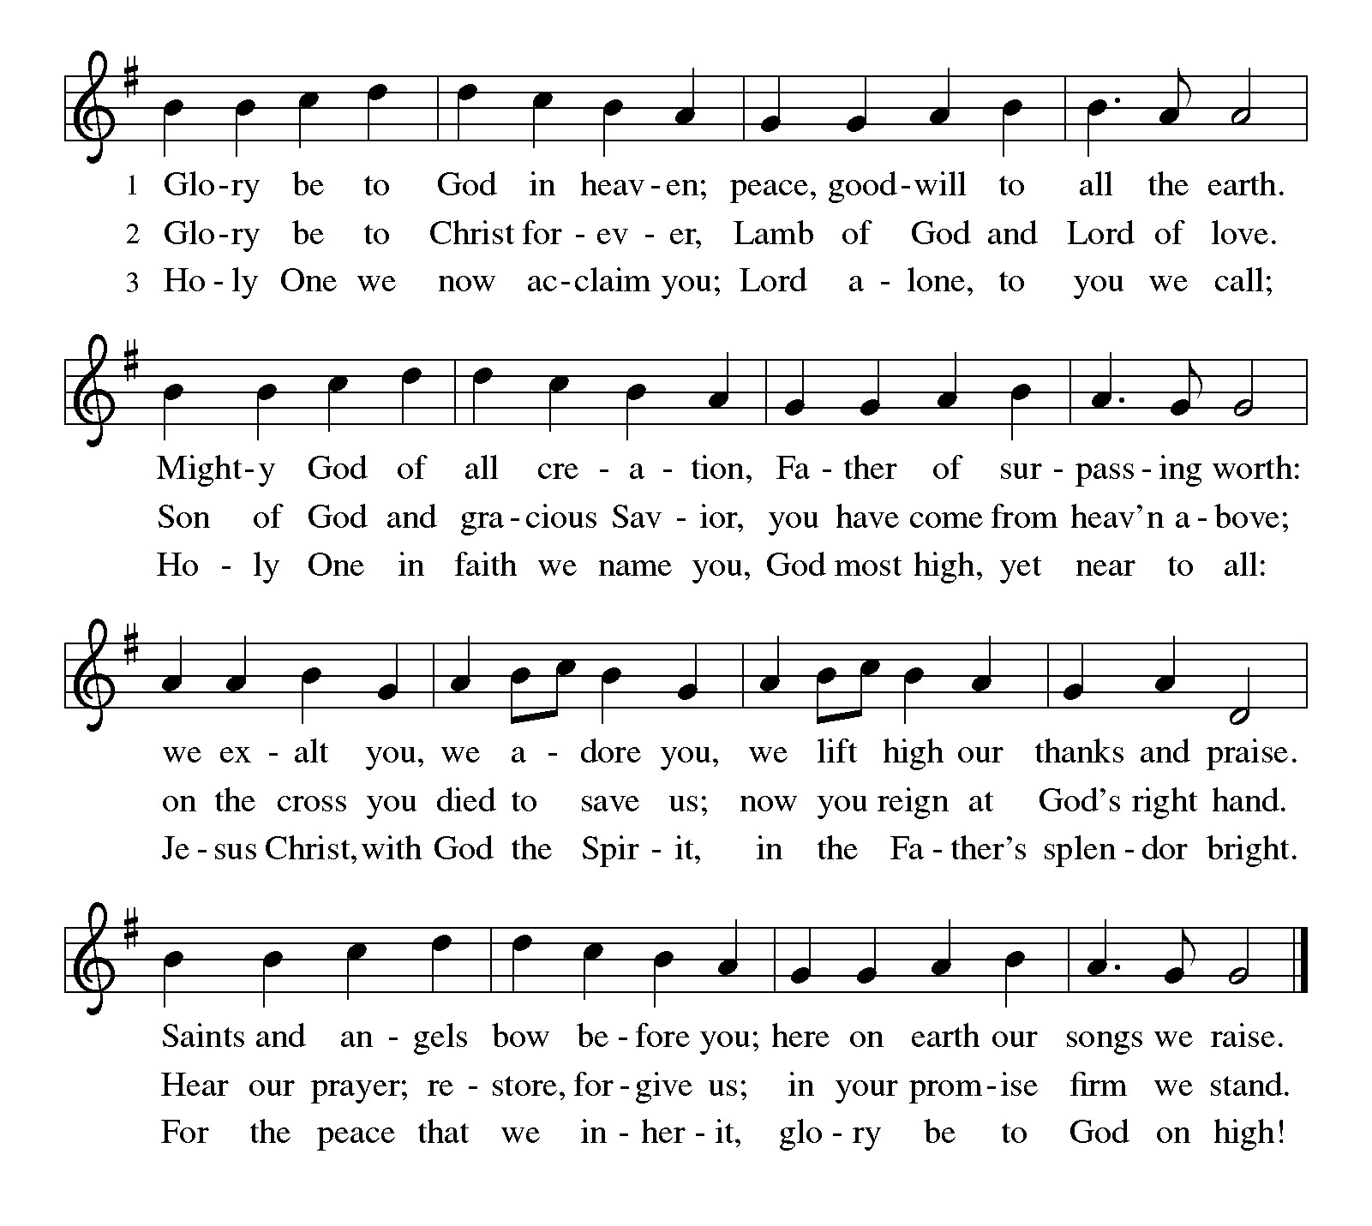

**Prayer of the Day**

P: The Lord be with you.

**C: And also with you.**

P: Let us pray.

Almighty Creator and ever-living God:

we worship your glory, eternal Three-in-One, and we praise your power, majestic One-in-Three. Keep us steadfast in this faith, defend us in all adversity, and bring us at last into your presence, where you live in endless joy and love, Father, Son, and Holy Spirit, one God, now and forever.

**C: Amen.**

*Please be seated.*

**Word**

*God speaks to us in Scripture reading, preaching, and song*

**First Reading** **– Proverbs 8: 1-4, 22-31**

 1 Does not wisdom call  
  and understanding raise her voice?  
 2 On the heights, beside the way,  
  at the crossroads she takes her stand;  
 3 beside the gates in front of the town,  
  at the entrance of the portals she cries out:  
 4 “To you, O people, I call,  
  and my cry is to all who live.

 22 “The Lord created me at the beginning of God’s work,  
  the first of God’s acts of long ago.  
 23 Ages ago I was set up,  
  at the first, before the beginning of the earth.  
 24 When there were no depths I was brought forth,  
  when there were no springs abounding with water.  
 25 Before the mountains had been shaped,  
  before the hills, I was brought forth,  
 26 when the Lord had not yet made earth and fields  
  or the world’s first bits of soil.  
 27 When the Lord established the heavens, I was there;  
  when the Lord drew a circle on the face of the deep,  
 28 when the Lord made firm the skies above,  
  when the Lord established the fountains of the deep,  
 29 when the Lord assigned to the sea its limit,  
  so that the waters might not transgress God’s command,  
 when the Lord marked out the foundations of the earth,  
  30 then I was beside God, like a master worker,  
 and I was daily God’s delight,  
  playing before God always,  
 31 playing in God’s inhabited world  
  and delighting in the human race.

L: Word of God, word of life.

**C: Thanks be to God.**

**Psalm 8**

*The psalm will be sung responsively, led by the cantor,*

*with the congregation responding with the bold verses and refrain.*

*Psalm tone*

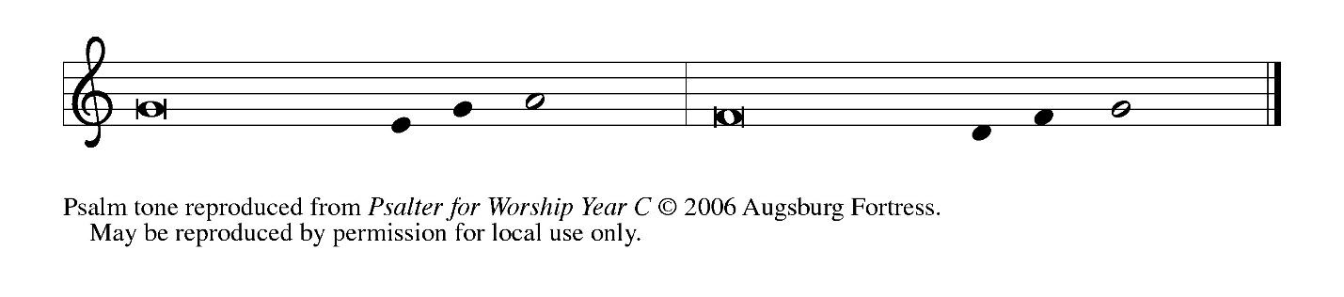

*Psalm refrain*

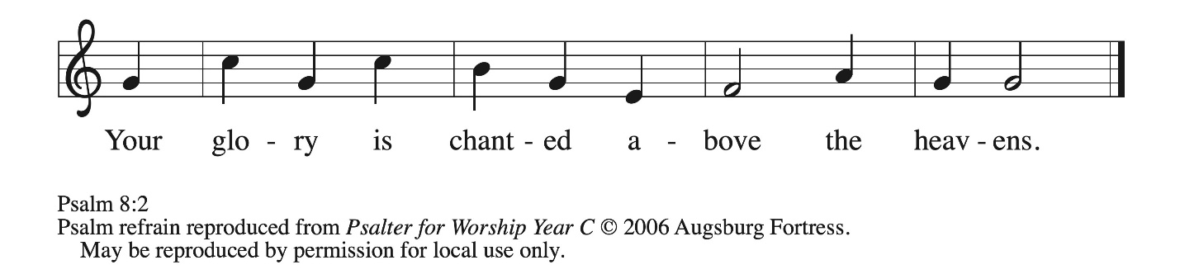

1 O **|** Lord our Lord,  
  how majestic is your name in **|** all the earth!—  
 2 **you whose glory is chanted above the heavens out of the mouths of in- | fants and children;**  
  **you have set up a fortress against your enemies, to silence the foe | and avenger. R**  
 3 When I consider your heavens, the work **|** of your fingers,  
  the moon and the stars you have set **|** in their courses,  
 4 **what are mere mortals that you should be mind- | ful of them,**  
  **human beings that you should | care for them? R**  
 5 Yet you have made them little less **|** than divine;  
  with glory and hon- **|** or you crown them.  
 6 **You have made them rule over the works | of your hands;**  
  **you have put all things un- | der their feet:**  
 7 all **|** flocks and cattle,  
  even the wild beasts **|** of the field,  
 8 **the birds of the air, the fish | of the sea,**  
  **and whatever passes along the paths | of the sea.**  
 9 O **|** Lord our Lord,  
  how majestic is your name in **|** all the earth!**R**

**Second Reading – Romans 5: 1-5**

14 For all who are led by the Spirit of God are children of God. 15 For you did not receive a spirit of slavery to fall back into fear, but you received a spirit of adoption. When we cry, “Abba! Father!” 16 it is that very Spirit bearing witness with our spirit that we are children of God, 17 and if children, then heirs: heirs of God and joint heirs with Christ, if we in fact suffer with him so that we may also be glorified with him.

L: Word of God, word of life.

**C: Thanks be to God.**

*Please rise as you are able.*

**Gospel Acclamation** *ELW* p. 205

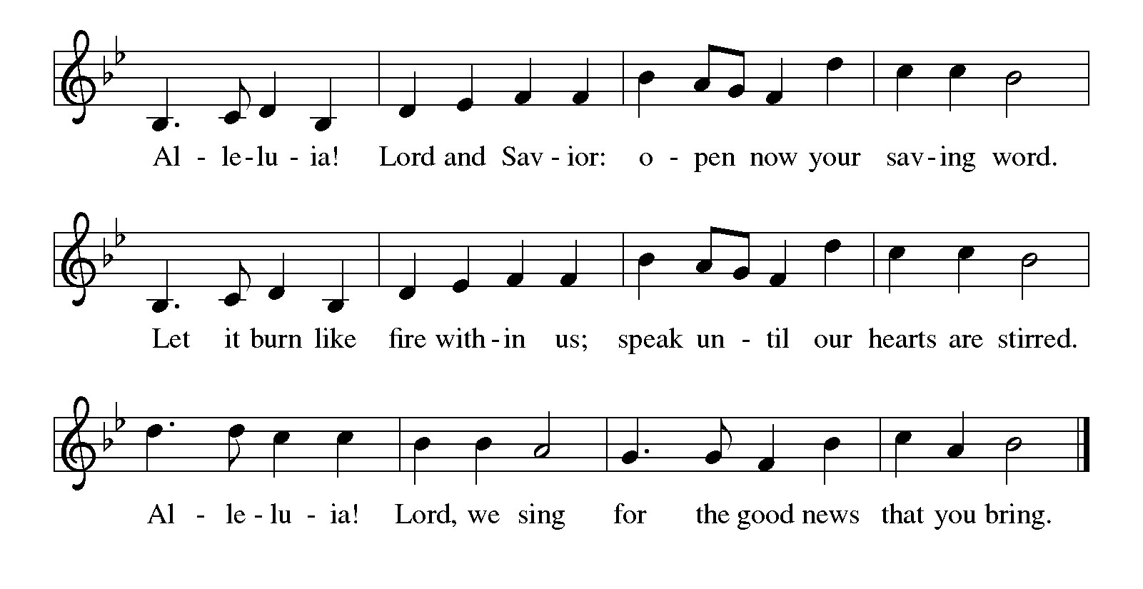

**Gospel – John 16: 12-15**

P: The holy Gospel according to St. John.

**C: Glory to you, O Lord.**

[Jesus said,] 12 “I still have many things to say to you, but you cannot bear them now. 13 When the Spirit of truth comes, he will guide you into all the truth, for he will not speak on his own but will speak whatever he hears, and he will declare to you the things that are to come. 14 He will glorify me because he will take what is mine and declare it to you. 15 All that the Father has is mine. For this reason I said that he will take what is mine and declare it to you.

P: The Gospel of the Lord.

**C: Praise to you, O Christ.**

*Please be seated.*

**Sermon**

*A time of silence for prayer and reflection follows the sermon.*

*When the hymn of the day begins, please rise as you are able.*

**Hymn of the Day Mothering God, You Gave Me Birth *ELW* 735**

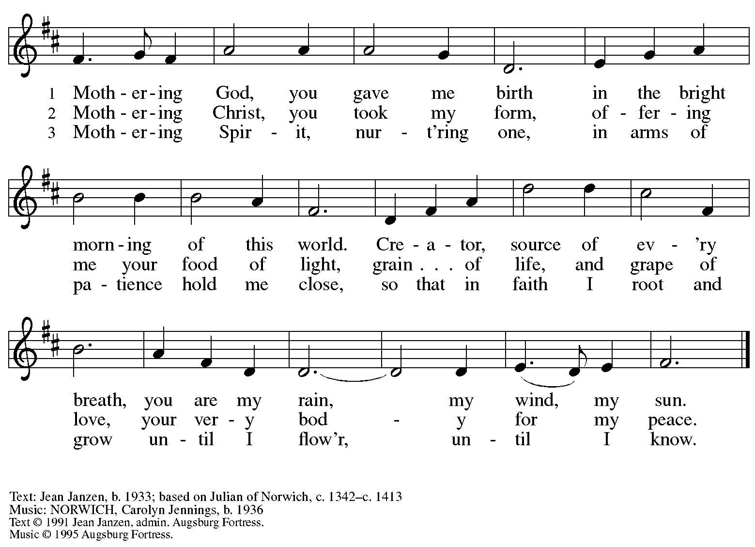

All rights reserved. Reprinted with permission under OneLIcense.net # A-722139.



**Nicene Creed**

**C: We believe in one God,**

**the Father, the Almighty,**

**maker of heaven and earth,**

**of all that is, seen and unseen.**

**We believe in one Lord, Jesus Christ,**

**the only Son of God,**

**eternally begotten of the Father,**

**God from God, Light from Light,**

**true God from true God,**

**begotten, not made,**

**of one Being with the Father;**

**through him all things were made.**

**For us and for our salvation**

**he came down from heaven,**

**was incarnate of the Holy Spirit and the virgin Mary**

**and became truly human.**

**For our sake he was crucified under Pontius Pilate;**

**he suffered death and was buried.**

**On the third day he rose again**

**in accordance with the scriptures;**

**he ascended into heaven**

**and is seated at the right hand of the Father.**

**He will come again in glory to judge the living and the dead,**

**and his kingdom will have no end.**

**We believe in the Holy Spirit, the Lord, the giver of life,**

**who proceeds from the Father and the Son,\***

**who with the Father and the Son is worshiped and glorified,**

**who has spoken through the prophets.**

**We believe in one holy catholic and apostolic church.**

**We acknowledge one baptism for the forgiveness of sins.**

**We look for the resurrection of the dead,**

**and the life of the world to come. Amen.**

*Or, “who proceeds from the Father.” The phrase “and the Son” is a later addition to the creed.

**Prayers of the People**

A: Drawn into the embrace of the Holy Trinity,

we lift our prayers for the wholeness of the church,

those in need, and all creation.

*After each petition*

A: God of grace,

**C: receive our prayer.**

*The presiding minister concludes the prayers*

P: Gather all our prayers in your mercy, O God, through Jesus Christ our Savior.

**C: Amen.**

**Peace**

*The presiding minister and the assembly greet one another in the peace of the risen Christ.*

P: The peace of Christ be with you always.

**C: And also with you.**

*The people may greet those around them with a sign of Christ’s peace and may say*

Peace be with you *or similar words. Please be mindful that not everyone will be comfortable with sharing the peace, so please seek consent before shaking hands or hugging. Other possible ways to share the peace include a simple bow with the verbal greeting of peace, or simply a verbal expression of peace.*

*When the greetings of peace have concluded, please be seated.*

**Meal**

*God feeds us with the presence of Jesus Christ*

**Offering**

*We offer ourselves, our gifts, and our faithful service to God.*

*As the offering is gathered for the mission of the church, including the care of those in need,*

*the table is set for Holy Communion.*

*There are laminated giving cards in the pew racks that feature a QR code for anyone who would like to give online. Those who give using the QR code, as well as those who give regularly online or through their bank are encouraged to place the laminated card in the plate as an expression of your offering.*

**Noisy Offering**

*As children of the congregation carry buckets around the sanctuary, people of the congregation are invited to throw in their change as an offering. This month’s noisy offering will benefit Proud Haven, whose mission is to provide a safe shelter for LGBTQIA+ youth and young adults, (ages 18-25), as well as emotional support and resources to help LGBTQIA+ youth live independently.*

**Offertory Music**

*As the gifts are brought forward for presentation, please rise as you are able.*

**Offertory Song** **As the Grains of Wheat *ELW* 465**

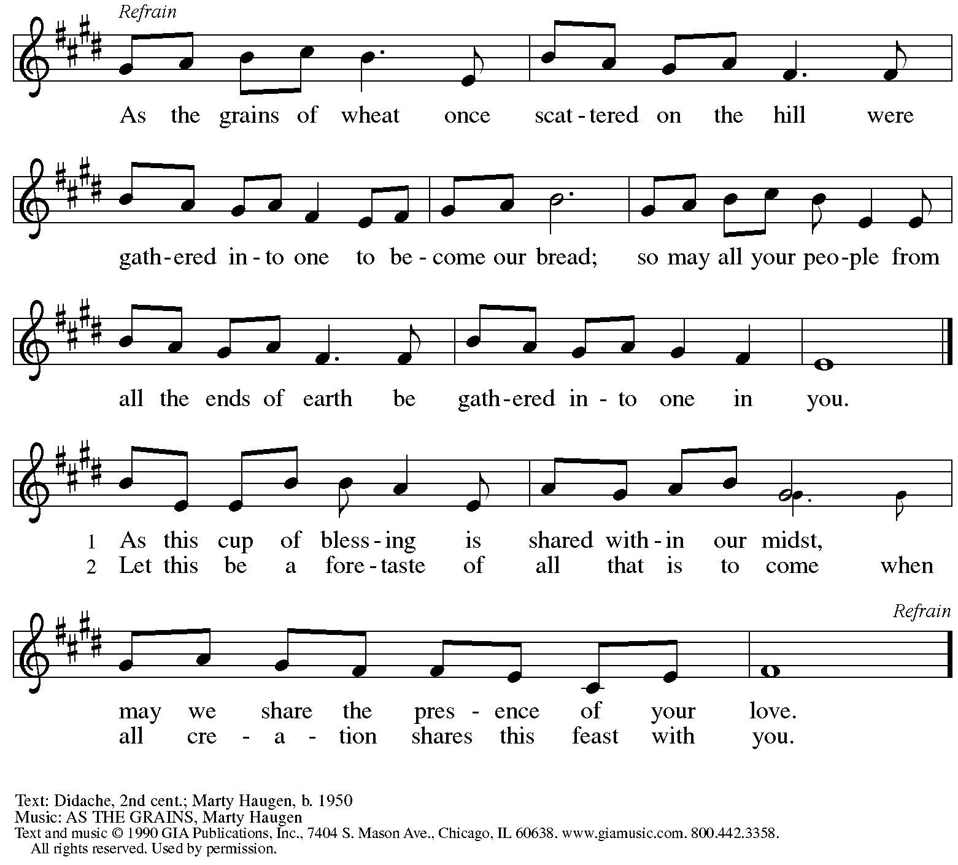

Reprinted under OneLicense.net # A-722139.

**Offertory Prayer**

A: Let us pray.

God of all creation,

**C: all you have made is good and** **your love endures forever.**

**You bring forth bread from the earth and fruit from the vine.**

**Nourish us with these gifts,**

**that we might be for the world signs of your gracious presence**

**in Jesus Christ, our Savior and Lord.**

**Amen.**

**Dialogue** *ELW* p. 206

P: The Lord be with you.

**C: And also with you.**

P: Lift up your hearts.

**C: We lift them to the Lord.**

P: Let us give thanks to the Lord our God.

**C: It is right to give our thanks and praise.**

**Preface** *(Spoken by the presiding minister)*

P: It is indeed right, our duty and our joy,

that we should at all times and in all places

give thanks and praise to you, almighty and merciful God.

You reveal your glory

as the glory of the Father, the Son, and the Holy Spirit:

equal in majesty, undivided in splendor, one Lord, one God,

ever to be adored in your eternal glory.

And so, with all the choirs of angels,

with the church on earth and the hosts of heaven,

we praise your name and join their unending hymn:

**Sanctus** *ELW* p. 207

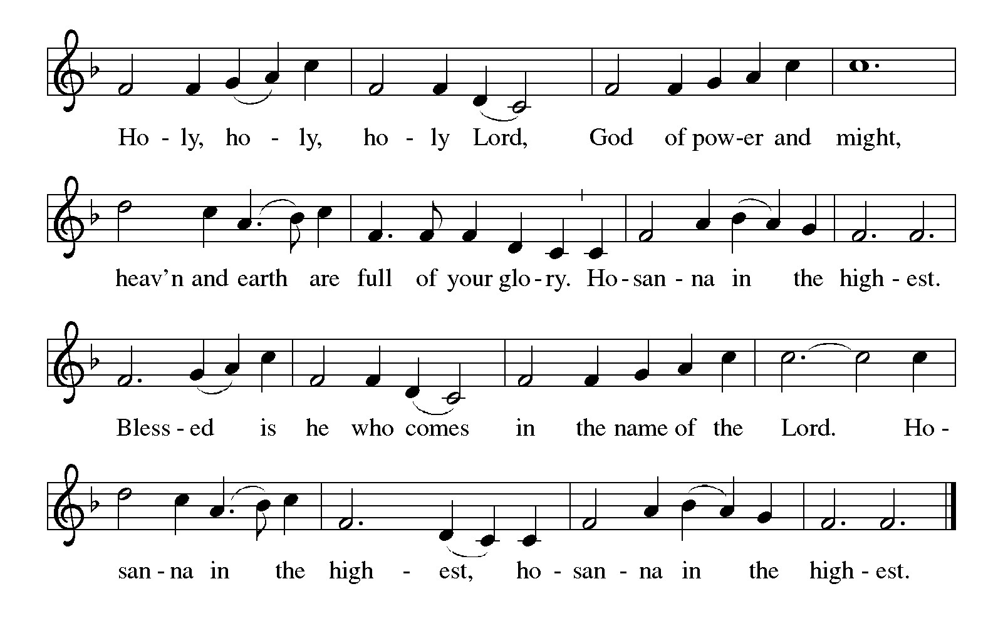

**Eucharistic Prayer**

P: Holy God, Holy One, Holy Three …

your grace our path to rebirth.

And so we cry, Mercy:

**C: Mercy!**

P: And so we cry, Glory:

**C: Glory!**

P: And so we cry, Blessing:

**C: Blessing!**

P: Holy God, we eagerly anticipate the work of your Spirit …

make us, despite death, alive.

And so we cry, Come, Holy Spirit:

**C: Come, Holy Spirit!**

P: And so the church shouts, Come, Holy Spirit:

**C: Come, Holy Spirit!**

P: And so the earth pleads, Come, Holy Spirit:

**C: Come, Holy Spirit!**

P: You, Holy God, Holy One, Holy Three …

Praise now, Praise tomorrow, Praise forever.

And so we cry, Amen, Amen, and Amen!

**C: Amen, Amen, and Amen!**

**Lord’s Prayer**

P: Gathered as one by the Holy Spirit, let us pray as Jesus taught us.

**C: Our Father, who art in heaven,**

**hallowed be thy name,**

**thy kingdom come,**

**thy will be done,**

**on earth as it is in heaven.**

**Give us this day our daily bread;**

**and forgive us our trespasses,**

**as we forgive those**

**who trespass against us;**

**and lead us not into temptation,**

**but deliver us from evil.**

**For thine is the kingdom,**

**and the power, and the glory,**

**forever and ever. Amen.**

**Fraction and Invitation**

P: These are the gifts of our triune God for the people of God.

Come, share the feast.



***Agnus Dei /* Lamb of God** *ELW* p. 208

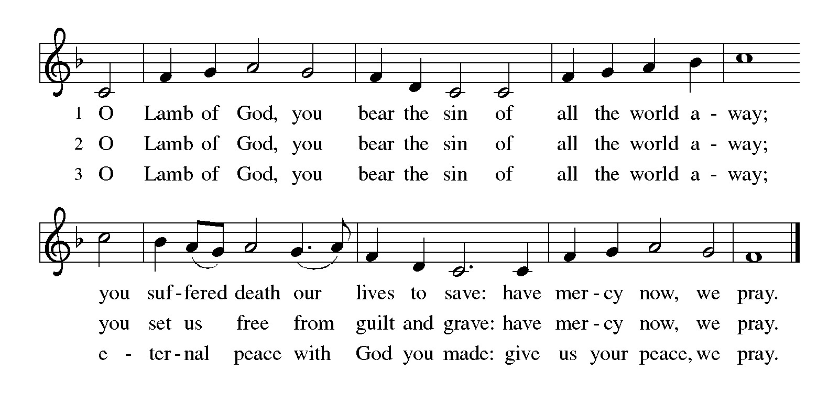

*Please be seated.*

**Holy Communion**

* *All who seek God and desire a deeper and stronger life in Christ are welcome to receive Holy Communion.*
* *Worshipers from the pulpit side will proceed forward first, followed by the center section, and then the lectern side.*
* *Please inform an usher if you would like the ministers to bring Communion to you.*
* *Holy Communion will be served with bread and wine or grape juice.*
* *The presiding minister will first distribute the bread (host) to each communicant. Please indicate if you require a gluten-free host.*
* *Once you have consumed the bread, please pick up an empty glass from the tray next to the presiding minister. The Communion Assistant will pour wine or grape juice into your glass.*
* *Please step to the side to consume the wine or grape juice.*
* *Feel free to kneel at the altar rail for prayer after receiving the sacrament.*
* *As you return to your pew, glasses may be returned to the empty tray on the side of the center section.*
* *A blessing will be provided for anyone who does not yet receive the sacrament.*
* *All are invited to join in singing the hymns during Holy Communion.*

**Hymns during Holy Communion**

**O Holy Spirit, Root of Life *ELW* 399**

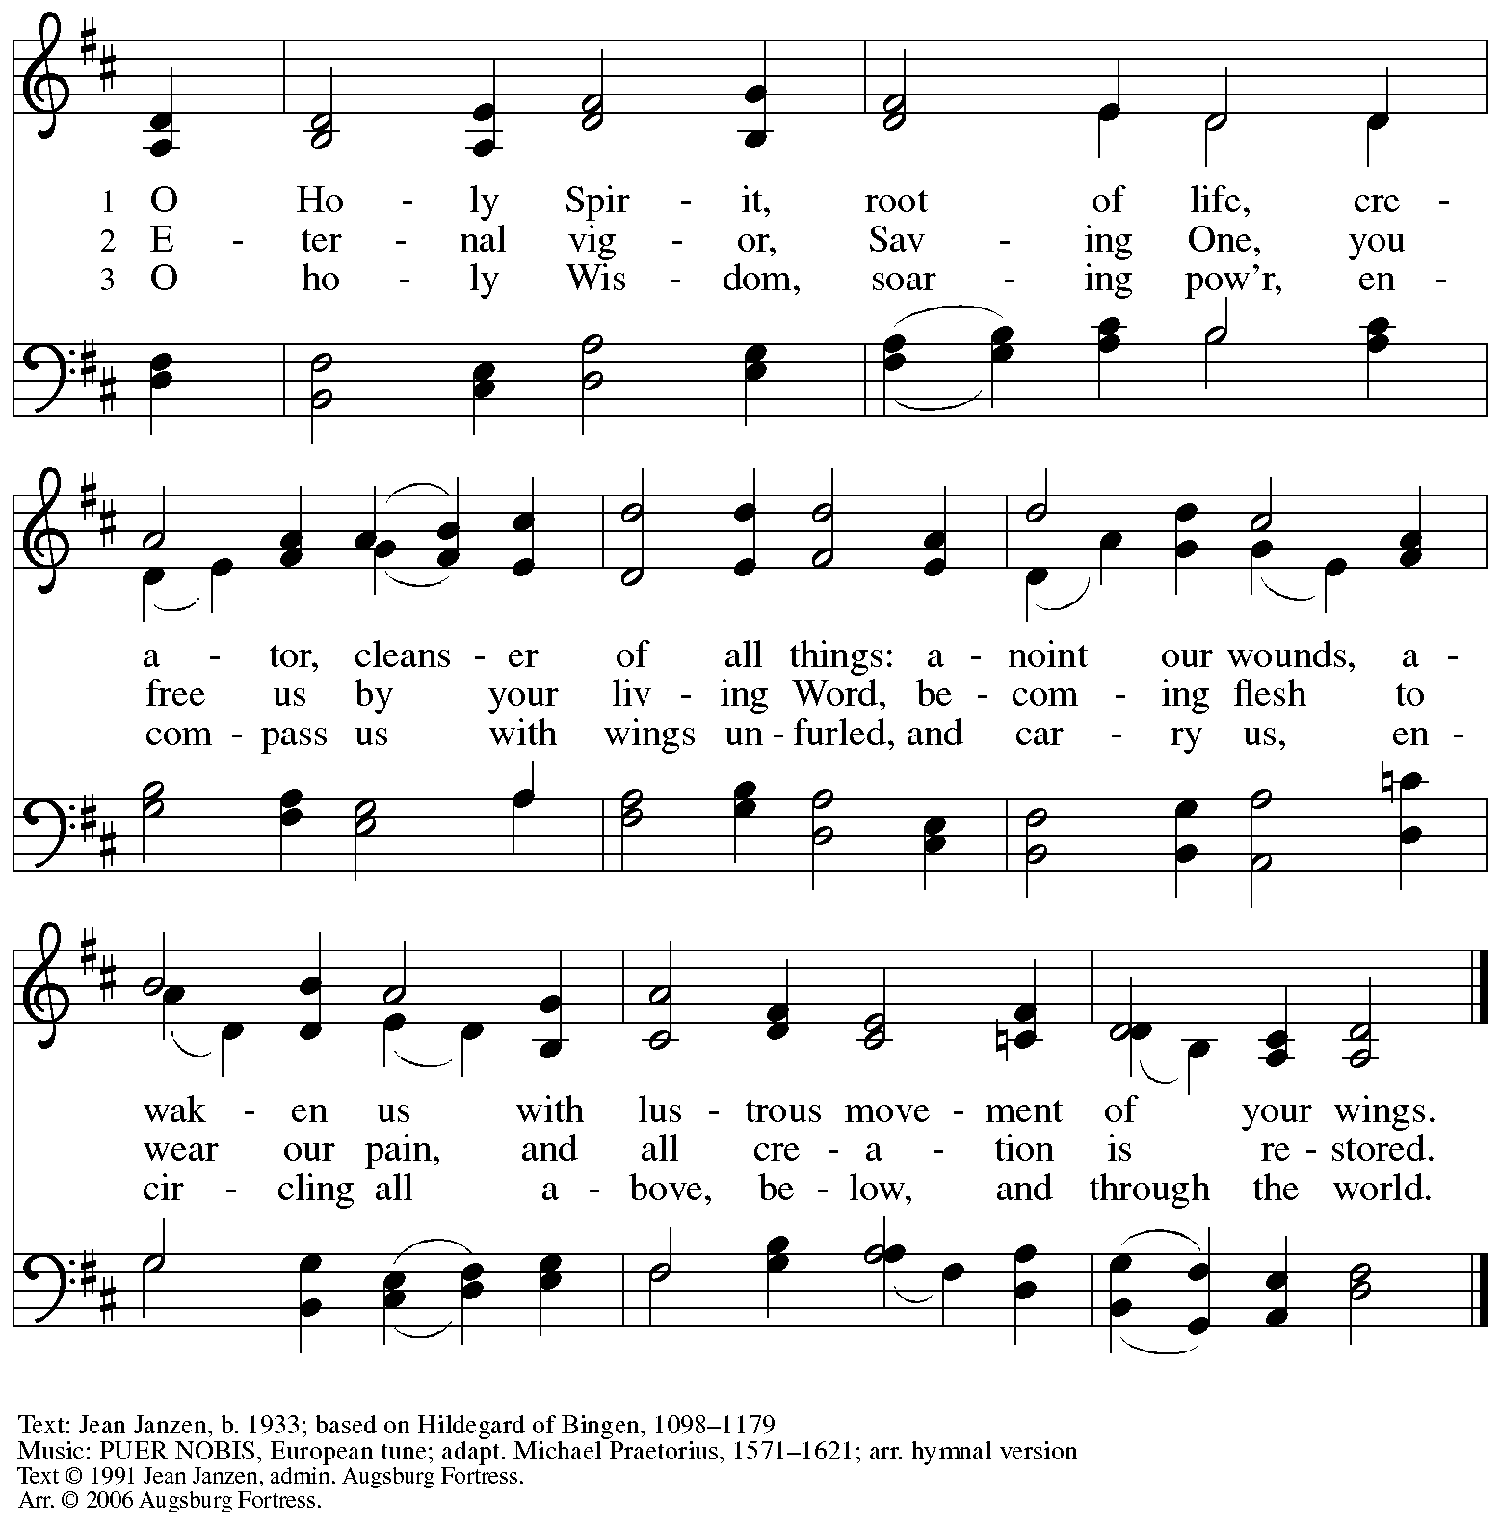

All rights reserved. Reprinted with permission under Onelicnese.net # A-722139.

**Hymns during Holy Communion**

**The Play of the Godhead *ACS* 946**

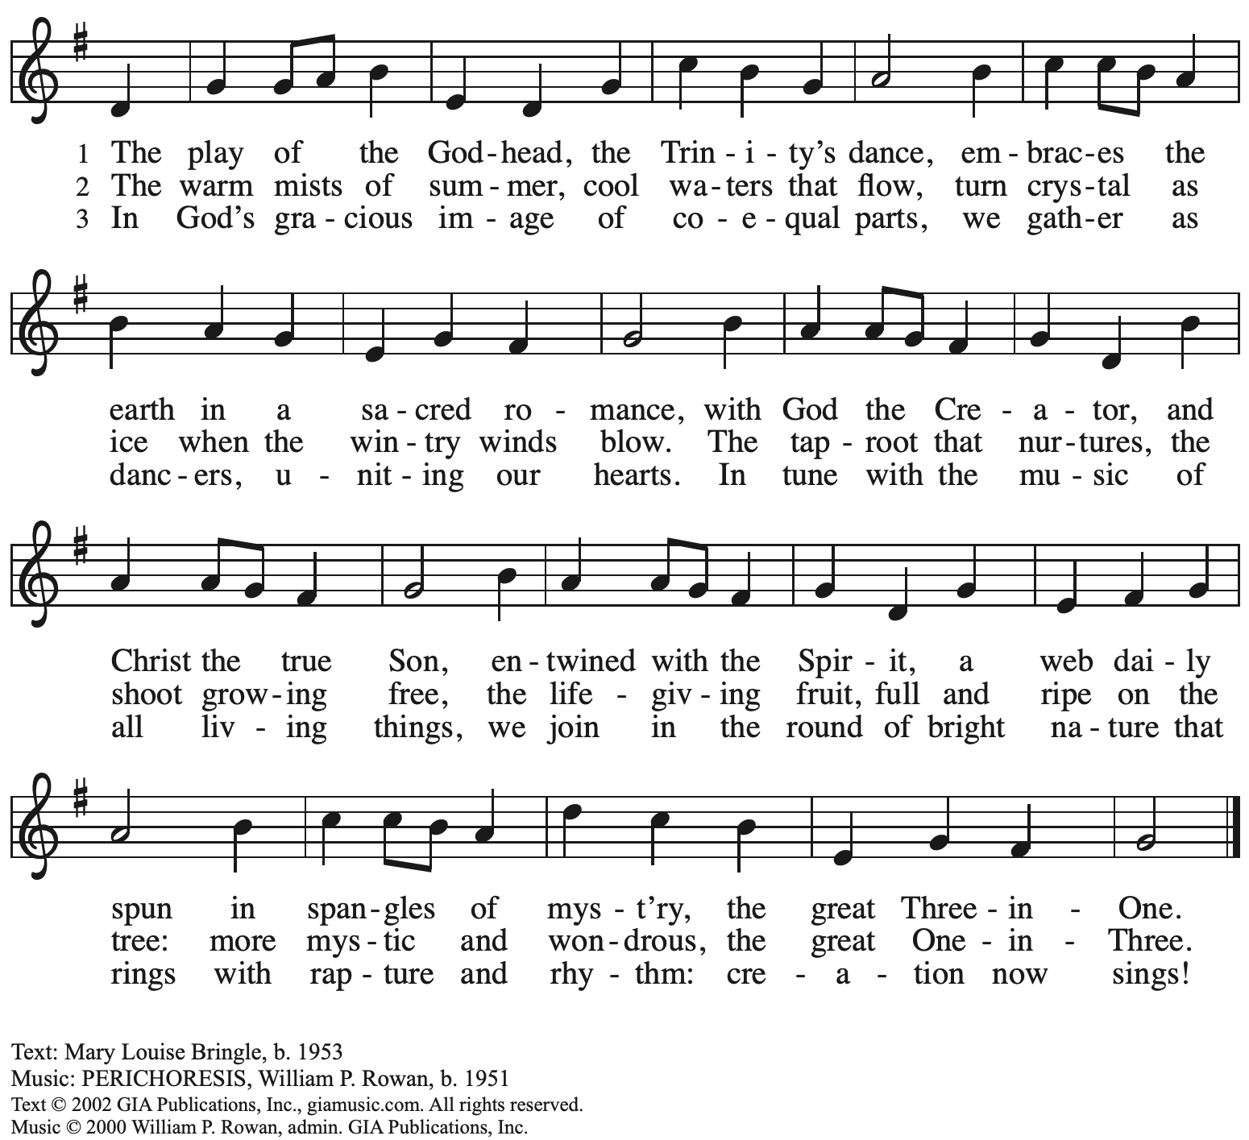

All rights reserved. Reprinted with permission under OneLicense.net # A-722139.

**Hymns during Holy Communion**

**Source and Sovereign, Rock and Cloud**  ***ACS* 947**

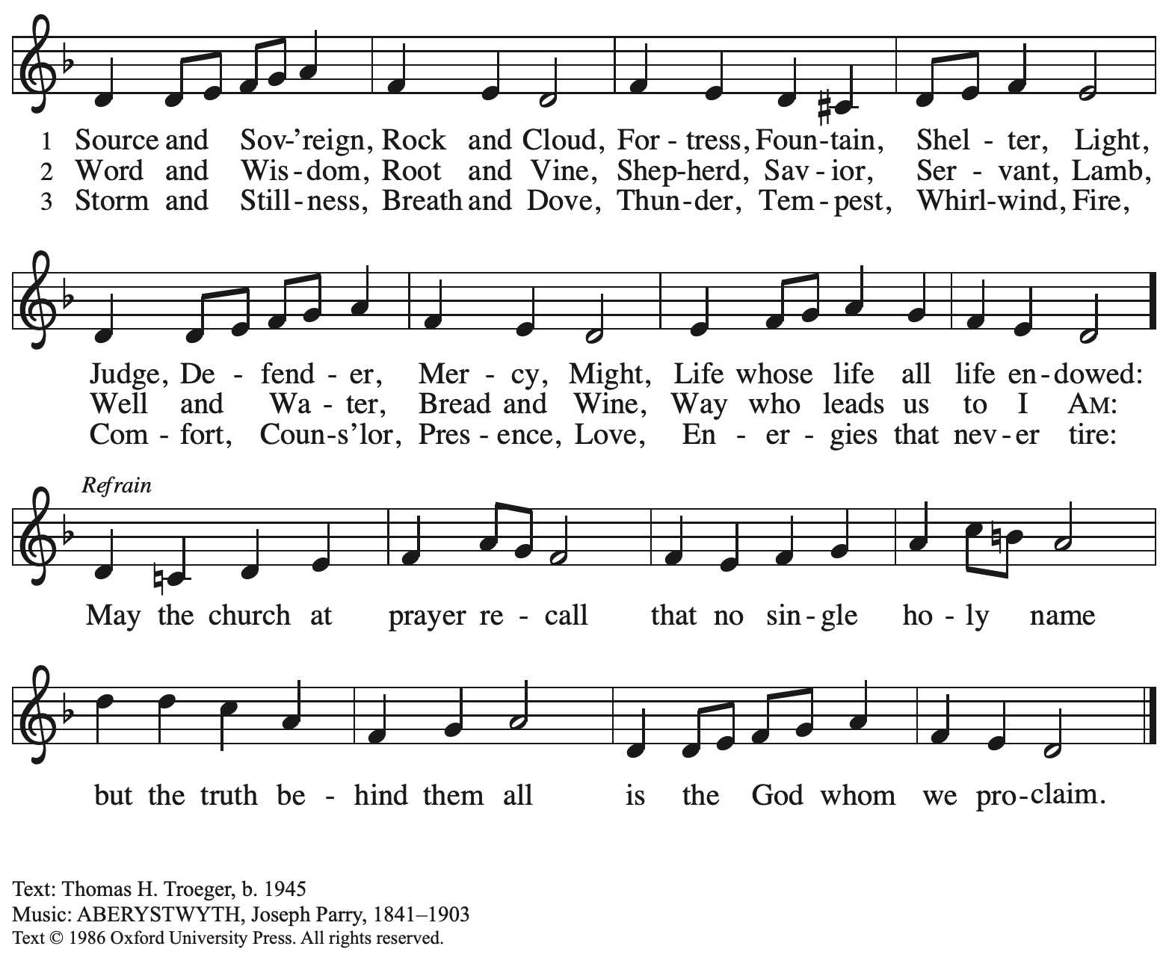

Reprinted with permission under OneLicense.net # A-722139.

**Hymns during Holy Communion**

**God, Whose Almighty Word *ELW* 673**

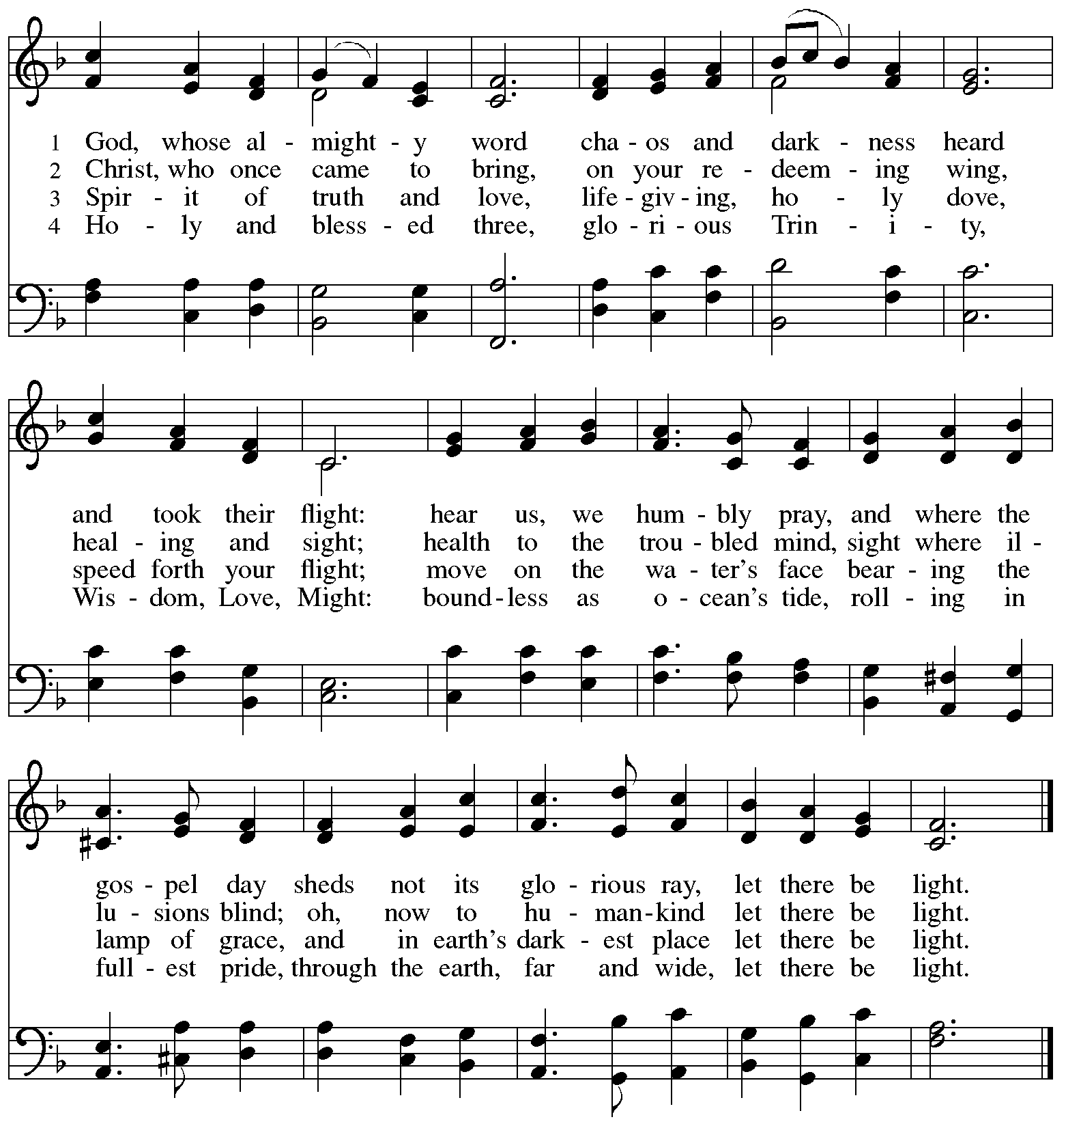



*When all have returned to their places, please rise as you are able.*

**Blessing**

P: The body and blood of our Lord Jesus Christ strengthen you and keep you in his grace.

**C: Amen.**

**Prayer**

A: Let us pray.

O God, our life, our strength, our food,

we give you thanks for sustaining us with the body and blood of your Son.

By your Holy Spirit, enliven us to be his body in the world,

that more and more we will give you praise and serve your earth and its many peoples,

through Jesus Christ, our Savior and Lord.

**C: Amen.**

*Please be seated.*

**Sending**

*God blesses us and sends us in mission to the world*

**Announcements**

*Please rise as you are able.*

**Benediction**

P: The God of steadfastness and encouragement

grant you to live in harmony with one another,

in accordance with Christ Jesus.

**C: Amen.**

P: The God of hope fill you with all joy and peace in believing,

so that you may abound in hope by the power of the Holy Spirit.

**C: Amen.**

P: The God of all grace ☩ bless you now and forever.

**C: Amen.**

**Sending Hymn** *Following page*

**Sending Hymn Holy, Holy, Holy, Lord God Almighty! *ELW* 413**

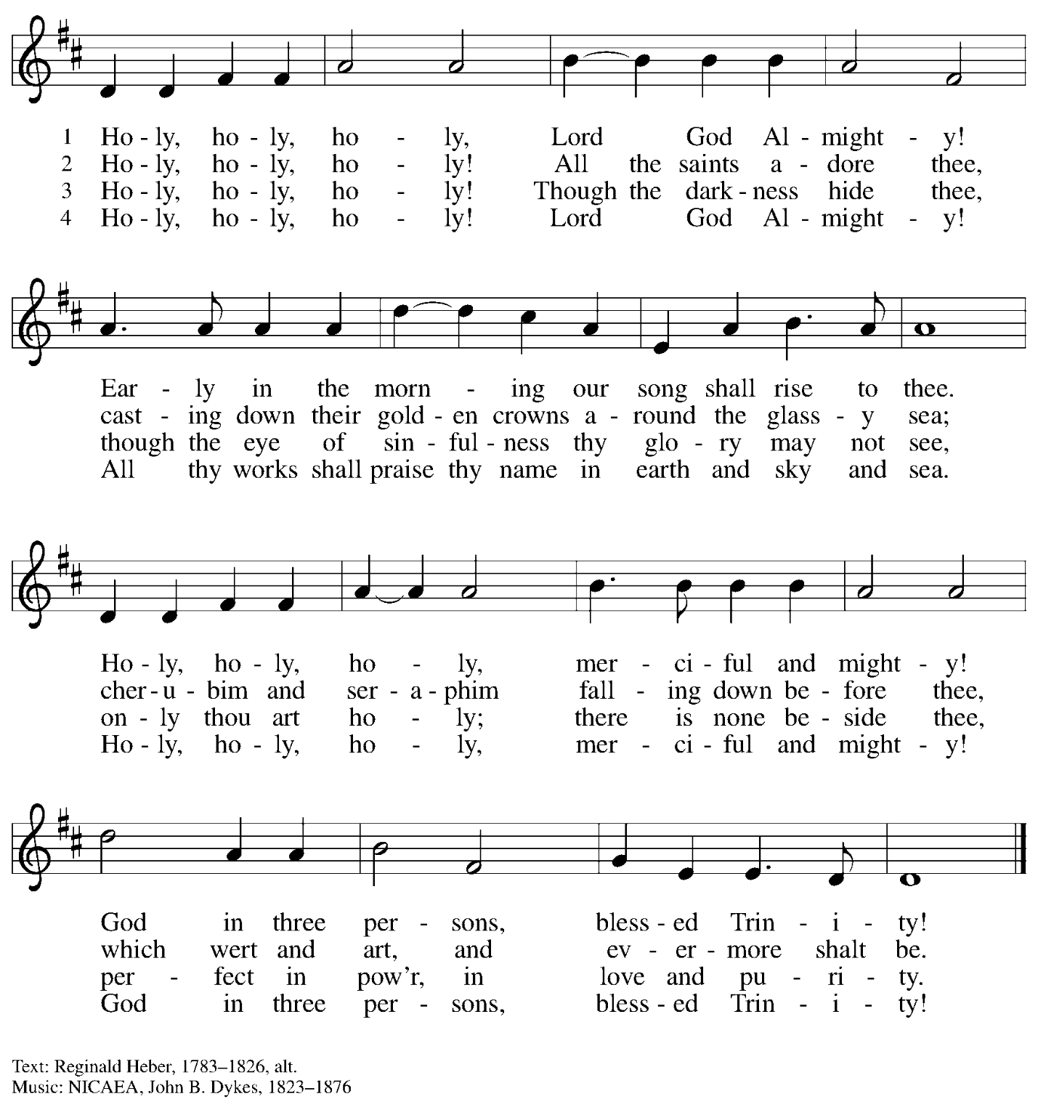

**Dismissal**

A: Go in peace. Serve the Lord.

**C: Thanks be to God!**

**Postlude**

*Those serving in worship today*

Altar Care Jodie Minor

Assisting Minister Jeff Denlinger

Audio-Visual Ministers Kristen Asplin

Tyler Rietze

Cantor Joseph Paetz

Lector Lester Prince

Organ Jimmi Kocher-Hillmer

Pre-Service Music Kristen Asplin

Vocal Prelude The Rev. Erin Jones

Minister of Music Laura Reynolds

Presiding Minister The Rev. Ross I. Carmichael

*Liturgy and Hymnody Acknowledgements*

From SundaysandSeasons.com. Copyright © 2025 Augsburg Fortress. All rights reserved. Reprinted under OneLicense.net # A-722139.

Used by permission of Augsburg Fortress.

The Scripture readings contained herein are from *New Revised Standard Version Updated Edition* of the Bible © 2021 National Council of Churches of Christ in the United States of America. Used by permission. All rights reserved worldwide.

*Please use the QR code below to link to St. Andrew’s Announcements online!*



**St. Andrew Lutheran Church Announcements**

**June 15th, 2025**

* **Welcome to Worship at St. Andrew on Holy Trinity Sunday!** –We are so glad you are here, and we offer a special welcome to all visitors and guests who are here for the first time! There are worship “toolkits” to help children engage with worship and “busy bags” for younger children available in the bookcase at the back of the sanctuary. Please feel free to take one to use with/for your children. A nursery is available through the door to the left of the worship space and across the social hall (look for a purple room). Everyone is invited to gather in social hall for coffee, other drinks, food, and conversation after worship!
* **Commemoration of the Emanuel Nine, Martyrs, June 17th, 2015**

Worship this week begins on a solemn note as we remember the Emanuel Nine, the saints of God whose lives were taken by a gunman during their Bible study at Mother Emanuel African Methodist Episcopal (AME) Church in Charleston, SC on June 17th, 2015.

We confess and lament the sins of racism and white supremacy that continue to harm God's people, the church, and our society, and we dedicate ourselves anew to the work of repentance, reconciliation, restoration, and repair, especially with our siblings in Christ in the AME Church.

* **Noisy Offering Today during Worship – On the third Sunday of each month, St. Andrew’s children lead the congregation in a Noisy Offering, in which people are invited to throw their change into buckets that the children carry around the church and bring forward as an additional offering. Each month’s Noisy Offering supports a local, national, or international church-related or otherwise charitable organization. This month’s offering will benefit Proud Haven, whose** mission is to provide a safe shelter for LGBTQIA+ youth and young adults, (ages 18-25), as well as emotional support and resources to help LGBTQIA+ youth live independently. For more information on the organization and their work, please visit [Home | Proud Haven](https://proudhaven.org/).
* **June Shelter Dinner for Guests of East End Cooperative Ministry – Third Thursday of the Month, June 19th, 6:30 p.m. –** Each month, people of St. Andrew provide dinner for guests of East End Cooperative Ministry (EECM), 6140 Station St. (East Liberty), 15206. This month’s shelter dinner is on Thursday, June 19th, with arrival/drop-off at 6:00 p.m. and the meal served at 6:30 p.m. If you would like to contribute, please sign up at <https://www.signupgenius.com/go/5080544AAAC22A1F58-57031436-june>.
* **Bethel AME Church Juneteenth Celebrations – Sunday, June 22nd, 11:00 a.m. and 2:00 p.m. –** Friends at Bethel AME Church have invited St. Andrew to join in their events on Sunday, June 22nd in celebration of Juneteenth. Morning worship will be at 11:00 a.m., with Bishop Stafford J.N. Wicker, Presiding Bishop of the Third Episcopal District of the AME Church, preaching. A fellowship meal will follow the service. Afternoon worship will be at 2:00 p.m. with Bishop Kurt Kusserow of our Southwestern Pennsylvania Synod of the Evangelical Lutheran Church in America, preaching.

Musicians, choir members, and soloists are invited to help lead worship. Please contact Minister of Music Laura Reynolds at ministerofmusic@standrewpittsburgh.org if you would like to participate and she will coordinate with Minister Holt of Bethel.

* **Renaissance City Choir “This Is Me” 2025 Pride and 40th Anniversary Concerts – Friday, June 27th and Saturday, June 28th, 7:30 p.m. – Renaissance City Choir, Western Pennsylvania’s LGBTQIA+ choir, is presenting “This Is Me,” its 2025 Pride concert as the choir celebrates its 40th anniversary. The concerts will be Friday, June 27th and Saturday, June 28th at 7:30 p.m. at Point Park University Pittsburgh Playhouse, 350 Forbes Ave. In-person tickets may be purchased at** [RCC 2025 #THIS IS ME Pride Concert in Pittsburgh - Checkout](https://www.ticketleap.events/tickets/rccpittsburgh/rcc-2025-pride-concerts) and tickets for the live-stream can be purchased here: [#This is Me LIVE-STREAM TICKETS ONLY in Pittsburgh - Checkout](https://www.ticketleap.events/tickets/rccpittsburgh/this-is-me-live-stream-tickets-only). Accessibility questions may be directed to [accessibility@rccpittsburgh.com](mailto:accessibility@rccpittsburgh.com). An ASL interpreter will be present on both dates.
* **Community Ministry Team Seeking Donations to Supply Backpacks to Students at The Neighborhood Academy – St**. Andrew’s community ministry team was invited by St. Andrew’s Episcopal Church in Highland Park to assist with a project to supply backpacks for students at The Neighborhood Academy, a school in Garfield that supports students in grades 6-12 from low-income backgrounds with a college preparatory curriculum (For more information please see <https://www.theneighborhoodacademy.org/>).

We will be collecting materials for 25 backpacks, with each backpack including one 2-inch, three-ring binder; a package of binder subject dividers; a pack of 6 pens (blue or black, gel or retractable ballpoints); a pack of 6 pencils; 2 yellow highlighters; a pack of white index cards (100, 3x5); 3 report pocket folders; 2 give-subject spiral notebooks. **It is key that donations be relatively uniform, so all items should be in plain, simple colors – please no designs, logos, characters, etc.** A donation bin will be set up in the social hall. If you purchase items, please indicate your donation at this link so we can track that we have all the items: <https://www.signupgenius.com/go/5080B4AAFAF2CABF85-57266709-backpacks>. **Thank you for considering a gift for this new (to us) ministry initiative!**

* **Coffee Hour Signups Available** –One way that St. Andrew builds community is by sharing conversation over food and drinks at coffee hour after worship on Sundays. We invite people of the congregation to sign up to coordinate coffee hour each week, which includes brewing the coffee; setting out cups, napkins, food items, and cold drinks; and cleaning up afterward. Everything needed is at St. Andrew and instructions are available. Please sign up to host coffee hour here: <https://www.signupgenius.com/go/5080B4AAFAF2CABF85-47069030-coffee>.
* **New *Christ in Our Home* Devotional Booklets for July-September Available at Entrances** – This resource offers a daily Bible reading with a short reflection and prayer, along with additional readings and prayer topics for those who would like to expand their devotional practices. We encourage people of the congregation to take one for yourself, your family/household, or others. There are still some copies of the April-June edition available, too!