

+ Second Sunday after Pentecost
June 22, 2025



St. Andrew Lutheran Church
304 Morewood Ave.
Pittsburgh, PA 15213
St_andrewELCA@verizon.net
www.standrewpittsburgh.org

+ Second Sunday after Pentecost
Order for Worship

This Sunday’s texts paint startling pictures of the horrific nature of sin.
The church’s repeated celebration of Holy Communion counters that tragedy by continuously showing forth of the death of Jesus until he comes again.
This practice is a dramatic declaration of “how much God has done for you.”

Welcome to St. Andrew!
- St. Andrew welcomes all who are seeking a place of healing, wholeness, and acceptance in a nurturing and faith-forming spiritual home. We are striving toward racial equity worldwide
and we seek to honor the lived experience of all individuals regardless of background. Our community embraces people of all ages, ethnicities, cultures, abilities, sexual orientations,
gender identities and expressions, and family constellations. Come and See!
- Worship Services are live-streamed to multiple online platforms. By attending worship, you agree that your image and voice may be broadcast.
- Everyone is invited to make a name tag at the black bookcase in the back of the worship space if they would like. There are stickers indicating pronouns on the bookcase if you would like to include them on your name tag.
- A nursery is available through the doors at the left side of the sanctuary and across from the doorway to the Social Hall. Look for a purple-colored room.
- Worship “toolkits” to help children engage with the service, along with “busy bags” for younger children, are available in the bookcase at the back of the sanctuary. Please feel free to take one to use with/for your children.
- Holy Communion is served with bread (gluten-free available) and wine or grape juice. The presiding minister will distribute the bread (host). Please consume this and then pick up an empty glass from the tray. The Communion Assistant will pour wine or grape juice into your glass. Please step to the side to consume the wine or grape juice. Feel free to kneel at the altar for prayer and reflection. As you return to your pew, glasses may be returned to the empty trays on either side of the center section.
- A restroom is available on the main level of the church, through the doors to the Social Hall and to the right in the main office.

Abbreviations
P: Pastor/Presiding Minister ELW: Evangelical Lutheran Worship hymnal
A: Assisting Minister ACS: All Creation Sings hymnal
L: Lector
C: Congregation

Musical Offering

Each week, different people from the congregation make an offering of pre-service music, with singing or instrumentation, to help the assembly focus and pray in preparation for worship.

Welcome

Prelude

Gathering
The Holy Spirit calls us together as the people of God

Please rise as you are able. All may make the sign of the cross, the sign marked at Baptism,
as the presiding minister begins.

Confession and Forgiveness

P: Blessed be the holy Trinity, ☩ one God,
who forgives all our sin,
whose mercy endures forever.
C: Amen.

P: Baptized into Christ, let us confess our sins.

Silence is kept for reflection.

P: Merciful God,
C: you free us to love others,
but we neglect our neighbors and follow our own way.
You lead us by the Spirit of joy and peace,
but we turn away from the abundant life you offer.
You surround us with patience, kindness, and generosity,
but we grow weary in doing what is right.
In your mercy, forgive us. Do not give up on us.
Heal us, break our bonds, and show us the path of life.
Amen.

P: You belong to Christ Jesus
and you are God’s children through faith.
In the cross of ☩ Christ,
and through the power of the Holy Spirit, your sins are forgiven.
Clothed with Christ, you are a new creation.
C: Amen.

Hymn All Are Welcome ELW 641

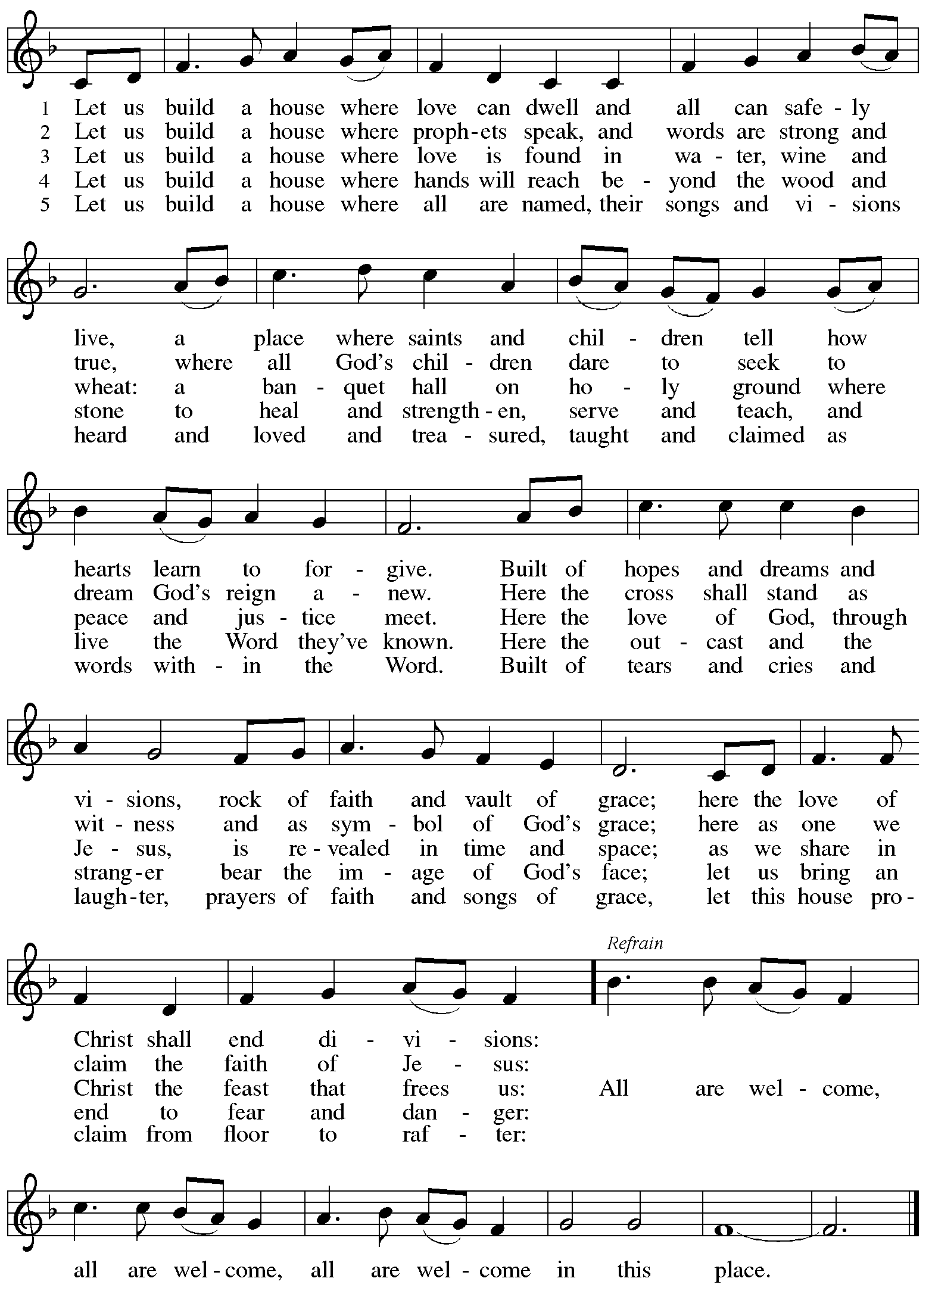

Greeting

P: The grace of our Lord Jesus Christ, the love of God,
and the communion of the Holy Spirit be with you all.
C: And also with you.

Hymn of Praise ELW p. 204

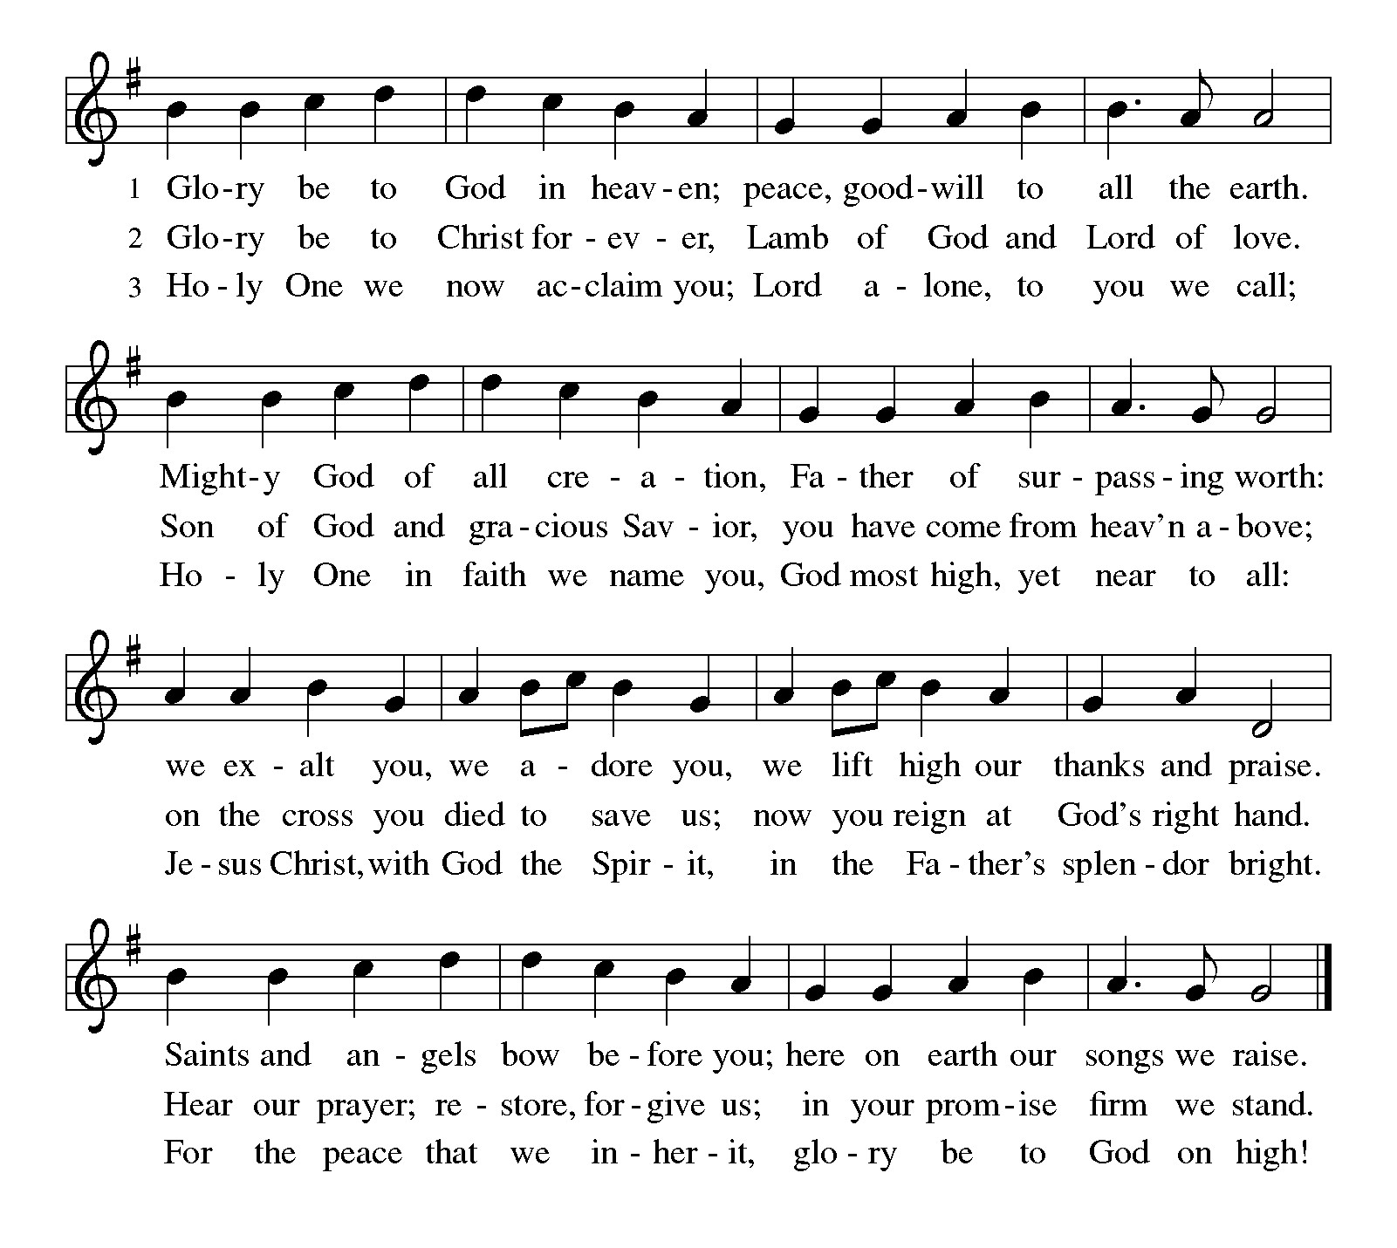
Prayer of the Day

P: The Lord be with you.
C: And also with you.

P: Let us pray.
P: O Lord God, we bring before you the cries of a sorrowing world.
In your mercy set us free from the chains that bind us,
and defend us from everything that is evil,
through Jesus Christ, our Savior and Lord.
C: Amen.

Please be seated.

Word
God speaks to us in Scripture reading, preaching, and song

First Reading – Isaiah 65: 1-9

¹ I was ready to be sought out by those who did not ask,
to be found by those who did not seek me.
I said, “Here I am, here I am,”
to a nation that did not call on my name.
² I held out my hands all day long
to a rebellious people,
who walk in a way that is not good,
following their own devices;
³ a people who provoke me
to my face continually,
sacrificing in gardens
and offering incense on bricks;
⁴ who sit inside tombs
and spend the night in secret places;
who eat the flesh of pigs,
with broth of abominable things in their vessels;
⁵ who say, “Keep to yourself;
do not come near me, for I am too holy for you.”
These are a smoke in my nostrils,
a fire that burns all day long.
⁶ See, it is written before me:
I will not keep silent, but I will repay;
I will indeed repay into their laps
⁷ their iniquities and their ancestors’ iniquities together,
says the Lord;
because they offered incense on the mountains
and reviled me on the hills,
I will measure into their laps
full payment for their actions.
⁸ Thus says the Lord:
As the wine is found in the cluster,
and they say, “Do not destroy it,
for there is a blessing in it,”
so I will do for my servants’ sake
and not destroy them all.
⁹ I will bring forth descendants from Jacob
and from Judah inheritors of my mountains;
my chosen shall inherit it,
and my servants shall settle there.

L: Word of God, word of life.
C: Thanks be to God.

Psalm 22: 19-28

The psalm will be sung responsively, led by the cantor,
with the congregation responding with the bold verses and refrain.

Psalm tone

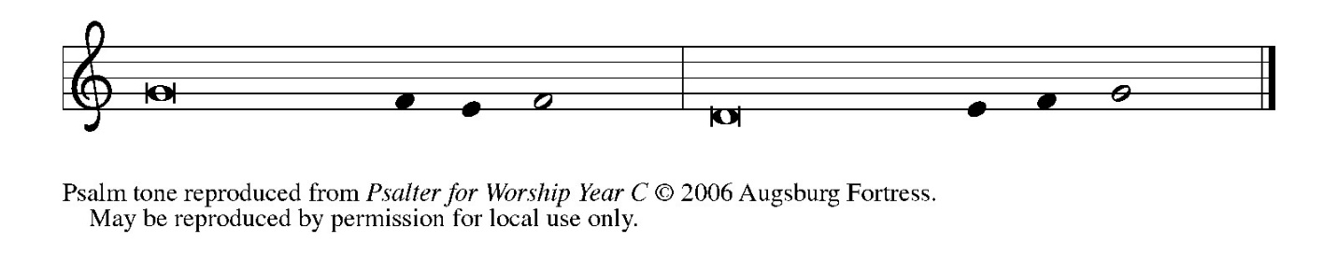

Psalm refrain

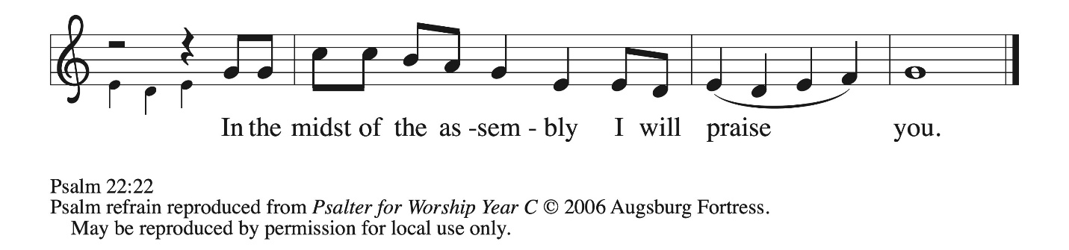

¹⁹ But you, O Lord, be not | far away;
O my help, hasten | to my aid.
²⁰ Deliver me | from the sword,
my life from the power | of the dog.
²¹ Save me from the | lion’s mouth!
From the horns of wild bulls you have | rescued me.
²² I will declare your name | to my people;
in the midst of the assembly | I will praise you. R

Psalm refrain

Psalm 22 continues
²³ You who fear the Lord, give praise! All you of Jacob’s | line, give glory.
Stand in awe of the Lord, all you off- | spring of Israel.
²⁴ For the Lord does not despise nor abhor the poor in their poverty; neither is the Lord’s face hid- | den from them;
but when they cry out, | the Lord hears them.
²⁵ From you comes my praise in the | great assembly;
I will perform my vows in the sight of those who | fear the Lord.
²⁶ The poor shall eat | and be satisfied,
Let those who seek the Lord give praise! May your hearts | live forever! R
²⁷ All the ends of the earth shall remember and turn | to the Lord;
all the families of nations shall bow | before God.
²⁸ For dominion belongs | to the Lord,
who rules o- | ver the nations. R

Second Reading – Galatians 3: 23-29

²³ Now before faith came, we were imprisoned and guarded under the law until faith would be revealed. ²⁴ Therefore the law was our disciplinarian until Christ came, so that we might be reckoned as righteous by faith. ²⁵ But now that faith has come, we are no longer subject to a disciplinarian, ²⁶ for in Christ Jesus you are all children of God through faith. ²⁷ As many of you as were baptized into Christ have clothed yourselves with Christ. ²⁸ There is no longer Jew or Greek; there is no longer slave or free; there is no longer male and female, for all of you are one in Christ Jesus. ²⁹ And if you belong to Christ, then you are Abraham’s offspring, heirs according
to the promise.

L: Word of God, word of life.
C: Thanks be to God.

Please rise as you are able.

Gospel Acclamation ELW p. 205

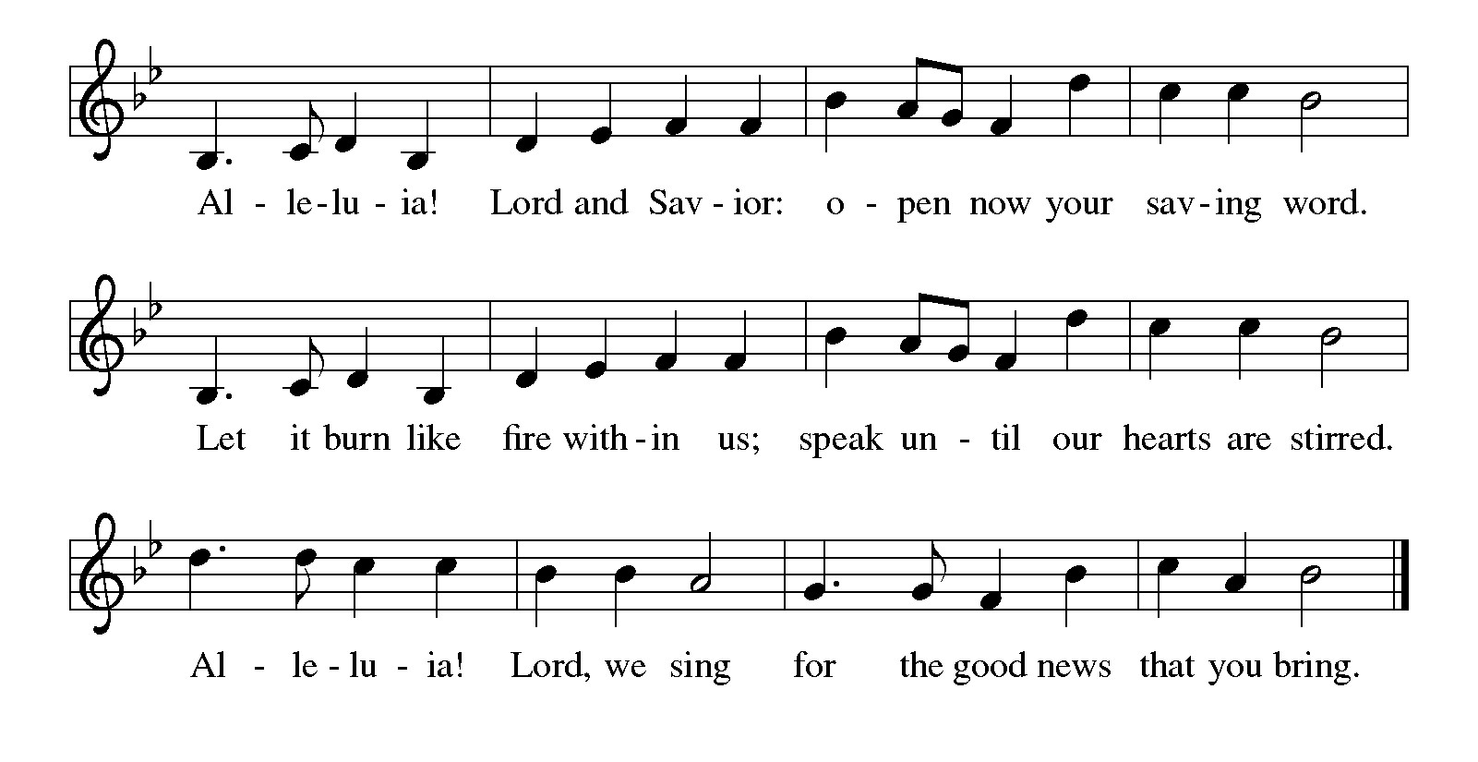

Gospel – Luke 8: 26-39

P: The holy Gospel according to St. Luke.
C: Glory to you, O Lord.

²⁶Then they arrived at the country of the Gerasenes, which is opposite Galilee. ²⁷As he stepped out on land, a man of the city who had demons met him. For a long time he had worn no clothes, and he did not live in a house but in the tombs. ²⁸When he saw Jesus, he fell down before him and shouted at the top of his voice, “What have you to do with me, Jesus, Son of the Most High God? I beg you, do not torment me” — ²⁹for Jesus had commanded the unclean spirit to come out of the man. (For many times it had seized him; he was kept under guard and bound with chains and shackles, but he would break the bonds and be driven by the demon into the wilds.) ³⁰Jesus then asked him, “What is your name?” He said, “Legion”; for many demons had entered him. ³¹They begged him not to order them to go back into the abyss. ³²Now there on the hillside a large herd of swine was feeding; and the demons begged Jesus to let them enter these. So he gave them permission. ³³Then the demons came out of the man and entered the swine, and the herd rushed down the steep bank into the lake and was drowned.
³⁴When the swineherds saw what had happened, they ran off and told it in the city and in the country. ³⁵Then people came out to see what had happened, and when they came to Jesus, they found the man from whom the demons had gone sitting at the feet of Jesus, clothed and in his right mind. And they were afraid. ³⁶Those who had seen it told them how the one who had been possessed by demons had been healed. ³⁷Then all the people of the surrounding country of the Gerasenes asked Jesus to leave them; for they were seized with great fear. So he got into the boat and returned. ³⁸The man from whom the demons had gone begged that he might be with him; but Jesus sent him away, saying, ³⁹Return to your home, and declare how much God has done for you. So he went away, proclaiming throughout the city how much Jesus had done for him.

P: The Gospel of the Lord.
C: Praise to you, O Christ.

Please be seated.

Sermon

A time of silence for prayer and reflection follows the sermon.
When the hymn of the day begins, please rise as you are able.

Hymn of the Day Praise the One Who Breaks the Darkness ELW 843

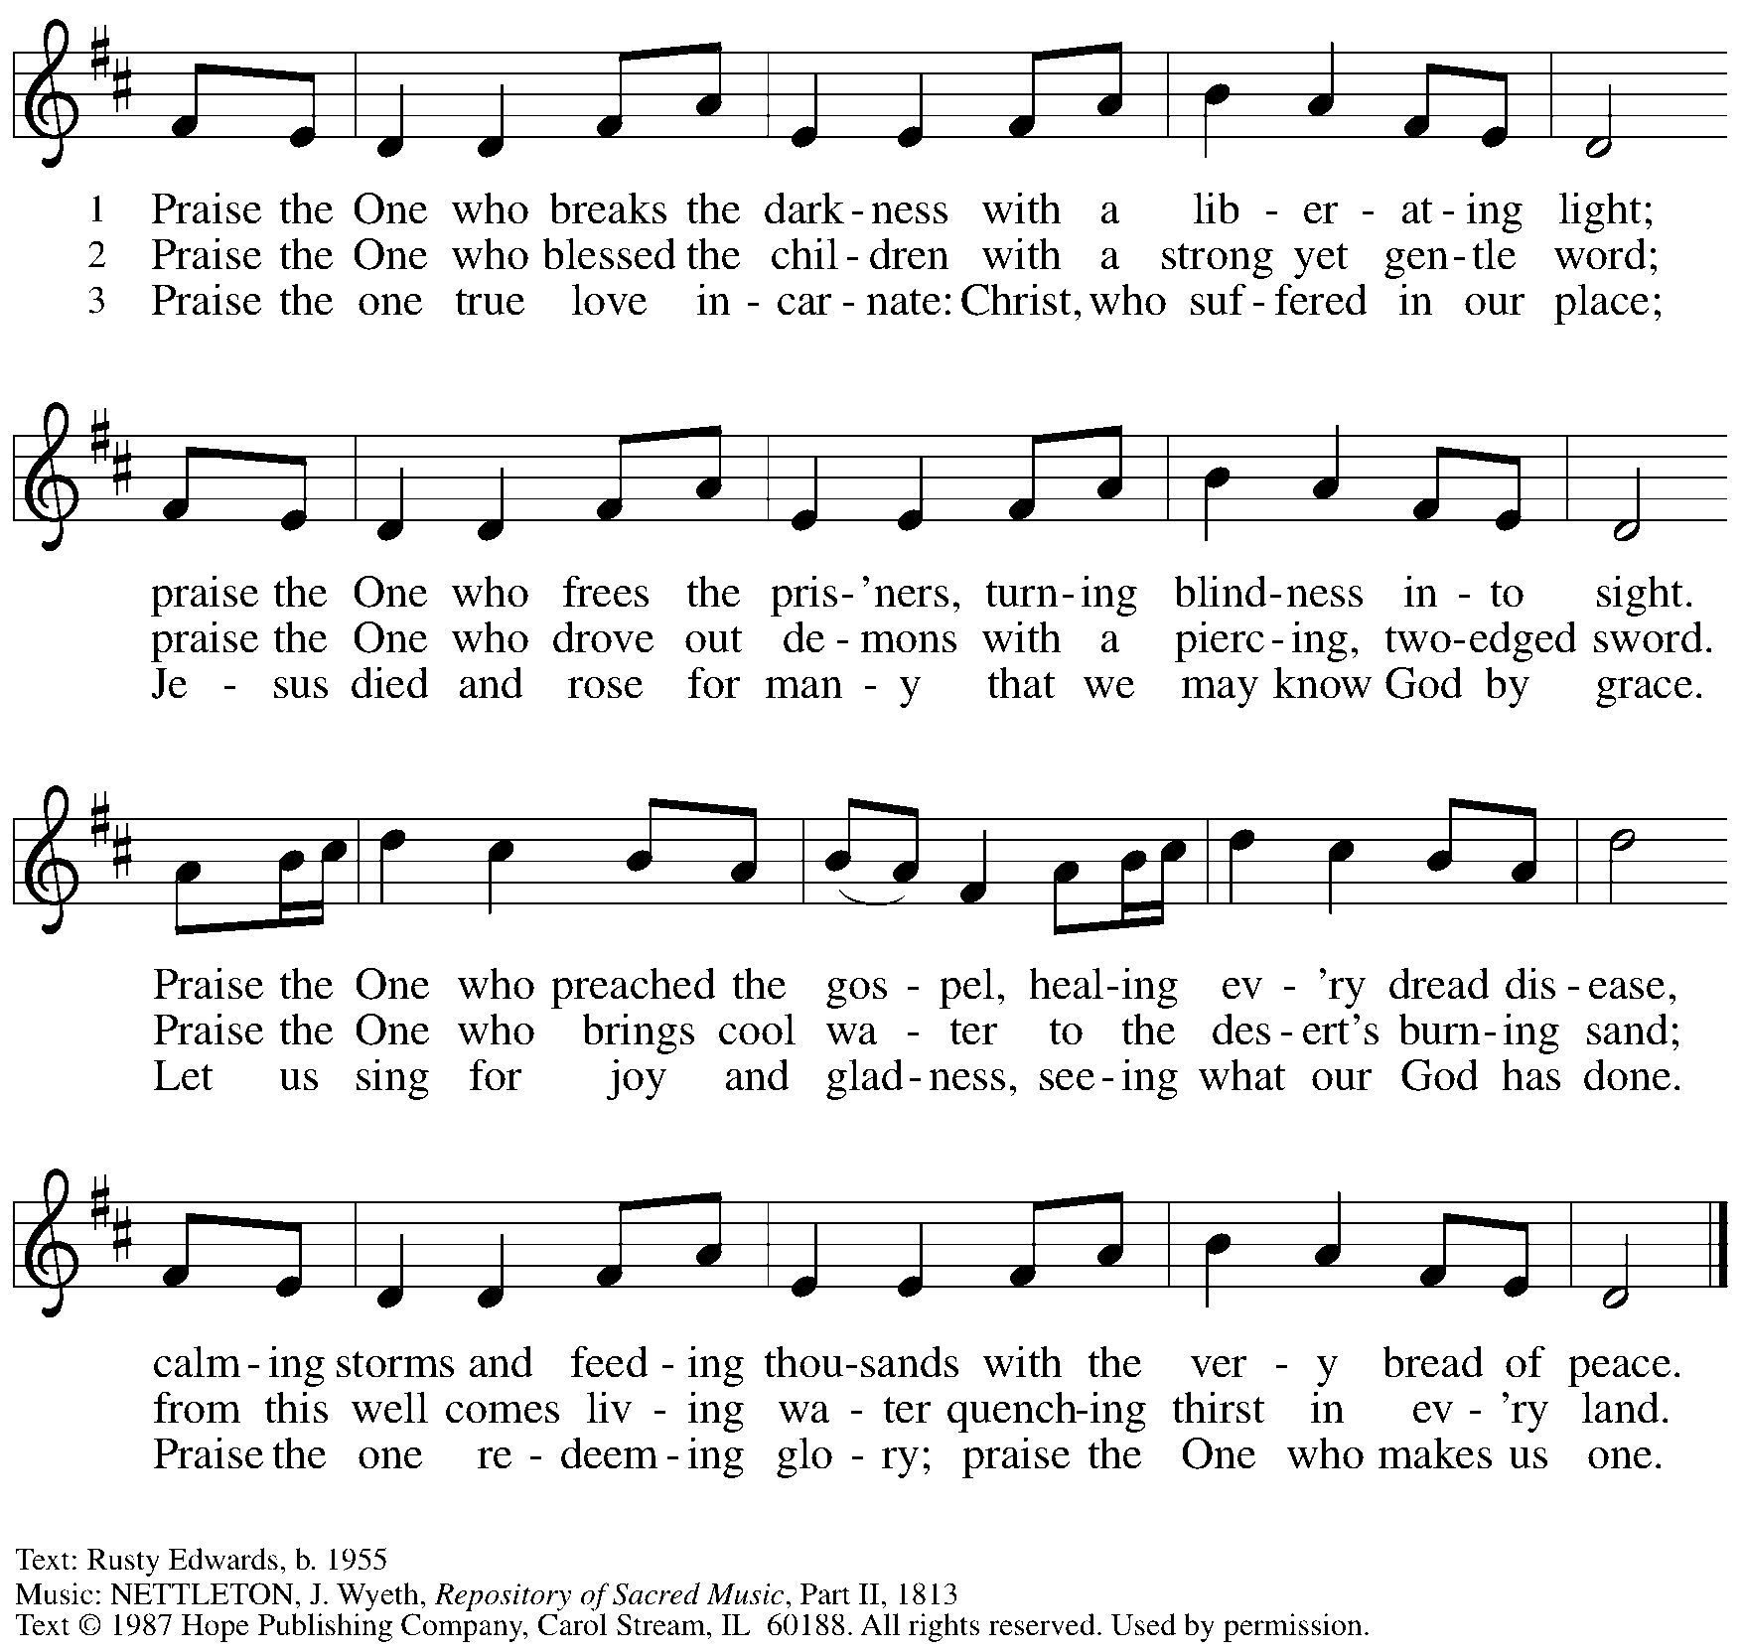
Reprinted under OneLicense.net # A-722139.

Apostles’ Creed

C: I believe in God, the Father almighty,
creator of heaven and earth.

I believe in Jesus Christ, God’s only Son, our Lord,
who was conceived by the Holy Spirit,
born of the virgin Mary,
suffered under Pontius Pilate,
was crucified, died, and was buried;
he descended to the dead.*
On the third day he rose again;
he ascended into heaven,
he is seated at the right hand of the Father,
and he will come to judge the living and the dead.

I believe in the Holy Spirit,
the holy catholic church,
the communion of saints,
the forgiveness of sins,
the resurrection of the body,
and the life everlasting. Amen.

*Or, “he descended into hell,” another translation of this text in widespread use.

When all have returned to their places, worship continues with the Prayers of the People.

Prayers of the People

A: With the whole people of God in Christ Jesus, let us pray for the church, those in need,
and all of God’s creation.

After each petition
A: God of grace,
C: receive our prayer.

The presiding minister concludes the prayers
P: Into your hands, gracious God, we commend all for whom we pray,
trusting in your mercy; through Jesus Christ, our Savior.
C: Amen.

Peace

The presiding minister and the assembly greet one another in the peace of the risen Christ.
P: The peace of Christ be with you always.
C: And also with you.

The people may greet those around them with a sign of Christ’s peace and may say
Peace be with you or similar words. Please be mindful that not everyone will be comfortable with sharing the peace, so please seek consent before shaking hands or hugging. Other possible ways to share the peace include a simple bow with the verbal greeting of peace, or simply a verbal expression of peace.

When the greetings of peace have concluded, please be seated.



Meal
God feeds us with the presence of Jesus Christ

Offering

We offer ourselves, our gifts, and our faithful service to God.
As the offering is gathered for the mission of the church, including the care of those in need,
the table is set for Holy Communion.

There are laminated giving cards in the pew racks that feature a QR code for anyone who would like to give online. Those who give using the QR code, as well as those who give regularly online or through their bank are encouraged to place the laminated card in the plate as an expression of your offering.

Offertory Music

As the gifts are brought forward for presentation, please rise as you are able.

Offertory Song As the Grains of Wheat ELW 465

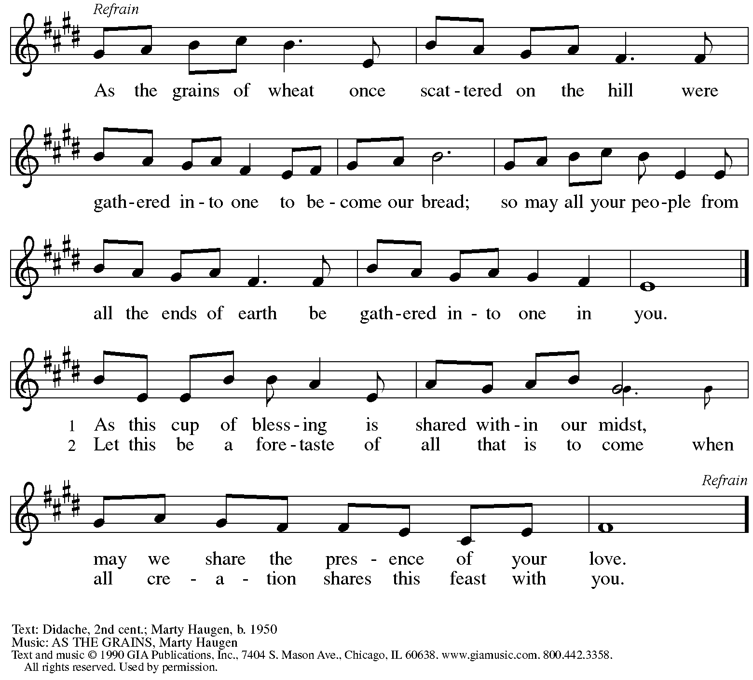
Reprinted under OneLicense.net # A-722139.

Offertory Prayer

A: Let us pray.
God of all creation,
C: all you have made is good and your love endures forever.
You bring forth bread from the earth and fruit from the vine.
Nourish us with these gifts,
that we might be for the world signs of your gracious presence
in Jesus Christ, our Savior and Lord.
Amen.

Dialogue ELW p. 206

P: The Lord be with you.
C: And also with you.

P: Lift up your hearts.
C: We lift them to the Lord.

P: Let us give thanks to the Lord our God.
C: It is right to give our thanks and praise.

Preface (Spoken by the presiding minister)

P: It is indeed right, our duty and our joy,
that we should at all times and in all places
give thanks and praise to you, almighty and merciful God,
through our Savior Jesus Christ;
who on this day overcame death and the grave,
and by his glorious resurrection
opened to us the way of everlasting life.
And so, with all the choirs of angels,
with the church on earth and the hosts of heaven,
we praise your name and join their unending hymn:

Sanctus ELW p. 207

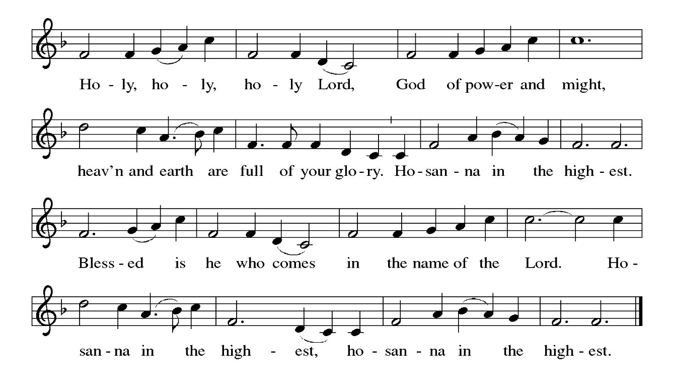

Eucharistic Prayer

P: Holy, mighty, and merciful Lord …
… to whom with you and the Holy Spirit
be all honor and glory, now and forever.
C: Amen.

Lord’s Prayer

P: Gathered as one by the Holy Spirit, let us pray as Jesus taught us.
C: Our Father, who art in heaven,
hallowed be thy name,
thy kingdom come,
thy will be done,
on earth as it is in heaven.
Give us this day our daily bread;
and forgive us our trespasses,
as we forgive those
who trespass against us;
and lead us not into temptation,
but deliver us from evil.
For thine is the kingdom,
and the power, and the glory,
forever and ever. Amen.

Fraction and Invitation



Agnus Dei / Lamb of God ELW p. 208

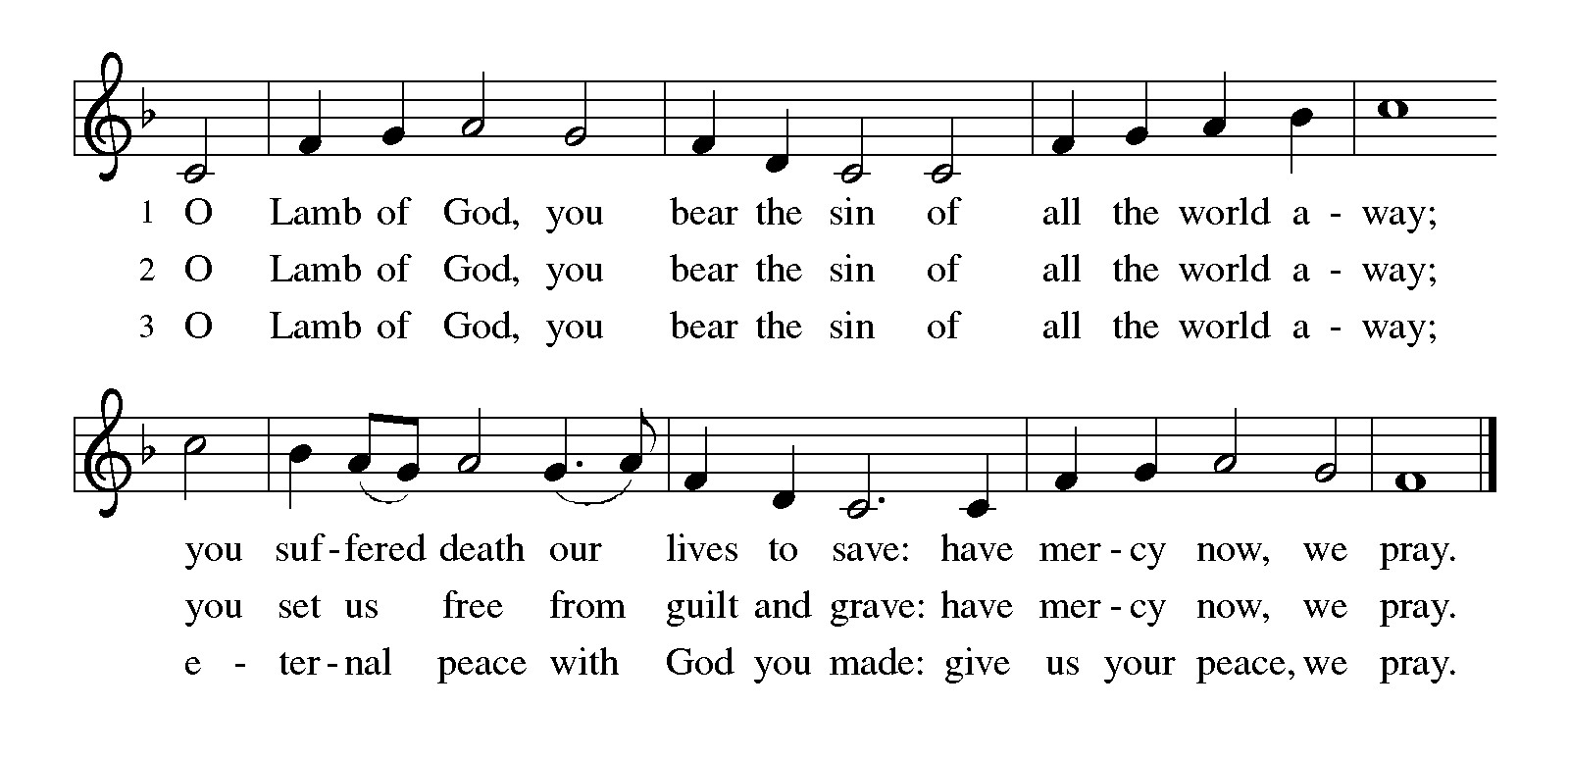
Please be seated.

Holy Communion

- All who seek God and desire a deeper and stronger life in Christ are welcome to receive Holy Communion.
- Worshipers from the pulpit side will proceed forward first, followed by the center section, and then the lectern side.
- Please inform an usher if you would like the ministers to bring Communion to you.
- Holy Communion will be served with bread and wine (amber) or grape juice (purple).
- The presiding minister will first distribute the bread (host) to each communicant. Please indicate if you require a gluten-free host.
- Once you have consumed the bread, please pick up an empty glass from the tray next to the presiding minister. The Communion Assistant will pour wine or grape juice into your glass.
- Please step to the side to consume the wine or grape juice.
- Feel free to kneel at the altar rail for prayer after receiving the sacrament.
- As you return to your pew, glasses may be returned to the empty tray on the side of the center section.
- A blessing will be provided for anyone who does not yet receive the sacrament.
- All are invited to join in singing the hymns during Holy Communion.

Hymns during Holy Communion
We Come to the Hungry Feast ELW 479

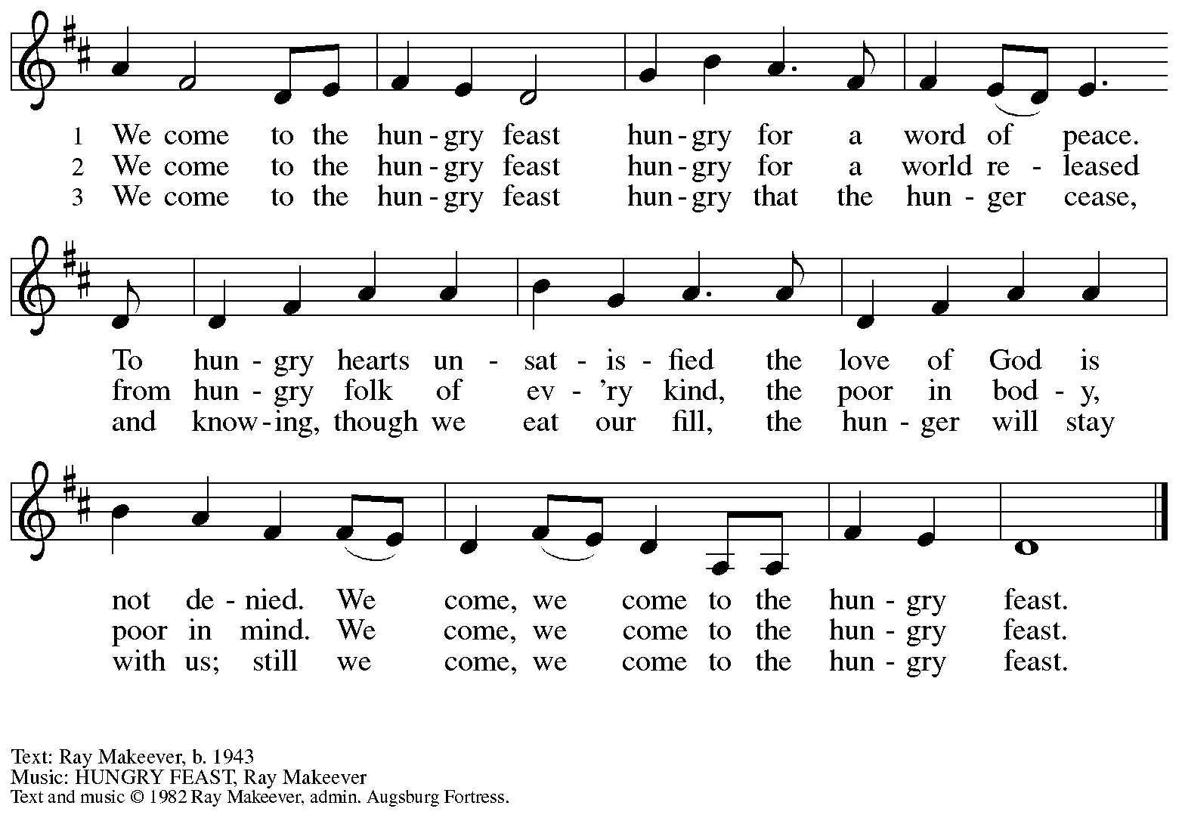
All rights reserved. Reprinted with permission under OneLicense.net # A-722139.

Hymns during Holy Communion
Come to Me, O Weary Traveler ACS 1017

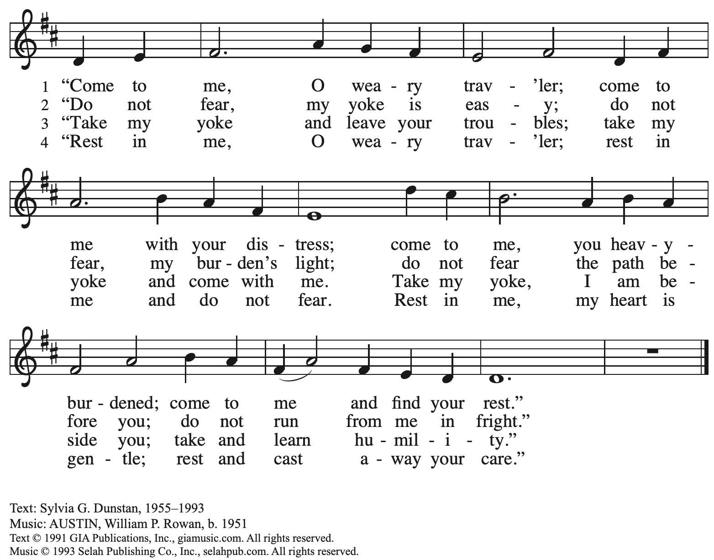
Reprinted with permission under OneLicense.net # A-7222139.

Hymns during Holy Communion
Bread of Life from Heaven ELW 474

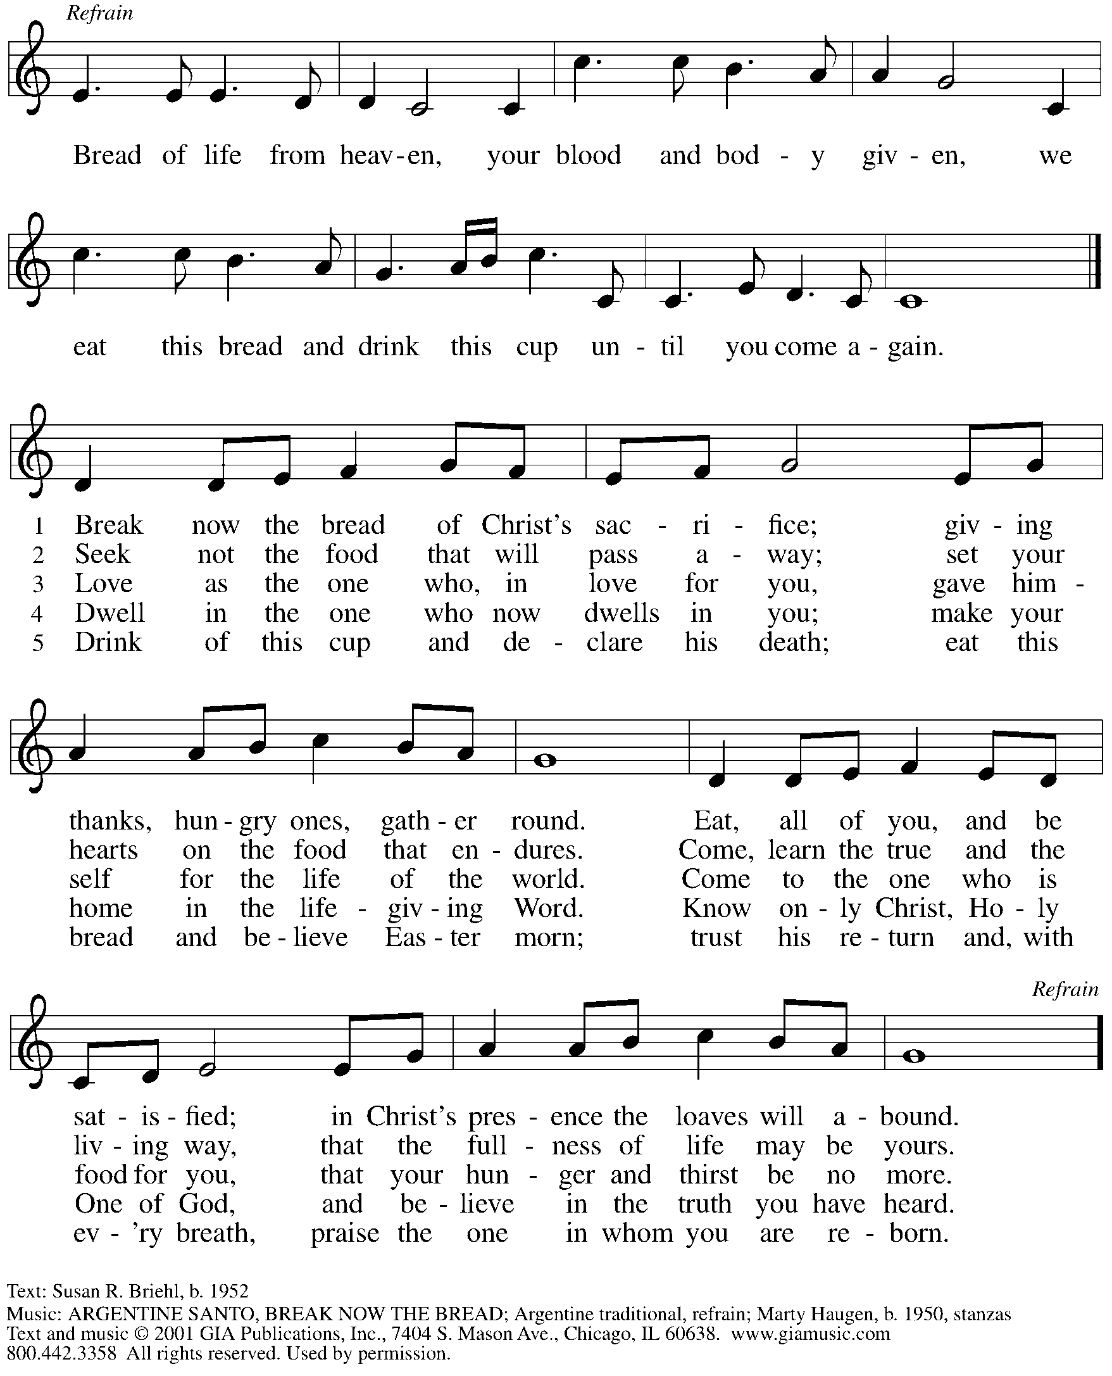
Reprinted under OneLicense.net # A-722139.

Hymns during Holy Communion
One Bread, One Body ELW 496

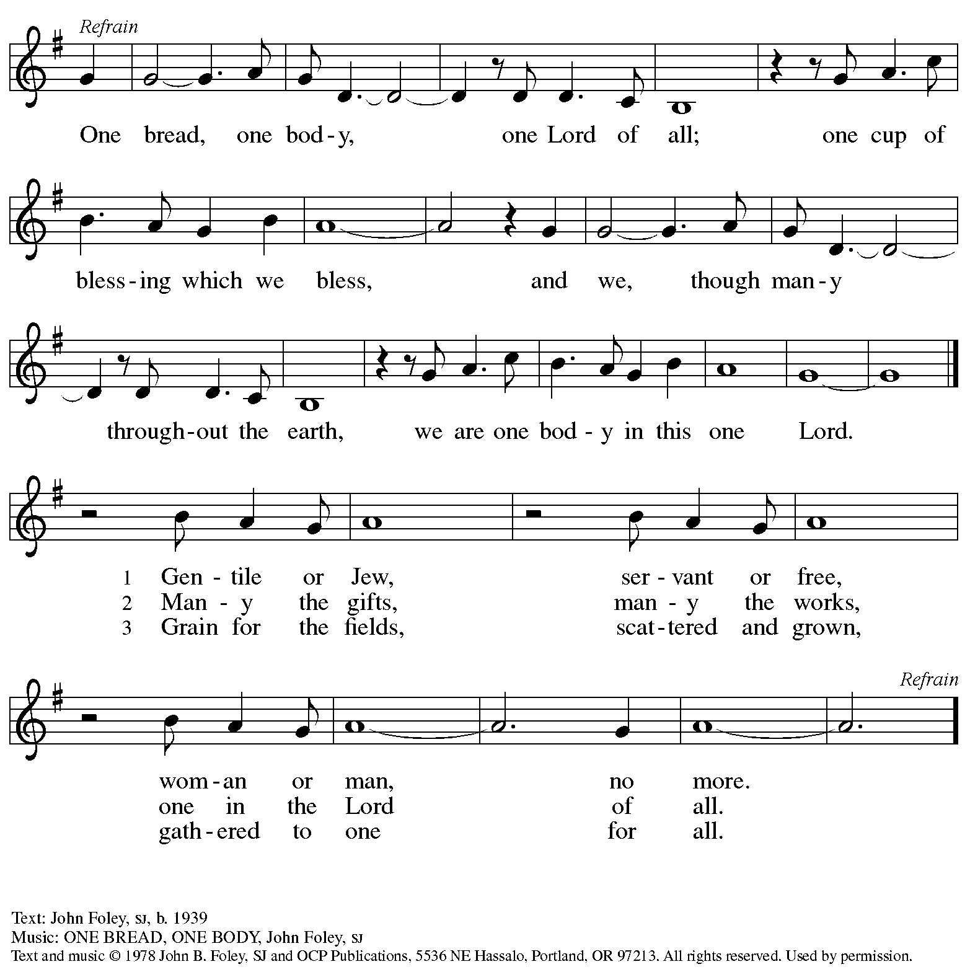
Reprinted under OneLicense.net # A-722139.

When all have returned to their places, please rise as you are able.

Blessing

P: The body and blood of our Lord Jesus Christ strengthen you and keep you in his grace.
C: Amen.

Prayer

A: Let us pray.
O God, our life, our strength, our food,
we give you thanks for sustaining us with the body and blood of your Son.
By your Holy Spirit, enliven us to be his body in the world,
that more and more we will give you praise
and serve your earth and its many peoples,
through Jesus Christ, our Savior and Lord.
C: Amen.

Please be seated.

Sending
God blesses us and sends us in mission to the world

Announcements

Please rise as you are able.

Benediction

P: The God of steadfastness and encouragement
grant you to live in harmony with one another,
in accordance with Christ Jesus.
C: Amen.

P: The God of hope fill you with all joy and peace in believing,
so that you may abound in hope by the power of the Holy Spirit.
C: Amen.

P: The God of all grace ☩ bless you now and forever.
C: Amen.

Sending Hymn Following page

Dismissal

A: Go in peace. Serve the Lord.
C: Thanks be to God!

Postlude

Sending Hymn To Christ Belong, in Christ Behold ACS 958

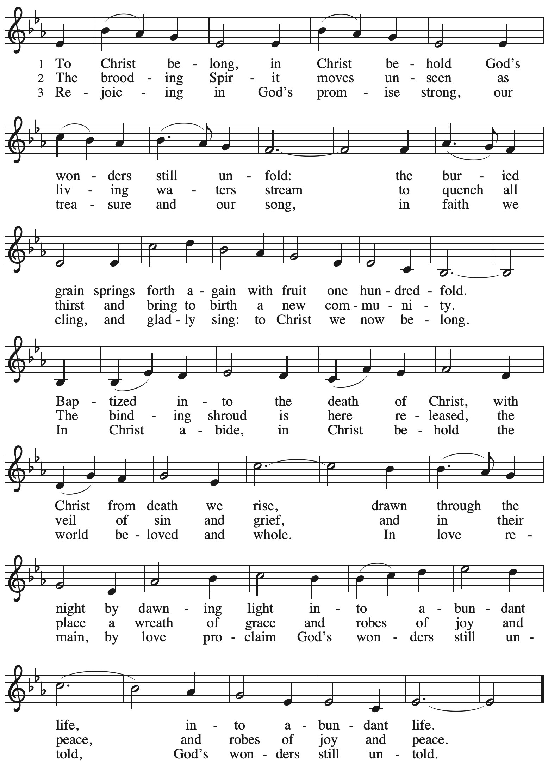

Those serving in worship today

Altar Care Beverley Chapman
Assisting Minister Timothy Kocher-Hillmer
Audio-Visual Ministers Jason Galyardt
Sarita
Cantor Miriam Bohlmann Kunz
Lector Kelly Spanninger
Pre-Service Music Tom Leech and Family
Piano Jeff Denlinger
Presiding Minister The Rev. Martin Rafanan

Liturgy and Hymnody Acknowledgements

From SundaysandSeasons.com. Copyright © 2025 Augsburg Fortress. All rights reserved. Reprinted under OneLicense.net # A-722139.
Used by permission of Augsburg Fortress.

The Scripture readings contained herein are from New Revised Standard Version Updated Edition of the Bible © 2021 National Council of Churches of Christ in the United States of America. Used by permission. All rights reserved worldwide.

All Are Welcome – Text: Marty Haugen, b. 1950. Music: TWO OAKS, Marty Haugen. Text and music © 1994 GIA Publications, Inc, 7404 S. Mason Ave., Chicago, IL 60638. www.giamusic.com. 800.442.3356. All rights reserved. Reprinted with permission under OneLicense.net # A-722139.

To Christ Belong, in Christ Behold – Text: Susan R. Briehl, b. 1952. Music: WONDERS, Robert Buckley Farlee, b. 1950. Text © 2011 Susan R. Briehl, admin. Augsburg Fortress. Music © 2011 Robert Buckley Farlee, admin. Augsburg Fortress. All rights reserved. Reprinted with permission under OneLicense.net # A-722139.

Please use the QR code below to link to St. Andrew’s Announcements online!



St. Andrew Lutheran Church Announcements
June 22nd, 2025

- Welcome to Worship at St. Andrew on the Second Sunday after Pentecost! – We are so glad you are here, and we offer a special welcome to all visitors and guests who are here for the first time! There are worship “toolkits” to help children engage with worship and “busy bags” for younger children available in the bookcase at the back of the sanctuary. Please feel free to take one to use with/for your children. A nursery is available through the door to the left of the worship space and across the social hall (look for a purple room). Everyone is invited to gather in the social hall for coffee, other drinks, food, and conversation after worship!
- Thank You to The Rev. Martin Rafanan for Preaching and Leading Worship Today! – Rev. Rafanan is a retired pastor of the Evangelical Lutheran Church in America (ELCA) and a member of St. Andrew. We thank Pastor Martin for sharing his gifts and God’s Word today!
- Thank You to St. Andrew Member Jeff Denlinger for Leading the Music for Worship on Piano!
- Congratulations and Blessings to The Rev. Melissa Stoller, St. Andrew Member Elected as the Third Bishop of the Southwestern Pennsylvania Synod! – At the Southwestern Pennsylvania Synod Assembly that met June 12th – 14th, Director of Evangelical Mission, Assistant to the Bishop, and St. Andrew member The Rev. Melissa Stoller was elected on the fourth ballot to a six-year term as Bishop of the synod! Her term of office will begin on September 1st and her installation will be on Saturday, October 18th, at Berkeley Hills Lutheran Church. Please pray for Pastor Melissa, Eric, and Adam in this time of transition!
- Bethel AME Church Juneteenth Celebrations – Today at 11:00 a.m. and 2:00 p.m. – Friends at Bethel AME Church have invited St. Andrew to join in their celebration of Juneteenth today! Morning worship will be at 11:00 a.m., with Bishop Stafford J.N. Wicker, Presiding Bishop of the Third Episcopal District of the AME Church, preaching. A fellowship meal will follow the service. Afternoon worship will be at 2:00 p.m. with Bishop Kurt Kusserow of our Southwestern Pennsylvania Synod of the Evangelical Lutheran Church in America, preaching.
- Renaissance City Choir “This Is Me” 2025 Pride and 40th Anniversary Concerts – Friday, June 27th and Saturday, June 28th, 7:30 p.m. – Renaissance City Choir, Western Pennsylvania’s LGBTQIA+ choir, is presenting “This Is Me,” its 2025 Pride concert as the choir celebrates its 40th anniversary. The concerts will be Friday, June 27th and Saturday, June 28th at 7:30 p.m. at Point Park University Pittsburgh Playhouse, 350 Forbes Ave. In-person tickets may be purchased at RCC 2025 #THIS IS ME Pride Concert in Pittsburgh - Checkout and tickets for the live-stream can be purchased here: #This is Me LIVE-STREAM TICKETS ONLY in Pittsburgh - Checkout. Accessibility questions may be directed to accessibility@rccpittsburgh.com. An ASL interpreter will be present on both dates.
- Community Ministry Team Seeking Donations to Supply Backpacks to Students at The Neighborhood Academy – St. Andrew’s community ministry team was invited by St. Andrew’s Episcopal Church in Highland Park to assist with a project to supply backpacks for students at The Neighborhood Academy, a school in Garfield that supports students in grades 6-12 from low-income backgrounds with a college preparatory curriculum (For more information please see https://www.theneighborhoodacademy.org/). We will be collecting materials for 25 backpacks, with each backpack including one 2-inch, three-ring binder; a package of binder subject dividers; a pack of 6 pens (blue or black, gel or retractable ballpoints); a pack of 6 pencils; 2 yellow highlighters; a pack of white index cards (100, 3x5); 3 report pocket folders; 2 give-subject spiral notebooks. It is key that donations be relatively uniform, so binders, folders, notebooks etc. should be plain, simple colors – please no designs, logos, characters, etc. A donation bin will be set up in the social hall.

If you purchase items, please indicate your donation at this link so we can track that we have all the items: https://www.signupgenius.com/go/5080B4AAFAF2CABF85-57266709-backpacks. Thank you for considering a gift for this new (to us) ministry initiative!
- Coffee Hour Signups Available – One way that St. Andrew builds community is by sharing conversation over food and drinks at coffee hour after worship on Sundays. We invite people of the congregation to sign up to coordinate coffee hour each week, which includes brewing the coffee; setting out cups, napkins, food items, and cold drinks; and cleaning up afterward. Everything needed is at St. Andrew and instructions are available. Please sign up to host coffee hour here: https://www.signupgenius.com/go/5080B4AAFAF2CABF85-47069030-coffee.
- New Christ in Our Home Devotional Booklets for July-September Available at Entrances – This resource offers a daily Bible reading with a short reflection and prayer, along with additional readings and prayer topics for those who would like to expand their devotional practices. We encourage people of the congregation to take one for yourself, your family/household, or others. There are still some copies of the April-June edition available, too!

