

+ Third Sunday after Pentecost
June 29, 2025



St. Andrew Lutheran Church
304 Morewood Ave.
Pittsburgh, PA 15213
St_andrewELCA@verizon.net
www.standrewpittsburgh.org

+ Third Sunday after Pentecost
Order for Worship

We have no good apart from God. That makes Jesus’ call to follow him an invitation to freedom. This is freedom to revel in the Spirit’s fruit: love, joy, peace, and patience.
This is freedom to not be imprisoned by anything that would keep us from the fullness of the life God has given us. This is the path of life.

Welcome to St. Andrew!
- St. Andrew welcomes all who are seeking a place of healing, wholeness, and acceptance in a nurturing and faith-forming spiritual home. We are striving toward racial equity worldwide
and we seek to honor the lived experience of all individuals regardless of background. Our community embraces people of all ages, ethnicities, cultures, abilities, sexual orientations,
gender identities and expressions, and family constellations. Come and See!
- Worship Services are live-streamed to multiple online platforms. By attending worship, you agree that your image and voice may be broadcast.
- Everyone is invited to make a name tag at the black bookcase in the back of the worship space if they would like. There are stickers indicating pronouns on the bookcase if you would like to include them on your name tag.
- A nursery is available through the doors at the left side of the sanctuary and across from the doorway to the Social Hall. Look for a purple-colored room.
- Worship “toolkits” to help children engage with the service, along with “busy bags” for younger children, are available in the bookcase at the back of the sanctuary. Please feel free to take one to use with/for your children.
- Holy Communion is served with bread (gluten-free available) and wine or grape juice. The presiding minister will distribute the bread (host). Please consume this and then pick up an empty glass from the tray. The Communion Assistant will pour wine or grape juice into your glass. Please step to the side to consume the wine or grape juice. Feel free to kneel at the altar for prayer and reflection. As you return to your pew, glasses may be returned to the empty trays on either side of the center section.
- A restroom is available on the main level of the church, through the doors to the Social Hall and to the right in the main office.

Abbreviations
P: Pastor/Presiding Minister ELW: Evangelical Lutheran Worship hymnal
A: Assisting Minister ACS: All Creation Sings hymnal
L: Lector
C: Congregation

Musical Offering

Each week, different people from the congregation make an offering of pre-service music, with singing or instrumentation, to help the assembly focus and pray in preparation for worship.

Welcome

Prelude

Gathering
The Holy Spirit calls us together as the people of God

Please rise as you are able. All may make the sign of the cross, the sign marked at Baptism,
as the presiding minister begins.

Confession and Forgiveness

P: Blessed be the holy Trinity, ☩ one God,
who forgives all our sin,
whose mercy endures forever.
C: Amen.

P: Baptized into Christ, let us confess our sins.

Silence is kept for reflection.

P: Merciful God,
C: you free us to love others,
but we neglect our neighbors and follow our own way.
You lead us by the Spirit of joy and peace,
but we turn away from the abundant life you offer.
You surround us with patience, kindness, and generosity,
but we grow weary in doing what is right.
In your mercy, forgive us.
Do not give up on us.
Heal us, break our bonds, and show us the path of life.
Amen.

P: You belong to Christ Jesus
and you are God’s children through faith.
In the cross of ☩ Christ,
and through the power of the Holy Spirit,
your sins are forgiven.
Clothed with Christ, you are a new creation.
C: Amen.

Gathering Hymn As We Gather at Your Table ELW 522

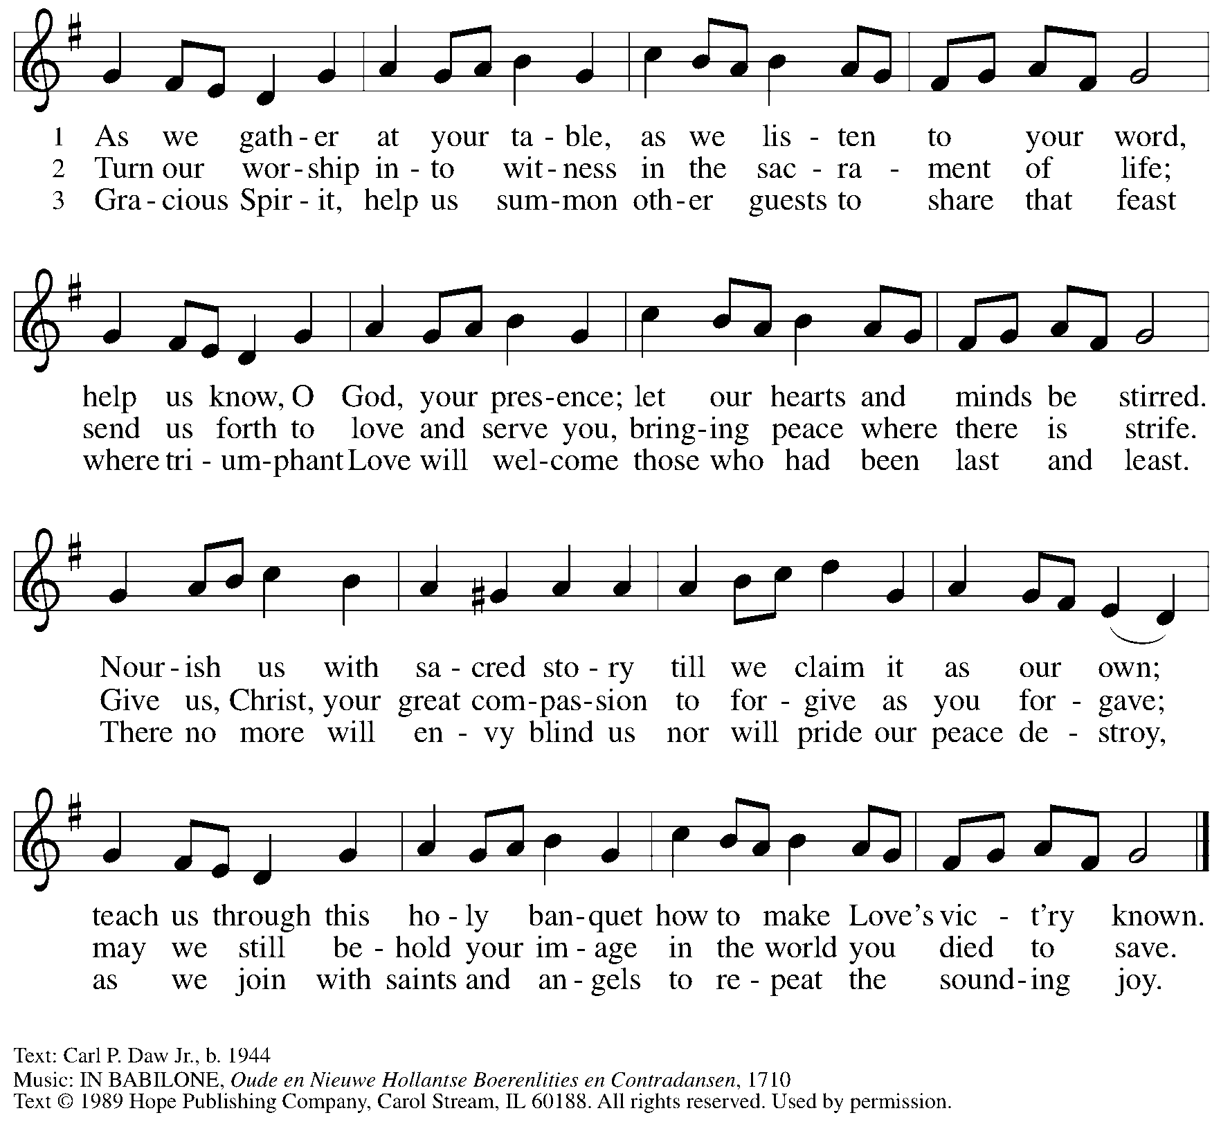
Reprinted under OneLicense.net # A-722139.

Greeting

P: The grace of our Lord Jesus Christ, the love of God,
and the communion of the Holy Spirit be with you all.
C: And also with you.

Hymn of Praise ELW p. 204

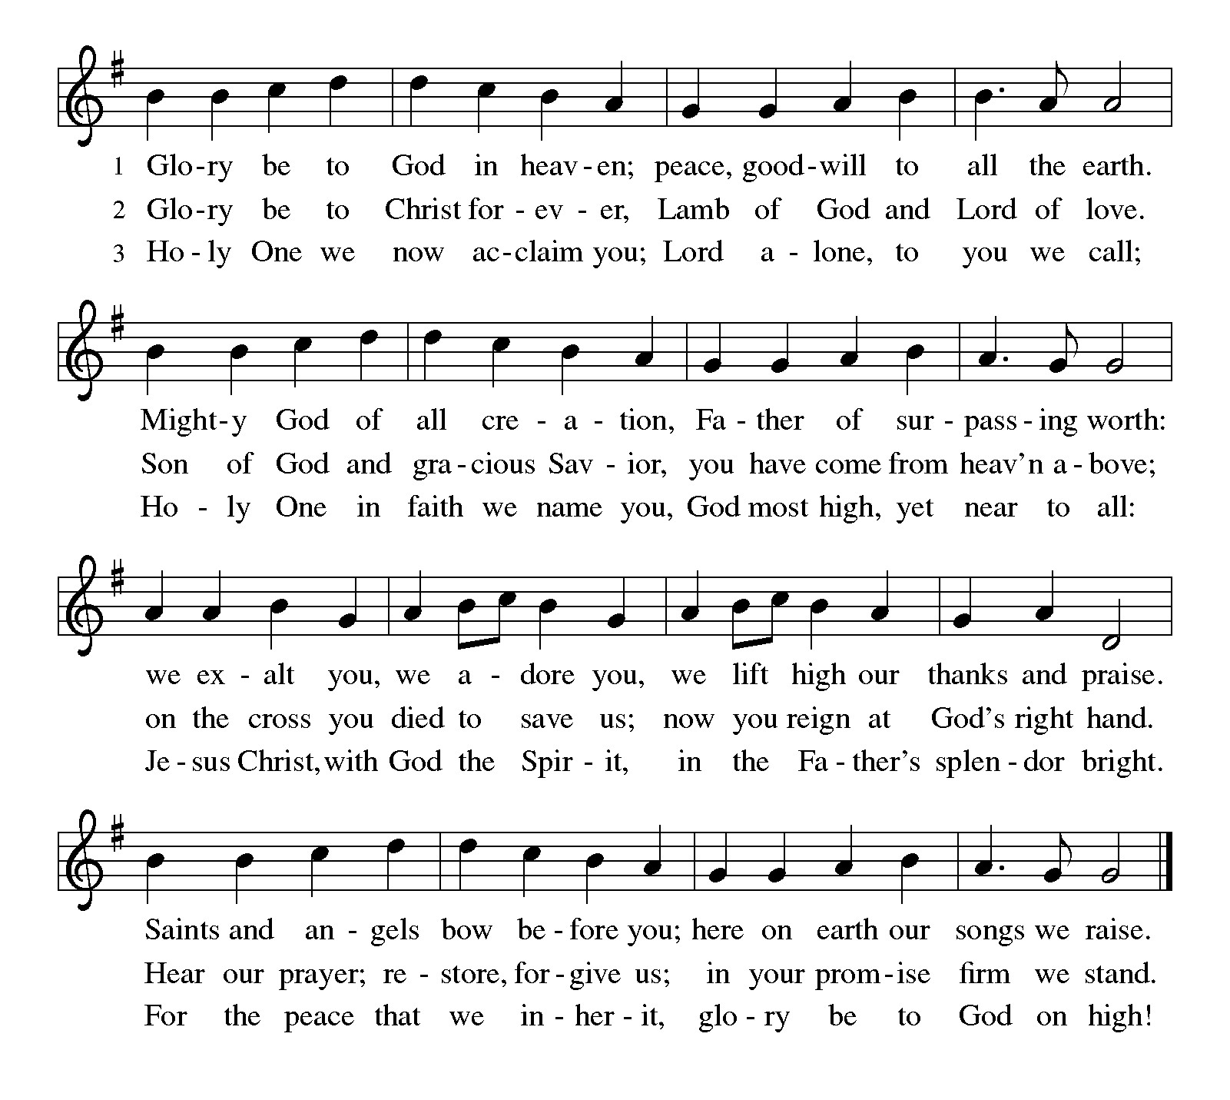

Prayer of the Day

P: The Lord be with you.
C: And also with you.

P: Let us pray.
Sovereign God, ruler of all hearts, you call us to obey you, and you favor us with true freedom. Keep us faithful to the ways of your Son, that, leaving behind all that hinders us,
we may steadfastly follow your paths, through Jesus Christ, our Savior and Lord.
C: Amen.

Please be seated.

Word
God speaks to us in Scripture reading, preaching, and song

First Reading – 1 Kings 19: 15-16, 19-21

¹⁵ Then the Lord said to him, “Go, return on your way to the wilderness of Damascus; when you arrive, you shall anoint Hazael as king over Aram. ¹⁶ Also you shall anoint Jehu son of Nimshi as king over Israel, and you shall anoint Elisha son of Shaphat of Abel-meholah as prophet in your place.

¹⁹ So he set out from there and found Elisha son of Shaphat, who was plowing. There were twelve yoke of oxen ahead of him, and he was with the twelfth. Elijah passed by him and threw his mantle over him. ²⁰ He left the oxen, ran after Elijah, and said, “Let me kiss my father and my mother, and then I will follow you.” Then Elijah said to him, “Go back again, for what have I done to you?” ²¹ He returned from following him, took the yoke of oxen, and slaughtered them; using the equipment from the oxen, he boiled their flesh and gave it to the people, and they ate. Then he set out and followed Elijah and became his servant.

L: Word of God, word of life.
C: Thanks be to God.



Psalm 16

The psalm will be sung responsively, led by the cantor,
with the congregation responding with the bold verses and refrain.

Psalm tone

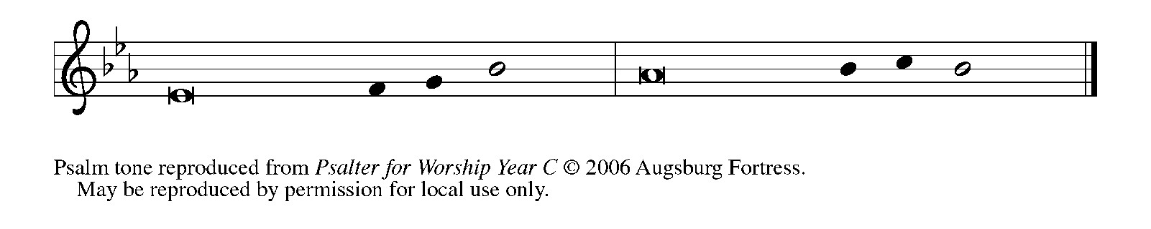

Psalm refrain

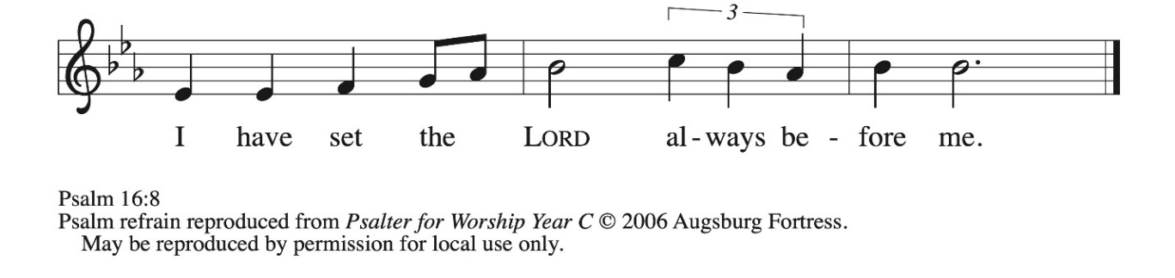

¹ Protect me, O God, for I take ref- | uge in you;
I have said to the Lord, “You are my Lord, my good a- | bove all other.”
² All my delight is in the godly that are | in the land,
upon those who are noble a- | mong the people.
³ But those who run after | other gods
shall have their troubles | multiplied.
⁴ I will not pour out drink offerings | to such gods,
never take their names up- | on my lips. R
⁵ O Lord, you are my portion | and my cup;
it is you who up- | hold my lot.
⁶ My boundaries enclose a | pleasant land;
indeed, I have a | rich inheritance.
⁷ I will bless the Lord who | gives me counsel;
my heart teaches me night | after night.
⁸ I have set the Lord al- | ways before me;
because God is at my right hand, I shall | not be shaken. R
⁹ My heart, therefore, is glad, and my spir- | it rejoices;
my body also shall | rest in hope.
¹⁰ For you will not abandon me | to the grave,
nor let your holy one | see the pit.
¹¹ You will show me the | path of life;
in your presence there is fullness of joy, and in your right hand are pleasures
for- | evermore. R

Second Reading – Galatians 5: 1, 13-25

¹ For freedom Christ has set us free. Stand firm, therefore, and do not submit again to a yoke of slavery.

¹³ For you were called to freedom, siblings, only do not use your freedom as an opportunity for self-indulgence, but through love become enslaved to one another. ¹⁴ For the whole law is summed up in a single commandment, “You shall love your neighbor as yourself.” ¹⁵ If, however, you bite and devour one another, take care that you are not consumed by one another.
¹⁶ Live by the Spirit, I say, and do not gratify the desires of the flesh. ¹⁷ For what the flesh desires is opposed to the Spirit, and what the Spirit desires is opposed to the flesh, for these are opposed to each other, to prevent you from doing what you want. ¹⁸ But if you are led by the Spirit, you are not subject to the law. ¹⁹ Now the works of the flesh are obvious: sexual immorality, impurity, debauchery, ²⁰ idolatry, sorcery, enmities, strife, jealousy, anger, quarrels, dissensions, factions, ²¹ envy, drunkenness, carousing, and things like these. I am warning you, as I warned you before: those who do such things will not inherit the kingdom of God.
²² By contrast, the fruit of the Spirit is love, joy, peace, patience, kindness, generosity, faithfulness, ²³ gentleness, and self-control. There is no law against such things. ²⁴ And those who belong to Christ have crucified the flesh with its passions and desires. ²⁵ If we live by the Spirit, let us also be guided by the Spirit. ²⁶ Let us not become conceited, competing against one another, envying one another.

L: Word of God, word of life.
C: Thanks be to God.

Please rise as you are able.

Gospel Acclamation ELW p. 205

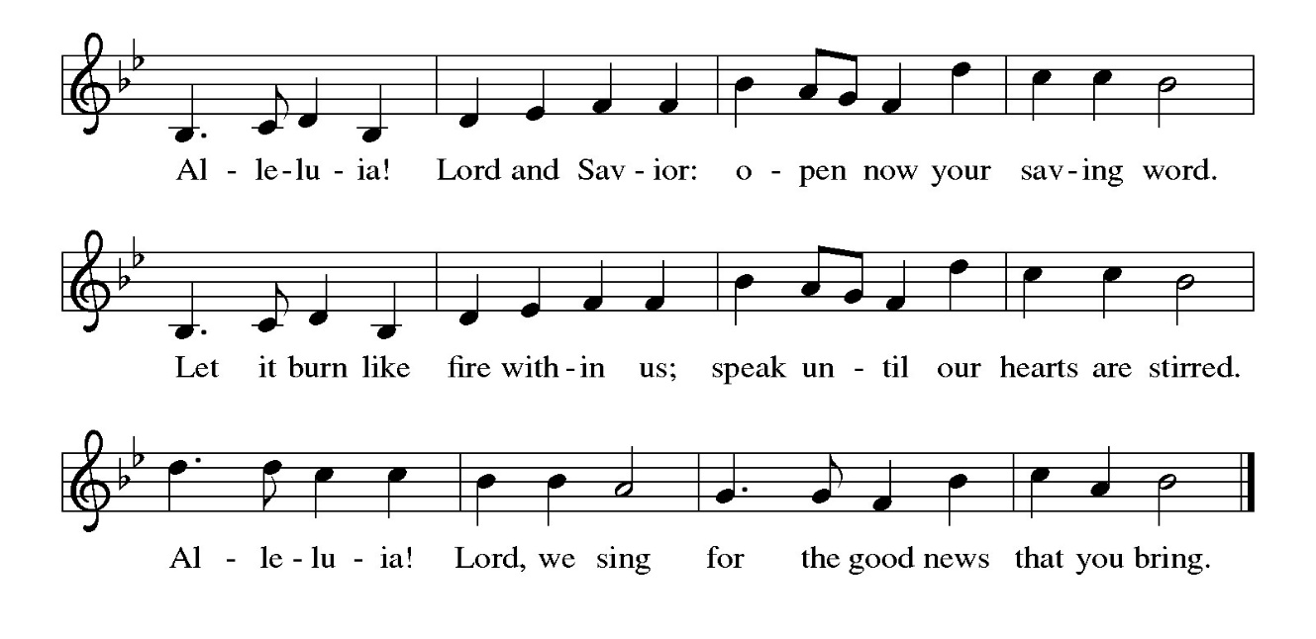
Gospel – Luke 9: 51-62

P: The holy Gospel according to St. Luke.
C: Glory to you, O Lord.

⁵¹ When the days drew near for [Jesus] to be taken up, he set his face to go to Jerusalem. ⁵² And he sent messengers ahead of him. On their way they entered a village of the Samaritans to prepare for his arrival, ⁵³ but they did not receive him because his face was set toward Jerusalem. ⁵⁴ When his disciples James and John saw this, they said, “Lord, do you want us to command fire to come down from heaven and consume them?” ⁵⁵ But he turned and rebuked them. ⁵⁶ Then they went on to another village.
⁵⁷ As they were going along the road, someone said to him, “I will follow you wherever you go.” ⁵⁸ And Jesus said to him, “Foxes have holes, and birds of the air have nests, but the Son of Humanity has nowhere to lay his head.” ⁵⁹ To another he said, “Follow me.” But he said, “Lord, first let me go and bury my father.” ⁶⁰ And Jesus said to him, “Let the dead bury their own dead, but as for you, go and proclaim the kingdom of God.” ⁶¹ Another said, “I will follow you, Lord, but let me first say farewell to those at my home.” ⁶² And Jesus said to him, “No one who puts a hand to the plow and looks back is fit for the kingdom of God.”

P: The Gospel of the Lord.
C: Praise to you, O Christ.

Please be seated.

Sermon

A time of silence for prayer and reflection follows the sermon.
When the hymn of the day begins, please rise as you are able.

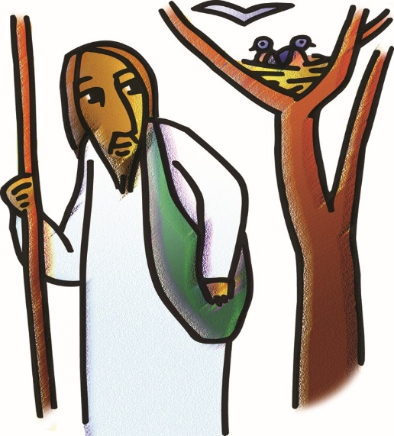

Hymn of the Day Will You Come and Follow Me ELW 798

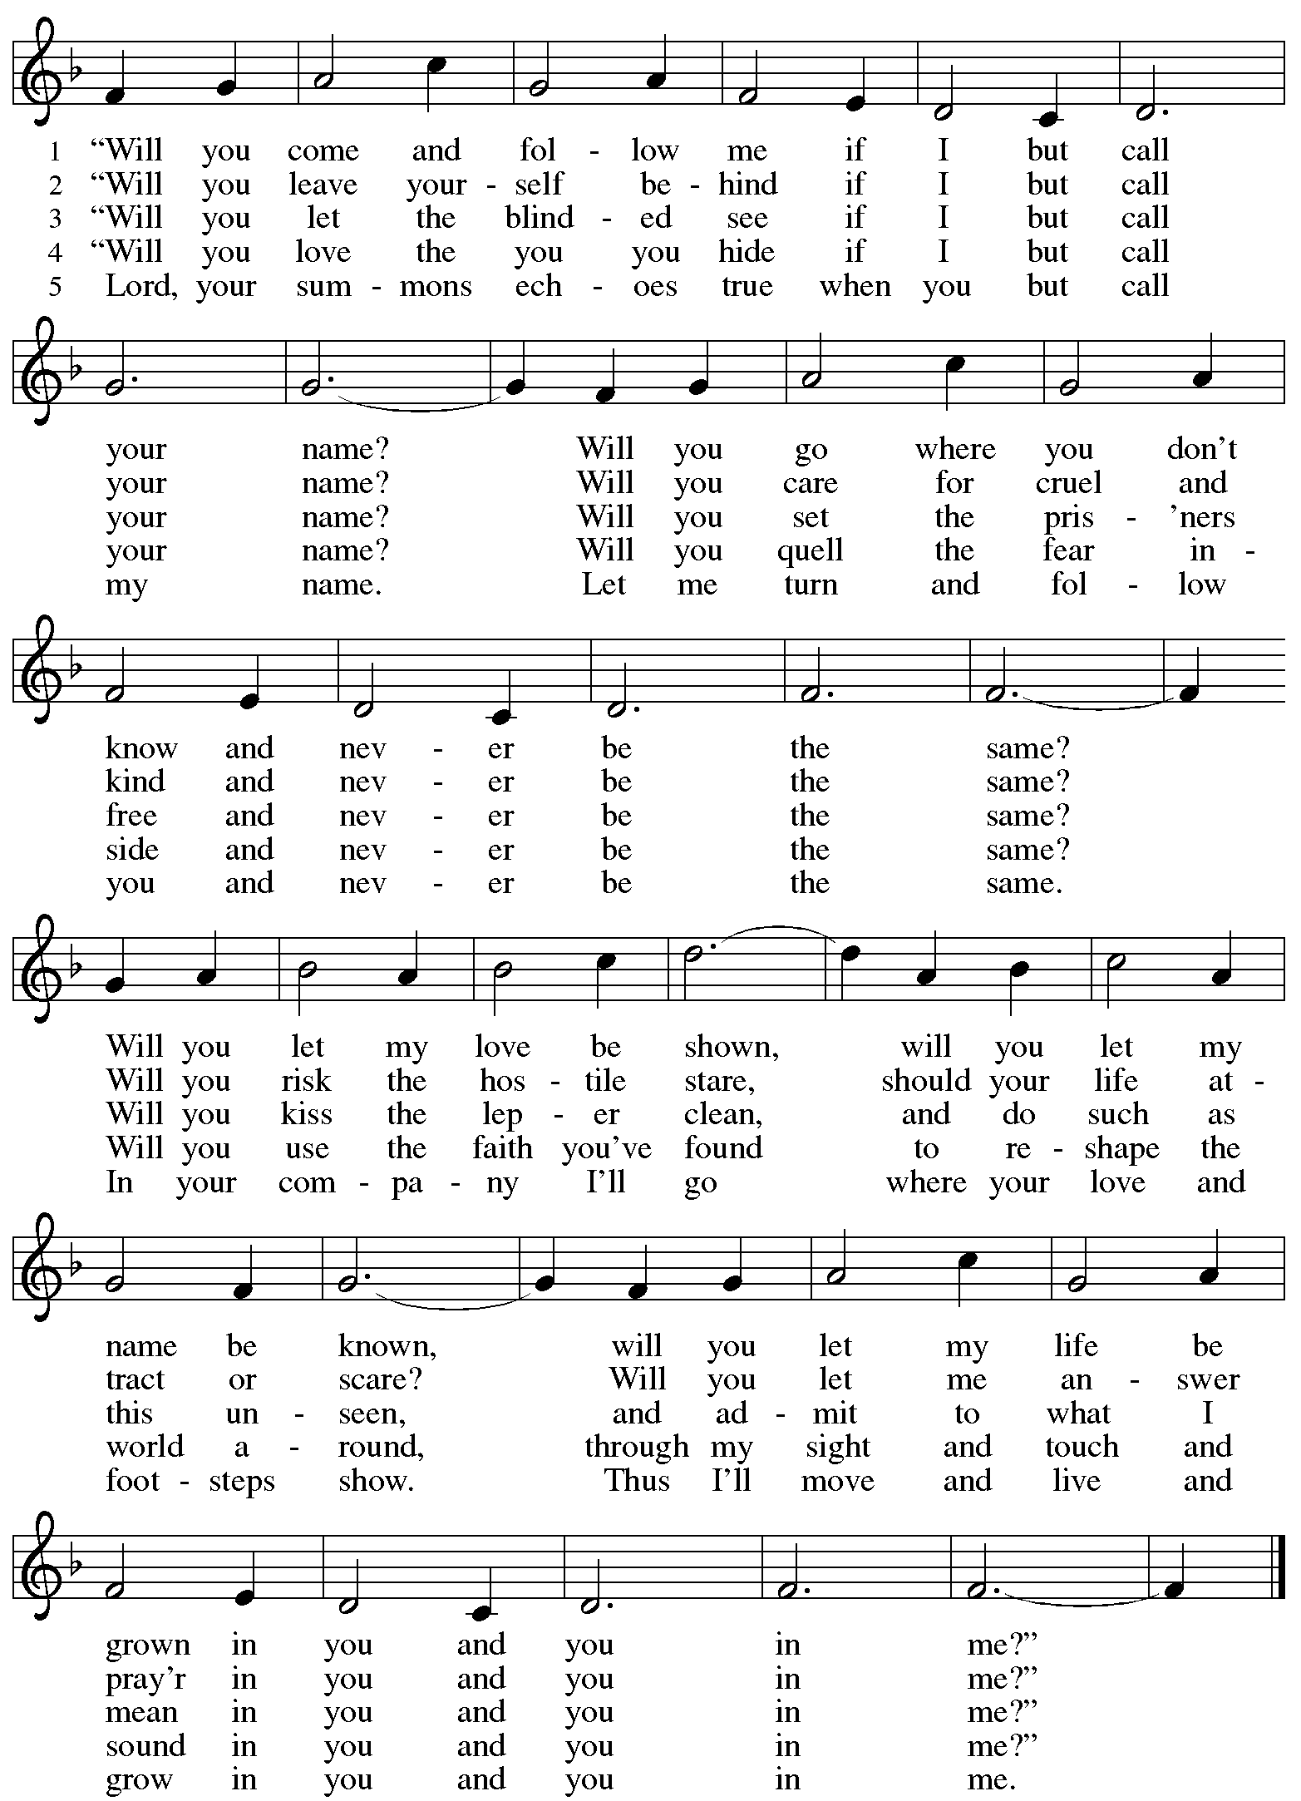
Apostles’ Creed

C: I believe in God, the Father almighty,
creator of heaven and earth.

I believe in Jesus Christ, God’s only Son, our Lord,
who was conceived by the Holy Spirit,
born of the virgin Mary,
suffered under Pontius Pilate,
was crucified, died, and was buried;
he descended to the dead.*
On the third day he rose again;
he ascended into heaven,
he is seated at the right hand of the Father,
and he will come to judge the living and the dead.

I believe in the Holy Spirit,
the holy catholic church,
the communion of saints,
the forgiveness of sins,
the resurrection of the body,
and the life everlasting. Amen.

*Or, “he descended into hell,” another translation of this text in widespread use.

When all have returned to their places, worship continues with the Prayers of the People.

Prayers of the People

A: With the whole people of God in Christ Jesus, let us pray for the church, those in need,
and all of God’s creation.

After each petition
A: God of grace,
C: receive our prayer.

P: Into your hands, gracious God, we commend all for whom we pray,
trusting in your mercy; through Jesus Christ, our Savior.
C: Amen.

Peace

The presiding minister and the assembly greet one another in the peace of the risen Christ.
P: The peace of Christ be with you always.
C: And also with you.

The people may greet those around them with a sign of Christ’s peace and may say
Peace be with you or similar words. Please be mindful that not everyone will be comfortable with sharing the peace, so please seek consent before shaking hands or hugging. Other possible ways to share the peace include a simple bow with the verbal greeting of peace, or simply a verbal expression of peace.

When the greetings of peace have concluded, please be seated.



Meal
God feeds us with the presence of Jesus Christ

Offering

We offer ourselves, our gifts, and our faithful service to God.
As the offering is gathered for the mission of the church, including the care of those in need,
the table is set for Holy Communion.

There are laminated giving cards in the pew racks that feature a QR code for anyone who would like to give online. Those who give using the QR code, as well as those who give regularly online or through their bank are encouraged to place the laminated card in the plate as an expression of your offering.

Offertory Music

As the gifts are brought forward for presentation, please rise as you are able.
Offertory Song As the Grains of Wheat ELW 465

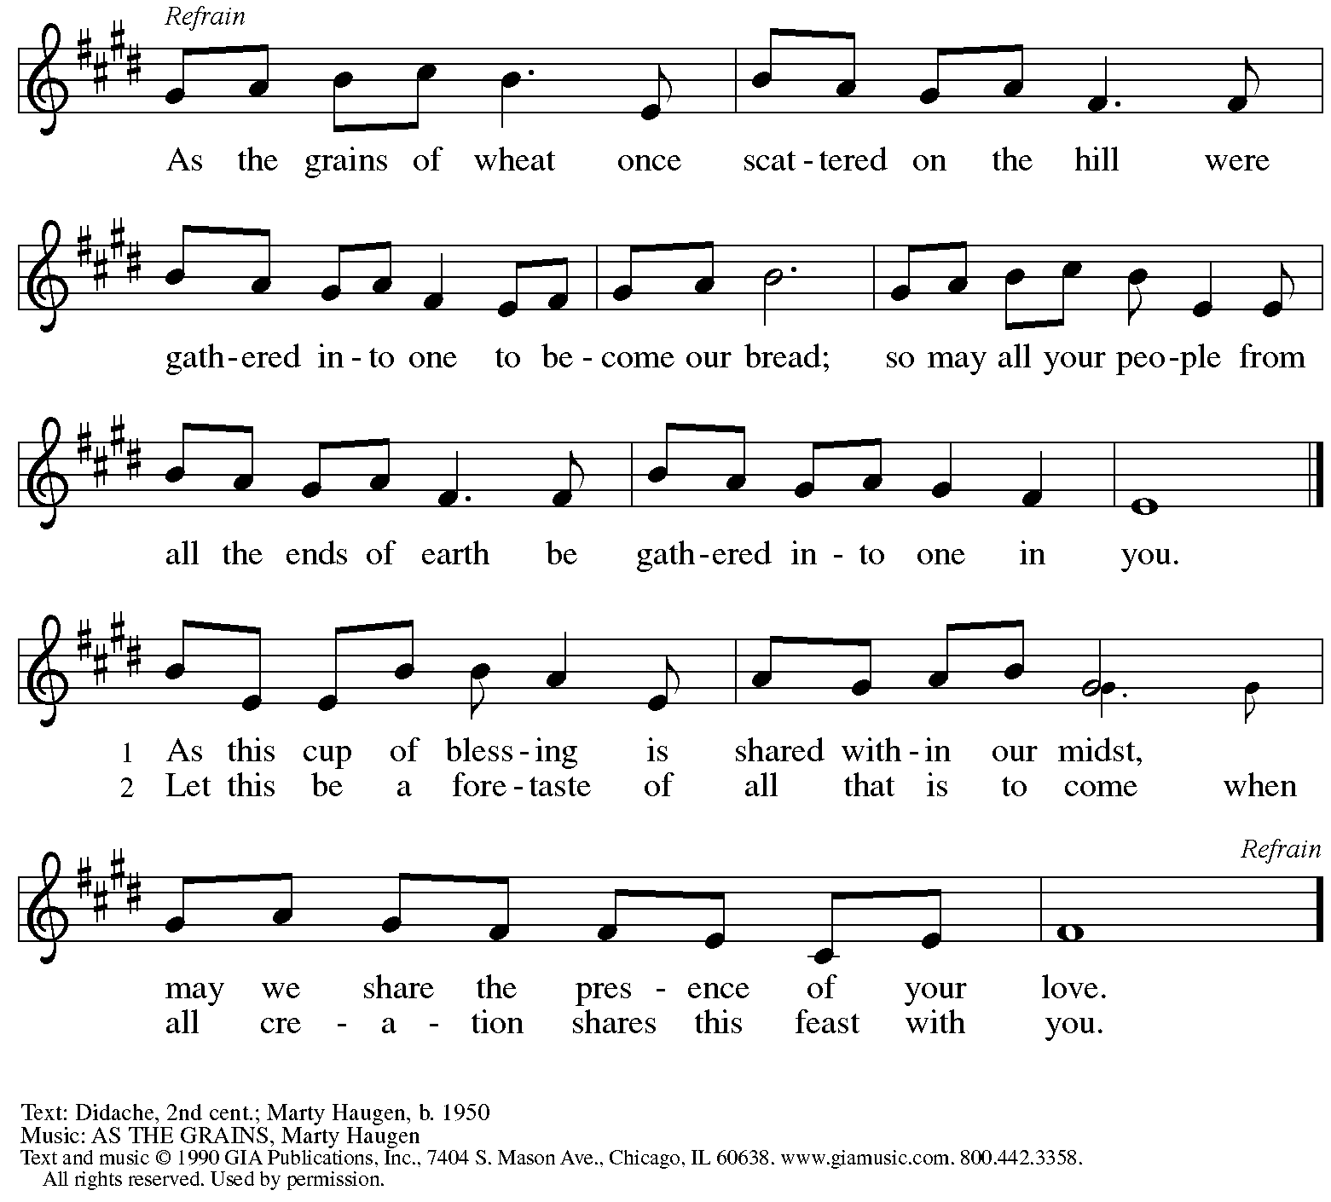
Reprinted under OneLicense.net # A-722139.

Offertory Prayer

A: A: Let us pray.
God of all creation,
C: all you have made is good and your love endures forever.
You bring forth bread from the earth and fruit from the vine.
Nourish us with these gifts,
that we might be for the world signs of your gracious presence
in Jesus Christ, our Savior and Lord.
Amen.

Dialogue ELW p. 206

P: The Lord be with you.
C: And also with you.

P: Lift up your hearts.
C: We lift them to the Lord.

P: Let us give thanks to the Lord our God.
C: It is right to give our thanks and praise.

Preface (Spoken by the presiding minister)

P: It is indeed right, our duty and our joy …
we praise your name and join their unending hymn:

Sanctus ELW p. 207

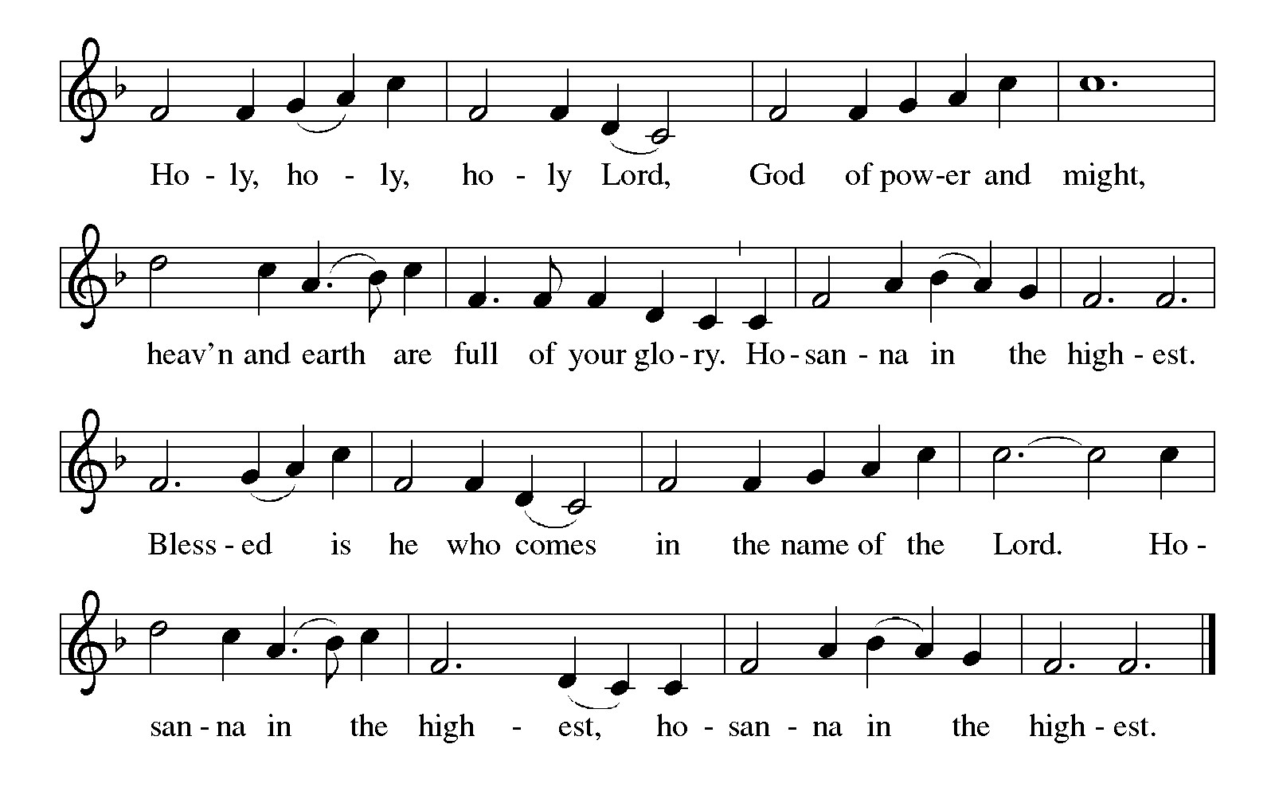

Eucharistic Prayer

P: Holy, mighty, and merciful Lord …
… to whom with you and the Holy Spirit
be all honor and glory, now and forever.
C: Amen.

Lord’s Prayer

P: Gathered as one by the Holy Spirit, let us pray as Jesus taught us.
C: Our Father, who art in heaven,
hallowed be thy name,
thy kingdom come,
thy will be done,
on earth as it is in heaven.
Give us this day our daily bread;
and forgive us our trespasses,
as we forgive those
who trespass against us;
and lead us not into temptation,
but deliver us from evil.
For thine is the kingdom,
and the power, and the glory,
forever and ever. Amen.

Fraction and Invitation


Agnus Dei / Lamb of God ELW p. 208

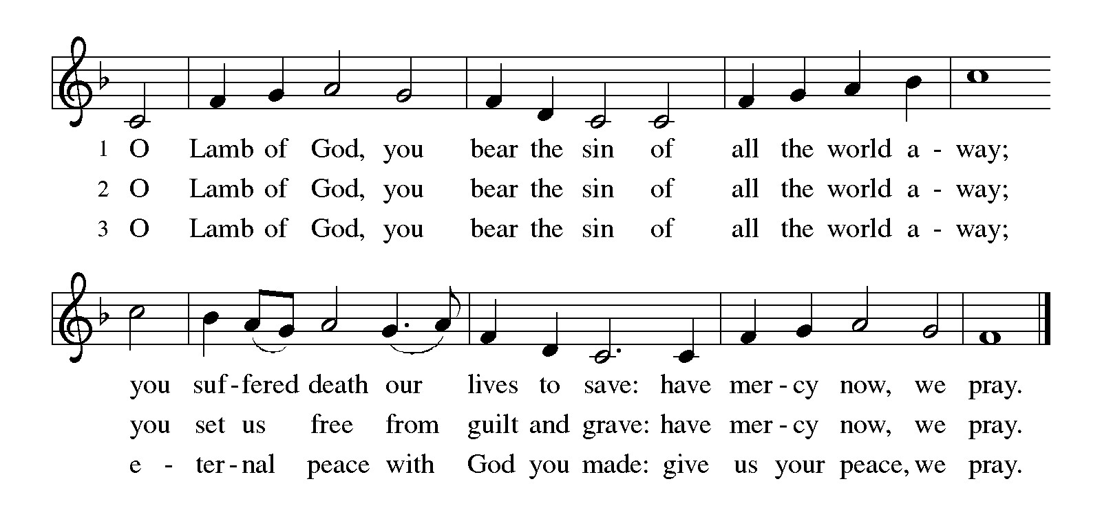
Please be seated.

Holy Communion

- All who seek God and desire a deeper and stronger life in Christ are welcome to receive Holy Communion.
- Worshipers from the pulpit side will proceed forward first, followed by the center section, and then the lectern side.
- Please inform an usher if you would like the ministers to bring Communion to you.
- Holy Communion will be served with bread and wine or grape juice..
- The presiding minister will first distribute the bread (host) to each communicant. Please indicate if you require a gluten-free host.
- Once you have consumed the bread, please pick up an empty glass from the tray next to the presiding minister. The Communion Assistant will pour wine or grape juice into your glass.
- Please step to the side to consume the wine or grape juice.
- Feel free to kneel at the altar rail for prayer after receiving the sacrament.
- As you return to your pew, glasses may be returned to the empty tray on the side of the center section.
- A blessing will be provided for anyone who does not yet receive the sacrament.
- All are invited to join in singing the hymns during Holy Communion.

Hymns during Holy Communion
Let Us Ever Walk with Jesus ELW 802

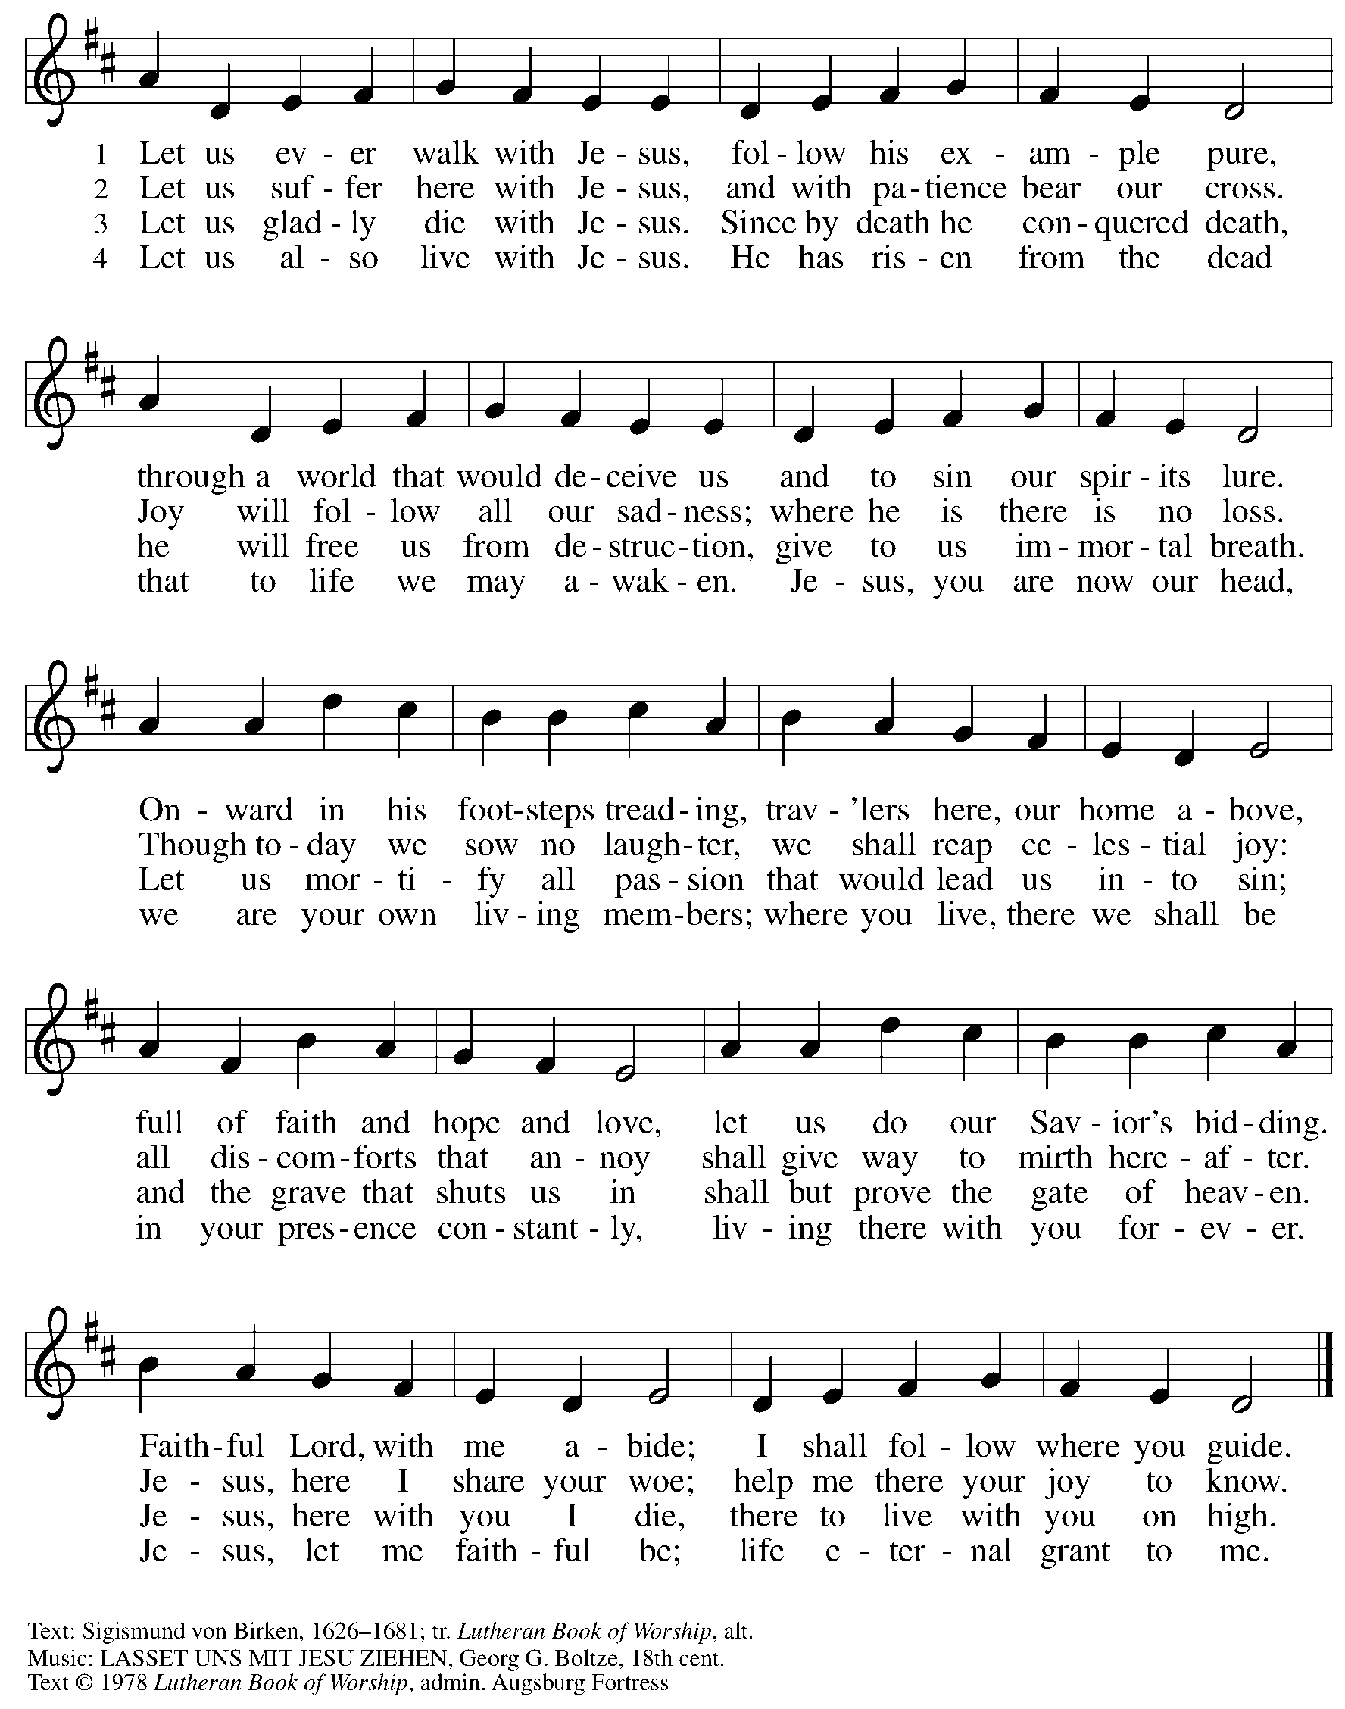
All rights reserved. Reprinted with permission under OneLicense.net # A-722139.

Hymns during Holy Communion
Be Thou My Vision ELW 793

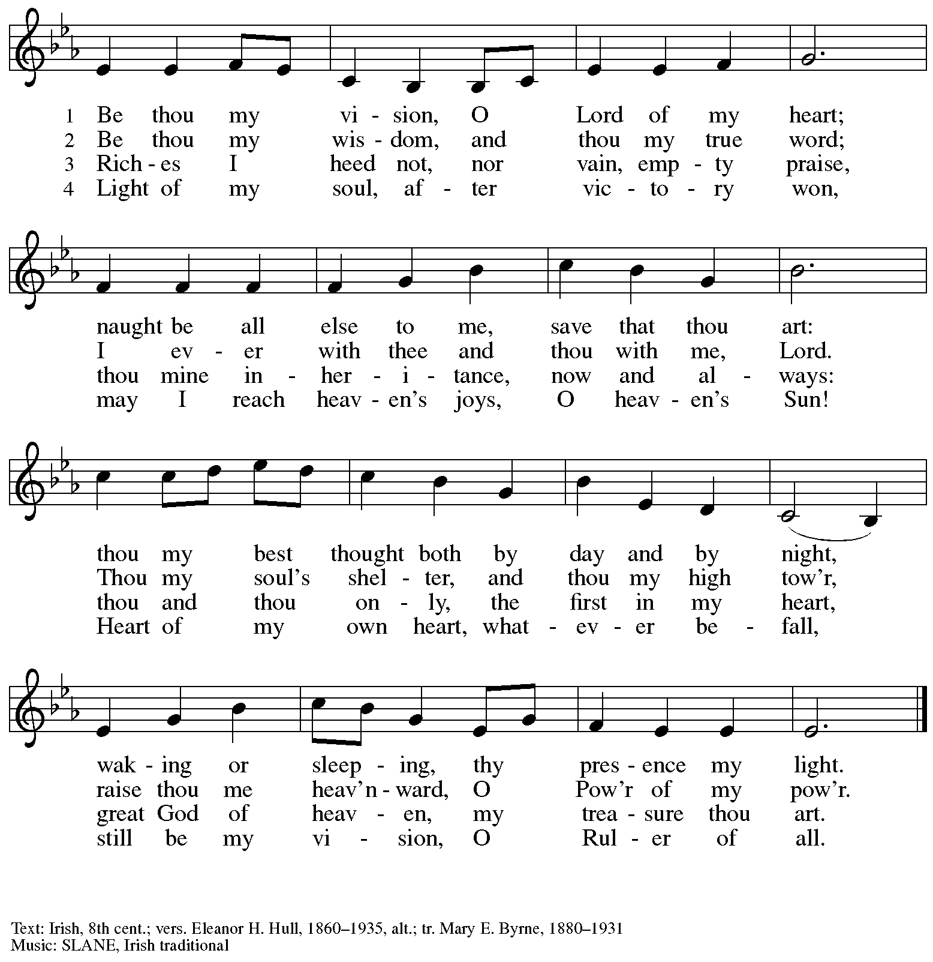

Hymns during Holy Communion
God Is Love ACS 1041

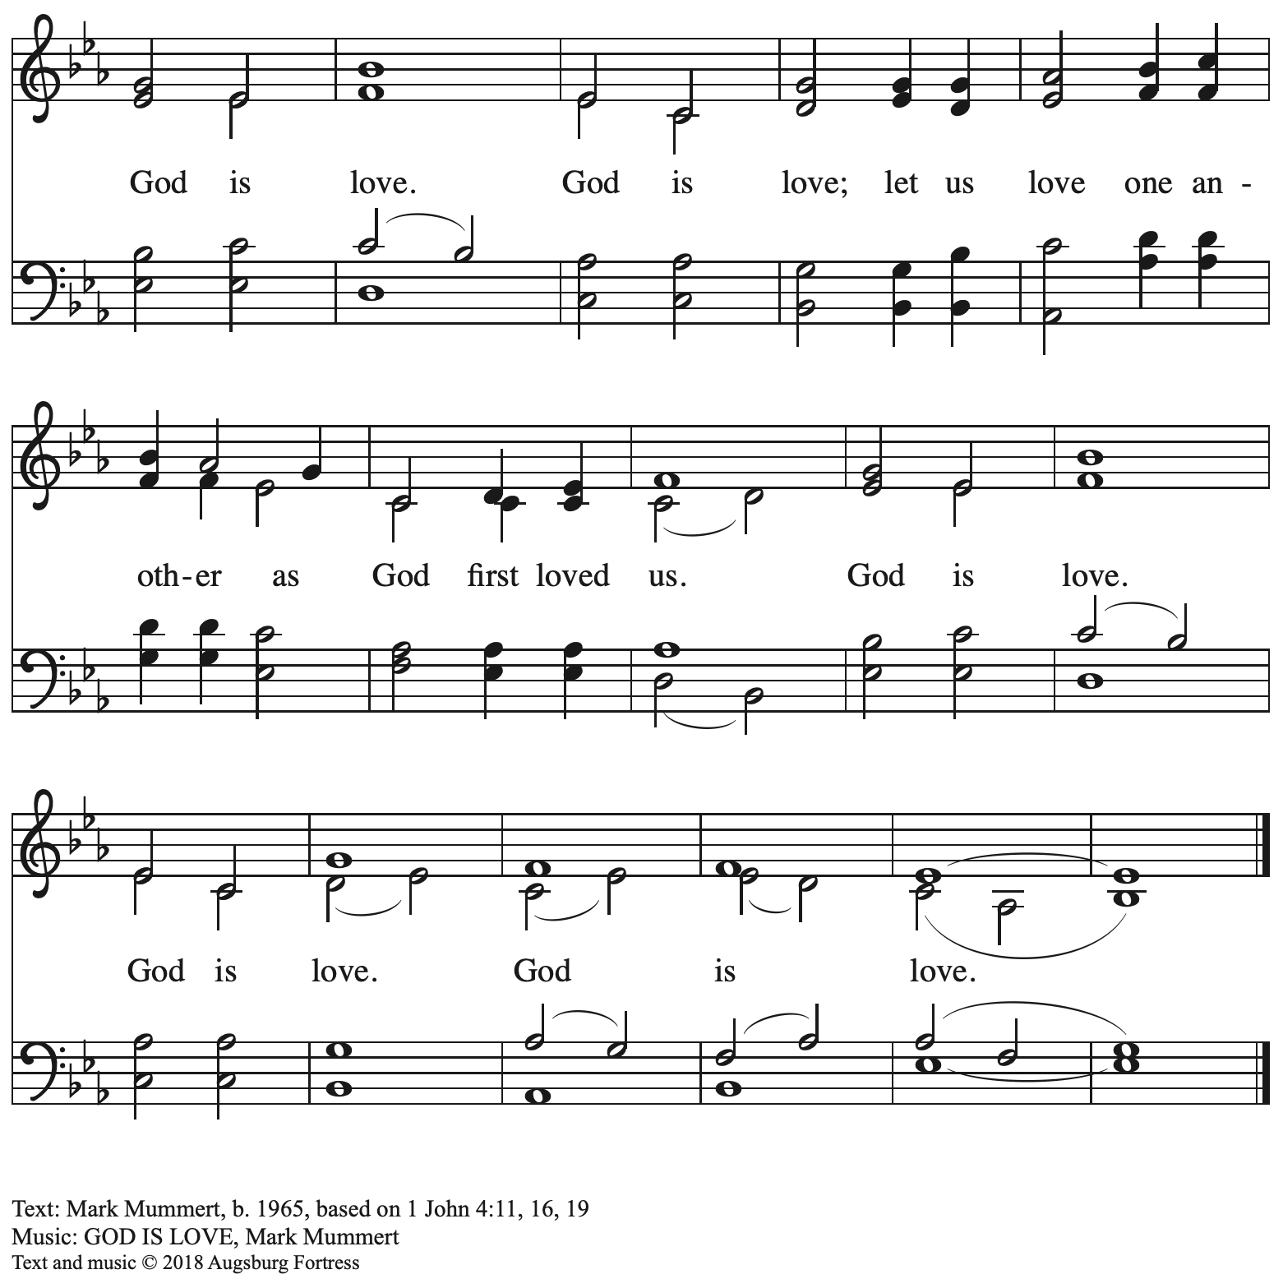
All rights reserved. Reprinted with permission under OneLicense.net # A-722139.

Hymns during Holy Communion
Lead Me, Guide Me ELW 768

No download was available for this hymn. Please turn to Hymn 768 at the back of the red Evangelical Lutheran Worship hymnals found in the pews.

When all have returned to their places, please rise as you are able.

Blessing

P: The body and blood of our Lord Jesus Christ strengthen you and keep you in his grace.
C: Amen.

Prayer

A: Let us pray.
O God, our life, our strength, our food,
we give you thanks for sustaining us with the body and blood of your Son.
By your Holy Spirit, enliven us to be his body in the world,
that more and more we will give you praise
and serve your earth and its many peoples,
through Jesus Christ, our Savior and Lord.
C: Amen.

Please be seated.

Sending
God blesses us and sends us in mission to the world

Announcements

Please rise as you are able.

Benediction

P: The God of steadfastness and encouragement
grant you to live in harmony with one another,
in accordance with Christ Jesus.
C: Amen.

P: The God of hope fill you with all joy and peace in believing,
so that you may abound in hope by the power of the Holy Spirit.
C: Amen.

P: The God of all grace ☩ bless you now and forever.
C: Amen.

Sending Hymn Following page

Dismissal

A: Go in peace. Serve the Lord.
C: Thanks be to God!

Postlude

Sending Hymn Sent Forth by God’s Blessing ELW 547

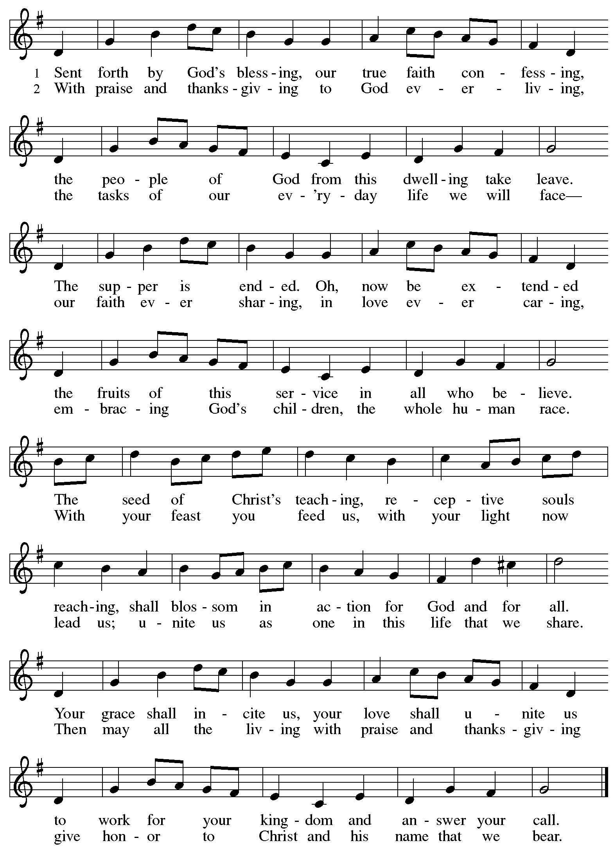

Those serving in worship today

Assisting Minister and Lector Colleen Cooke
Audio-Visual Ministers Sarita
Cantor Timothy Kocher-Hillmer
Minister of Music Laura Reynolds
Presiding Minister The Rev. Ross I. Carmichael

Liturgy and Hymnody Acknowledgements

From SundaysandSeasons.com. Copyright © 2025 Augsburg Fortress. All rights reserved. Reprinted under OneLicense.net # A-722139.
Used by permission of Augsburg Fortress.

The Scripture readings contained herein are from New Revised Standard Version Updated Edition of the Bible © 2021 National Council of Churches of Christ in the United States of America. Used by permission. All rights reserved worldwide.

Will You Come and Follow Me – The Summons – Text: John L. Bell, b. 1949. Music: KELVINGROVE, Scottish traditional. Text © 1987 Iona Community, GIA Publications, Inc., agent. 7404 S. Mason Ave., Chicago, IL 60638. www.giamusic.com. 800.442.3358. All rights reserved. Reprinted with permission under OneLicense.net # A-722139.

Sent Forth by God’s Blessing – Text: Omar Westendorf, 1916-1997, alt. Music: THE ASH GROVE, Welsh folk tune. Text © 1964 World Library Publications, 3708 River Rd., Franklin Park, IL 60131-2158. All rights reserved. Reprinted with permission under OneLicense.net # A-722139.

Please use the QR code below to link to St. Andrew’s Announcements online!



St. Andrew Lutheran Church Announcements
June 29th, 2025

- Welcome to Worship at St. Andrew on the Third Sunday after Pentecost! – We are so glad you are here, and we offer a special welcome to all visitors and guests who are here for the first time! There are worship “toolkits” to help children engage with worship and “busy bags” for younger children available in the bookcase at the back of the sanctuary. Please feel free to take one to use with/for your children. A nursery is available through the door to the left of the worship space and across the social hall (look for a purple room). Everyone is invited to gather in the social hall for coffee, other drinks, food, and conversation after worship!
- July Produce Distribution – Tuesday, July 1st, 5:30-7:00 p.m. – St. Andrew partners with Greater Pittsburgh Community Food Bank to serve as a distribution site for fresh produce on the first Tuesday of every month. This month’s distribution will be on Tuesday, July 1st. We invite people of the congregation to help with the distribution from 5:30-7:00 p.m. and/or to help with unloading and setup during the day between 10:00 a.m. and 1:00 p.m.
- Monthly Reparations Offering Next Week, Sunday, July 6th, during Worship – In Luke’s Gospel, Jesus tells a story about a compassionate Samaritan, suggesting that God’s people are called to work for healing and restoration for our neighbors, regardless of who or what caused them harm. In light of this, St. Andrew has made a commitment to reparations in regard to African American spiritual songs used in our worship. The text and music of most hymns is attributed to specific authors, with copyrights in place, usage reported, and royalties paid to those whose works are featured in worship. With African American spirituals, this is not possible. In response to many years of such uncredited use, St. Andrew invites the congregation to give a reparations offering. Funds received in worship will be donated to our siblings at Bethel AME Church, whose land and building were taken from them in the 1950s, to fund their development in the Hill District.
- July Shelter Dinner for Guests of East End Cooperative Ministry – No Assistance Needed – Due to an uncertain number of people available to serve, St. Andrew will not be asking for individual contributions to meal preparation for the East End Cooperative Ministry shelter dinner on Thursday, July 17th. We will uphold our commitment by funding the dinner in advance, which EECM will then arrange. Please watch for another opportunity to serve in August!
- Bible Book Club Taking a Break for Summer – Please watch for more information in August and September for when the group will resume its meetings!
- Unveiling the Lamb: Hope, Resistance, and the Church in Revelation – Zoom Study Led by The Rev. Dr. Martin Rafanan, Thursdays, July 24th – August 21st – Pastor Martin Rafanan has invited the people of St. Andrew to a Zoom study he is leading with PLUM – Pittsburgh Lutheran United Ministries on Thursdays, July 24th – August 21st: “Join us for a 5-session Zoom-based Bible study that explores the Book of Revelation not as a roadmap of fear, but as a bold unveiling of Jesus Christ. In a world of empire, confusion, and compromise, this vision from exile speaks hope and courage to the Church. Each session blends scriptural teaching, theological reflection, pastoral insight, and visual exploration.” To receive the link, please register here:
Google Registration Form:
https://forms.gle/JmbuU7RncG34auJs8
- Community Ministry Team Seeking Donations to Supply Backpacks to Students at The Neighborhood Academy – St. Andrew’s community ministry team was invited by St. Andrew’s Episcopal Church in Highland Park to assist with a project to supply backpacks for students at The Neighborhood Academy, a school in Garfield that supports students in grades 6-12 from low-income backgrounds with a college preparatory curriculum (For more information please see https://www.theneighborhoodacademy.org/). We will be collecting materials for 25 backpacks, with each backpack including one 2-inch, three-ring binder; a package of binder subject dividers; a pack of 6 pens (blue or black, gel or retractable ballpoints); a pack of 6 pencils; 2 yellow highlighters; a pack of white index cards (100, 3x5); 3 report pocket folders; 2 five-subject spiral notebooks. It is key that donations be relatively uniform, so binders, folders, notebooks etc. should be plain, simple colors – please no designs, logos, characters, etc. A donation bin will be set up in the social hall.
If you purchase items, please indicate your donation at this link so we can track that we have all the items: https://www.signupgenius.com/go/5080B4AAFAF2CABF85-57266709-backpacks. Thank you for considering a gift for this new (to us) ministry initiative!
- Christ in Our Home Devotional Booklets for July-September Available at Entrances – This resource offers a daily Bible reading with a short reflection and prayer, along with additional readings and prayer topics for those who would like to expand their devotional practices. We encourage people of the congregation to take one for yourself, your family/household, or others.

