

+ Fourth Sunday after Pentecost
July 6, 2025



St. Andrew Lutheran Church
304 Morewood Ave.
Pittsburgh, PA 15213
St_andrewELCA@verizon.net
www.standrewpittsburgh.org

+ Fourth Sunday after Pentecost
Order for Worship

God is the source of our nourishment,
Jesus’ invitation to “take and eat . . . take and drink” is a repeated one.
In Holy Communion, in the word read and proclaimed, in the assembly of the people of God,
the dominion of God has come near. Rejoice! Your name is written in heaven.

Welcome to St. Andrew!
- St. Andrew welcomes all who are seeking a place of healing, wholeness, and acceptance in a nurturing and faith-forming spiritual home. We are striving toward racial equity worldwide
and we seek to honor the lived experience of all individuals regardless of background. Our community embraces people of all ages, ethnicities, cultures, abilities, sexual orientations,
gender identities and expressions, and family constellations. Come and See!
- Worship Services are live-streamed to multiple online platforms. By attending worship, you agree that your image and voice may be broadcast.
- Everyone is invited to make a name tag at the black bookcase in the back of the worship space if they would like. There are stickers indicating pronouns on the bookcase if you would like to include them on your name tag.
- A nursery is available through the doors at the left side of the sanctuary and across from the doorway to the Social Hall. Look for a purple-colored room.
- Worship “toolkits” to help children engage with the service, along with “busy bags” for younger children, are available in the bookcase at the back of the sanctuary. Please feel free to take one to use with/for your children.
- Holy Communion is served with bread (gluten-free available) and wine or grape juice. The presiding minister will distribute the bread (host). Please consume this and then pick up an empty glass from the tray. The Communion Assistant will pour wine or grape juice into your glass. Please step to the side to consume the wine or grape juice. Feel free to kneel at the altar for prayer and reflection. As you return to your pew, glasses may be returned to the empty trays on either side of the center section.
- A restroom is available on the main level of the church, through the doors to the Social Hall and to the right in the main office.

Abbreviations
P: Pastor/Presiding Minister ELW: Evangelical Lutheran Worship hymnal
A: Assisting Minister ACS: All Creation Sings hymnal
L: Lector HS: Hymnal Supplement (GIA Publications)
C: Congregation

Musical Offering

Each week, different people from the congregation make an offering of pre-service music,
with singing or instrumentation, to help the assembly focus and pray in preparation for worship.

Welcome

Prelude This Is My Maker’s World arr. Keveren

Gathering
The Holy Spirit calls us together as the people of God

Please rise as you are able. All may make the sign of the cross, the sign marked at Baptism,
as the presiding minister begins.

Confession and Forgiveness

P: Blessed be the holy Trinity, ☩ one God,
who forgives all our sin,
whose mercy endures forever.
C: Amen.

P: Baptized into Christ, let us confess our sins.

Silence is kept for reflection.
.
P: Merciful God,
C: you free us to love others,
but we neglect our neighbors and follow our own way.
You lead us by the Spirit of joy and peace,
but we turn away from the abundant life you offer.
You surround us with patience, kindness, and generosity,
but we grow weary in doing what is right.
In your mercy, forgive us. Do not give up on us.
Heal us, break our bonds, and show us the path of life.
Amen.

P: You belong to Christ Jesus
and you are God’s children through faith.
In the cross of ☩ Christ,
and through the power of the Holy Spirit, your sins are forgiven.
Clothed with Christ, you are a new creation.
C: Amen.

Gathering Hymn Remember and Rejoice ELW 454

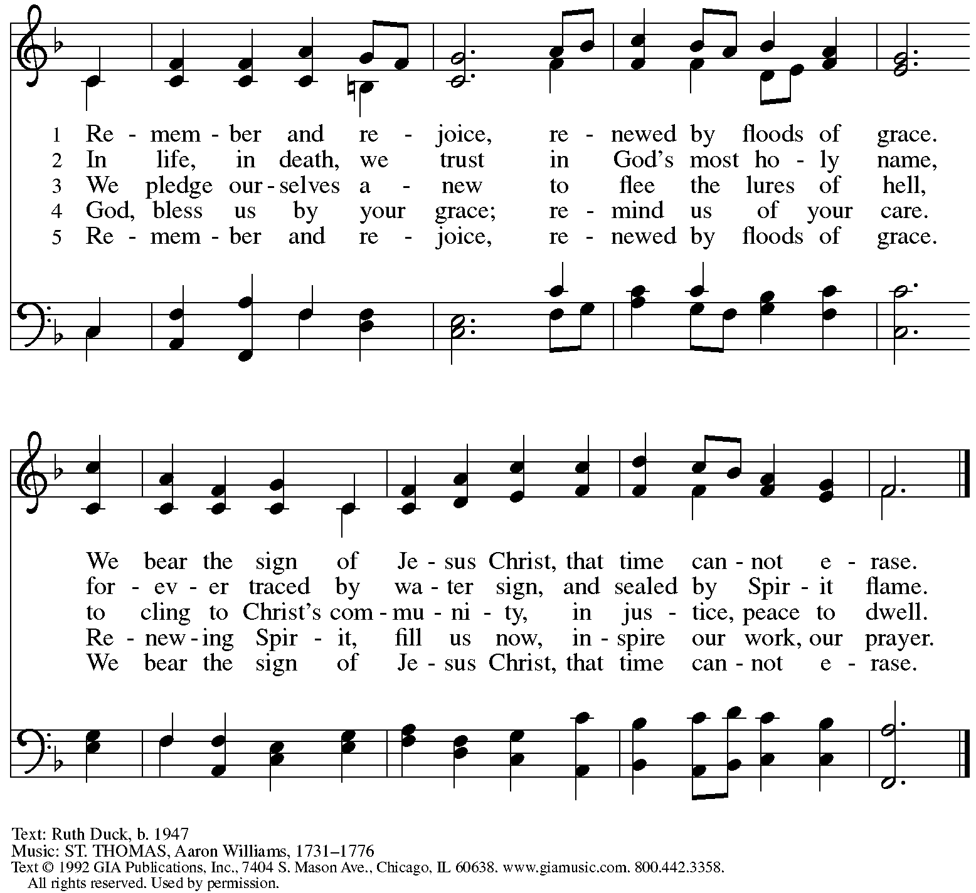
Reprinted with permission under OneLicense.net # A-722139.

Greeting

P: The grace of our Lord Jesus Christ, the love of God,
and the communion of the Holy Spirit be with you all.
C: And also with you.

Hymn of Praise ELW p. 204

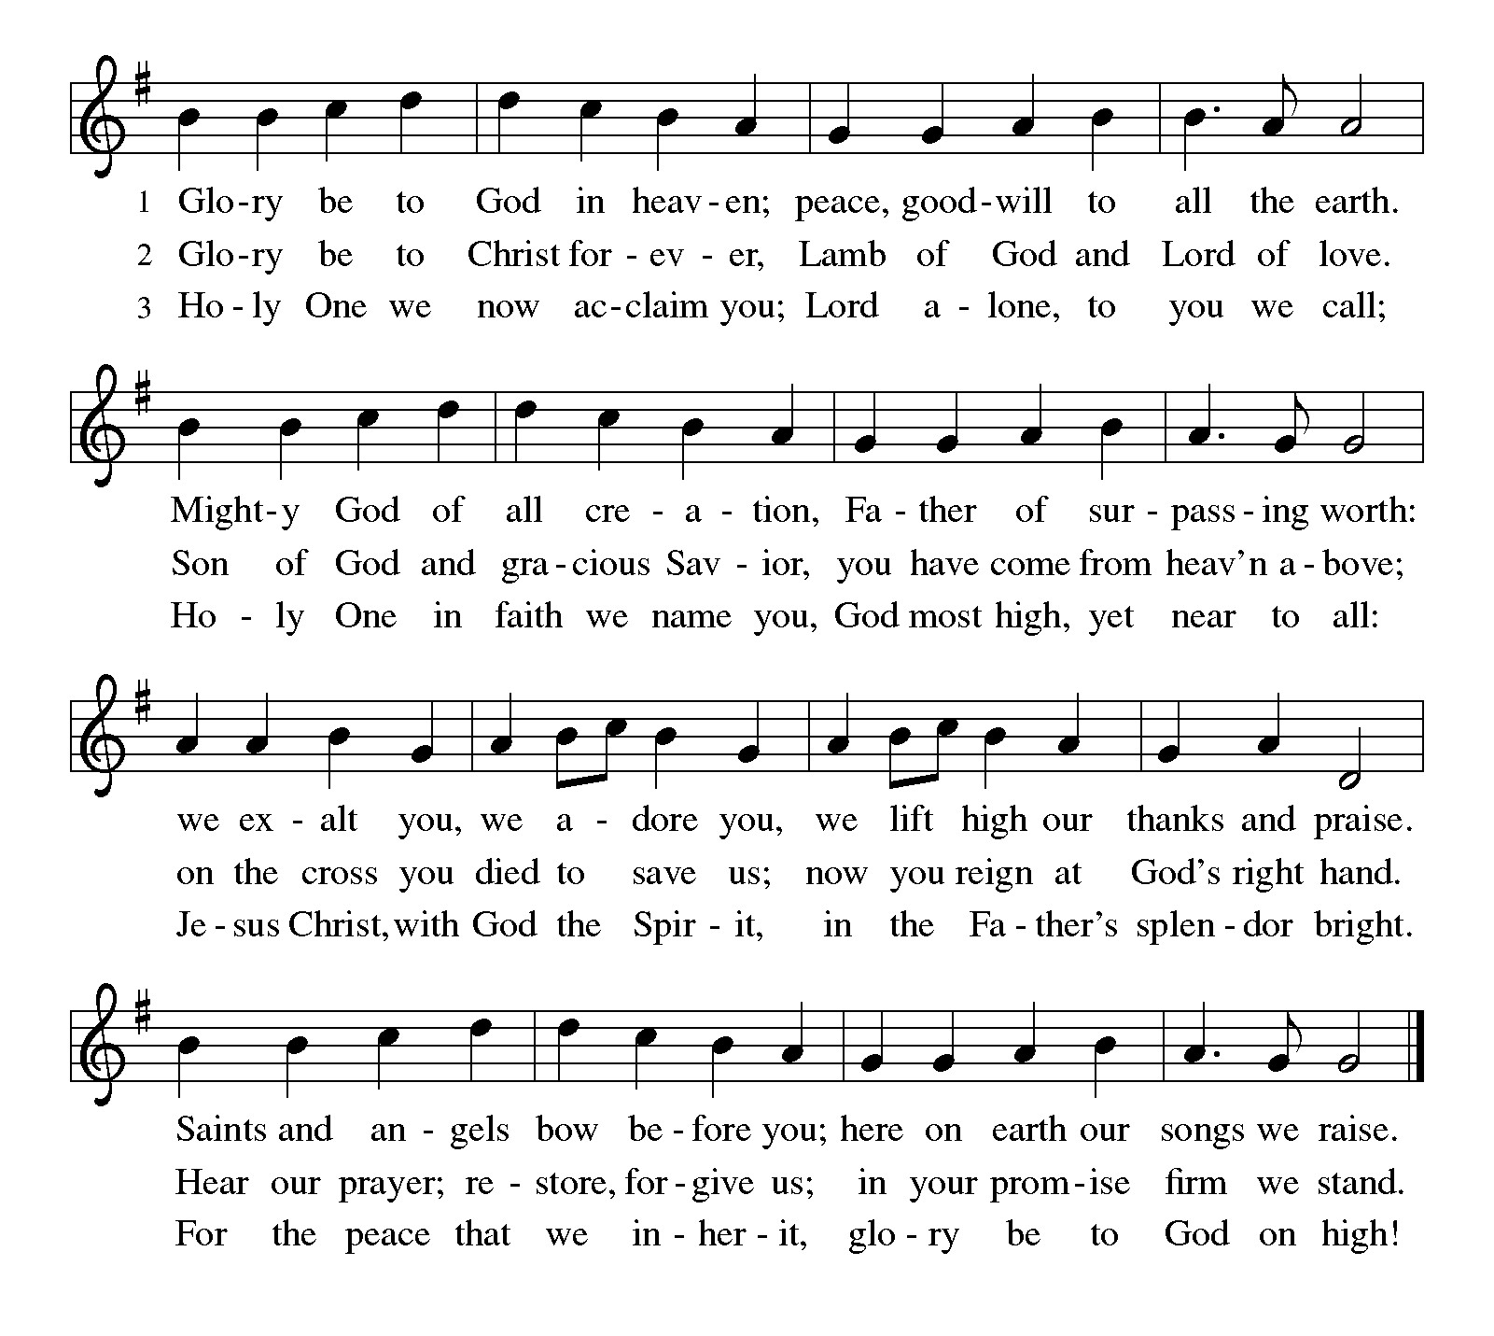

Prayer of the Day

P: The Lord be with you.
C: And also with you.

P: Let us pray. O God, the Father of our Lord Jesus,
you are the city that shelters us, the mother who comforts us.
With your Spirit, accompany us on our life’s journey,
that we may extend your peace to all the world,
through your Son, Jesus Christ, our Savior and Lord.
C: Amen.

Please be seated.

Word
God speaks to us in Scripture reading, preaching, and song

First Reading – Isaiah 66: 10-14

¹⁰ Rejoice with Jerusalem, and be glad for her,
all you who love her;
rejoice with her in joy,
all you who mourn over her—
¹¹ that you may nurse and be satisfied
from her consoling breast,
that you may drink deeply with delight
from her glorious bosom.
¹² For thus says the Lord:
I will extend prosperity to her like a river
and the wealth of the nations like an overflowing stream,
and you shall nurse and be carried on her arm
and bounced on her knees.
¹³ As a mother comforts her child,
so I will comfort you;
you shall be comforted in Jerusalem.
¹⁴ You shall see, and your heart shall rejoice;
your bodies shall flourish like the grass,
and it shall be known that the power of the Lord is with God’s servants,
and the Lord’s indignation is against God’s enemies.

L: Word of God, word of life.
C: Thanks be to God.

Psalm 66: 1-9

The psalm will be sung responsively, led by the cantor,
with the congregation responding with the bold verses and refrain.

Psalm tone

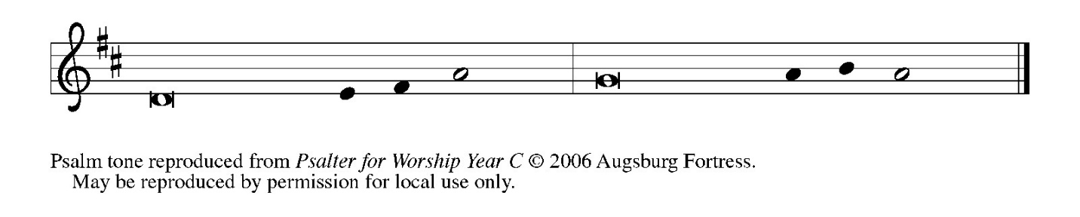

Psalm refrain

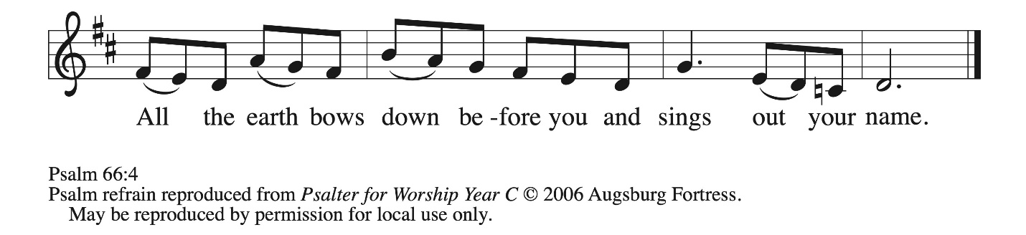

¹ Be joyful in God, | all you lands;
be joyful, | all the earth.
² Sing the glory | of God’s name;
sing the glory | of God’s praise.
³ Say to God, “How awesome | are your deeds!
Because of your great strength your enemies | cringe before you.
⁴ All the earth bows | down before you,
sings to you, sings | out your name.” R
⁵ Come now and see the | works of God,
how awesome are God’s deeds | toward all people.
⁶ God turned the sea into dry land, so that they went through the wa- | ter on foot,
and there we re- | joiced in God.
⁷ Ruling forever in might, God keeps watch o- | ver the nations;
let no rebels ex- | alt themselves.
⁸ Bless our | God, you peoples;
let the sound of | praise be heard.
⁹ Our God has kept us a- | mong the living
and has not allowed our | feet to slip. R

Second Reading – Galatians 6: [1-6] 7-16

[ ¹ My siblings, if anyone is detected in a transgression, you who have received the Spirit should restore such a one in a spirit of gentleness. Take care that you yourselves are not tempted. ² Bear one another’s burdens, and in this way you will fulfill the law of Christ. ³ For if those who are nothing think they are something, they deceive themselves. ⁴ All must test their own work; then that work, rather than their neighbor’s work, will become a cause for pride. ⁵ For all must carry their own loads.
⁶ Those who are taught the word must share in all good things with their teacher.]
⁷ Do not be deceived; God is not mocked, for you reap whatever you sow. ⁸ If you sow to your own flesh, you will reap corruption from the flesh, but if you sow to the Spirit, you will reap eternal life from the Spirit. ⁹ So let us not grow weary in doing what is right, for we will reap at harvest time, if we do not give up. ¹⁰ So then, whenever we have an opportunity, let us work for the good of all and especially for those of the family of faith.
¹¹ See what large letters I make when I am writing in my own hand! ¹² It is those who want to make a good showing in the flesh who try to compel you to be circumcised—only that they may not be persecuted for the cross of Christ. ¹³ Even the circumcised do not themselves obey the law, but they want you to be circumcised so that they may boast about your flesh. ¹⁴ May I never boast of anything except the cross of our Lord Jesus Christ, by which the world has been crucified to me and I to the world. ¹⁵ For neither circumcision nor uncircumcision is anything, but a new creation is everything! ¹⁶ As for those who will follow this rule—peace be upon them, and mercy, and upon the Israel of God.

L: Word of God, word of life.
C: Thanks be to God.

Please rise as you are able.

Gospel Acclamation ELW p. 205

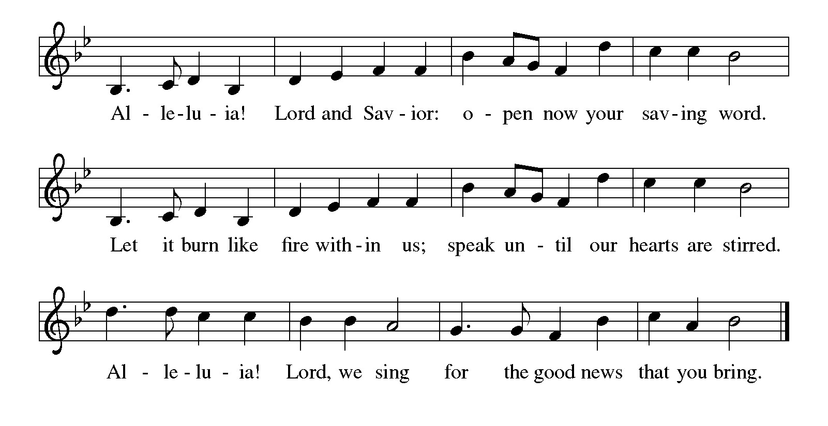

Gospel – Luke 10: 1-11, 16-20

P: The holy Gospel according to St. Luke.
C: Glory to you, O Lord.

¹ After this the Lord appointed seventy-two others and sent them on ahead of him in pairs to every town and place where he himself intended to go. ² He said to them, “The harvest is plentiful, but the laborers are few; therefore ask the Lord of the harvest to send out laborers into his harvest. ³ Go on your way; I am sending you out like lambs into the midst of wolves. ⁴ Carry no purse, no bag, no sandals, and greet no one on the road. ⁵ Whatever house you enter, first say, ‘Peace to this house!’ ⁶ And if a person of peace is there, your peace will rest on that person, but if not, it will return to you. ⁷ Remain in the same house, eating and drinking whatever they provide, for the laborer deserves to be paid. Do not move about from house to house. ⁸ Whenever you enter a town and its people welcome you, eat what is set before you; ⁹ cure the sick who are there, and say to them, ‘The kingdom of God has come near to you.’ ¹⁰ But whenever you enter a town and they do not welcome you, go out into its streets and say, ¹¹ ‘Even the dust of your town that clings to our feet, we wipe off in protest against you. Yet know this: the kingdom of God has come near.’

¹⁶ “Whoever listens to you listens to me, and whoever rejects you rejects me, and whoever rejects me rejects the one who sent me.”
¹⁷ The seventy-two returned with joy, saying, “Lord, in your name even the demons submit to us!” ¹⁸ He said to them, “I watched Satan fall from heaven like a flash of lightning. ¹⁹ Indeed, I have given you authority to tread on snakes and scorpions and over all the power of the enemy, and nothing will hurt you. ²⁰ Nevertheless, do not rejoice at this, that the spirits submit to you, but rejoice that your names are written in heaven.”

P: The Gospel of the Lord.
C: Praise to you, O Christ.

Please be seated.

Sermon

A time of silence for prayer and reflection follows the sermon.
When the hymn of the day begins, please rise as you are able.

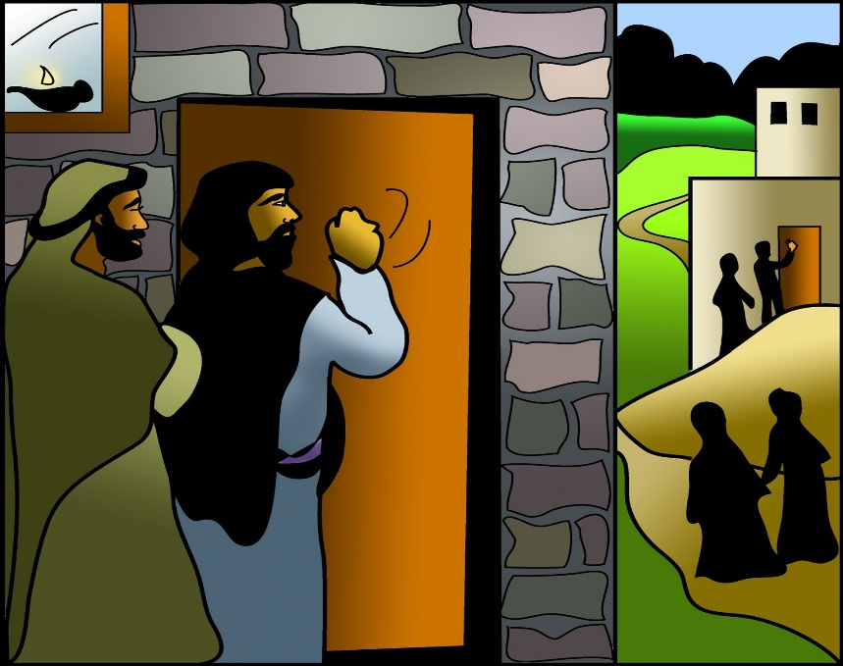

Hymn of the Day Lord, You Give the Great Commission ELW 579

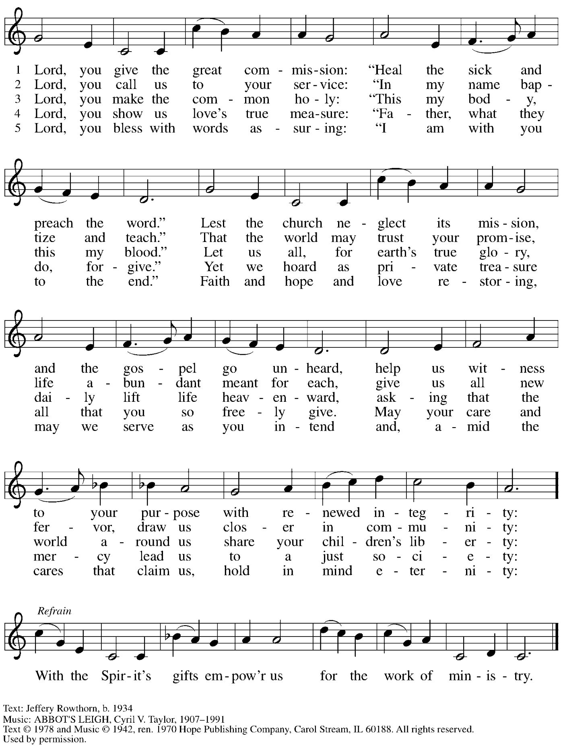
Reprinted under OneLicense.net # A-722139.
The Sacrament of Holy Baptism

Candidates for Baptism, sponsors, and parents gather with the ministers at the font.
The assembly is seated.

Presentation

The presiding minister may address the assembly in these or similar words:
P: God, who is rich in mercy and love, gives us a new birth into a living hope through the sacrament of Holy Baptism. By water and the Word God delivers us from sin and death and raises us to new life in Jesus Christ. We are united with all the baptized in the one body of Christ, anointed with the gift of the Holy Spirit, and joined in God's mission for the life of the world.

Sponsors for each candidate, in turn, present the candidates:
S: I present Reed Anders for Baptism.

The presiding minister addresses parents or others who bring for Baptism
children who are not able to answer for themselves:
P: Called by the Holy Spirit, trusting in the grace and love of God,
do you desire to have your child baptized into Christ?
Response: I do.

P: As you bring your child to receive the gift of Baptism, you are entrusted with responsibilities:
to live with him among God's faithful people,
bring him to the word of God and the holy supper,
teach him the Lord's Prayer, the Creed, and the Ten Commandments,
place in his hands the holy scriptures,
and nurture him in faith and prayer,
so that your child may learn to trust God,
proclaim Christ through word and deed,
care for others and the world God made,
and work for justice and peace.
Do you promise to help your child grow in the Christian faith and life?
Response: I do.

The presiding minister addresses sponsors:
P: Sponsor(s), do you promise to nurture this person in the Christian faith as you are empowered by God's Spirit, and to help him live in the covenant of Baptism and in communion with the church?
Response: I do.

The presiding minister addresses the assembly:
P: People of God, do you promise to support Reed and pray for him in his new life in Christ?
C: We do.

People of the assembly please rise as you are able.

Profession of Faith

The presiding minister addresses candidates for Baptism as well as the parents and sponsors of young children. The assembly may join in the responses.
P: I ask you to profess your faith in Christ Jesus, reject sin, and confess the faith of the church.

Do you renounce the devil and all the forces that defy God?
Response: I renounce them.

P: Do you renounce the powers of this world that rebel against God?
Response: I renounce them.

P: Do you renounce the ways of sin that draw you from God?
Response: I renounce them.

The presiding minister addresses the candidates and the assembly.
P: Do you believe in God the Father?
C: I believe in God, the Father almighty,
creator of heaven and earth.

P: Do you believe in Jesus Christ, the Son of God?
C: I believe in Jesus Christ, God’s only Son, our Lord,
who was conceived by the Holy Spirit,
born of the virgin Mary,
suffered under Pontius Pilate,
was crucified, died, and was buried;
he descended to the dead.*
On the third day he rose again;
he ascended into heaven,
he is seated at the right hand of the Father,
and he will come to judge the living and the dead.

P: Do you believe in God the Holy Spirit?
C: I believe in the Holy Spirit,
the holy catholic church,
the communion of saints,
the forgiveness of sins,
the resurrection of the body,
and the life everlasting.

*Or, “he descended into hell,” another translation of this text in widespread use.

Thanksgiving at the Font

Water may be poured into the font before or during the thanksgiving.

At the font, the presiding minister begins the thanksgiving:
P: The Lord be with you.
C: And also with you.

P: Let us give thanks to the Lord our God.
C: It is right to give our thanks and praise.

P: We give you thanks, O God, for in the beginning your Spirit moved over the waters,
and by your Word you created the world, calling forth life in which you took delight.
Through the waters of the flood you delivered Noah and his family, and through the sea you led your people Israel from slavery into freedom. At the river your Son was baptized by John and anointed with the Holy Spirit. By the baptism of Jesus' death and resurrection you set us free from the power of sin and death and raise us up to live in you.

Pour out your Holy Spirit, the power of your living Word, that those who are washed in the waters of baptism may be given new life. To you be given honor and praise through Jesus Christ our Lord, in the unity of the Holy Spirit, now and forever.
C: Amen.

The assembly may be seated.

Baptism

The presiding minister baptizes the candidate. The candidate is immersed into the water,
or water is poured on the candidate's head, as the presiding minister says:
P: Reed Anders, I baptize you in the name of the Father,*
The candidate is immersed or water is poured on the candidate's head a second time:
and of the Son,
The candidate is immersed or water is poured on the candidate's head a third time:
and of the Holy Spirit.
C: Amen.

*Or, " Name is baptized in the name of the Father, . . ."

After the Baptism, the assembly sings the acclamation of the congregational refrain,
which is sung on special occasions in the life of the congregation.

Congregational Refrain HS 808

Text: Jaroslav J. Vajda, b. 1919, © 1987.
Music: RIVERSIDE, Irregular; Carl F. Schalk, b. 1929, © 1987 GIA Publications, Inc.
All rights reserved. Reprinted with permission under OneLicense.net # A-722139.

The presiding minister continues:
P: Let us pray.
We give you thanks, O God, that through water and the Holy Spirit you give your children new birth, cleanse them from sin, and raise them to eternal life.

Laying both hands on the head of the newly baptized, the minister prays:
P: Sustain Reed with the gift of your Holy Spirit: the spirit of wisdom and understanding, the spirit of counsel and might, the spirit of knowledge and the fear of the Lord, the spirit of joy in your presence, both now and forever.
C: Amen.

The presiding minister marks the sign of the cross on the forehead of the baptized.
Oil prepared for this purpose may be used. As the sign of the cross is made, the minister says:
P: Reed Anders, child of God, you have been sealed by the Holy Spirit and marked with the cross of Christ forever.
C: Amen.

Welcome

A lighted candle may be given to each of the newly baptized (to a sponsor of a young child)
as a representative of the congregation says:
A: Jesus said, I am the light of the world.
Whoever follows me
will have the light of life.

The ministers and the baptismal group face the assembly.
A representative of the congregation leads the assembly in the welcome.
A: Let us welcome the newly baptized.
C: We welcome you into the body of Christ and into the mission we share:
join us in giving thanks and praise to God
and bearing God's creative and redeeming word to all the world.

As those who have gathered at the font move through the congregation
to introduce our new sibling in Christ,
all are invited to join in singing the baptismal hymn.

Baptismal Hymn Baptized in Water ELW 456

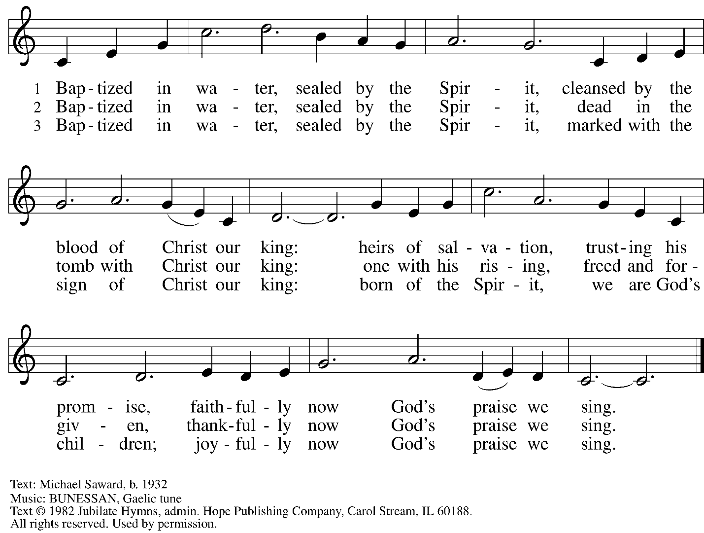
Reprinted under OneLicense.net # A-722139.

When all have returned to their places, worship continues with the Prayers of the People.

Prayers of the People

A: With the whole people of God in Christ Jesus, let us pray for the church, those in need,
and all of God’s creation.

After each petition
A: God of grace,
C: receive our prayer.

The presiding minister concludes the prayers
P: Into your hands, gracious God, we commend all for whom we pray,
trusting in your mercy; through Jesus Christ, our Savior.
C: Amen.

Peace

The presiding minister and the assembly greet one another in the peace of the risen Christ.
P: The peace of Christ be with you always.
C: And also with you.

The people may greet those around them with a sign of Christ’s peace and may say
Peace be with you or similar words. Please be mindful that not everyone will be comfortable with sharing the peace, so please seek consent before shaking hands or hugging. Other possible ways to share the peace include a simple bow with the verbal greeting of peace, or simply a verbal expression of peace.

When the greetings of peace have concluded, please be seated.

Meal
God feeds us with the presence of Jesus Christ

Offering

We offer ourselves, our gifts, and our faithful service to God.
As the offering is gathered for the mission of the church, including the care of those in need,
the table is set for Holy Communion.

There are laminated giving cards in the pew racks that feature a QR code for anyone who would like to give online. Those who give using the QR code, as well as those who give regularly online or through their bank are encouraged to place the laminated card in the plate as an expression of your offering.

Reparations Offering

On the first Sunday of each month, St. Andrew invites people of the congregation to give a second offering for a reparations fund in acknowledgement of St. Andrew’s use of African American spiritual songs in our worship services. Please see the note in the announcements for more information.

Offertory Music In the Garden arr. Keveren

As the gifts are brought forward for presentation, please rise as you are able.

Offertory Song As the Grains of Wheat ELW 465

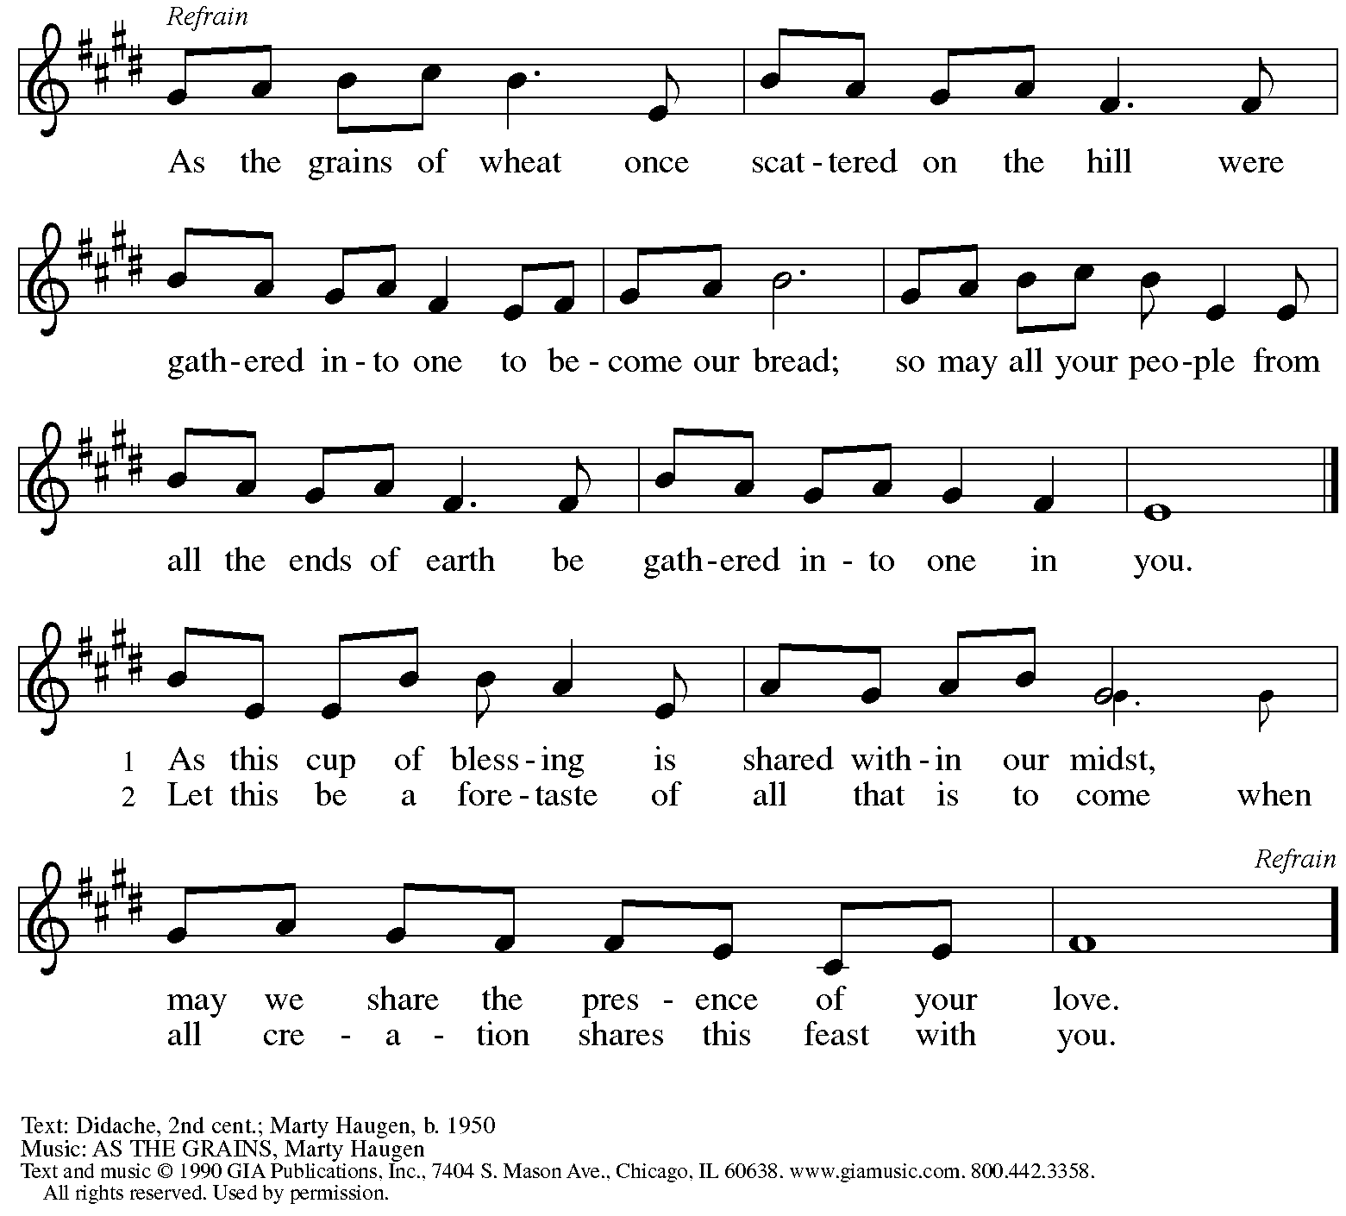
Reprinted under OneLicense.net # A-722139.

Offertory Prayer

A: A: Let us pray.
God of all creation,
C: all you have made is good and your love endures forever.
You bring forth bread from the earth and fruit from the vine.
Nourish us with these gifts,
that we might be for the world signs of your gracious presence
in Jesus Christ, our Savior and Lord.
Amen.

Dialogue ELW p. 206

P: The Lord be with you.
C: And also with you.

P: Lift up your hearts.
C: We lift them to the Lord.

P: Let us give thanks to the Lord our God.
C: It is right to give our thanks and praise.

Preface (Spoken by the presiding minister)

P: It is indeed right, our duty and our joy,
that we should at all times and in all places
give thanks and praise to you, almighty and merciful God,
through our Savior Jesus Christ;
who on this day overcame death and the grave,
and by his glorious resurrection
opened to us the way of everlasting life.
And so, with all the choirs of angels,
with the church on earth and the hosts of heaven,
we praise your name and join their unending hymn:

Sanctus ELW p. 207

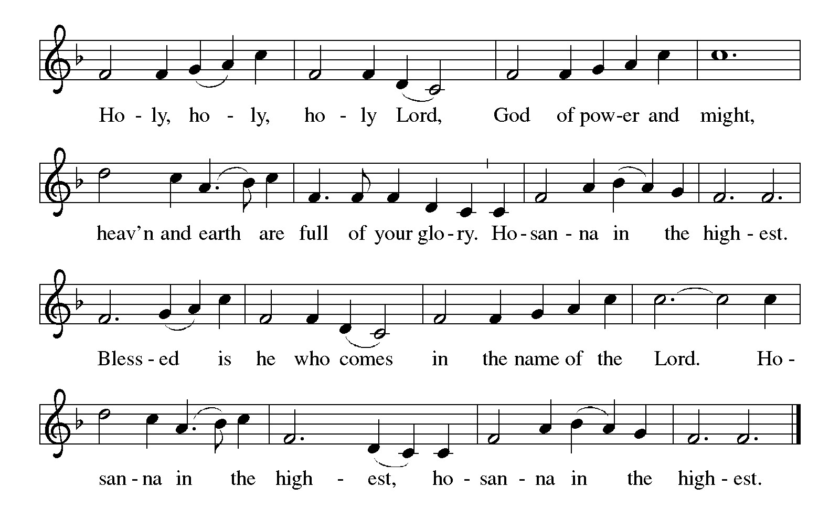

Eucharistic Prayer

P: Holy, mighty, and merciful Lord …
… to whom with you and the Holy Spirit
be all honor and glory, now and forever.
C: Amen.

Lord’s Prayer

P: Gathered as one by the Holy Spirit, let us pray as Jesus taught us.
C: Our Father, who art in heaven,
hallowed be thy name,
thy kingdom come,
thy will be done,
on earth as it is in heaven.
Give us this day our daily bread;
and forgive us our trespasses,
as we forgive those
who trespass against us;
and lead us not into temptation,
but deliver us from evil.
For thine is the kingdom,
and the power, and the glory,
forever and ever. Amen.

Fraction and Invitation

Agnus Dei / Lamb of God ELW p. 208

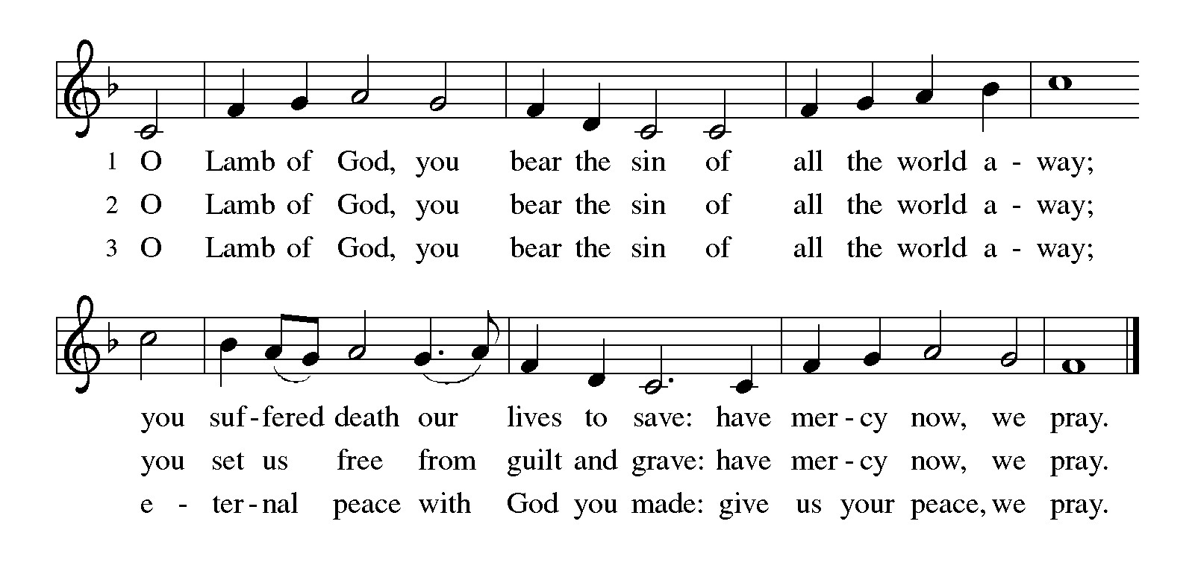
Please be seated.

Holy Communion

- All who seek God and desire a deeper and stronger life in Christ are welcome to receive Holy Communion.
- Worshipers from the pulpit side will proceed forward first, followed by the center section, and then the lectern side.
- Please inform an usher if you would like the ministers to bring Communion to you.
- Holy Communion will be served with bread and wine (amber) or grape juice (purple).
- The presiding minister will first distribute the bread (host) to each communicant. Please indicate if you require a gluten-free host.
- Once you have consumed the bread, please pick up an empty glass from the tray next to the presiding minister. The Communion Assistant will pour wine or grape juice into your glass.
- Please step to the side to consume the wine or grape juice.
- Feel free to kneel at the altar rail for prayer after receiving the sacrament.
- As you return to your pew, glasses may be returned to the empty tray on the side of the center section.
- A blessing will be provided for anyone who does not yet receive the sacrament.
- All are invited to join in singing the hymns during Holy Communion.

Hymns during Holy Communion
O God, Whose Word Well-Planted ACS 975

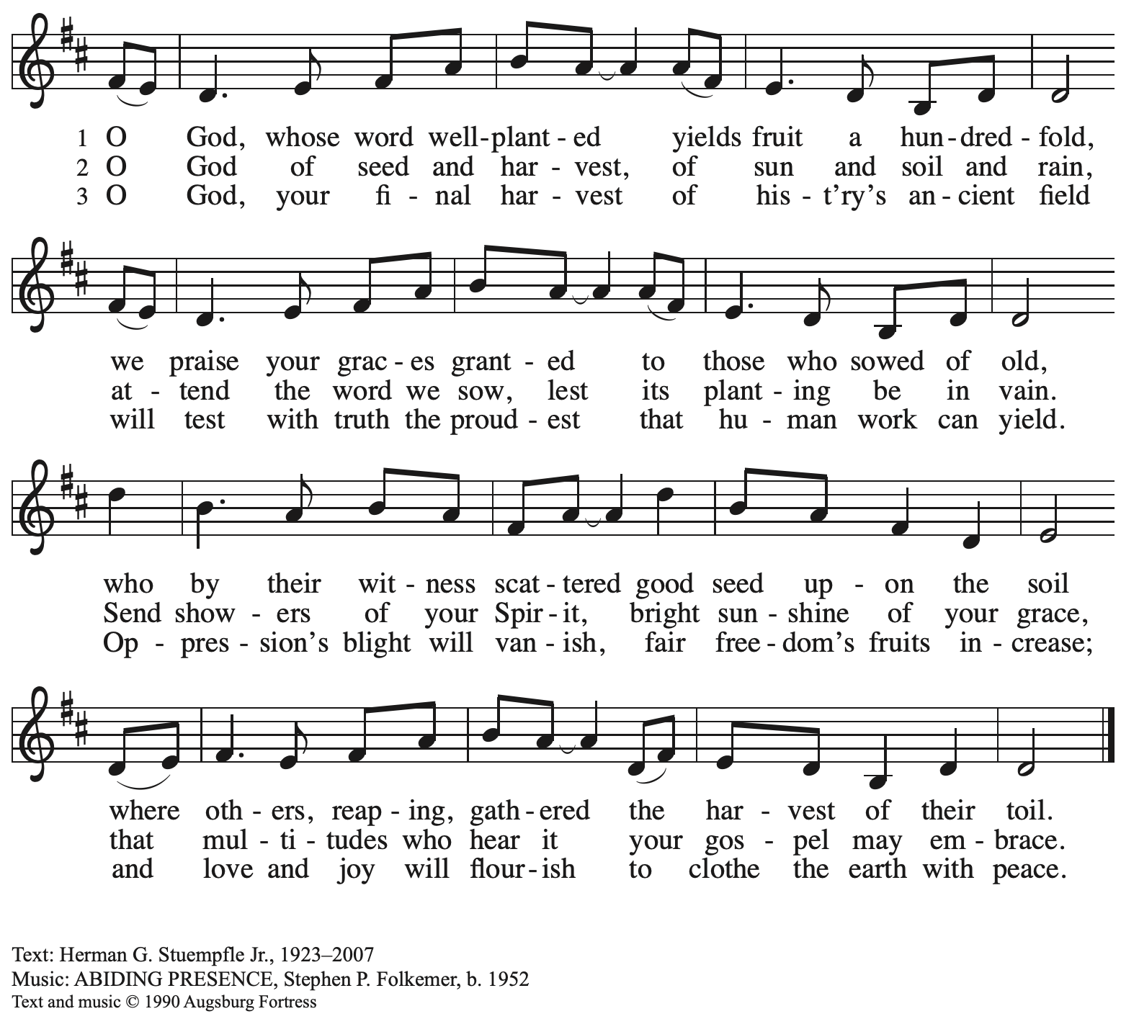
All rights reserved. Reprinted with permission under OneLicense.net # A-722139.

Hymns during Holy Communion
As a Mother Comforts Her Child ACS 1015

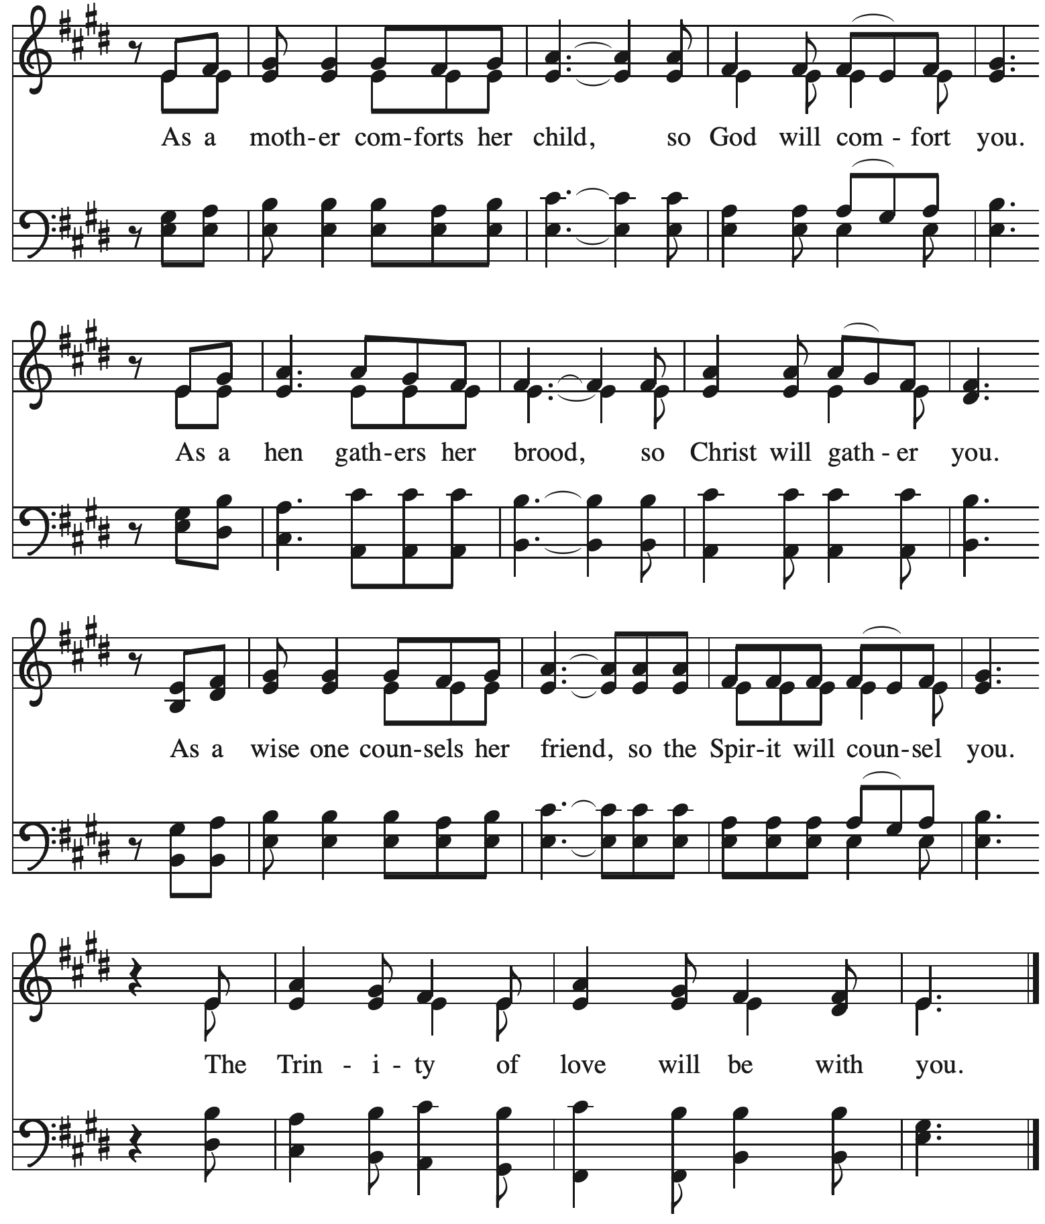

Hymns during Holy Communion
Strengthen for Service, Lord ELW 497

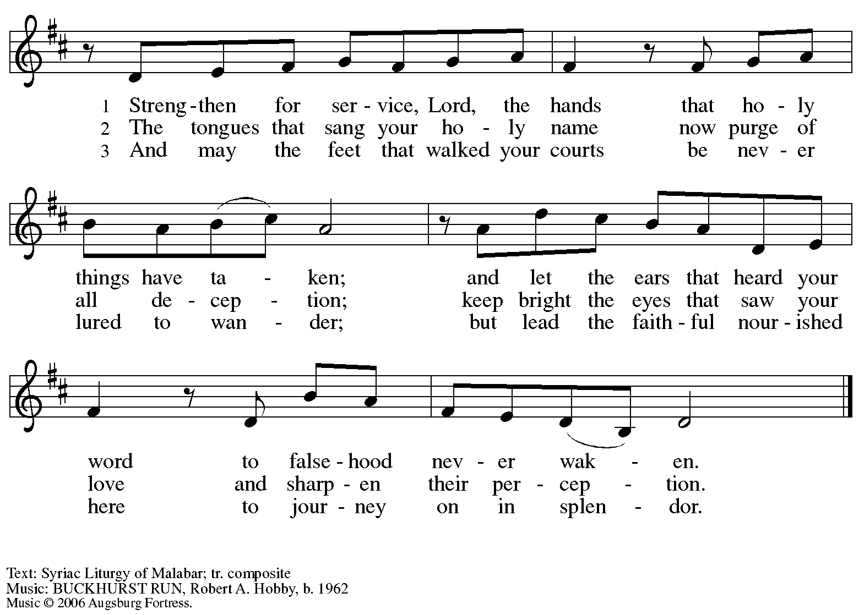
All rights reserved. Reprinted under OneLicense.net # A-722139.

Hymns during Holy Communion
I Received the Living God ELW 477
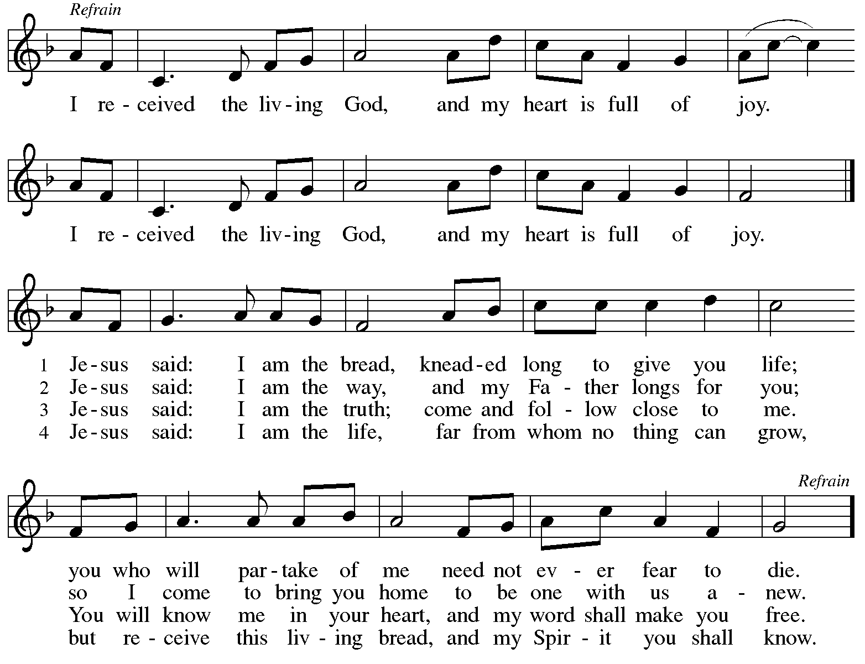


When all have returned to their places, please rise as you are able.

Blessing

P: The body and blood of our Lord Jesus Christ strengthen you and keep you in his grace.
C: Amen.

Prayer

A: Let us pray.
O God, our life, our strength, our food,
we give you thanks for sustaining us with the body and blood of your Son.
A: By your Holy Spirit, enliven us to be his body in the world,
that more and more we will give you praise
and serve your earth and its many peoples,
through Jesus Christ, our Savior and Lord.
C: Amen.

Please be seated.

Sending
God blesses us and sends us in mission to the world

Announcements

Please rise as you are able.

Benediction

P: The God of steadfastness and encouragement
grant you to live in harmony with one another,
in accordance with Christ Jesus.
C: Amen.

P: The God of hope fill you with all joy and peace in believing,
so that you may abound in hope by the power of the Holy Spirit.
C: Amen.

P: The God of all grace ☩ bless you now and forever.
C: Amen.

Sending Hymn Following page

Dismissal

A: Go in peace. Serve the Lord.
C: Thanks be to God!

Postlude

Sending Hymn ELW 538
Enviado soy de Dios – The Lord Now Sends Us Forth

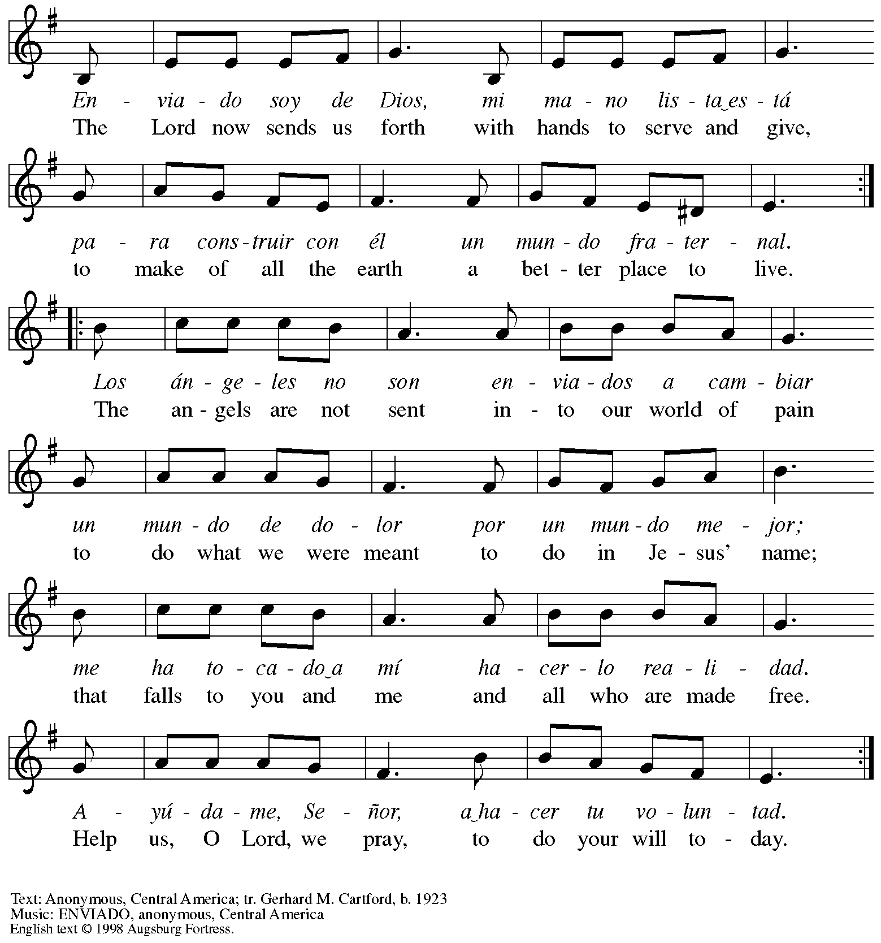
All rights reserved. Reprinted with permission under OneLicense.net #A-77219.

Those serving in worship today

Altar Care Jodie Minor
Assisting Minister Jeff Denlinger
Audio-Visual Ministers Jason Galyardt
Kristen Asplin
Cantor Ian Brown
Lector The Rev. Dr. Paul F. Koch
Minister of Music Laura Reynolds
Presiding Minister The Rev. Ross I. Carmichael

Liturgy and Hymnody Acknowledgements

From SundaysandSeasons.com. Copyright © 2025 Augsburg Fortress. All rights reserved. Reprinted under OneLicense.net # A-722139.
Used by permission of Augsburg Fortress.

The Scripture readings contained herein are from New Revised Standard Version Updated Edition of the Bible © 2021 National Council of Churches of Christ in the United States of America. Used by permission. All rights reserved worldwide.

Please use the QR code below to link to St. Andrew’s Announcements online!



St. Andrew Lutheran Church Announcements
July 6th, 2025

- Welcome to Worship at St. Andrew on the Fourth Sunday after Pentecost! – We are so glad you are here, and we offer a special welcome to all visitors and guests who are here for the first time! There are worship “toolkits” to help children engage with worship and “busy bags” for younger children available in the bookcase at the back of the sanctuary. Please feel free to take one to use with/for your children. A nursery is available through the door to the left of the worship space and across the social hall (look for a purple room). Everyone is invited to gather in the social hall for coffee, other drinks, food, and conversation after worship!
- Blessings to Reed, Receiving the Sacrament of Holy Baptism Today! – This morning, we welcome a new brother in Christ, Reed, through the Sacrament of Holy Baptism! We invite your prayers for Reed, parents Marit and Jered, godparent Christian, and the whole family as together we give thanks for the gifts of God’s love and grace!
- Monthly Reparations Offering Today during Worship – In Luke’s Gospel, Jesus tells a story about a compassionate Samaritan, suggesting that God’s people are called to work for healing and restoration for our neighbors, regardless of who or what caused them harm. In light of this, St. Andrew has made a commitment to reparations in regard to African American spiritual songs used in our worship. The text and music of most hymns is attributed to specific authors, with copyrights in place, usage reported, and royalties paid to those whose works are featured in worship. With African American spirituals, this is not possible. In response to many years of such uncredited use, St. Andrew invites the congregation to give a reparations offering. Funds received in worship will be donated to our siblings at Bethel AME Church, whose land and building were taken from them in the 1950s, to fund their development in the Hill District.
- July Shelter Dinner for Guests of East End Cooperative Ministry – No Assistance Needed – Due to an uncertain number of people available to serve, St. Andrew will not be asking for individual contributions to meal preparation for the East End Cooperative Ministry shelter dinner on Thursday, July 17th. We will uphold our commitment by funding the dinner in advance, which EECM will then arrange. Please watch for another opportunity to serve in August!
- Unveiling the Lamb: Hope, Resistance, and the Church in Revelation – Zoom Study Led by The Rev. Dr. Martin Rafanan, Thursdays, July 24th – August 21st – Pastor Martin Rafanan has invited the people of St. Andrew to a Zoom study he is leading with PLUM – Pittsburgh Lutheran United Ministries on Thursdays, July 24th – August 21st: “Join us for a 5-session Zoom-based Bible study that explores the Book of Revelation not as a roadmap of fear, but as a bold unveiling of Jesus Christ. In a world of empire, confusion, and compromise, this vision from exile speaks hope and courage to the Church. Each session blends scriptural teaching, theological reflection, pastoral insight, and visual exploration.” To receive the link, please register here:
Google Registration Form:
https://forms.gle/JmbuU7RncG34auJs8
- Community Ministry Team Seeking Donations to Supply Backpacks to Students at The Neighborhood Academy – St. Andrew’s community ministry team was invited by St. Andrew’s Episcopal Church in Highland Park to assist with a project to supply backpacks for students at The Neighborhood Academy, a school in Garfield that supports students in grades 6-12 from low-income backgrounds with a college preparatory curriculum (For more information please see https://www.theneighborhoodacademy.org/). We will be collecting materials for 25 backpacks, with each backpack including one 2-inch, three-ring binder; a package of binder subject dividers; a pack of 6 pens (blue or black, gel or retractable ballpoints); a pack of 6 pencils; 2 yellow highlighters; a pack of white index cards (100, 3x5); 3 report pocket folders; 2 five-subject spiral notebooks. It is key that donations be relatively uniform, so binders, folders, notebooks etc. should be plain, simple colors – please no designs, logos, characters, etc. A donation bin will be set up in the social hall.
If you purchase items, please indicate your donation at this link so we can track that we have all the items: https://www.signupgenius.com/go/5080B4AAFAF2CABF85-57266709-backpacks. Thank you for considering a gift for this new (to us) ministry initiative!
- Christ in Our Home Devotional Booklets for July-September Available at Entrances – This resource offers a daily Bible reading with a short reflection and prayer, along with additional readings and prayer topics for those who would like to expand their devotional practices. We encourage people of the congregation to take one for yourself, your family/household, or others.

