

+ Fifth Sunday after Pentecost
July 13, 2025



St. Andrew Lutheran Church
304 Morewood Ave.
Pittsburgh, PA 15213
St_andrewELCA@verizon.net
www.standrewpittsburgh.org

+ Fifth Sunday after Pentecost
Order for Worship

To love the Lord your God with all your heart, soul, strength, and mind is to reflect God’s mercy in responding to one’s neighbor. That mercy found its most profound expression in the “gospel that has come to you”—namely the life, death, and resurrection of Jesus Christ.
That gospel mercy comes to us again today: at the font, at the table, and from the pulpit.
It is very near to you.

Welcome to St. Andrew!
- St. Andrew welcomes all who are seeking a place of healing, wholeness, and acceptance in a nurturing and faith-forming spiritual home. We are striving toward racial equity worldwide
and we seek to honor the lived experience of all individuals regardless of background. Our community embraces people of all ages, ethnicities, cultures, abilities, sexual orientations,
gender identities and expressions, and family constellations. Come and See!
- Worship Services are live-streamed to multiple online platforms. By attending worship, you agree that your image and voice may be broadcast.
- Everyone is invited to make a name tag at the black bookcase in the back of the worship space if they would like. There are stickers indicating pronouns on the bookcase if you would like to include them on your name tag.
- A nursery is available through the doors at the left side of the sanctuary and across from the doorway to the Social Hall. Look for a purple-colored room.
- Worship “toolkits” to help children engage with the service, along with “busy bags” for younger children, are available in the bookcase at the back of the sanctuary. Please feel free to take one to use with/for your children.
- Holy Communion is served with bread (gluten-free available) and wine or grape juice. The presiding minister will distribute the bread (host). Please consume this and then pick up an empty glass from the tray. The Communion Assistant will pour wine or grape juice into your glass. Please step to the side to consume the wine or grape juice. Feel free to kneel at the altar for prayer and reflection. As you return to your pew, glasses may be returned to the empty trays on either side of the center section.
- A restroom is available on the main level of the church, through the doors to the Social Hall and to the right in the main office.

Abbreviations
P: Pastor/Presiding Minister ELW: Evangelical Lutheran Worship hymnal
A: Assisting Minister ACS: All Creation Sings hymnal
L: Lector TFF: This Far by Faith hymnal
C: Congregation

Musical Offering

Each week, different people from the congregation make an offering of pre-service music,
with singing or instrumentation, to help the assembly focus and pray in preparation for worship

Welcome

Prelude

Gathering
The Holy Spirit calls us together as the people of God

Confession and Forgiveness

P: Blessed be the holy Trinity, ☩ one God,
who forgives all our sin,
whose mercy endures forever.
C: Amen.

P: Baptized into Christ, let us confess our sins.

Silence is kept for reflection.

P: Merciful God,
C: you free us to love others,
but we neglect our neighbors and follow our own way.
You lead us by the Spirit of joy and peace,
but we turn away from the abundant life you offer.
You surround us with patience, kindness, and generosity,
but we grow weary in doing what is right.
In your mercy, forgive us.
Do not give up on us.
Heal us, break our bonds, and show us the path of life.
Amen.

P: You belong to Christ Jesus
and you are God’s children through faith.
In the cross of ☩ Christ,
and through the power of the Holy Spirit,
your sins are forgiven.
Clothed with Christ, you are a new creation.
C: Amen.

Gathering Hymn Look Who Gathers at Christ’s Table ACS 977

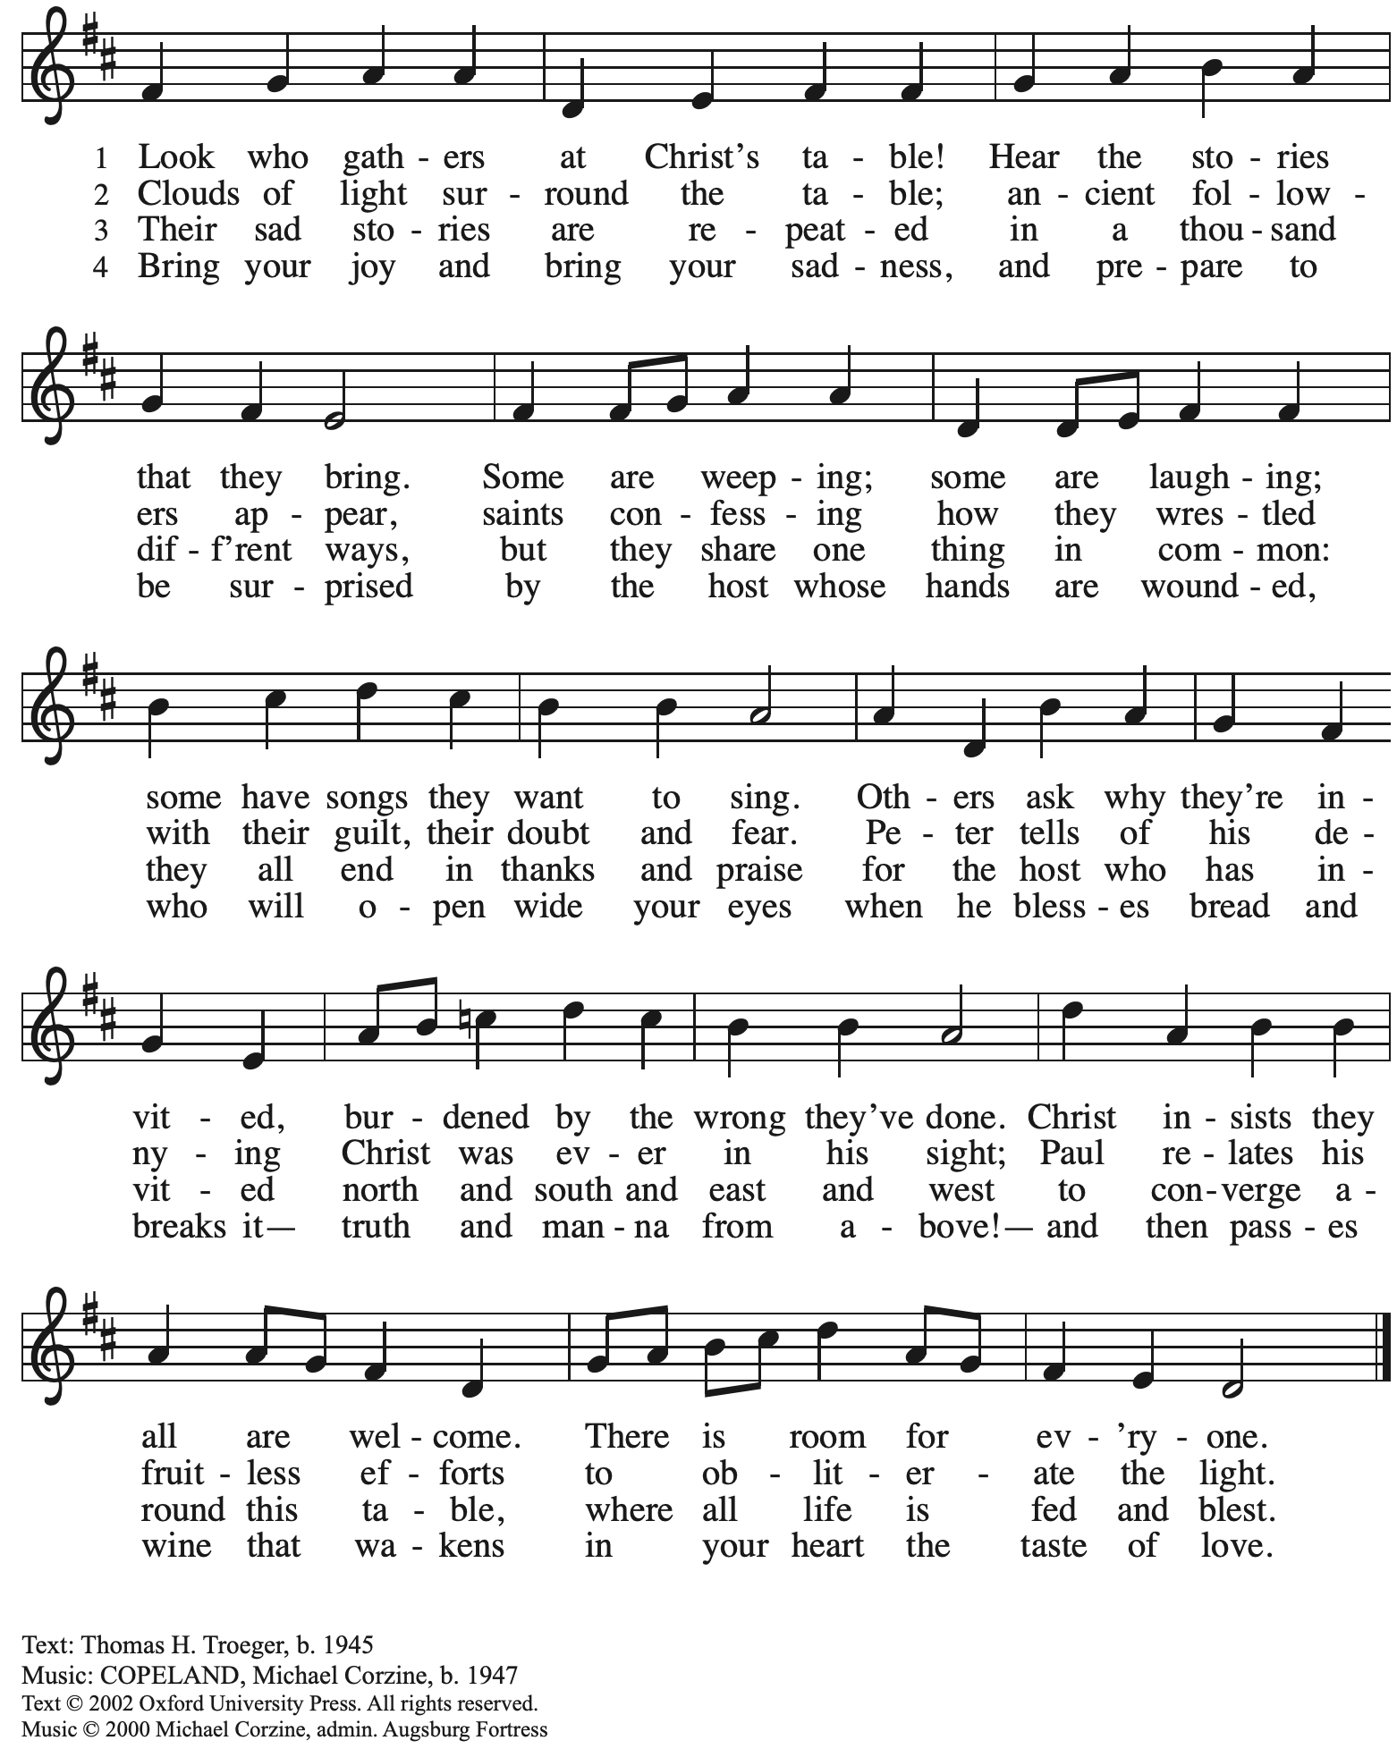
All rights reserved. Reprinted with permission under OneLicense.net # A-722139.

Greeting

P: The grace of our Lord Jesus Christ, the love of God,
and the communion of the Holy Spirit be with you all.
C: And also with you.

Hymn of Praise ELW p. 204

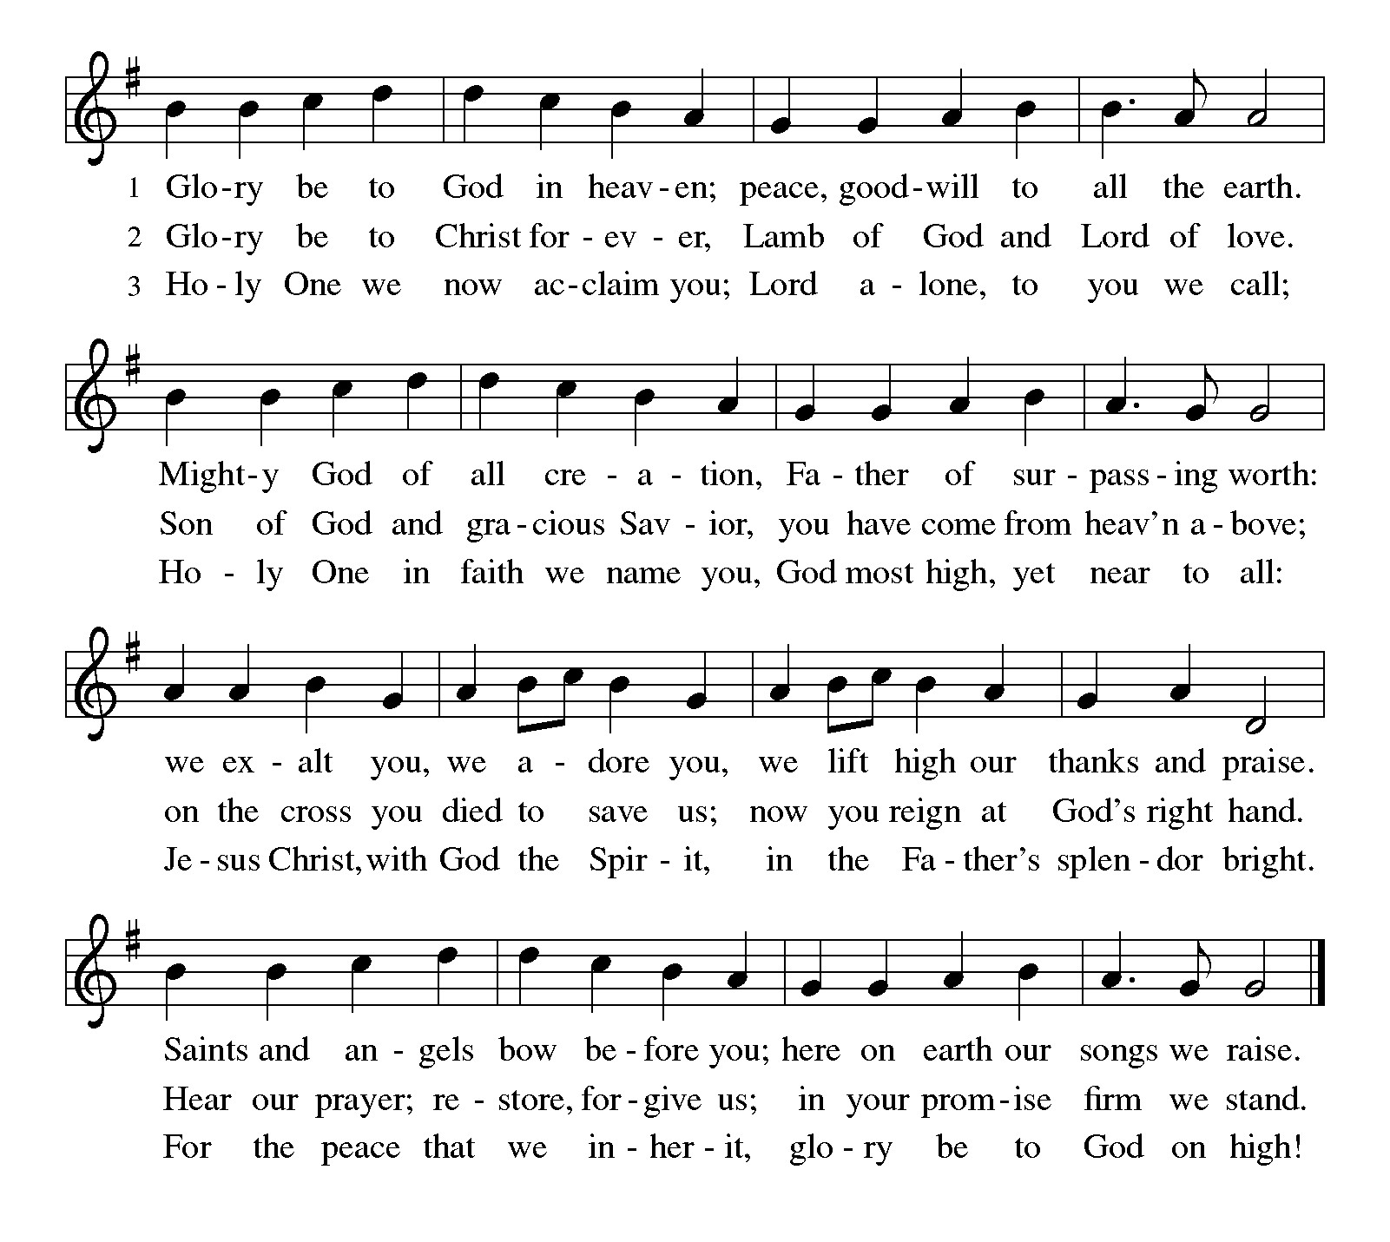

Prayer of the Day

P: The Lord be with you.
C: And also with you.

P: Let us pray.
O Lord God, your mercy delights us, and the world longs for your loving care.
Hear the cries of everyone in need, and turn our hearts to love our neighbors
with the love of your Son, Jesus Christ, our Savior and Lord.
C: Amen.

Please be seated.

Word
God speaks to us in Scripture reading, preaching, and song

First Reading – Deuteronomy 30: 9-14

⁹ The Lord your God will make you abundantly prosperous in all your undertakings, in the fruit of your body, in the fruit of your livestock, and in the fruit of your soil. For the Lord will again take delight in prospering you, just as the Lord delighted in prospering your ancestors, ¹⁰ when you obey the Lord your God by observing God’s commandments and decrees that are written in this book of the law, because you turn to the Lord your God with all your heart and with all your soul.
¹¹ “Surely, this commandment that I am commanding you today is not too hard for you, nor is it too far away. ¹² It is not in heaven, that you should say, ‘Who will go up to heaven for us and get it for us so that we may hear it and observe it?’ ¹³ Neither is it beyond the sea, that you should say, ‘Who will cross to the other side of the sea for us and get it for us so that we may hear it and observe it?’ ¹⁴ No, the word is very near to you; it is in your mouth and in your heart for you to observe.

L: Word of God, word of life.
C: Thanks be to God.

Psalm 25: 1-10

The psalm will be sung responsively, led by the cantor,
with the congregation responding with the bold verses and refrain.

Psalm tone

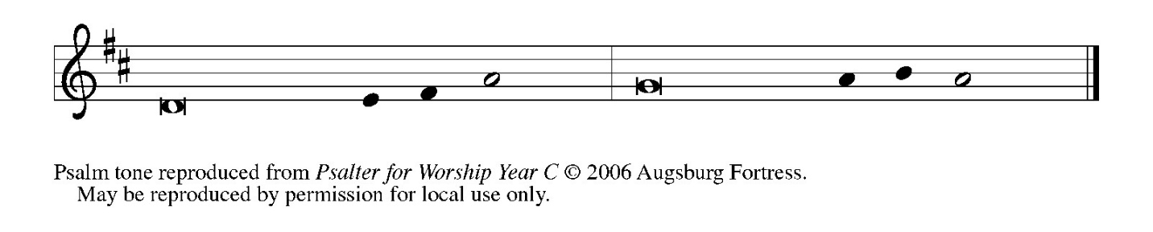

Psalm refrain

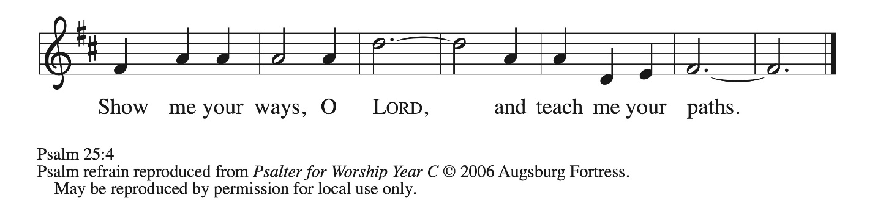

¹ To | you, O Lord,
I lift | up my soul.
² My God, I put my trust in you; let me not be | put to shame,
nor let my enemies triumph | over me.
³ Let none who look to you be | put to shame;
rather let those be put to shame | who are treacherous.
⁴ Show me your | ways, O Lord,
and teach | me your paths. R
⁵ Lead me in your | truth and teach me,
for you are the God of my salvation; in you have I trusted all | the day long.
⁶ Remember, O Lord, your compas- | sion and love,
for they are from | everlasting.
⁷ Remember not the sins of my youth and | my transgressions;
remember me according to your steadfast love and for the sake of your good- | ness, O Lord.
⁸ You are gracious and up- | right, O Lord;
therefore you teach sinners | in your way.
⁹ You lead the low- | ly in justice
and teach the low- | ly your way.
¹⁰ All your paths, O Lord, are steadfast | love and faithfulness
to those who keep your covenant and your | testimonies. R

Second Reading – Colossians 1: 1-14

¹ Paul, an apostle of Christ Jesus by the will of God, and Timothy our brother,
² To the saints and faithful siblings in Christ in Colossae:
Grace to you and peace from God our Father.
³ In our prayers for you we always thank God, the Father of our Lord Jesus Christ, ⁴ for we have heard of your faith in Christ Jesus and of the love that you have for all the saints, ⁵ because of the hope laid up for you in heaven. You have heard of this hope before in the word of the truth, the gospel ⁶ that has come to you. Just as it is bearing fruit and growing in the whole world, so it has been bearing fruit among yourselves from the day you heard it and truly comprehended the grace of God. ⁷ This you learned from Epaphras, our beloved fellow servant. He is a faithful minister of Christ on our behalf, ⁸ and he has made known to us your love in the Spirit.
⁹ For this reason, since the day we heard it, we have not ceased praying for you and asking that you may be filled with the knowledge of God’s will in all spiritual wisdom and understanding, ¹⁰ so that you may walk worthy of the Lord, fully pleasing to him, as you bear fruit in every good work and as you grow in the knowledge of God. ¹¹ May you be made strong with all the strength that comes from his glorious power, so that you may have all endurance and patience, joyfully ¹² giving thanks to the Father, who has enabled you to share in the inheritance of the saints in the light. ¹³ God has rescued us from the power of darkness and transferred us into the kingdom of God’s beloved Son, ¹⁴ in whom we have redemption, the forgiveness of sins.

L: Word of God, word of life.
C: Thanks be to God.

Please rise as you are able.

Gospel Acclamation ELW p. 205

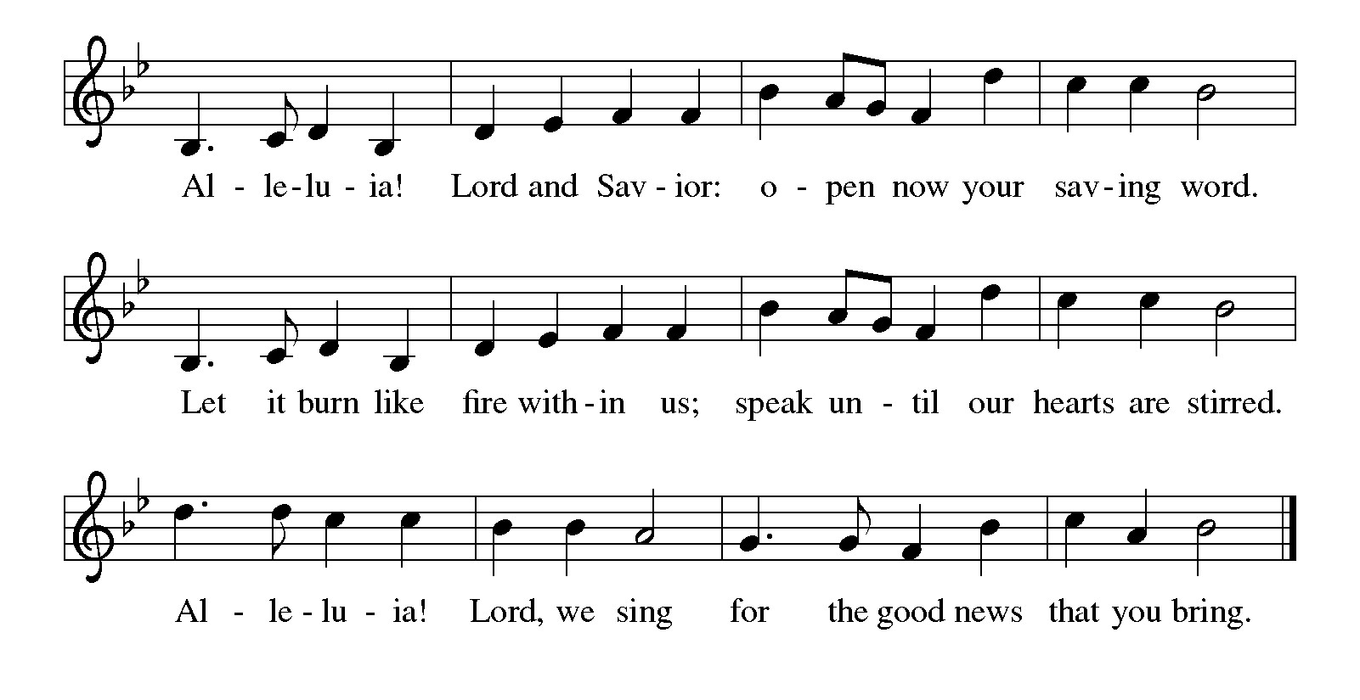

Gospel – Luke 10: 25-37

P: The holy Gospel according to St. Luke.
C: Glory to you, O Lord.

²⁵ An expert in the law stood up to test Jesus. “Teacher,” he said, “what must I do to inherit eternal life?” ²⁶ He said to him, “What is written in the law? What do you read there?” ²⁷ He answered, “You shall love the Lord your God with all your heart and with all your soul and with all your strength and with all your mind and your neighbor as yourself.” ²⁸ And he said to him, “You have given the right answer; do this, and you will live.”
²⁹ But wanting to vindicate himself, he asked Jesus, “And who is my neighbor?” ³⁰ Jesus replied, “A man was going down from Jerusalem to Jericho and fell into the hands of robbers, who stripped him, beat him, and took off, leaving him half dead. ³¹ Now by chance a priest was going down that road, and when he saw him he passed by on the other side. ³² So likewise a Levite, when he came to the place and saw him, passed by on the other side. ³³ But a Samaritan while traveling came upon him, and when he saw him he was moved with compassion. ³⁴ He went to him and bandaged his wounds, treating them with oil and wine. Then he put him on his own animal, brought him to an inn, and took care of him. ³⁵ The next day he took out two denarii, gave them to the innkeeper, and said, ‘Take care of him, and when I come back I will repay you whatever more you spend.’ ³⁶ Which of these three, do you think, was a neighbor to the man who fell into the hands of the robbers?” ³⁷ He said, “The one who showed him mercy.” Jesus said to him, “Go and do likewise.”

P: The Gospel of the Lord.
C: Praise to you, O Christ.

Please be seated.

Sermon

A time of silence for prayer and reflection follows the sermon.
When the hymn of the day begins, please rise as you are able.

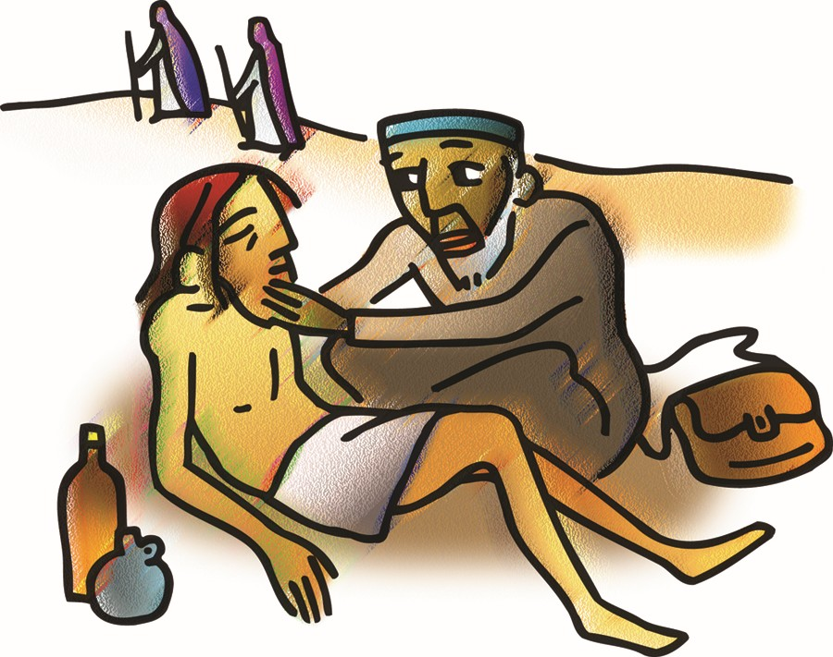

Hymn of the Day Jesu, Jesu, Fill Us with Your Love ELW 708

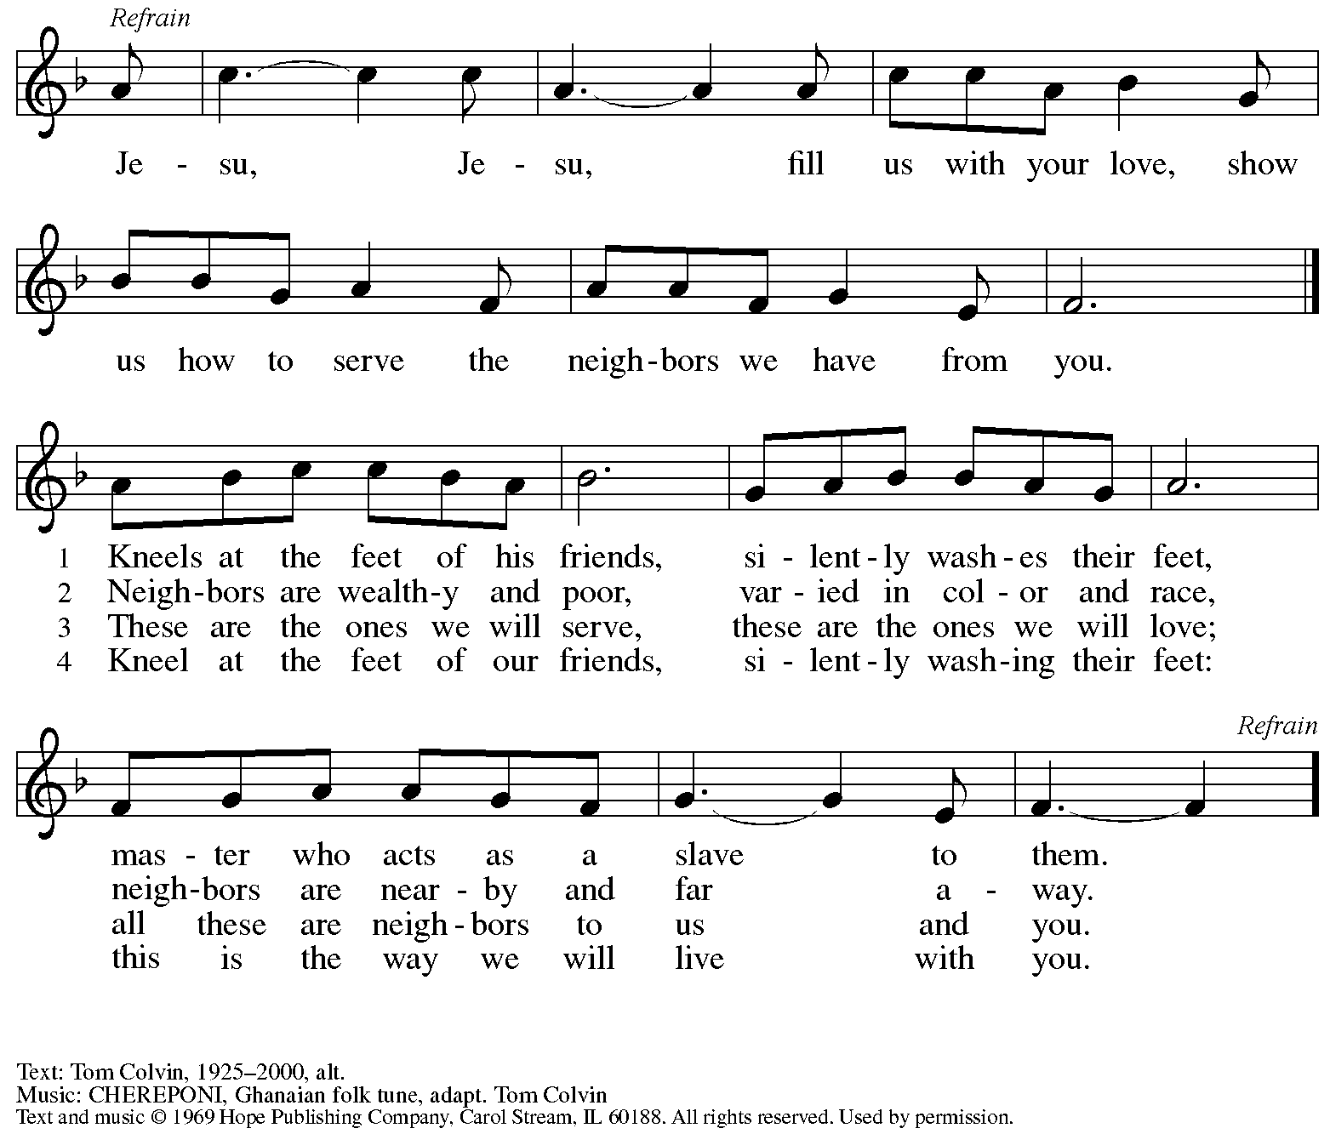
All rights reserved. Reprinted with permission under OneLicense.net # A-722139.

Apostles’ Creed

C: I believe in God, the Father almighty,
creator of heaven and earth.

I believe in Jesus Christ, God’s only Son, our Lord,
who was conceived by the Holy Spirit,
born of the virgin Mary,
suffered under Pontius Pilate,
was crucified, died, and was buried;
he descended to the dead.*
On the third day he rose again;
he ascended into heaven,
he is seated at the right hand of the Father,
and he will come to judge the living and the dead.

I believe in the Holy Spirit,
the holy catholic church,
the communion of saints,
the forgiveness of sins,
the resurrection of the body,
and the life everlasting. Amen.

*Or, “he descended into hell,” another translation of this text in widespread use.

Prayers of the People

A: With the whole people of God in Christ Jesus, let us pray for the church, those in need,
and all of God’s creation.

After each petition
A: God of grace,
C: receive our prayer.

P: Into your hands, gracious God, we commend all for whom we pray,
trusting in your mercy; through Jesus Christ, our Savior.
C: Amen.

Peace

The presiding minister and the assembly greet one another in the peace of the risen Christ.
P: The peace of Christ be with you always.
C: And also with you.

The people may greet those around them with a sign of Christ’s peace and may say
Peace be with you or similar words. Please be mindful that not everyone will be comfortable with sharing the peace, so please seek consent before shaking hands or hugging. Other possible ways to share the peace include a simple bow with the verbal greeting of peace, or simply a verbal expression of peace.

When the greetings of peace have concluded, please be seated.

Meal
God feeds us with the presence of Jesus Christ

Offering

We offer ourselves, our gifts, and our faithful service to God.
As the offering is gathered for the mission of the church, including the care of those in need,
the table is set for Holy Communion.

There are laminated giving cards in the pew racks that feature a QR code for anyone who would like to give online. Those who give using the QR code, as well as those who give regularly online or through their bank are encouraged to place the laminated card in the plate as an expression of your offering.

Musical Offering

As the gifts are brought forward for presentation, please rise as you are able.

Offertory Song As the Grains of Wheat ELW 465

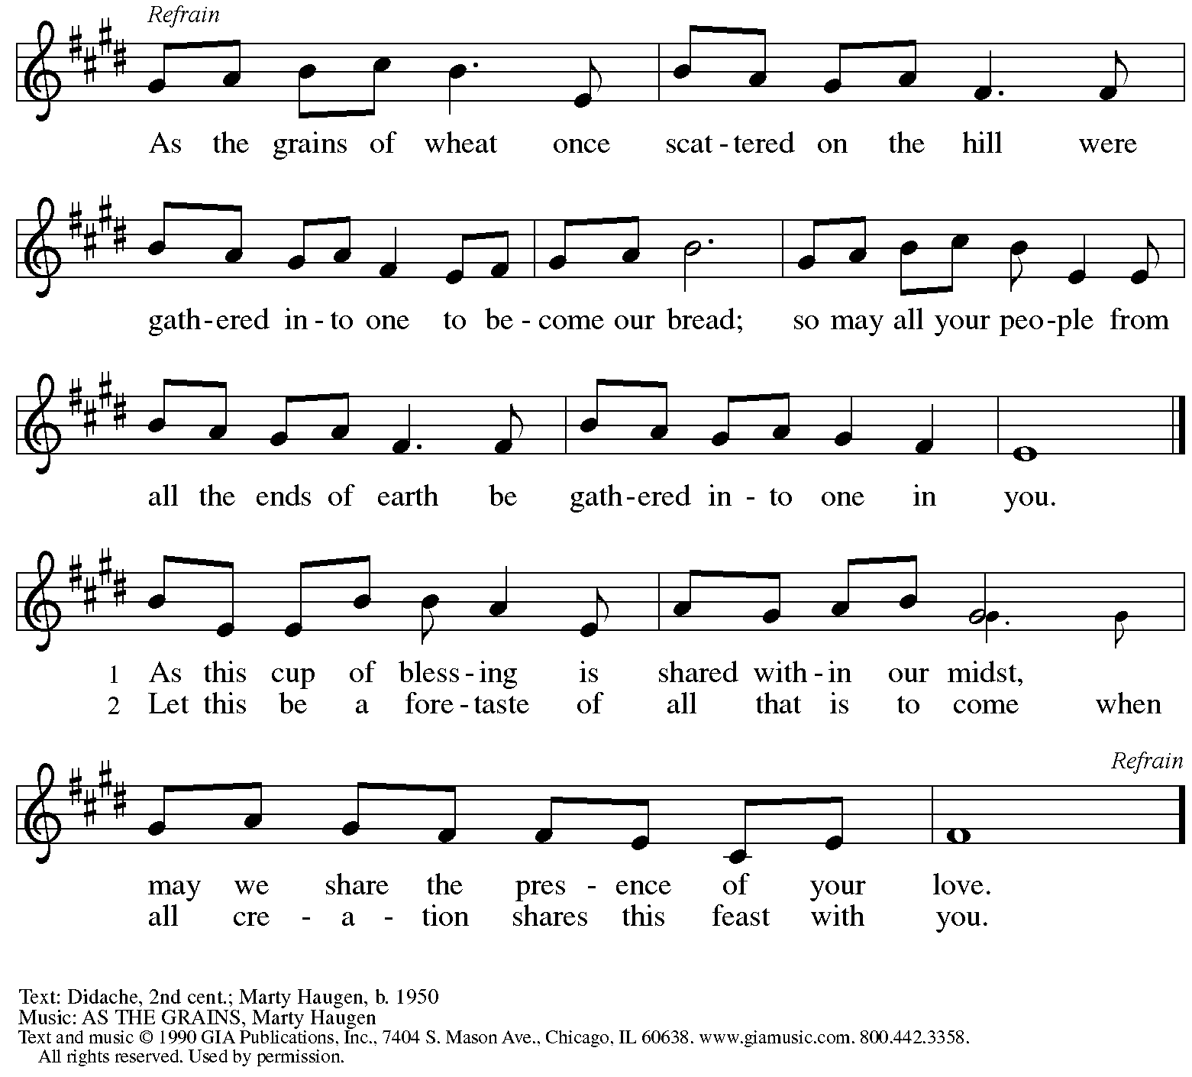
Reprinted under OneLicense.net # A-722139.

Offertory Prayer

A: Let us pray.
God of all creation,
C: all you have made is good and your love endures forever.
You bring forth bread from the earth and fruit from the vine.
Nourish us with these gifts,
that we might be for the world signs of your gracious presence
in Jesus Christ, our Savior and Lord.
Amen.

Dialogue ELW p. 206

P: The Lord be with you.
C: And also with you.

P: Lift up your hearts.
C: We lift them to the Lord.

P: Let us give thanks to the Lord our God.
C: It is right to give our thanks and praise.

Preface (Spoken by the presiding minister)

P: It is indeed right, our duty and our joy,
that we should at all times and in all places
give thanks and praise to you, almighty and merciful God,
through our Savior Jesus Christ;
who on this day overcame death and the grave,
and by his glorious resurrection
opened to us the way of everlasting life.
And so, with all the choirs of angels,
with the church on earth and the hosts of heaven,
we praise your name and join their unending hymn:

Sanctus ELW p. 207

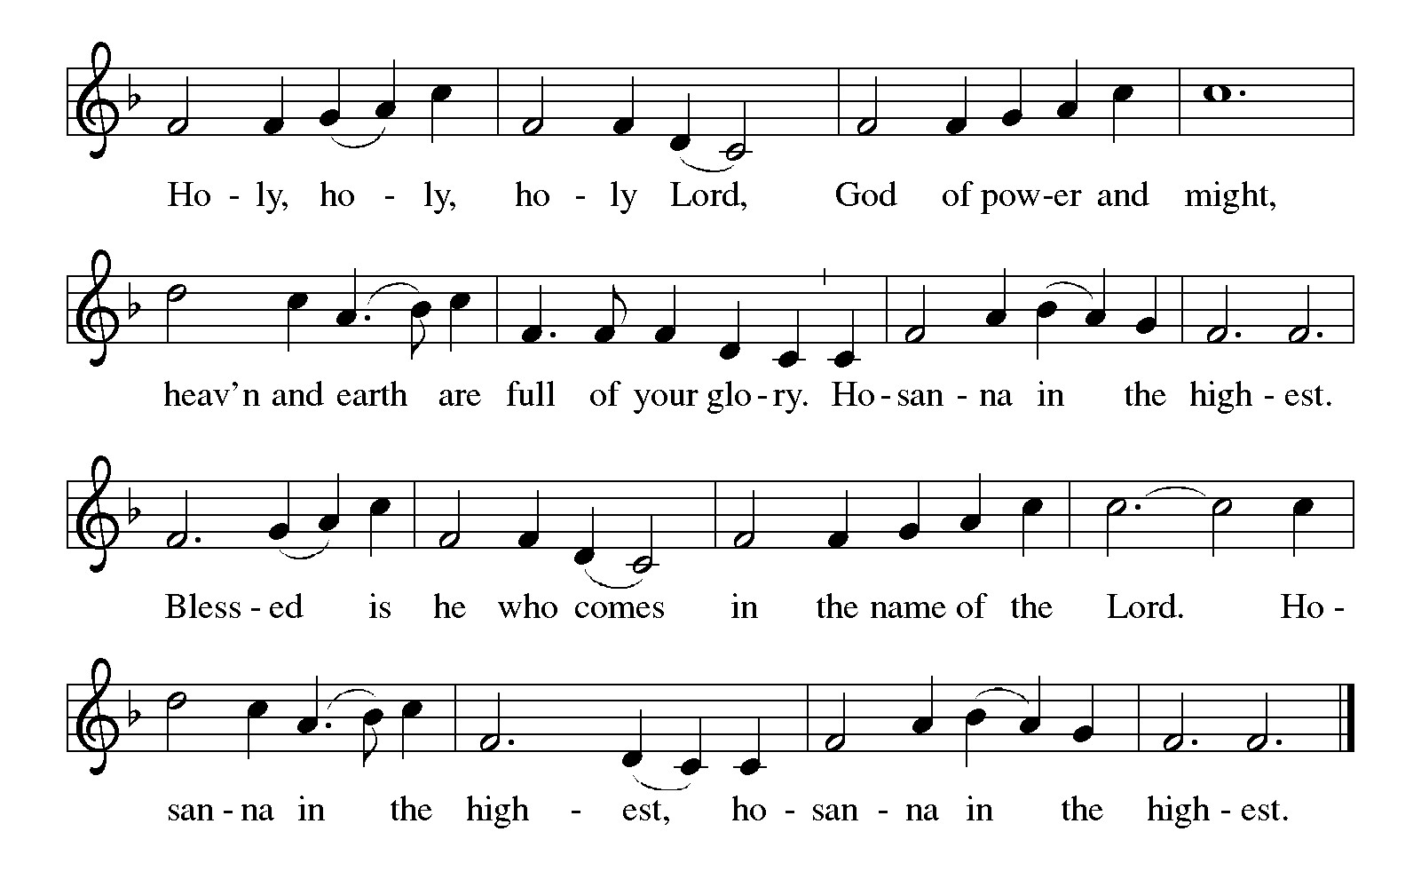
Eucharistic Prayer

P: Holy, mighty, and merciful Lord …
… to whom with you and the Holy Spirit
be all honor and glory, now and forever.
C: Amen.

Lord’s Prayer

P: Gathered as one by the Holy Spirit, let us pray as Jesus taught us.
C: Our Father, who art in heaven,
hallowed be thy name,
thy kingdom come,
thy will be done,
on earth as it is in heaven.
Give us this day our daily bread;
and forgive us our trespasses,
as we forgive those
who trespass against us;

and lead us not into temptation,
but deliver us from evil.
For thine is the kingdom,
and the power, and the glory,
forever and ever. Amen.

Fraction and Invitation

Agnus Dei / Lamb of God ELW p. 208

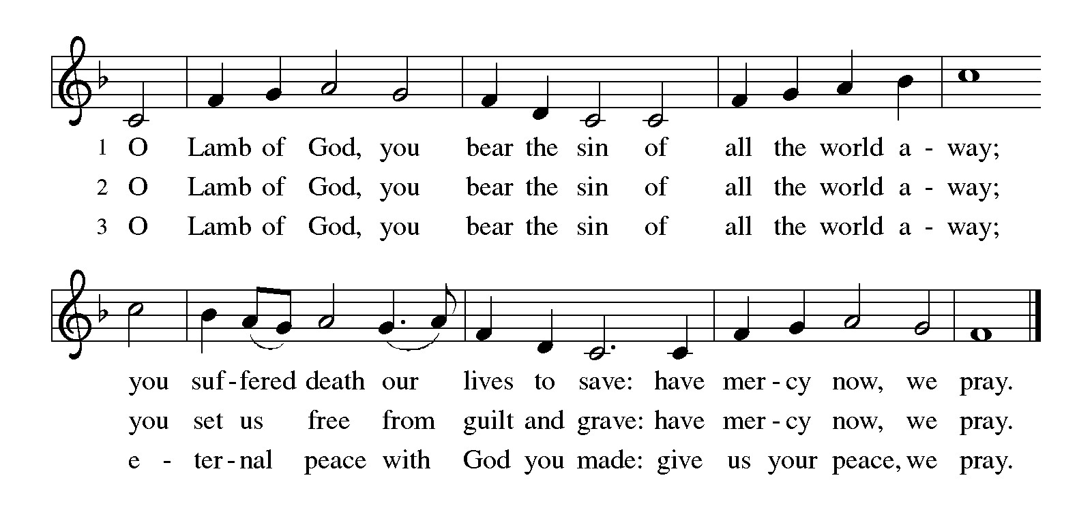
Please be seated.

Holy Communion

- All who seek God and desire a deeper and stronger life in Christ are welcome to receive Holy Communion.
- Worshipers from the pulpit side will proceed forward first, followed by the center section, and then the lectern side.
- Please inform an usher if you would like the ministers to bring Communion to you.
- Holy Communion will be served with bread and wine (amber) or grape juice (purple).
- The presiding minister will first distribute the bread (host) to each communicant. Please indicate if you require a gluten-free host.
- Once you have consumed the bread, please pick up an empty glass from the tray next to the presiding minister. The Communion Assistant will pour wine or grape juice into your glass.
- Please step to the side to consume the wine or grape juice.
- Feel free to kneel at the altar rail for prayer after receiving the sacrament.
- As you return to your pew, glasses may be returned to the empty tray on the side of the center section.
- A blessing will be provided for anyone who does not yet receive the sacrament.
- All are invited to join in singing the hymns during Holy Communion.

Hymns during Holy Communion
There’s a Wideness in God’s Mercy ELW 588

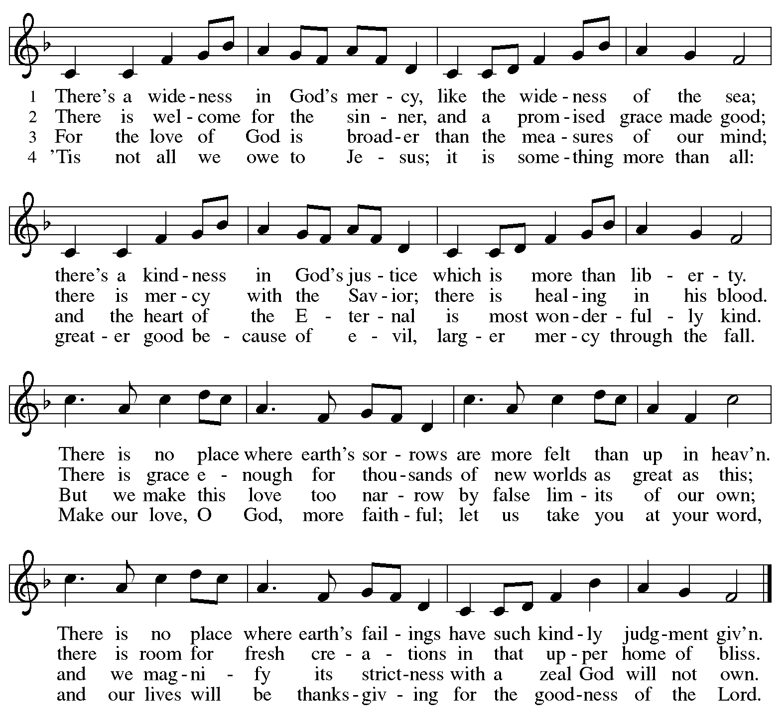

Hymns during Holy Communion
Spirit, Open My Heart ACS 1043

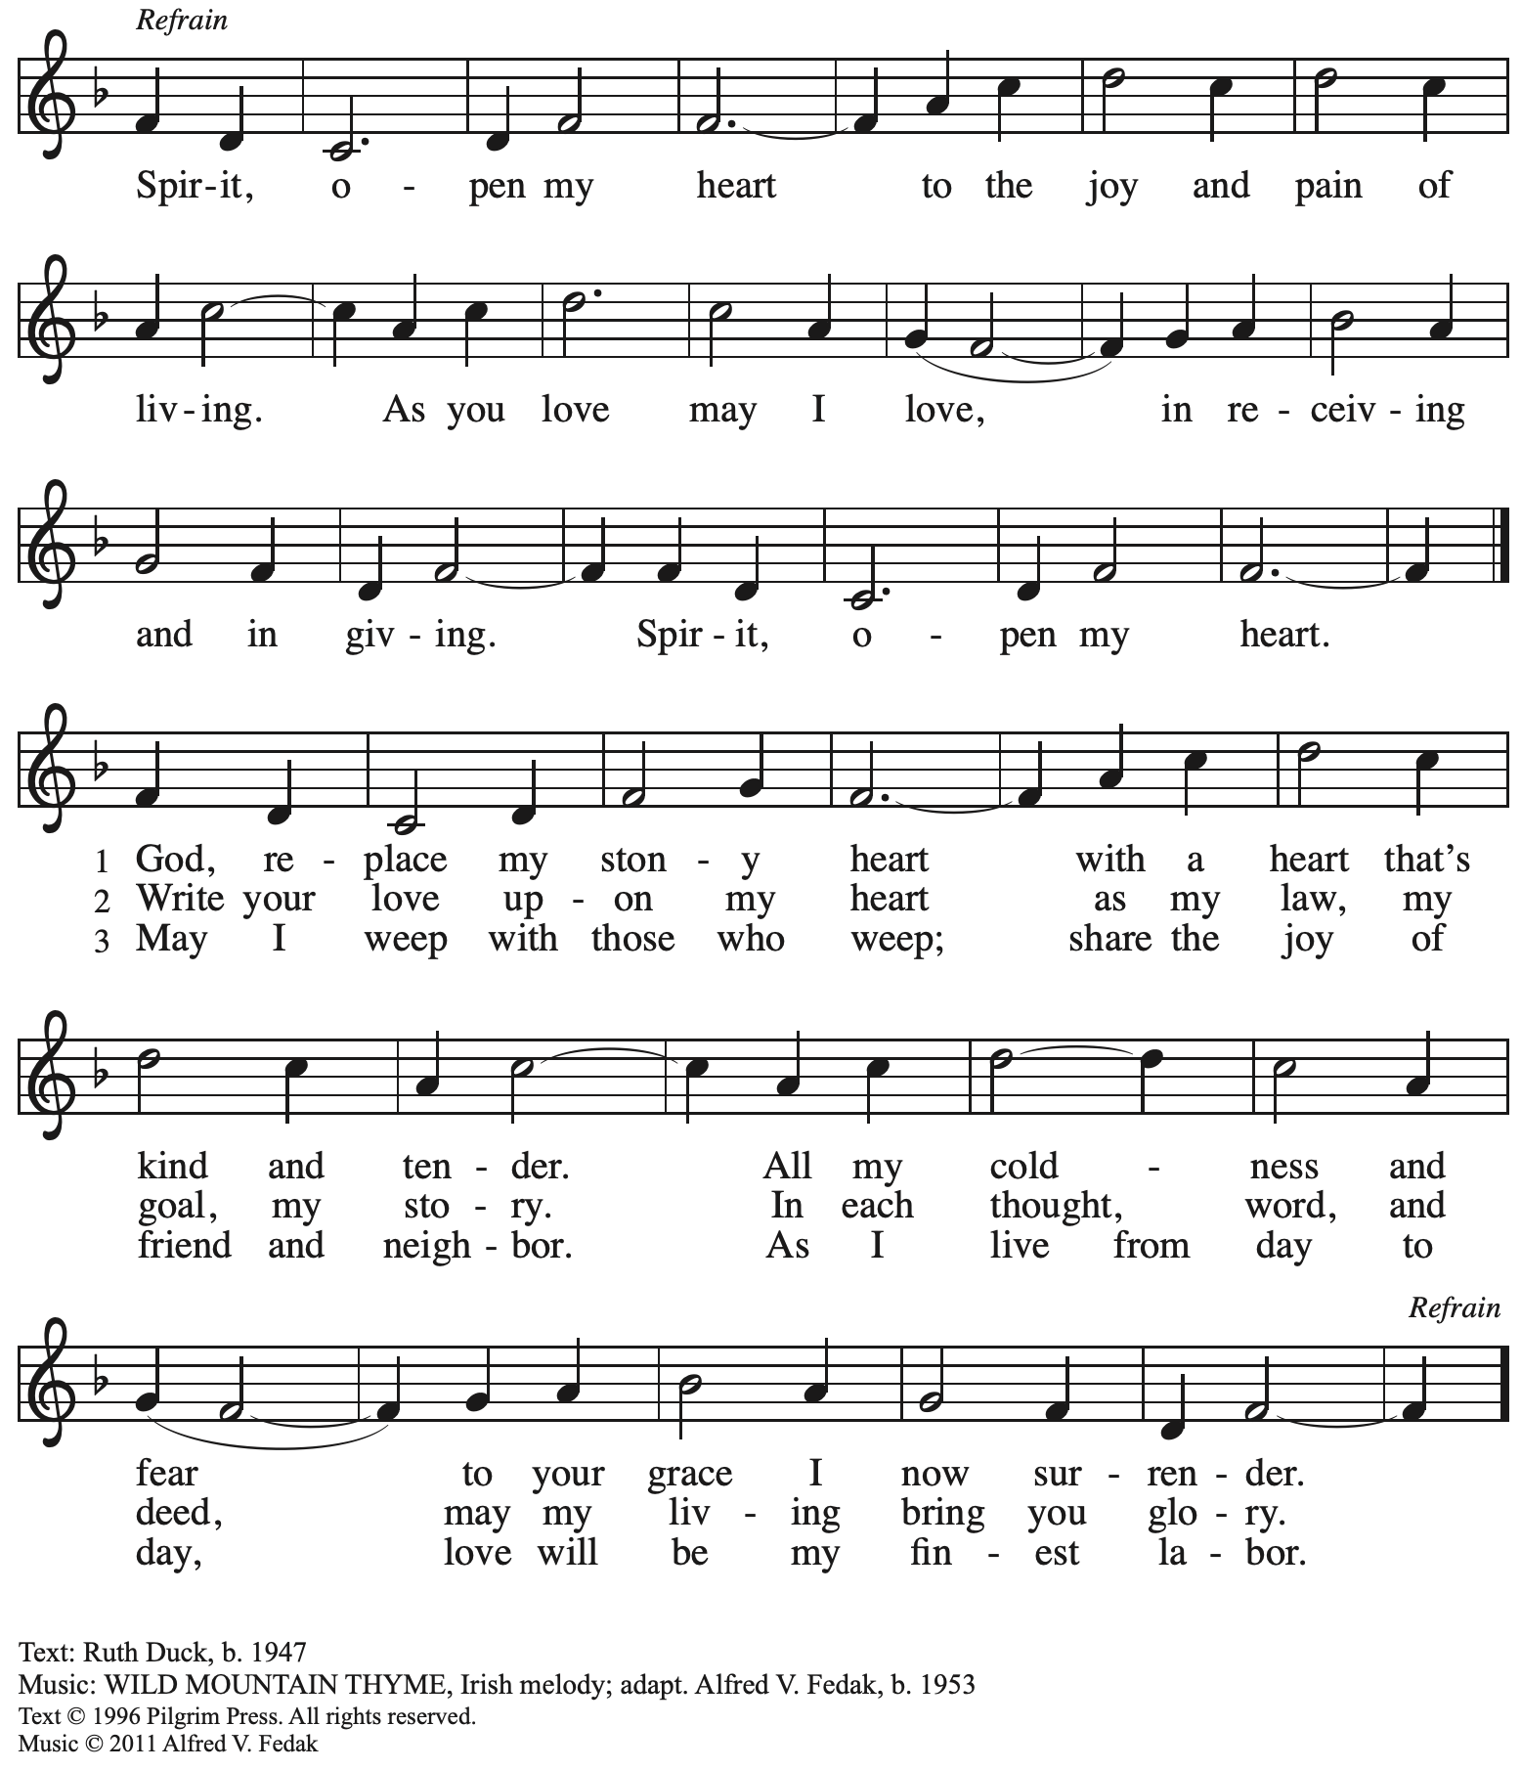
All rights reserved. Reprinted with permission under OneLicense.net # A-722139.

Hymns during Holy Communion
What Is the World Like ACS 1047

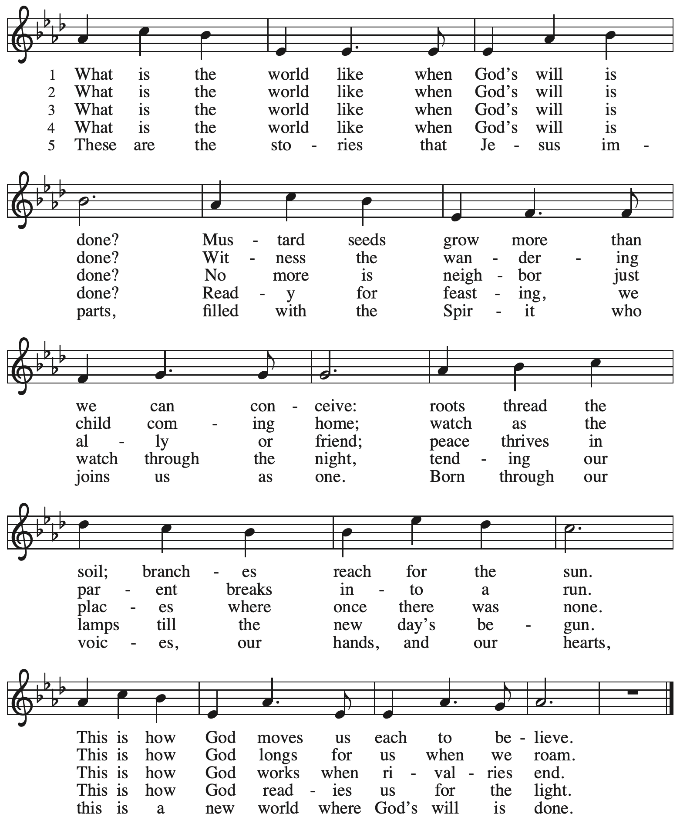

When all have returned to their places, please rise as you are able.

Blessing

P: The body and blood of our Lord Jesus Christ strengthen you and keep you in his grace.
C: Amen.

Prayer

A: Let us pray.
O God, our life, our strength, our food,
we give you thanks for sustaining us with the body and blood of your Son.
By your Holy Spirit, enliven us to be his body in the world,
that more and more we will give you praise
and serve your earth and its many peoples,
through Jesus Christ, our Savior and Lord.
C: Amen.

Please be seated.

Sending
God blesses us and sends us in mission to the world

Announcements

Please rise as you are able.

Benediction

P: The God of steadfastness and encouragement
grant you to live in harmony with one another,
in accordance with Christ Jesus.
C: Amen.

P: The God of hope fill you with all joy and peace in believing,
so that you may abound in hope by the power of the Holy Spirit.
C: Amen.

P: The God of all grace ☩ bless you now and forever.
C: Amen.

Sending Hymn Following page

Sending Hymn Pass Me Not, O Gentle Savior TFF 150

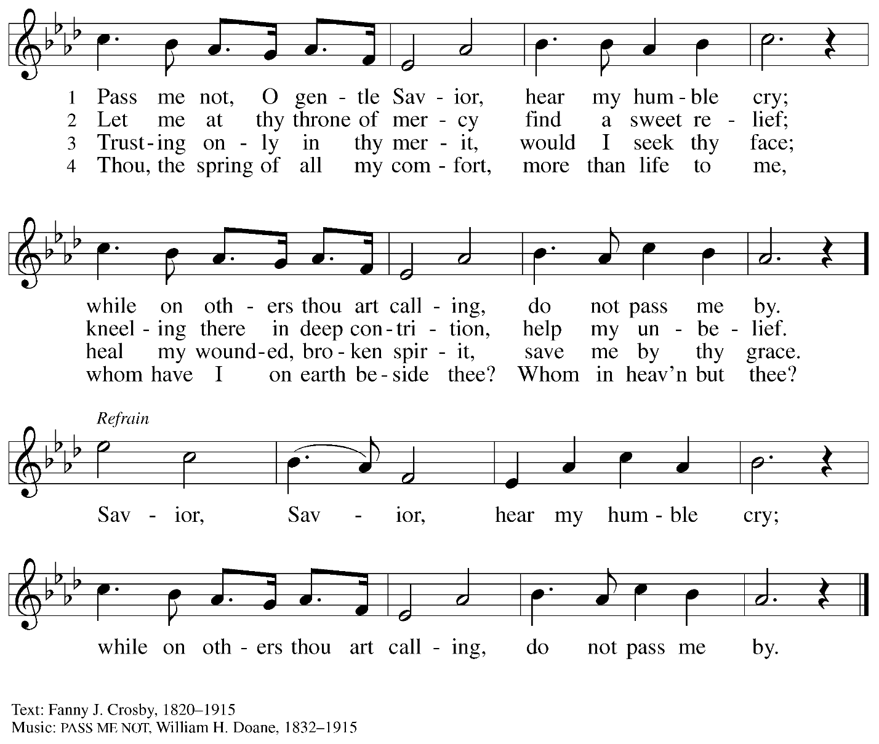

Dismissal

A: Go in peace. Serve the Lord.
C: Thanks be to God!

Postlude

Those serving in worship today

Altar Care Jodie Minor
Assisting Minister Colleen Cooke
Audio-Visual Ministers Tyler Rietze
Jered Stratton
Cantor Maria Mangano
Lector Kelly Spanninger
Minister of Music Laura Reynolds
Presiding Minister The Rev. Ross I. Carmichael

Liturgy and Hymnody Acknowledgements

From SundaysandSeasons.com. Copyright © 2025 Augsburg Fortress. All rights reserved. Reprinted under OneLicense.net # A-722139.
Used by permission of Augsburg Fortress.

The Scripture readings contained herein are from New Revised Standard Version Updated Edition of the Bible © 2021 National Council of Churches of Christ in the United States of America. Used by permission. All rights reserved worldwide.

What Is the World Like – Text: Adam M.L. Tice, b. 1979. Music: NEW WORLD, Sally Ann Morris, b. 1952. Text and music © 2009 GIA Publications, Inc, giamusic.com. All rights reserved. Reprinted with permission under OneLicense.net # A-722139.

Please use the QR code below to link to St. Andrew’s Announcements online!



St. Andrew Lutheran Church Announcements
July 13th, 2025

- Welcome to Worship at St. Andrew on the Fifth Sunday after Pentecost! – We are so glad you are here, and we offer a special welcome to all visitors and guests who are here for the first time! There are worship “toolkits” to help children engage with worship and “busy bags” for younger children available in the bookcase at the back of the sanctuary. Please feel free to take one to use with/for your children. A nursery is available through the door to the left of the worship space and across the social hall (look for a purple room).
- Community Ministry Meeting – Monday, July 14th at 7:00 p.m. on Zoom – St. Andrew’s community ministry committee coordinates our local service ministries such as the outdoor Little Library, the pantry, produce distribution, shelter dinner, and various other activities. New participants are always welcome, and the next meeting is Monday, July 14th, at 7:00 p.m. on Zoom. Please contact PastorRCarmichael@gmail.com or community@standrewpittsburgh.org if you would like the link.
- Noisy Offering Next Sunday, July 20th, during Worship – On the third Sunday of each month, St. Andrew’s children lead the congregation in a Noisy Offering, in which people are invited to throw their change into buckets that the children carry around the church and bring forward as an additional offering. Each month’s Noisy Offering supports a local, national, or international church-related or otherwise charitable organization. This month’s offering will benefit Literacy Pittsburgh, which offers free educational programs for adults and families in Allegheny and County and Beaver County. For more information about the organization, please visit https://www.literacypittsburgh.org/.
- July Shelter Dinner for Guests of East End Cooperative Ministry – No Assistance Needed – Due to an uncertain number of people available to serve, St. Andrew will not be asking for individual contributions to meal preparation for the East End Cooperative Ministry shelter dinner on Thursday, July 17th. We will uphold our commitment by funding the dinner in advance, which EECM will then arrange. Please watch for another opportunity to serve in August!
- Unveiling the Lamb: Hope, Resistance, and the Church in Revelation – Zoom Study Led by The Rev. Dr. Martin Rafanan, Thursdays, July 24th – August 21st – Pastor Martin Rafanan has invited the people of St. Andrew to a Zoom study he is leading with PLUM – Pittsburgh Lutheran United Ministries on Thursdays, July 24th – August 21st: “Join us for a 5-session Zoom-based Bible study that explores the Book of Revelation not as a roadmap of fear, but as a bold unveiling of Jesus Christ. In a world of empire, confusion, and compromise, this vision from exile speaks hope and courage to the Church. Each session blends scriptural teaching, theological reflection, pastoral insight, and visual exploration.” To receive the link, please register here:
Google Registration Form:
https://forms.gle/JmbuU7RncG34auJs8
- Community Ministry Team Seeking Donations to Supply Backpacks to Students at The Neighborhood Academy – St. Andrew’s community ministry team was invited by St. Andrew’s Episcopal Church in Highland Park to assist with a project to supply backpacks for students at The Neighborhood Academy, a school in Garfield that supports students in grades 6-12 from low-income backgrounds with a college preparatory curriculum (For more information please see https://www.theneighborhoodacademy.org/). We will be collecting materials for 25 backpacks, with each backpack including one 2-inch, three-ring binder; a package of binder subject dividers; a pack of 6 pens (blue or black, gel or retractable ballpoints); a pack of 6 pencils; 2 yellow highlighters; a pack of white index cards (100, 3x5); 3 report pocket folders; 2 five-subject spiral notebooks. It is key that donations be relatively uniform, so binders, folders, notebooks etc. should be plain, simple colors – please no designs, logos, characters, etc. A donation bin will be set up in the social hall. If you purchase items, please indicate your donation at this link so we can track that we have all the items: https://www.signupgenius.com/go/5080B4AAFAF2CABF85-57266709-backpacks. Thank you for considering a gift for this new (to us) ministry initiative!
- Christ in Our Home Devotional Booklets for July-September Available at Entrances – This resource offers a daily Bible reading with a short reflection and prayer, along with additional readings and prayer topics for those who would like to expand their devotional practices. We encourage people of the congregation to take one for yourself, your family/household, or others.

