

+ Sixth Sunday after Pentecost
July 20, 2025



St. Andrew Lutheran Church
304 Morewood Ave.
Pittsburgh, PA 15213
St_andrewELCA@verizon.net
www.standrewpittsburgh.org

+ Sixth Sunday after Pentecost
Order for Worship

Perhaps the church is at its best when we are mindful, aware, listening and paying attention. God urges the faithful, again and again, to “listen up!”—to heed the word that gives life.
So it was with Abraham and Sarah, Mary and Martha, and the early church at Colossae.
So it is today as we join the assembly to hear the word of God, the word of life.

Welcome to St. Andrew!
- St. Andrew welcomes all who are seeking a place of healing, wholeness, and acceptance in a nurturing and faith-forming spiritual home. We are striving toward racial equity worldwide
and we seek to honor the lived experience of all individuals regardless of background. Our community embraces people of all ages, ethnicities, cultures, abilities, sexual orientations,
gender identities and expressions, and family constellations. Come and See!
- Worship Services are live-streamed to multiple online platforms. By attending worship, you agree that your image and voice may be broadcast.
- Everyone is invited to make a name tag at the black bookcase in the back of the worship space if they would like. There are stickers indicating pronouns on the bookcase if you would like to include them on your name tag.
- A nursery is available through the doors at the left side of the sanctuary and across from the doorway to the Social Hall. Look for a purple-colored room.
- Worship “toolkits” to help children engage with the service, along with “busy bags” for younger children, are available in the bookcase at the back of the sanctuary. Please feel free to take one to use with/for your children.
- Holy Communion is served with bread (gluten-free available) and wine or grape juice. The presiding minister will distribute the bread (host). Please consume this and then pick up an empty glass from the tray. The Communion Assistant will pour wine or grape juice into your glass. Please step to the side to consume the wine or grape juice. Feel free to kneel at the altar for prayer and reflection. As you return to your pew, glasses may be returned to the empty trays on either side of the center section.
- A restroom is available on the main level of the church, through the doors to the Social Hall and to the right in the main office.

Abbreviations
P: Pastor/Presiding Minister ELW: Evangelical Lutheran Worship hymnal
A: Assisting Minister ACS: All Creation Sings hymnal
L: Lector TFF: This Far by Faith hymnal
C: Congregation

Pre-Service Music

Welcome

Prelude For All the Faithful Women C.E. Walz

Gathering
The Holy Spirit calls us together as the people of God

Confession and Forgiveness

P: Blessed be the holy Trinity, ☩ one God,
who forgives all our sin,
whose mercy endures forever.
C: Amen.

P: Baptized into Christ, let us confess our sins.

Silence is kept for reflection.

P: Merciful God,
C: you free us to love others,
but we neglect our neighbors and follow our own way.
You lead us by the Spirit of joy and peace,
but we turn away from the abundant life you offer.
You surround us with patience, kindness, and generosity,
but we grow weary in doing what is right.
In your mercy, forgive us.
Do not give up on us.
Heal us, break our bonds, and show us the path of life.
Amen.

P: You belong to Christ Jesus
and you are God’s children through faith.
In the cross of ☩ Christ,
and through the power of the Holy Spirit,
your sins are forgiven.
Clothed with Christ, you are a new creation.
C: Amen.

Gathering Hymn Immortal, Invisible, God Only Wise ELW 834

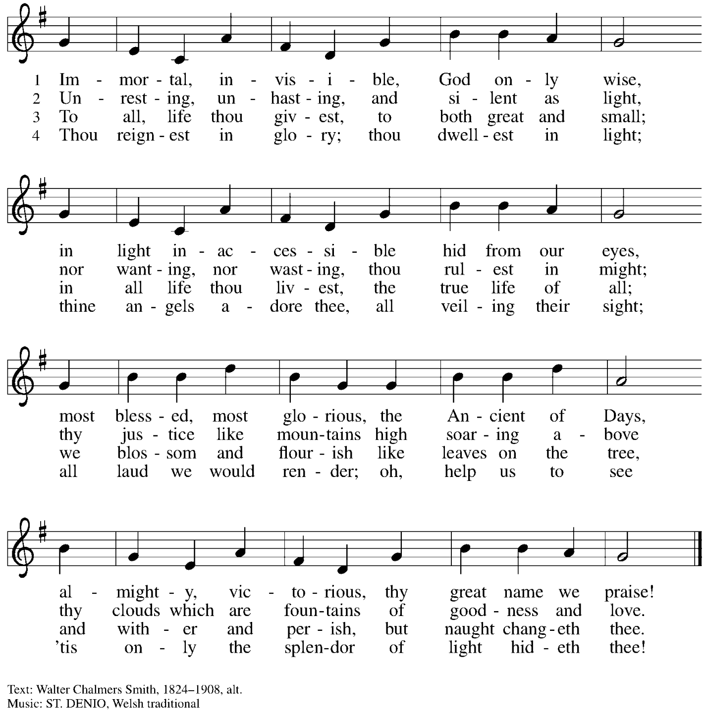

Greeting

P: The grace of our Lord Jesus Christ, the love of God,
and the communion of the Holy Spirit be with you all.
C: And also with you.

Prayer of the Day

P: Let us pray.
Eternal God, you draw near to us in Christ, and you make yourself our guest.
Amid the cares of our lives, make us attentive to your presence,
that we may treasure your word above all else, through Jesus Christ, our Savior and Lord.
C: Amen.

Please be seated.

Word
God speaks to us in Scripture reading, preaching, and song

First Reading – Genesis 18: 1-10a

¹ The Lord appeared to Abraham by the oaks of Mamre, as he sat at the entrance of his tent in the heat of the day. ² He looked up and saw three men standing near him. When he saw them, he ran from the tent entrance to meet them and bowed down to the ground. ³ He said, “My lord, if I find favor with you, do not pass by your servant. ⁴ Let a little water be brought, and wash your feet, and rest yourselves under the tree. ⁵ Let me bring a little bread, that you may refresh yourselves, and after that you may pass on—since you have come to your servant.” So they said, “Do as you have said.” ⁶ And Abraham hastened into the tent to Sarah and said, “Make ready quickly three measures of choice flour, knead it, and make cakes.” ⁷ Abraham ran to the herd and took a calf, tender and good, and gave it to the servant, who hastened to prepare it. ⁸ Then he took curds and milk and the calf that he had prepared and set it before them, and he stood by them under the tree while they ate.
⁹ They said to him, “Where is your wife Sarah?” And he said, “There, in the tent.” ¹⁰ Then one said, “I will surely return to you in due season, and your wife Sarah shall have a son.”

L: Word of God, word of life.
C: Thanks be to God.

Psalm 15

The psalm will be spoken responsively, led by the cantor,
with the congregation reading the verses in bold type.

¹ Lord, who may dwell in your tabernacle?
Who may abide upon your holy hill?
² Those who lead a blameless life and do what is right,
who speak the truth from their heart;
³ they do not slander with the tongue, they do no evil to their friends;
they do not cast discredit upon a neighbor.
⁴ In their sight the wicked are rejected, but they honor those who fear the Lord.
They have sworn upon their health and do not take back their word.
⁵ They do not give their money in hope of gain, nor do they take bribes against the innocent.
Those who do these things shall never be overthrown.

Second Reading – Colossians 1: 15-28

¹⁵ [Christ Jesus] is the image of the invisible God, the firstborn of all creation; ¹⁶ for in him all things in heaven and on earth were created, things visible and invisible, whether thrones or dominions or rulers or powers—all things have been created through him and for him. ¹⁷ He himself is before all things, and in him all things hold together. ¹⁸ He is the head of the body, the church; he is the beginning, the firstborn from the dead, so that he might come to have first place in everything. ¹⁹ For in him all the fullness of God was pleased to dwell, ²⁰ and through him God was pleased to reconcile to Godself all things, whether on earth or in heaven, by making peace through the blood of his cross.
²¹ And you who were once estranged and hostile in mind, doing evil deeds, ²² he has now reconciled in his fleshly body through death, so as to present you holy and blameless and irreproachable before him—²³ provided that you continue securely established and steadfast in the faith, without shifting from the hope promised by the gospel that you heard, which has been proclaimed to every creature under heaven. I, Paul, became a servant of this gospel.
²⁴ I am now rejoicing in my sufferings for your sake, and in my flesh I am completing what is lacking in Christ’s afflictions for the sake of his body, that is, the church. ²⁵ I became its servant according to God’s commission that was given to me for you, to make the word of God fully known, ²⁶ the mystery that has been hidden throughout the ages and generations but has now been revealed to God’s saints. ²⁷ To them God chose to make known how great among the Gentiles are the riches of the glory of this mystery, which is Christ in you, the hope of glory. ²⁸ It is he whom we proclaim, warning everyone and teaching everyone in all wisdom, so that we may present everyone mature in Christ.

L: Word of God, word of life.
C: Thanks be to God.

Please rise as you are able.

Gospel Acclamation

C: Alleluia. Blessed are those who hold the word fast in an honest and good heart,
and bear fruit with patient endurance. Alleluia.

Gospel – Luke 10: 38-42

P: The holy Gospel according to St. Luke.
C: Glory to you, O Lord.

³⁸ Now as [Jesus and his disciples] went on their way, he entered a certain village, where a woman named Martha welcomed him into her home. ³⁹ She had a sister named Mary, who sat at the Lord’s feet and listened to what he was saying. ⁴⁰ But Martha was distracted by her many tasks; so she came to him and asked, “Lord, do you not care that my sister has left me to do all the work by myself? Tell her then to help me.” ⁴¹ But the Lord answered her, “Martha, Martha, you are worried and distracted by many things; ⁴² there is need of only one thing. Mary has chosen the better part, which will not be taken away from her.”

P: The Gospel of the Lord.
C: Praise to you, O Christ.

Please be seated.

Sermon

A time of silence for prayer and reflection follows the sermon.
When the hymn of the day begins, please rise as you are able.

Hymn of the Day O Jesus, Joy of Loving Hearts ELW 658

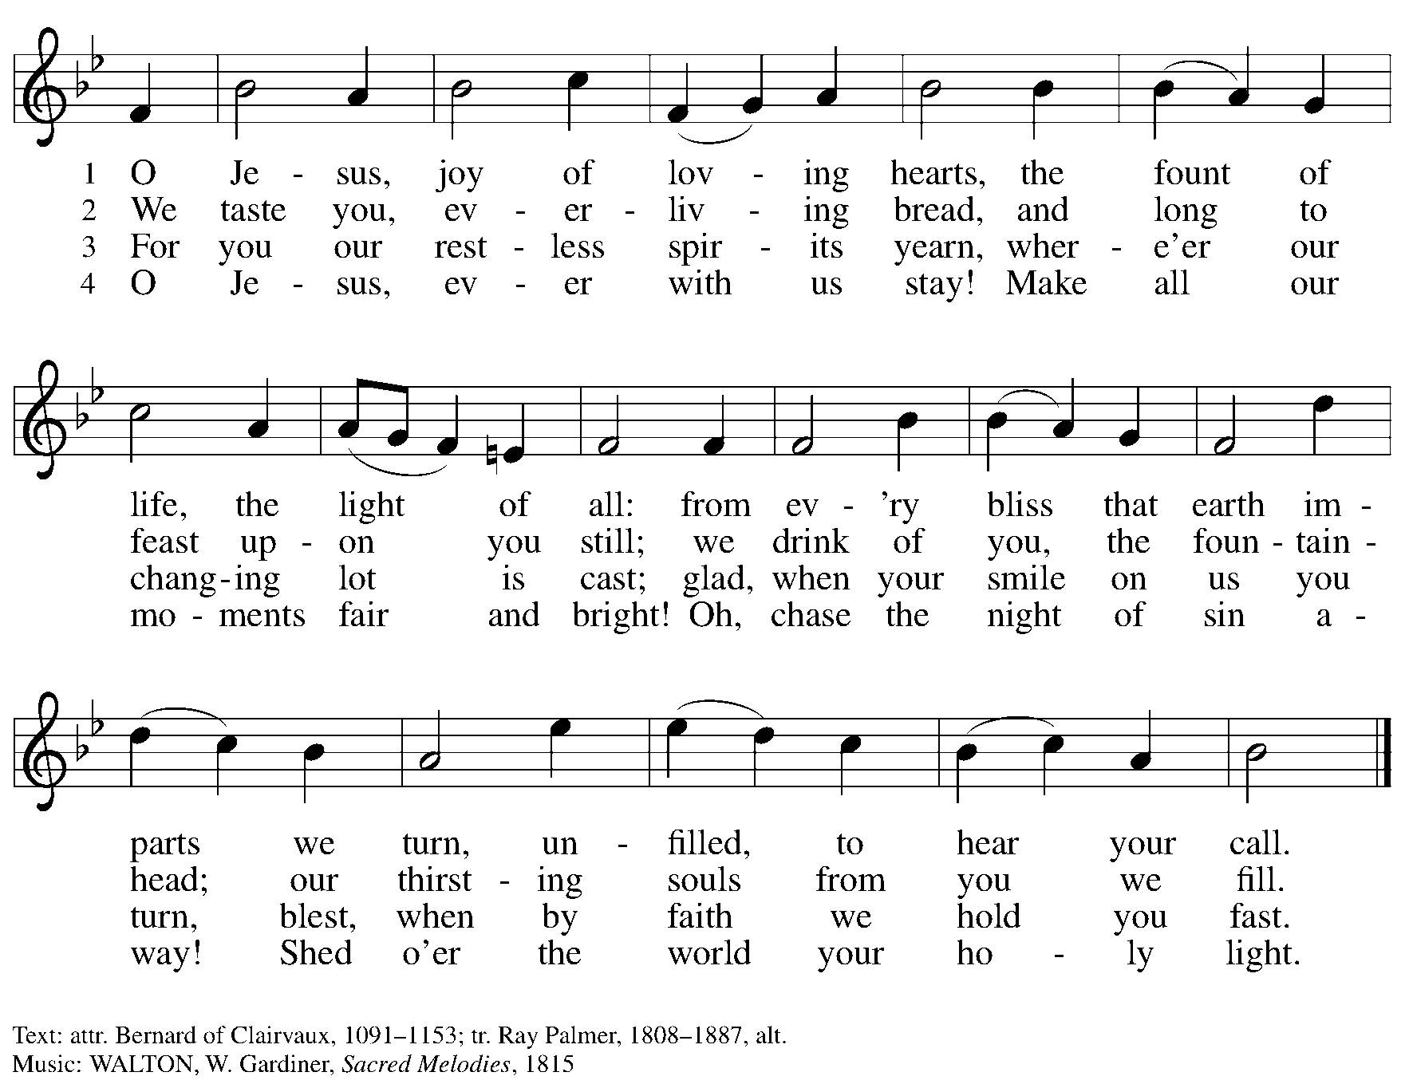

Apostles’ Creed

C: I believe in God, the Father almighty,
creator of heaven and earth.

I believe in Jesus Christ, God’s only Son, our Lord,
who was conceived by the Holy Spirit,
born of the virgin Mary,
suffered under Pontius Pilate,
was crucified, died, and was buried;
he descended to the dead.*
On the third day he rose again;
he ascended into heaven,
he is seated at the right hand of the Father,
and he will come to judge the living and the dead.

I believe in the Holy Spirit,
the holy catholic church,
the communion of saints,
the forgiveness of sins,
the resurrection of the body,
and the life everlasting. Amen.

*Or, “he descended into hell,” another translation of this text in widespread use.

When all have returned to their places, worship continues with the Prayers of the People.

Prayers of the People

A: As stewards of God’s creation,
we join with the whole church to pray for the needs of the world and its people.

After each petition
A: Gracious God,
C: receive our prayer.

P: Trusting in your lovingkindness, we place our prayers and hopes in you, O God,
in the name of Jesus Christ, our Savior.
C: Amen.

Peace

The presiding minister and the assembly greet one another in the peace of the risen Christ.
P: The peace of Christ be with you always.
C: And also with you.

The people may greet those around them with a sign of Christ’s peace and may say
Peace be with you or similar words. Please be mindful that not everyone will be comfortable with sharing the peace, so please seek consent before shaking hands or hugging. Other possible ways to share the peace include a simple bow with the verbal greeting of peace, or simply a verbal expression of peace.

When the greetings of peace have concluded, please be seated.

Meal
God feeds us with the presence of Jesus Christ

Offering

We offer ourselves, our gifts, and our faithful service to God.
As the offering is gathered for the mission of the church, including the care of those in need,
the table is set for Holy Communion.

There are laminated giving cards in the pew racks that feature a QR code for anyone who would like to give online. Those who give using the QR code, as well as those who give regularly online or through their bank are encouraged to place the laminated card in the plate as an expression of your offering.

Noisy Offering

As children of the congregation carry buckets around the sanctuary, people of the congregation are invited to throw in their change as an offering. This month’s noisy offering will benefit Literacy Pittsburgh, which offers free educational programs for adults and families in Allegheny County and Beaver County.

Offertory Music Just a Closer Walk with Thee arr. B. Edstrom

As the gifts are brought forward for presentation, please rise as you are able.

Offertory Song As the Grains of Wheat ELW 465

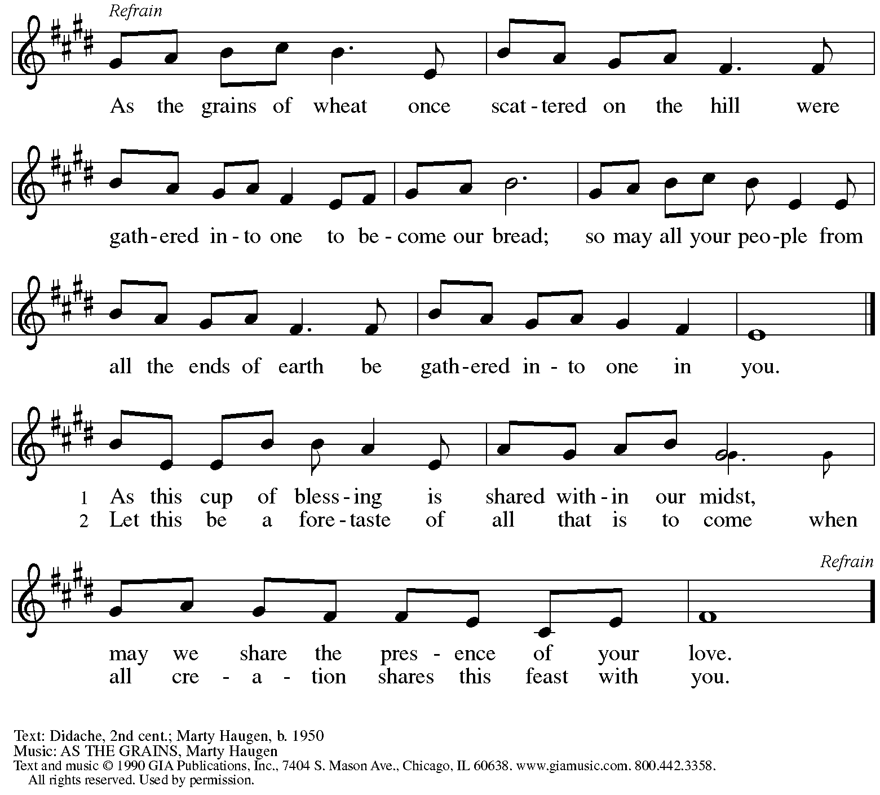
Reprinted under OneLicense.net # A-722139.

Offertory Prayer

A: Let us pray.
Creator God,
C: in your wisdom you bring forth all that is good
and the harvest is plentiful.
Strengthen us at your table with these gifts of the earth
and our labor, that we may work for the good of all;
through Jesus Christ, our Savior.
Amen.

Dialogue

P: The Lord be with you.
C: And also with you.

P: Lift up your hearts.
C: We lift them to the Lord.

P: Let us give thanks to the Lord our God.
C: It is right to give our thanks and praise.

Preface

P: It is indeed right, our duty and our joy …
… we praise your name and join their unending hymn:

Sanctus

C: Holy, holy, holy Lord, God of power and might,
heaven and earth are full of your glory.
Hosanna in the highest.
Blessed is the one who comes in the name of the Lord.
Hosanna in the highest.

Eucharistic Prayer

P: Holy, mighty, and merciful Lord …
… to whom with you and the Holy Spirit
be all honor and glory, now and forever.
C: Amen.

Lord’s Prayer

P: Gathered as one by the Holy Spirit, let us pray as Jesus taught us.
C: Our Father, who art in heaven,
hallowed be thy name,
thy kingdom come,
thy will be done,
on earth as it is in heaven.
Give us this day our daily bread;
and forgive us our trespasses,
as we forgive those
who trespass against us;
and lead us not into temptation,
but deliver us from evil.
For thine is the kingdom,
and the power, and the glory,
forever and ever. Amen.

Fraction and Invitation

Agnus Dei / Lamb of God

C: Lamb of God, you take away the sin of the world; have mercy on us.
Lamb of God, you take away the sin of the world; have mercy on us.
Lamb of God, you take away the sin of the world; grant us peace.

Please be seated.

Holy Communion

- All who seek God and desire a deeper and stronger life in Christ are welcome to receive Holy Communion.
- Worshipers from the pulpit side will proceed forward first, followed by the center section, and then the lectern side.
- Please inform an usher if you would like the ministers to bring Communion to you.
- Holy Communion will be served with bread and wine (amber) or grape juice (purple).
- The presiding minister will first distribute the bread (host) to each communicant. Please indicate if you require a gluten-free host.
- Once you have consumed the bread, please pick up an empty glass from the tray next to the presiding minister. The Communion Assistant will pour wine or grape juice into your glass.
- Please step to the side to consume the wine or grape juice.
- Feel free to kneel at the altar rail for prayer after receiving the sacrament.
- As you return to your pew, glasses may be returned to the empty tray on the side of the center section.
- A blessing will be provided for anyone who does not yet receive the sacrament.
- All are invited to join in singing the hymns during Holy Communion.

Hymns during Holy Communion
Jesus, the Very Thought of You ELW 754

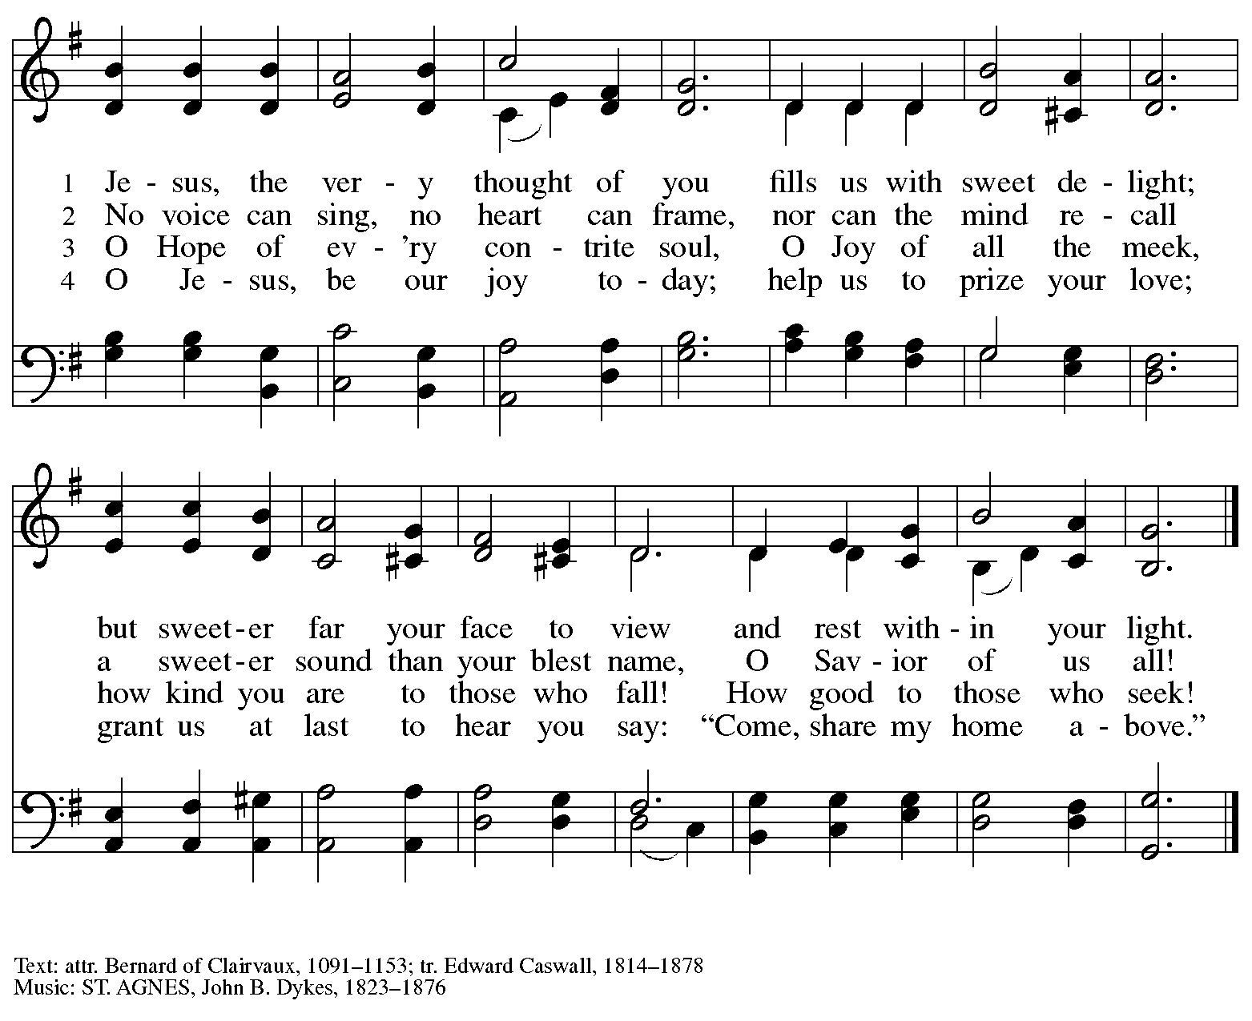

Hymns during Holy Communion
Listen to the Word That God Has Spoken ACS 974

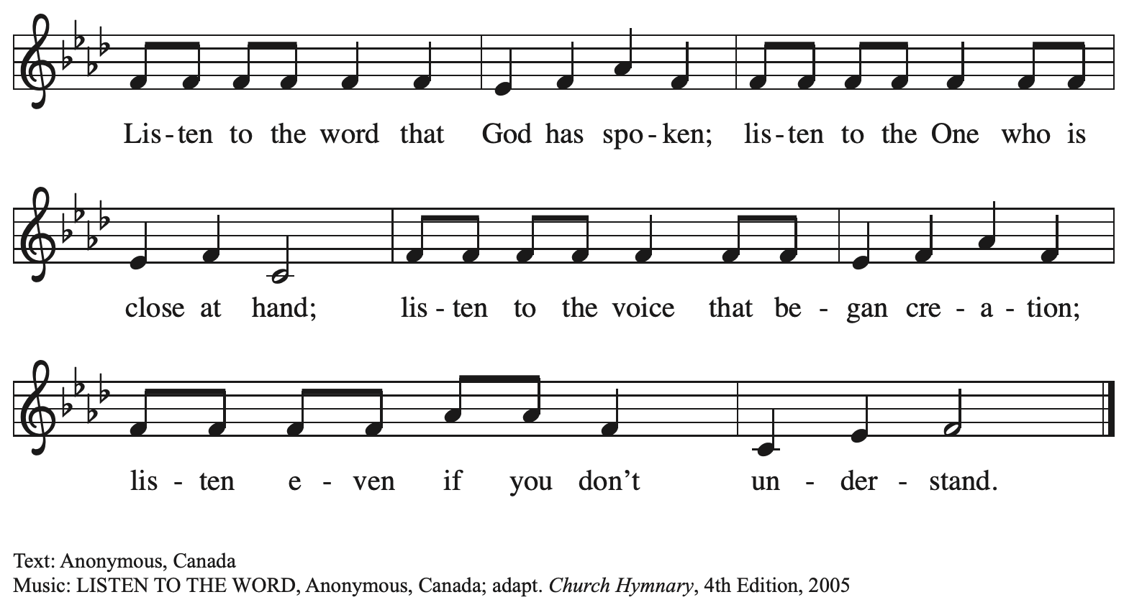

Hymns during Holy Communion
I Can Hear My Savior Calling TFF 146

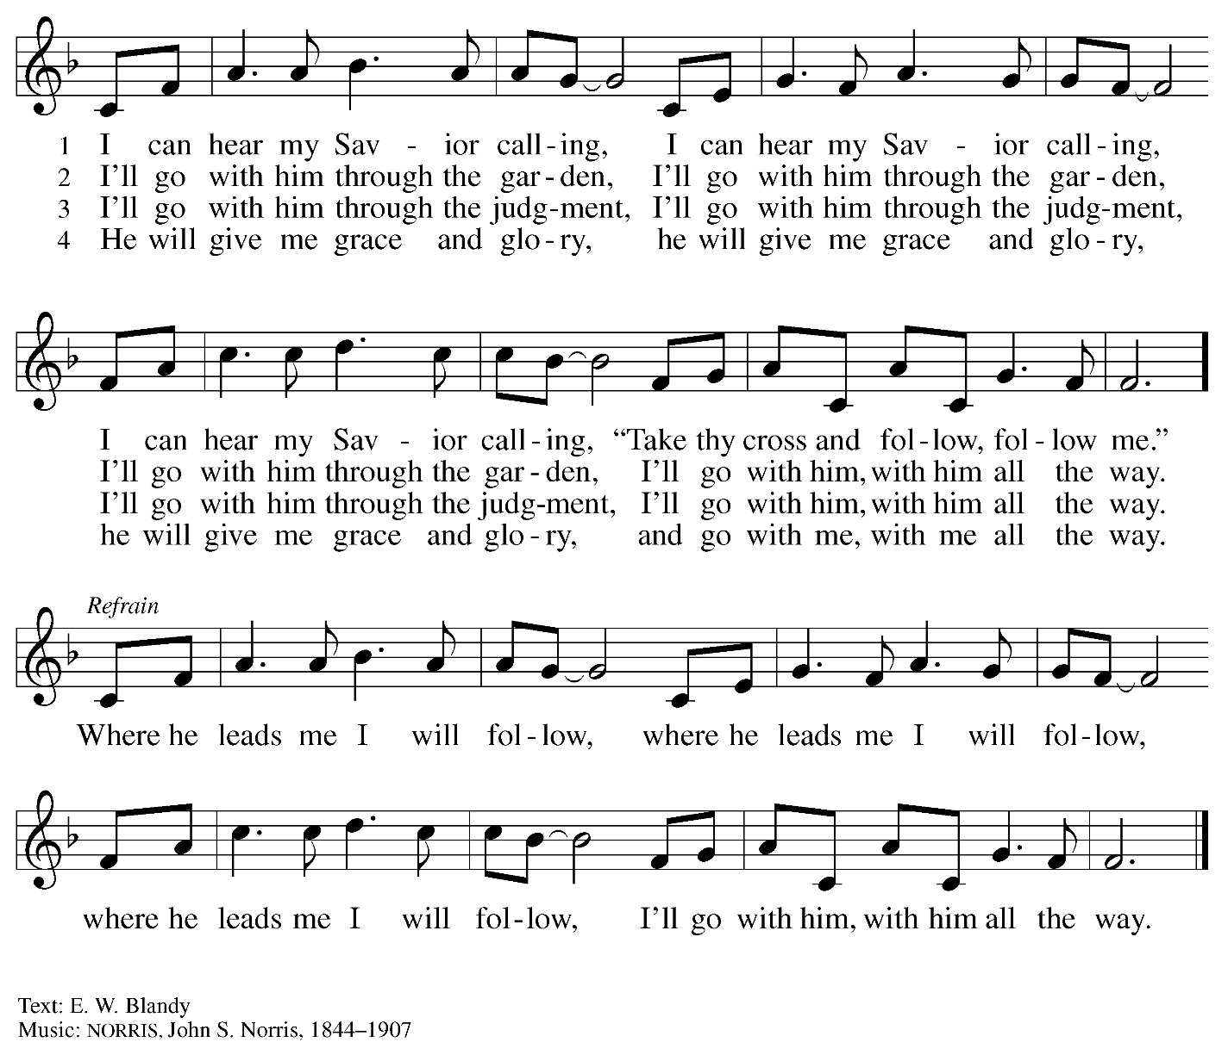

When all have returned to their places, please rise as you are able.

Blessing

P: The body and blood of our Lord Jesus Christ strengthen you and keep you in his grace.
C: Amen.

Prayer

A: Let us pray.

A: Gracious God, in this meal you have drawn us to your heart,
and nourished us at your table with food and drink, the body and blood of Christ.
Now send us forth to be your people in the world,
and to proclaim your truth this day and evermore,
through Jesus Christ, our Savior and Lord.
C: Amen.

Please be seated.

Sending
God blesses us and sends us in mission to the world

Announcements

Please rise as you are able.

Benediction

P: The love of God abound in you;
the grace of our Savior Jesus Christ fill your hearts;
and the life of the Spirit
☩ bless you and give you peace.
C: Amen.

Sending Hymn Following page

Dismissal

A: Go in peace. Serve the Lord.
C: Thanks be to God!

Postlude

Sending Hymn Neno make Mungu – Listen, God Is Calling ELW 513

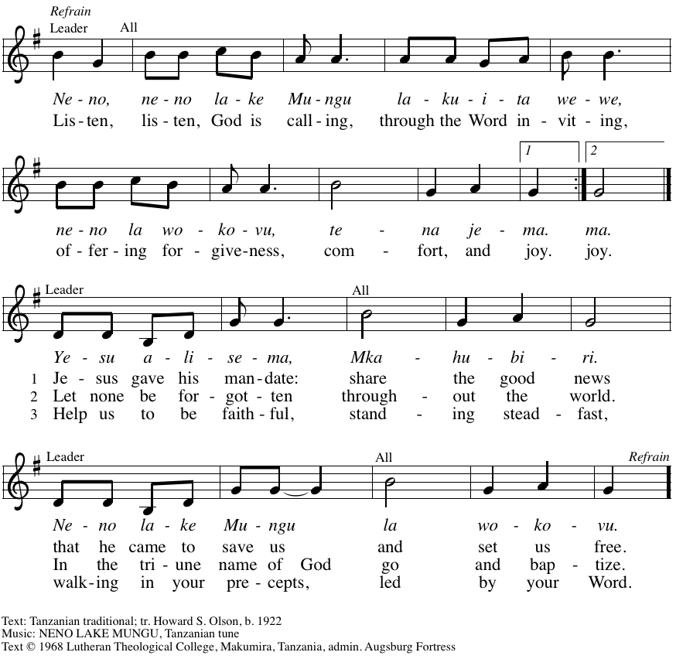
All rights reserved. Reprinted with permission under OneLicense.net # A-722139.

Serving in worship today

Assisting Minister Jeff Denlinger
Audio-Visual Ministers Joseph Paetz
Sarita
Cantor Marit Bakken
Lector Lester Prince
Minister of Music Laura Reynolds
Presiding Minister The Rev. Ross I. Carmichael

Liturgy and Hymnody Acknowledgements

From SundaysandSeasons.com. Copyright © 2025 Augsburg Fortress. All rights reserved. Reprinted under OneLicense.net # A-722139.
Used by permission of Augsburg Fortress.

The Scripture readings contained herein are from New Revised Standard Version Updated Edition of the Bible © 2021 National Council of Churches of Christ in the United States of America. Used by permission. All rights reserved worldwide.

Please use the QR code below to link to St. Andrew’s Announcements online!



St. Andrew Lutheran Church Announcements
July 20th, 2025

- Welcome to Worship at St. Andrew on the Sixth Sunday after Pentecost! – We are so glad you are here, and we offer a special welcome to all visitors and guests who are here for the first time! In the heat of summer St. Andrew moves to a primarily spoken setting of worship. There are worship “toolkits” to help children engage with worship and “busy bags” for younger children available in the bookcase at the back of the sanctuary. Please feel free to take one to use with/for your children. A nursery is available through the door to the left of the worship space and across the social hall (look for a purple room).!
- Noisy Offering Today during Worship – On the third Sunday of each month, St. Andrew’s children lead the congregation in a Noisy Offering, in which people are invited to throw their change into buckets that the children carry around the church and bring forward as an additional offering. Each month’s Noisy Offering supports a local, national, or international church-related or otherwise charitable organization. This month’s offering will benefit Literacy Pittsburgh, which offers free educational programs for adults and families in Allegheny and County and Beaver County. For more information about the organization, please visit https://www.literacypittsburgh.org/.
- Represent St. Andrew at Munhall Main Street Market Night – Friday, July 25th, 5:00 – 9:00 p.m. – St. Andrew will have a booth at Munhall’s Main Street Market Night to meet our neighbors and share information about the church and our welcoming commitments as a Reconciling in Christ congregation. July’s Market Night is Friday, July 25th, from 5:00 – 9:00 p.m. Please see Kelly Spanninger or Kathy Hays if you would like to participate. We also plan to participate in the August date, Friday, August 22nd!
- Unveiling the Lamb: Hope, Resistance, and the Church in Revelation – Zoom Study Led by The Rev. Dr. Martin Rafanan, Thursdays, July 24th – August 21st – Pastor Martin Rafanan has invited the people of St. Andrew to a Zoom study he is leading with PLUM – Pittsburgh Lutheran United Ministries on Thursdays, July 24th – August 21st: “Join us for a 5-session Zoom-based Bible study that explores the Book of Revelation not as a roadmap of fear, but as a bold unveiling of Jesus Christ. In a world of empire, confusion, and compromise, this vision from exile speaks hope and courage to the Church. Each session blends scriptural teaching, theological reflection, pastoral insight, and visual exploration.” To receive the link, please register here:
Google Registration Form:
https://forms.gle/JmbuU7RncG34auJs8
- Community Ministry Team Seeking Donations to Supply Backpacks to Students at The Neighborhood Academy – St. Andrew’s community ministry team was invited by St. Andrew’s Episcopal Church in Highland Park to assist with a project to supply backpacks for students at The Neighborhood Academy, a school in Garfield that supports students in grades 6-12 from low-income backgrounds with a college preparatory curriculum (For more information please see https://www.theneighborhoodacademy.org/). We will be collecting materials for 25 backpacks, with each backpack including one 2-inch, three-ring binder; a package of binder subject dividers; a pack of 6 pens (blue or black, gel or retractable ballpoints); a pack of 6 pencils; 2 yellow highlighters; a pack of white index cards (100, 3x5); 3 report pocket folders; 2 five-subject spiral notebooks. It is key that donations be relatively uniform, so binders, folders, notebooks etc. should be plain, simple colors – please no designs, logos, characters, etc. A donation bin will be set up in the social hall. If you purchase items, please indicate your donation at this link so we can track that we have all the items: https://www.signupgenius.com/go/5080B4AAFAF2CABF85-57266709-backpacks. Thank you for considering a gift for this new ministry initiative! People of the congregation are invited to help put together the backpacks after worship on Sunday, August 10th.
- Lutheran Disaster Response Seeking Donations to Respond to Flooding in Texas – Our hearts break anew with each update about the catastrophic flash floods in South Central Texas. We join the Rev. Sue Briner, bishop of the Southwestern Texas Synod, in her call to “pray, pray, pray" for those who are still lost as well as the families of those who are lost, who have died, or who have experienced loss of home or property.” Please help support Lutheran Disaster Response and the Southwestern Texas Synod in their work to respond to urgent needs, provide emotional and spiritual care, and support cleanup and long-term recovery here: https://give.elca.org/page/85307/donate/.
- SWPA Synod Lutheran Disaster Response Trip, August 3rd - 9th – Our synod's Lutheran Disaster Response team is organizing a work trip to help the Carolinas recover from Hurricane Helene damage. They are searching for 20 willing adults (18 years old and over) to join. The estimated cost is $200 per person. For more information, contact Pastor Jerry Lynn at jjlynn143@gmail.com.
- Christ in Our Home Devotional Booklets for July-September Available at Entrances – This resource offers a daily Bible reading with a short reflection and prayer, along with additional readings and prayer topics for those who would like to expand their devotional practices. We encourage people of the congregation to take one for yourself, your family/household, or others.

