

+ Seventh Sunday after Pentecost
July 27, 2025



St. Andrew Lutheran Church
304 Morewood Ave.
Pittsburgh, PA 15213
St_andrewELCA@verizon.net
www.standrewpittsburgh.org

+ Seventh Sunday after Pentecost
Order for Worship

Persistence in prayer is encouraged by Jesus and wins the attention of God when Abraham intercedes for Sodom. The life of the baptized—to be rooted and built up in Christ Jesus—is to be nurtured with prayer. God hears and answers prayer and so strengthens God’s own.
“When I called, you answered me; you increased my strength within me.”

Welcome to St. Andrew!
- St. Andrew welcomes all who are seeking a place of healing, wholeness, and acceptance in a nurturing and faith-forming spiritual home. We are striving toward racial equity worldwide
and we seek to honor the lived experience of all individuals regardless of background. Our community embraces people of all ages, ethnicities, cultures, abilities, sexual orientations,
gender identities and expressions, and family constellations. Come and See!
- Worship Services are live-streamed to multiple online platforms. By attending worship, you agree that your image and voice may be broadcast.
- Everyone is invited to make a name tag at the black bookcase in the back of the worship space if they would like. There are stickers indicating pronouns on the bookcase if you would like to include them on your name tag.
- A nursery is available through the doors at the left side of the sanctuary and across from the doorway to the Social Hall. Look for a purple-colored room.
- Worship “toolkits” to help children engage with the service, along with “busy bags” for younger children, are available in the bookcase at the back of the sanctuary. Please feel free to take one to use with/for your children.
- Holy Communion is served with bread (gluten-free available) and wine or grape juice. The presiding minister will distribute the bread (host). Please consume this and then pick up an empty glass from the tray. The Communion Assistant will pour wine or grape juice into your glass. Please step to the side to consume the wine or grape juice. Feel free to kneel at the altar for prayer and reflection. As you return to your pew, glasses may be returned to the empty trays on either side of the center section.
- A restroom is available on the main level of the church, through the doors to the Social Hall and to the right in the main office.

Abbreviations
P: Pastor/Presiding Minister ELW: Evangelical Lutheran Worship hymnal
A: Assisting Minister ACS: All Creation Sings hymnal
L: Lector TFF: This Far by Faith hymnal
C: Congregation W&P: Worship & Praise hymnal

Musical Offering

Each week, different people from the congregation make an offering of pre-service music, with singing or instrumentation, to help the assembly focus and pray in preparation for worship.

Welcome

Prelude Breathe on Me, Breath of God Jackson/arr. Hayes

Gathering
The Holy Spirit calls us together as the people of God

Confession and Forgiveness

P: Blessed be the holy Trinity, ☩ one God,
who forgives all our sin,
whose mercy endures forever.
C: Amen.

P: Baptized into Christ, let us confess our sins.

Silence is kept for reflection.

P: Merciful God,
C: you free us to love others,
but we neglect our neighbors and follow our own way.
You lead us by the Spirit of joy and peace,
but we turn away from the abundant life you offer.
You surround us with patience, kindness, and generosity,
but we grow weary in doing what is right.
In your mercy, forgive us.
Do not give up on us.
Heal us, break our bonds, and show us the path of life.
Amen.

P: You belong to Christ Jesus
and you are God’s children through faith.
In the cross of ☩ Christ,
and through the power of the Holy Spirit,
your sins are forgiven.
Clothed with Christ, you are a new creation.
C: Amen.

Gathering Hymn What a Friend We Have in Jesus ELW 742

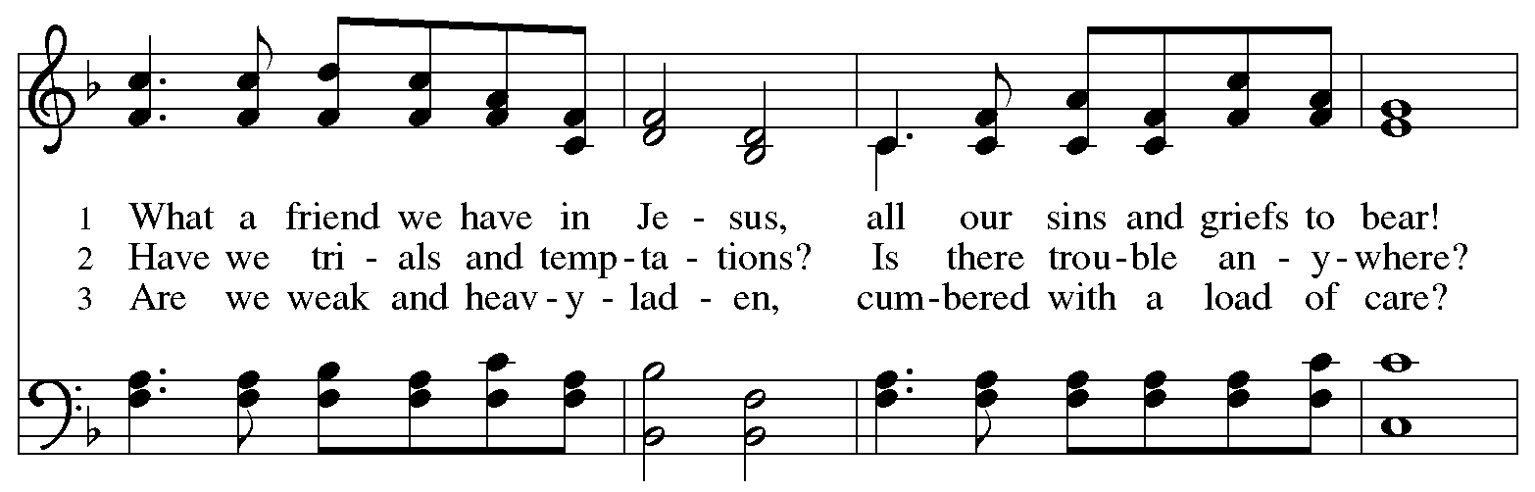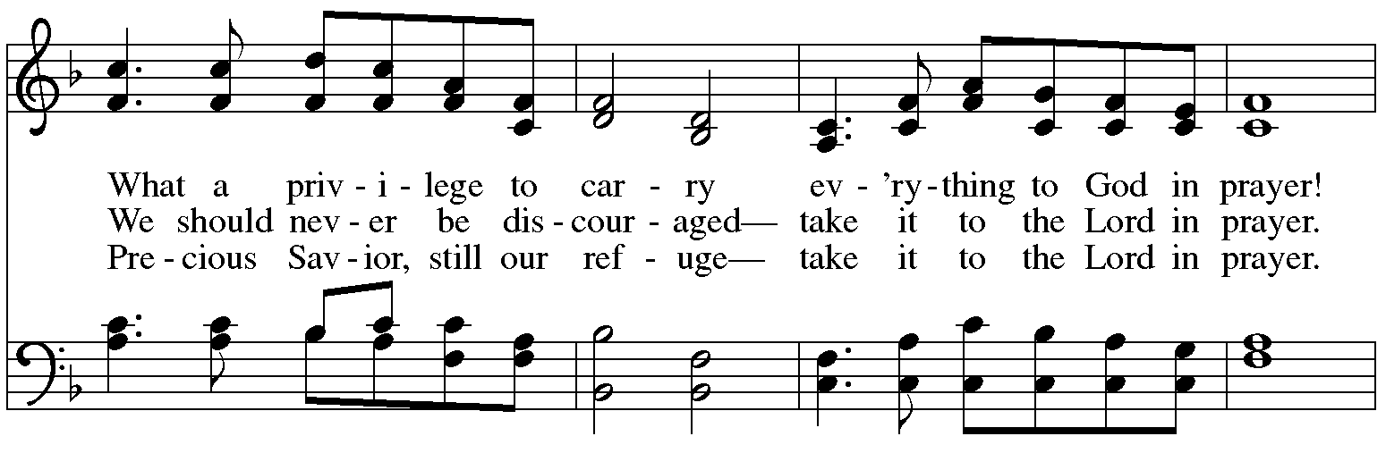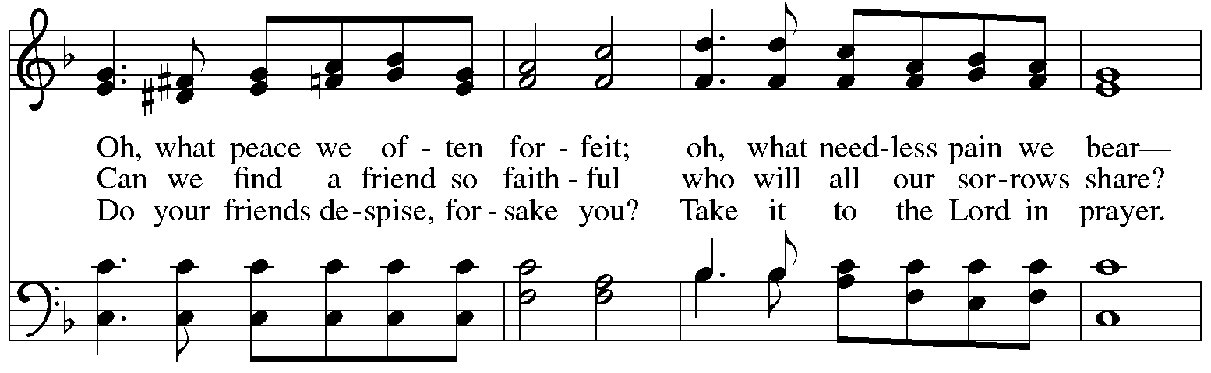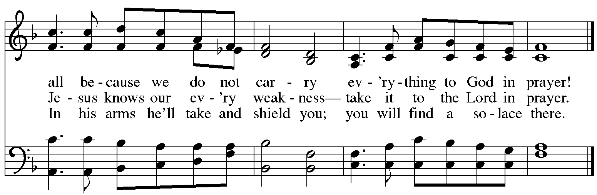
Greeting

P: The grace of our Lord Jesus Christ, the love of God,
and the communion of the Holy Spirit be with you all.
C: And also with you.

Prayer of the Day

P: Let us pray.
Almighty and ever-living God, you are always more ready to hear than we are to pray,
and you gladly give more than we either desire or deserve. Pour upon us your abundant mercy. Forgive us those things that weigh on our conscience, and give us those good things
that come only through your Son, Jesus Christ, our Savior and Lord.
C: Amen.

Please be seated.

Word
God speaks to us in Scripture reading, preaching, and song

First Reading – Genesis 18: 20-32

²⁰ Then the Lord said, “How great is the outcry against Sodom and Gomorrah and how very grave their sin! ²¹ I must go down and see whether they have done altogether according to the outcry that has come to me, and if not, I will know.”
²² So the men turned from there and went toward Sodom, while Abraham remained standing before the Lord. ²³ Then Abraham came near and said, “Will you indeed sweep away the righteous with the wicked? ²⁴ Suppose there are fifty righteous within the city; will you then sweep away the place and not forgive it for the fifty righteous who are in it? ²⁵ Far be it from you to do such a thing, to slay the righteous with the wicked, so that the righteous fare as the wicked! Far be that from you! Shall not the Judge of all the earth do what is just?” ²⁶ And the Lord said, “If I find at Sodom fifty righteous in the city, I will forgive the whole place for their sake.”
²⁷ Abraham answered, “Let me take it upon myself to speak to my lord, I who am but dust and ashes. ²⁸ Suppose five of the fifty righteous are lacking? Will you destroy the whole city for lack of five?” And the Lord said, “I will not destroy it if I find forty-five there.” ²⁹ Again he spoke to the Lord, “Suppose forty are found there.” The Lord answered, “For the sake of forty I will not do it.” ³⁰ Then he said, “Oh, do not let my lord be angry if I speak. Suppose thirty are found there.” The Lord answered, “I will not do it, if I find thirty there.” ³¹ He said, “Let me take it upon myself to speak to my lord. Suppose twenty are found there.” The Lord answered, “For the sake of twenty I will not destroy it.” ³² Then he said, “Oh, do not let my lord be angry if I speak just once more. Suppose ten are found there.” The Lord answered, “For the sake of ten I will not destroy it.”

L: Word of God, word of life.
C: Thanks be to God.

Psalm 138

The psalm will be spoken responsively, led by the cantor,
with the congregation reading the verses in bold type.

¹ I will give thanks to you, O Lord, with my whole heart;
before the gods I will sing your praise.
² I will bow down toward your holy temple and praise your name, because of your steadfast love and faithfulness;
for you have glorified your name and your word above all things.
³ When I called, you answered me;
you increased my strength within me.
⁴ All the rulers of the earth will praise you, O Lord,
when they have heard the words of your mouth.
⁵ They will sing of the ways of the Lord,
that great is the glory of the Lord.
⁶ The Lord is high, yet cares for the lowly,
perceiving the haughty from afar.
⁷ Though I walk in the midst of trouble, you keep me safe;
you stretch forth your hand against the fury of my enemies; your right hand shall save me.
⁸ You will make good your purpose for me;
O Lord, your steadfast love endures forever; do not abandon the works of your hands.

Second Reading – Colossians 2: 6-15

⁶ As you therefore have received Christ Jesus the Lord, continue to walk in him, ⁷ rooted and built up in him and established in the faith, just as you were taught, abounding in thanksgiving.
⁸ Watch out that no one takes you captive through philosophy and empty deceit, according to human tradition, according to the elemental principles of the world, and not according to Christ.
⁹ For in him the whole fullness of deity dwells bodily, ¹⁰ and you have come to fullness in him, who is the head of every ruler and authority. ¹¹ In him also you were circumcised with a spiritual circumcision, by the removal of the body of the flesh in the circumcision of Christ; ¹² when you were buried with him in baptism, you were also raised with him through faith in the power of God, who raised him from the dead. ¹³ And when you were dead in trespasses and the uncircumcision of your flesh, God made you alive together with him, when he forgave us all our trespasses, ¹⁴ erasing the record that stood against us with its legal demands. He set this aside, nailing it to the cross. ¹⁵ He disarmed the rulers and authorities and made a public example of them, triumphing over them in it.

L: Word of God, word of life.
C: Thanks be to God.

Please rise as you are able.

Gospel Acclamation

C: Alleluia. Ask, and it will be given you; search, and you will find;
knock, and the door will be opened to you. Alleluia.

Gospel – Luke 11: 1-13

P: The holy Gospel according to St. Luke.
C: Glory to you, O Lord.

¹ [Jesus] was praying in a certain place, and after he had finished, one of his disciples said to him, “Lord, teach us to pray, as John taught his disciples.” ² So he said to them, “When you pray, say:
Father, may your name be revered as holy.
May your kingdom come.
³ Give us each day our daily bread.
⁴ And forgive us our sins,
for we ourselves forgive everyone indebted to us.
And do not bring us to the time of trial.”
⁵ And he said to them, “Suppose one of you has a friend, and you go to him at midnight and say to him, ‘Friend, lend me three loaves of bread, ⁶ for a friend of mine has arrived, and I have nothing to set before him.’ ⁷ And he answers from within, ‘Do not bother me; the door has already been locked, and my children are with me in bed; I cannot get up and give you anything.’ ⁸ I tell you, even though he will not get up and give him anything out of friendship, at least because of his persistence he will get up and give him whatever he needs.
⁹ “So I say to you, Ask, and it will be given to you; search, and you will find; knock, and the door will be opened for you. ¹⁰ For everyone who asks receives, and everyone who searches finds, and for everyone who knocks, the door will be opened. ¹¹ Is there anyone among you who, if your child asked for a fish, would give a snake instead of a fish? ¹² Or if the child asked for an egg, would give a scorpion? ¹³ If you, then, who are evil, know how to give good gifts to your children, how much more will the heavenly Father give the Holy Spirit to those who ask him!

P: The Gospel of the Lord.
C: Praise to you, O Christ.

Please be seated.

Sermon

A time of silence for prayer and reflection follows the sermon.
When the hymn of the day begins, please rise as you are able.

Hymn of the Day Lord, Teach Us How to Pray Aright ELW 745

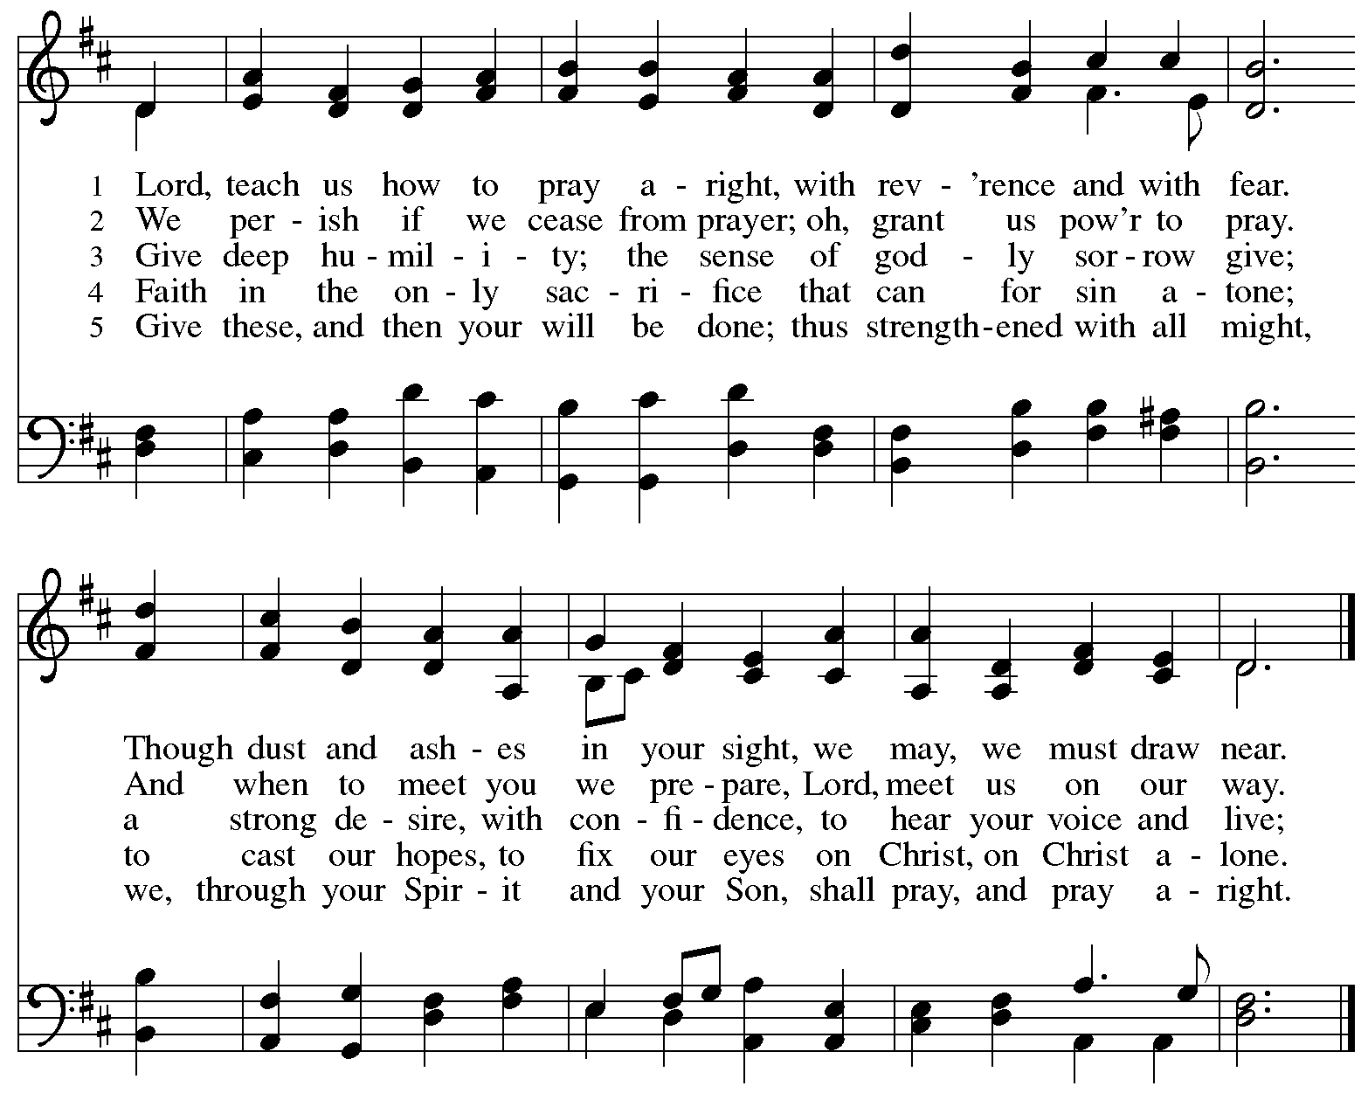

Apostles’ Creed

C: I believe in God, the Father almighty,
creator of heaven and earth.

I believe in Jesus Christ, God’s only Son, our Lord,
who was conceived by the Holy Spirit,
born of the virgin Mary,
suffered under Pontius Pilate,
was crucified, died, and was buried;
he descended to the dead.*
On the third day he rose again;
he ascended into heaven,
he is seated at the right hand of the Father,
and he will come to judge the living and the dead.

I believe in the Holy Spirit,
the holy catholic church,
the communion of saints,
the forgiveness of sins,
the resurrection of the body,
and the life everlasting. Amen.

*Or, “he descended into hell,” another translation of this text in widespread use.

Prayers of the People

A: As stewards of God’s creation,
we join with the whole church to pray for the needs of the world and its people.

After each petition
A: Gracious God,
C: receive our prayer.

P: Trusting in your lovingkindness, we place our prayers and hopes in you, O God,
in the name of Jesus Christ, our Savior.
C: Amen.

Peace

The presiding minister and the assembly greet one another in the peace of the risen Christ.
P: The peace of Christ be with you always.
C: And also with you.

The people may greet those around them with a sign of Christ’s peace and may say
Peace be with you or similar words. Please be mindful that not everyone will be comfortable with sharing the peace, so please seek consent before shaking hands or hugging. Other possible ways to share the peace include a simple bow with the verbal greeting of peace, or simply a verbal expression of peace.

When the greetings of peace have concluded, please be seated.

Meal
God feeds us with the presence of Jesus Christ

Offering

We offer ourselves, our gifts, and our faithful service to God.
As the offering is gathered for the mission of the church, including the care of those in need,
the table is set for Holy Communion.

There are laminated giving cards in the pew racks that feature a QR code for anyone who would like to give online. Those who give using the QR code, as well as those who give regularly online or through their bank are encouraged to place the laminated card in the plate as an expression of your offering.

Offertory Music I Need Thee Every Hour Lowry/arr. Keveren

As the gifts are brought forward for presentation, please rise as you are able.

Offertory Song As the Grains of Wheat ELW 465

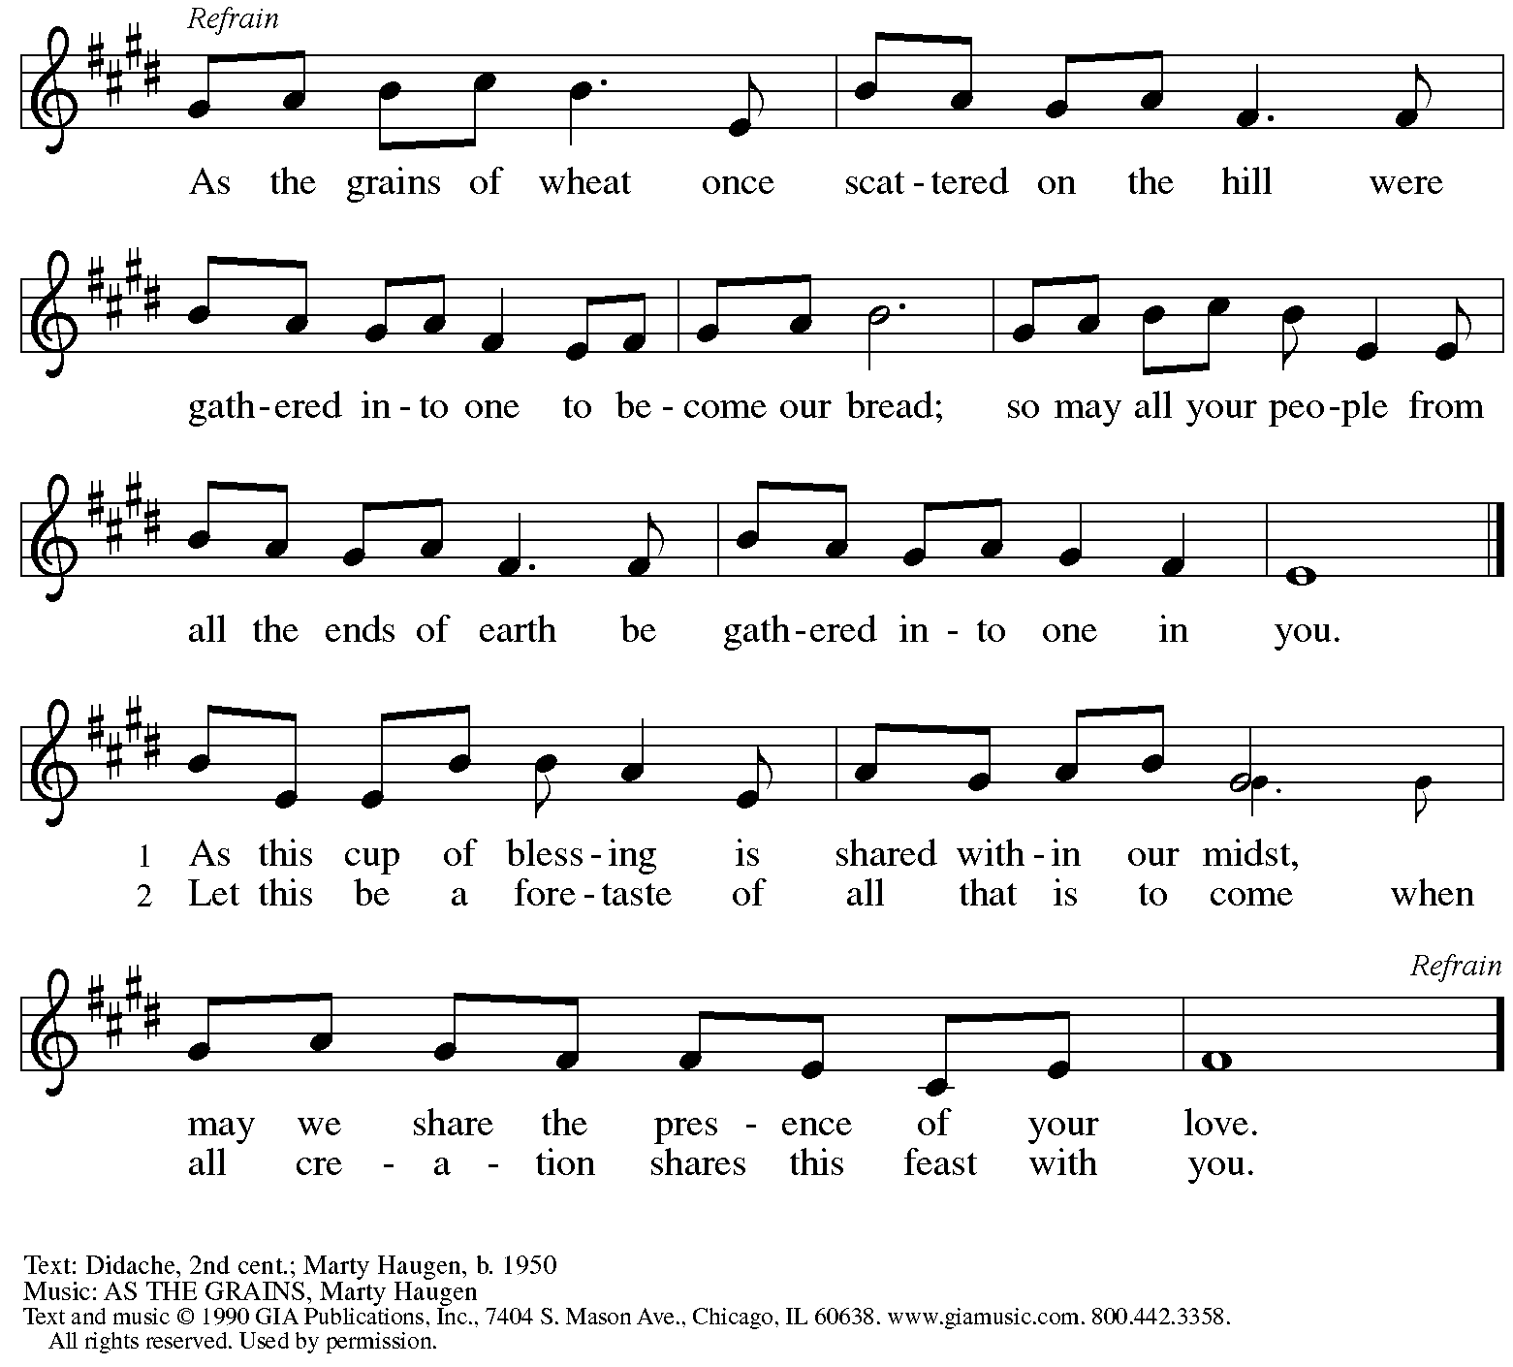
Reprinted under OneLicense.net # A-722139.

Offertory Prayer

A: Let us pray.
Creator God,
C: in your wisdom you bring forth all that is good
and the harvest is plentiful.
Strengthen us at your table with these gifts of the earth
and our labor, that we may work for the good of all;
through Jesus Christ, our Savior.
Amen.

Dialogue

P: The Lord be with you.
C: And also with you.

P: Lift up your hearts.
C: We lift them to the Lord.

P: Let us give thanks to the Lord our God.
C: It is right to give our thanks and praise.

Preface

P: It is indeed right, our duty and our joy …
… we praise your name and join their unending hymn:

Sanctus

C: Holy, holy, holy Lord, God of power and might,
heaven and earth are full of your glory.
Hosanna in the highest.
Blessed is the one who comes in the name of the Lord.
Hosanna in the highest.

Eucharistic Prayer

P: Holy, mighty, and merciful Lord …
… to whom with you and the Holy Spirit
be all honor and glory, now and forever.
C: Amen.

Lord’s Prayer

P: Gathered as one by the Holy Spirit, let us pray as Jesus taught us.
C: Our Father, who art in heaven,
hallowed be thy name,
thy kingdom come,
thy will be done,
on earth as it is in heaven.
Give us this day our daily bread;
and forgive us our trespasses,
as we forgive those
who trespass against us;
and lead us not into temptation,
but deliver us from evil.
For thine is the kingdom,
and the power, and the glory,
forever and ever. Amen.

Fraction and Invitation

Agnus Dei / Lamb of God

C: Lamb of God, you take away the sin of the world; have mercy on us.
Lamb of God, you take away the sin of the world; have mercy on us.
Lamb of God, you take away the sin of the world; grant us peace.

Please be seated.

Holy Communion

- All who seek God and desire a deeper and stronger life in Christ are welcome to receive Holy Communion.
- Worshipers from the pulpit side will proceed forward first, followed by the center section, and then the lectern side.
- Please inform an usher if you would like the ministers to bring Communion to you.
- Holy Communion will be served with bread and wine (amber) or grape juice (purple).
- The presiding minister will first distribute the bread (host) to each communicant. Please indicate if you require a gluten-free host.
- Once you have consumed the bread, please pick up an empty glass from the tray next to the presiding minister. The Communion Assistant will pour wine or grape juice into your glass.
- Please step to the side to consume the wine or grape juice.
- Feel free to kneel at the altar rail for prayer after receiving the sacrament.
- As you return to your pew, glasses may be returned to the empty tray on the side of the center section.
- A blessing will be provided for anyone who does not yet receive the sacrament.
- All are invited to join in singing the hymns during Holy Communion.

Hymns during Holy Communion
O Lord, Hear My Prayer ELW 751

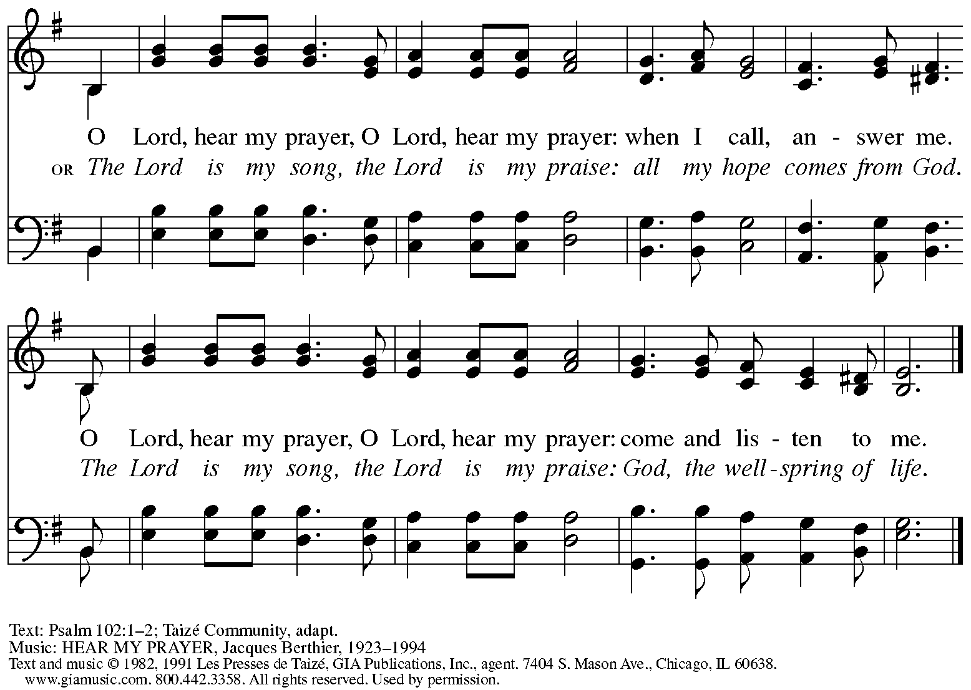
Reprinted under OneLicense.net # A-722139.

Hymns during Holy Communion
There Is a Longing in Our Heart ACS 1078

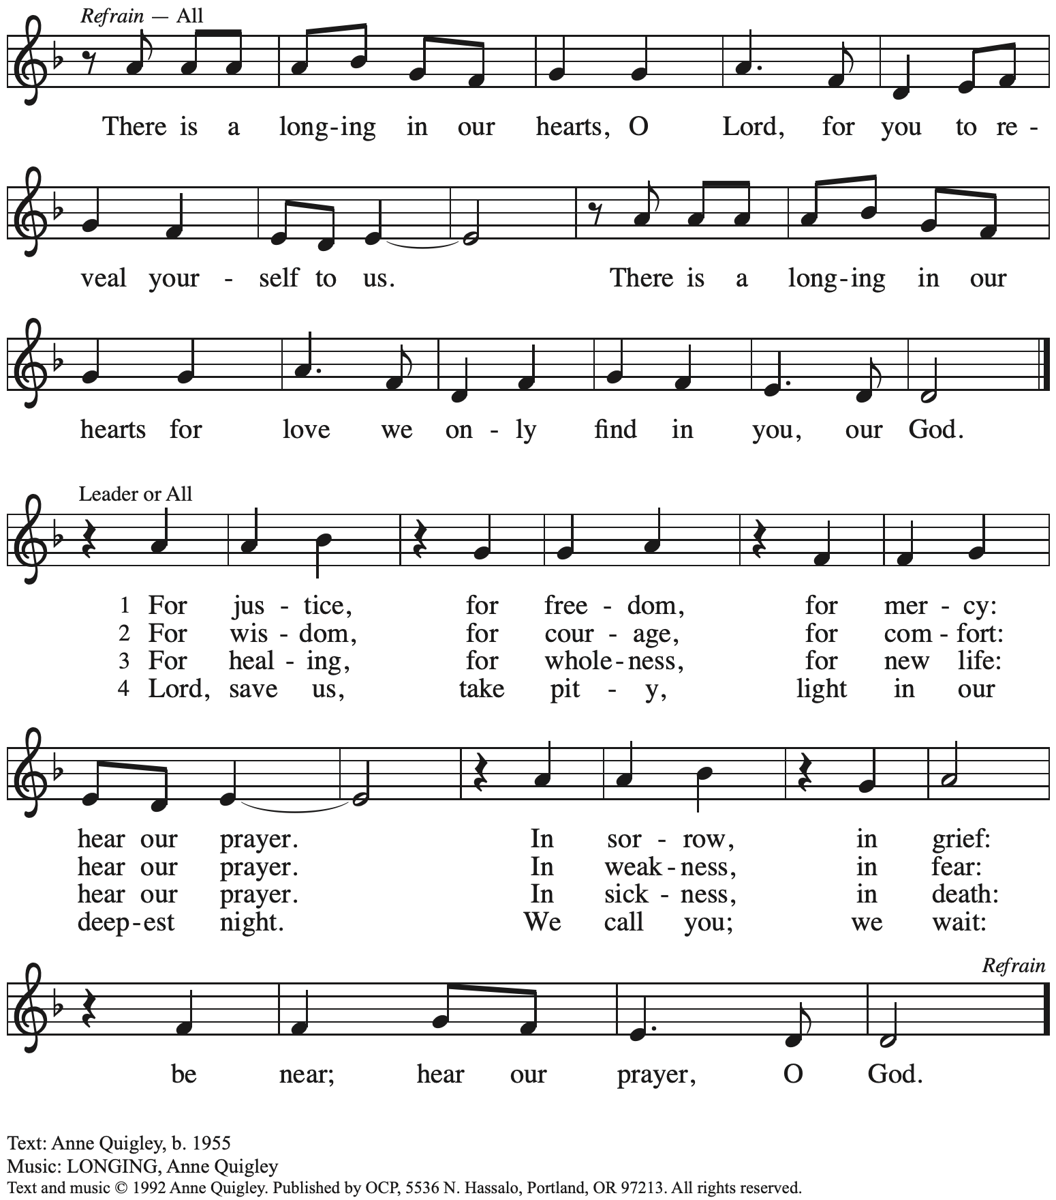
Reprinted with permission under OneLicense.net # A-722139.

Hymns during Holy Communion
Let My Prayer Rise Up ELW 232

Due to the size of the download file, we ask that the congregation refer to the red
Evangelical Lutheran Worship hymnal found in the pews for hymn 232.

Hymns during Holy Communion
Sweet Hour of Prayer TFF 242

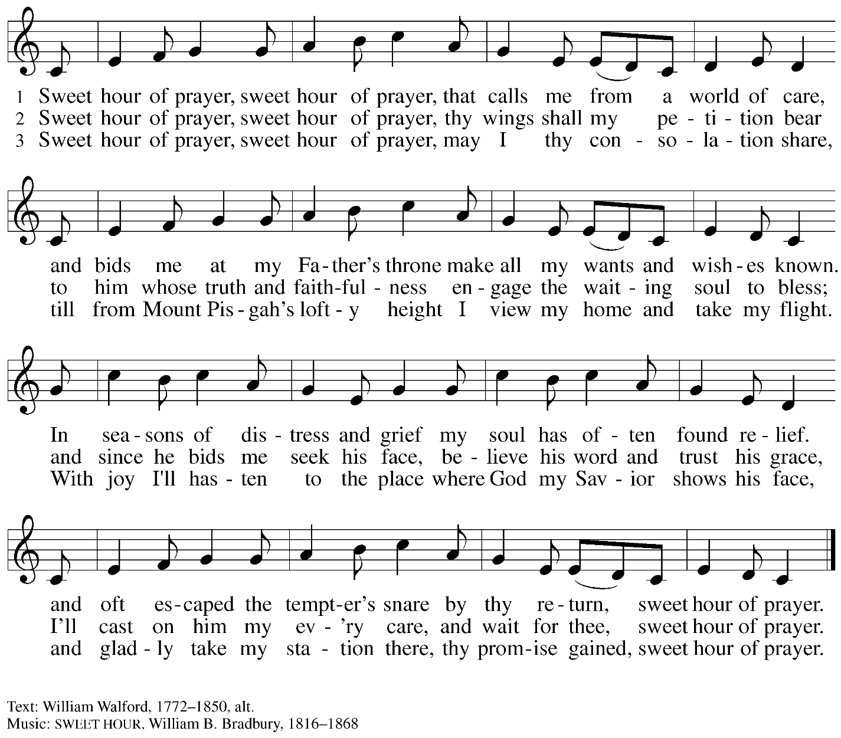

When all have returned to their places, please rise as you are able.

Blessing

P: The body and blood of our Lord Jesus Christ strengthen you and keep you in his grace.
C: Amen.

Prayer

A: Let us pray.
Gracious God, in this meal you have drawn us to your heart,
and nourished us at your table with food and drink, the body and blood of Christ.
Now send us forth to be your people in the world,
and to proclaim your truth this day and evermore,
through Jesus Christ, our Savior and Lord.
C: Amen.

Please be seated.

Sending
God blesses us and sends us in mission to the world

Announcements

Please rise as you are able.

Benediction

P: The love of God abound in you;
the grace of our Savior Jesus Christ fill your hearts;
and the life of the Spirit
☩ bless you and give you peace.
C: Amen.

Sending Hymn Following page

Dismissal

A: Go in peace. Serve the Lord.
C: Thanks be to God!

Postlude

Sending Hymn I Will Call upon the Lord W&P 70

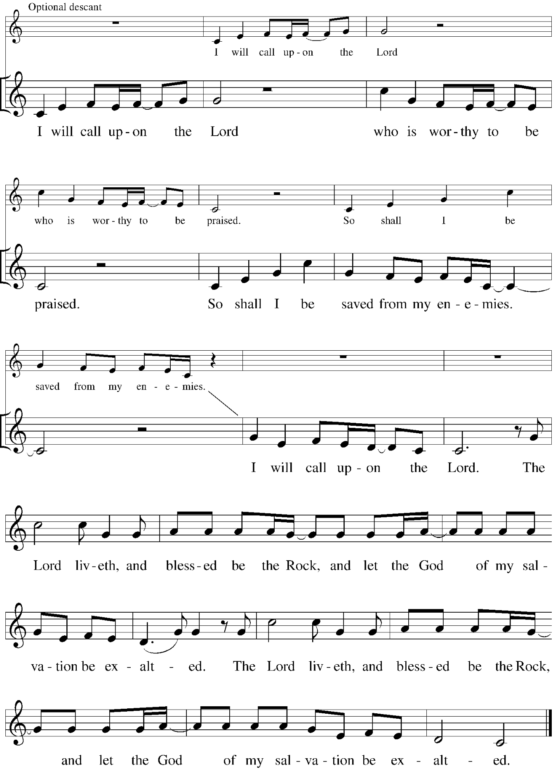

Serving in worship today

Altar Care Christy Ruhe
Assisting Minister Kathy Hays
Audio-Visual Ministers Sarita
Jered Stratton
Cantor Joy Givens
Lector Sue Gaugler
Minister of Music Laura Reynolds
Presiding Minister The Rev. Ross I. Carmichael

Liturgy and Hymnody Acknowledgements

From SundaysandSeasons.com. Copyright © 2025 Augsburg Fortress. All rights reserved. Reprinted under OneLicense.net # A-722139.
Used by permission of Augsburg Fortress.

The Scripture readings contained herein are from New Revised Standard Version Updated Edition of the Bible © 2021 National Council of Churches of Christ in the United States of America. Used by permission. All rights reserved worldwide.

I Will Call upon the Lord – Text: Michael O’Shields. Music: O’SHIELDS, Michael O’Shields. Text and music © 1981 Sound III and All Nations Music; assigned to MCA Music Publishing and The Lorenz Corporation. All rights reserved. Reprinted with permission under OneLicense.net # A-722139.

Please use the QR code below to link to St. Andrew’s Announcements online!



St. Andrew Lutheran Church Announcements
July 27th, 2025

- Welcome to Worship at St. Andrew on the Seventh Sunday after Pentecost! – We are so glad you are here, and we offer a special welcome to all visitors and guests who are here for the first time! In the heat of summer St. Andrew moves to a primarily spoken setting of worship. There are worship “toolkits” to help children engage with worship and “busy bags” for younger children available in the bookcase at the back of the sanctuary. Please feel free to take one to use with/for your children. A nursery is available through the door to the left of the worship space and across the social hall (look for a purple room).
- Monthly Reparations Offering Next Week, Sunday, August 3rd, during Worship – In Luke’s Gospel, Jesus tells a story about a compassionate Samaritan, suggesting that God’s people are called to work for healing and restoration for our neighbors, regardless of who or what caused them harm. In light of this, St. Andrew has made a commitment to reparations in regard to African American spiritual songs used in our worship. The text and music of most hymns is attributed to specific authors, with copyrights in place, usage reported, and royalties paid to those whose works are featured in worship. With African American spirituals, this is not possible. In response to many years of such uncredited use, St. Andrew invites the congregation to give a reparations offering. Funds received in worship will be donated to our siblings at Bethel AME Church, whose land and building were taken from them in the 1950s, to fund their development in the Hill District.
- Unveiling the Lamb: Hope, Resistance, and the Church in Revelation – Zoom Study Led by The Rev. Dr. Martin Rafanan, Continues Thursdays, July 31st – August 21st – Pastor Martin Rafanan has invited the people of St. Andrew to a Zoom study he is leading with PLUM – Pittsburgh Lutheran United Ministries. It began last Thursday, and continues each week, July 31st – August 21st: “Join us for a 5-session Zoom-based Bible study that explores the Book of Revelation not as a roadmap of fear, but as a bold unveiling of Jesus Christ. In a world of empire, confusion, and compromise, this vision from exile speaks hope and courage to the Church. Each session blends scriptural teaching, theological reflection, pastoral insight, and visual exploration.” To receive the link, please register here:
Google Registration Form:
https://forms.gle/JmbuU7RncG34auJs8
- August Produce Distribution – First Tuesday of the Month, August 5th, 5:30-7:00 p.m. – St. Andrew partners with Greater Pittsburgh Community Food Bank to serve as a distribution site for fresh produce on the first Tuesday of every month. Next month’s distribution will be on Tuesday, August 5th. We invite people of the congregation to help with the distribution from 5:30-7:00 p.m. and/or to help with unloading and setup during the day between 10:00 a.m. and 1:00 p.m.
- Community Ministry Team Seeking Donations to Supply Backpacks to Students at The Neighborhood Academy – St. Andrew’s community ministry team was invited by St. Andrew’s Episcopal Church in Highland Park to assist with a project to supply backpacks for students at The Neighborhood Academy, a school in Garfield that supports students in grades 6-12 from low-income backgrounds with a college preparatory curriculum (For more information please see https://www.theneighborhoodacademy.org/). We will be collecting materials for 25 backpacks, with each backpack including one 2-inch, three-ring binder; a package of binder subject dividers; a pack of 6 pens (blue or black, gel or retractable ballpoints); a pack of 6 pencils; 2 yellow highlighters; a pack of white index cards (100, 3x5); 3 report pocket folders; 2 five-subject spiral notebooks. It is key that donations be relatively uniform, so binders, folders, notebooks etc. should be plain, simple colors – please no designs, logos, characters, etc. A donation bin will be set up in the social hall. If you purchase items, please indicate your donation at this link so we can track that we have all the items: https://www.signupgenius.com/go/5080B4AAFAF2CABF85-57266709-backpacks. Thank you for considering a gift for this new ministry initiative! People of the congregation are invited to help put together the backpacks after worship on Sunday, August 10th.
- August Shelter Dinner for Guests of East End Cooperative Ministry – Third Thursday of the Month, August 21st, 6:30 p.m. – Each month, people of St. Andrew provide dinner for guests of East End Cooperative Ministry (EECM), 6140 Station St. (East Liberty), 15206. We invite you to prepare or purchase one menu item and bring it to the shelter by 6:00 p.m., or just come to help serve at 6:30 p.m.
- Lutheran Disaster Response Seeking Donations to Respond to Flooding in Texas – Our hearts break anew with each update about the catastrophic flash floods in South Central Texas. We join the Rev. Sue Briner, bishop of the Southwestern Texas Synod, in her call to “pray, pray, pray" for those who are still lost as well as the families of those who are lost, who have died, or who have experienced loss of home or property.” Please help support Lutheran Disaster Response and the Southwestern Texas Synod in their work to respond to urgent needs, provide emotional and spiritual care, and support cleanup and long-term recovery here: https://give.elca.org/page/85307/donate/.
- Christ in Our Home Devotional Booklets for July-September Available at Entrances – This resource offers a daily Bible reading with a short reflection and prayer, along with additional readings and prayer topics for those who would like to expand their devotional practices. We encourage people of the congregation to take one for yourself, your family/household, or others.

