

+ Eighth Sunday after Pentecost
August 3, 2025



St. Andrew Lutheran Church
304 Morewood Ave.
Pittsburgh, PA 15213
St_andrewELCA@verizon.net
www.standrewpittsburgh.org

+ Eighth Sunday after Pentecost
Order for Worship

Today’s texts offer instruction and encouragement for all who are occasionally overwhelmed by the “unhappy business” of life. Jesus urges us to take care and be on guard against all kinds of greed. We who have died with Christ in holy baptism have also been raised with him and are encouraged to elevate our thinking, seeking the “things that are above.” To that end we seek the sustenance of the Lord’s supper and the encouragement of God’s word.

Welcome to St. Andrew!
- St. Andrew welcomes all who are seeking a place of healing, wholeness, and acceptance in a nurturing and faith-forming spiritual home. We are striving toward racial equity worldwide
and we seek to honor the lived experience of all individuals regardless of background. Our community embraces people of all ages, ethnicities, cultures, abilities, sexual orientations,
gender identities and expressions, and family constellations. Come and See!
- Worship Services are live-streamed to multiple online platforms. By attending worship, you agree that your image and voice may be broadcast.
- Everyone is invited to make a name tag at the black bookcase in the back of the worship space if they would like. There are stickers indicating pronouns on the bookcase if you would like to include them on your name tag.
- A nursery is available through the doors at the left side of the sanctuary and across from the doorway to the Social Hall. Look for a purple-colored room.
- Worship “toolkits” to help children engage with the service, along with “busy bags” for younger children, are available in the bookcase at the back of the sanctuary. Please feel free to take one to use with/for your children.
- Holy Communion is served with bread (gluten-free available) and wine or grape juice. The presiding minister will distribute the bread (host). Please consume this and then pick up an empty glass from the tray. The Communion Assistant will pour wine or grape juice into your glass. Please step to the side to consume the wine or grape juice. Feel free to kneel at the altar for prayer and reflection. As you return to your pew, glasses may be returned to the empty trays on either side of the center section.
- A restroom is available on the main level of the church, through the doors to the Social Hall and to the right in the main office.

Abbreviations
P: Pastor/Presiding Minister ELW: Evangelical Lutheran Worship hymnal
A: Assisting Minister ACS: All Creation Sings hymnal
L: Lector
C: Congregation

Musical Offering

Each week, different people from the congregation make an offering of pre-service music, with singing or instrumentation, to help the assembly focus and pray in preparation for worship.

Welcome

Prelude

Gathering
The Holy Spirit calls us together as the people of God

Confession and Forgiveness

P: Blessed be the holy Trinity, ☩ one God,
who forgives all our sin,
whose mercy endures forever.
C: Amen.

P: Baptized into Christ, let us confess our sins.

Silence is kept for reflection.

P: Merciful God,
C: you free us to love others,
but we neglect our neighbors and follow our own way.
You lead us by the Spirit of joy and peace,
but we turn away from the abundant life you offer.
You surround us with patience, kindness, and generosity,
but we grow weary in doing what is right.
In your mercy, forgive us.
Do not give up on us.
Heal us, break our bonds, and show us the path of life.
Amen.

P: You belong to Christ Jesus
and you are God’s children through faith.
In the cross of ☩ Christ,
and through the power of the Holy Spirit,
your sins are forgiven.
Clothed with Christ, you are a new creation.
C: Amen.

Gathering Hymn Come and Seek the Ways of Wisdom ACS 971

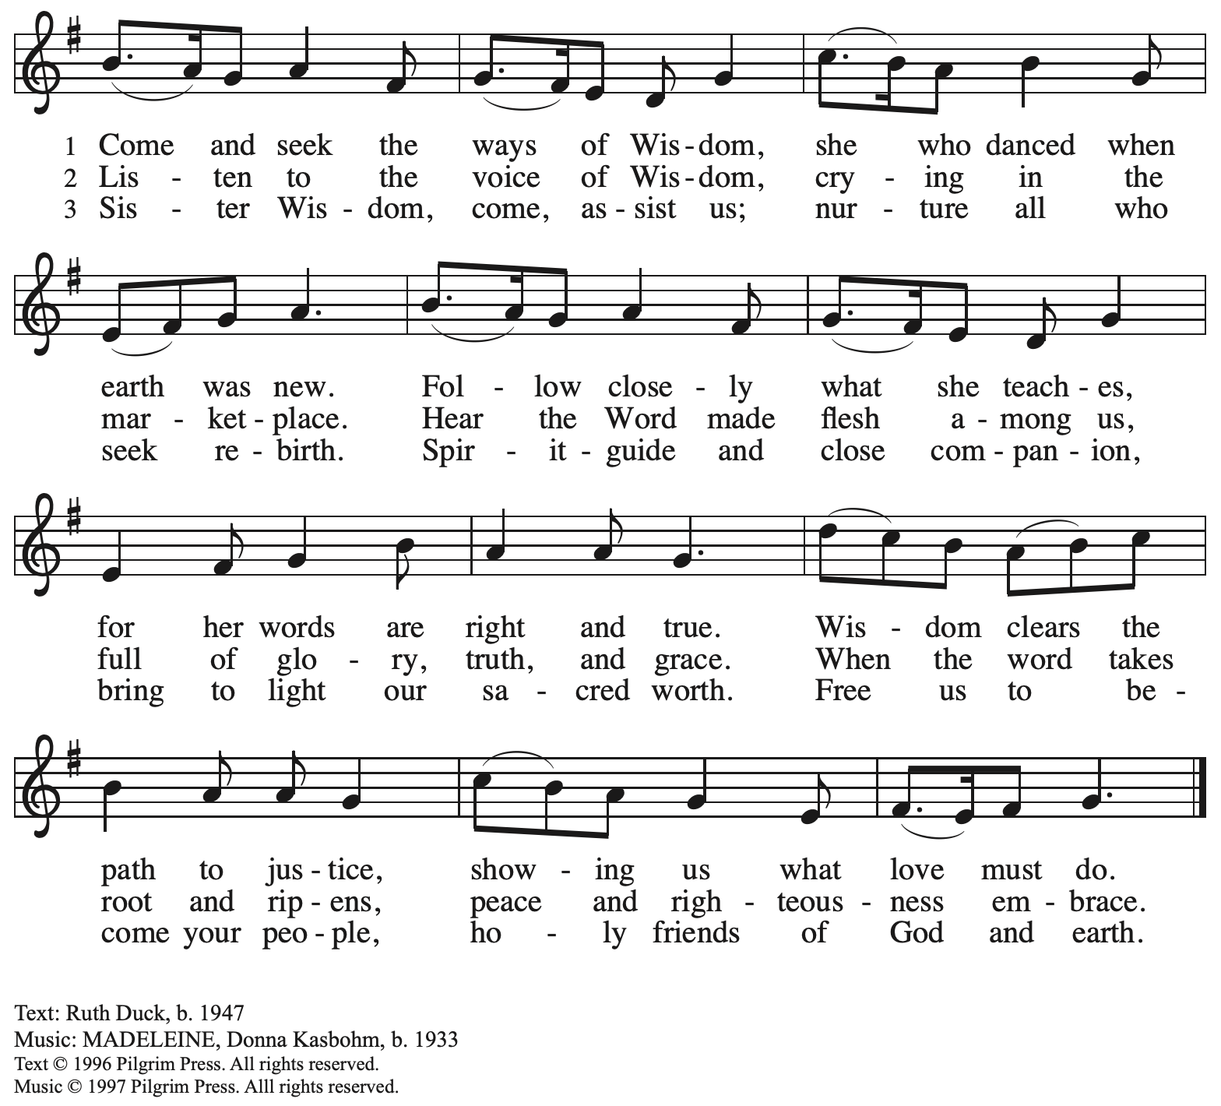
Reprinted with permission under OneLicense.net # A-722139.

Greeting

P: The grace of our Lord Jesus Christ, the love of God,
and the communion of the Holy Spirit be with you all.
C: And also with you.

Prayer of the Day

P: Let us pray.
Benevolent God, you are the source, the guide, and the goal of our lives.
Teach us to love what is worth loving, to reject what is offensive to you,
and to treasure what is precious in your sight, through Jesus Christ, our Savior and Lord.
C: Amen.

Please be seated.

Word
God speaks to us in Scripture reading, preaching, and song

First Reading – Ecclesiastes 1: 2, 12-14; 2: 18-23

² Vanity of vanities, says the Teacher,
vanity of vanities! All is vanity.
¹² I, the Teacher, was king over Israel in Jerusalem. ¹³ I applied my mind to seek and to search out by wisdom all that is done under heaven; it is an unhappy business that God has given to humans to be busy with. ¹⁴ I saw all the deeds that are done under the sun, and see, all is vanity and a chasing after wind.
^{2:18} I hated all my toil in which I had toiled under the sun, seeing that I must leave it to my successor, ¹⁹ and who knows whether he will be wise or foolish? Yet he will be master of all for which I toiled and used my wisdom under the sun. This also is vanity. ²⁰ So I turned and gave my heart up to despair concerning all the toil of my labors under the sun, ²¹ because sometimes one who has toiled with wisdom and knowledge and skill must leave all to be enjoyed by another who did not toil for it. This also is vanity and a great evil. ²² What do mortals get from all the toil and strain with which they toil under the sun? ²³ For all their days are full of pain, and their work is a vexation; even at night their minds do not rest. This also is vanity.

L: Word of God, word of life.
C: Thanks be to God.

Psalm 49: 1-12

The psalm will be spoken responsively, led by the cantor,
with the congregation reading the verses in bold type.

¹ Hear this, | all you peoples;
give ear, all you who dwell | in the world,
² you of high de- | gree and low,
rich and | poor together.
³ My mouth shall | speak of wisdom,
and my heart shall meditate on | understanding.
⁴ I will incline my ear | to a proverb
and set forth my riddle up- | on the harp.
⁵ Why should I be afraid in | evil days,
when the wickedness of those at my | heels surrounds me,
⁶ the wickedness of those who put their trust in | their own prowess,
and boast of | their great riches?
⁷ One can never re- | deem another,
or give to God the ransom for an- | other’s life;
⁸ for the ransom of a life | is so great
that there would never be e- | nough to pay it,
⁹ in order to live forev- | er and ever
and never | see the grave.
¹⁰ For we see that the wise die also; like the dull and stu- | pid they perish
and leave their wealth to those who come | after them.
¹¹ Their graves shall be their homes forever, their dwelling places from generation to | generation,
though they had named lands af- | ter themselves.
¹² Even though honored, they cannot | live forever;
they are like the | beasts that perish.

Second Reading – Colossians 3: 1-11

¹ So if you have been raised with Christ, seek the things that are above, where Christ is, seated at the right hand of God. ² Set your minds on the things that are above, not on the things that are on earth, ³ for you have died, and your life is hidden with Christ in God. ⁴ When Christ who is your life is revealed, then you also will be revealed with him in glory.
⁵ Put to death, therefore, whatever in you is earthly: sexual immorality, impurity, passion, evil desire, and greed (which is idolatry). ⁶ On account of these the wrath of God is coming on those who are disobedient. ⁷ These are the ways you also once followed, when you were living that life. ⁸ But now you must get rid of all such things: anger, wrath, malice, slander, and abusive language from your mouth. ⁹ Do not lie to one another, seeing that you have stripped off the old self with its practices ¹⁰ and have clothed yourselves with the new self, which is being renewed in knowledge according to the image of its creator. ¹¹ In that renewal there is no longer Greek and Jew, circumcised and uncircumcised, barbarian, Scythian, enslaved and free, but Christ is all and in all!

L: Word of God, word of life.
C: Thanks be to God.

Please rise as you are able.

Gospel Acclamation

C: Alleluia. Blessed are the poor in spirit,
for theirs is the kingdom of heaven. Alleluia.

Gospel – Luke 12: 13-21

P: The holy Gospel according to St. Luke.
C: Glory to you, O Lord.

¹³ Someone in the crowd said to [Jesus,] “Teacher, tell my brother to divide the family inheritance with me.” ¹⁴ But he said to him, “Friend, who set me to be a judge or arbitrator over you?” ¹⁵ And he said to them, “Take care! Be on your guard against all kinds of greed, for one’s life does not consist in the abundance of possessions.” ¹⁶ Then he told them a parable: “The land of a rich man produced abundantly. ¹⁷ And he thought to himself, ‘What should I do, for I have no place to store my crops?’ ¹⁸ Then he said, ‘I will do this: I will pull down my barns and build larger ones, and there I will store all my grain and my goods. ¹⁹ And I will say to my soul, Soul, you have ample goods laid up for many years; relax, eat, drink, be merry.’ ²⁰ But God said to him, ‘You fool! This very night your life is being demanded of you. And the things you have prepared, whose will they be?’ ²¹ So it is with those who store up treasures for themselves but are not rich toward God.”

P: The Gospel of the Lord.
C: Praise to you, O Christ.

Please be seated.

Sermon

A time of silence for prayer and reflection follows the sermon.
When the hymn of the day begins, please rise as you are able.



Hymn of the Day Faith Begins by Letting Go ACS 1004

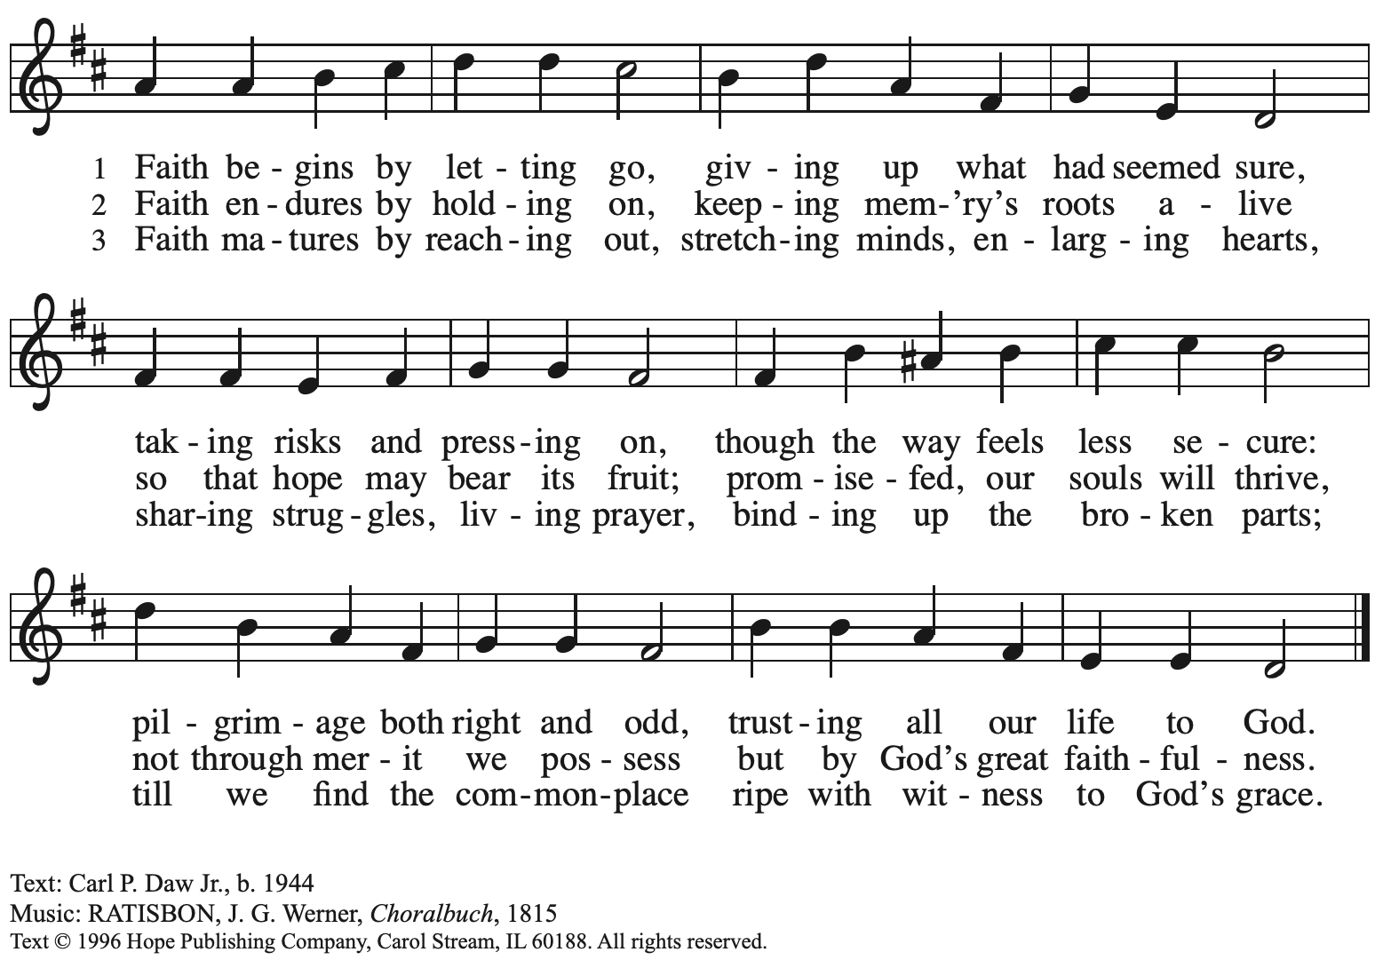
Reprinted with permission under OneLicense.net # A-722139.

Apostles’ Creed

C: I believe in God, the Father almighty,
creator of heaven and earth.

I believe in Jesus Christ, God’s only Son, our Lord,
who was conceived by the Holy Spirit,
born of the virgin Mary,
suffered under Pontius Pilate,
was crucified, died, and was buried;
he descended to the dead.*
On the third day he rose again;
he ascended into heaven,
he is seated at the right hand of the Father,
and he will come to judge the living and the dead.

I believe in the Holy Spirit,
the holy catholic church,
the communion of saints,
the forgiveness of sins,
the resurrection of the body,
and the life everlasting. Amen.

*Or, “he descended into hell,” another translation of this text in widespread use.

Prayers of the People

A: As stewards of God’s creation,
we join with the whole church to pray for the needs of the world and its people.

After each petition
A: Gracious God,
C: receive our prayer.

P: Trusting in your loving kindness, we place our prayers and hopes in you, O God,
in the name of Jesus Christ, our Savior.
C: Amen.

Peace

The presiding minister and the assembly greet one another in the peace of the risen Christ.
P: The peace of Christ be with you always.
C: And also with you.

The people may greet those around them with a sign of Christ’s peace and may say
Peace be with you or similar words. Please be mindful that not everyone will be comfortable with sharing the peace, so please seek consent before shaking hands or hugging. Other possible ways to share the peace include a simple bow with the verbal greeting of peace, or simply a verbal expression of peace.

When the greetings of peace have concluded, please be seated.

Meal
God feeds us with the presence of Jesus Christ

Offering

We offer ourselves, our gifts, and our faithful service to God. As the offering is gathered for the mission of the church, including the care of those in need, the table is set for Holy Communion.

There are laminated giving cards in the pew racks that feature a QR code for anyone who would like to give online. Those who give using the QR code, as well as those who give regularly online or through their bank are encouraged to place the laminated card in the plate as an expression of your offering.

Reparations Offering

On the first Sunday of each month, St. Andrew invites people of the congregation to give a second offering for a reparations fund in acknowledgement of St. Andrew’s use of African American spiritual songs in our worship services. Please see the note in the announcements for more information.

Offertory Music

As the gifts are brought forward for presentation, please rise as you are able.

Offertory Song As the Grains of Wheat ELW 465
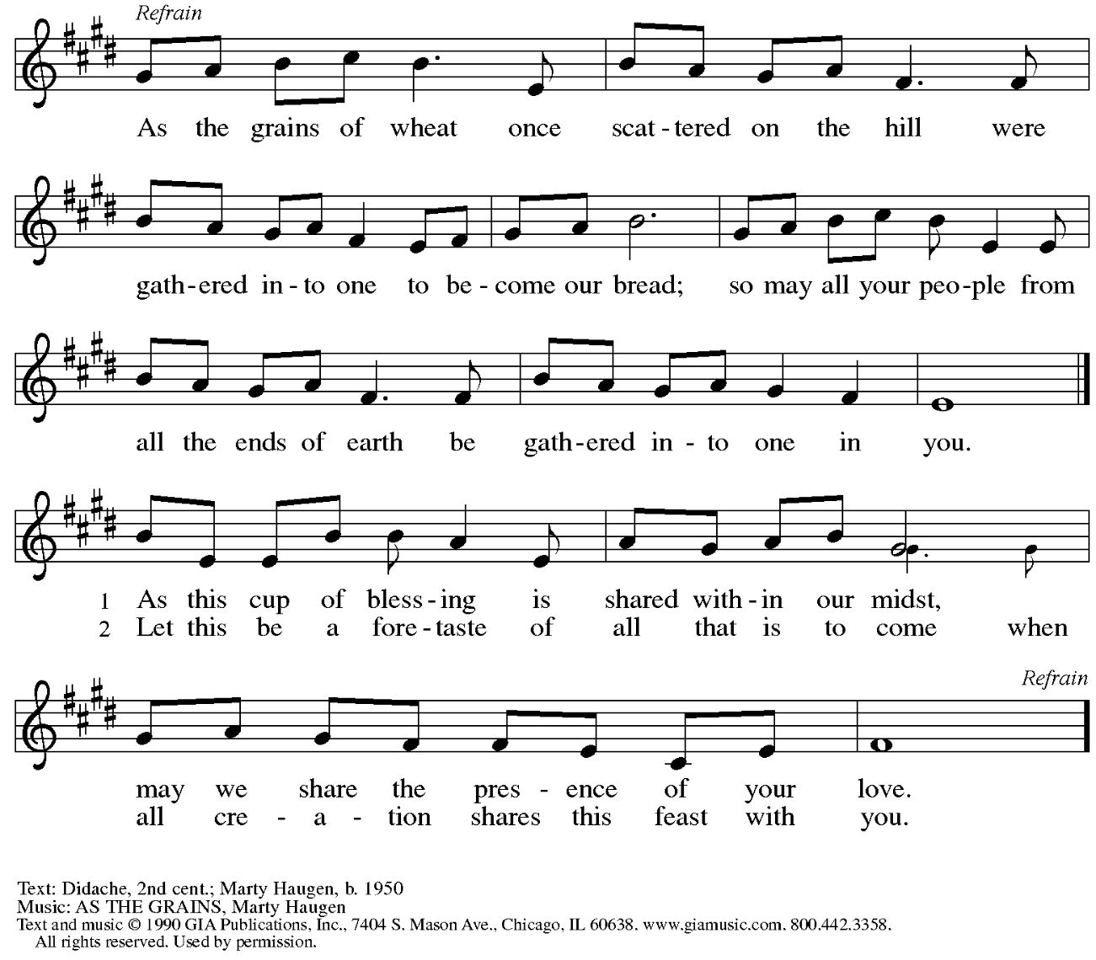
Reprinted under OneLicense.net # A-722139.
Offertory Prayer

A: Let us pray.
Creator God,
C: in your wisdom you bring forth all that is good
and the harvest is plentiful.
Strengthen us at your table with these gifts of the earth
and our labor, that we may work for the good of all;
through Jesus Christ, our Savior.
Amen.

Dialogue

P: The Lord be with you.
C: And also with you.

P: Lift up your hearts.
C: We lift them to the Lord.

P: Let us give thanks to the Lord our God.
C: It is right to give our thanks and praise.

Preface

P: It is indeed right, our duty and our joy,
that we should at all times and in all places
give thanks and praise to you, almighty and merciful God,
through our Savior Jesus Christ;
who on this day overcame death and the grave,
and by his glorious resurrection
opened to us the way of everlasting life.
And so, with all the choirs of angels,
with the church on earth and the hosts of heaven,
we praise your name and join their unending hymn:

Sanctus

C: Holy, holy, holy Lord, God of power and might,
heaven and earth are full of your glory.
Hosanna in the highest.
Blessed is the one who comes in the name of the Lord.
Hosanna in the highest.

Eucharistic Prayer

P: Holy, mighty, and merciful Lord …
… to whom with you and the Holy Spirit
be all honor and glory, now and forever.
C: Amen.

Lord’s Prayer

P: Gathered as one by the Holy Spirit, let us pray as Jesus taught us.
C: Our Father, who art in heaven,
hallowed be thy name,
thy kingdom come,
thy will be done,
on earth as it is in heaven.
Give us this day our daily bread;
and forgive us our trespasses,
as we forgive those
who trespass against us;
and lead us not into temptation,
but deliver us from evil.
For thine is the kingdom,
and the power, and the glory,
forever and ever. Amen.

Fraction and Invitation

Agnus Dei / Lamb of God

C: Lamb of God, you take away the sin of the world; have mercy on us.
Lamb of God, you take away the sin of the world; have mercy on us.
Lamb of God, you take away the sin of the world; grant us peace.

Please be seated.



Holy Communion

- All who seek God and desire a deeper and stronger life in Christ are welcome to receive Holy Communion.
- Worshipers from the pulpit side will proceed forward first, followed by the center section, and then the lectern side.
- Please inform an usher if you would like the ministers to bring Communion to you.
- Holy Communion will be served with bread and wine (amber) or grape juice (purple).
- The presiding minister will first distribute the bread (host) to each communicant. Please indicate if you require a gluten-free host.
- Once you have consumed the bread, please pick up an empty glass from the tray next to the presiding minister. The Communion Assistant will pour wine or grape juice into your glass.
- Please step to the side to consume the wine or grape juice.
- Feel free to kneel at the altar rail for prayer after receiving the sacrament.
- As you return to your pew, glasses may be returned to the empty tray on the side of the center section.
- A blessing will be provided for anyone who does not yet receive the sacrament.
- All are invited to join in singing the hymns during Holy Communion.

Hymns during Holy Communion
All Depends on Our Possessing ELW 589

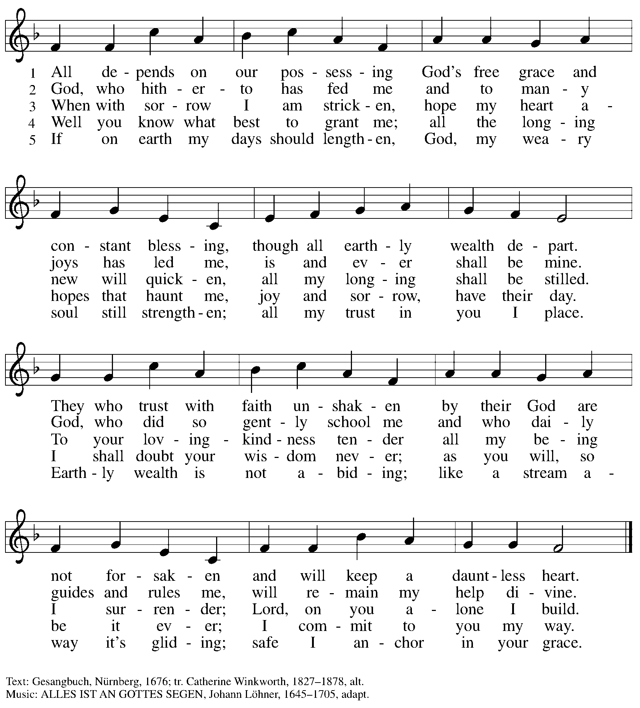

Hymns during Holy Communion
God, Whose Giving Knows No Ending ELW 678

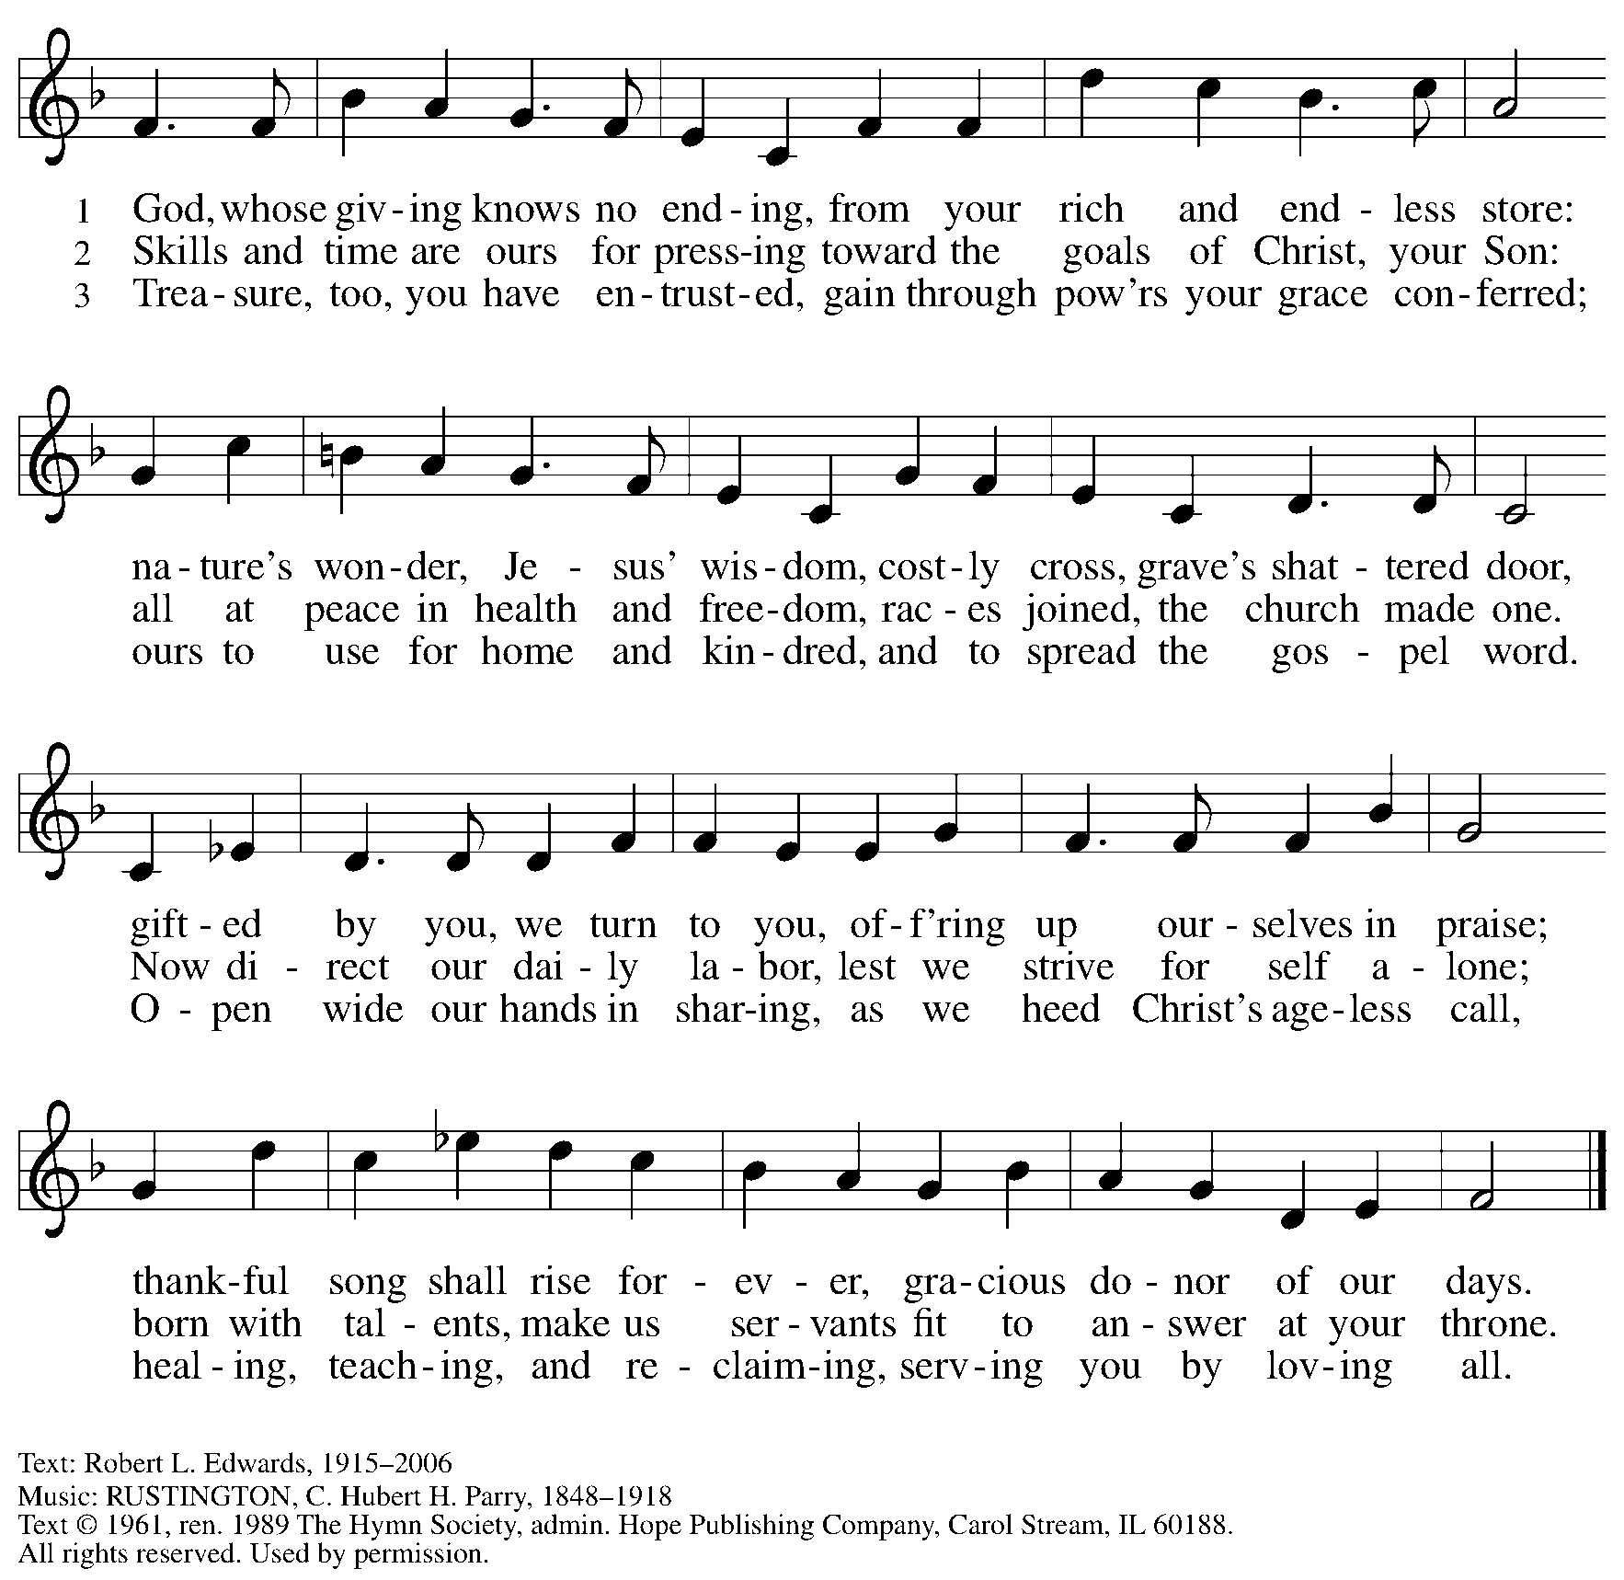
Reprinted under OneLicense.net # A-722139.

Hymns during Holy Communion
Praise and Thanksgiving ELW 689

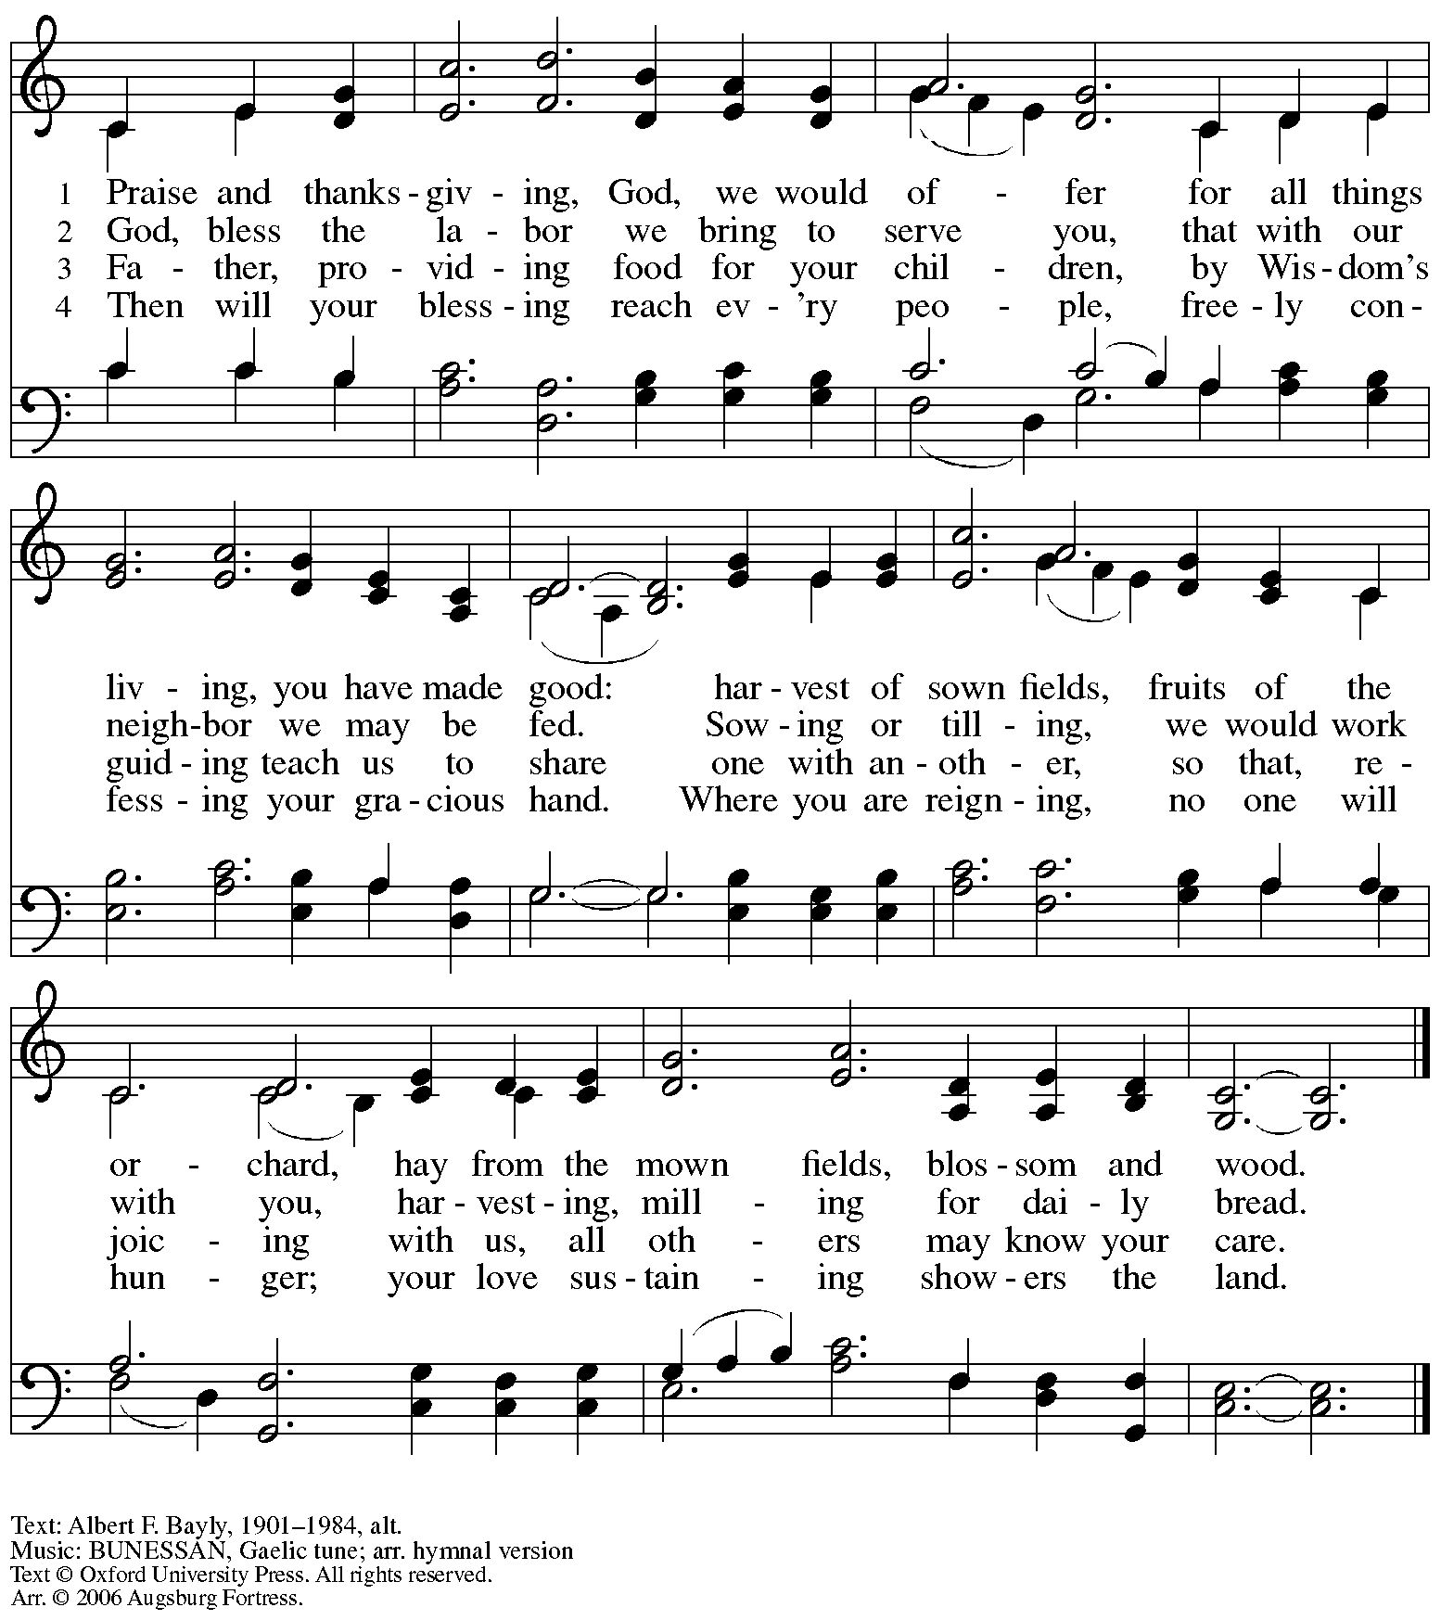
Reprinted with permission under OneLicense.net # A-722139.

When all have returned to their places, please rise as you are able.

Blessing

P: The body and blood of our Lord Jesus Christ strengthen you and keep you in his grace.
C: Amen.

Prayer

A: Let us pray.
Gracious God, in this meal you have drawn us to your heart,
and nourished us at your table with food and drink, the body and blood of Christ.
Now send us forth to be your people in the world,
and to proclaim your truth this day and evermore,
through Jesus Christ, our Savior and Lord.
C: Amen.

Please be seated.

Sending
God blesses us and sends us in mission to the world

Announcements

Please rise as you are able.

Benediction

P: The love of God abound in you;
the grace of our Savior Jesus Christ fill your hearts;
and the life of the Spirit
☩ bless you and give you peace.
C: Amen.

Sending Hymn Following page

Dismissal

A: Go in peace. Serve the Lord.
C: Thanks be to God!

Postlude

Sending Hymn Build a Longer Table ACS 1062

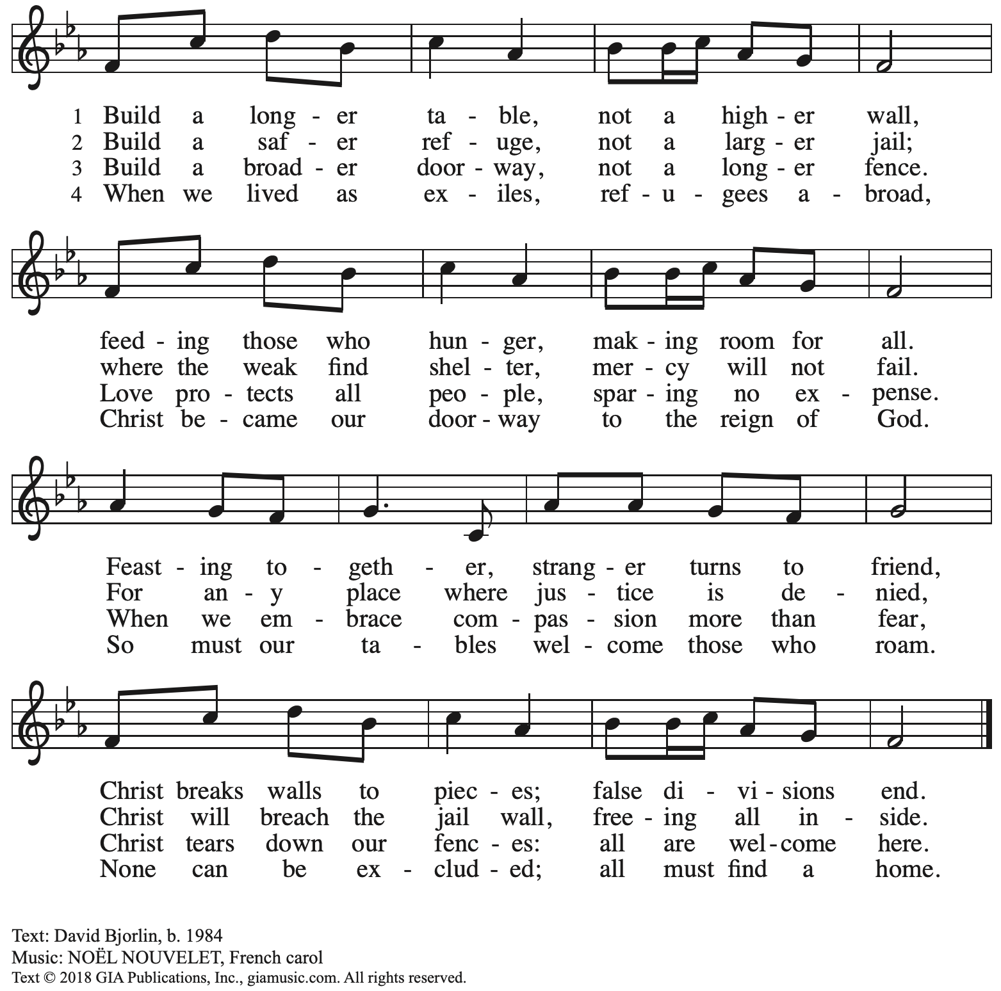
Reprinted with permission under OneLicense.net # A-722139.

Serving in Worship Today

Altar Care Jodie Minor
Assisting Minister Timothy Kocher-Hillmer
Audio-Visual Ministers Kristen Asplin
Tyler Rietze
Cantor David Rollinson
Lector Alda Maria Gonzaga
Piano Jeff Denlinger
Preaching and Presiding Minister The Rev. Erin Jones

Liturgy and Hymnody Acknowledgements

From SundaysandSeasons.com. Copyright © 2025 Augsburg Fortress. All rights reserved. Reprinted under OneLicense.net # A-722139.
Used by permission of Augsburg Fortress.

The Scripture readings contained herein are from New Revised Standard Version Updated Edition of the Bible © 2021 National Council of Churches of Christ in the United States of America. Used by permission. All rights reserved worldwide.

Please use the QR code below to link to St. Andrew’s Announcements online!



St. Andrew Lutheran Church Announcements
August 3rd, 2025

- Welcome to Worship at St. Andrew on the Eighth Sunday after Pentecost! – We are so glad you are here, and we offer a special welcome to all visitors and guests who are here for the first time! In the heat of summer St. Andrew moves to a primarily spoken setting of worship. There are worship “toolkits” to help children engage with worship and “busy bags” for younger children available in the bookcase at the back of the sanctuary. Please feel free to take one to use with/for your children. A nursery is available through the door to the left of the worship space and across the social hall (look for a purple room).
- Thank You to The Rev. Erin Jones, Today’s Preaching and Presiding Minister! – The Rev. Erin Jones is a member of St. Andrew and the Communications and Advocacy Engagement Manager for LAMPa – Lutheran Advocacy Ministry in Pennsylvania. We thank Pastor Erin for sharing her gifts with the congregation today!
- Thank You to Jeff Denlinger for Leading Today’s Music on Piano! – Today’s musician is Jeff Denlinger, a member of the St. Andrew congregation. We thank Jeff for sharing his gifts with the congregation this week!
- Monthly Reparations Offering Today during Worship – In Luke’s Gospel, Jesus tells a story about a compassionate Samaritan, suggesting that God’s people are called to work for healing and restoration for our neighbors, regardless of who or what caused them harm. In light of this, St. Andrew has made a commitment to reparations in regard to African American spiritual songs used in our worship. The text and music of most hymns is attributed to specific authors, with copyrights in place, usage reported, and royalties paid to those whose works are featured in worship. With African American spirituals, this is not possible. In response to many years of such uncredited use, St. Andrew invites the congregation to give a reparations offering. Funds received in worship will be donated to our siblings at Bethel AME Church, whose land and building were taken from them in the 1950s, to fund their development in the Hill District.
- Unveiling the Lamb: Hope, Resistance, and the Church in Revelation – Zoom Study Led by The Rev. Dr. Martin Rafanan, Continues Thursdays, July 31st – August 21st – Pastor Martin Rafanan has invited the people of St. Andrew to a Zoom study he is leading with PLUM – Pittsburgh Lutheran United Ministries. It began last Thursday, and continues each week, July 31st – August 21st: “Join us for a 5-session Zoom-based Bible study that explores the Book of Revelation not as a roadmap of fear, but as a bold unveiling of Jesus Christ. In a world of empire, confusion, and compromise, this vision from exile speaks hope and courage to the Church. Each session blends scriptural teaching, theological reflection, pastoral insight, and visual exploration.” To receive the link, please register here:
Google Registration Form: https://forms.gle/JmbuU7RncG34auJs8
- August Produce Distribution – First Tuesday of the Month, August 5th, 5:30-7:00 p.m. – St. Andrew partners with Greater Pittsburgh Community Food Bank to serve as a distribution site for fresh produce on the first Tuesday of every month. Next month’s distribution will be on Tuesday, August 5th. We invite people of the congregation to help with the distribution from 5:30-7:00 p.m. and/or to help with unloading and setup during the day between 10:00 a.m. and 1:00 p.m.
- Community Ministry Team to Supply Backpacks to Students at The Neighborhood Academy – St. Andrew’s community ministry team was invited by St. Andrew’s Episcopal Church in Highland Park to assist with a project to supply backpacks for students at The Neighborhood Academy, a school in Garfield that supports students in grades 6-12 from low-income backgrounds with a college preparatory curriculum (For more information please see https://www.theneighborhoodacademy.org/). People of the congregation are invited to help put together the backpacks after worship on next Sunday, August 10th.
- August Shelter Dinner for Guests of East End Cooperative Ministry – Third Thursday of the Month, August 21st, 6:30 p.m. – Each month, people of St. Andrew provide dinner for guests of East End Cooperative Ministry (EECM), 6140 Station St. (East Liberty), 15206. We invite you to prepare or purchase one menu item and bring it to the shelter by 6:00 p.m., or just come to help serve at 6:30 p.m.
- Lutheran Disaster Response Seeking Donations to Respond to Flooding in Texas – Our hearts break anew with each update about the catastrophic flash floods in South Central Texas. We join the Rev. Sue Briner, bishop of the Southwestern Texas Synod, in her call to “pray, pray, pray" for those who are still lost as well as the families of those who are lost, who have died, or who have experienced loss of home or property.” Please help support Lutheran Disaster Response and the Southwestern Texas Synod in their work to respond to urgent needs, provide emotional and spiritual care, and support cleanup and long-term recovery here: https://give.elca.org/page/85307/donate/.
- Christ in Our Home Devotional Booklets for July-September Available at Entrances – This resource offers a daily Bible reading with a short reflection and prayer, along with additional readings and prayer topics for those who would like to expand their devotional practices. We encourage people of the congregation to take one for yourself, your family/household, or others.

