

+ Tenth Sunday after Pentecost
August 17, 2025



St. Andrew Lutheran Church
304 Morewood Ave.
Pittsburgh, PA 15213
St_andrewELCA@verizon.net
www.standrewpittsburgh.org

+ Tenth Sunday after Pentecost
Order for Worship

The Word of God is a refining fire. Jesus is the great divide in human history.
He invites our undivided attention and devotion.
Today in worship we are surrounded by a great “cloud of witnesses.”
In the Word and in Holy Communion we are invited yet again to look to Jesus,
“the pioneer and perfecter of our faith.”

Welcome to St. Andrew!
- St. Andrew welcomes all who are seeking a place of healing, wholeness, and acceptance in a nurturing and faith-forming spiritual home. We are striving toward racial equity worldwide
and we seek to honor the lived experience of all individuals regardless of background. Our community embraces people of all ages, ethnicities, cultures, abilities, sexual orientations,
gender identities and expressions, and family constellations. Come and See!
- Worship Services are live-streamed to multiple online platforms. By attending worship, you agree that your image and voice may be broadcast.
- Everyone is invited to make a name tag at the black bookcase in the back of the worship space if they would like. There are stickers indicating pronouns on the bookcase if you would like to include them on your name tag.
- A nursery is available through the doors at the left side of the sanctuary and across from the doorway to the Social Hall. Look for a purple-colored room.
- Worship “toolkits” to help children engage with the service, along with “busy bags” for younger children, are available in the bookcase at the back of the sanctuary. Please feel free to take one to use with/for your children.
- Holy Communion is served with bread (gluten-free available) and wine or grape juice. The presiding minister will distribute the bread (host). Please consume this and then pick up an empty glass from the tray. The Communion Assistant will pour wine or grape juice into your glass. Please step to the side to consume the wine or grape juice. Feel free to kneel at the altar for prayer and reflection. As you return to your pew, glasses may be returned to the empty trays on either side of the center section.
- A restroom is available on the main level of the church, through the doors to the Social Hall and to the right in the main office.

Abbreviations
P: Pastor/Presiding Minister ELW: Evangelical Lutheran Worship hymnal
A: Assisting Minister ACS: All Creation Sings hymnal
L: Lector
C: Congregation

Musical Offering

Each week, different people from the congregation make an offering of pre-service music, with singing or instrumentation, to help the assembly focus and pray in preparation for worship.

Welcome

Prelude We All Are One in Mission arr. Carter

Gathering
The Holy Spirit calls us together as the people of God

Confession and Forgiveness

P: Blessed be the holy Trinity, ☩ one God,
who forgives all our sin,
whose mercy endures forever.
C: Amen.

P: Baptized into Christ, let us confess our sins.

Silence is kept for reflection.

P: Merciful God,
C: you free us to love others,
but we neglect our neighbors and follow our own way.
You lead us by the Spirit of joy and peace,
but we turn away from the abundant life you offer.
You surround us with patience, kindness, and generosity,
but we grow weary in doing what is right.
In your mercy, forgive us.
Do not give up on us.
Heal us, break our bonds, and show us the path of life.
Amen.

P: You belong to Christ Jesus
and you are God’s children through faith.
In the cross of ☩ Christ,
and through the power of the Holy Spirit,
your sins are forgiven.
Clothed with Christ, you are a new creation.
C: Amen.

Gathering Hymn God Is Here! ELW 526

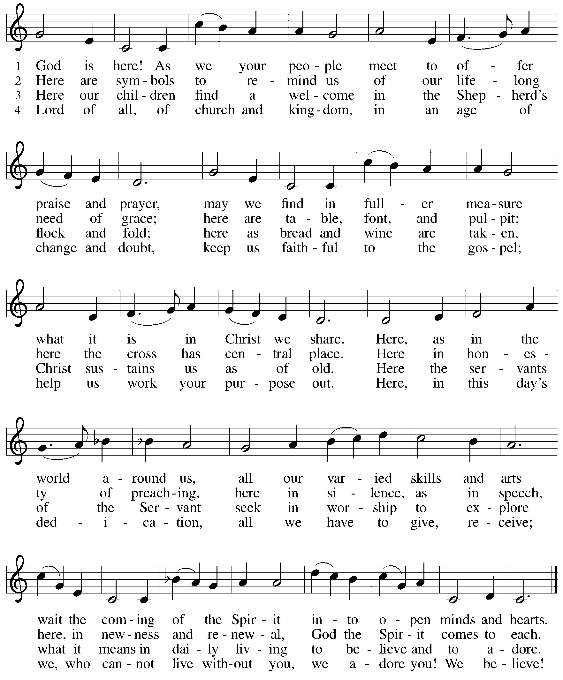

Greeting

P: The grace of our Lord Jesus Christ, the love of God,
and the communion of the Holy Spirit be with you all.
C: And also with you.

Prayer of the Day

P: Let us pray.
O God, judge eternal, you love justice and hate oppression,
and you call us to share your zeal for truth.
Give us courage to take our stand with all victims of bloodshed and greed, and,
following your servants and prophets, to look to the pioneer and perfecter of our faith,
your Son, Jesus Christ, our Savior and Lord.
C: Amen.

Please be seated.

Word
God speaks to us in Scripture reading, preaching, and song

First Reading – Jeremiah 23: 23-29

²³ Am I a God near by, says the Lord, and not a God far off? ²⁴ Who can hide in secret places so that I cannot see them? says the Lord. Do I not fill heaven and earth? says the Lord. ²⁵ I have heard what the prophets have said who prophesy lies in my name, saying, “I have dreamed! I have dreamed!” ²⁶ How long? Will the hearts of the prophets ever turn back—those who prophesy lies and who prophesy the deceit of their own heart? ²⁷ They plan to make my people forget my name by their dreams that they tell one another, just as their ancestors forgot my name for Baal. ²⁸ Let the prophet who has a dream tell the dream, but let the one who has my word speak my word faithfully. What has straw in common with wheat? says the Lord. ²⁹ Is not my word like fire, says the Lord, and like a hammer that breaks a rock in pieces?

L: Word of God, word of life.
C: Thanks be to God.

Psalm 82

The psalm will be spoken responsively, led by the cantor,
with the congregation reading the verses in bold type.

¹ God stands to charge the divine council assembled,
giving judgment in the midst of the gods:
² “How long will you judge unjustly,
and show favor to the wicked?
³ Save the weak and the orphan;
defend the humble and needy;
⁴ rescue the weak and the poor;
deliver them from the power of the wicked.
⁵ They do not know, neither do they understand; they wander about in darkness;
all the foundations of the earth are shaken.
⁶ Now I say to you, ‘You are gods,
and all of you children of the Most High;
⁷ nevertheless, you shall die like mortals,
and fall like any prince.’ ”
⁸ Arise, O God, and rule the earth,
for you shall take all nations for your own.

Second Reading – Hebrews 11: 29 – 12: 2

²⁹ By faith the people passed through the Red Sea as if it were dry land, but when the Egyptians attempted to do so they were drowned. ³⁰ By faith the walls of Jericho fell after they had been encircled for seven days. ³¹ By faith Rahab the prostitute did not perish with those who were disobedient, because she had received the spies in peace.
³² And what more should I say? For time would fail me to tell of Gideon, Barak, Samson, Jephthah, of David and Samuel and the prophets, ³³ who through faith conquered kingdoms, administered justice, obtained promises, shut the mouths of lions, ³⁴ quenched the power of fire, escaped the edge of the sword, were made strong out of weakness, became mighty in war, put foreign armies to flight. ³⁵ Women received their dead by resurrection. Others were tortured, refusing to accept release, in order to obtain a better resurrection. ³⁶ Others suffered mocking and flogging and even chains and imprisonment. ³⁷ They were stoned to death; they were sawn in two; they were killed by the sword; they went about in skins of sheep and goats, destitute, persecuted, tormented ³⁸ of whom the world was not worthy. They wandered in deserts and mountains and in caves and holes in the ground.
³⁹ Yet all these, though they were commended for their faith, did not receive what was promised, ⁴⁰ since God had provided something better so that they would not, apart from us, be made perfect.
^{12:1} Therefore, since we are surrounded by so great a cloud of witnesses, let us also lay aside every weight and the sin that clings so closely, and let us run with perseverance the race that is set before us, ² looking to Jesus, the pioneer and perfecter of faith, who for the sake of the joy that was set before him endured the cross, disregarding its shame, and has taken his seat at the right hand of the throne of God.

L: Word of God, word of life.
C: Thanks be to God.

Please rise as you are able.

Gospel Acclamation

C: Alleluia. My sheep hear my voice.
I know them, and they follow me. Alleluia.

Gospel – Luke 12: 49-56

P: The holy Gospel according to St. Luke.
C: Glory to you, O Lord.

[Jesus said:] ⁴⁹ “I have come to cast fire upon the earth, and how I wish it were already ablaze!
⁵⁰ I have a baptism with which to be baptized, and what constraint I am under until it is completed! ⁵¹ Do you think that I have come to bring peace to the earth? No, I tell you, but rather division! ⁵² From now on five in one household will be divided, three against two and two against three; ⁵³ they will be divided:
father against son
and son against father,
mother against daughter
and daughter against mother,
mother-in-law against her daughter-in-law
and daughter-in-law against mother-in-law.”
⁵⁴ He also said to the crowds, “When you see a cloud rising in the west, you immediately say, ‘It is going to rain,’ and so it happens. ⁵⁵ And when you see the south wind blowing, you say, ‘There will be scorching heat,’ and it happens. ⁵⁶ You hypocrites! You know how to interpret the appearance of earth and sky, but why do you not know how to interpret the present time?”

P: The Gospel of the Lord.
C: Praise to you, O Christ.

Please be seated.

Sermon

A time of silence for prayer and reflection follows the sermon.
When the hymn of the day begins, please rise as you are able.

Hymn of the Day Christ Is the Life ACS 927

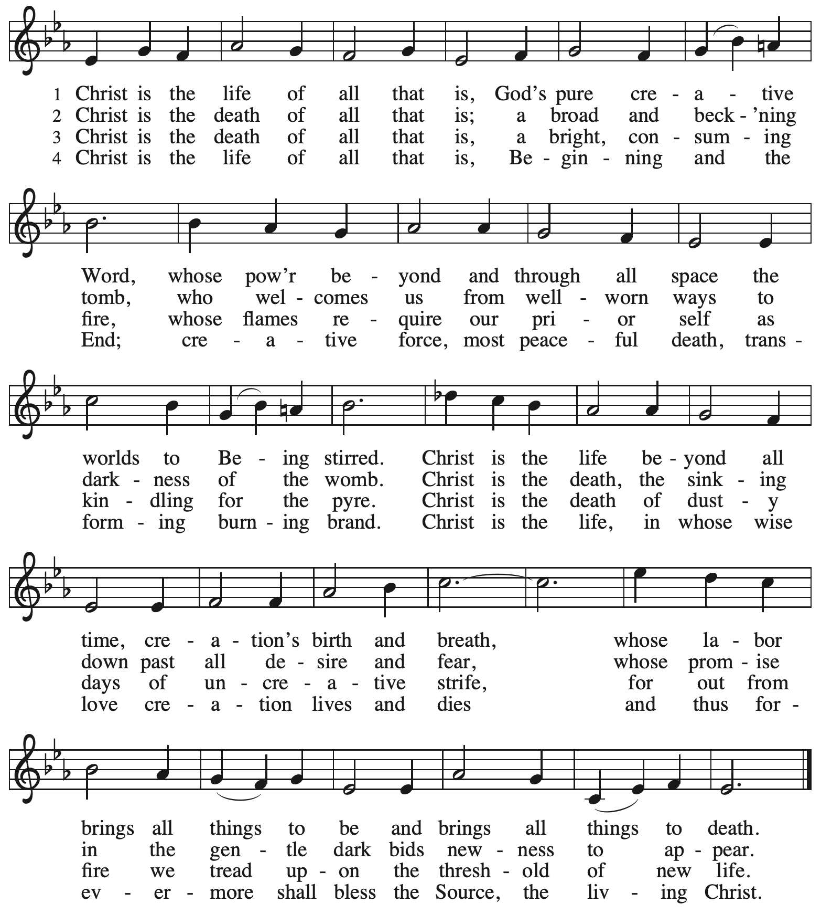

Reprinted with permission under OneLicense.net # A-722139.

Apostles’ Creed

C: I believe in God, the Father almighty,
creator of heaven and earth.

I believe in Jesus Christ, God’s only Son, our Lord,
who was conceived by the Holy Spirit,
born of the virgin Mary,
suffered under Pontius Pilate,
was crucified, died, and was buried;
he descended to the dead.*
On the third day he rose again;
he ascended into heaven,
he is seated at the right hand of the Father,
and he will come to judge the living and the dead.

I believe in the Holy Spirit,
the holy catholic church,
the communion of saints,
the forgiveness of sins,
the resurrection of the body,
and the life everlasting. Amen.

*Or, “he descended into hell,” another translation of this text in widespread use.

Prayers of the People

A: As stewards of God’s creation,
we join with the whole church to pray for the needs of the world and its people.

After each petition
A: Gracious God,
C: receive our prayer.

P: Trusting in your lovingkindness, we place our prayers and hopes in you, O God,
in the name of Jesus Christ, our Savior.
C: Amen.

Peace

The presiding minister and the assembly greet one another in the peace of the risen Christ.
P: The peace of Christ be with you always.
C: And also with you.

The people may greet those around them with a sign of Christ’s peace and may say
Peace be with you or similar words. Please be mindful that not everyone will be comfortable with sharing the peace, so please seek consent before shaking hands or hugging. Other possible ways to share the peace include a simple bow with the verbal greeting of peace, or simply a verbal expression of peace.

When the greetings of peace have concluded, please be seated.



Meal
God feeds us with the presence of Jesus Christ

Offering

We offer ourselves, our gifts, and our faithful service to God.
As the offering is gathered for the mission of the church, including the care of those in need,
the table is set for Holy Communion.

There are laminated giving cards in the pew racks that feature a QR code for anyone who would like to give online. Those who give using the QR code, as well as those who give regularly online or through their bank are encouraged to place the laminated card in the plate as an expression of your offering.

Noisy Offering

As children of the congregation carry buckets around the sanctuary, people of the congregation are invited to throw in their change as an offering. This month’s noisy offering will benefit the nearby Latino Community Center, whose mission is “To provide our children, youth, and families the tools and opportunities needed to reach their full potential through educational programming, family support, and community building.”

Offertory Music How Firm a Foundation arr. Edstrom

As the gifts are brought forward for presentation, please rise as you are able.

Offertory Song ELW 465

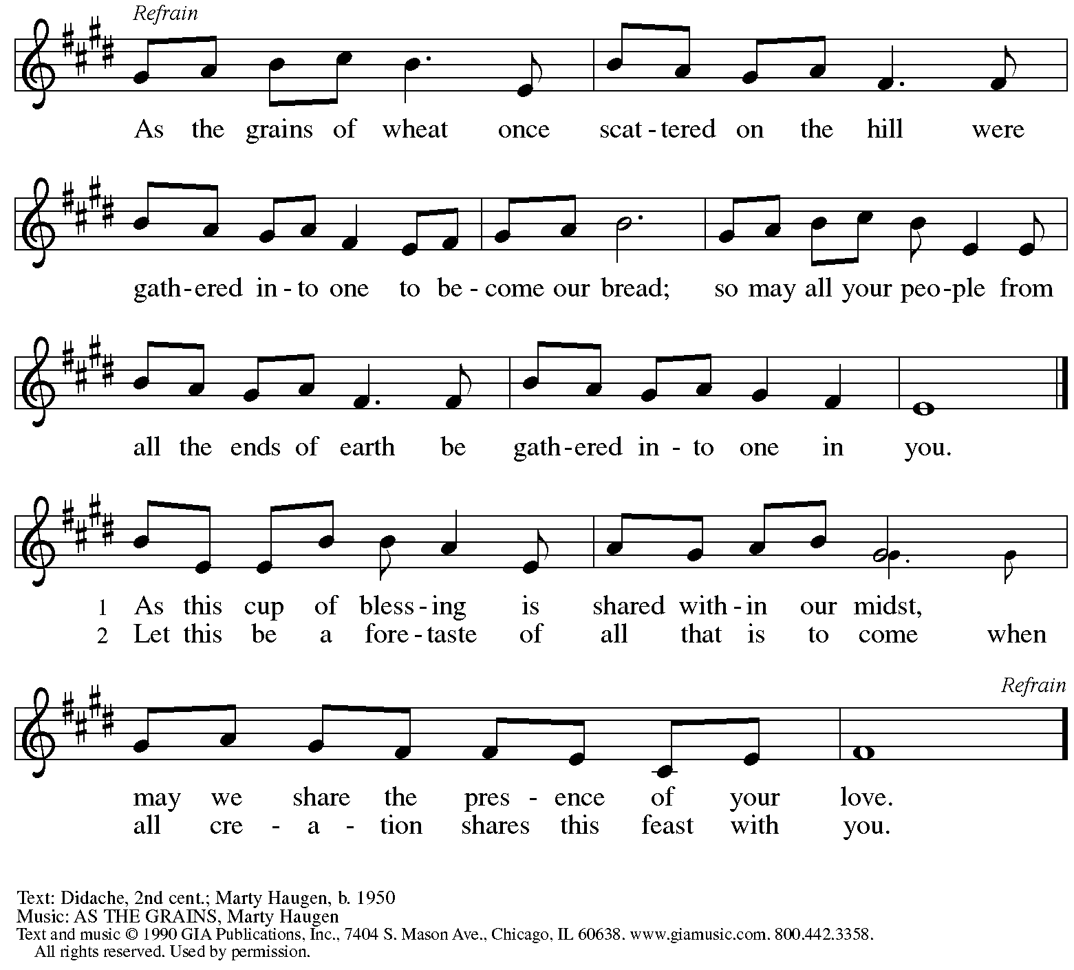
Reprinted under OneLicense.net # A-722139.

Offertory Prayer

A: Let us pray.
Creator God,
C: in your wisdom you bring forth all that is good
and the harvest is plentiful.
Strengthen us at your table with these gifts of the earth
and our labor, that we may work for the good of all;
through Jesus Christ, our Savior.
Amen.

Dialogue

P: The Lord be with you.
C: And also with you.

P: Lift up your hearts.
C: We lift them to the Lord.

P: Let us give thanks to the Lord our God.
C: It is right to give our thanks and praise.

Preface

P: It is indeed right, our duty and our joy,
that we should at all times and in all places
give thanks and praise to you, almighty and merciful God,
through our Savior Jesus Christ;
who on this day overcame death and the grave,
and by his glorious resurrection
opened to us the way of everlasting life.
And so, with all the choirs of angels,
with the church on earth and the hosts of heaven,
we praise your name and join their unending hymn:

Sanctus

C: Holy, holy, holy Lord, God of power and might,
heaven and earth are full of your glory.
Hosanna in the highest.
Blessed is the one who comes in the name of the Lord.
Hosanna in the highest.

Eucharistic Prayer

P: Holy, mighty, and merciful Lord …
… to whom with you and the Holy Spirit
be all honor and glory, now and forever.
C: Amen.

Lord’s Prayer

P: Gathered as one by the Holy Spirit, let us pray as Jesus taught us.
C: Our Father, who art in heaven,
hallowed be thy name,
thy kingdom come,
thy will be done,
on earth as it is in heaven.
Give us this day our daily bread;
and forgive us our trespasses,
as we forgive those
who trespass against us;
and lead us not into temptation,
but deliver us from evil.
For thine is the kingdom,
and the power, and the glory,
forever and ever. Amen.

Fraction and Invitation

Agnus Dei / Lamb of God

C: Lamb of God, you take away the sin of the world; have mercy on us.
Lamb of God, you take away the sin of the world; have mercy on us.
Lamb of God, you take away the sin of the world; grant us peace.

Please be seated.

Holy Communion

- All who seek God and desire a deeper and stronger life in Christ are welcome to receive Holy Communion.
- Worshipers from the pulpit side will proceed forward first, followed by the center section, and then the lectern side.
- Please inform an usher if you would like the ministers to bring Communion to you.
- Holy Communion will be served with bread and wine (amber) or grape juice (purple).
- The presiding minister will first distribute the bread (host) to each communicant. Please indicate if you require a gluten-free host.
- Once you have consumed the bread, please pick up an empty glass from the tray next to the presiding minister. The Communion Assistant will pour wine or grape juice into your glass.
- Please step to the side to consume the wine or grape juice.
- Feel free to kneel at the altar rail for prayer after receiving the sacrament.
- As you return to your pew, glasses may be returned to the empty tray on the side of the center section.
- A blessing will be provided for anyone who does not yet receive the sacrament.
- All are invited to join in singing the hymns during Holy Communion.

Hymns during Holy Communion
Lord, Keep Us Steadfast in Your Word ELW 517

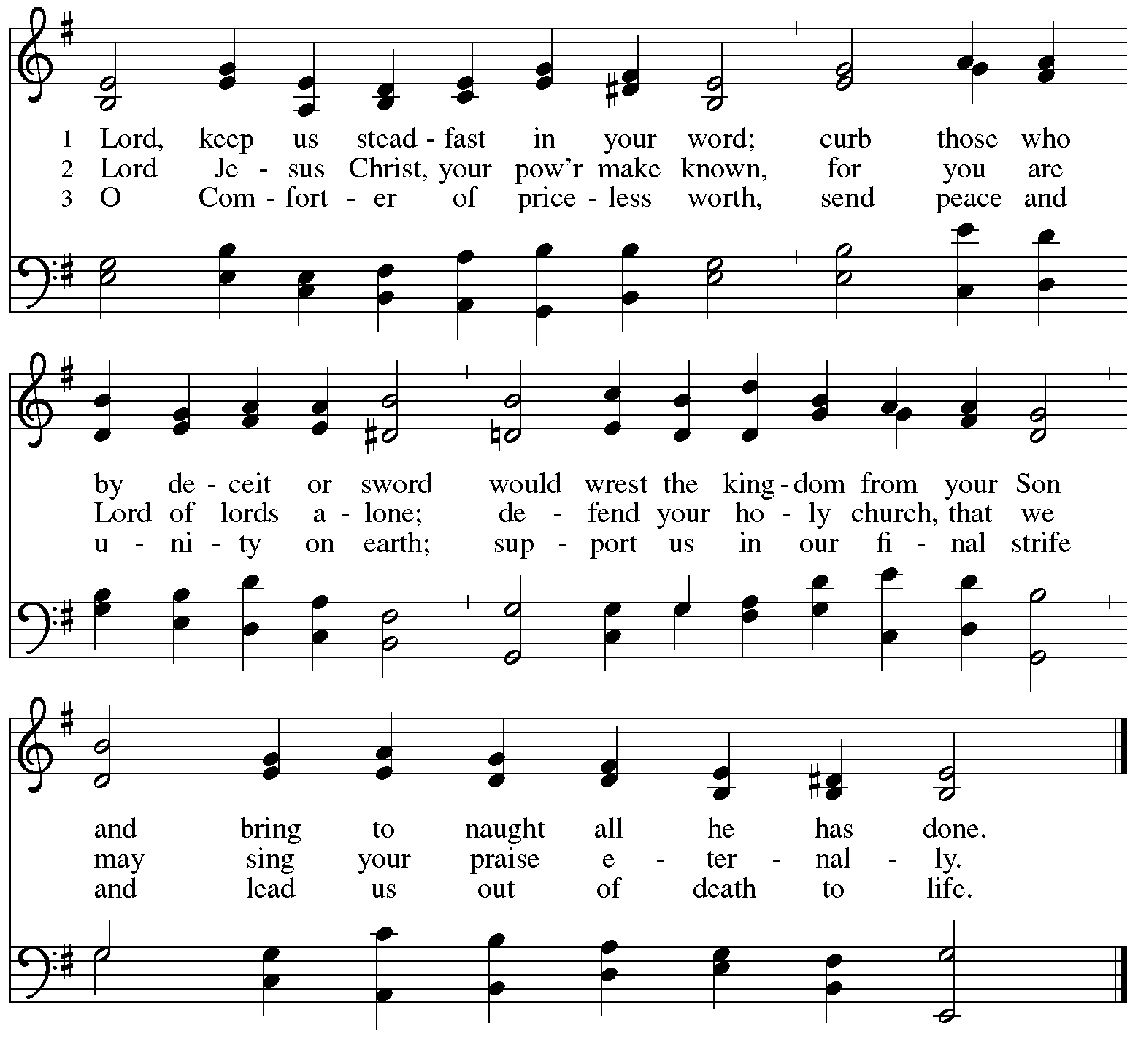

Hymns during Holy Communion
How Firm a Foundation ELW 796

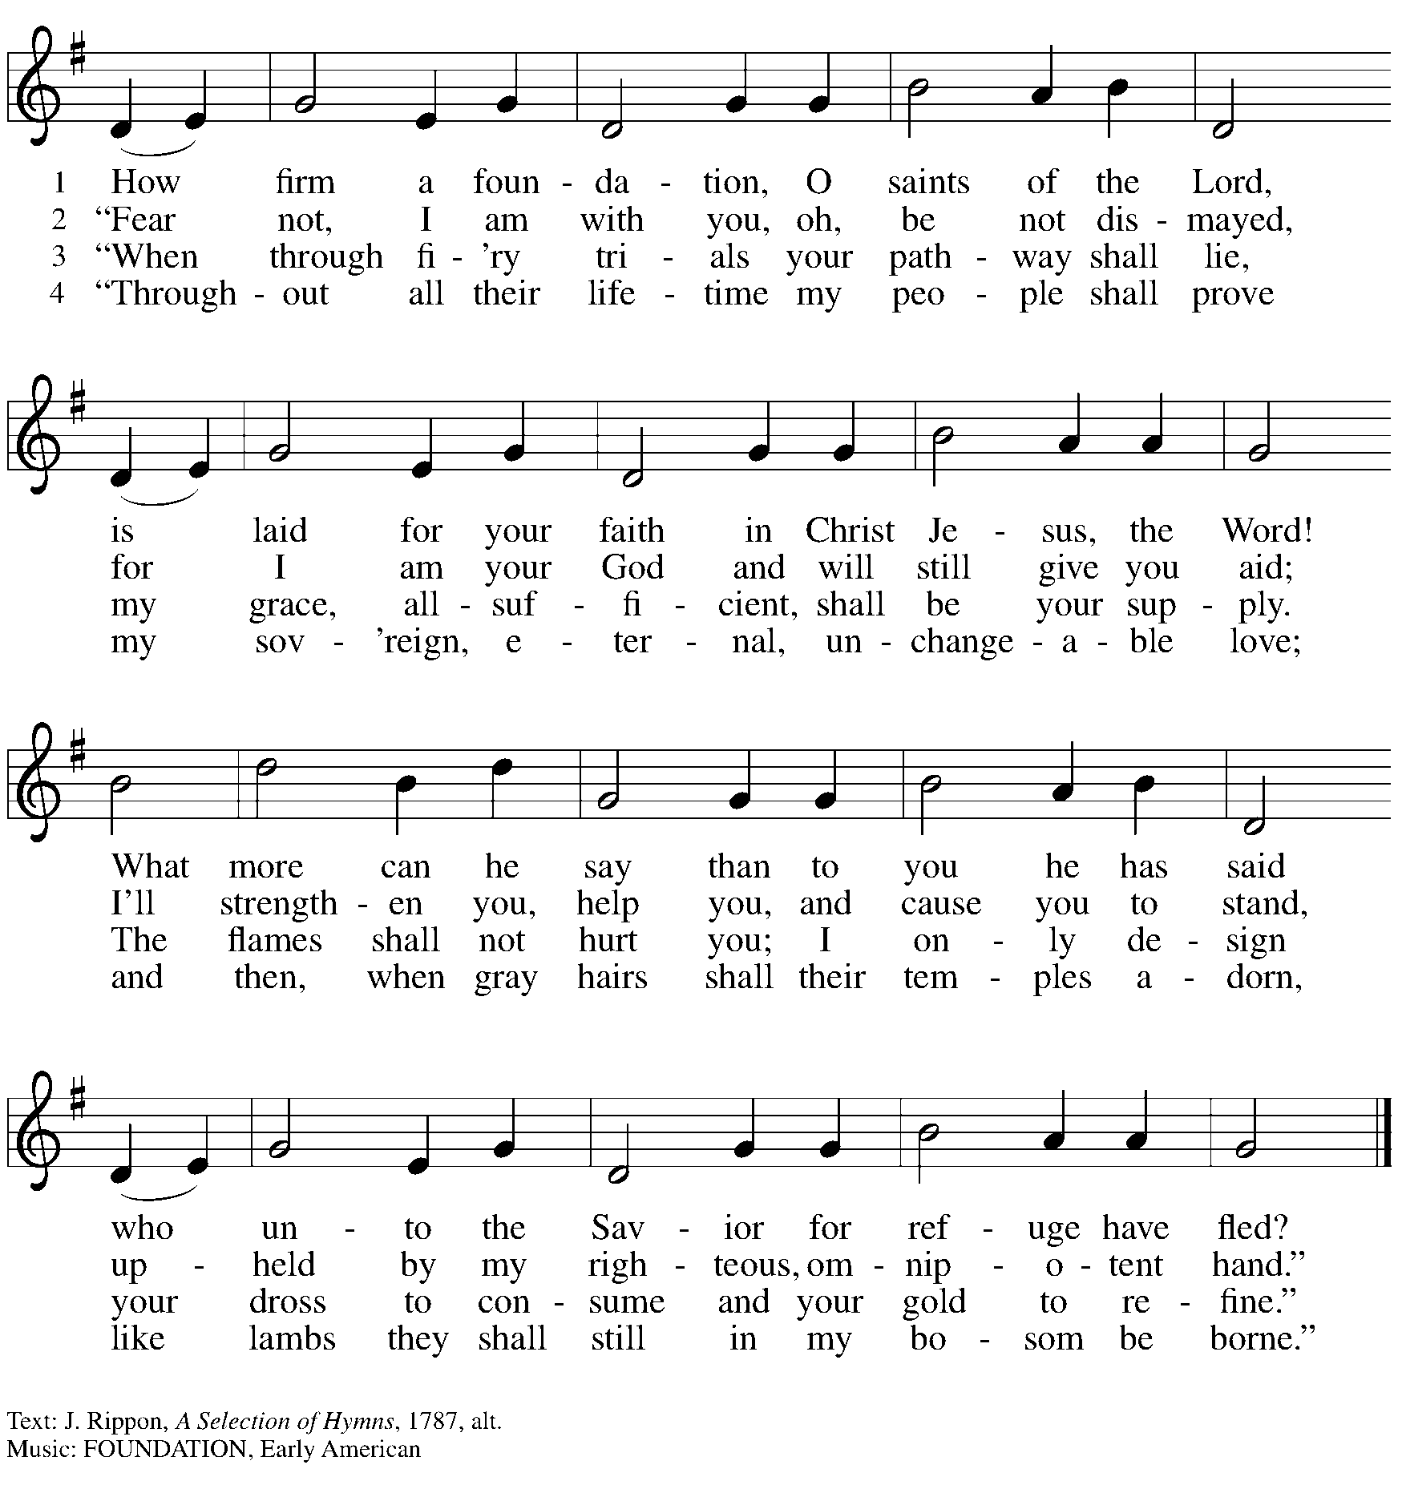

Hymns during Holy Communion
Rejoice in God’s Saints ELW 418

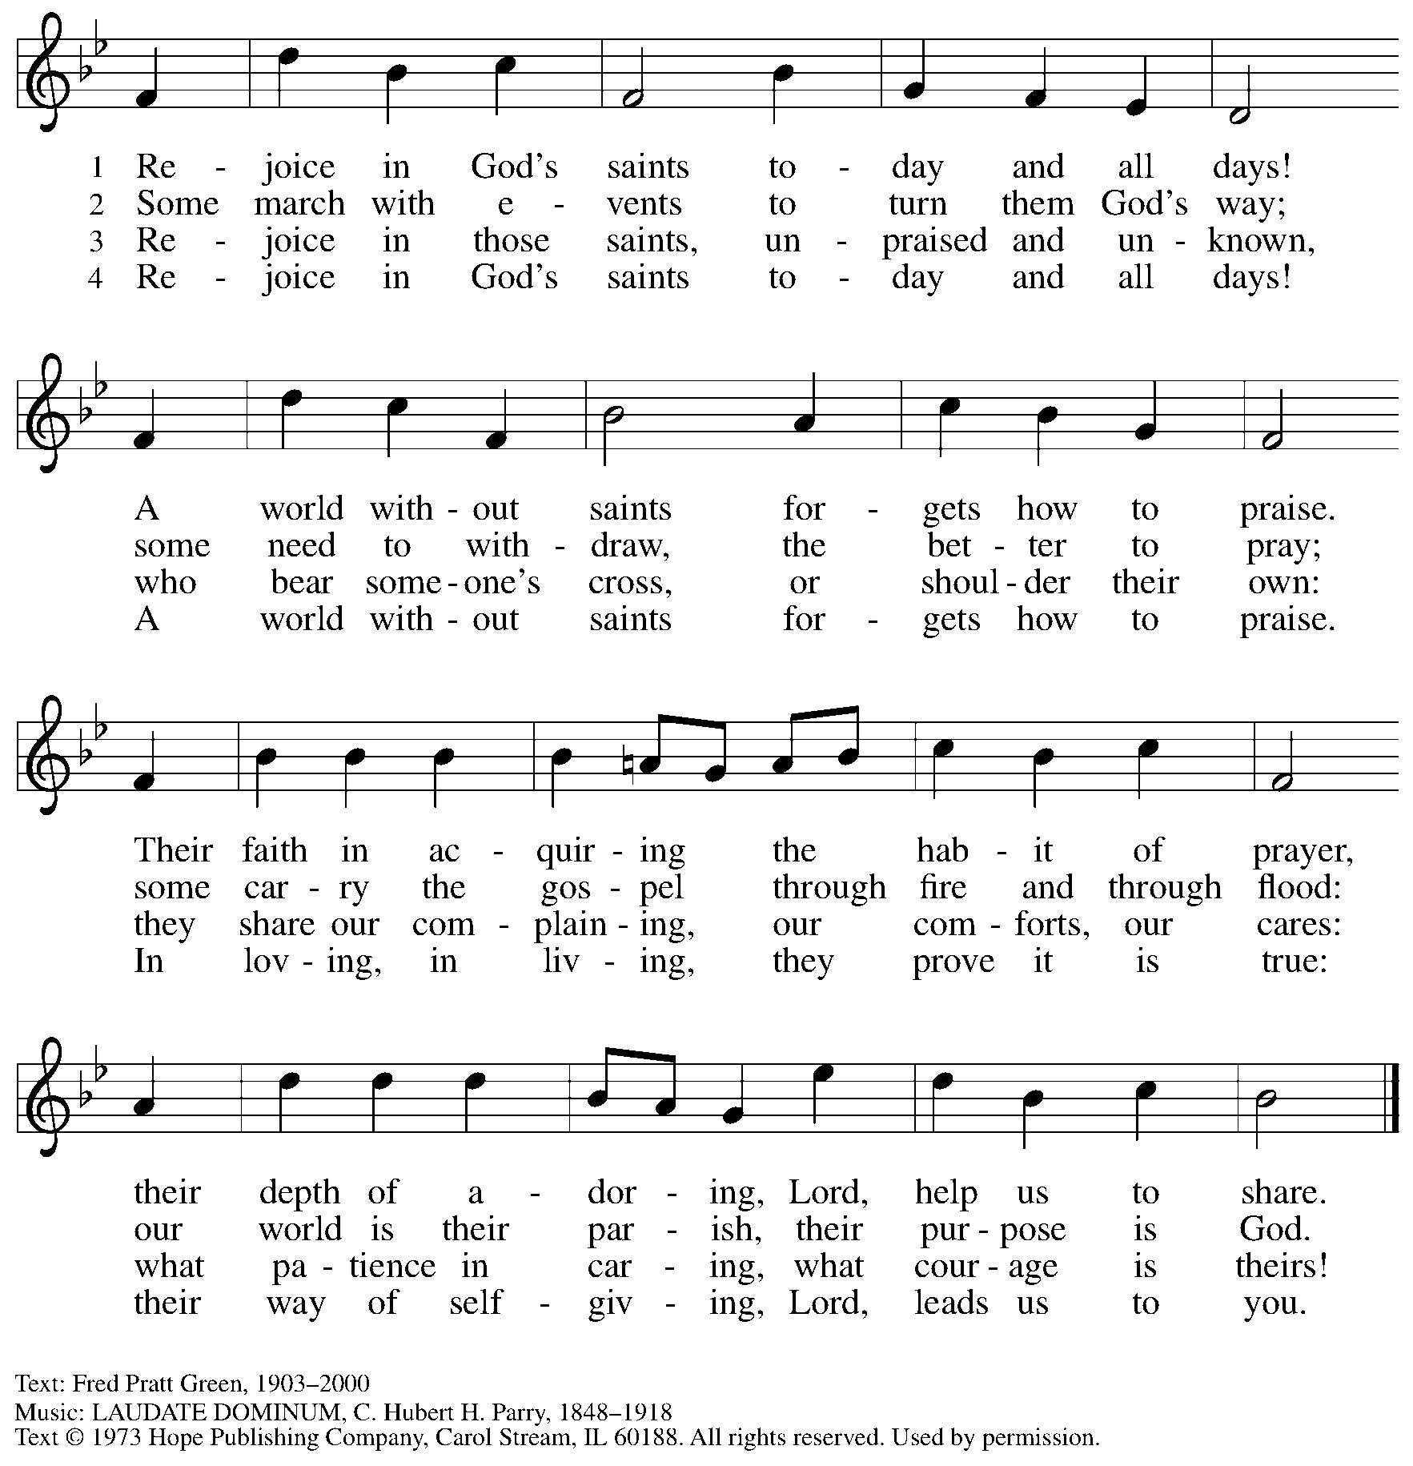
Reprinted with permission under OneLicense.net # A-722139.

When all have returned to their places, please rise as you are able.

Blessing

P: The body and blood of our Lord Jesus Christ strengthen you and keep you in his grace.
C: Amen.

Prayer

A: Let us pray.
Gracious God, in this meal you have drawn us to your heart,
and nourished us at your table with food and drink, the body and blood of Christ.
Now send us forth to be your people in the world,
and to proclaim your truth this day and evermore,
through Jesus Christ, our Savior and Lord.
C: Amen.

Please be seated.

Sending
God blesses us and sends us in mission to the world

Announcements

Please rise as you are able.

Benediction

P: The love of God abound in you;
the grace of our Savior Jesus Christ fill your hearts;
and the life of the Spirit
☩ bless you and give you peace.
C: Amen.

Sending Hymn Following page

Dismissal

A: Go in peace. Serve the Lord.
C: Thanks be to God!

Postlude

Sending Hymn We’ve Come This Far by Faith ELW 633

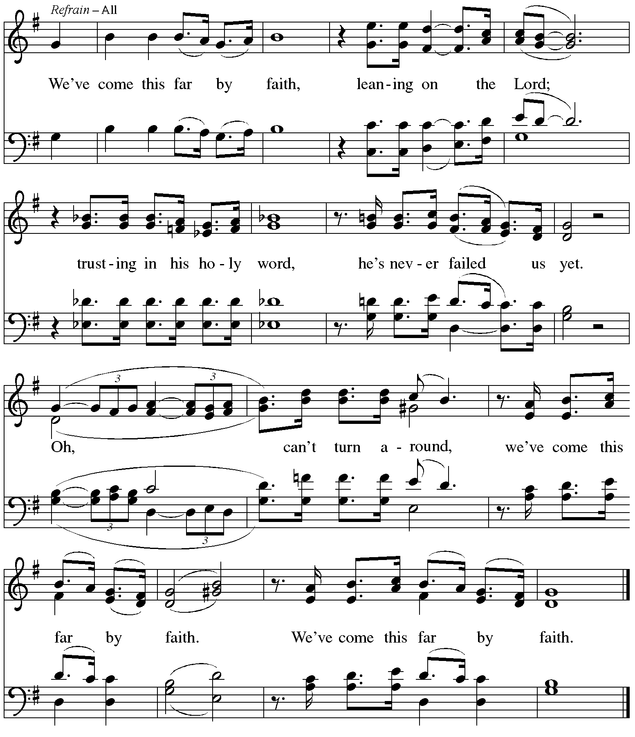
Reprinted under OneLicense.net # A-722139.

Serving in Worship Today

Altar Care Beverley Chapman
Assisting Minister Colleen Cooke
Audio-Visual Ministers David Rollinson
Jered Stratton
Cantor Richard Krug
Lector Michael Chapman
Minister of Music Laura Reynolds
Presiding Minister The Rev. Ross I. Carmichael

Liturgy and Hymnody Acknowledgements

From SundaysandSeasons.com. Copyright © 2025 Augsburg Fortress. All rights reserved. Reprinted under OneLicense.net # A-722139.
Used by permission of Augsburg Fortress.

The Scripture readings contained herein are from New Revised Standard Version Updated Edition of the Bible © 2021 National Council of Churches of Christ in the United States of America. Used by permission. All rights reserved worldwide.

God Is Here! – Text: Fred Pratt Green, 1903-2000. Music: ABBOTT’S LEIGH, Cyril V. Taylor, 1907-1991. Text © 1979 and music © 1942, re. 1970 Hope Publishing Company, Carol Stream, IL 60188. All rights reserved. Reprinted with permission under OneLicense.net # A-22139.

Please use the QR code below to link to St. Andrew’s Announcements online!



St. Andrew Lutheran Church Announcements
August 17th, 2025

- Welcome to Worship at St. Andrew on the Tenth Sunday after Pentecost! – We are so glad you are here, and we offer a special welcome to all visitors and guests who are here for the first time! In the heat of summer St. Andrew moves to a primarily spoken setting of worship. There are worship “toolkits” to help children engage with worship and “busy bags” for younger children available in the bookcase at the back of the sanctuary. Please feel free to take one to use with/for your children. A nursery is available through the door to the left of the worship space and across the social hall (look for a purple room).
- Noisy Offering during Worship Today – This month’s noisy offering will benefit the Latino Community Center. Located on Baum Blvd., this organization’s mission is “To provide our children, youth, and families the tools and opportunities needed to reach their full potential through educational programming, family support, and community building.” For more information, please visit https://www.latinocommunitycenter.org/.
- August Shelter Dinner for Guests of East End Cooperative Ministry – Third Thursday of the Month, August 21st, 6:30 p.m. – Each month, people of St. Andrew provide dinner for guests of East End Cooperative Ministry (EECM), 6140 Station St. (East Liberty), 15206. We invite you to prepare or purchase one menu item and bring it to the shelter by 6:00 p.m., or just come to help serve at 6:30 p.m. Please sign up at https://www.signupgenius.com/go/5080544AAAC22A1F58-57656574-august.
- St. Andrew at Munhall Main Street Market Night – August 22nd, 5:00 p.m. - 9:00 p.m. – St. Andrew will have a booth at Munhall’s Main Street Market Night to meet our neighbors and share information about the church and our welcoming commitments as a Reconciling in Christ congregation. August’s Market Night is on the 22nd, from 5:00 p.m. - 9:00 p.m. Please see Kelly Spanninger or Kathy Hays if you would like to participate.
- Records Update - Please Respond – St. Andrew is looking to update our records with information from newer attendees, as well as offering current members the opportunity to include current information. This includes name, preferred pronouns, email, phone number, birthdays, anniversaries, and more. The information will only be used within the congregation - for example to acknowledge celebrations and milestones in worship, in the prayers of the church, or in the weekly newsletter. Please fill out the form at: https://forms.gle/kKvp19UozuRrhhaV7.
- Unveiling the Lamb: Hope, Resistance, and the Church in Revelation – Zoom Study Led by The Rev. Dr. Martin Rafanan, Continues Thursdays, July 31st - August 21st – Pastor Martin Rafanan has invited the people of St. Andrew to a Zoom study he is leading with PLUM – Pittsburgh Lutheran United Ministries. It began last Thursday, and continues each week, July 31st – August 21st: “Join us for a 5-session Zoom-based Bible study that explores the Book of Revelation not as a roadmap of fear, but as a bold unveiling of Jesus Christ. In a world of empire, confusion, and compromise, this vision from exile speaks hope and courage to the Church. Each session blends scriptural teaching, theological reflection, pastoral insight, and visual exploration.” To receive the link, please register here: Google Registration Form: https://forms.gle/JmbuU7RncG34auJs8
- Christ in Our Home Devotional Booklets for July-September Available at Entrances – This resource offers a daily Bible reading with a short reflection and prayer, along with additional readings and prayer topics for those who would like to expand their devotional practices. We encourage people of the congregation to take one for yourself, your family/household, or others.

