

+ Eleventh Sunday after Pentecost
August 24, 2025



St. Andrew Lutheran Church
304 Morewood Ave.
Pittsburgh, PA 15213
St_andrewELCA@verizon.net
www.standrewpittsburgh.org

+ Eleventh Sunday after Pentecost
Order for Worship

Remember the Sabbath day. Call the Sabbath a delight.
This is the Lord’s day, and the Lord will do for us what the Lord does:
feed us, forgive us, help and heal us. Rejoice at all the wonderful things God is doing!

Welcome to St. Andrew!
- St. Andrew welcomes all who are seeking a place of healing, wholeness, and acceptance in a nurturing and faith-forming spiritual home. We are striving toward racial equity worldwide
and we seek to honor the lived experience of all individuals regardless of background. Our community embraces people of all ages, ethnicities, cultures, abilities, sexual orientations,
gender identities and expressions, and family constellations. Come and See!
- Worship Services are live-streamed to multiple online platforms. By attending worship, you agree that your image and voice may be broadcast.
- Everyone is invited to make a name tag at the black bookcase in the back of the worship space if they would like. There are stickers indicating pronouns on the bookcase if you would like to include them on your name tag.
- A nursery is available through the doors at the left side of the sanctuary and across from the doorway to the Social Hall. Look for a purple-colored room.
- Worship “toolkits” to help children engage with the service, along with “busy bags” for younger children, are available in the bookcase at the back of the sanctuary. Please feel free to take one to use with/for your children.
- Holy Communion is served with bread (gluten-free available) and wine or grape juice. The presiding minister will distribute the bread (host). Please consume this and then pick up an empty glass from the tray. The Communion Assistant will pour wine or grape juice into your glass. Please step to the side to consume the wine or grape juice. Feel free to kneel at the altar for prayer and reflection. As you return to your pew, glasses may be returned to the empty trays on either side of the center section.
- A restroom is available on the main level of the church, through the doors to the Social Hall and to the right in the main office.

Abbreviations
P: Pastor/Presiding Minister ELW: Evangelical Lutheran Worship hymnal
A: Assisting Minister ACS: All Creation Sings hymnal
L: Lector
C: Congregation

Musical Offering

Each week, different people from the congregation make an offering of pre-service music, with singing or instrumentation, to help the assembly focus and pray in preparation for worship.

Welcome

Prelude Praise to the Lord, the Almighty arr. Keveren

Gathering
The Holy Spirit calls us together as the people of God

Confession and Forgiveness

P: Blessed be the holy Trinity, ☩ one God,
who forgives all our sin,
whose mercy endures forever.
C: Amen.

P: Baptized into Christ, let us confess our sins.

Silence is kept for reflection.

P: Merciful God,
C: you free us to love others,
but we neglect our neighbors and follow our own way.
You lead us by the Spirit of joy and peace,
but we turn away from the abundant life you offer.
You surround us with patience, kindness, and generosity,
but we grow weary in doing what is right.
In your mercy, forgive us.
Do not give up on us.
Heal us, break our bonds, and show us the path of life.
Amen.

P: You belong to Christ Jesus
and you are God’s children through faith.
In the cross of ☩ Christ,
and through the power of the Holy Spirit,
your sins are forgiven.
Clothed with Christ, you are a new creation.
C: Amen.

Gathering Hymn Praise to the Lord, the Almighty ELW 859

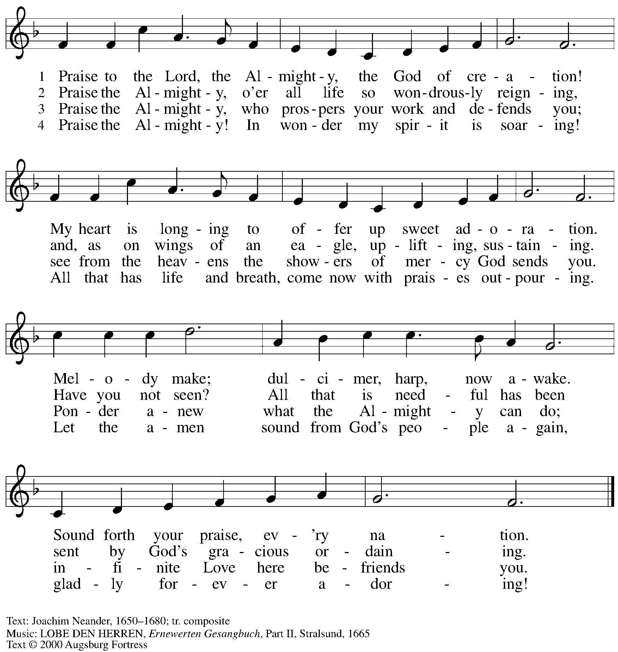
Reprinted with permission under OneLicense.net # A-722139.

Greeting

P: The grace of our Lord Jesus Christ, the love of God,
and the communion of the Holy Spirit be with you all.
C: And also with you.

Prayer of the Day

P: Let us pray.
O God, mighty and immortal,
you know that as fragile creatures surrounded by great dangers,
we cannot by ourselves stand upright. Give us strength of mind and body,
so that even when we suffer because of human sin,
we may rise victorious through your Son, Jesus Christ, our Savior and Lord.
C: Amen.

Please be seated.

Word
God speaks to us in Scripture reading, preaching, and song

First Reading – Isaiah 58: 9b-14

^{9b} If you remove the yoke from among you,
the pointing of the finger, the speaking of evil,
¹⁰ if you offer your food to the hungry
and satisfy the needs of the afflicted,
then your light shall rise in the darkness
and your gloom be like the noonday.
¹¹ The Lord will guide you continually
and satisfy your needs in parched places
and make your bones strong,
and you shall be like a watered garden,
like a spring of water
whose waters never fail.
¹² Your ancient ruins shall be rebuilt;
you shall raise up the foundations of many generations;
you shall be called the repairer of the breach,
the restorer of streets to live in.
¹³ If you refrain from trampling the Sabbath,
from pursuing your own interests on my holy day;
if you call the Sabbath a delight
and the holy day of the Lord honorable;
if you honor it, not going your own ways,
serving your own interests or pursuing your own affairs;
¹⁴ then you shall take delight in the Lord,
and I will make you ride upon the heights of the earth;
I will feed you with the heritage of your ancestor Jacob,
for the mouth of the Lord has spoken.

L: Word of God, word of life. C: Thanks be to God.

Psalm 103: 1-8

The psalm will be spoken responsively, led by the cantor,
with the congregation reading the verses in bold type.

¹ Bless the Lord, O my soul,
and all that is within me, bless God’s holy name.
² Bless the Lord, O my soul,
and forget not all God’s benefits—
³ who forgives all your sins
and heals all your diseases;
⁴ who redeems your life from the grave
and crowns you with steadfast love and mercy;
⁵ who satisfies your desires with good things
so that your youth is renewed like an eagle’s.
⁶ O Lord, you provide vindication
and justice for all who are oppressed.
⁷ You made known your ways to Moses
and your works to the children of Israel.
⁸ Lord, you are full of compassion and mercy,
slow to anger and abounding in steadfast love.

Second Reading – Hebrews 12: 18-29

¹⁸ You have not come to something that can be touched, a blazing fire, and darkness, and gloom, and a tempest, ¹⁹ and the sound of a trumpet, and a voice whose words made the hearers beg that not another word be spoken to them. ²⁰ (For they could not endure the order that was given, “If even an animal touches the mountain, it shall be stoned to death.” ²¹ Indeed, so terrifying was the sight that Moses said, “I tremble with fear.”) ²² But you have come to Mount Zion and to the city of the living God, the heavenly Jerusalem, and to innumerable angels in festal gathering, ²³ and to the assembly of the firstborn who are enrolled in heaven, and to God the judge of all, and to the spirits of the righteous made perfect, ²⁴ and to Jesus, the mediator of a new covenant, and to the sprinkled blood that speaks a better word than the blood of Abel.
²⁵ See that you do not refuse the one who is speaking, for if they did not escape when they refused the one who warned them on earth, how much less will we escape if we reject the one who warns from heaven! ²⁶ At that time his voice shook the earth, but now he has promised, “Yet once more I will shake not only the earth but also the heaven.” ²⁷ This phrase, “Yet once more,” indicates the removal of what is shaken—that is, created things—so that what cannot be shaken may remain. ²⁸ Therefore, since we are receiving a kingdom that cannot be shaken, let us show gratitude, by which we may offer to God an acceptable worship with reverence and awe, ²⁹ for indeed our God is a consuming fire.

L: Word of God, word of life.
C: Thanks be to God.

Please rise as you are able.

Gospel Acclamation

C: Alleluia. The crowd was rejoicing
at the wonderful things Jesus was doing. Alleluia.

Gospel – Luke 13: 10-17

P: The holy Gospel according to St. Luke.
C: Glory to you, O Lord.

¹⁰ Now [Jesus] was teaching in one of the synagogues on the Sabbath. ¹¹ And just then there appeared a woman with a spirit that had crippled her for eighteen years. She was bent over and was quite unable to stand up straight. ¹² When Jesus saw her, he called her over and said, “Woman, you are set free from your ailment.” ¹³ When he laid his hands on her, immediately she stood up straight and began praising God. ¹⁴ But the leader of the synagogue, indignant because Jesus had cured on the Sabbath, kept saying to the crowd, “There are six days on which work ought to be done; come on those days and be cured and not on the Sabbath day.” ¹⁵ But the Lord answered him and said, “You hypocrites! Does not each of you on the Sabbath untie his ox or his donkey from the manger and lead it to water? ¹⁶ And ought not this woman, a daughter of Abraham whom Satan bound for eighteen long years, be set free from this bondage on the Sabbath day?” ¹⁷ When he said this, all his opponents were put to shame, and the entire crowd was rejoicing at all the wonderful things being done by him.

P: The Gospel of the Lord.
C: Praise to you, O Christ.

Please be seated.

Sermon

A time of silence for prayer and reflection follows the sermon.
When the hymn of the day begins, please rise as you are able.

Hymn of the Day Come, Ye Disconsolate ELW 607

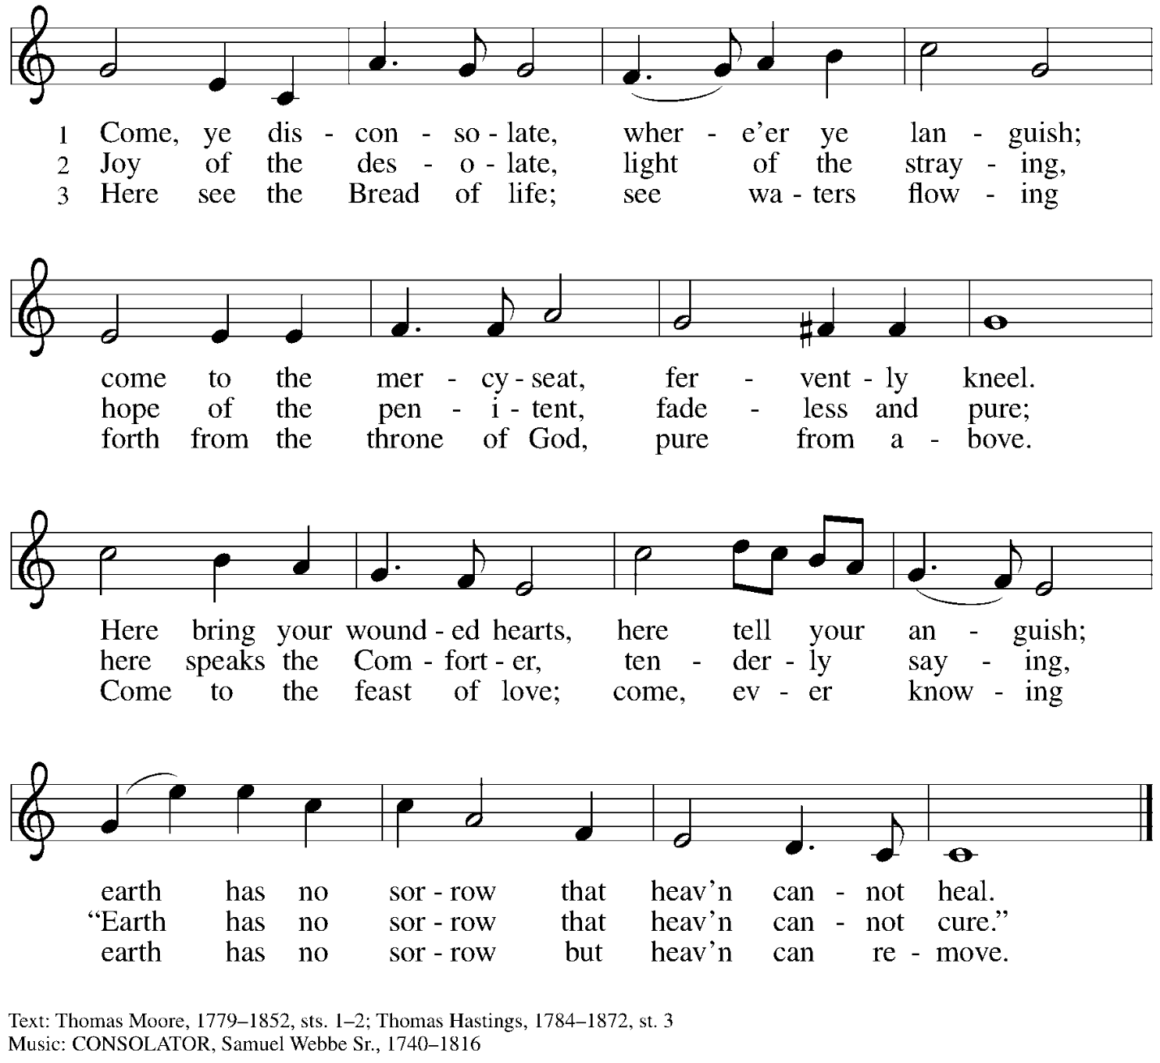

Apostles’ Creed

C: I believe in God, the Father almighty,
creator of heaven and earth.

I believe in Jesus Christ, God’s only Son, our Lord,
who was conceived by the Holy Spirit,
born of the virgin Mary,
suffered under Pontius Pilate,
was crucified, died, and was buried;
he descended to the dead.*
On the third day he rose again;
he ascended into heaven,
he is seated at the right hand of the Father,
and he will come to judge the living and the dead.

I believe in the Holy Spirit,
the holy catholic church,
the communion of saints,
the forgiveness of sins,
the resurrection of the body,
and the life everlasting. Amen.

*Or, “he descended into hell,” another translation of this text in widespread use.

Prayers of the People

A: As stewards of God’s creation,
we join with the whole church to pray for the needs of the world and its people.

After each petition
A: Gracious God,
C: receive our prayer.

P: Trusting in your lovingkindness, we place our prayers and hopes in you, O God,
in the name of Jesus Christ, our Savior.
C: Amen.

Peace

The presiding minister and the assembly greet one another in the peace of the risen Christ.
P: The peace of Christ be with you always.
C: And also with you.

The people may greet those around them with a sign of Christ’s peace and may say
Peace be with you or similar words. Please be mindful that not everyone will be comfortable with sharing the peace, so please seek consent before shaking hands or hugging. Other possible ways to share the peace include a simple bow with the verbal greeting of peace, or simply a verbal expression of peace.
When the greetings of peace have concluded, please be seated.

Meal
God feeds us with the presence of Jesus Christ

Offering

We offer ourselves, our gifts, and our faithful service to God.
As the offering is gathered for the mission of the church, including the care of those in need,
the table is set for Holy Communion.

There are laminated giving cards in the pew racks that feature a QR code for anyone who would like to give online. Those who give using the QR code, as well as those who give regularly online or through their bank are encouraged to place the laminated card in the plate as an expression of your offering.

Offertory Music As Rain from the Clouds arr. Hamilton

As the gifts are brought forward for presentation, please rise as you are able.

Offertory Song As the Grains of Wheat ELW 465

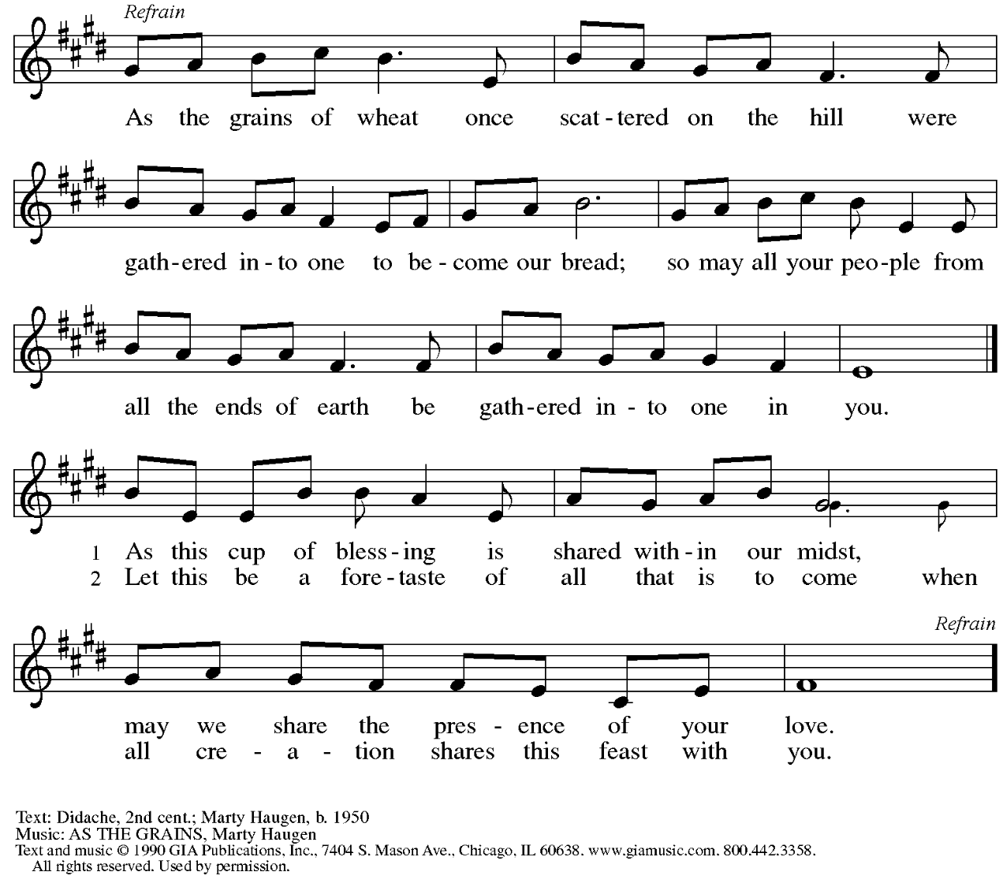
Reprinted under OneLicense.net # A-722139.

Offertory Prayer

A: Let us pray.
Creator God,
C: in your wisdom you bring forth all that is good
and the harvest is plentiful.
Strengthen us at your table with these gifts of the earth
and our labor, that we may work for the good of all;
through Jesus Christ, our Savior.
Amen.

Dialogue

P: The Lord be with you.
C: And also with you.

P: Lift up your hearts.
C: We lift them to the Lord.

P: Let us give thanks to the Lord our God.
C: It is right to give our thanks and praise.

Preface

P: It is indeed right, our duty and our joy,
that we should at all times and in all places
give thanks and praise to you, almighty and merciful God,
through our Savior Jesus Christ;
who on this day overcame death and the grave,
and by his glorious resurrection
opened to us the way of everlasting life.
And so, with all the choirs of angels,
with the church on earth and the hosts of heaven,
we praise your name and join their unending hymn:

Sanctus

C: Holy, holy, holy Lord, God of power and might,
heaven and earth are full of your glory.
Hosanna in the highest.
Blessed is the one who comes in the name of the Lord.
Hosanna in the highest.

Eucharistic Prayer

P: Holy, mighty, and merciful Lord …
… to whom with you and the Holy Spirit
be all honor and glory, now and forever.
C: Amen.

Lord’s Prayer

P: Gathered as one by the Holy Spirit, let us pray as Jesus taught us.
C: Our Father, who art in heaven,
hallowed be thy name,
thy kingdom come,
thy will be done,
on earth as it is in heaven.
Give us this day our daily bread;
and forgive us our trespasses,
as we forgive those
who trespass against us;
and lead us not into temptation,
but deliver us from evil.
For thine is the kingdom,
and the power, and the glory,
forever and ever. Amen.

Fraction and Invitation

Agnus Dei / Lamb of God

C: Lamb of God, you take away the sin of the world; have mercy on us.
Lamb of God, you take away the sin of the world; have mercy on us.
Lamb of God, you take away the sin of the world; grant us peace.

Please be seated.



Holy Communion

- All who seek God and desire a deeper and stronger life in Christ are welcome to receive Holy Communion.
- Worshipers from the pulpit side will proceed forward first, followed by the center section, and then the lectern side.
- Please inform an usher if you would like the ministers to bring Communion to you.
- Holy Communion will be served with bread and wine (amber) or grape juice (purple).
- The presiding minister will first distribute the bread (host) to each communicant. Please indicate if you require a gluten-free host.
- Once you have consumed the bread, please pick up an empty glass from the tray next to the presiding minister. The Communion Assistant will pour wine or grape juice into your glass.
- Please step to the side to consume the wine or grape juice.
- Feel free to kneel at the altar rail for prayer after receiving the sacrament.
- As you return to your pew, glasses may be returned to the empty tray on the side of the center section.
- A blessing will be provided for anyone who does not yet receive the sacrament.
- All are invited to join in singing the hymns during Holy Communion.

Hymns during Holy Communion
Let My Spirit Always Sing ACS 1020

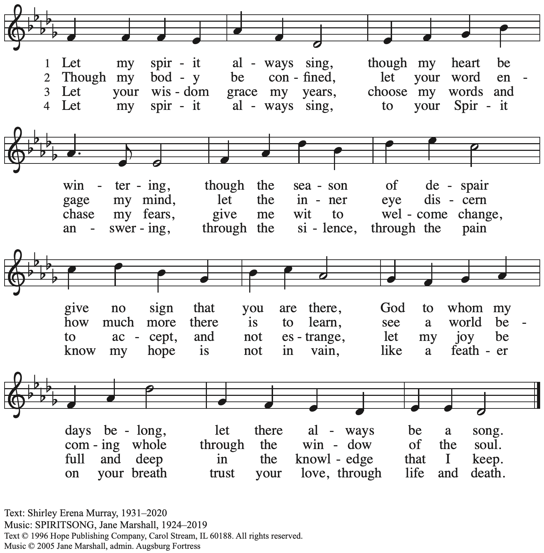
All rights reserved. Reprinted with permission under OneLicense.net # A-722139.

Hymns during Holy Communion
We Come to You for Healing, Lord ELW 617

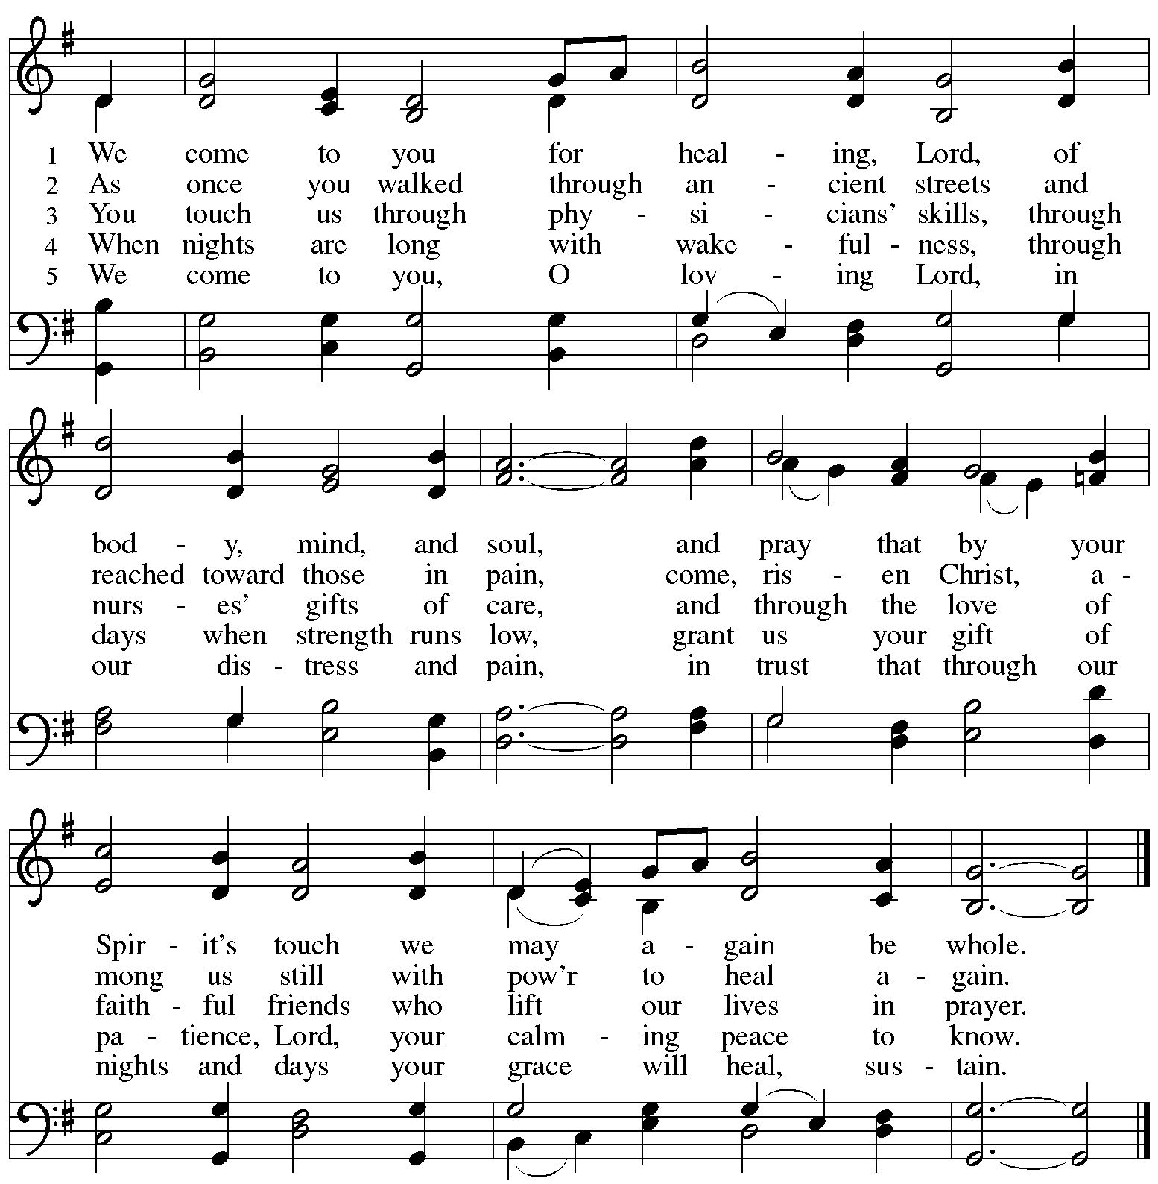
Reprinted with permission under OneLicense.net # A-722139.

Hymns during Holy Communion
O Beauty Ever Ancient ACS 1100

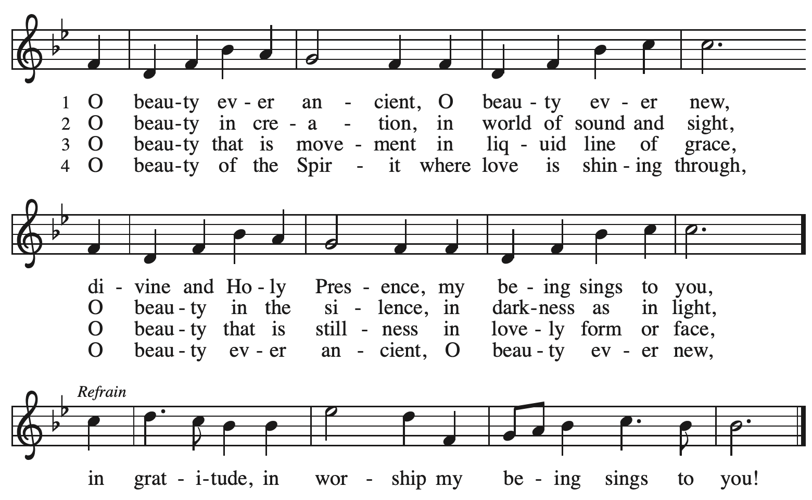
Reprinted with permission under PneLicense.net # A-722139.

When all have returned to their places, please rise as you are able.

Blessing

P: The body and blood of our Lord Jesus Christ strengthen you and keep you in his grace.
C: Amen.

Prayer

A: Let us pray.
Gracious God, in this meal you have drawn us to your heart,
and nourished us at your table with food and drink, the body and blood of Christ.
Now send us forth to be your people in the world,
and to proclaim your truth this day and evermore,
through Jesus Christ, our Savior and Lord.
C: Amen.

Please be seated.

Sending
God blesses us and sends us in mission to the world

Announcements

Please rise as you are able.

Benediction

P: The love of God abound in you;
the grace of our Savior Jesus Christ fill your hearts;
and the life of the Spirit
☩ bless you and give you peace.
C: Amen.

Sending Hymn Following page

Dismissal

A: Go in peace. Serve the Lord.
C: Thanks be to God!

Postlude

Sending Hymn I’m So Glad Jesus Lifted Me ELW 860

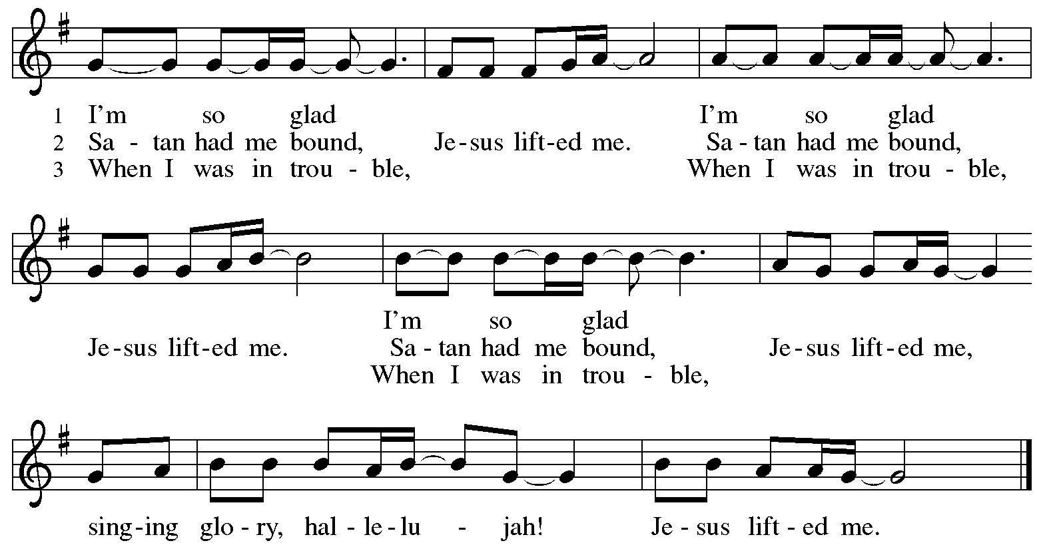

Serving in worship today

Altar Care Jodie Minor
Assisting Minister Jimmi Kocher-Hillmer
Audio-Visual Ministers Kristen Asplin
Jason Galyardt
Cantor Mandy Best
Lector Lindsay Baxter
Minister of Music Laura Reynolds
Presiding Minister The Rev. Ross Carmichael

Liturgy and Hymnody Acknowledgements

From SundaysandSeasons.com. Copyright © 2025 Augsburg Fortress. All rights reserved. Reprinted under OneLicense.net # A-722139.
Used by permission of Augsburg Fortress.

The Scripture readings contained herein are from New Revised Standard Version Updated Edition of the Bible © 2021 National Council of Churches of Christ in the United States of America. Used by permission. All rights reserved worldwide.

Please use the QR code below to link to St. Andrew’s Announcements online!



St. Andrew Lutheran Church Announcements
August 24th, 2025

- Welcome to Worship at St. Andrew on the Eleventh Sunday after Pentecost! – We are so glad you are here, and we offer a special welcome to all visitors and guests who are here for the first time! In the heat of summer St. Andrew uses a primarily spoken setting of worship. There are worship “toolkits” to help children engage with worship and “busy bags” for younger children available in the bookcase at the back of the sanctuary. Please feel free to take one to use with/for your children. A nursery is available through the door to the left of the worship space and across the social hall (look for a purple room).
- Invitation to Prayer Team and New Address – St. Andrew maintains a list of weekly prayer concerns that is sent by email, usually on Wednesdays, to members of the congregation who have opted in. In an effort to coordinate our communications under our organization’s Google Workspace, our new prayer team email address is prayerteam@standrewpittsburgh.org. If you have been on the prayer team email list and would like to continue receiving weekly updates, or if you would like to be included for the first time, please send administrative assistant Jay a message at the email above. Any prayer concerns or requests can be sent to this address in the future. We will discontinue using st.a.prayer.team@gmail.com for sending prayer requests, updates, and the weekly list starting September 3rd. As we renew this prayer ministry, we will also move to a practice of keeping names on the list for a maximum of four weeks unless otherwise requested. Thank you for your ministry of prayer!
- Records Update - Please Respond – St. Andrew is looking to update our records with information from newer attendees, as well as offering current members the opportunity to include current information. This includes name, preferred pronouns, email, phone number, birthdays, anniversaries, and more. The information will only be used within the congregation - for example to acknowledge celebrations and milestones in worship, in the prayers of the church, or in the weekly newsletter. Please fill out the form at: https://forms.gle/kKvp19UozuRrhhaV7.
- September Produce Distribution – First Tuesday of the Month, September 2nd, 5:30-7:00 p.m. – St. Andrew partners with Greater Pittsburgh Community Food Bank to serve as a distribution site for fresh produce on the first Tuesday of every month. Next month’s distribution will be on Tuesday, September 2nd. We invite people of the congregation to help with the distribution from 5:30-7:00 p.m. and/or to help with unloading and setup during the day between 10:00 a.m. and 1:00 p.m.
- Good Food Project Volunteering Opportunity – 412 Food Rescue swiftly rescues fresh surplus food and delivers it where it’s needed most, leveraging people-powered technology and strong community partnerships to tackle both food insecurity and climate change. 412 Food Rescue’s Good Food Project is located inside the Food & Energy Hub in Millvale. Their mission is to transform surplus foods into healthy, heat-and-eat meals and grocery bags of nutritious food to be distributed to neighbors experiencing food insecurity. There are opportunities from now until the end of September to volunteer in either their kitchen prep and bagging programs. You can learn more about the project here: https://412foodrescue.org/programs/good-food-project/ and sign up to volunteer here: https://www.signupgenius.com/go/10C0F48A8AD2CA2FDCE9-412frs and https://www.signupgenius.com/go/10c0f48a8ad2ca2fdce9-new.
- Coffee Hour Resumes September 7th – Signup Link Available! – Coffee Hour will resume on Sunday, September 7th, after worship. If you would like to serve by setting up the coffee hour and would like additional information about the duties, please go to the following form:
https://www.signupgenius.com/go/5080B4AAFAF2CABF85-47069030-coffee#/
- Pittsburgh Compline Choir – Sundays at 8:00 p.m. at Heinz Chapel, starting September 7th – Compline was traditionally a monastic prayer service, and the Pittsburgh Compline Choir, a ministry of Lutheran Campus Ministry in Greater Pittsburgh, sings a choral version of compline rooted in this thousand-year-old tradition of scripture, song, and silence each Sunday at Heinz Chapel at 8:00 p.m. This service also streams on Facebook (Pittsburgh Compline Choir) and YouTube (The Pittsburgh Compline Choir). Heinz Chapel is located off of S. Bellefield Ave. in Oakland. For more information, please visit: Pittsburgh Compline Choir.
- Lutheran Campus Ministry in Greater Pittsburgh’s Third Annual BBQ Bash – Friday, September 19th, 5:00-8:00 p.m. – The Lutheran Campus Ministry in Greater Pittsburgh invites you to its third annual “friend raiser” to enjoy and evening of great food, conversation, and a silent auction to support the campus ministry. The event location is Hampton Township Community Center, 3200 Lochner Way, Allison Park, PA 15101. To register, please visit www.lucpgh.com, call 412-682-6886, or use the QR code in St. Andrew’s Friday email.
- Christ in Our Home Devotional Booklets for July-September Available at Entrances – This resource offers a daily Bible reading with a short reflection and prayer, along with additional readings and prayer topics for those who would like to expand their devotional practices. We encourage people of the congregation to take one for yourself, your family/household, or others.

