

+ Twelfth Sunday after Pentecost
August 31, 2025



St. Andrew Lutheran Church
304 Morewood Ave.
Pittsburgh, PA 15213
St_andrewELCA@verizon.net
www.standrewpittsburgh.org

+ Twelfth Sunday after Pentecost
Order for Worship

Invited and inviting—that is the nature of the church.
By God’s grace in Holy Baptism we have a place at Christ’s banquet table.
When, by the power of that same Spirit, humility and mutual love continue among us,
the church can be more inviting still.

Welcome to St. Andrew!
- St. Andrew welcomes all who are seeking a place of healing, wholeness, and acceptance in a nurturing and faith-forming spiritual home. We are striving toward racial equity worldwide
and we seek to honor the lived experience of all individuals regardless of background. Our community embraces people of all ages, ethnicities, cultures, abilities, sexual orientations,
gender identities and expressions, and family constellations. Come and See!
- Worship Services are live-streamed to multiple online platforms. By attending worship, you agree that your image and voice may be broadcast.
- Everyone is invited to make a name tag at the black bookcase in the back of the worship space if they would like. There are stickers indicating pronouns on the bookcase if you would like to include them on your name tag.
- A nursery is available through the doors at the left side of the sanctuary and across from the doorway to the Social Hall. Look for a purple-colored room.
- Worship “toolkits” to help children engage with the service, along with “busy bags” for younger children, are available in the bookcase at the back of the sanctuary. Please feel free to take one to use with/for your children.
- Holy Communion is served with bread (gluten-free available) and wine or grape juice. The presiding minister will distribute the bread (host). Please consume this and then pick up an empty glass from the tray. The Communion Assistant will pour wine or grape juice into your glass. Please step to the side to consume the wine or grape juice. Feel free to kneel at the altar for prayer and reflection. As you return to your pew, glasses may be returned to the empty trays on either side of the center section.
- A restroom is available on the main level of the church, through the doors to the Social Hall and to the right in the main office.

Abbreviations
P: Pastor/Presiding Minister ELW: Evangelical Lutheran Worship hymnal
A: Assisting Minister ACS: All Creation Sings hymnal
L: Lector
C: Congregation

Musical Offering

Each week, different people from the congregation make an offering of pre-service music, with singing or instrumentation, to help the assembly focus and pray in preparation for worship.

Welcome

Prelude Morning Has Broken arr. Keveren

Gathering
The Holy Spirit calls us together as the people of God

Confession and Forgiveness

P: Blessed be the holy Trinity, ☩ one God,
who forgives all our sin,
whose mercy endures forever.
C: Amen.

P: Baptized into Christ, let us confess our sins.

Silence is kept for reflection.

P: Merciful God,
C: you free us to love others,
but we neglect our neighbors and follow our own way.
You lead us by the Spirit of joy and peace,
but we turn away from the abundant life you offer.
You surround us with patience, kindness, and generosity,
but we grow weary in doing what is right.
In your mercy, forgive us.
Do not give up on us.
Heal us, break our bonds, and show us the path of life.
Amen.

P: You belong to Christ Jesus
and you are God’s children through faith.
In the cross of ☩ Christ,
and through the power of the Holy Spirit,
your sins are forgiven.
Clothed with Christ, you are a new creation.
C: Amen.

Gathering Hymn All Are Welcome ELW 641
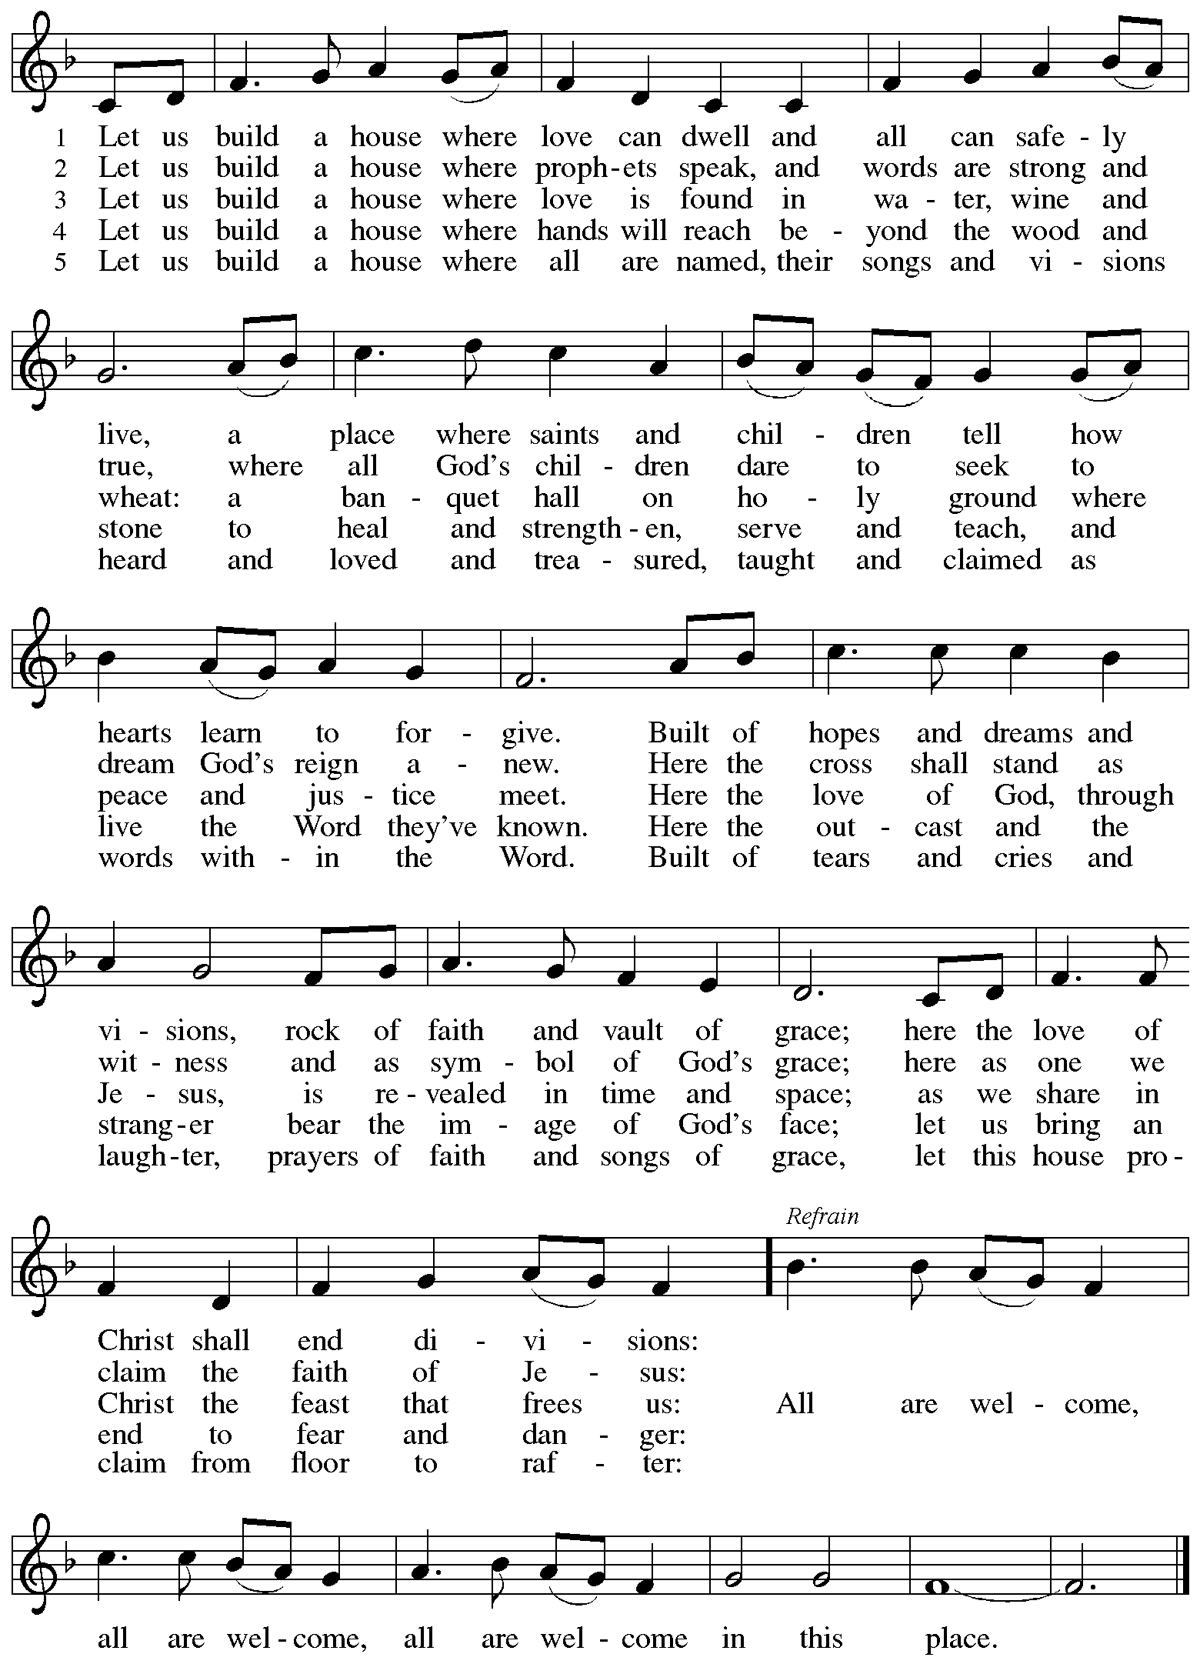

Greeting

P: The grace of our Lord Jesus Christ, the love of God,
and the communion of the Holy Spirit be with you all.
C: And also with you.

Prayer of the Day

P: Let us pray.
O God, you resist those who are proud and give grace to those who are humble.
Give us the humility of your Son, that we may embody the generosity of Jesus Christ,
our Savior and Lord.
C: Amen.

Please be seated.

Word
God speaks to us in Scripture reading, preaching, and song

First Reading – Proverbs 25: 6-7a

⁶ Do not put yourself forward in the king’s presence
or stand in the place of the great,
^{7a} for it is better to be told, “Come up here,”
than to be put lower in the presence of a noble.

L: Word of God, word of life.
C: Thanks be to God.

Psalm 112

The psalm will be spoken responsively, led by the cantor,
with the congregation reading the verses in bold type.

¹ Hallelujah! Happy are they who fear the Lord
and have great delight in God’s commandments!
² Their descendants will be mighty in the land;
the generation of the upright will be blessed.
³ Wealth and riches will be in their house,
and their righteousness will last forever.
⁴ Light shines in the darkness for the upright;
the righteous are merciful and full of compassion.
⁵ It is good for them to be generous in lending
and to manage their affairs with justice.
⁶ For they will never be shaken;
the righteous will be kept in everlasting remembrance.
⁷ They will not be afraid of any evil rumors;
their heart is steadfast, trusting in the Lord.
⁸ Their heart is established and will not shrink,
until they see their desire upon their enemies.
⁹ They have given freely to the poor, and their righteousness stands fast forever;
they will hold up their head with honor.
¹⁰ The wicked will see it and be angry; they will gnash their teeth and pine away;
the desires of the wicked will perish.

Second Reading – Hebrews 13: 1-8, 15-16

¹ Let mutual affection continue. ² Do not neglect to show hospitality to strangers, for by doing that some have entertained angels without knowing it. ³ Remember those who are in prison, as though you were in prison with them, those who are being tortured, as though you yourselves were being tortured. ⁴ Let marriage be held in honor by all, and let the marriage bed be kept undefiled, for God will judge the sexually immoral and adulterers. ⁵ Keep your lives free from the love of money, and be content with what you have, for God [God]self has said, “I will never leave you or forsake you.” ⁶ So we can say with confidence,
“The Lord is my helper;
I will not be afraid.
What can anyone do to me?”
⁷ Remember your leaders, those who spoke the word of God to you; consider the outcome of their way of life, and imitate their faith. ⁸ Jesus Christ is the same yesterday and today and forever. ¹⁵ Through him, then, let us continually offer a sacrifice of praise to God, that is, the fruit of lips that confess God’s name. ¹⁶ Do not neglect to do good and to share what you have, for such sacrifices are pleasing to God.

L: Word of God, word of life.
C: Thanks be to God.

Please rise as you are able.

Gospel Acclamation

C: Alleluia. Take my yoke upon you and learn from me,
for I am gentle and humble in heart. Alleluia.

Gospel – Luke 14: 1, 7-14

P: The holy Gospel according to St. Luke.
C: Glory to you, O Lord.

¹ On one occasion when Jesus was going to the house of a leader of the Pharisees to eat a meal on the Sabbath, they were watching him closely.
⁷ When he noticed how the guests chose the places of honor, he told them a parable. ⁸ “When you are invited by someone to a wedding banquet, do not sit down at the place of honor, in case someone more distinguished than you has been invited by your host, ⁹ and the host who invited both of you may come and say to you, ‘Give this person your place,’ and then in disgrace you would start to take the lowest place. ¹⁰ But when you are invited, go and sit down at the lowest place, so that when your host comes, he may say to you, ‘Friend, move up higher’; then you will be honored in the presence of all who sit at the table with you. ¹¹ For all who exalt themselves will be humbled, and those who humble themselves will be exalted.”
¹² He said also to the one who had invited him, “When you give a luncheon or a dinner, do not invite your friends or your brothers and sisters or your relatives or rich neighbors, in case they may invite you in return, and you would be repaid. ¹³ But when you give a banquet, invite the poor, the crippled, the lame, and the blind. ¹⁴ And you will be blessed because they cannot repay you, for you will be repaid at the resurrection of the righteous.”

P: The Gospel of the Lord.
C: Praise to you, O Christ.

Please be seated.

Sermon

A time of silence for prayer and reflection follows the sermon.
When the hymn of the day begins, please rise as you are able.



Hymn of the Day Commonwealth Is God’s Commandment ACS 1036

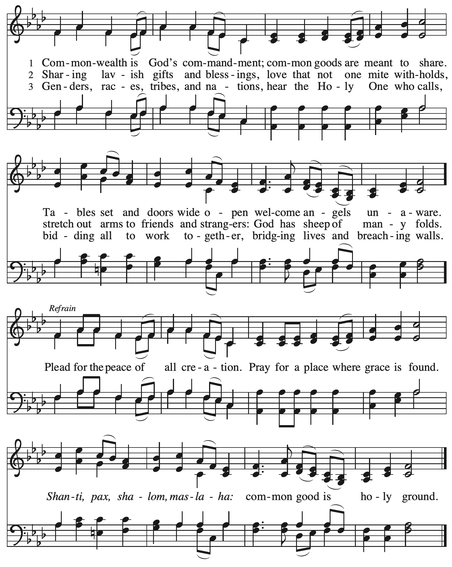

Apostles’ Creed

C: I believe in God, the Father almighty,
creator of heaven and earth.

I believe in Jesus Christ, God’s only Son, our Lord,
who was conceived by the Holy Spirit,
born of the virgin Mary,
suffered under Pontius Pilate,
was crucified, died, and was buried;
he descended to the dead.*
On the third day he rose again;
he ascended into heaven,
he is seated at the right hand of the Father,
and he will come to judge the living and the dead.

I believe in the Holy Spirit,
the holy catholic church,
the communion of saints,
the forgiveness of sins,
the resurrection of the body,
and the life everlasting. Amen.

*Or, “he descended into hell,” another translation of this text in widespread use.

Prayers of the People

A: As stewards of God’s creation,
we join with the whole church to pray for the needs of the world and its people.

After each petition
A: Gracious God,
C: receive our prayer.

P: Trusting in your lovingkindness, we place our prayers and hopes in you, O God,
in the name of Jesus Christ, our Savior.
C: Amen.

Peace

The presiding minister and the assembly greet one another in the peace of the risen Christ.
P: The peace of Christ be with you always.
C: And also with you.

The people may greet those around them with a sign of Christ’s peace and may say
Peace be with you or similar words. Please be mindful that not everyone will be comfortable with sharing the peace, so please seek consent before shaking hands or hugging. Other possible ways to share the peace include a simple bow with the verbal greeting of peace, or simply a verbal expression of peace.

When the greetings of peace have concluded, please be seated.

Meal
God feeds us with the presence of Jesus Christ



Offering

We offer ourselves, our gifts, and our faithful service to God.
As the offering is gathered for the mission of the church, including the care of those in need,
the table is set for Holy Communion.

There are laminated giving cards in the pew racks that feature a QR code for anyone who would like to give online. Those who give using the QR code, as well as those who give regularly online or through their bank are encouraged to place the laminated card in the plate as an expression of your offering.

Offertory Music God Welcomes All arr. Howarth

As the gifts are brought forward for presentation, please rise as you are able.

Offertory Song As the Grains of Wheat ELW 465

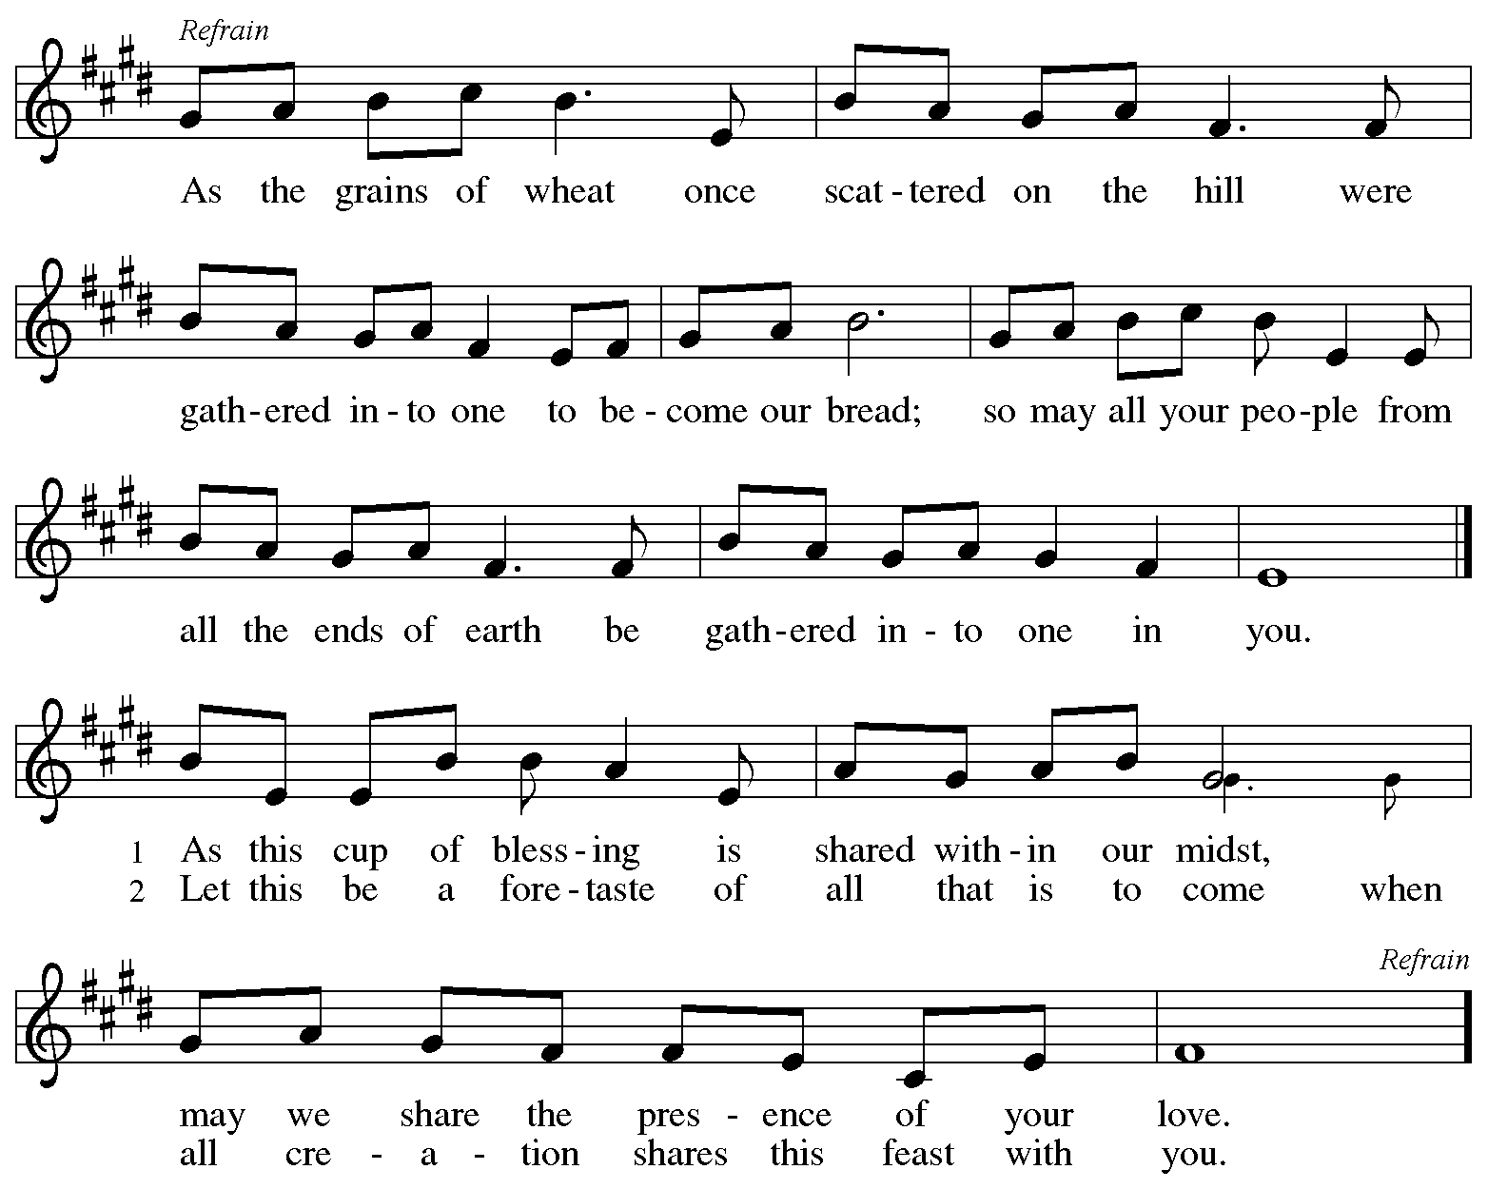
Reprinted with permission under OneLicense.net # A-722139.

Offertory Prayer

A: Let us pray.
Creator God,
C: in your wisdom you bring forth all that is good
and the harvest is plentiful.
Strengthen us at your table with these gifts of the earth
and our labor, that we may work for the good of all;
through Jesus Christ, our Savior.
Amen.

Dialogue

P: The Lord be with you.
C: And also with you.

P: Lift up your hearts.
C: We lift them to the Lord.

P: Let us give thanks to the Lord our God.
C: It is right to give our thanks and praise.

Preface

P: It is indeed right, our duty and our joy,
that we should at all times and in all places
give thanks and praise to you, almighty and merciful God,
through our Savior Jesus Christ;
who on this day overcame death and the grave,
and by his glorious resurrection
opened to us the way of everlasting life.
And so, with all the choirs of angels,
with the church on earth and the hosts of heaven,
we praise your name and join their unending hymn:

Sanctus

C: Holy, holy, holy Lord, God of power and might,
heaven and earth are full of your glory.
Hosanna in the highest.
Blessed is the one who comes in the name of the Lord.
Hosanna in the highest.

Eucharistic Prayer

P: Holy, mighty, and merciful Lord …
… to whom with you and the Holy Spirit
be all honor and glory, now and forever.
C: Amen.

Lord’s Prayer

P: Gathered as one by the Holy Spirit, let us pray as Jesus taught us.
C: Our Father, who art in heaven,
hallowed be thy name,
thy kingdom come,
thy will be done,
on earth as it is in heaven.
Give us this day our daily bread;
and forgive us our trespasses,
as we forgive those
who trespass against us;
and lead us not into temptation,
but deliver us from evil.
For thine is the kingdom,
and the power, and the glory,
forever and ever. Amen.

Fraction and Invitation

Agnus Dei / Lamb of God

C: Lamb of God, you take away the sin of the world; have mercy on us.
Lamb of God, you take away the sin of the world; have mercy on us.
Lamb of God, you take away the sin of the world; grant us peace.

Please be seated.

Holy Communion

- All who seek God and desire a deeper and stronger life in Christ are welcome to receive Holy Communion.
- Worshipers from the pulpit side will proceed forward first, followed by the center section, and then the lectern side.
- Please inform an usher if you would like the ministers to bring Communion to you.
- Holy Communion will be served with bread and wine (amber) or grape juice (purple).
- The presiding minister will first distribute the bread (host) to each communicant. Please indicate if you require a gluten-free host.
- Once you have consumed the bread, please pick up an empty glass from the tray next to the presiding minister. The Communion Assistant will pour wine or grape juice into your glass.
- Please step to the side to consume the wine or grape juice.
- Feel free to kneel at the altar rail for prayer after receiving the sacrament.
- As you return to your pew, glasses may be returned to the empty tray on the side of the center section.
- A blessing will be provided for anyone who does not yet receive the sacrament.
- All are invited to join in singing the hymns during Holy Communion.

Hymns during Holy Communion
O God of Light ELW 507

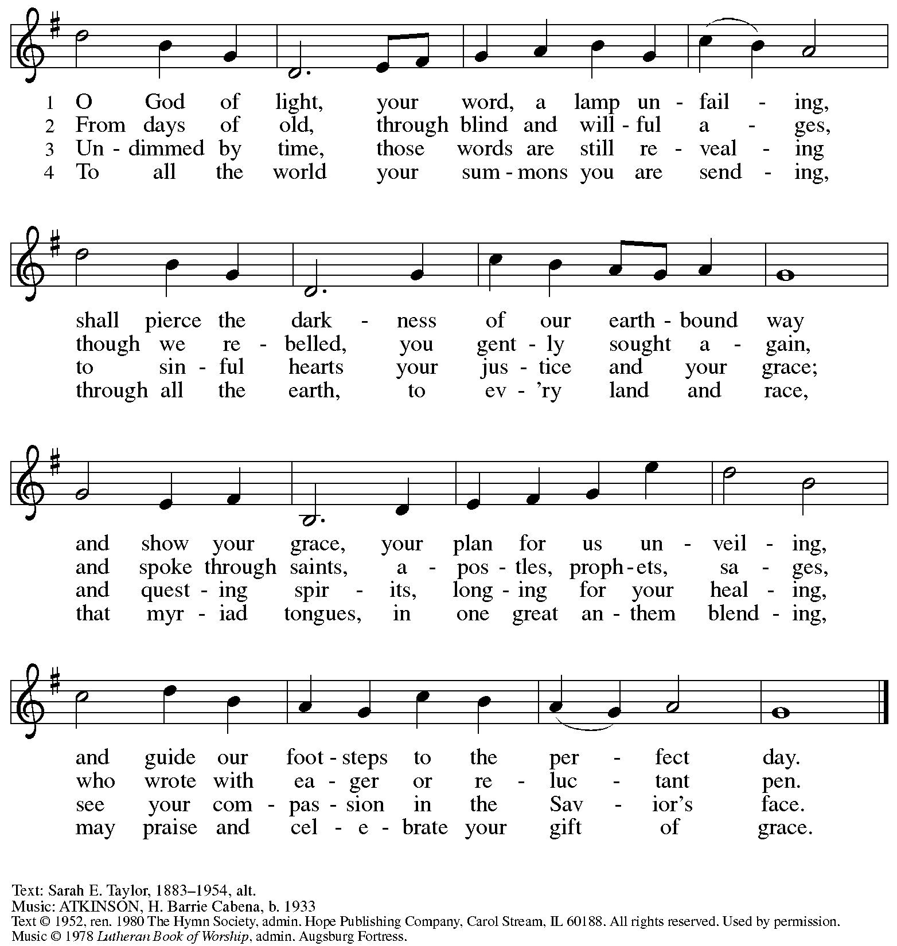
All rights reserved. Reprinted under OneLicense.net # A-722139.

Hymns during Holy Communion
Beloved, God’s Chosen ELW 648

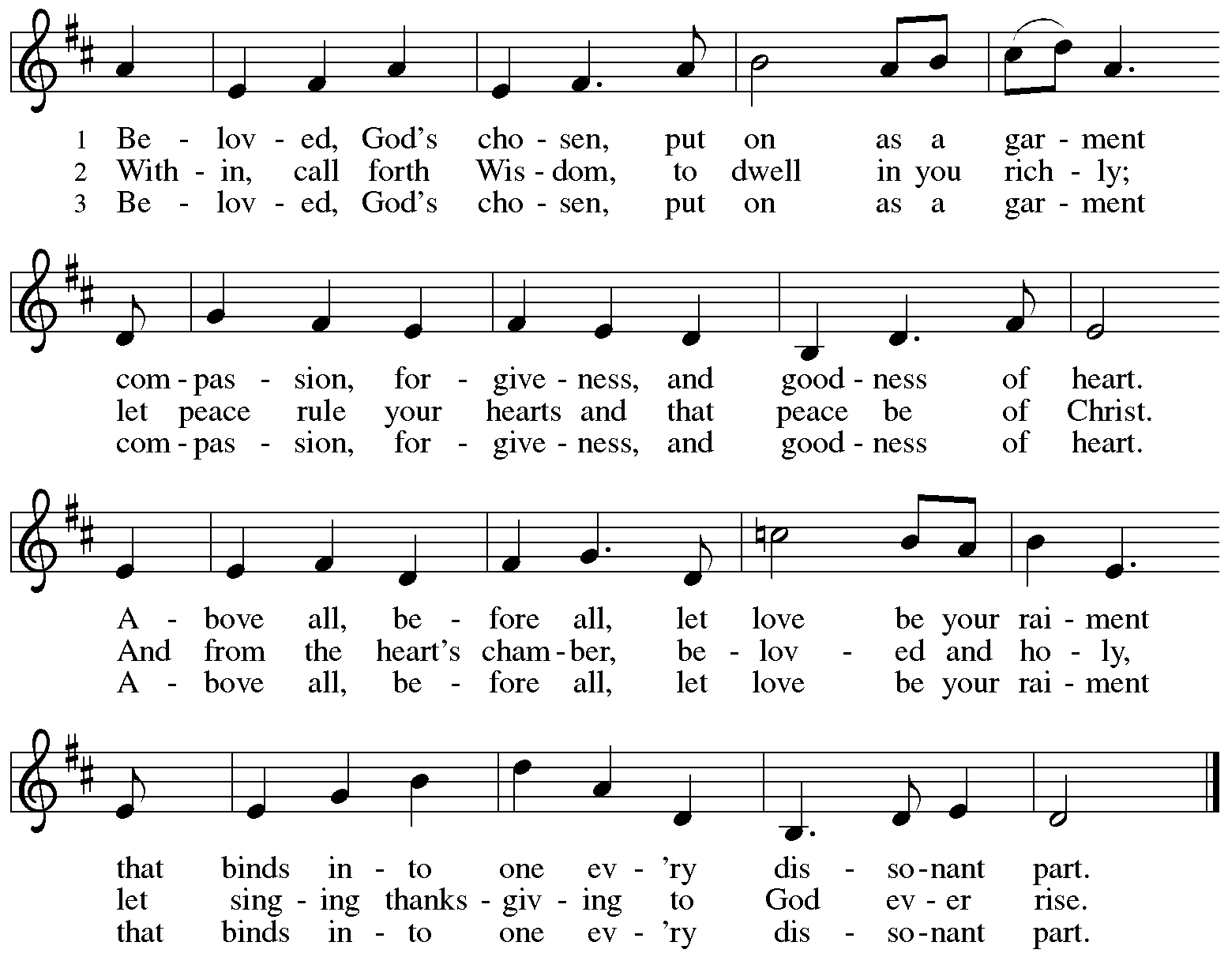


All rights reserved. Reprinted with permission under OneLicense.net # A-722139.

Hymns during Holy Communion
All Who Hunger, Gather Gladly ELW 461

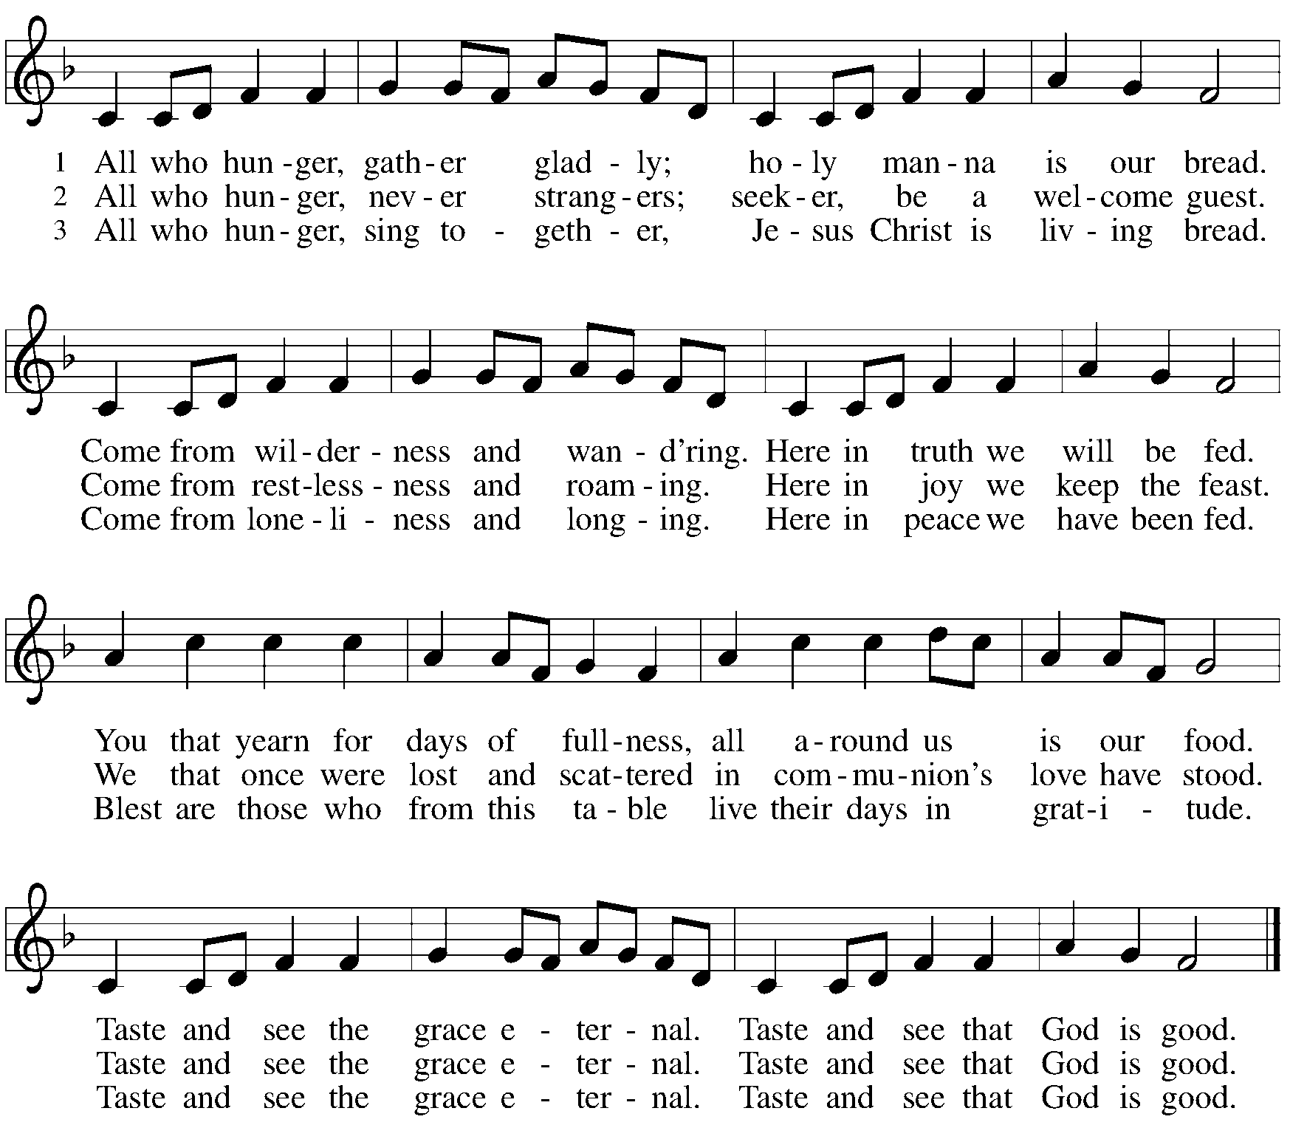
Reprinted under OneLicense.net # A-722139.

When all have returned to their places, please rise as you are able.

Blessing

P: The body and blood of our Lord Jesus Christ strengthen you and keep you in his grace.
C: Amen.

Prayer

A: Let us pray.
Gracious God, in this meal you have drawn us to your heart,
and nourished us at your table with food and drink, the body and blood of Christ.
Now send us forth to be your people in the world,
and to proclaim your truth this day and evermore,
through Jesus Christ, our Savior and Lord.
C: Amen.

Please be seated.

Sending
God blesses us and sends us in mission to the world

Announcements

Please rise as you are able.

Benediction

P: The love of God abound in you;
the grace of our Savior Jesus Christ fill your hearts;
and the life of the Spirit
☩ bless you and give you peace.
C: Amen.

Sending Hymn Following page

Dismissal

A: Go in peace. Serve the Lord.
C: Thanks be to God!

Postlude

Sending Hymn Welcome Table ACS 969

1 I'm gonna eat at the welcome table,
I'm gonna eat at the welcome table,
some of these days.
I'm gonna eat at the welcome table,
I'm gonna eat at the welcome table,
some of these days.

2 I'm gonna feast on milk and honey,
I'm gonna feast on milk and honey,
some of these days.
I'm gonna feast on milk and honey,
I'm gonna feast on milk and honey,
some of these days.

3 I'm gonna wade 'cross Jordan's river,
I'm gonna wade 'cross Jordan's river,
some of these days.
I'm gonna wade 'cross Jordan's river,
I'm gonna wade 'cross Jordan's river,
some of these days.

Text: African American spiritual. Music: WELCOME TABLE, African American spiritual.

Serving in Worship Today

Altar Care
Assisting Minister Kathy Hays
Audio-Visual Ministers Tyler Rietze
Joseph Paetz
Cantor Pastor Erin Jones
Lector Brennan Coleman
Minister of Music Laura Reynolds
Presiding Minister The Rev. Peter Asplin

Liturgy and Hymnody Acknowledgements

From SundaysandSeasons.com. Copyright © 2025 Augsburg Fortress. All rights reserved. Reprinted under OneLicense.net # A-722139.
Used by permission of Augsburg Fortress.

The Scripture readings contained herein are from New Revised Standard Version Updated Edition of the Bible © 2021 National Council of Churches of Christ in the United States of America. Used by permission. All rights reserved worldwide.

All Are Welcome – Text: Marty Haugen, b. 1950. Music: TWO OAKS, Marty Haugen. Text and music © 1994 GIA Publications, Inc., 7404 S. Mason Ave., Chicago, IL 60638. www.giamusic.com. 800.442.3358. All rights reserved. Reprinted with permission under OneLicense.net # A-722139.

Commonwealth Is God’s Commandment – Text: Mary Louise Bringle, b. 1953. Music: RESTORATION, W. Walker, Southern Harmony. Text © 2018 GIA Publications, Inc., giamusic.com. All rights reserved. Reprinted with permission under Onelicense.net # A-722139.

Welcome Table – Text: African American spiritual. Music: WELCOME TABLE, African American spiritual, arr. Mark Hayes, b. 1953. Arr. © 2003 Augsburg Fortress. All rights reserved. Reprinted with permission under OneLicense.net # A-722139.

Please use the QR code below to link to St. Andrew’s Announcements online!



St. Andrew Lutheran Church Announcements
August 31st, 2025

- Welcome to Worship at St. Andrew on the Twelfth Sunday after Pentecost! – We are so glad you are here, and we offer a special welcome to all visitors and guests who are here for the first time! In the heat of summer St. Andrew moves to a primarily spoken setting of worship. There are worship “toolkits” to help children engage with worship and “busy bags” for younger children available in the bookcase at the back of the sanctuary. Please feel free to take one to use with/for your children. A nursery is available through the door to the left of the worship space and across the social hall (look for a purple room).
- September Produce Distribution – First Tuesday of the Month, September 2nd, 5:30-7:00 p.m. – St. Andrew partners with Greater Pittsburgh Community Food Bank to serve as a distribution site for fresh produce on the first Tuesday of every month. Next month’s distribution will be on Tuesday, September 2nd. We invite people of the congregation to help with the distribution from 5:30-7:00 p.m. and/or to help with unloading and setup during the day between 10:00 a.m. and 1:00 p.m.
- Little Church – Big Faith Resumes Next Sunday, September 7th, during Worship – St. Andrew’s Christian Education offering for children up through 6th grade is called Little Church – Big Faith. Each week, during worship, children move to classroom to hear a Bible story, watch a video, and take part in a related craft or activity. LCBF has been on break for summer but we will resume meeting during worship next Sunday, September 7th! Please speak with the Christian Education liaison to council, Ty Best, or contact him at christian.education@standrewpittsburgh.org, if you have questions.
- Reparations Offering during Worship Next Sunday, September 7th – In Luke’s Gospel, Jesus tells a story about a compassionate Samaritan, suggesting that God’s people are called to work for healing and restoration for our neighbors, regardless of who or what caused them harm. In light of this, St. Andrew has made a commitment to reparations in regard to African American spiritual songs used in our worship. The text and music of most hymns is attributed to specific authors, with copyrights in place, usage reported, and royalties paid to those whose works are featured in worship. With African American spirituals, this is not possible. In response to many years of such uncredited use, St. Andrew invites the congregation to give a reparations offering. Funds received in worship will be donated to our siblings at Bethel AME Church, whose land and building were taken from them in the 1950s, to fund their development in the Hill District.
- Coffee Hour Resumes Next Sunday, September 7th, after Worship – If you would like to participate and would like additional information about the duties, please sign up using the following form: https://www.signupgenius.com/go/5080B4AAFAF2CABF85-47069030-coffee#/
- September Shelter Dinner for Guests of East End Cooperative Ministry – Third Thursday of the Month, September 18th, 6:30 p.m. – Each month, people of St. Andrew provide dinner for guests of East End Cooperative Ministry (EECM), 6140 Station St. (East Liberty), 15206. We invite you to prepare or purchase one menu item and bring it to the shelter by 6:00 p.m., or just come to help serve at 6:30 p.m. You can sign up at this following link: https://www.signupgenius.com/go/5080544AAAC22A1F58-58193716-sept
- Invitation to Prayer Team and New Address – St. Andrew maintains a list of weekly prayer concerns that is sent by email, usually on Wednesdays, to members of the congregation who have opted in. In an effort to coordinate our communications under our organization’s Google Workspace, our new prayer team email address is prayerteam@standrewpittsburgh.org. If you have been on the prayer team email list and would like to continue receiving weekly updates, or if you would like to be included for the first time, please send administrative assistant Jay a message at the email above. Any prayer concerns or requests can be sent to this address in the future. We will discontinue using st.a.prayer.team@gmail.com for sending prayer requests, updates, and the weekly list starting September 3rd. As we renew this prayer ministry, we will also move to a practice of keeping names on the list for a maximum of four weeks unless otherwise requested. Thank you for your ministry of prayer!
- Records Update - Please Respond – St. Andrew is looking to update our records with information from newer attendees, as well as offering current members the opportunity to include current information. This includes name, preferred pronouns, email, phone number, birthdays, anniversaries, and more. The information will only be used within the congregation - for example to acknowledge celebrations and milestones in worship, in the prayers of the church, or in the weekly newsletter. Please fill out the form at: https://forms.gle/kKvp19UozuRrhhaV7.
- Good Food Project Volunteering Opportunity – 412 Food Rescue swiftly rescues fresh surplus food and delivers it where it’s needed most, leveraging people-powered technology and strong community partnerships to tackle both food insecurity and climate change. 412 Food Rescue’s Good Food Project is located inside the Food & Energy Hub in Millvale. Their mission is to transform surplus foods into healthy, heat-and-eat meals and grocery bags of nutritious food to be distributed to neighbors experiencing food insecurity. There are opportunities from now until the end of September to volunteer in either their kitchen prep and bagging programs. You can learn more about the project here: https://412foodrescue.org/programs/good-food-project/ and sign up to volunteer here: https://www.signupgenius.com/go/10C0F48A8AD2CA2FDCE9-412frs and https://www.signupgenius.com/go/10c0f48a8ad2ca2fdce9-new.
- Pittsburgh Compline Choir – Sundays at 8:00 p.m. at Heinz Chapel, starting September 7th – Compline was traditionally a monastic prayer service, and the Pittsburgh Compline Choir, a ministry of Lutheran Campus Ministry in Greater Pittsburgh, sings a choral version of compline rooted in this thousand-year-old tradition of scripture, song, and silence each Sunday at Heinz Chapel at 8:00 p.m. This service also streams on Facebook (Pittsburgh Compline Choir) and YouTube (The Pittsburgh Compline Choir). Heinz Chapel is located off of S. Bellefield Ave. in Oakland. For more information, please visit: Pittsburgh Compline Choir.
- Christ in Our Home Devotional Booklets for July-September Available at Entrances – This resource offers a daily Bible reading with a short reflection and prayer, along with additional readings and prayer topics for those who would like to expand their devotional practices. We encourage people of the congregation to take one for yourself, your family/household, or others.

