

+ Ninth Sunday after Pentecost
August 10, 2025



St. Andrew Lutheran Church
304 Morewood Ave.
Pittsburgh, PA 15213
St_andrewELCA@verizon.net
www.standrewpittsburgh.org

+ Ninth Sunday after Pentecost
Order for Worship

Jesus says it is God’s “good pleasure to give you the kingdom.” This is God’s promise from the beginning – to Abraham, to the early church, and to the “little flock” of which we are a part in this week’s assembly. Faith, God’s baptismal gift, trusts in God’s promises. Have no fear.

Welcome to St. Andrew!
- St. Andrew welcomes all who are seeking a place of healing, wholeness, and acceptance in a nurturing and faith-forming spiritual home. We are striving toward racial equity worldwide
and we seek to honor the lived experience of all individuals regardless of background. Our community embraces people of all ages, ethnicities, cultures, abilities, sexual orientations,
gender identities and expressions, and family constellations. Come and See!
- Worship Services are live-streamed to multiple online platforms. By attending worship, you agree that your image and voice may be broadcast.
- Everyone is invited to make a name tag at the black bookcase in the back of the worship space if they would like. There are stickers indicating pronouns on the bookcase if you would like to include them on your name tag.
- A nursery is available through the doors at the left side of the sanctuary and across from the doorway to the Social Hall. Look for a purple-colored room.
- Worship “toolkits” to help children engage with the service, along with “busy bags” for younger children, are available in the bookcase at the back of the sanctuary. Please feel free to take one to use with/for your children.
- Holy Communion is served with bread (gluten-free available) and wine or grape juice. The presiding minister will distribute the bread (host). Please consume this and then pick up an empty glass from the tray. The Communion Assistant will pour wine or grape juice into your glass. Please step to the side to consume the wine or grape juice. Feel free to kneel at the altar for prayer and reflection. As you return to your pew, glasses may be returned to the empty trays on either side of the center section.
- A restroom is available on the main level of the church, through the doors to the Social Hall and to the right in the main office.

Abbreviations
P: Pastor/Presiding Minister ELW: Evangelical Lutheran Worship hymnal
A: Assisting Minister ACS: All Creation Sings hymnal
L: Lector TFF: This Far by Faith hymnal
C: Congregation

Musical Offering

Each week, different people from the congregation make an offering of pre-service music, with singing or instrumentation, to help the assembly focus and pray in preparation for worship.

Welcome

Prelude

Gathering
The Holy Spirit calls us together as the people of God

Confession and Forgiveness

P: Blessed be the holy Trinity, ☩ one God,
who forgives all our sin,
whose mercy endures forever.
C: Amen.

P: Baptized into Christ, let us confess our sins.

Silence is kept for reflection.

P: Merciful God,
C: you free us to love others,
but we neglect our neighbors and follow our own way.
You lead us by the Spirit of joy and peace,
but we turn away from the abundant life you offer.
You surround us with patience, kindness, and generosity,
but we grow weary in doing what is right.
In your mercy, forgive us.
Do not give up on us.
Heal us, break our bonds, and show us the path of life.
Amen.

P: You belong to Christ Jesus
and you are God’s children through faith.
In the cross of ☩ Christ,
and through the power of the Holy Spirit,
your sins are forgiven.
Clothed with Christ, you are a new creation.
C: Amen.

Gathering Hymn ELW 771
God, Who Stretched the Spangled Heavens

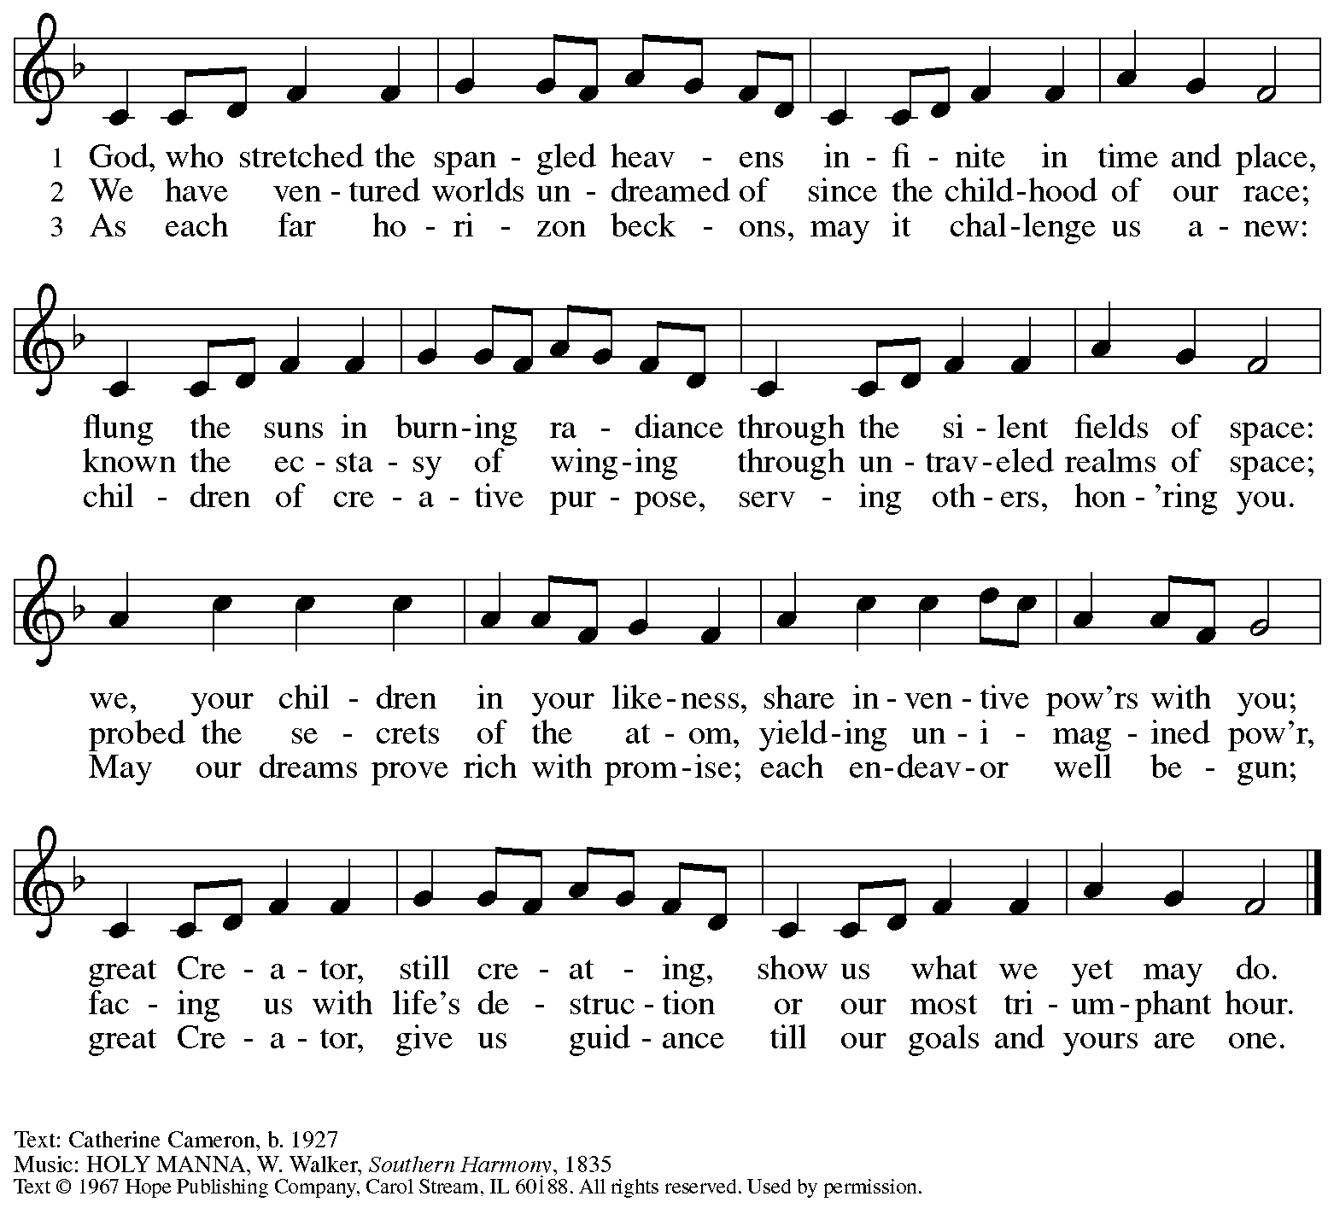
Reprinted under OneLicense.net # A-722139.

Greeting

P: The grace of our Lord Jesus Christ, the love of God,
and the communion of the Holy Spirit be with you all.
C: And also with you.

Prayer of the Day

P: Let us pray.
Almighty God, you sent your Holy Spirit to be the life and light of your church.
Open our hearts to the riches of your grace, that we may be ready to receive you wherever you appear, through Jesus Christ, our Savior and Lord.
C: Amen.

Please be seated.

Word
God speaks to us in Scripture reading, preaching, and song

First Reading – Genesis 15: 1-6

¹ After these things the word of the Lord came to Abram in a vision, “Do not be afraid, Abram, I am your shield; your reward shall be very great.” ² But Abram said, “O Lord God, what will you give me, for I continue childless, and the heir of my house is Eliezer of Damascus?” ³ And Abram said, “You have given me no offspring, so a slave born in my house is to be my heir.”
⁴ But the word of the Lord came to him, “This man shall not be your heir; no one but your very own issue shall be your heir.” ⁵ God brought him outside and said, “Look toward heaven and count the stars, if you are able to count them.” Then God said to him, “So shall your descendants be.” ⁶ And he believed the Lord, and the Lord reckoned it to him as righteousness.

L: Word of God, word of life.
C: Thanks be to God.

Psalm 33: 12-22

The psalm will be spoken responsively, led by the cantor,
with the congregation reading the verses in bold type.

¹² Happy is the nation whose God | is the Lord!
Happy the people chosen to | be God’s heritage!
¹³ The Lord looks | down from heaven,
and sees all | humankind.
¹⁴ God sits firmly en- | throned and watches
all who dwell | on the earth.
¹⁵ God fashions | all their hearts
and observes | all their deeds.
¹⁶ A king is not saved by the size | of the army,
nor are warriors rescued by | their great strength.
¹⁷ The horse gives vain | hope for victory;
despite its great strength it | cannot save.
¹⁸ Truly, your eye is upon those who fear | you, O Lord,
upon those who wait for your | steadfast love,
¹⁹ to deliver their | lives from death,
and to keep them alive in | time of famine.
²⁰ Our innermost being waits for | you, O Lord,
our helper | and our shield.
²¹ Surely, our heart rejoic- | es in you,
for in your holy name we | put our trust.
²² Let your loving kindness, O Lord, | be upon us,
even as we place our | hope in you.

Second Reading – Hebrews 11: 1-3, 8-16

⁸ By faith Abraham obeyed when he was called to set out for a place that he was to receive as an inheritance, and he set out, not knowing where he was going. ⁹ By faith he stayed for a time in the land he had been promised, as in a foreign land, living in tents, as did Isaac and Jacob, who were heirs with him of the same promise. ¹⁰ For he looked forward to the city that has foundations, whose architect and builder is God. ¹¹ By faith, with Sarah’s involvement, he received power of procreation, even though he was too old, because he considered the one faithful who had promised. ¹² Therefore from one person, and this one as good as dead, descendants were born, “as many as the stars of heaven and as the innumerable grains of sand by the seashore.”
¹³ All of these died in faith without having received the promises, but from a distance they saw and greeted them. They confessed that they were strangers and foreigners on the earth, ¹⁴ for people who speak in this way make it clear that they are seeking a homeland. ¹⁵ If they had been thinking of the land that they had left behind, they would have had opportunity to return. ¹⁶ But as it is, they desire a better homeland, that is, a heavenly one. Therefore God is not ashamed to be called their God; indeed, God has prepared a city for them.

L: Word of God, word of life.
C: Thanks be to God.

Please rise as you are able.

Gospel Acclamation

C: Alleluia. Keep awake and be ready,
for you do not know on what day your Lord is coming. Alleluia.

Gospel – Luke 12: 32-40

P: The holy Gospel according to St. Luke.
C: Glory to you, O Lord.

[Jesus said:] ³² “Do not be afraid, little flock, for it is your Father’s good pleasure to give you the kingdom. ³³ Sell your possessions and give alms. Make purses for yourselves that do not wear out, an unfailing treasure in heaven, where no thief comes near and no moth destroys. ³⁴ For where your treasure is, there your heart will be also.
³⁵ “Be dressed for action and have your lamps lit; ³⁶ be like those who are waiting for their master to return from the wedding banquet, so that they may open the door for him as soon as he comes and knocks. ³⁷ Blessed are those slaves whom the master finds alert when he comes; truly I tell you, he will fasten his belt and have them sit down to eat, and he will come and serve them. ³⁸ If he comes during the middle of the night or near dawn and finds them so, blessed are those slaves.
³⁹ “But know this: if the owner of the house had known at what hour the thief was coming, he would not have let his house be broken into. ⁴⁰ You also must be ready, for the Son of Humanity is coming at an hour you do not expect.”

P: The Gospel of the Lord.
C: Praise to you, O Christ.

Please be seated.

Sermon

A time of silence for prayer and reflection follows the sermon.
When the hymn of the day begins, please rise as you are able.



Hymn of the Day Have No Fear, Little Flock ELW 764

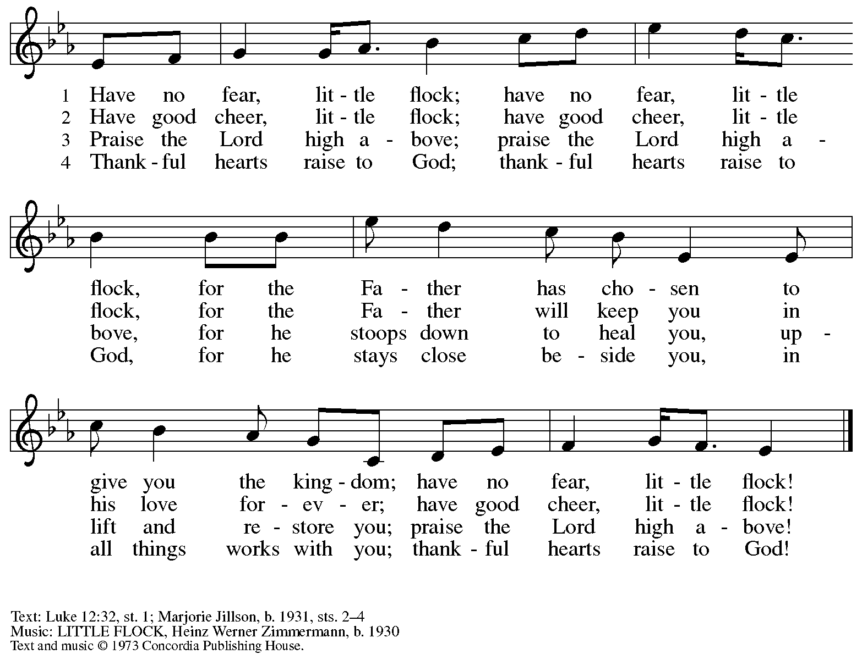
All rights reserved. Reprinted with permission under OneLicense.net # A-722139.

Apostles’ Creed

C: I believe in God, the Father almighty,
creator of heaven and earth.

I believe in Jesus Christ, God’s only Son, our Lord,
who was conceived by the Holy Spirit,
born of the virgin Mary,
suffered under Pontius Pilate,
was crucified, died, and was buried;
he descended to the dead.*
On the third day he rose again;
he ascended into heaven,
he is seated at the right hand of the Father,
and he will come to judge the living and the dead.
I believe in the Holy Spirit,
the holy catholic church,
the communion of saints,
the forgiveness of sins,
the resurrection of the body,
and the life everlasting. Amen.

*Or, “he descended into hell,” another translation of this text in widespread use.

Prayers of the People

A: As stewards of God’s creation,
we join with the whole church to pray for the needs of the world and its people.

After each petition
A: Gracious God,
C: receive our prayer.

P: Trusting in your lovingkindness, we place our prayers and hopes in you, O God,
in the name of Jesus Christ, our Savior.
C: Amen.

Peace

The presiding minister and the assembly greet one another in the peace of the risen Christ.
P: The peace of Christ be with you always.
C: And also with you.

The people may greet those around them with a sign of Christ’s peace and may say
Peace be with you or similar words. Please be mindful that not everyone will be comfortable with sharing the peace, so please seek consent before shaking hands or hugging. Other possible ways to share the peace include a simple bow with the verbal greeting of peace, or simply a verbal expression of peace.
When the greetings of peace have concluded, please be seated.

Meal
God feeds us with the presence of Jesus Christ

Offering

We offer ourselves, our gifts, and our faithful service to God.
As the offering is gathered for the mission of the church, including the care of those in need,
the table is set for Holy Communion.

There are laminated giving cards in the pew racks that feature a QR code for anyone who would like to give online. Those who give using the QR code, as well as those who give regularly online or through their bank are encouraged to place the laminated card in the plate as an expression of your offering.

Offertory Music

As the gifts are brought forward for presentation, please rise as you are able.

Offertory Song As the Grains of Wheat ELW 465
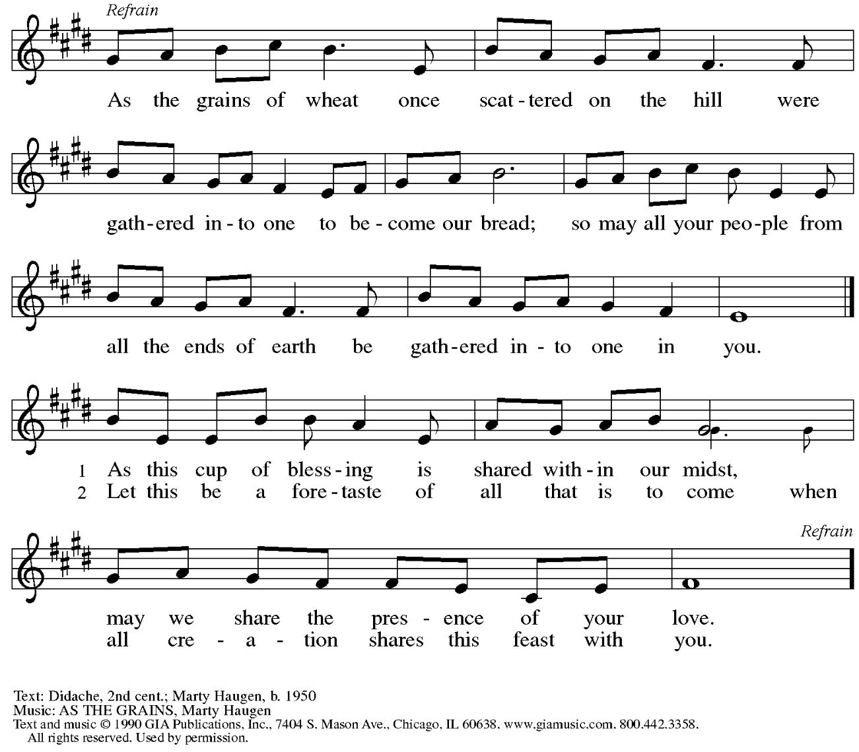
Reprinted under OneLicense.net # A-722139.
Offertory Prayer

A: Let us pray.
Creator God,
C: in your wisdom you bring forth all that is good
and the harvest is plentiful.
Strengthen us at your table with these gifts of the earth
and our labor, that we may work for the good of all;
through Jesus Christ, our Savior.
Amen.

Dialogue

P: The Lord be with you.
C: And also with you.

P: Lift up your hearts.
C: We lift them to the Lord.

P: Let us give thanks to the Lord our God.
C: It is right to give our thanks and praise.

Preface

P: It is indeed right, our duty and our joy,
that we should at all times and in all places
give thanks and praise to you, almighty and merciful God,
through our Savior Jesus Christ;
who on this day overcame death and the grave,
and by his glorious resurrection
opened to us the way of everlasting life.
And so, with all the choirs of angels,
with the church on earth and the hosts of heaven,
we praise your name and join their unending hymn:

Sanctus

C: Holy, holy, holy Lord, God of power and might,
heaven and earth are full of your glory.
Hosanna in the highest.
Blessed is the one who comes in the name of the Lord.
Hosanna in the highest.

Eucharistic Prayer

P: Holy, mighty, and merciful Lord …
… to whom with you and the Holy Spirit
be all honor and glory, now and forever.
C: Amen.

Lord’s Prayer

P: Gathered as one by the Holy Spirit, let us pray as Jesus taught us.
C: Our Father, who art in heaven,
hallowed be thy name,
thy kingdom come,
thy will be done,
on earth as it is in heaven.
Give us this day our daily bread;
and forgive us our trespasses,
as we forgive those
who trespass against us;
and lead us not into temptation,
but deliver us from evil.
For thine is the kingdom,
and the power, and the glory,
forever and ever. Amen.

Fraction and Invitation

Agnus Dei / Lamb of God

C: Lamb of God, you take away the sin of the world; have mercy on us.
Lamb of God, you take away the sin of the world; have mercy on us.
Lamb of God, you take away the sin of the world; grant us peace.

Please be seated.



Holy Communion

- All who seek God and desire a deeper and stronger life in Christ are welcome to receive Holy Communion.
- Worshipers from the pulpit side will proceed forward first, followed by the center section, and then the lectern side.
- Please inform an usher if you would like the ministers to bring Communion to you.
- Holy Communion will be served with bread and wine (amber) or grape juice (purple).
- The presiding minister will first distribute the bread (host) to each communicant. Please indicate if you require a gluten-free host.
- Once you have consumed the bread, please pick up an empty glass from the tray next to the presiding minister. The Communion Assistant will pour wine or grape juice into your glass.
- Please step to the side to consume the wine or grape juice.
- Feel free to kneel at the altar rail for prayer after receiving the sacrament.
- As you return to your pew, glasses may be returned to the empty tray on the side of the center section.
- A blessing will be provided for anyone who does not yet receive the sacrament.
- All are invited to join in singing the hymns during Holy Communion.

Hymns during Holy Communion
The God of Abraham Praise ELW 831
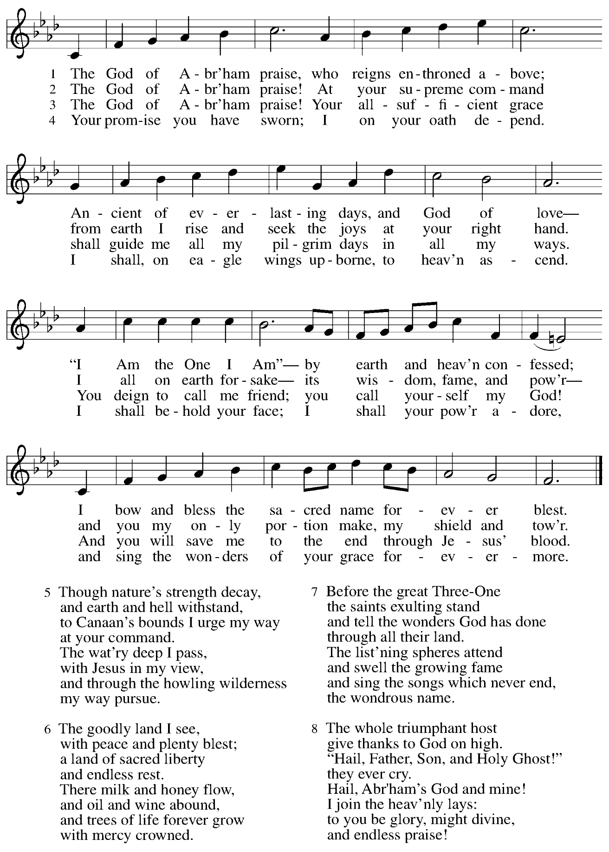

Hymns during Holy Communion
Keep Your Lamps Trimmed and Burning ACS 949

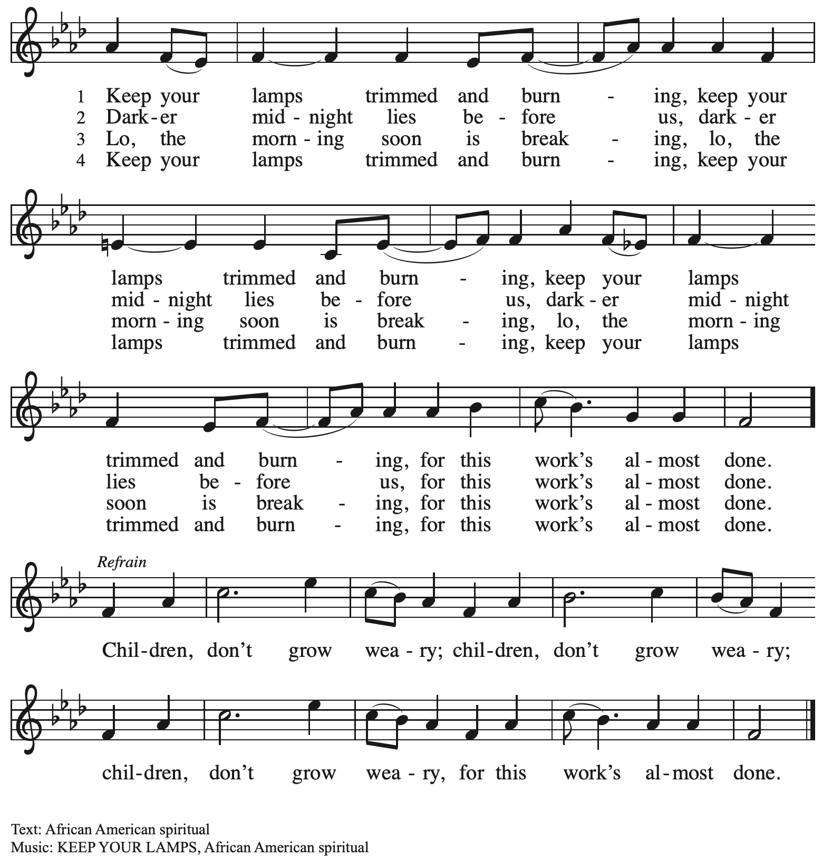

Hymns during Holy Communion
Lord Jesus, You Shall Be My Song ELW 808
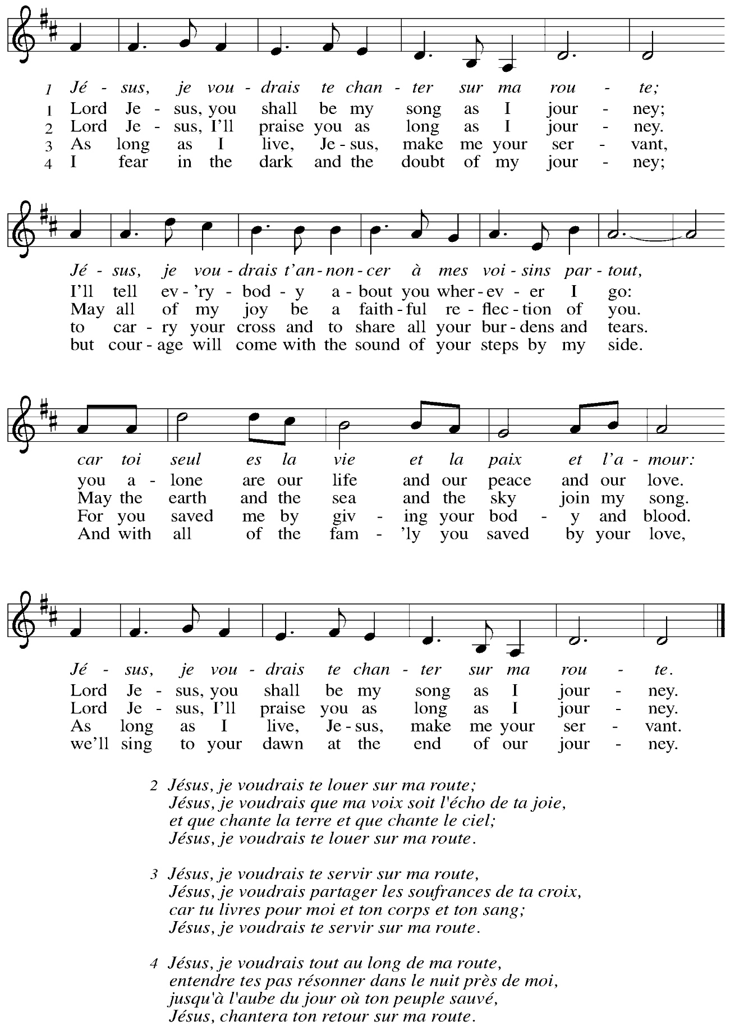
When all have returned to their places, please rise as you are able.

Blessing

P: The body and blood of our Lord Jesus Christ strengthen you and keep you in his grace.
C: Amen.

Prayer

A: Let us pray.
Gracious God, in this meal you have drawn us to your heart,
and nourished us at your table with food and drink, the body and blood of Christ.
Now send us forth to be your people in the world,
and to proclaim your truth this day and evermore,
through Jesus Christ, our Savior and Lord.
C: Amen.

Please be seated.

Sending
God blesses us and sends us in mission to the world

Announcements

Please rise as you are able.

Benediction

P: The love of God abound in you;
the grace of our Savior Jesus Christ fill your hearts;
and the life of the Spirit
☩ bless you and give you peace.
C: Amen.

Sending Hymn Following page

Dismissal

A: Go in peace. Serve the Lord.
C: Thanks be to God!

Postlude

Sending Hymn I Want to Be Ready TFF 41

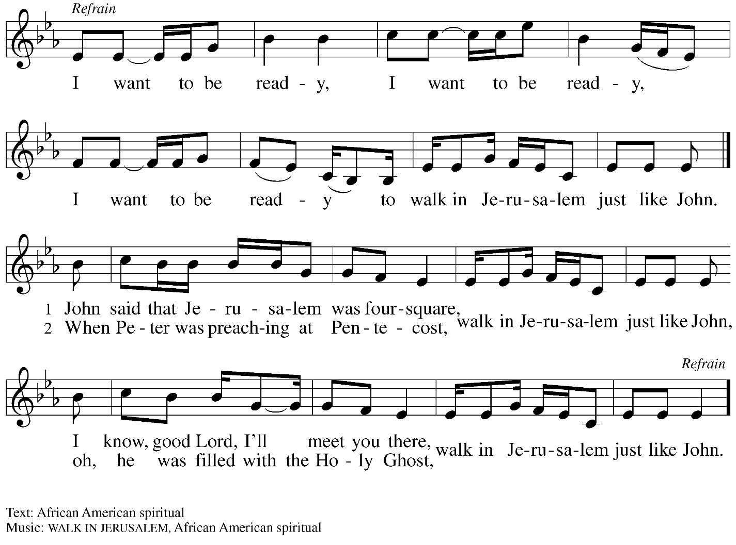

Serving in Worship Today

Altar Care Christy Ruhe
Assisting Minister Jeff Denlinger
Audio-Visual Ministers Kristen
Jason
Cantor Jered Stratton
Lector Colleen Cooke
Minister of Music Laura Reynolds
Preaching and Presiding Minister The Rev. Ross I. Carmichael

Liturgy and Hymnody Acknowledgements

From SundaysandSeasons.com. Copyright © 2025 Augsburg Fortress. All rights reserved. Reprinted under OneLicense.net # A-722139.
Used by permission of Augsburg Fortress.

The Scripture readings contained herein are from New Revised Standard Version Updated Edition of the Bible © 2021 National Council of Churches of Christ in the United States of America. Used by permission. All rights reserved worldwide.

The God of Abraham Praise – Text: Thomas Olivers, 1725-1799, alt., based on the Yigdal, ca. 14th cent. Music: YIGDAL, Jewish melody; arr. Meyer Lyon, 1751-1797.

Lord Jesus, You Shall Be My Song – Text: Les Petites Soeurs de Jésus and L’Arche Community; tr. Stephen Sommerville, b. 1931. Music: LES PETITES SOEURS, Les Petites Soeurs de Jésus and L’Arche Community. Text and music © 1987 Les Petites Soeurs de Jésus. Tr. © 1970 Stephen Sommerville. All rights reserved. Reprinted with permission under OneLicense.net # A-722139.

Please use the QR code below to link to St. Andrew’s Announcements online!



St. Andrew Lutheran Church Announcements
August 10th, 2025

- Welcome to Worship at St. Andrew on the Ninth Sunday after Pentecost! – We are so glad you are here, and we offer a special welcome to all visitors and guests who are here for the first time! In the heat of summer St. Andrew moves to a primarily spoken setting of worship. There are worship “toolkits” to help children engage with worship and “busy bags” for younger children available in the bookcase at the back of the sanctuary. Please feel free to take one to use with/for your children. A nursery is available through the door to the left of the worship space and across the social hall (look for a purple room).
- Community Ministry Team Invites Congregation to Assemble Backpacks for Students at The Neighborhood Academy Today – St. Andrew’s community ministry team was invited by St. Andrew’s Episcopal Church in Highland Park to assist with a project to supply backpacks for students at The Neighborhood Academy, a school in Garfield that supports students in grades 6-12 from low-income backgrounds with a college preparatory curriculum (For more information please see https://www.theneighborhoodacademy.org/).
- Congregation Council Retreat, Saturday August 16th, 9:00 a.m. - 2:00 p.m. – The work of St. Andrew is regularly guided by a twelve-person council, made up of elected members of the congregation. Twice a year, St. Andrew’s Congregation Council gathers for a longer meeting to discuss big-picture mission topics on behalf of the congregation. Current council members please mark your calendars. If you are interested in learning more about the work of the council, please contact Kristen Asplin at president@standrewpittsburgh.org.
- Noisy Offering Next Sunday, August 17th During Worship – On the third Sunday of each month, St. Andrew’s children lead the congregation in a Noisy Offering, in which people are invited to throw their change into buckets that the children carry around the church and bring forward as an additional offering. Each month’s Noisy Offering supports a local, national, or international church-related or otherwise charitable organization. This month’s offering will benefit the Latino Community Center in their mission to provide children, youth, and families the tools and opportunities needed to reach their full potential through educational programming, family support, and community building. For more information about the organization, please visit www.latinocommunitycenter.org.
- August Shelter Dinner for Guests of East End Cooperative Ministry – Third Thursday of the Month, August 21st, 6:30 p.m. – Each month, people of St. Andrew provide dinner for guests of East End Cooperative Ministry (EECM), 6140 Station St. (East Liberty), 15206. We invite you to prepare or purchase one menu item and bring it to the shelter by 6:00 p.m., or just come to help serve at 6:30 p.m. You can sign up at the following link: https://www.signupgenius.com/go/5080544AAAC22A1F58-57656574-august.
- Unveiling the Lamb: Hope, Resistance, and the Church in Revelation – Zoom Study Led by The Rev. Dr. Martin Rafanan, Continues Thursdays, July 31st – August 21st – Pastor Martin Rafanan has invited the people of St. Andrew to a Zoom study he is leading with PLUM – Pittsburgh Lutheran United Ministries. It began last Thursday, and continues each week, July 31st – August 21st: “Join us for a 5-session Zoom-based Bible study that explores the Book of Revelation not as a roadmap of fear, but as a bold unveiling of Jesus Christ. In a world of empire, confusion, and compromise, this vision from exile speaks hope and courage to the Church. Each session blends scriptural teaching, theological reflection, pastoral insight, and visual exploration.” To receive the link, please register here: https://forms.gle/JmbuU7RncG34auJs8.
- Christ in Our Home Devotional Booklets for July-September Available at Entrances – This resource offers a daily Bible reading with a short reflection and prayer, along with additional readings and prayer topics for those who would like to expand their devotional practices. We encourage people of the congregation to take one for yourself, your family/household, or others.

