

+ Thirteenth Sunday after Pentecost
September 7, 2025



St. Andrew Lutheran Church
304 Morewood Ave.
Pittsburgh, PA 15213
St_andrewELCA@verizon.net
www.standrewpittsburgh.org

+ Thirteenth Sunday after Pentecost
Order for Worship

Called to contemplate the cost of discipleship, we might be helped by translating Paul’s request to Philemon into our prayer of the day: Refresh my heart in Christ. Strengthened by the company and forgiveness of Christ in holy communion and recalling God’s grace in remembrance of baptism, we can be strengthened in this hour to “choose life”—to choose life in God as our own.

Welcome to St. Andrew!
- St. Andrew welcomes all who are seeking a place of healing, wholeness, and acceptance in a nurturing and faith-forming spiritual home. We are striving toward racial equity worldwide
and we seek to honor the lived experience of all individuals regardless of background. Our community embraces people of all ages, ethnicities, cultures, abilities, sexual orientations,
gender identities and expressions, and family constellations. Come and See!
- Worship Services are live-streamed to multiple online platforms. By attending worship, you agree that your image and voice may be broadcast.
- Everyone is invited to make a name tag at the black bookcase in the back of the worship space if they would like. There are stickers indicating pronouns on the bookcase if you would like to include them on your name tag.
- A nursery is available through the doors at the left side of the sanctuary and across from the doorway to the Social Hall. Look for a purple-colored room.
- Children are invited to attend Little Church – Big Faith, a Bible lesson and activity, during worship (after the Prayer of the Day). The group returns to the worship space for the liturgy of Holy Communion.
- Worship “toolkits” to help children engage with the service, along with “busy bags” for younger children, are available in the bookcase at the back of the sanctuary. Please feel free to take one to use with/for your children.
- Holy Communion is served with bread (gluten-free available) and wine or grape juice. The presiding minister will distribute the bread (host). Please consume this and then pick up an empty glass from the tray. The Communion Assistant will pour wine or grape juice into your glass. Please step to the side to consume the wine or grape juice. Feel free to kneel at the altar for prayer and reflection. As you return to your pew, glasses may be returned to the empty trays on either side of the center section.
- A restroom is available on the main level of the church, through the doors to the Social Hall and to the right in the main office.

Abbreviations
P: Pastor/Presiding Minister ELW: Evangelical Lutheran Worship hymnal
A: Assisting Minister ACS: All Creation Sings hymnal
L: Lector OLS: Of the Land and Seasons
C: Congregation

Musical Offering

Each week, different people from the congregation make an offering of pre-service music, with singing or instrumentation, to help the assembly focus and pray in preparation for worship.

Welcome

Prelude Lord, Speak to Us Schumann/arr. Shaw

Gathering
The Holy Spirit calls us together as the people of God

Please rise as you are able. All may make the sign of the cross,
the sign that is marked at Baptism, as the presiding minister begins.

Confession and Forgiveness

P: In the name of Father
and of the ☩ Son,
and of the Holy Spirit.
C: Amen.

P: Let us confess our sins in the presence of God and one another.

Silence is kept for reflection.

P: Most Merciful God,
C: we confess that we are captive to sin and cannot free ourselves.
We have sinned against you in thought, word, and deed,
by what we have done and by what we have left undone.
We have squandered your bountiful gifts.
We have considered the blessings of the harvest our due.
We have been indifferent in planning and planting
for the future needs of your church.
For the sake of your Son, Jesus Christ, have mercy on us.
Forgive us, cause gratitude to ripen in our hearts,
and wisdom to mature in our minds,
so that we may delight in your will and follow in your ways,
to the glory of your holy name.
Amen.

P: God, who is rich in mercy,
Loved us even when we were dead in sin
and made us alive together with Christ.
By grace you have been saved.
In the name of ☩ Jesus Christ, your sins are forgiven.
Almighty God strengthen you with power through the Holy Spirit,
that Christ may live in your hearts through faith.
C: Amen.

Gathering Hymn God, Whose Almighty Word ELW 673

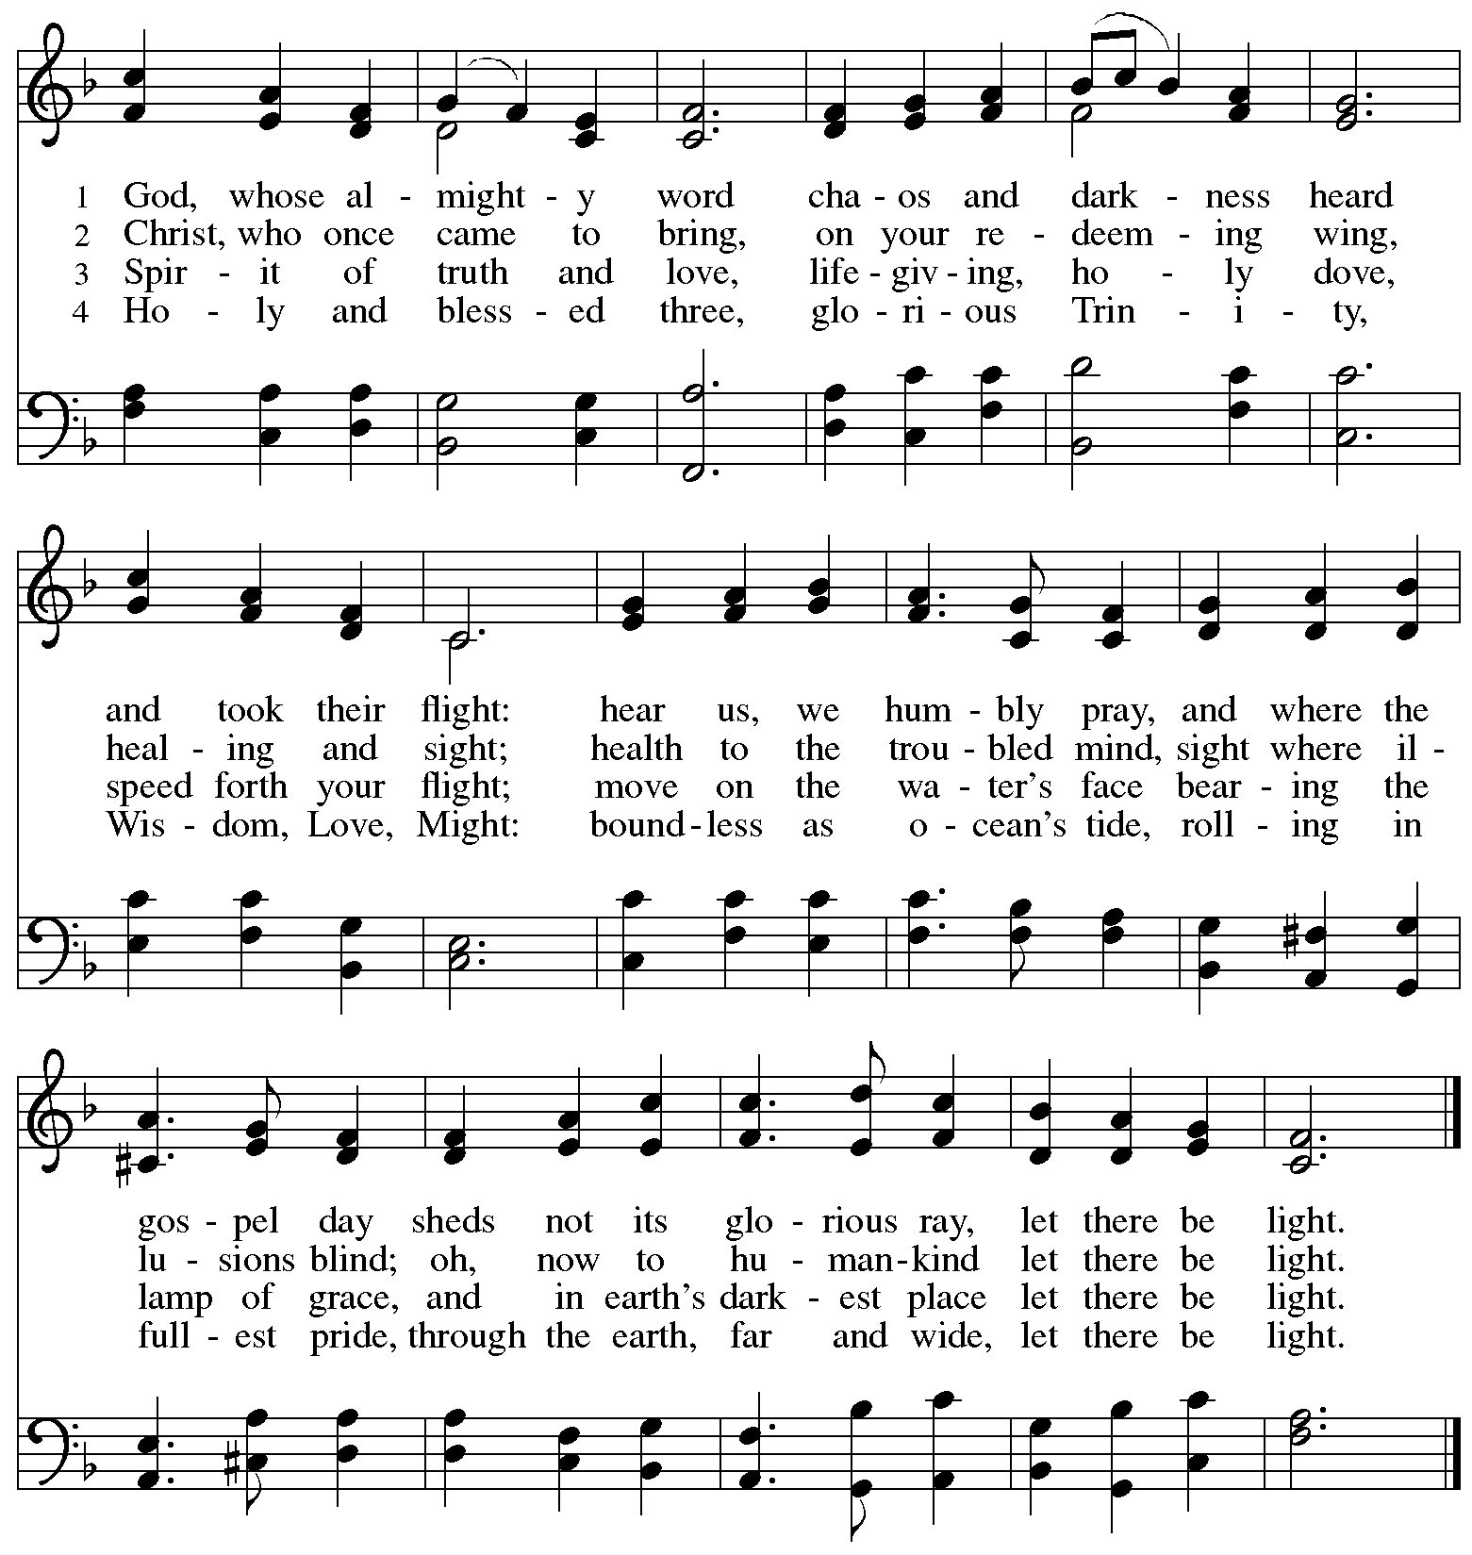

Greeting

P: The grace of our Lord Jesus Christ, the love of God,
and the communion of the Holy Spirit be with you all.
C: And also with you.

Hymn of Praise Oh, Sing of God’s Great Victory! OLS 3

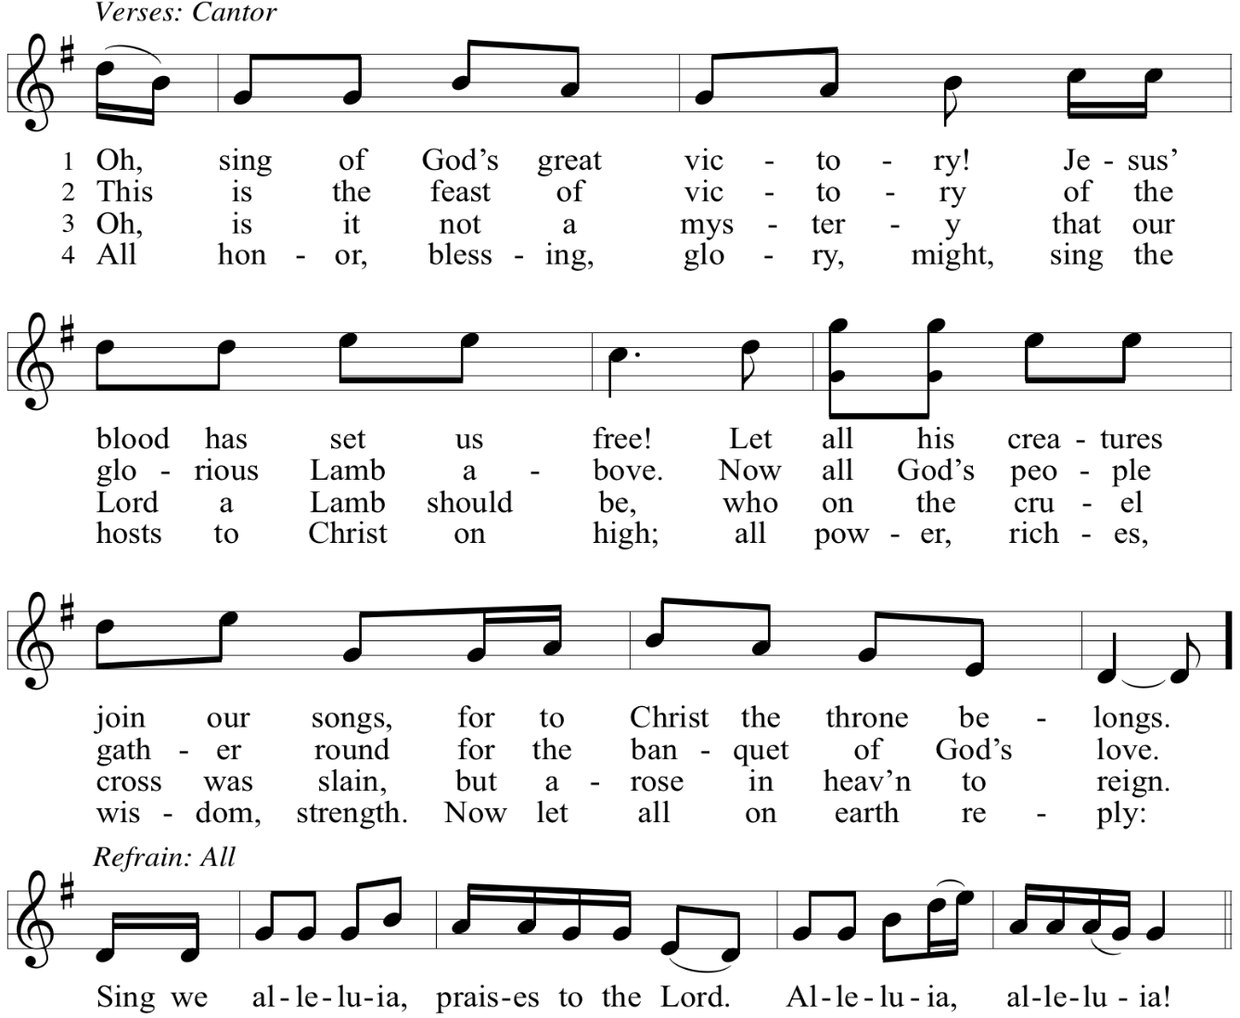

Reprinted with permission under OneLicense.net # A-722139.

Prayer of the Day

P: The Lord be with you.
C: And also with you.

P: Let us pray.
Direct us, O Lord God, in all our doings with your continual help,
that in all our works, begun, continued, and ended in you, we may glorify your holy name;
and finally, by your mercy, bring us to everlasting life,
through Jesus Christ, our Savior and Lord.
C: Amen.

Please be seated.
Children are invited to join the adult leader(s) at the side door for Little Church – Big Faith.
We ask that an additional adult from the congregation attend with the children.

Word
God speaks to us in Scripture reading, preaching, and song

First Reading – Deuteronomy 30: 15-20

¹⁵ “See, I have set before you today life and prosperity, death and adversity. ¹⁶ If you obey the commandments of the Lord your God that I am commanding you today, by loving the
Lord your God, walking in God’s ways, and observing God’s commandments, decrees, and ordinances, then you shall live and become numerous, and the Lord your God will bless you in the land that you are entering to possess. ¹⁷ But if your heart turns away and you do not hear but are led astray to bow down to other gods and serve them, ¹⁸ I declare to you today that you shall certainly perish; you shall not live long in the land that you are crossing the Jordan to enter and possess. ¹⁹ I call heaven and earth to witness against you today that I have set before you life and death, blessings and curses. Choose life so that you and your descendants may live, ²⁰ loving the Lord your God, obeying God, and holding fast to God, for that means life to you and length of days, so that you may live in the land that the Lord swore to give to your ancestors, to Abraham, to Isaac, and to Jacob.”

L: Word of God, word of life.
C: Thanks be to God.

Psalm 1

The psalm will be sung responsively, led by the cantor, with the congregation singing the verses in bold type and joining in the refrain.

Psalm Tone

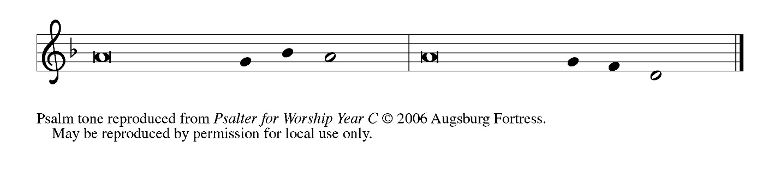

Psalm Refrain

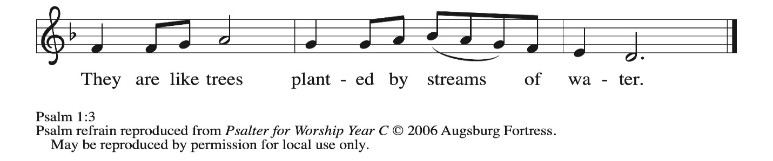

¹ Happy are they who have not walked in the counsel | of the wicked,
nor lingered in the way of sinners, nor sat in the seats | of the scornful!
² Their delight is in the law | of the Lord,
and they meditate on God’s teaching | day and night. R
³ They are like trees planted by streams of water, bearing fruit in due season, with leaves that | do not wither;
everything they | do shall prosper.
⁴ It is not so | with the wicked;
they are like chaff which the wind | blows away.
⁵ Therefore the wicked shall not stand upright when | judgment comes,
nor the sinner in the council | of the righteous.
⁶ For the Lord knows the way | of the righteous,
but the way of the wicked shall | be destroyed. R

Second Reading – Philemon 1-21

¹ Paul, a prisoner of Christ Jesus, and Timothy our brother,
To our beloved coworker Philemon, ² to our sister Apphia, to our fellow soldier Archippus, and to the church in your house:
³ Grace to you and peace from God our Father and the Lord Jesus Christ.
⁴ I thank my God always when I mention you in my prayers, ⁵ because I hear of your love for all the saints and your faith toward the Lord Jesus. ⁶ I pray that the partnership of your faith may become effective as you comprehend all the good that we share in Christ. ⁷ I have indeed received much joy and encouragement from your love, because the hearts of the saints have been refreshed through you, my brother.
⁸ For this reason, though I am more than bold enough in Christ to command you to do the right thing, ⁹ yet I would rather appeal to you on the basis of love—and I, Paul, do this as an old man and now also as a prisoner of Christ Jesus. ¹⁰ I am appealing to you for my child, Onesimus, whose father I have become during my imprisonment. ¹¹ Formerly he was useless to you, but now he is indeed useful to you and to me. ¹² I am sending him, that is, my own heart, back to you. ¹³ I wanted to keep him with me so that he might minister to me in your place during my imprisonment for the gospel, ¹⁴ but I preferred to do nothing without your consent in order that your good deed might be voluntary and not something forced. ¹⁵ Perhaps this is the reason he was separated from you for a while, so that you might have him back for the long term, ¹⁶ no longer as a slave but more than a slave, a beloved brother—especially to me but how much more to you, both in the flesh and in the Lord.
¹⁷ So if you consider me your partner, welcome him as you would welcome me. ¹⁸ If he has wronged you in any way or owes you anything, charge that to me. ¹⁹ I, Paul, am writing this with my own hand: I will repay it. I say nothing about your owing me even your own self. ²⁰ Yes, brother, let me have this benefit from you in the Lord! Refresh my heart in Christ. ²¹ Confident of your obedience, I am writing to you, knowing that you will do even more than I ask.

L: Word of God, word of life. C: Thanks be to God.

Please rise as you are able.

Gospel Acclamation O God, Whose Word Well-Planted OLS 4
v. 1-2

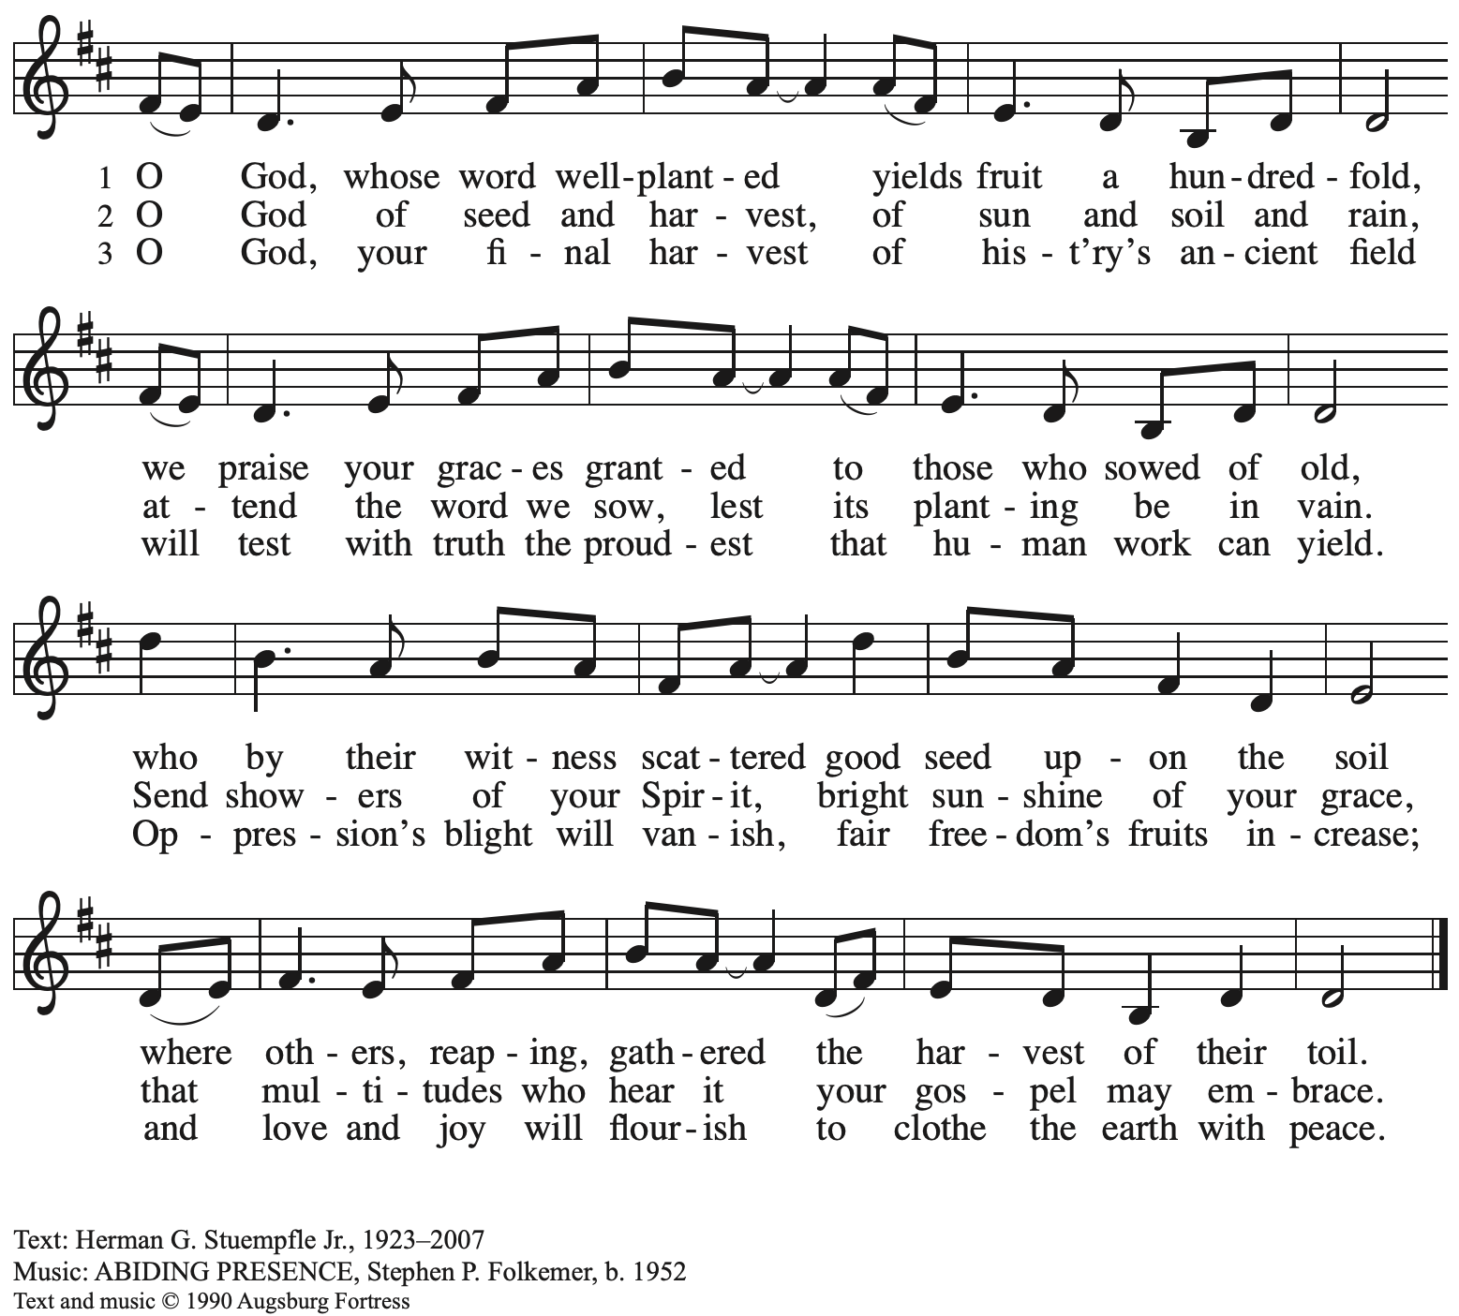 All rights reserved. Reprinted under OneLicense.net # A-722139.
Gospel – Luke 14: 25-33

P: The holy Gospel according to St. Luke.
C: Glory to you, O Lord.

²⁵ Now large crowds were traveling with [Jesus], and he turned and said to them, ²⁶ “Whoever comes to me and does not hate father and mother, wife and children, brothers and sisters, yes, and even life itself, cannot be my disciple. ²⁷ Whoever does not carry the cross and follow me cannot be my disciple. ²⁸ For which of you, intending to build a tower, does not first sit down and estimate the cost, to see whether he has enough to complete it? ²⁹ Otherwise, when he has laid a foundation and is not able to finish, all who see it will begin to ridicule him, ³⁰ saying, ‘This fellow began to build and was not able to finish.’ ³¹ Or what king, going out to wage war against another king, will not sit down first and consider whether he is able with ten thousand to oppose the one who comes against him with twenty thousand? ³² If he cannot, then while the other is still far away, he sends a delegation and asks for the terms of peace. ³³ So therefore, none of you can become my disciple if you do not give up all your possessions.”

P: The Gospel of the Lord.
C: Praise to you, O Christ.

Please be seated.

Sermon

A time of silence for prayer and reflection follows the sermon.
When the hymn of the day begins, please rise as you are able.



Hymn of the Day O God, My Faithful God ELW 806

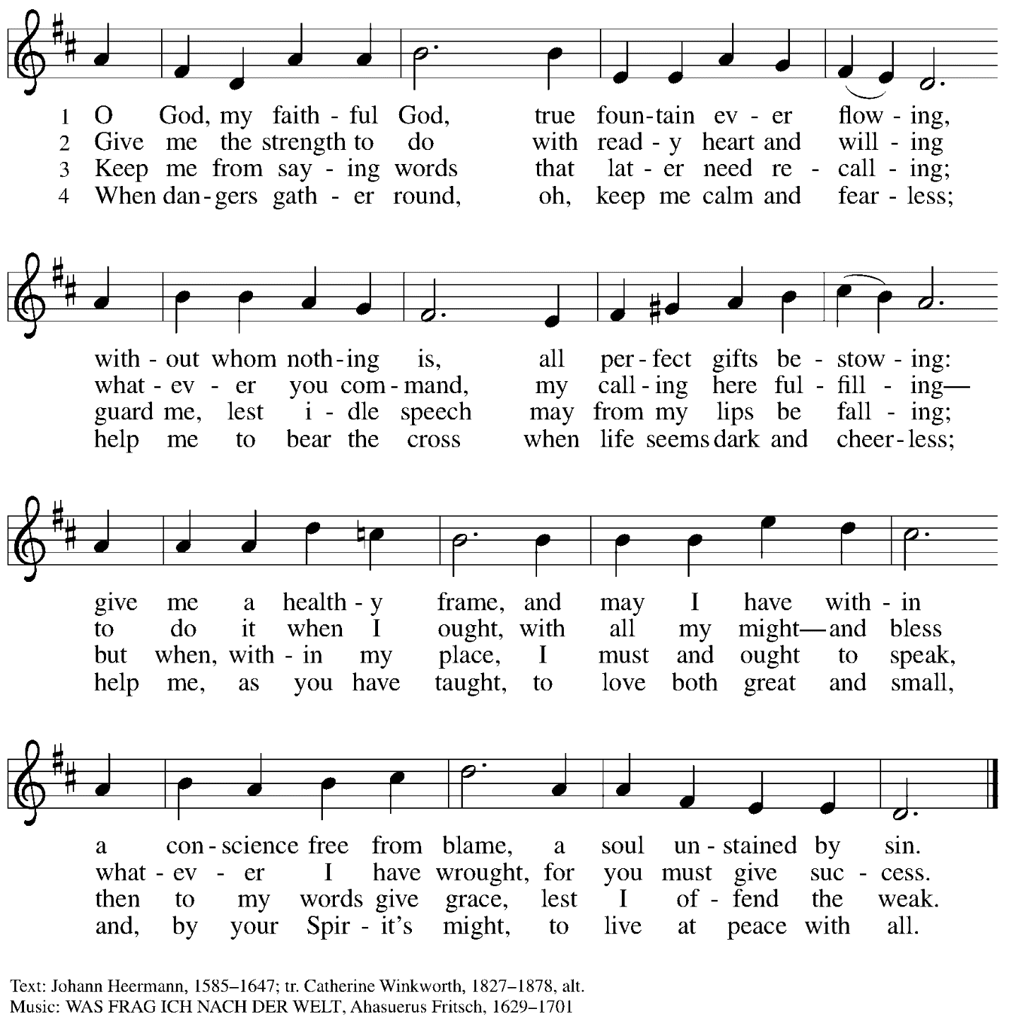

Apostles’ Creed

C: I believe in God, the Father almighty,
creator of heaven and earth.

I believe in Jesus Christ, God’s only Son, our Lord,
who was conceived by the Holy Spirit,
born of the virgin Mary,
suffered under Pontius Pilate,
was crucified, died, and was buried;
he descended to the dead.*
On the third day he rose again;
he ascended into heaven,
he is seated at the right hand of the Father,
and he will come to judge the living and the dead.

I believe in the Holy Spirit,
the holy catholic church,
the communion of saints,
the forgiveness of sins,
the resurrection of the body,
and the life everlasting. Amen.

*Or, “he descended into hell,” another translation of this text in widespread use.

When all have returned to their places, worship continues with the Prayers of the People.

Prayers of the People

A: With the whole people of God in Christ Jesus,
let us pray for the church, those in need, and all of God’s creation.

After each petition
A: Lord, in your mercy,
C: receive our prayer.

P: Into your hands, gracious God, we commend all for whom we pray,
trusting in your mercy; through Jesus Christ, our Savior.
C: Amen.

Peace

The presiding minister and the assembly greet one another in the peace of the risen Christ.
P: The peace of Christ be with you always.
C: And also with you.

The people may greet those around them with a sign of Christ’s peace and may say
Peace be with you or similar words. Please be mindful that not everyone will be comfortable with sharing the peace, so please seek consent before shaking hands or hugging. Other possible ways to share the peace include a simple bow with the verbal greeting of peace, or simply a verbal expression of peace.

When the greetings of peace have concluded, please be seated.

Meal
God feeds us with the presence of Jesus Christ



Offering

We offer ourselves, our gifts, and our faithful service to God.
As the offering is gathered for the mission of the church, including the care of those in need,
the table is set for Holy Communion.

There are laminated giving cards in the pew racks that feature a QR code for anyone who would like to give online. Those who give using the QR code, as well as those who give regularly online or through their bank are encouraged to place the laminated card in the plate as an expression of your offering.

Reparations Offering

On the first Sunday of each month, St. Andrew invites people of the congregation to give a second offering for a reparations fund in acknowledgement of St. Andrew’s use of African American spiritual songs in our worship services. Please see the note in the announcements for more information.

Offertory Music The Reign of God, Like Farmer’s Field arr. Kim

As the gifts are brought forward for presentation, please rise as you are able.

Offertory Song Accept, O Lord, the Gifts We Bring OLS 5

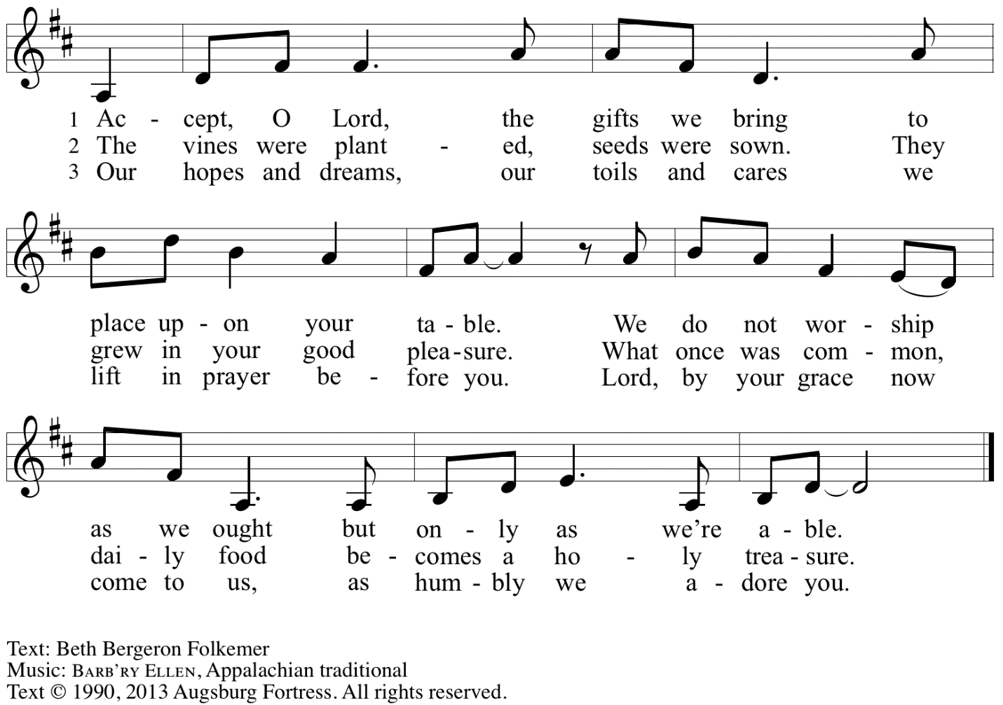
Reprinted with permission under OneLicense.net # A-722139.

Offertory Prayer

A: Let us pray.
Gracious God,
C: you bless us with gifts of guidance, new life,
Growth in grace, and fruitful labor.
Accept the first fruits of time and toil, field and orchard,
that we offer here.
Bless and multiply these gifts to our nurture
and to the care of your creation;
for the sake of your Son, Jesus Christ our Lord.
Amen.

Dialogue

P: The Lord be with you.
C: And also with you.

P: Lift up your hearts.
C: We lift them to the Lord.

P: Let us give thanks to the Lord our God.
C: It is right to give our thanks and praise.

Preface

P: It is indeed right, our duty and our joy…
we praise your name and join in adoring song:

Sanctus Holy, Holy, Holy OLS 6

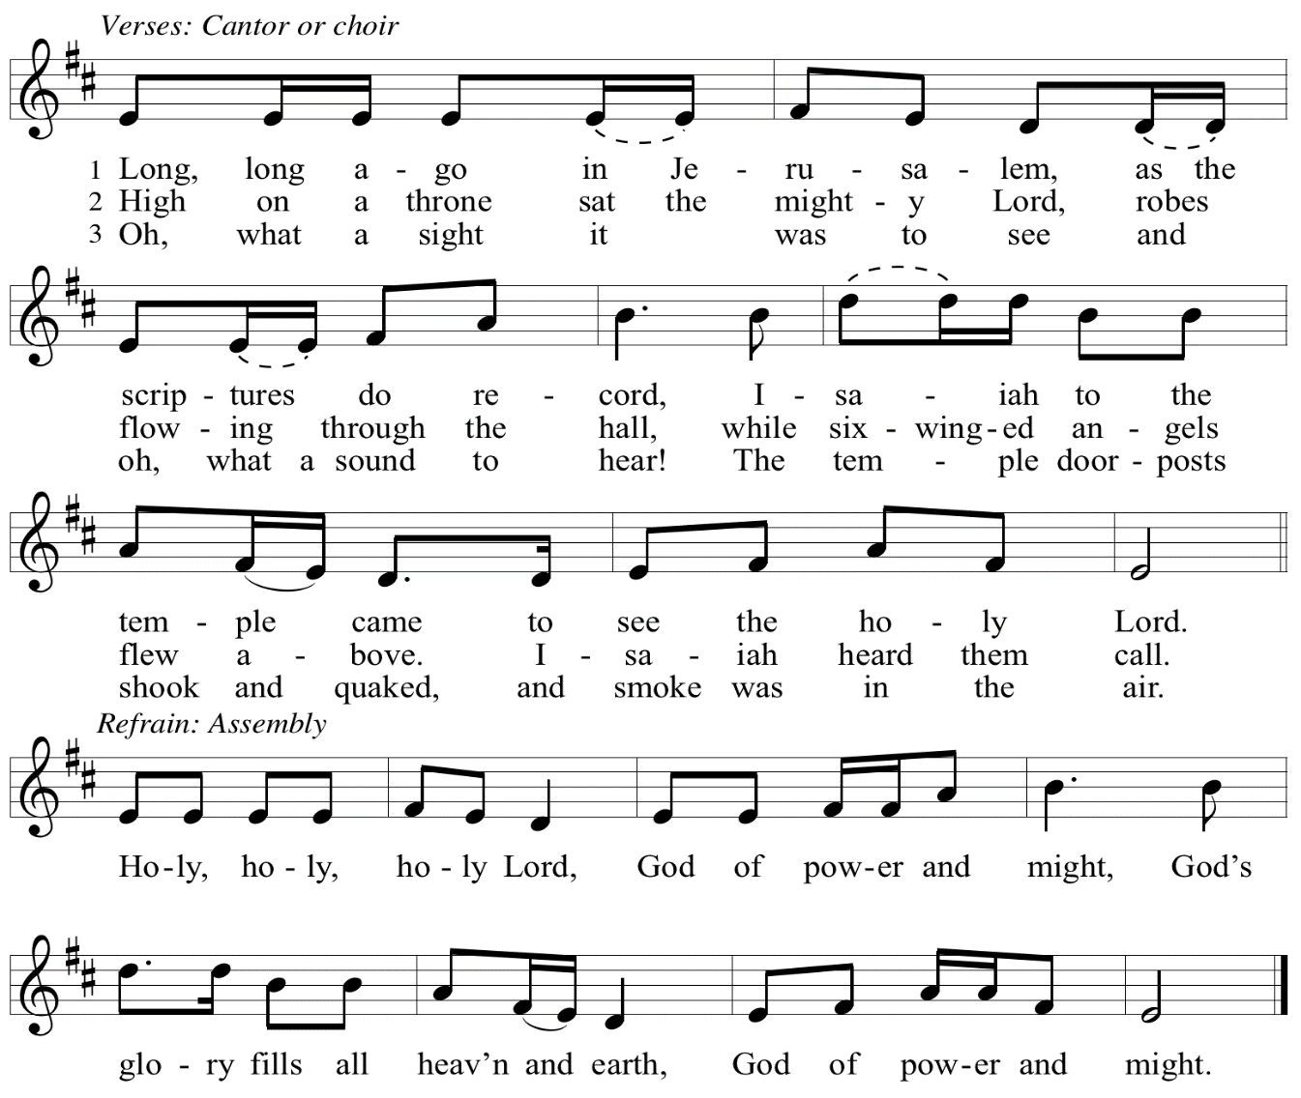

Eucharistic Prayer

P: Let the peoples praise you, generous and abundant Creator: …
… in generosity to all in need.

United by your Spirit with all your people,
we pray through your Son, Jesus Christ,
to you, our Source and our Goal, our Sun and our Shield, our God now and forever.
C: Amen.

Lord’s Prayer

P: Gathered as one by the Holy Spirit, let us pray as Jesus taught us.
C: Our Father in heaven,
hallowed be your name,
your kingdom come,
your will be done,
on earth as in heaven.
Give us today our daily bread.
Forgive us our sins
as we forgive those
who sin against us.
Save us from the time of trial
and deliver us from evil.
For the kingdom, the power,
and the glory are yours,
now and forever. Amen.

Fraction and Invitation

P: Just as this broken bread was first scattered on the hills, then was brought together and became one, so let your church be brought together from the ends of the earth into your kingdom, for yours are the glory and the power through Jesus Christ forever.
C: Amen.



Agnus Dei / Lamb of God OLS 7
O Lamb of God, to Earth You Came

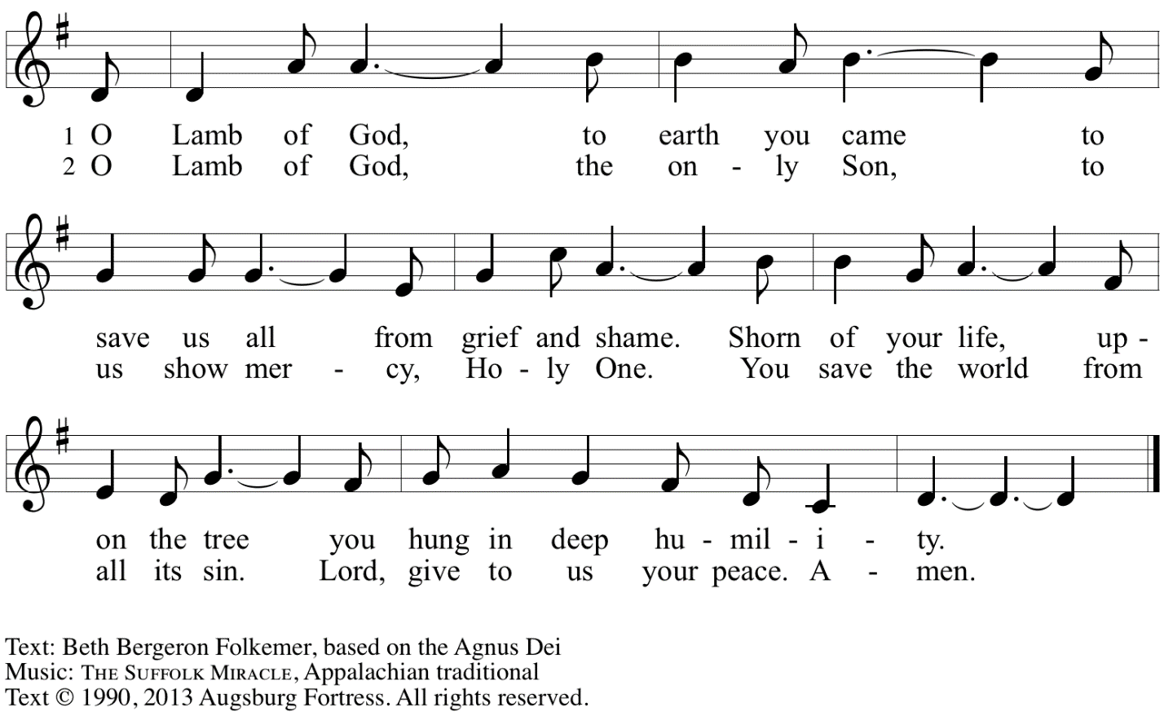
Reprinted with permission under OneLicense.net A# A-722139.

Please be seated.

Holy Communion

- All who seek God and desire a deeper and stronger life in Christ are welcome to receive Holy Communion.
- Worshipers from the pulpit side will proceed forward first, followed by the center section, and then the lectern side.
- Please inform an usher if you would like the ministers to bring Communion to you.
- Holy Communion will be served with bread and wine (amber) or grape juice (purple).
- The presiding minister will first distribute the bread (host) to each communicant. Please indicate if you require a gluten-free host.
- Once you have consumed the bread, please pick up an empty glass from the tray next to the presiding minister. The Communion Assistant will pour wine or grape juice into your glass.
- Please step to the side to consume the wine or grape juice.
- Feel free to kneel at the altar rail for prayer after receiving the sacrament.
- As you return to your pew, glasses may be returned to the empty tray on the side of the center section.
- A blessing will be provided for anyone who does not yet receive the sacrament.
- All are invited to join in singing the hymns during Holy Communion.
Hymns during Holy Communion
Listen to the Word ACS 974

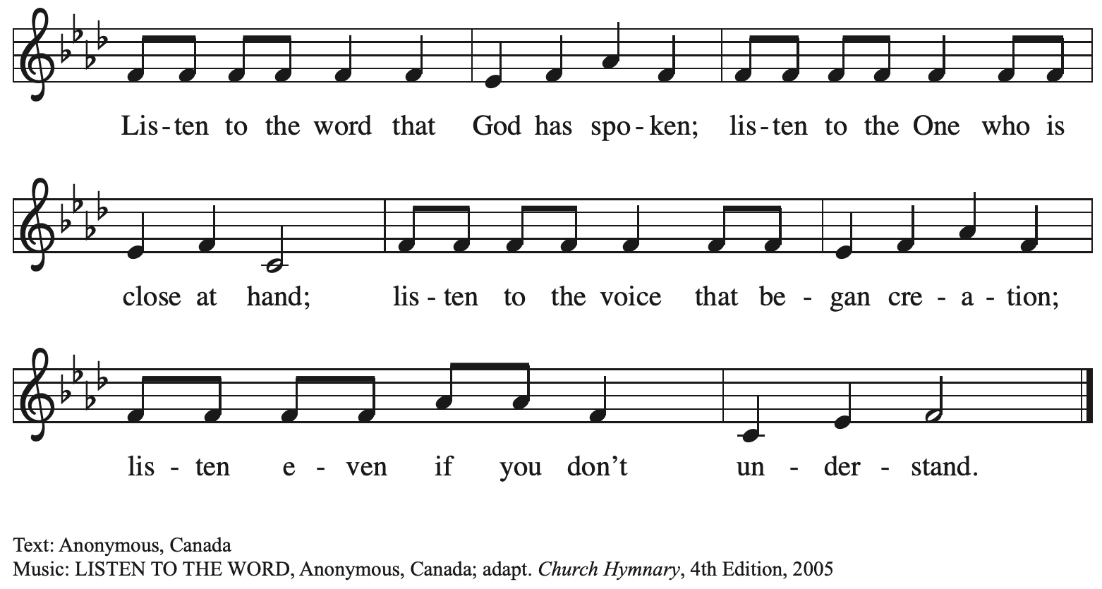

Hymns during Holy Communion
Oh, That the Lord Would Guide My Ways ELW 772

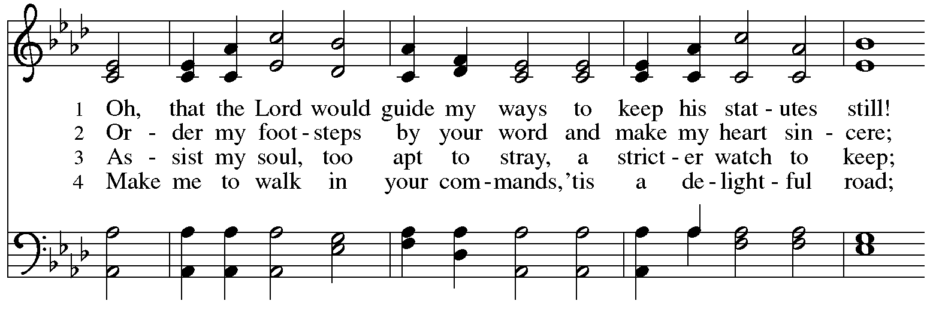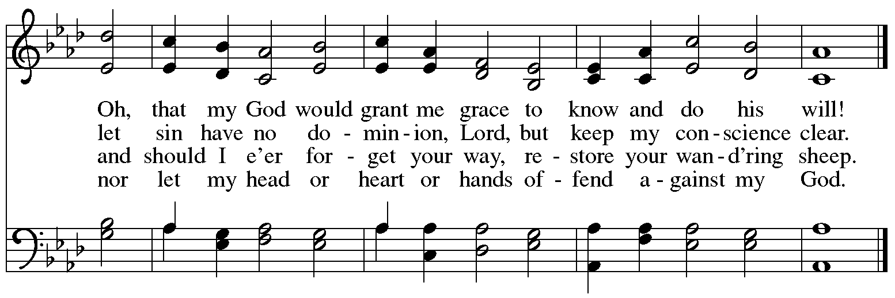

Hymns during Holy Communion
Take, Oh, Take Me as I Am ELW 814

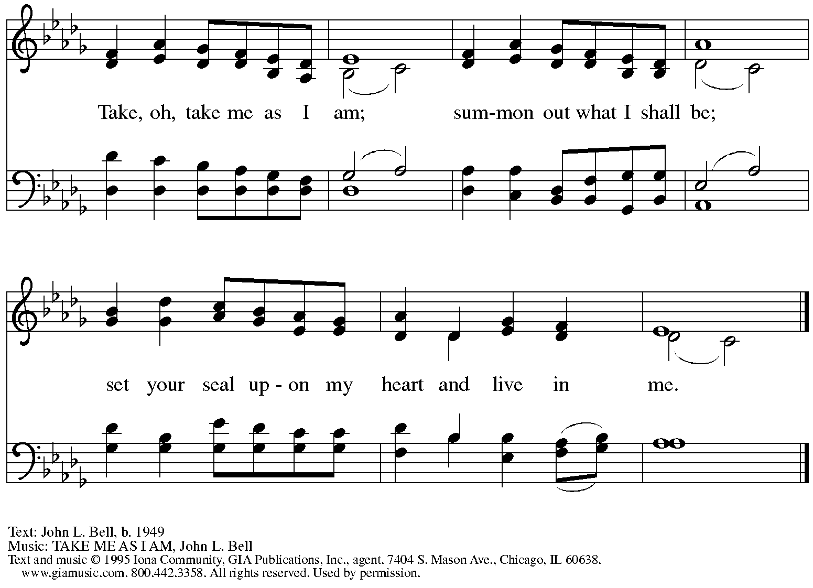
Reprinted under OneLicense.net # A-722139.

Hymns during Holy Communion
Open Your Ears, You Faithful People ELW 519

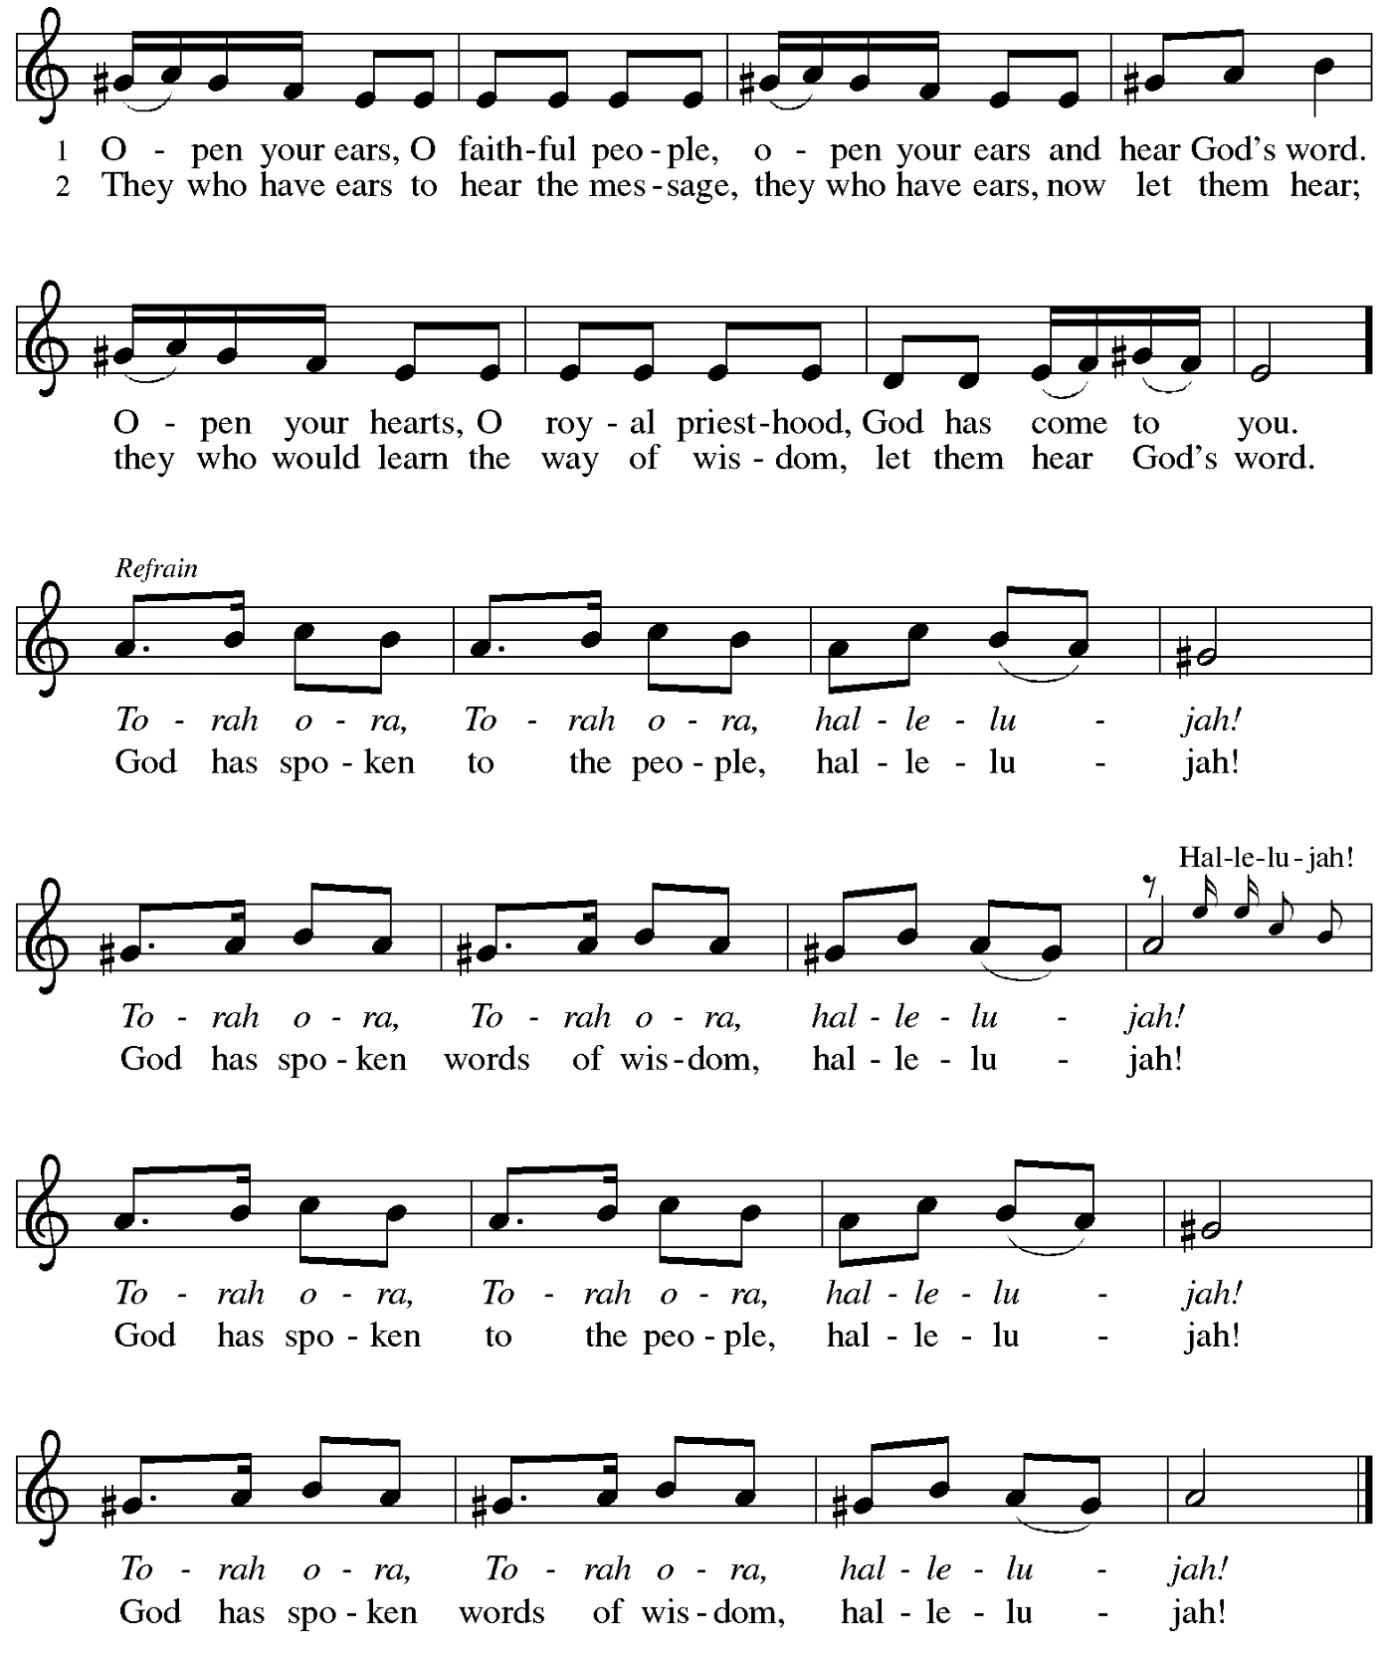
Reprinted under OneLicense.net # A-722139.

When all have returned to their places, please rise as you are able.

Blessing

P: The body and blood of our Lord Jesus Christ strengthen you and keep you in his grace.
C: Amen.

Prayer

A: Let us pray.
Gracious God,
we give thanks for your pruning, planting, and nurture.
We rejoice that you have used the harvest of field and vineyard
to renew and sustain us.
Lead us as we go from this life-giving meal
into lives of grateful service to you and your cherished creation;
through Jesus Christ, your Son, our Lord.
C: Amen.

Please be seated.

Sending
God blesses us and sends us in mission to the world

Announcements

Please rise as you are able.

Benediction

P: The God of steadfastness and encouragement
grant you to live in harmony with one another,
in accordance with Christ Jesus.
C: Amen.

P: The God of hope fill you with all joy and peace in believing,
so that you may abound in hope by the power of the Holy Spirit.
C: Amen.

P: The God of all grace ☩ bless you now and forever.
C: Amen.

Sending Hymn Lift High the Cross ELW 660

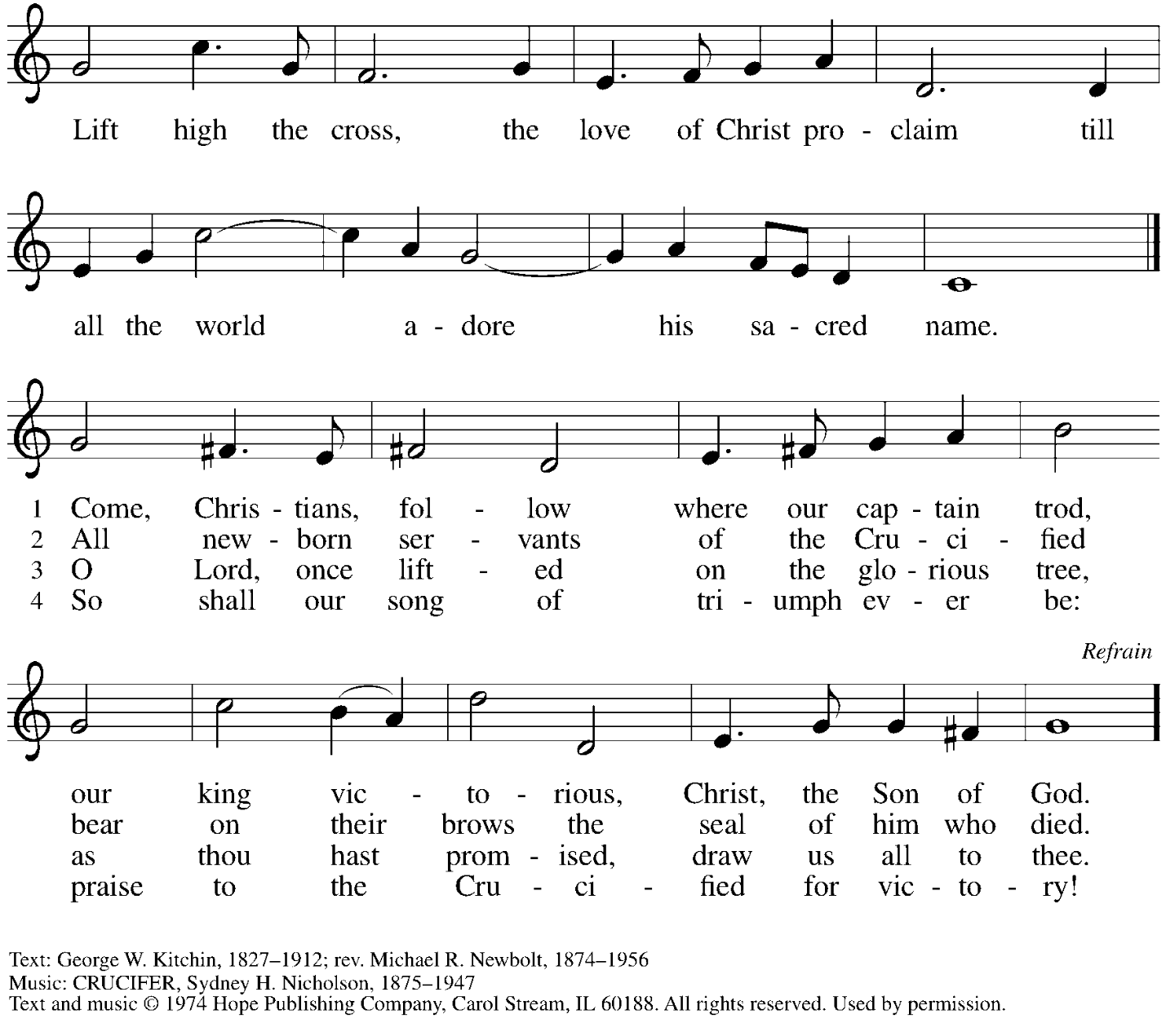
Reprinted under OneLicense.net # A-722139.

Dismissal

A: Go in peace. Serve the Lord.
C: Thanks be to God!

Postlude

Serving in Worship Today

Altar Care Jodie Minor
Assisting Minister Timothy Kocher-Hillmer
Audio-Visual Ministers David Rollinson
Sarita
Cantor C.E. Pino
Lector Alda Maria Gonzaga
Minister of Music Laura Reynolds
Presiding Minister The Rev. Ross Carmichael

Liturgy and Hymnody Acknowledgements

From SundaysandSeasons.com. Copyright © 2025 Augsburg Fortress. All rights reserved. Reprinted under OneLicense.net # A-722139.
Used by permission of Augsburg Fortress.

The Scripture readings contained herein are from New Revised Standard Version Updated Edition of the Bible © 2021 National Council of Churches of Christ in the United States of America. Used by permission. All rights reserved worldwide.

Holy, Holy, Holy / Long, Long Ago in Jerusalem – Text: Beth Bergeron Folkemer, based on the Sanctus. Music: SHADY GROVE, Appalachian traditional. Text © 1990, 2013, Augsburg Fortress. All rights reserved. Reprinted with permission under OneLicense.net # A-722139.

Please use the QR code below to link to St. Andrew’s Announcements online!



St. Andrew Lutheran Church Announcements
September 7th, 2025

- Welcome to Worship at St. Andrew on the Thirteenth Sunday after Pentecost! – We are so glad you are here, and we offer a special welcome to all visitors and guests who are here for the first time! A nursery is available through the door to the left of the worship space and across the social hall (look for a purple room). Little Church – Big Faith, a Bible lesson and activity for children up to sixth grade, will take place after the prayer of the day. There are also worship “toolkits” to help children engage with worship and “busy bags” for younger children available in the bookcase at the back of the sanctuary. Please feel free to take one to use with/for your children. All are invited to stay for coffee and other drinks, food, and conversation in the Social Hall (through the side door at the left of the worship space) after the service.
- Little Church – Big Faith Resumes Today! – Little Church-Big Faith is a time set aside for a Bible lesson and activity for children up to sixth grade. After the prayer of the day, the presiding minister will invite children to meet their teacher at the door on the left side of the worship space. The group returns to worship for the service of Holy Communion.
- Monthly Reparations Offering Today during Worship – In Luke’s Gospel, Jesus tells a story about a compassionate Samaritan, suggesting that God’s people are called to work for healing and restoration for our neighbors, regardless of who or what caused them harm. In light of this, St. Andrew has made a commitment to reparations in regard to African American spiritual songs used in our worship. The text and music of most hymns is attributed to specific authors, with copyrights in place, usage reported, and royalties paid to those whose works are featured in worship. With African American spirituals, this is not possible. In response to many years of such uncredited use, St. Andrew invites the congregation to give a reparations offering. Funds received in worship will be donated to our siblings at Bethel AME Church, whose land and building were taken from them in the 1950s, to fund their development in the Hill District.
- Welcome Jamie Donne from The Neighborhood Academy! – This summer, St. Andrew took part in a ministry initiative with several Episcopal congregations to provide backpacks for students at The Neighborhood Academy at the start of the school year. Jamie Donne, Assistant Director of Development at The Neighborhood Academy, is here today to tell us a more about the school, as well as the context and impact of the backpack project. Welcome, Ms. Donne, and thank you for taking time to speak with the congregation!
- Community Ministry Team Meeting – Monday, September 8th, 7:00 p.m. on Zoom –
St. Andrew’s community ministry team plans for and leads the congregation’s ministries of service to the community, including the monthly produce distribution, East End Cooperative Ministry shelter dinner, the outdoor pantry and little library, and more. All are welcome to participate. The next meeting will be Monday, September 8th, on Zoom at 7:00 p.m. Please use the link here to join the meeting: https://us02web.zoom.us/j/89385884806?pwd=aytsDaCywdjNTe5QmHbtk3AVPA6c40.1, and contact council liaison Tyler Rietze at community@standrewpittsburgh.org if you have any questions or need assistance joining the meeting.
- September Shelter Dinner for Guests of East End Cooperative Ministry – Third Thursday of the Month, September 18th, 6:30 p.m. – Each month, people of St. Andrew provide dinner for guests of East End Cooperative Ministry (EECM), 6140 Station St. (East Liberty), 15206. We invite you to prepare or purchase one menu item and bring it to the shelter by 6:00 p.m., or just come to help serve at 6:30 p.m. You can sign up at this following link: https://www.signupgenius.com/go/5080544AAAC22A1F58-58193716-sept
- Invitation to Prayer Team and New Address! – St. Andrew maintains a list of weekly prayer concerns that is sent by email, usually on Wednesdays, to members of the congregation who have opted in. In an effort to coordinate our communications under our organization’s Google Workspace, our new prayer team email address is prayerteam@standrewpittsburgh.org. Any prayer concerns or requests can be sent to this address in the future. As we renew this prayer ministry, we will also move to a practice of keeping names on the list for a maximum of four weeks unless otherwise requested. Thank you for your ministry of prayer!
- Records Update - Please Respond – St. Andrew is looking to update our records with information from newer attendees, as well as offering current members the opportunity to include current information. This includes name, preferred pronouns, email, phone number, birthdays, anniversaries, and more. The information will only be used within the congregation - for example to acknowledge celebrations and milestones in worship, in the prayers of the church, or in the weekly newsletter. Please fill out the form at: https://forms.gle/kKvp19UozuRrhhaV7.
- Coffee Hour Signups – Coffee Hour will resume September 7th. If you would like to participate and would like additional information about the duties, please sign up using the following form: https://www.signupgenius.com/go/5080B4AAFAF2CABF85-47069030-coffee#/.
- Pittsburgh Compline Choir – Sundays at 8:00 p.m. at Heinz Chapel, starting September 7th – Compline was traditionally a monastic prayer service, and the Pittsburgh Compline Choir, a ministry of Lutheran Campus Ministry in Greater Pittsburgh, sings a choral version of compline rooted in this thousand-year-old tradition of scripture, song, and silence each Sunday at Heinz Chapel at 8:00 p.m. This service also streams on Facebook (Pittsburgh Compline Choir) and YouTube (The Pittsburgh Compline Choir). Heinz Chapel is located off of S. Bellefield Ave. in Oakland. For more information, please visit: Pittsburgh Compline Choir.
- Christ in Our Home Devotional Booklets for July-September Available at Entrances – This resource offers a daily Bible reading with a short reflection and prayer, along with additional readings and prayer topics for those who would like to expand their devotional practices. We encourage people of the congregation to take one for yourself, your family/household, or others.





