

+ Fifteenth Sunday after Pentecost
September 21, 2025



St. Andrew Lutheran Church
304 Morewood Ave.
Pittsburgh, PA 15213
St_andrewELCA@verizon.net
www.standrewpittsburgh.org

+ Fifteenth Sunday after Pentecost
Order for Worship

As we are invited today to consider what it means to be managers (rather than owners) of all that we have, it is crucial to recognize that we are bought with a price. “Christ Jesus, himself human, . . . gave himself a ransom for all.” Apart from the generosity of God we have nothing—we are nothing. By God’s gracious favor we have everything we need.

Welcome to St. Andrew!
- St. Andrew welcomes all who are seeking a place of healing, wholeness, and acceptance in a nurturing and faith-forming spiritual home. We are striving toward racial equity worldwide
and we seek to honor the lived experience of all individuals regardless of background. Our community embraces people of all ages, ethnicities, cultures, abilities, sexual orientations,
gender identities and expressions, and family constellations. Come and See!
- Worship Services are live-streamed to multiple online platforms. By attending worship, you agree that your image and voice may be broadcast.
- Everyone is invited to make a name tag at the black bookcase in the back of the worship space if they would like. There are stickers indicating pronouns on the bookcase if you would like to include them on your name tag.
- A nursery is available through the doors at the left side of the sanctuary and across from the doorway to the Social Hall. Look for a purple-colored room.
- Children are invited to attend Little Church – Big Faith, a Bible lesson and activity, during worship (after the Prayer of the Day). The group returns to the worship space for the liturgy of Holy Communion.
- Worship “toolkits” to help children engage with the service, along with “busy bags” for younger children, are available in the bookcase at the back of the sanctuary. Please feel free to take one to use with/for your children.
- Holy Communion is served with bread (gluten-free available) and wine or grape juice. The presiding minister will distribute the bread (host). Please consume this and then pick up an empty glass from the tray. The Communion Assistant will pour wine or grape juice into your glass. Please step to the side to consume the wine or grape juice. Feel free to kneel at the altar for prayer and reflection. As you return to your pew, glasses may be returned to the empty trays on either side of the center section.
- A restroom is available on the main level of the church, through the doors to the Social Hall and to the right in the main office.

Abbreviations
P: Pastor/Presiding Minister ELW: Evangelical Lutheran Worship hymnal
A: Assisting Minister ACS: All Creation Sings hymnal
L: Lector OLS: Of the Land and Seasons
C: Congregation TFF: This Far by Faith hymnal

Musical Offering

Each week, different people from the congregation make an offering of pre-service music, with singing or instrumentation, to help the assembly focus and pray in preparation for worship.

Welcome

Prelude I Surrender All Weeden/arr. Keveren

Gathering
The Holy Spirit calls us together as the people of God

Please rise as you are able. All may make the sign of the cross,
the sign that is marked at Baptism, as the presiding minister begins.

Confession and Forgiveness

P: In the name of Father
and of the ☩ Son,
and of the Holy Spirit.
C: Amen.

P: Let us confess our sins in the presence of God and one another.

Silence is kept for reflection.

P: Most Merciful God,
C: we confess that we are captive to sin and cannot free ourselves.
We have sinned against you in thought, word, and deed,
by what we have done and by what we have left undone.
We have squandered your bountiful gifts.
We have considered the blessings of the harvest our due.
We have been indifferent in planning and planting
for the future needs of your church.
For the sake of your Son, Jesus Christ, have mercy on us.
Forgive us, cause gratitude to ripen in our hearts,
and wisdom to mature in our minds,
so that we may delight in your will and follow in your ways,
to the glory of your holy name.
Amen.

P: God, who is rich in mercy,
Loved us even when we were dead in sin
and made us alive together with Christ.
By grace you have been saved.
In the name of ☩ Jesus Christ, your sins are forgiven.
Almighty God strengthen you with power through the Holy Spirit,
that Christ may live in your hearts through faith.
C: Amen.

Gathering Hymn God of the Fertile Fields ACS 1063

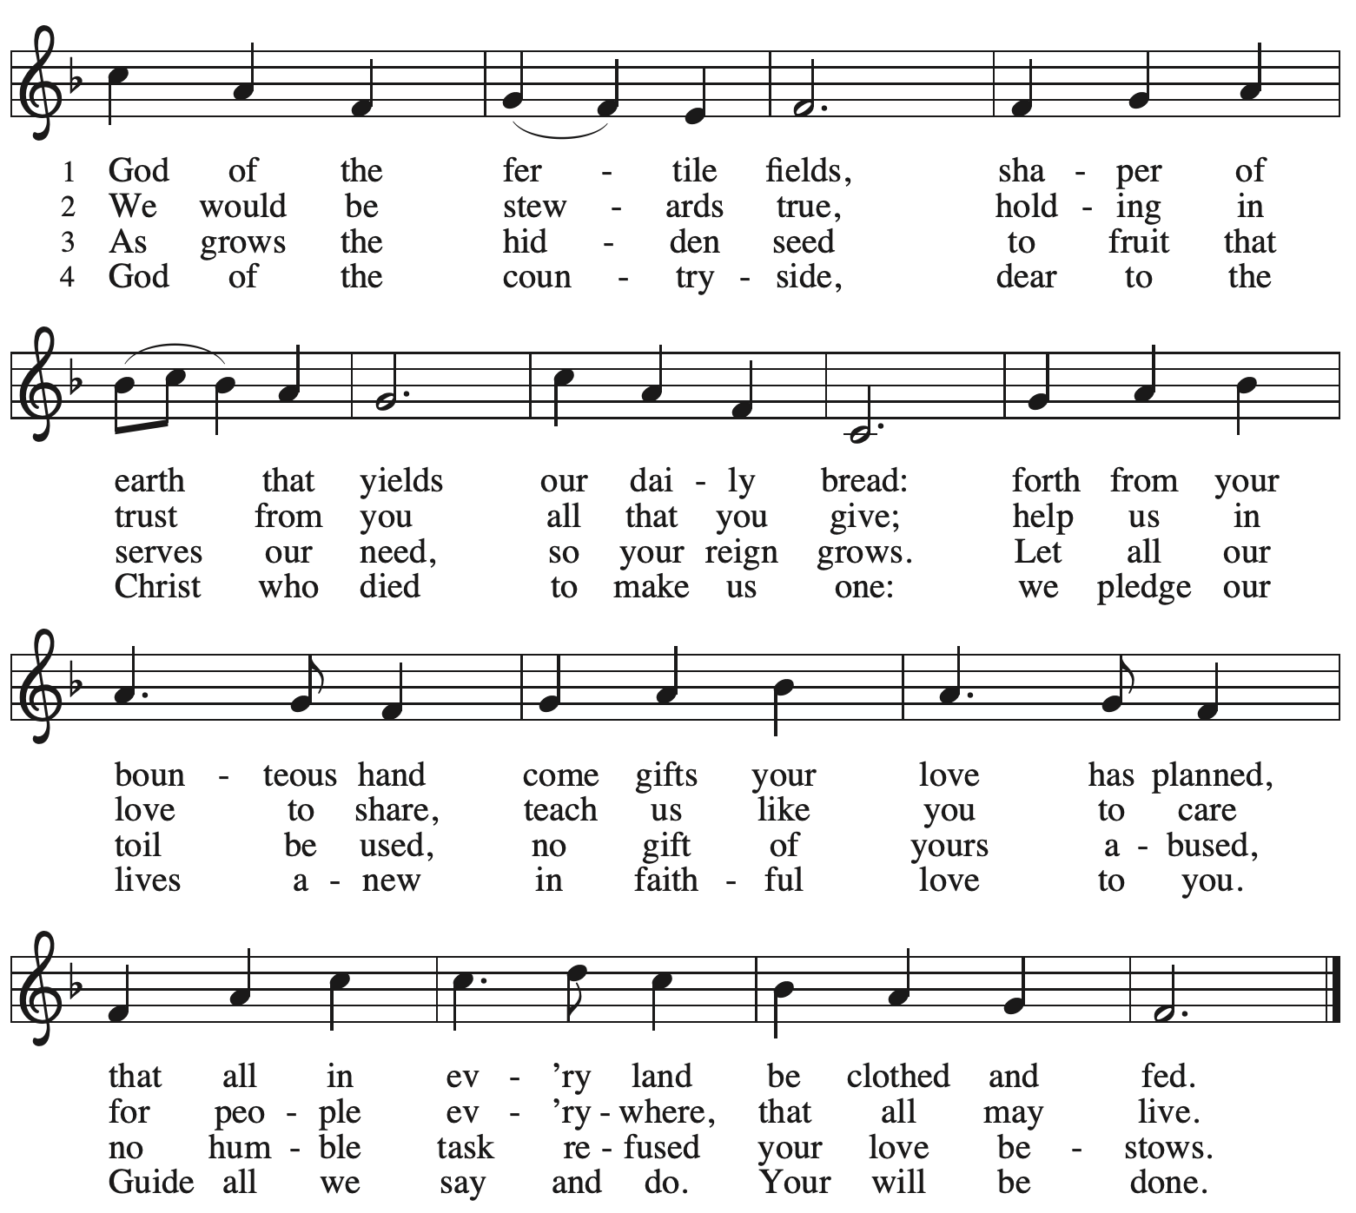
Reprinted with permission under OneLicense.net # A-722139.

Greeting

P: The grace of our Lord Jesus Christ, the love of God,
and the communion of the Holy Spirit be with you all.
C: And also with you.

Hymn of Praise Oh, Sing of God’s Great Victory! OLS 3

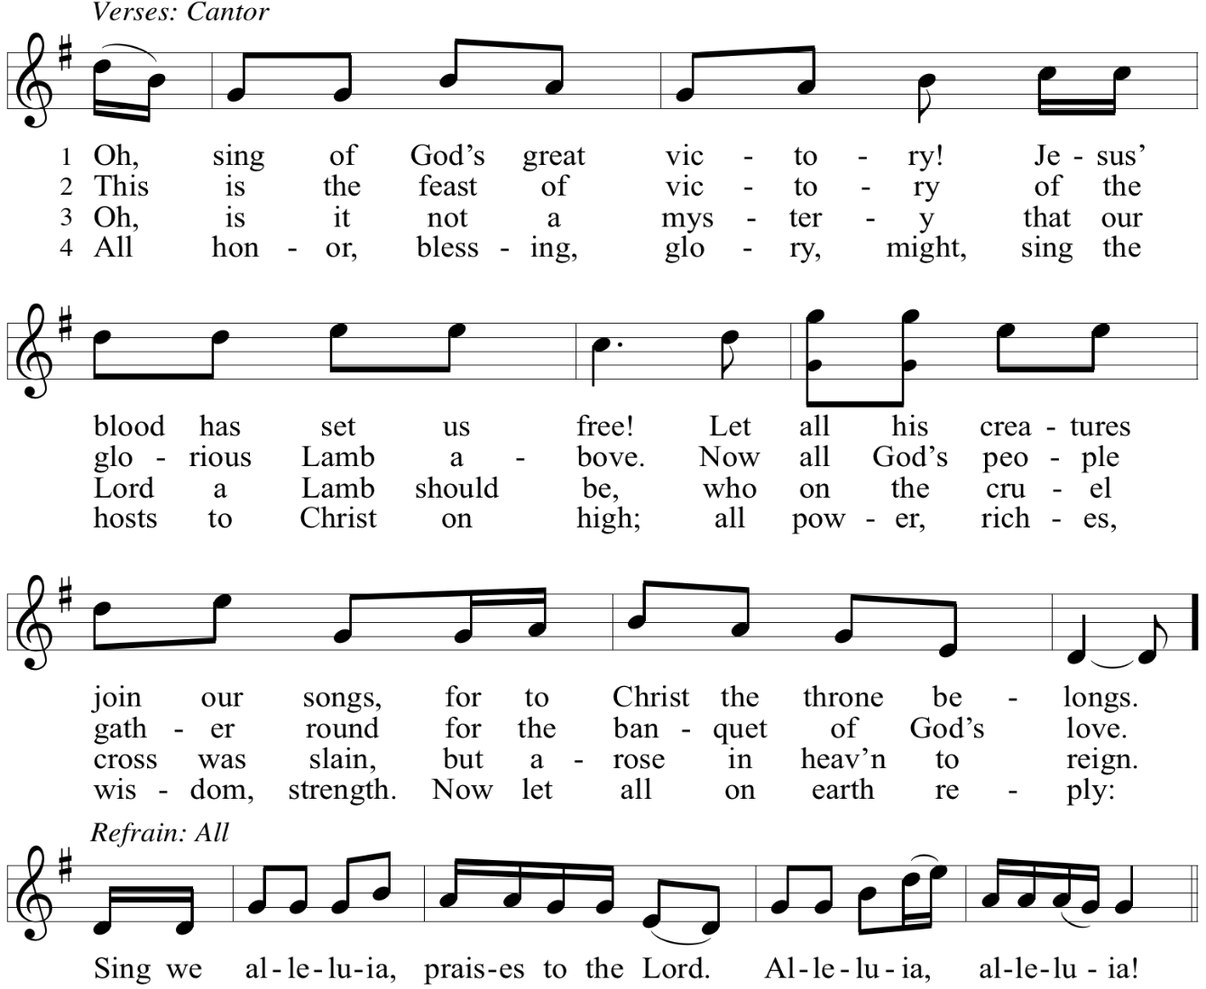

Reprinted with permission under OneLicense.net # A-722139.

Prayer of the Day

P: The Lord be with you.
C: And also with you.

P: Let us pray.
God among us, we gather in the name of Jesus to learn love for one another.
Keep our feet from evil paths. Turn our minds to your wisdom and our hearts to the grace
revealed in your Son, Jesus Christ, our Lord.
C: Amen.

Please be seated.
Children are invited to join the adult leader(s) at the side door for Little Church – Big Faith.
We ask that an additional adult from the congregation attend with the children.

Word
God speaks to us in Scripture reading, preaching, and song

First Reading – Amos 8: 4-7

⁴ Hear this, you who trample on the needy,
and bring to ruin the poor of the land,
⁵ saying, “When will the new moon be over
so that we may sell grain,
and the Sabbath,
so that we may offer wheat for sale?
We will make the ephah smaller and the shekel heavier
and practice deceit with false balances,
⁶ buying the poor for silver
and the needy for a pair of sandals
and selling the sweepings of the wheat.”
⁷ The Lord has sworn by the pride of Jacob:
Surely I will never forget any of their deeds.

L: Word of God, word of life.
C: Thanks be to God.

Psalm 113

The psalm will be sung responsively, led by the cantor, with the congregation singing the verses in bold type and joining in the refrain.

Psalm Tone

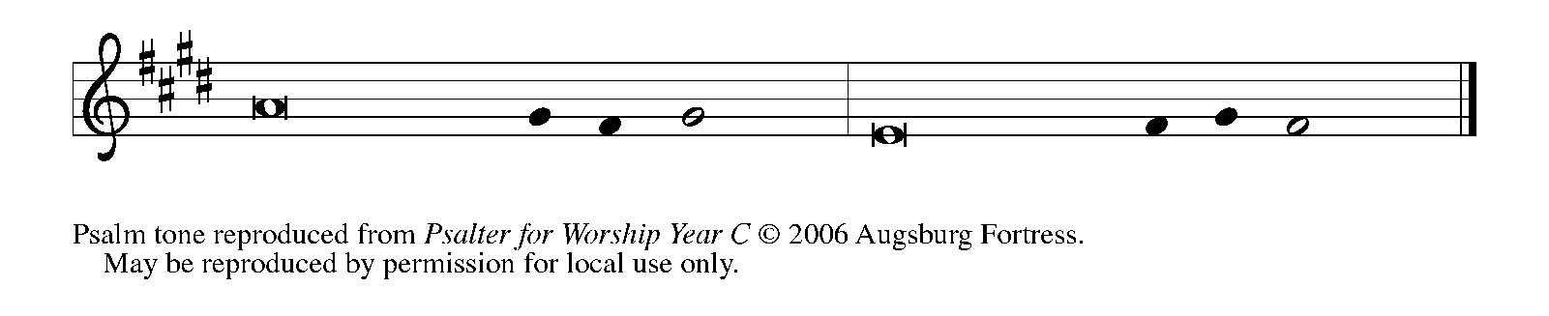

Psalm Refrain

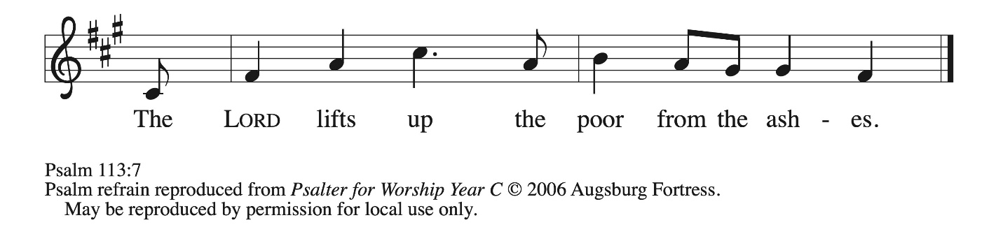

¹ Hallelujah! Give praise, you servants | of the Lord;
praise the name | of the Lord.
² Let the name of the | Lord be blessed,
from this time forth for- | evermore.
³ From the rising of the sun to its | going down
let the name of the | Lord be praised.
⁴ The Lord is high a- | bove all nations;
God’s glory a- | bove the heavens. R
⁵ Who is like the | Lord our God,
who sits en- | throned on high,
⁶ but stoops | to behold
the heavens | and the earth?
⁷ The Lord takes up the weak out | of the dust
and lifts up the poor | from the ashes,
⁸ enthroning them | with the rulers,
with the rulers | of the people.
⁹ The Lord makes the woman of a | childless house
to be a joyful mother of children. | Hallelujah! R

Second Reading – 1 Timothy 1: 12-17

¹ First of all, then, I urge that supplications, prayers, intercessions, and thanksgivings be made for everyone, ² for kings and all who are in high positions, so that we may lead a quiet and peaceable life in all godliness and dignity. ³ This is right and acceptable before God our Savior, ⁴ who desires everyone to be saved and to come to the knowledge of the truth. ⁵ For
there is one God;
there is also one mediator between God and humankind,
Christ Jesus, himself human,
⁶ who gave himself a ransom for all
—this was attested at the right time. ⁷ For this I was appointed a herald and an apostle (I am telling the truth; I am not lying), a teacher of the gentiles in faith and truth.

L: Word of God, word of life.
C: Thanks be to God.

Please rise as you are able.

Gospel Acclamation O God, Whose Word Well-Planted OLS 4
v. 1-2

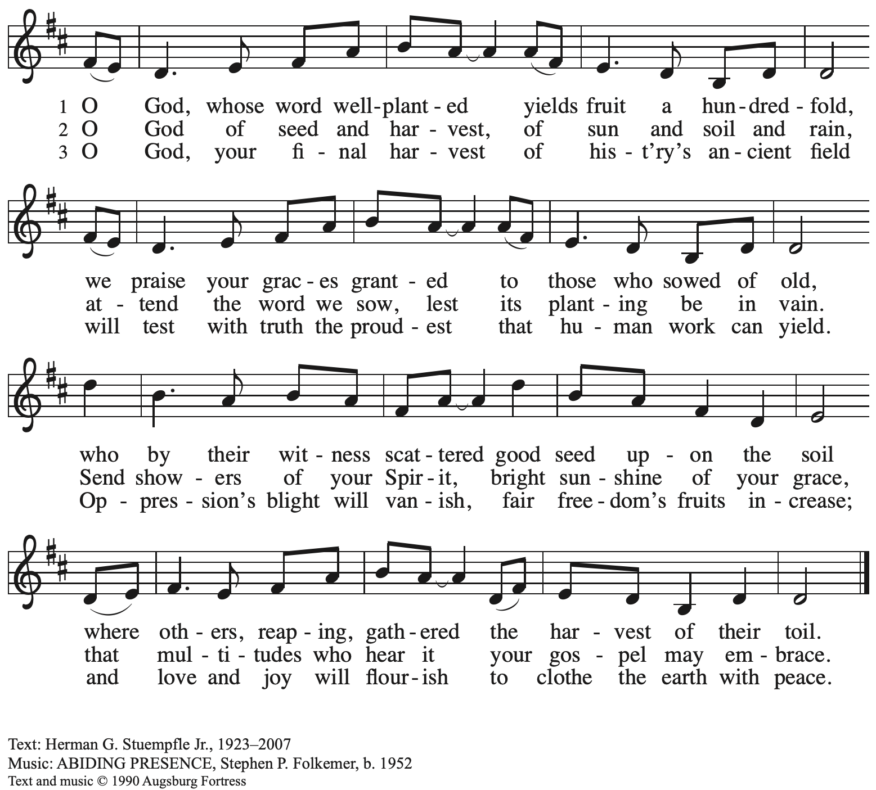 All rights reserved. Reprinted under OneLicense.net # A-722139.

Gospel – Luke 16: 1-13

P: The holy Gospel according to St. Luke.
C: Glory to you, O Lord.

¹ Then Jesus said to the disciples, “There was a rich man who had a manager, and charges were brought to him that this man was squandering his property. ² So he summoned him and said to him, ‘What is this that I hear about you? Give me an accounting of your management because you cannot be my manager any longer.’ ³ Then the manager said to himself, ‘What will I do, now that my master is taking the position away from me? I am not strong enough to dig, and I am ashamed to beg. ⁴ I have decided what to do so that, when I am dismissed as manager, people may welcome me into their homes.’ ⁵ So, summoning his master’s debtors one by one, he asked the first, ‘How much do you owe my master?’ ⁶ He answered, ‘A hundred jugs of olive oil.’ He said to him, ‘Take your bill, sit down quickly, and make it fifty.’ ⁷ Then he asked another, ‘And how much do you owe?’ He replied, ‘A hundred containers of wheat.’ He said to him, ‘Take your bill and make it eighty.’ ⁸ And his master commended the dishonest manager because he had acted shrewdly, for the children of this age are more shrewd in dealing with their own generation than are the children of light. ⁹ And I tell you, make friends for yourselves by means of dishonest wealth so that when it is gone they may welcome you into the eternal homes.
¹⁰ “Whoever is faithful in a very little is faithful also in much, and whoever is dishonest in a very little is dishonest also in much. ¹¹ If, then, you have not been faithful with the dishonest wealth, who will entrust to you the true riches? ¹² And if you have not been faithful with what belongs to another, who will give you what is your own? ¹³ No slave can serve two masters, for a slave will either hate the one and love the other or be devoted to the one and despise the other. You cannot serve God and wealth.”

P: The Gospel of the Lord.
C: Praise to you, O Christ.

Please be seated.

Sermon

A time of silence for prayer and reflection follows the sermon.
When the hymn of the day begins, please rise as you are able.

Hymn of the Day We Give Thee but Thine Own ELW 686

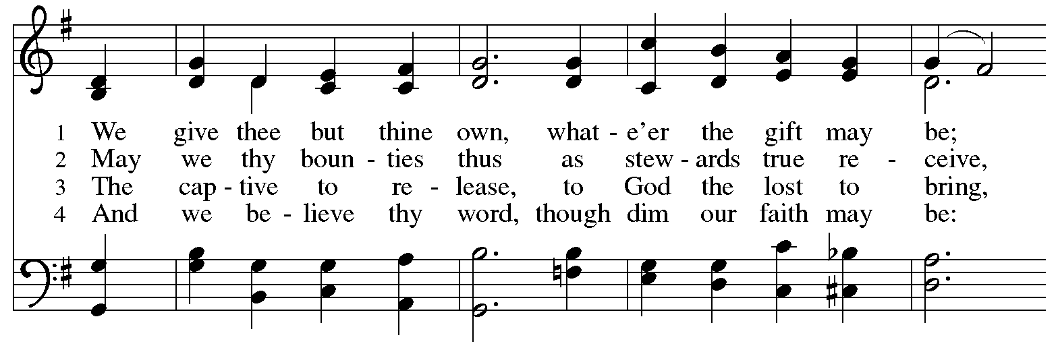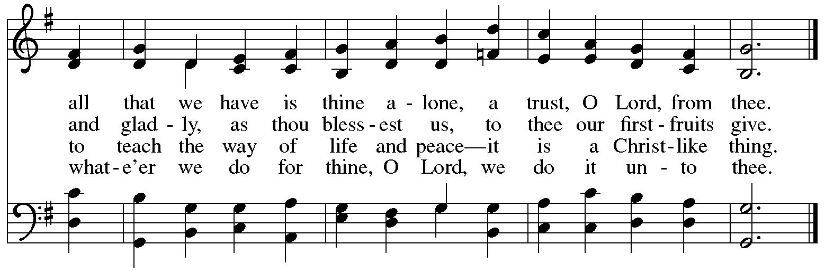

Apostles’ Creed

C: I believe in God, the Father almighty,
creator of heaven and earth.

I believe in Jesus Christ, God’s only Son, our Lord,
who was conceived by the Holy Spirit,
born of the virgin Mary,
suffered under Pontius Pilate,
was crucified, died, and was buried;
he descended to the dead.*
On the third day he rose again;
he ascended into heaven,
he is seated at the right hand of the Father,
and he will come to judge the living and the dead.

I believe in the Holy Spirit,
the holy catholic church,
the communion of saints,
the forgiveness of sins,
the resurrection of the body,
and the life everlasting. Amen.

*Or, “he descended into hell,” another translation of this text in widespread use.

Prayers of the People

A: With the whole people of God in Christ Jesus,
let us pray for the church, those in need, and all of God’s creation,

After each petition
A: Lord, in your mercy,
C: receive our prayer.

P: Into your hands, gracious God, we commend all for whom we pray,
trusting in your mercy; through Jesus Christ, our Savior.
C: Amen.

Peace

The presiding minister and the assembly greet one another in the peace of the risen Christ.
P: The peace of Christ be with you always.
C: And also with you.

The people may greet those around them with a sign of Christ’s peace and may say
Peace be with you or similar words. Please be mindful that not everyone will be comfortable with sharing the peace, so please seek consent before shaking hands or hugging. Other possible ways to share the peace include a simple bow with the verbal greeting of peace, or simply a verbal expression of peace.

When the greetings of peace have concluded, please be seated.

Meal
God feeds us with the presence of Jesus Christ

Offering

We offer ourselves, our gifts, and our faithful service to God.
As the offering is gathered for the mission of the church, including the care of those in need,
the table is set for Holy Communion.

There are laminated giving cards in the pew racks that feature a QR code for anyone who would like to give online. Those who give using the QR code, as well as those who give regularly online or through their bank are encouraged to place the laminated card in the plate as an expression of your offering.

Noisy Offering

As children of the congregation carry buckets around the sanctuary, people of the congregation are invited to throw in their change as an offering. This month’s noisy offering will benefit Greater Pittsburgh Community Food Ban. To learn more about their work, please visit https://pittsburghfoodbank.org.

Offertory Music Take My Life and Let It Be Herold/arr. Edstrom

As the gifts are brought forward for presentation, please rise as you are able.

Offertory Song Accept, O Lord, the Gifts We Bring OLS 5

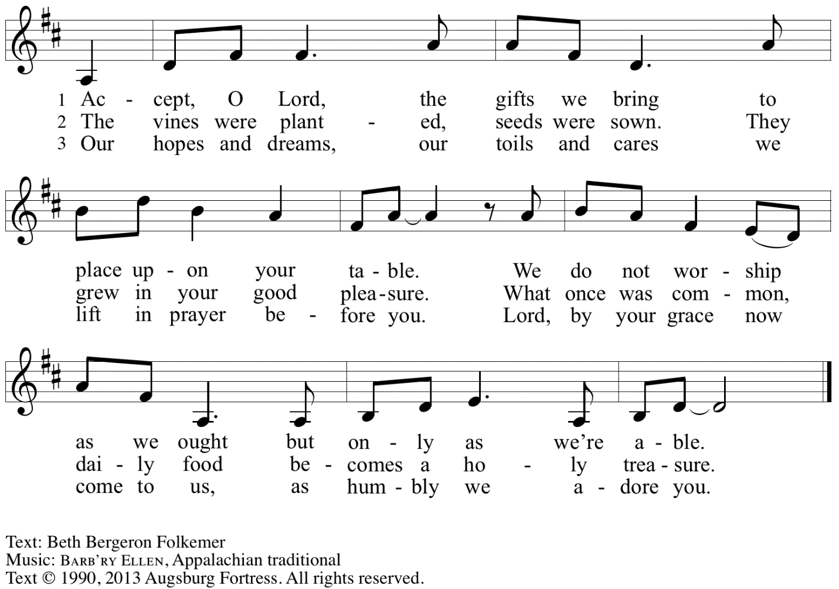
Reprinted with permission under OneLicense.net # A-722139.

Offertory Prayer

A: Let us pray.
Gracious God,
C: you bless us with gifts of guidance, new life,
Growth in grace, and fruitful labor.
Accept the first fruits of time and toil, field and orchard,
that we offer here.
Bless and multiply these gifts to our nurture
and to the care of your creation;
for the sake of your Son, Jesus Christ our Lord.
Amen.

Dialogue

P: The Lord be with you.
C: And also with you.

P: Lift up your hearts.
C: We lift them to the Lord.

P: Let us give thanks to the Lord our God.
C: It is right to give our thanks and praise.

Preface

P: It is indeed right, our duty and our joy,
that we should at all times and in all places
give thanks and praise to you, almighty and merciful God,
through our Savior Jesus Christ;
who on this day overcame death and the grave,
and by his glorious resurrection
opened to us the way of everlasting life.
And so, with all the choirs of angels,
with the church on earth and the hosts of heaven,
we praise your name and join their unending hymn:

Sanctus Holy, Holy, Holy OLS 6

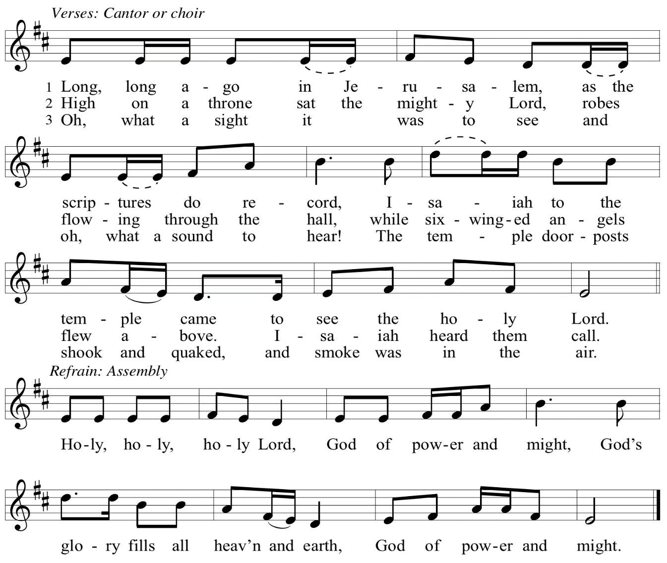

Eucharistic Prayer

P: Let the peoples praise you, generous and abundant Creator: …
… in generosity to all in need.

United by your Spirit with all your people,
we pray through your Son, Jesus Christ,
to you, our Source and our Goal, our Sun and our Shield, our God now and forever.
C: Amen.

Lord’s Prayer

P: Gathered as one by the Holy Spirit, let us pray as Jesus taught us.
C: Our Father in heaven,
hallowed be your name,
your kingdom come,
your will be done,
on earth as in heaven.
Give us today our daily bread.
Forgive us our sins
as we forgive those
who sin against us.
Save us from the time of trial
and deliver us from evil.
For the kingdom, the power,
and the glory are yours,
now and forever. Amen.

Fraction and Invitation

P: Just as this broken bread was first scattered on the hills,
then was brough together and became one,
so let your church be brought together from the ends of the earth into your kingdom,
for yours are the glory and the power through Jesus Christ forever.
C: Amen.



Agnus Dei / Lamb of God OLS 7
O Lamb of God, to Earth You Came

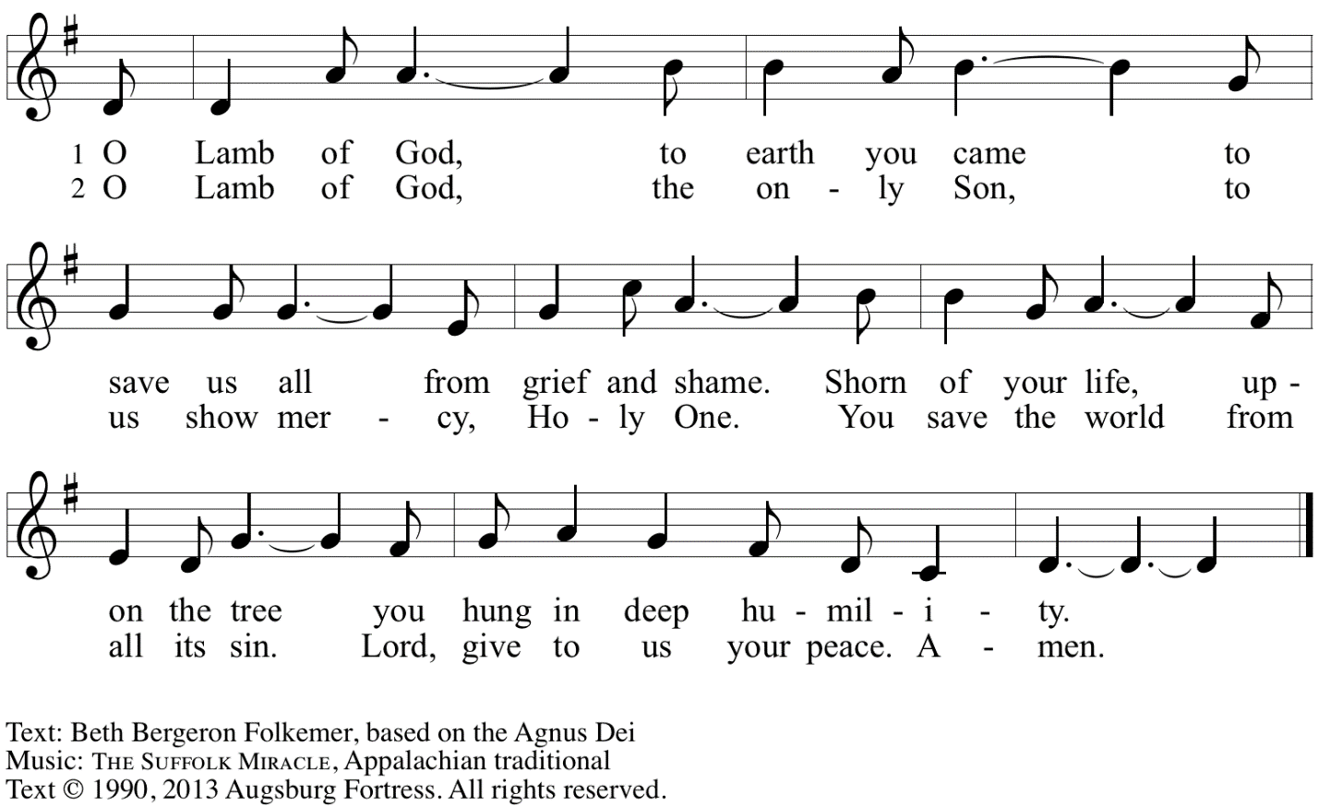
Reprinted with permission under OneLicense.net A# A-722139.

Please be seated.

Holy Communion

- All who seek God and desire a deeper and stronger life in Christ are welcome to receive Holy Communion.
- Worshipers from the pulpit side will proceed forward first, followed by the center section, and then the lectern side.
- Please inform an usher if you would like the ministers to bring Communion to you.
- Holy Communion will be served with bread and wine (amber) or grape juice (purple).
- The presiding minister will first distribute the bread (host) to each communicant. Please indicate if you require a gluten-free host.
- Once you have consumed the bread, please pick up an empty glass from the tray next to the presiding minister. The Communion Assistant will pour wine or grape juice into your glass.
- Please step to the side to consume the wine or grape juice.
- Feel free to kneel at the altar rail for prayer after receiving the sacrament.
- As you return to your pew, glasses may be returned to the empty tray on the side of the center section.
- A blessing will be provided for anyone who does not yet receive the sacrament.
- All are invited to join in singing the hymns during Holy Communion.
Hymns during Holy Communion
God, Whose Giving Knows No Ending ELW 678

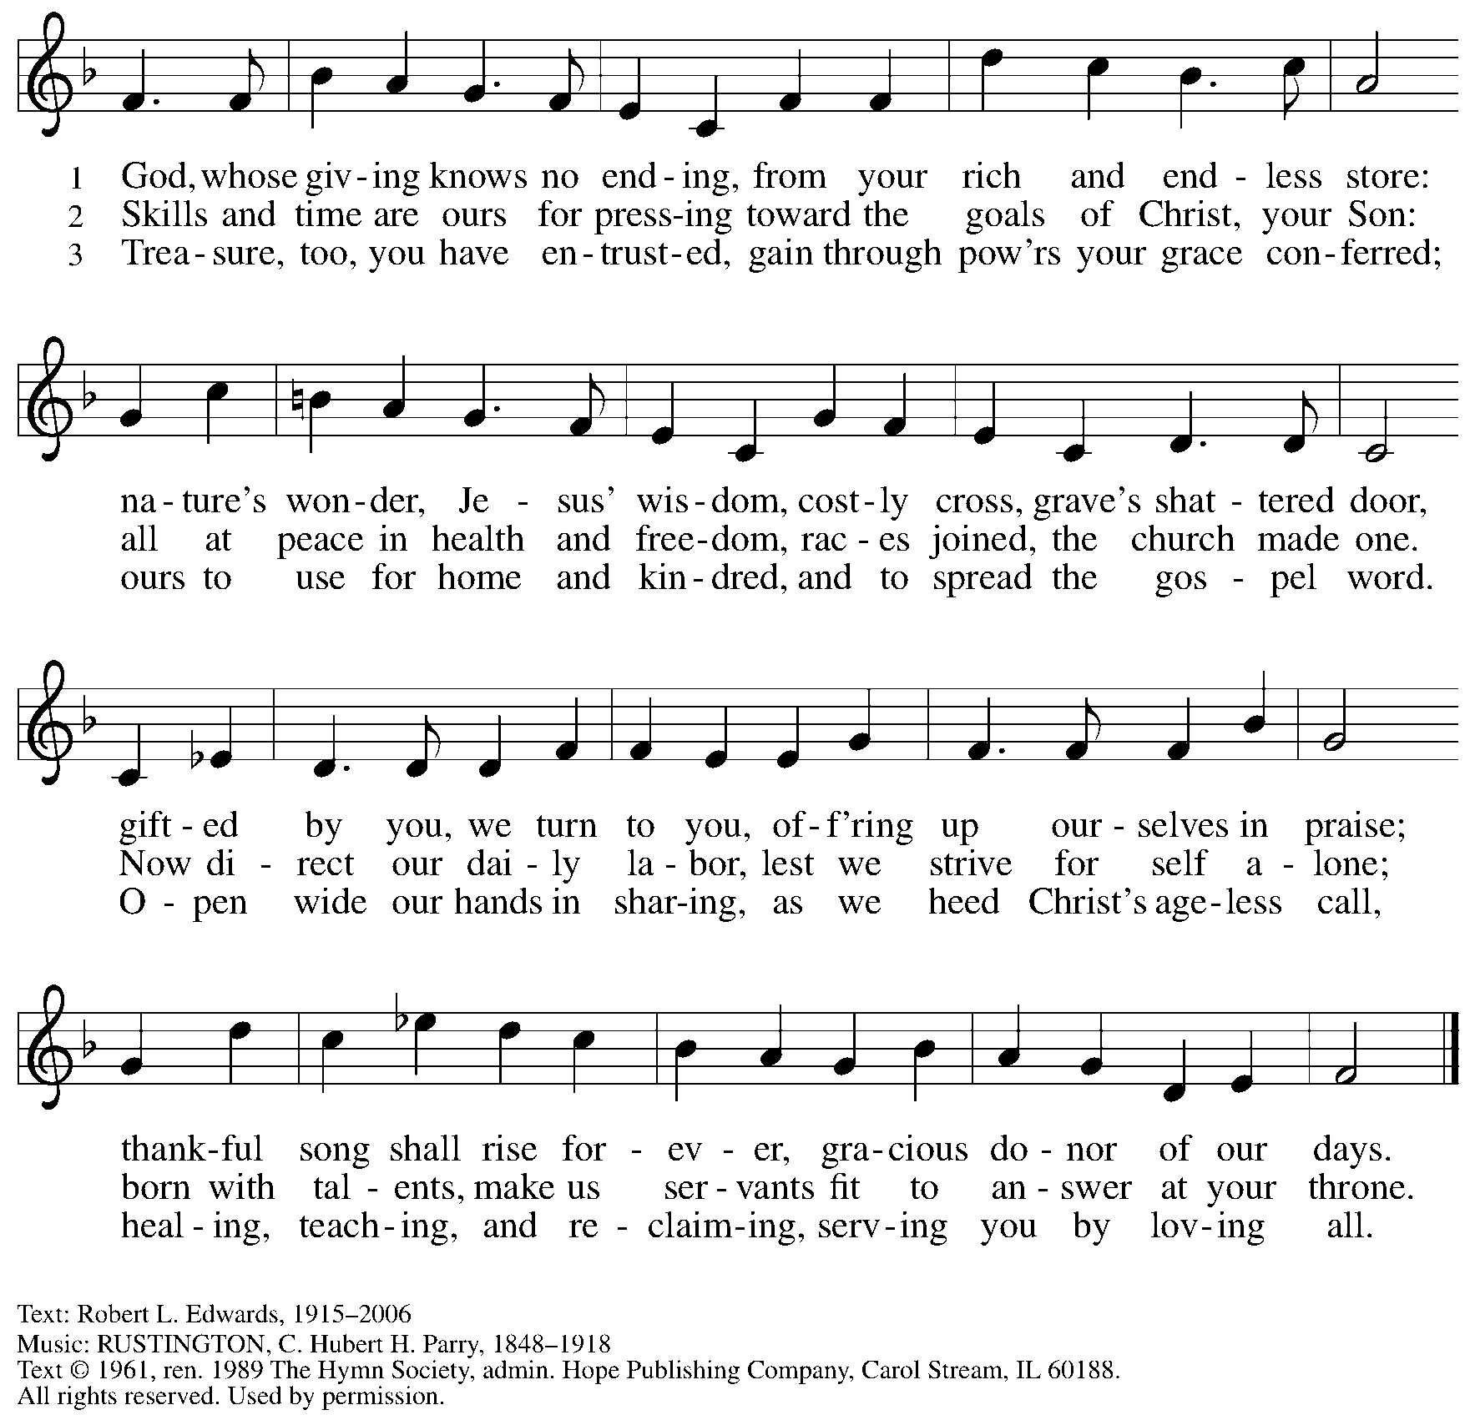
Reprinted under OneLicense.net # A-722139.

Hymns during Holy Communion
All to Jesus I Surrender TFF 235

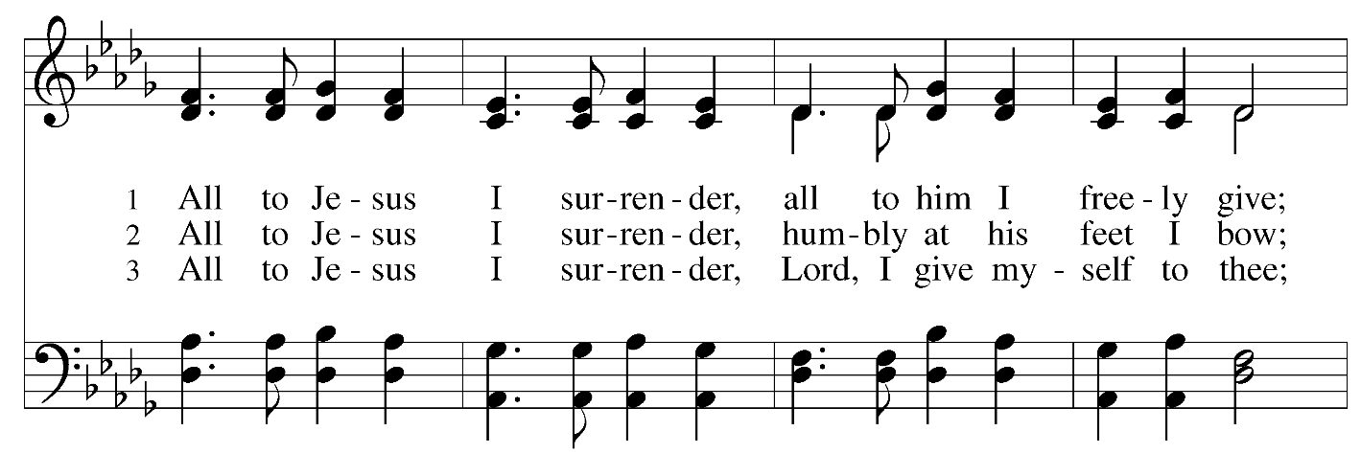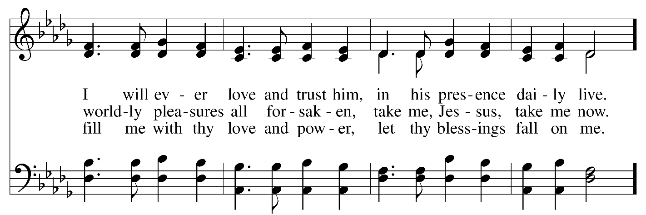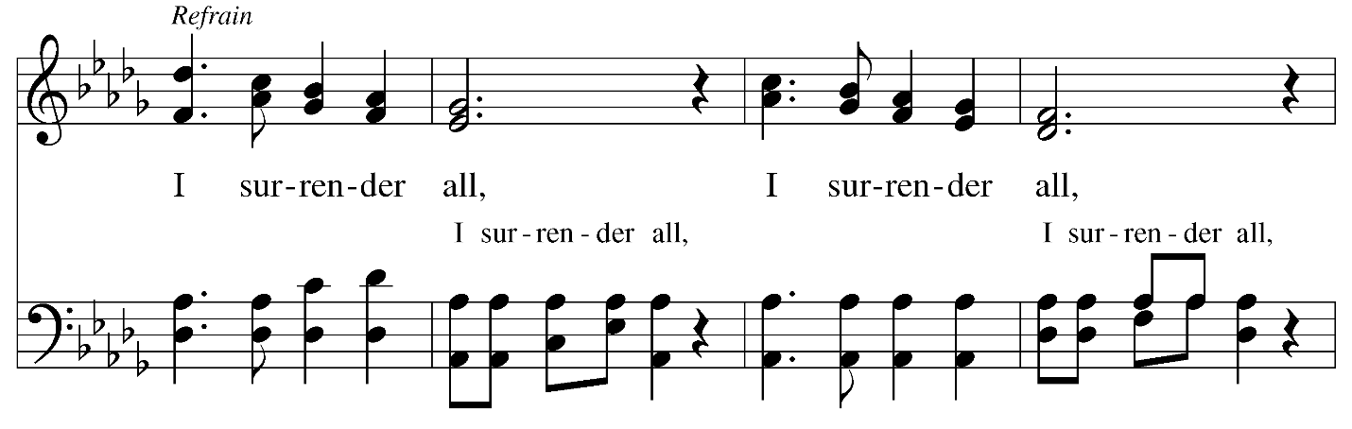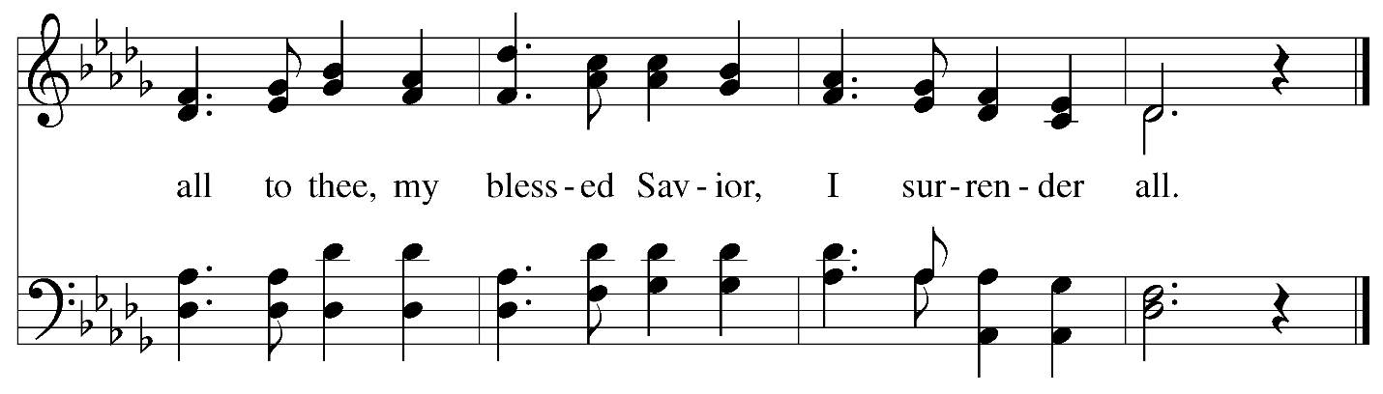
Text: Judson W. Van DeVenter, 1855-1939. Music: SURRENDER, William S. Weeden, 1847-1908.

Hymns during Holy Communion
All Who Love and Serve Your City ELW 724

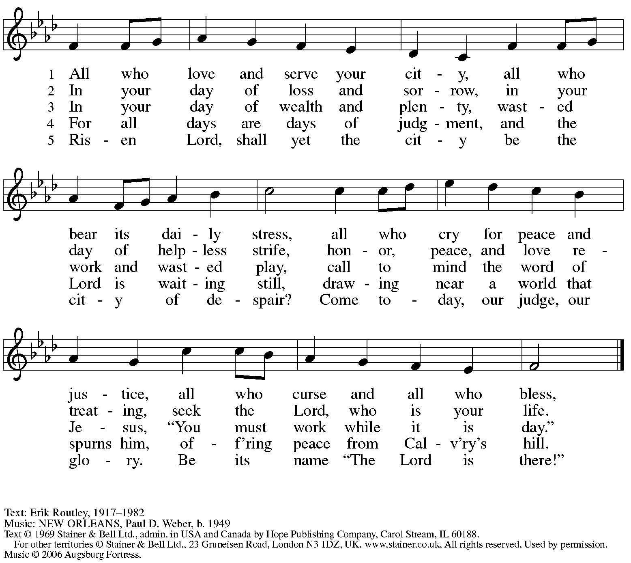
All rights reserved. Reprinted with permission under OneLicense.net # A-722139.

Hymns during Holy Communion
Light Dawns on a Weary World ELW 726

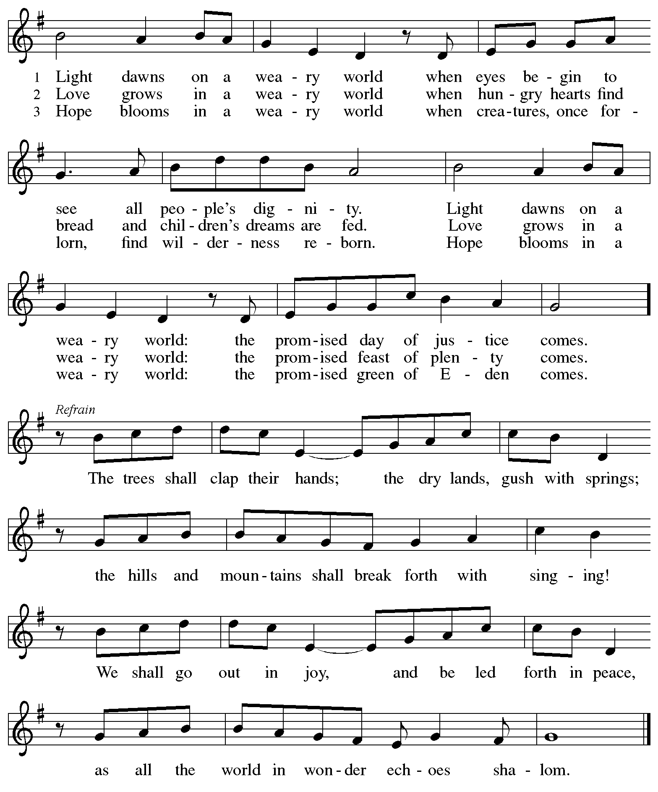

When all have returned to their places, please rise as you are able.

Blessing

P: The body and blood of our Lord Jesus Christ strengthen you and keep you in his grace.
C: Amen.

Prayer

A: Let us pray.
Gracious God,
we give thanks for your pruning, planting, and nurture.
We rejoice that you have used the harvest of field and vineyard
to renew and sustain us.
Lead us as we go from this life-giving meal
into lives of grateful service to you and your cherished creation;
through Jesus Christ, your Son, our Lord.
C: Amen.

Please be seated.

Sending
God blesses us and sends us in mission to the world

Announcements

Please rise as you are able.

Benediction

P: The God of steadfastness and encouragement
grant you to live in harmony with one another,
in accordance with Christ Jesus.
C: Amen.

P: The God of hope fill you with all joy and peace in believing,
so that you may abound in hope by the power of the Holy Spirit.
C: Amen.

P: The God of all grace ☩ bless you now and forever.
C: Amen.

Sending Hymn
Let Us Talents and Tongues Employ ELW 674

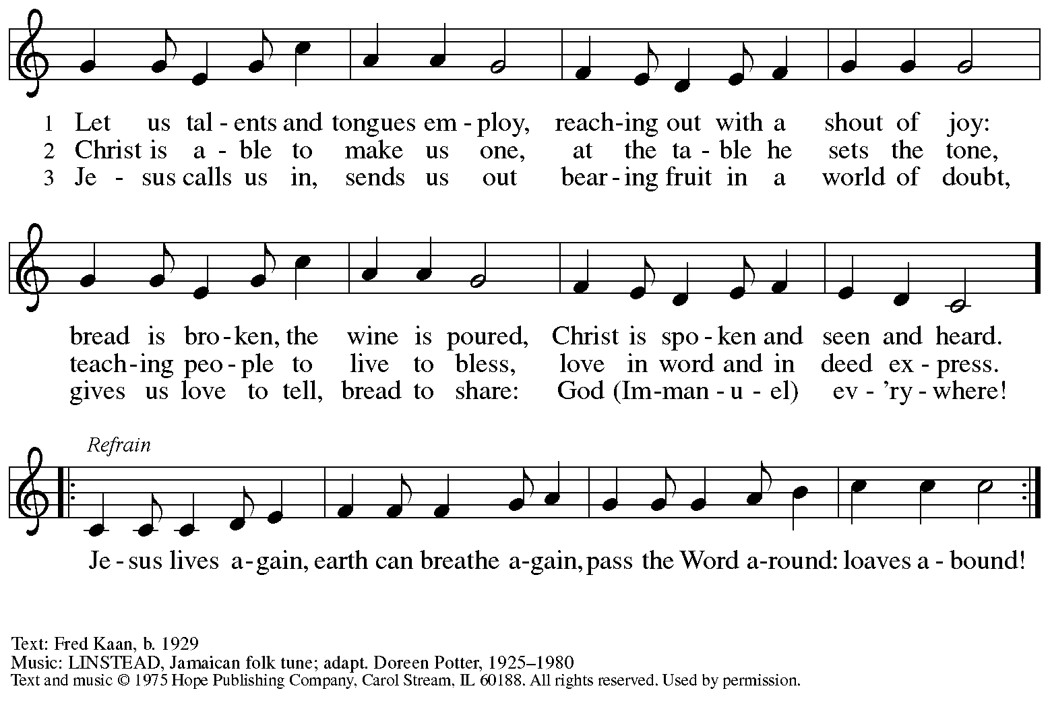
Reprinted under OneLicense.net # A-722139.

Dismissal

A: Go in peace. Serve the Lord.
C: Thanks be to God!

Postlude

Serving in Worship Today

Altar Care Christy Ruhe
Assisting Minister Colleen Cooke
Audio-Visual Ministers Kristen Asplin
Tyler Rietze
Cantor Joseph Paetz
Lector Lindsay Baxter
Minister of Music Laura Reynolds
Presiding Minister The Rev. Ross Carmichael

Liturgy and Hymnody Acknowledgements

From SundaysandSeasons.com. Copyright © 2025 Augsburg Fortress. All rights reserved. Reprinted under OneLicense.net # A-722139.
Used by permission of Augsburg Fortress.

The Scripture readings contained herein are from New Revised Standard Version Updated Edition of the Bible © 2021 National Council of Churches of Christ in the United States of America. Used by permission. All rights reserved worldwide.

Holy, Holy, Holy / Long, Long Ago in Jerusalem – Text: Beth Bergeron Folkemer, based on the Sanctus. Music: SHADY GROVE, Appalachian traditional. Text © 1990, 2013, Augsburg Fortress. All rights reserved. Reprinted with permission under OneLicense.net # A-722139.

Light Dawns on a Weary World – Text: Mary Louise Bringle, b. 1953. Music: TEMPLE OF PEACE, William P. Rowan, b. 1951. Text © 2002 GIA Publications, Inc., 7404 S. Mason Ave., Chicago, IL 60638. www.giamusic.com. 800.442.3358. All rights reserved. Used by permission. Music © 2000 William P. Rowan, admin. GIA Publications, Inc., 7404 S. Mason Ave., Chicago, IL 60638. www.giamusic.com. 800.442.3358. All rights reserved. Used by permission. Reprinted under OneLicense.net # A-722139.

Please use the QR code below to link to St. Andrew’s Announcements online!



St. Andrew Lutheran Church Announcements
September 21st, 2025

- Welcome to Worship at St. Andrew on the Fifteenth Sunday after Pentecost! – We are so glad you are here, and we offer a special welcome to all visitors and guests who are here for the first time! A nursery is available through the door to the left of the worship space and across the social hall (look for a purple room). Little Church – Big Faith, a Bible lesson and activity for children up to sixth grade, will take place after the prayer of the day. There are also worship “toolkits” to help children engage with worship and “busy bags” for younger children available in the bookcase at the back of the sanctuary. Please feel free to take one to use with/for your children. All are invited to stay for coffee and other drinks, food, and conversation in the Social Hall (through the side door at the left of the worship space) after the service.
- Noisy Offering Today During Worship – On the third Sunday of each month, St. Andrew’s children lead the congregation in a Noisy Offering, in which people are invited to throw their change into buckets that the children carry around the church and bring forward as an additional offering. Each month’s Noisy Offering supports a local, national, or international church-related or otherwise charitable organization. This week’s offering is supporting the Greater Pittsburgh Community Food Bank. Their mission is to leverage the power of community to achieve lasting solutions to hunger and its root causes. For more information, visit: https://pittsburghfoodbank.org/what-we-do/how-we-work/.
- Discipleship that Heals the World, Studies in Matthew’s Gospel, Thursdays, 8:00 - 9:00 p.m. on Zoom, Sept. 25th - Dec. 11th, 2025 – Join us for a 11-week journey through the Gospel of Matthew, organized and facilitated by Rev. Dr. Martin Rafanan. Together we’ll explore Jesus’ Sermon on the Mount and his healing ministry, discovering Matthew’s distinctive vision of discipleship as a way of blessing, healing, and hope. You are welcome to join the zoom whenever you can. This study is designed for both newcomers to the Gospel and those already familiar with it. We will engage contemporary perspectives – feminist, liberationist, and wisdom teacher readings – that help us hear Matthew’s message afresh in today’s world. Register for the sessions to receive zoom info: https://forms.gle/amy439vfUpwdJpKx7.
- Invitation to Prayer Team and New Address – St. Andrew maintains a list of weekly prayer concerns that is sent by email, usually on Wednesdays, to members of the congregation who have opted in. In an effort to coordinate our communications, our new prayer team email address is prayerteam@standrewpittsburgh.org. Any prayer concerns or requests can be sent to this address in the future. As we renew this prayer ministry, we will also move to a practice of keeping names on the list for a maximum of four weeks unless otherwise requested. Thank you for your ministry of prayer!
- Records Update – St. Andrew is looking to update our records with information from newer attendees, as well as offering current members the opportunity to include current information. The information will only be used within the congregation - for example to acknowledge celebrations, milestones in worship, and in prayers of the church. Please fill out the form at: https://forms.gle/kKvp19UozuRrhhaV7.
- Coffee Hour Signups – Coffee Hour has resumed! If you would like to participate and would like additional information about the duties, please sign up using the following form: https://www.signupgenius.com/go/5080B4AAFAF2CABF85-47069030-coffee#/
- God's Work - Our Hands 2025: Share the Warmth through Sunday, October 26th –
Each year, the Evangelical Lutheran Church in America asks congregations to participate in its God's Work - Our Hands initiative, an act of service to the congregation's larger community. St. Andrew's God's Work - Our Hands project for this year will be to support "Share the Warmth," a collection of new and gently used winter coats for East End Cooperative Ministry (EECM). St. Andrew will be collecting new and gently used winter coats in the social hall through October. You can also drop off coats for EECM at Strong II Dry Cleaners until October 15th to have them cleaned for free and Strong will deliver them to EECM. They are located at 7620 Frankstown Ave., 15208. Thank you for continuing to do God's Work for the good of our neighbors!

