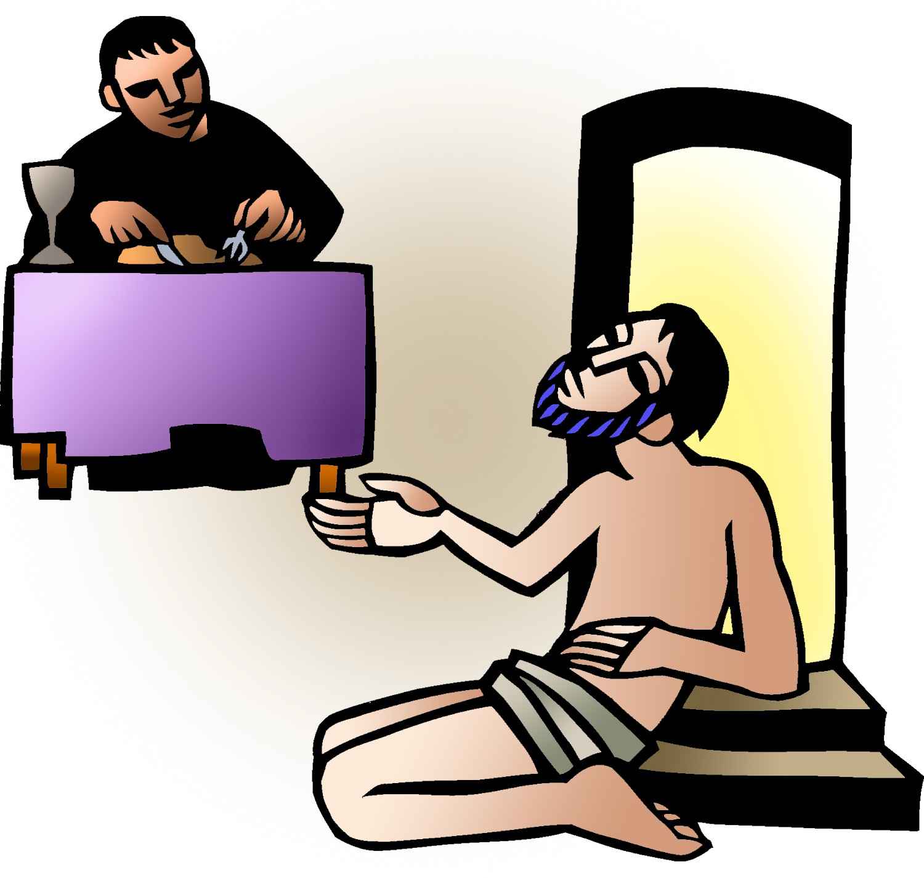

+ Sixteenth Sunday after Pentecost
September 28, 2025



St. Andrew Lutheran Church
304 Morewood Ave.
Pittsburgh, PA 15213
St_andrewELCA@verizon.net
www.standrewpittsburgh.org

+ Sixteenth Sunday after Pentecost
Order for Worship

Consideration and care for those in need (especially those “at our gate,” visible to us, of whom we are aware) is an essential component of good stewardship – the care and use of God’s gifts.
In the sharing of wealth we avoid the snare of wealth. It is the one whom death could not hold – who comes to us risen from the dead – who can free us from the death grip of greed.

Welcome to St. Andrew!
- St. Andrew welcomes all who are seeking a place of healing, wholeness, and acceptance in a nurturing and faith-forming spiritual home. We are striving toward racial equity worldwide
and we seek to honor the lived experience of all individuals regardless of background. Our community embraces people of all ages, ethnicities, cultures, abilities, sexual orientations,
gender identities and expressions, and family constellations. Come and See!
- Worship Services are live-streamed to multiple online platforms. By attending worship, you agree that your image and voice may be broadcast.
- Everyone is invited to make a name tag at the black bookcase in the back of the worship space if they would like. There are stickers indicating pronouns on the bookcase if you would like to include them on your name tag.
- A nursery is available through the doors at the left side of the sanctuary and across from the doorway to the Social Hall. Look for a purple-colored room.
- Children are invited to attend Little Church – Big Faith, a Bible lesson and activity, during worship (after the Prayer of the Day). The group returns to the worship space for the liturgy of Holy Communion.
- Worship “toolkits” to help children engage with the service, along with “busy bags” for younger children, are available in the bookcase at the back of the sanctuary. Please feel free to take one to use with/for your children.
- Holy Communion is served with bread (gluten-free available) and wine or grape juice. The presiding minister will distribute the bread (host). Please consume this and then pick up an empty glass from the tray. The Communion Assistant will pour wine or grape juice into your glass. Please step to the side to consume the wine or grape juice. Feel free to kneel at the altar for prayer and reflection. As you return to your pew, glasses may be returned to the empty trays on either side of the center section.
- A restroom is available on the main level of the church, through the doors to the Social Hall and to the right in the main office.

Abbreviations
P: Pastor/Presiding Minister ELW: Evangelical Lutheran Worship hymnal
A: Assisting Minister ACS: All Creation Sings hymnal
L: Lector OLS: Of the Land and Seasons
C: Congregation

Musical Offering

Each week, different people from the congregation make an offering of pre-service music, with singing or instrumentation, to help the assembly focus and pray in preparation for worship.

Welcome

Prelude For the Fruit of All Creation arr. Shaw

Gathering
The Holy Spirit calls us together as the people of God

Please rise as you are able. All may make the sign of the cross,
the sign that is marked at Baptism, as the presiding minister begins.

Confession and Forgiveness

P: In the name of Father
and of the ☩ Son,
and of the Holy Spirit.
C: Amen.

P: Let us confess our sins in the presence of God and one another.

Silence is kept for reflection.

P: Most Merciful God,
C: we confess that we are captive to sin and cannot free ourselves.
We have sinned against you in thought, word, and deed,
by what we have done and by what we have left undone.
We have squandered your bountiful gifts.
We have considered the blessings of the harvest our due.
We have been indifferent in planning and planting
for the future needs of your church.
For the sake of your Son, Jesus Christ, have mercy on us.
Forgive us, cause gratitude to ripen in our hearts,
and wisdom to mature in our minds,
so that we may delight in your will and follow in your ways,
to the glory of your holy name.
Amen.

P: God, who is rich in mercy,
Loved us even when we were dead in sin
and made us alive together with Christ.
By grace you have been saved.
In the name of ☩ Jesus Christ, your sins are forgiven.
Almighty God strengthen you with power through the Holy Spirit,
that Christ may live in your hearts through faith.
C: Amen.

Gathering Hymn Gather Us In ELW 532

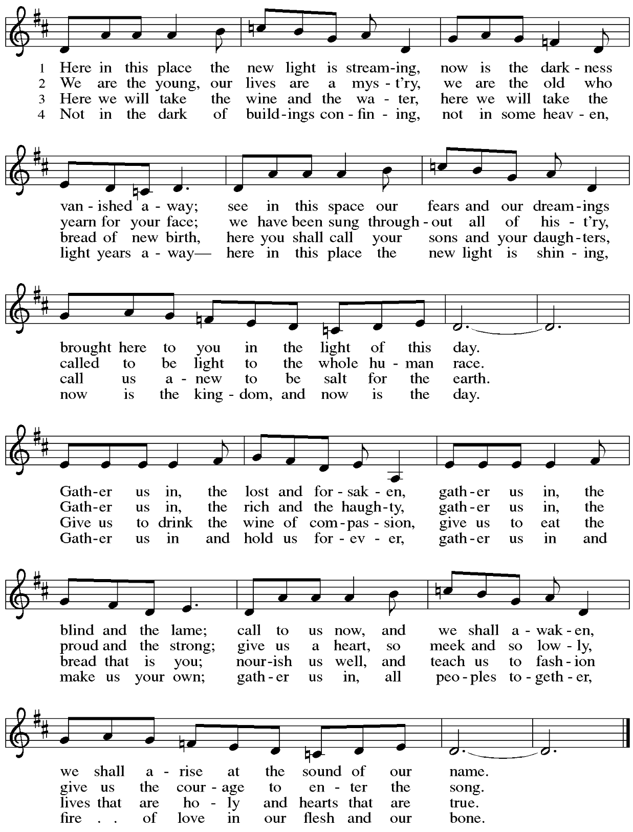
Greeting

P: The grace of our Lord Jesus Christ, the love of God,
and the communion of the Holy Spirit be with you all.
C: And also with you.

Hymn of Praise Oh, Sing of God’s Great Victory! OLS 3

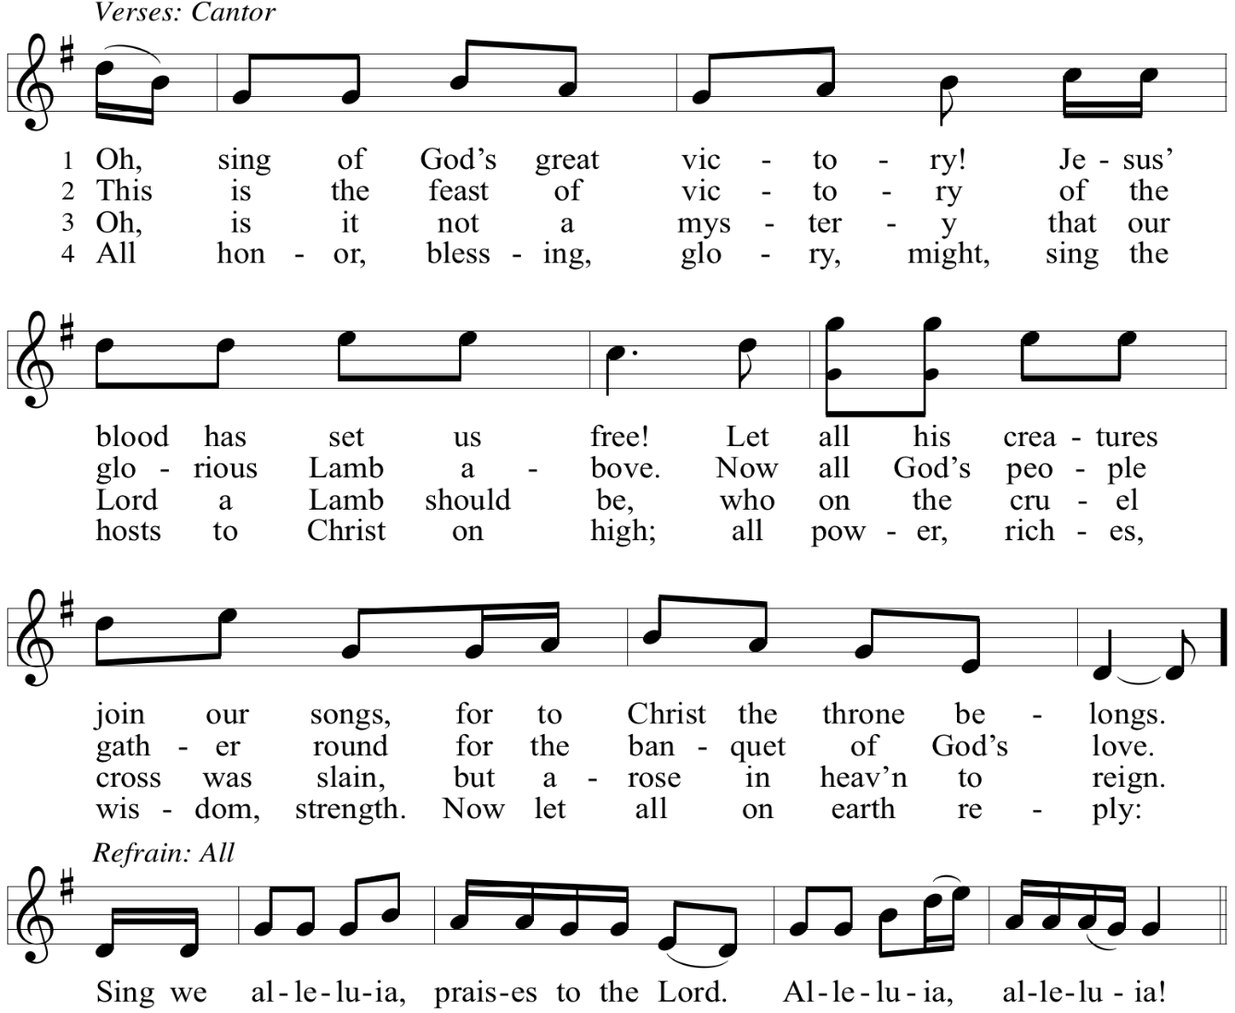

Reprinted with permission under OneLicense.net # A-722139.

Prayer of the Day

P: The Lord be with you.
C: And also with you.

P: Let us pray.
O God, rich in mercy, you look with compassion on this troubled world.
Feed us with your grace, and grant us the treasure that comes only from you,
through Jesus Christ, our Savior and Lord.
C: Amen.

Please be seated.
Children are invited to join the adult leader(s) at the side door for Little Church – Big Faith.
We ask that an additional adult from the congregation attend with the children.

Word
God speaks to us in Scripture reading, preaching, and song

First Reading – Amos 6: 1a, 4-7

^{1a} Woe to those who are at ease in Zion
and for those who feel secure on Mount Samaria.
⁴ Woe to those who lie on beds of ivory
and lounge on their couches
and eat lambs from the flock
and calves from the stall,
⁵ who sing idle songs to the sound of the harp
and like David improvise on instruments of music,
⁶ who drink wine from bowls
and anoint themselves with the finest oils
but are not grieved over the ruin of Joseph!
⁷ Therefore they shall now be the first to go into exile,
and the revelry of the loungers shall pass away.

L: Word of God, word of life.
C: Thanks be to God.

Psalm 146

The psalm will be sung responsively, led by the cantor, with the congregation singing the verses in bold type and joining in the refrain.

Psalm Tone

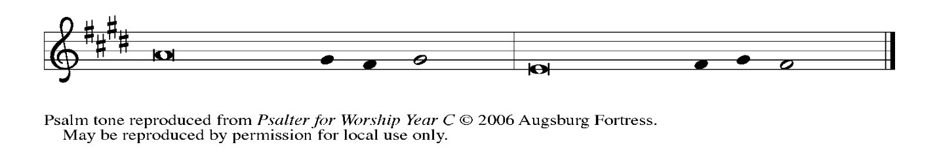

Psalm Refrain

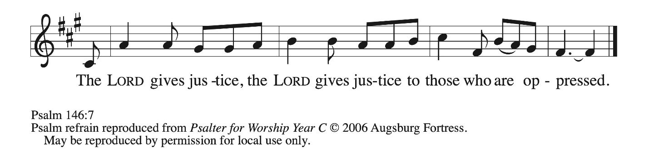

¹ Hal- | lelujah!
Praise the Lord, | O my soul!
² I will praise the Lord as long | as I live;
I will sing praises to my God while I | have my being.
³ Put not your | trust in rulers,
in mortals in whom there | is no help.
⁴ When they breathe their last, they re- | turn to earth,
and in that day | their thoughts perish. R
⁵ Happy are they who have the God of Jacob | for their help,
whose hope is in the | Lord their God;
⁶ who made heaven and earth, the seas, and all that | is in them;
who keeps promis- | es forever;
⁷ who gives justice to those who are oppressed, and food to | those who hunger.
The Lord sets the | captive free.
⁸ The Lord opens the eyes of the blind; the Lord lifts up those who | are bowed down;
the Lord | loves the righteous.
⁹ The Lord cares | for the stranger;
the Lord sustains the orphan and widow, but frustrates the way | of the wicked.
¹⁰ The Lord shall | reign forever,
your God, O Zion, throughout all generations. | Hallelujah! R

Second Reading – 1 Timothy 6: 6-19

⁶ Of course, there is great gain in godliness combined with contentment, ⁷ for we brought nothing into the world, so that we can take nothing out of it, ⁸ but if we have food and clothing, we will be content with these. ⁹ But those who want to be rich fall into temptation and are trapped by many senseless and harmful desires that plunge people into ruin and destruction. ¹⁰ For the love of money is a root of all kinds of evil, and in their eagerness to be rich some have wandered away from the faith and pierced themselves with many pains.
¹¹ But as for you, person of God, shun all this; pursue righteousness, godliness, faith, love, endurance, gentleness. ¹² Fight the good fight of the faith; take hold of the eternal life to which you were called and for which you made the good confession in the presence of many witnesses. ¹³ In the presence of God, who gives life to all things, and of Christ Jesus,
who in his testimony before Pontius Pilate made the good confession, I charge you ¹⁴ to keep the commandment without spot or blame until the manifestation of our Lord Jesus Christ, ¹⁵ which he will bring about at the right time—he who is the blessed and only Sovereign, the King of kings and Lord of lords. ¹⁶ It is he alone who has immortality and dwells in unapproachable light, whom no one has ever seen or can see; to him be honor and eternal dominion. Amen.
¹⁷ As for those who in the present age are rich, command them not to be haughty or to set their hopes on the uncertainty of riches but rather on God, who richly provides us with everything for our enjoyment. ¹⁸ They are to do good, to be rich in good works, generous, and ready to share,
¹⁹ thus storing up for themselves the treasure of a good foundation for the future, so that they may take hold of the life that really is life.

L: Word of God, word of life.
C: Thanks be to God.

Please rise as you are able.

Gospel Acclamation O God, Whose Word Well-Planted OLS 4

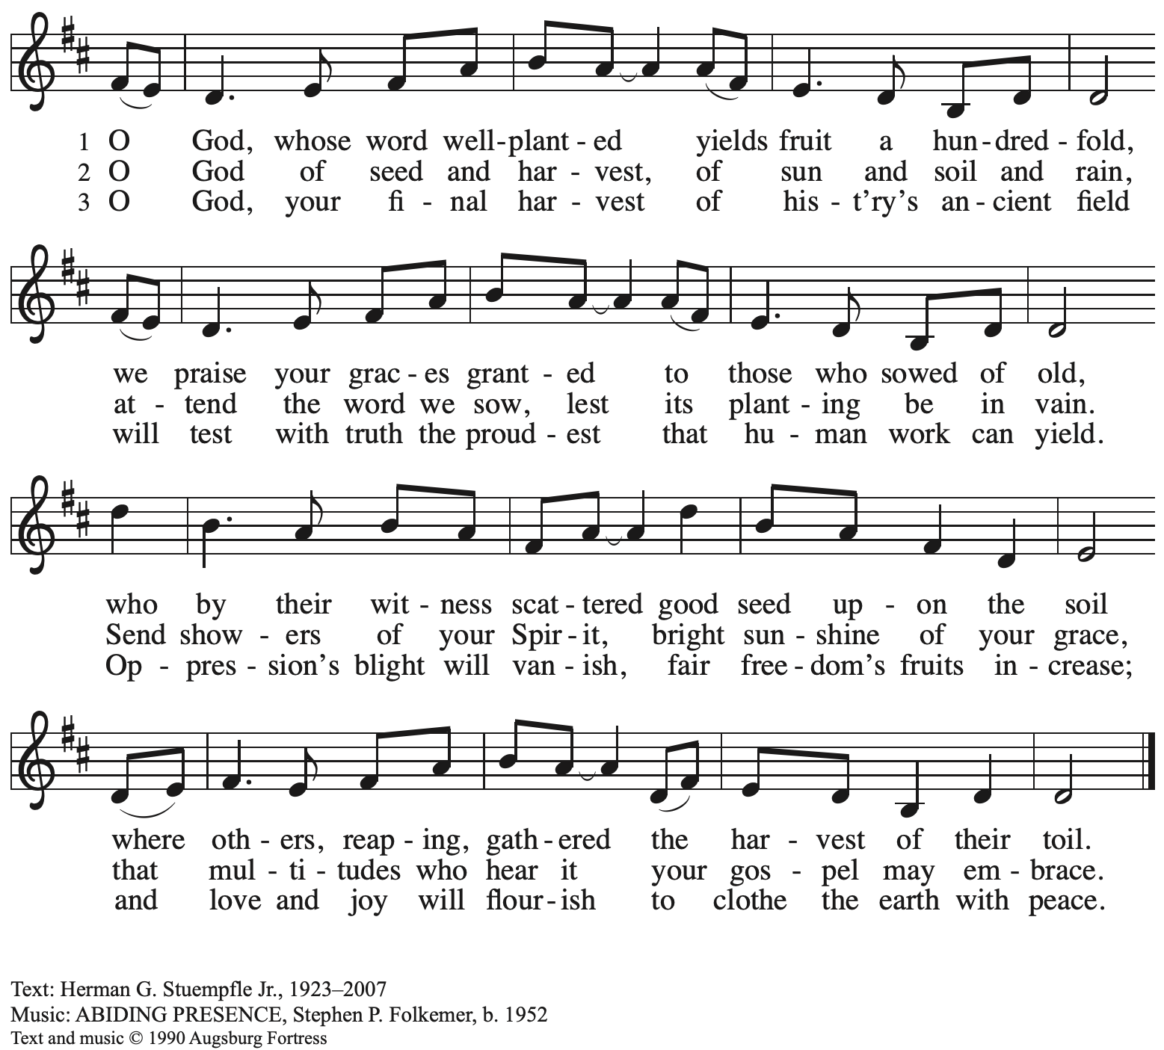
All rights reserved. Reprinted under OneLicense.net # A-722139.
Gospel – Luke 16: 19-31

P: The holy Gospel according to St. Luke.
C: Glory to you, O Lord.

[Jesus said:] ¹⁹ “There was a rich man who was dressed in purple and fine linen and who feasted sumptuously every day. ²⁰ And at his gate lay a poor man named Lazarus, covered with sores,
²¹ who longed to satisfy his hunger with what fell from the rich man’s table; even the dogs would come and lick his sores. ²² The poor man died and was carried away by the angels to be with Abraham. The rich man also died and was buried. ²³ In Hades, where he was being tormented, he lifted up his eyes and saw Abraham far away with Lazarus by his side. ²⁴ He called out, ‘Father Abraham, have mercy on me, and send Lazarus to dip the tip of his finger in water and cool my tongue, for I am in agony in these flames.’ ²⁵ But Abraham said, ‘Child, remember that during your lifetime you received your good things and Lazarus in like manner evil things, but now he is comforted here, and you are in agony. ²⁶ Besides all this, between you and us a great chasm has been fixed, so that those who might want to pass from here to you cannot do so, and no one can cross from there to us.’ ²⁷ He said, ‘Then I beg you, father, to send him to my father’s house ²⁸ for I have five brothers—that he may warn them, so that they will not also come into this place of torment.’ ²⁹ Abraham replied, ‘They have Moses and the prophets; they should listen to them.’ ³⁰ He said, ‘No, father Abraham, but if someone from the dead goes to them, they will repent.’ ³¹ He said to him, ‘If they do not listen to Moses and the prophets, neither will they be convinced even if someone rises from the dead.’ ”

P: The Gospel of the Lord.
C: Praise to you, O Christ.

Please be seated.

Sermon

A time of silence for prayer and reflection follows the sermon.
When the hymn of the day begins, please rise as you are able.



Hymn of the Day Let Streams of Living Justice ELW 710

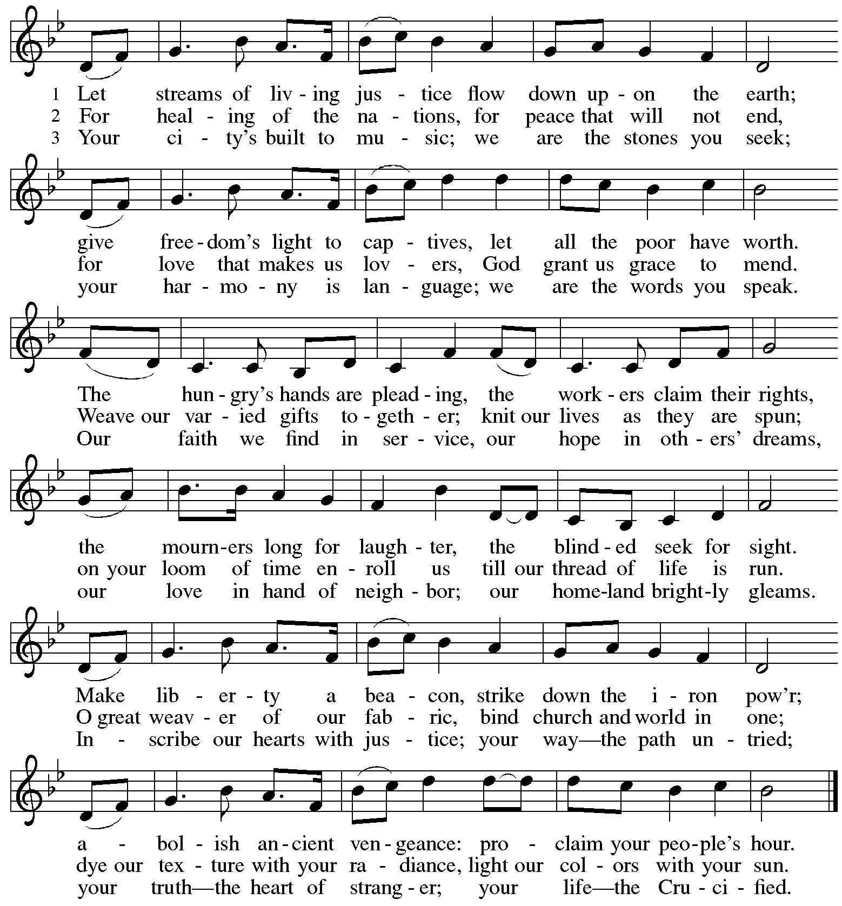
Used by permission of the lyricist.

Apostles’ Creed

C: I believe in God, the Father almighty,
creator of heaven and earth.

I believe in Jesus Christ, God’s only Son, our Lord,
who was conceived by the Holy Spirit,
born of the virgin Mary,
suffered under Pontius Pilate,
was crucified, died, and was buried;
he descended to the dead.*
On the third day he rose again;
he ascended into heaven,
he is seated at the right hand of the Father,
and he will come to judge the living and the dead.

I believe in the Holy Spirit,
the holy catholic church,
the communion of saints,
the forgiveness of sins,
the resurrection of the body,
and the life everlasting. Amen.

*Or, “he descended into hell,” another translation of this text in widespread use.

Prayers of the People

A: With the whole people of God in Christ Jesus,
let us pray for the church, those in need, and all of God’s creation,

After each petition
A: Lord, in your mercy,
C: receive our prayer.

P: Into your hands, gracious God, we commend all for whom we pray,
trusting in your mercy; through Jesus Christ, our Savior.
C: Amen.

Peace

The presiding minister and the assembly greet one another in the peace of the risen Christ.
P: The peace of Christ be with you always.
C: And also with you.

The people may greet those around them with a sign of Christ’s peace and may say
Peace be with you or similar words. Please be mindful that not everyone will be comfortable with sharing the peace, so please seek consent before shaking hands or hugging. Other possible ways to share the peace include a simple bow with the verbal greeting of peace, or simply a verbal expression of peace. When the greetings of peace have concluded, please be seated.

Meal
God feeds us with the presence of Jesus Christ

Offering

We offer ourselves, our gifts, and our faithful service to God.
As the offering is gathered for the mission of the church, including the care of those in need,
the table is set for Holy Communion.

There are laminated giving cards in the pew racks that feature a QR code for anyone who would like to give online. Those who give using the QR code, as well as those who give regularly online or through their bank are encouraged to place the laminated card in the plate as an expression of your offering.

Offertory Music Hark! I Hear the Harps Eternal arr. Harmon
St. Andrew Choir

As the gifts are brought forward for presentation, please rise as you are able.

Offertory Song Accept, O Lord, the Gifts We Bring OLS 5

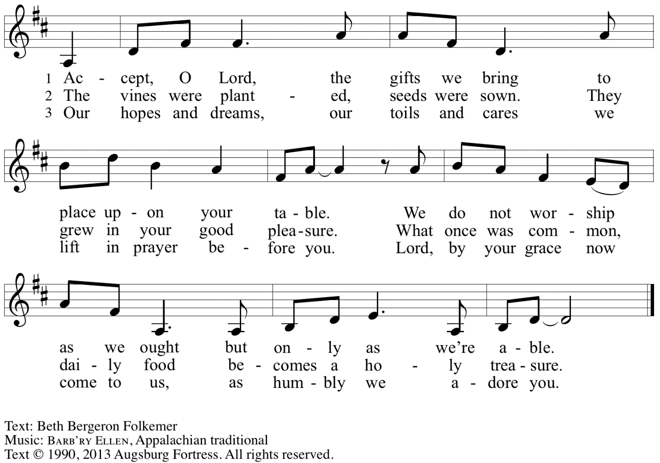
Reprinted with permission under OneLicense.net # A-722139.

Offertory Prayer

A: Let us pray.
Gracious God,
C: you bless us with gifts of guidance, new life,
growth in grace, and fruitful labor.
Accept the first fruits of time and toil, field and orchard,
that we offer here.
Bless and multiply these gifts to our nurture
and to the care of your creation;
for the sake of your Son, Jesus Christ our Lord.
Amen.

Dialogue

P: The Lord be with you.
C: And also with you.

P: Lift up your hearts.
C: We lift them to the Lord.

P: Let us give thanks to the Lord our God.
C: It is right to give our thanks and praise.

Preface

P: It is indeed right, our duty and our joy,
that we should at all times and in all places
give thanks and praise to you, almighty and merciful God,
through our Savior Jesus Christ;
who on this day overcame death and the grave,
and by his glorious resurrection
opened to us the way of everlasting life.
And so, with all the choirs of angels,
with the church on earth and the hosts of heaven,
we praise your name and join their unending hymn:

Sanctus Holy, Holy, Holy OLS 6

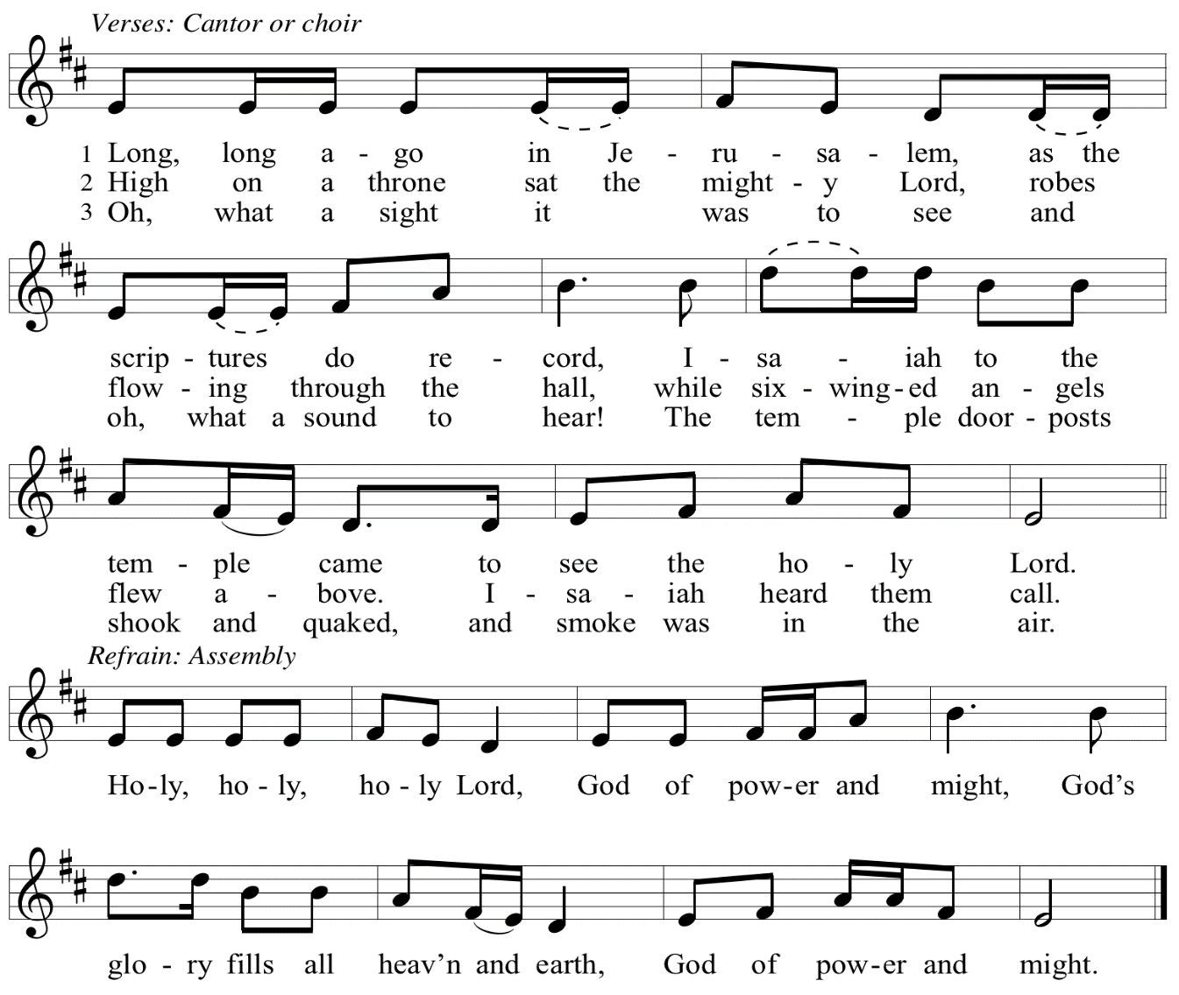

Eucharistic Prayer

P: Let the peoples praise you, generous and abundant Creator: …
… in generosity to all in need.

United by your Spirit with all your people,
we pray through your Son, Jesus Christ,
to you, our Source and our Goal, our Sun and our Shield,
our God now and forever.
C: Amen.

Lord’s Prayer

P: Gathered as one by the Holy Spirit, let us pray as Jesus taught us.
C: Our Father in heaven,
hallowed be your name,
your kingdom come,
your will be done,
on earth as in heaven.
Give us today our daily bread.
Forgive us our sins
as we forgive those
who sin against us.
Save us from the time of trial
and deliver us from evil.
For the kingdom, the power,
and the glory are yours,
now and forever. Amen.

Fraction and Invitation

P: Just as this broken bread was first scattered on the hills, then was brought together and became one, so let your church be brought together from the ends of the earth into your kingdom, for yours are the glory and the power through Jesus Christ forever.
C: Amen.



Agnus Dei / Lamb of God OLS 7
O Lamb of God, to Earth You Came

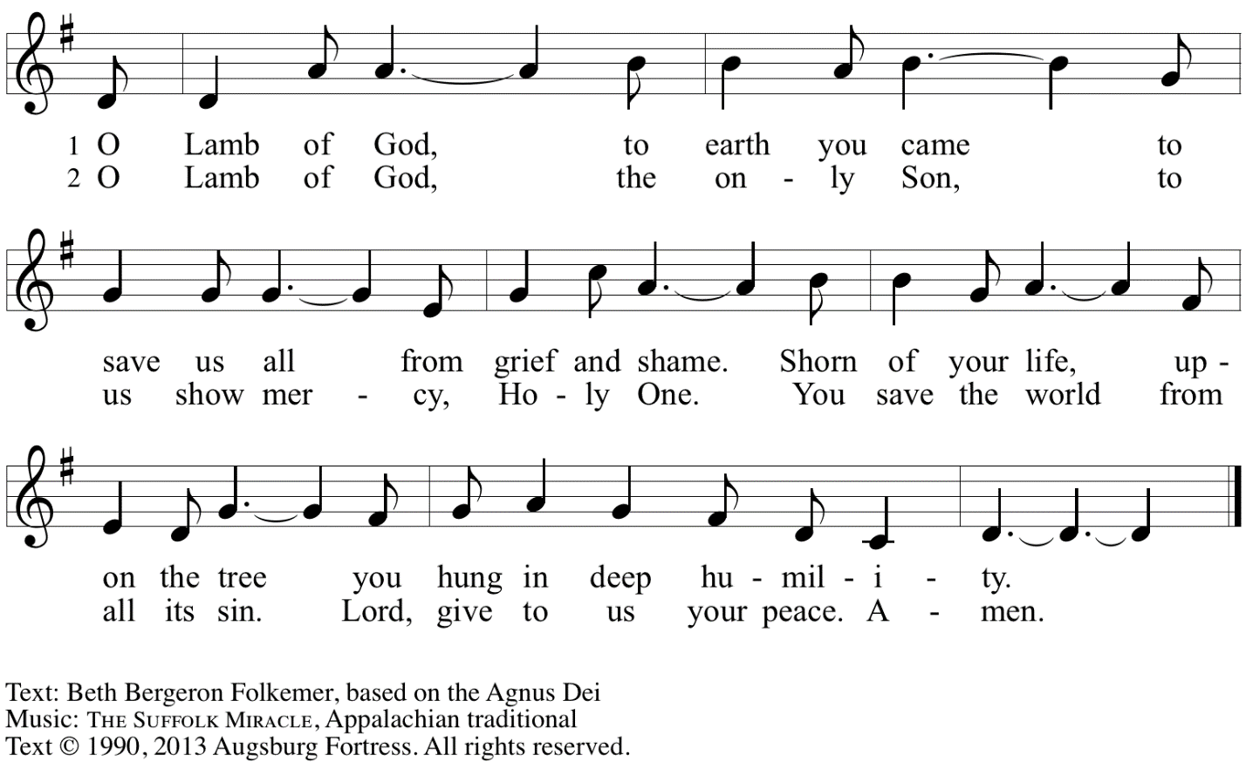
Reprinted with permission under OneLicense.net A# A-722139.

Please be seated.

Holy Communion

- All who seek God and desire a deeper and stronger life in Christ are welcome to receive Holy Communion.
- Worshipers from the pulpit side will proceed forward first, followed by the center section, and then the lectern side.
- Please inform an usher if you would like the ministers to bring Communion to you.
- Holy Communion will be served with bread and wine (amber) or grape juice (purple).
- The presiding minister will first distribute the bread (host) to each communicant. Please indicate if you require a gluten-free host.
- Once you have consumed the bread, please pick up an empty glass from the tray next to the presiding minister. The Communion Assistant will pour wine or grape juice into your glass.
- Please step to the side to consume the wine or grape juice.
- Feel free to kneel at the altar rail for prayer after receiving the sacrament.
- As you return to your pew, glasses may be returned to the empty tray on the side of the center section.
- A blessing will be provided for anyone who does not yet receive the sacrament.
- All are invited to join in singing the hymns during Holy Communion.

Hymns during Holy Communion
Where Cross the Crowded Ways of Life ELW 719

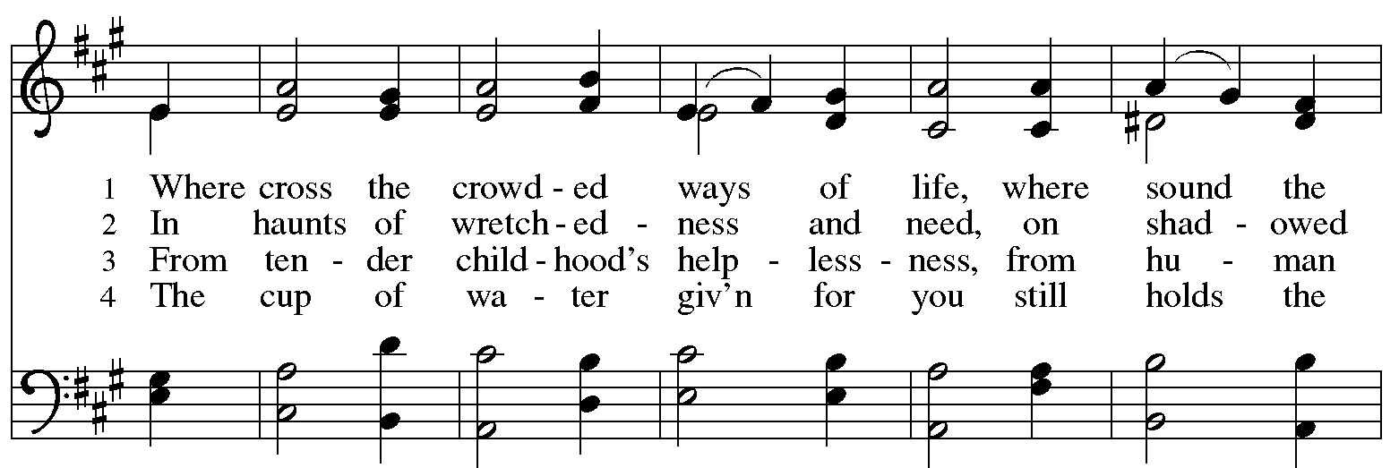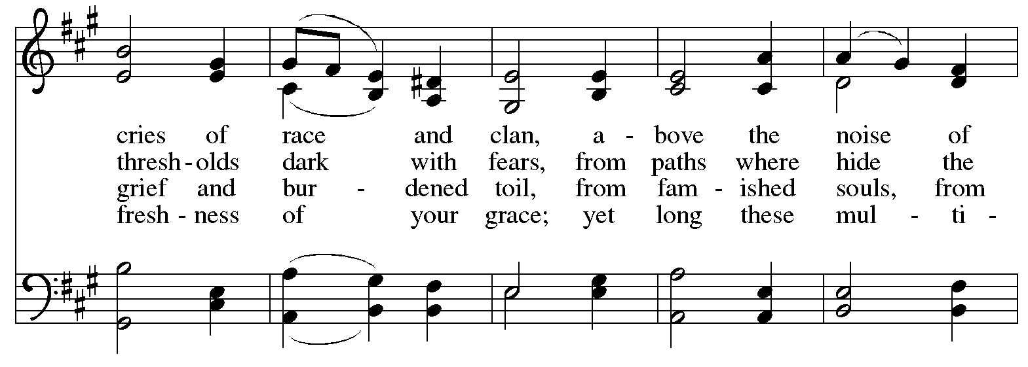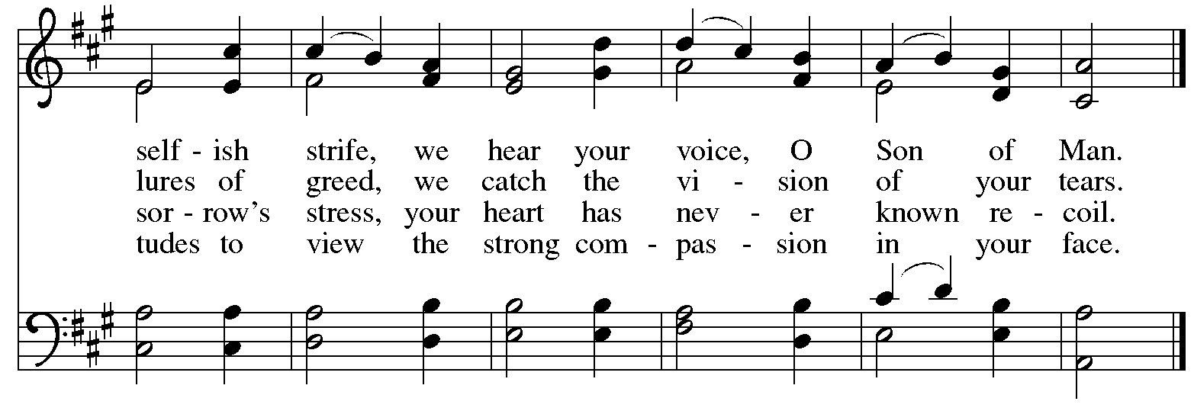
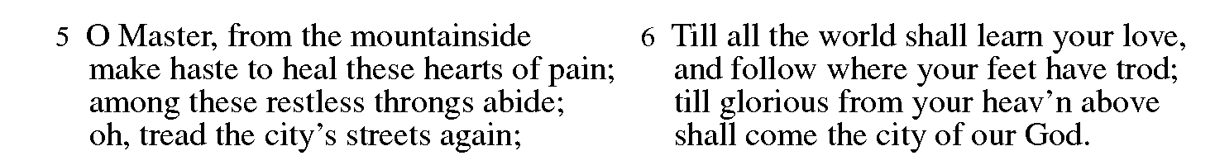

Hymns during Holy Communion
When Pain of the World Surrounds Us ELW 704

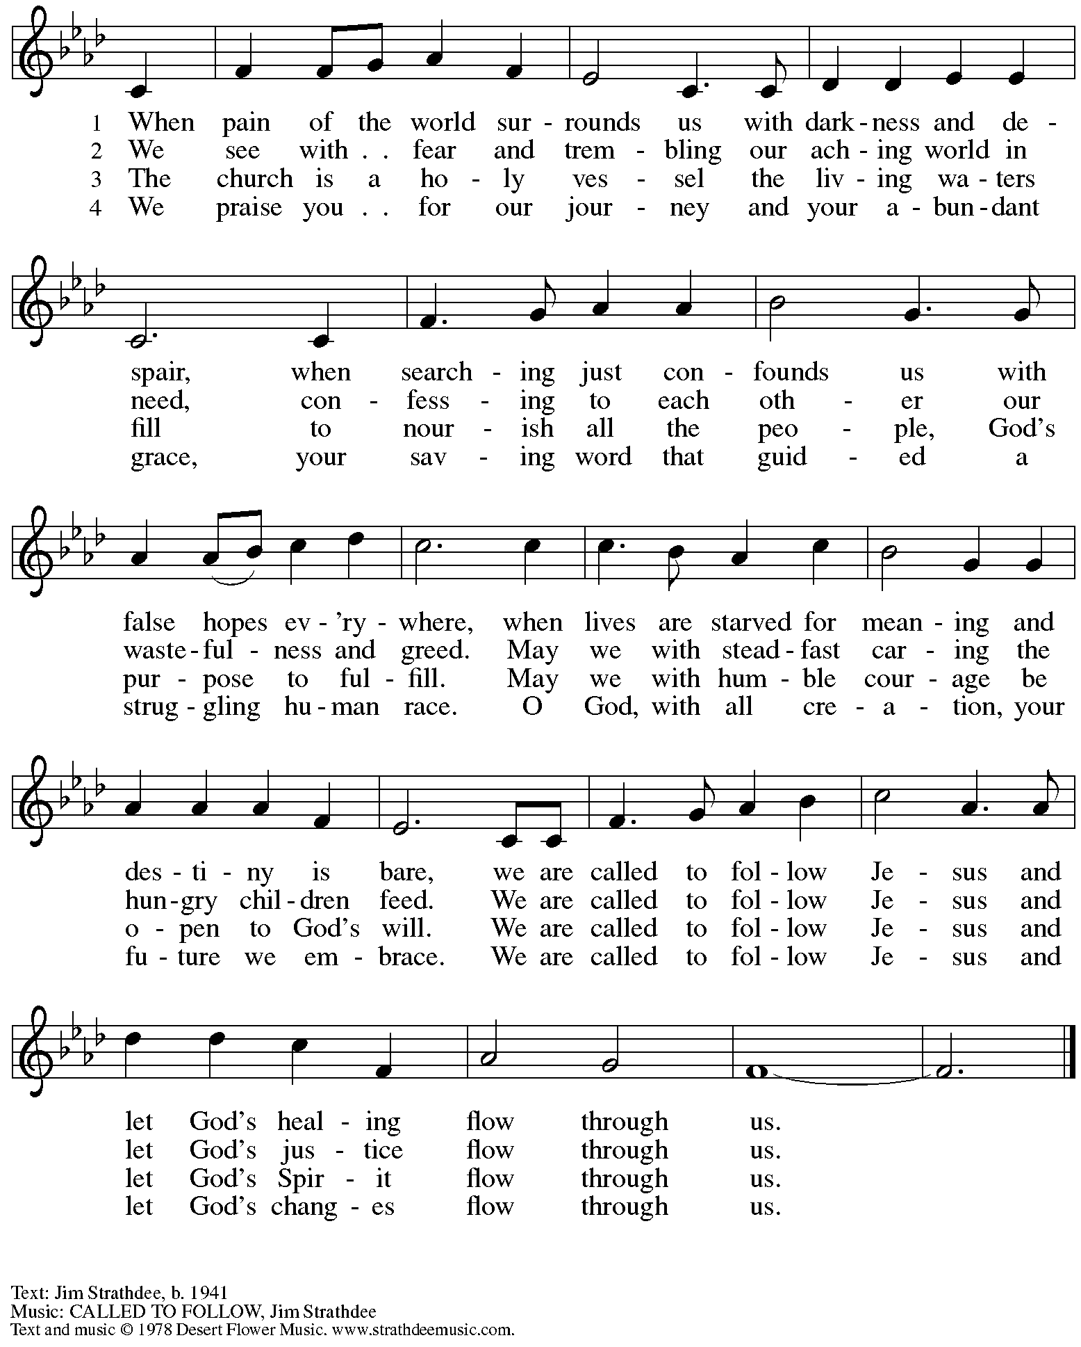
All rights reserved. Reprinted with permission under OneLicense.net # A-722139.

Hymns during Holy Communion
We Come to the Hungry Feast ELW 479

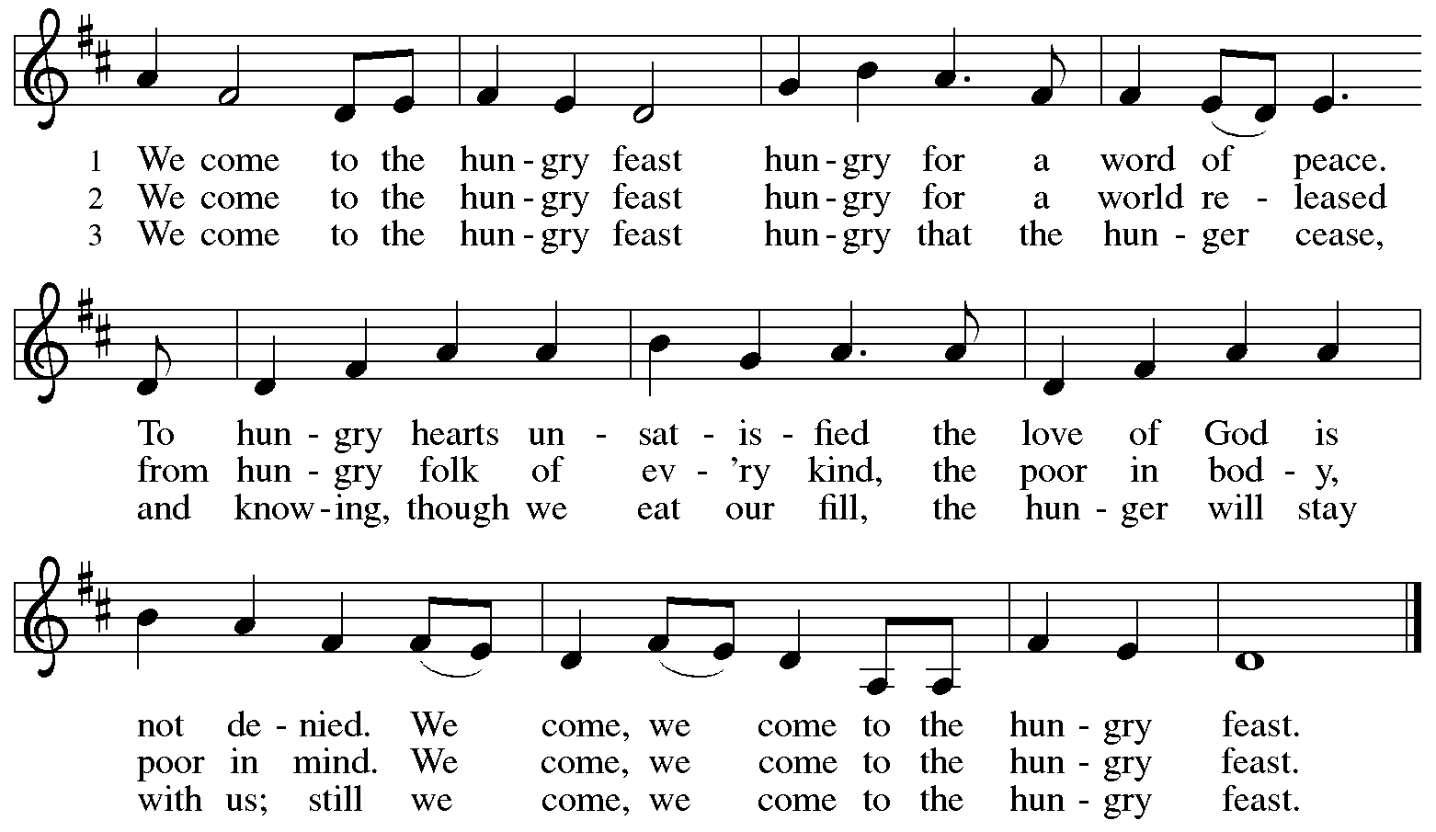

All rights reserved. Reprinted with permission under OneLicense.net # &22139.



Hymns during Holy Communion
All Depends on Our Possessing ELW 589

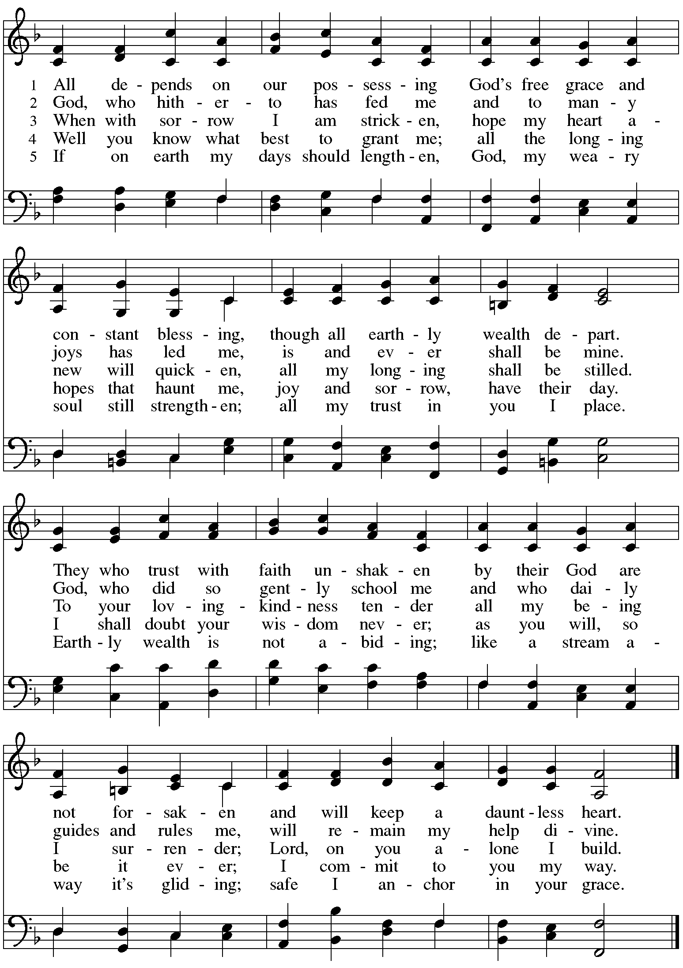

When all have returned to their places, please rise as you are able.

Blessing

P: The body and blood of our Lord Jesus Christ strengthen you and keep you in his grace.
C: Amen.

Prayer

A: Let us pray.
Gracious God,
we give thanks for your pruning, planting, and nurture.
We rejoice that you have used the harvest of field and vineyard
to renew and sustain us.
Lead us as we go from this life-giving meal
into lives of grateful service to you and your cherished creation;
through Jesus Christ, your Son, our Lord.
C: Amen.

Please be seated.

Sending
God blesses us and sends us in mission to the world

Announcements

Please rise as you are able.

Benediction

P: The God of steadfastness and encouragement
grant you to live in harmony with one another,
in accordance with Christ Jesus.
C: Amen.

P: The God of hope fill you with all joy and peace in believing,
so that you may abound in hope by the power of the Holy Spirit.
C: Amen.

P: The God of all grace ☩ bless you now and forever.
C: Amen.

Sending Hymn Founded on Faith ACS 1048

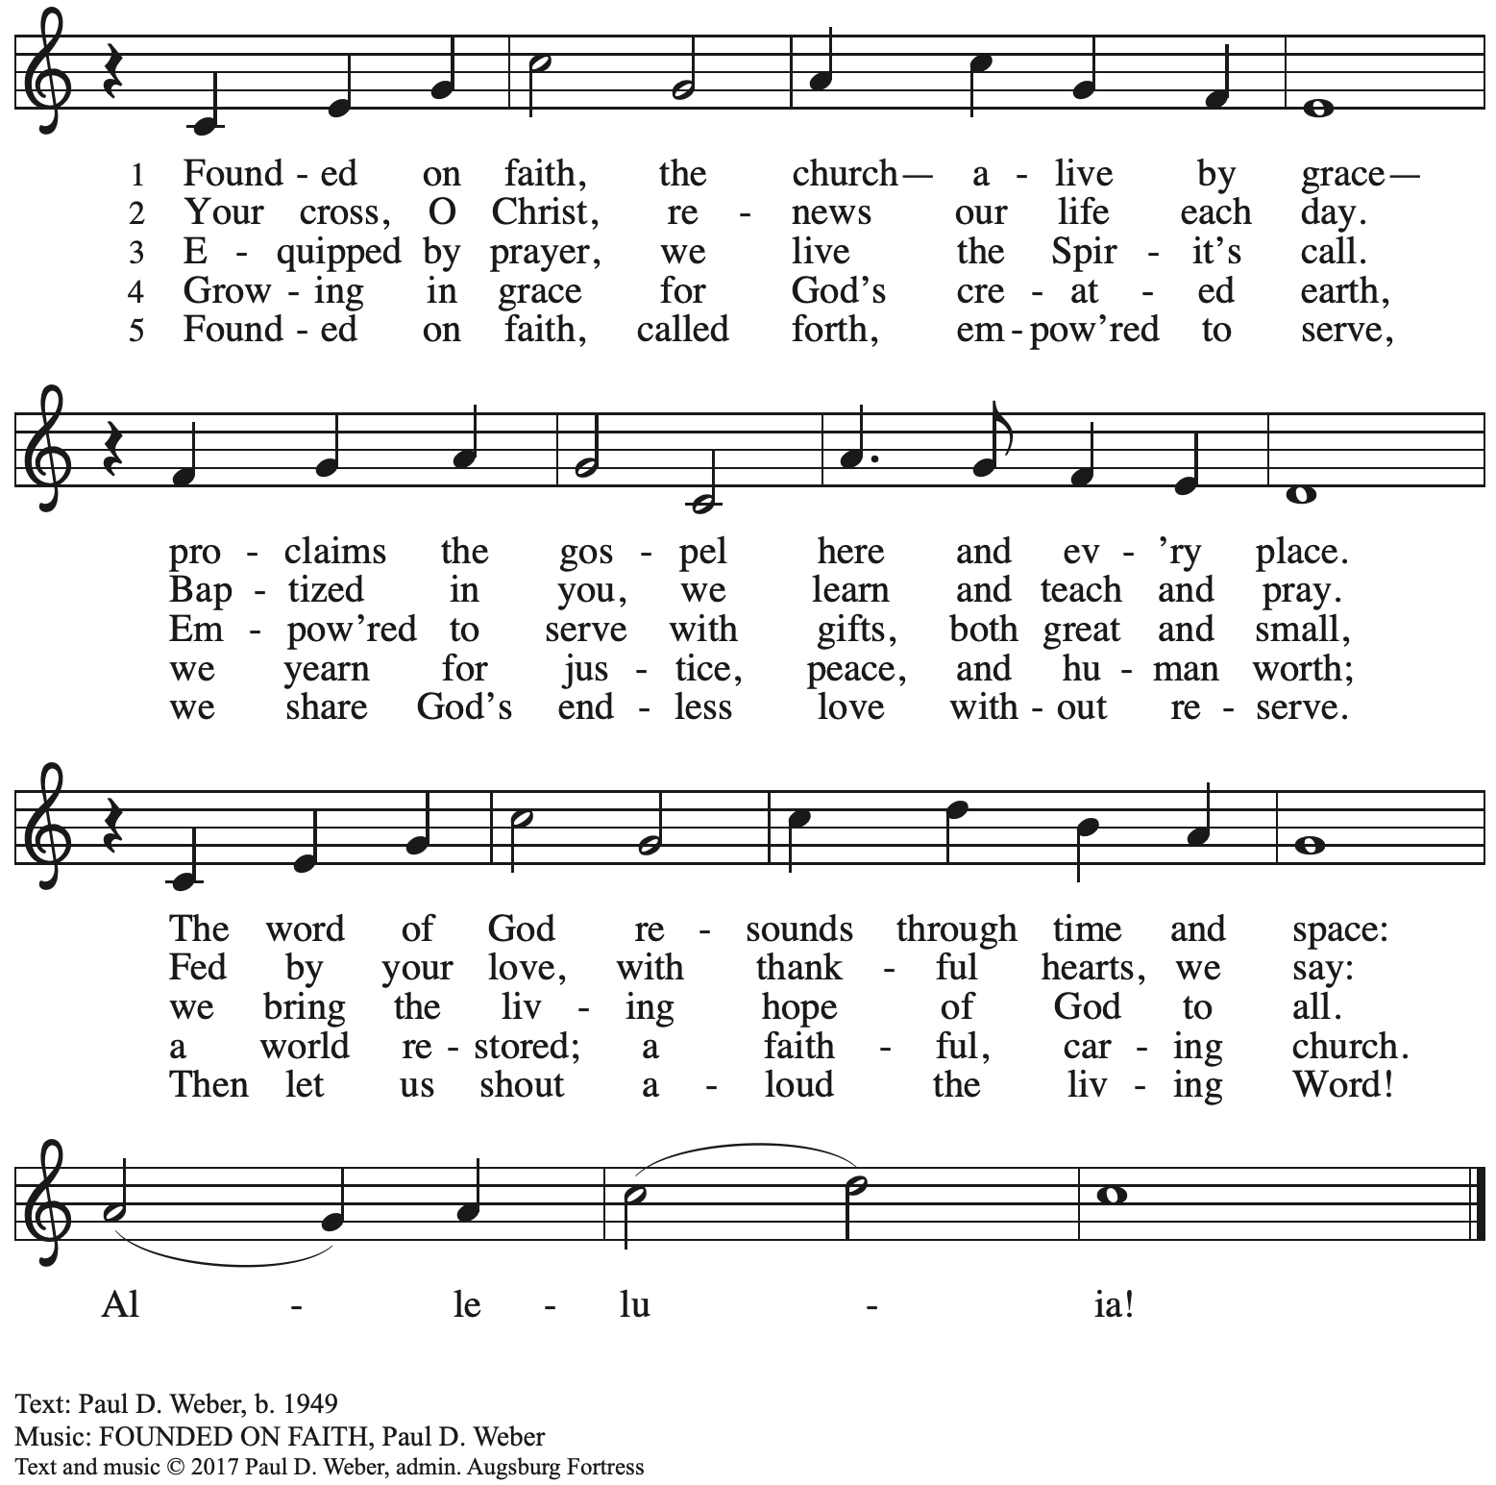
All rights reserved. Reprinted with permission under OneLicense.net # A-722139.

Dismissal

A: Go in peace. Serve the Lord.
C: Thanks be to God!

Postlude

Serving in Worship Today

Altar Care Jodie Minor
Assisting Minister Jimmi Kocher-Hillmer
Audio-Visual Ministers Jered Stratton
Sarita
Cantor Ian Brown
Lector Sue Gaugler
Minister of Music Laura Reynolds
Presiding Minister The Rev. Ross Carmichael

Liturgy and Hymnody Acknowledgements

From SundaysandSeasons.com. Copyright © 2025 Augsburg Fortress. All rights reserved. Reprinted under OneLicense.net # A-722139.
Used by permission of Augsburg Fortress.

The Scripture readings contained herein are from New Revised Standard Version Updated Edition of the Bible © 2021 National Council of Churches of Christ in the United States of America. Used by permission. All rights reserved worldwide.

Gather Us In – Text: Marty Haugen, b. 1950. Music: GATHER US IN, Marty Huagen. Text and music © 1982 GIA Publications, Inc., 7404 S. Mason Ave., Chicago, IL 60638www.giamusic.com. 800.442.3358. All rights reserved. Reprinted with permission under OneLicense.net # A-722139.

Please use the QR code below to link to St. Andrew’s Announcements online!



St. Andrew Lutheran Church Announcements
September 28th, 2025

- Welcome to Worship at St. Andrew on the Sixteenth Sunday after Pentecost! – We are so glad you are here, and we offer a special welcome to all visitors and guests who are here for the first time! A nursery is available through the door to the left of the worship space and across the social hall (look for a purple room). Little Church – Big Faith, a Bible lesson and activity for children up to sixth grade, will take place after the prayer of the day. There are also worship “toolkits” to help children engage with worship and “busy bags” for younger children available in the bookcase at the back of the sanctuary. Please feel free to take one to use with/for your children. All are invited to stay for coffee and other drinks, food, and conversation in the Social Hall (through the side door at the left of the worship space) after the service.
- Monthly Reparations Offering Next Week, Sunday, October 5th, during Worship – In Luke’s Gospel, Jesus tells a story about a compassionate Samaritan, suggesting that God’s people are called to work for healing and restoration for our neighbors, regardless of who or what caused them harm. In light of this, St. Andrew has made a commitment to reparations in regard to African American spiritual songs used in our worship. The text and music of most hymns is attributed to specific authors, with copyrights in place, usage reported, and royalties paid to those whose works are featured in worship. With African American spirituals, this is not possible. In response to many years of such uncredited use, St. Andrew invites the congregation to give a reparations offering. Funds received in worship will be donated to our siblings at Bethel AME Church, whose land and building were taken from them in the 1950s, to fund their development in the Hill District.
- God's Work - Our Hands 2025: Share the Warmth – Through Sunday, October 26th – Each year, the Evangelical Lutheran Church in America asks congregations to participate in its God's Work - Our Hands initiative, an act of service to the congregation's larger community. St. Andrew's God's Work - Our Hands project for this year will be to support "Share the Warmth," a collection of new and gently used winter coats for East End Cooperative Ministry (EECM). St. Andrew will be collecting new and gently used winter coats in the social hall through October. You can also drop off coats for EECM at Strong II Dry Cleaners until October 15th to have them cleaned for free and Strong will deliver them to EECM. They are located at 7620 Frankstown Ave., 15208. Thank you for continuing to do God's Work for the good of our neighbors!
- Reckoning with Antisemitism as Christians Kick-Off – Tuesday, October 21st from 7:00 p.m. - 8:30 p.m. – At this program, we will get inspired by stories of Reckoning from across western PA, and then provide guided planning time for you to decide how you will take part in the Reckoning with Antisemitism as Christians project this year. Like all things, this work is best done together. Join us for an evening with Christian clergy and lay leaders from across our region. We'll learn from those who are engaging in this important work: exploring Christian scriptures, studying the impact of antisemitism, partnering with neighboring houses of worship, or befriending Jewish colleagues. We'll then participate in an interactive planning session, working together to consider how each one of us can reckon with antisemitism and build relationships with Jewish neighbors this year. You can pre-register for the event here: https://www.casp.org/reckoning#oct21.
- Invitation to Prayer Team and New Address! – St. Andrew maintains a list of weekly prayer concerns that is sent by email to members of the congregation who have opted in. In an effort to coordinate our communications, our new prayer team email address is prayerteam@standrewpittsburgh.org. As we renew this prayer ministry, we will also move to a practice of keeping names on the list for a maximum of four weeks unless otherwise requested. Thank you for your ministry of prayer!
- Records Update - Please Respond – St. Andrew is seeking to update our records with information from newer attendees, as well as offering current members the opportunity to include current information. The information will only be used within the congregation - for example to acknowledge celebrations, milestones in worship, and in prayers of the church. Please fill out the form at: https://forms.gle/kKvp19UozuRrhhaV7.
- Coffee Hour Signups – Coffee Hour has resumed! If you would like to participate and would like additional information about the duties, please sign up using the following form: https://www.signupgenius.com/go/5080B4AAFAF2CABF85-47069030-coffee#/.

