

+ All Saints Sunday
November 2, 2025



St. Andrew Lutheran Church
304 Morewood Ave.
Pittsburgh, PA 15213
St_andrewELCA@verizon.net
www.standrewpittsburgh.org

+ All Saints Sunday
Order for Worship

In Holy Baptism God makes saints out of sinners.
In Holy Communion God forgives the sins of all the saints.
In worship today we give thanks for all the saints “who from their labors rest.”
In the same breath, we petition our God for the strength to hear and to heed
the admonitions of Jesus in today’s gospel. Sealed by the Spirit and sustained by the Savior’s body and blood, we live with joy as God gives us breath, to the praise of God’s glory.

Welcome to St. Andrew!
- St. Andrew welcomes all who are seeking a place of healing, wholeness, and acceptance in a nurturing and faith-forming spiritual home. We are striving toward racial equity worldwide
and we seek to honor the lived experience of all individuals regardless of background. Our community embraces people of all ages, ethnicities, cultures, abilities, sexual orientations,
gender identities and expressions, and family constellations. Come and See!
- Worship Services are live-streamed to multiple online platforms. By attending worship, you agree that your image and voice may be broadcast.
- Everyone is invited to make a name tag at the black bookcase in the back of the worship space if they would like. There are stickers indicating pronouns on the bookcase if you would like to include them on your name tag.
- A nursery is available through the doors at the left side of the sanctuary and across from the doorway to the Social Hall. Look for a purple-colored room.
- Children are invited to attend Little Church – Big Faith, a Bible lesson and activity, during worship (after the Prayer of the Day). The group returns to the worship space for the liturgy of Holy Communion.
- Worship “toolkits” to help children engage with the service, along with “busy bags” for younger children, are available in the bookcase at the back of the sanctuary. Please feel free to take one to use with/for your children.
- Holy Communion is served with bread (gluten-free available) and wine or grape juice. The presiding minister will distribute the bread (host). Please consume this and then pick up an empty glass from the tray. The Communion Assistant will pour wine or grape juice into your glass. Please step to the side to consume the wine or grape juice. Feel free to kneel at the altar for prayer and reflection. As you return to your pew, glasses may be returned to the empty trays on either side of the center section.
- A restroom is available on the main level of the church, through the doors to the Social Hall and to the right in the main office.

Abbreviations
P: Pastor/Presiding Minister ELW: Evangelical Lutheran Worship hymnal
A: Assisting Minister ACS: All Creation Sings hymnal
L: Lector TFF: This Far by Faith hymnal
C: Congregation

Musical Offering

Each week, different people from the congregation make an offering of pre-service music, with singing or instrumentation, to help the assembly focus and pray in preparation for worship.

Welcome

Prelude Deep River Spiritual/arr. Shackley

Gathering
The Holy Spirit calls us together as the people of God

Please rise as you are able. All may make the sign of the cross,
the sign that is marked at Baptism, as the presiding minister begins.

Thanksgiving for Baptism

P: Blessed be the holy Trinity, ☩ one God,
the fountain of living water,
the rock who gave us birth,
our light and our salvation.
C: Amen.

P: Joined to Christ in the waters of Baptism, we are clothed with God’s mercy and forgiveness.
Let us give thanks for the gift of Baptism.

Silence is kept for reflection

P: We bless you, almighty God, for the gift of water –
for the oceans that surround the earth,
for the rivers that nurture the land,
for the Allegheny, Monongahela, and Ohio Rivers that you provide for our community –
we bless you, O God, for the waters of the earth:
C: We bless you, O God, for the waters of the earth.

P: We honor you, merciful God, for showering us with water –
for the rain that nourishes the plants and trees,
for the floods that restore the fields,
for the dew that freshens dry places –
we honor you, O God, for the waters you send:
C: We honor you, O God, for the waters you send.

P: We glorify you, gracious God, for the waters of Baptism –
for the water of the Jordan that washed our Lord Jesus,
for the water that baptized the believers on Pentecost,
for the water that illumines us with your Word,
P: for the water that pours out the gifts of the Spirit,
for the water that bathes the church universal and all the saints –
we glorify you, O God, for the waters of Baptism:
C: We glorify you, O God, for the waters of Baptism.

P: We worship you, O God, Father, Son, and Holy Spirit,
almighty, merciful, and gracious.
Well of forgiveness, you revive us.
Cup of cold water, you refresh us.
Pool of rebirth, you renew us.
To you comes the worship of all your people, now and forever:
C: To you comes the worship of all your people, now and forever.
Amen.

Gathering Hymn For All Your Saints, O Lord ELW 427

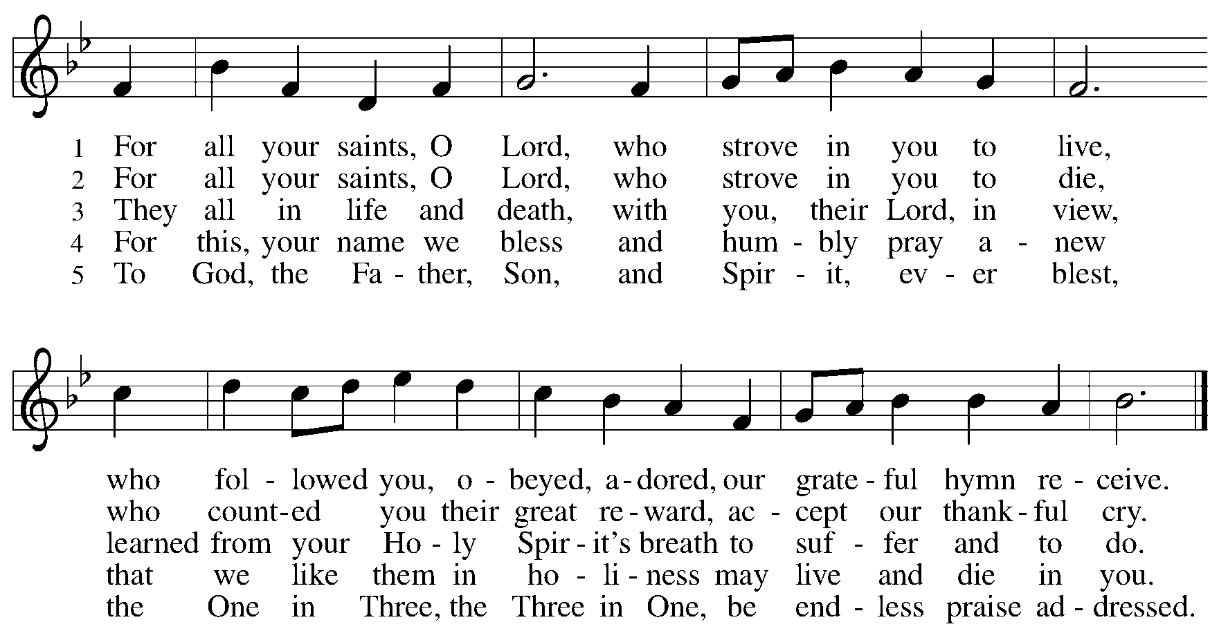

Greeting

P: The grace of our Lord Jesus Christ, the love of God,
and the communion of the Holy Spirit be with you all.
C: And also with you.

Kyrie ELW p. 147

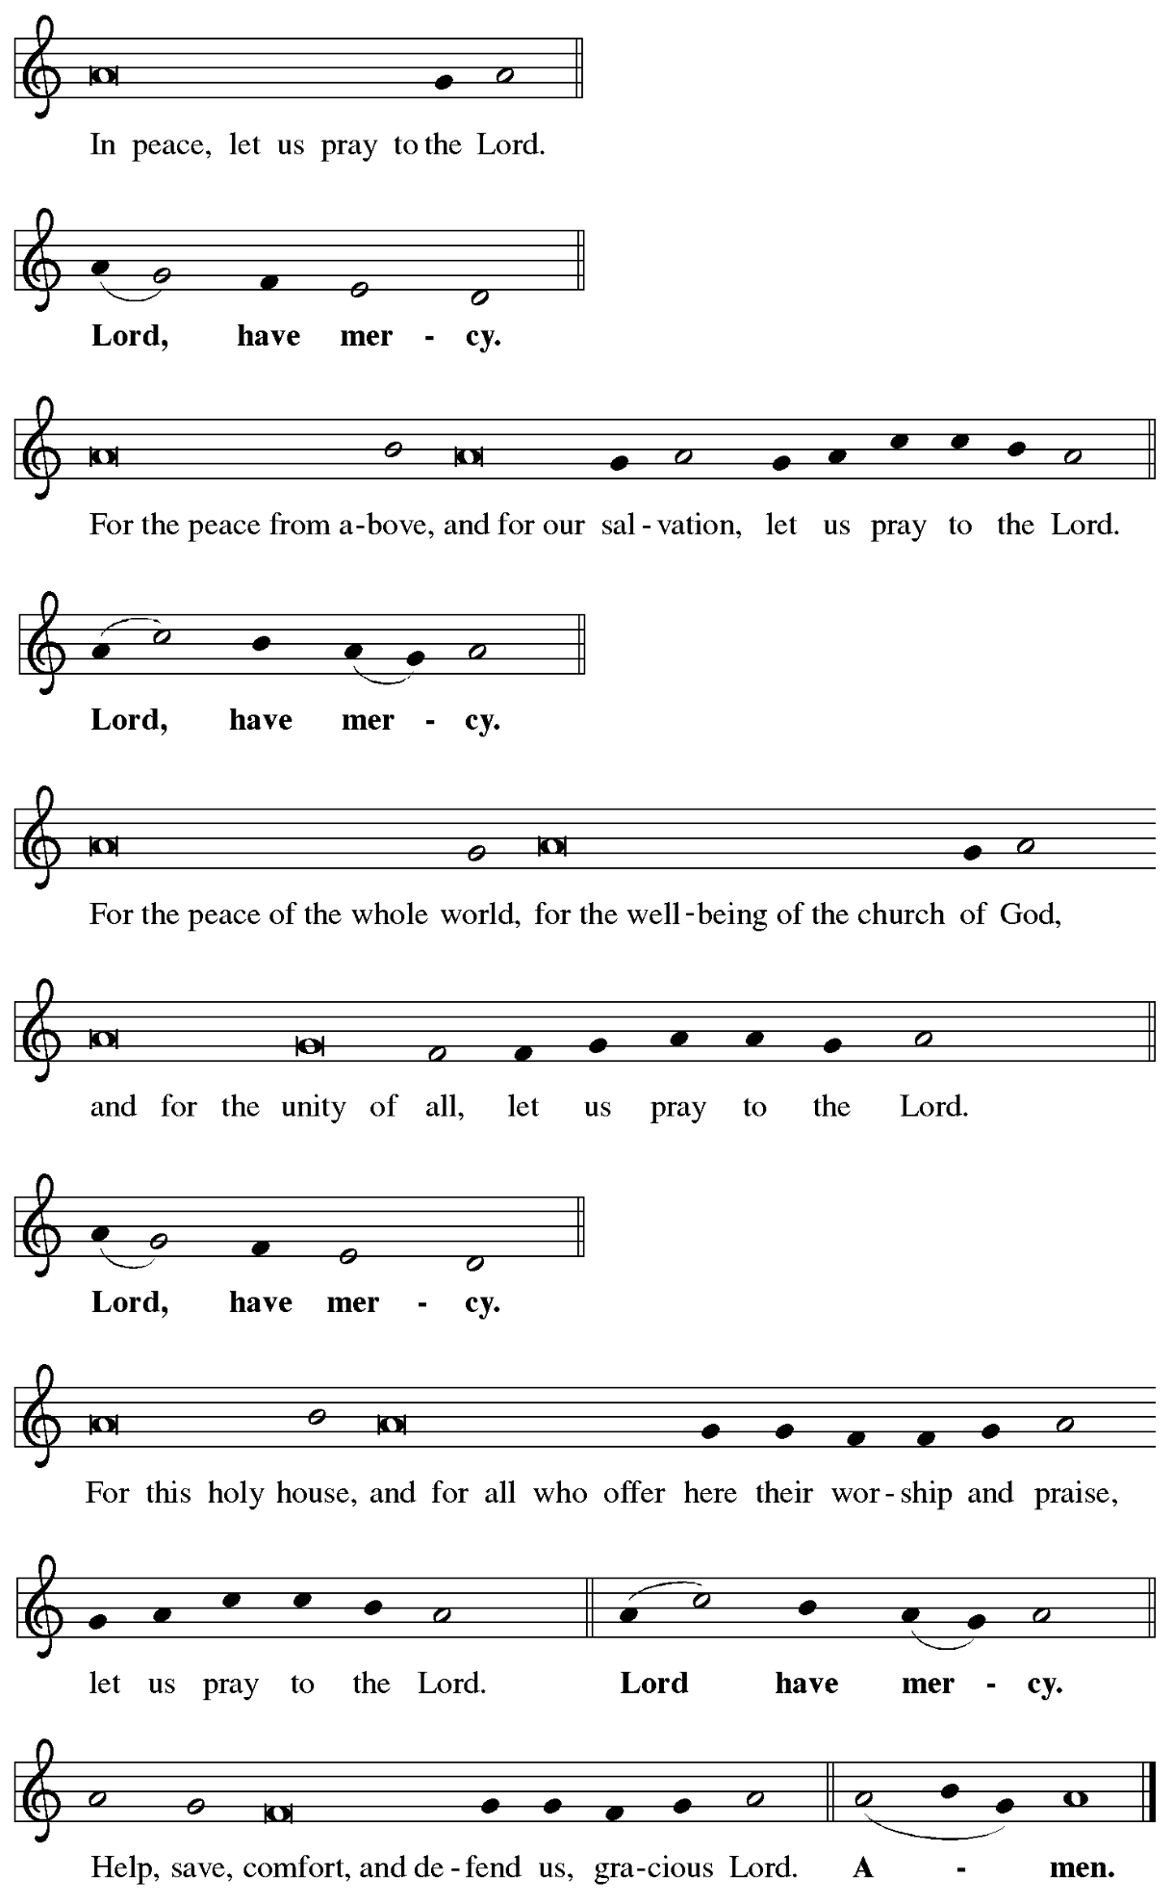
Hymn of Praise ELW p. 149

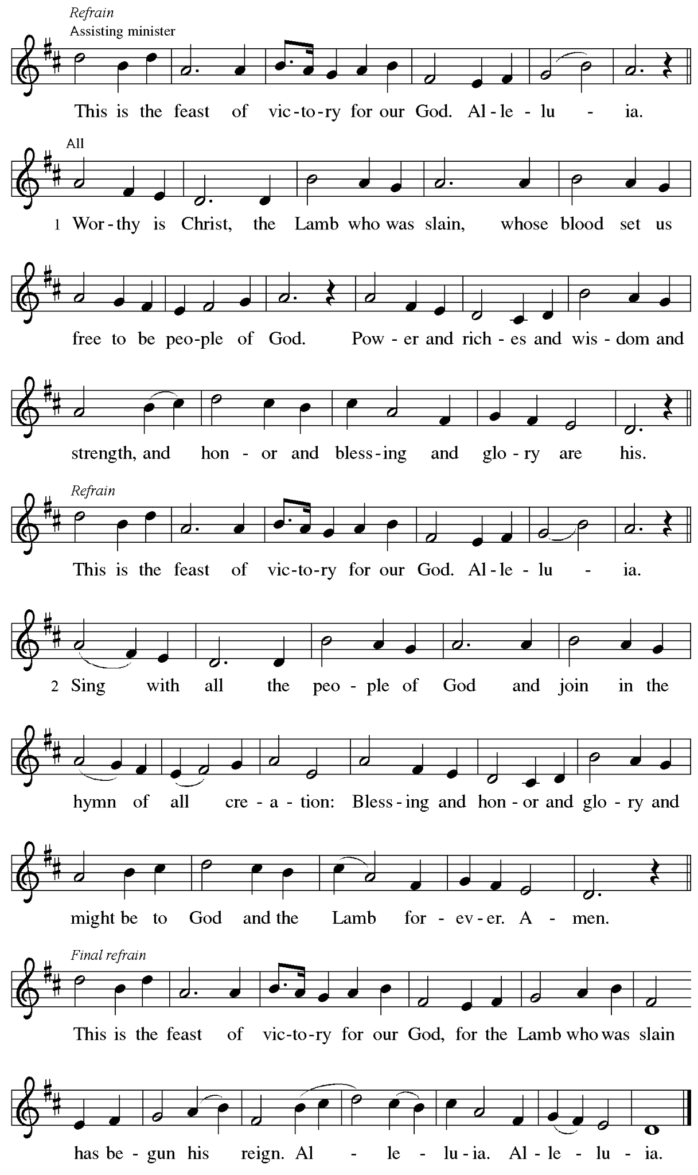
Prayer of the Day

P: The Lord be with you.
C: And also with you.

P: Let us pray.
Almighty God, you have knit your people together in one communion
in the mystical body of your Son, Jesus Christ our Lord.
Grant us grace to follow your blessed saints in lives of faith and commitment,
and to know the inexpressible joys you have prepared for those who love you,
through Jesus Christ, our Savior and Lord, who lives and reigns with you and the Holy Spirit, one God, now and forever.
C: Amen.

Please be seated.
Children are invited to join the adult leader(s) at the side door for Little Church – Big Faith.
We ask that an additional adult from the congregation attend with the children.

Word
God speaks to us in Scripture reading, preaching, and song

First Reading – Daniel 7: 1-3, 15-18

¹ In the first year of King Belshazzar of Babylon, Daniel had a dream and visions of his head as he lay in bed. Then he wrote down the dream: ² I, Daniel, saw in my vision by night the four winds of heaven stirring up the great sea, ³ and four great beasts came up out of the sea, different from one another.
¹⁵ As for me, Daniel, my spirit was troubled within me, and the visions of my head terrified me. ¹⁶ I approached one of the attendants to ask him the truth concerning all this. So he said that he would disclose to me the interpretation of the matter: ¹⁷ “As for these four great beasts, four kings shall arise out of the earth. ¹⁸ But the holy ones of the Most High shall receive the kingdom and possess the kingdom forever—forever and ever.”

L: Word of God, word of life.
C: Thanks be to God.

Psalm 149

The psalm will be sung responsively, led by the cantor, with the congregation singing the verses in bold type and joining in the refrain.

Psalm Tone

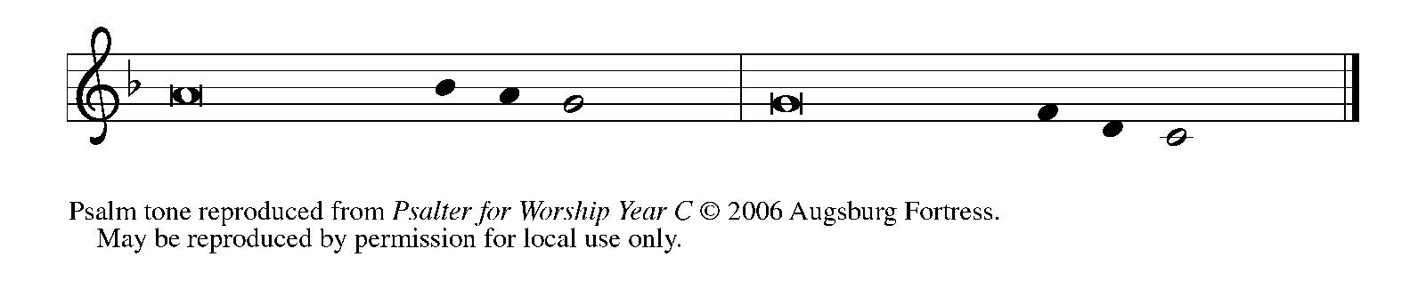

Psalm Refrain

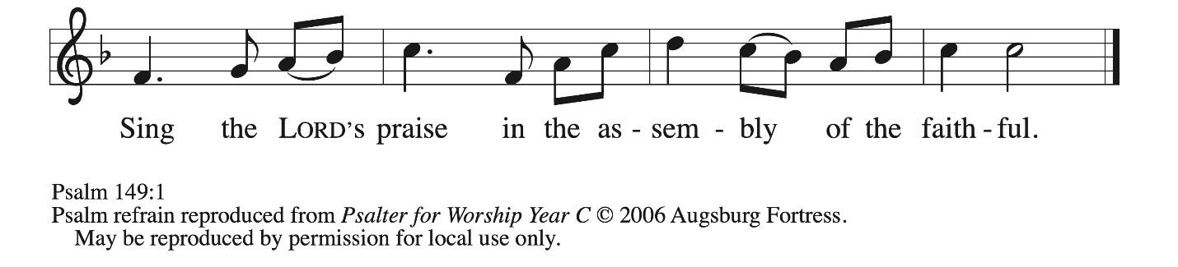

¹ Hallelujah! Sing to the Lord | a new song,
God’s praise in the assembly | of the faithful.
² Let Israel rejoice | in their maker;
let the children of Zion be joyful | in their ruler.
³ Let them praise their maker’s | name with dancing;
let them sing praise with tambou- | rine and harp.
⁴ For the Lord takes pleasure | in the people
and adorns the | poor with victory. R
⁵ Let the faithful re- | joice in triumph;
let them sing for joy | on their beds.
⁶ Let the praises of God be | in their throat
and a two-edged sword | in their hand,
⁷ to wreak vengeance | on the nations
and punishment | on the peoples,
⁸ to bind their | kings in chains
and their nobles with | links of iron,
⁹ to inflict on them the judg- | ment decreed;
this is glory for all God’s faithful ones. | Hallelujah! R

Second Reading – Ephesians 1: 11-23

¹¹ In Christ we have also obtained an inheritance, having been destined according to the purpose of the one who accomplishes all things according to God’s counsel and will, ¹² so that we, who were the first to set our hope on Christ, might live for the praise of his glory. ¹³ In him you also, when you had heard the word of truth, the gospel of your salvation, and had believed in him, were marked with the seal of the promised Holy Spirit; ¹⁴ this is the pledge of our inheritance toward redemption as God’s own people, to the praise of God’s glory.
¹⁵ I have heard of your faith in the Lord Jesus and your love toward all the saints, and for this reason ¹⁶ I do not cease to give thanks for you as I remember you in my prayers, ¹⁷ that the God of our Lord Jesus Christ, the Father of glory, may give you a spirit of wisdom and revelation as you come to know God, ¹⁸ so that, with the eyes of your heart enlightened, you may perceive what is the hope to which God has called you, what are the riches of God’s glorious inheritance among the saints, ¹⁹ and what is the immeasurable greatness of God’s power for us who believe, according to the working of God’s great power. ²⁰ God put this power to work in Christ when God raised him from the dead and seated him at God’s right hand in the heavenly places, ²¹ far above all rule and authority and power and dominion and above every name that is named, not only in this age but also in the age to come. ²² And God has put all things under [Christ’s] feet and has made him the head over all things for the church, ²³ which is his body, the fullness of the one fills all in all.

L: Word of God, word of life.
C: Thanks be to God.

Please rise as you are able.

Gospel Acclamation ELW p. 151

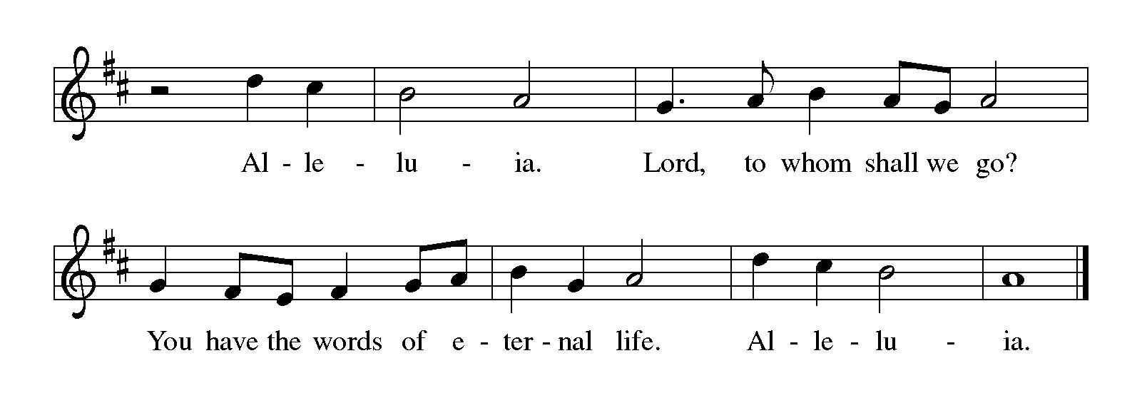
Gospel – Luke 6: 20-31

P: The holy Gospel according to St. Luke.
C: Glory to you, O Lord.

²⁰ Then [Jesus] looked up at his disciples and said:
“Blessed are you who are poor,
for yours is the kingdom of God.
²¹ “Blessed are you who are hungry now,
for you will be filled.
“Blessed are you who weep now,
for you will laugh.
²² “Blessed are you when people hate you and when they exclude you, revile you, and defame you on account of the Son of Humanity. ²³ Rejoice on that day and leap for joy, for surely your reward is great in heaven, for that is how their ancestors treated the prophets.
²⁴ “But woe to you who are rich,
for you have received your consolation.
²⁵ “Woe to you who are full now,
for you will be hungry.
“Woe to you who are laughing now,
for you will mourn and weep.
²⁶ “Woe to you when all speak well of you, for that is how their ancestors treated the false prophets.
²⁷ “But I say to you who are listening: Love your enemies; do good to those who hate you; ²⁸ bless those who curse you; pray for those who mistreat you. ²⁹ If anyone strikes you on the cheek, offer the other also, and from anyone who takes away your coat do not withhold even your shirt. ³⁰ Give to everyone who asks of you, and if anyone takes away what is yours, do not ask for it back again. ³¹ Do to others as you would have them do to you.”

P: The Gospel of the Lord.
C: Praise to you, O Christ.

Please be seated.

Sermon

A time of silence for prayer and reflection follows the sermon.

All Saints Remembrance

P: The Lord be with you.
C: And also with you.

P: Let us pray.
Gracious and loving God, the generations rise and pass away before you,
and you hold all your people in your tender care.
You are the strength of those who labor; you are the rest of the blessed dead.
We rejoice today in the company of your saints.
We remember those dear to us who now rest in you,
who have lived in faith and who have died and are at peace,
Give us in time our share with those who have trusted in you
and have sought to do your holy will.

To your name, O Triune God, with the Church on earth and the hosts of heaven,
we ascribe all honor, glory, and praise, now and forever.
C: Amen.

Organ chimes ring before and after the name of each member of the St. Andrew community who has joined the communion of saints in the past year.

As the presiding minister reads the names of family and friends of the congregation who have died since the last All Saints Sunday, the Hymn of the Day, “For All the Saints, begins. Once the reading of names has concluded, the congregation is invited to join in singing the hymn.

During this time, people of the congregation are invited to come forward to light a candle and place it in the sand at the center of the worship space in memory of loved ones. Please place your candles from the back of the tray moving toward the front so that those who follow can more easily place theirs.

Hymn of the Day For All the Saints ELW 422

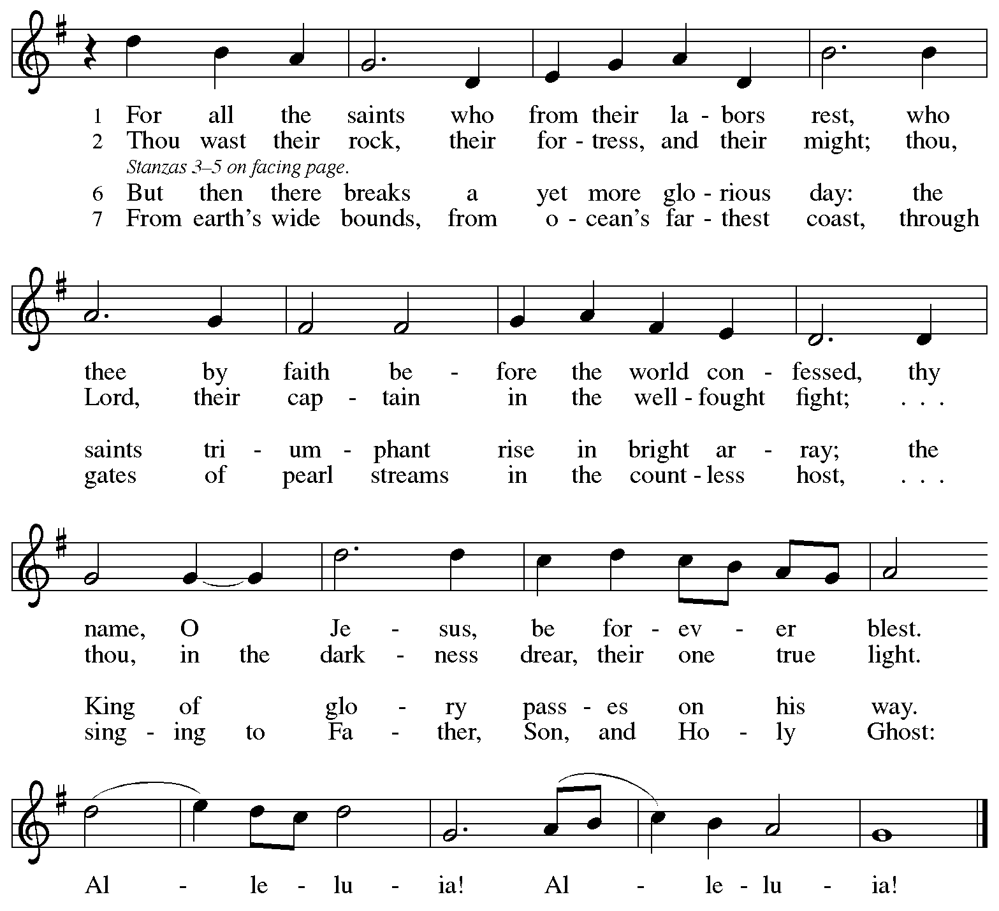
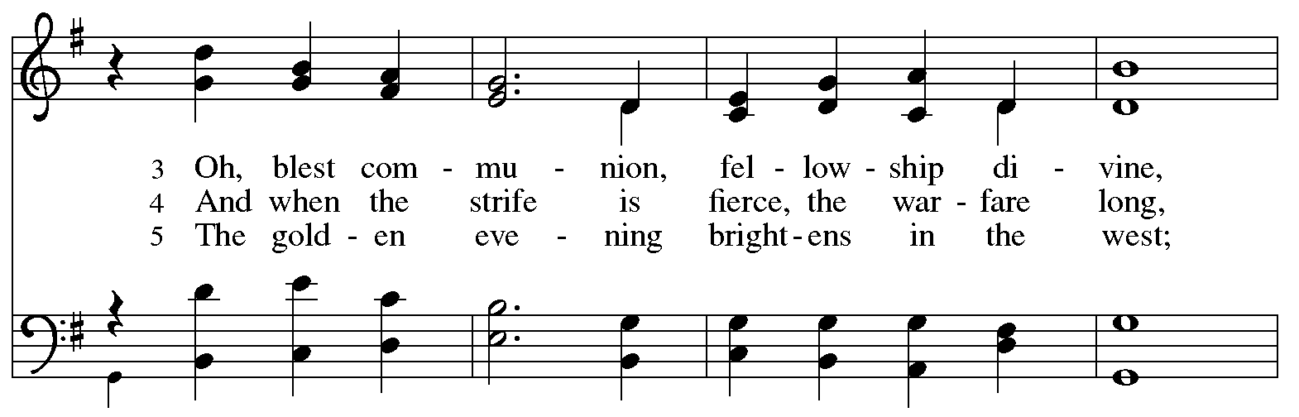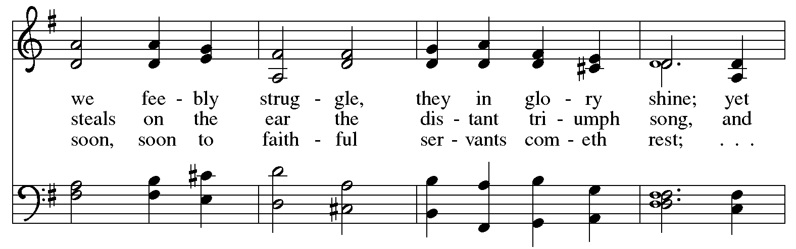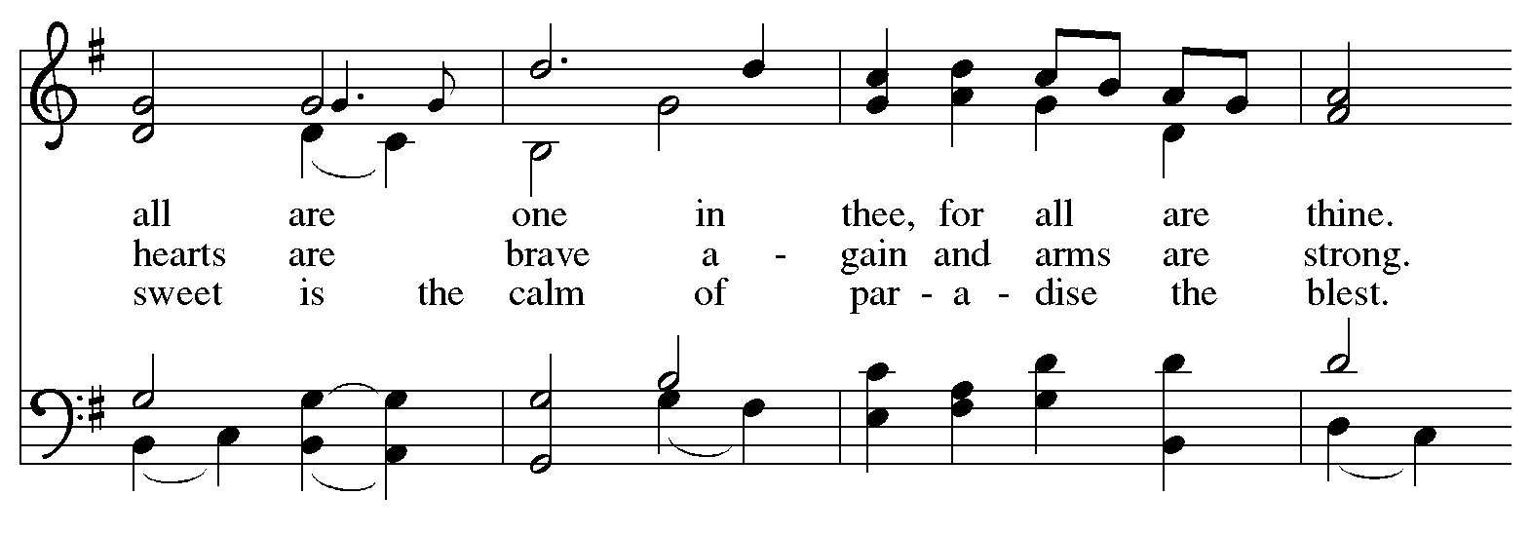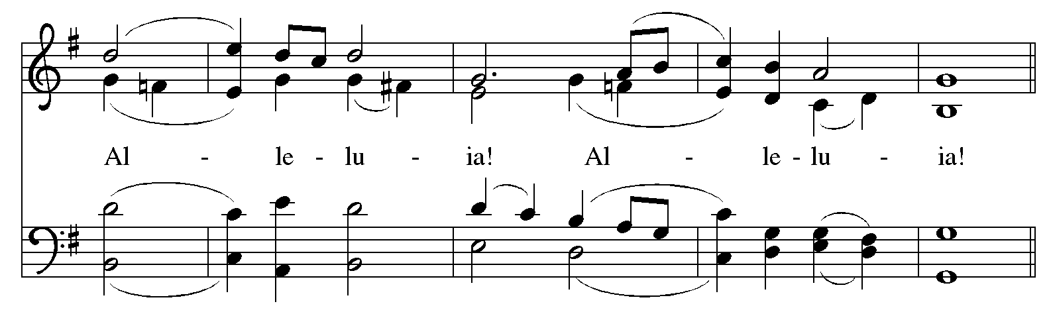
Text: William W. How, 1823-1897. Music: SINE NOMINE, Ralph Vaughan Williams, 1872-1958.

When all have returned to their places, the rite of remembrance concludes:
P: Rest eternal grant them, O Lord,
C: and let light perpetual shine upon them.

P: By your mercy,
C: may they, and all the faithful departed, rest in peace. Amen.

Choir Anthem No Night There Forrest

Please rise as you are able

Prayers of the People

A: Renewed in God’s everlasting grace, let us pray for the church, the world,
and all who are in need.

After each petition
A: God of grace,
C: receive our prayer.

P: We offer our prayers to you, O God, trusting in your abundant mercy,
through Jesus Christ our Lord.
C: Amen.

Peace

The presiding minister and the assembly greet one another in the peace of the risen Christ.
P: The peace of Christ be with you always.
C: And also with you.

The people may greet those around them with a sign of Christ’s peace and may say
Peace be with you or similar words. Please be mindful that not everyone will be comfortable with sharing the peace, so please seek consent before shaking hands or hugging. Other possible ways to share the peace include a simple bow with the verbal greeting of peace, or simply a verbal expression of peace.

When the greetings of peace have concluded, please be seated.

Meal
God feeds us with the presence of Jesus Christ



Offering

We offer ourselves, our gifts, and our faithful service to God.
As the offering is gathered for the mission of the church, including the care of those in need,
the table is set for Holy Communion.

There are laminated giving cards in the pew racks that feature a QR code for anyone who would like to give online. Those who give using the QR code, as well as those who give regularly online or through their bank are encouraged to place the laminated card in the plate as an expression of your offering.

Reparations Offering

On the first Sunday of each month, St. Andrew invites people of the congregation to give a second offering for a reparations fund in acknowledgment of St. Andrew’s use of African American spiritual songs in our worship services. Please see the note in the announcements for more information.

Offertory Music Shall We Gather at the River Lowry/arr. Raney

As the gifts are brought forward for presentation, please rise as you are able.

Offertory Song Let the Vineyards Be Fruitful ELW 184

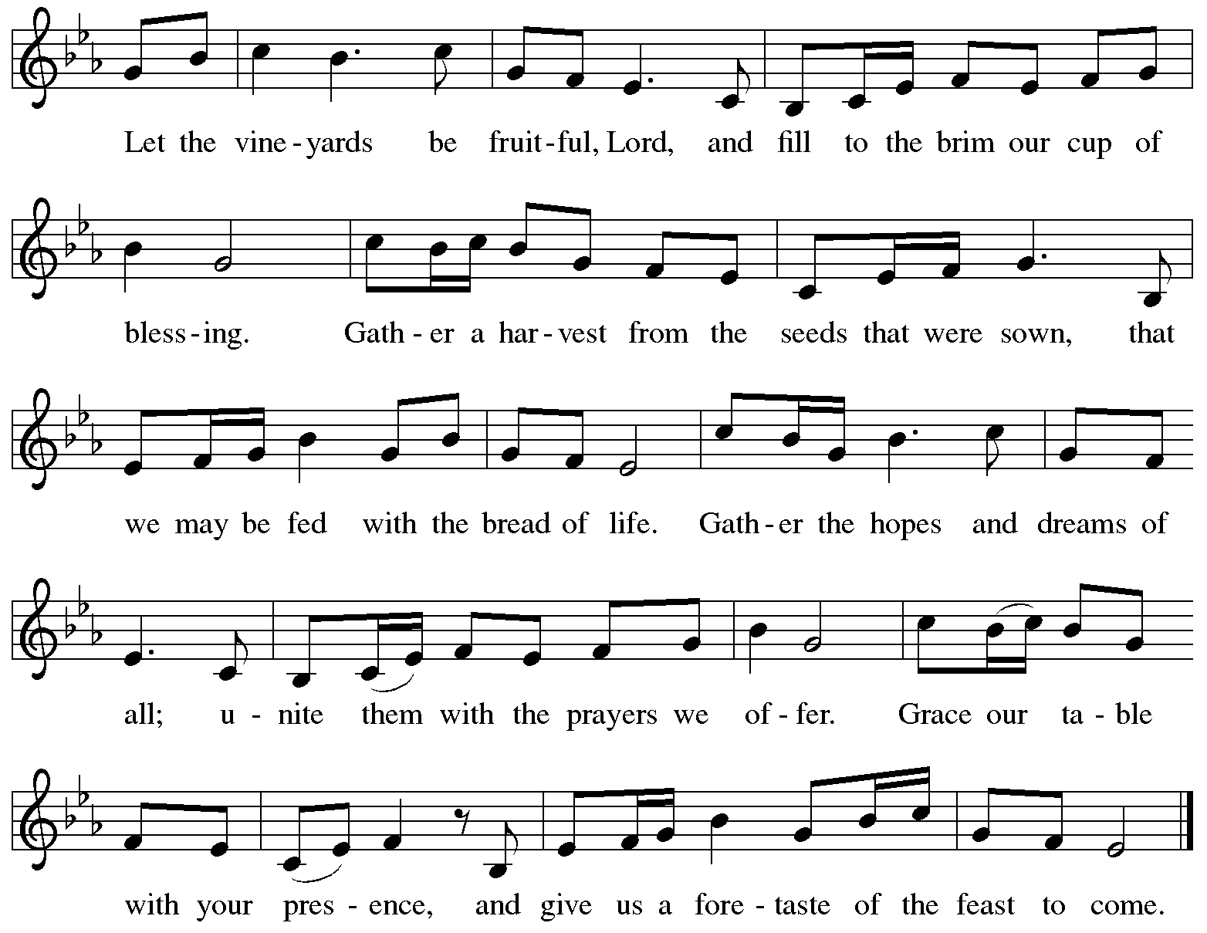
All rights reserved. Reprinted with permission under OneLicense.net # A-722139.

Offertory Prayer

A: Let us pray.
God of mercy and grace,
C: the eyes of all wait upon you, and you open your hand in blessing.
Fill us with good things at your table, that we may come to the help of all in need,
through Jesus Christ, our redeemer and Lord.
Amen.

Dialogue ELW p. 152

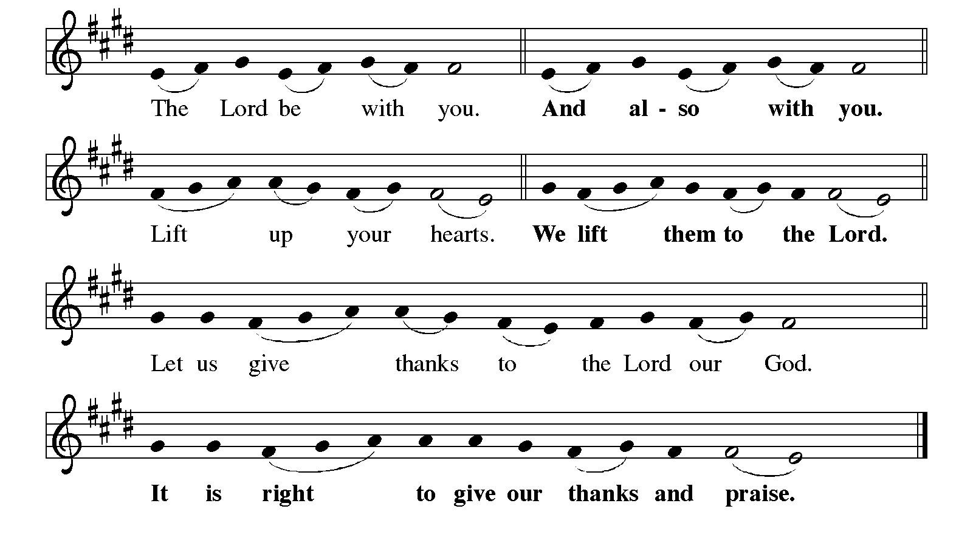

Preface

P: It is indeed right, our duty and our joy,
that we should at all times and in all places
give thanks and praise to you, almighty and merciful God,
through our Savior Jesus Christ.
By the witness of your saints you show us the hope of our calling
and strengthen us to run the race set before us,
that we may delight in your mercy and rejoice with them in glory.
And so, with Janet and all the saints,
with the choirs of angels and all the hosts of heaven,
we praise your name and join their unending hymn:

Sanctus ELW p. 153

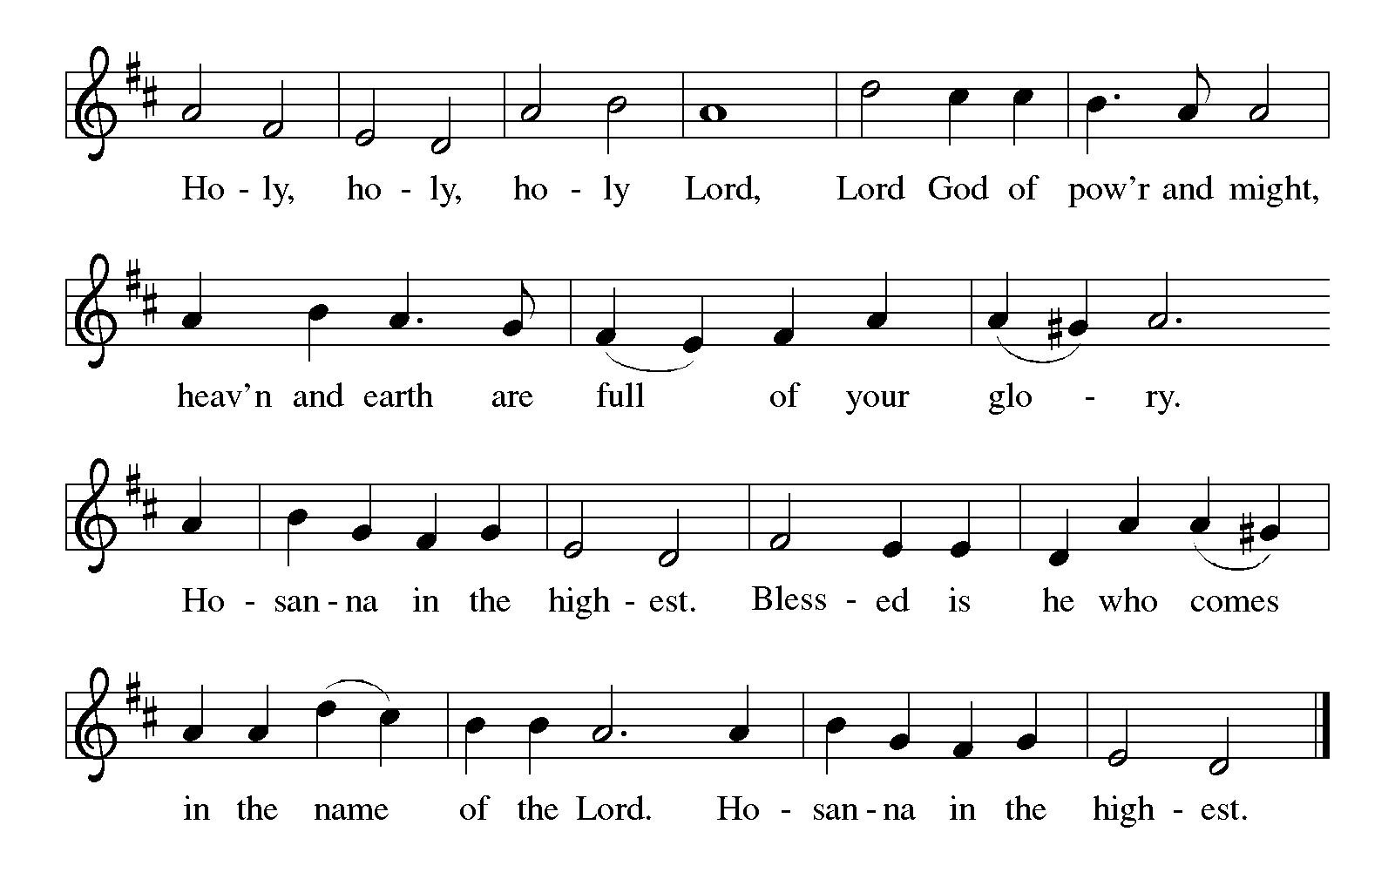
Eucharistic Prayer

P: Holy God, mighty Lord, gracious Father, …
… Do this for the remembrance of me.

For as often as we eat of this bread and drink from this cup,
we proclaim the Lord’s death until he comes.
C: Christ has died. Christ is risen. Christ will come again.

P: Therefore, O God, with this bread and cup …
… to share with us the great and promised feast.
C: Amen. Come, Lord Jesus.

P: Send now, we pray, your Holy Spirit …
… and receive our inheritance with all your saints in light.
C: Amen. Come, Holy Spirit.

P: Join our prayers …
… all glory and honor are yours, almighty Father,
now and forever.
C: Amen.
Lord’s Prayer

P: Gathered as one by the Holy Spirit, let us pray as Jesus taught us.
C: Our Father in heaven,
hallowed be your name,
your kingdom come,
your will be done,
on earth as in heaven.
Give us today our daily bread.
Forgive us our sins
as we forgive those
who sin against us.
Save us from the time of trial
and deliver us from evil.
For the kingdom, the power,
and the glory are yours,
now and forever. Amen.

Fraction and Invitation



Agnus Dei / Lamb of God ELW p. 154

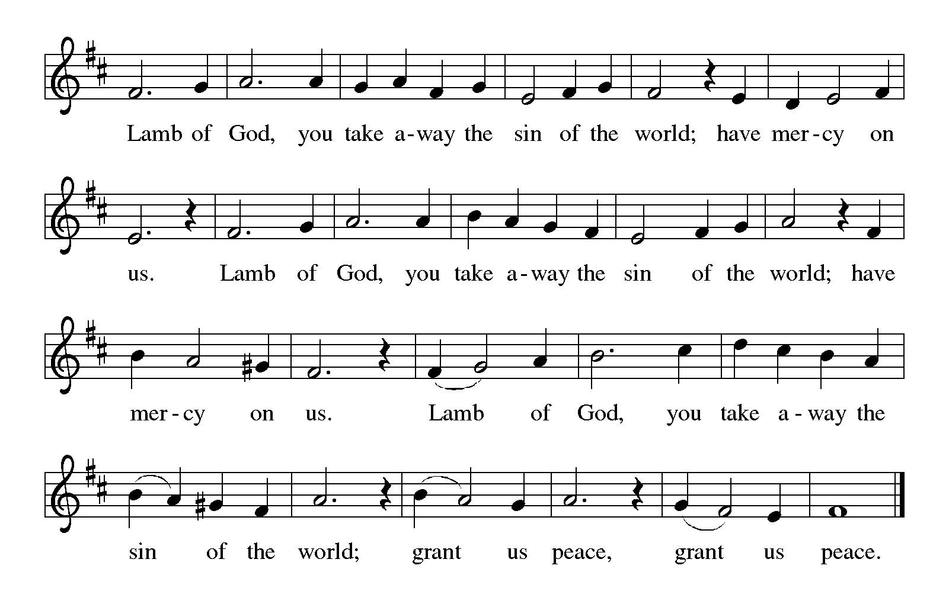

Please be seated.

Holy Communion

- All who seek God and desire a deeper and stronger life in Christ are welcome to receive Holy Communion.
- Worshipers from the pulpit side will proceed forward first, followed by the center section, and then the lectern side.
- Please inform an usher if you would like the ministers to bring Communion to you.
- Holy Communion will be served with bread and wine (amber) or grape juice (purple).
- The presiding minister will first distribute the bread (host) to each communicant. Please indicate if you require a gluten-free host.
- Once you have consumed the bread, please pick up an empty glass from the tray next to the presiding minister. The Communion Assistant will pour wine or grape juice into your glass.
- Please step to the side to consume the wine or grape juice.
- Feel free to kneel at the altar rail for prayer after receiving the sacrament.
- As you return to your pew, glasses may be returned to the empty tray on the side of the center section.
- A blessing will be provided for anyone who does not yet receive the sacrament.
- All are invited to join in singing the hymns during Holy Communion.
Hymns during Holy Communion
Shall We Gather at the River ELW 423

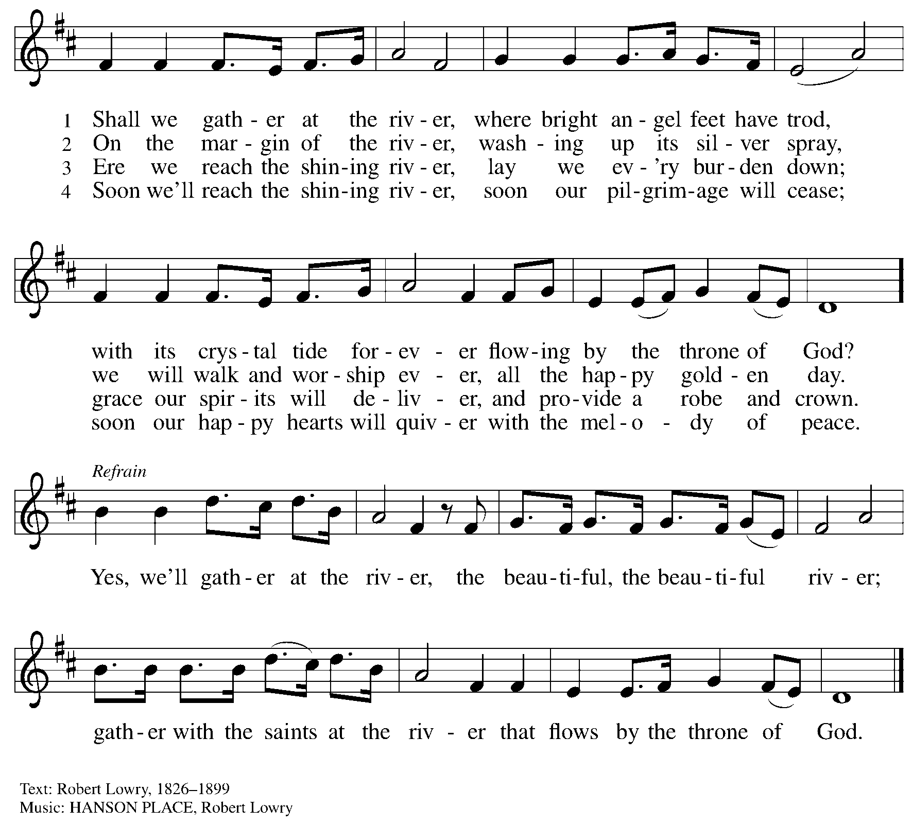

Hymns during Holy Communion
Death Be Never Last ACS 1030

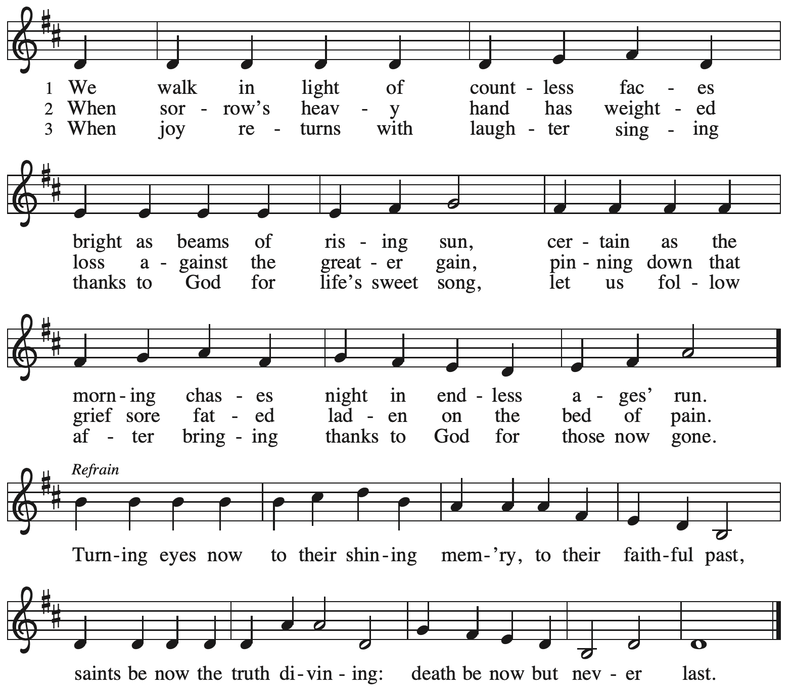

All rights reserved. Reprinted with permission under OneLicense.net # A-722139.

Hymns during Holy Communion
O Beauty, Ever Ancient ACS 1100

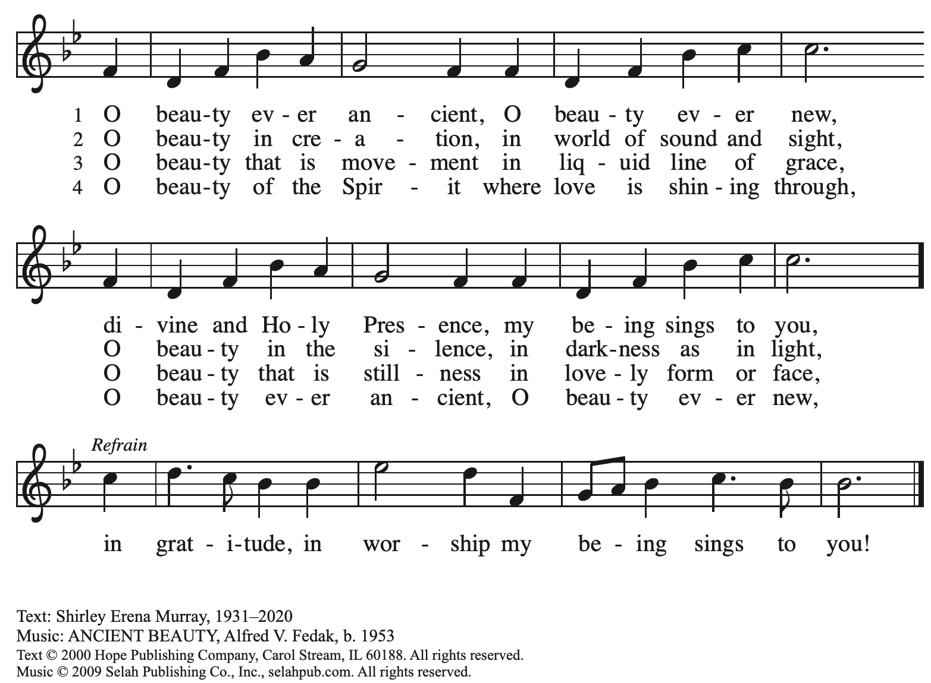
Reprinted under OneLicense.net # A-722139.

Hymns during Holy Communion
Ye Watchers and Ye Holy Ones ELW 424

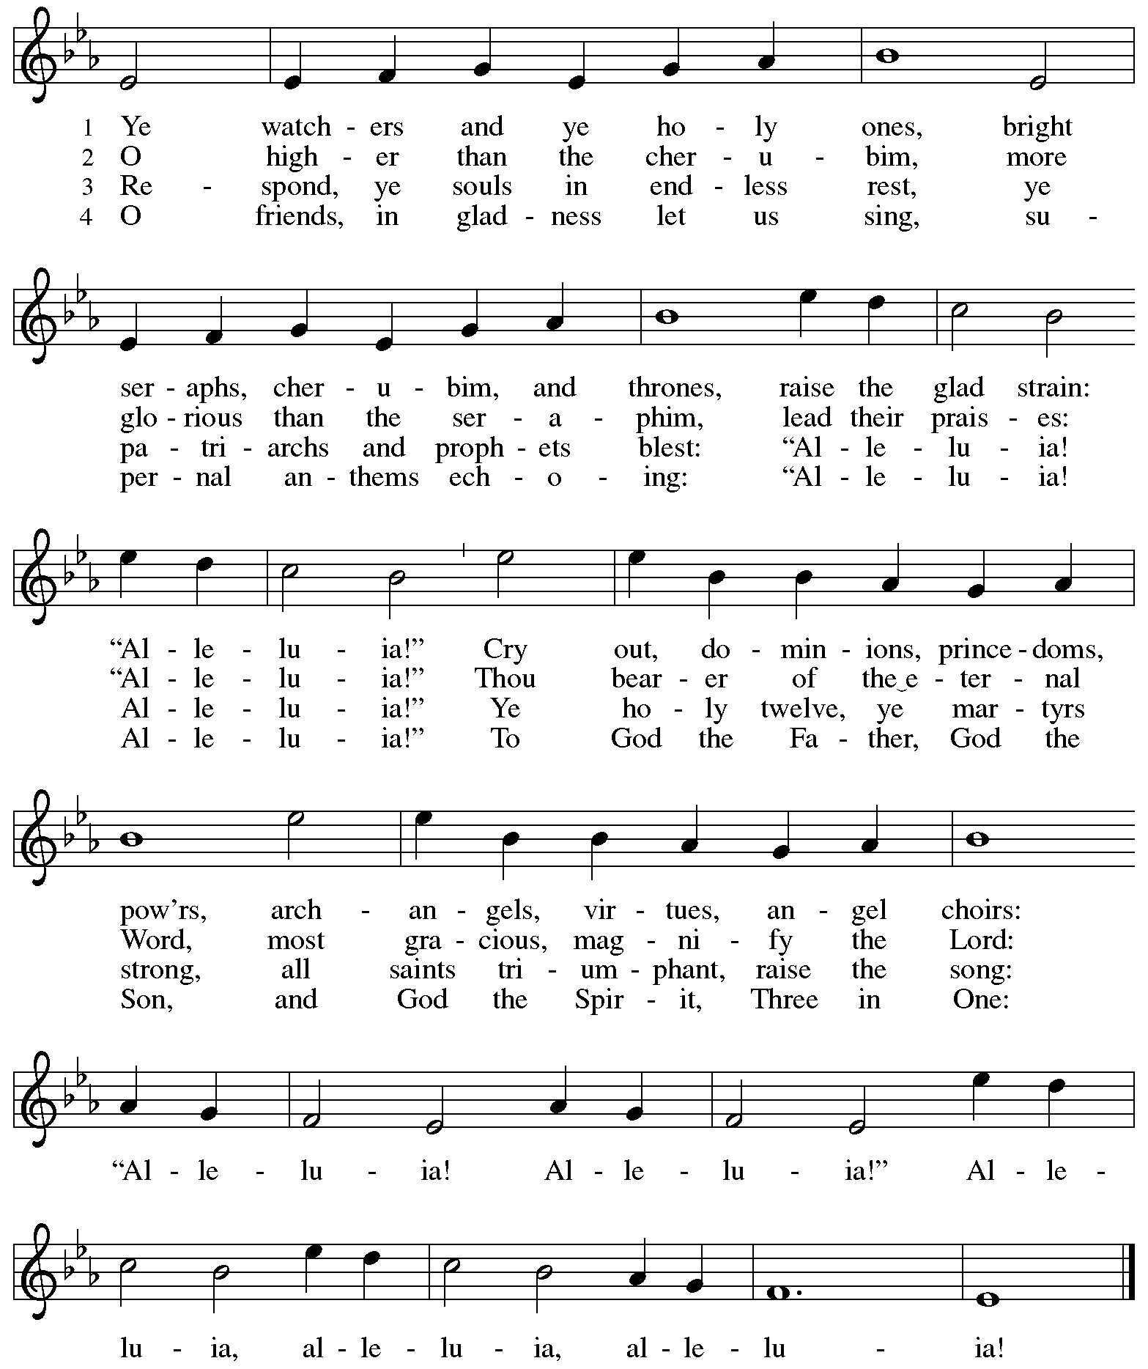
Reprinted with permission under OneLicense.net # A-722139.
When all have returned to their places, please rise as you are able.

Blessing

P: The body and blood of our Lord Jesus Christ strengthen you and keep you in his grace.
C: Amen.

Prayer

A: Let us pray.
O God our life, our strength, our food,
we give you thanks for sustaining us with the body and blood of your Son.
By your Holy Spirit, enliven us to be the Body of Christ in the world,
that more and more we will give you praise and serve your earth and its many peoples,
through Jesus Christ, our Savior and Lord.
C: Amen.

Please be seated.

Sending
God blesses us and sends us in mission to the world

Announcements

Please rise as you are able.

Benediction

P: The love of God the Sovereign strengthen you,
God the Son save you,
and the Holy Spirit anoint and sustain you.

The Holy Trinity ☩ bless you
and grant you a faithful and courageous heart,
now and forever.
C: Amen.

Sending Hymn Following page

Sending Hymn Oh, When the Saints Go Marching In TFF 180

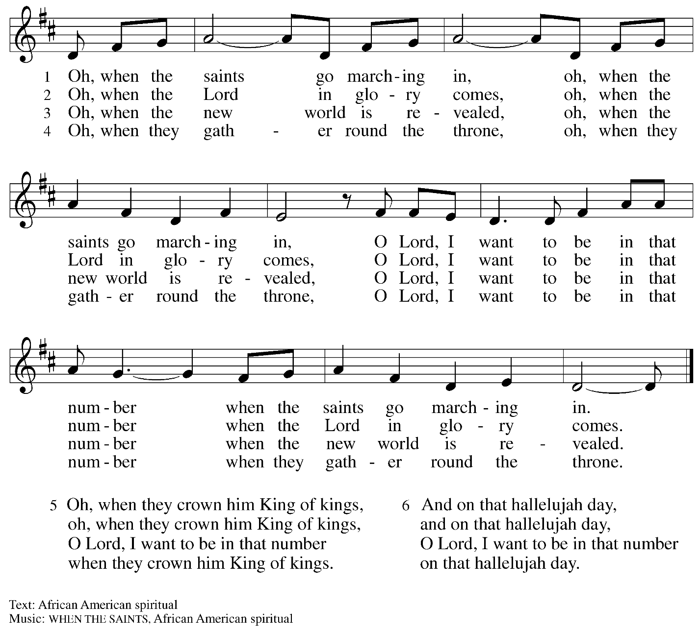

Dismissal

A: Go in peace. Serve the Lord.
C: Thanks be to God!

Postlude

Serving in Worship Today

Altar Care Beverley Chapman
Assisting Minister Kathy Hays
Audio-Visual Ministers Joseph Paetz
Sarita
Cantor Marit Bakken
Lector Brennan Coleman
Minister of Music Laura Reynolds
Preaching Minister The Rev. Janet B. Grill, Pastor Emerita
Presiding Minister The Rev. Ross Carmichael

Liturgy and Hymnody Acknowledgements

From SundaysandSeasons.com. Copyright © 2025 Augsburg Fortress. All rights reserved. Reprinted under OneLicense.net # A-722139.
Used by permission of Augsburg Fortress.

The Scripture readings contained herein are from New Revised Standard Version Updated Edition of the Bible © 2021 National Council of Churches of Christ in the United States of America. Used by permission. All rights reserved worldwide.

Please use the QR code below to link to St. Andrew’s Announcements online!



St. Andrew Lutheran Church Announcements
November 2nd, 2025

- Welcome to Worship at St. Andrew on All Saints Sunday – We are so thankful you are here, and we offer a special welcome to all visitors and guests who are here for the first time! A nursery is available through the door to the left of the worship space and across the social hall (look for a purple room). Little Church – Big Faith, a Bible lesson and activity for children up to sixth grade, will take place after the prayer of the day. There are also worship “toolkits” to help children engage with worship and “busy bags” for younger children available in the bookcase at the back of the sanctuary. Please feel free to take one to use with/for your children. All are invited to stay for coffee and other drinks, food, and conversation in the Social Hall (through the side door at the left of the worship space) after the service.
- Thank You to Today’s Preaching Minister, The Rev. Janet B. Grill, Pastor Emerita – The Rev. Janet B. Grill served as pastor of St. Andrew for 25 years until her retirement in 2013, when the congregation conferred to her the title of Pastor Emerita. Pastor Janet has been worshiping with St. Andrew since moving back to the area last year, and she will serve as the preaching minister for today’s worship. We give thanks to Pastor Janet for sharing her gifts with the congregation!
- Monthly Reparations Offering Today during Worship – In Luke’s Gospel, Jesus tells a story about a compassionate Samaritan, suggesting that God’s people are called to work for healing and restoration for our neighbors, regardless of who or what caused them harm. In light of this, St. Andrew has made a commitment to reparations in regard to African American spiritual songs used in our worship. The text and music of most hymns is attributed to specific authors, with copyrights in place, usage reported, and royalties paid to those whose works are featured in worship. With African American spirituals, this is not possible. In response to many years of such uncredited use, St. Andrew invites the congregation to give a reparations offering. Funds received in worship will be donated to our siblings at Bethel AME Church, whose land and building were taken from them in the 1950s, to fund their development in the Hill District.
- Produce Distribution Supplemental Food of the Month – St. Andrew has begun collecting supplemental food each month to accompany our produce distribution. For the upcoming month, we ask for donations of instant mashed potatoes and stuffing mix. There are collection boxes at the back of the worship space and social hall.
- November Produce Distributions, First and Third Tuesday of the Month, November 4th and 18th, 5:30-6:30 p.m. – St. Andrew is pleased to announce that we are adding a second produce distribution on the third Tuesday of each month, starting in November. November’s distribution will be on Tuesdays, November 4th and 18th. We invite people of the congregation to help with the distribution from 5:30 p.m. - 6:30 p.m. and/or to help with unloading and setup during the day between 10:00 a.m. and 1:00 p.m.
- November Shelter Dinner for Guests of East End Cooperative Ministry, Third Thursday of the Month, November 20th, 6:30 p.m. – Each month, people of St. Andrew provide dinner for guests of East End Cooperative Ministry (EECM), 6140 Station St. (East Liberty), 15206. We invite you to prepare or purchase one menu item and bring it to the shelter by 6:00 p.m., or just come to help serve at 6:30 p.m. If you would like to contribute, please sign up at: https://www.signupgenius.com/go/5080544AAAC22A1F58-59953094-shelter.
- East End Interfaith Thanksgiving Service, Tuesday, November 25th, 7:00 p.m. – This year's East End Interfaith Thanksgiving Service, with the theme Lift Every Voice, will be held at Episcopal Church of the Redeemer at 5700 Forbes Ave., Pittsburgh, PA 15217 and will be co-hosted by leaders of the Hindu-Jain Temple in Monroeville. Following the service, all are welcome to a light reception in the Parish Hall. As part of our Thanksgiving offering, we invite all attendees to bring a non-perishable food item or toiletry as an offering to support our immigrant neighbors through JFCS.
- St. Andrew Soup and Service, Sunday, November 30th, after Worship – All are invited to gather after worship on Sunday, November 30th, when we will share a soup lunch and then tie blankets to be given to Proud Haven (https://proudhaven.org/) and Humane Animal Rescue (https://humaneanimalrescue.org). People of all ages are welcome to join.
- Discipleship that Heals the World – Studies in Matthew’s Gospel, Thursdays, 8:00 - 9:00 p.m. on Zoom, through Dec. 11th, 2025 – Join us for a 11-week journey through the Gospel of Matthew, organized and facilitated by Rev. Dr. Martin Rafanan. Together we’ll explore Jesus’ Sermon on the Mount and his healing ministry, discovering Matthew’s distinctive vision of discipleship as a way of blessing, healing, and hope. You are welcome to join the zoom whenever you can. This study is designed for both newcomers to the Gospel and those already familiar with it. We will engage contemporary perspectives — feminist, liberationist, and wisdom teacher readings — that help us hear Matthew’s message afresh in today’s world. Register for the sessions to receive zoom info: https://forms.gle/amy439vfUpwdJpKx7.
- Community Ministry Team Collecting Gifts for Foster Children Served by Allegheny County CYS, Through Dec. 7th – Allegheny County’s Office of Children, Youth, and Families of children is in need of gifts to support those who come into the system late, or who weren’t sponsored. We are collecting some highly-requested items for children in the foster system to ensure that they receive some cheer this holiday season. Please bring the following items, unwrapped, for donation: winter wear for ages 0-18, baby necessities (blankets, wipes, bottles, pacifiers, bibs), developmental toys and board books for babies and toddlers, crayons, colored pencils, gel pens, coloring books, LEGO and Mega Blok sets, board games, ethnically diverse dolls, superhero action figures, craft kits, earbuds, headphones, gaming mouse and keyboard, science/STEM kits, remote control vehicles (cars, trucks, helicopters, drones), sports equipment for ages 3-18, Steelers/Penguins/Pirates apparel, sensory toys (slime, kinetic sand, fidgets), makeup, toiletries (body lotion, shower gel, bath poufs, body spray), wallets, watches, and fleece blankets.
- Receive Prayer Team Emails – St. Andrew maintains a list of weekly prayer concerns sent by email to members of the congregation who have opted in. Our prayer team’s email is prayerteam@standrewpittsburgh.org. We will keep names on the list for a maximum of four weeks unless otherwise requested. Thank you for your ministry of prayer!
- Records Update - St. Andrew is updating our records with information from newer attendees, as well as offering current members the opportunity to include current information to be used within the congregation: for emergency contacts, to acknowledge celebrations, milestones, and prayers. Please fill out the form at: https://forms.gle/kKvp19UozuRrhhaV7.
- Coffee Hour Signups – St. Andrew provides hospitality during a coffee hour after worship each Sunday. If you would like to participate and would like information about the duties of setting up, please sign up using the following form: https://www.signupgenius.com/go/5080B4AAFAF2CABF85-47069030-coffee#/.

All Saints Sunday
St. Andrew Lutheran Church
November 4, 2024 – November 2, 2025

Saints of St. Andrew

Janet Grzegorczyk

Saints Loved Ones of St. Andrew

Charlotte Belser  Melvin Bohlmann  Dave Brewton  Gerard Bridge  Alyssa Caldarelli  Luis Espinoza  Greg Hardy  Elaine Helsel  Mark Hicks  Joan  Clair Klingensmith  Ruth Krug  Doris Kurth  Earl Lash  Wes Lindstrom  Marvin Meyer  Michael Milardo  Michelle  Mike | Christopher Moss  Sandra Mueller  Norman  Cheryl Anne Parkhurst  Pat  Pete  Pope Francis  Joan Rolf  Kim Shaffer  Janet Spanninger  Jeff Sprenkle  Marissa Stout  Thomas Swanson  Sue  Tony  Kenneth Unger  Beth Usher  Katrina Waller  Frank Zeppenfeld

