

+ Seventeenth Sunday after Pentecost
October 5, 2025



St. Andrew Lutheran Church
304 Morewood Ave.
Pittsburgh, PA 15213
St_andrewELCA@verizon.net
www.standrewpittsburgh.org

+ Seventeenth Sunday after Pentecost
Order for Worship

In this week’s Gospel, Jesus highlights an important point: a little faith goes a long way.
A mustard seed worth of faith has miraculous potential.
The patience, tenacity, and endurance required for a life of faith
are blessings received in Holy Baptism, Holy Communion, and the word read and proclaimed
in the assembly. Receive them with thanksgiving.

Welcome to St. Andrew!
- St. Andrew welcomes all who are seeking a place of healing, wholeness, and acceptance in a nurturing and faith-forming spiritual home. We are striving toward racial equity worldwide
and we seek to honor the lived experience of all individuals regardless of background. Our community embraces people of all ages, ethnicities, cultures, abilities, sexual orientations,
gender identities and expressions, and family constellations. Come and See!
- Worship Services are live-streamed to multiple online platforms. By attending worship, you agree that your image and voice may be broadcast.
- Everyone is invited to make a name tag at the black bookcase in the back of the worship space if they would like. There are stickers indicating pronouns on the bookcase if you would like to include them on your name tag.
- A nursery is available through the doors at the left side of the sanctuary and across from the doorway to the Social Hall. Look for a purple-colored room.
- Children are invited to attend Little Church – Big Faith, a Bible lesson and activity, during worship (after the Prayer of the Day). The group returns to the worship space for the liturgy of Holy Communion.
- Worship “toolkits” to help children engage with the service, along with “busy bags” for younger children, are available in the bookcase at the back of the sanctuary. Please feel free to take one to use with/for your children.
- Holy Communion is served with bread (gluten-free available) and wine or grape juice. The presiding minister will distribute the bread (host). Please consume this and then pick up an empty glass from the tray. The Communion Assistant will pour wine or grape juice into your glass. Please step to the side to consume the wine or grape juice. Feel free to kneel at the altar for prayer and reflection. As you return to your pew, glasses may be returned to the empty trays on either side of the center section.
- A restroom is available on the main level of the church, through the doors to the Social Hall and to the right in the main office.

Abbreviations
P: Pastor/Presiding Minister ELW: Evangelical Lutheran Worship hymnal
A: Assisting Minister ACS: All Creation Sings hymnal
L: Lector OLS: Of the Land and Seasons
C: Congregation WP: Worship and Praise

Musical Offering

Each week, different people from the congregation make an offering of pre-service music, with singing or instrumentation, to help the assembly focus and pray in preparation for worship.

Welcome

Prelude Let Justice Flow Like Streams arr. Shaw

Gathering
The Holy Spirit calls us together as the people of God

Please rise as you are able. All may make the sign of the cross,
the sign that is marked at Baptism, as the presiding minister begins.

Confession and Forgiveness

P: In the name of Father
and of the ☩ Son,
and of the Holy Spirit.
C: Amen.

P: Let us confess our sins in the presence of God and one another.

Silence is kept for reflection.

P: Most Merciful God,
C: we confess that we are captive to sin and cannot free ourselves.
We have sinned against you in thought, word, and deed,
by what we have done and by what we have left undone.
We have squandered your bountiful gifts.
We have considered the blessings of the harvest our due.
We have been indifferent in planning and planting
for the future needs of your church.
For the sake of your Son, Jesus Christ, have mercy on us.
Forgive us, cause gratitude to ripen in our hearts,
and wisdom to mature in our minds,
so that we may delight in your will and follow in your ways,
to the glory of your holy name.
Amen.

P: God, who is rich in mercy,
Loved us even when we were dead in sin
and made us alive together with Christ.
By grace you have been saved.
In the name of ☩ Jesus Christ, your sins are forgiven.
Almighty God strengthen you with power through the Holy Spirit,
that Christ may live in your hearts through faith.
C: Amen.

Gathering Hymn Lord Jesus Christ, Be Present Now ELW 527

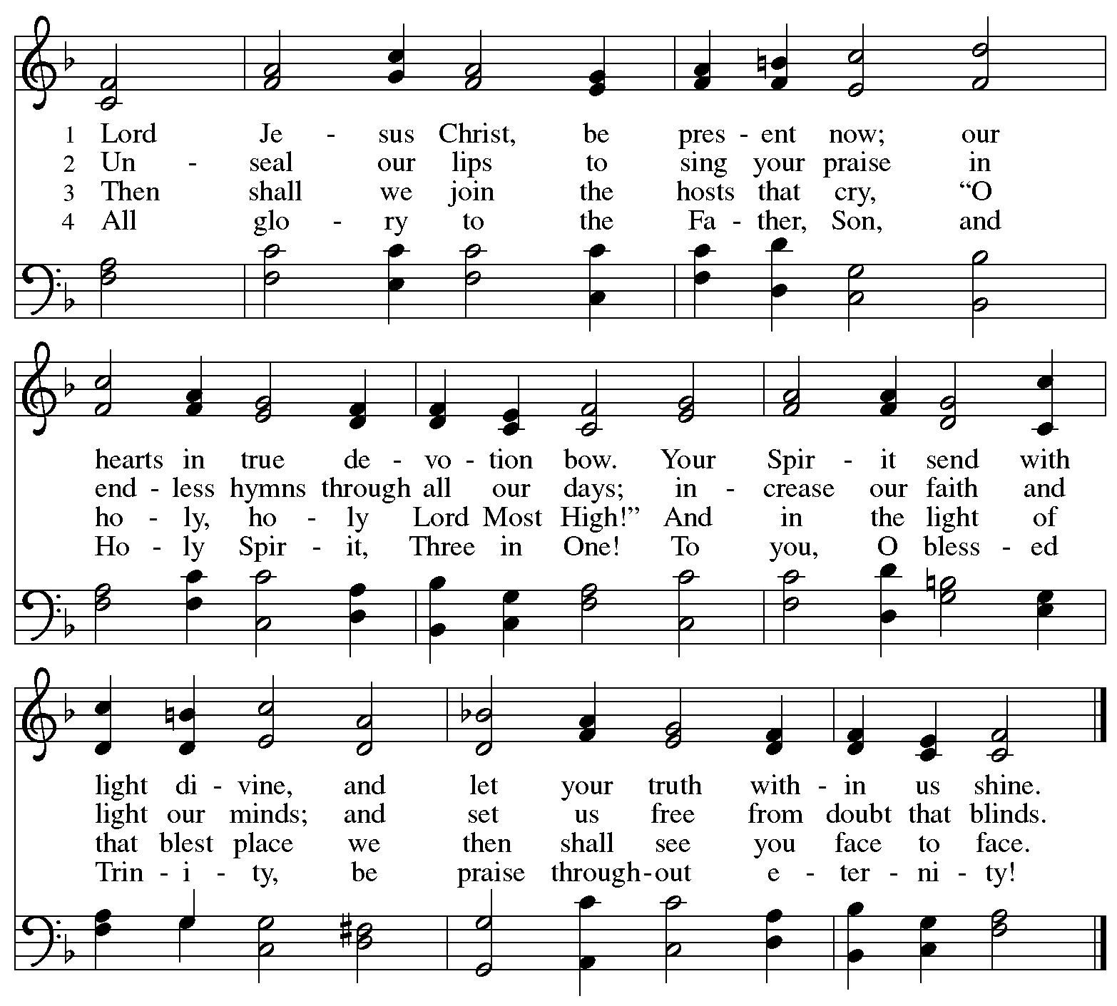

Greeting

P: The grace of our Lord Jesus Christ, the love of God,
and the communion of the Holy Spirit be with you all.
C: And also with you.

Hymn of Praise Oh, Sing of God’s Great Victory! OLS 3

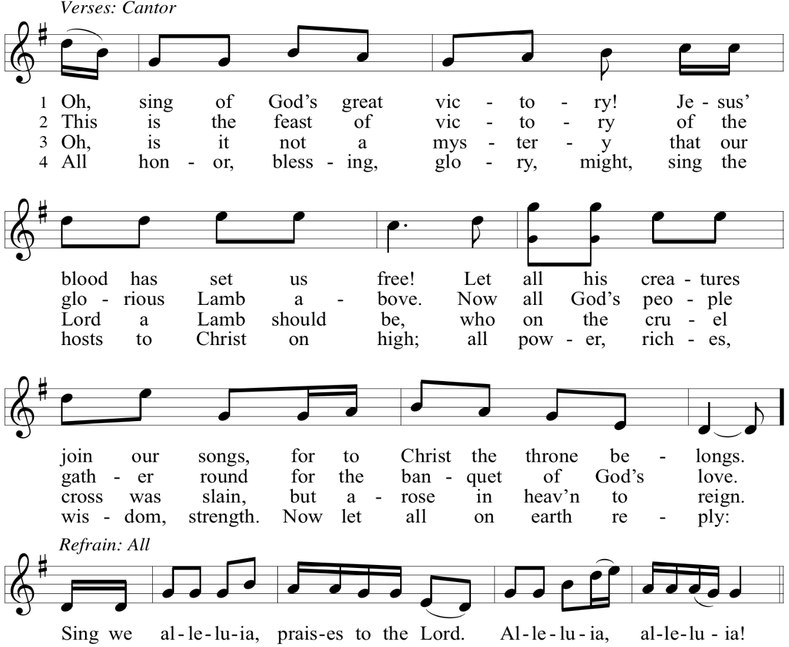

Reprinted with permission under OneLicense.net # A-722139.

Prayer of the Day

P: The Lord be with you.
C: And also with you.

P: Let us pray. Benevolent, merciful God: When we are empty, fill us.
When we are weak in faith, strengthen us.
When we are cold in love, warm us,
that with fervor we may love our neighbors and serve them
for the sake of your Son, Jesus Christ, our Savior and Lord.
C: Amen.

Please be seated.
Children are invited to join the adult leader(s) at the side door for Little Church – Big Faith.
We ask that an additional adult from the congregation attend with the children.

Word
God speaks to us in Scripture reading, preaching, and song

First Reading – Habakkuk 1: 1-4, 2: 1-4

¹ The oracle that the prophet Habakkuk saw.
² O Lord, how long shall I cry for help,
and you will not listen?
Or cry to you “Violence!”
and you will not save?
³ Why do you make me see wrongdoing
and look at trouble?
Destruction and violence are before me;
strife and contention arise.
⁴ So the law becomes slack,
and justice never prevails.
The wicked surround the righteous;
therefore judgment comes forth perverted.
^{2:1}I will stand at my watchpost
and station myself on the rampart;
I will keep watch to see what the Lord will say to me
and what the Lord will answer concerning my complaint.
² Then the Lord answered me and said:
Write the vision;
make it plain on tablets,
so that a runner may read it.
³ For there is still a vision for the appointed time;
it speaks of the end and does not lie.
If it seems to tarry, wait for it;
it will surely come; it will not delay.
⁴ Look at the proud!
Their spirit is not right in them,
but the righteous live by their faithfulness.

L: Word of God, word of life.
C: Thanks be to God.

Psalm 37: 1-9

The psalm will be sung responsively, led by the cantor, with the congregation singing the verses in bold type and joining in the refrain.

Psalm Tone

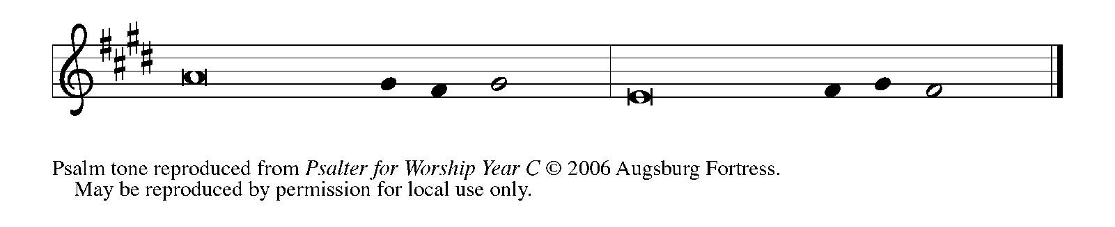

Psalm Refrain

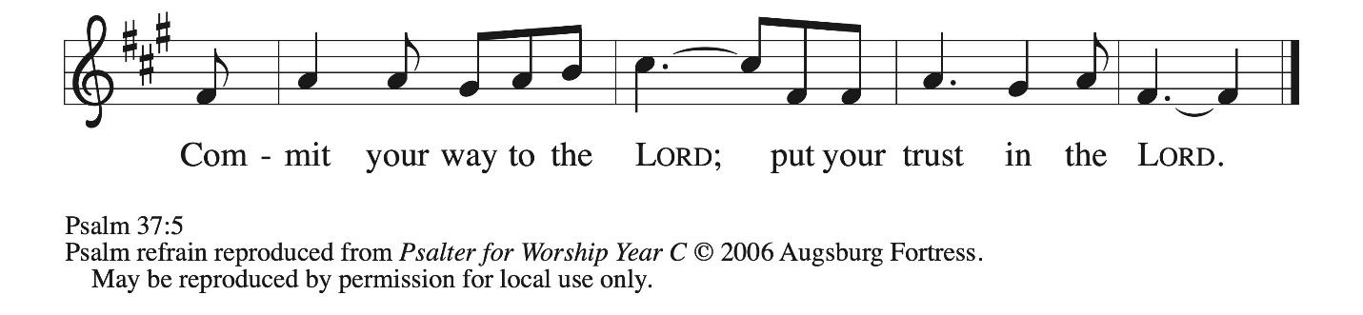

¹ Do not be provoked by | evildoers;
do not be jealous of those | who do wrong.
² For they shall soon wither | like the grass,
and like the green grass | fade away.
³ Put your trust in the Lord | and do good;
dwell in the land and | find safe pasture.
⁴ Take delight | in the Lord,
who shall give you your | heart’s desire. R
⁵ Commit your way to the Lord; put your trust | in the Lord,
and see what | God will do.
⁶ The Lord will make your vindication as clear | as the light
and the justice of your case like the | noonday sun.
⁷ Be still before the Lord and wait | patiently.
Do not be provoked by the one who prospers, the one who succeeds in | evil schemes.
⁸ Refrain from anger, leave | rage alone;
do not be provoked; it leads on- | ly to evil.
⁹ For evildoers shall | be cut off,
but those who hope in the Lord shall pos- | sess the land. R

Second Reading – 2 Timothy 1: 1-14

¹ Paul, an apostle of Christ Jesus by the will of God, for the sake of the promise of life that is in Christ Jesus,
² To Timothy, my beloved child:
Grace, mercy, and peace from God the Father and Christ Jesus our Lord.
³ I am grateful to God—whom I worship with a clear conscience, as my ancestors did—when I remember you constantly in my prayers night and day. ⁴ Recalling your tears, I long to see you so that I may be filled with joy. ⁵ I am reminded of your sincere faith, a faith that lived first in your grandmother Lois and your mother Eunice and now, I am sure, lives in you. ⁶ For this reason I remind you to rekindle the gift of God that is within you through the laying on of my hands, ⁷ for God did not give us a spirit of cowardice but rather a spirit of power and of love and of self-discipline.
⁸ Do not be ashamed, then, of the testimony about our Lord or of me his prisoner, but join with me in suffering for the gospel, in the power of God, ⁹ who saved us and called us with a holy calling, not according to our works but according to God’s own purpose and grace, and this grace was given to us in Christ Jesus before the ages began, ¹⁰ but it has now been revealed through the appearing of our Savior Jesus Christ, who abolished death and brought life and immortality to light through the gospel. ¹¹ For this gospel I was appointed a herald and an apostle and a teacher, ¹² and for this reason I suffer as I do. But I am not ashamed, for I know the one in whom I have put my trust, and I am sure that he is able to guard until that day the deposit I have entrusted to him. ¹³ Hold to the standard of sound teaching that you have heard from me, in the faith and love that are in Christ Jesus. ¹⁴ Guard the good deposit entrusted to you, with the help of the Holy Spirit living in us.

L: Word of God, word of life.
C: Thanks be to God.

Please rise as you are able.



Gospel Acclamation O God, Whose Word Well-Planted OLS 4

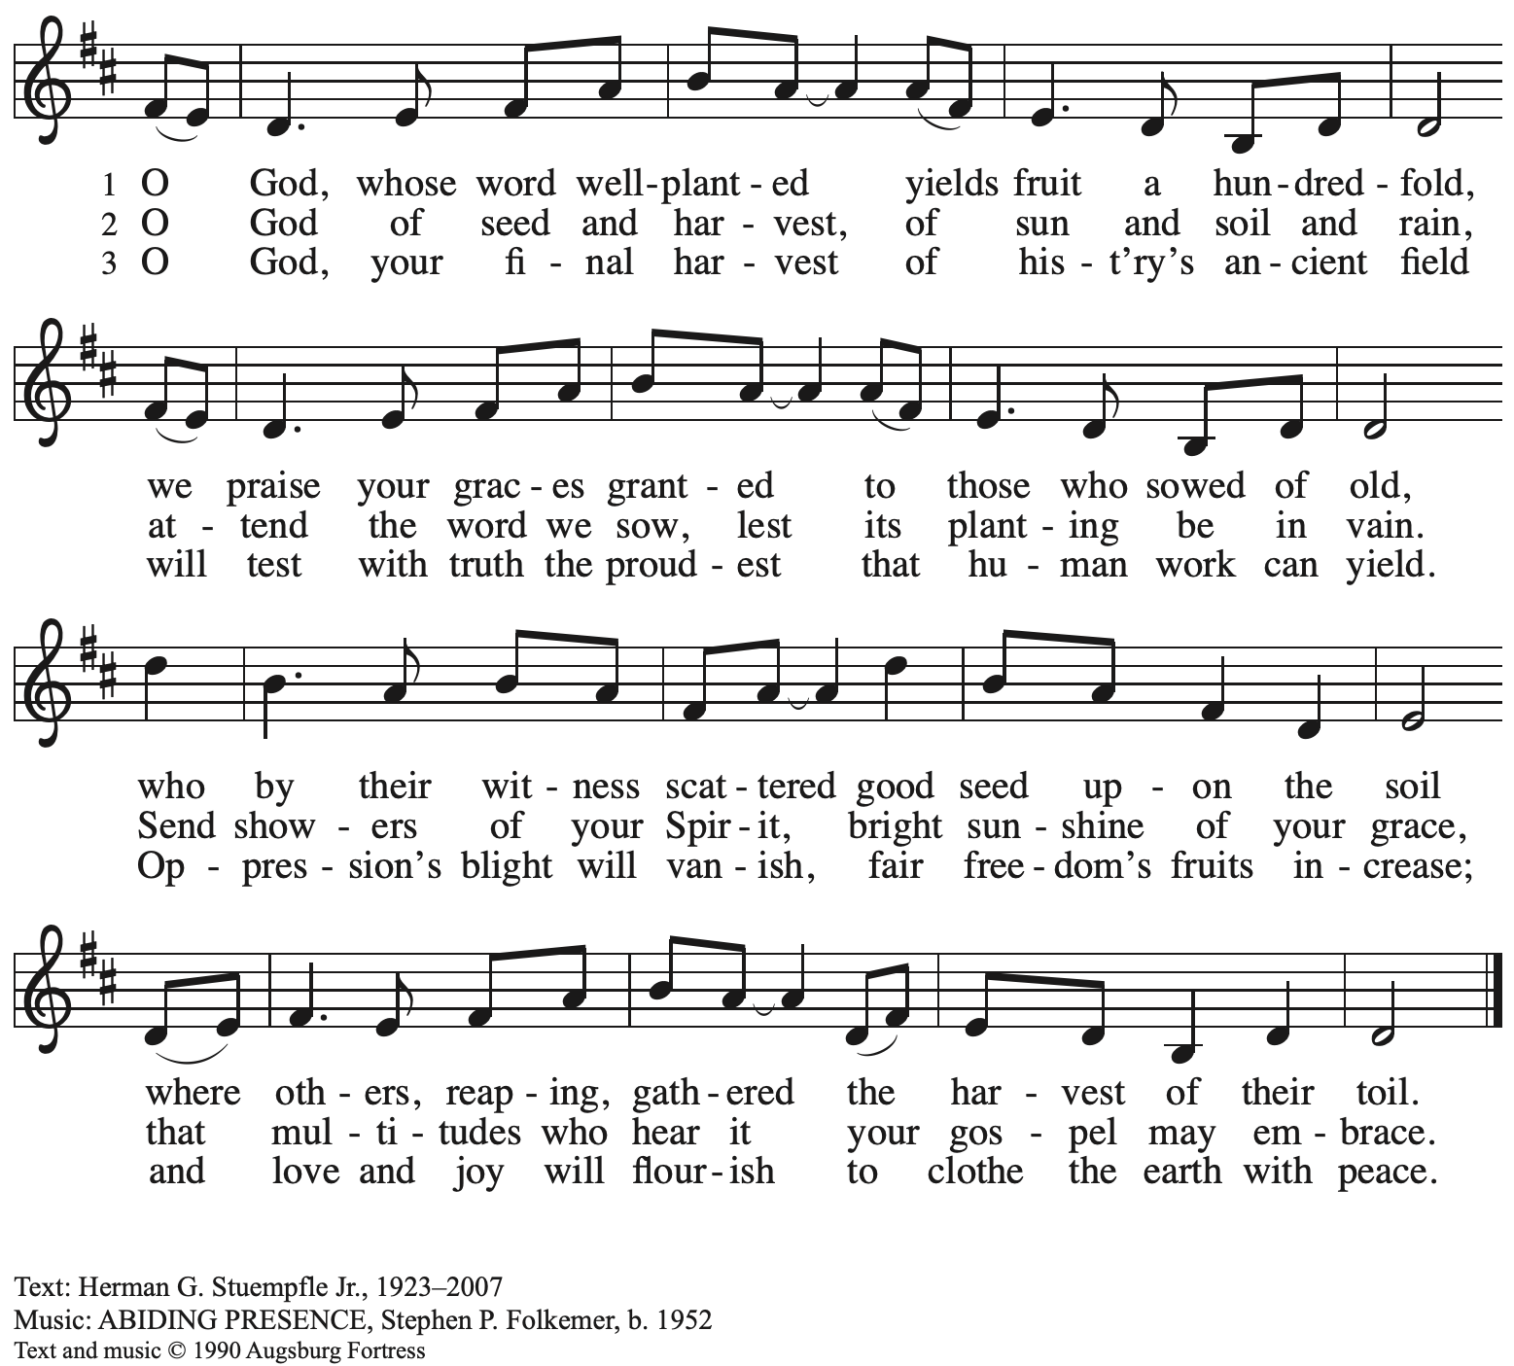 All rights reserved. Reprinted under OneLicense.net # A-722139.

Gospel – Luke 17: 5-10

P: The holy Gospel according to St. Luke.
C: Glory to you, O Lord.

⁵ The apostles said to the Lord, “Increase our faith!” ⁶ The Lord replied, “If you had faith the size of a mustard seed, you could say to this mulberry tree, ‘Be uprooted and planted in the sea,’ and it would obey you.
⁷ “Who among you would say to your slave who has just come in from plowing or tending sheep in the field, ‘Come here at once and take your place at the table’? ⁸ Would you not rather say to him, ‘Prepare supper for me; put on your apron and serve me while I eat and drink; later you may eat and drink’? ⁹ Do you thank the slave for doing what was commanded?
¹⁰ So you also, when you have done all that you were ordered to do, say, ‘We are worthless slaves; we have done only what we ought to have done!’”

P: The Gospel of the Lord.
C: Praise to you, O Christ.

Please be seated.

Sermon

A time of silence for prayer and reflection follows the sermon.
When the hymn of the day begins, please rise as you are able.

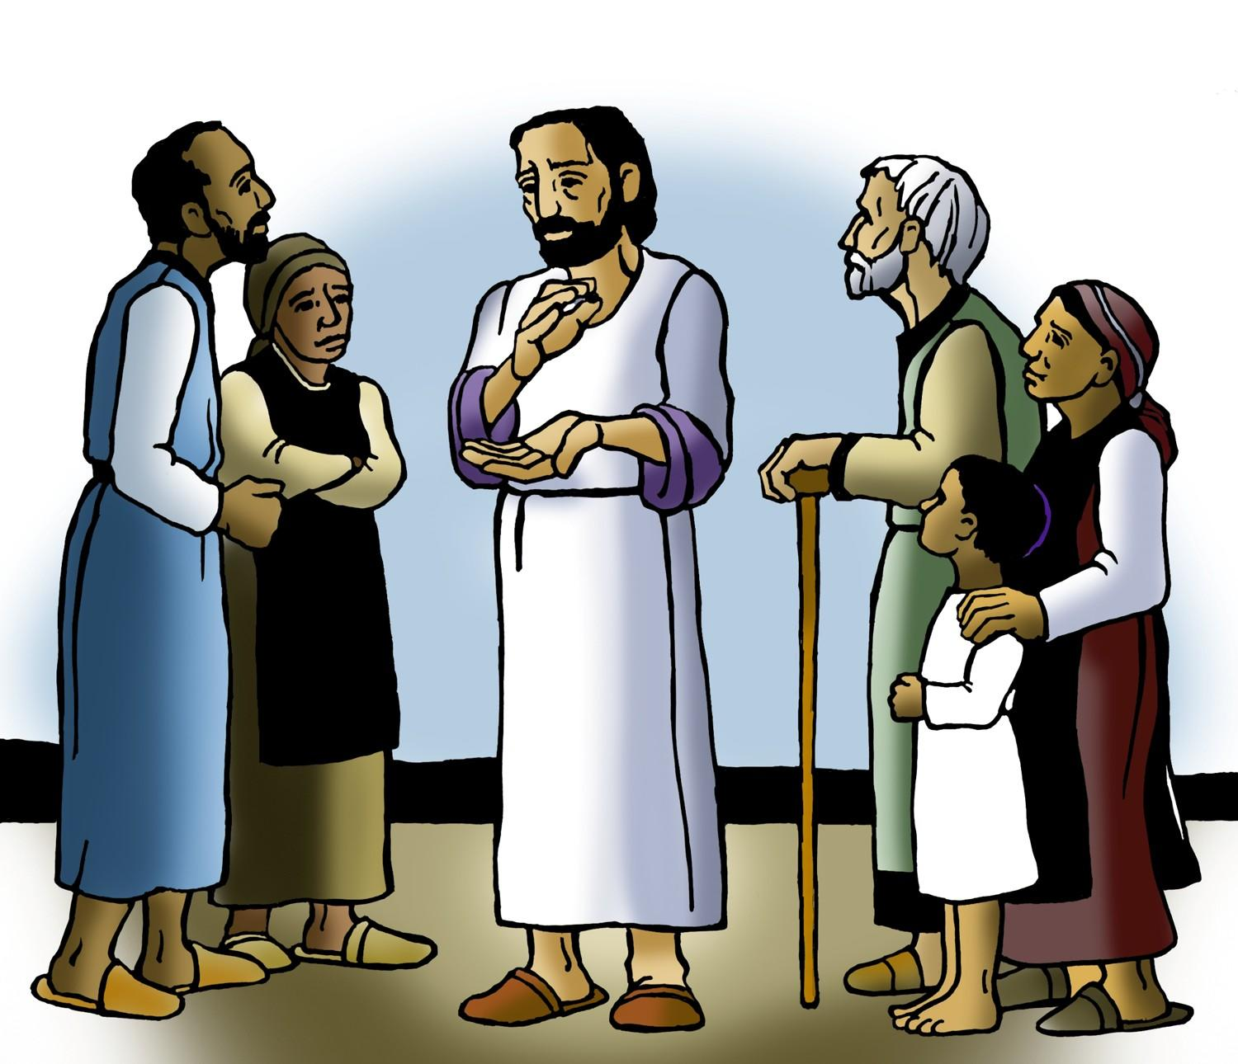

Hymn of the Day Bring forth the Kingdom WP 22

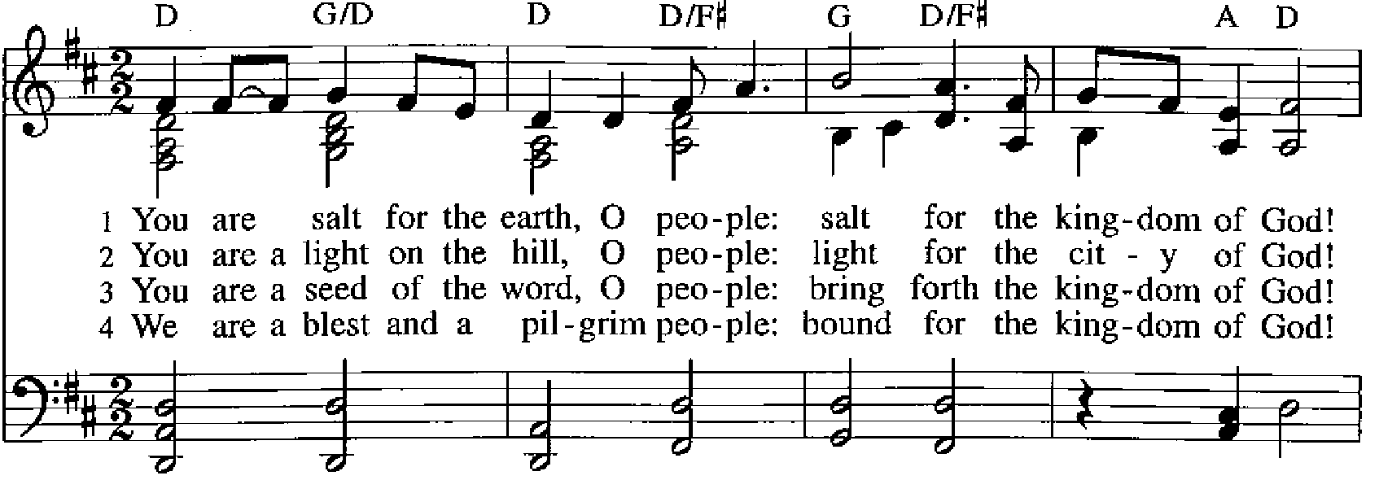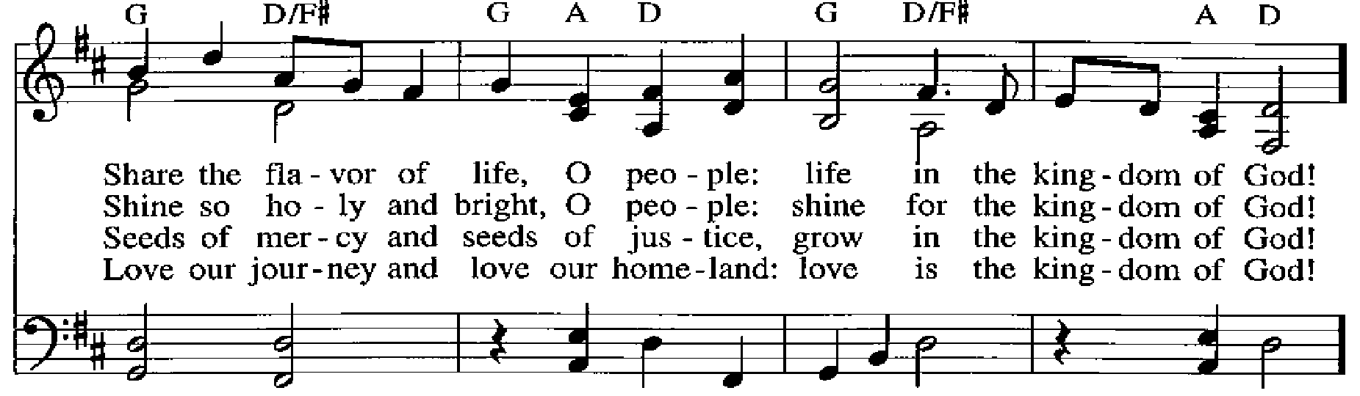
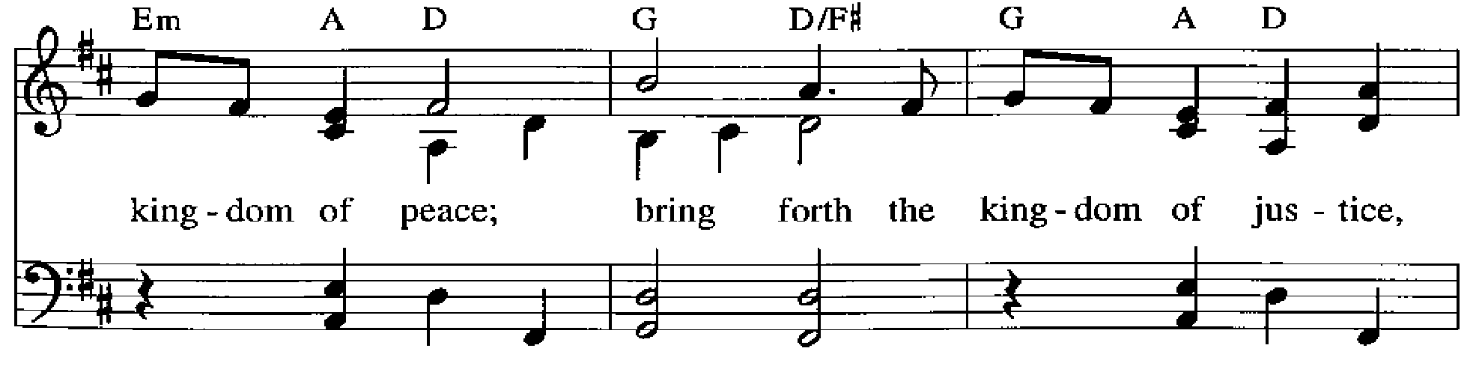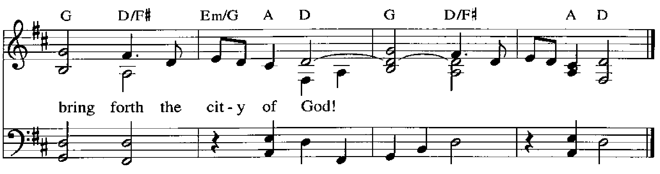

Apostles’ Creed

C: I believe in God, the Father almighty,
creator of heaven and earth.

I believe in Jesus Christ, God’s only Son, our Lord,
who was conceived by the Holy Spirit,
born of the virgin Mary,
suffered under Pontius Pilate,
was crucified, died, and was buried;
he descended to the dead.*
On the third day he rose again;
he ascended into heaven,
he is seated at the right hand of the Father,
and he will come to judge the living and the dead.

I believe in the Holy Spirit,
the holy catholic church,
the communion of saints,
the forgiveness of sins,
the resurrection of the body,
and the life everlasting. Amen.

*Or, “he descended into hell,” another translation of this text in widespread use.

Prayers of the People

A: With the whole people of God in Christ Jesus,
let us pray for the church, those in need, and all of God’s creation.

After each petition
A: Lord, in your mercy,
C: receive our prayer.

P: Into your hands, gracious God, we commend all for whom we pray,
trusting in your mercy; through Jesus Christ, our Savior.
C: Amen.

Peace

The presiding minister and the assembly greet one another in the peace of the risen Christ.
P: The peace of Christ be with you always.
C: And also with you.

The people may greet those around them with a sign of Christ’s peace and may say
Peace be with you or similar words. Please be mindful that not everyone will be comfortable with sharing the peace, so please seek consent before shaking hands or hugging. Other possible ways to share the peace include a simple bow with the verbal greeting of peace, or simply a verbal expression of peace.

When the greetings of peace have concluded, please be seated.



Meal
God feeds us with the presence of Jesus Christ

Offering

We offer ourselves, our gifts, and our faithful service to God.
As the offering is gathered for the mission of the church, including the care of those in need,
the table is set for Holy Communion.

There are laminated giving cards in the pew racks that feature a QR code for anyone who would like to give online. Those who give using the QR code, as well as those who give regularly online or through their bank are encouraged to place the laminated card in the plate as an expression of your offering.

Reparations Offering

On the first Sunday of each month, St. Andrew invites people of the congregation to give a second offering for a reparations fund in acknowledgment of St. Andrew’s use of African American spiritual songs in our worship services. Please see the note in the announcements for more information.

Offertory Music Amazing Grace arr. Edstrom

As the gifts are brought forward for presentation, please rise as you are able.

Offertory Song Accept, O Lord, the Gifts We Bring OLS 5

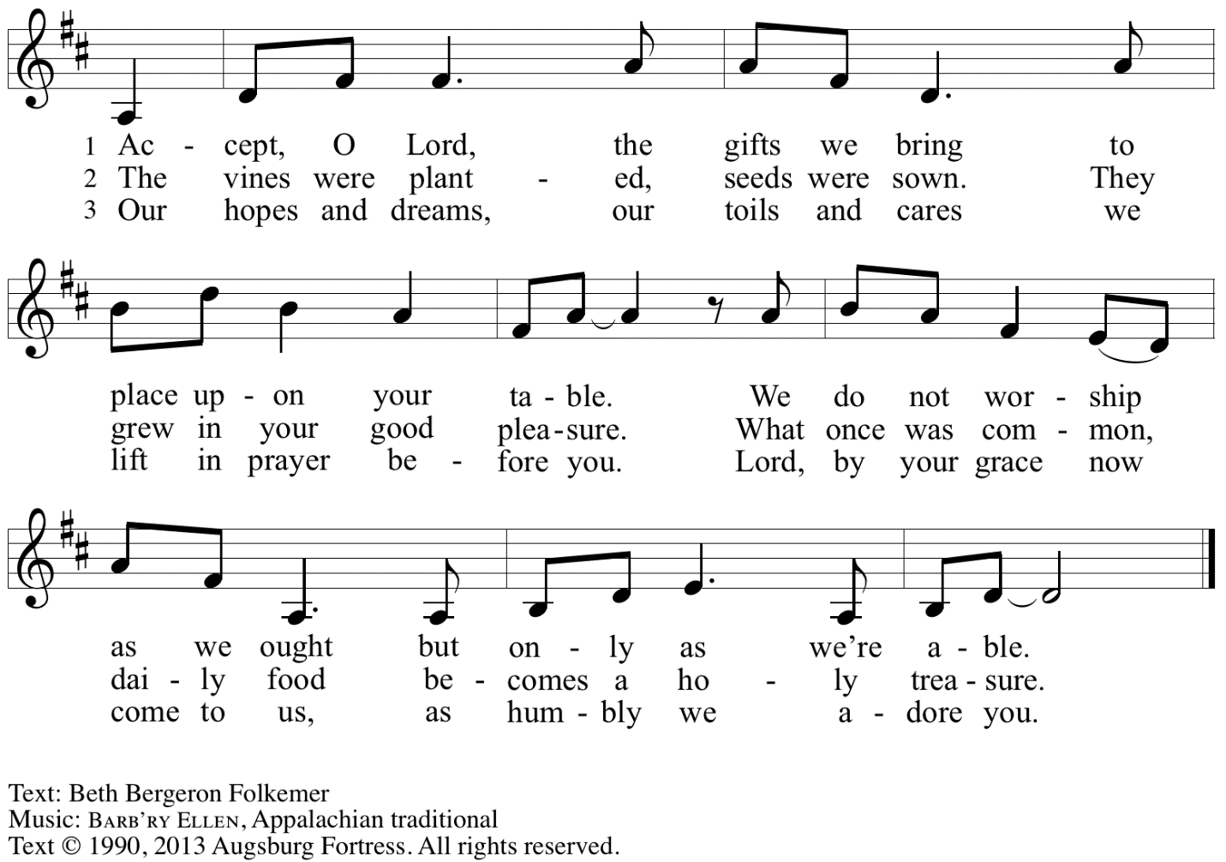
Reprinted with permission under OneLicense.net # A-722139.

Offertory Prayer

A: Let us pray.
Gracious God,
C: you bless us with gifts of guidance, new life,
growth in grace, and fruitful labor.
Accept the first fruits of time and toil, field and orchard,
that we offer here.
Bless and multiply these gifts to our nurture
and to the care of your creation;
for the sake of your Son, Jesus Christ our Lord.
Amen.

Dialogue

P: The Lord be with you.
C: And also with you.

P: Lift up your hearts.
C: We lift them to the Lord.

P: Let us give thanks to the Lord our God.
C: It is right to give our thanks and praise.

Preface

P: It is indeed right, our duty and our joy …
… we praise your name and join their unending hymn:

Sanctus Holy, Holy, Holy OLS 6

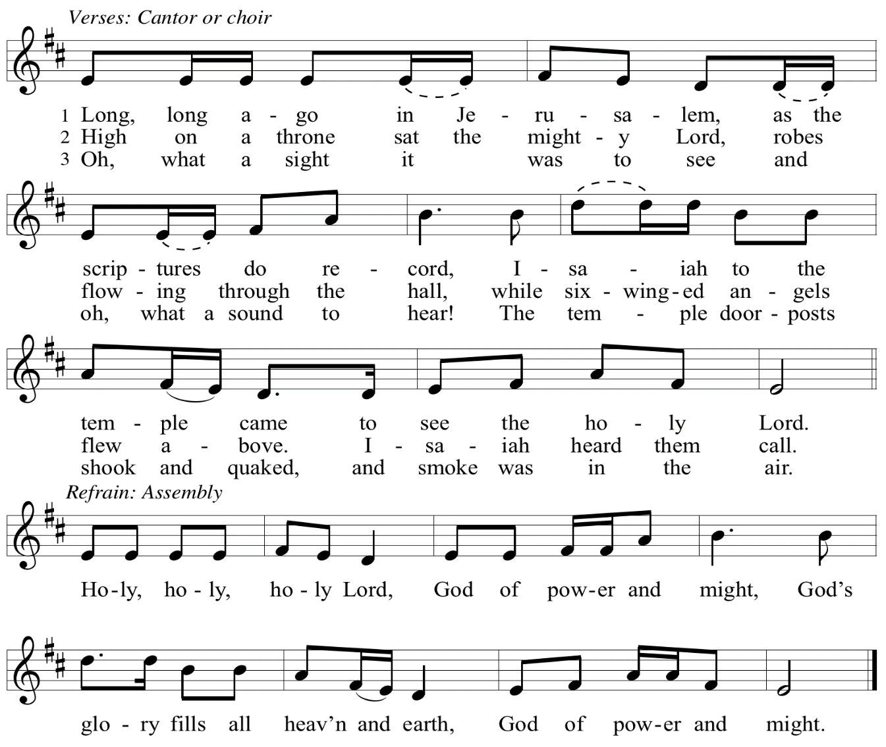

Eucharistic Prayer

P: Let the peoples praise you, generous and abundant Creator: …
… in generosity to all in need.

United by your Spirit with all your people,
we pray through your Son, Jesus Christ,
to you, our Source and our Goal, our Sun and our Shield, our God now and forever.
C: Amen.

Lord’s Prayer

P: Gathered as one by the Holy Spirit, let us pray as Jesus taught us.
C: Our Father in heaven,
hallowed be your name,
your kingdom come,
your will be done,
on earth as in heaven.
Give us today our daily bread.
Forgive us our sins
as we forgive those
who sin against us.
Save us from the time of trial
and deliver us from evil.
For the kingdom, the power,
and the glory are yours,
now and forever. Amen.

Fraction and Invitation

P: Just as this broken bread was first scattered on the hills, then was brought together and became one, so let your church be brought together from the ends of the earth into your kingdom, for yours are the glory and the power through Jesus Christ forever.
C: Amen.


Agnus Dei / Lamb of God OLS 7
O Lamb of God, to Earth You Came

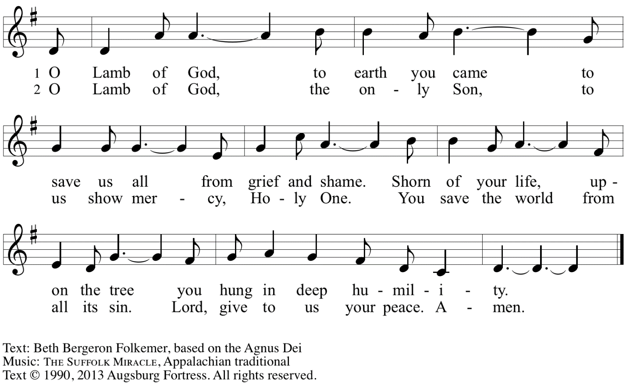
Reprinted with permission under OneLicense.net A# A-722139.

Please be seated.

Holy Communion

- All who seek God and desire a deeper and stronger life in Christ are welcome to receive Holy Communion.
- Worshipers from the pulpit side will proceed forward first, followed by the center section, and then the lectern side.
- Please inform an usher if you would like the ministers to bring Communion to you.
- Holy Communion will be served with bread and wine (amber) or grape juice (purple).
- The presiding minister will first distribute the bread (host) to each communicant. Please indicate if you require a gluten-free host.
- Once you have consumed the bread, please pick up an empty glass from the tray next to the presiding minister. The Communion Assistant will pour wine or grape juice into your glass.
- Please step to the side to consume the wine or grape juice.
- Feel free to kneel at the altar rail for prayer after receiving the sacrament.
- As you return to your pew, glasses may be returned to the empty tray on the side of the center section.
- A blessing will be provided for anyone who does not yet receive the sacrament.
- All are invited to join in singing the hymns during Holy Communion.

Hymns during Holy Communion
By Grace We Have Been Saved ACS 1006

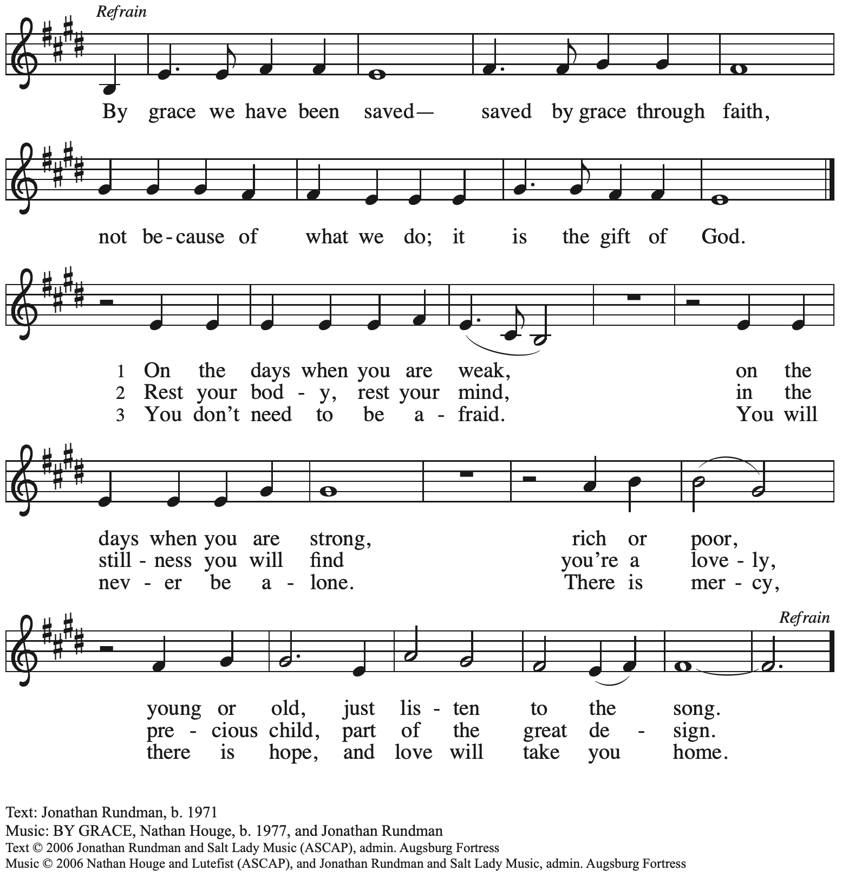
All rights reserved. Reprinted with permission under OneLicense.net # A-722139.

Hymns during Holy Communion
When Our World Is Rent by Violence ACS 1052

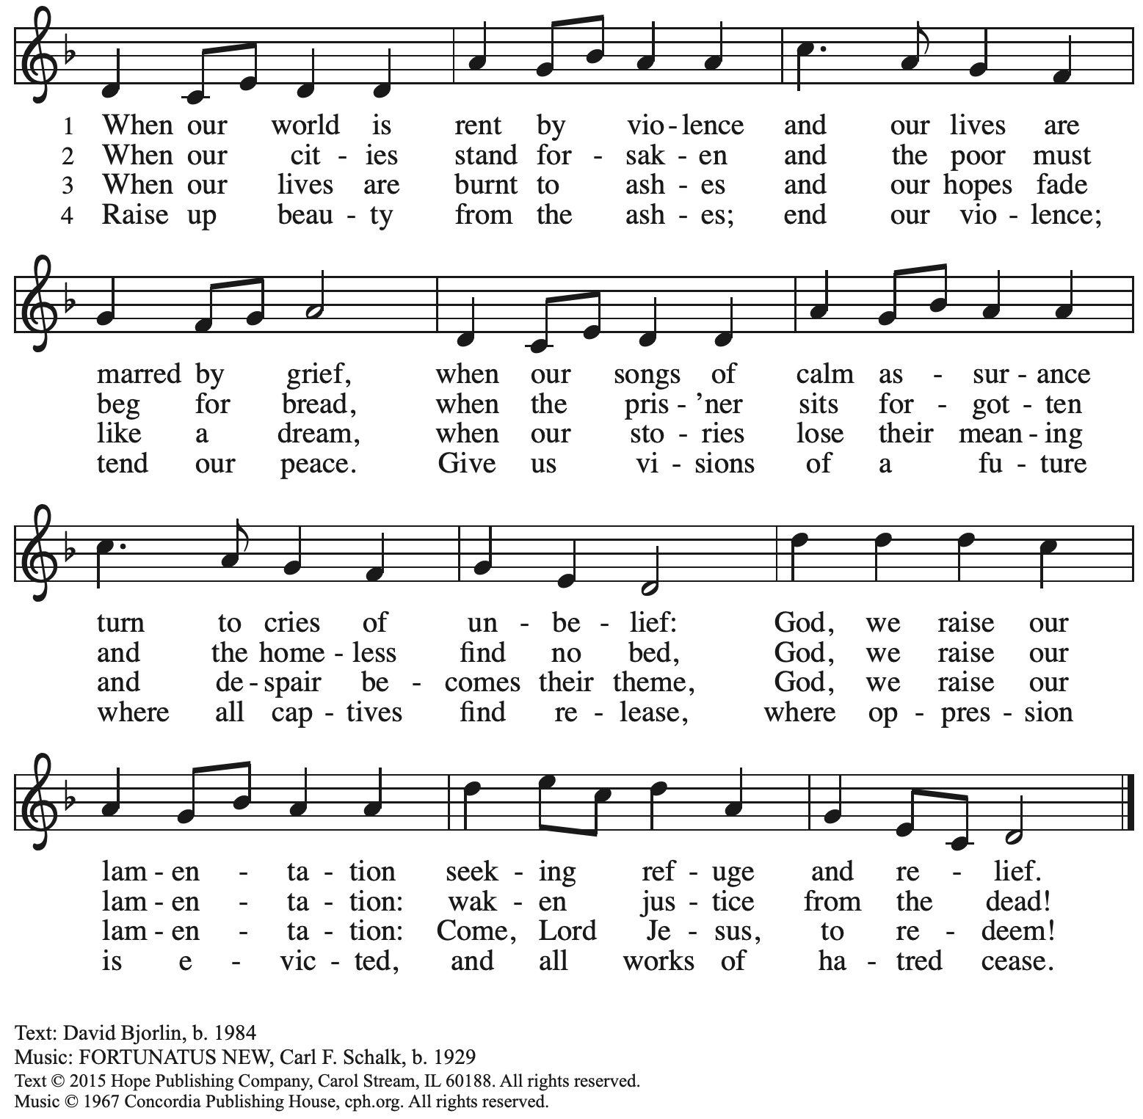
Reprinted with permission under OneLicense.net # A-722139.

Hymns during Holy Communion
Wait for the Lord ELW 262

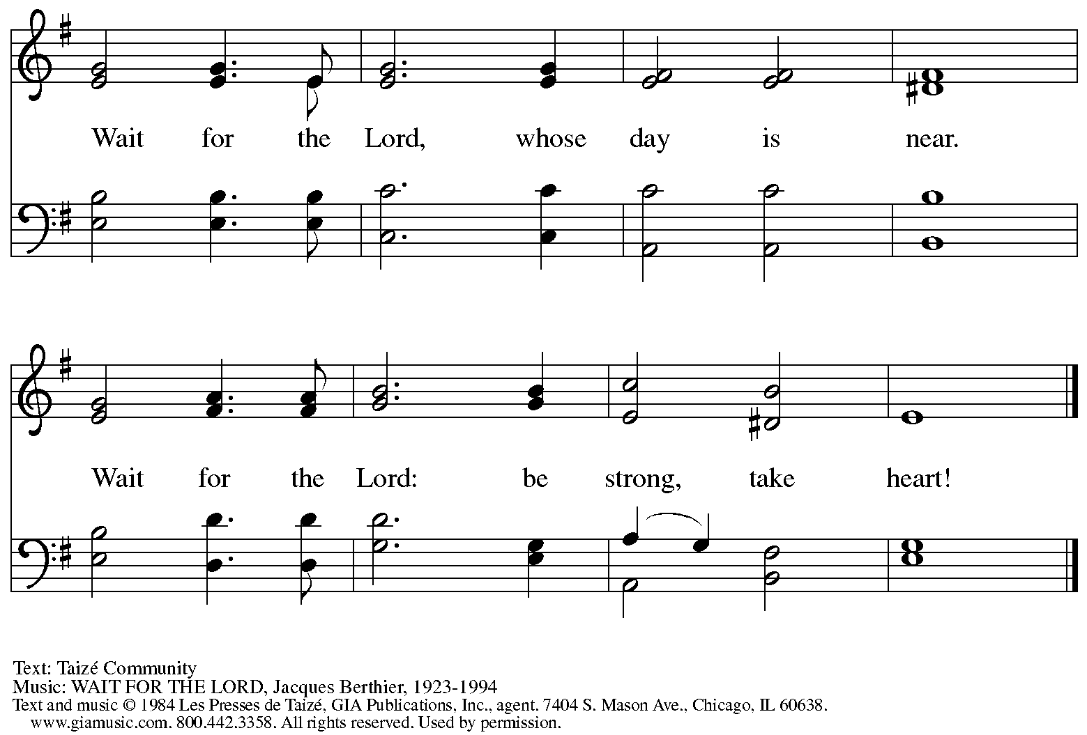
Reprinted under OneLicense.net # A-722139.

Hymns during Holy Communion
Just As I Am, without One Plea ELW 592

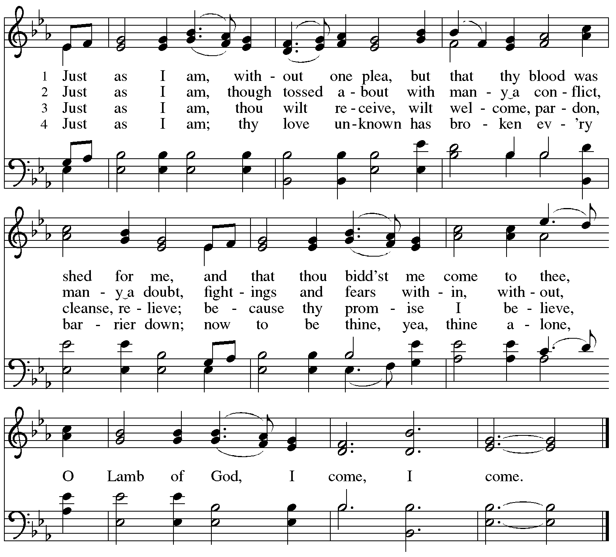

When all have returned to their places, please rise as you are able.

Blessing

P: The body and blood of our Lord Jesus Christ strengthen you and keep you in his grace.
C: Amen.

Prayer

A: Let us pray.
Gracious God,
we give thanks for your pruning, planting, and nurture.
We rejoice that you have used the harvest of field and vineyard
to renew and sustain us.
Lead us as we go from this life-giving meal
into lives of grateful service to you and your cherished creation;
through Jesus Christ, your Son, our Lord.
C: Amen.

Please be seated.

Sending
God blesses us and sends us in mission to the world

Announcements

Please rise as you are able.

Benediction

P: The God of steadfastness and encouragement
grant you to live in harmony with one another,
in accordance with Christ Jesus.
C: Amen.

P: The God of hope fill you with all joy and peace in believing,
so that you may abound in hope by the power of the Holy Spirit.
C: Amen.

P: The God of all grace ☩ bless you now and forever.
C: Amen.

Sending Hymn Following page
Dismissal

A: Go in peace. Serve the Lord.
C: Thanks be to God!

Sending Hymn Guide My Feet ACS 987

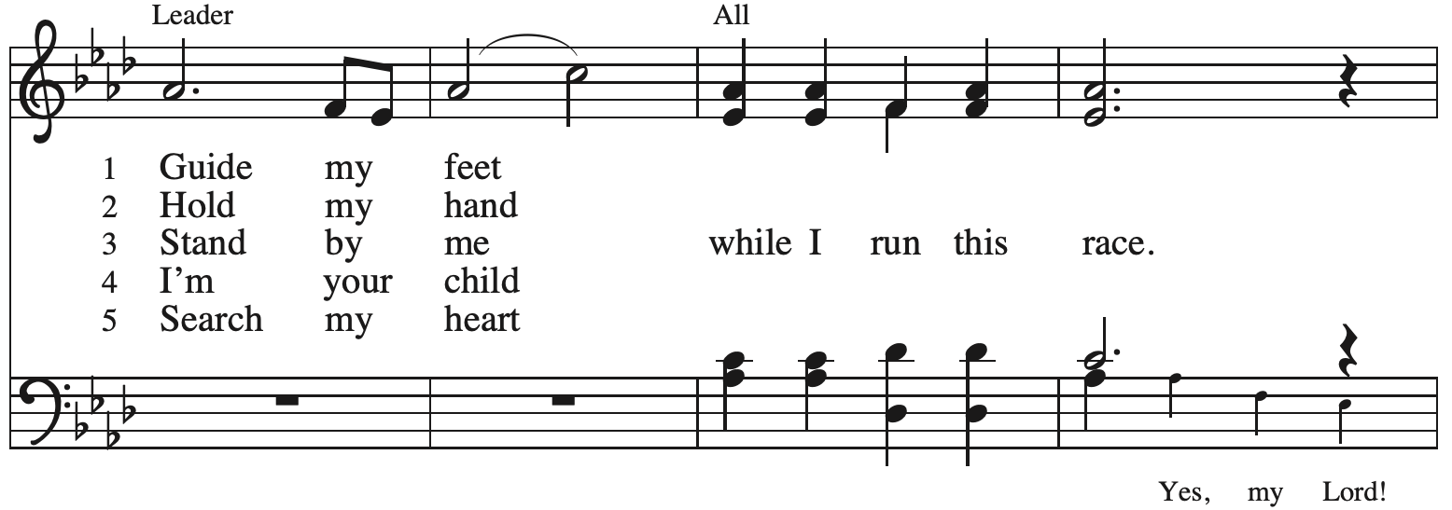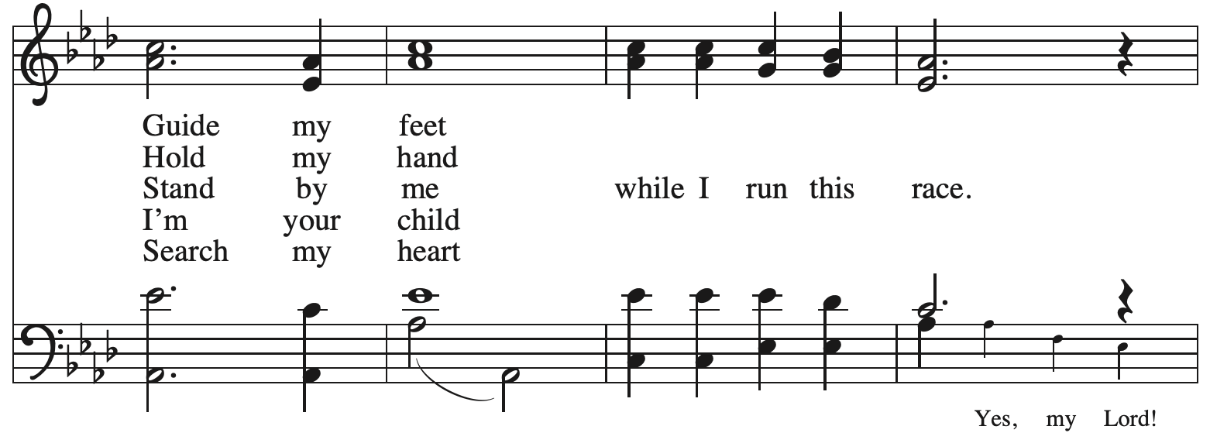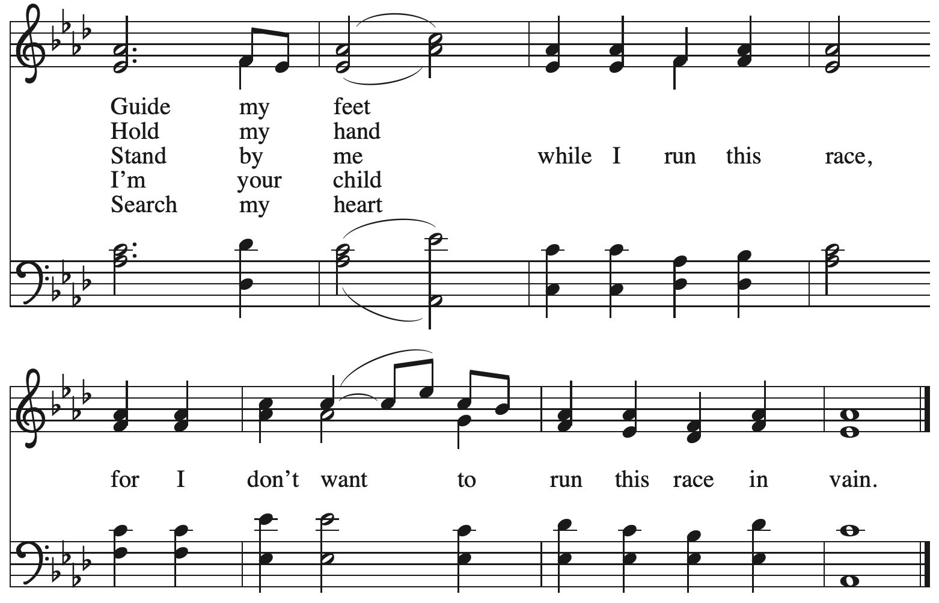

Postlude

Serving in Worship Today

Altar Care Jodie Minor
Assisting Minister Kathy Hays
Audio-Visual Ministers David Rollinson
Jered Stratton
Cantor Timothy Kocher-Hillmer
Lector Alda Maria Gonzaga
Minister of Music Laura Reynolds
Presiding Minister The Rev. Ross Carmichael

Liturgy and Hymnody Acknowledgements

From SundaysandSeasons.com. Copyright © 2025 Augsburg Fortress. All rights reserved. Reprinted under OneLicense.net # A-722139.
Used by permission of Augsburg Fortress.

The Scripture readings contained herein are from New Revised Standard Version Updated Edition of the Bible © 2021 National Council of Churches of Christ in the United States of America. Used by permission. All rights reserved worldwide.

Bring forth the Kingdom – Text and music Marty Haugen. Text and music © 1986 GIA Publications.

Holy, Holy, Holy / Long, Long Ago in Jerusalem – Text: Beth Bergeron Folkemer, based on the Sanctus. Music: SHADY GROVE, Appalachian traditional. Text © 1990, 2013, Augsburg Fortress. All rights reserved. Reprinted with permission under OneLicense.net #A-722139.

Guide My Feet – Text: African American spiritual. Music: GUIDE MY FEET, African American spiritual; arr. This Far by Faith. Arr. © 1999 Augsburg Fortress. All rights reserved. Reprinted with permission under OneLicense.net # A-722139.

Please use the QR code below to link to St. Andrew’s Announcements online!



St. Andrew Lutheran Church Announcements
September October 5th, 2025

- Welcome to Worship at St. Andrew on the Seventeenth Sunday after Pentecost! – We are so glad you are here, and we offer a special welcome to all visitors and guests who are here for the first time! A nursery is available through the door to the left of the worship space and across the social hall (look for a purple room). Little Church – Big Faith, a Bible lesson and activity for children up to sixth grade, will take place after the prayer of the day. There are also worship “toolkits” to help children engage with worship and “busy bags” for younger children available in the bookcase at the back of the sanctuary. Please feel free to take one to use with/for your children. All are invited to stay for coffee and other drinks, food, and conversation in the Social Hall (through the side door at the left of the worship space) after the service.
- Monthly Reparations Offering Today during Worship – In Luke’s Gospel, Jesus tells a story about a compassionate Samaritan, suggesting that God’s people are called to work for healing and restoration for our neighbors, regardless of who or what caused them harm. In light of this, St. Andrew has made a commitment to reparations in regard to African American spiritual songs used in our worship. The text and music of most hymns is attributed to specific authors, with copyrights in place, usage reported, and royalties paid to those whose works are featured in worship. With African American spirituals, this is not possible. In response to many years of such uncredited use, St. Andrew invites the congregation to give a reparations offering. Funds received in worship will be donated to our siblings at Bethel AME Church, whose land and building were taken from them in the 1950s, to fund their development in the Hill District.
- Congregational Meeting Today, October 5th, after Worship – As announced on Sunday, September 21st and in a letter to the congregation, St. Andrew will hold a congregational meeting on Sunday, October 5th, after worship. The purpose of the meeting is to provide updates on the current roofing project and related construction work and to present the council's recommendation for a capital campaign consulting provider so that we can move forward with fundraising. In accordance with the constitution, no proxy or absentee votes can be accepted, so please plan to attend.
- October Produce Distribution –First Tuesday of the Month, October 7th, 5:30-7:00 p.m. – St. Andrew partners with Greater Pittsburgh Community Food Bank to serve as a distribution site for fresh produce on the first Tuesday of every month. This month’s distribution will be on Tuesday, October 7th. We invite people of the congregation to help with the distribution from 5:30 p.m. - 7:00 p.m. and/or to help with unloading and setup during the day between 10:00 a.m. and 1:00 p.m. After this month, we will begin a second distribution on the third Tuesday of the month to better support the needs of our community.
- Produce Distribution Supplemental Food of the Month – St. Andrew will begin collecting supplemental food each month to accompany our produce distribution. For the upcoming month, we ask for donations of rice and dried beans. There will be a collection bin in the social hall.
- Celebrate St. Andrew’s Congregational and Reconciling in Christ Anniversaries Next Sunday, Oct 12th! – Next Sunday, St. Andrew celebrates the 134th anniversary of the congregation and the 29th anniversary of becoming a Reconciling in Christ congregation, intentionally committed to the full inclusion of LGBTQIA+ individuals in the life of the church, congregation, and society. We give thanks for the grace of God that has brought us this far along the way!
- October Shelter Dinner for Guests of East End Cooperative Ministry – Third Thursday of the Month, October 16th, 6:30 p.m. – Each month, people of St. Andrew provide dinner for guests of East End Cooperative Ministry (EECM), 6140 Station St. (East Liberty), 15206. We invite you to prepare or purchase one menu item and bring it to the shelter by 6:00 p.m., or just come to help serve at 6:30 p.m. If you would like to contribute, please sign up at: https://www.signupgenius.com/go/5080544AAAC22A1F58-59036568-octshelter.
- Reckoning with Antisemitism as Christians Kick-Off, Tuesday, October 21st from 7:00 p.m. - 8:30 p.m. – At this program, we will get inspired by stories of Reckoning from across western PA, and then provide guided planning time for you to decide how you will take part in the Reckoning with Antisemitism as Christians project this year. Join us for an evening with Christian clergy and lay leaders from across our region. We will learn from those who are engaging in this important work: exploring Christian scriptures, studying the impact of antisemitism, partnering with neighboring houses of worship, or befriending Jewish colleagues. We will then participate in an interactive planning session, working together to consider how each one of us can reckon with antisemitism and build relationships with Jewish neighbors this year. You can pre-register for the event here: https://www.casp.org/reckoning#oct21.
- St. Andrew Lunch at Hofbrauhaus on Reformation Sunday, Sunday, October 26th, 12:15 p.m. – Kelly Spanninger is organizing a renewal of St. Andrew lunch outings after Sunday worship. On Reformation Sunday, October 26th, all are invited to gather at Hofbrauhaus at South Side Works, 2705 S. Water St., 15203 at 12:15 p.m. Please let Kelly know if you plan to attend, or contact her at pkspanninger@verizon.net.
- God's Work - Our Hands 2025: Share the Warmth, through Sunday, October 26th
– Each year, the Evangelical Lutheran Church in America asks congregations to participate in its God's Work - Our Hands initiative, an act of service to the congregation's larger community. St. Andrew's God's Work - Our Hands project for this year will be to support "Share the Warmth," a collection of new and gently used winter coats for East End Cooperative Ministry (EECM). St. Andrew will be collecting new and gently used winter coats in the social hall through October. You can also drop off coats for EECM at Strong II Dry Cleaners until October 15th to have them cleaned for free and Strong will deliver them to EECM. They are located at 7620 Frankstown Ave., 15208. Thank you for continuing to do God's Work for the good of our neighbors!
- Discipleship that Heals the World, Studies in Matthew’s Gospel – Thursdays, 8:00 - 9:00 p.m. on Zoom, Sept. 25th – Dec. 11th, 2025 –Join us for a 11-week journey through the Gospel of Matthew, organized and facilitated by Rev. Dr. Martin Rafanan. Together we’ll explore Jesus’ Sermon on the Mount and his healing ministry, discovering Matthew’s distinctive vision of discipleship as a way of blessing, healing, and hope. You are welcome to join the zoom whenever you can. This study is designed for both newcomers to the Gospel and those already familiar with it. We will engage contemporary perspectives that help us hear Matthew’s message afresh in today’s world. Register for the sessions to receive zoom info: https://forms.gle/amy439vfUpwdJpKx7.
- Invitation to Prayer Team – St. Andrew maintains a list of weekly prayer concerns sent by email to members of the congregation who have opted in. Our prayer team’s email is prayerteam@standrewpittsburgh.org. We will keep names on the list for a maximum of four weeks unless otherwise requested. Thank you for your ministry of prayer!
- Records Update - St. Andrew is updating our records with information from newer attendees, as well as offering current members the opportunity to include current information to be used within the congregation: to acknowledge celebrations, milestones, and prayers. Please fill out the form at: https://forms.gle/kKvp19UozuRrhhaV7.
- Coffee Hour Signups – If you would like to participate and would like additional information about the duties, please sign up using the following form:
https://www.signupgenius.com/go/5080B4AAFAF2CABF85-47069030-coffee#/.

