

+ Eighteenth Sunday after Pentecost
October 12, 2025



St. Andrew Lutheran Church
304 Morewood Ave.
Pittsburgh, PA 15213
St_andrewELCA@verizon.net
www.standrewpittsburgh.org

+ Eighteenth Sunday after Pentecost
Order for Worship

It’s a miracle! Multiple miracles! The waters of Holy Baptism have healed us.
The body and blood of Jesus in Holy Communion have made us clean.
We have died with Christ and been raised with him. For all this we have returned to offer thanks. From this place we are sent on our way rejoicing to share the good news.

Today St. Andrew celebrates the 134th anniversary of the congregation and the 29th anniversary of becoming a Reconciling in Christ congregation, intentionally committed to the full inclusion of LGBTQIA+ individuals in the life of the church, congregation, and society. We give thanks for the grace of God that has brought us this far along the way!

Welcome to St. Andrew!
- St. Andrew welcomes all who are seeking a place of healing, wholeness, and acceptance in a nurturing and faith-forming spiritual home. We are striving toward racial equity worldwide
and we seek to honor the lived experience of all individuals regardless of background. Our community embraces people of all ages, ethnicities, cultures, abilities, sexual orientations,
gender identities and expressions, and family constellations. Come and See!
- Worship Services are live-streamed to multiple online platforms. By attending worship, you agree that your image and voice may be broadcast.
- Everyone is invited to make a name tag at the black bookcase in the back of the worship space if they would like. There are stickers indicating pronouns on the bookcase if you would like to include them on your name tag.
- A nursery is available through the doors at the left side of the sanctuary and across from the doorway to the Social Hall. Look for a purple-colored room.
- Children are invited to attend Little Church – Big Faith, a Bible lesson and activity, during worship (after the Prayer of the Day). The group returns to the worship space for the liturgy of Holy Communion.
- Worship “toolkits” to help children engage with the service, along with “busy bags” for younger children, are available in the bookcase at the back of the sanctuary. Please feel free to take one to use with/for your children.
- Holy Communion is served with bread (gluten-free available) and wine or grape juice. The presiding minister will distribute the bread (host). Please consume this and then pick up an empty glass from the tray. The Communion Assistant will pour wine or grape juice into your glass. Please step to the side to consume the wine or grape juice. Feel free to kneel at the altar for prayer and reflection. As you return to your pew, glasses may be returned to the empty trays on either side of the center section.
- A restroom is available on the main level of the church, through the doors to the Social Hall and to the right in the main office.

Abbreviations
P: Pastor/Presiding Minister ELW: Evangelical Lutheran Worship hymnal
A: Assisting Minister ACS: All Creation Sings hymnal
L: Lector
C: Congregation
Musical Offering

Each week, different people from the congregation make an offering of pre-service music, with singing or instrumentation, to help the assembly focus and pray in preparation for worship.

Welcome

Prelude Plowshare Prayer LaJoye/arr. Kocher-Hillmer
St. Andrew Bishop’s Installation Choir

Gathering
The Holy Spirit calls us together as the people of God

Please rise as you are able. All may make the sign of the cross,
the sign that is marked at Baptism, as the presiding minister begins.

Thanksgiving for Baptism

P: Blessed be the Holy Trinity, ☩ one God,
the fountain of living water,
the source of breath and nourishment.
C: Amen.

P: O God, you call us through the waters of Baptism to be your people and our authentic selves.
You call us to participate in your holy reign made manifest on earth through Jesus Christ.
Let us give thanks for the gift of Baptism.

Water may be poured into the font as the presiding minister gives thanks.

P: Loving God,
We praise you for the water of life:
for rivers and oceans, lakes and streams,
and for the rain and snow that bring life to every living thing.
We give you thanks for making water a means of our salvation,
and that through the waters of the flood and the parting of the sea,
you showed your promises to be true.
In the waters of Baptism, you claimed us and called each of us by our true name.
Through this gift you have transformed our lives, made us whole, and incorporated us
in the Body of Christ. Send now your Holy Spirit to move again among us,
and to immerse us in your gifts of mercy, grace, and love.

To you be given honor and praise
through Jesus Christ our Lord
in the unity of the Holy Spirit, now and forever.
C: Amen.
Gathering Hymn God of the Sparrow ELW 740

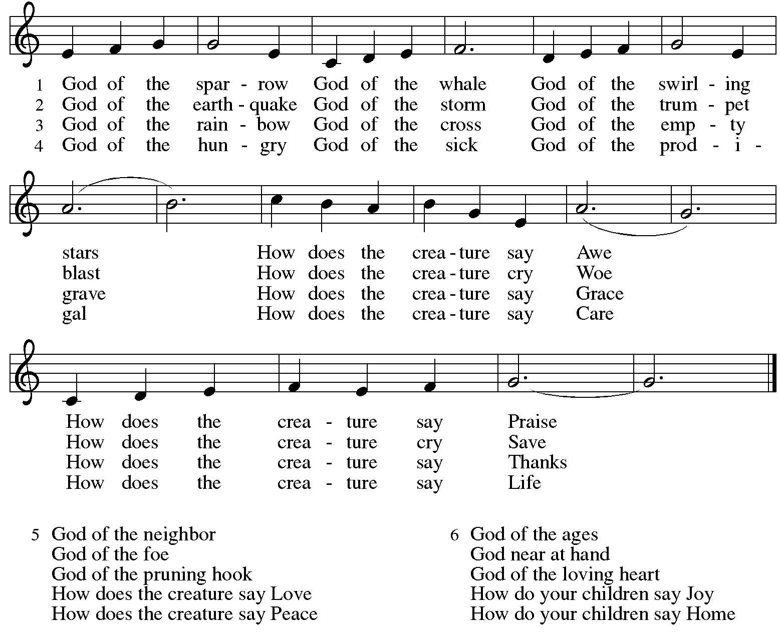
Reprinted under OneLicense.net # A-722139.

Greeting

P: The grace of our Lord Jesus Christ, the love of God,
and the communion of the Holy Spirit be with you all.
C: And also with you.

Hymn of Praise ELW p. 148

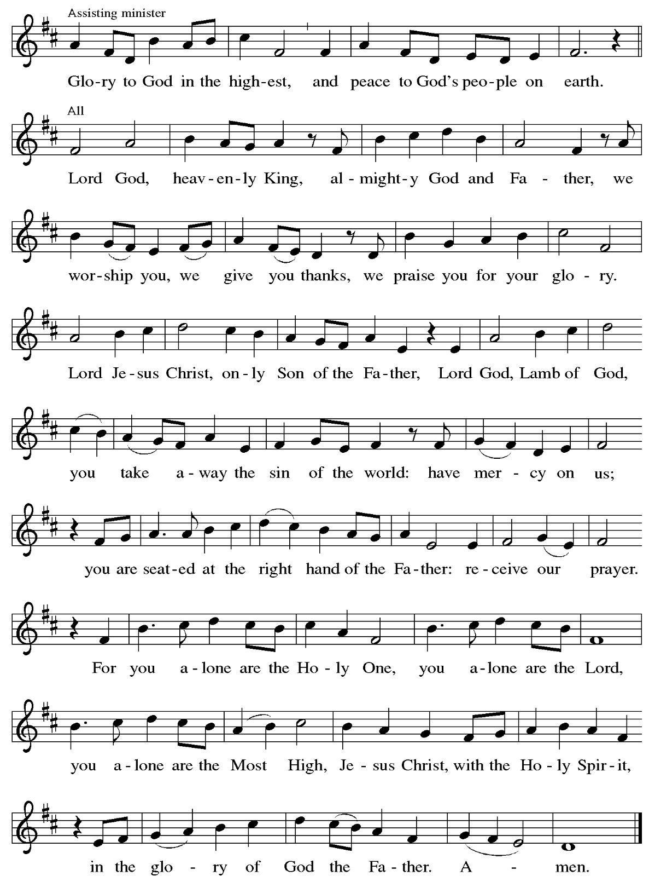

Prayer of the Day

P: The Lord be with you.
C: And also with you.
P: Let us pray. Almighty and most merciful God, your bountiful goodness fills all creation, and you have promised through your Son to be with your church forever. We give you thanks for those who founded this community of believers and for the signs of your presence in this congregation. Increase in us the spirit of faith and love and keep us safe from all that may hurt us, that, whole and well in body and spirit, we may with grateful hearts accomplish all that you would have us do, through Jesus Christ, our Savior and Lord, who lives and reigns with you and the Holy Spirit, one God, now and forever.
C: Amen.

Please be seated.
Children are invited to join the adult leader(s) at the side door for Little Church – Big Faith.
We ask that an additional adult from the congregation attend with the children.

Word
God speaks to us in Scripture reading, preaching, and song

First Reading – 2 Kings 5: 1-3, 7-15c

¹ Naaman, commander of the army of the king of Aram, was a great man and in high favor with his master because by him the Lord had given victory to Aram. The man, though a mighty warrior, suffered from a skin disease. ² Now the Arameans on one of their raids had taken a young girl captive from the land of Israel, and she served Naaman’s wife. ³ She said to her mistress, “If only my lord were with the prophet who is in Samaria! He would cure him of his skin disease.”
⁷ When the king of Israel read the letter, he tore his clothes and said, “Am I God, to give death or life, that this man sends word to me to cure a man of his skin disease? Just look and see how he is trying to pick a quarrel with me.”
⁸ But when Elisha the man of God heard that the king of Israel had torn his clothes, he sent a message to the king, “Why have you torn your clothes? Let him come to me, that he may learn that there is a prophet in Israel.” ⁹ So Naaman came with his horses and chariots and halted at the entrance of Elisha’s house. ¹⁰ Elisha sent a messenger to him, saying, “Go, wash in the Jordan seven times, and your flesh shall be restored, and you shall be clean.” ¹¹ But Naaman became angry and went away, saying, “I thought that for me he would surely come out and stand and call on the name of the Lord his God and would wave his hand over the spot and cure the skin disease! ¹² Are not Abana and Pharpar, the rivers of Damascus, better than all the waters of Israel? Could I not wash in them and be clean?” He turned and went away in a rage. ¹³ But his servants approached and said to him, “Father, if the prophet had commanded you to do something difficult, would you not have done it? How much more, when all he said to you was, ‘Wash, and be clean’?” ¹⁴ So he went down and immersed himself seven times in the Jordan, according to the word of the man of God; his flesh was restored like the flesh of a young boy, and he was clean.
^{15a, b, c} Then he returned to the man of God, he and all his company; he came and stood before him and said, “Now I know that there is no God in all the earth except in Israel.”

L: Word of God, word of life.
C: Thanks be to God.
Psalm 111

The psalm will be sung responsively, led by the cantor,
with the congregation singing the verses in bold type and joining in the refrain.

Psalm Tone

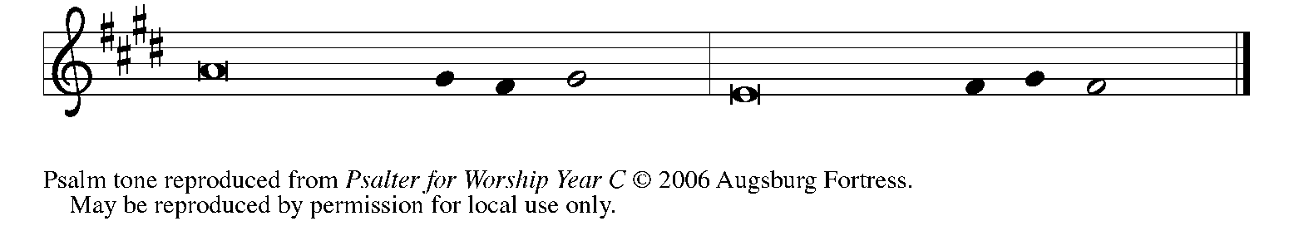

Psalm Refrain

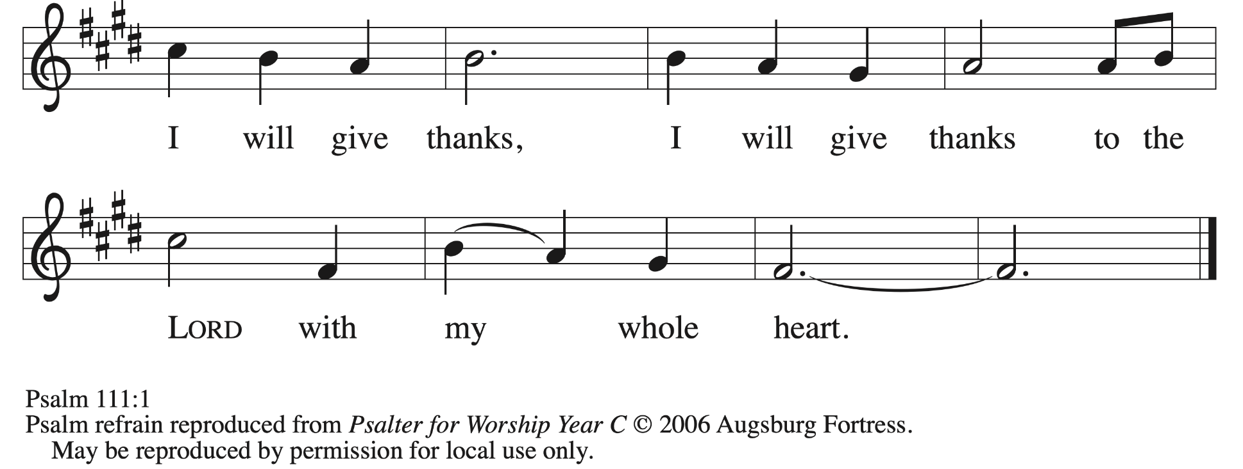

1 Hallelujah! I will give thanks to the Lord with | my whole heart,
in the assembly of the upright, in the | congregation.
2 Great are your | works, O Lord,
pondered by all who de- | light in them. R
3 Majesty and splendor | mark your deeds,
and your righteousness en- | dures forever.
4 You cause your wonders to | be remembered;
you are gracious and full | of compassion.
5 You give food to | those who fear you,
remembering forev- | er your covenant.
6 You have shown your people the power | of your works
in giving them the lands | of the nations. R
7 The works of your hands are faithful- | ness and justice;
all of your pre- | cepts are sure.
8 They stand fast forev- | er and ever,
because they are done in | truth and equity.
9 You sent redemption to your people and commanded your cove- | nant forever;
holy and awesome | is your name.
10 The fear of the Lord is the begin- | ning of wisdom;
all who practice this have a good understanding. God’s praise en- | dures forever. R

Second Reading – 2 Timothy 2: 8-15

⁸ Remember Jesus Christ, raised from the dead, a descendant of David—that is my gospel, ⁹ for which I suffer hardship, even to the point of being chained like a criminal. But the word of God is not chained. ¹⁰ Therefore I endure everything for the sake of the elect, so that they may also obtain the salvation that is in Christ Jesus, with eternal glory. ¹¹ The saying is sure:
If we have died with him, we will also live with him;
¹² if we endure, we will also reign with him;
if we deny him, he will also deny us;
¹³ if we are faithless, he remains faithful—
he cannot deny himself.
¹⁴ Remind them of this, and warn them before the Lord that they are to avoid wrangling over words, which does no good but only ruins those who are listening. ¹⁵ Do your best to present yourself to God as one approved by God, a worker who has no need to be ashamed, rightly explaining the word of truth.

L: Word of God, word of life.
C: Thanks be to God.

Please rise as you are able.

Gospel Acclamation ELW p. 151

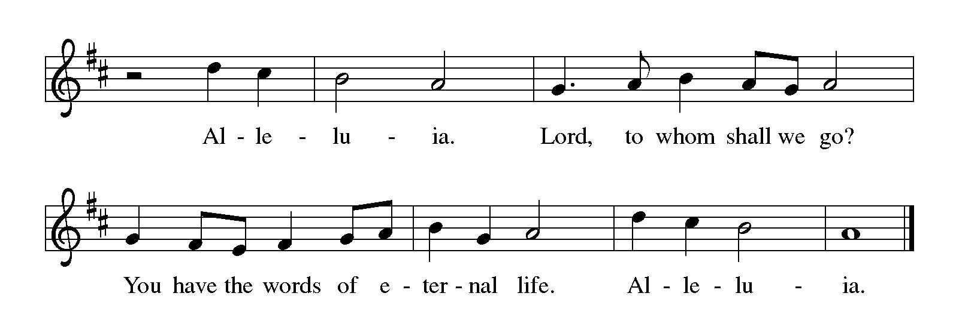

Gospel – Luke 17: 11-19

P: The holy Gospel according to St. Luke.
C: Glory to you, O Lord.

¹¹ On the way to Jerusalem Jesus was going through the region between Samaria and Galilee. ¹² As he entered a village, ten men with a skin disease approached him. Keeping their distance, ¹³ they called out, saying, “Jesus, Master, have mercy on us!” ¹⁴ When he saw them, he said to them, “Go and show yourselves to the priests.” And as they went, they were made clean. ¹⁵ Then one of them, when he saw that he was healed, turned back, praising God with a loud voice. ¹⁶ He prostrated himself at Jesus’s feet and thanked him. And he was a Samaritan. ¹⁷ Then Jesus asked, “Were not ten made clean? So where are the other nine? ¹⁸ Did none of them return to give glory to God except this foreigner?” ¹⁹ Then he said to him, “Get up and go on your way; your faith has made you well.”

P: The Gospel of the Lord.
C: Praise to you, O Christ.

Please be seated.

Sermon



A time of silence for prayer and reflection follows the sermon.
When the hymn of the day begins, please rise as you are able.

Hymn of the Day Now Thank We All Our God ELW 840

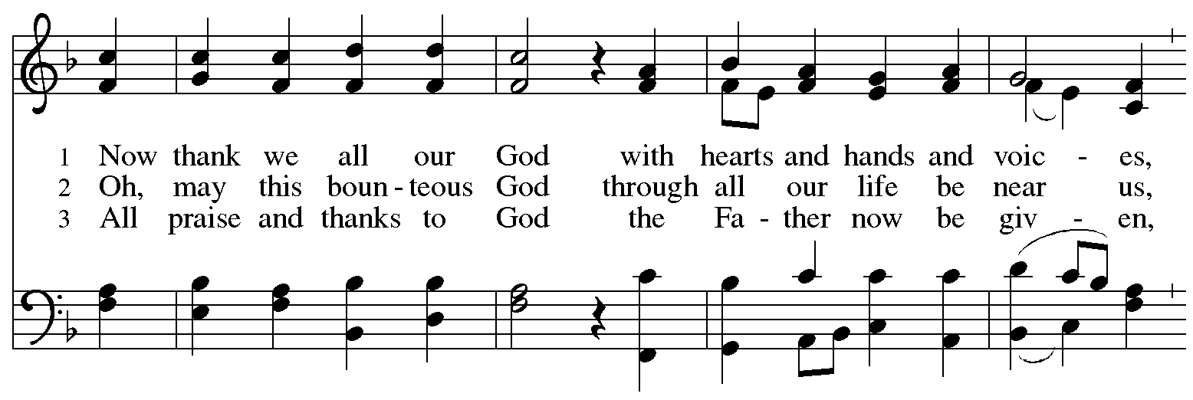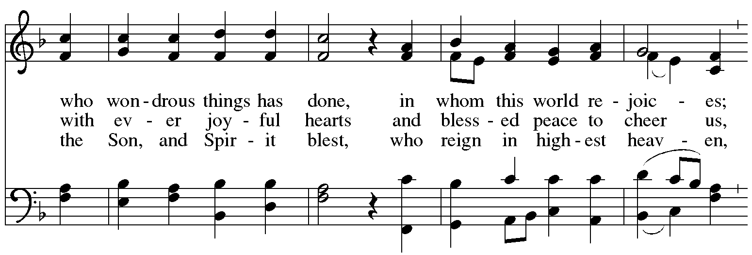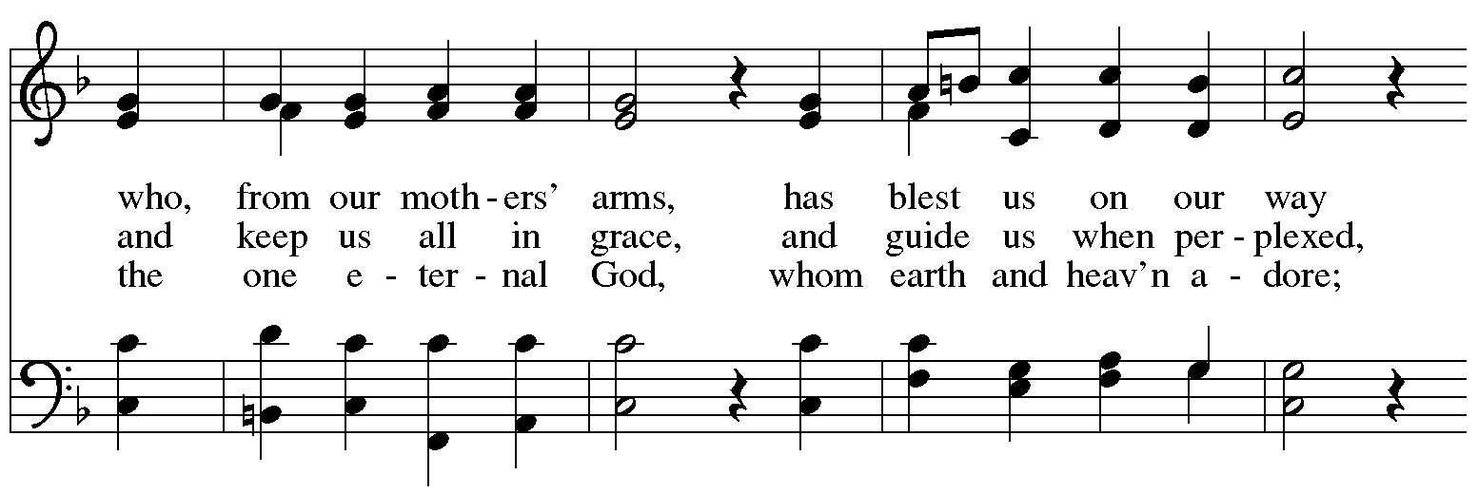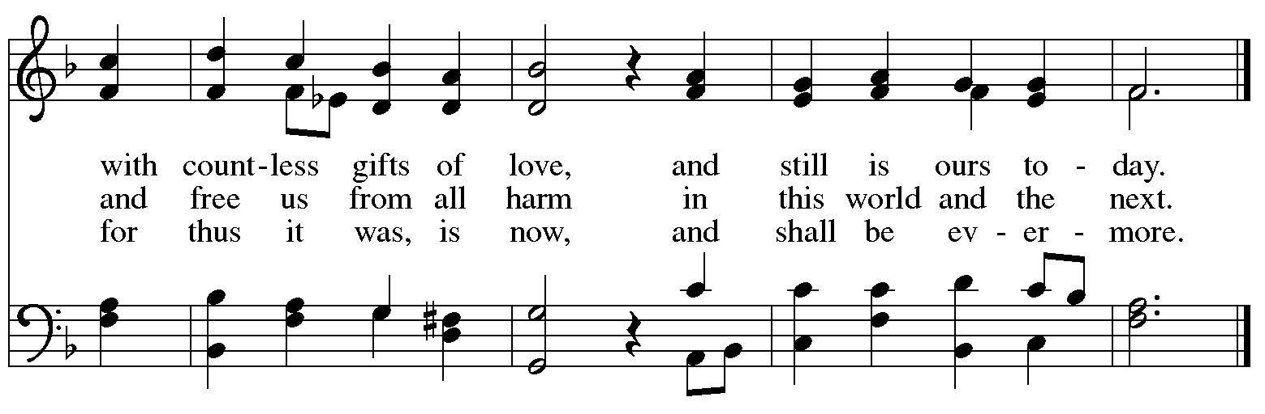

Apostles’ Creed

C: I believe in God, the Father almighty,
creator of heaven and earth.

I believe in Jesus Christ, God’s only Son, our Lord,
who was conceived by the Holy Spirit,
born of the virgin Mary,
suffered under Pontius Pilate,
was crucified, died, and was buried;
he descended to the dead.*
On the third day he rose again;
he ascended into heaven,
he is seated at the right hand of the Father,
and he will come to judge the living and the dead.

I believe in the Holy Spirit,
the holy catholic church,
the communion of saints,
the forgiveness of sins,
the resurrection of the body,
and the life everlasting. Amen.

*Or, “he descended into hell,” another translation of this text in widespread use.

Prayers of the People

A: Renewed in God’s everlasting grace, let us pray for the church, the world,
and all who are in need.

After each petition
A: God of grace,
C: receive our prayer.

P: We offer our prayers to you, O God, trusting in your abundant mercy,
through Jesus Christ our Lord.
C: Amen.

Peace

The presiding minister and the assembly greet one another in the peace of the risen Christ.
P: The peace of Christ be with you always.
C: And also with you.

The people may greet those around them with a sign of Christ’s peace and may say
Peace be with you or similar words. Please be mindful that not everyone will be comfortable with sharing the peace, so please seek consent before shaking hands or hugging. Other possible ways to share the peace include a simple bow with the verbal greeting of peace, or simply a verbal expression of peace.

When the greetings of peace have concluded, please be seated.



Meal
God feeds us with the presence of Jesus Christ

Offering

We offer ourselves, our gifts, and our faithful service to God.
As the offering is gathered for the mission of the church, including the care of those in need,
the table is set for Holy Communion.

There are laminated giving cards in the pew racks that feature a QR code for anyone who would like to give online. Those who give using the QR code, as well as those who give regularly online or through their bank are encouraged to place the laminated card in the plate as an expression of your offering.

Offertory Music All Are Welcome arr. Hayes

As the gifts are brought forward for presentation, please rise as you are able.

Offertory Song Let the Vineyards Be Fruitful ELW 184

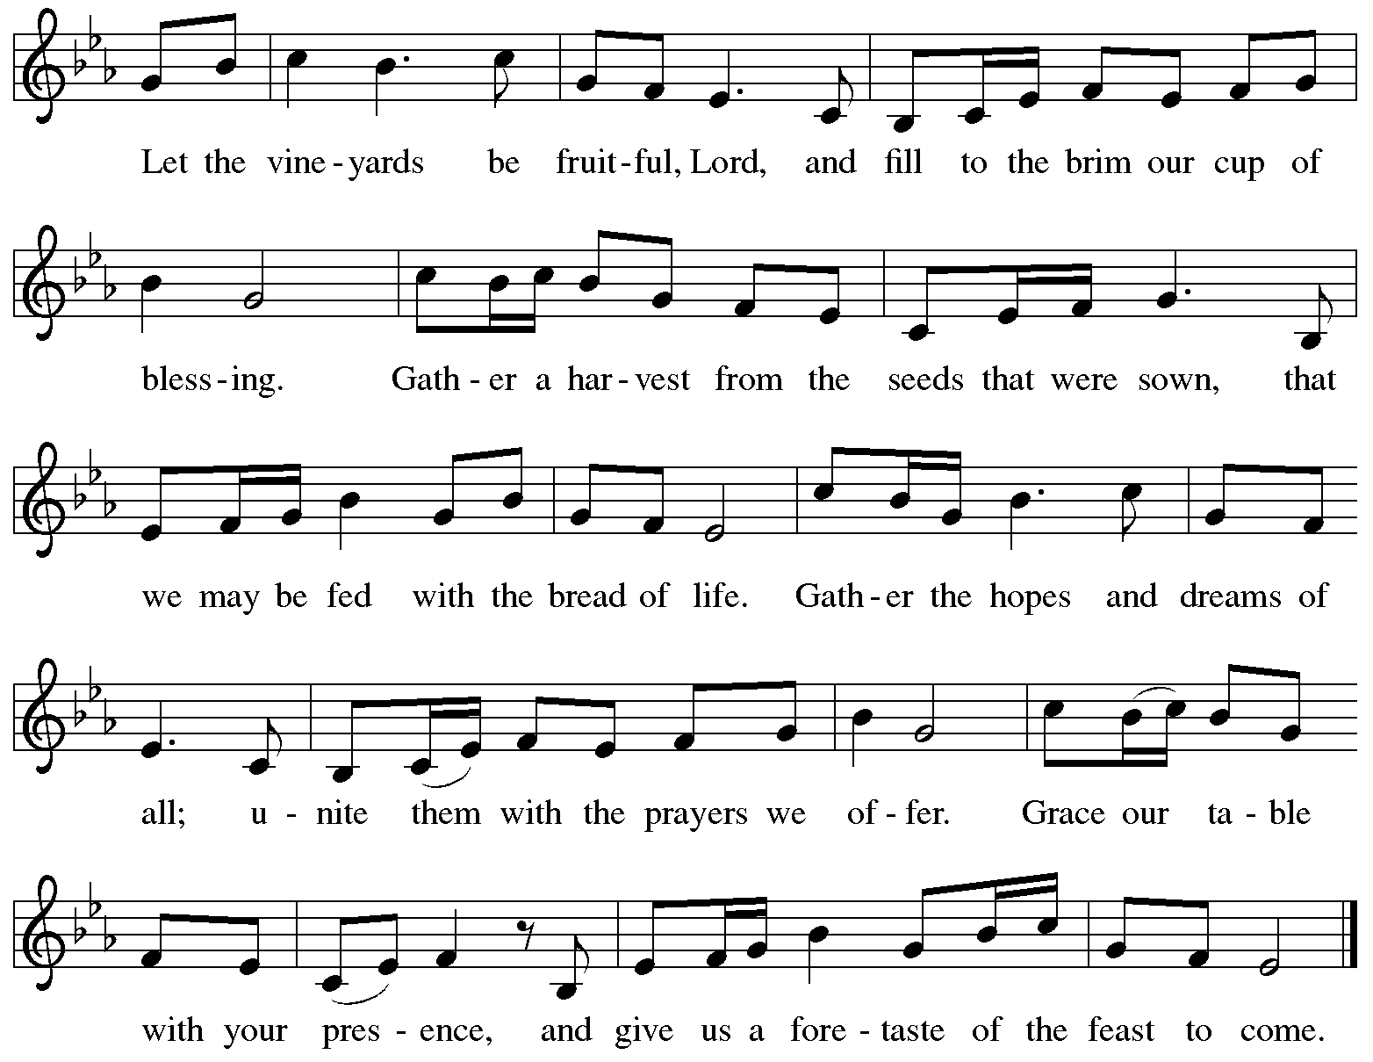
All rights reserved. Reprinted with permission under OneLicense.net # A-722139.

Offertory Prayer

A: Let us pray.
God of mercy and grace,
C: the eyes of all wait upon you,
and you open your hand in blessing.
Fill us with good things at your table,
that we may come to the help of all in need,
through Jesus Christ, our redeemer and Lord.
Amen.

Dialogue ELW p. 152

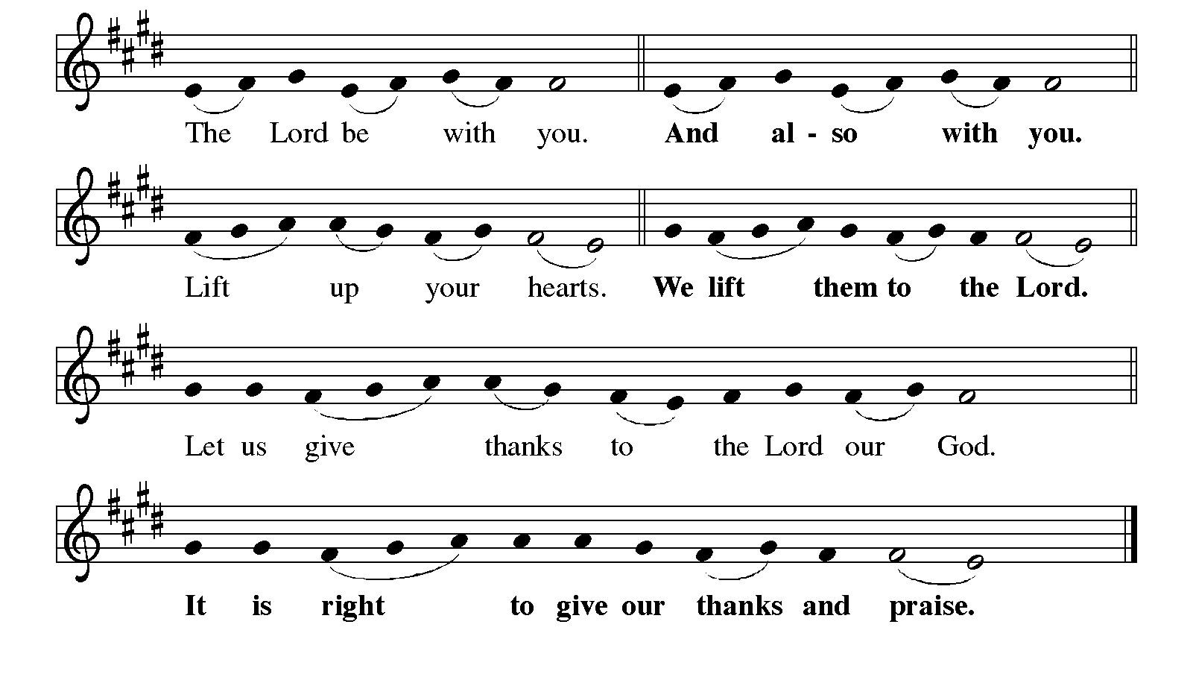

Preface

P: It is indeed right, our duty and our joy,
that we should at all times and in all places
give thanks and praise to you, almighty and merciful God,
through our Savior Jesus Christ;
who one this day overcame death and the grave,
and by his glorious resurrection opened to us the way of everlasting life.
And so, with all the choirs of angels,
with the church on earth and the hosts of heaven,
we praise your name and join their unending hymn:

Sanctus ELW p. 153

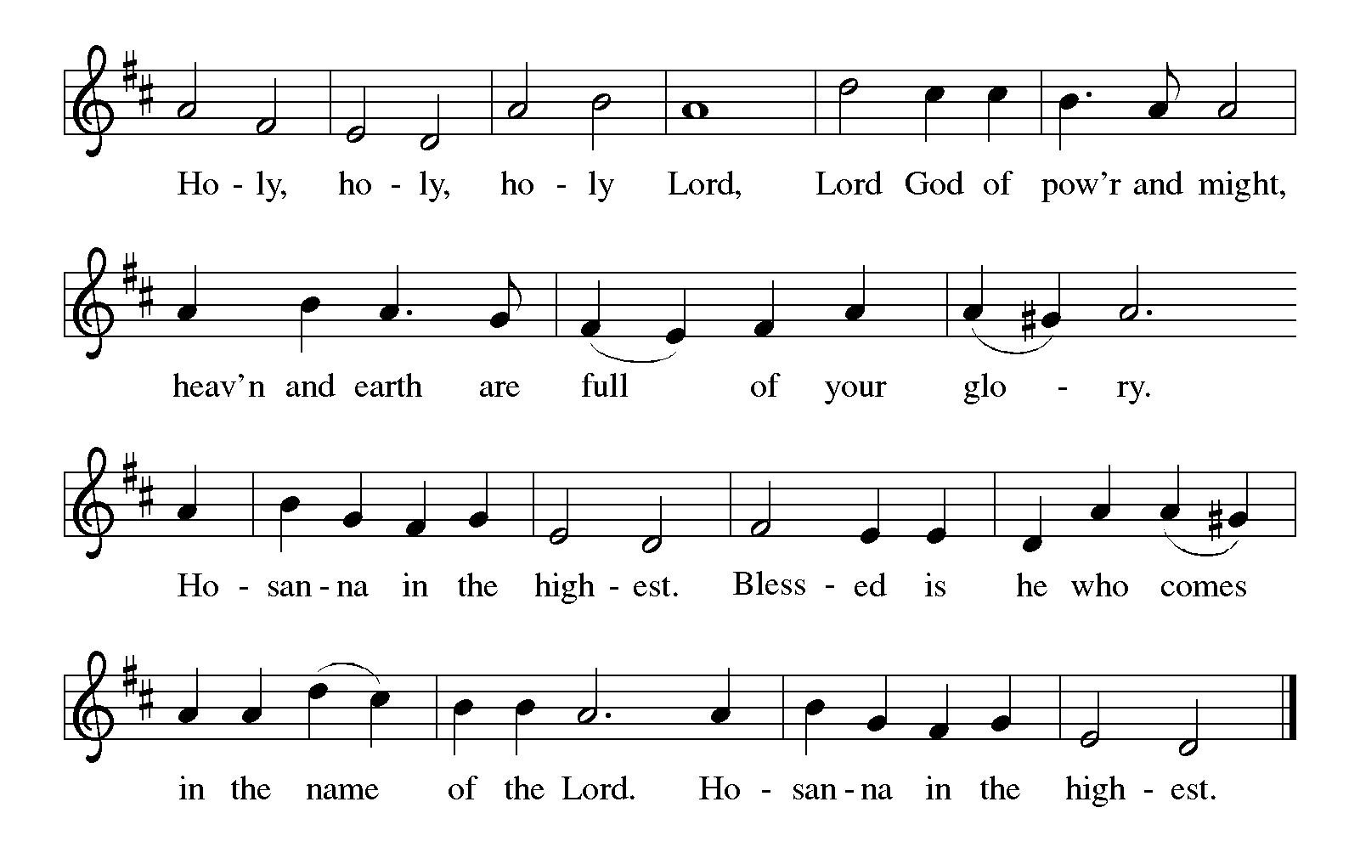
Eucharistic Prayer

P: Holy God, you alone are holy, you alone are God. …
… with every breath.
C: We praise you, O God.

P: Generations bless your faithfulness: …
… into the future.
C: We bless you, O God.

P: We give you thanks for your dear Son: …
… with us now.
C: We thank you, O God.

P: In the night in which he was betrayed …
… Do this for the remembrance of me.

Remembering his love for us on the way …
… we proclaim the mystery of faith.
C: Christ has died. Christ is risen. Christ will come again.

P: We pray for the gift of your Spirit: …
… in your church, without end.
C: Amen.

Lord’s Prayer

P: Gathered as one by the Holy Spirit, let us pray as Jesus taught us.
C: Our Father in heaven,
hallowed be your name,
your kingdom come,
your will be done,
on earth as in heaven.
Give us today our daily bread.
Forgive us our sins
as we forgive those
who sin against us.
Save us from the time of trial
and deliver us from evil.
For the kingdom, the power,
and the glory are yours,
now and forever. Amen.

Fraction and Invitation



Agnus Dei / Lamb of God ELW p. 154

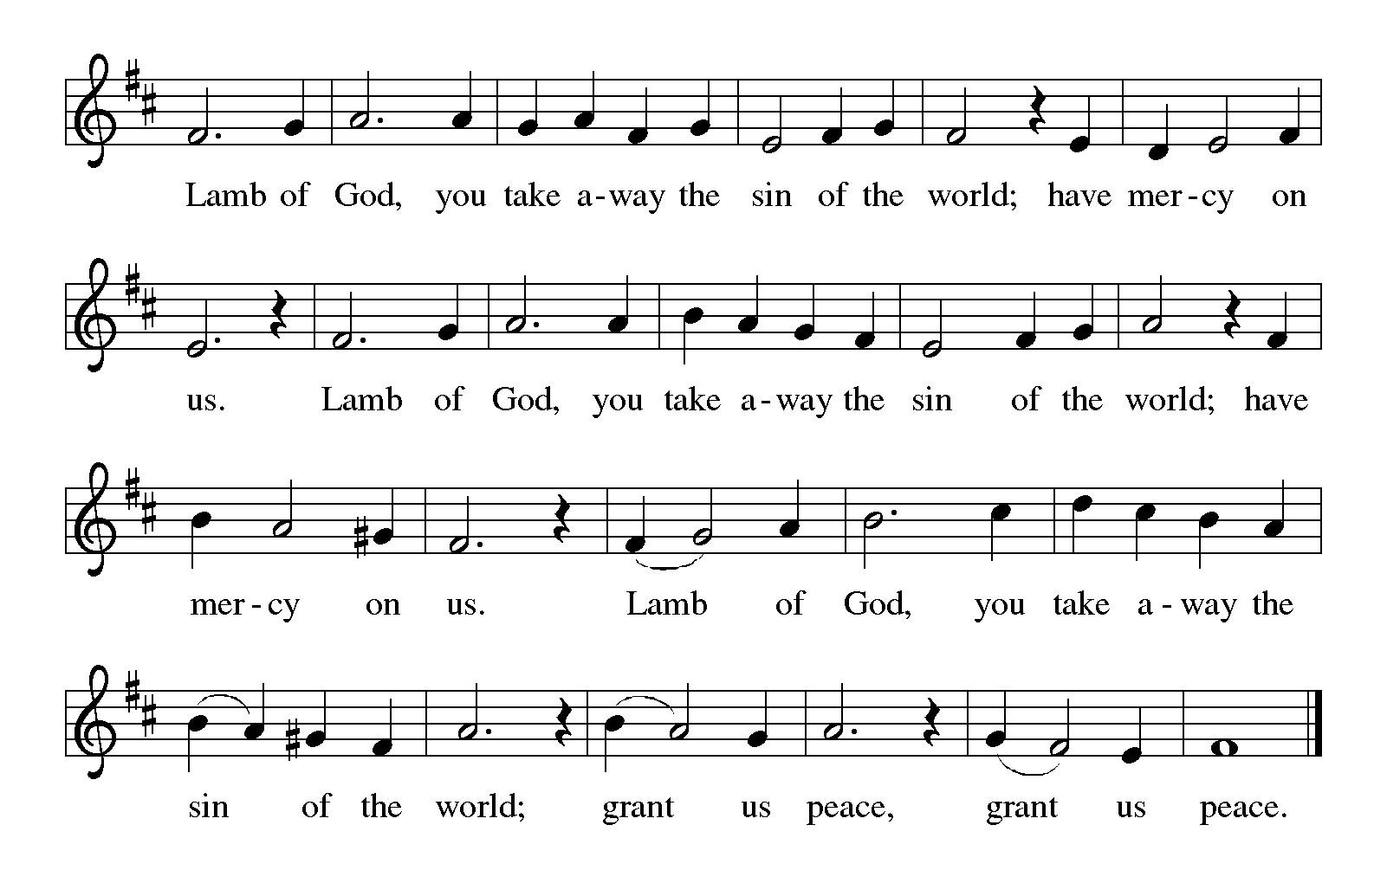

Please be seated.

Holy Communion

- All who seek God and desire a deeper and stronger life in Christ are welcome to receive Holy Communion.
- Worshipers from the pulpit side will proceed forward first, followed by the center section, and then the lectern side.
- Please inform an usher if you would like the ministers to bring Communion to you.
- Holy Communion will be served with bread and wine (amber) or grape juice (purple).
- The presiding minister will first distribute the bread (host) to each communicant. Please indicate if you require a gluten-free host.
- Once you have consumed the bread, please pick up an empty glass from the tray next to the presiding minister. The Communion Assistant will pour wine or grape juice into your glass.
- Please step to the side to consume the wine or grape juice.
- Feel free to kneel at the altar rail for prayer after receiving the sacrament.
- As you return to your pew, glasses may be returned to the empty tray on the side of the center section.
- A blessing will be provided for anyone who does not yet receive the sacrament.
- All are invited to join in singing the hymns during Holy Communion.
Hymns during Holy Communion
Baptized and Set Free ELW 453

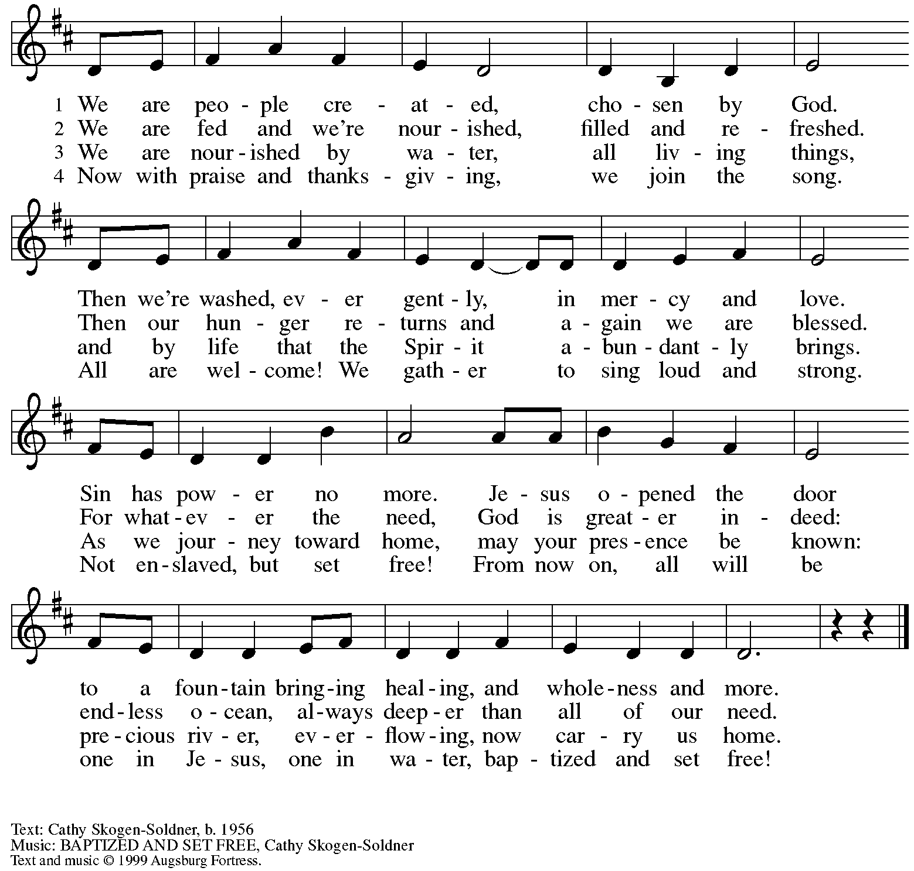
All rights reserved. Reprinted with permission under OneLicense.net # A-722139.

Hymns during Holy Communion
Oh, for a Thousand Tongues to Sing ELW 886

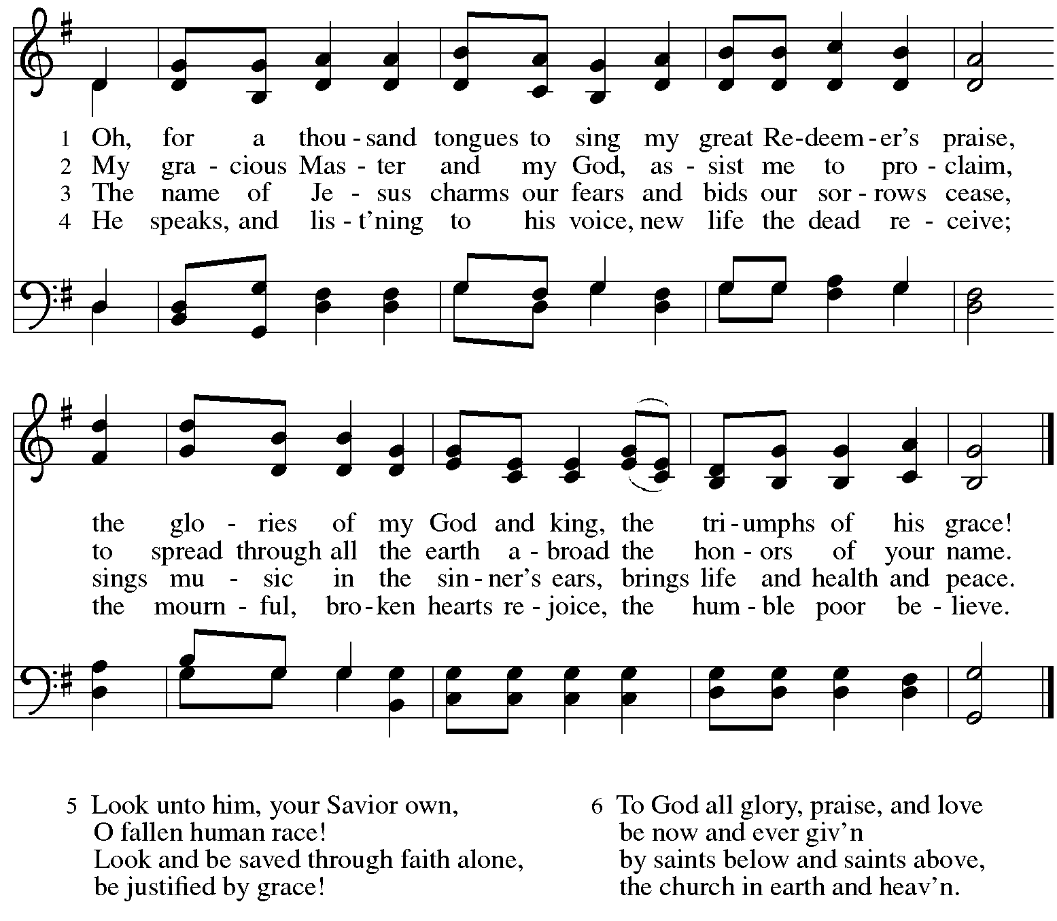

Hymns during Holy Communion
May This Church Be Like a Tree ACS 1042

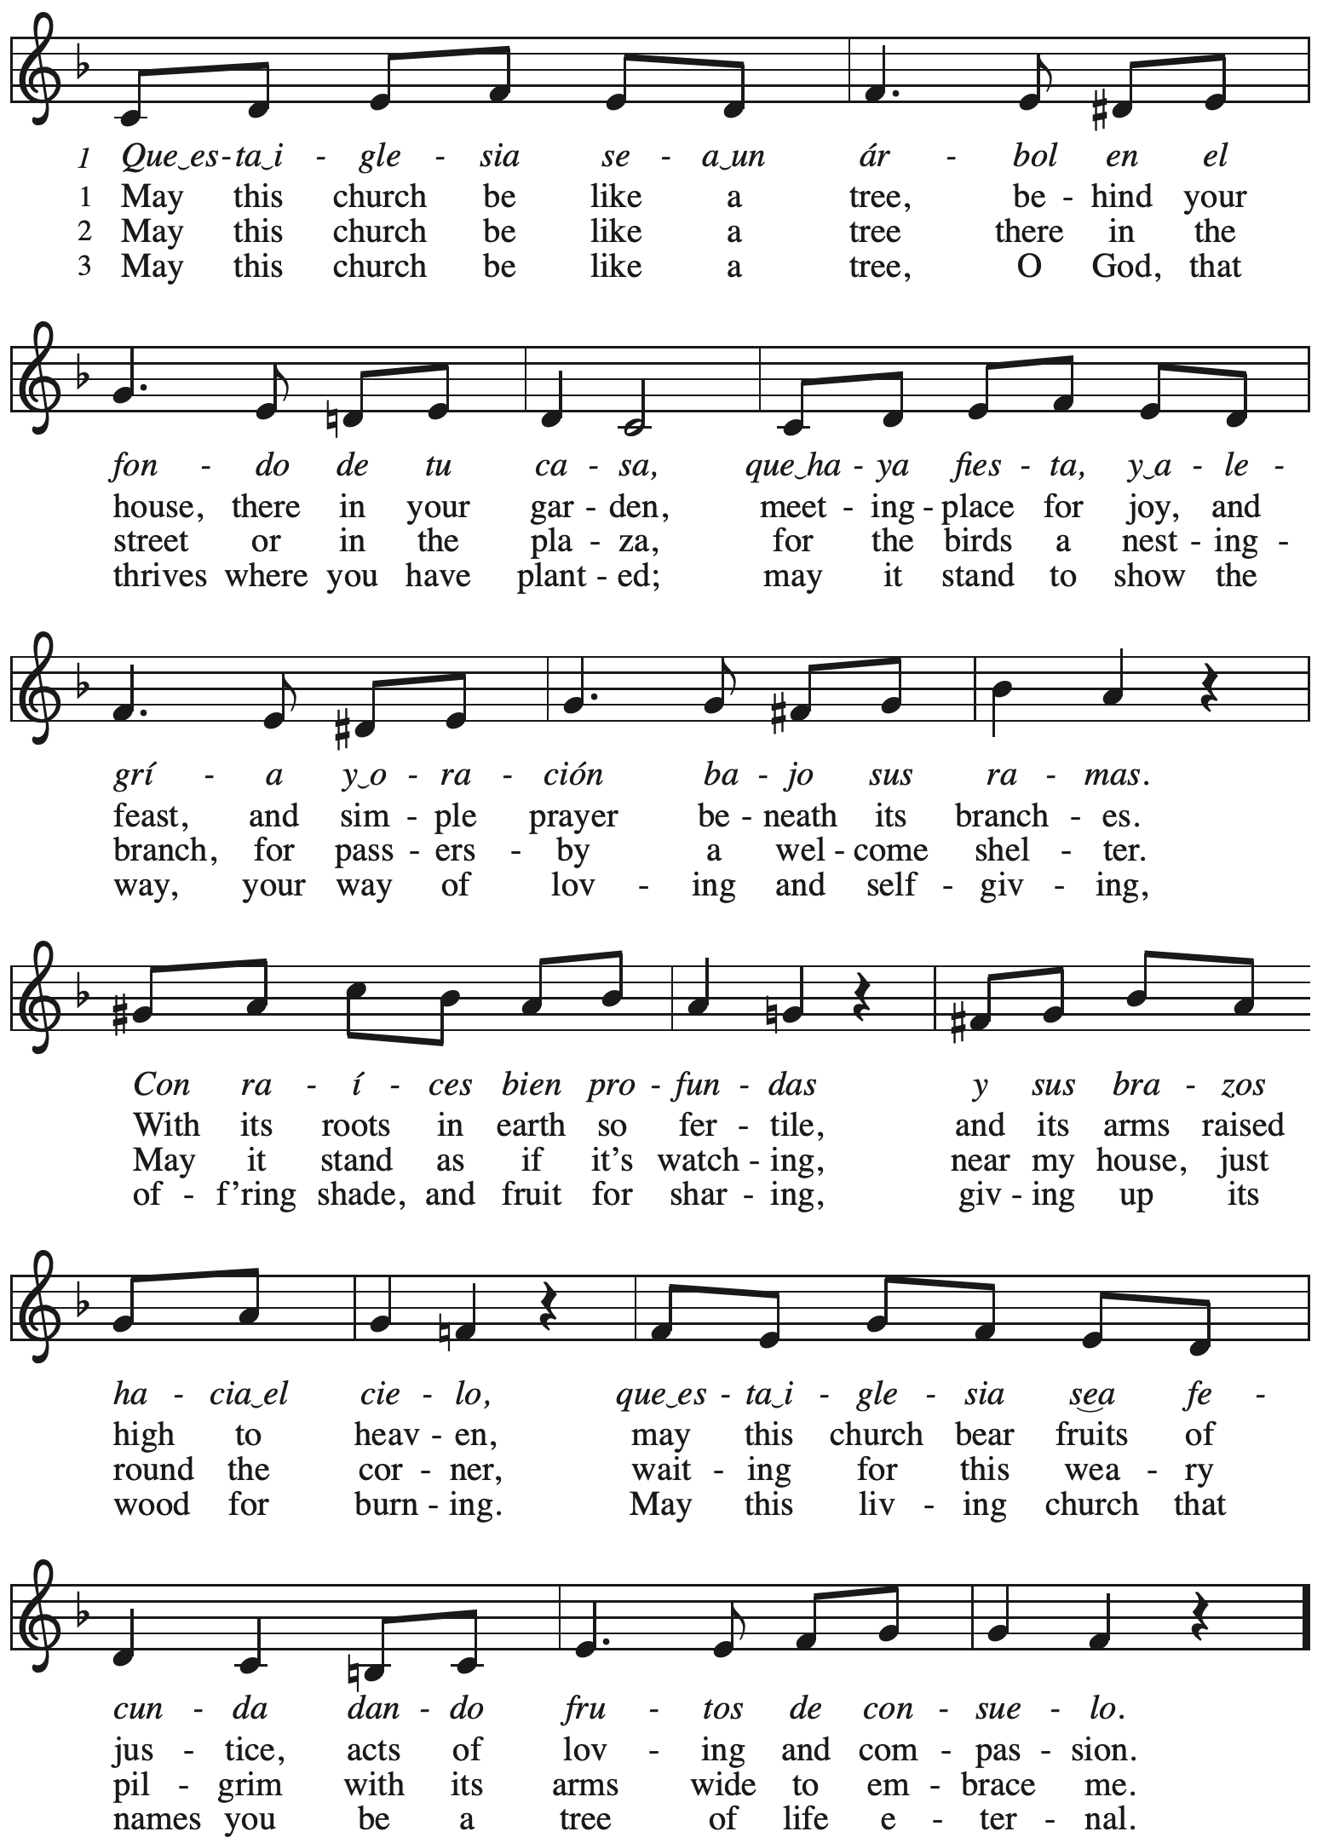
Continued
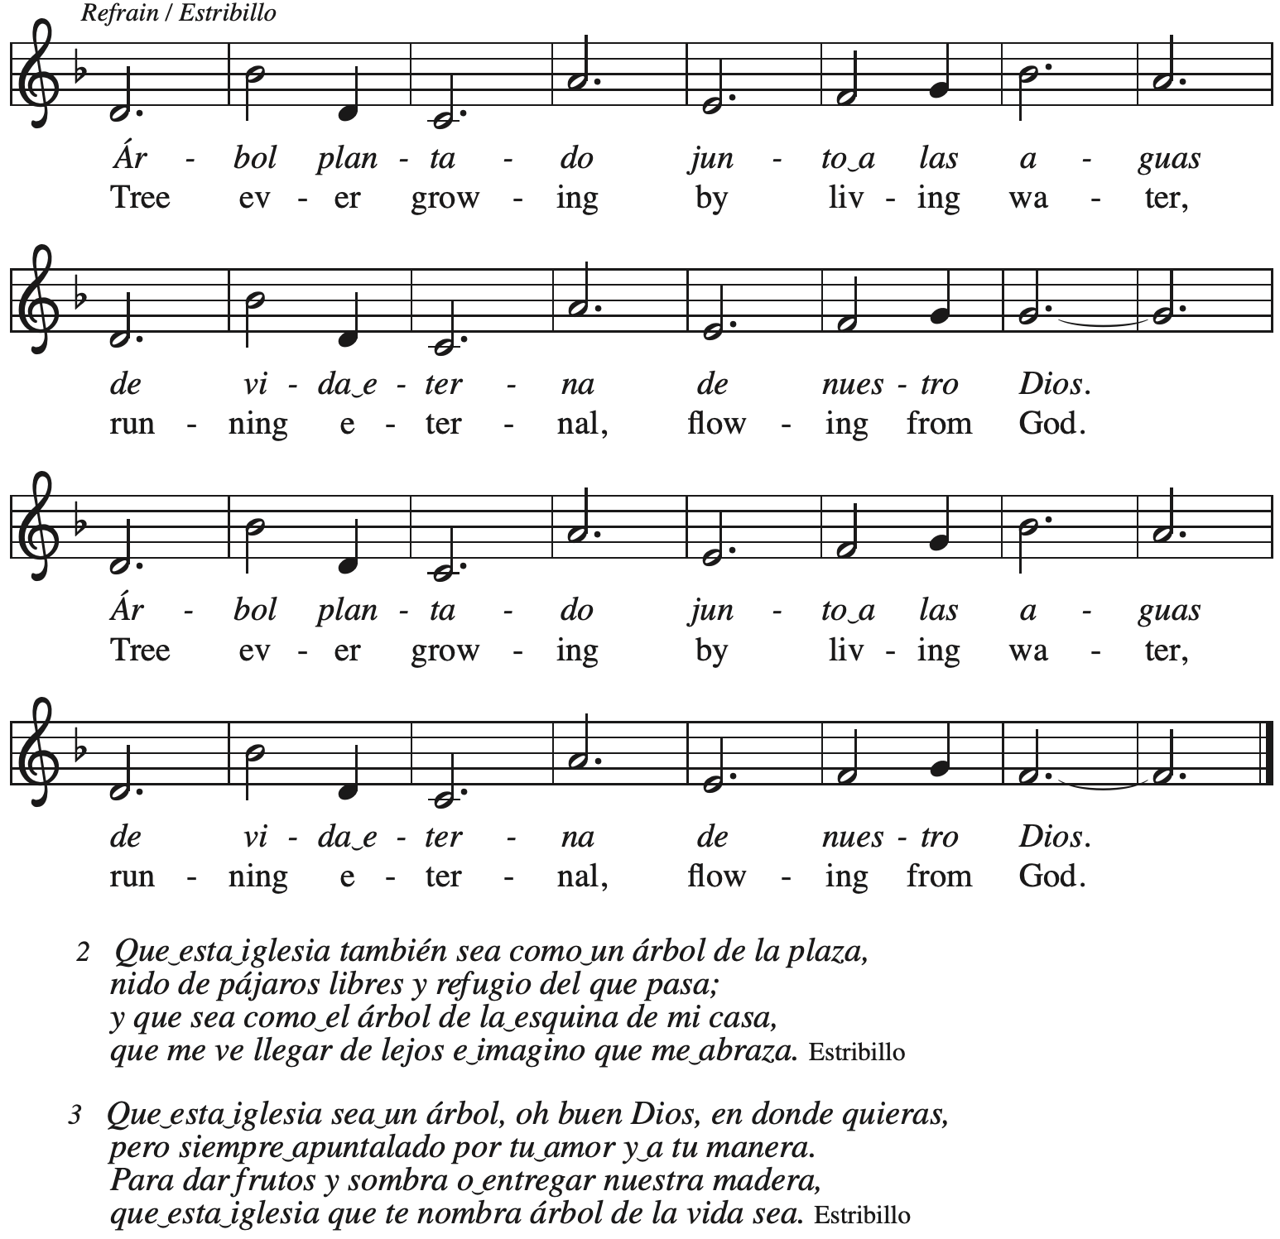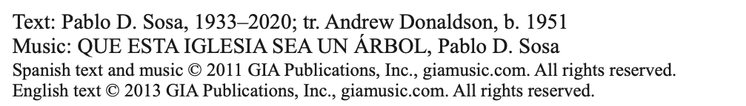
Reprinted under OneLicense.net # A-722139.

Hymns during Holy Communion
Come, Share the Spirit ACS 1045

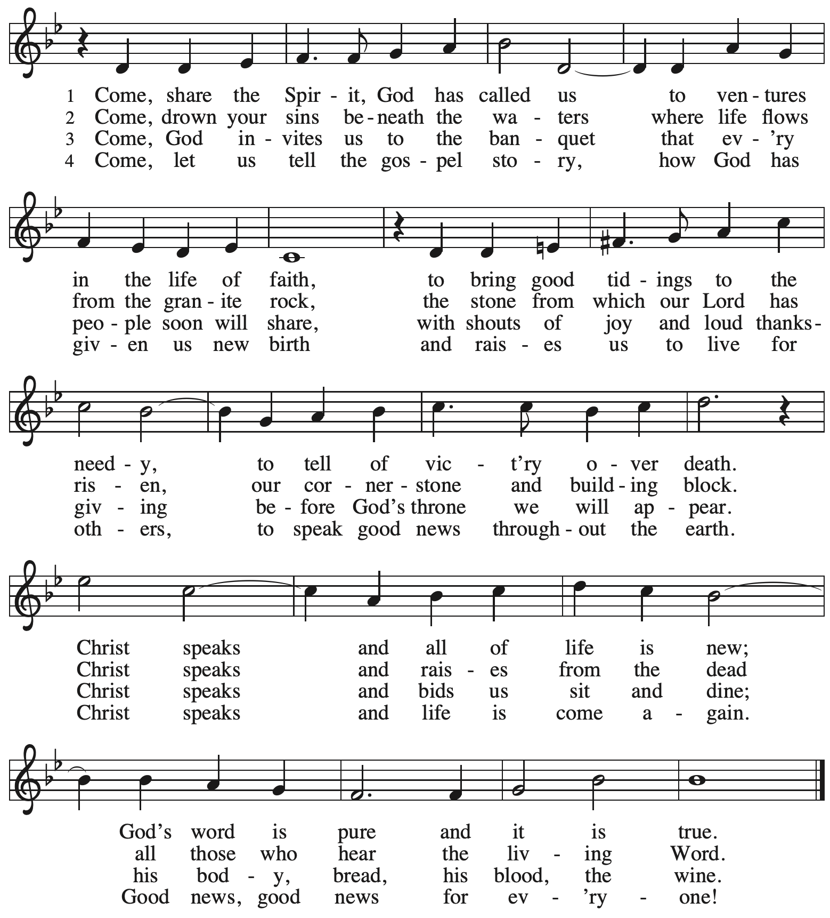
All rights reserved. Reprinted with permission under OneLicense.net # A-722139.

Hymns during Holy Communion
On Our Way Rejoicing ELW 537

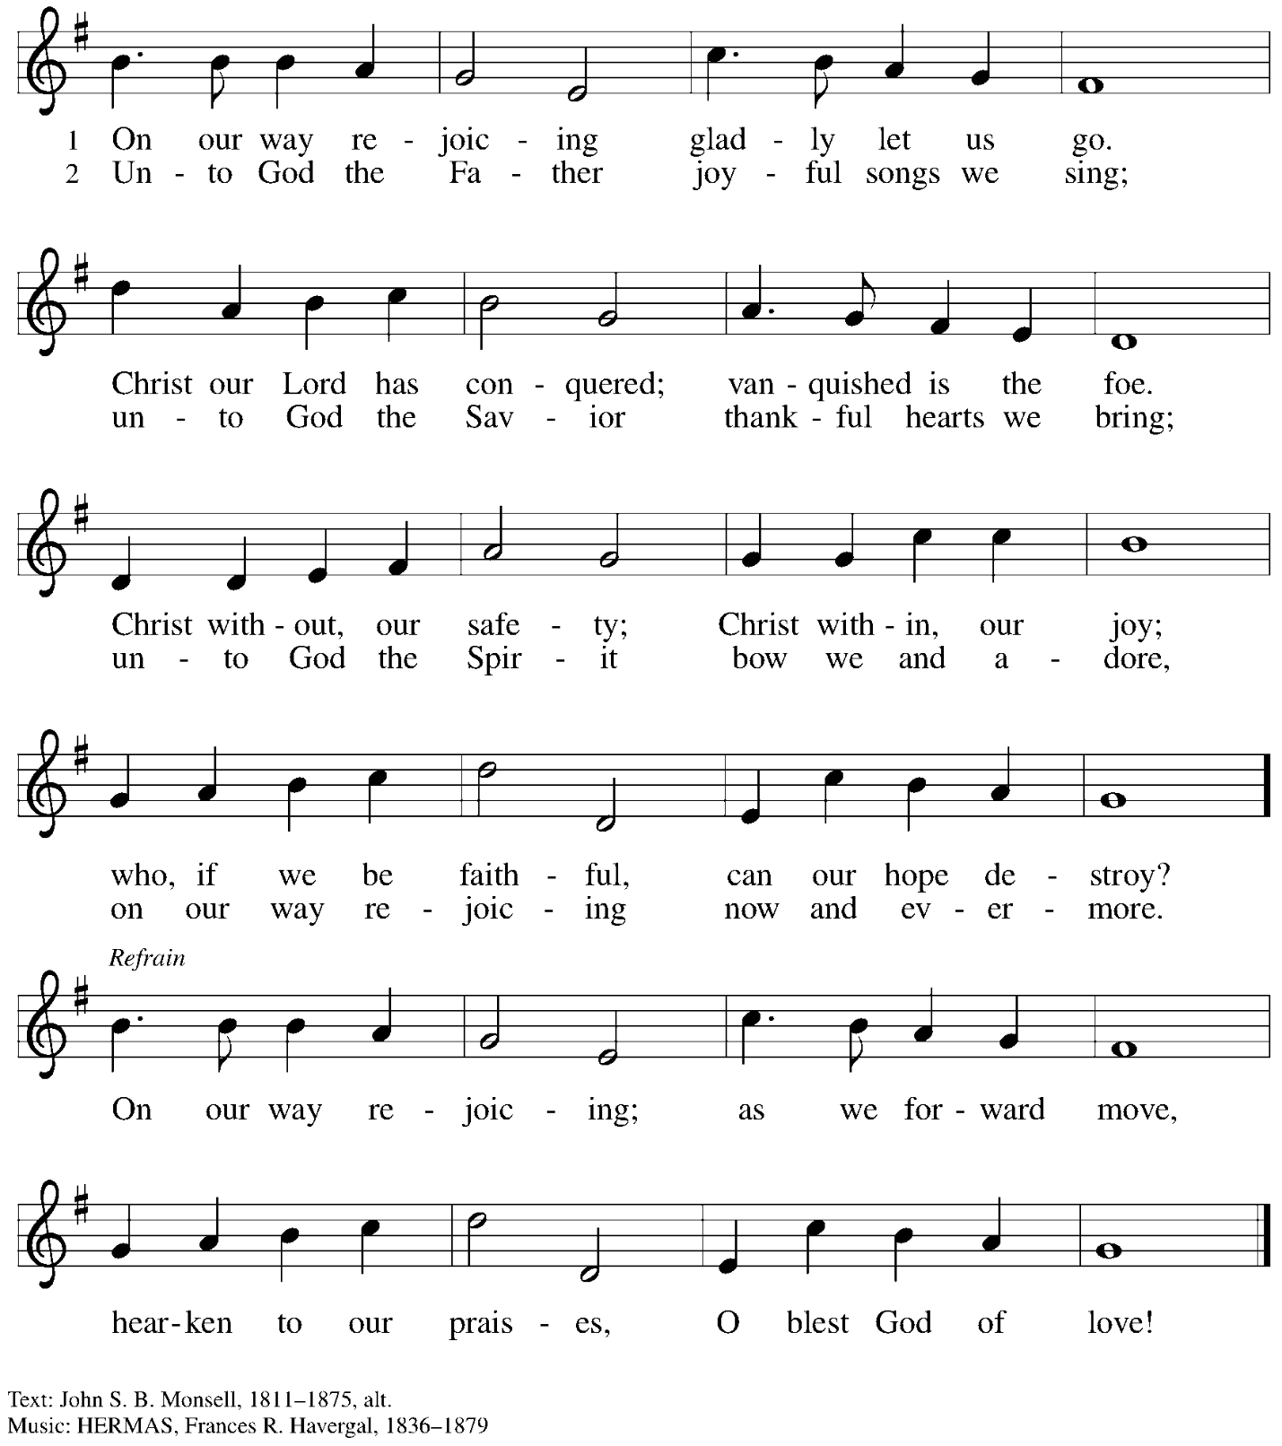

When all have returned to their places, please rise as you are able.

Blessing

P: The body and blood of our Lord Jesus Christ strengthen you and keep you in his grace.
C: Amen.

Prayer

A: Let us pray.
Almighty God, we give you thanks that you have fed us with this heavenly food.
In your grace and by your Spirit, help us to be what we celebrate, the body of Christ in the world.
Send us out, renewed by this sacramental meal,
to do the work you have given us to do: to witness for Christ,
to love you with singleness of heart, and to serve you with clarity of purpose;
through Jesus Christ, our Savior and Lord.
C: Amen.

Please be seated.

Sending
God blesses us and sends us in mission to the world

Announcements

Please rise as you are able.

Benediction

P: The love of God the Sovereign strengthen you,
God the Son save you,
and God the Holy Spirit anoint and sustain you.

The Holy Trinity ☩ bless you
and grant you a faithful and courageous heart,
now and forever.
C: Amen.

Sending Hymn Following page

Sending Hymn All Are Welcome ELW 641

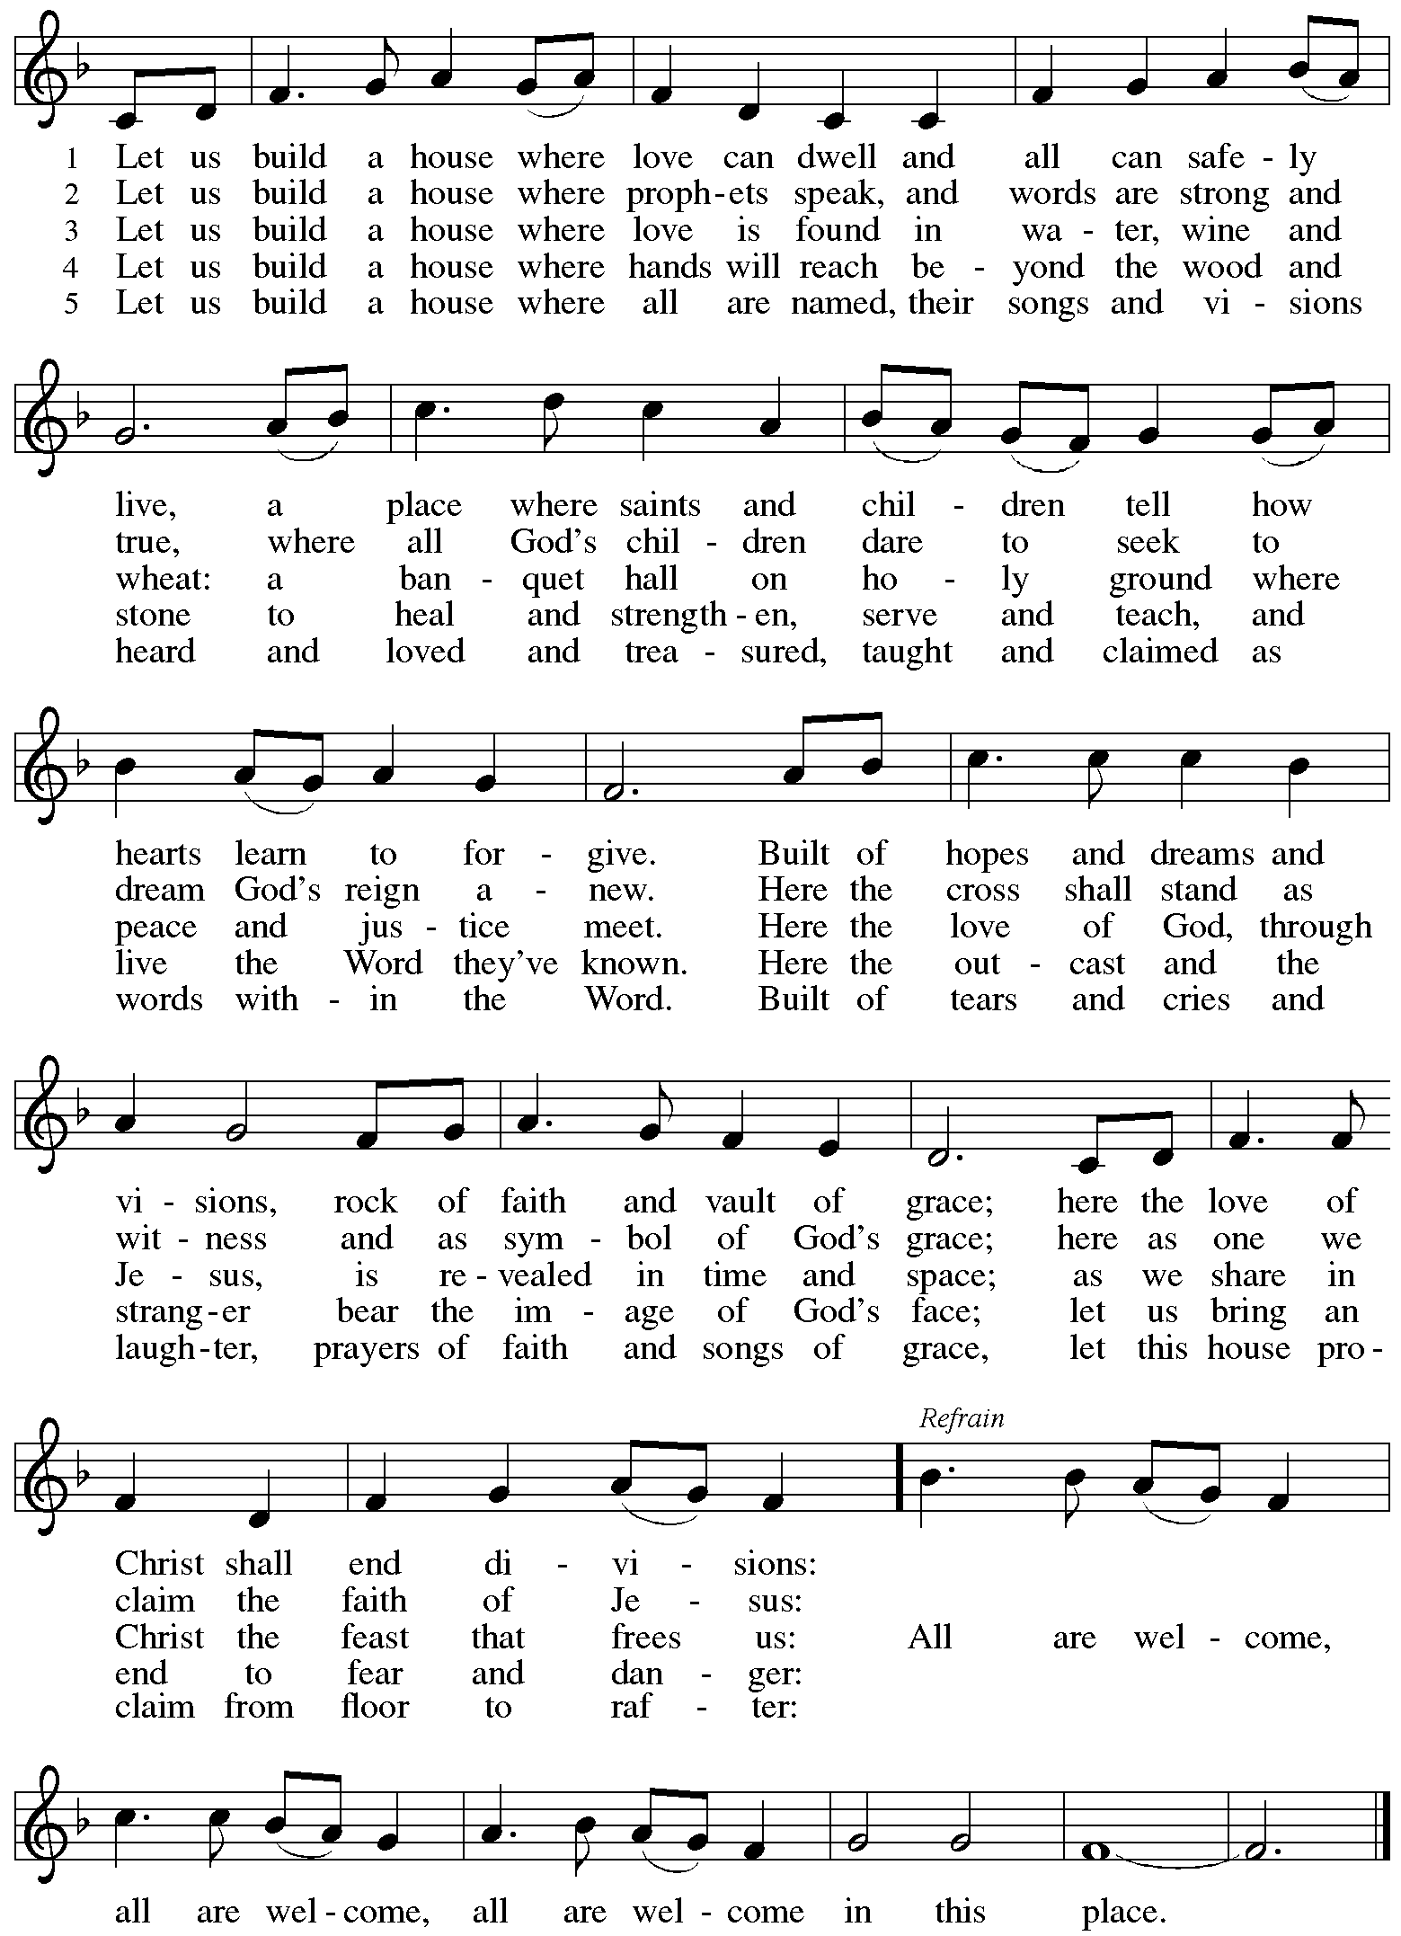
Dismissal

A: Go in peace. Serve the Lord.
C: Thanks be to God!

Postlude

Serving in Worship Today

Altar Care Beverley Chapman
Assisting Minister Timothy Kocher-Hillmer
Audio-Visual Ministers Jason Galyardt
Joseph Paetz
Cantor Miriam Bohlmann Kunz
Lector Colleen Cooke
Soloists on Prelude The Rev. Rin Jones
Emily Duque
Minister of Music Laura Reynolds
Presiding Minister The Rev. Ross Carmichael

Liturgy and Hymnody Acknowledgements

From SundaysandSeasons.com. Copyright © 2025 Augsburg Fortress. All rights reserved. Reprinted under OneLicense.net # A-722139.
Used by permission of Augsburg Fortress.

The Scripture readings contained herein are from New Revised Standard Version Updated Edition of the Bible © 2021 National Council of Churches of Christ in the United States of America. Used by permission. All rights reserved worldwide.

Now Thank We All Our God – Text: Martin Rinkhart, 1586-1649; tr. Catherine Winkworth, 1827-1878. Music: NUN DANKET ALLE GOTT, Johann Crüger, 1598-1662.

All Are Welcome – Text: Marty Haugen, b. 1950. Music: TWO OAKS, Marty Haugen. Text and music © 1994 GIA Publications, Inc., 7404 S. Mason Ave., Chicago, IL 60638. www.giamusic.com. 800.442.3358. All rights reserved. Reprinted with permission under OneLicense.net # A-722139.

Please use the QR code below to link to St. Andrew’s Announcements online!



St. Andrew Lutheran Church Announcements
October 12th, 2025

- Welcome to Worship at St. Andrew on the Eighteenth Sunday after Pentecost and the 134th Anniversary of the Congregation! – We are so glad you are here, and we offer a special welcome to all visitors and guests who are here for the first time! A nursery is available through the door to the left of the worship space and across the social hall (look for a purple room). Little Church – Big Faith, a Bible lesson and activity for children up to sixth grade, will take place after the prayer of the day. There are also worship “toolkits” to help children engage with worship and “busy bags” for younger children available in the bookcase at the back of the sanctuary. Please feel free to take one to use with/for your children. All are invited to stay for coffee and other drinks, food, and conversation in the Social Hall (through the side door at the left of the worship space) after the service.
- Community Ministry Meeting, Monday October 13th – Our community ministry team plans for and leads the congregation’s ministries of service to the community, including the monthly produce distribution, East End Cooperative Ministry shelter dinner, the outdoor pantry and little library, and more. All are welcome to participate. Please use this link to join the meeting: https://us02web.zoom.us/j/89385884806?pwd=aytsDaCywdjNTe5QmHbtk3AVPA6c40.1, and contact council liaison Tyler Rietze at community@standrewpittsburgh.org if you have any questions or need assistance joining the meeting.
- October Shelter Dinner for Guests of East End Cooperative Ministry – Third Thursday of the Month, October 16th, 6:30 p.m. – Each month, people of St. Andrew provide dinner for guests of East End Cooperative Ministry (EECM), 6140 Station St. (East Liberty), 15206. We invite you to prepare or purchase one menu item and bring it to the shelter by 6:00 p.m., or just come to help serve at 6:30 p.m. If you would like to contribute, please sign up at: https://www.signupgenius.com/go/5080544AAAC22A1F58-59036568-octshelter.
- Installation of Bishop Melissa Stoller Livestream – October 18th at 12:30 p.m. – With reservations to attend in person now closed, the service will be livestreamed beginning at 12:30 p.m. We invite you to join us in celebrating her installation by watching online here: http://youtube.com/live/hKjwBsNu1pw.
- Reckoning with Antisemitism as Christians, Tuesday, October 21st from 7:00 p.m. - 8:30 p.m. – At this program, we will get inspired by stories of Reckoning from across western PA, and then provide guided planning time for you to decide how you will take part in the Reckoning with Antisemitism as Christians project this year. Like all things, this work is best done together. Join us for an evening with Christian clergy and lay leaders from across our region. We will learn from those who are engaging in this important work: exploring Christian scriptures, studying the impact of antisemitism, partnering with neighboring houses of worship, or befriending Jewish colleagues. We will then participate in an interactive planning session, working together to consider how each one of us can reckon with antisemitism and build relationships with Jewish neighbors this year. You can pre-register for the event here: https://www.casp.org/reckoning#oct21.
- St. Andrew Lunch at Hofbrauhaus on Reformation Sunday, Sunday, October 26th, 12:15 p.m. – Kelly Spanninger is organizing a renewal of St. Andrew lunch outings after Sunday worship. On Reformation Sunday, October 26th, all are invited to gather at Hofbrauhaus at South Side Works, 2705 S. Water St., 15203 at 12:15 p.m. Please let Kelly know if you plan to attend, or contact her at pkspanninger@verizon.net.
- Produce Distribution Supplemental Food of the Month – St. Andrew has begun collecting supplemental food each month to accompany our produce distribution. For the upcoming month, we ask for donations of rice and dried beans. There will be a collection box at the back of the worship space.
- God's Work - Our Hands 2025: Share the Warmth, through Sunday, October 26th
– Each year, the Evangelical Lutheran Church in America asks congregations to participate in its God's Work - Our Hands initiative, an act of service to the congregation's larger community. St. Andrew's God's Work - Our Hands project for this year will be to support "Share the Warmth," a collection of new and gently used winter coats for East End Cooperative Ministry (EECM). St. Andrew will be collecting new and gently used winter coats in the social hall through October. You can also drop off coats for EECM at Strong II Dry Cleaners until October 15th to have them cleaned for free and Strong will deliver them to EECM. They are located at 7620 Frankstown Ave., 15208. Thank you for continuing to do God's Work for the good of our neighbors!
- East End Interfaith Thanksgiving Service, Tuesday, November 25th, 7:00 p.m. – This year's East End Interfaith Thanksgiving Service, with the theme Lift Every Voice, will be held at Episcopal Church of the Redeemer at 5700 Forbes Ave., Pittsburgh, PA 15217 and will be co-hosted by leaders of the Hindu-Jain Temple in Monroeville. Following the service, all are welcome to a light reception in the Parish Hall. As part of our Thanksgiving offering, we invite all attendees to bring a non-perishable food item or toiletry as an offering to support our immigrant neighbors through JFCS.
- Discipleship that Heals the World, Studies in Matthew’s Gospel – Thursdays, 8:00 - 9:00 p.m. on Zoom, Sept. 25th – Dec. 11th, 2025 – Join us for an 11-week journey through the Gospel of Matthew, organized and facilitated by Rev. Dr. Martin Rafanan. Together we will explore Jesus’ Sermon on the Mount and his healing ministry, discovering Matthew’s distinctive vision of discipleship as a way of blessing, healing, and hope. This study is designed for both newcomers to the Gospel and those already familiar with it. We will engage contemporary perspectives that help us hear Matthew’s message afresh in today’s world. Register for the sessions to receive zoom info: https://forms.gle/amy439vfUpwdJpKx7.
- Christ in our Home Devotional Booklets for October-December – Available at church entrances, this resource offers a daily Bible reading with a short reflection and prayer, along with additional readings and prayer topics for those who would like to expand their devotional practices. We encourage people of the congregation to take one for yourself, your family/household, or others.
- Invitation to Prayer Team – St. Andrew maintains a list of weekly prayer concerns sent by email to members of the congregation who have opted in. Our prayer team’s email is prayerteam@standrewpittsburgh.org. We will keep names on the list for a maximum of four weeks unless otherwise requested. Thank you for your ministry of prayer!
- Records Update – St. Andrew is seeking to update our records with information from attendees so that we can acknowledge celebrations and milestones, and for prayers of the church. Please fill out the form at: https://forms.gle/kKvp19UozuRrhhaV7.
- Coffee Hour Signups – If you would like to participate and would like additional information about the duties, please sign up using the following form: https://www.signupgenius.com/go/5080B4AAFAF2CABF85-47069030-coffee#/.

