

+ Nineteenth Sunday after Pentecost
October 19, 2025



St. Andrew Lutheran Church
304 Morewood Ave.
Pittsburgh, PA 15213
St_andrewELCA@verizon.net
www.standrewpittsburgh.org

+ Nineteenth Sunday after Pentecost
Order for Worship

Pray always. Do not lose heart. This is Jesus’ encouragement in the Gospel today.
Remember your Baptism again and again. Come regularly to Christ’s table.
Persistence in our every encounter with the divine yields the possibility of blessing.

Welcome to St. Andrew!
- St. Andrew welcomes all who are seeking a place of healing, wholeness, and acceptance in a nurturing and faith-forming spiritual home. We are striving toward racial equity worldwide
and we seek to honor the lived experience of all individuals regardless of background. Our community embraces people of all ages, ethnicities, cultures, abilities, sexual orientations,
gender identities and expressions, and family constellations. Come and See!
- Worship Services are live-streamed to multiple online platforms. By attending worship, you agree that your image and voice may be broadcast.
- Everyone is invited to make a name tag at the black bookcase in the back of the worship space if they would like. There are stickers indicating pronouns on the bookcase if you would like to include them on your name tag.
- A nursery is available through the doors at the left side of the sanctuary and across from the doorway to the Social Hall. Look for a purple-colored room.
- Children are invited to attend Little Church – Big Faith, a Bible lesson and activity, during worship (after the Prayer of the Day). The group returns to the worship space for the liturgy of Holy Communion.
- Worship “toolkits” to help children engage with the service, along with “busy bags” for younger children, are available in the bookcase at the back of the sanctuary. Please feel free to take one to use with/for your children.
- Holy Communion is served with bread (gluten-free available) and wine or grape juice. The presiding minister will distribute the bread (host). Please consume this and then pick up an empty glass from the tray. The Communion Assistant will pour wine or grape juice into your glass. Please step to the side to consume the wine or grape juice. Feel free to kneel at the altar for prayer and reflection. As you return to your pew, glasses may be returned to the empty trays on either side of the center section.
- A restroom is available on the main level of the church, through the doors to the Social Hall and to the right in the main office.

Abbreviations
P: Pastor/Presiding Minister ELW: Evangelical Lutheran Worship hymnal
A: Assisting Minister ACS: All Creation Sings hymnal
L: Lector TFF: This Far by Faith hymnal
C: Congregation

Musical Offering

Each week, different people from the congregation make an offering of pre-service music, with singing or instrumentation, to help the assembly focus and pray in preparation for worship.

Welcome

Prelude Prelude J.S. Bach
Zie Weaver - Flute

Gathering
The Holy Spirit calls us together as the people of God

Please rise as you are able. All may make the sign of the cross,
the sign that is marked at Baptism, as the presiding minister begins.

Confession and Forgiveness

P: Blessed be the Holy Trinity, one ☩ God,
our maker, our help, and our keeper.
C: Amen.

P: Trusting in God’s mercy, let us confess our sins in the presence of God and one another.

Silence is kept for reflection.

P: Faithful God,
C: you have shown us the ways of your heart,
yet we stray from your paths.
We are stuck in sinful systems of oppression
and do not embrace the freedom your faithful promises offer us.
We ignore our neighbors. We exploit the earth.
We reject your abundance,
trusting our impulses instead of your steadfast love.
Repair our relationships, restore what we have broken, renew our hearts,
and bring us to new life.
Amen.

P: Receive the good news:
God the Faithful One loves you,
in ☩ Christ Jesus, your sins are forgiven,
and by the power of the Holy Spirit, you are set free.
C: Amen.

Gathering Hymn Rise Up, O Saints of God! ELW 669

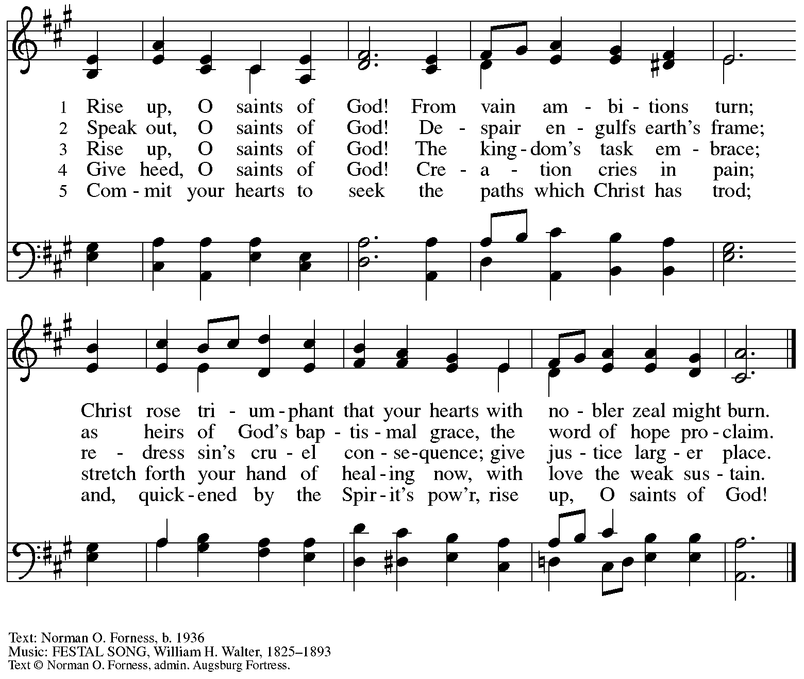
All rights reserved. Reprinted under OneLicense.net # A-722139.

Greeting

P: The grace of our Lord Jesus Christ, the love of God,
and the communion of the Holy Spirit be with you all.
C: And also with you.

Hymn of Praise ELW p. 148

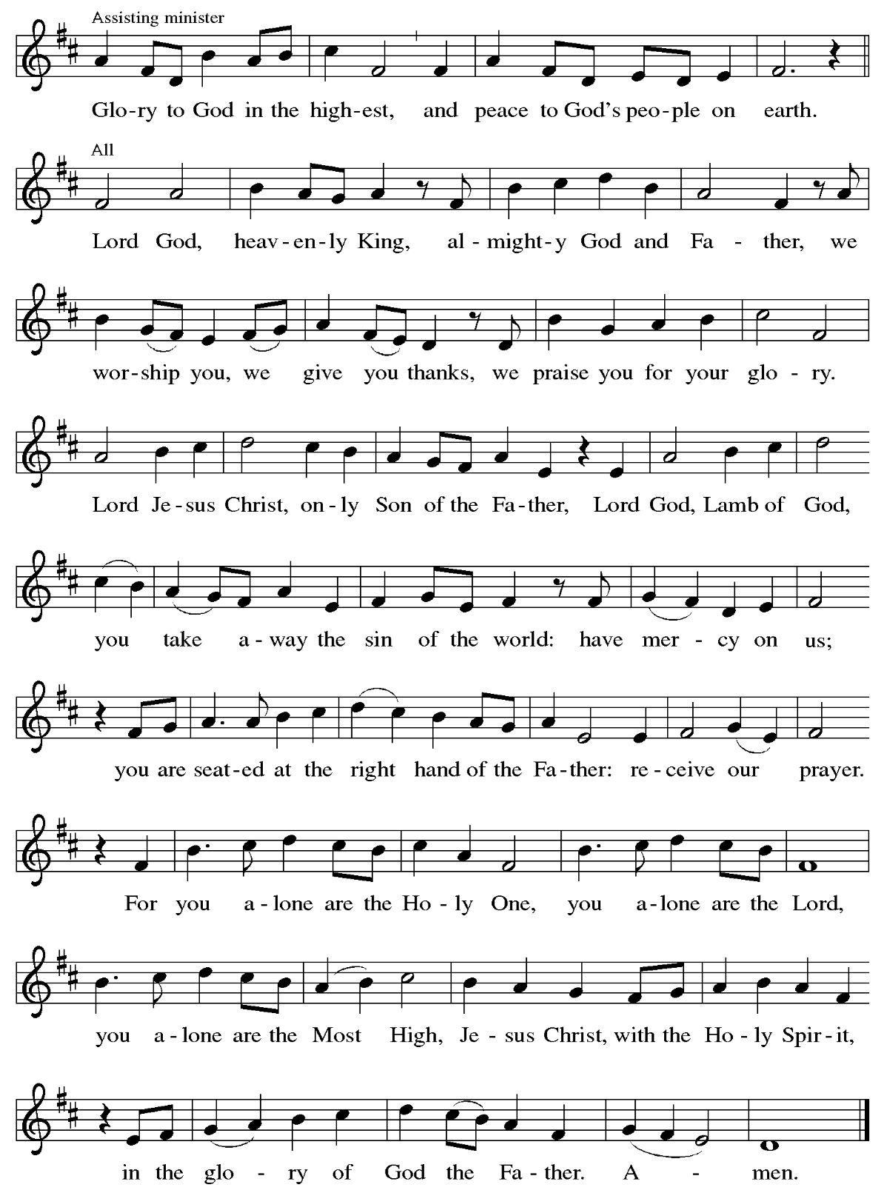

Prayer of the Day

P: The Lord be with you.
C: And also with you.
P: Let us pray.
O Lord God, tireless guardian of your people, you are always ready to hear our cries.
Teach us to rely day and night on your care.
Inspire us to seek your enduring justice for all this suffering world,
through Jesus Christ, our Savior and Lord.
C: Amen.

Please be seated.
Children are invited to join the adult leader(s) at the side door for Little Church – Big Faith.
We ask that an additional adult from the congregation attend with the children.

Word
God speaks to us in Scripture reading, preaching, and song

First Reading – Genesis 32: 22-31

²² The same night [Jacob] got up and took his two wives, his two maids, and his eleven children and crossed the ford of the Jabbok. ²³ He took them and sent them across the stream, and likewise everything that he had. ²⁴ Jacob was left alone, and a man wrestled with him until daybreak.
²⁵ When the man saw that he did not prevail against Jacob, he struck him on the hip socket, and Jacob’s hip was put out of joint as he wrestled with him. ²⁶ Then he said, “Let me go, for the day is breaking.” But Jacob said, “I will not let you go, unless you bless me.” ²⁷ So he said to him, “What is your name?” And he said, “Jacob.” ²⁸ Then the man said, “You shall no longer be called Jacob, but Israel, for you have striven with God and with humans and have prevailed.” ²⁹ Then Jacob asked him, “Please tell me your name.” But he said, “Why is it that you ask my name?” And there he blessed him. ³⁰ So Jacob called the place Peniel, saying, “For I have seen God face to face, yet my life is preserved.” ³¹ The sun rose upon him as he passed Penuel, limping because of his hip.

L: Word of God, word of life.
C: Thanks be to God.

Psalm 121

Psalm Tone

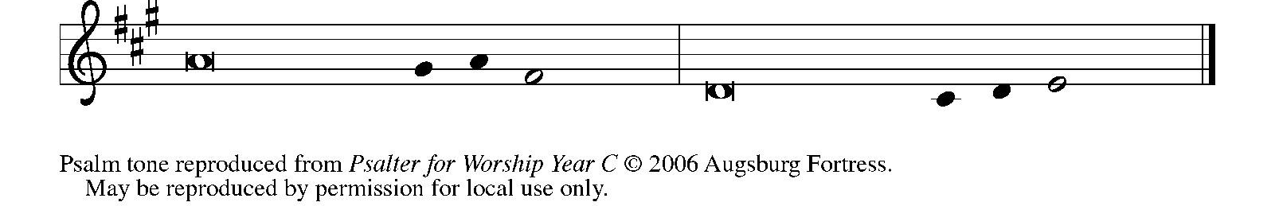

Psalm Refrain

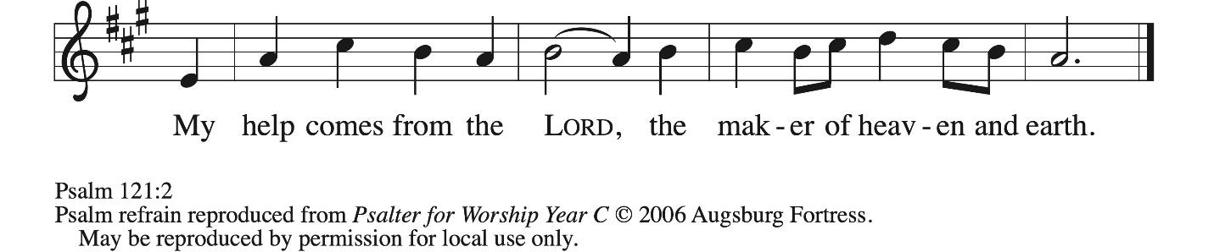

¹ I lift up my eyes | to the hills;
from where is my | help to come?
² My help comes | from the Lord,
the maker of heav- | en and earth.
³ The Lord will not let your | foot be moved
nor will the one who watches over you | fall asleep.
⁴ Behold, the keep- | er of Israel
will neither slum- | ber nor sleep; R
⁵ the Lord watches | over you;
the Lord is your shade at | your right hand;
⁶ the sun will not strike | you by day,
nor the | moon by night.
⁷ The Lord will preserve you | from all evil
and will | keep your life.
⁸ The Lord will watch over your going out and your | coming in,
from this time forth for- | evermore. R

Second Reading – 2 Timothy 3: 14 – 4: 5

¹⁴ But as for you, continue in what you have learned and firmly believed, knowing from whom you learned it ¹⁵ and how from childhood you have known sacred writings that are able to instruct you for salvation through faith in Christ Jesus. ¹⁶ All scripture is inspired by God and is useful for teaching, for reproof, for correction, and for training in righteousness, ¹⁷ so that the person of God may be proficient, equipped for every good work.
^{4:1} In the presence of God and of Christ Jesus, who is to judge the living and the dead, and in view of his appearing and his kingdom, I solemnly urge you: ² proclaim the message; be persistent whether the time is favorable or unfavorable; convince, rebuke, and encourage with the utmost patience in teaching. ³ For the time is coming when people will not put up with sound teaching, but, having their ears tickled, they will accumulate for themselves teachers to suit their own desires ⁴ and will turn away from listening to the truth and wander away to myths. ⁵ As for you, be sober in everything, endure suffering, do the work of an evangelist, carry out your ministry fully.

L: Word of God, word of life.
C: Thanks be to God.

Please rise as you are able.

Gospel Acclamation ELW p. 151

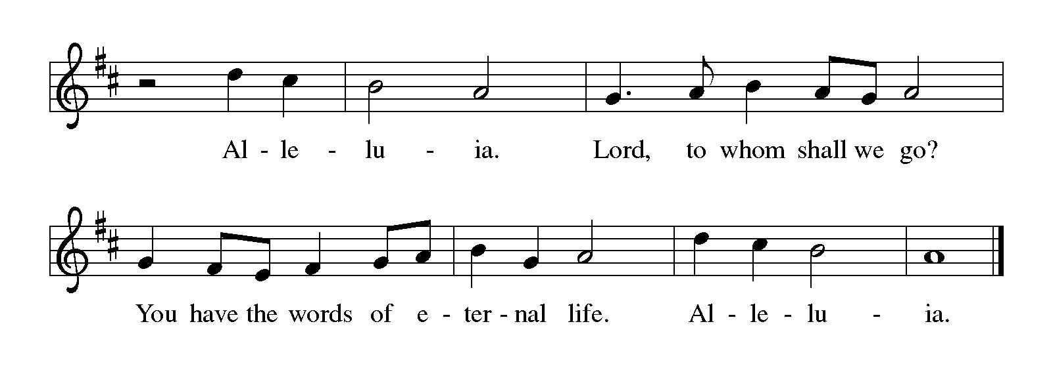

Gospel – Luke 18: 1-8

P: The holy Gospel according to St. Luke.
C: Glory to you, O Lord.

¹ Then Jesus told them a parable about their need to pray always and not to lose heart. ² He said, “In a certain city there was a judge who neither feared God nor had respect for people. ³ In that city there was a widow who kept coming to him and saying, ‘Grant me justice against my accuser.’ ⁴ For a while he refused, but later he said to himself, ‘Though I have no fear of God and no respect for anyone, ⁵ yet because this widow keeps bothering me, I will grant her justice, so that she may not wear me out by continually coming.’ ” ⁶ And the Lord said, “Listen to what the unjust judge says. ⁷ And will not God grant justice to God’s chosen ones who cry to God day and night? Will God delay long in helping them? ⁸ I tell you, God will quickly grant justice to them. And yet, when the Son of Humanity comes, will he find faith on earth?”

P: The Gospel of the Lord.
C: Praise to you, O Christ.

Please be seated.

Sermon

A time of silence for prayer and reflection follows the sermon.
When the hymn of the day begins, please rise as you are able.

Hymn of the Day There Is a Longing in Our Hearts ACS 1078

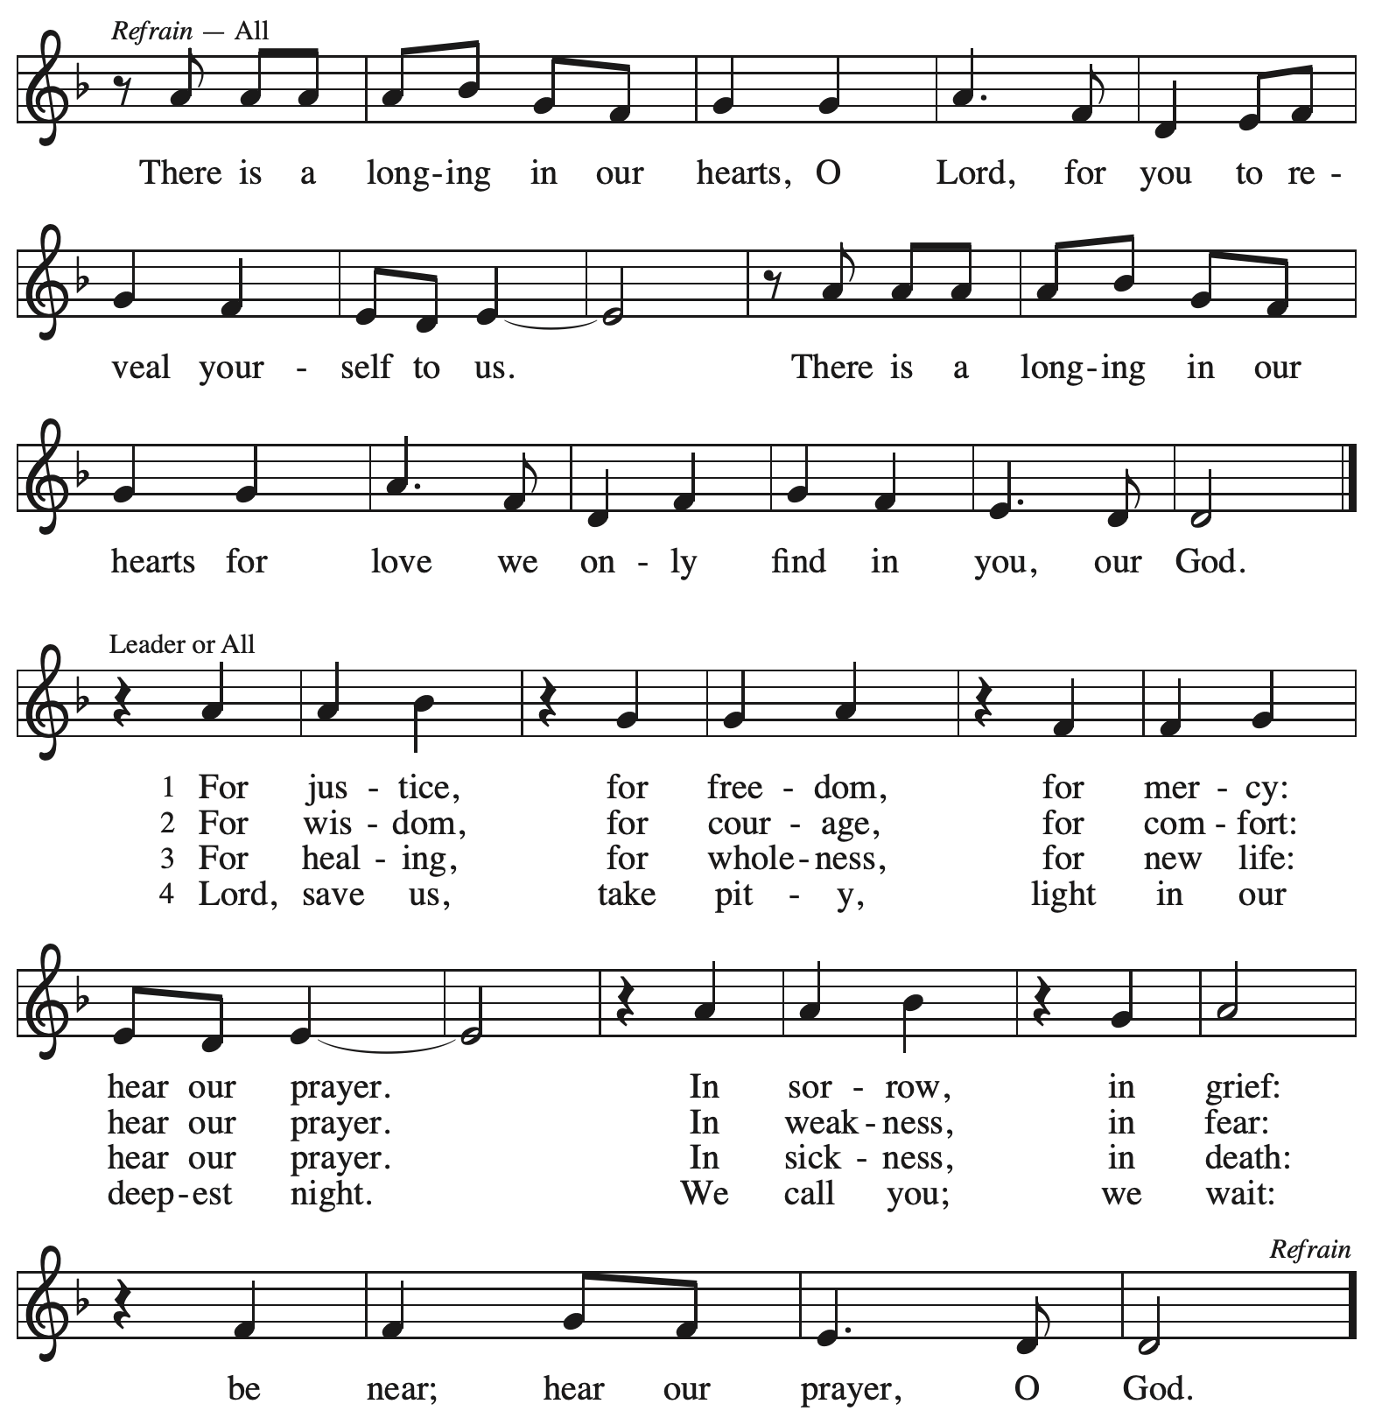
Reprinted with permission under OneLicense.net # A-722139.

Apostles’ Creed

C: I believe in God, the Father almighty,
creator of heaven and earth.
C: I believe in Jesus Christ, God’s only Son, our Lord,
who was conceived by the Holy Spirit,
born of the virgin Mary,
suffered under Pontius Pilate,
was crucified, died, and was buried;
he descended to the dead.*
On the third day he rose again;
he ascended into heaven,
he is seated at the right hand of the Father,
and he will come to judge the living and the dead.

I believe in the Holy Spirit,
the holy catholic church,
the communion of saints,
the forgiveness of sins,
the resurrection of the body,
and the life everlasting. Amen.

*Or, “he descended into hell,” another translation of this text in widespread use.

Prayers of the People

A: Renewed in God’s everlasting grace, let us pray for the church, the world,
and all who are in need.

After each petition
A: God of grace,
C: receive our prayer.

P: We offer our prayers to you, O God, trusting in your abundant mercy,
through Jesus Christ our Lord.
C: Amen.

Peace

The presiding minister and the assembly greet one another in the peace of the risen Christ.
P: The peace of Christ be with you always.
C: And also with you.

The people may greet those around them with a sign of Christ’s peace and may say
Peace be with you or similar words. Please be mindful that not everyone will be comfortable with sharing the peace, so please seek consent before shaking hands or hugging.
Other possible ways to share the peace include a simple bow with the verbal greeting of peace, or simply a verbal expression of peace.
When the greetings of peace have concluded, please be seated.

Meal
God feeds us with the presence of Jesus Christ



Offering

We offer ourselves, our gifts, and our faithful service to God.
As the offering is gathered for the mission of the church, including the care of those in need,
the table is set for Holy Communion.

There are laminated giving cards in the pew racks that feature a QR code for anyone who would like to give online. Those who give using the QR code, as well as those who give regularly online or through their bank are encouraged to place the laminated card in the plate as an expression of your offering.

Noisy Offering

As children of the congregation carry buckets around the sanctuary, people of the congregation are invited to throw in their change as an offering. This month’s Noisy Offering will benefit Humane Animal Rescue of Pittsburgh.

Offertory Music Abide with Me arr. Edstrom

As the gifts are brought forward for presentation, please rise as you are able.

Offertory Song Let the Vineyards Be Fruitful ELW 184

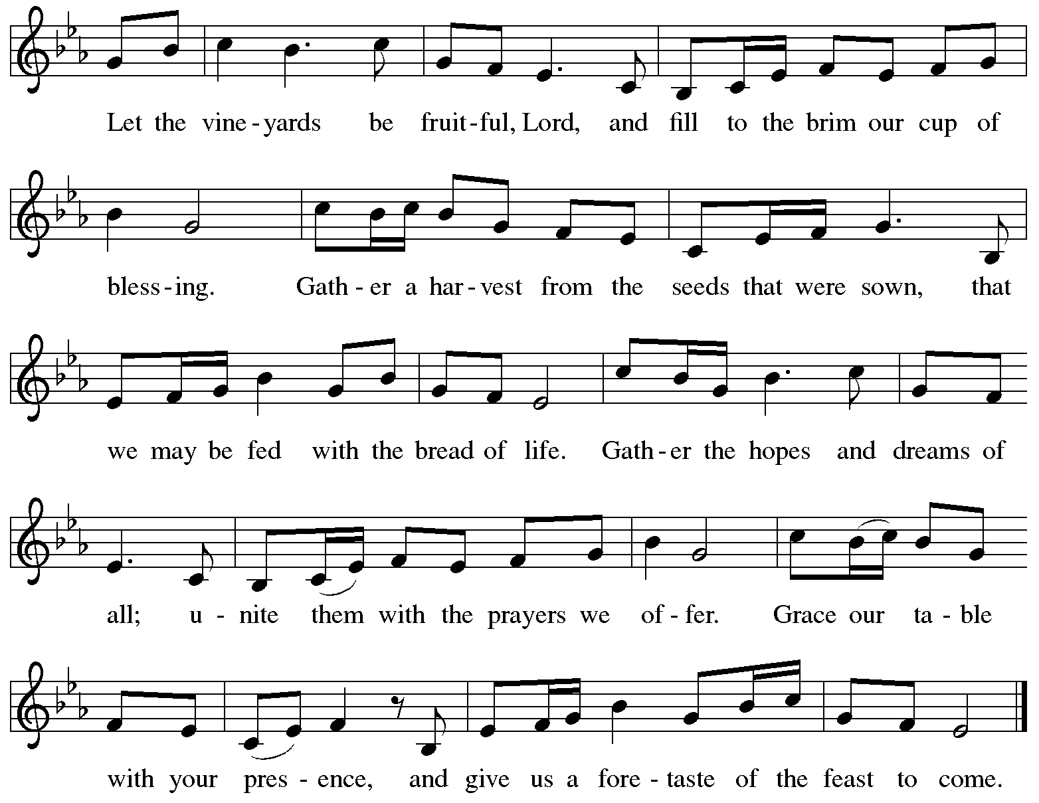
All rights reserved. Reprinted with permission under OneLicense.net # A-722139.

Offertory Prayer

A: Let us pray.
God of mercy and grace,
C: the eyes of all wait upon you,
and you open your hand in blessing.
Fill us with good things at your table,
that we may come to the help of all in need,
through Jesus Christ, our redeemer and Lord.
Amen.

Dialogue ELW p. 152

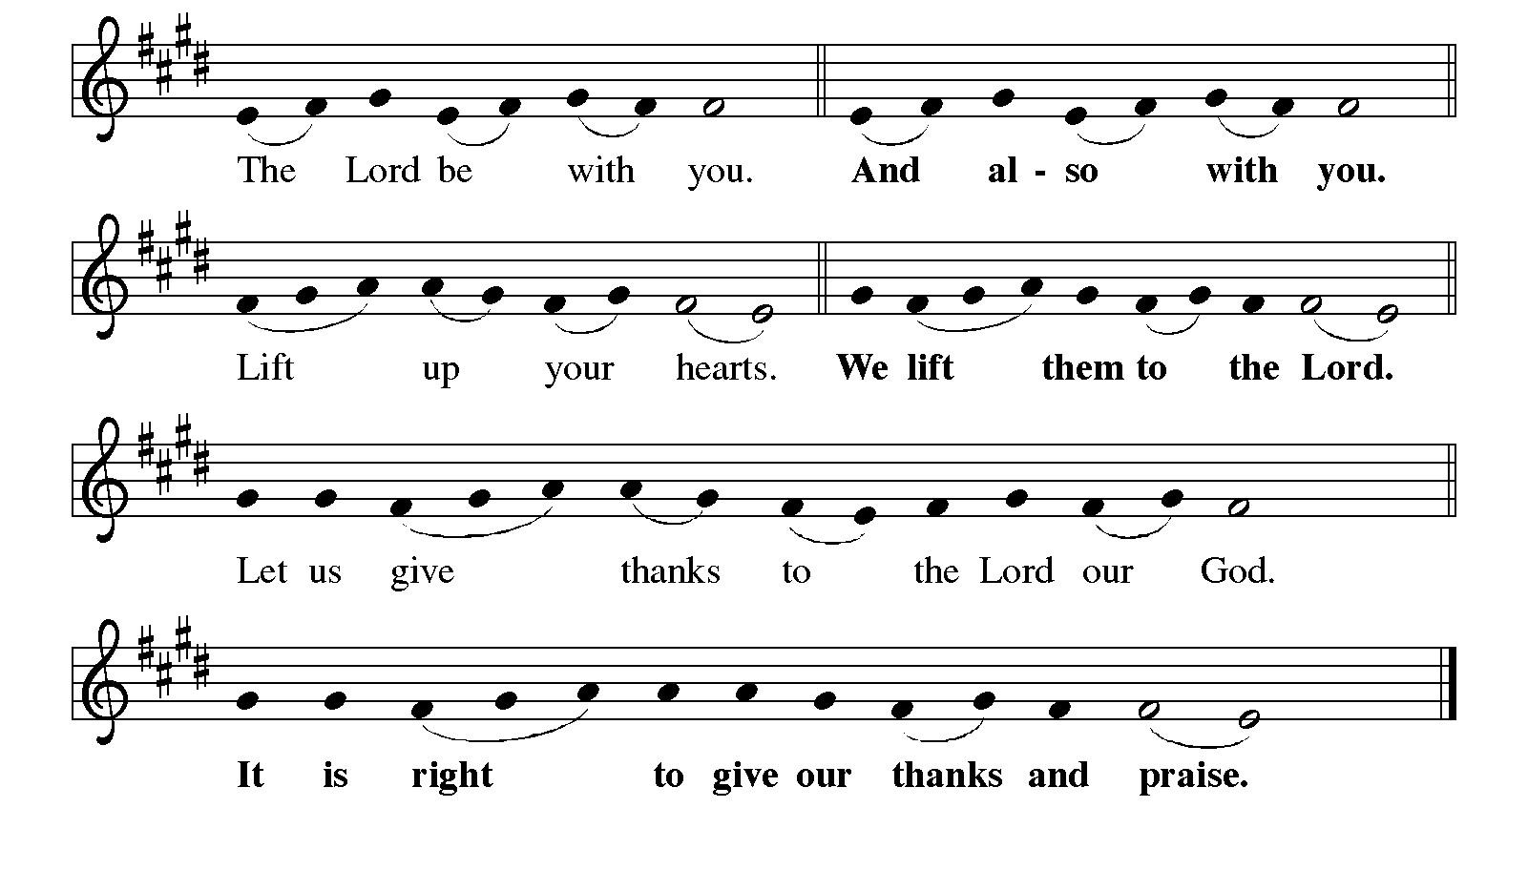

Preface (Sung by the presiding minister)

P: It is indeed right, our duty and our joy,
that we should at all times and in all places
give thanks and praise to you, almighty and merciful God,
through our Savior Jesus Christ;
who on this day overcame death and the grave,
and by his glorious resurrection opened to us the way of everlasting life.
And so, with all the choirs of angels,
with the church on earth and the hosts of heaven,
we praise your name and join their unending hymn:

Sanctus ELW p. 153

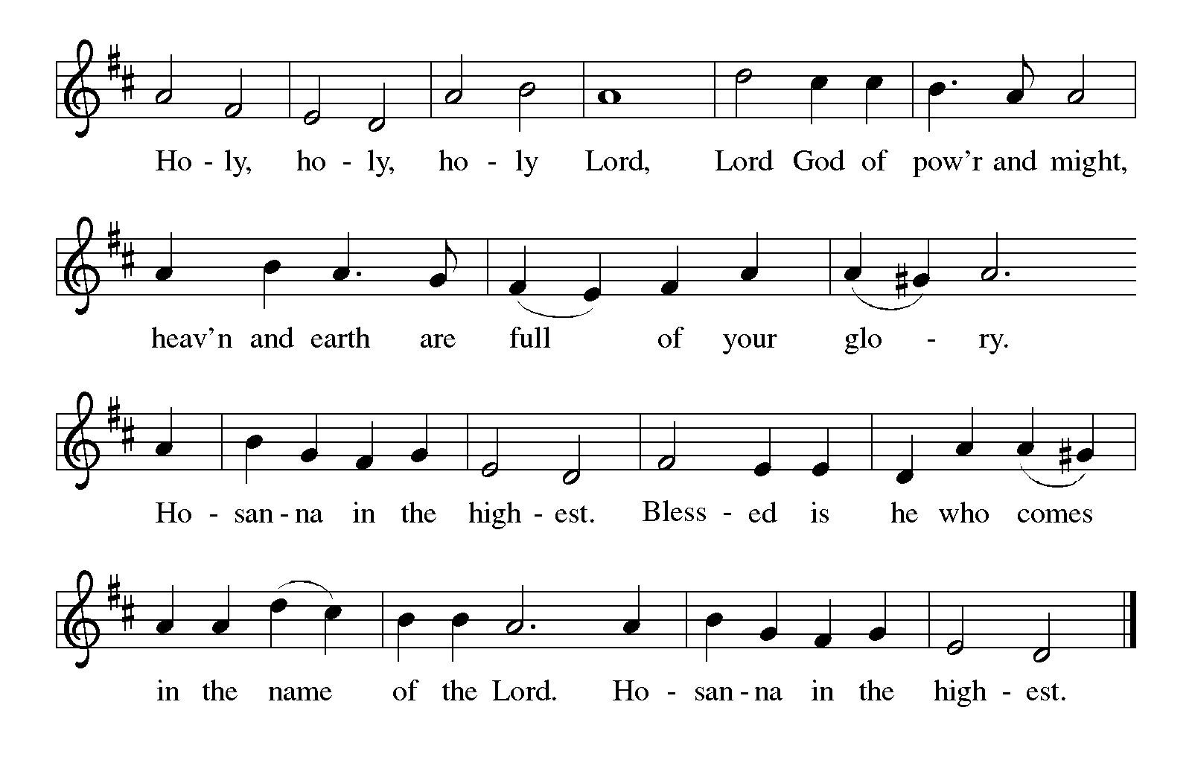
Eucharistic Prayer

P: Holy God, mighty Lord, gracious Father, …
… Do this for the remembrance of me.

For as often as we eat of this bread and drink from this cup,
we proclaim the Lord’s death until he comes.
C: Christ has died. Christ is risen. Christ will come again.

P: Therefore, O God, with this bread and cup …
… to share with us the great and promised feast.
C: Amen. Come, Lord Jesus.

P: Send now, we pray, your Holy Spirit …
… and receive our inheritance with all your saints in light.
C: Amen. Come, Holy Spirit.

P: Join our prayers …
… all glory and honor are yours, almighty Father,
now and forever.
C: Amen.
Lord’s Prayer

P: Gathered as one by the Holy Spirit, let us pray as Jesus taught us.
C: Our Father in heaven,
hallowed be your name,
your kingdom come,
your will be done,
on earth as in heaven.
Give us today our daily bread.
Forgive us our sins
as we forgive those
who sin against us.
Save us from the time of trial
and deliver us from evil.
For the kingdom, the power,
and the glory are yours,
now and forever. Amen.

Fraction and Invitation



Agnus Dei / Lamb of God ELW p. 154

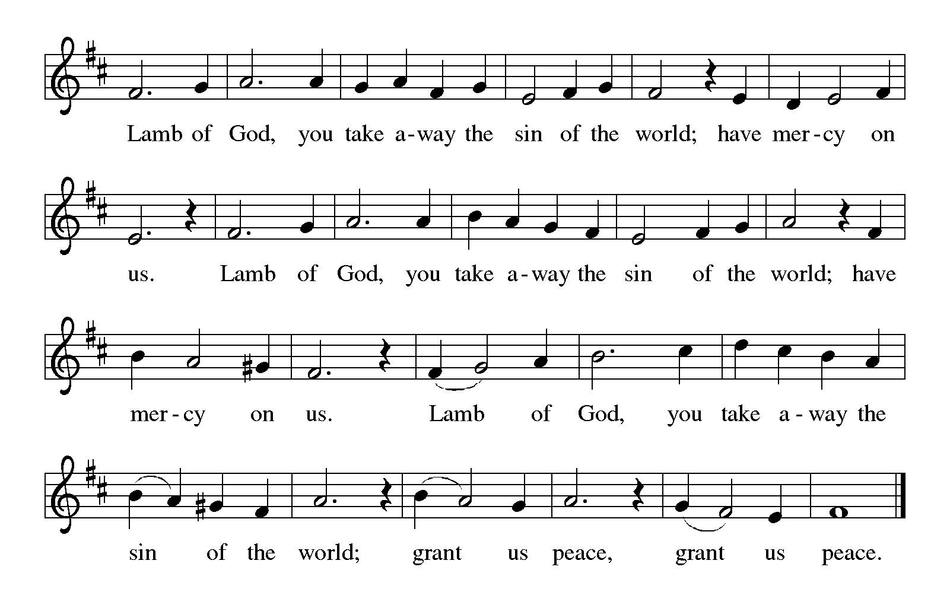
Please be seated.

Holy Communion

- All who seek God and desire a deeper and stronger life in Christ are welcome to receive Holy Communion.
- Worshipers from the pulpit side will proceed forward first, followed by the center section, and then the lectern side.
- Please inform an usher if you would like the ministers to bring Communion to you.
- Holy Communion will be served with bread and wine (amber) or grape juice (purple).
- The presiding minister will first distribute the bread (host) to each communicant. Please indicate if you require a gluten-free host.
- Once you have consumed the bread, please pick up an empty glass from the tray next to the presiding minister. The Communion Assistant will pour wine or grape juice into your glass.
- Please step to the side to consume the wine or grape juice.
- Feel free to kneel at the altar rail for prayer after receiving the sacrament.
- As you return to your pew, glasses may be returned to the empty tray on the side of the center section.
- A blessing will be provided for anyone who does not yet receive the sacrament.
- All are invited to join in singing the hymns during Holy Communion.

Hymns during Holy Communion
Un pueblo que camina – The People Walk ELW 706

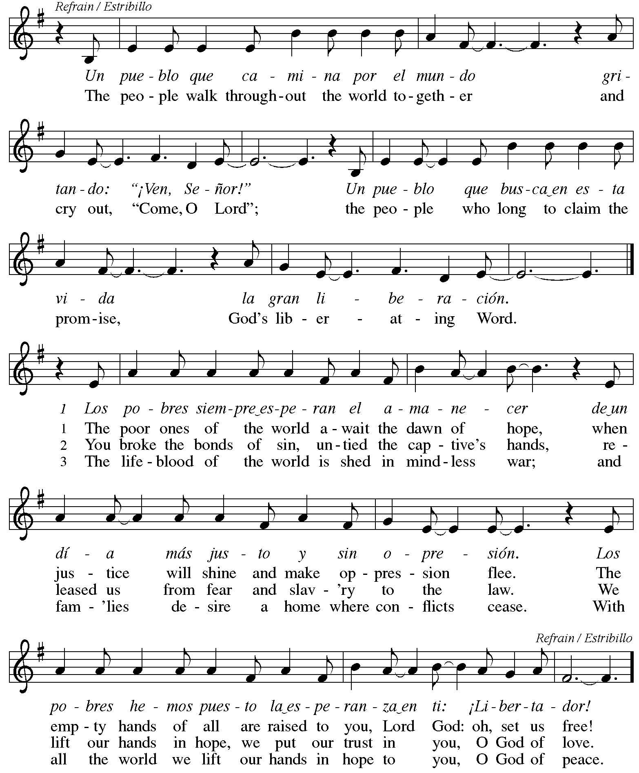

Hymns during Holy Communion
Give Me a Clean Heart TFF 216

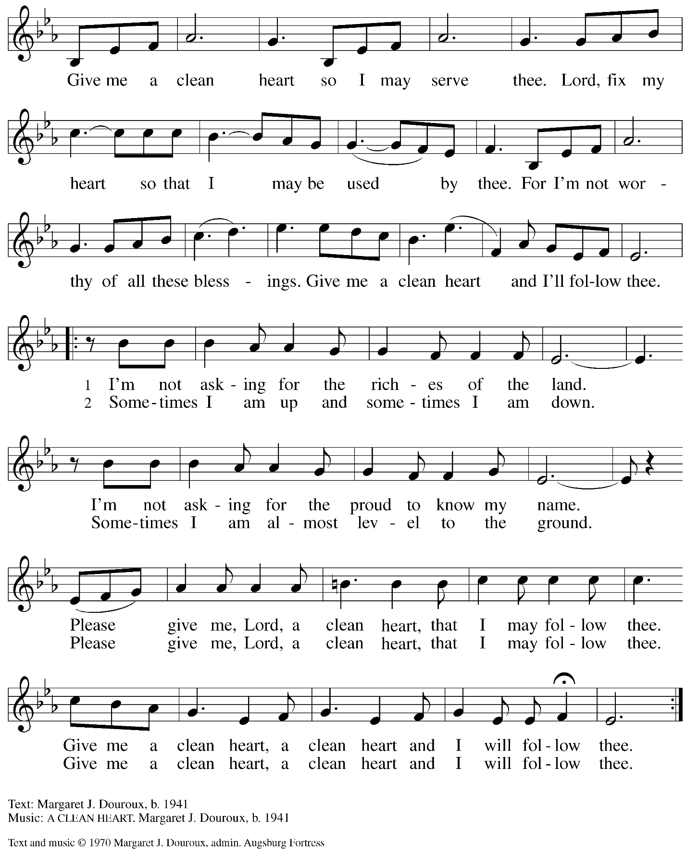
All rights reserved. Reprinted with permission under OneLicense.net # A-722139.
Hymns during Holy Communion
Listen to the Word That God Has Spoken ACS 974

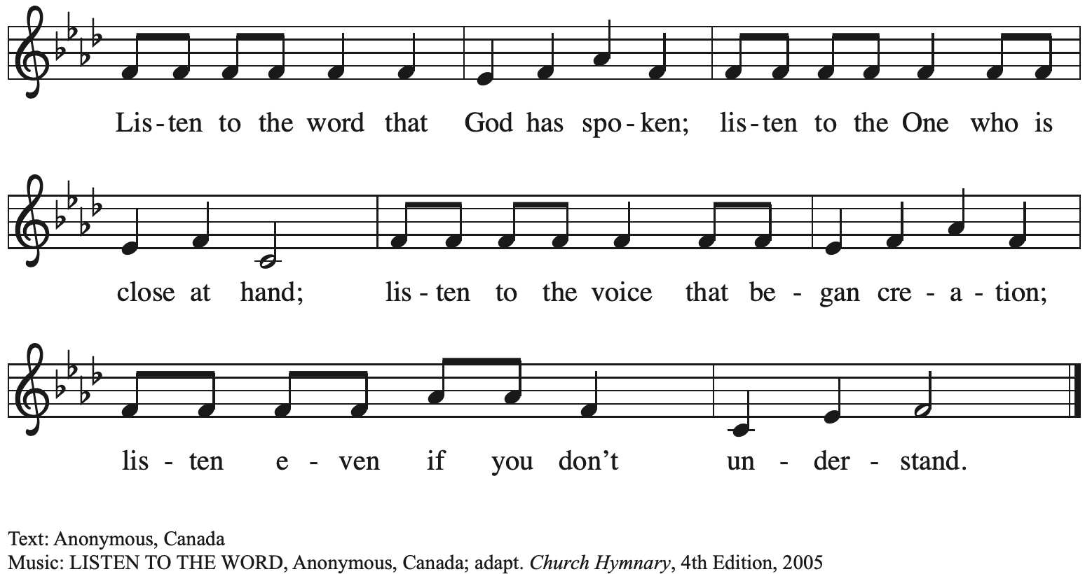

Hymns during Holy Communion
Give Me Jesus ELW 770

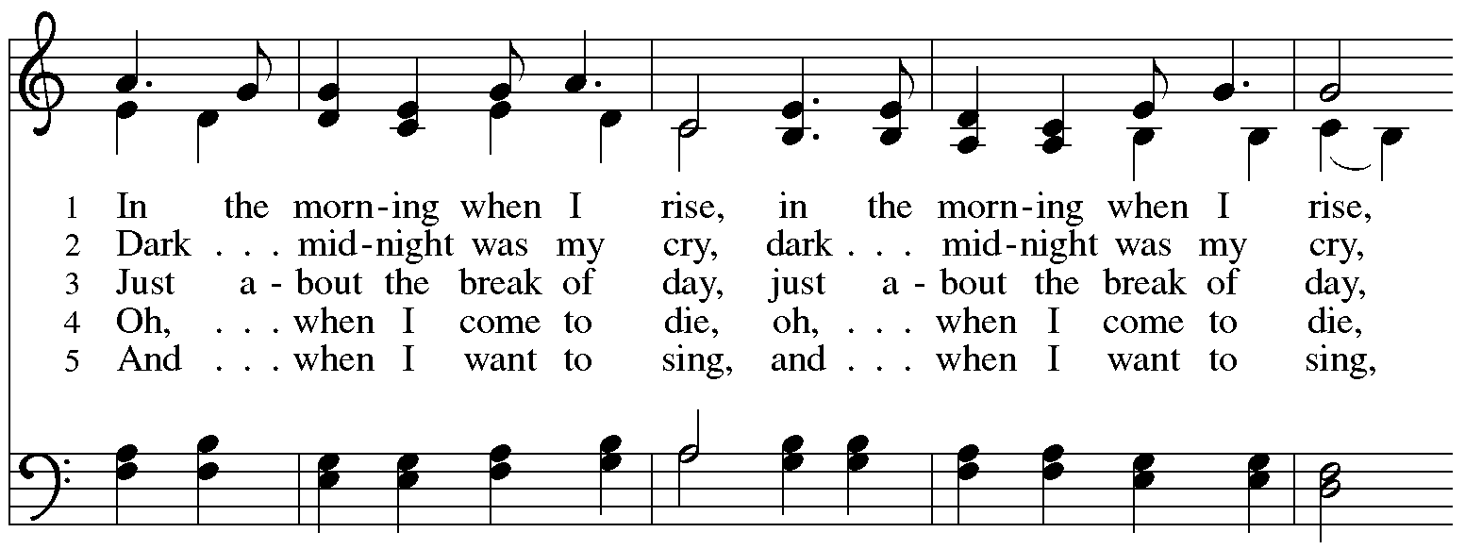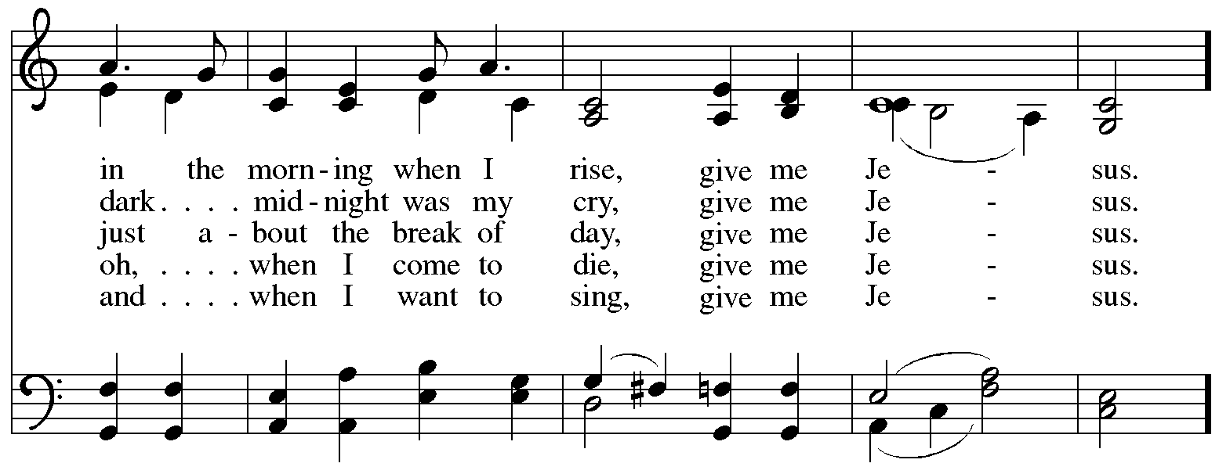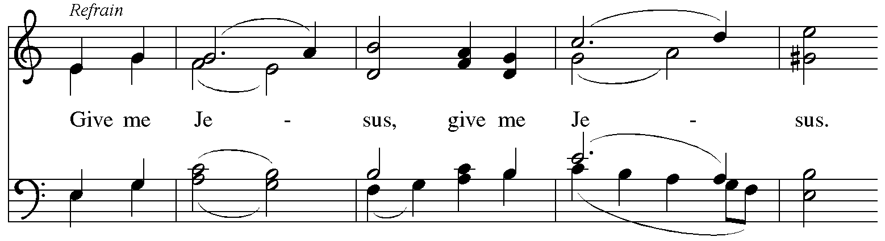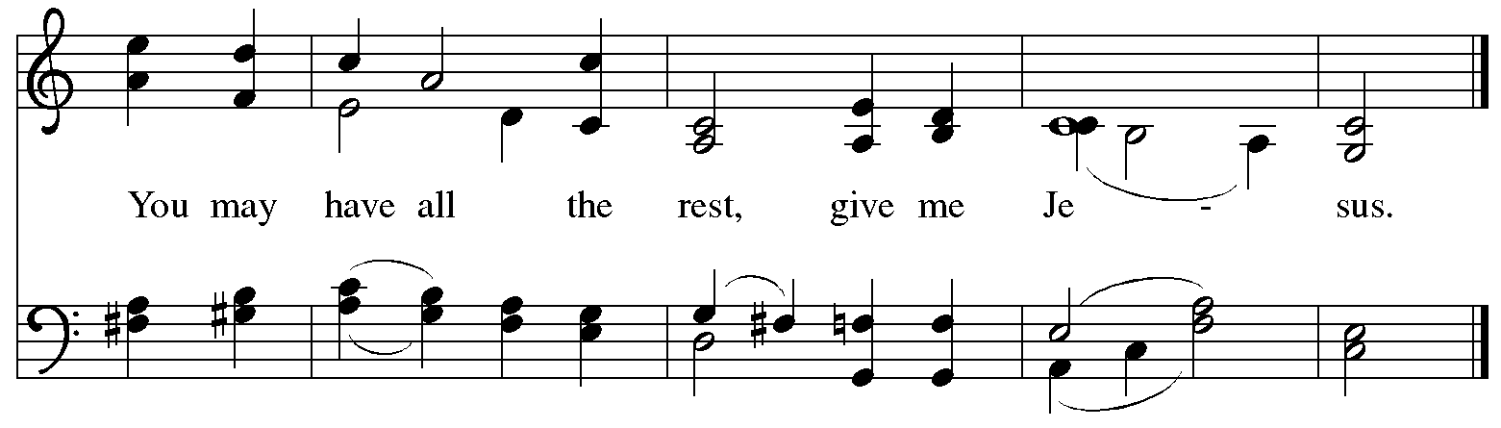

When all have returned to their places, please rise as you are able.

Blessing

P: The body and blood of our Lord Jesus Christ strengthen you and keep you in his grace.
C: Amen.

Prayer

A: Let us pray.
O God our life, our strength, our food,
we give you thanks for sustaining us with the body and blood of your Son.
By your Holy Spirit, enliven us to be the Body of Christ in the world,
that more and more we will give you praise and serve your earth and its many peoples,
through Jesus Christ, our Savior and Lord.
C: Amen.

Please be seated.

Sending
God blesses us and sends us in mission to the world

Announcements

Please rise as you are able.

Benediction

P: The love of God the Sovereign strengthen you,
God the Son save you,
and God the Holy Spirit anoint and sustain you.

The Holy Trinity ☩ bless you
and grant you a faithful and courageous heart,
now and forever.
C: Amen.

Sending Hymn Following page

Sending Hymn Canticle of the Turning ELW 723

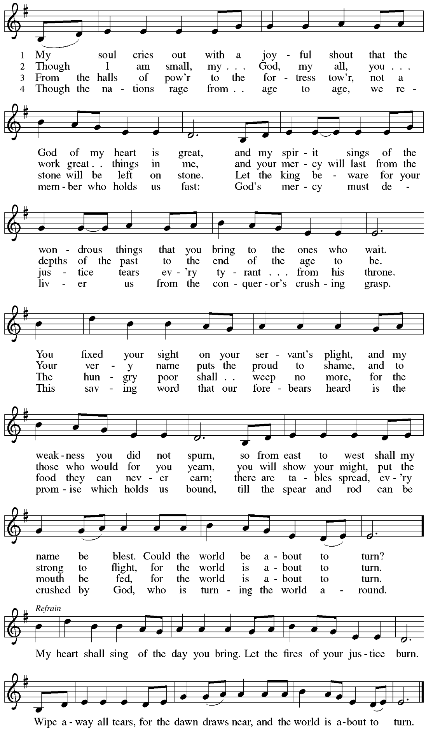
Dismissal

A: Go in peace. Serve the Lord.
C: Thanks be to God!

Postlude

Serving in Worship Today

Altar Care Christy Ruhe
Assisting Minister Colleen Cooke
Audio-Visual Ministers Kristen Asplin
Tyler Rietze
Cantor Miriam Bohlmann Kunz
Flute Zie Weaver
Lector Michael Chapman
Minister of Music Laura Reynolds
Presiding Minister The Rev. Ross Carmichael

Liturgy and Hymnody Acknowledgements

From SundaysandSeasons.com. Copyright © 2025 Augsburg Fortress. All rights reserved. Reprinted under OneLicense.net # A-722139.
Used by permission of Augsburg Fortress.

The Scripture readings contained herein are from New Revised Standard Version Updated Edition of the Bible © 2021 National Council of Churches of Christ in the United States of America. Used by permission. All rights reserved worldwide.

Un pueblo que camina – The People Walk – Text: Juan A. Espinosa. 1940; tr. Martin A. Seltz, b. 1951. Music: UN PUEBLO QUE CAMINA, Juan A. Espinosa. Text and music © 1972, 1998 Juan A. Espinosa. Published by OCP Publications, 5536 NE Hassalo, Portland, OR 97213. All rights reserved. Reprinted with permission under OneLicense.net # A-722139.

Give Me Jesus – Text: African American spiritual. Music: GIVE ME JESUS, African American spiritual; arr. hymnal version. Arr. © 2006 Augsburg Fortress. All rights reserved. Reprinted with permission under OneLicense.net # A-722139.

Canticle of the Turning – Text: Rory Cooney, b. 1952, based on the Magnificat. Music: STAR OF COUNTY DOWN, Irish traditional. Text © 1990 GIA Publications, Inc., 7404 S. Mason Ave., Chicago, IL 60638. www.giamusic.com. 800.442.3358. All rights reserved. Reprinted with permission under OneLicense.net # A-722139.

Please use the QR code below to link to St. Andrew’s Announcements online!



St. Andrew Lutheran Church Announcements
October 19th, 2025

- Welcome to Worship at St. Andrew on the Nineteenth Sunday after Pentecost – We are so glad you are here, and we offer a special welcome to all guests who are here for the first time! A nursery is available through the door to the left of the worship space and across the social hall (look for a purple room). Little Church – Big Faith, a Bible lesson and activity for children up to sixth grade, will take place after the prayer of the day. There are also worship “toolkits” to help children engage with worship and “busy bags” for younger children available in the bookcase at the back of the sanctuary. Please feel free to take one to use with/for your children. All are invited to stay for coffee and other drinks, food, and conversation in the Social Hall (through the side door at the left of the worship space) after the service.
- Noisy Offering Today During Worship – On the third Sunday of each month, St. Andrew’s children lead the congregation in a Noisy Offering, in which people are invited to throw their change into buckets that the children carry around the church and bring forward as an additional offering. Each month’s Noisy Offering supports a local, national, or international church-related or otherwise charitable organization. This month’s Noisy Offering will support Humane Animal Rescue of Pittsburgh. For more information on the organization, please visit Humane Animal Rescue - Care They Need. Love They Deserve.
- Reckoning with Antisemitism as Christians, Tuesday, October 21st from 7:00 p.m. - 8:30 p.m. – At this program, we will get inspired by stories of Reckoning from across western PA, and then provide guided planning time for you to decide how you will take part in the Reckoning with Antisemitism as Christians project this year. Like all things, this work is best done together. Join us for an evening with Christian clergy and lay leaders from across our region. We will learn from those who are engaging in this important work: exploring Christian scriptures, studying the impact of antisemitism, partnering with neighboring houses of worship, or befriending Jewish colleagues. We will then participate in an interactive planning session, working together to consider how each one of us can reckon with antisemitism and build relationships with Jewish neighbors this year. You can pre-register for the event here: https://www.casp.org/reckoning#oct21.
- St. Andrew Lunch at Hofbrauhaus on Reformation Sunday, Sunday, October 26th, 12:15 p.m. – Kelly Spanninger is organizing a renewal of St. Andrew lunch outings after Sunday worship. On Reformation Sunday, October 26th, all are invited to gather at Hofbrauhaus at South Side Works, 2705 S. Water St., 15203 at 12:15 p.m. Please let Kelly know if you plan to attend, or contact her at pkspanninger@verizon.net.
- Produce Distribution Supplemental Food of the Month – St. Andrew has begun collecting supplemental food each month to accompany our produce distribution. For the upcoming month, we ask for donations of rice and dried beans. There are collection boxes at the back of the worship space and social hall
- All Saints Sunday, November 2nd – Invitation to Bring Photos – The Christian church observes All Saints Day on November 1st, and because that date does not fall on a Sunday this year, St. Andrew will observe All Saints Sunday on November 2nd. On All Saints Sunday, we give thanks for the grace of God that allows all of us to be saints through the righteousness Jesus shares with us. St. Andrew also joins the church throughout the world in giving thanks to God for the saints who have gone before us in faith, all whose lives have been for us a testimony to God’s love and grace. On All Saints Sunday, we remember people of the congregation and those we have prayed for who have died since last All Saints Day. We invite the congregation to bring photographs of loved ones you would like to remember that day, to be placed near the baptismal font as we give thanks for the communion of all the saints who are one with us in the Body of Christ. We will also offer a place in the service when everyone can light candles in remembrance of the saints.
- East End Interfaith Thanksgiving Service, Tuesday, November 25th, 7:00 p.m. – This year's East End Interfaith Thanksgiving Service, with the theme Lift Every Voice, will be held at Episcopal Church of the Redeemer at 5700 Forbes Ave., Pittsburgh, PA 15217 and will be co-hosted by leaders of the Hindu-Jain Temple in Monroeville. Following the service, all are welcome to a light reception in the Parish Hall. As part of our Thanksgiving offering, we invite all attendees to bring a non-perishable food item or toiletry as an offering to support our immigrant neighbors through JFCS.
- Discipleship that Heals the World, Studies in Matthew’s Gospel – Thursdays, 8:00 - 9:00 p.m. on Zoom, Sept. 25th – Dec. 11th, 2025 – Join us for an 11-week journey through the Gospel of Matthew, organized and facilitated by Rev. Dr. Martin Rafanan. Together we will explore Jesus’ Sermon on the Mount and his healing ministry, discovering Matthew’s distinctive vision of discipleship as a way of blessing, healing, and hope. This study is designed for both newcomers to the Gospel and those already familiar with it. We will engage contemporary perspectives that help us hear Matthew’s message afresh in today’s world. Register for the sessions to receive zoom info: https://forms.gle/amy439vfUpwdJpKx7.
- Christ in our Home Devotional Booklets for October-December – Available at church entrances, this resource offers a daily Bible reading with a short reflection and prayer, along with additional readings and prayer topics for those who would like to expand their devotional practices. We encourage people of the congregation to take one for yourself, your family/household, or others.
- Invitation to Prayer Team – St. Andrew maintains a list of weekly prayer concerns sent by email to members of the congregation who have opted in. Our prayer team’s email is prayerteam@standrewpittsburgh.org. We will keep names on the list for a maximum of four weeks unless otherwise requested. Thank you for your ministry of prayer!
- Records Update – St. Andrew is seeking to update our records with information from attendees so that we can acknowledge celebrations and milestones, and for prayers of the church. Please fill out the form at: https://forms.gle/kKvp19UozuRrhhaV7.
- Coffee Hour Signups – St. Andrew provides hospitality during a coffee hour after worship each Sunday. If you would like to participate and would like information about the duties of setting up, please sign up using the following form: https://www.signupgenius.com/go/5080B4AAFAF2CABF85-47069030-coffee#/.

