

+ Reformation Sunday
October 26, 2025



St. Andrew Lutheran Church
304 Morewood Ave.
Pittsburgh, PA 15213
St_andrewELCA@verizon.net
www.standrewpittsburgh.org

+ Reformation Sunday
Order for Worship

Rooted in the past and growing into the future, the church must always be reforming in order to live out the love of Christ in an ever-changing world. We celebrate the good news of God’s grace, that Jesus Christ sets us free every day to do this life-transforming work. Trusting that God has freed us in Baptism, we pray for the Church, that Christians may unite more fully in worship and mission.

Welcome to St. Andrew!
- St. Andrew welcomes all who are seeking a place of healing, wholeness, and acceptance in a nurturing and faith-forming spiritual home. We are striving toward racial equity worldwide
and we seek to honor the lived experience of all individuals regardless of background. Our community embraces people of all ages, ethnicities, cultures, abilities, sexual orientations,
gender identities and expressions, and family constellations. Come and See!
- Worship Services are live-streamed to multiple online platforms. By attending worship, you agree that your image and voice may be broadcast.
- Everyone is invited to make a name tag at the black bookcase in the back of the worship space if they would like. There are stickers indicating pronouns on the bookcase if you would like to include them on your name tag.
- A nursery is available through the doors at the left side of the sanctuary and across from the doorway to the Social Hall. Look for a purple-colored room.
- Children are invited to attend Little Church – Big Faith, a Bible lesson and activity, during worship (after the Prayer of the Day). The group returns to the worship space for the liturgy of Holy Communion.
- Worship “toolkits” to help children engage with the service, along with “busy bags” for younger children, are available in the bookcase at the back of the sanctuary. Please feel free to take one to use with/for your children.
- Holy Communion is served with bread (gluten-free available) and wine or grape juice. The presiding minister will distribute the bread (host). Please consume this and then pick up an empty glass from the tray. The Communion Assistant will pour wine or grape juice into your glass. Please step to the side to consume the wine or grape juice. Feel free to kneel at the altar for prayer and reflection. As you return to your pew, glasses may be returned to the empty trays on either side of the center section.
- A restroom is available on the main level of the church, through the doors to the Social Hall and to the right in the main office.

Abbreviations
P: Pastor/Presiding Minister ELW: Evangelical Lutheran Worship hymnal
A: Assisting Minister ACS: All Creation Sings hymnal
L: Lector TFF: This Far by Faith hymnal
C: Congregation

Musical Offering

Each week, different people from the congregation make an offering of pre-service music, with singing or instrumentation, to help the assembly focus and pray in preparation for worship.

Welcome

Prelude Lord, Keep Us Steadfast in Your Word Luther/arr. Unke

Gathering
The Holy Spirit calls us together as the people of God

Please rise as you are able. All may make the sign of the cross,
the sign that is marked at Baptism, as the presiding minister begins.

Confession and Forgiveness

P: Blessed be the Holy Trinity, one ☩ God,
our maker, our helper, and our keeper.
C: Amen.

P: Trusting in God’s mercy, let us confess our sins in the presence of God and one another.

Silence is kept for reflection.

P: Faithful God,
C: you have shown us the ways of your heart, yet we stray from your paths.
We are stuck in sinful systems of oppression
and do not embrace the freedom your faithful promises offer us.
We ignore our neighbors. We exploit the earth. We reject your abundance,
trusting our impulses instead of your steadfast love.
Repair our relationships, restore what we have broken, renew our hearts,
and bring us to new life.
Amen.

P: Hear the good news:
God the Faithful One loves you,
in ☩ Christ Jesus, your sins are forgiven.
and by the power of the Holy Spirit you are set free.
C: Amen.

Gathering Hymn A Mighty Fortress Is Our God ELW 505

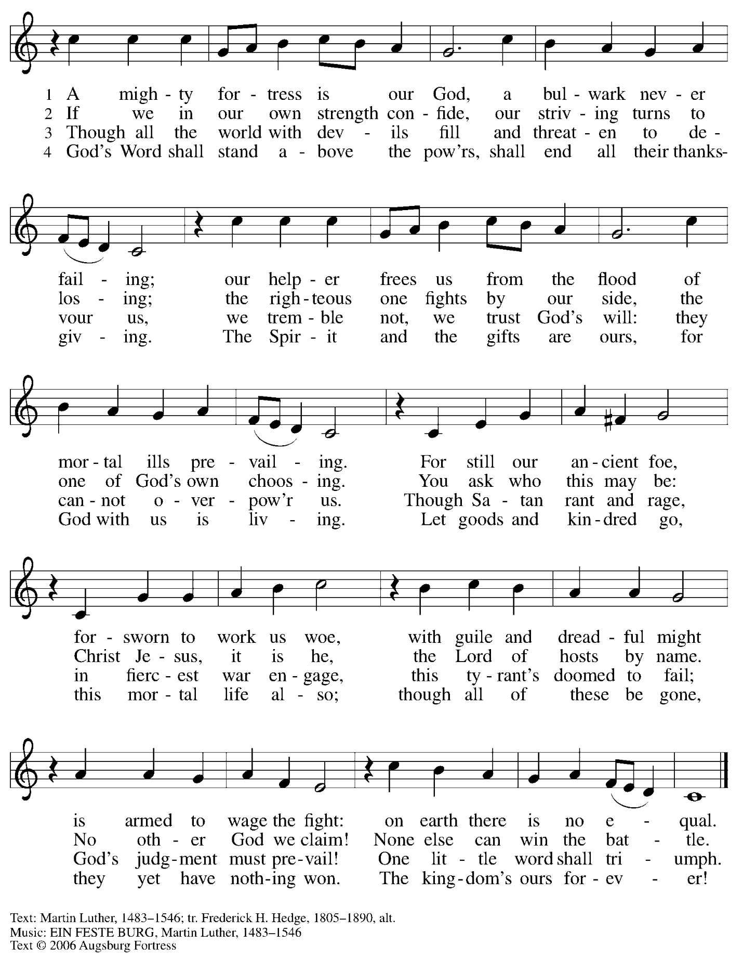
All rights reserved. Reprinted under OneLicense.net # A-722139.
Greeting

P: The grace of our Lord Jesus Christ, the love of God,
and the communion of the Holy Spirit be with you all.
C: And also with you.

Kyrie
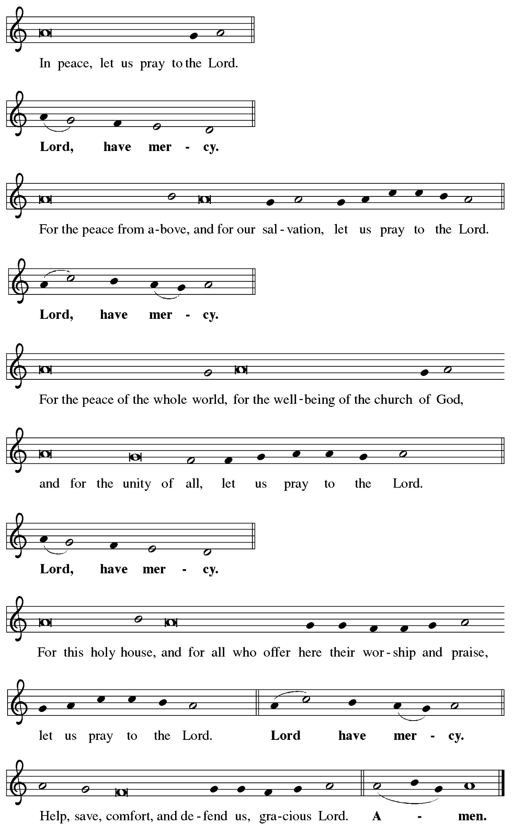
Hymn of Praise ELW p. 148

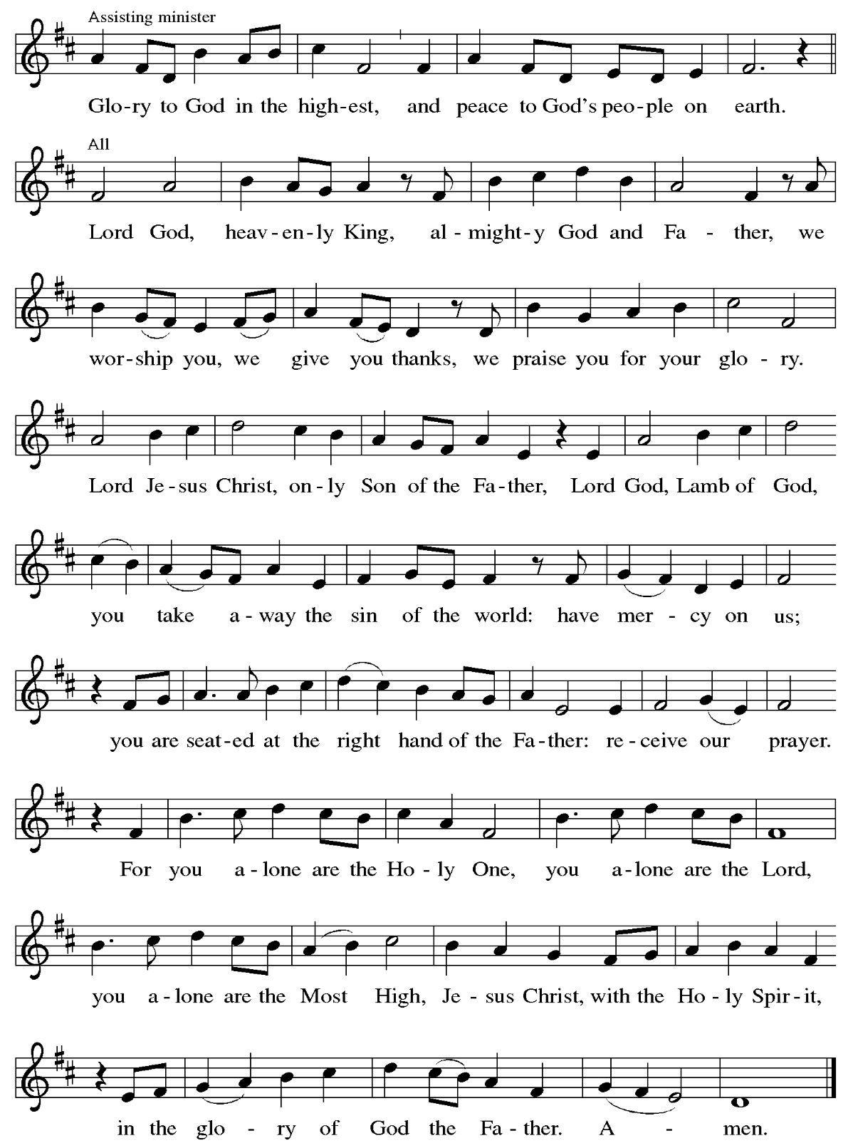

Prayer of the Day

P: The Lord be with you.
C: And also with you.

P: Let us pray.
Almighty God, gracious Lord,
we thank you that your Holy Spirit renews the church in every age.
Pour out your Holy Spirit on your faithful people. Keep them steadfast in your word,
protect and comfort them in times of trial, defend them against all enemies of the gospel,
and bestow on the church your saving peace, through Jesus Christ, our Savior and Lord,
who lives and reigns with you and the Holy Spirit, one God, now and forever.
C: Amen.

Please be seated.
Children are invited to join the adult leader(s) at the side door for Little Church – Big Faith.
We ask that an additional adult from the congregation attend with the children.

Word
God speaks to us in Scripture reading, preaching, and song

First Reading – Jeremiah 31: 31-34

³¹ The days are surely coming, says the Lord, when I will make a new covenant with the house of Israel and the house of Judah. ³² It will not be like the covenant that I made with their ancestors when I took them by the hand to bring them out of the land of Egypt—a covenant that they broke, though I was their husband, says the Lord. ³³ But this is the covenant that I will make with the house of Israel after those days, says the Lord: I will put my law within them, and I will write it on their hearts, and I will be their God, and they shall be my people. ³⁴ No longer shall they teach one another or say to each other, “Know the Lord,” for they shall all know me, from the least of them to the greatest, says the Lord, for I will forgive their iniquity and remember their sin no more.

L: Word of God, word of life.
C: Thanks be to God.

Psalm 46

The psalm will be sung responsively, led by the cantor, with the congregation singing the verses in bold type and joining in the refrain.

Psalm Tone
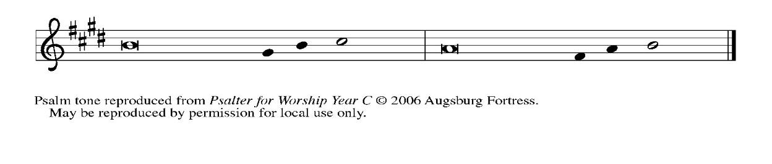
Psalm Refrain

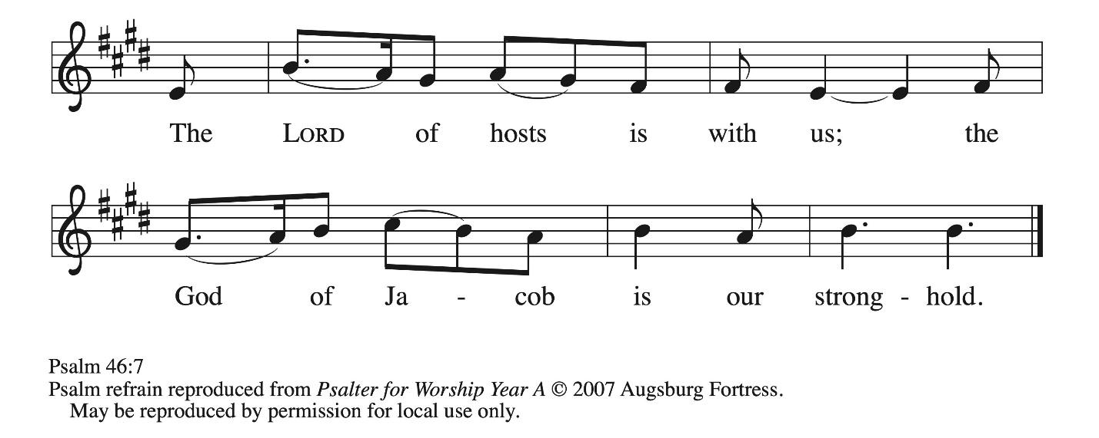

¹ God is our ref- | uge and strength,
a very present | help in trouble.
² Therefore we will not fear, though the | earth be moved,
and though the mountains shake in the depths | of the sea;
³ though its waters | rage and foam,
and though the mountains tremble | with its tumult.
⁴ There is a river whose streams make glad the cit- | y of God,
the holy habitation of | the Most High.
⁵ God is in the midst of the city; it shall | not be shaken;
God shall help it at the | break of day.
⁶ The nations rage, and the | kingdoms shake;
God speaks, and the earth | melts away. R
⁷ The Lord of | hosts is with us;
the God of Jacob | is our stronghold.
⁸ Come now, regard the works | of the Lord,
what desolations God has brought up- | on the earth;
⁹ behold the one who makes war to cease in | all the world;
who breaks the bow, and shatters the spear, and burns the | shields with fire.
¹⁰ “Be still, then, and know that | I am God;
I will be exalted among the nations; I will be exalted | in the earth.”
¹¹ The Lord of | hosts is with us;
the God of Jacob | is our stronghold. R

Second Reading – Romans 3: 19-28

¹⁹ Now we know that, whatever the law says, it speaks to those who are under the law, so that every mouth may be silenced and the whole world may be held accountable to God. ²⁰ For no human will be justified before God by deeds prescribed by the law, for through the law comes the knowledge of sin.
²¹ But now, apart from the law, the righteousness of God has been disclosed and is attested by the Law and the Prophets, ²² the righteousness of God through the faith of Jesus Christ for all who believe. For there is no distinction, ²³ since all have sinned and fall short of the glory of God; ²⁴ they are now justified by God’s grace as a gift, through the redemption that is in Christ Jesus, ²⁵ whom God put forward as a sacrifice of atonement by his blood, effective through faith. God did this to demonstrate God’s righteousness, because in God’s divine forbearance God had passed over the sins previously committed; ²⁶ it was to demonstrate at the present time God’s own righteousness, so that God is righteous and God justifies the one who has the faith of Jesus.
²⁷ Then what becomes of boasting? It is excluded. Through what kind of law? That of works? No, rather through the law of faith. ²⁸ For we hold that a person is justified by faith apart from works prescribed by the law.

L: Word of God, word of life.
C: Thanks be to God.

Please rise as you are able.

Gospel Acclamation ELW 517

Lord, Keep Us Steadfast in Your Word
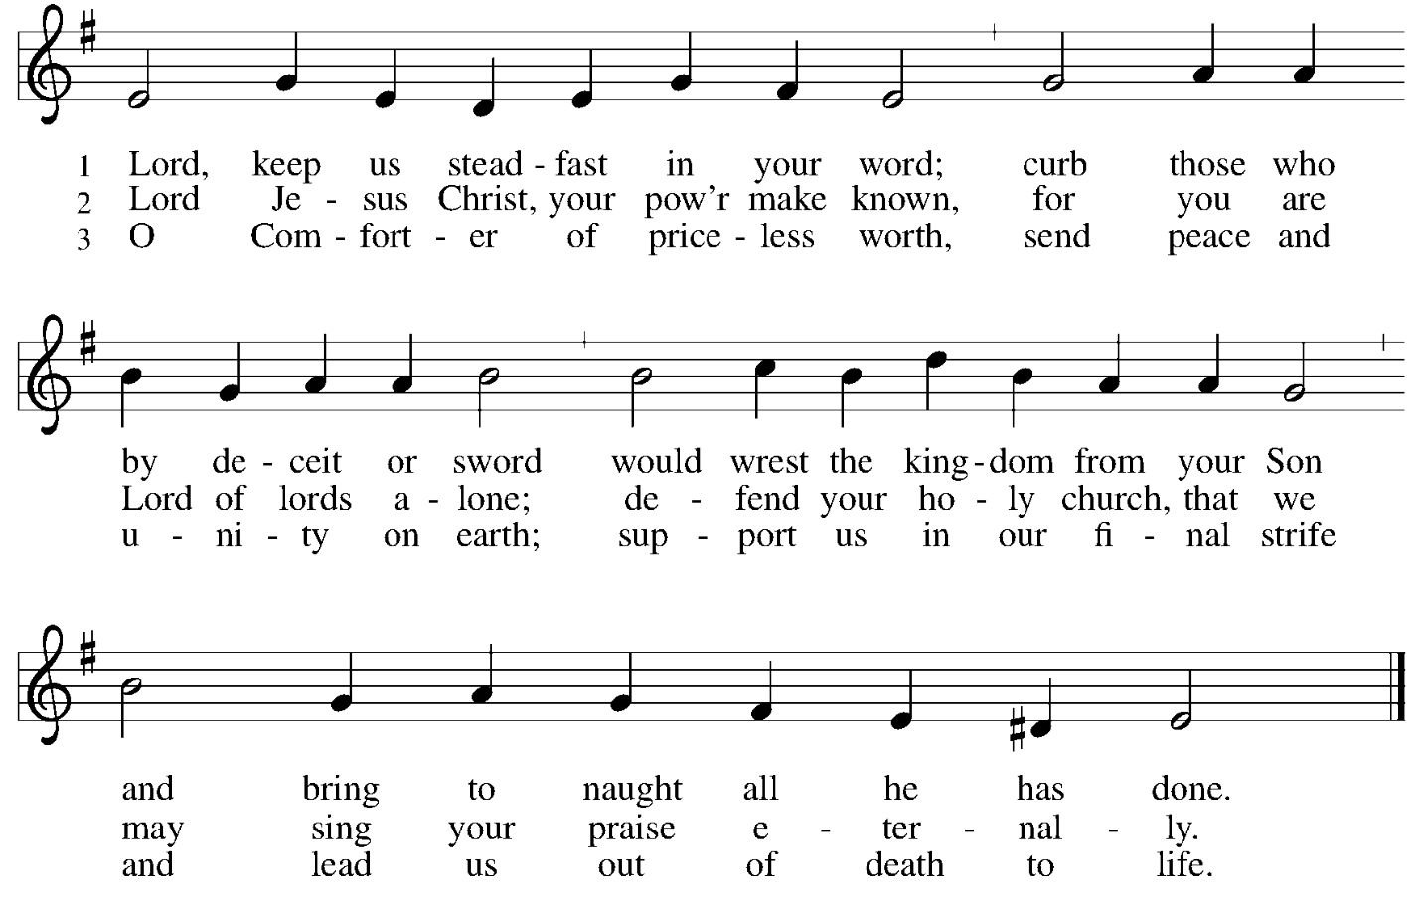

Gospel – John 8: 31-36

P: The holy Gospel according to St. John.
C: Glory to you, O Lord.

³¹ Jesus said to the Jews who had believed in him, “If you continue in my word, you are truly my disciples, ³² and you will know the truth, and the truth will make you free.” ³³ They answered him, “We are descendants of Abraham and have never been slaves to anyone. What do you mean by saying, ‘You will be made free’?”
³⁴ Jesus answered them, “Very truly, I tell you, everyone who commits sin is a slave to sin.
³⁵ The slave does not have a permanent place in the household; the son has a place there forever.
³⁶ So if the Son makes you free, you will be free indeed.”

P: The Gospel of the Lord.
C: Praise to you, O Christ.

Please be seated.

Sermon

A time of silence for prayer and reflection follows the sermon.
When the hymn of the day begins, please rise as you are able.

Hymn of the Day You Are the Way ELW 758

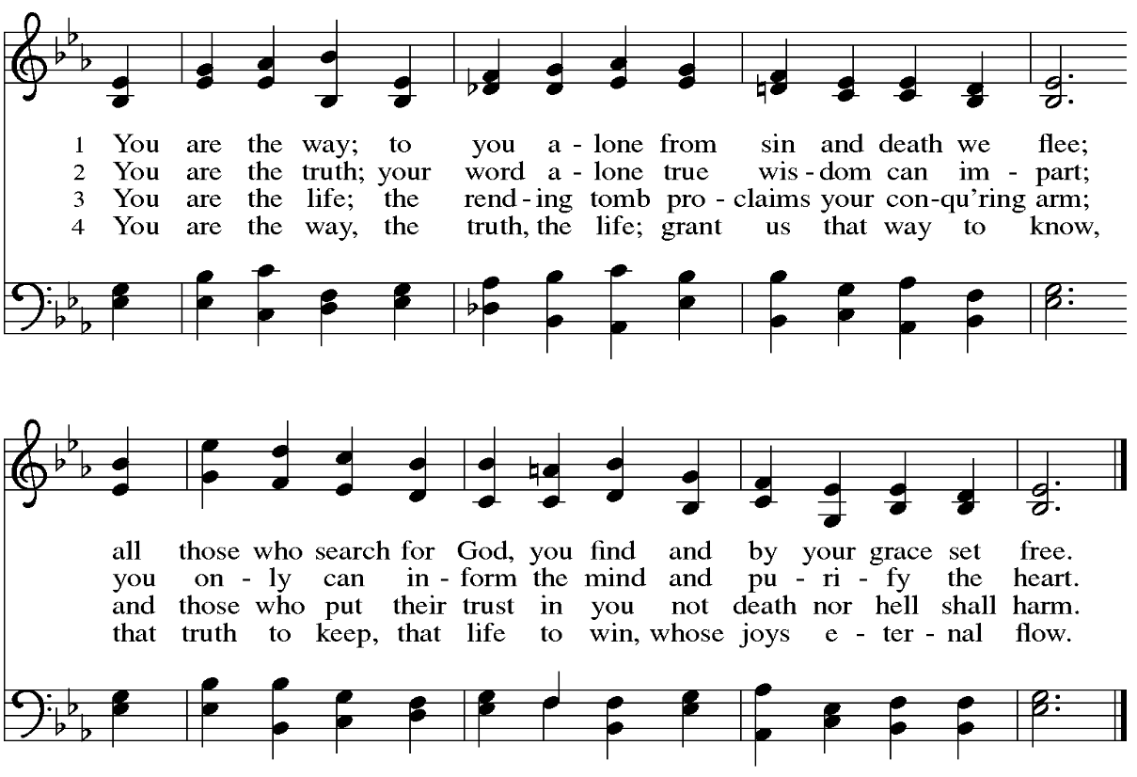


Apostles’ Creed

C: I believe in God, the Father almighty,
creator of heaven and earth.

I believe in Jesus Christ, God’s only Son, our Lord,
who was conceived by the Holy Spirit,
born of the virgin Mary,
suffered under Pontius Pilate,
was crucified, died, and was buried;
he descended to the dead.*
On the third day he rose again;
he ascended into heaven,
he is seated at the right hand of the Father,
and he will come to judge the living and the dead.

I believe in the Holy Spirit,
the holy catholic church,
the communion of saints,
the forgiveness of sins,
the resurrection of the body,
and the life everlasting. Amen.

*Or, “he descended into hell,” another translation of this text in widespread use.

Prayers of the People

A: Renewed in God’s everlasting grace, let us pray for the church, the world,
and all who are in need.

After each petition
A: God of grace,
C: receive our prayer.

P: We offer our prayers to you, O God, trusting in your abundant mercy,
through Jesus Christ our Lord.
C: Amen.

Peace

The presiding minister and the assembly greet one another in the peace of the risen Christ.
P: The peace of Christ be with you always.
C: And also with you.

The people may greet those around them with a sign of Christ’s peace and may say
Peace be with you or similar words. Please be mindful that not everyone will be comfortable with sharing the peace, so please seek consent before shaking hands or hugging. Other possible ways to share the peace include a simple bow with the verbal greeting of peace, or simply a verbal expression of peace.

When the greetings of peace have concluded, please be seated.



Meal
God feeds us with the presence of Jesus Christ

Offering

We offer ourselves, our gifts, and our faithful service to God.
As the offering is gathered for the mission of the church, including the care of those in need,
the table is set for Holy Communion.

There are laminated giving cards in the pew racks that feature a QR code for anyone who would like to give online. Those who give using the QR code, as well as those who give regularly online or through their bank are encouraged to place the laminated card in the plate as an expression of your offering.

Offertory Music The Church’s One Foundation Wesley/arr. Rice

As the gifts are brought forward for presentation, please rise as you are able.

Offertory Song Let the Vineyards Be Fruitful ELW 184

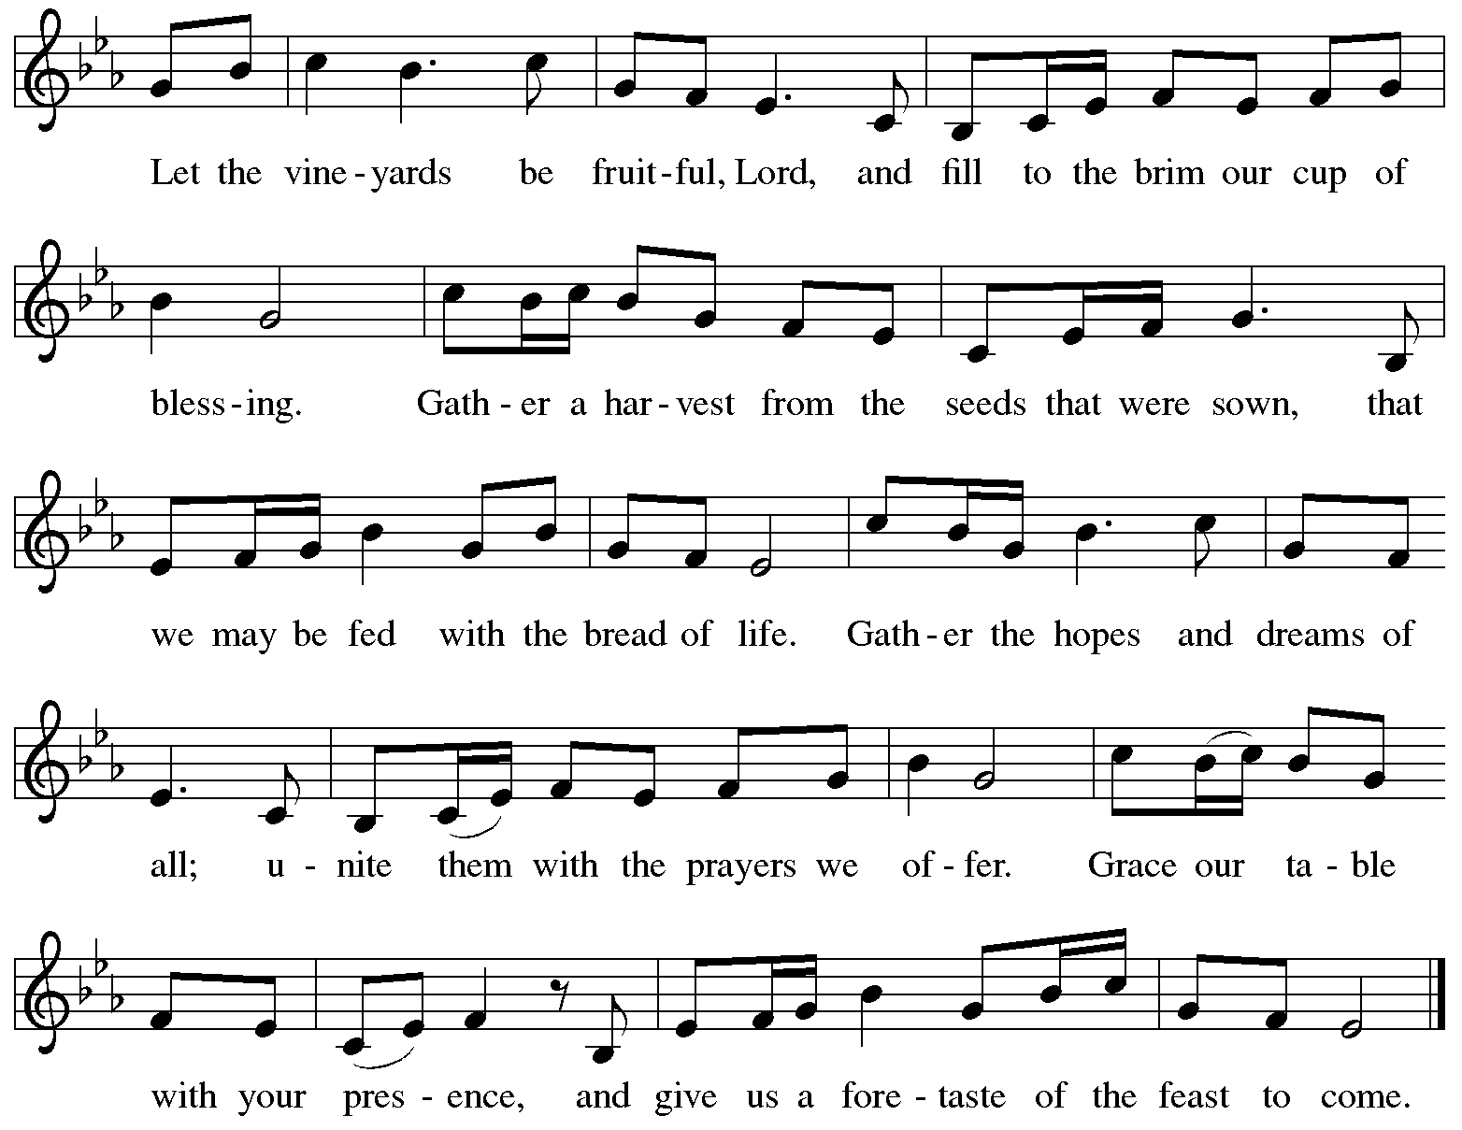
All rights reserved. Reprinted with permission under OneLicense.net # A-722139.

Offertory Prayer

A: Let us pray.
God of mercy and grace,
C: the eyes of all wait upon you, and you open your hand in blessing.
Fill us with good things at your table, that we may come to the help of all in need,
through Jesus Christ, our redeemer and Lord.
Amen.

Dialogue ELW p. 152

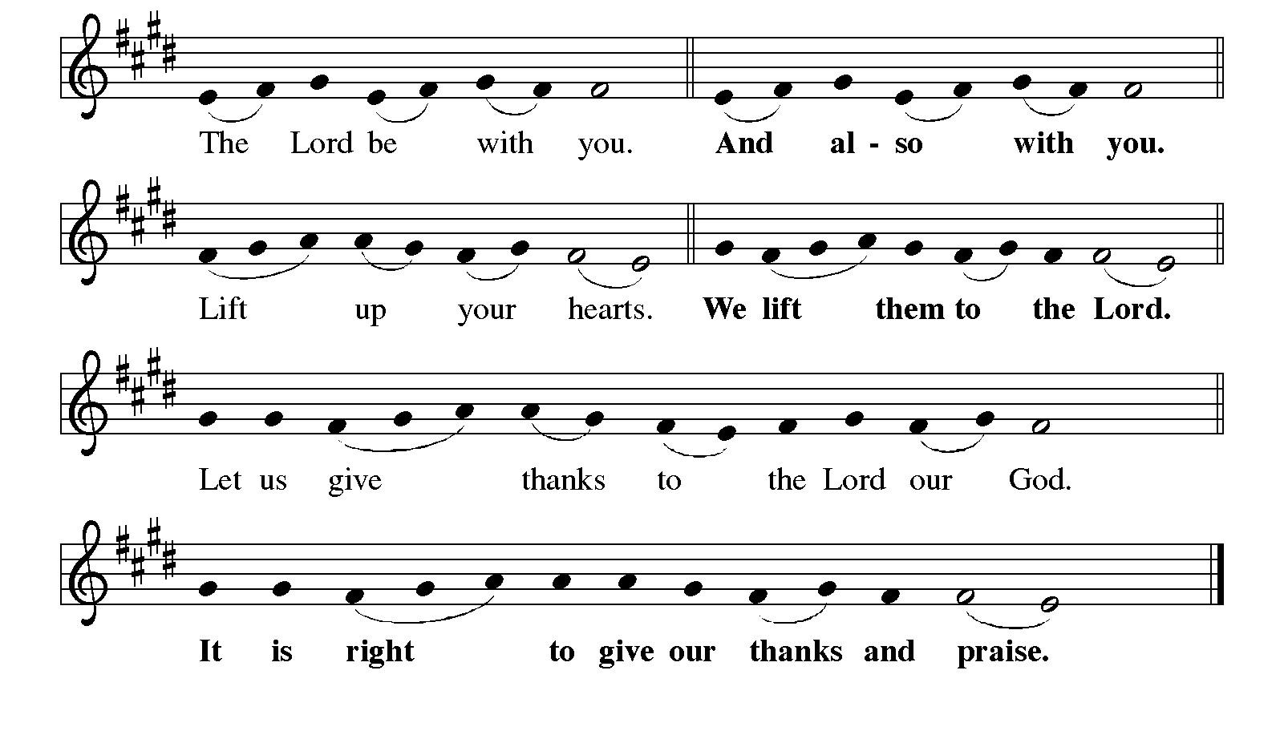

Preface

P: It is indeed right, our duty and our joy,
that we should at all times and in all places
give thanks and praise to you, almighty and merciful God,
through our Savior Jesus Christ;
who one this day overcame death and the grave,
and by his glorious resurrection opened to us the way of everlasting life.
And so, with all the choirs of angels,
with the church on earth and the hosts of heaven,
we praise your name and join their unending hymn:

Sanctus ELW p. 153

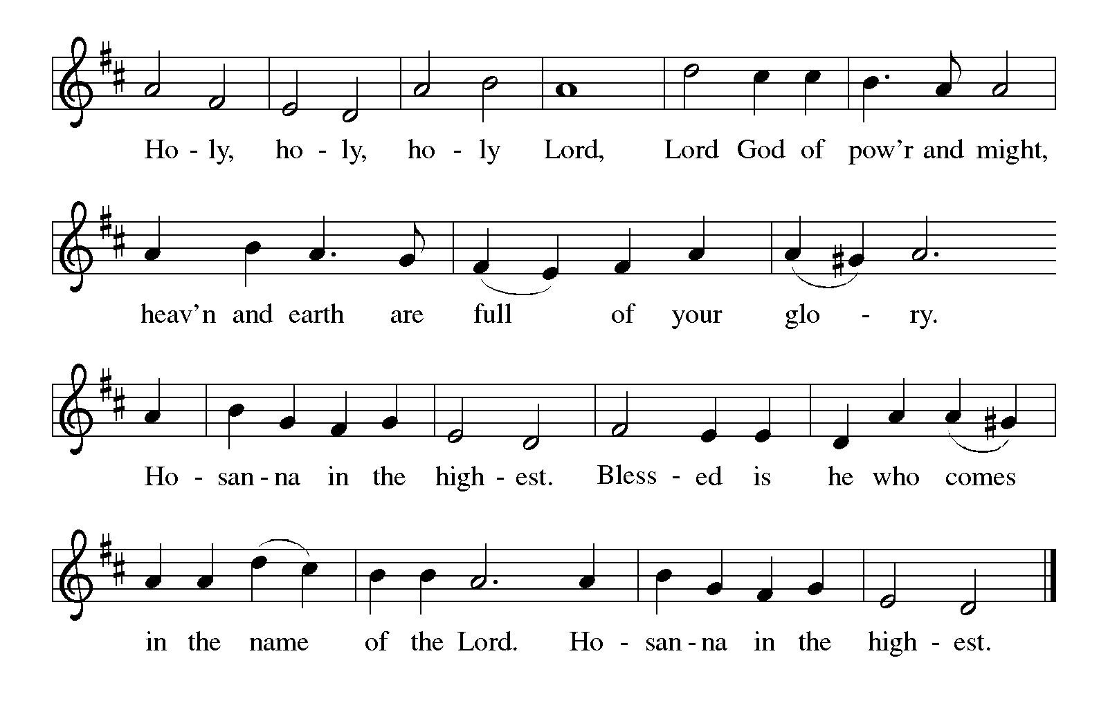
Eucharistic Prayer

P: Holy God, mighty Lord, gracious Father, …
… Do this for the remembrance of me.

For as often as we eat of this bread and drink from this cup,
we proclaim the Lord’s death until he comes.
C: Christ has died. Christ is risen. Christ will come again.

P: Therefore, O God, with this bread and cup …
… to share with us the great and promised feast.
C: Amen. Come, Lord Jesus.

P: Send now, we pray, your Holy Spirit …
… and receive our inheritance with all your saints in light.
C: Amen. Come, Holy Spirit.

P: Join our prayers …
… all glory and honor are yours, almighty Father,
now and forever.
C: Amen.
Lord’s Prayer

P: Gathered as one by the Holy Spirit, let us pray as Jesus taught us.
C: Our Father in heaven,
hallowed be your name,
your kingdom come,
your will be done,
on earth as in heaven.
Give us today our daily bread.
Forgive us our sins
as we forgive those
who sin against us.
Save us from the time of trial
and deliver us from evil.
For the kingdom, the power,
and the glory are yours,
now and forever. Amen.

Fraction and Invitation



Agnus Dei / Lamb of God ELW p. 154

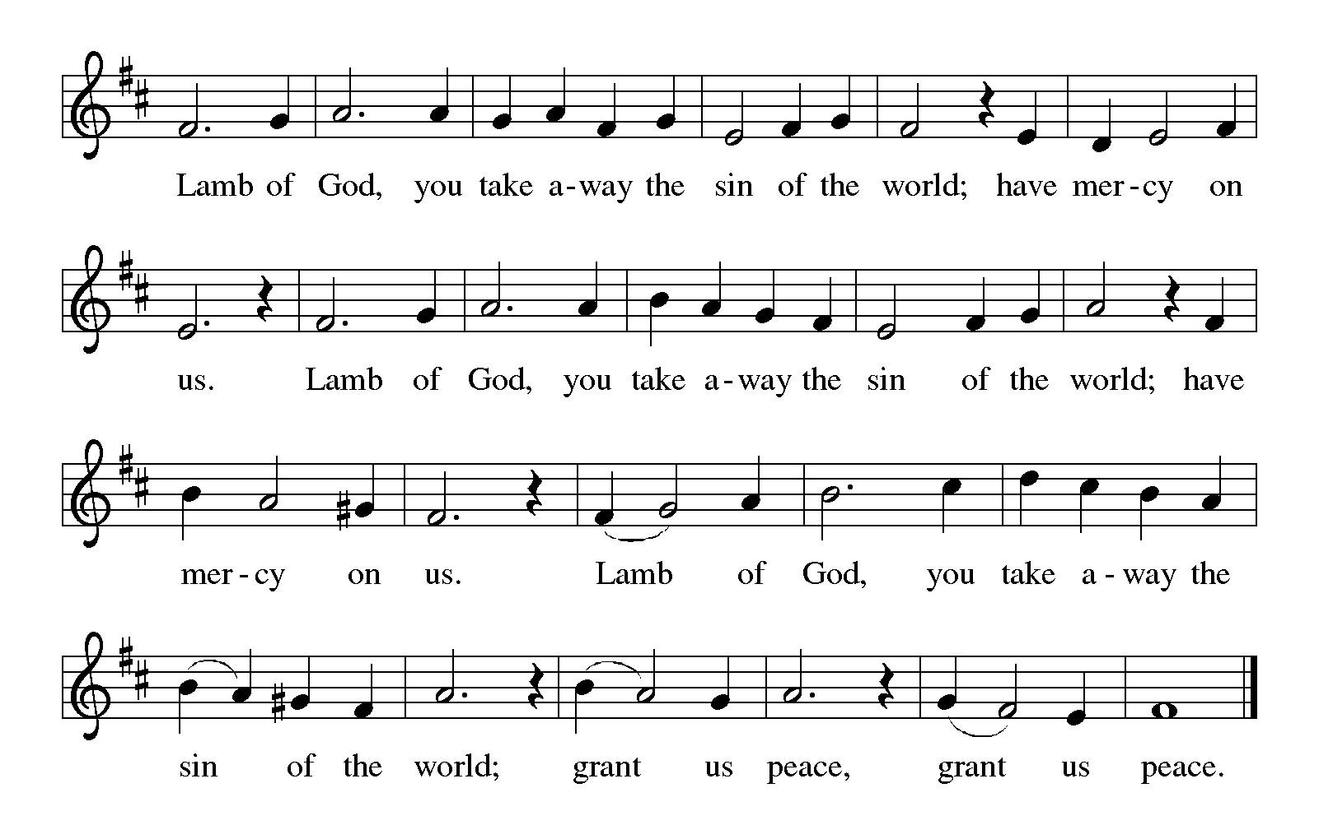

Please be seated.

Holy Communion

- All who seek God and desire a deeper and stronger life in Christ are welcome to receive Holy Communion.
- Worshipers from the pulpit side will proceed forward first, followed by the center section, and then the lectern side.
- Please inform an usher if you would like the ministers to bring Communion to you.
- Holy Communion will be served with bread and wine (amber) or grape juice (purple).
- The presiding minister will first distribute the bread (host) to each communicant. Please indicate if you require a gluten-free host.
- Once you have consumed the bread, please pick up an empty glass from the tray next to the presiding minister. The Communion Assistant will pour wine or grape juice into your glass.
- Please step to the side to consume the wine or grape juice.
- Feel free to kneel at the altar rail for prayer after receiving the sacrament.
- As you return to your pew, glasses may be returned to the empty tray on the side of the center section.
- A blessing will be provided for anyone who does not yet receive the sacrament.
- All are invited to join in singing the hymns during Holy Communion.
Hymns during Holy Communion
The Church’s One Foundation ELW 654

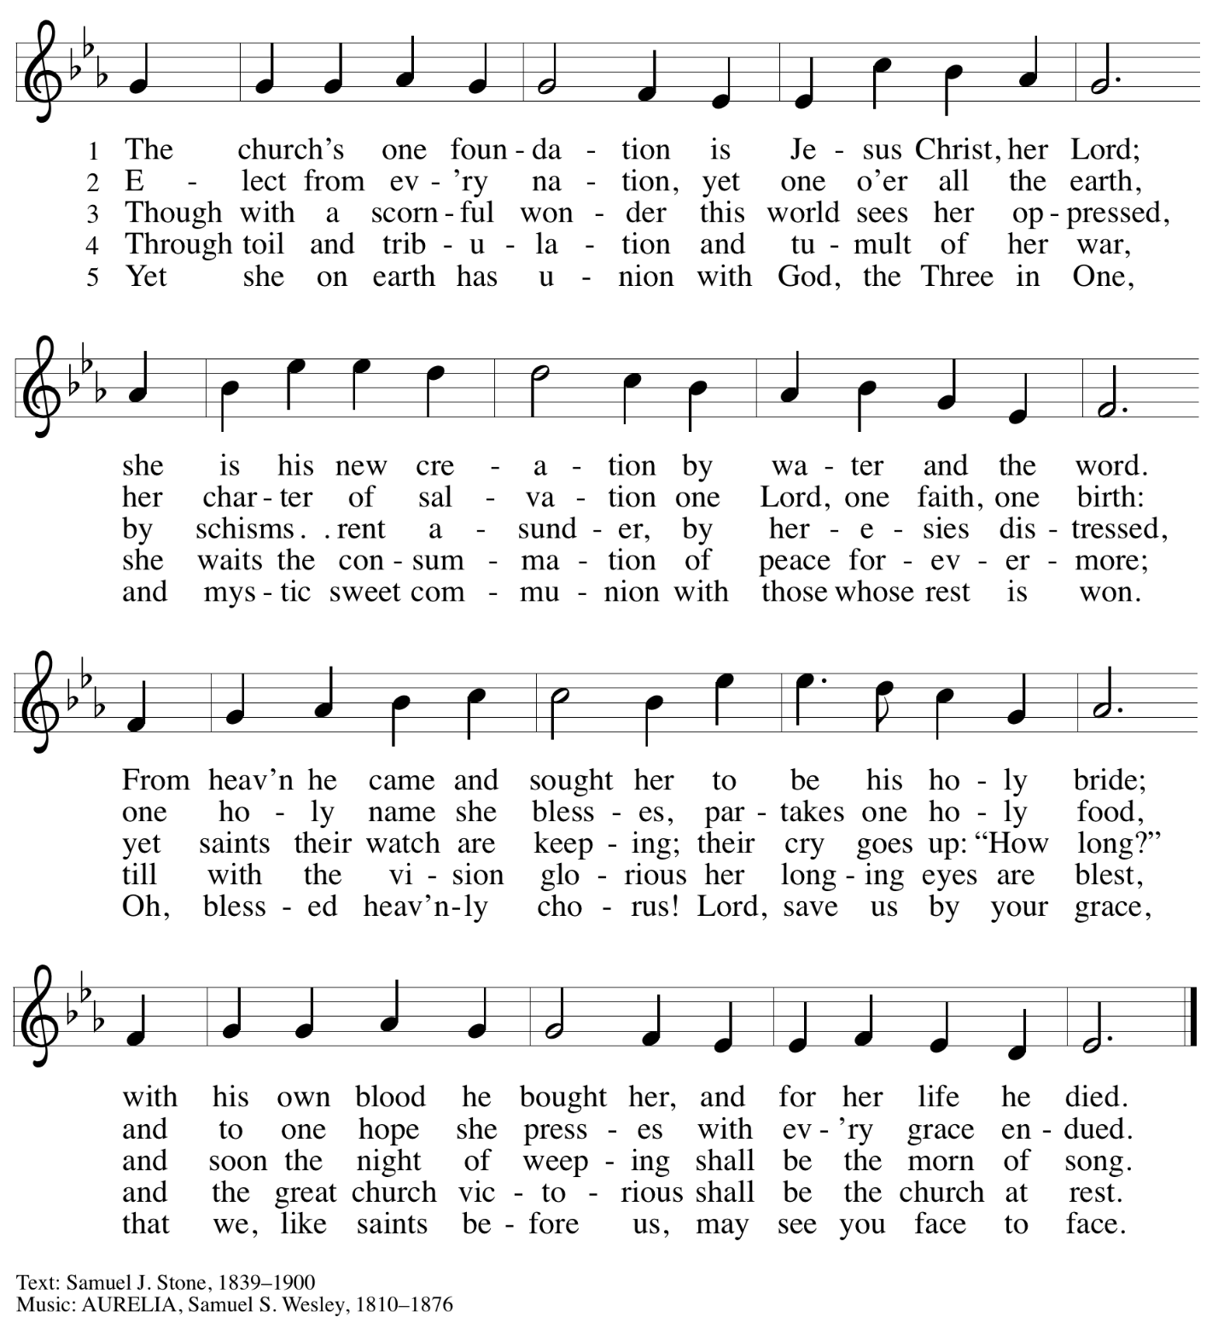

Hymns during Holy Communion
My Hope Is Built on Nothing Less ELW 596

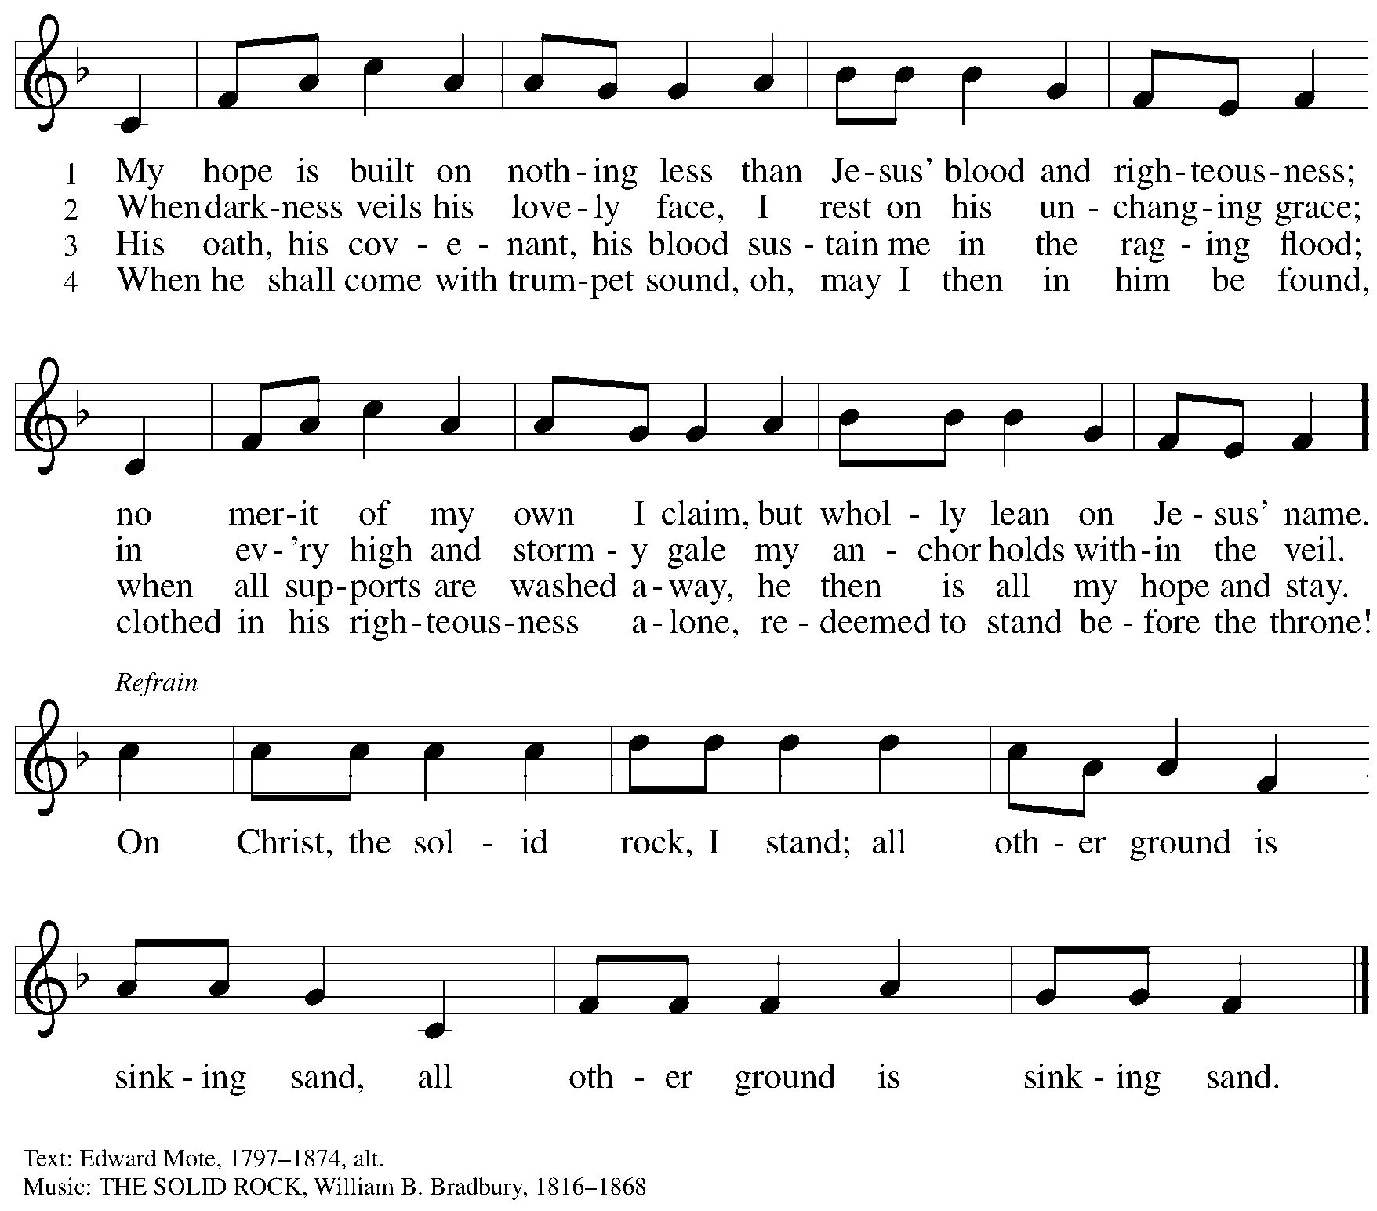

Hymns during Holy Communion
The Church of Christ, in Every Age ELW 729

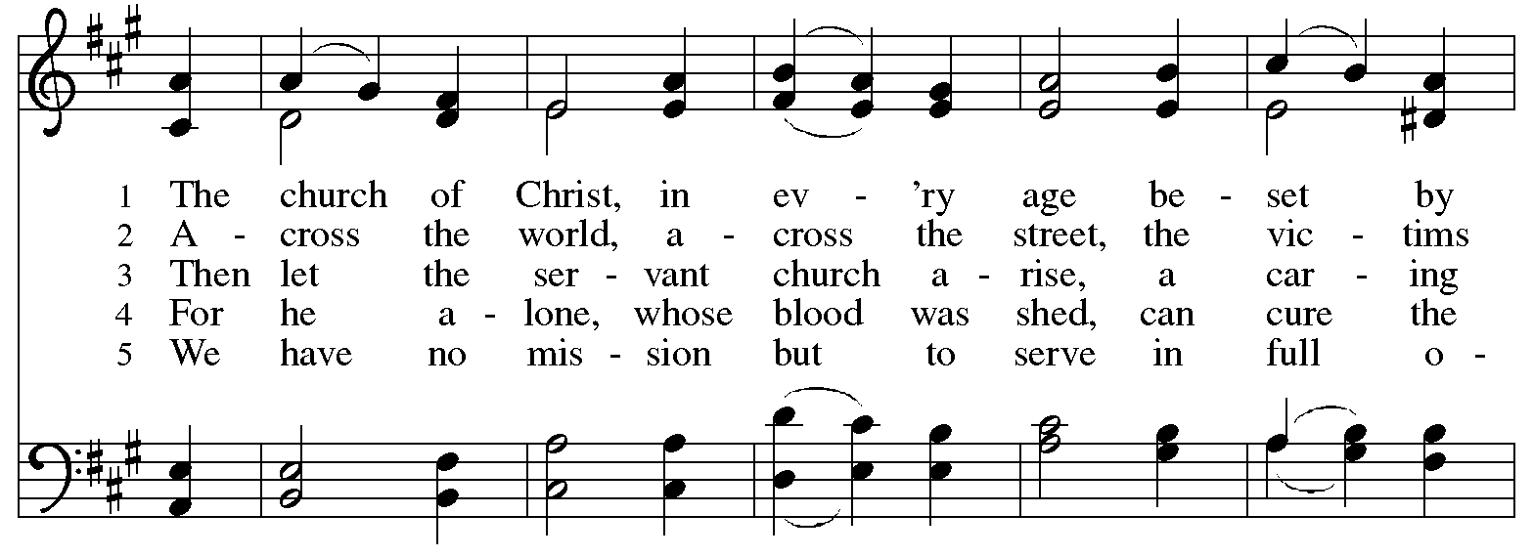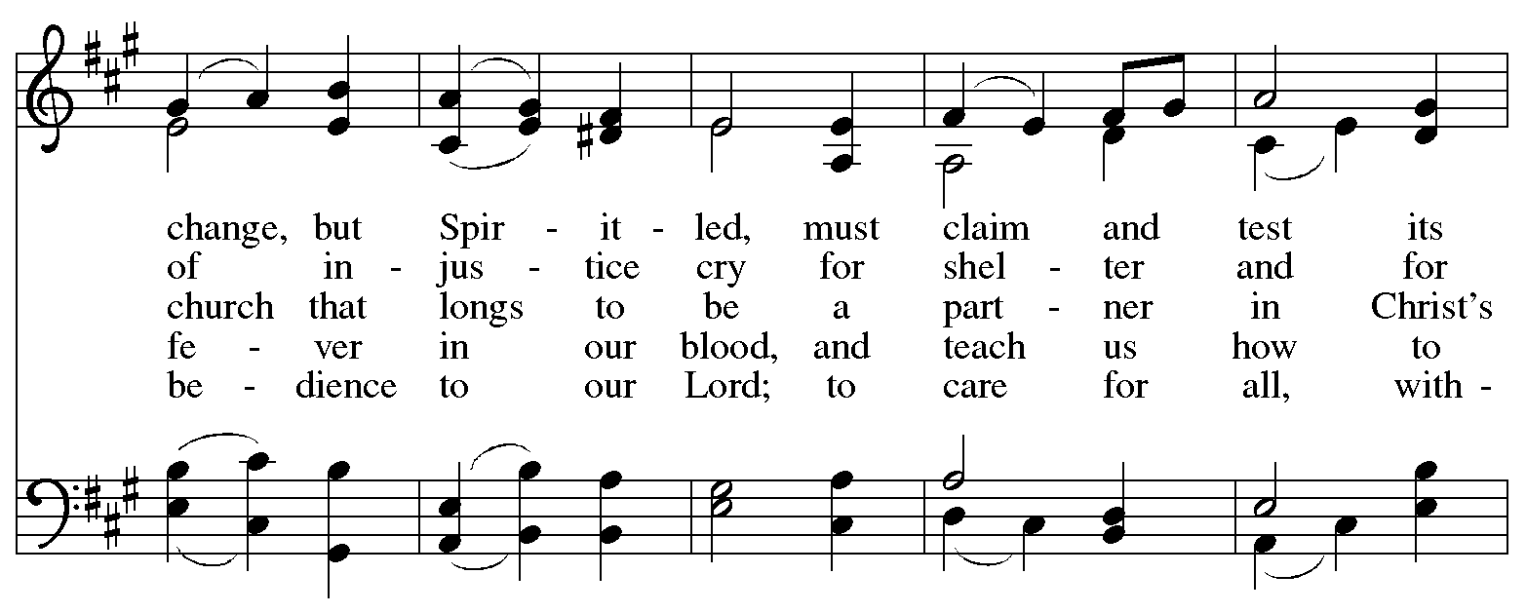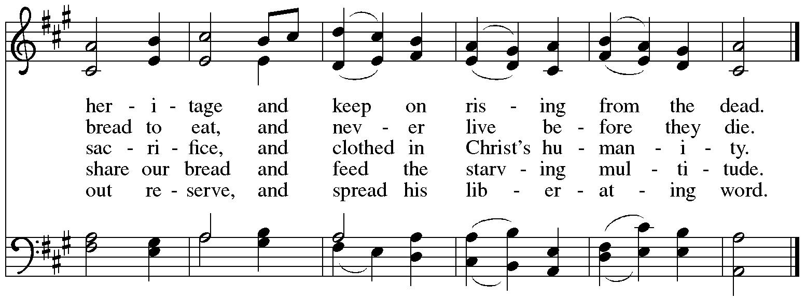
Reprinted under OneLicense.net # A-722139.
Hymns during Holy Communion
I Love to Tell the Story ELW 661

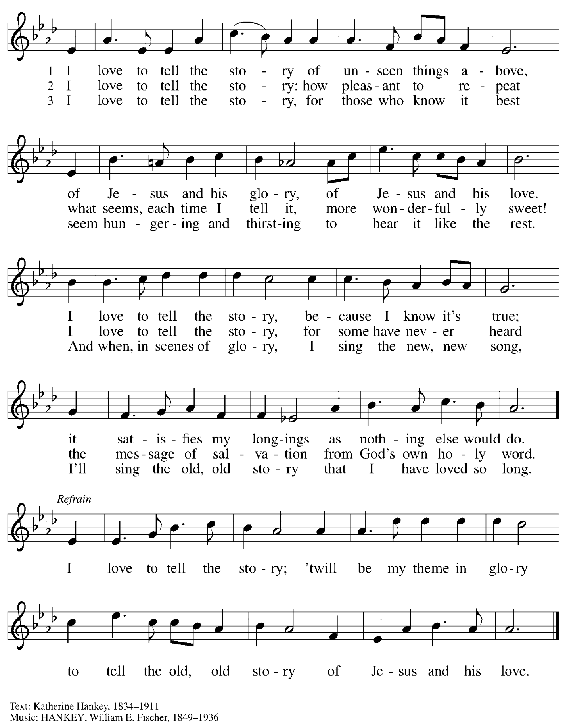
When all have returned to their places, please rise as you are able.

Blessing

P: The body and blood of our Lord Jesus Christ strengthen you and keep you in his grace.
C: Amen.

Prayer

A: Let us pray.
O God our life, our strength, our food,
we give you thanks for sustaining us with the body and blood of your Son.
By your Holy Spirit, enliven us to be the Body of Christ in the world,
that more and more we will give you praise and serve your earth and its many peoples,
through Jesus Christ, our Savior and Lord.
C: Amen.

Please be seated.

Sending
God blesses us and sends us in mission to the world

Announcements

Please rise as you are able.

Benediction

P: The love of God the Sovereign strengthen you,
God the Son save you,
and the Holy Spirit anoint and sustain you.

The Holy Trinity ☩ bless you
and grant you a faithful and courageous heart,
now and forever.
C: Amen.

Sending Hymn Following page

Sending Hymn We’ve Come This Far by Faith ELW 633

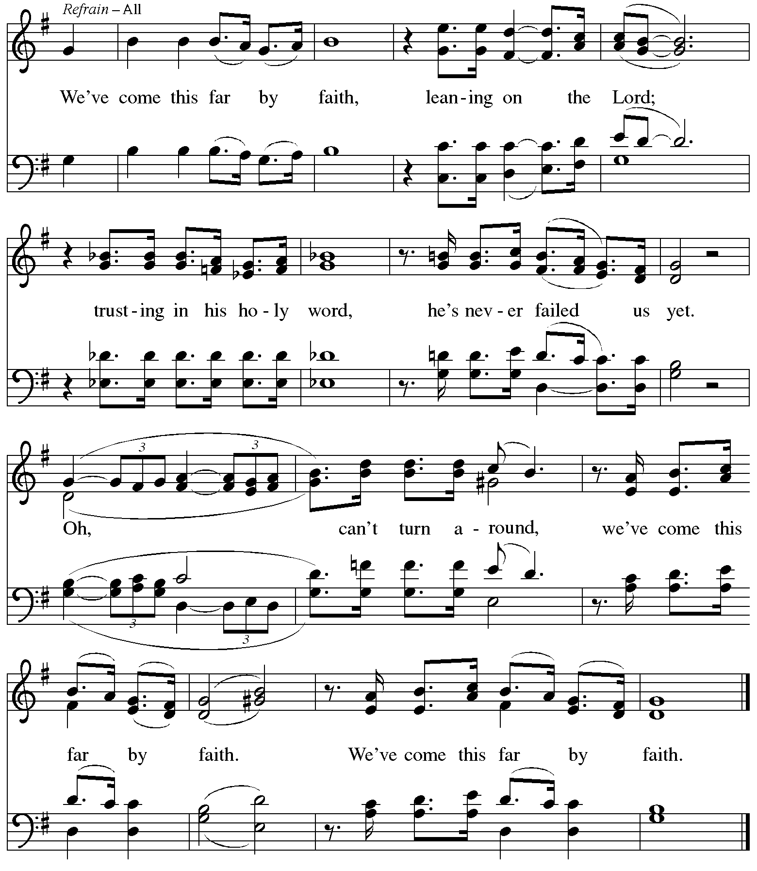
Reprinted under OneLicense.net # A-722319.
Dismissal

A: Go in peace. Serve the Lord.
C: Thanks be to God!

Postlude

Serving in Worship Today

Altar Care Jodie Minor
Assisting Minister Jeff Denlinger
Audio-Visual Ministers Sarita
Dave Rollinson
Cantor Joy Givens
Lector Lindsay Baxter
Minister of Music Laura Reynolds
Presiding Minister The Rev. Ross Carmichael

Liturgy and Hymnody Acknowledgements

From SundaysandSeasons.com. Copyright © 2025 Augsburg Fortress. All rights reserved. Reprinted under OneLicense.net # A-722139.
Used by permission of Augsburg Fortress.

The Scripture readings contained herein are from New Revised Standard Version Updated Edition of the Bible © 2021 National Council of Churches of Christ in the United States of America. Used by permission. All rights reserved worldwide.

Please use the QR code below to link to St. Andrew’s Announcements online!



St. Andrew Lutheran Church Announcements
October 26th, 2025

- Welcome to Worship at St. Andrew on Reformation Sunday! – We are so glad you are here, and we offer a special welcome to all guests and those who are here for the first time! A nursery is available through the door to the left of the worship space and across the social hall (look for a purple room). Little Church – Big Faith, a Bible lesson and activity for children up to sixth grade, will take place after the prayer of the day. There are also worship “toolkits” to help children engage with worship and “busy bags” for younger children available in the bookcase at the back of the sanctuary. Please feel free to take one to use with/for your children. All are invited to stay for coffee and other drinks, food, and conversation in the Social Hall (through the side door at the left of the worship space) after the service.
- St. Andrew Lunch at Hofbrauhaus Today, October 26th, at 12:30 p.m. – Kelly Spanninger has organized a renewal of St. Andrew lunch outings after Sunday worship. Today, Reformation Sunday, all are invited to gather at Hofbrauhaus at South Side Works, 2705 S. Water St., 15203 at 12:30 p.m. Because Hofbrauhaus is no longer taking large reservations, Kelly asks that everyone make their own reservation and indicate that you would like to sit with the “St. Andrew Group.” This can be done online at their website, https://www.hofbrauhauspittsburgh.com/, but if you have any issues you may call and speak with Justin at 412-224-2328.
- Produce Distribution Supplemental Food of the Month – St. Andrew has begun collecting supplemental food each month to accompany our produce distribution. For the month of October, we ask for donations of rice and dried beans. There are collection boxes at the back of the worship space and social hall.
- All Saints Sunday, November 2nd – Invitation to Bring Photos – The Christian church observes All Saints Day on November 1st, and because that date does not fall on a Sunday this year, St. Andrew will observe All Saints Sunday on November 2nd. On All Saints Sunday, we give thanks for the grace of God that allows all of us to be saints through the righteousness Jesus shares with us. St. Andrew also joins the church throughout the world in giving thanks to God for the saints who have gone before us in faith, all whose lives have been for us a testimony to God’s love and grace. On All Saints Sunday, we remember people of the congregation and those we have prayed for who have died since last All Saints Day. We invite the congregation to bring photographs of loved ones you would like to remember that day, to be placed near the baptismal font as we give thanks for the communion of all the saints who are one with us in the Body of Christ. We will also offer a place in the service when everyone can light candles in remembrance of the saints.
- November Produce Distributions, First and Third Tuesday of the Month, November 4th and 18th, 5:30-6:30 p.m. – St. Andrew partners with Greater Pittsburgh Community Food Bank to serve as a distribution site for fresh produce on the first and third Tuesday of every month. Next month’s distribution will be on Tuesday, November 4th. We invite people of the congregation to help with the distribution from 5:30 p.m. - 6:30 p.m. and/or to help with unloading and setup during the day between 10:00 a.m. and 1:00 p.m.
- East End Interfaith Thanksgiving Service, Tuesday, November 25th, 7:00 p.m. – This year's East End Interfaith Thanksgiving Service, with the theme Lift Every Voice, will be held at Episcopal Church of the Redeemer at 5700 Forbes Ave., Pittsburgh, PA 15217 and will be co-hosted by leaders of the Hindu-Jain Temple in Monroeville. Following the service, all are welcome to a light reception in the Parish Hall. As part of our Thanksgiving offering, we invite all attendees to bring a non-perishable food item or toiletry as an offering to support our immigrant neighbors through JFCS.
- Discipleship that Heals the World, Studies in Matthew’s Gospel – Thursdays, 8:00 - 9:00 p.m. on Zoom, through Dec. 11th, 2025 – Join us for an 11-week journey through the Gospel of Matthew, organized and facilitated by Rev. Dr. Martin Rafanan. Together we will explore Jesus’ Sermon on the Mount and his healing ministry, discovering Matthew’s distinctive vision of discipleship as a way of blessing, healing, and hope. This study is designed for both newcomers to the Gospel and those already familiar with it. We will engage contemporary perspectives that help us hear Matthew’s message afresh in today’s world. Register for the sessions to receive zoom info: https://forms.gle/amy439vfUpwdJpKx7.
- Christ in our Home Devotional Booklets for October-December – Available at church entrances, this resource offers a daily Bible reading with a short reflection and prayer, along with additional readings and prayer topics for those who would like to expand their devotional practices. We encourage people of the congregation to take one for yourself, your family/household, or others.
- Invitation to Prayer Team – St. Andrew maintains a list of weekly prayer concerns sent by email to members of the congregation who have opted in. Our prayer team’s email is prayerteam@standrewpittsburgh.org. We will keep names on the list for a maximum of four weeks unless otherwise requested. Thank you for your ministry of prayer!
- Records Update – St. Andrew is seeking to update our records with information from attendees so that we can acknowledge celebrations and milestones, and for prayers of the church. Please fill out the form at: https://forms.gle/kKvp19UozuRrhhaV7.
- Coffee Hour Signups – St. Andrew provides hospitality during a coffee hour after worship each Sunday. If you would like to participate and would like information about the duties of setting up, please sign up using the following form: https://www.signupgenius.com/go/5080B4AAFAF2CABF85-47069030-coffee#/.

