

+ First Sunday of Advent
November 30, 2025



St. Andrew Lutheran Church
304 Morewood Ave.
Pittsburgh, PA 15213
St_andrewELCA@verizon.net
www.standrewpittsburgh.org

+ First Sunday of Advent
Order for Worship

A new church year begins with a wake-up call: Christ is coming soon!
In today’s readings, both Paul and Jesus challenge us to wake from sleep, for we know neither the day nor hour of the Lord’s coming. Isaiah proclaims the day when God will gather all people on the holy mountain and there will be no more war or suffering. Though we vigilantly watch for the promised day of salvation, we wait for what we already have: Christ comes among us this day as the word and meal that strengthens our faith in the promises of God.

Welcome to St. Andrew!
- St. Andrew welcomes all who are seeking a place of healing, wholeness, and acceptance in a nurturing and faith-forming spiritual home. We are striving toward racial equity worldwide
and we seek to honor the lived experience of all individuals regardless of background. Our community embraces people of all ages, ethnicities, cultures, abilities, sexual orientations,
gender identities and expressions, and family constellations. Come and See!
- Worship Services are live-streamed to multiple online platforms. By attending worship, you agree that your image and voice may be broadcast.
- Everyone is invited to make a name tag at the black bookcase in the back of the worship space if they would like. There are stickers indicating pronouns on the bookcase if you would like to include them on your name tag.
- A nursery is available through the doors at the left side of the sanctuary and across from the doorway to the Social Hall. Look for a purple-colored room.
- Children are invited to attend Little Church – Big Faith, a Bible lesson and activity, during worship (after the Prayer of the Day). The group returns to the worship space for the liturgy of Holy Communion.
- Worship “toolkits” to help children engage with the service, along with “busy bags” for younger children, are available in the bookcase at the back of the sanctuary. Please feel free to take one to use with/for your children.
- Holy Communion is served with bread (gluten-free available) and wine or grape juice. The presiding minister will distribute the bread (host). Please consume this and then pick up an empty glass from the tray. The Communion Assistant will pour wine or grape juice into your glass. Please step to the side to consume the wine or grape juice. Feel free to kneel at the altar for prayer and reflection. As you return to your pew, glasses may be returned to the empty trays on either side of the center section.
- A restroom is available on the main level of the church, through the doors to the Social Hall and to the right in the main office.

Abbreviations
P: Pastor/Presiding Minister ELW: Evangelical Lutheran Worship hymnal
A: Assisting Minister ACS: All Creation Sings hymnal
L: Lector
C: Congregation

Musical Offering

Each week, different people from the congregation make an offering of pre-service music, with singing or instrumentation, to help the assembly focus and pray in preparation for worship.

Welcome

Prelude Ballade de Jésus Christ arr. Shackley

Gathering
The Holy Spirit calls us together as the people of God

Please rise as you are able. All may make the sign of the cross,
the sign that is marked at Baptism, as the presiding minister begins.

Confession and Forgiveness

P: Blessed be the Holy Trinity, one ☩ God,
whose home is heaven and earth, whose salvation is sure.
C: Amen.

P: Let us confess our sin in the presence of God and of one another.

Silence is kept for reflection.

P: Long-expected God,
C: we confess that we look to ourselves
for the peace and security only you can provide.
We reach for swords and spears,
reluctant to release our grip on the ways of war.
We become impatient while waiting
and weary of keeping awake.
Free us from self-reliance,
and teach us to live in harmony with our neighbors.
Increase our trust in God’s timing,
and awaken us to your advent among us,
that we may abound in the hope you have promised.
Amen.

P: God judges us not as we deserve,
but according to God’s own righteousness.
in ☩ Christ Jesus, you are freed and forgiven, saved by grace,
and ready to welcome the Savior.
C: Amen.
Gathering Hymn O Lord, How Shall I Meet You ELW 241

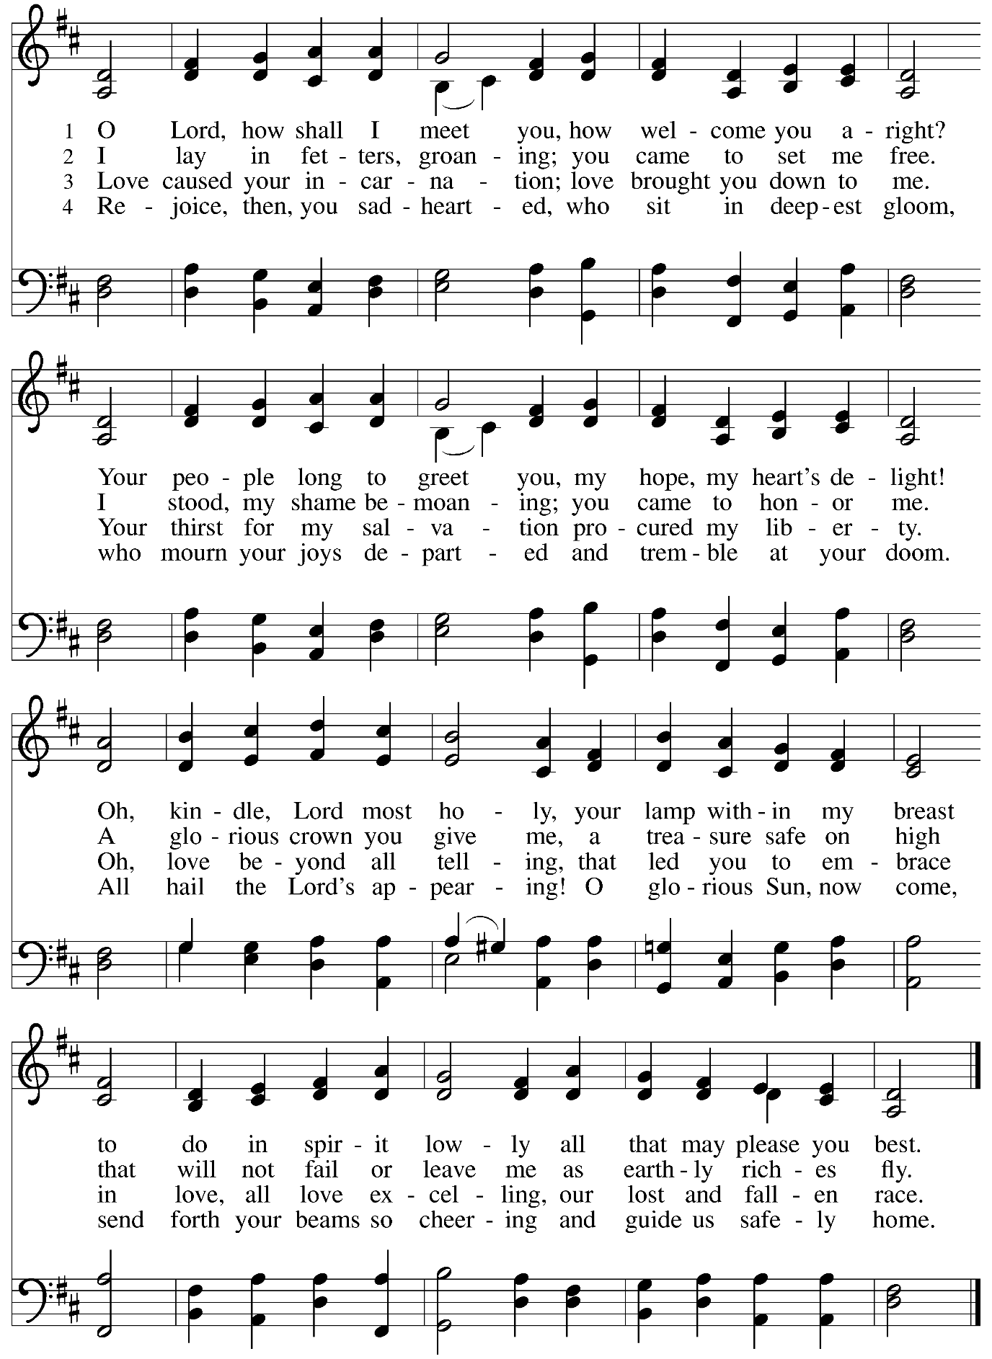

Greeting

P: The grace of our Lord Jesus Christ, the love of God,
and the communion of the Holy Spirit be with you all.
C: And also with you.

Kyrie ACS p. 12

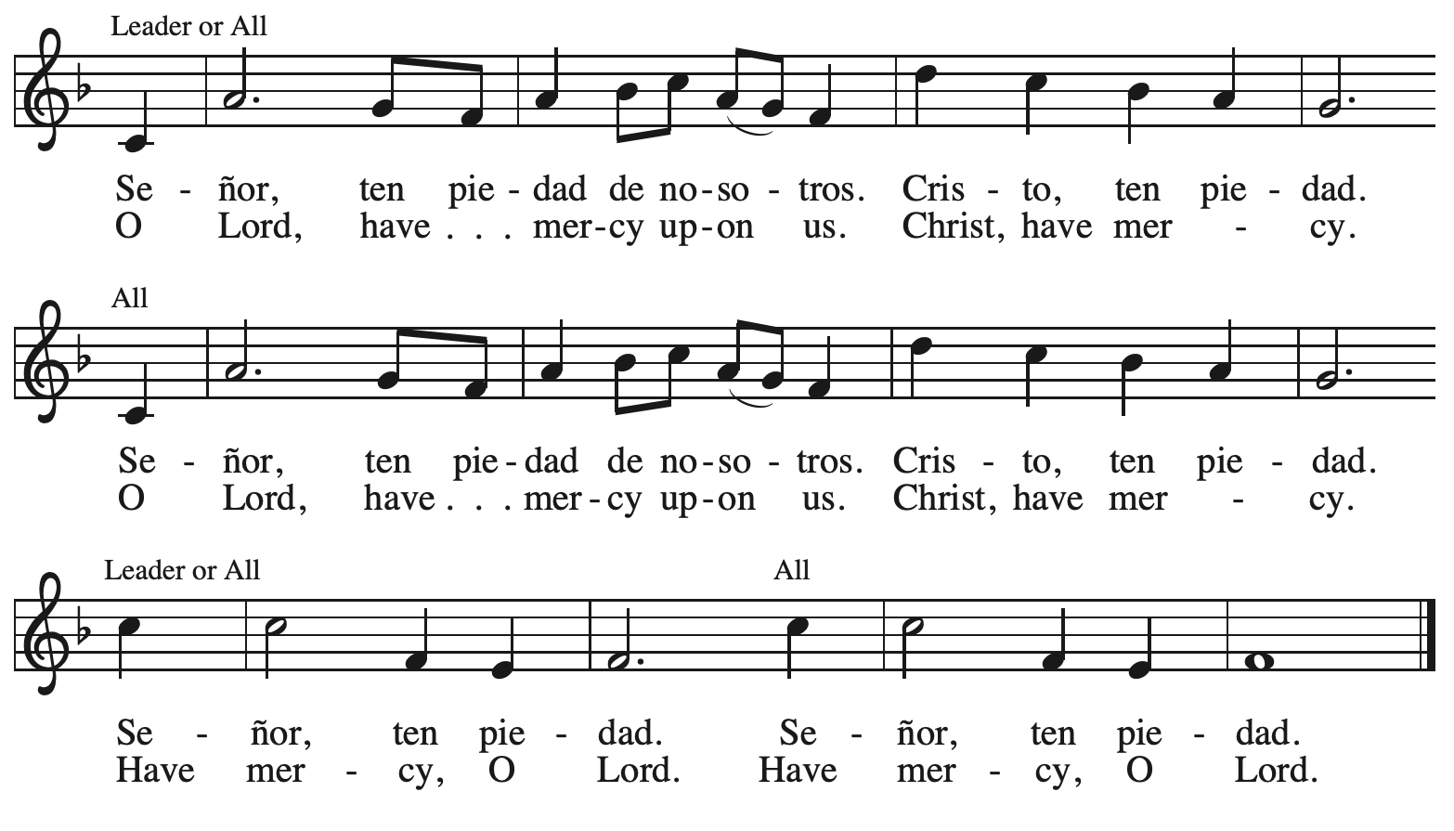

Prayer of the Day

P: The Lord be with you.
C: And also with you.

P: Let us pray.
Stir up your power, Lord Christ, and come.
By your merciful protection save us from the threatening dangers of our sins,
and enlighten our walk in the way of your salvation,
for you live and reign with the Father and the Holy Spirit, one God, now and forever.
C: Amen.

Please be seated.
Children are invited to join the adult leader(s) at the side door for Little Church – Big Faith.
We ask that an additional adult from the congregation attend with the children.

Word
God speaks to us in Scripture reading, preaching, and song

First Reading – Isaiah 2: 1-5

¹ The word that Isaiah son of Amoz saw concerning Judah and Jerusalem.
² In days to come
the mountain of the Lord’s house
shall be established as the highest of the mountains
and shall be raised above the hills;
all the nations shall stream to it.
³ Many peoples shall come and say,
“Come, let us go up to the mountain of the Lord,
to the house of the God of Jacob,
that the Lord may teach us God’s ways
and that we may walk in God’s paths.”
For out of Zion shall go forth instruction
and the word of the Lord from Jerusalem.
⁴ The Lord shall judge between the nations
and shall arbitrate for many peoples;
they shall beat their swords into plowshares
and their spears into pruning hooks;
nation shall not lift up sword against nation;
neither shall they learn war any more.
⁵ O house of Jacob,
come, let us walk
in the light of the Lord!

L: Word of God, word of life.
C: Thanks be to God.

Psalm 122

The psalm will be sung responsively, led by the cantor, with the congregation singing the verses in bold type and joining in the refrain.

Psalm Tone

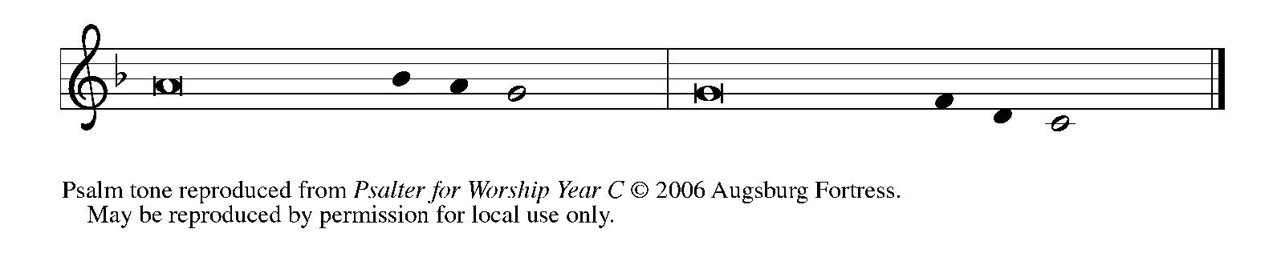
Psalm Refrain

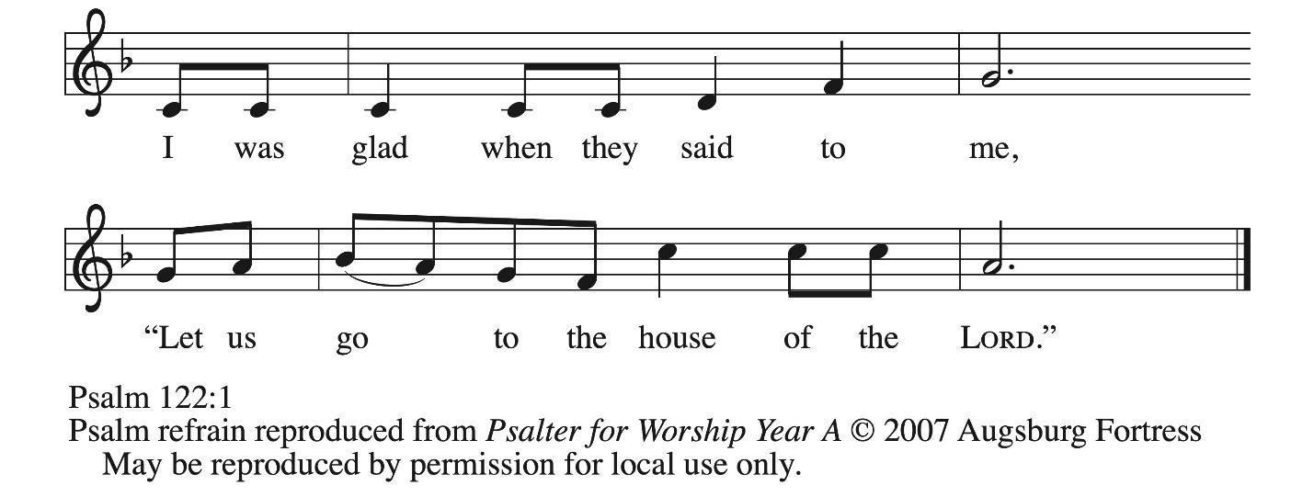

¹ I was glad when they | said to me,
“Let us go to the house | of the Lord.”
² Now our | feet are standing
within your gates, | O Jerusalem.
³ Jerusalem is built | as a city
that is at unity | with itself;
⁴ to which the tribes go up, the tribes | of the Lord,
the assembly of Israel, to praise the name | of the Lord. R
⁵ For there are the | thrones of judgment,
the thrones of the | house of David.
⁶ Pray for the peace | of Jerusalem:
“May they pros- | per who love you.
⁷ Peace be with- | in your walls
and quietness with- | in your towers.
⁸ For the sake of my kindred | and companions,
I pray for | your prosperity.
⁹ Because of the house of the | Lord our God,
I will seek to | do you good.” R

Second Reading – Romans 13: 11-14

¹¹ Besides this, you know what time it is, how it is already the moment for you to wake from sleep. For salvation is nearer to us now than when we became believers; ¹² the night is far gone; the day is near. Let us then throw off the works of darkness and put on the armor of light; ¹³ let us walk decently as in the day, not in reveling and drunkenness, not in illicit sex and licentiousness, not in quarreling and jealousy. ¹⁴ Instead, put on the Lord Jesus Christ, and make no provision for the flesh, to gratify its desires.

L: Word of God, word of life.
C: Thanks be to God.
Please rise as you are able.

Gospel Acclamation ELW p. 188

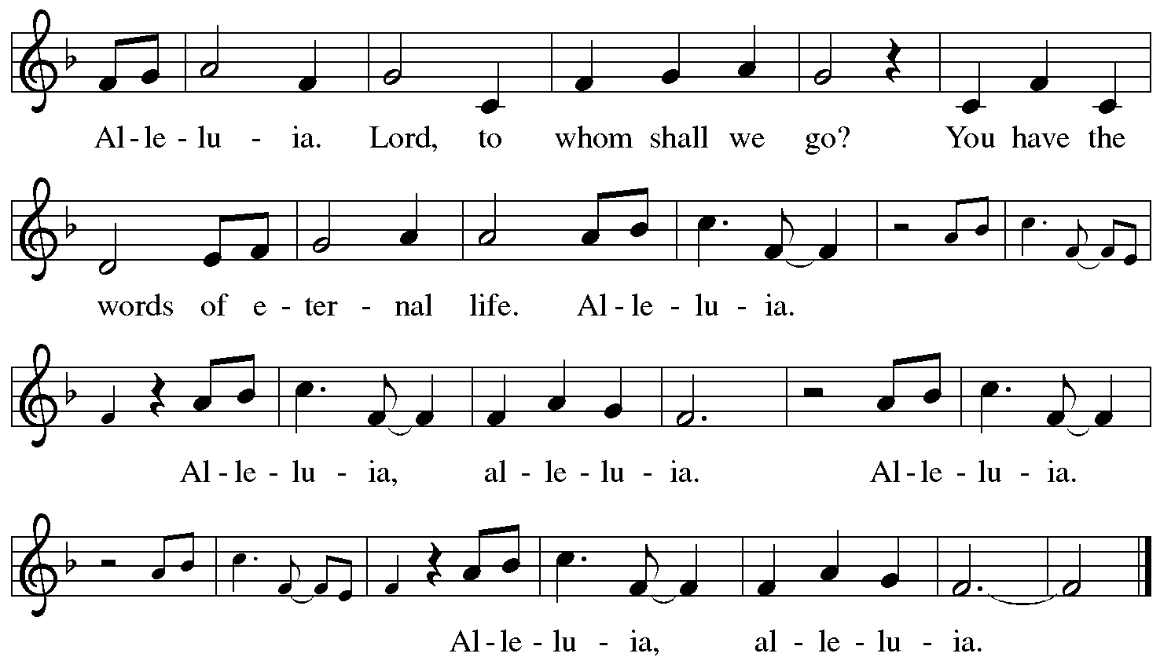

Gospel – Matthew 24: 36-44

P: The holy Gospel according to St. Matthew.
C: Glory to you, O Lord.

[Jesus said to the disciples,] ³⁶ “About that day and hour no one knows, neither the angels of heaven, nor the Son, but only the Father. ³⁷ For as the days of Noah were, so will be the coming of the Son of Humanity. ³⁸ For as in the days before the flood they were eating and drinking, marrying and giving in marriage, until the day Noah entered the ark, ³⁹ and they knew nothing until the flood came and swept them all away, so, too, will be the coming of the Son of Humanity. ⁴⁰ Then two will be in the field; one will be taken, and one will be left. ⁴¹ Two women will be grinding meal together; one will be taken, and one will be left. ⁴² Keep awake, therefore, for you do not know on what day your Lord is coming. ⁴³ But understand this: if the owner of the house had known in what part of the night the thief was coming, he would have stayed awake and would not have let his house be broken into. ⁴⁴ Therefore you also must be ready, for the Son of Humanity is coming at an hour you do not expect.”

P: The Gospel of the Lord.
C: Praise to you, O Christ.

Please be seated.

Sermon

A time of silence for prayer and reflection follows the sermon.
When the hymn of the day begins, please rise as you are able.

Hymn of the Day Hark! A Thrilling Voice Is Sounding! ELW 246

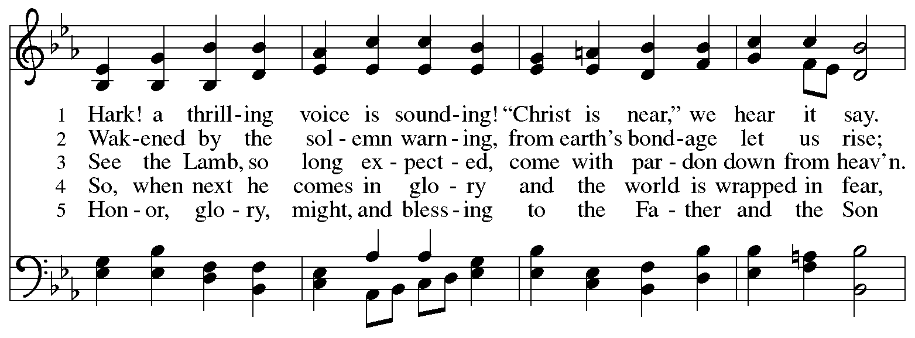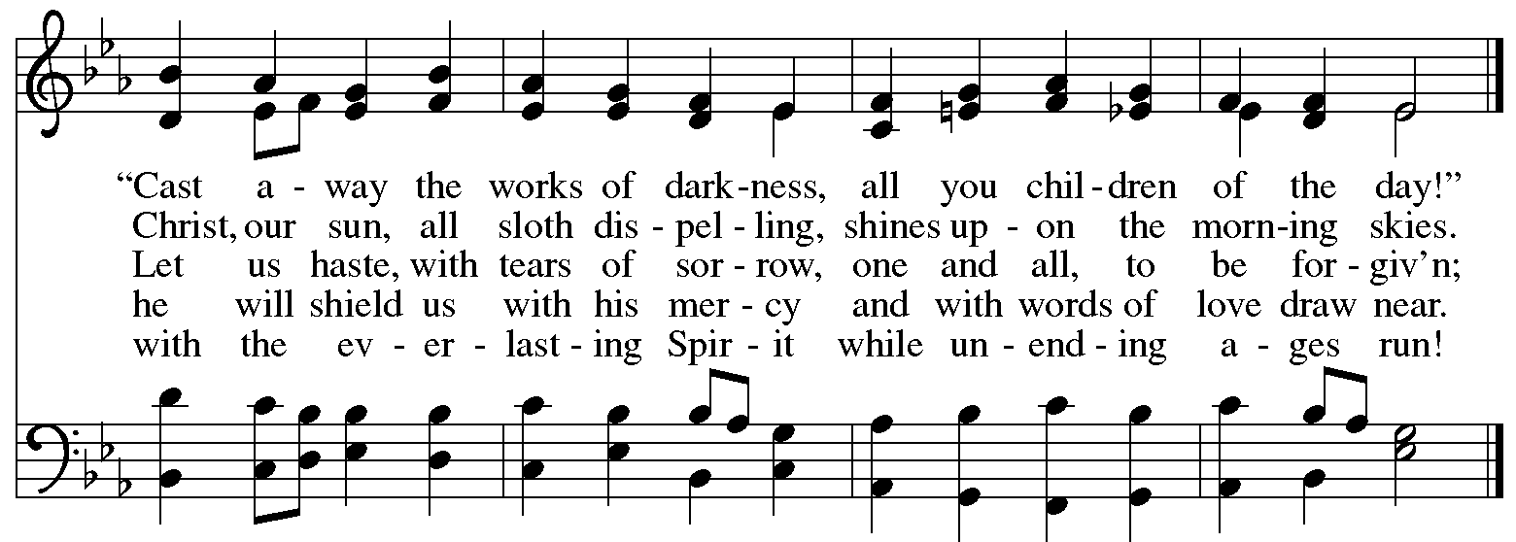

Nicene Creed

C: We believe in one God,
the Father, the Almighty,
maker of heaven and earth,
of all that is, seen and unseen.

We believe in one Lord, Jesus Christ,
the only Son of God,
eternally begotten of the Father,
God from God, Light from Light,
true God from true God,
begotten, not made,
of one Being with the Father;
through him all things were made.
For us and for our salvation
he came down from heaven,
was incarnate of the Holy Spirit and the virgin Mary
and became truly human.
For our sake he was crucified under Pontius Pilate;
he suffered death and was buried.
On the third day he rose again
in accordance with the scriptures;
he ascended into heaven
and is seated at the right hand of the Father.
He will come again in glory to judge the living and the dead,
and his kingdom will have no end.

We believe in the Holy Spirit, the Lord, the giver of life,
who proceeds from the Father and the Son,*
who with the Father and the Son is worshiped and glorified,
who has spoken through the prophets.
We believe in one holy catholic and apostolic church.
We acknowledge one baptism for the forgiveness of sins.
We look for the resurrection of the dead,
and the life of the world to come. Amen.

*Or, “who proceeds from the Father.” The phrase “and the Son” is a later addition to the creed.

Prayers of the People

A: In our waiting and watching, we come to you in prayer, O God,
trusting in your promise to renew the church, the nations, and your whole creation.

After each petition
A: God of grace,
C: receive our prayer.

The presiding minister concludes the prayers
P: Draw near to us, O God, as we commend into your care all for whom we pray,
trusting in your mercy, through Jesus Christ our Savior.
C: Amen.

Peace

The presiding minister and the assembly greet one another in the peace of the risen Christ.
P: The peace of Christ be with you always.
C: And also with you.

The people may greet those around them with a sign of Christ’s peace and may say
Peace be with you or similar words. Please be mindful that not everyone will be comfortable with sharing the peace, so please seek consent before shaking hands or hugging. Other possible ways to share the peace include a simple bow with the verbal greeting of peace, or simply a verbal expression of peace.

When the greetings of peace have concluded, please be seated.



Meal
God feeds us with the presence of Jesus Christ

Offering

We offer ourselves, our gifts, and our faithful service to God.
As the offering is gathered for the mission of the church, including the care of those in need,
the table is set for Holy Communion.

There are laminated giving cards in the pew racks that feature a QR code for anyone who would like to give online. Those who give using the QR code, as well as those who give regularly online or through their bank are encouraged to place the laminated card in the plate as an expression of your offering.

Offertory Music An Advent Reflection Gibson

As the gifts are brought forward for presentation, please rise as you are able.

Offertory Song As Saints of Old ELW 695
v. 3

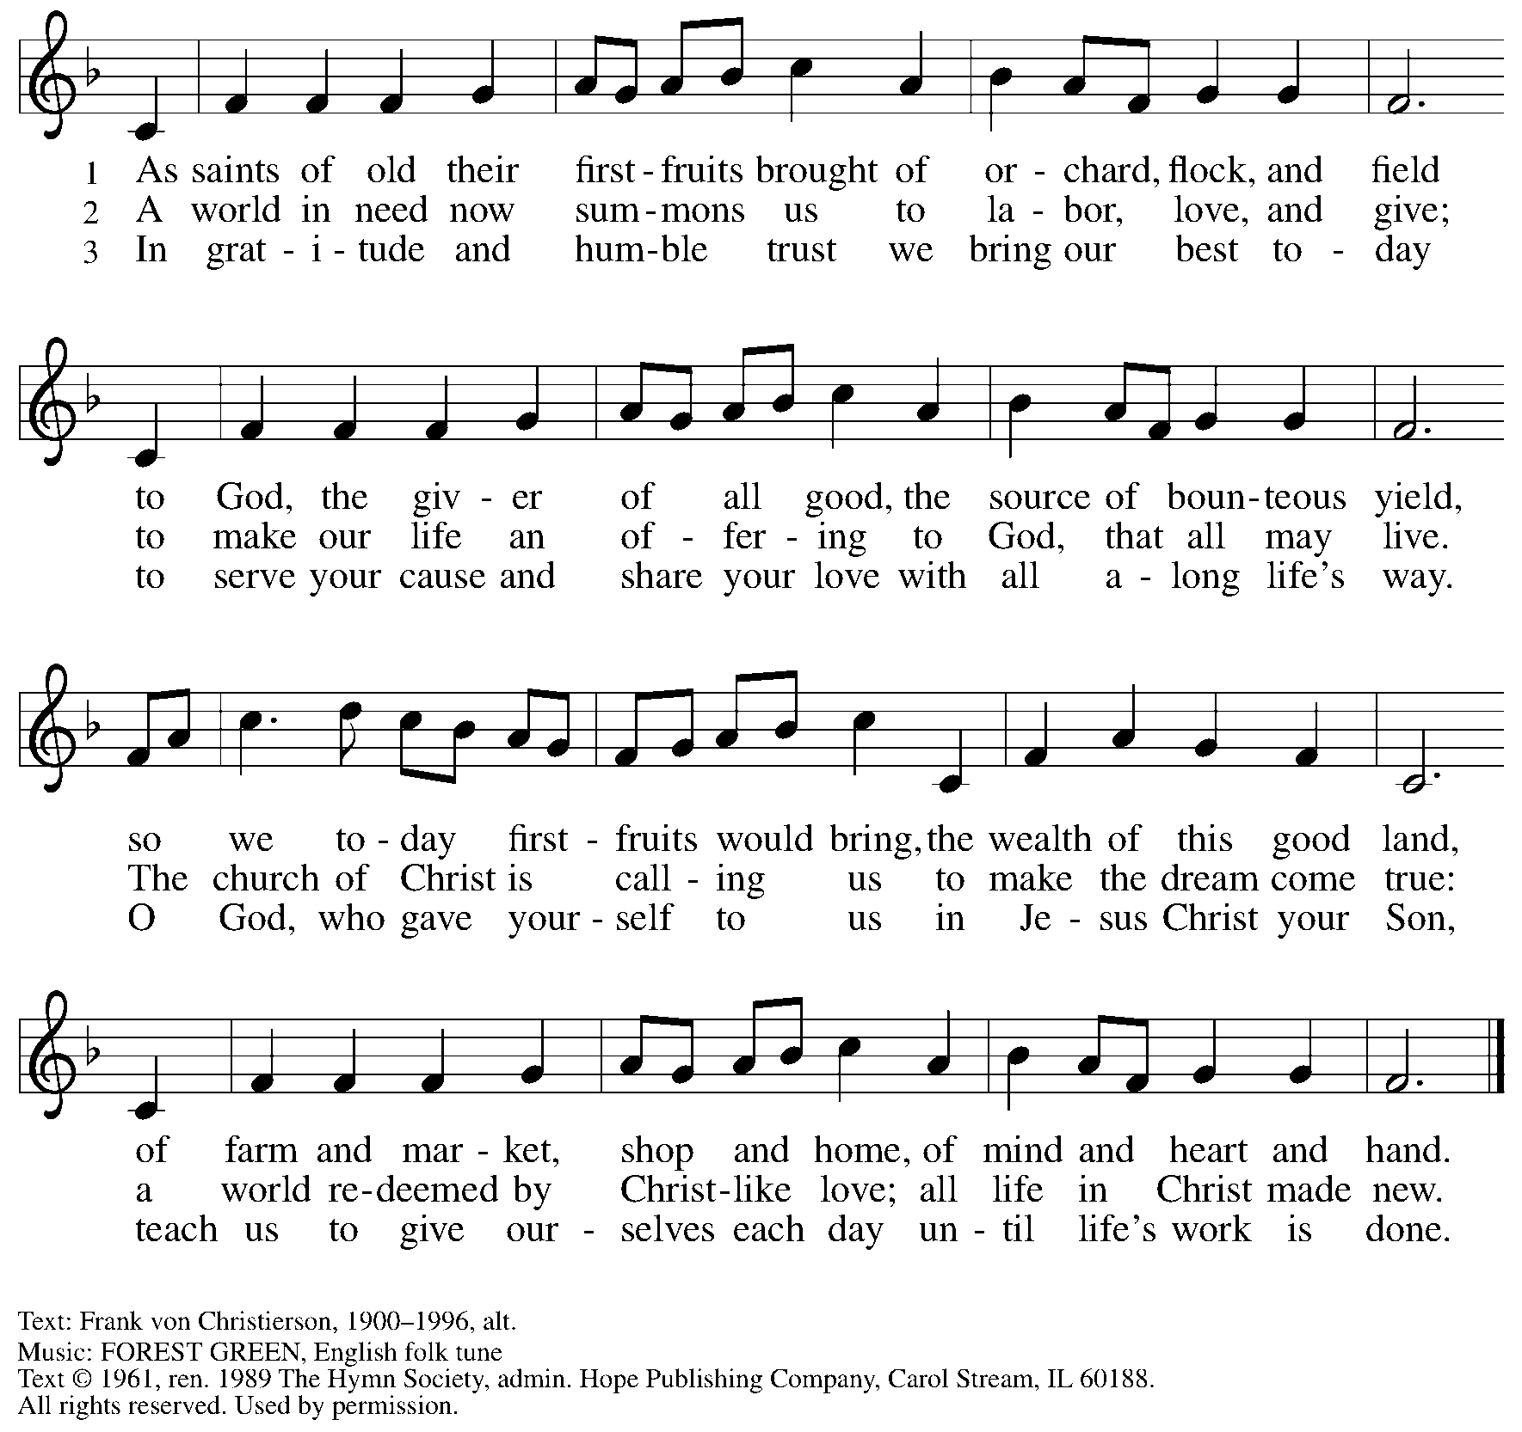
Reprinted under OneLicense.net # A-722139.

Offertory Prayer

A: Let us pray.
God of abundance,
C: we bring before you the precious fruits of your creation, and with them our very lives. Teach us patience and hope as we care for all those in need until the coming of your Son, our Savior and Lord. Amen.

Dialogue

P: The Lord be with you.
C: And also with you.

P: Lift up your hearts.
C: We lift them to the Lord.

P: Let us give thanks to the Lord our God.
C: It is right to give our thanks and praise.

Preface

P: It is indeed right, our duty and our joy, …
… we praise your name and join their unending hymn:

Sanctus ELW p. 190

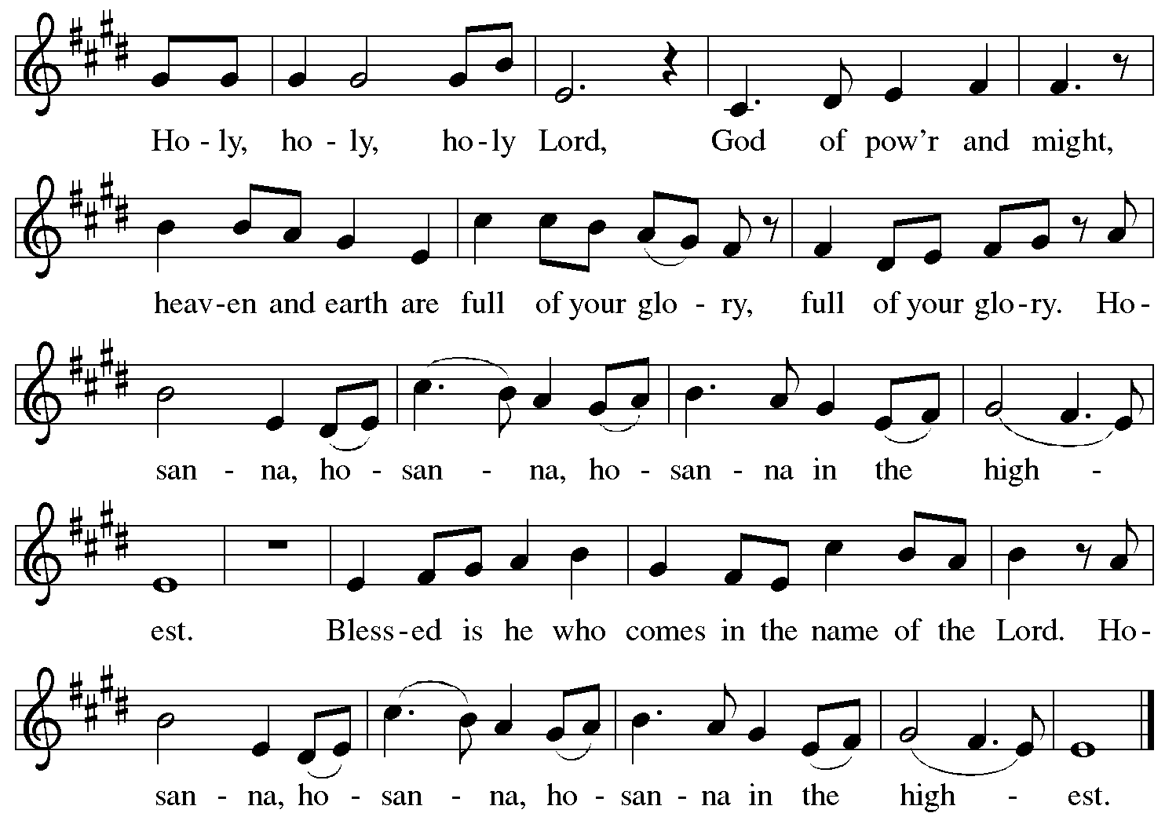

Eucharistic Prayer

P: Holy One, the beginning and the end, the giver of life …
… Do this for the remembrance of me.

P: Let us proclaim the mystery of faith:
C: Christ has died. Christ is risen. Christ will come again.

P: With this bread and cup …
… we look with hope for his coming.
C: Come, Lord Jesus.

P: Holy God, we long for your Spirit …
… Bring the gift of peace on earth.
C: Come, Holy Spirit.

P: All praise and glory are yours,
Holy One of Israel, Word of God incarnate, Power of the Most High,
now and forever.
C: Amen.

Lord’s Prayer

P: Gathered as one by the Holy Spirit, let us pray as Jesus taught us.
C: Our Father in heaven,
hallowed be your name,
your kingdom come,
your will be done,
on earth as in heaven.
Give us today our daily bread.
Forgive us our sins
as we forgive those
who sin against us.
Save us from the time of trial
and deliver us from evil.
For the kingdom, the power,
and the glory are yours,
now and forever. Amen.

Fraction and Invitation

Agnus Dei / Lamb of God ELW p. 191

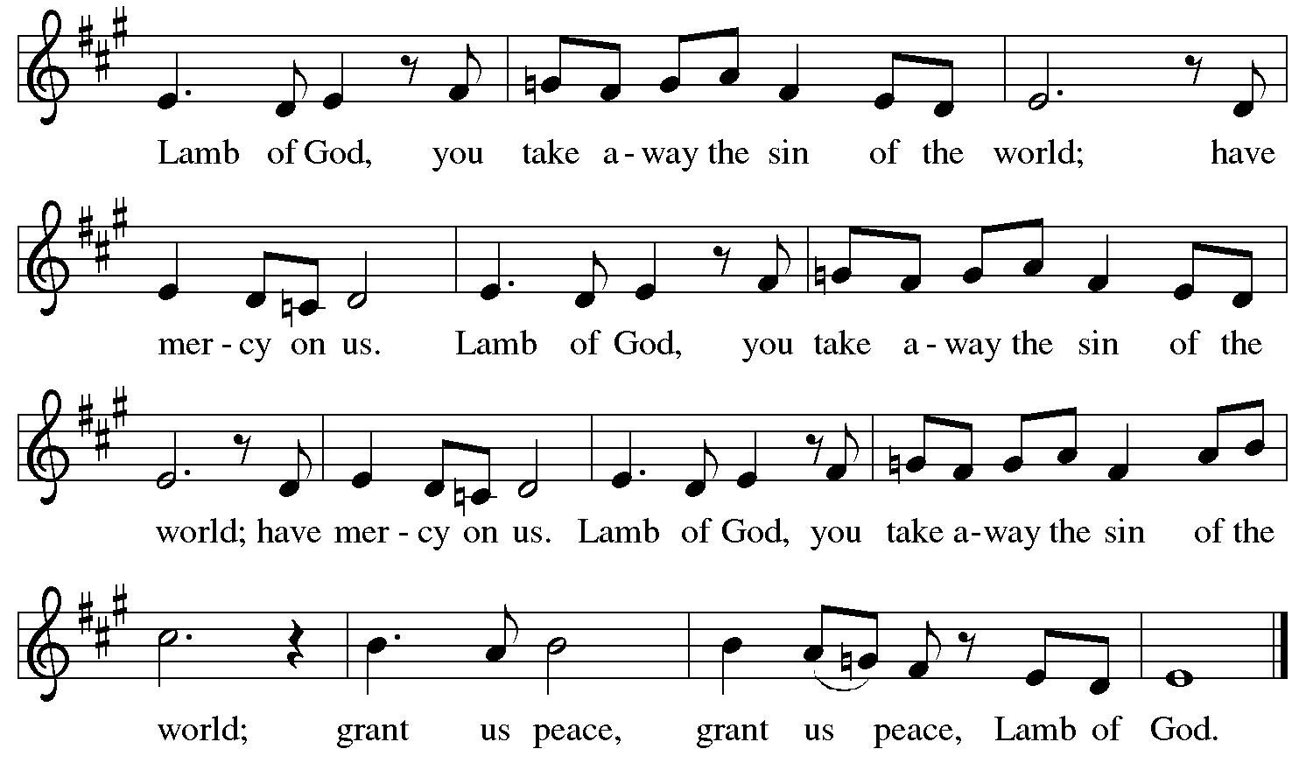

Please be seated.

Holy Communion

- All who seek God and desire a deeper and stronger life in Christ are welcome to receive Holy Communion.
- Worshipers from the pulpit side will proceed forward first, followed by the center section, and then the lectern side.
- Please inform an usher if you would like the ministers to bring Communion to you.
- Holy Communion will be served with bread and wine (amber) or grape juice (purple).
- The presiding minister will first distribute the bread (host) to each communicant. Please indicate if you require a gluten-free host.
- Once you have consumed the bread, please pick up an empty glass from the tray next to the presiding minister. The Communion Assistant will pour wine or grape juice into your glass.
- Please step to the side to consume the wine or grape juice.
- Feel free to kneel at the altar rail for prayer after receiving the sacrament.
- As you return to your pew, glasses may be returned to the empty tray on the side of the center section.
- A blessing will be provided for anyone who does not yet receive the sacrament.
- All are invited to join in singing the hymns during Holy Communion.

Hymns during Holy Communion
The Trumpets Sound, the Angels Sing ELW 531

No downloads are available. Please refer to the Evangelical Worship hymnal, # 531

Hymns during Holy Communion
Come, Thou Long-Expected Jesus ELW 254

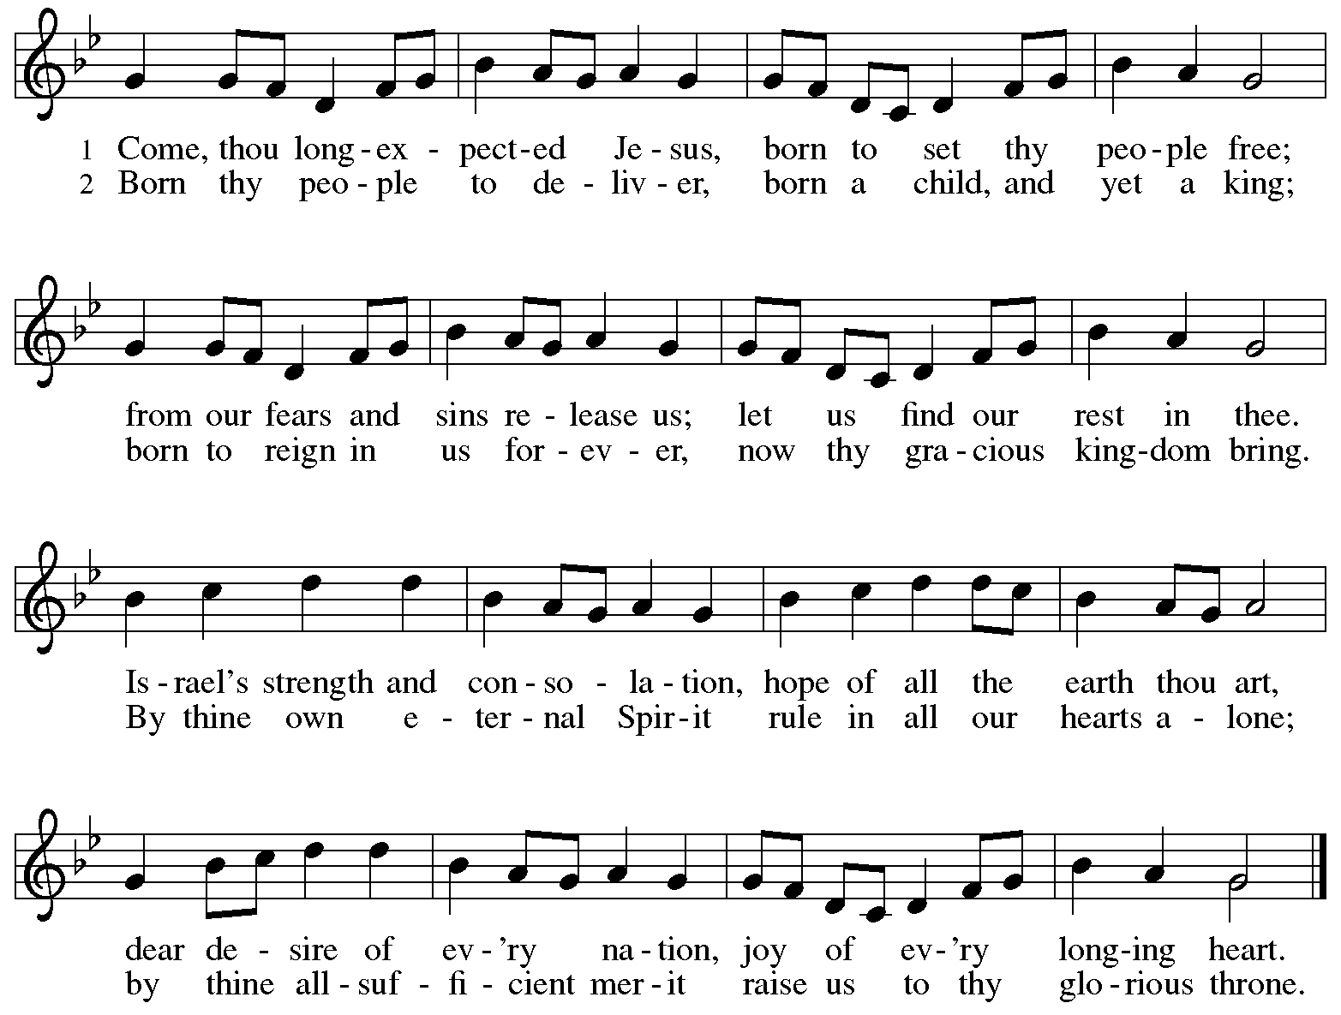

Hymns during Holy Communion ELW 808
Jésus, je voudrais te chanter – Lord Jesus, You Shall Be My Song

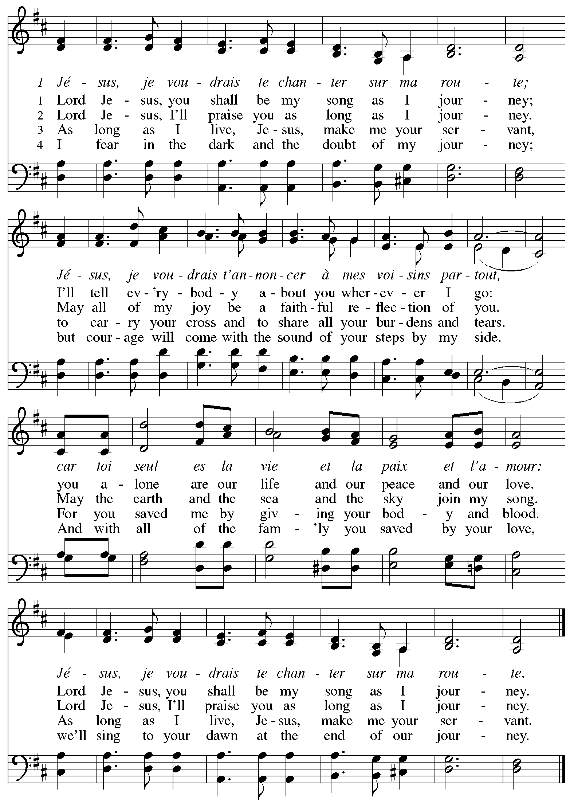

When all have returned to their places, please rise as you are able.

Blessing

P: The body and blood of our Lord Jesus Christ strengthen you and keep you in his grace.
C: Amen.

Prayer

A: Let us pray.
God for whom we wait,
in this meal you give us a foretaste of that day when the hungry will be fed with good things. Send us forth to make known your deeds and to proclaim the greatness of your name,
through Jesus Christ, our Savior and Lord.
C: Amen.

Please be seated.

Sending
God blesses us and sends us in mission to the world

Announcements

Please rise as you are able.

Benediction

P: The God of peace bless you,
the love of ☩ Christ sustain you in hope,
and the anointing of the Holy Spirit remain upon you,
now and forever.
C: Amen.

Sending Hymn Following page

Dismissal

A: Go in peace. Keep awake!
C: Thanks be to God!

Postlude

Sending Hymn Christ, Be Our Light ELW 715

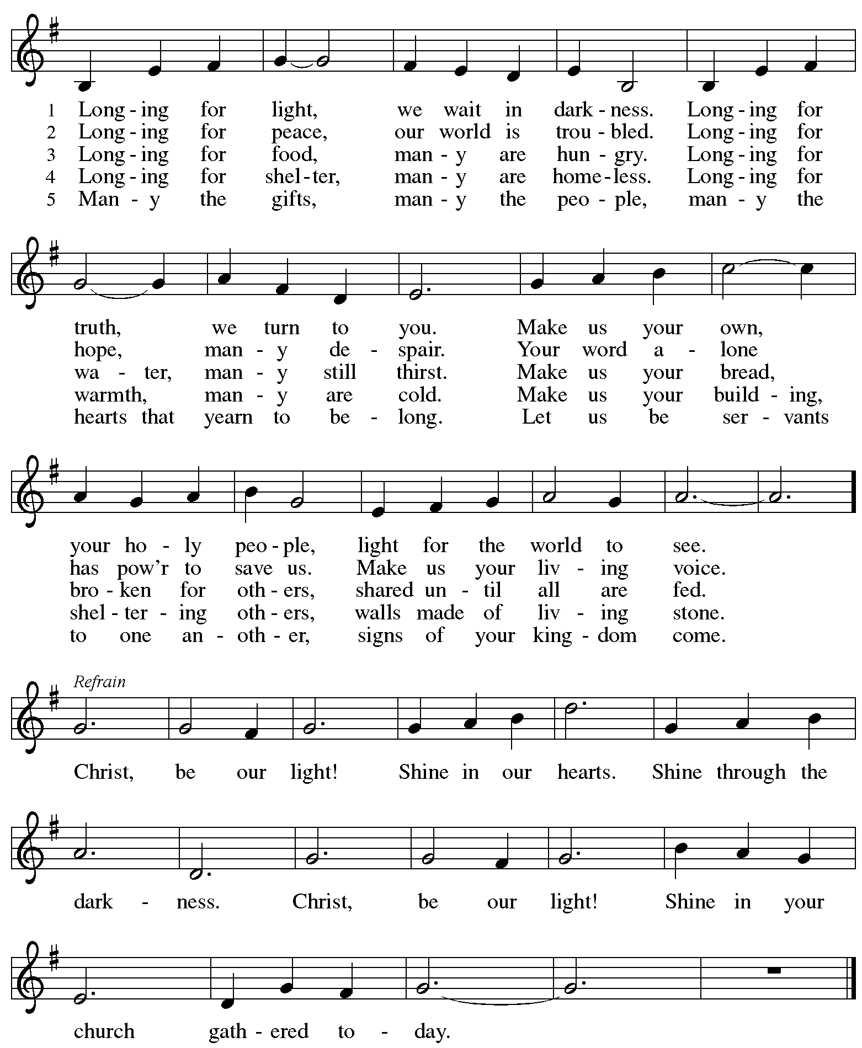

Serving in Worship Today

Altar Care Jodie Minor
Assisting Minister Timothy Kocher-Hillmer
Audio-Visual Minister Jason Galyardt
Cantor Jered Stratton
Lector Kelly Spanninger
Minister of Music Laura Reynolds
Presiding Minister The Rev. Ross Carmichael

Liturgy and Hymnody Acknowledgements

From SundaysandSeasons.com. Copyright © 2025 Augsburg Fortress. All rights reserved. Reprinted under OneLicense.net # A-722139.
Used by permission of Augsburg Fortress.

The Scripture readings contained herein are from New Revised Standard Version Updated Edition of the Bible © 2021 National Council of Churches of Christ in the United States of America. Used by permission. All rights reserved worldwide.

O Lord, How Shall I Meet You – Text: Paul Gerhardt, 1607-1676; tr. composite. Music: WIE SOLL ICH DICH EMPFANGEN, Johann Crüger, 1598-1662.

Jésus, je voudrais te chanter – Lord Jesus, You Shall Be My Song as I Journey – Text: Les Petites Soeurs de Jésus and L’Arche Community; tr. Stephen Sommerville, b. 1931. Music: LES PETITES SOUERS, Les Petites Souers de Jésus and L’Arche Community. Text and music © 1987 Les Petites Souers de Jésus, admin. Augsburg Fortress. Tr. © 1970 Stephen Sommerville, admin. Augsburg Fortress. All rights reserved. Reprinted with permission under OneLicense.net # A-722139.

Christ, Be Our Light – Text: Bernadette Farrell, b. 1957. Music: CHRIST BE OUR LIGHT, Bernadette Farrell. Text and music © 1993 Bernadette Farrell. Published by OCP Publications, 5536 NE Hassalo, Portland, OR 97213. All rights reserved. Reprinted with permission under OneLicense.net # A-722139.

Please use the QR code below to link to St. Andrew’s Announcements online!



St. Andrew Lutheran Church Announcements
November 30th, 2025

- Welcome to Worship at St. Andrew on the First Sunday of Advent – We are thankful you are here, and we offer a special welcome to all visitors and guests who are here for the first time! A nursery is available through the door to the left of the worship space and across the social hall (look for a purple room). Little Church – Big Faith, a Bible lesson and activity for children up to sixth grade, will take place after the prayer of the day. There are also worship “toolkits” to help children engage with worship and “busy bags” for younger children available in the bookcase at the back of the sanctuary. Please feel free to take one to use with/for your children. All are invited to stay for coffee and other drinks, food, and conversation in the Social Hall (through the side door at the left of the worship space) after the service.
- Welcoming the Season of Advent with an Advent Calendar – A new church year in the liturgical calendar begins with the season of Advent, a time of preparation and hope as the church awaits the celebration of Christ’s birth at Christmas and the second coming of Jesus promised in Scripture. The World Hunger ministry of the Evangelical Lutheran Church in America (ELCA) has provided an Advent calendar for congregations titled “A Stable Lamp Is Lighted.” These calendars offer daily Bible readings, suggestions for supporting our neighbors in need, and activities, including a color and cut-out Nativity scene that would be a great activity for children. There is also a three-session online study with videos available here: https://www.elca.org/our-work/relief-and-development/elca-world-hunger/wh-advent#whadventaccordionsection. Please take a calendar and study guide up at the entrances to the church!
- St. Andrew Soup and Service, Sunday, November 30th, after Worship – All are invited to gather after worship today, when we will share a soup lunch and then tie blankets to be given to Proud Haven (https://proudhaven.org/) and Humane Animal Rescue (https://humaneanimalrescue.org). People of all ages are welcome to join.
- In Loving Memory of The Rev. Dr. Paul F. Koch – In the sure and certain hope of the resurrection to eternal life through our Savior Jesus Christ, we share that The Rev. Dr. Paul Frederick Koch passed away peacefully on November 16th, 2025. He was a caring husband, devoted father, and proud grandfather whose love and gentleness anchored his family. Pastor Paul dedicated his life to ministry, justice, and caring for those at the margins. His kindness, faith, and compassion shaped everyone who knew him. A service of remembrance will be held Saturday, December 6th at St. Andrew; 10:00 a.m. Visitation, 11:00 a.m. Memorial Service, 1:00 p.m. Luncheon at Square Café (134 S. Highland Ave., Pittsburgh, PA 15206). We ask your prayers for Pastor Paul’s wife Sharon; their sons Jeremy (Molly Orlando) and Phil (Deanna); grandchildren Ben, Giovanni, Julian, Caley (Leo), and Samuel; and all their family and friends.
- Produce Distribution Supplemental Food of the Month – St. Andrew is collecting supplemental food each month to accompany our produce distribution. For this month, we ask for donations of instant mashed potatoes and stuffing mix. Next month we will be collecting peanut butter. There are collection boxes at the back of the worship space and social hall.
- December Produce Distributions, First and Third Tuesday Each Month, December 2nd and 16th, 5:30-6:30 p.m. – St. Andrew partners with Greater Pittsburgh Community Food Bank to serve as a distribution site for fresh produce on the first and third Tuesday of every month. Next month’s distributions will be on Tuesday, December 2nd and 16th. We invite people of the congregation to help with the distribution from 5:30 p.m. - 6:30 p.m. and/or to help with unloading and setup during the day between 10:00 a.m. and 1:00 p.m.
- Pittsburgh Pride Choir Winter Concert - “A Not So Silent Night," Saturday, December 6th, 7:30 p.m. – The Board of Directors of the Pittsburgh PRIDE Choir, Pittsburgh's esteemed LGBTQIA+ choir would be privileged if you attended their Holiday Concert on December 6th titled “A Not So Silent Night." The concert begins at 7:30 p.m., at East Liberty Presbyterian Church (116 S. Highland Ave), a fully affirming and inclusive venue. For tickets, you can use the following link: https://www.ticketleap.events/tickets/pittsburgh-pride-choir/a-not-so-silent-night-ppc-holiday-concert-2025. Concert details are available at www.pittsburghpridechoir.org. If you have questions, please notify them at volunteer@pittsburghpridechoir.org. Accessibility questions may be directed to accessibility@pittsburghpridechoir.org. If you would like to attend but cannot afford a ticket, contact Jay at communications@standrewpittsburgh.org for a comp ticket as she has a few to give away.
- Community Ministry Team Collecting Gifts for Foster Children Served by Allegheny County CYS, Through Dec. 7th – Allegheny County’s Office of Children, Youth, and Families of children is in need of gifts to support those who come into the system late, or who weren’t sponsored. We are collecting some highly-requested items for children in the foster system to ensure that they receive some cheer this holiday season. Please bring the following items, unwrapped, for donation: winter wear for ages 0-18, baby necessities (blankets, wipes, bottles, pacifiers, bibs), developmental toys and board books for babies and toddlers, crayons, colored pencils, gel pens, coloring books, LEGO and Mega Blok sets, board games, ethnically diverse dolls, superhero action figures, craft kits, earbuds, headphones, gaming mouse and keyboard, science/STEM kits, remote control vehicles (cars, trucks, helicopters, drones), sports equipment for ages 3-18, local sports team apparel, sensory toys (slime, kinetic sand, fidgets), makeup, toiletries (body lotion, shower gel, bath poufs, body spray), wallets, watches, and fleece blankets.
- Discipleship that Heals the World - Studies in Matthew’s Gospel, Thursdays, 8:00 - 9:00 p.m. on Zoom, through Dec. 11th, 2025 – Join us for a journey through the Gospel of Matthew, organized and facilitated by Rev. Dr. Martin Rafanan. Together we’ll explore Jesus’ Sermon on the Mount and his healing ministry, discovering Matthew’s distinctive vision of discipleship as a way of blessing, healing, and hope. You are welcome to join the zoom whenever you can. This study is designed for both newcomers to the Gospel and those already familiar with it. We will engage contemporary perspectives that help us hear Matthew’s message afresh in today’s world. Register for the sessions to receive zoom info: https://forms.gle/amy439vfUpwdJpKx7.
- Receive Prayer Team Emails – St. Andrew maintains a list of weekly prayer concerns sent by email to members of the congregation who have opted in. Our prayer team’s email is prayerteam@standrewpittsburgh.org. We will keep names on the list for a maximum of four weeks unless otherwise requested. Thank you for your ministry of prayer!
- Records Update – St. Andrew is updating our records with information from newer attendees, as well as offering current members the opportunity to include current information to be used within the congregation: for emergency contacts, to acknowledge celebrations, milestones, and prayers. Please fill out the form at: https://forms.gle/kKvp19UozuRrhhaV7.
- Coffee Hour Signups – St. Andrew provides hospitality during a coffee hour after worship each Sunday. If you would like to participate and would like information about the duties of setting up, please sign up using the following form: https://www.signupgenius.com/go/5080B4AAFAF2CABF85-47069030-coffee#/.

