

+ Twenty-Second Sunday after Pentecost
November 9, 2025



St. Andrew Lutheran Church
304 Morewood Ave.
Pittsburgh, PA 15213
St_andrewELCA@verizon.net
www.standrewpittsburgh.org

+ Twenty-Second Sunday after Pentecost
Order for Worship

We worship on the first day of the week because Jesus was raised on that day. Every Sunday is a little Easter. This Sunday feels more like Easter than many as the appointed texts celebrate the reality of the resurrection. Live it up this Lord’s day. Our God is the God of the living.

Welcome to St. Andrew!
- St. Andrew welcomes all who are seeking a place of healing, wholeness, and acceptance in a nurturing and faith-forming spiritual home. We are striving toward racial equity worldwide
and we seek to honor the lived experience of all individuals regardless of background. Our community embraces people of all ages, ethnicities, cultures, abilities, sexual orientations,
gender identities and expressions, and family constellations. Come and See!
- Worship Services are live-streamed to multiple online platforms. By attending worship, you agree that your image and voice may be broadcast.
- Everyone is invited to make a name tag at the black bookcase in the back of the worship space if they would like. There are stickers indicating pronouns on the bookcase if you would like to include them on your name tag.
- A nursery is available through the doors at the left side of the sanctuary and across from the doorway to the Social Hall. Look for a purple-colored room.
- Children are invited to attend Little Church – Big Faith, a Bible lesson and activity, during worship (after the Prayer of the Day). The group returns to the worship space for the liturgy of Holy Communion.
- Worship “toolkits” to help children engage with the service, along with “busy bags” for younger children, are available in the bookcase at the back of the sanctuary. Please feel free to take one to use with/for your children.
- Holy Communion is served with bread (gluten-free available) and wine or grape juice. The presiding minister will distribute the bread (host). Please consume this and then pick up an empty glass from the tray. The Communion Assistant will pour wine or grape juice into your glass. Please step to the side to consume the wine or grape juice. Feel free to kneel at the altar for prayer and reflection. As you return to your pew, glasses may be returned to the empty trays on either side of the center section.
- A restroom is available on the main level of the church, through the doors to the Social Hall and to the right in the main office.

Abbreviations
P: Pastor/Presiding Minister ELW: Evangelical Lutheran Worship hymnal
A: Assisting Minister ACS: All Creation Sings hymnal
L: Lector TFF: This Far by Faith hymnal
C: Congregation

Musical Offering

Each week, different people from the congregation make an offering of pre-service music, with singing or instrumentation, to help the assembly focus and pray in preparation for worship.

Welcome

Prelude Abide with Me arr. Park

Gathering
The Holy Spirit calls us together as the people of God

Please rise as you are able. All may make the sign of the cross,
the sign that is marked at Baptism, as the presiding minister begins.

Confession and Forgiveness

P: Blessed be the Holy Trinity, one ☩ God,
our maker, our help, and our keeper.
C: Amen.

P: Trusting in God’s mercy, let us confess our sins in the presence of God and one another.

Silence is kept for reflection.

P: Faithful God,
C: you have shown us the ways of your heart, yet we stray from your paths.
We are stuck in sinful systems of oppression
and do not embrace the freedom your faithful promises offer us.
We ignore our neighbors. We exploit the earth. We reject your abundance,
trusting our impulses instead of your steadfast love.
Repair our relationships, restore what we have broken, renew our hearts,
and bring us to new life.
Amen.

P: Receive the good news:
God the Faithful One loves you,
in ☩ Christ Jesus, your sins are forgiven.
and by the power of the Holy Spirit you are set free.
C: Amen.

Gathering Hymn How Small Our Span of Life ELW 636

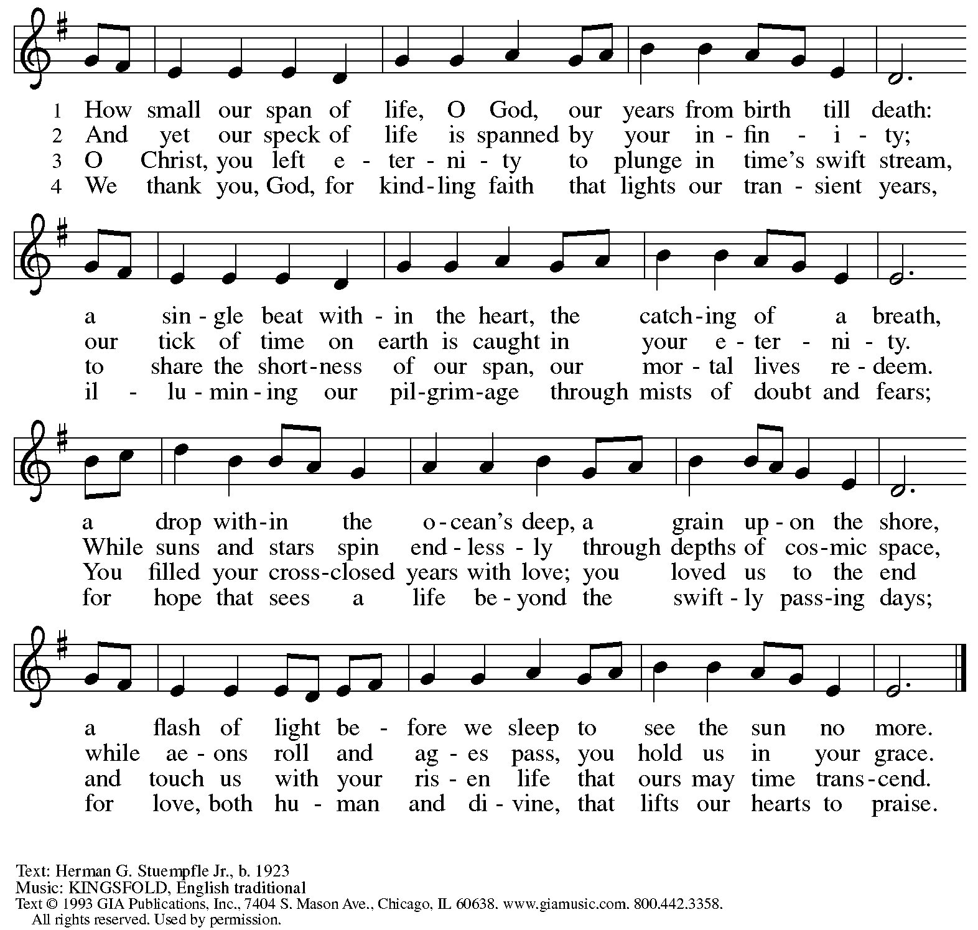
Reprinted under OneLicense.net # A-722139.

Greeting

P: The grace of our Lord Jesus Christ, the love of God,
and the communion of the Holy Spirit be with you all.
C: And also with you.

Hymn of Praise ELW p. 148

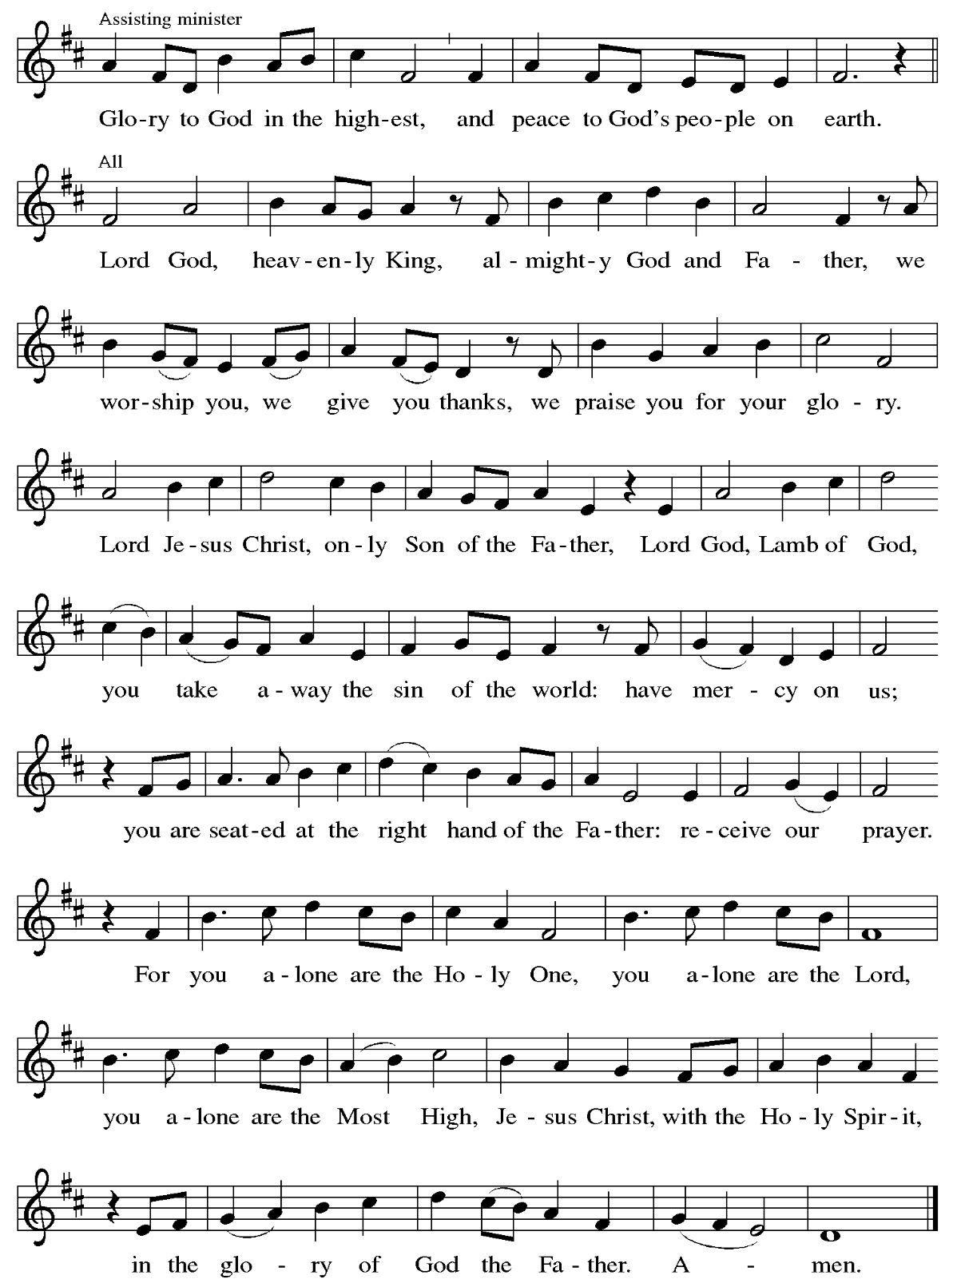

Prayer of the Day

P: The Lord be with you.
C: And also with you.
P: Let us pray.
O God, our eternal redeemer, by the presence of your Spirit you renew and direct our hearts. Keep always in our mind the end of all things and the day of judgment.
Inspire us for a holy life here, and bring us to the joy of the resurrection,
through Jesus Christ, our Savior and Lord.
C: Amen.

Please be seated.
Children are invited to join the adult leader(s) at the side door for Little Church – Big Faith.
We ask that an additional adult from the congregation attend with the children.

Word
God speaks to us in Scripture reading, preaching, and song

First Reading – Job 19: 23-27a

²³ “O that my words were written down!
O that they were inscribed in a book!
²⁴ O that with an iron pen and with lead
they were engraved on a rock forever!
²⁵ For I know that my vindicator lives
and that in the end he will stand upon the earth;
²⁶ and after my skin has been destroyed,
then in my flesh I shall see God,
^{27a} whom I shall see on my side,
and my eyes shall behold, and not another.”

L: Word of God, word of life.
C: Thanks be to God.

Psalm 17: 1-9

The psalm will be sung responsively, led by the cantor, with the congregation singing the verses in bold type and joining in the refrain.

Psalm Tone

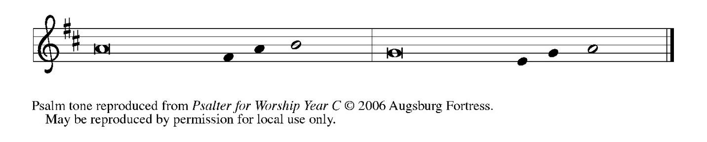

Psalm Refrain

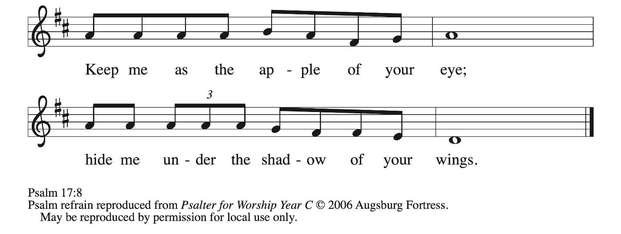

¹ Hear a just cause, O Lord; give heed | to my cry;
listen to my prayer, which does not come from | lying lips.
² Let my vindication come forth | from your presence;
let your eyes be | fixed on justice.
³ Examine my heart, visit | me by night,
melt me down; you will find no impuri- | ty in me.
⁴ I have not regarded what | others do;
at the word of your lips I have avoided the ways | of the violent. R
⁵ My footsteps hold fast to your | well-worn path;
and my feet | do not slip.
⁶ I call upon you, O God, for you will | answer me;
incline your ear to me and | hear my words.
⁷ Show me your marvelous | lovingkindness,
O Savior of those who take refuge at your right hand from those who | rise against them.
⁸ Keep me as the apple | of your eye;
hide me under the shadow | of your wings,
⁹ from the wicked | who assault me,
from my deadly enemies | who surround me. R

Second Reading – 2 Thessalonians 2: 1-5, 13-17

¹ As to the coming of our Lord Jesus Christ and our being gathered together with him, we beg you, kindred, ² not to be quickly shaken in mind or alarmed, either by spirit or by word or by letter, as though from us, to the effect that the day of the Lord is already here. ³ Let no one deceive you in any way, for that day will not come unless the rebellion comes first and the lawless one is revealed, the one destined for destruction. ⁴ He opposes and exalts himself above every so-called god or object of worship, so that he takes his seat in the temple of God, declaring himself to be God. ⁵ Do you not remember that I told you these things when I was still with you?
¹³ But we must always give thanks to God for you, siblings beloved by the Lord, because God chose you as the first fruits for salvation through sanctification by the Spirit and through belief in the truth. ¹⁴ For this purpose God called you through our gospel, so that you may obtain the glory of our Lord Jesus Christ. ¹⁵ So then, kindred, stand firm and hold fast to the traditions that you were taught by us, either by word of mouth or by our letter.
¹⁶ Now may our Lord Jesus Christ himself and God our Father, who loved us and through grace gave us eternal comfort and good hope, ¹⁷ comfort your hearts and strengthen them in every good work and word.

L: Word of God, word of life.
C: Thanks be to God.

Please rise as you are able.

Gospel Acclamation ELW p. 151

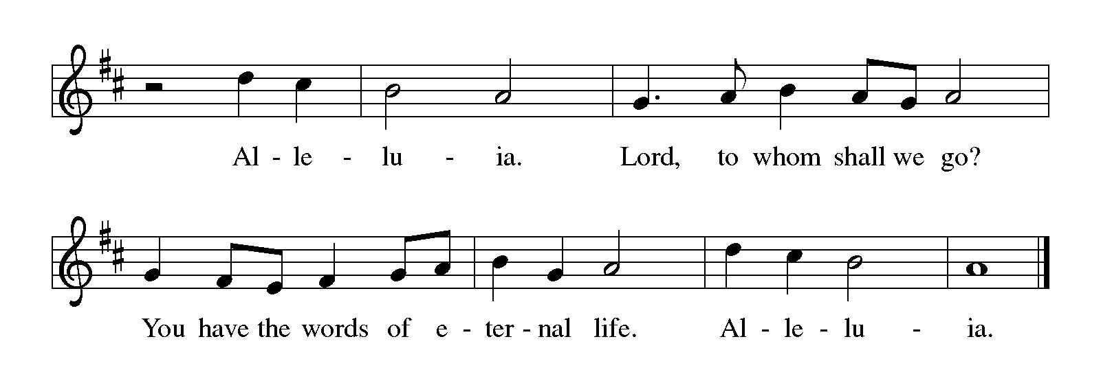

Gospel – Luke 20: 27-38

P: The holy Gospel according to St. Luke.
C: Glory to you, O Lord.

²⁷ Some Sadducees, those who say there is no resurrection, came to [Jesus] ²⁸ and asked him a question: “Teacher, Moses wrote for us that if a man’s brother dies, leaving a wife but no children, the man shall marry the widow and raise up children for his brother. ²⁹ Now there were seven brothers; the first married a woman and died childless; ³⁰ then the second ³¹ and the third married her, and so in the same way all seven died childless. ³² Finally the woman also died.
³³ In the resurrection, therefore, whose wife will the woman be? For the seven had married her.”
³⁴ Jesus said to them, “Those who belong to this age marry and are given in marriage, ³⁵ but those who are considered worthy of a place in that age and in the resurrection from the dead neither marry nor are given in marriage. ³⁶ Indeed, they cannot die anymore, because they are like angels and are children of God, being children of the resurrection. ³⁷ And the fact that the dead are raised Moses himself showed, in the story about the bush, where he speaks of the Lord as the God of Abraham, the God of Isaac, and the God of Jacob. ³⁸ Now God is God not of the dead but of the living, for to God all of them are alive.”

P: The Gospel of the Lord.
C: Praise to you, O Christ.

Please be seated.

Sermon

A time of silence for prayer and reflection follows the sermon.
When the hymn of the day begins, please rise as you are able.

Hymn of the Day Pues si vivimos – When We Are Living ELW 639

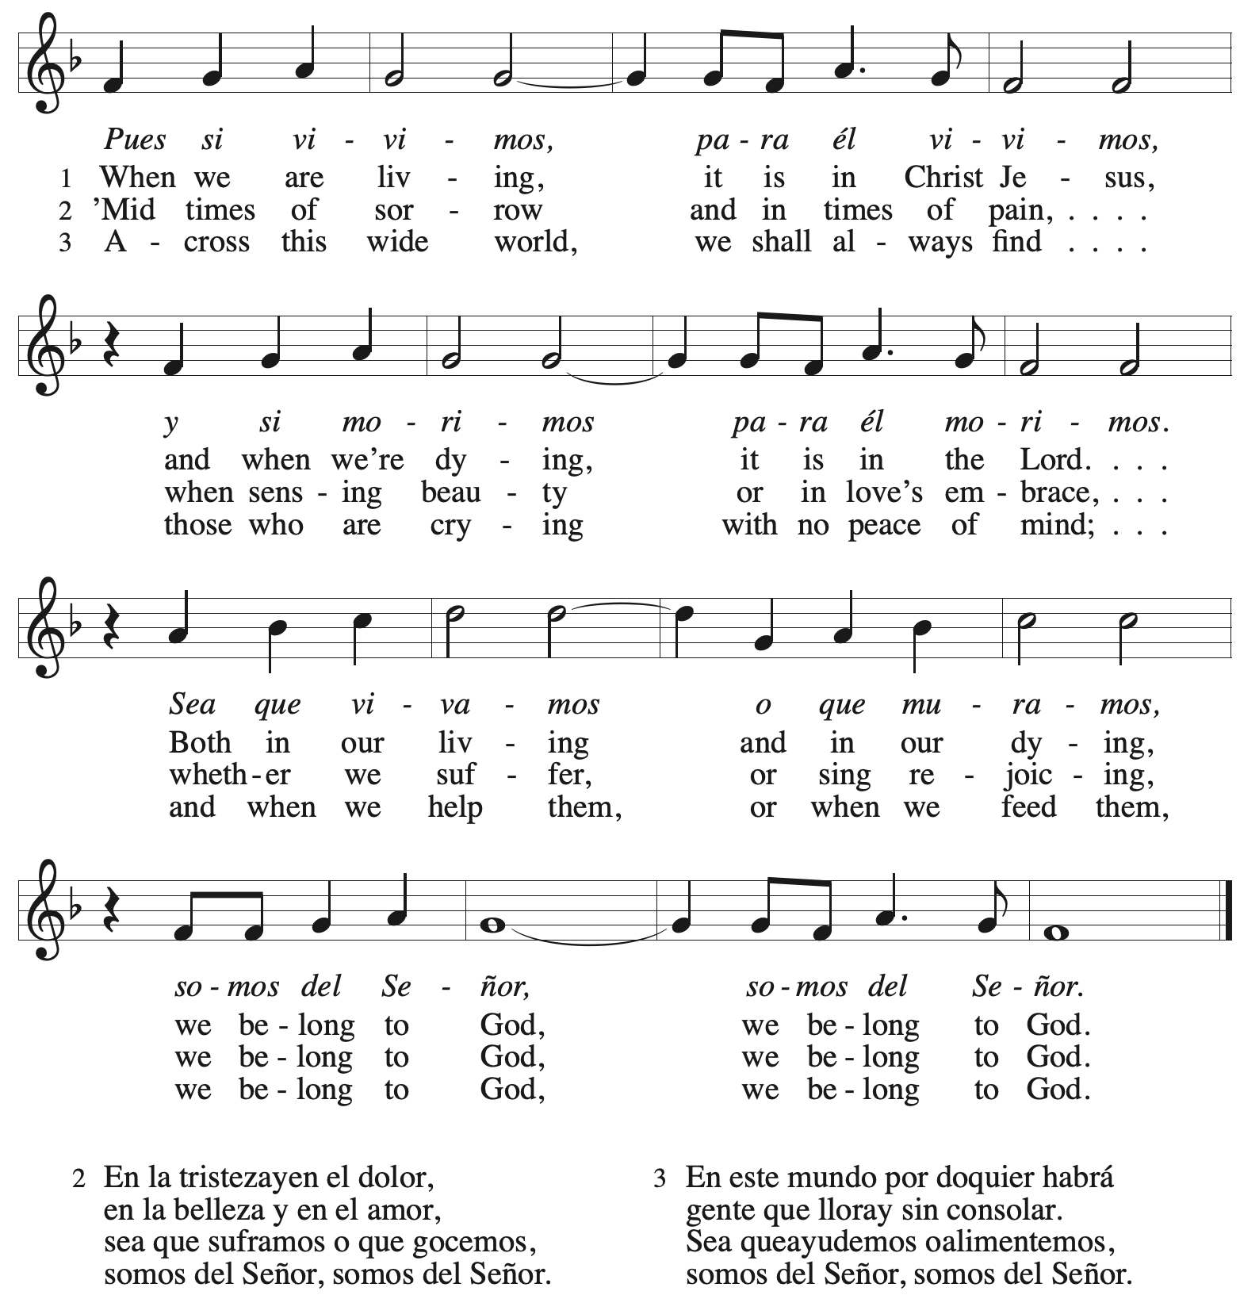

Apostles’ Creed

C: I believe in God, the Father almighty,
creator of heaven and earth.

I believe in Jesus Christ, God’s only Son, our Lord,
who was conceived by the Holy Spirit,
born of the virgin Mary,
suffered under Pontius Pilate,
was crucified, died, and was buried;
he descended to the dead.*
On the third day he rose again;
he ascended into heaven,
he is seated at the right hand of the Father,
and he will come to judge the living and the dead.

I believe in the Holy Spirit,
the holy catholic church,
the communion of saints,
the forgiveness of sins,
the resurrection of the body,
and the life everlasting. Amen.

*Or, “he descended into hell,” another translation of this text in widespread use.

Prayers of the People

A: Renewed in God’s everlasting grace, let us pray for the church, the world,
and all who are in need.

After each petition
A: God of grace,
C: receive our prayer.

P: We offer our prayers to you, O God, trusting in your abundant mercy,
through Jesus Christ our Lord.
C: Amen.

Peace

The presiding minister and the assembly greet one another in the peace of the risen Christ.
P: The peace of Christ be with you always.
C: And also with you.

The people may greet those around them with a sign of Christ’s peace and may say
Peace be with you or similar words. Please be mindful that not everyone will be comfortable with sharing the peace, so please seek consent before shaking hands or hugging. Other possible ways to share the peace include a simple bow with the verbal greeting of peace, or simply a verbal expression of peace.

When the greetings of peace have concluded, please be seated.



Meal
God feeds us with the presence of Jesus Christ

Offering

We offer ourselves, our gifts, and our faithful service to God.
As the offering is gathered for the mission of the church, including the care of those in need,
the table is set for Holy Communion.

There are laminated giving cards in the pew racks that feature a QR code for anyone who would like to give online. Those who give using the QR code, as well as those who give regularly online or through their bank are encouraged to place the laminated card in the plate as an expression of your offering.

Offertory Music Give Thanks / Now Thank We All Our God arr. Raney

As the gifts are brought forward for presentation, please rise as you are able.

Offertory Song Let the Vineyards Be Fruitful ELW 184

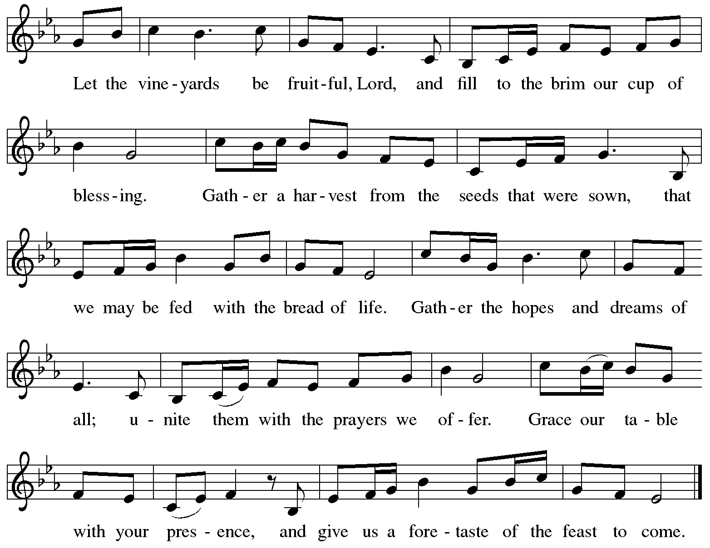
All rights reserved. Reprinted with permission under OneLicense.net # A-722139.

Offertory Prayer

A: Let us pray.
God of mercy and grace,
C: the eyes of all wait upon you,
and you open your hand in blessing.
Fill us with good things at your table,
that we may come to the help of all in need,
through Jesus Christ, our redeemer and Lord.
Amen.

Dialogue ELW p. 152

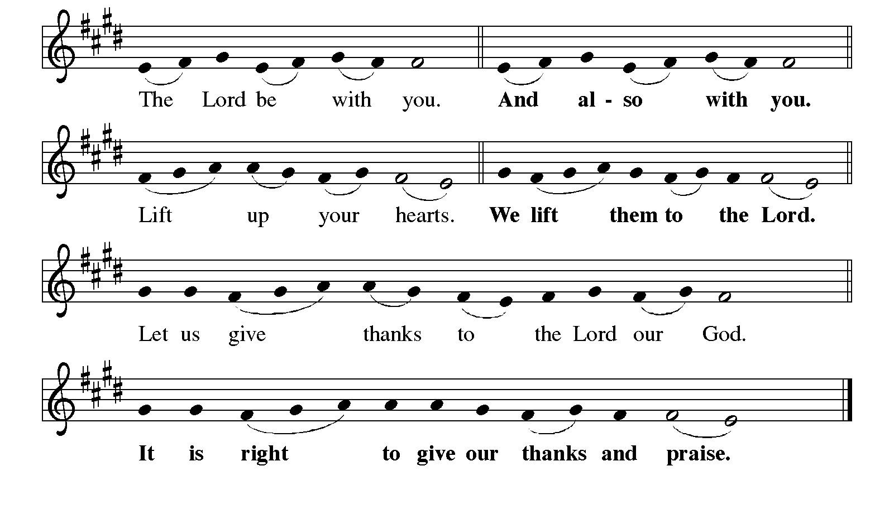

Preface

P: It is indeed right, our duty and our joy,
that we should at all times and in all places
give thanks and praise to you, almighty and merciful God,
through our Savior Jesus Christ;
who one this day overcame death and the grave,
and by his glorious resurrection opened to us the way of everlasting life.
And so, with all the choirs of angels,
with the church on earth and the hosts of heaven,
we praise your name and join their unending hymn:

Sanctus ELW p. 153

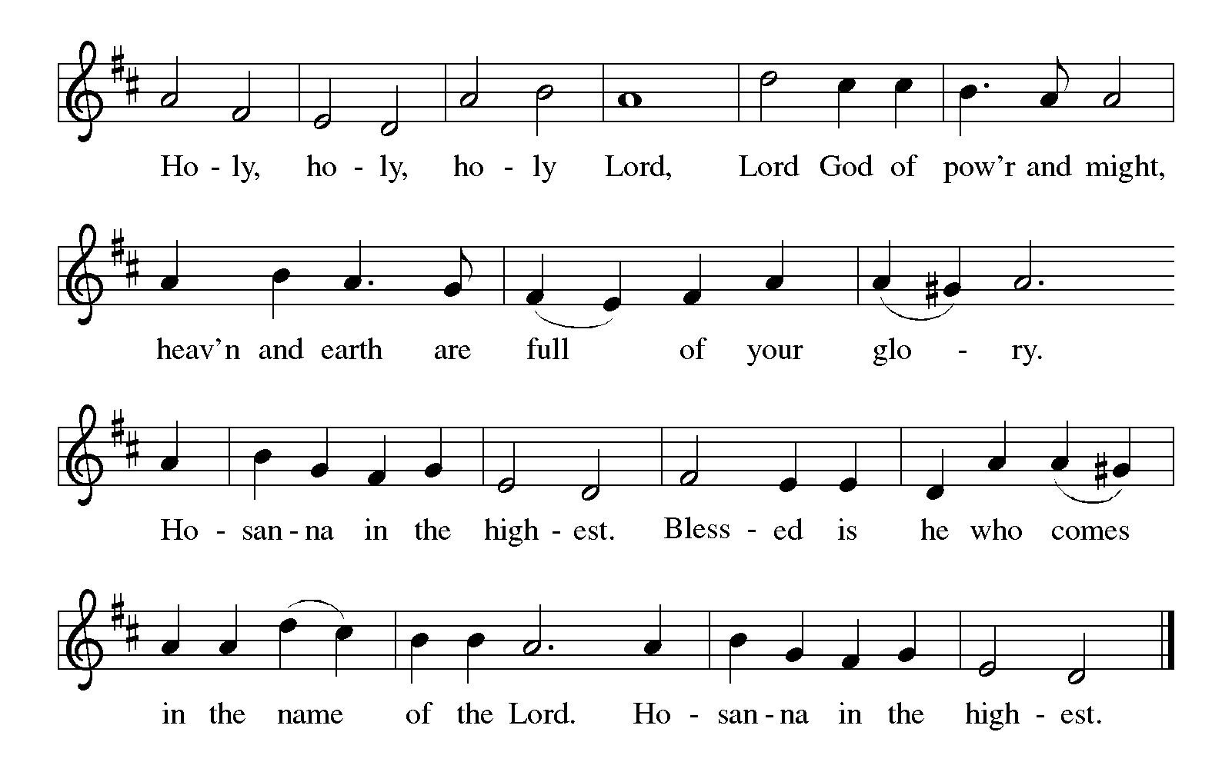
Eucharistic Prayer

P: Holy God, mighty Lord, gracious Father, …
… Do this for the remembrance of me.

For as often as we eat of this bread and drink from this cup,
we proclaim the Lord’s death until he comes.
C: Christ has died. Christ is risen. Christ will come again.

P: Therefore, O God, with this bread and cup …
… to share with us the great and promised feast.
C: Amen. Come, Lord Jesus.

P: Send now, we pray, your Holy Spirit …
… and receive our inheritance with all your saints in light.
C: Amen. Come, Holy Spirit.

P: Join our prayers …
… all glory and honor are yours, almighty Father,
now and forever.
C: Amen.
Lord’s Prayer

P: Gathered as one by the Holy Spirit, let us pray as Jesus taught us.
C: Our Father in heaven,
hallowed be your name,
your kingdom come,
your will be done,
on earth as in heaven.
Give us today our daily bread.
Forgive us our sins
as we forgive those
who sin against us.
Save us from the time of trial
and deliver us from evil.
For the kingdom, the power,
and the glory are yours,
now and forever. Amen.

Fraction and Invitation



Agnus Dei / Lamb of God ELW p. 154

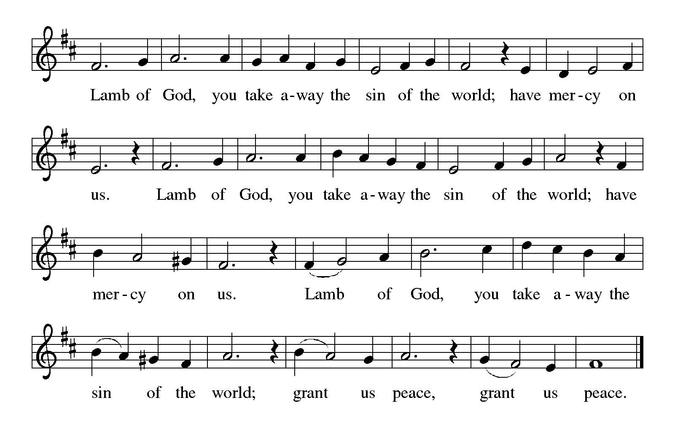

Please be seated.

Holy Communion

- All who seek God and desire a deeper and stronger life in Christ are welcome to receive Holy Communion.
- Worshipers from the pulpit side will proceed forward first, followed by the center section, and then the lectern side.
- Please inform an usher if you would like the ministers to bring Communion to you.
- Holy Communion will be served with bread and wine (amber) or grape juice (purple).
- The presiding minister will first distribute the bread (host) to each communicant. Please indicate if you require a gluten-free host.
- Once you have consumed the bread, please pick up an empty glass from the tray next to the presiding minister. The Communion Assistant will pour wine or grape juice into your glass.
- Please step to the side to consume the wine or grape juice.
- Feel free to kneel at the altar rail for prayer after receiving the sacrament.
- As you return to your pew, glasses may be returned to the empty tray on the side of the center section.
- A blessing will be provided for anyone who does not yet receive the sacrament.
- All are invited to join in singing the hymns during Holy Communion.
Hymns during Holy Communion
In Heaven Above ELW 630

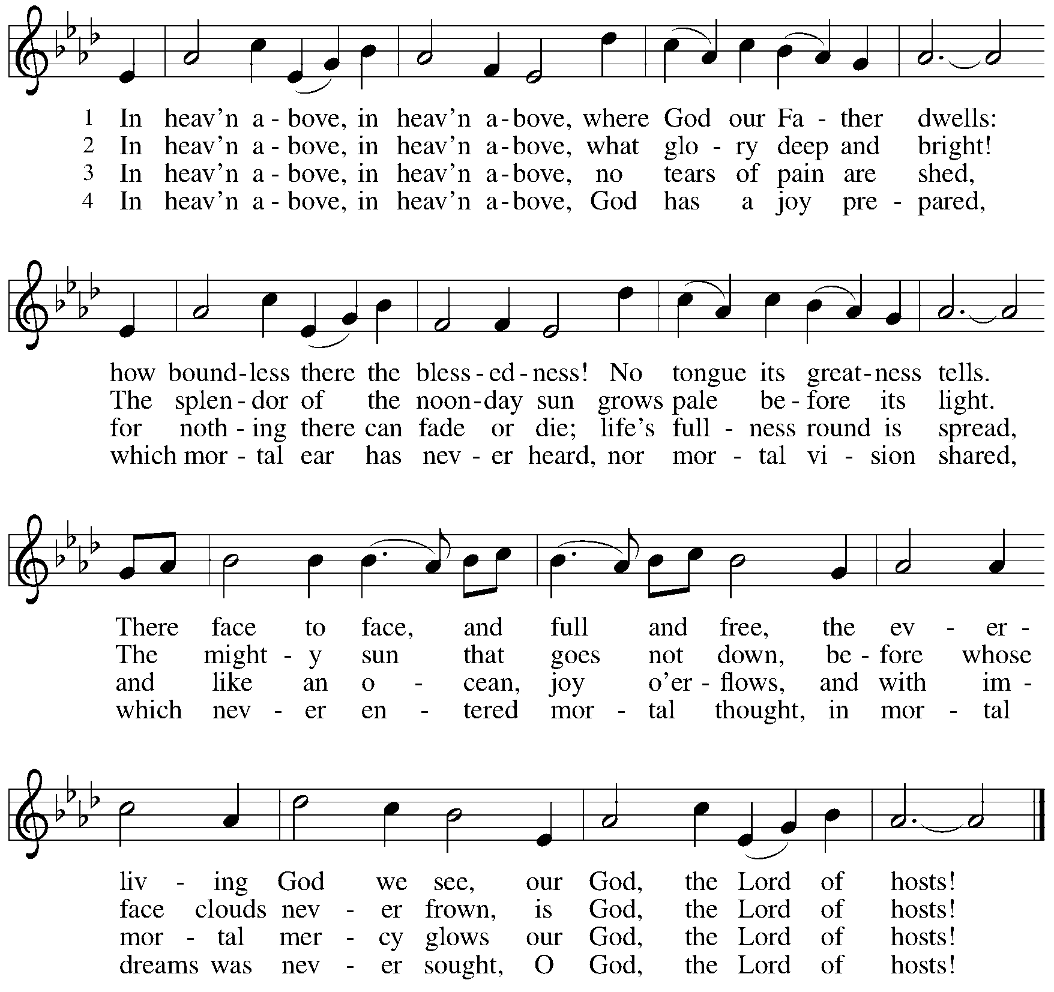

Hymns during Holy Communion
If We Live, We Live to the Lord ACS 1025

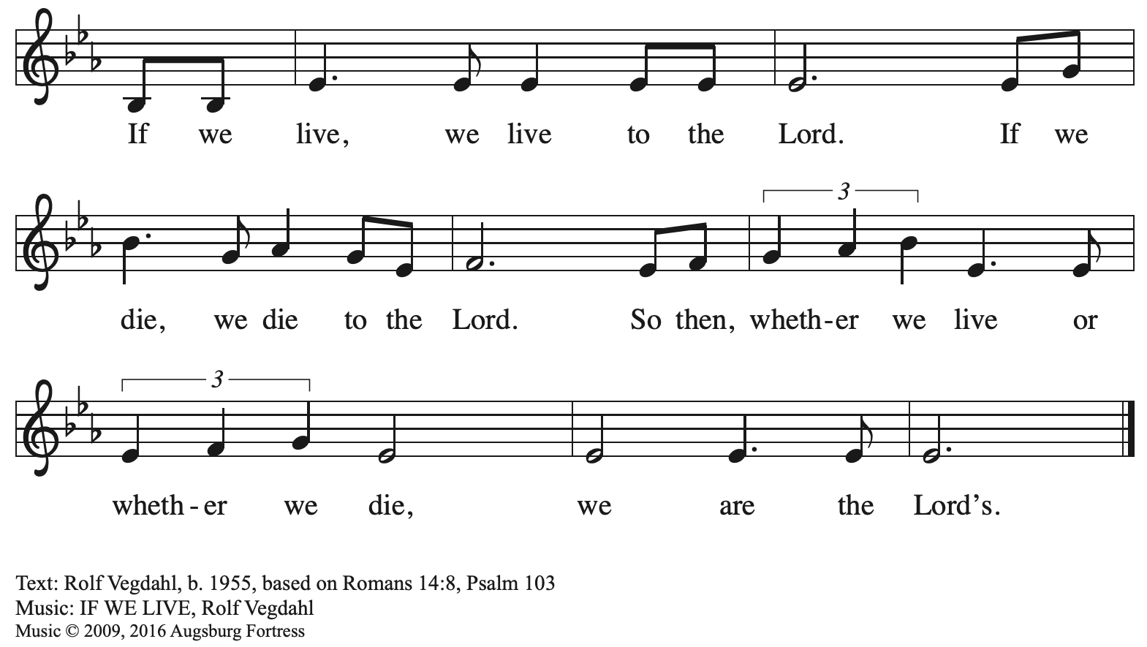
All rights reserved. Reprinted with permission under OneLicense.net # A-722139.

Hymns during Holy Communion
Blessed Assurance ELW 638

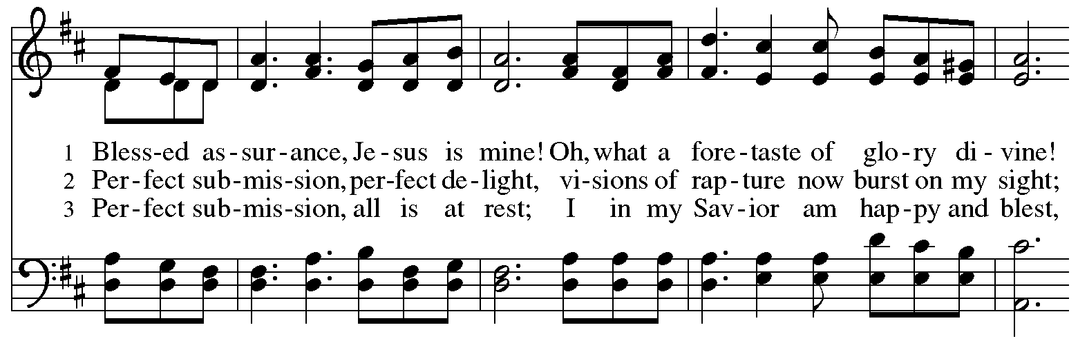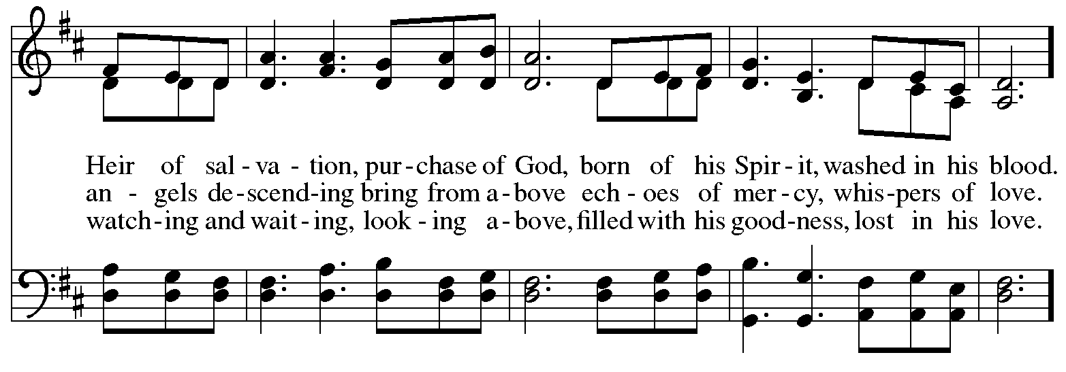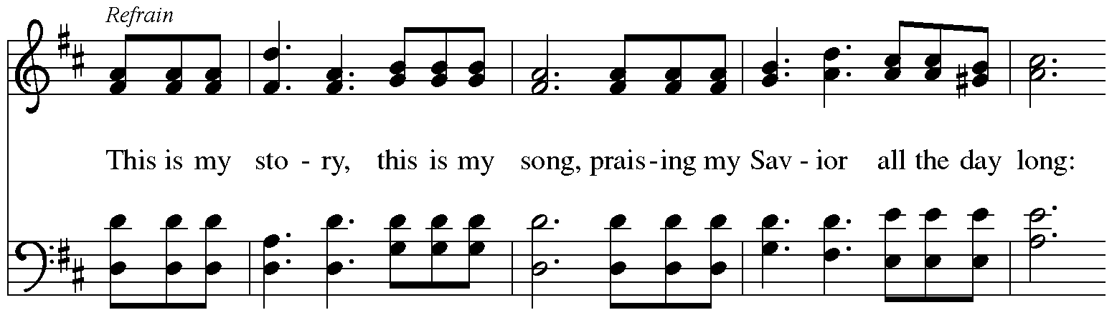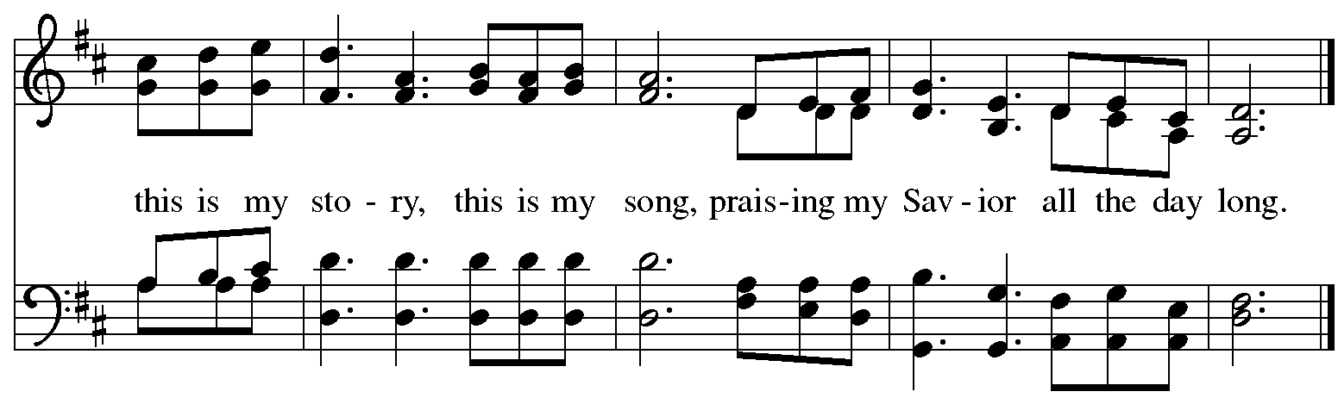
When all have returned to their places, please rise as you are able.

Blessing

P: The body and blood of our Lord Jesus Christ strengthen you and keep you in his grace.
C: Amen.

Prayer

A: Let us pray.
O God our life, our strength, our food,
we give you thanks for sustaining us with the body and blood of your Son.
By your Holy Spirit, enliven us to be the Body of Christ in the world,
that more and more we will give you praise and serve your earth and its many peoples,
through Jesus Christ, our Savior and Lord.
C: Amen.

Please be seated.

Sending
God blesses us and sends us in mission to the world

Announcements

Please rise as you are able.

Benediction

P: The love of God the Sovereign strengthen you,
God the Son save you,
and the Holy Spirit anoint and sustain you.

The Holy Trinity ☩ bless you
and grant you a faithful and courageous heart,
now and forever.
C: Amen.

Sending Hymn Following page

Sending Hymn I Know That My Redeemer Lives! ELW 619
v. 1-4, 8

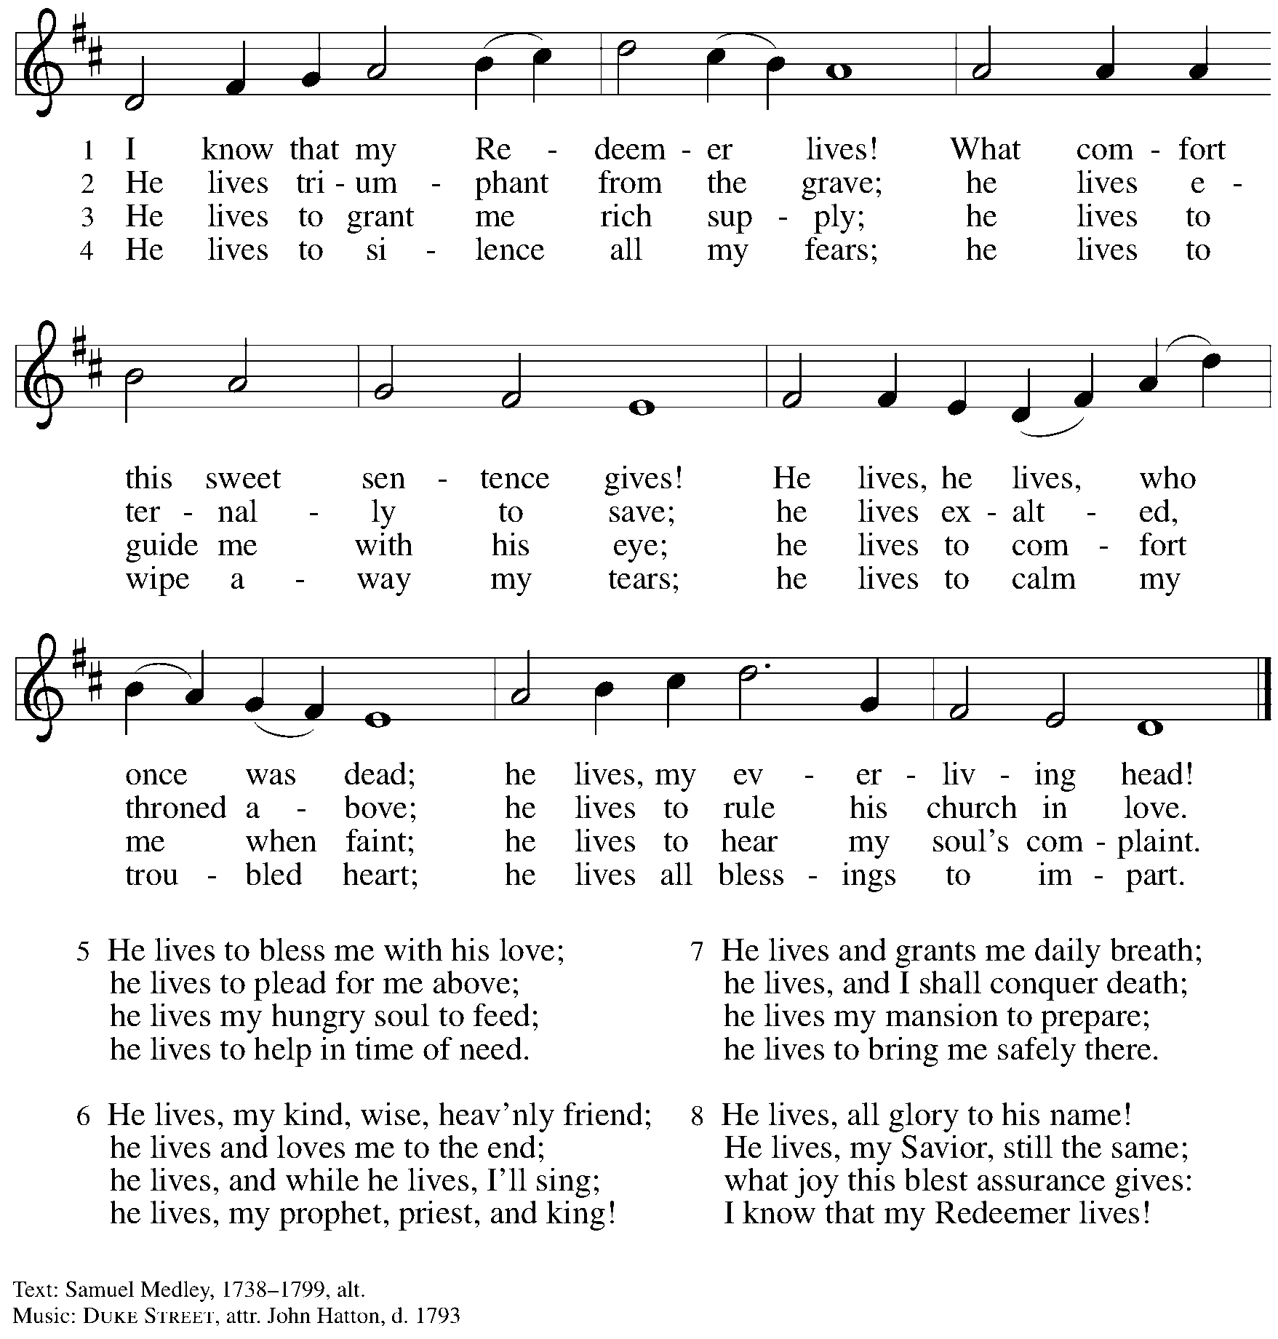

Dismissal

A: Go in peace. Serve the Lord.
C: Thanks be to God!

Postlude
Serving in Worship Today

Altar Care Christy Ruhe
Assisting Minister Jimmi Kocher-Hillmer
Audio-Visual Ministers Kristen Asplin
Tyler Rietze
Cantor Dave Rollinson
Lector Brennan Coleman
Minister of Music Laura Reynolds
Presiding Minister The Rev. Ross Carmichael

Liturgy and Hymnody Acknowledgements

From SundaysandSeasons.com. Copyright © 2025 Augsburg Fortress. All rights reserved. Reprinted under OneLicense.net # A-722139.
Used by permission of Augsburg Fortress.

The Scripture readings contained herein are from New Revised Standard Version Updated Edition of the Bible © 2021 National Council of Churches of Christ in the United States of America. Used by permission. All rights reserved worldwide.

Pues si vivimos – When We Are Living – Text: st. 1, based on Romans 14: 8; tr. Elise S. Eslinger, b. 1942; sts. 2-3, Roberto Escamilla, b. 1931; tr. George Lockwood, b. 1946. Music: SOMOS DEL SEÑOR, Spanish traditional. Spanish text, sts. 2-3 © 1983 Abingdon Press and tr. © 1989 The United Methodist Publishing House, admin. The Copyright Company. All rights reserved. Reprinted with permission under OneLicense.net # A-722139.

Blessed Assurance – Text: Fanny J. Crosby, 1820-1915. Music: ASSURANCE, Phoebe P. Knapp, 1830-1908.

Please use the QR code below to link to St. Andrew’s Announcements online!



St. Andrew Lutheran Church Announcements
November 9th, 2025

- Welcome to Worship at St. Andrew on the Twenty-Second Sunday after Pentecost – We are so glad you are here, and we offer a special welcome to all visitors and guests who are here for the first time! A nursery is available through the door to the left of the worship space and across the social hall (look for a purple room). Little Church – Big Faith, a Bible lesson and activity for children up to sixth grade, will take place after the prayer of the day. There are also worship “toolkits” to help children engage with worship and “busy bags” for younger children available in the bookcase at the back of the sanctuary. Please feel free to take one to use with/for your children. All are invited to stay for coffee and other drinks, food, and conversation in the Social Hall (through the side door at the left of the worship space) after the service.
- Noisy Offering Next Sunday During Worship – On the third Sunday of each month, St. Andrew’s children lead the congregation in a Noisy Offering, in which people are invited to throw their change into buckets that the children carry around the church and bring forward as an additional offering. Each month’s Noisy Offering supports a local, national, or international church-related or otherwise charitable organization. This week’s offering is supporting the Greater Pittsburgh Community Food Bank. Their mission is to leverage the power of community to achieve lasting solutions to hunger and its root causes. For more information, please visit: https://pittsburghfoodbank.org/what-we-do/how-we-work/.
- Kristallnacht Commemoration at Rodef Shalom Congregation, Monday, November 10th at 6:30 p.m. – Join the Holocaust Center of Pittsburgh for our annual Kristallnacht commemoration featuring a 20 minute film screening of Harbor from the Holocaust, which tells the story of nearly 20,000 Jewish refugees who fled Nazi-occupied Europe during World War II to the Chinese port city of Shanghai. The film will be followed by a discussion with Iris Samson, co-producer of Harbor from the Holocaust, and Cindy Berg-Vayonis, whose parents and grandparents found refuge in the Shanghai Ghetto and survived the Holocaust. You can learn more and register for the event here: https://www.eventbrite.com/e/1758226174819?aff=oddtdtcreator.
- Produce Distribution Supplemental Food of the Month – St. Andrew has begun collecting supplemental food each month to accompany our produce distribution. For the upcoming month, we ask for donations of instant mashed potatoes and stuffing mix. There are collection boxes at the back of the worship space and social hall.
- Additional November Produce Distribution, Third Tuesday of the Month, November 18th, 5:30-6:30 p.m. – St. Andrew is pleased to announce that we are adding a second produce distribution on the third Tuesday of each month. We invite people of the congregation to help with the distribution from 5:30 p.m. - 6:30 p.m. and/or to help with unloading and setup during the day between 10:00 a.m. and 1:00 p.m.
- November Shelter Dinner for Guests of East End Cooperative Ministry, Third Thursday of the Month, November 20th, 6:30 p.m. – Each month, people of St. Andrew provide dinner for guests of East End Cooperative Ministry (EECM), 6140 Station St. (East Liberty), 15206. We invite you to prepare or purchase one menu item and bring it to the shelter by 6:00 p.m., or just come to help serve at 6:30 p.m. If you would like to contribute, please sign up at: https://www.signupgenius.com/go/5080544AAAC22A1F58-59953094-shelter.
- East End Interfaith Thanksgiving Service, Tuesday, November 25th, 7:00 p.m. – This year's East End Interfaith Thanksgiving Service, with the theme Lift Every Voice, will be held at Episcopal Church of the Redeemer at 5700 Forbes Ave., Pittsburgh, PA 15217 and will be co-hosted by leaders of the Hindu-Jain Temple in Monroeville. Following the service, all are welcome to a light reception in the Parish Hall. As part of our Thanksgiving offering, we invite all attendees to bring a non-perishable food item or toiletry as an offering to support our immigrant neighbors through JFCS.
- St. Andrew Soup and Service, Sunday, November 30th, after Worship – All are invited to gather after worship on Sunday, November 30th, when we will share a soup lunch and then tie blankets to be given to Proud Haven (https://proudhaven.org/) and Humane Animal Rescue (https://humaneanimalrescue.org). People of all ages are welcome to join.
- Discipleship that Heals the World - Studies in Matthew’s Gospel, Thursdays, 8:00 - 9:00 p.m. on Zoom, through Dec. 11th, 2025 – Join us for a 11-week journey through the Gospel of Matthew, organized and facilitated by Rev. Dr. Martin Rafanan. Together we’ll explore Jesus’ Sermon on the Mount and his healing ministry, discovering Matthew’s distinctive vision of discipleship as a way of blessing, healing, and hope. You are welcome to join the zoom whenever you can. This study is designed for both newcomers to the Gospel and those already familiar with it. We will engage contemporary perspectives – feminist, liberationist, and wisdom teacher readings – that help us hear Matthew’s message afresh in today’s world. Register for the sessions to receive zoom info: https://forms.gle/amy439vfUpwdJpKx7.
- Community Ministry Team Collecting Gifts for Foster Children Served by Allegheny County CYS, Through Dec. 7th – Allegheny County’s Office of Children, Youth, and Families of children is in need of gifts to support those who come into the system late, or who weren’t sponsored. We are collecting some highly-requested items for children in the foster system to ensure that they receive some cheer this holiday season. Please bring the following items, unwrapped, for donation: winter wear for ages 0-18, baby necessities (blankets, wipes, bottles, pacifiers, bibs), developmental toys and board books for babies and toddlers, crayons, colored pencils, gel pens, coloring books, LEGO and Mega Blok sets, board games, ethnically diverse dolls, superhero action figures, craft kits, earbuds, headphones, gaming mouse and keyboard, science/STEM kits, remote control vehicles (cars, trucks, helicopters, drones), sports equipment for ages 3-18, Steelers/Penguins/Pirates apparel, sensory toys (slime, kinetic sand, fidgets), makeup, toiletries (body lotion, shower gel, bath poufs, body spray), wallets, watches, and fleece blankets.
- Pittsburgh Pride Choir Winter Concert - “A Not So Silent Night," Saturday, December 6th, 7:30 p.m. – The Board of Directors of the Pittsburgh PRIDE Choir, Pittsburgh's esteemed LGBTQIA+ choir (formally known as the Renaissance City Choir), acknowledges and thanks you for your unwavering support and advocacy on behalf of our local LGBTQIA+ community. The Holiday Season approaches rapidly and we would be privileged if you joined us for our Holiday Concert on December 6th titled “A Not So Silent Night." The concert begins at 7:30 p.m., at East Liberty Presbyterian Church (116 S. Highland Ave), a fully affirming and inclusive venue. You will be sure to find a toe-tapping number or two during this holiday compilation. For tickets, you can use the following link: https://www.ticketleap.events/tickets/pittsburgh-pride-choir/a-not-so-silent-night-ppc-holiday-concert-2025. Concert details are available at www.pittsburghpridechoir.org. If you have questions, please notify us at volunteer@pittsburghpridechoir.org so they can accommodate your needs. Additional accessibility questions may be directed to accessibility@pittsburghpridechoir.org. If you would like to attend but cannot afford a ticket, please reach out to Jay at communications@standrewpittsburgh.org for a comp ticket as she has a few to give away.
- Receive Prayer Team Emails – St. Andrew maintains a list of weekly prayer concerns sent by email to members of the congregation who have opted in. Our prayer team’s email is prayerteam@standrewpittsburgh.org. We will keep names on the list for a maximum of four weeks unless otherwise requested. Thank you for your ministry of prayer!
- Records Update – St. Andrew is updating our records with information from newer attendees, as well as offering current members the opportunity to include current information to be used within the congregation: for emergency contacts, to acknowledge celebrations, milestones, and prayers. Please fill out the form at: https://forms.gle/kKvp19UozuRrhhaV7.
- Coffee Hour Signups – St. Andrew provides hospitality during a coffee hour after worship each Sunday. If you would like to participate and would like information about the duties of setting up, please sign up using the following form: https://www.signupgenius.com/go/5080B4AAFAF2CABF85-47069030-coffee#/.

