

+ Twenty-Third Sunday after Pentecost
November 16, 2025



St. Andrew Lutheran Church
304 Morewood Ave.
Pittsburgh, PA 15213
St_andrewELCA@verizon.net
www.standrewpittsburgh.org

+ Twenty-Third Sunday after Pentecost
Order for Worship

Warnings about the end times dominate this week’s readings. The tone is ominous.
But the baptized know how to live in the meantime. The baptized are strengthened for the living of these days in word and sacrament. The baptized rally around the invitation of the apostle: “Do not be weary in doing what is right.”

Welcome to St. Andrew!
- St. Andrew welcomes all who are seeking a place of healing, wholeness, and acceptance in a nurturing and faith-forming spiritual home. We are striving toward racial equity worldwide
and we seek to honor the lived experience of all individuals regardless of background. Our community embraces people of all ages, ethnicities, cultures, abilities, sexual orientations,
gender identities and expressions, and family constellations. Come and See!
- Worship Services are live-streamed to multiple online platforms. By attending worship, you agree that your image and voice may be broadcast.
- Everyone is invited to make a name tag at the black bookcase in the back of the worship space if they would like. There are stickers indicating pronouns on the bookcase if you would like to include them on your name tag.
- A nursery is available through the doors at the left side of the sanctuary and across from the doorway to the Social Hall. Look for a purple-colored room.
- Children are invited to attend Little Church – Big Faith, a Bible lesson and activity, during worship (after the Prayer of the Day). The group returns to the worship space for the liturgy of Holy Communion.
- Worship “toolkits” to help children engage with the service, along with “busy bags” for younger children, are available in the bookcase at the back of the sanctuary. Please feel free to take one to use with/for your children.
- Holy Communion is served with bread (gluten-free available) and wine or grape juice. The presiding minister will distribute the bread (host). Please consume this and then pick up an empty glass from the tray. The Communion Assistant will pour wine or grape juice into your glass. Please step to the side to consume the wine or grape juice. Feel free to kneel at the altar for prayer and reflection. As you return to your pew, glasses may be returned to the empty trays on either side of the center section.
- A restroom is available on the main level of the church, through the doors to the Social Hall and to the right in the main office.

Abbreviations
P: Pastor/Presiding Minister ELW: Evangelical Lutheran Worship hymnal
A: Assisting Minister ACS: All Creation Sings hymnal
L: Lector TFF: This Far by Faith hymnal
C: Congregation

Musical Offering

Each week, different people from the congregation make an offering of pre-service music, with singing or instrumentation, to help the assembly focus and pray in preparation for worship.

Welcome

Prelude In Christ There Is No East or West Reinagle/arr. Hayes

Gathering
The Holy Spirit calls us together as the people of God

Please rise as you are able. All may make the sign of the cross,
the sign that is marked at Baptism, as the presiding minister begins.

Confession and Forgiveness

P: Blessed be the Holy Trinity, one ☩ God,
our maker, our help, and our keeper.
C: Amen.

P: Trusting in God’s mercy, let us confess our sins in the presence of God and one another.

Silence is kept for reflection.

P: Faithful God,
C: you have shown us the ways of your heart, yet we stray from your paths.
We are stuck in sinful systems of oppression
and do not embrace the freedom your faithful promises offer us.
We ignore our neighbors. We exploit the earth. We reject your abundance,
trusting our impulses instead of your steadfast love.
Repair our relationships, restore what we have broken, renew our hearts,
and bring us to new life.
Amen.

P: Receive the good news:
God the Faithful One loves you,
in ☩ Christ Jesus, your sins are forgiven.
and by the power of the Holy Spirit you are set free.
C: Amen.

Gathering Hymn How Firm a Foundation ELW 796

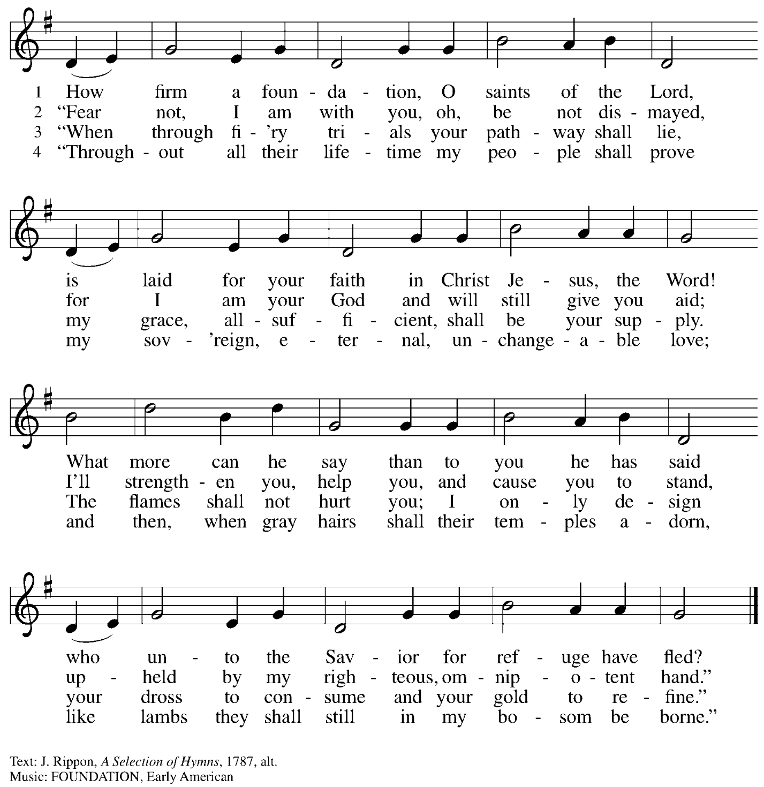

Greeting

P: The grace of our Lord Jesus Christ, the love of God,
and the communion of the Holy Spirit be with you all.
C: And also with you.

Hymn of Praise ELW p. 148
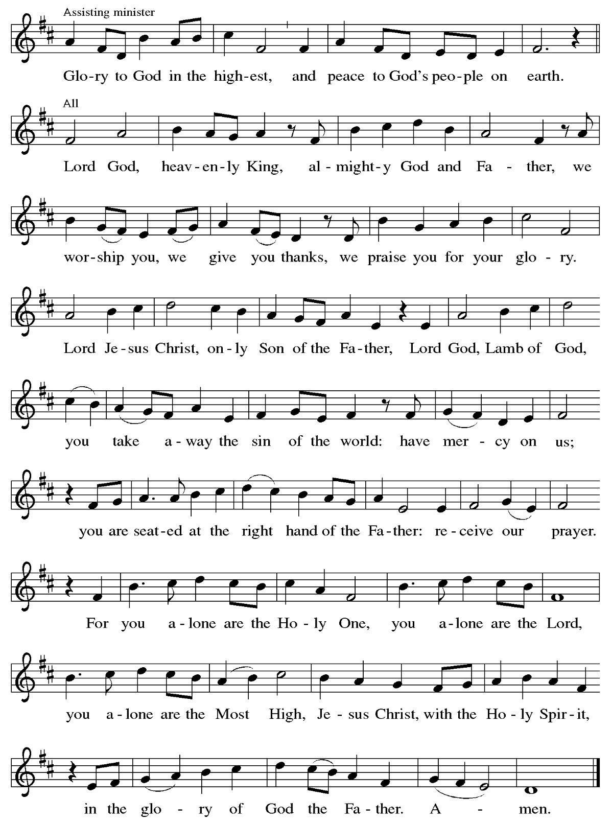

Prayer of the Day

P: The Lord be with you.
C: And also with you.

P: Let us pray.
O God, the protector of all who trust in you,
without you nothing is strong, nothing is holy.
Embrace us with your mercy, that with you as our ruler and guide,
we may live through what is temporary without losing what is eternal,
through Jesus Christ, our Savior and Lord.
C: Amen.

Please be seated.
Children are invited to join the adult leader(s) at the side door for Little Church – Big Faith.
We ask that an additional adult from the congregation attend with the children.

Word
God speaks to us in Scripture reading, preaching, and song

First Reading – Malachi 4: 1-2a

¹ See, the day is coming, burning like an oven, when all the arrogant and all evildoers will be stubble; the day that comes shall burn them up, says the Lord of hosts, so that it will leave them neither root nor branch. ^{2a} But for you who revere my name the sun of righteousness shall rise, with healing in its wings.

L: Word of God, word of life.
C: Thanks be to God.

Psalm Earth and All Stars! ELW 731

In the spirit of Psalm 98, the appointed psalm for the day, the congregation is invited to join
in singing the hymn Earth and All Stars!, ELW 731.


Psalm Earth and All Stars! ELW 731

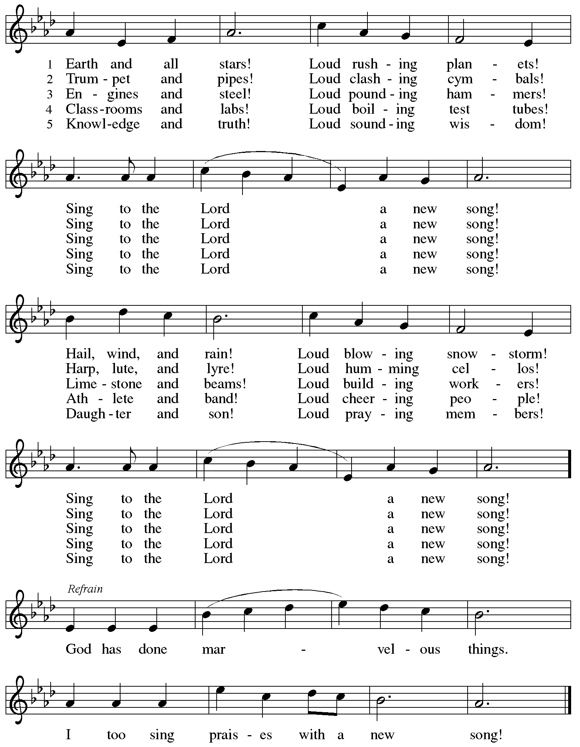
Second Reading – 2 Thessalonians 3: 6-13

⁶ Now we command you, kindred, in the name of our Lord Jesus Christ, to keep away from every sibling living irresponsibly and not according to the tradition that they received from us. ⁷ For you yourselves know how you ought to imitate us; we were not irresponsible when we were with you, ⁸ and we did not eat anyone’s bread without paying for it, but with toil and labor we worked night and day so that we might not burden any of you. ⁹ This was not because we do not have that right but in order to give you an example to imitate. ¹⁰ For even when we were with you, we gave you this command: anyone unwilling to work should not eat. ¹¹ For we hear that some of you are living irresponsibly, mere busybodies, not doing any work. ¹² Now such persons we command and exhort in the Lord Jesus Christ to do their work quietly and to earn their own living. ¹³ Kindred, do not be weary in doing what is right.

L: Word of God, word of life.
C: Thanks be to God.

Please rise as you are able.

Gospel Acclamation ELW p. 151

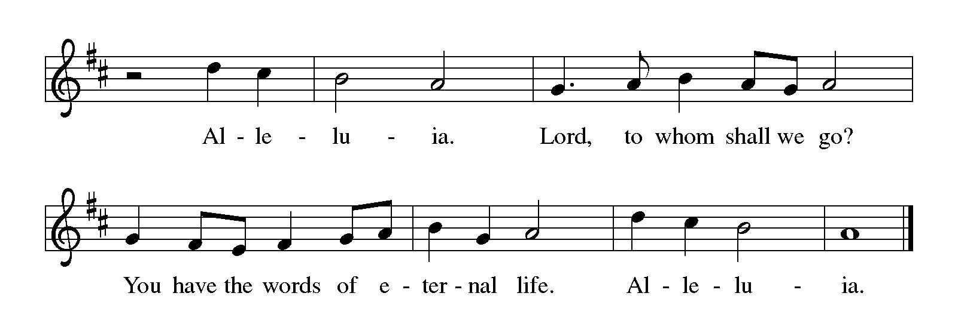

Gospel – Luke 21: 5-19

P: The holy Gospel according to St. Luke.
C: Glory to you, O Lord.

⁵ When some were speaking about the temple, how it was adorned with beautiful stones and gifts dedicated to God, [Jesus] said, ⁶ “As for these things that you see, the days will come when not one stone will be left upon another; all will be thrown down.”
⁷ They asked him, “Teacher, when will this be, and what will be the sign that this is about to take place?” ⁸ And he said, “Beware that you are not led astray, for many will come in my name and say, ‘I am he!’ and, ‘The time is near!’ Do not go after them.
⁹ “When you hear of wars and insurrections, do not be terrified, for these things must take place first, but the end will not follow immediately.” ¹⁰ Then he said to them, “Nation will rise against nation and kingdom against kingdom; ¹¹ there will be great earthquakes and in various places famines and plagues, and there will be dreadful portents and great signs from heaven.
¹² “But before all this occurs, they will arrest you and persecute you; they will hand you over to synagogues and prisons, and you will be brought before kings and governors because of my name. ¹³ This will give you an opportunity to testify. ¹⁴ So make up your minds not to prepare your defense in advance, ¹⁵ for I will give you words and a wisdom that none of your opponents will be able to withstand or contradict. ¹⁶ You will be betrayed even by parents and siblings, by relatives and friends, and they will put some of you to death. ¹⁷ You will be hated by all because of my name. ¹⁸ But not a hair of your head will perish. ¹⁹ By your endurance you will gain your souls.”

P: The Gospel of the Lord.
C: Praise to you, O Christ.

Please be seated.

Sermon

A time of silence for prayer and reflection follows the sermon.
When the hymn of the day begins, please rise as you are able.



Hymn of the Day By Gracious Powers ELW 626

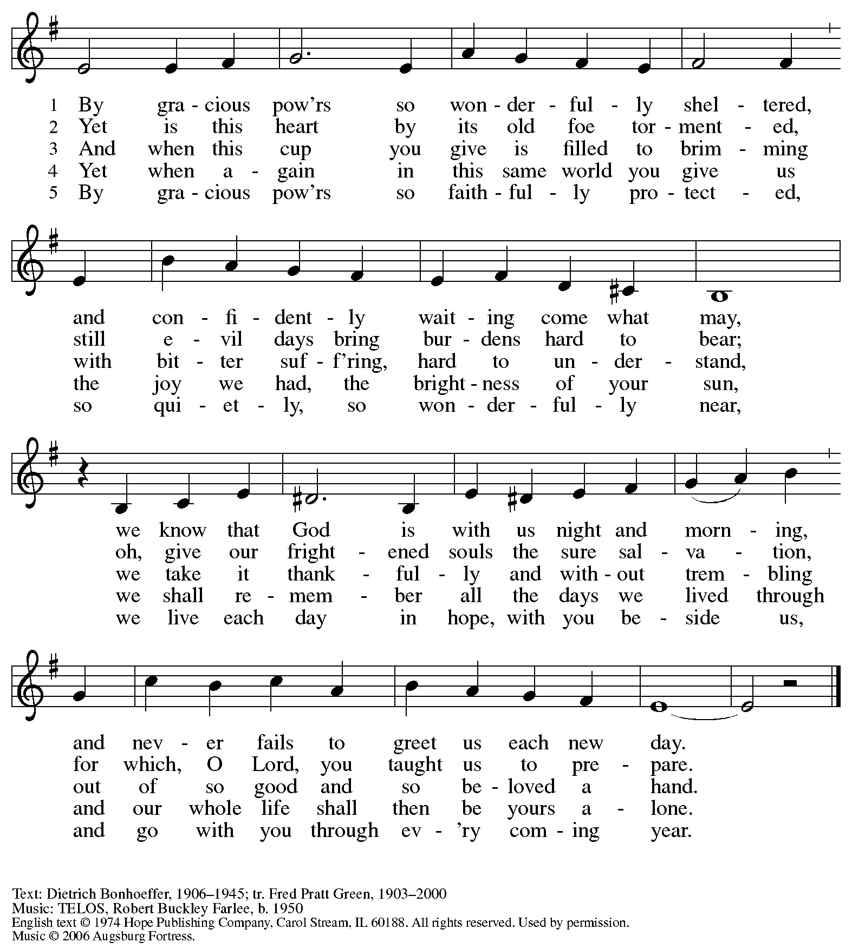
All rights reserved. Reprinted with permission under OneLicense.net # A-722139.

Apostles’ Creed

C: I believe in God, the Father almighty,
creator of heaven and earth.

I believe in Jesus Christ, God’s only Son, our Lord,
who was conceived by the Holy Spirit,
born of the virgin Mary,
suffered under Pontius Pilate,
was crucified, died, and was buried;
he descended to the dead.*
On the third day he rose again;
he ascended into heaven,
he is seated at the right hand of the Father,
and he will come to judge the living and the dead.

I believe in the Holy Spirit,
the holy catholic church,
the communion of saints,
the forgiveness of sins,
the resurrection of the body,
and the life everlasting. Amen.

*Or, “he descended into hell,” another translation of this text in widespread use.

Prayers of the People

A: Renewed in God’s everlasting grace, let us pray for the church, the world,
and all who are in need.

After each petition
A: God of grace,
C: receive our prayer.

P: We offer our prayers to you, O God, trusting in your abundant mercy,
through Jesus Christ our Lord.
C: Amen.

Peace

The presiding minister and the assembly greet one another in the peace of the risen Christ.
P: The peace of Christ be with you always.
C: And also with you.

The people may greet those around them with a sign of Christ’s peace and may say
Peace be with you or similar words. Please be mindful that not everyone will be comfortable with sharing the peace, so please seek consent before shaking hands or hugging. Other possible ways to share the peace include a simple bow with the verbal greeting of peace, or simply a verbal expression of peace.

When the greetings of peace have concluded, please be seated.



Meal
God feeds us with the presence of Jesus Christ

Offering

We offer ourselves, our gifts, and our faithful service to God.
As the offering is gathered for the mission of the church, including the care of those in need,
the table is set for Holy Communion.

There are laminated giving cards in the pew racks that feature a QR code for anyone who would like to give online. Those who give using the QR code, as well as those who give regularly online or through their bank are encouraged to place the laminated card in the plate as an expression of your offering.

Noisy Offering

As children of the congregation carry buckets around the sanctuary, people of the congregation are invited to throw in their change as an offering. This month’s Noisy Offering will support Greater Pittsburgh Community Food Bank, whose mission is to increase access to nutritious food and foster long-term stability for neighbors.

Offertory Music Just a Closer Walk arr. Edstrom

As the gifts are brought forward for presentation, please rise as you are able.

Offertory Song Let the Vineyards Be Fruitful ELW 184

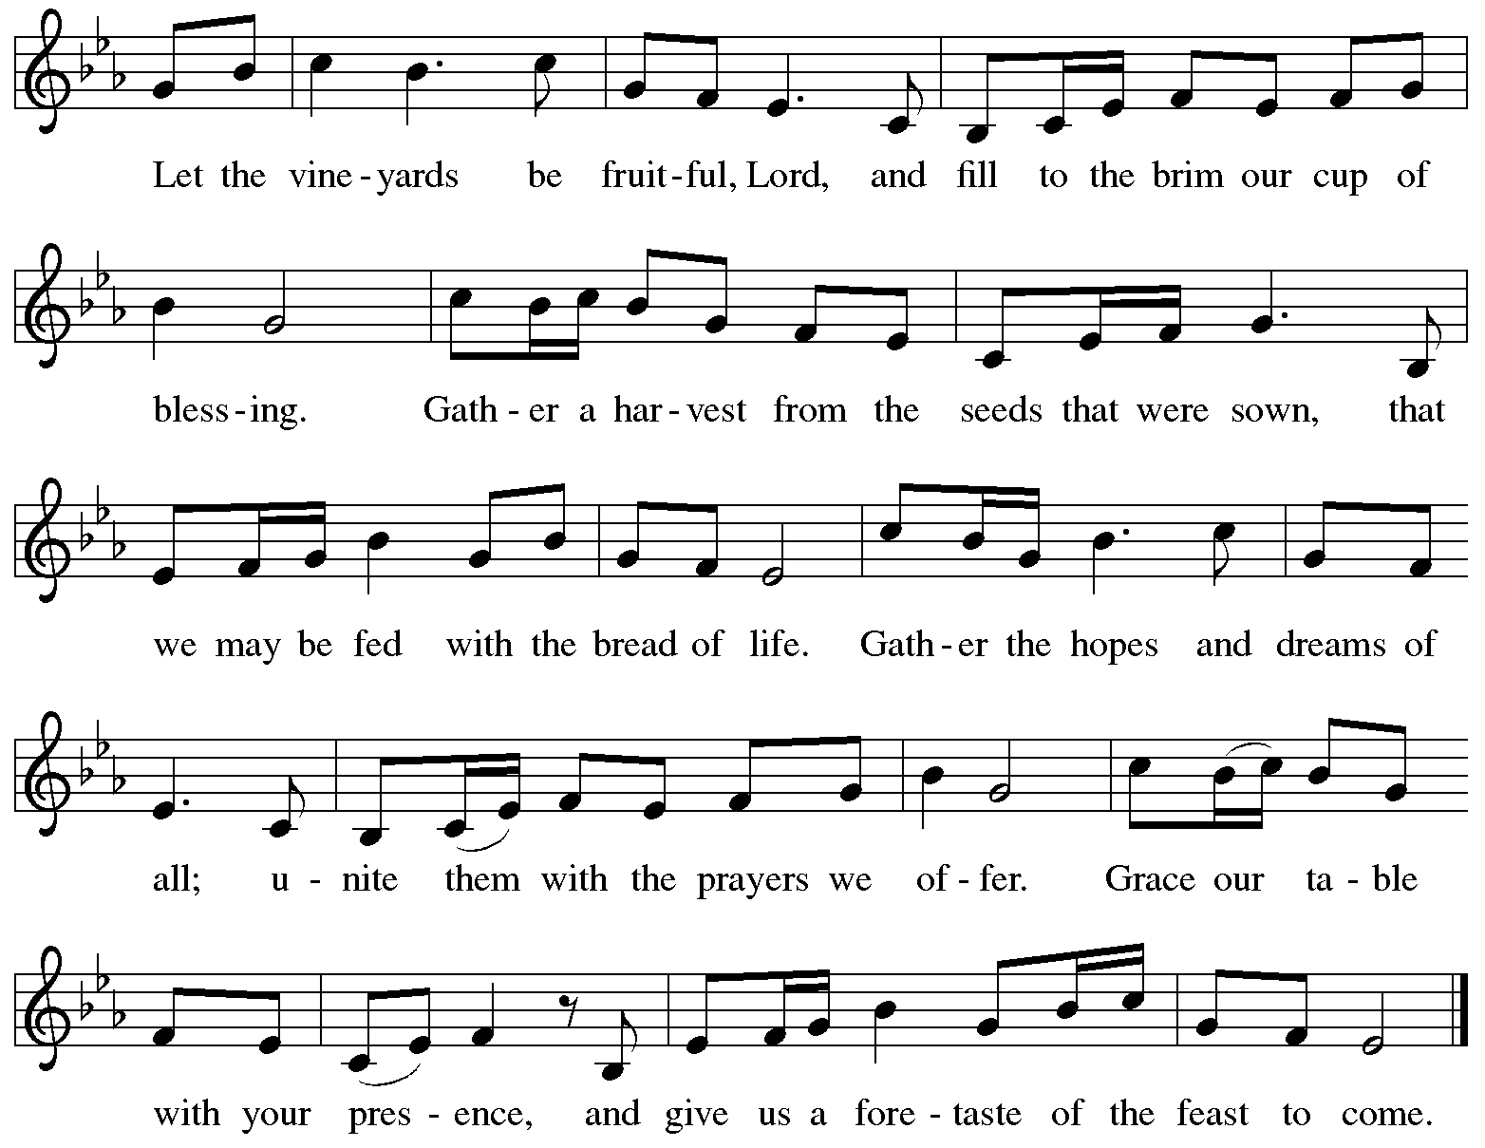
All rights reserved. Reprinted with permission under OneLicense.net # A-722139.

Offertory Prayer

A: Let us pray.
God of mercy and grace,
C: the eyes of all wait upon you, and you open your hand in blessing.
Fill us with good things at your table, that we may come to the help of all in need,
through Jesus Christ, our redeemer and Lord.
Amen.

Dialogue ELW p. 152

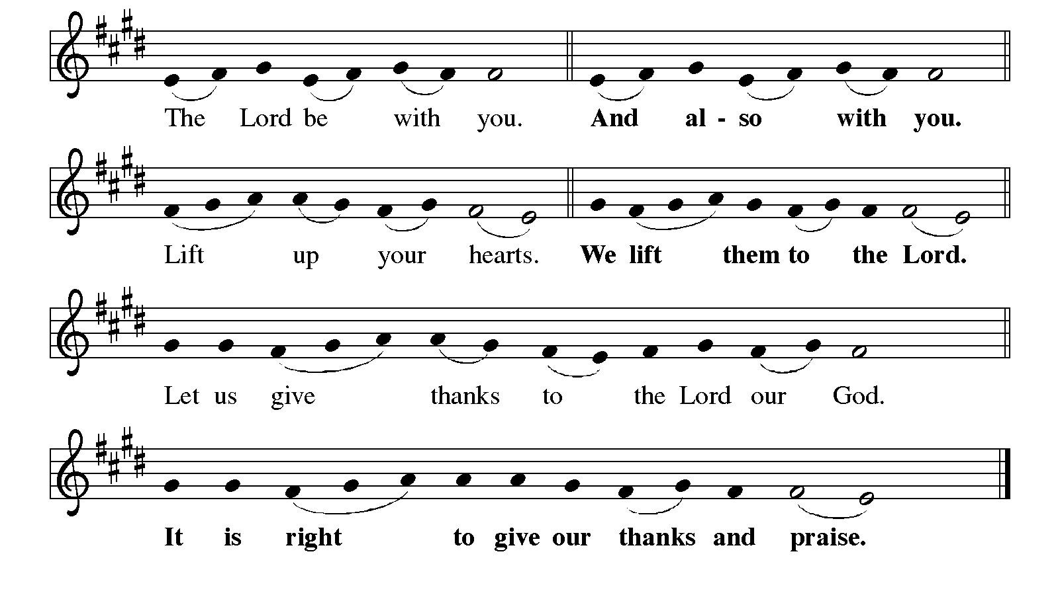

Preface

P: It is indeed right, our duty and our joy,
that we should at all times and in all places
give thanks and praise to you, almighty and merciful God,
through our Savior Jesus Christ;
who one this day overcame death and the grave,
and by his glorious resurrection opened to us the way of everlasting life.
And so, with all the choirs of angels,
with the church on earth and the hosts of heaven,
we praise your name and join their unending hymn:

Sanctus ELW p. 153

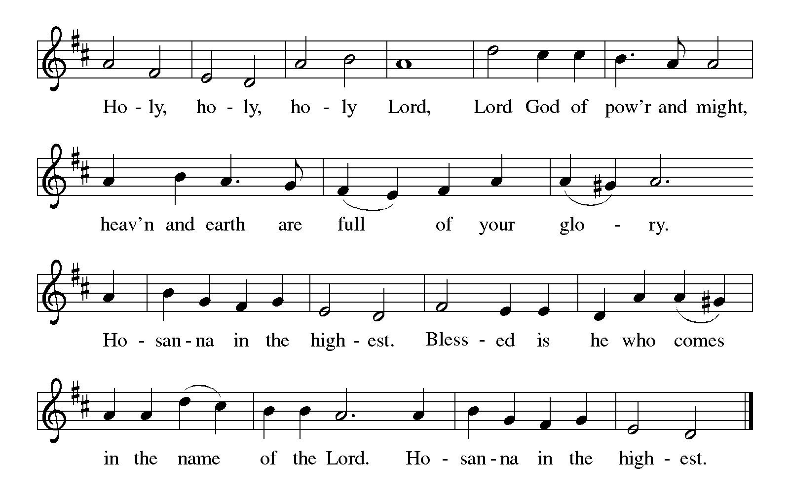
Eucharistic Prayer

P: Holy God, mighty Lord, gracious Father, …
… Do this for the remembrance of me.

For as often as we eat of this bread and drink from this cup,
we proclaim the Lord’s death until he comes.
C: Christ has died. Christ is risen. Christ will come again.

P: Therefore, O God, with this bread and cup …
… to share with us the great and promised feast.
C: Amen. Come, Lord Jesus.

P: Send now, we pray, your Holy Spirit …
… and receive our inheritance with all your saints in light.
C: Amen. Come, Holy Spirit.

P: Join our prayers …
… all glory and honor are yours, almighty Father,
now and forever.
C: Amen.
Lord’s Prayer

P: Gathered as one by the Holy Spirit, let us pray as Jesus taught us.
C: Our Father in heaven,
hallowed be your name,
your kingdom come,
your will be done,
on earth as in heaven.
Give us today our daily bread.
Forgive us our sins
as we forgive those
who sin against us.
Save us from the time of trial
and deliver us from evil.
For the kingdom, the power,
and the glory are yours,
now and forever. Amen.

Fraction and Invitation



Agnus Dei / Lamb of God ELW p. 154

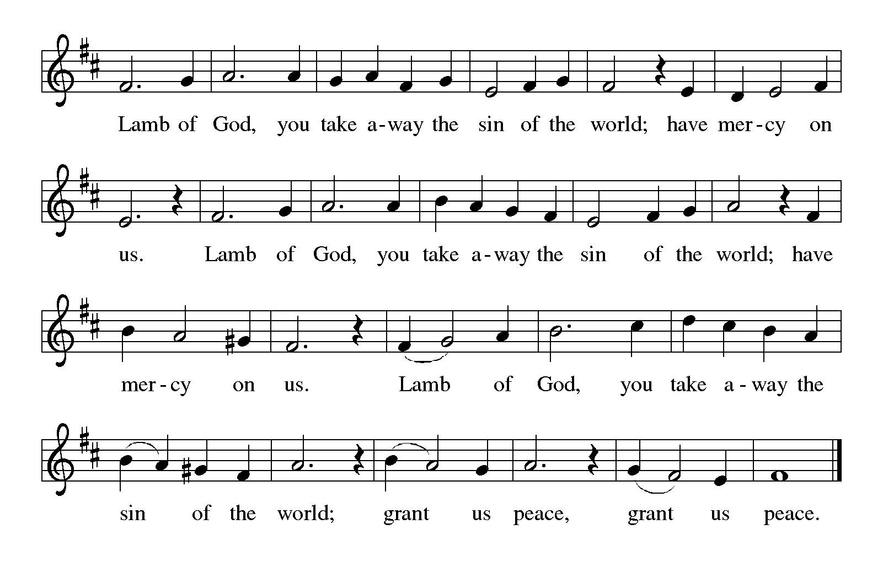

Please be seated.

Holy Communion

- All who seek God and desire a deeper and stronger life in Christ are welcome to receive Holy Communion.
- Worshipers from the pulpit side will proceed forward first, followed by the center section, and then the lectern side.
- Please inform an usher if you would like the ministers to bring Communion to you.
- Holy Communion will be served with bread and wine (amber) or grape juice (purple).
- The presiding minister will first distribute the bread (host) to each communicant. Please indicate if you require a gluten-free host.
- Once you have consumed the bread, please pick up an empty glass from the tray next to the presiding minister. The Communion Assistant will pour wine or grape juice into your glass.
- Please step to the side to consume the wine or grape juice.
- Feel free to kneel at the altar rail for prayer after receiving the sacrament.
- As you return to your pew, glasses may be returned to the empty tray on the side of the center section.
- A blessing will be provided for anyone who does not yet receive the sacrament.
- All are invited to join in singing the hymns during Holy Communion.
Hymns during Holy Communion
O Jesus, I Have Promised ELW 810

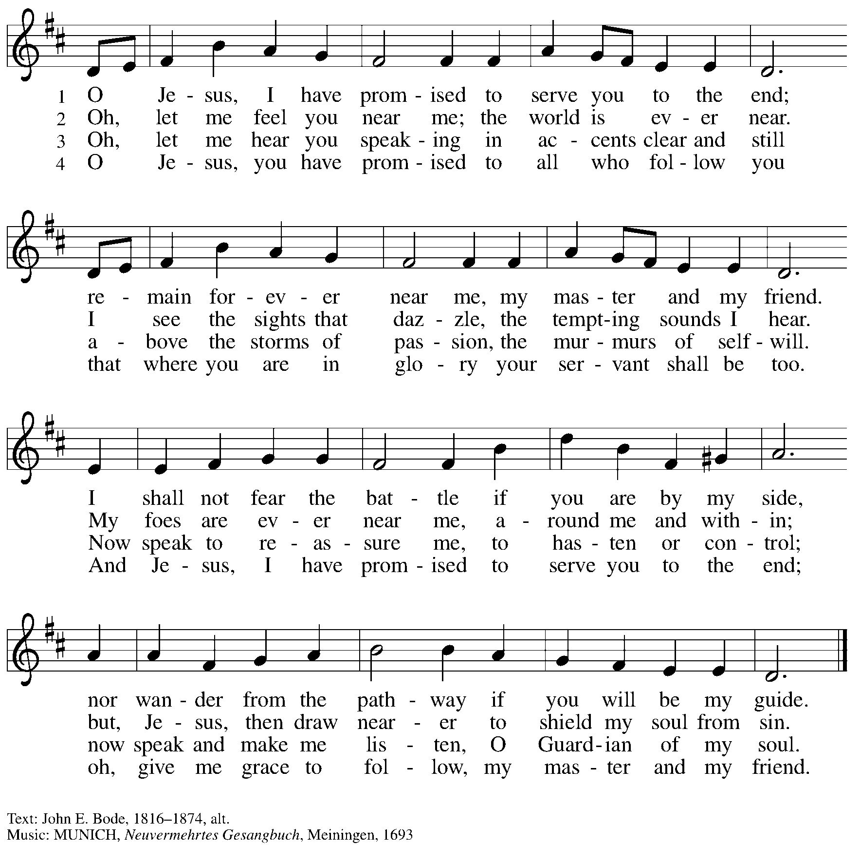

Hymns during Holy Communion
Though the Earth Shall Change ACS 1035

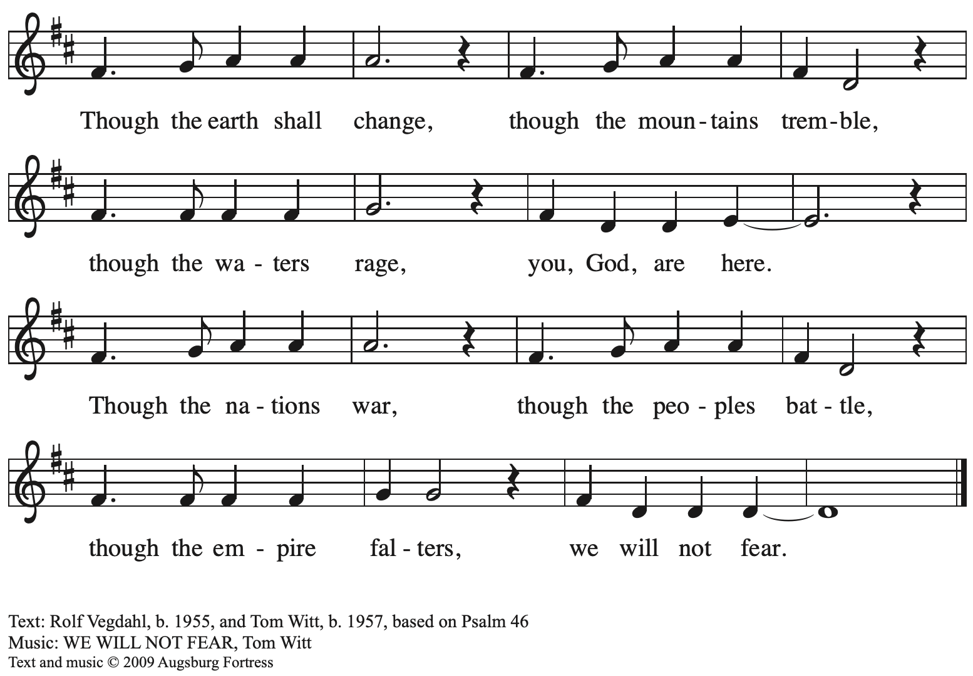
All rights reserved. Reprinted with permission under OneLicense.net # A-722139.

Hymns during Holy Communion
O God of Every Nation ELW 713

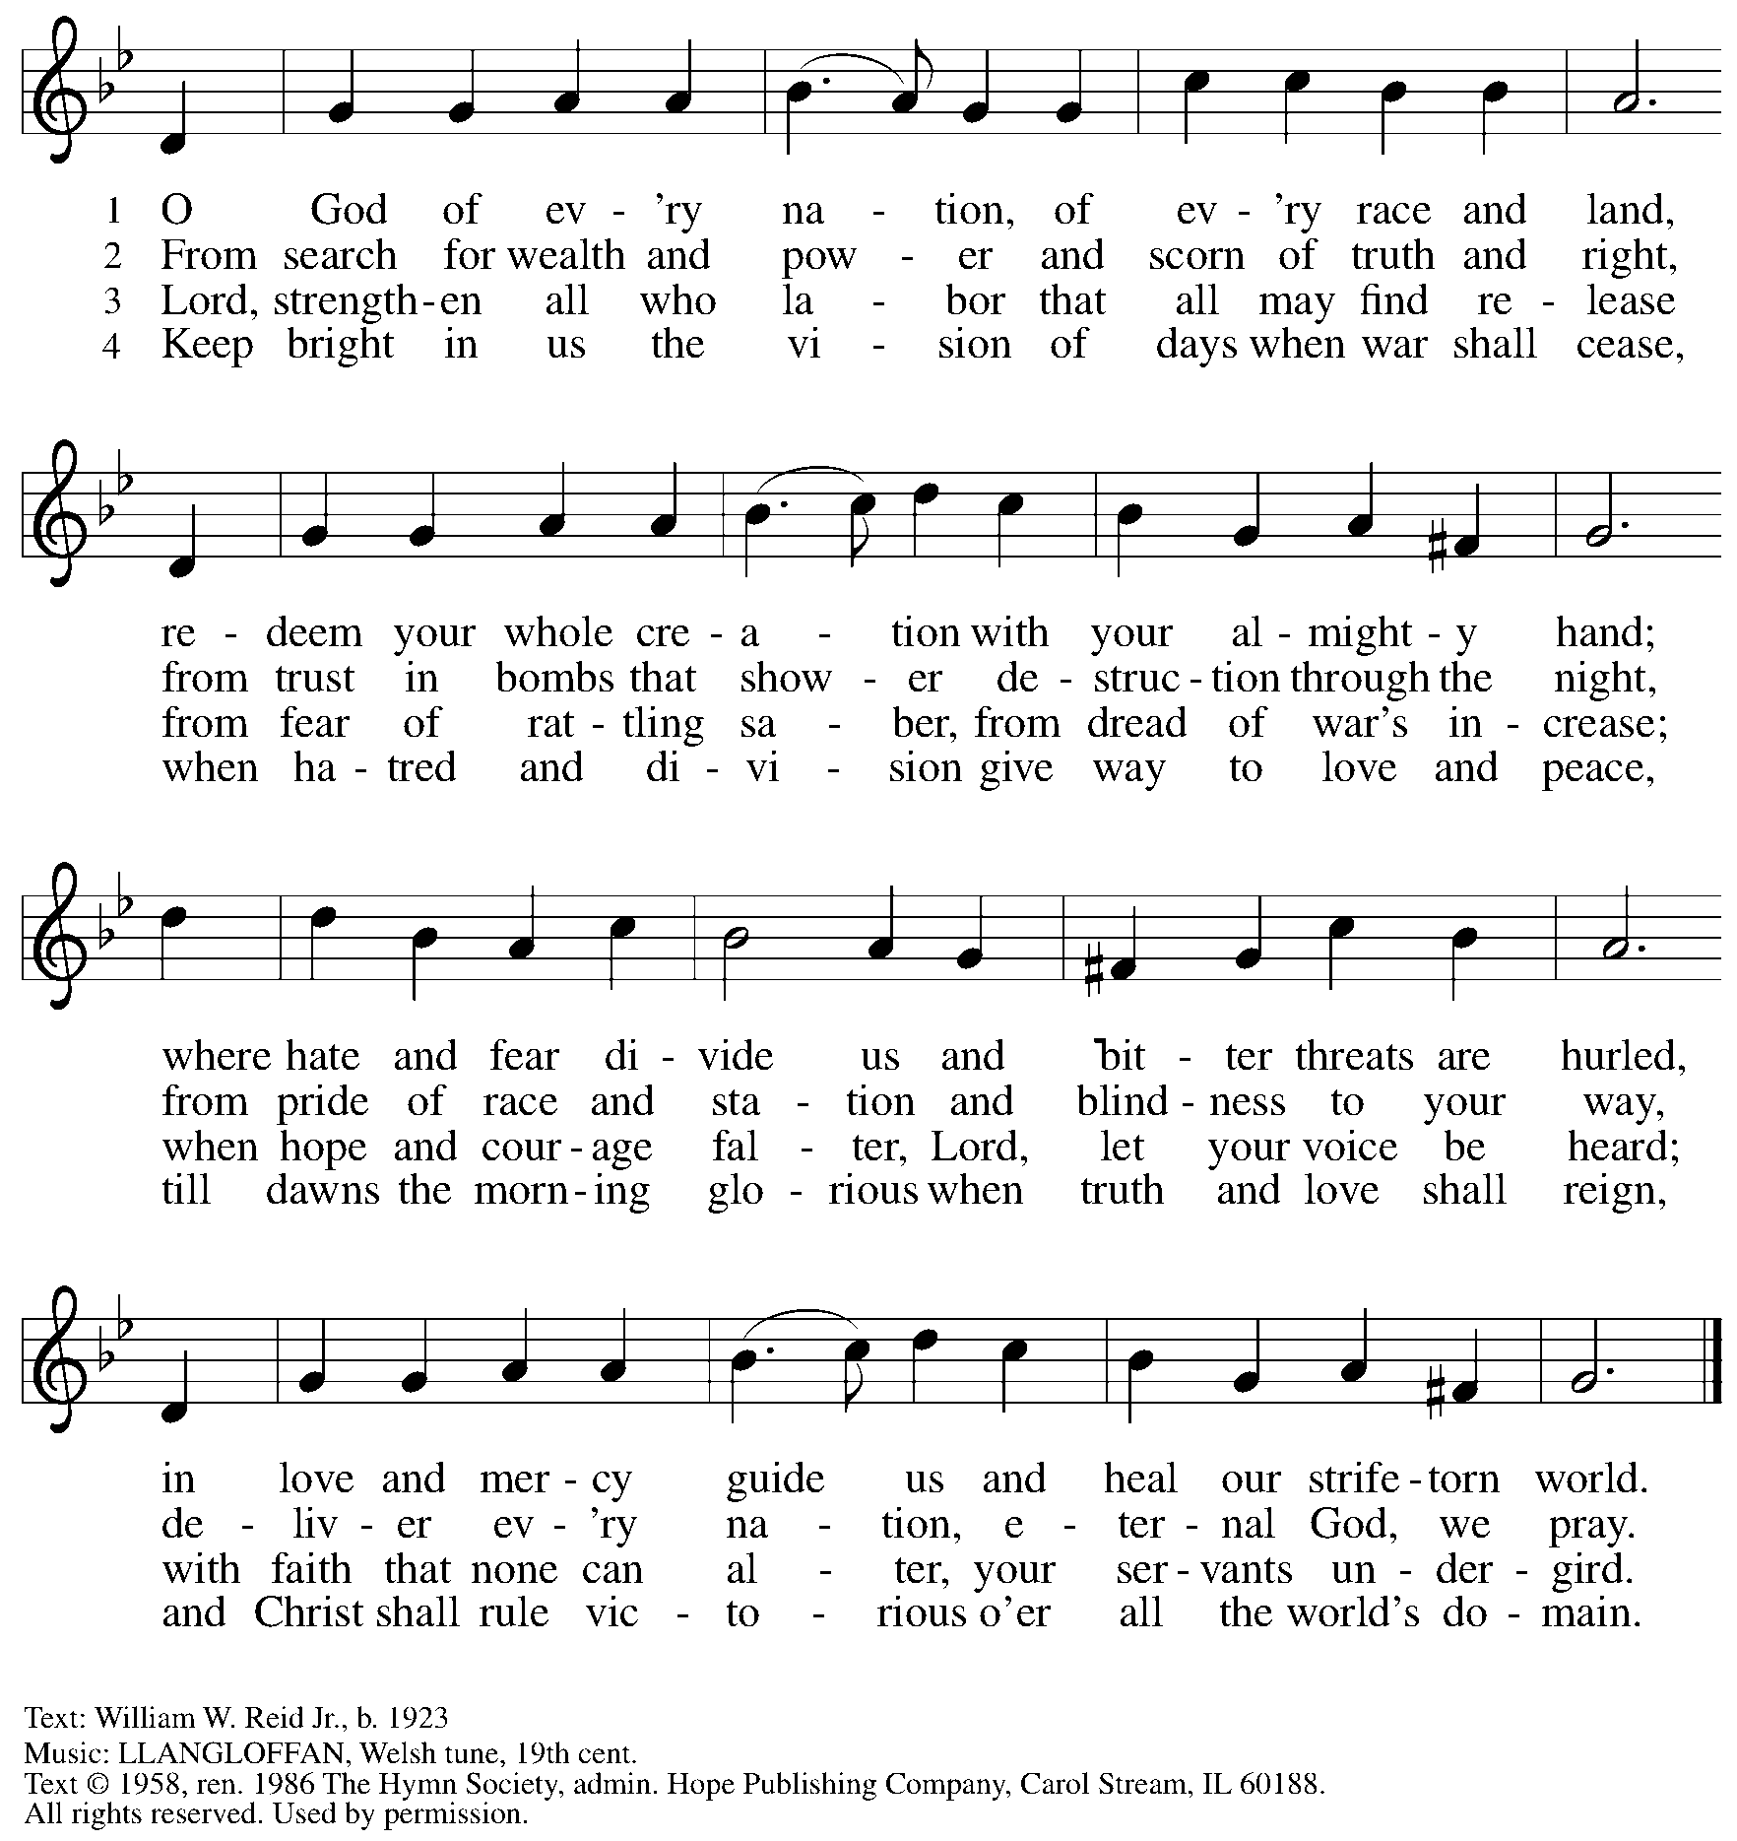
Reprinted under OneLicense.net # A-722139.

When all are returning to their places and the ministers are clearing the table,
a vocal trio will sing a musical offering.

Sung Offering All Things New Elaine Hagenberg
Vocal Trio

Please rise as you are able.

Blessing

P: The body and blood of our Lord Jesus Christ strengthen you and keep you in his grace.
C: Amen.

Prayer

A: Let us pray.
O God our life, our strength, our food,
we give you thanks for sustaining us with the body and blood of your Son.
By your Holy Spirit, enliven us to be the Body of Christ in the world,
that more and more we will give you praise and serve your earth and its many peoples,
through Jesus Christ, our Savior and Lord.
C: Amen.

Please be seated.

Sending
God blesses us and sends us in mission to the world

Announcements

Please rise as you are able.

Benediction

P: The love of God the Sovereign strengthen you,
God the Son save you,
and the Holy Spirit anoint and sustain you.

The Holy Trinity ☩ bless you and grant you a faithful and courageous heart, now and forever.
C: Amen.

Sending Hymn May the God of Hope Go with Us ACS 984

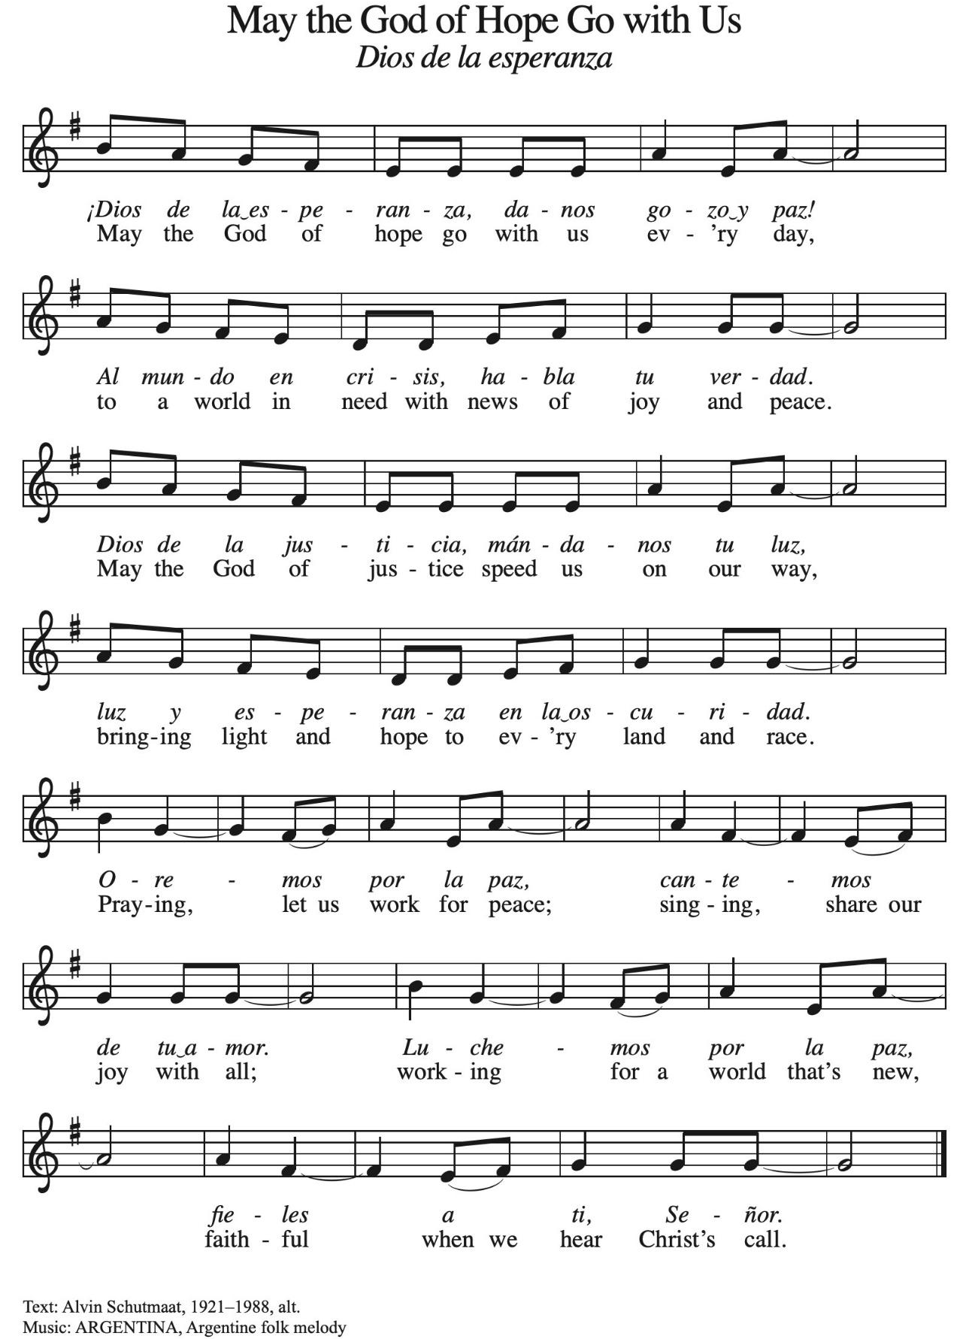

Dismissal

A: Go in peace. Serve the Lord.
C: Thanks be to God!

Postlude

Serving in Worship Today

Altar Care Jodie Minor
Assisting Minister Jeff Denlinger
Audio-Visual Ministers Jered Stratton
Sarita
Cantor Richard Krug
Lector Sue Gaugler
Vocal Trio Kristen Asplin
The Rev. Erin Jones
Emily Duque
Minister of Music Laura Reynolds
Presiding Minister The Rev. Ross Carmichael

Liturgy and Hymnody Acknowledgements

From SundaysandSeasons.com. Copyright © 2025 Augsburg Fortress. All rights reserved. Reprinted under OneLicense.net # A-722139.
Used by permission of Augsburg Fortress.

The Scripture readings contained herein are from New Revised Standard Version Updated Edition of the Bible © 2021 National Council of Churches of Christ in the United States of America. Used by permission. All rights reserved worldwide.

Earth and All Stars! – Text: Herbert F. Brokering, b. 1926. Music: EARTH AND ALL STARS, David N. Johnson, 1922-1987. Text and music © 1968 Augsburg Publishing House, admin. Augsburg Fortress. All rights reserved. Reprinted with permission under OneLicense.net # A-722139.

Please use the QR code below to link to St. Andrew’s Announcements online!



St. Andrew Lutheran Church Announcements
November 16th, 2025

- Welcome to Worship at St. Andrew on the Twenty-Third Sunday after Pentecost – We are so glad you are here, and we offer a special welcome to all visitors and guests who are here for the first time! A nursery is available through the door to the left of the worship space and across the social hall (look for a purple room). Little Church – Big Faith, a Bible lesson and activity for children up to sixth grade, will take place after the prayer of the day. There are also worship “toolkits” to help children engage with worship and “busy bags” for younger children available in the bookcase at the back of the sanctuary. Please feel free to take one to use with/for your children. All are invited to stay for coffee and other drinks, food, and conversation in the Social Hall (through the side door at the left of the worship space) after the service.
- Noisy Offering This Sunday During Worship – On the third Sunday of each month, St. Andrew’s children lead the congregation in a Noisy Offering, in which people are invited to throw their change into buckets that the children carry around the church and bring forward as an additional offering. Each month’s Noisy Offering supports a local, national, or international church-related or otherwise charitable organization. This week’s offering is supporting the Greater Pittsburgh Community Food Bank. Their mission is to leverage the power of community to achieve lasting solutions to hunger and its root causes. For more information, please visit: https://pittsburghfoodbank.org/what-we-do/how-we-work/.
- Produce Distribution Supplemental Food of the Month – St. Andrew has begun collecting supplemental food each month to accompany our produce distribution. For the upcoming month, we ask for donations of instant mashed potatoes and stuffing mix. There are collection boxes at the back of the worship space and social hall.
- Additional November Produce Distribution, Third Tuesday of the Month, November 18th, 5:30-6:30 p.m. – St. Andrew is pleased to announce that we are adding a second produce distribution on the third Tuesday of each month. We invite people of the congregation to help with the distribution from 5:30 p.m. - 6:30 p.m. and/or to help with unloading and setup during the day between 10:00 a.m. and 1:00 p.m.
- November Shelter Dinner for Guests of East End Cooperative Ministry, Third Thursday of the Month, November 20th, 6:30 p.m. – Each month, people of St. Andrew provide dinner for guests of East End Cooperative Ministry (EECM), 6140 Station St. (East Liberty), 15206. We invite you to prepare or purchase one menu item and bring it to the shelter by 6:00 p.m., or just come to help serve at 6:30 p.m. If you would like to contribute, please sign up at: https://www.signupgenius.com/go/5080544AAAC22A1F58-59953094-shelter.
- East End Interfaith Thanksgiving Service, Tuesday, November 25th, 7:00 p.m. – This year's East End Interfaith Thanksgiving Service, with the theme Lift Every Voice, will be held at Episcopal Church of the Redeemer at 5700 Forbes Ave., Pittsburgh, PA 15217 and will be co-hosted by leaders of the Hindu-Jain Temple in Monroeville. Following the service, all are welcome to a light reception in the Parish Hall. As part of our Thanksgiving offering, we invite all attendees to bring a non-perishable food item or toiletry as an offering to support our immigrant neighbors through JFCS.
- St. Andrew Soup and Service, Sunday, November 30th, after Worship – All are invited to gather after worship on Sunday, November 30th, when we will share a soup lunch and then tie blankets to be given to Proud Haven (https://proudhaven.org/) and Humane Animal Rescue (https://humaneanimalrescue.org). People of all ages are welcome to join.
- Welcoming the Season of Advent with an Advent Calendar – A new church year in the liturgical calendar begins with the season of Advent, a time of preparation and hope as the church awaits the celebration of Christ’s birth at Christmas and the second coming of Jesus promised in Scripture. Each year there are four Sundays of Advent, and this year, Advent begins on Sunday, November 30th. During this time of preparation, many find it helpful to add additional faith practices to their daily routines, and one of those practices is the use of an Advent calendar to keep time throughout the season. The World Hunger ministry of the Evangelical Lutheran Church in America (ELCA) has provided an Advent calendar for congregations titled “A Stable Lamp Is Lighted.” These calendars offer daily Bible readings, suggestions for supporting our neighbors in need, and activities, including a color and cut-out Nativity scene that would be a great activity for children. There is also a three-session online study with videos that accompanies the Advent calendar available here: https://www.elca.org/our-work/relief-and-development/elca-world-hunger/wh-advent#whadventaccordionsection. Please take a calendar and study guide up at the entrances to the church!
- Community Ministry Team Collecting Gifts for Foster Children Served by Allegheny County CYS, Through Dec. 7th – Allegheny County’s Office of Children, Youth, and Families of children is in need of gifts to support those who come into the system late, or who weren’t sponsored. We are collecting some highly-requested items for children in the foster system to ensure that they receive some cheer this holiday season. Please bring the following items, unwrapped, for donation: winter wear for ages 0-18, baby necessities (blankets, wipes, bottles, pacifiers, bibs), developmental toys and board books for babies and toddlers, crayons, colored pencils, gel pens, coloring books, LEGO and Mega Blok sets, board games, ethnically diverse dolls, superhero action figures, craft kits, earbuds, headphones, gaming mouse and keyboard, science/STEM kits, remote control vehicles (cars, trucks, helicopters, drones), sports equipment for ages 3-18, local sports team apparel, sensory toys (slime, kinetic sand, fidgets), makeup, toiletries (body lotion, shower gel, bath poufs, body spray), wallets, watches, and fleece blankets.
- Pittsburgh Pride Choir Winter Concert - “A Not So Silent Night," Saturday, December 6th, 7:30 p.m. – The Board of Directors of the Pittsburgh PRIDE Choir, Pittsburgh's esteemed LGBTQIA+ choir would be privileged if you attended their Holiday Concert on December 6th titled “A Not So Silent Night." The concert begins at 7:30 p.m., at East Liberty Presbyterian Church (116 S. Highland Ave), a fully affirming and inclusive venue. For tickets, you can use the following link: https://www.ticketleap.events/tickets/pittsburgh-pride-choir/a-not-so-silent-night-ppc-holiday-concert-2025. Concert details are available at www.pittsburghpridechoir.org. If you have questions, please notify them at volunteer@pittsburghpridechoir.org. Accessibility questions may be directed to accessibility@pittsburghpridechoir.org. If you would like to attend but cannot afford a ticket, contact Jay at communications@standrewpittsburgh.org for a comp ticket as she has a few to give away.
- Discipleship that Heals the World - Studies in Matthew’s Gospel, Thursdays, 8:00 - 9:00 p.m. on Zoom, through Dec. 11th, 2025 – Join us for a journey through the Gospel of Matthew, organized and facilitated by Rev. Dr. Martin Rafanan. Together we’ll explore Jesus’ Sermon on the Mount and his healing ministry, discovering Matthew’s distinctive vision of discipleship as a way of blessing, healing, and hope. You are welcome to join the zoom whenever you can. This study is designed for both newcomers to the Gospel and those already familiar with it. We will engage contemporary perspectives that help us hear Matthew’s message afresh in today’s world. Register for the sessions to receive zoom info: https://forms.gle/amy439vfUpwdJpKx7.
- Receive Prayer Team Emails – St. Andrew maintains a list of weekly prayer concerns sent by email to members of the congregation who have opted in. Our prayer team’s email is prayerteam@standrewpittsburgh.org. We will keep names on the list for a maximum of four weeks unless otherwise requested. Thank you for your ministry of prayer!
- Records Update – St. Andrew is updating our records with information from newer attendees, as well as offering current members the opportunity to include current information to be used within the congregation: for emergency contacts, to acknowledge celebrations, milestones, and prayers. Please fill out the form at: https://forms.gle/kKvp19UozuRrhhaV7.
- Coffee Hour Signups – St. Andrew provides hospitality during a coffee hour after worship each Sunday. If you would like to participate and would like information about the duties of setting up, please sign up using the following form: https://www.signupgenius.com/go/5080B4AAFAF2CABF85-47069030-coffee#/.

