

+ Reign of Christ
November 23, 2025



St. Andrew Lutheran Church
304 Morewood Ave.
Pittsburgh, PA 15213
St_andrewELCA@verizon.net
www.standrewpittsburgh.org

+ Reign of Christ
Order for Worship

Jeremiah’s promise of the execution of “justice and righteousness in the land”
finds ironic fulfillment in the execution of Jesus of Nazareth, the King of the Jews.
It appears utterly contradictory that a king should be crucified with a criminal.
This victory appears for all the world as humiliating defeat.
Yet through the gate of death Jesus opens the door to paradise.

Welcome to St. Andrew!
- St. Andrew welcomes all who are seeking a place of healing, wholeness, and acceptance in a nurturing and faith-forming spiritual home. We are striving toward racial equity worldwide
and we seek to honor the lived experience of all individuals regardless of background. Our community embraces people of all ages, ethnicities, cultures, abilities, sexual orientations,
gender identities and expressions, and family constellations. Come and See!
- Worship Services are live-streamed to multiple online platforms. By attending worship, you agree that your image and voice may be broadcast.
- Everyone is invited to make a name tag at the black bookcase in the back of the worship space if they would like. There are stickers indicating pronouns on the bookcase if you would like to include them on your name tag.
- A nursery is available through the doors at the left side of the sanctuary and across from the doorway to the Social Hall. Look for a purple-colored room.
- Children are invited to attend Little Church – Big Faith, a Bible lesson and activity, during worship (after the Prayer of the Day). The group returns to the worship space for the liturgy of Holy Communion.
- Worship “toolkits” to help children engage with the service, along with “busy bags” for younger children, are available in the bookcase at the back of the sanctuary. Please feel free to take one to use with/for your children.
- Holy Communion is served with bread (gluten-free available) and wine or grape juice. The presiding minister will distribute the bread (host). Please consume this and then pick up an empty glass from the tray. The Communion Assistant will pour wine or grape juice into your glass. Please step to the side to consume the wine or grape juice. Feel free to kneel at the altar for prayer and reflection. As you return to your pew, glasses may be returned to the empty trays on either side of the center section.
- A restroom is available on the main level of the church, through the doors to the Social Hall and to the right in the main office.

Abbreviations
P: Pastor/Presiding Minister ELW: Evangelical Lutheran Worship hymnal
A: Assisting Minister ACS: All Creation Sings hymnal
L: Lector
C: Congregation

Musical Offering

Each week, different people from the congregation make an offering of pre-service music, with singing or instrumentation, to help the assembly focus and pray in preparation for worship.

Welcome

Prelude Come, Thou Almighty King arr. Mangano-Rollinson

Gathering
The Holy Spirit calls us together as the people of God

Please rise as you are able. All may make the sign of the cross,
the sign that is marked at Baptism, as the presiding minister begins.

Confession and Forgiveness

P: Blessed be the Holy Trinity, one ☩ God,
our maker, our helper, and our keeper.
C: Amen.

P: Trusting in God’s mercy, let us confess our sins in the presence of God and one another.

Silence is kept for reflection.

P: Faithful God,
C: You have shown us the ways of your heart, yet we stray from your paths.
We are stuck in sinful systems of oppression
and do not embrace the freedom your faithful promises offer us.
We ignore our neighbors. We exploit the earth. We reject your abundance,
trusting our impulses instead of your steadfast love.
Repair our relationships, restore what we have broken, renew our hearts,
and bring us to new life.
Amen.

P: Receive the good news:
God the Faithful One loves you,
in ☩ Christ Jesus, your sins are forgiven.
and by the power of the Holy Spirit you are set free.
C: Amen.

Gathering Hymn Savior, Like a Shepherd Lead Us ELW 789

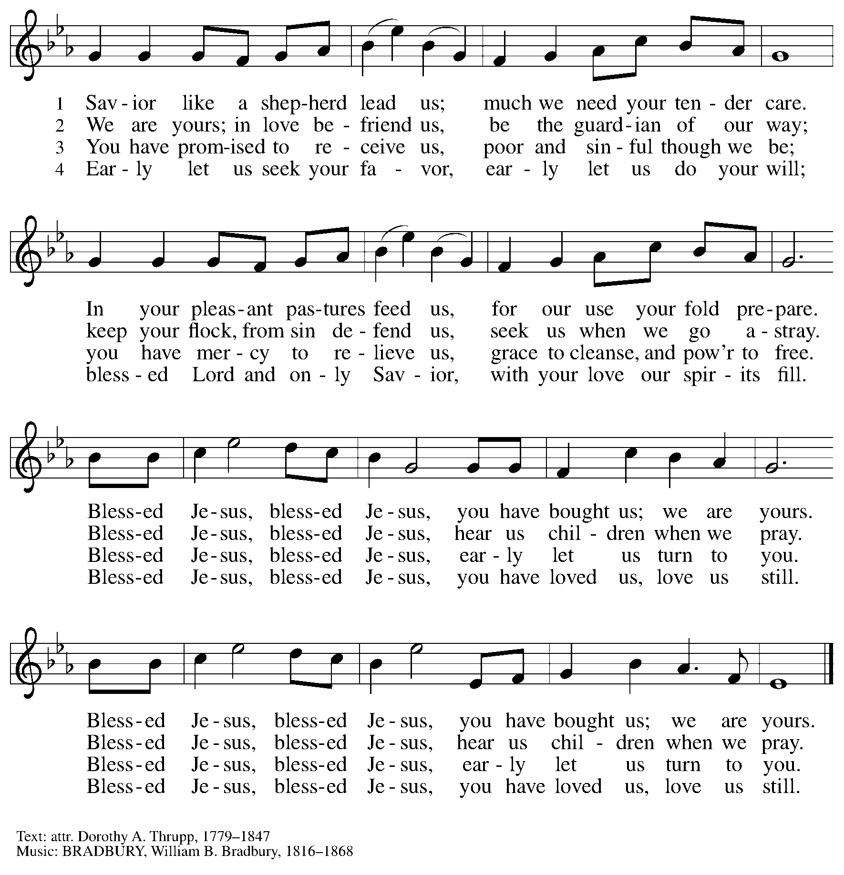

Greeting

P: The grace of our Lord Jesus Christ, the love of God,
and the communion of the Holy Spirit be with you all.
C: And also with you.

Kyrie ELW p. 147
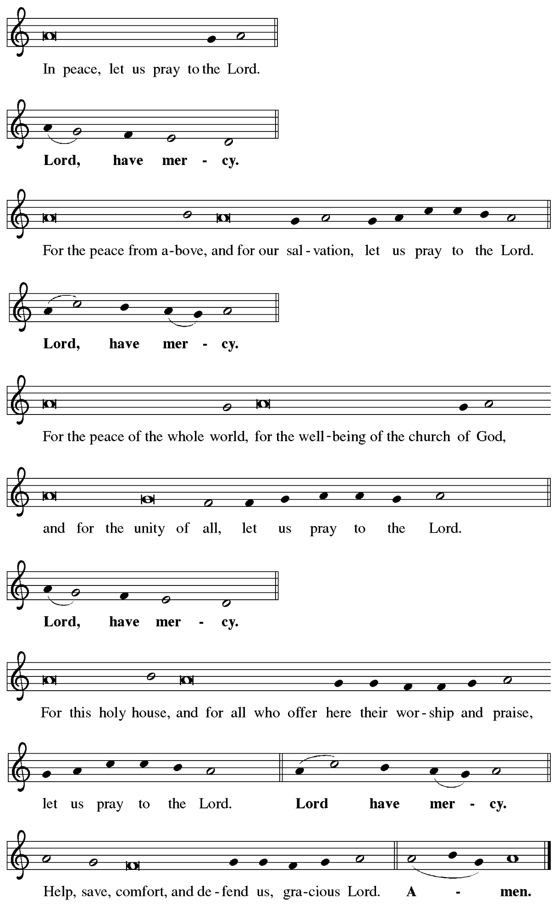
Hymn of Praise ELW p. 149

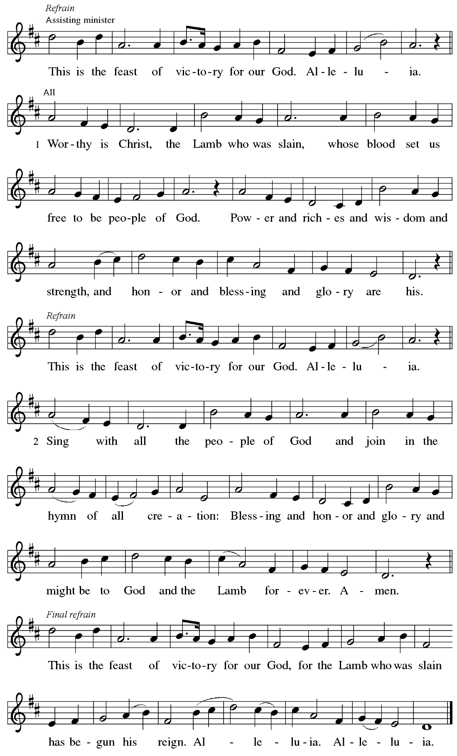

Prayer of the Day

P: The Lord be with you.
C: And also with you.

P: Let us pray. O God, our true life, to serve you is freedom, and to know you is unending joy.
We worship you, we glorify you, we give thanks to you for your great glory.
Abide with us, reign in us, and make this world into a fit habitation for your divine majesty, through Jesus Christ, our Savior and Lord, who lives and reigns with you and the Holy Spirit, one God, now and forever.
C: Amen.

Please be seated.
Children are invited to join the adult leader(s) at the side door for Little Church – Big Faith.
We ask that an additional adult from the congregation attend with the children.

Word
God speaks to us in Scripture reading, preaching, and song

First Reading – Jeremiah 23: 1-6

¹ Woe to the shepherds who destroy and scatter the sheep of my pasture! says the Lord.
² Therefore thus says the Lord, the God of Israel, concerning the shepherds who shepherd my people: It is you who have scattered my flock and have driven them away, and you have not attended to them. So I will attend to you for your evil doings, says the Lord. ³ Then I myself will gather the remnant of my flock out of all the lands where I have driven them, and I will bring them back to their fold, and they shall be fruitful and multiply. ⁴ I will raise up shepherds over them who will shepherd them, and they shall no longer fear or be dismayed, nor shall any be missing, says the Lord.
⁵ The days are surely coming, says the Lord, when I will raise up for David a righteous Branch, and he shall reign as king and deal wisely and shall execute justice and righteousness in the land. ⁶ In his days Judah will be saved, and Israel will live in safety. And this is the name by which he will be called: “The Lord is our righteousness.”

L: Word of God, word of life.
C: Thanks be to God.

Psalm 46

The psalm will be sung responsively, led by the cantor, with the congregation singing the verses in bold type and joining in the refrain.

Psalm Tone

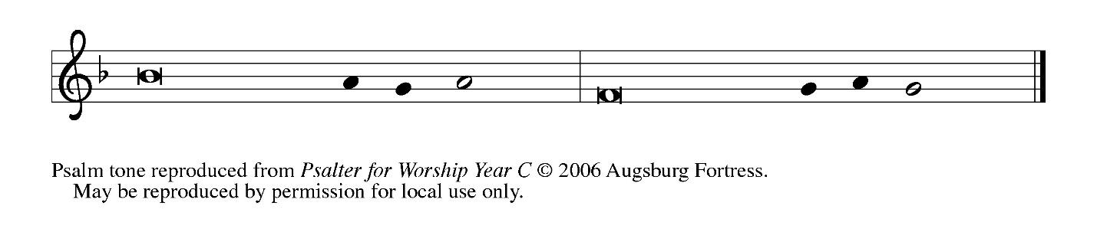

Psalm Refrain

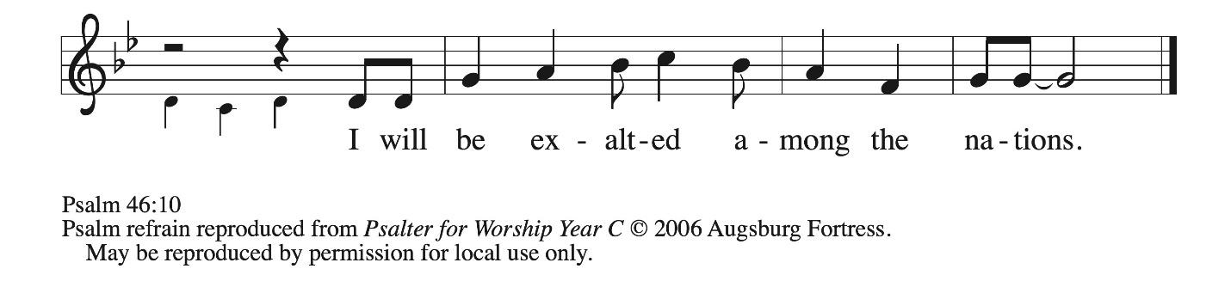

¹ God is our ref- | uge and strength,
a very present | help in trouble.
² Therefore we will not fear, though the | earth be moved,
and though the mountains shake in the depths | of the sea;
³ though its waters | rage and foam,
and though the mountains tremble | with its tumult.
⁴ There is a river whose streams make glad the cit- | y of God,
the holy habitation of | the Most High.
⁵ God is in the midst of the city; it shall | not be shaken;
God shall help it at the | break of day.
⁶ The nations rage, and the | kingdoms shake;
God speaks, and the earth | melts away. R
⁷ The Lord of | hosts is with us;
the God of Jacob | is our stronghold.
⁸ Come now, regard the works | of the Lord,
what desolations God has brought up- | on the earth;
⁹ behold the one who makes war to cease in | all the world;
who breaks the bow, and shatters the spear, and burns the | shields with fire.
¹⁰ “Be still, then, and know that | I am God;
I will be exalted among the nations; I will be exalted | in the earth.”
¹¹ The Lord of | hosts is with us;
the God of Jacob | is our stronghold. R

Second Reading – Colossians 1: 11-20

¹¹ May you be made strong with all the strength that comes from [Christ’s] glorious power, so that you may have all endurance and patience, joyfully ¹² giving thanks to the Father, who has enabled you to share in the inheritance of the saints in the light. ¹³ God has rescued us from the power of darkness and transferred us into the kingdom of God’s beloved Son, ¹⁴ in whom we have redemption, the forgiveness of sins.
¹⁵ He is the image of the invisible God, the firstborn of all creation, ¹⁶ for in him all things in heaven and on earth were created, things visible and invisible, whether thrones or dominions or rulers or powers—all things have been created through him and for him. ¹⁷ He himself is before all things, and in him all things hold together. ¹⁸ He is the head of the body, the church; he is the beginning, the firstborn from the dead, so that he might come to have first place in everything.
¹⁹ For in him all the fullness of God was pleased to dwell, ²⁰ and through him God was pleased to reconcile to Godself all things, whether on earth or in heaven, by making peace through the blood of his cross.

L: Word of God, word of life.
C: Thanks be to God.

Please rise as you are able.

Gospel Acclamation ELW p. 151

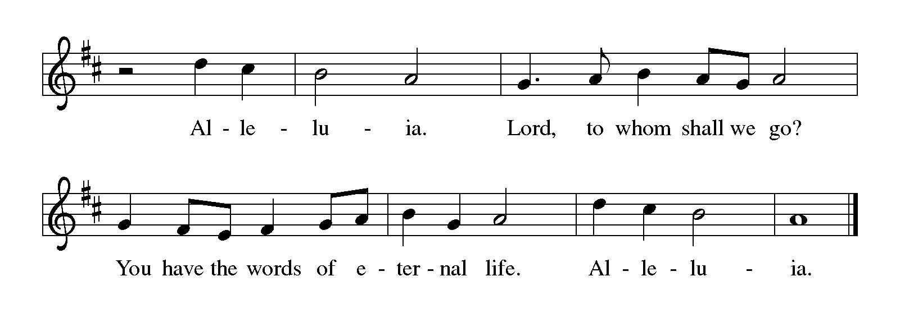

Gospel – Luke 23: 33-43

P: The holy Gospel according to St. Luke.
C: Glory to you, O Lord.

³³ When they came to the place that is called The Skull, they crucified Jesus there with the criminals, one on his right and one on his left. ³⁴ [[Then Jesus said, “Father, forgive them, for they do not know what they are doing.”]] And they cast lots to divide his clothing. ³⁵ And the people stood by watching, but the leaders scoffed at him, saying, “He saved others; let him save himself if he is the Messiah of God, God’s chosen one!” ³⁶ The soldiers also mocked him, coming up and offering him sour wine ³⁷ and saying, “If you are the King of the Jews, save yourself!”
³⁸ There was also an inscription over him, “This is the King of the Jews.”
³⁹ One of the criminals who were hanged there kept deriding him and saying, “Are you not the Messiah? Save yourself and us!” ⁴⁰ But the other rebuked him, saying, “Do you not fear God, since you are under the same sentence of condemnation? ⁴¹ And we indeed have been condemned justly, for we are getting what we deserve for our deeds, but this man has done nothing wrong.”
⁴² Then he said, “Jesus, remember me when you come in your kingdom.” ⁴³ He replied, “Truly I tell you, today you will be with me in paradise.”

P: The Gospel of the Lord.
C: Praise to you, O Christ.

Please be seated.

Sermon

A time of silence for prayer and reflection follows the sermon.
When the hymn of the day begins, please rise as you are able.



Hymn of the Day Jesus Shall Reign ELW 434

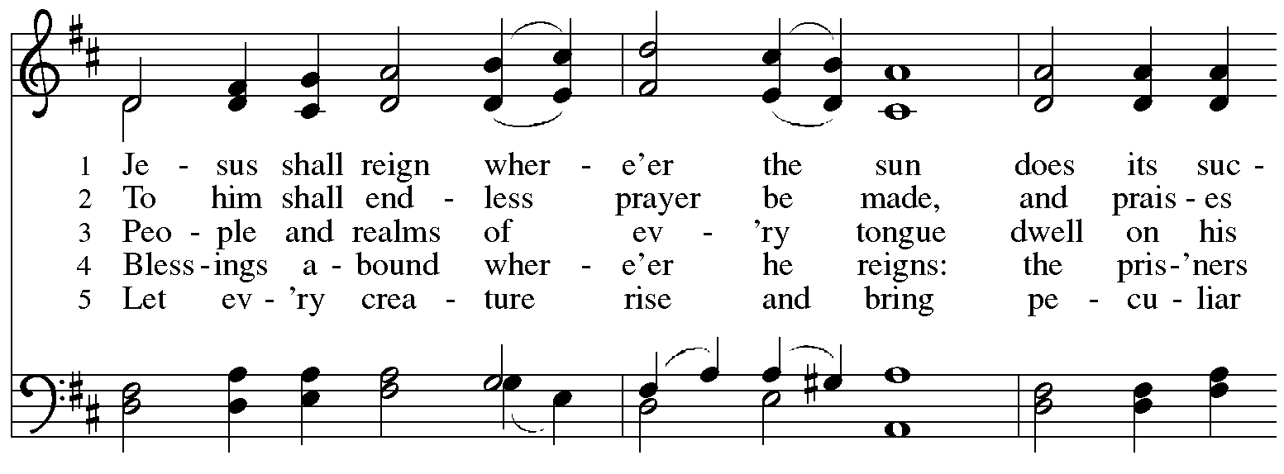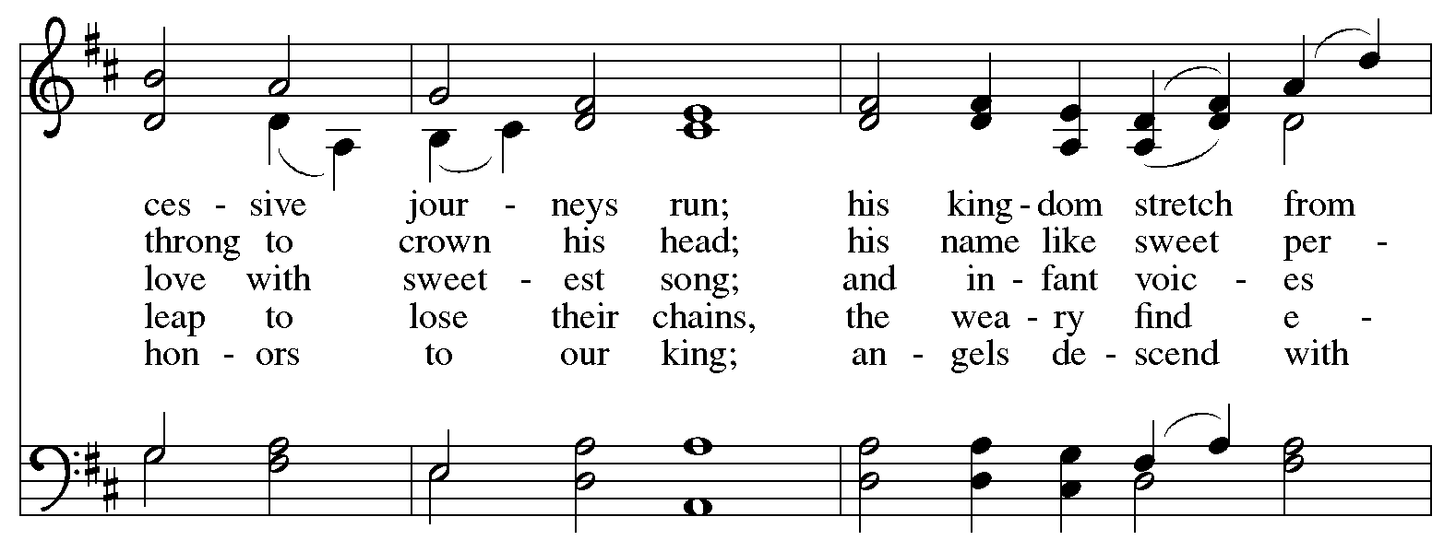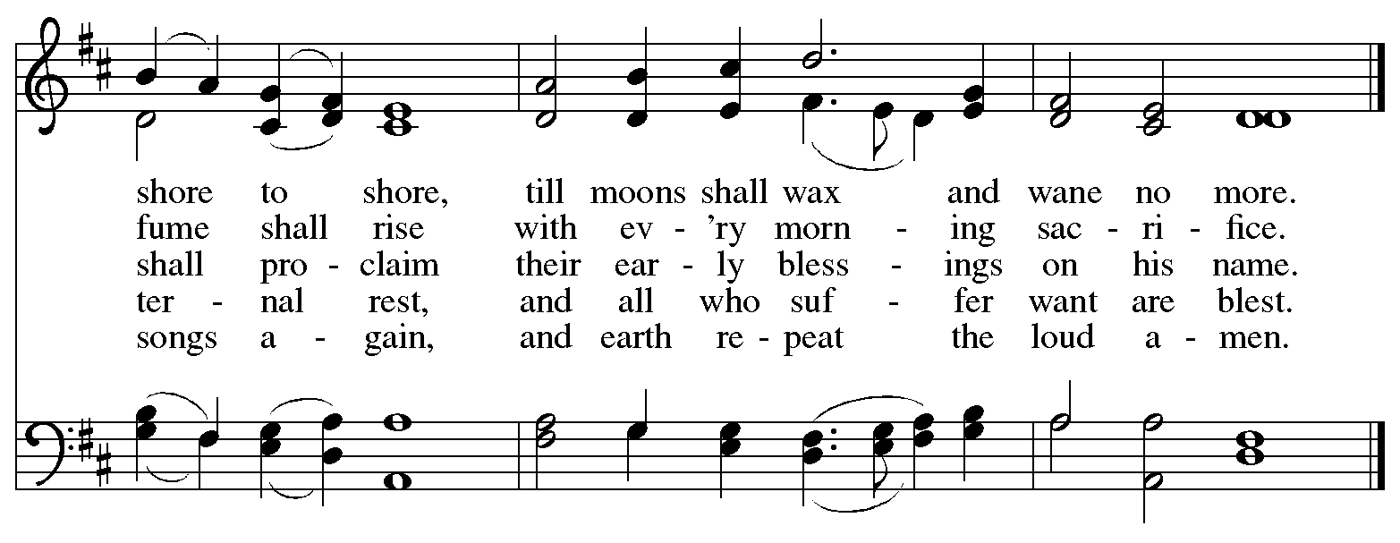


Nicene Creed

C: We believe in one God,
the Father, the Almighty,
maker of heaven and earth,
of all that is, seen and unseen.

We believe in one Lord, Jesus Christ,
the only Son of God,
eternally begotten of the Father,
God from God, Light from Light,
true God from true God,
begotten, not made,
of one Being with the Father;
through him all things were made.
For us and for our salvation
he came down from heaven,
was incarnate of the Holy Spirit and the virgin Mary
and became truly human.
For our sake he was crucified under Pontius Pilate;
he suffered death and was buried.
On the third day he rose again
in accordance with the scriptures;
he ascended into heaven
and is seated at the right hand of the Father.
He will come again in glory to judge the living and the dead,
and his kingdom will have no end.

We believe in the Holy Spirit, the Lord, the giver of life,
who proceeds from the Father and the Son,*
who with the Father and the Son is worshiped and glorified,
who has spoken through the prophets.
We believe in one holy catholic and apostolic church.
We acknowledge one baptism for the forgiveness of sins.
We look for the resurrection of the dead,
and the life of the world to come. Amen.

*Or, “who proceeds from the Father.” The phrase “and the Son” is a later addition to the creed.

Prayers of the People

A: Renewed in God’s everlasting grace, let us pray for the church, the world,
and all who are in need.
After each petition
A: God of grace,
C: receive our prayer.

P: We offer our prayers to you, O God, trusting in your abundant mercy,
through Jesus Christ our Lord.
C: Amen.

Peace

The presiding minister and the assembly greet one another in the peace of the risen Christ.
P: The peace of Christ be with you always.
C: And also with you.

The people may greet those around them with a sign of Christ’s peace and may say
Peace be with you or similar words. Please be mindful that not everyone will be comfortable with sharing the peace, so please seek consent before shaking hands or hugging. Other possible ways to share the peace include a simple bow with the verbal greeting of peace, or simply a verbal expression of peace.

When the greetings of peace have concluded, please be seated.

Meal
God feeds us with the presence of Jesus Christ

Offering

We offer ourselves, our gifts, and our faithful service to God.
As the offering is gathered for the mission of the church, including the care of those in need,
the table is set for Holy Communion.

There are laminated giving cards in the pew racks that feature a QR code for anyone who would like to give online. Those who give using the QR code, as well as those who give regularly online or through their bank are encouraged to place the laminated card in the plate as an expression of your offering.

Offertory Song Hallelujah Cohen/arr. Kurtz

As the gifts are brought forward for presentation, please rise as you are able.

Offertory Song Let the Vineyards Be Fruitful ELW 184

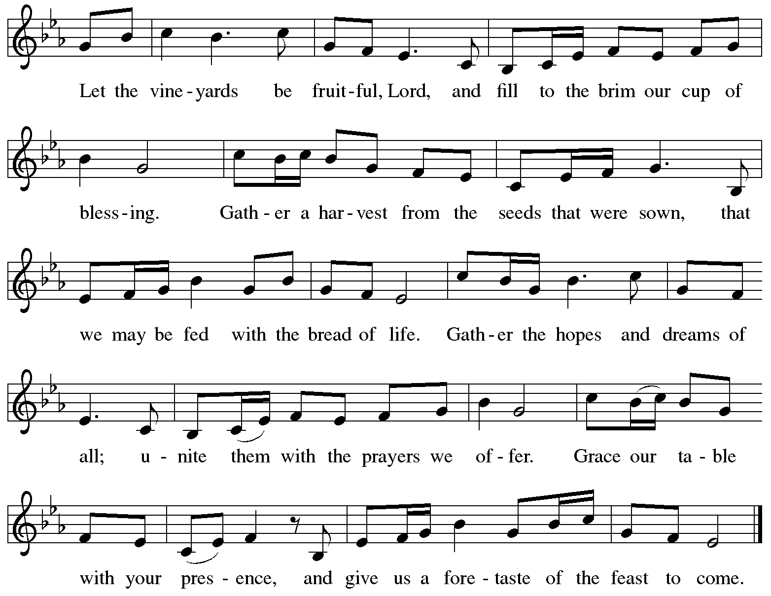
All rights reserved. Reprinted with permission under OneLicense.net # A-722139.

Offertory Prayer

A: Let us pray.
God of mercy and grace,
C: the eyes of all wait upon you, and you open your hand in blessing.
Fill us with good things at your table, that we may come to the help of all in need,
through Jesus Christ, our redeemer and Lord.
Amen.

Dialogue ELW p. 152

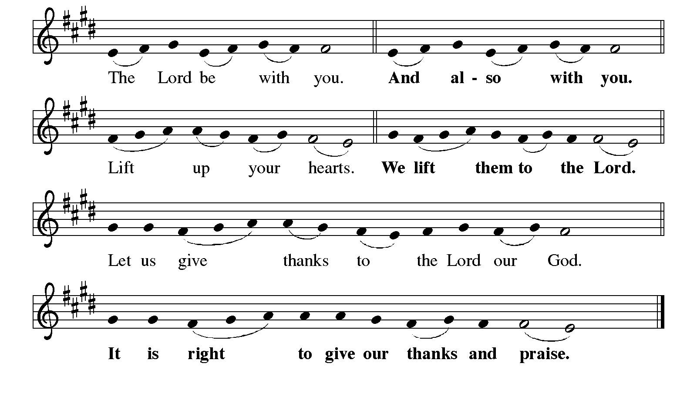

Preface

P: It is indeed right, our duty and our joy,
that we should at all times and in all places
give thanks and praise to you, almighty and merciful God,
through our Savior Jesus Christ;
who one this day overcame death and the grave,
and by his glorious resurrection opened to us the way of everlasting life.
And so, with all the choirs of angels,
with the church on earth and the hosts of heaven,
we praise your name and join their unending hymn:

Sanctus ELW p. 153

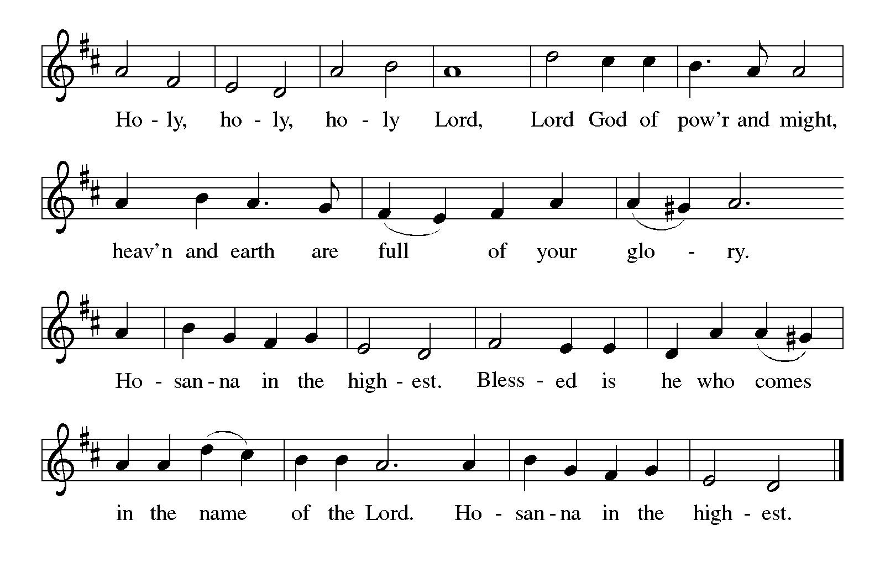
Eucharistic Prayer

P: Holy God, mighty Lord, gracious Father, …
… Do this for the remembrance of me.

For as often as we eat of this bread and drink from this cup,
we proclaim the Lord’s death until he comes.
C: Christ has died. Christ is risen. Christ will come again.

P: Therefore, O God, with this bread and cup …
… to share with us the great and promised feast.
C: Amen. Come, Lord Jesus.

P: Send now, we pray, your Holy Spirit …
… and receive our inheritance with all your saints in light.
C: Amen. Come, Holy Spirit.

P: Join our prayers …
… all glory and honor are yours, almighty Father,
now and forever.
C: Amen.

Lord’s Prayer

P: Gathered as one by the Holy Spirit, let us pray as Jesus taught us.
C: Our Father in heaven,
hallowed be your name,
your kingdom come,
your will be done,
on earth as in heaven.
Give us today our daily bread.
Forgive us our sins
as we forgive those
who sin against us.
Save us from the time of trial
and deliver us from evil.
For the kingdom, the power,
and the glory are yours,
now and forever. Amen.

Fraction and Invitation



Agnus Dei / Lamb of God ELW p. 154

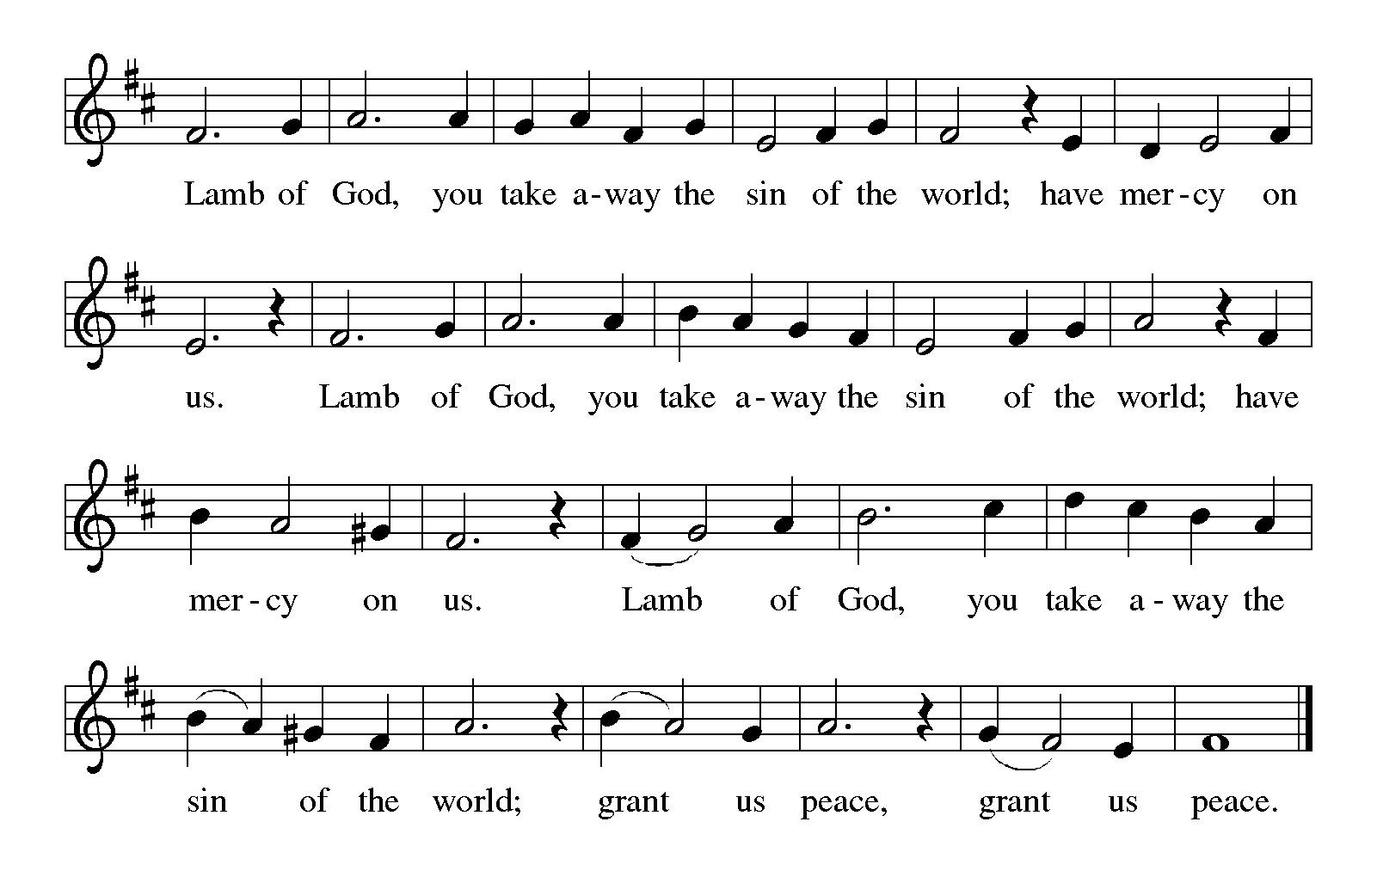

Please be seated.

Holy Communion

- All who seek God and desire a deeper and stronger life in Christ are welcome to receive Holy Communion.
- Worshipers from the pulpit side will proceed forward first, followed by the center section, and then the lectern side.
- Please inform an usher if you would like the ministers to bring Communion to you.
- Holy Communion will be served with bread and wine (amber) or grape juice (purple).
- The presiding minister will first distribute the bread (host) to each communicant. Please indicate if you require a gluten-free host.
- Once you have consumed the bread, please pick up an empty glass from the tray next to the presiding minister. The Communion Assistant will pour wine or grape juice into your glass.
- Please step to the side to consume the wine or grape juice.
- Feel free to kneel at the altar rail for prayer after receiving the sacrament.
- As you return to your pew, glasses may be returned to the empty tray on the side of the center section.
- A blessing will be provided for anyone who does not yet receive the sacrament.
- All are invited to join in singing the hymns during Holy Communion.
Hymns during Holy Communion
O Christ, What Can It Mean for Us ELW 431
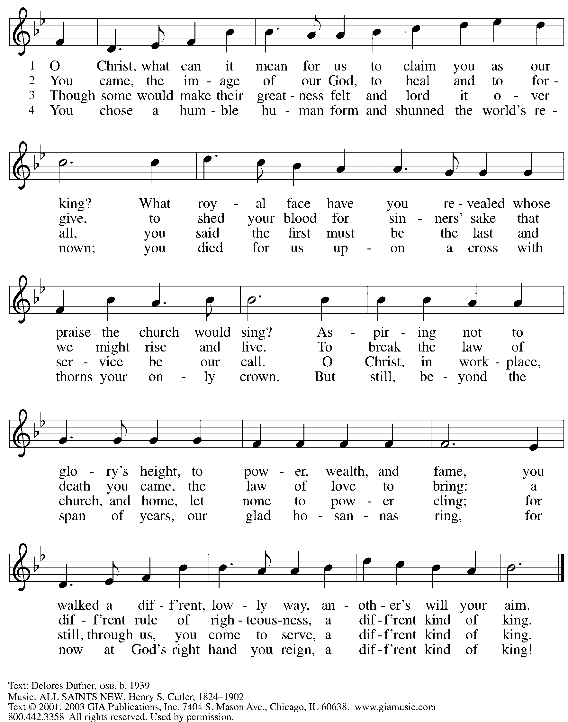
Reprinted under OneLicense.net # A-722139.

Hymns during Holy Communion
Christ Is the Life ACS 927

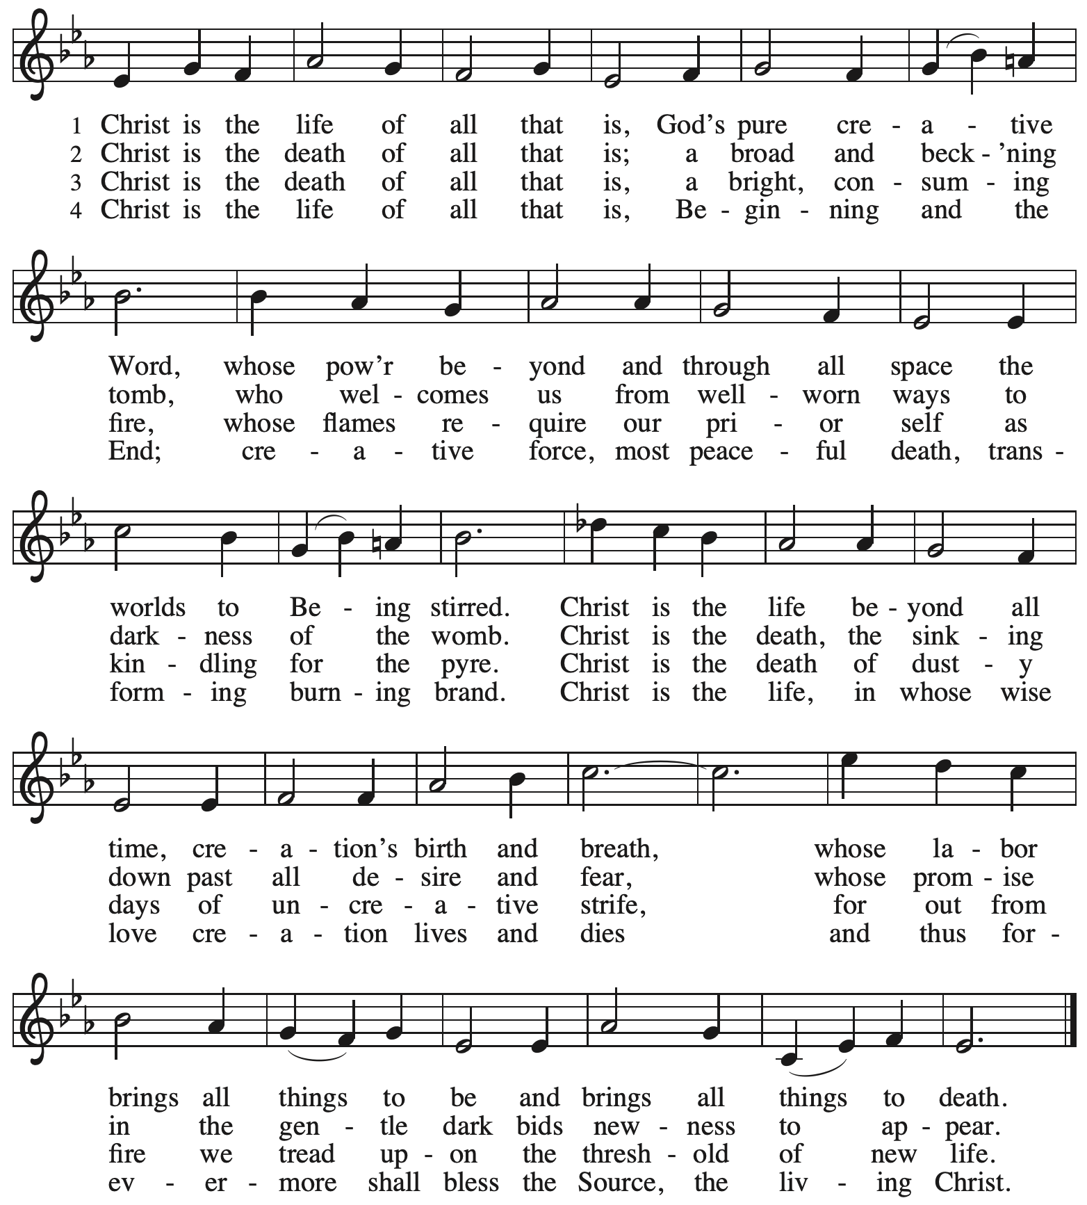
Reprinted with permission under OneLicense.net # A-722139.

Hymns during Holy Communion
In the Cross of Christ I Glory ELW 324

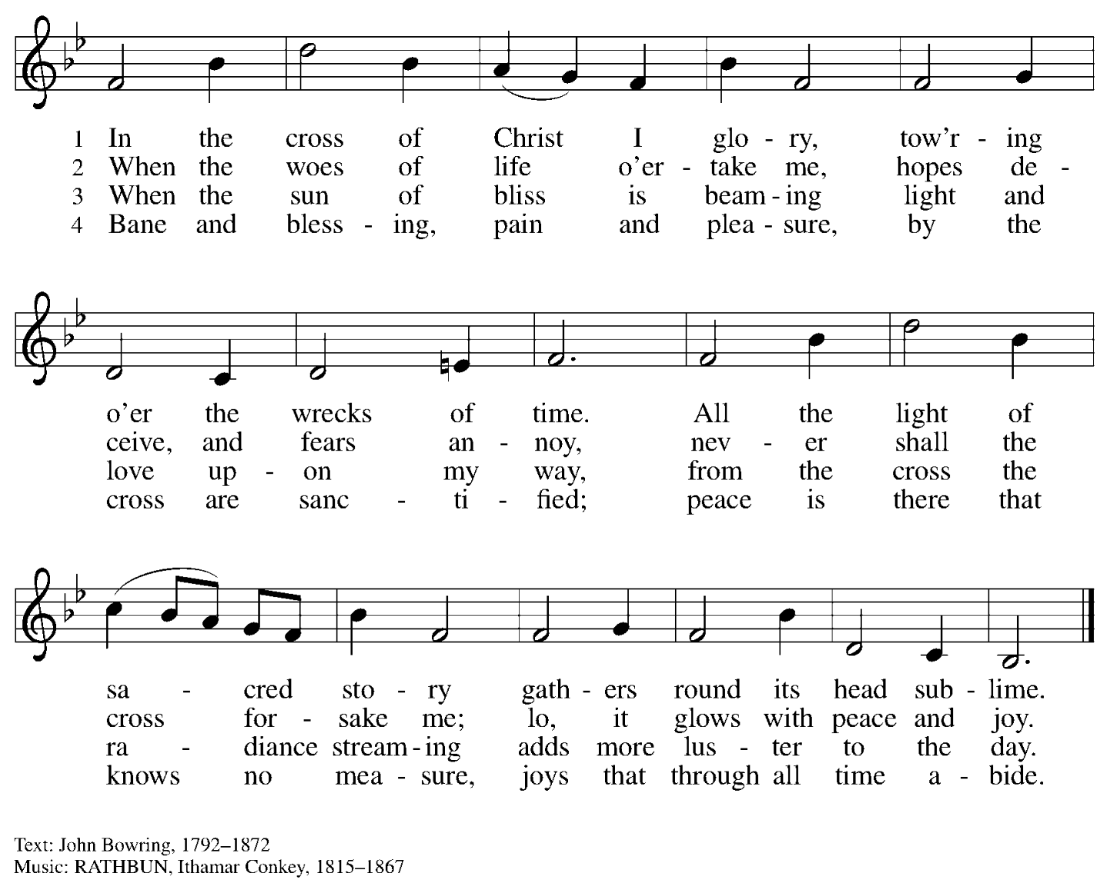

When all have returned to their places, please rise as you are able.

Blessing

P: The body and blood of our Lord Jesus Christ strengthen you and keep you in his grace.
C: Amen.

Prayer

A: Let us pray.
O God our life, our strength, our food,
we give you thanks for sustaining us with the body and blood of your Son.
By your Holy Spirit, enliven us to be the Body of Christ in the world,
that more and more we will give you praise and serve your earth and its many peoples,
through Jesus Christ, our Savior and Lord.
C: Amen.

Please be seated.

Sending
God blesses us and sends us in mission to the world

Announcements

Please rise as you are able.

Benediction

P: The love of God the Sovereign strengthen you,
God the Son save you,
and the Holy Spirit anoint and sustain you.

The Holy Trinity ☩ bless you
and grant you a faithful and courageous heart,
now and forever.
C: Amen.

Sending Hymn Following page
Dismissal

A: Go in peace. Serve the Lord.
C: Thanks be to God!

Postlude

Sending Hymn Crown Him with Many Crowns ELW 855

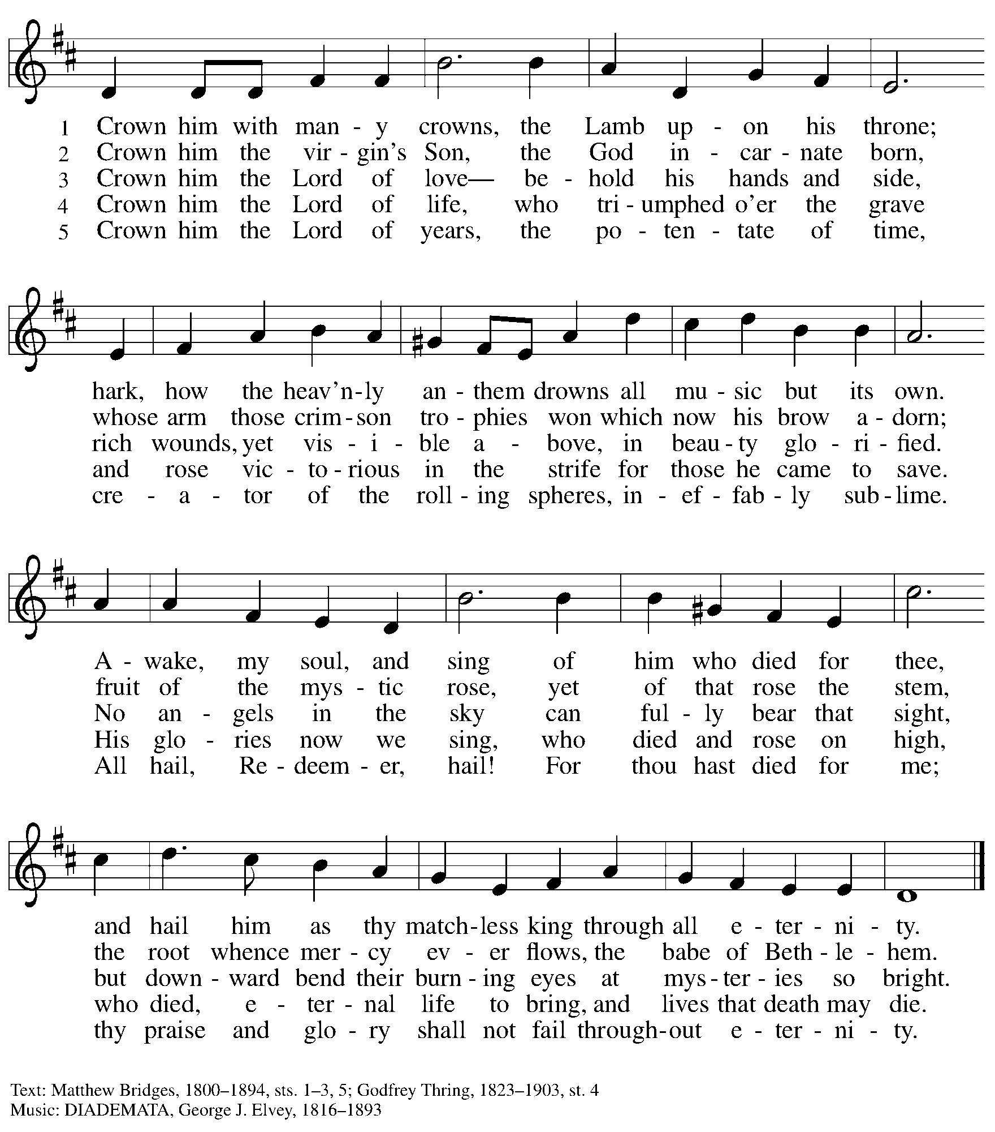

Serving in Worship Today

Altar Care Jodie Minor
Assisting Minister Jeff Denlinger
Audio-Visual Ministers Dave Rollinson
Jered Stratton
Cantor Mandy Best
Lector Lester Prince
Offertory Vocal Kelly Spanninger
Organ Jimmi Kocher-Hillmer
Prelude Trio
Clarinet Maria Mangano
Euphonium Dave Rollinson
Piano Amos
Minister of Music Laura Reynolds
Presiding Minister The Rev. Ross Carmichael

Liturgy and Hymnody Acknowledgements

From SundaysandSeasons.com. Copyright © 2025 Augsburg Fortress. All rights reserved. Reprinted under OneLicense.net # A-722139.
Used by permission of Augsburg Fortress.

The Scripture readings contained herein are from New Revised Standard Version Updated Edition of the Bible © 2021 National Council of Churches of Christ in the United States of America. Used by permission. All rights reserved worldwide.

Please use the QR code below to link to St. Andrew’s Announcements online!



St. Andrew Lutheran Church Announcements
November 23rd, 2025

- Welcome to Worship at St. Andrew on Reign of Christ Sunday – We are so glad you are here, and we offer a special welcome to all visitors and guests who are here for the first time! A nursery is available through the door to the left of the worship space and across the social hall (look for a purple room). Little Church – Big Faith, a Bible lesson and activity for children up to sixth grade, will take place after the prayer of the day. There are also worship “toolkits” to help children engage with worship and “busy bags” for younger children available in the bookcase at the back of the sanctuary. Please feel free to take one to use with/for your children. All are invited to stay for coffee and other drinks, food, and conversation in the Social Hall (through the side door at the left of the worship space) after the service.
- In Loving Memory of The Rev. Dr. Paul F. Koch – In the sure and certain hope of the resurrection to eternal life through our Savior Jesus Christ, we share that The Rev. Dr. Paul Frederick Koch passed away peacefully on November 16th, 2025. He was a caring husband, devoted father, and proud grandfather whose love and gentleness anchored his family. Pastor Paul dedicated his life to ministry, justice, and caring for those at the margins. His kindness, faith, and compassion shaped everyone who knew him. A service of remembrance will be held Saturday, December 6th at St. Andrew; 10:00 a.m. Visitation, 11:00 a.m. Memorial Service, 1:00 p.m. Luncheon at Square Café (134 S. Highland Ave., Pittsburgh, PA 15206). We ask your prayers for Pastor Paul’s wife Sharon; their sons Jeremy (Molly Orlando) and Phil (Deanna); grandchildren Ben, Giovanni, Julian, Caley (Leo), and Samuel; and all their family and friends. To support Sharon, we invite people of the congregation to prepare and deliver meals over the next few weeks. Please sign up here: https://www.signupgenius.com/go/5080B4AAFAF2CABF85-60585068-meals#/
- Produce Distribution Supplemental Food of the Month – St. Andrew is collecting supplemental food each month to accompany our produce distribution. For this month, we ask for donations of instant mashed potatoes and stuffing mix. There are collection boxes at the back of the worship space and social hall.
- East End Interfaith Thanksgiving Service, Tuesday, November 25th, 7:00 p.m. – This year's East End Interfaith Thanksgiving Service, with the theme Lift Every Voice, will be held at Episcopal Church of the Redeemer at 5700 Forbes Ave., Pittsburgh, PA 15217 and will be co-hosted by leaders of the Hindu-Jain Temple in Monroeville. Following the service, all are welcome to a light reception in the Parish Hall. As part of our Thanksgiving offering, we invite all attendees to bring a non-perishable food item or toiletry as an offering to support our immigrant neighbors through JFCS.
- Welcoming the Season of Advent with an Advent Calendar – A new church year in the liturgical calendar begins with the season of Advent, a time of preparation and hope as the church awaits the celebration of Christ’s birth at Christmas and the second coming of Jesus promised in Scripture. The World Hunger ministry of the Evangelical Lutheran Church in America (ELCA) has provided an Advent calendar for congregations titled “A Stable Lamp Is Lighted.” These calendars offer daily Bible readings, suggestions for supporting our neighbors in need, and activities, including a color and cut-out Nativity scene that would be a great activity for children. There is also a three-session online study with videos available here: https://www.elca.org/our-work/relief-and-development/elca-world-hunger/wh-advent#whadventaccordionsection. Please take a calendar and study guide up at the entrances to the church!
- St. Andrew Soup and Service, Sunday, November 30th, after Worship – All are invited to gather after worship on Sunday, November 30th, when we will share a soup lunch and then tie blankets to be given to Proud Haven (https://proudhaven.org/) and Humane Animal Rescue (https://humaneanimalrescue.org). People of all ages are welcome to join.
- Community Ministry Team Collecting Gifts for Foster Children Served by Allegheny County CYS, Through Dec. 7th – Allegheny County’s Office of Children, Youth, and Families of children is in need of gifts to support those who come into the system late, or who weren’t sponsored. We are collecting some highly-requested items for children in the foster system to ensure that they receive some cheer this holiday season. Please bring the following items, unwrapped, for donation: winter wear for ages 0-18, baby necessities (blankets, wipes, bottles, pacifiers, bibs), developmental toys and board books for babies and toddlers, crayons, colored pencils, gel pens, coloring books, LEGO and Mega Blok sets, board games, ethnically diverse dolls, superhero action figures, craft kits, earbuds, headphones, gaming mouse and keyboard, science/STEM kits, remote control vehicles (cars, trucks, helicopters, drones), sports equipment for ages 3-18, local sports team apparel, sensory toys (slime, kinetic sand, fidgets), makeup, toiletries (body lotion, shower gel, bath poufs, body spray), wallets, watches, and fleece blankets.
- Pittsburgh Pride Choir Winter Concert - “A Not So Silent Night," Saturday, December 6th, 7:30 p.m. – The Board of Directors of the Pittsburgh PRIDE Choir, Pittsburgh's esteemed LGBTQIA+ choir would be privileged if you attended their Holiday Concert on December 6th titled “A Not So Silent Night." The concert begins at 7:30 p.m., at East Liberty Presbyterian Church (116 S. Highland Ave), a fully affirming and inclusive venue. For tickets, you can use the following link: https://www.ticketleap.events/tickets/pittsburgh-pride-choir/a-not-so-silent-night-ppc-holiday-concert-2025. Concert details are available at www.pittsburghpridechoir.org. If you have questions, please notify them at volunteer@pittsburghpridechoir.org. Accessibility questions may be directed to accessibility@pittsburghpridechoir.org. If you would like to attend but cannot afford a ticket, contact Jay at communications@standrewpittsburgh.org for a comp ticket as she has a few to give away.
- Discipleship that Heals the World - Studies in Matthew’s Gospel, Thursdays, 8:00 - 9:00 p.m. on Zoom, through Dec. 11th, 2025 – Join us for a journey through the Gospel of Matthew, organized and facilitated by Rev. Dr. Martin Rafanan. Together we’ll explore Jesus’ Sermon on the Mount and his healing ministry, discovering Matthew’s distinctive vision of discipleship as a way of blessing, healing, and hope. You are welcome to join the zoom whenever you can. This study is designed for both newcomers to the Gospel and those already familiar with it. We will engage contemporary perspectives that help us hear Matthew’s message afresh in today’s world. Register for the sessions to receive zoom info: https://forms.gle/amy439vfUpwdJpKx7.
- Receive Prayer Team Emails – St. Andrew maintains a list of weekly prayer concerns sent by email to members of the congregation who have opted in. Our prayer team’s email is prayerteam@standrewpittsburgh.org. We will keep names on the list for a maximum of four weeks unless otherwise requested. Thank you for your ministry of prayer!
- Records Update – St. Andrew is updating our records with information from newer attendees, as well as offering current members the opportunity to include current information to be used within the congregation: for emergency contacts, to acknowledge celebrations, milestones, and prayers. Please fill out the form at: https://forms.gle/kKvp19UozuRrhhaV7.
- Coffee Hour Signups – St. Andrew provides hospitality during a coffee hour after worship each Sunday. If you would like to participate and would like information about the duties of setting up, please sign up using the following form: https://www.signupgenius.com/go/5080B4AAFAF2CABF85-47069030-coffee#/.

