

+ Second Sunday of Advent
December 7, 2025



St. Andrew Lutheran Church
304 Morewood Ave.
Pittsburgh, PA 15213
St_andrewELCA@verizon.net
www.standrewpittsburgh.org

+ Second Sunday of Advent
Order for Worship

At the heart of our Advent preparation stands John the Baptist, who calls us to repent and make a new beginning. As the darkness increases, we turn toward the approaching light of Christ.
For Christians he is the root of Jesse, the righteous judge who welcomes all, especially the poor and meek of the earth. We wait with hope for that day when the wolf will dwell with the lamb, and there will be no more hurt or destruction. From the Lord’s table we are sent in the spirit of John the Baptist to proclaim that in Christ the kingdom of God has come near.

Welcome to St. Andrew!
- St. Andrew welcomes all who are seeking a place of healing, wholeness, and acceptance in a nurturing and faith-forming spiritual home. We are striving toward racial equity worldwide
and we seek to honor the lived experience of all individuals regardless of background. Our community embraces people of all ages, ethnicities, cultures, abilities, sexual orientations,
gender identities and expressions, and family constellations. Come and See!
- Worship Services are live-streamed to multiple online platforms. By attending worship, you agree that your image and voice may be broadcast.
- Everyone is invited to make a name tag at the black bookcase in the back of the worship space if they would like. There are stickers indicating pronouns on the bookcase if you would like to include them on your name tag.
- A nursery is available through the doors at the left side of the sanctuary and across from the doorway to the Social Hall. Look for a purple-colored room.
- Children are invited to attend Little Church – Big Faith, a Bible lesson and activity, during worship (after the Prayer of the Day). The group returns to the worship space for the liturgy of Holy Communion.
- Worship “toolkits” to help children engage with the service, along with “busy bags” for younger children, are available in the bookcase at the back of the sanctuary. Please feel free to take one to use with/for your children.
- Holy Communion is served with bread (gluten-free available) and wine or grape juice. The presiding minister will distribute the bread (host). Please consume this and then pick up an empty glass from the tray. The Communion Assistant will pour wine or grape juice into your glass. Please step to the side to consume the wine or grape juice. Feel free to kneel at the altar for prayer and reflection. As you return to your pew, glasses may be returned to the empty trays on either side of the center section.
- A restroom is available on the main level of the church, through the doors to the Social Hall and to the right in the main office.

Abbreviations
P: Pastor/Presiding Minister ELW: Evangelical Lutheran Worship hymnal
A: Assisting Minister ACS: All Creation Sings hymnal
L: Lector
C: Congregation

Musical Offering

Each week, different people from the congregation make an offering of pre-service music, with singing or instrumentation, to help the assembly focus and pray in preparation for worship.

Welcome

Prelude arr. Oines
Comfort, Comfort Now My People / Now the Heavens Start to Whisper

Gathering
The Holy Spirit calls us together as the people of God

Please rise as you are able. All may make the sign of the cross,
the sign that is marked at Baptism, as the presiding minister begins.

Confession and Forgiveness

P: P: Blessed be the Holy Trinity, one ☩ God,
whose home is heaven and earth, whose salvation is sure.
C: Amen.

P: Let us confess our sin in the presence of God and of one another.

Silence is kept for reflection.

P: Long-expected God,
C: we confess that we look to ourselves
for the peace and security only you can provide.
We reach for swords and spears,
reluctant to release our grip on the ways of war.
We become impatient while waiting
and weary of keeping awake.
Free us from self-reliance,
and teach us to live in harmony with our neighbors.
Increase our trust in God’s timing,
and awaken us to your advent among us,
that we may abound in the hope you have promised.
Amen.

P: God judges us not as we deserve,
but according to God’s own righteousness.
in ☩ Christ Jesus, you are freed and forgiven, saved by grace,
and ready to welcome the Savior.
C: Amen.
Gathering Hymn Awake! Awake and Greet the New Morn ELW 242
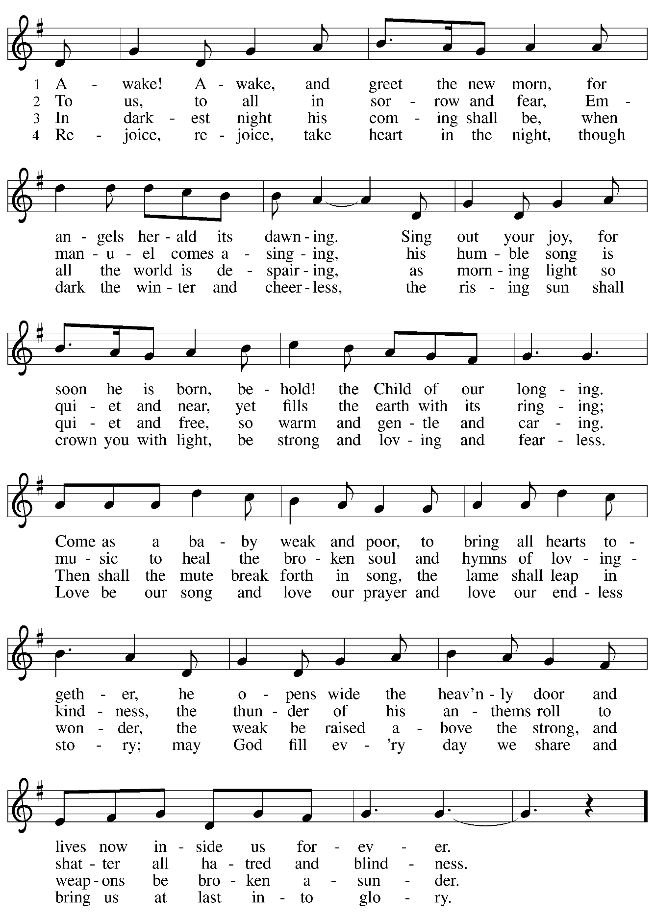
Greeting

P: The grace of our Lord Jesus Christ, the love of God,
and the communion of the Holy Spirit be with you all.
C: And also with you.

Kyrie ACS p. 12

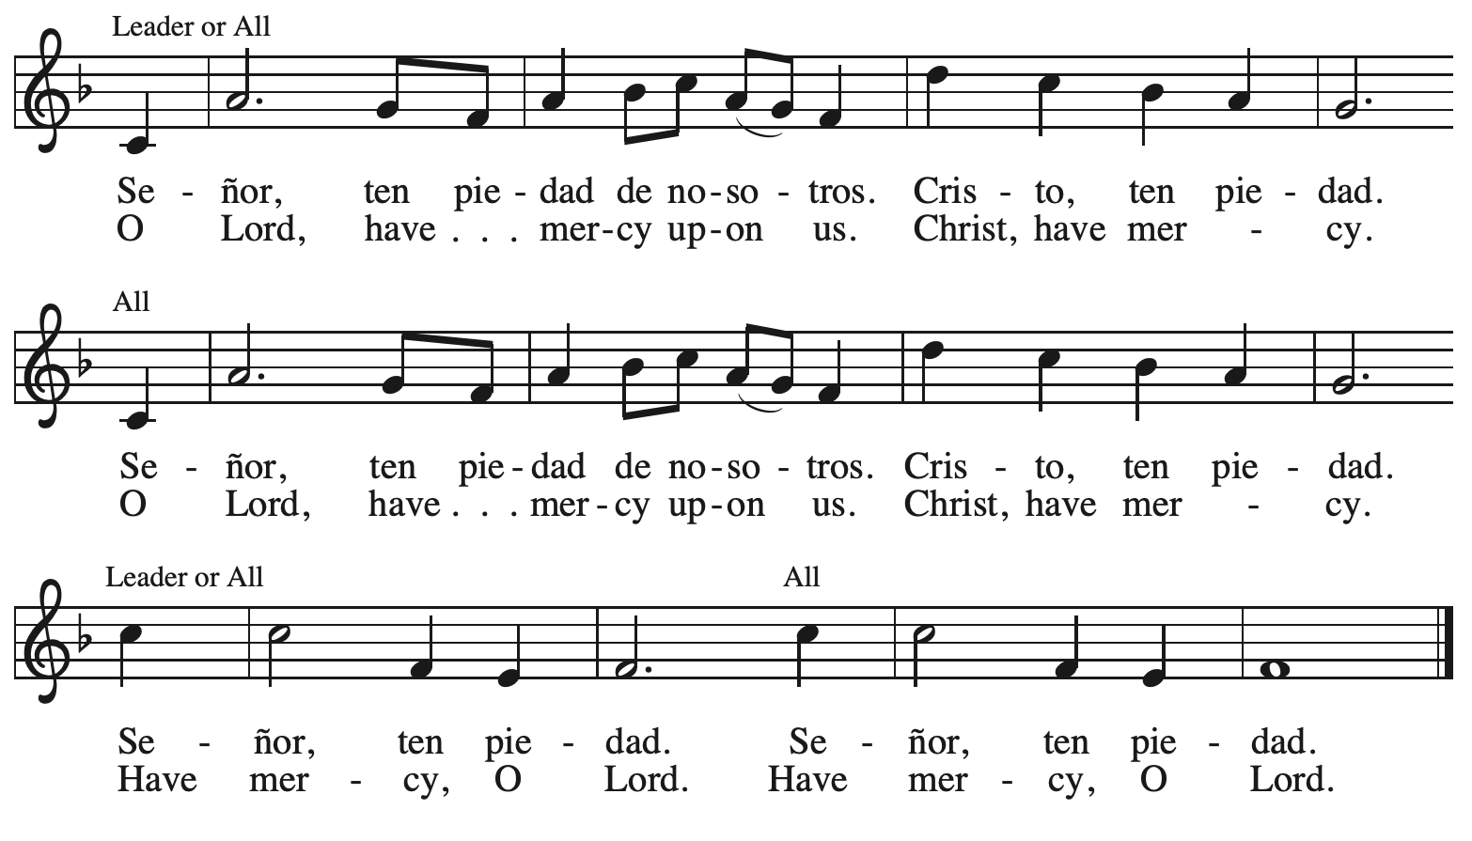

Prayer of the Day

P: The Lord be with you.
C: And also with you.

P: Let us pray.
Stir up our hearts, Lord God, to prepare the way of your only Son.
By his coming, nurture our growth as people of repentance and peace;
through Jesus Christ, our Savior and Lord,
who lives and reigns with you and the Holy Spirit,
one God, now and forever.
C: Amen.

Please be seated.
Children are invited to join the adult leader(s) at the side door for Little Church – Big Faith.
We ask that an additional adult from the congregation attend with the children.

Word
God speaks to us in Scripture reading, preaching, and song

First Reading – Isaiah 11: 1-10

¹ A shoot shall come out from the stump of Jesse,
and a branch shall grow out of his roots.
² The spirit of the Lord shall rest on him,
the spirit of wisdom and understanding,
the spirit of counsel and might,
the spirit of knowledge and the fear of the Lord.
³ His delight shall be in the fear of the Lord.
He shall not judge by what his eyes see
or decide by what his ears hear,
⁴ but with righteousness he shall judge for the poor
and decide with equity for the oppressed of the earth;
he shall strike the earth with the rod of his mouth,
and with the breath of his lips he shall kill the wicked.
⁵ Righteousness shall be the belt around his waist
and faithfulness the belt around his loins.
⁶ The wolf shall live with the lamb;
the leopard shall lie down with the kid;
the calf and the lion will feed together,
and a little child shall lead them.
⁷ The cow and the bear shall graze;
their young shall lie down together;
and the lion shall eat straw like the ox.
⁸ The nursing child shall play over the hole of the asp,
and the weaned child shall put its hand on the adder’s den.
⁹ They will not hurt or destroy
on all my holy mountain,
for the earth will be full of the knowledge of the Lord
as the waters cover the sea.
¹⁰ On that day the root of Jesse shall stand as a signal to the peoples; the nations shall inquire of him, and his dwelling shall be glorious.

L: Word of God, word of life.
C: Thanks be to God.

Psalm 72: 1-7, 18-19

The psalm will be sung responsively, led by the cantor, with the congregation singing the verses in bold type and joining in the refrain.

Psalm Tone

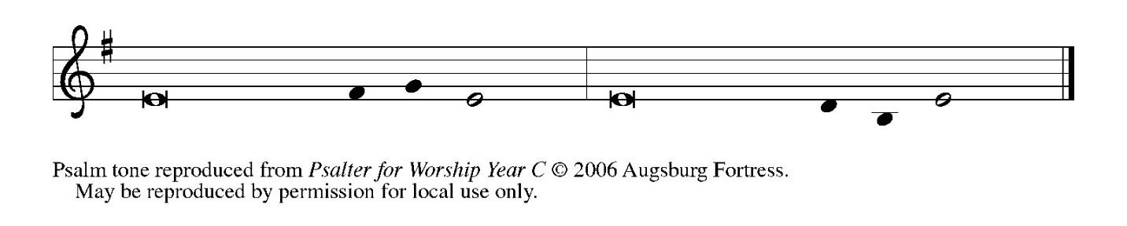

Psalm Refrain

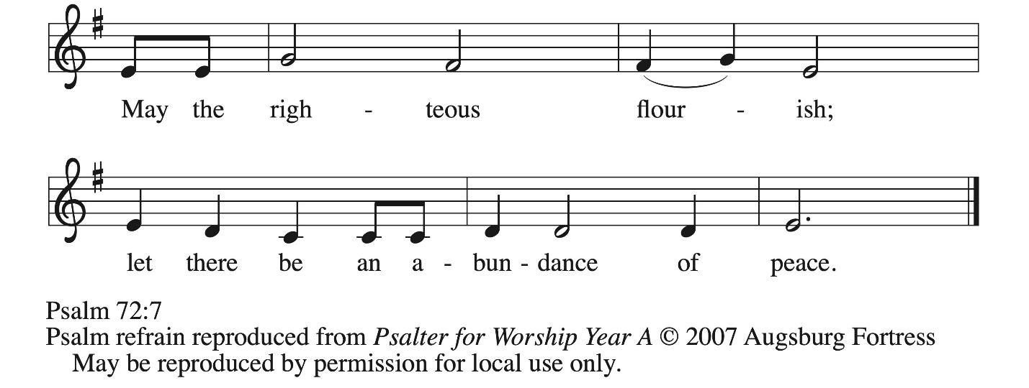

¹ Give the king your jus- | tice, O God,
and your righteousness to | the king’s son;
² that he may rule your | people righteously
and the | poor with justice;
³ that the mountains may bring prosperity | to the people,
and the | hills, in righteousness.
⁴ Let him defend the needy a- | mong the people,
rescue the poor, and crush | the oppressor. R
⁵ May he live as long as the sun and | moon endure,
from one generation | to another.
⁶ Let him come down like rain upon | the mown field,
like showers that wa- | ter the earth.
⁷ In his time may the | righteous flourish;
and let there be an abundance of peace till the moon shall | be no more.
¹⁸ Blessed are you, Lord God, the | God of Israel;
you alone do | wondrous deeds!
¹⁹ And blessed be your glorious | name forever,
and may all the earth be filled with your glory. A- | men. Amen. R

Second Reading – Romans 15: 4-13

⁴ Whatever was written in former days was written for our instruction, so that by steadfastness and by the encouragement of the scriptures we might have hope. ⁵ May the God of steadfastness and encouragement grant you to live in harmony with one another, in accordance with Christ Jesus, ⁶ so that together you may with one voice glorify the God and Father of our Lord Jesus Christ.
⁷ Welcome one another, therefore, just as Christ has welcomed you, for the glory of God.
⁸ For I tell you that Christ has become a servant of the circumcised on behalf of the truth of God in order that he might confirm the promises given to the ancestors ⁹ and that the gentiles might glorify God for God’s mercy. As it is written,
“Therefore I will confess you among the gentiles
and sing praises to your name”;
¹⁰ and again he says,
“Rejoice, O gentiles, with God’s people”;
¹¹ and again,
“Praise the Lord, all you gentiles,
and let all the peoples praise the Lord”;
¹² and again Isaiah says,
“The root of Jesse shall come,
the one who rises to rule the gentiles;
in him the gentiles shall hope.”
¹³ May the God of hope fill you with all joy and peace in believing, so that you may abound in hope by the power of the Holy Spirit.

L: Word of God, word of life.
C: Thanks be to God.

Please rise as you are able.

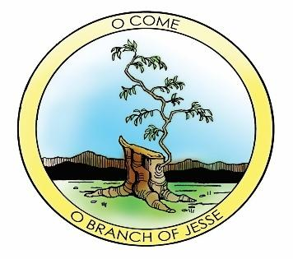

Gospel Acclamation ELW p. 188

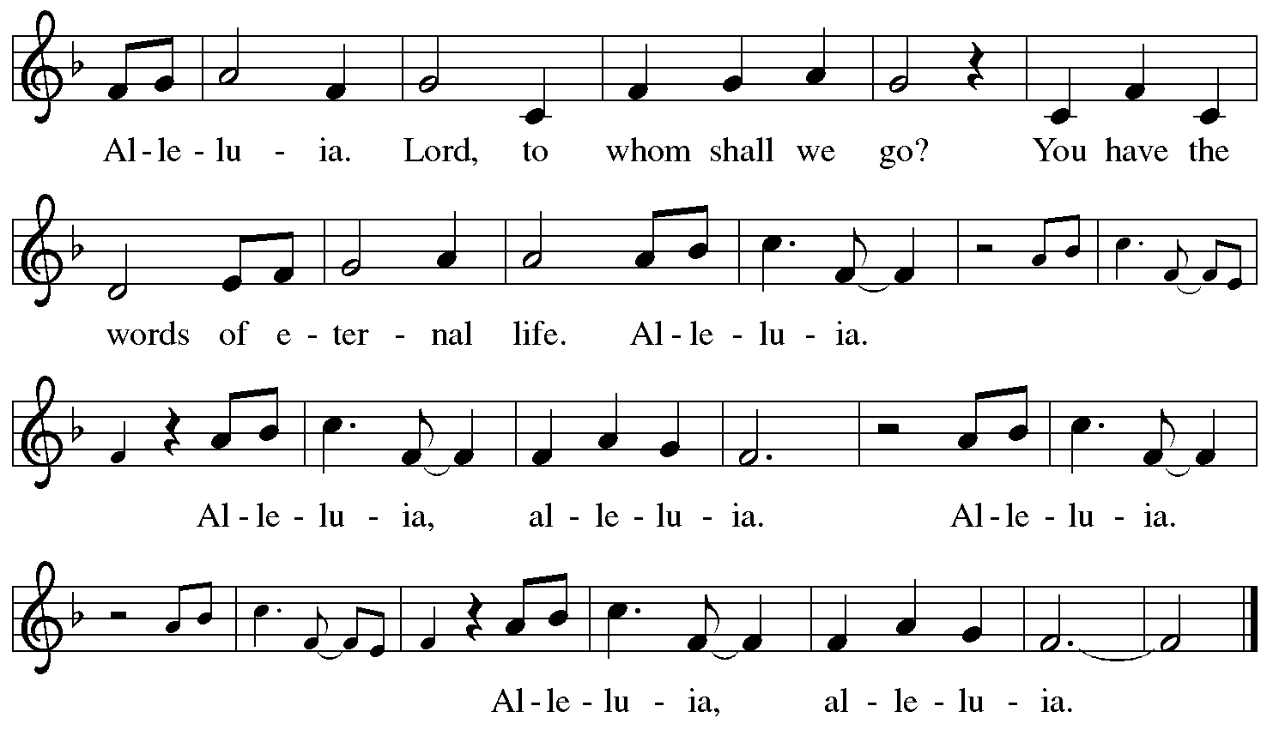

Gospel – Matthew 3: 1-12

P: The holy Gospel according to St. Matthew.
C: Glory to you, O Lord.

¹ In those days John the Baptist appeared in the wilderness of Judea, proclaiming, ² “Repent, for the kingdom of heaven has come near.” ³ This is the one of whom the prophet Isaiah spoke when he said,
“The voice of one crying out in the wilderness:
‘Prepare the way of the Lord;
make the Lord’s paths straight.’ ”
⁴ Now John wore clothing of camel’s hair with a leather belt around his waist, and his food was locusts and wild honey. ⁵ Then Jerusalem and all Judea and all the region around the Jordan were going out to him, ⁶ and they were baptized by him in the River Jordan, confessing their sins.
⁷ But when he saw many of the Pharisees and Sadducees coming for his baptism, he said to them, “You brood of vipers! Who warned you to flee from the coming wrath? ⁸ Therefore, bear fruit worthy of repentance, ⁹ and do not presume to say to yourselves, ‘We have Abraham as our ancestor,’ for I tell you, God is able from these stones to raise up children to Abraham. ¹⁰ Even now the ax is lying at the root of the trees; therefore every tree that does not bear good fruit will be cut down and thrown into the fire.
¹¹ “I baptize you with water for repentance, but the one who is coming after me is more powerful than I, and I am not worthy to carry his sandals. He will baptize you with the Holy Spirit and fire. ¹² His winnowing fork is in his hand, and he will clear his threshing floor and will gather his wheat into the granary, but the chaff he will burn with unquenchable fire.”

P: The Gospel of the Lord.
C: Praise to you, O Christ.

Please be seated.

Sermon

A time of silence for prayer and reflection follows the sermon.
When the hymn of the day begins, please rise as you are able.



Hymn of the Day On Jordan’s Bank the Baptist’s Cry ELW 249

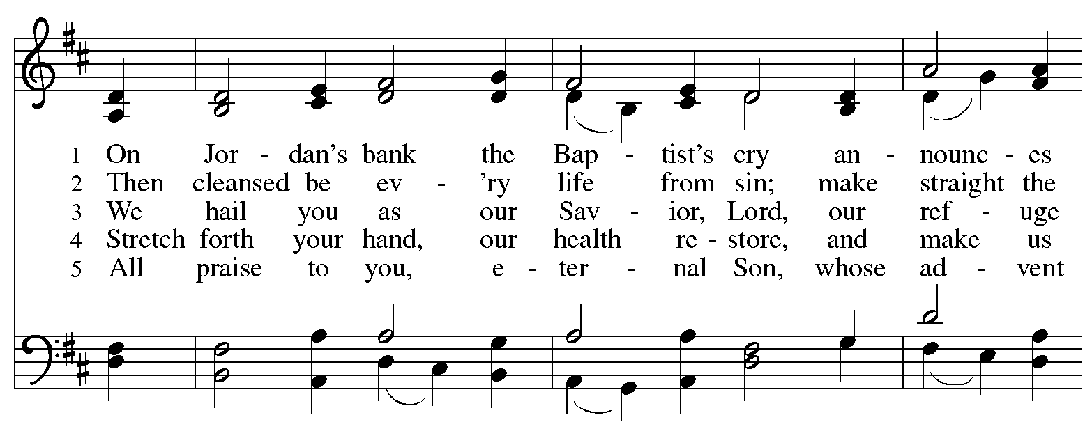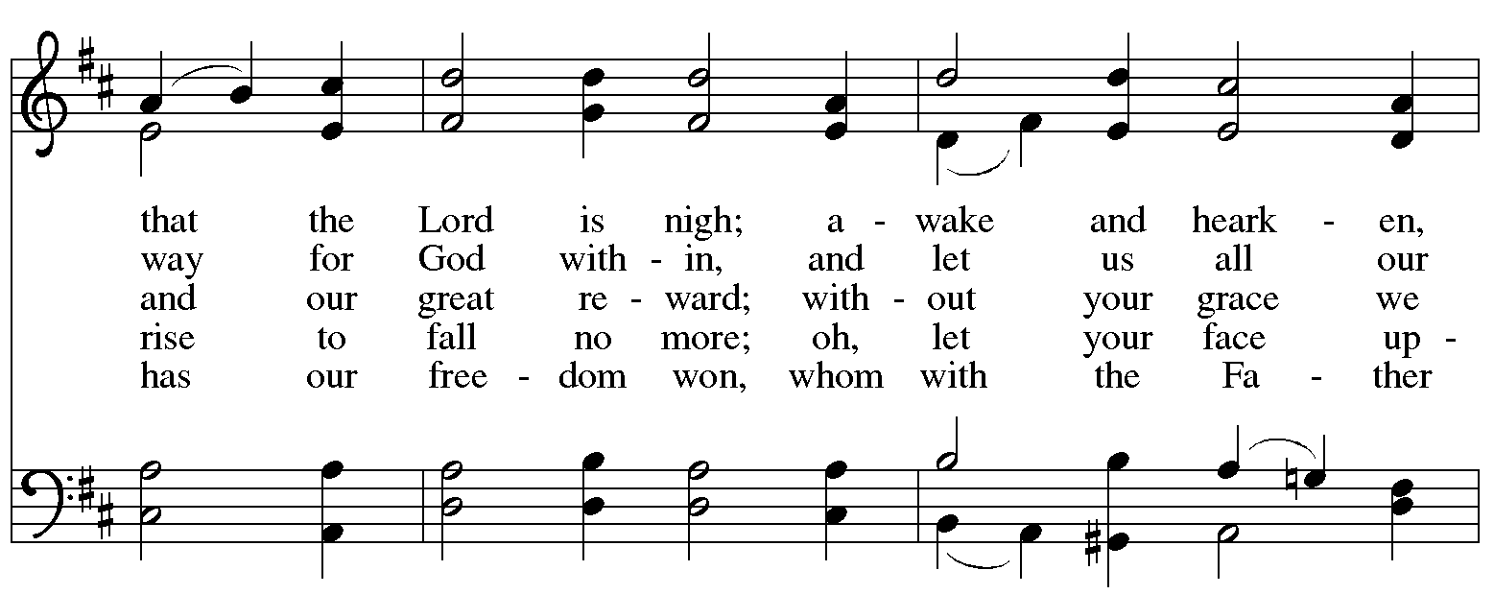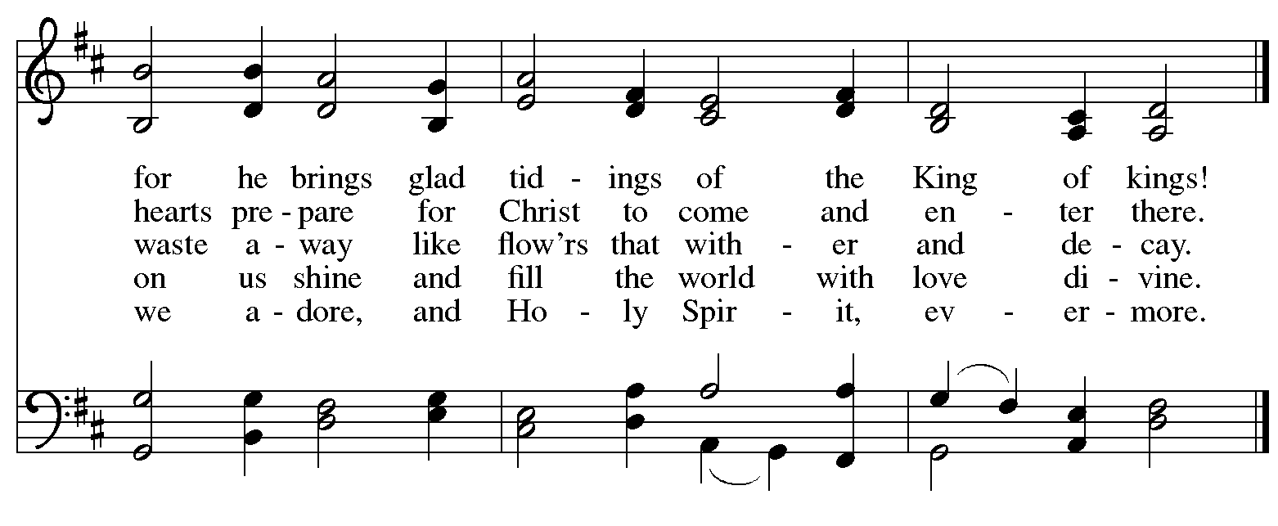
Nicene Creed

C: We believe in one God,
the Father, the Almighty,
maker of heaven and earth,
of all that is, seen and unseen.

We believe in one Lord, Jesus Christ,
the only Son of God,
eternally begotten of the Father,
God from God, Light from Light,
true God from true God,
begotten, not made,
of one Being with the Father;
through him all things were made.
For us and for our salvation
he came down from heaven,
was incarnate of the Holy Spirit and the virgin Mary
and became truly human.
For our sake he was crucified under Pontius Pilate;
he suffered death and was buried.
On the third day he rose again
in accordance with the scriptures;
he ascended into heaven
and is seated at the right hand of the Father.
He will come again in glory to judge the living and the dead,
and his kingdom will have no end.

We believe in the Holy Spirit, the Lord, the giver of life,
who proceeds from the Father and the Son,*
who with the Father and the Son is worshiped and glorified,
who has spoken through the prophets.
We believe in one holy catholic and apostolic church.
We acknowledge one baptism for the forgiveness of sins.
We look for the resurrection of the dead,
and the life of the world to come. Amen.

*Or, “who proceeds from the Father.” The phrase “and the Son” is a later addition to the creed.

Prayers of the People

A: In our waiting and watching, we come to you in prayer, O God,
trusting in your promise to renew the church, the nations, and your whole creation.

After each petition
A: God of grace,
C: receive our prayer.

P: Draw near to us, O God, as we commend into your care all for whom we pray,
trusting in your mercy, through Jesus Christ our Savior.
C: Amen.

Peace

The presiding minister and the assembly greet one another in the peace of the risen Christ.
P: The peace of Christ be with you always.
C: And also with you.

The people may greet those around them with a sign of Christ’s peace and may say
Peace be with you or similar words. Please be mindful that not everyone will be comfortable with sharing the peace, so please seek consent before shaking hands or hugging. Other possible ways to share the peace include a simple bow with the verbal greeting of peace, or simply a verbal expression of peace.

When the greetings of peace have concluded, please be seated.

Meal
God feeds us with the presence of Jesus Christ

Offering

We offer ourselves, our gifts, and our faithful service to God.
As the offering is gathered for the mission of the church, including the care of those in need,
the table is set for Holy Communion.

There are laminated giving cards in the pew racks that feature a QR code for anyone who would like to give online. Those who give using the QR code, as well as those who give regularly online or through their bank are encouraged to place the laminated card in the plate as an expression of your offering.

Reparations Offering
On the first Sunday of each month, St. Andrew invites people of the congregation to give a second offering for a reparations fund in acknowledgment of St. Andrew’s use of African American spiritual songs in our worship services. Please see the note in the announcements for more information.

Offertory Music On Jordan’s Bank the Baptist’s Cry arr. Oines

As the gifts are brought forward for presentation, please rise as you are able.

Offertory Song As Saints of Old ELW 695
v. 3
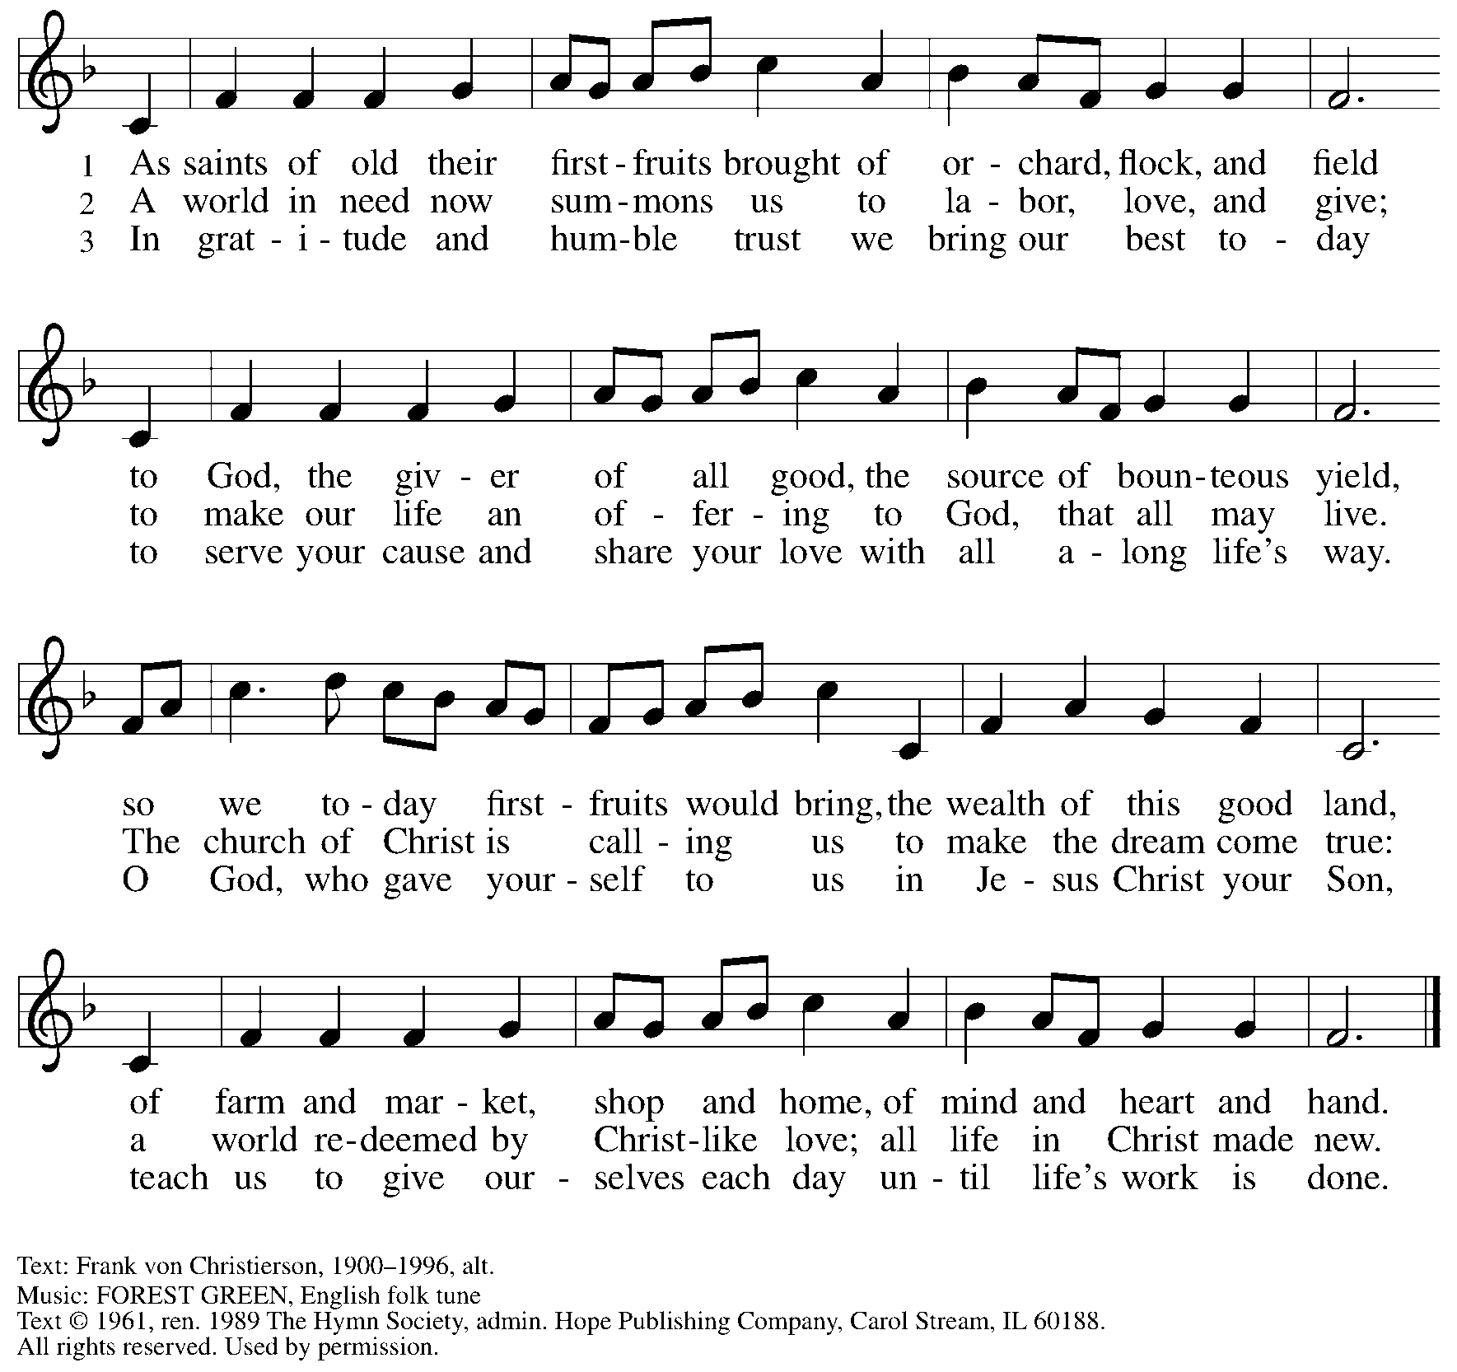
All rights reserved. Reprinted with permission under OneLicense.net # A-722139.

Offertory Prayer

A: Let us pray.
A: God of abundance,
C: we bring before you the precious fruits of your creation, and with them our very lives. Teach us patience and hope as we care for all those in need until the coming of your Son, our Savior and Lord. Amen.

Dialogue

P: The Lord be with you.
C: And also with you.

P: Lift up your hearts.
C: We lift them to the Lord.

P: Let us give thanks to the Lord our God.
C: It is right to give our thanks and praise.

Preface

P: It is indeed right, our duty and our joy, …
… we praise your name and join their unending hymn:

Sanctus ELW p. 190
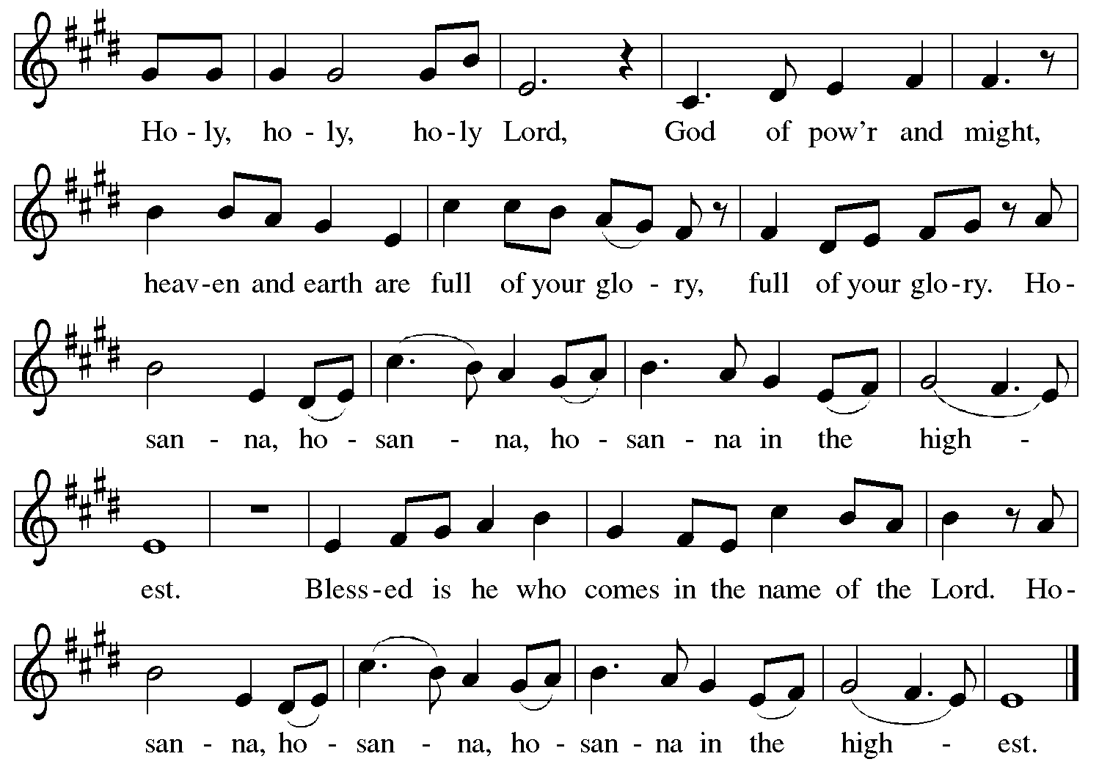

Eucharistic Prayer

P: Holy One, the beginning and the end, the giver of life …
… Do this for the remembrance of me.

P: Let us proclaim the mystery of faith:
C: Christ has died. Christ is risen. Christ will come again.

P: With this bread and cup …
… we look with hope for his coming.
C: Come, Lord Jesus.

P: Holy God, we long for your Spirit …
… Bring the gift of peace on earth.
C: Come, Holy Spirit.

P: All praise and glory are yours,
Holy One of Israel, Word of God incarnate, Power of the Most High,
now and forever.
C: Amen.

Lord’s Prayer

P: Gathered as one by the Holy Spirit, let us pray as Jesus taught us.
C: Our Father in heaven,
hallowed be your name,
your kingdom come,
your will be done,
on earth as in heaven.
Give us today our daily bread.
Forgive us our sins
as we forgive those
who sin against us.
Save us from the time of trial
and deliver us from evil.
For the kingdom, the power,
and the glory are yours,
now and forever. Amen.

Fraction and Invitation

Agnus Dei / Lamb of God ELW p. 191

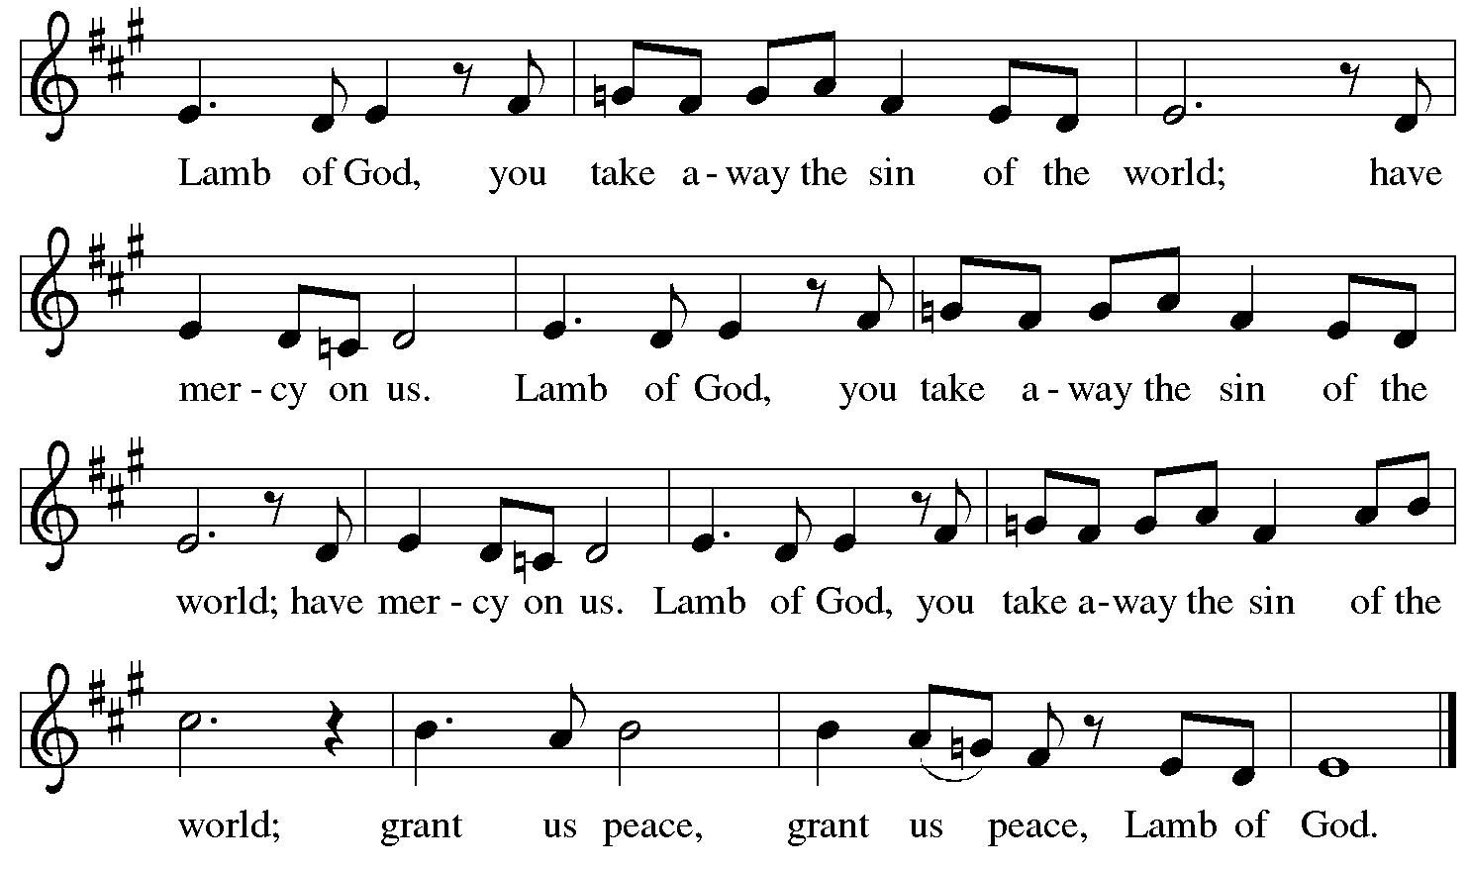

Please be seated.

Holy Communion

- All who seek God and desire a deeper and stronger life in Christ are welcome to receive Holy Communion.
- Worshipers from the pulpit side will proceed forward first, followed by the center section, and then the lectern side.
- Please inform an usher if you would like the ministers to bring Communion to you.
- Holy Communion will be served with bread and wine (amber) or grape juice (purple).
- The presiding minister will first distribute the bread (host) to each communicant. Please indicate if you require a gluten-free host.
- Once you have consumed the bread, please pick up an empty glass from the tray next to the presiding minister. The Communion Assistant will pour wine or grape juice into your glass.
- Please step to the side to consume the wine or grape juice.
- Feel free to kneel at the altar rail for prayer after receiving the sacrament.
- As you return to your pew, glasses may be returned to the empty tray on the side of the center section.
- A blessing will be provided for anyone who does not yet receive the sacrament.
- All are invited to join in singing the hymns during Holy Communion.

Hymns during Holy Communion
O Day of Peace ELW 711

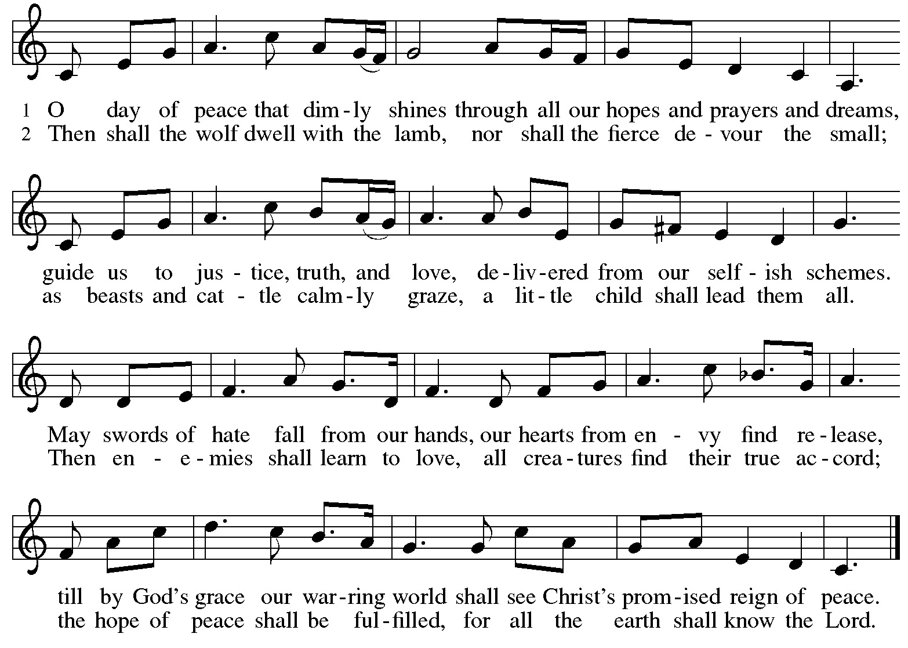

Hymns during Holy Communion
He Comes to Us as One Unknown ELW 737

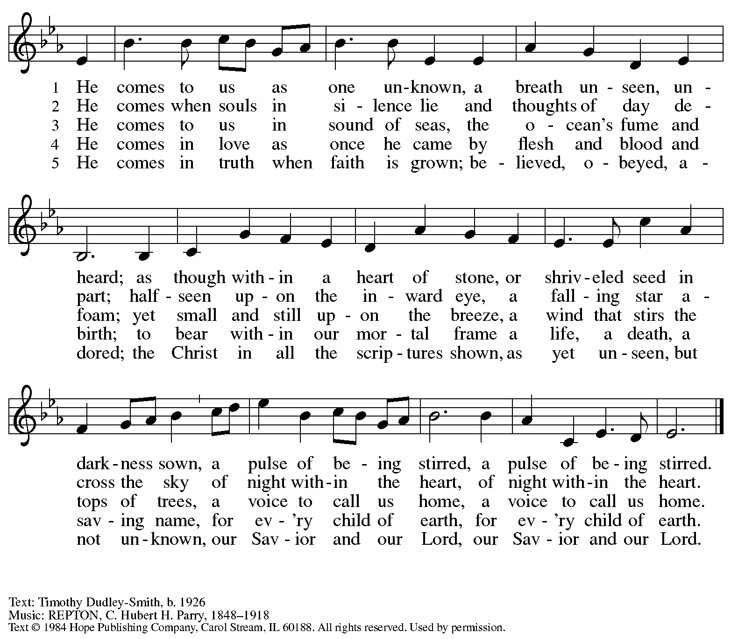
Reprinted under OneLicense.net # A-722139.

Hymns during Holy Communion
We Are Waiting for Jesus ACS 905

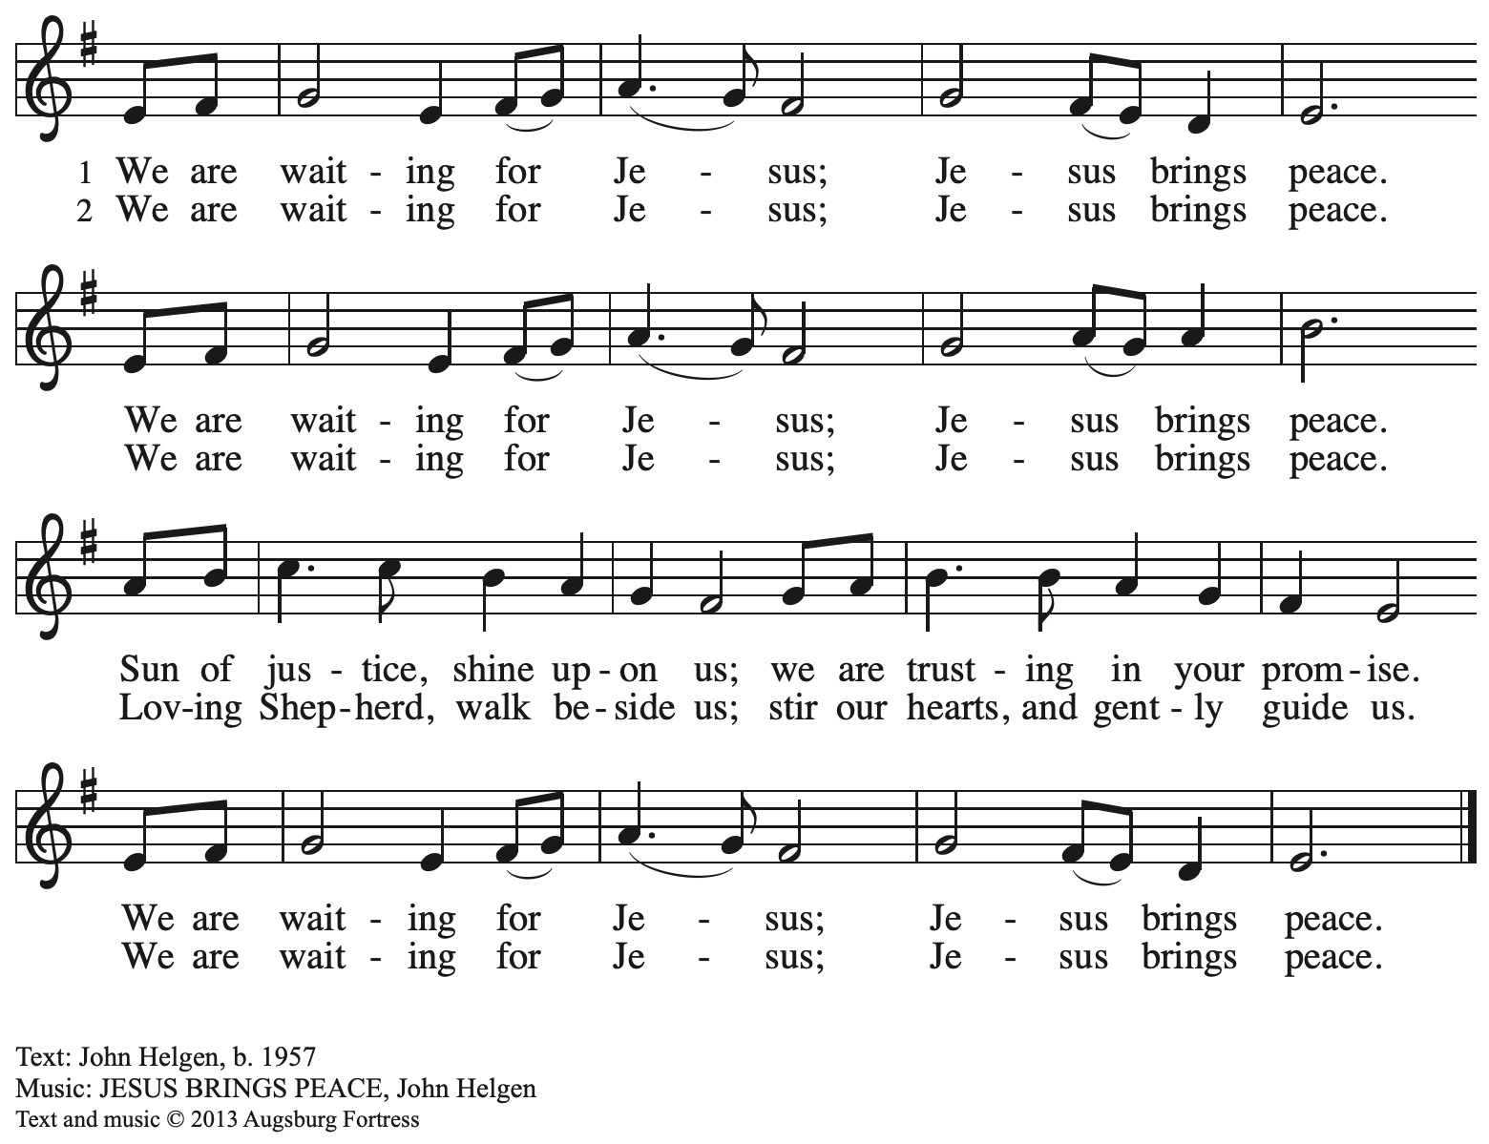
All rights reserved. Reprinted with permission under OneLicense.net # A-722139.
When all have returned to their places, please rise as you are able.

Blessing

P: The body and blood of our Lord Jesus Christ strengthen you and keep you in his grace.
C: Amen.

Prayer

A: Let us pray.
God for whom we wait,
in this meal you give us a foretaste of that day when the hungry will be fed with good things. Send us forth to make known your deeds and to proclaim the greatness of your name,
through Jesus Christ, our Savior and Lord.
C: Amen.

Please be seated.

Sending
God blesses us and sends us in mission to the world

Announcements

Please rise as you are able.

Benediction

P: The God of peace bless you,
the love of ☩ Christ sustain you in hope,
and the anointing of the Holy Spirit remain upon you,
now and forever.
C: Amen.

Sending Hymn Following page

Sending Hymn Rejoice, Rejoice, Believers ELW 244

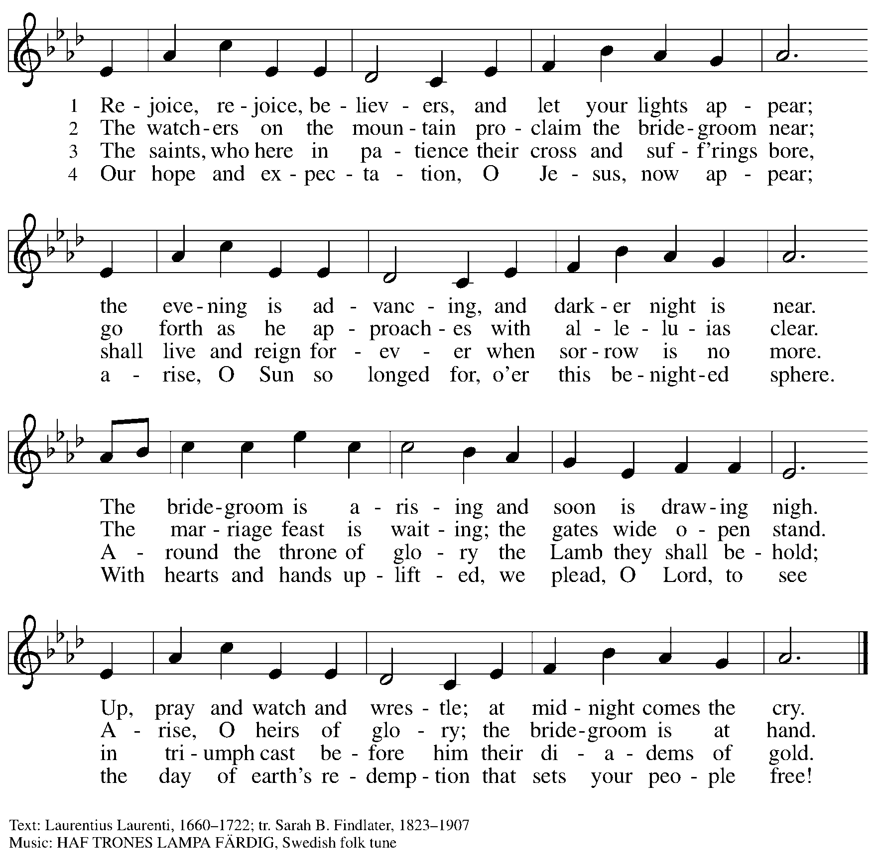

Dismissal

A: Go in peace. Keep awake!
C: Thanks be to God!

Postlude

Serving in Worship Today

Altar Care Beverley Chapman
Assisting Minister Kathy Hays
Audio-Visual Ministers Tyler Rietze
Joseph Paetz
Cantor Emily Duque
Lector Alda Maria Gonzaga
Minister of Music Laura Reynolds
Presiding Minister The Rev. Ross Carmichael

Liturgy and Hymnody Acknowledgements

From SundaysandSeasons.com. Copyright © 2025 Augsburg Fortress. All rights reserved. Reprinted under OneLicense.net # A-722139.
Used by permission of Augsburg Fortress.

The Scripture readings contained herein are from New Revised Standard Version Updated Edition of the Bible © 2021 National Council of Churches of Christ in the United States of America. Used by permission. All rights reserved worldwide.

Awake! Awake and Greet the New Morn – Text: Marty Haugen, b. 1950. Music: REJOICE, REJOICE, Marty Haugen. Text and music © 1983 GIA Publications, Inc., 7404 S. Mason Ave., Chicago, IL 60638. www.giamusic.com. 800.442.3358. All rights reserved. Reprinted with permission under OneLicense.net # A-722139.

Please use the QR code below to link to St. Andrew’s Announcements online!



St. Andrew Lutheran Church Announcements
December 7th, 2025

- Welcome to Worship at St. Andrew on the Second Sunday of Advent – We are thankful you are here, and we offer a special welcome to all visitors and guests who are here for the first time! A nursery is available through the door to the left of the worship space and across the social hall (look for a purple room). Little Church – Big Faith, a Bible lesson and activity for children up to sixth grade, will take place after the prayer of the day. There are also worship “toolkits” to help children engage with worship and “busy bags” for younger children available in the bookcase at the back of the sanctuary. Please feel free to take one to use with/for your children. All are invited to stay for coffee and other drinks, food, and conversation in the Social Hall (through the side door at the left of the worship space) after the service.
- Monthly Reparations Offering Today, December 7th, during Worship – In Luke’s Gospel, Jesus tells a story about a compassionate Samaritan, suggesting that God’s people are called to work for healing and restoration for our neighbors, regardless of who or what caused them harm. In light of this, St. Andrew has made a commitment to reparations in regard to African American spiritual songs used in our worship. The text and music of most hymns is attributed to specific authors, with copyrights in place, usage reported, and royalties paid to those whose works are featured in worship. With African American spirituals, this is not possible. In response to many years of such uncredited use, St. Andrew invites the congregation to give a reparations offering. Funds received in worship will be donated to our siblings at Bethel AME Church, whose land and building were taken from them in the 1950s, to fund their development in the Hill District.
- Welcoming the Season of Advent with an Advent Calendar – A new church year in the liturgical calendar begins with the season of Advent, a time of preparation and hope as the church awaits the celebration of Christ’s birth at Christmas and the second coming of Jesus promised in Scripture. The World Hunger ministry of the Evangelical Lutheran Church in America (ELCA) has provided an Advent calendar for congregations titled “A Stable Lamp Is Lighted.” These calendars offer daily Bible readings, suggestions for supporting our neighbors in need, and activities, including a color and cut-out Nativity scene that would be great for children. There is also a three-session online study with videos available here: https://www.elca.org/our-work/relief-and-development/elca-world-hunger/wh-advent#whadventaccordionsection. Please take a calendar and study guide up at the entrances to the church!
- Advent Devotional – ReconcilingWorks is delighted to share a brand-new free Advent Devotional to accompany you through this sacred season of hope, peace, joy, and love. Written by Rev. Liza Hawkins (she/they), this resource offers weekly reflections, prayers, and actions to help you and your community prepare their hearts for the coming of Christ. You can download the devotional here: https://tracking.etapestry.com/t/48811955/1334588820/107716055/0/100660/?x=85da9e4b
- Produce Distribution Supplemental Food of the Month – St. Andrew is collecting supplemental food each month to accompany our produce distribution. For this month, we ask for donations of peanut butter. There are collection boxes at the back of the worship space and social hall.
- Community Ministry Team Collecting Gifts for Foster Children Served by Allegheny County CYS, Today, December 7th – Allegheny County’s Office of Children, Youth, and Families of children is in need of gifts to support those who come into the system late, or who weren’t sponsored. We are collecting some highly-requested items for children in the foster system to ensure that they receive some cheer this holiday season. Please bring the following items, unwrapped, for donation: winter wear for ages 0-18, baby necessities (blankets, wipes, bottles, pacifiers, bibs), developmental toys and board books for babies and toddlers, crayons, colored pencils, gel pens, coloring books, LEGO and Mega Blok sets, board games, ethnically diverse dolls, superhero action figures, craft kits, earbuds, headphones, gaming mouse and keyboard, science/STEM kits, remote control vehicles (cars, trucks, helicopters, drones), sports equipment for ages 3-18, local sports team apparel, sensory toys (slime, kinetic sand, fidgets), makeup, toiletries (body lotion, shower gel, bath poufs, body spray), wallets, watches, and fleece blankets.
- Community Ministry Meeting, Monday, December 8th at 7:00 p.m. on Zoom – St. Andrew’s community ministry committee coordinates our local service ministries such as the outdoor Little Library, the pantry, produce distribution, shelter dinner, and various other activities. New participants are always welcome, and the next meeting is tomorrow, December 8th, at 7:00 p.m. on Zoom. Please contact PastorRCarmichael@gmail.com or community@standrewpittsburgh.org if you would like the link.
- Discipleship that Heals the World - Studies in Matthew’s Gospel, Thursdays, 8:00 - 9:00 p.m. on Zoom, through Dec. 11th, 2025 – Join us for one more session on the Gospel of Matthew, organized and facilitated by Rev. Dr. Martin Rafanan. Together the group has been exploring Jesus’ Sermon on the Mount and his healing ministry, and discovering Matthew’s distinctive vision of discipleship as a way of blessing, healing, and hope. Register for this last session to receive zoom info: https://forms.gle/amy439vfUpwdJpKx7.
- Annual Congregational Meeting, Sunday, December 14th – St. Andrew’s annual congregational meeting is coming up next weekend. You should have received an email or mailer containing the following documents: Announcement Letter, Proposed Budget Summary, Proposed Budget, Proposed Amendment to Congregational Constitution. If you have not, please reach out to PastorRCarmichael@gmail.com or communications@standrewpittsburgh.org for a copy. You can join the meeting using Zoom: https://us02web.zoom.us/j/81295765981?pwd=b0UvOXE1UnBGQlRNN1MvZ0VpRmVLZz09.
- Receive Prayer Team Emails – St. Andrew maintains a list of weekly prayer concerns sent by email to members of the congregation who have opted in. Our prayer team’s email is prayerteam@standrewpittsburgh.org. We will keep names on the list for a maximum of four weeks unless otherwise requested. Thank you for your ministry of prayer!
- Records Update – St. Andrew is updating our records with information from newer attendees, as well as offering current members the opportunity to include current information to be used within the congregation: for emergency contacts, to acknowledge celebrations, milestones, and prayers. Please fill out the form at: https://forms.gle/kKvp19UozuRrhhaV7.
- Coffee Hour Signups – St. Andrew provides hospitality during a coffee hour after worship each Sunday. If you would like to participate and would like information about the duties of setting up, please sign up using the following form: https://www.signupgenius.com/go/5080B4AAFAF2CABF85-47069030-coffee#/.

