

+ Third Sunday of Advent
December 14, 2025



St. Andrew Lutheran Church
304 Morewood Ave.
Pittsburgh, PA 15213
St_andrewELCA@verizon.net
www.standrewpittsburgh.org

+ Third Sunday of Advent
Order for Worship

A note of joyful expectation comes through in this week’s worship. Isaiah announces that the desert shall rejoice and blossom, and Jesus points to the unexpected and transforming signs of God’s reign. We wait with patience for the coming of the Lord, even as we rejoice at his presence among us this day: in word and holy supper, in church and in our homes, in silent reflection and in works of justice and love. We pray that God would open our eyes and ears to the wonders of Christ’s advent among us.

Welcome to St. Andrew!
- St. Andrew welcomes all who are seeking a place of healing, wholeness, and acceptance in a nurturing and faith-forming spiritual home. We are striving toward racial equity worldwide
and we seek to honor the lived experience of all individuals regardless of background. Our community embraces people of all ages, ethnicities, cultures, abilities, sexual orientations,
gender identities and expressions, and family constellations. Come and See!
- Worship Services are live-streamed to multiple online platforms. By attending worship, you agree that your image and voice may be broadcast.
- Everyone is invited to make a name tag at the black bookcase in the back of the worship space if they would like. There are stickers indicating pronouns on the bookcase if you would like to include them on your name tag.
- A nursery is available through the doors at the left side of the sanctuary and across from the doorway to the Social Hall. Look for a purple-colored room.
- Children are invited to attend Little Church – Big Faith, a Bible lesson and activity, during worship (after the Prayer of the Day). The group returns to the worship space for the liturgy of Holy Communion.
- Worship “toolkits” to help children engage with the service, along with “busy bags” for younger children, are available in the bookcase at the back of the sanctuary. Please feel free to take one to use with/for your children.
- Holy Communion is served with bread (gluten-free available) and wine or grape juice. The presiding minister will distribute the bread (host). Please consume this and then pick up an empty glass from the tray. The Communion Assistant will pour wine or grape juice into your glass. Please step to the side to consume the wine or grape juice. Feel free to kneel at the altar for prayer and reflection. As you return to your pew, glasses may be returned to the empty trays on either side of the center section.
- A restroom is available on the main level of the church, through the doors to the Social Hall and to the right in the main office.

Abbreviations
P: Pastor/Presiding Minister ELW: Evangelical Lutheran Worship hymnal
A: Assisting Minister ACS: All Creation Sings hymnal
L: Lector
C: Congregation
Musical Offering

Each week, different people from the congregation make an offering of pre-service music, with singing or instrumentation, to help the assembly focus and pray in preparation for worship.

Welcome

Prelude O Come, Emmanuel Elaine Hagenberg
St. Andrew Choir

Gathering
The Holy Spirit calls us together as the people of God

Please rise as you are able. All may make the sign of the cross,
the sign that is marked at Baptism, as the presiding minister begins.

Confession and Forgiveness

P: P: Blessed be the Holy Trinity, one ☩ God,
whose home is heaven and earth, whose salvation is sure.
C: Amen.

P: Let us confess our sin in the presence of God and of one another.

Silence is kept for reflection.

P: Long-expected God,
C: we confess that we look to ourselves
for the peace and security only you can provide.
We reach for swords and spears,
reluctant to release our grip on the ways of war.
We become impatient while waiting
and weary of keeping awake.
Free us from self-reliance,
and teach us to live in harmony with our neighbors.
Increase our trust in God’s timing,
and awaken us to your advent among us,
that we may abound in the hope you have promised.
Amen.

P: God judges us not as we deserve,
but according to God’s own righteousness.
in ☩ Christ Jesus, you are freed and forgiven, saved by grace,
and ready to welcome the Savior.
C: Amen.
Gathering Hymn Fling Wide the Door ELW 259

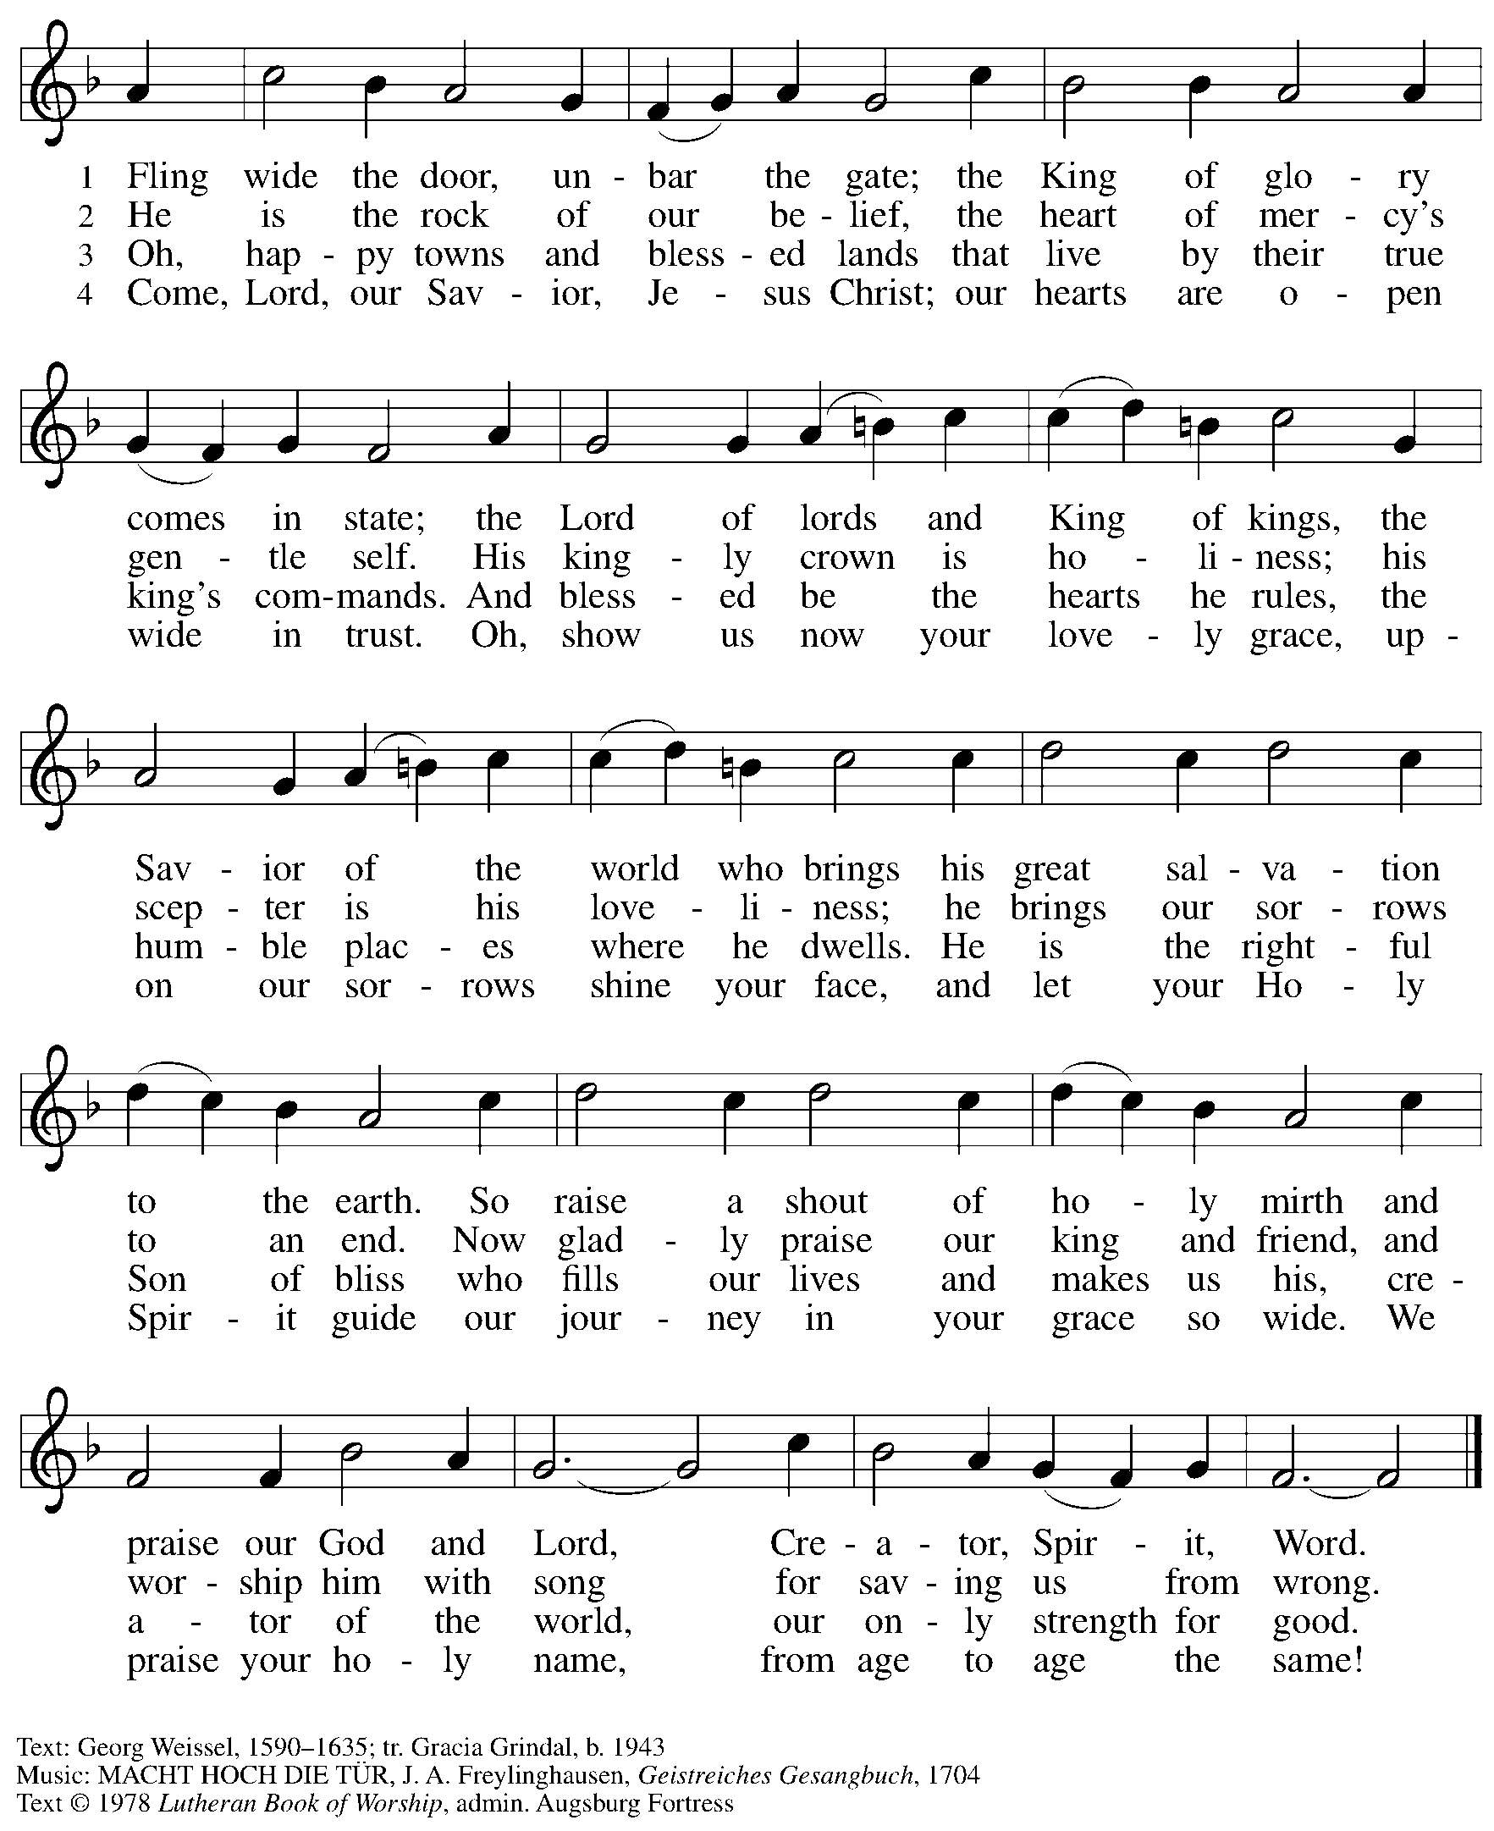
All rights reserved. Reprinted under OneLicense.net #722139.

Greeting

P: The grace of our Lord Jesus Christ, the love of God,
and the communion of the Holy Spirit be with you all.
C: And also with you.

Kyrie ACS p. 12

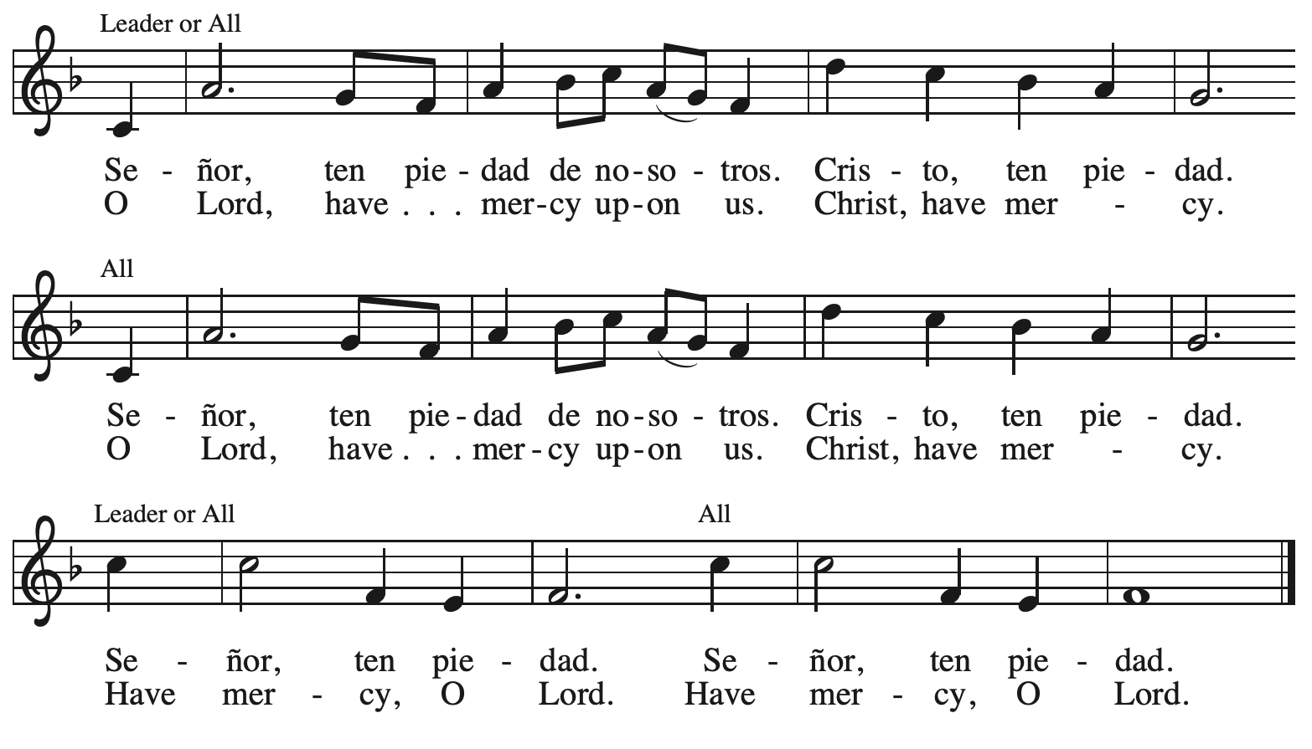

Prayer of the Day

P: The Lord be with you.
C: And also with you.

P: Let us pray.
Stir up the wills of all who look to you, Lord God, and strengthen our faith in your coming, that, transformed by grace, we may follow in your way; through Jesus Christ, our Savior and Lord,
who lives and reigns with you and the Holy Spirit, one God, now and forever.
C: Amen.

Please be seated.
Children are invited to join the adult leader(s) at the side door for Little Church – Big Faith.
We ask that an additional adult from the congregation attend with the children.

Word
God speaks to us in Scripture reading, preaching, and song

First Reading – Isaiah 35: 1-10

¹ The wilderness and the dry land shall be glad;
the desert shall rejoice and blossom;
like the crocus ² it shall blossom abundantly
and rejoice with joy and shouting.
The glory of Lebanon shall be given to it,
the majesty of Carmel and Sharon.
They shall see the glory of the Lord,
the majesty of our God.
³ Strengthen the weak hands
and make firm the feeble knees.
⁴ Say to those who are of a fearful heart,
“Be strong, do not fear!
Here is your God.
He will come with vengeance,
with terrible recompense.
He will come and save you.”
⁵ Then the eyes of the blind shall be opened,
and the ears of the deaf shall be opened;
⁶ then the lame shall leap like a deer,
and the tongue of the speechless sing for joy.
For waters shall break forth in the wilderness
and streams in the desert;
⁷ the burning sand shall become a pool
and the thirsty ground springs of water;
the haunt of jackals shall become a swamp;
the grass shall become reeds and rushes.
⁸ A highway shall be there,
and it shall be called the Holy Way;
the unclean shall not travel on it,
but it shall be for God’s people;
no traveler, not even fools, shall go astray.
⁹ No lion shall be there,
nor shall any ravenous beast come up on it;
they shall not be found there,
but the redeemed shall walk there.
¹⁰ And the ransomed of the Lord shall return
and come to Zion with singing;
everlasting joy shall be upon their heads;
they shall obtain joy and gladness,
and sorrow and sighing shall flee away.

L: Word of God, word of life.
C: Thanks be to God.

Magnificat – Luke 1: 46b-55

The alternate psalm for the week is the Magnificat, Mary’s song of praise to God when her cousin Elizabeth, filled with the Holy Spirit, greets and blesses her. Since it is not otherwise featured in this year’s lectionary cycle of readings, today the congregation will sing a hymn paraphrase of the text, My Soul Proclaims Your Greatness, ELW # 251, found on the following page. The text from the Bible is printed below.

“My soul magnifies the Lord,
⁴⁷ and my spirit rejoices in God my Savior,
⁴⁸ for he has looked with favor on the lowly state of his servant.
Surely from now on all generations will call me blessed,
⁴⁹ for the Mighty One has done great things for me,
and holy is his name;
⁵⁰ indeed, his mercy is for those who fear him
from generation to generation.
⁵¹ He has shown strength with his arm;
he has scattered the proud in the imagination of their hearts.
⁵² He has brought down the powerful from their thrones
and lifted up the lowly;
⁵³ he has filled the hungry with good things
and sent the rich away empty.
⁵⁴ He has come to the aid of his child Israel,
in remembrance of his mercy,
⁵⁵ according to the promise he made to our ancestors,
to Abraham and to his descendants forever.”
⁵⁶ And Mary remained with her about three months and then returned to her home.


Hymn My Soul Proclaims Your Greatness ELW 251

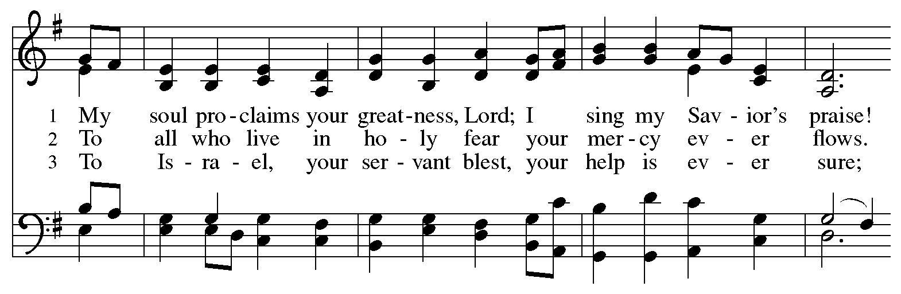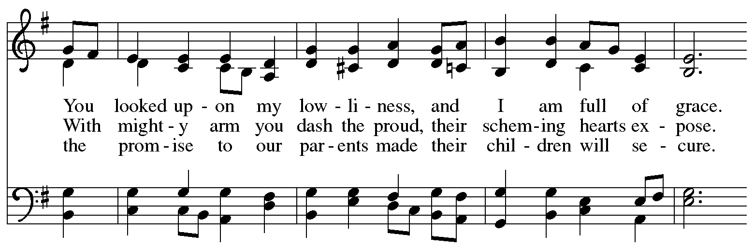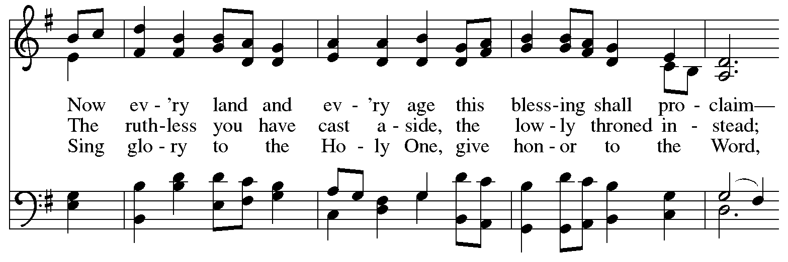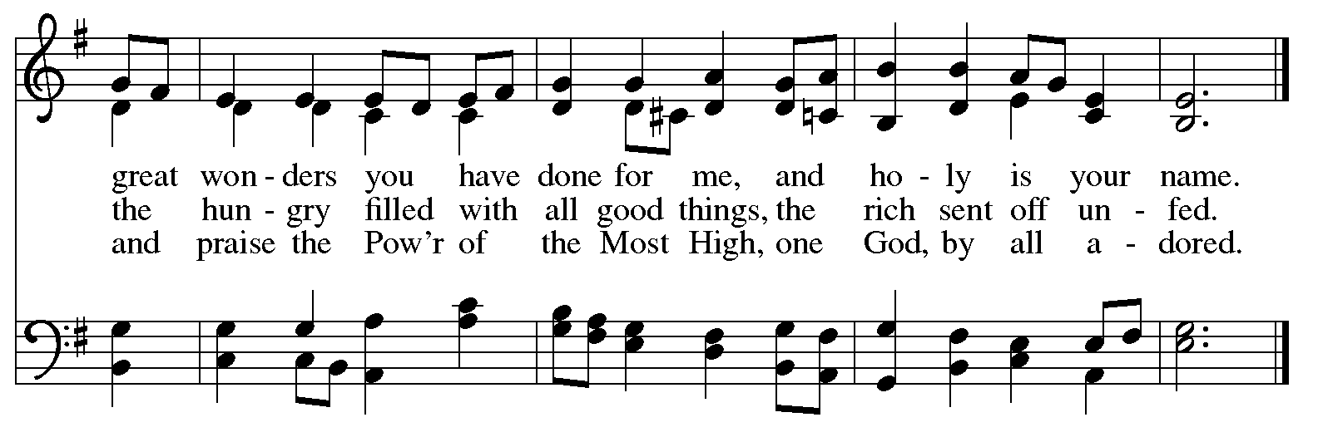
Second Reading – James 5: 7-10

⁷ Be patient, therefore, kindred, until the coming of the Lord. The farmer waits for the precious crop from the earth, being patient with it until it receives the early and the late rains. ⁸ You also must be patient. Strengthen your hearts, for the coming of the Lord is near. ⁹ Siblings, do not grumble against one another, so that you may not be judged. See, the Judge is standing at the doors! ¹⁰ As an example of suffering and patience, siblings, take the prophets who spoke in the name of the Lord.

L: Word of God, word of life.
C: Thanks be to God.

Please rise as you are able.

Gospel Acclamation ELW p. 188

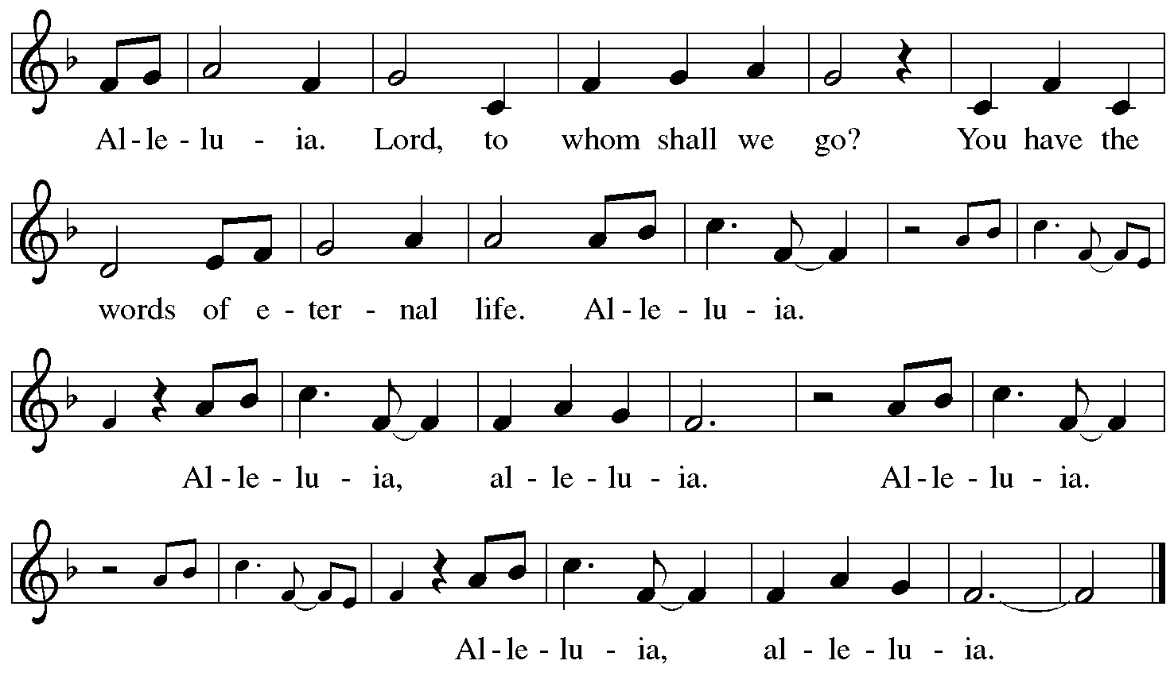

Gospel – Matthew 11: 2-11

P: The holy Gospel according to St. Matthew.
C: Glory to you, O Lord.

² When John heard in prison what the Messiah was doing, he sent word by his disciples ³ and said to him, “Are you the one who is to come, or are we to wait for another?” ⁴ Jesus answered them, “Go and tell John what you hear and see: ⁵ the blind receive their sight, the lame walk, those with
a skin disease are cleansed, the deaf hear, the dead are raised, and the poor have good news brought to them. ⁶ And blessed is anyone who takes no offense at me.”
⁷ As they went away, Jesus began to speak to the crowds about John: “What did you go out into the wilderness to look at? A reed shaken by the wind? ⁸ What, then, did you go out to see? Someone dressed in soft robes? Look, those who wear soft robes are in royal palaces. ⁹ What, then, did you go out to see? A prophet? Yes, I tell you, and more than a prophet. ¹⁰ This is the one about whom it is written,
‘See, I am sending my messenger ahead of you,
who will prepare your way before you.’
¹¹ “Truly I tell you, among those born of women no one has arisen greater than John the Baptist, yet the least in the kingdom of heaven is greater than he.”

P: The Gospel of the Lord.
C: Praise to you, O Christ.

Please be seated.

Sermon

A time of silence for prayer and reflection follows the sermon.
When the hymn of the day begins, please rise as you are able.



Hymn of the Day Prepare the Royal Highway ELW 264

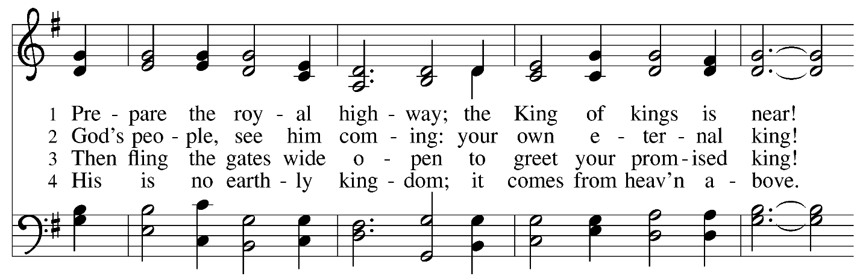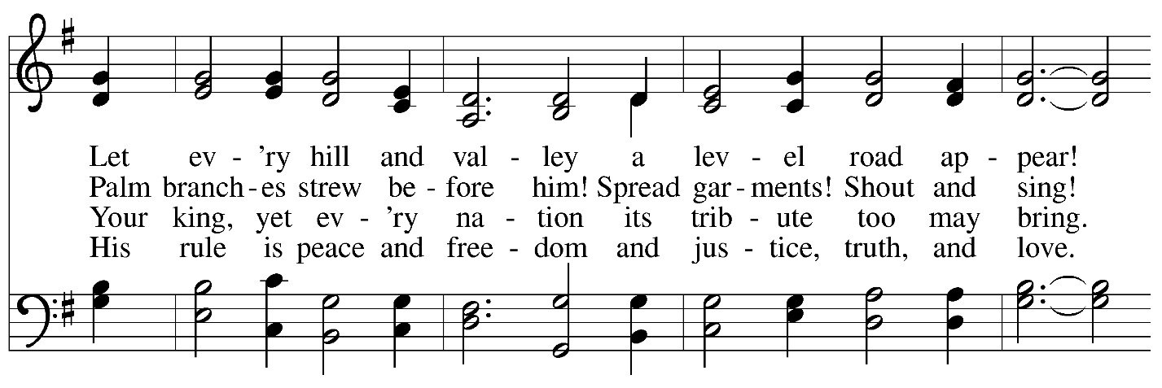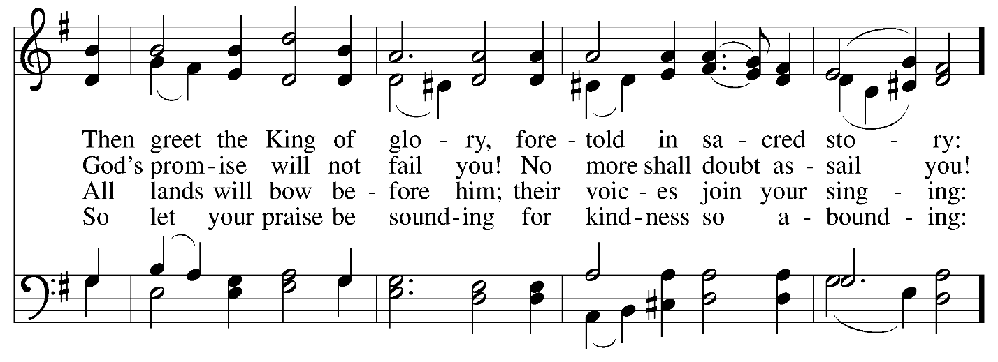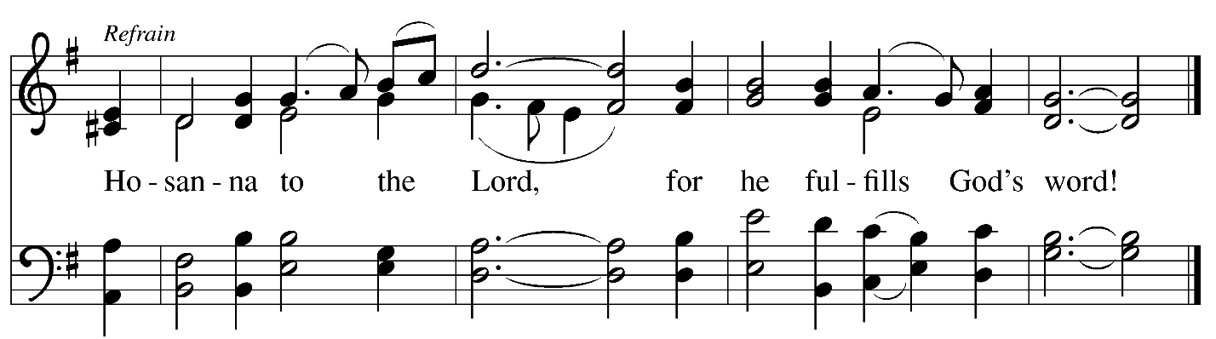
Nicene Creed

C: We believe in one God,
the Father, the Almighty,
maker of heaven and earth,
of all that is, seen and unseen.

We believe in one Lord, Jesus Christ,
the only Son of God,
eternally begotten of the Father,
God from God, Light from Light,
true God from true God,
begotten, not made,
of one Being with the Father;
through him all things were made.
For us and for our salvation
he came down from heaven,
was incarnate of the Holy Spirit and the virgin Mary
and became truly human.
For our sake he was crucified under Pontius Pilate;
he suffered death and was buried.
On the third day he rose again
in accordance with the scriptures;
he ascended into heaven
and is seated at the right hand of the Father.
He will come again in glory to judge the living and the dead,
and his kingdom will have no end.

We believe in the Holy Spirit, the Lord, the giver of life,
who proceeds from the Father and the Son,*
who with the Father and the Son is worshiped and glorified,
who has spoken through the prophets.
We believe in one holy catholic and apostolic church.
We acknowledge one baptism for the forgiveness of sins.
We look for the resurrection of the dead,
and the life of the world to come. Amen.

*Or, “who proceeds from the Father.” The phrase “and the Son” is a later addition to the creed.

Prayers of the People

A: In our waiting and watching, we come to you in prayer, O God,
trusting in your promise to renew the church, the nations, and your whole creation.

After each petition
A: God of grace,
C: receive our prayer.

P: Draw near to us, O God, as we commend into your care all for whom we pray,
trusting in your mercy, through Jesus Christ our Savior.
C: Amen.

Peace

The presiding minister and the assembly greet one another in the peace of the risen Christ.
P: The peace of Christ be with you always.
C: And also with you.

The people may greet those around them with a sign of Christ’s peace and may say
Peace be with you or similar words. Please be mindful that not everyone will be comfortable with sharing the peace, so please seek consent before shaking hands or hugging. Other possible ways to share the peace include a simple bow with the verbal greeting of peace, or simply a verbal expression of peace.

When the greetings of peace have concluded, please be seated.

Meal
God feeds us with the presence of Jesus Christ

Offering

We offer ourselves, our gifts, and our faithful service to God.
As the offering is gathered for the mission of the church, including the care of those in need,
the table is set for Holy Communion.

There are laminated giving cards in the pew racks that feature a QR code for anyone who would like to give online. Those who give using the QR code, as well as those who give regularly online or through their bank are encouraged to place the laminated card in the plate as an expression of your offering.

Offertory Music arr. Oines
The King Shall Come / ‘Twas in the Moon of Wintertime

As the gifts are brought forward for presentation, please rise as you are able.

Offertory Song As Saints of Old ELW 695
v. 3

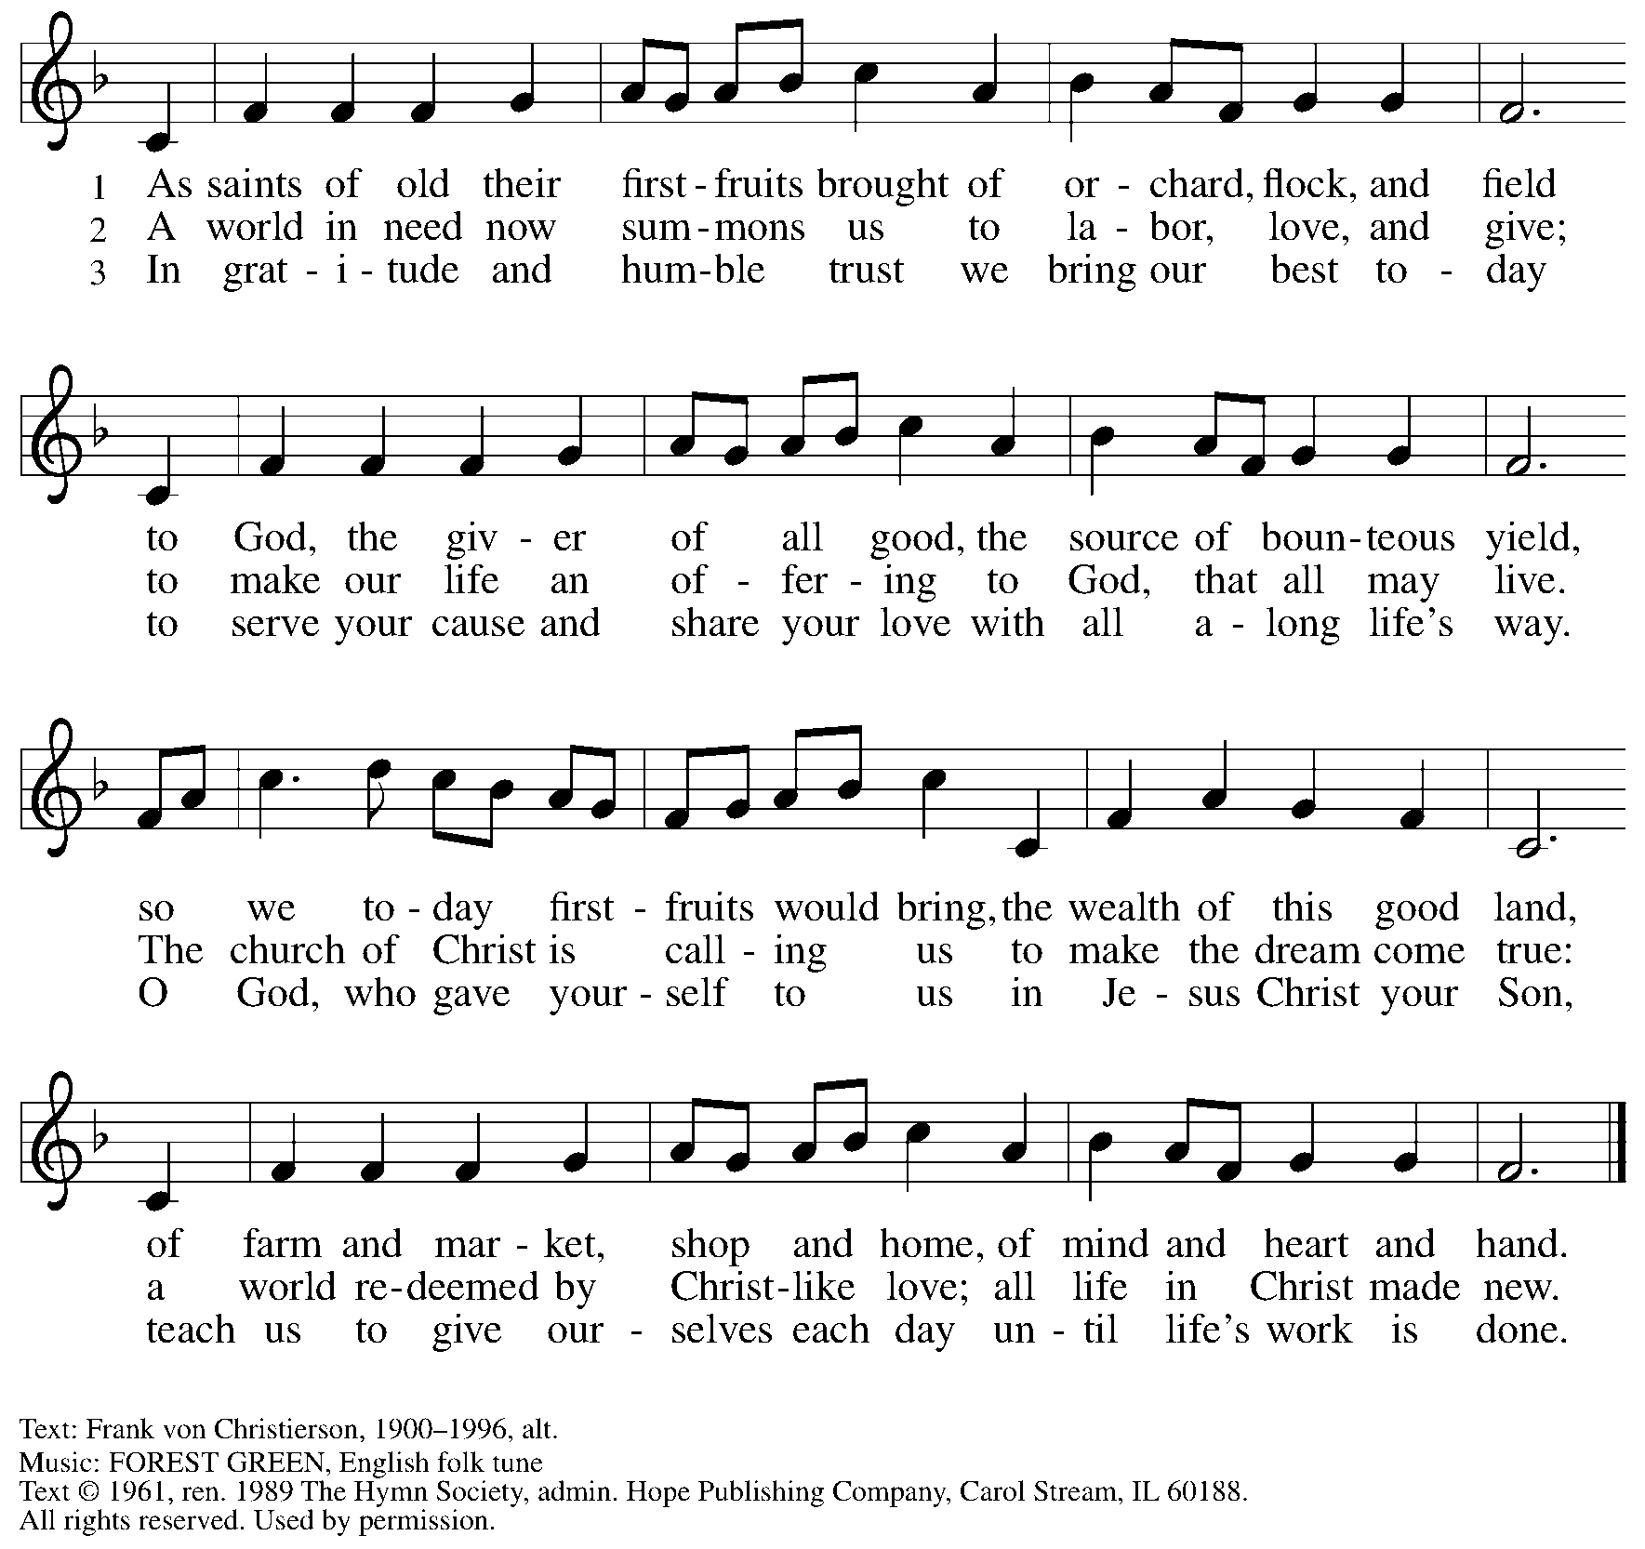
Reprinted under OneLicense.net # A-722139.

Offertory Prayer

A: Let us pray.
God of abundance,
C: we bring before you the precious fruits of your creation, and with them our very lives. Teach us patience and hope as we care for all those in need until the coming of your Son, our Savior and Lord.
Amen.

Dialogue

P: The Lord be with you.
C: And also with you.

P: Lift up your hearts.
C: We lift them to the Lord.

P: Let us give thanks to the Lord our God.
C: It is right to give our thanks and praise.

Preface

P: It is indeed right, our duty and our joy, …
… we praise your name and join their unending hymn:

Sanctus ELW p. 190

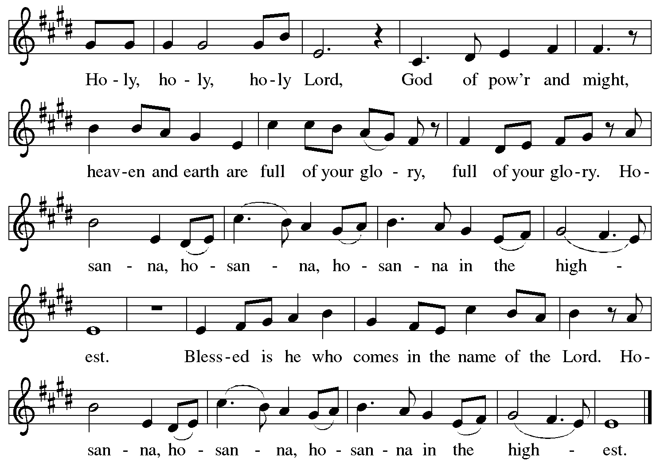

Eucharistic Prayer

P: Holy One, the beginning and the end, the giver of life …
… Do this for the remembrance of me.

P: Let us proclaim the mystery of faith:
C: Christ has died. Christ is risen. Christ will come again.

P: With this bread and cup …
… we look with hope for his coming.
C: Come, Lord Jesus.

P: Holy God, we long for your Spirit …
… Bring the gift of peace on earth.
C: Come, Holy Spirit.

P: All praise and glory are yours,
Holy One of Israel, Word of God incarnate, Power of the Most High,
now and forever.
C: Amen.

Lord’s Prayer

P: Gathered as one by the Holy Spirit, let us pray as Jesus taught us.
C: Our Father in heaven,
hallowed be your name,
your kingdom come,
your will be done,
on earth as in heaven.
Give us today our daily bread.
Forgive us our sins
as we forgive those
who sin against us.
Save us from the time of trial
and deliver us from evil.
For the kingdom, the power,
and the glory are yours,
now and forever. Amen.

Fraction and Invitation

Agnus Dei / Lamb of God ELW p. 191

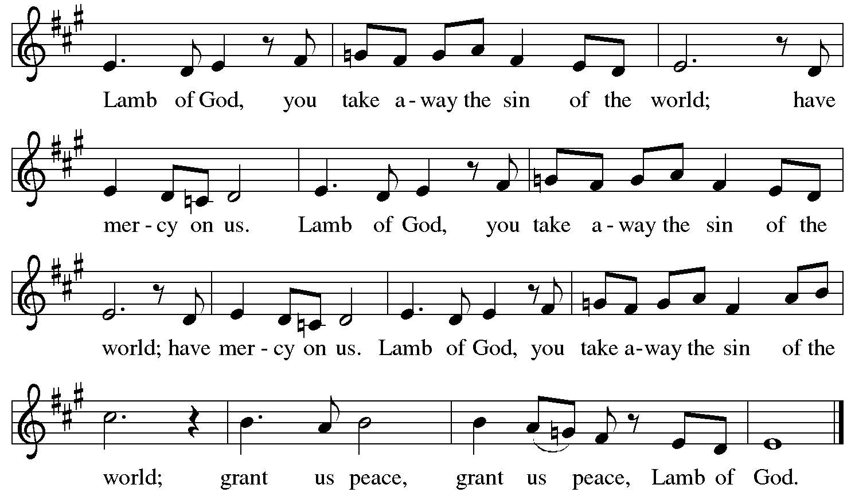

Please be seated.

Holy Communion

- All who seek God and desire a deeper and stronger life in Christ are welcome to receive Holy Communion.
- Worshipers from the pulpit side will proceed forward first, followed by the center section, and then the lectern side.
- Please inform an usher if you would like the ministers to bring Communion to you.
- Holy Communion will be served with bread and wine (amber) or grape juice (purple).
- The presiding minister will first distribute the bread (host) to each communicant. Please indicate if you require a gluten-free host.
- Once you have consumed the bread, please pick up an empty glass from the tray next to the presiding minister. The Communion Assistant will pour wine or grape juice into your glass.
- Please step to the side to consume the wine or grape juice.
- Feel free to kneel at the altar rail for prayer after receiving the sacrament.
- As you return to your pew, glasses may be returned to the empty tray on the side of the center section.
- A blessing will be provided for anyone who does not yet receive the sacrament.
- All are invited to join in singing the hymns during Holy Communion.

Hymns during Holy Communion

There Is a Longing in Our Hearts ACS 1078

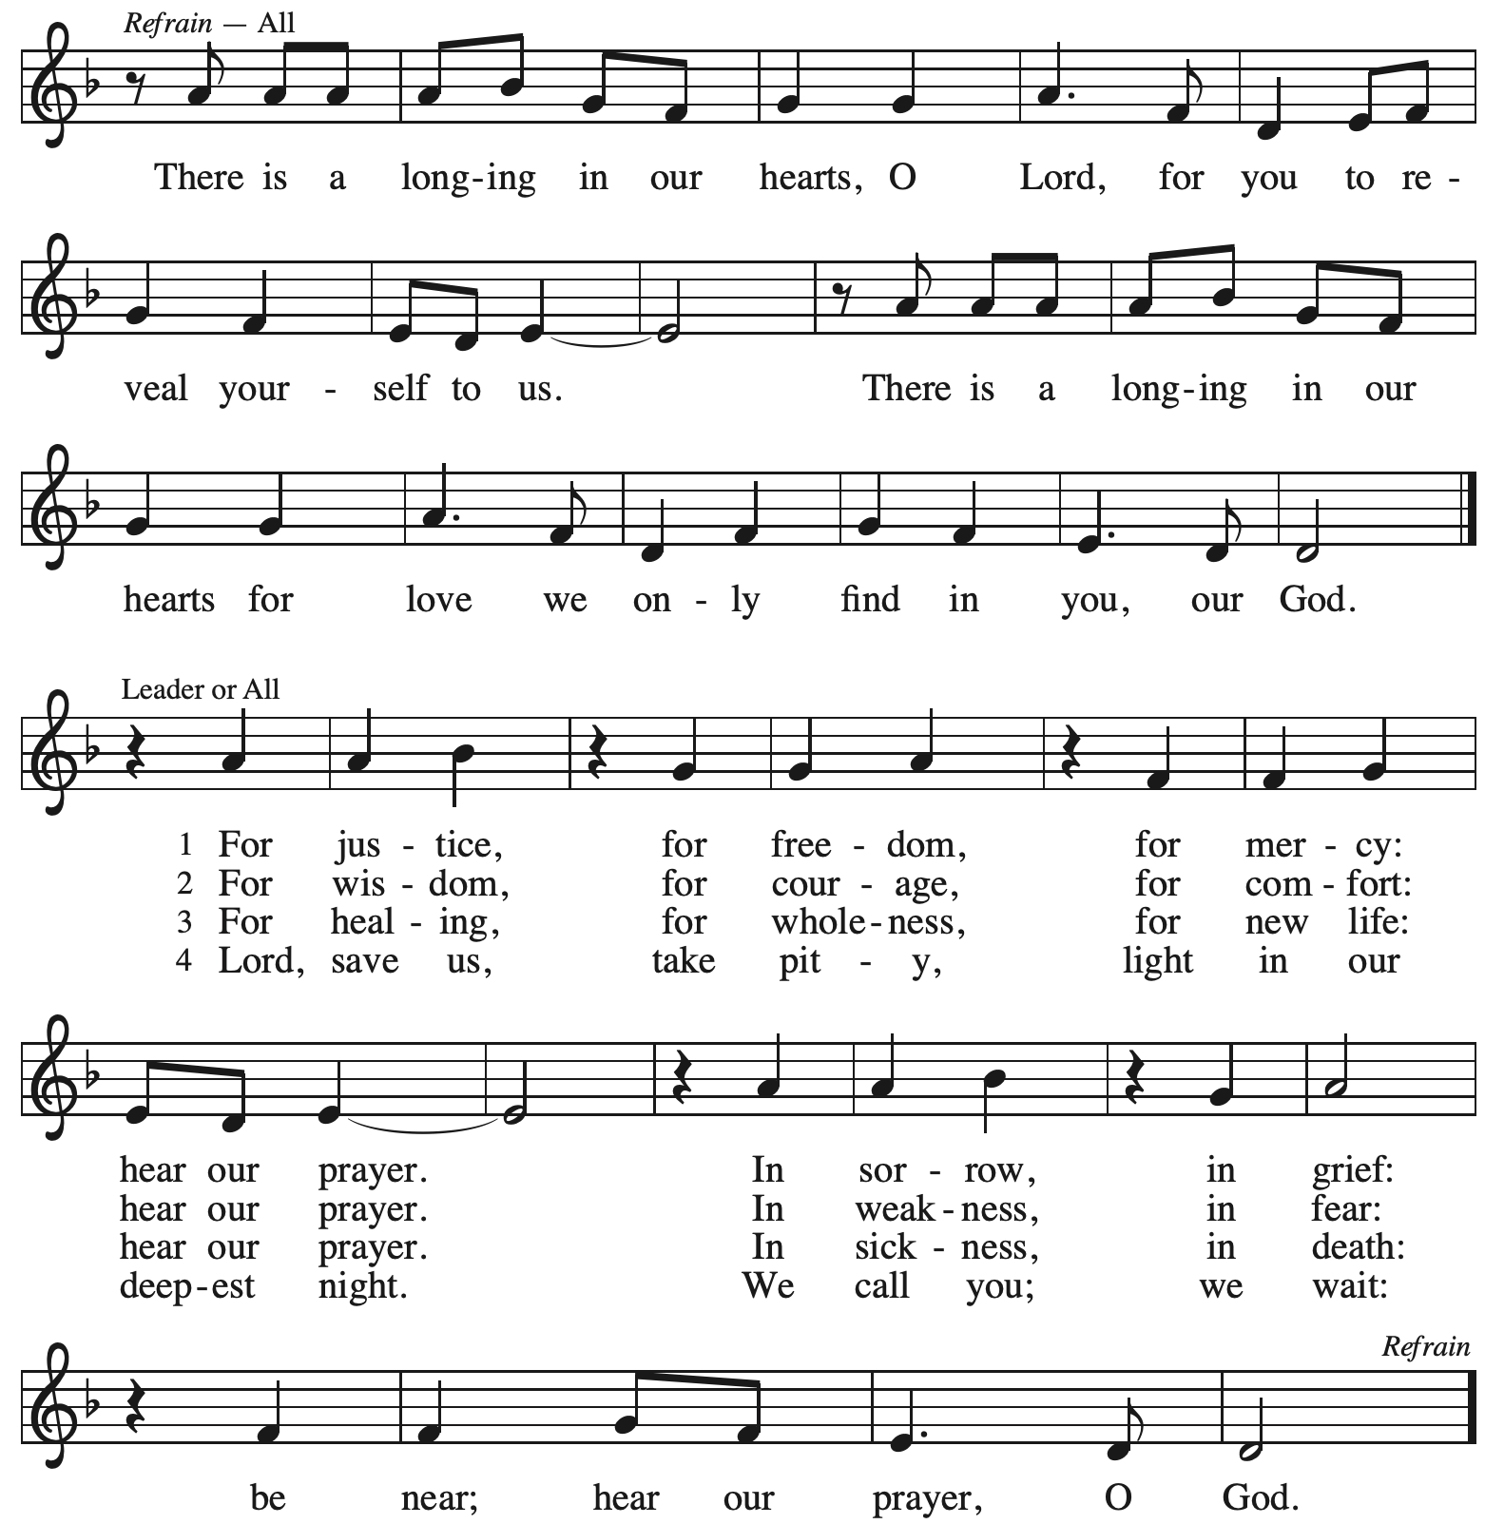
Reprinted under OneLicense.net # A-722139.

Hymns during Holy Communion

Wait for the Lord ELW 262

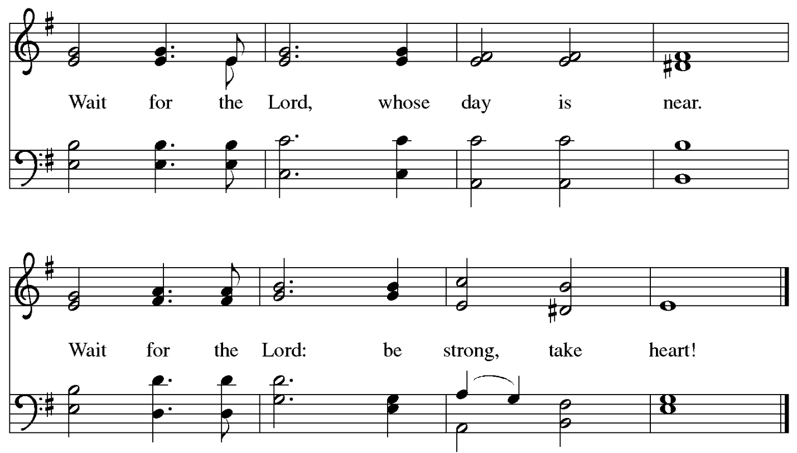

Reprinted under OneLicense.net # A-722139.

Hymns during Holy Communion

Comfort, Comfort Now My People ELW 256

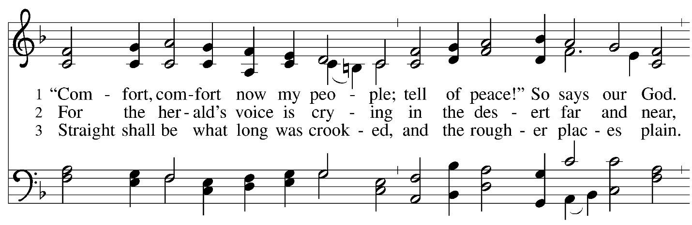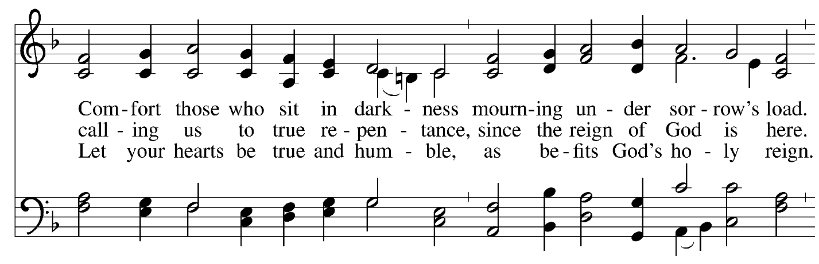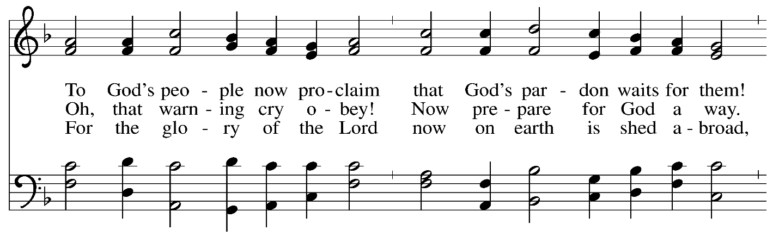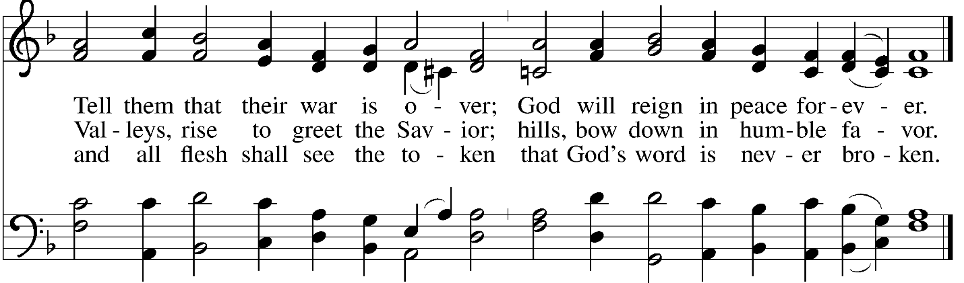 Reprinted under OneLicense.net # A-722139.
When all have returned to their places, please rise as you are able.

Blessing

P: The body and blood of our Lord Jesus Christ strengthen you and keep you in his grace.
C: Amen.

Prayer

A: Let us pray.
God for whom we wait,
in this meal you give us a foretaste of that day when the hungry will be fed with good things. Send us forth to make known your deeds and to proclaim the greatness of your name,
through Jesus Christ, our Savior and Lord.
C: Amen.

Please be seated.

Sending
God blesses us and sends us in mission to the world

Announcements

Please rise as you are able.

Benediction

P: The God of peace bless you,
the love of ☩ Christ sustain you in hope,
and the anointing of the Holy Spirit remain upon you,
now and forever.
C: Amen.

Sending Hymn Following page

Dismissal

A: Go in peace. Serve the Lord.
C: Thanks be to God!

Postlude

Sending Hymn He Came Down ELW 253

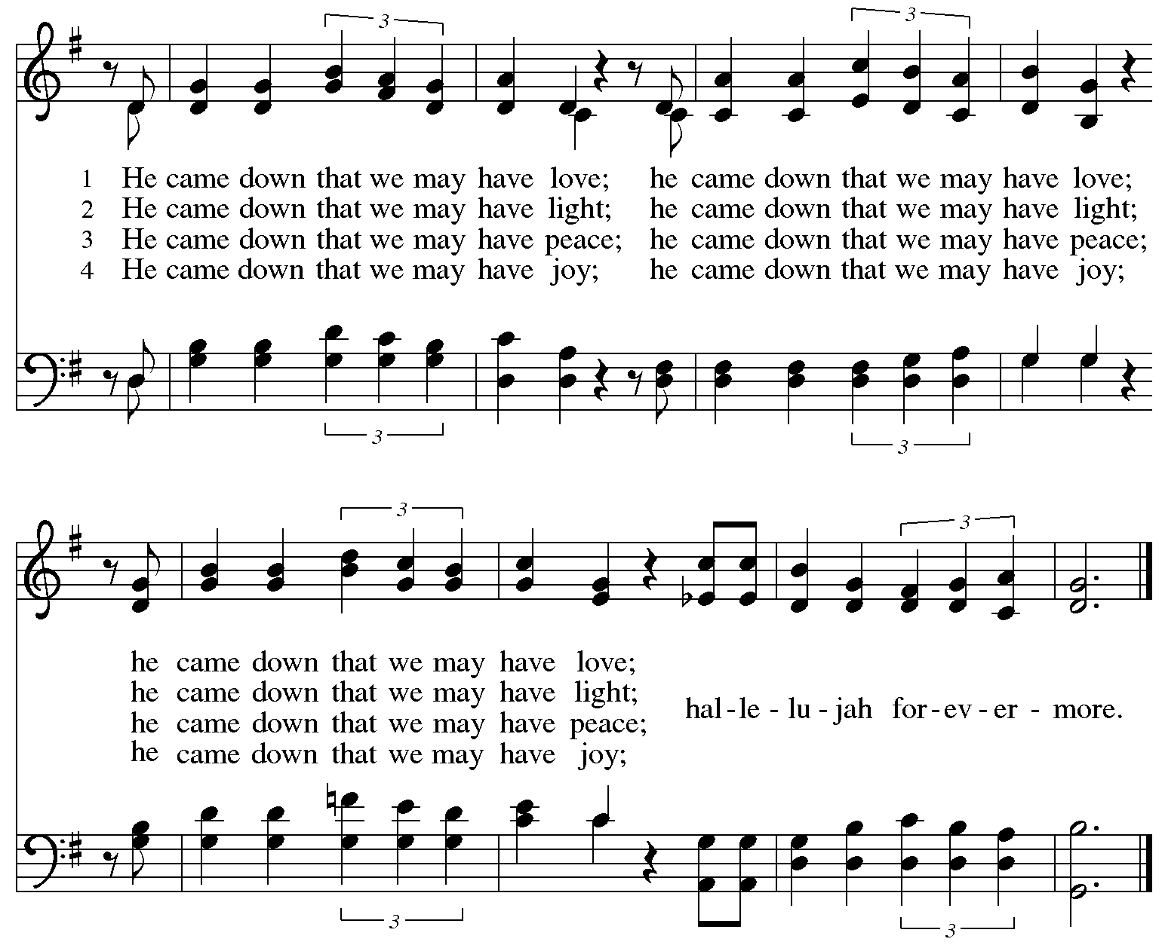
Reprinted under OneLicense.net # A-722319.

Serving in Worship Today

Altar Care Christy Ruhe
Assisting Minister Jimmi Kocher-Hillmer
Audio-Visual Ministers Sarita
Dave Rollinson
Cantor CE Pino
Lector Kelly Spanninger
Minister of Music Laura Reynolds
Presiding Minister The Rev. Ross Carmichael

Liturgy and Hymnody Acknowledgements

From SundaysandSeasons.com. Copyright © 2025 Augsburg Fortress. All rights reserved. Reprinted under OneLicense.net # A-722139.
Used by permission of Augsburg Fortress.

The Scripture readings contained herein are from New Revised Standard Version Updated Edition of the Bible © 2021 National Council of Churches of Christ in the United States of America. Used by permission. All rights reserved worldwide.

My Soul Proclaims Your Greatness – Text: With One Voice, 1995, based on the Magnificat. Music: KINGSFOLD, English folk tune; arr. Ralph Vaughan Williams, 1872-1958. Text © 1995 Augsburg Fortress. All rights reserved. Reprinted with permission under OneLicense.net # A-722139.

Prepare the Royal Highway – Text: Franz Mikael Franzén, 1772-1847; tr. Lutheran Book of Worship. Music: BEREDEN VÄG FÖR HARRAN, Swedish folk tune, 17th cent.

Comfort, Comfort Now My People = Text: Johann G. Olearius, 1635-1711; tr. Catherine Winkworth, 1827-1878, alt. Music: FREU DICH SEHR, Trente quatre pseaumes de David, Geneva, 1551. Text © 1978 Lutheran Book of Worship, admin. Augsburg Fortress. All rights reserved. Reprinted under OneLicense.net # A-722139.

Please use the QR code below to link to St. Andrew’s Announcements online!



St. Andrew Lutheran Church Announcements
December 14th, 2025

- Welcome to Worship at St. Andrew on the Third Sunday of Advent – We are thankful you are here, and we offer a special welcome to all visitors and guests who are here for the first time! A nursery is available through the door to the left of the worship space and across the social hall (look for a purple room). Little Church – Big Faith, a Bible lesson and activity for children up to sixth grade, will take place after the prayer of the day. There are also worship “toolkits” to help children engage with worship and “busy bags” for younger children available in the bookcase at the back of the sanctuary. Please feel free to take one to use with/for your children. All are invited to stay for coffee and other drinks, food, and conversation in the Social Hall (through the side door at the left of the worship space) after the service.
- Annual Congregational Meeting Today, December 14th after Worship – St. Andrew’s annual congregational meeting is today. You should have received an email or mailer containing the following documents: Announcement Letter, Proposed Budget Summary, Proposed Budget, Proposed Amendment to Congregational Constitution. If you have not, please reach out to PastorRCarmichael@gmail.com for a copy. You can join the meeting using Zoom: https://us02web.zoom.us/j/81295765981?pwd=b0UvOXE1UnBGQlRNN1MvZ0VpRmVLZz09.
- Noisy Offering Next Week, Sunday, December 21st, during Worship – On the third Sunday of each month, St. Andrew’s children lead the congregation in a Noisy Offering, in which people are invited to throw their change into buckets that the children carry around the church and bring forward as an additional offering. Each month’s Noisy Offering supports a local, national, or international church-related or otherwise charitable organization. The Noisy Offering recipient for December will be Best of the Batch Foundation's Annual Holiday Drive. Best of the Batch Foundation is a nonprofit organization founded in 1999 by former Pittsburgh Steelers quarterback Charlie Batch. It provides year-round educational programming to more than 4,000 children ages 5 to 18 across nine western Pennsylvania counties. Their goal is "to provide financially challenged communities with the purpose, desire, and resources to give their best efforts in all they do throughout their lives. For more information on this initiative, please visit: https://www.batchfoundation.org/batch-a-toys/.
- Church Decorating for Christmas, Sunday, December 21st, after Worship – We will be decorating the church after worship next Sunday and are looking for volunteers to assist. If you are interested or have questions, please contact Kathy Hays at kdhays2010@gmail.com.
- Welcoming the Season of Advent with an Advent Calendar – The World Hunger ministry of the Evangelical Lutheran Church in America (ELCA) has provided an Advent calendar for congregations titled “A Stable Lamp Is Lighted.” These calendars offer daily Bible readings, suggestions for supporting our neighbors in need, and activities, including a color and cut-out Nativity scene that would be great for children. There is also a three-session online study with videos available here: https://www.elca.org/our-work/relief-and-development/elca-world-hunger/wh-advent#whadventaccordionsection. Please take a calendar and study guide up at the entrances to the church!
- Produce Distribution Supplemental Food of the Month – St. Andrew is collecting supplemental food each month to accompany our produce distribution. For this month, we ask for donations of peanut butter. There are collection boxes at the back of the worship space and social hall.
- December Produce Distributions, First and Third Tuesday Each Month, 5:30-6:30 p.m. – St. Andrew partners with Greater Pittsburgh Community Food Bank to serve as a distribution site for fresh produce on the first and third Tuesday of every month. The next distribution will be this Tuesday, December 16th. We invite people of the congregation to help with the distribution from 5:30 p.m. - 6:30 p.m. and/or to help with unloading and setup during the day between 10:00 a.m. and 1:00 p.m.
- Volunteers Requested to help with WPA BOLD Holiday Party on Sunday, January 18th – For several years, the Western PA Blind Outdoor Leisure Development Organization (BOLD), has been holding their holiday parties at St. Andrew, and they will do so again on Sunday, January 18th, from 1:00 pm - 5:30 pm. The group has expressed that it would be helpful to have volunteers from the congregation there that day to help set up (this can be done after coffee hour), greet members and help them to find seats, assist with serving buffet food, leading and helping people to get food, and cleanup. If you are willing to help, please speak with Pastor Ross.
- Receive Prayer Team Emails – St. Andrew maintains a list of weekly prayer concerns sent by email to members of the congregation who have opted in. Our prayer team’s email is prayerteam@standrewpittsburgh.org. We will keep names on the list for a maximum of four weeks unless otherwise requested. Thank you for your ministry of prayer!
- Records Update – St. Andrew is updating our records with information from newer attendees, as well as offering current members the opportunity to include current information to be used within the congregation: for emergency contacts, to acknowledge celebrations, milestones, and prayers. Please fill out the form at: https://forms.gle/kKvp19UozuRrhhaV7.
- Coffee Hour Signups – St. Andrew provides hospitality during a coffee hour after worship each Sunday. If you would like to participate and would like information about the duties of setting up, please sign up using the following form: https://www.signupgenius.com/go/5080B4AAFAF2CABF85-47069030-coffee#/.

