

+ Fourth Sunday of Advent
December 21, 2025



St. Andrew Lutheran Church
304 Morewood Ave.
Pittsburgh, PA 15213
St_andrewELCA@verizon.net
www.standrewpittsburgh.org

+ Fourth Sunday of Advent
Order for Worship

Today Isaiah prophesies that a young woman will bear a son and name him Emmanuel.
The gospel is Matthew’s account of the annunciation and birth of the one named Emmanuel, God-with-us. During these final days of Advent we pray, “O come, O come, Emmanuel,”
a beloved hymn based on the O Antiphons, ancient prayers appointed for the seven days preceding Christmas. On this final Sunday of Advent, we prepare to celebrate the birth of the one born to save us from the power of sin and death.

Welcome to St. Andrew!
- St. Andrew welcomes all who are seeking a place of healing, wholeness, and acceptance in a nurturing and faith-forming spiritual home. We are striving toward racial equity worldwide
and we seek to honor the lived experience of all individuals regardless of background. Our community embraces people of all ages, ethnicities, cultures, abilities, sexual orientations,
gender identities and expressions, and family constellations. Come and See!
- Worship Services are live-streamed to multiple online platforms. By attending worship, you agree that your image and voice may be broadcast.
- Everyone is invited to make a name tag at the black bookcase in the back of the worship space if they would like. There are stickers indicating pronouns on the bookcase if you would like to include them on your name tag.
- A nursery is available through the doors at the left side of the sanctuary and across from the doorway to the Social Hall. Look for a purple-colored room.
- Children are invited to attend Little Church – Big Faith, a Bible lesson and activity, during worship (after the Prayer of the Day). The group returns to the worship space for the liturgy of Holy Communion.
- Worship “toolkits” to help children engage with the service, along with “busy bags” for younger children, are available in the bookcase at the back of the sanctuary. Please feel free to take one to use with/for your children.
- Holy Communion is served with bread (gluten-free available) and wine or grape juice. The presiding minister will distribute the bread (host). Please consume this and then pick up an empty glass from the tray. The Communion Assistant will pour wine or grape juice into your glass. Please step to the side to consume the wine or grape juice. Feel free to kneel at the altar for prayer and reflection. As you return to your pew, glasses may be returned to the empty trays on either side of the center section.
- A restroom is available on the main level of the church, through the doors to the Social Hall and to the right in the main office.

Abbreviations
P: Pastor/Presiding Minister ELW: Evangelical Lutheran Worship hymnal
A: Assisting Minister ACS: All Creation Sings hymnal
L: Lector
C: Congregation
Musical Offering

Each week, different people from the congregation make an offering of pre-service music, with singing or instrumentation, to help the assembly focus and pray in preparation for worship.

Welcome

Prelude Lost in the Night arr. Moore

Gathering
The Holy Spirit calls us together as the people of God

Please rise as you are able. All may make the sign of the cross,
the sign that is marked at Baptism, as the presiding minister begins.

Confession and Forgiveness

P: Blessed be the Holy Trinity, one ☩ God,
whose home is heaven and earth,
whose salvation is sure.
C: Amen.

P: Let us confess our sin in the presence of God and of one another.

Silence is kept for reflection.

P: Long-expected God,
C: we confess that we look to ourselves
for the peace and security only you can provide.
We reach for swords and spears,
reluctant to release our grip on the ways of war.
We become impatient while waiting
and weary of keeping awake.
Free us from self-reliance,
and teach us to live in harmony with our neighbors.
Increase our trust in God’s timing,
and awaken us to your advent among us,
that we may abound in the hope you have promised.
Amen.

P: God judges us not as we deserve,
but according to God’s own righteousness.
In ☩ Christ Jesus, you are freed and forgiven, saved by grace,
and ready to welcome the Savior.
C: Amen.
Gathering Hymn All Earth Is Hopeful – Toda la tierra ELW 266

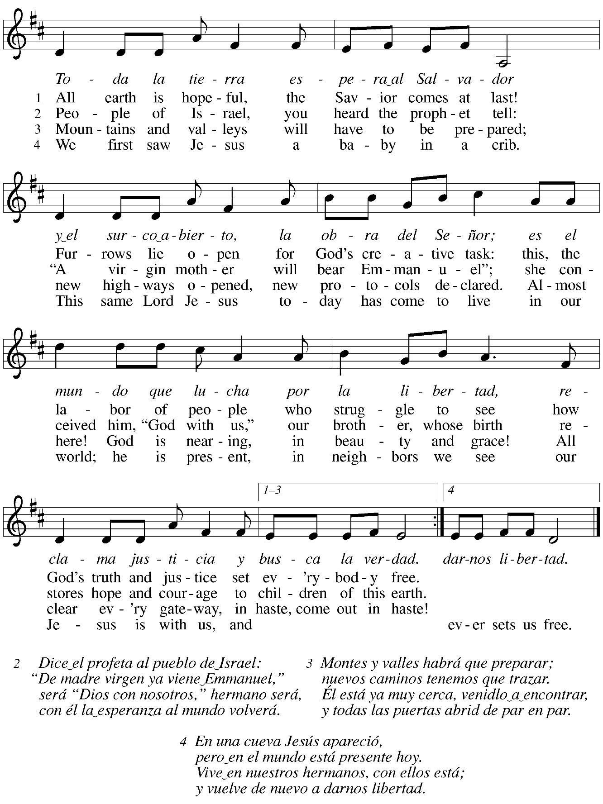

Greeting

P: The grace of our Lord Jesus Christ, the love of God,
and the communion of the Holy Spirit be with you all.
C: And also with you.

Kyrie ACS p. 12

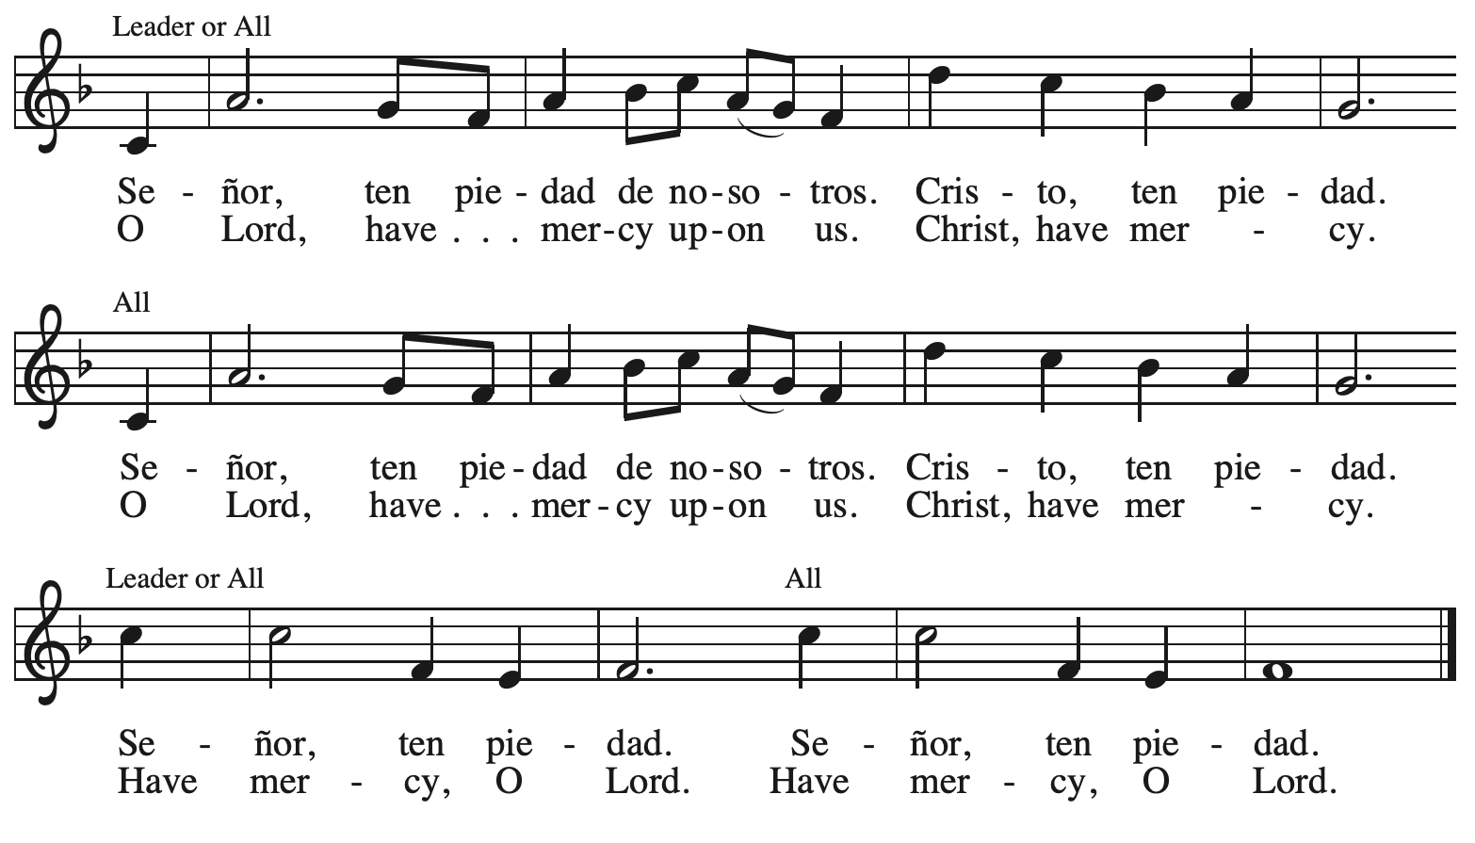

Prayer of the Day

P: The Lord be with you.
C: And also with you.

P: Let us pray.
Stir up your power, Lord Christ, and come. With your abundant grace and might,
free us from the sin that hinders our faith, that eagerly we may receive your promises,
for you live and reign with the Father and the Holy Spirit, one God, now and forever.
C: Amen.

Please be seated.
Children are invited to join the adult leader(s) at the side door for Little Church – Big Faith.
We ask that an additional adult from the congregation attend with the children.

Word
God speaks to us in Scripture reading, preaching, and song

First Reading – Isaiah 7: 10-16

¹⁰ The Lord spoke to Ahaz, saying, ¹¹ “Ask a sign of the Lord your God; let it be deep as Sheol or high as heaven.” ¹² But Ahaz said, “I will not ask, and I will not put the Lord to the test.” ¹³ Then Isaiah said, “Hear then, O house of David! Is it too little for you to weary mortals that you weary my God also? ¹⁴ Therefore the Lord [God]self will give you a sign. Look, the young woman is with child and shall bear a son and shall name him Immanuel. ¹⁵ He shall eat curds and honey by the time he knows how to refuse the evil and choose the good. ¹⁶ For before the child knows how to refuse the evil and choose the good, the land before whose two kings you are in dread will be deserted.”

L: Word of God, word of life.
C: Thanks be to God.

Psalm 80: 1-7, 17-19

The psalm will be sung responsively, led by the cantor, with the congregation singing the verses in bold type and joining in the refrain.

Psalm Tone

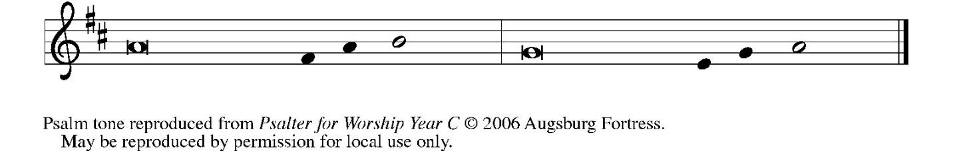

Psalm Refrain

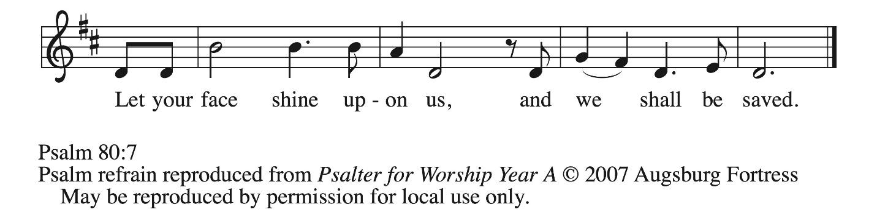

¹ Hear, O Shepherd of Israel, leading Joseph | like a flock;
shine forth, you that are enthroned up- | on the cherubim.
² In the presence of Ephraim, Benjamin, | and Manasseh,
stir up your strength and | come to help us.
³ Restore | us, O God;
let your face shine upon us, and we | shall be saved.
⁴ O Lord | God of hosts,
how long will your anger fume when your | people pray? R
⁵ You have fed them with the | bread of tears;
you have given them bowls of | tears to drink.
⁶ You have made us the derision | of our neighbors,
and our enemies laugh | us to scorn.
⁷ Restore us, O | God of hosts;
let your face shine upon us, and we | shall be saved.
¹⁷ Let your hand be upon the one at | your right hand,
the one you have made so strong | for yourself.
¹⁸ And so will we never turn a- | way from you;
give us life, that we may call up- | on your name.
¹⁹ Restore us, O Lord | God of hosts;
let your face shine upon us, and we | shall be saved. R

Second Reading – Romans 1: 1-7

¹ Paul, a servant of Christ Jesus, called to be an apostle, set apart for the gospel of God, ² which God promised beforehand through God’s prophets in the holy scriptures, ³ the gospel concerning God’s Son, who was descended from David according to the flesh ⁴ and was declared to be Son of God with power according to the spirit of holiness by resurrection from the dead, Jesus Christ our Lord, ⁵ through whom we have received grace and apostleship to bring about the obedience of faith among all the gentiles for the sake of his name, ⁶ including you who are called to belong to Jesus Christ,
⁷ To all God’s beloved in Rome, who are called to be saints:
Grace to you and peace from God our Father and the Lord Jesus Christ.

L: Word of God, word of life.
C: Thanks be to God.

Please rise as you are able.

Gospel Acclamation ELW p. 188

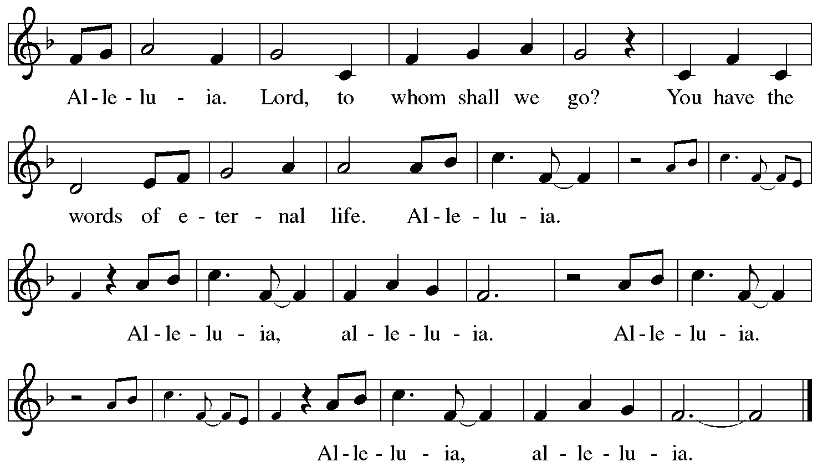

Gospel – Matthew 1: 18-25

P: The holy Gospel according to St. Matthew.
C: Glory to you, O Lord.

¹⁸ Now the birth of Jesus the Messiah took place in this way. When his mother Mary had been engaged to Joseph, but before they lived together, she was found to be pregnant from the Holy Spirit. ¹⁹ Her husband Joseph, being a righteous man and unwilling to expose her to public disgrace, planned to divorce her quietly. ²⁰ But just when he had resolved to do this, an angel of the Lord appeared to him in a dream and said, “Joseph, son of David, do not be afraid to take Mary as your wife, for the child conceived in her is from the Holy Spirit. ²¹ She will bear a son, and you are to name him Jesus, for he will save his people from their sins.” ²² All this took place to fulfill what had been spoken by the Lord through the prophet:
²³ “Look, the virgin shall become pregnant and give birth to a son,
and they shall name him Emmanuel,”
which means, “God is with us.” ²⁴ When Joseph awoke from sleep, he did as the angel of the Lord commanded him; he took her as his wife ²⁵ but had no marital relations with her until she had given birth to a son, and he named him Jesus.

P: The Gospel of the Lord.
C: Praise to you, O Christ.

Please be seated.

Sermon

A time of silence for prayer and reflection follows the sermon.
When the hymn of the day begins, please rise as you are able.

Hymn of the Day Savior of the Nations, Come ELW 263

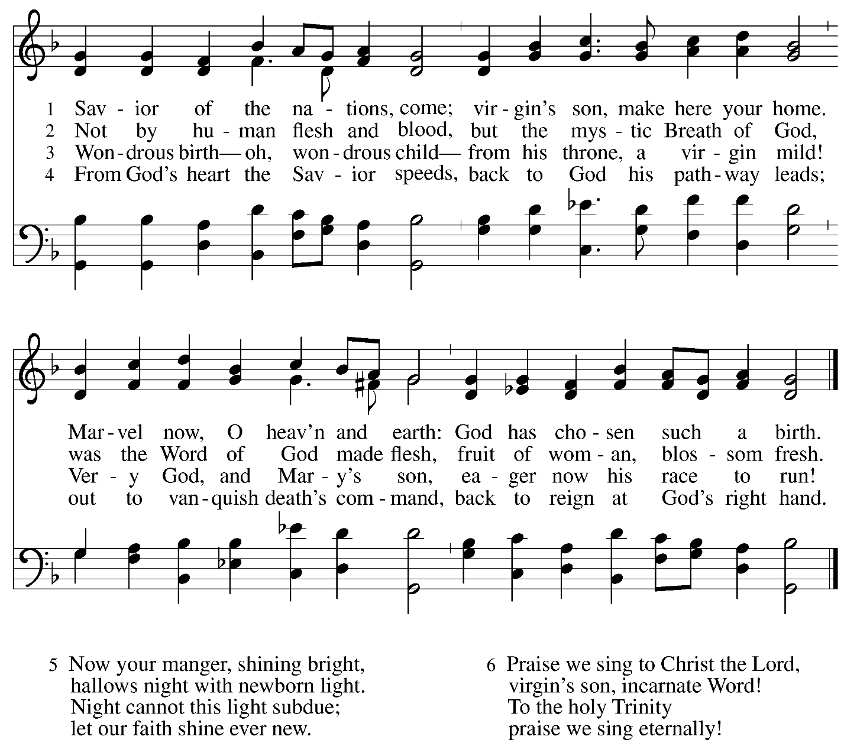
All rights reserved. Reprinted with permission under OneLicense.net # A-722139.

Nicene Creed

C: We believe in one God,
the Father, the Almighty,
maker of heaven and earth,
of all that is, seen and unseen.

We believe in one Lord, Jesus Christ,
the only Son of God,
eternally begotten of the Father,
God from God, Light from Light,
true God from true God,
begotten, not made,
of one Being with the Father;
through him all things were made.
For us and for our salvation
he came down from heaven,
was incarnate of the Holy Spirit and the virgin Mary
and became truly human.
For our sake he was crucified under Pontius Pilate;
he suffered death and was buried.
On the third day he rose again
in accordance with the scriptures;
he ascended into heaven
and is seated at the right hand of the Father.
He will come again in glory to judge the living and the dead,
and his kingdom will have no end.

We believe in the Holy Spirit, the Lord, the giver of life,
who proceeds from the Father and the Son,*
who with the Father and the Son is worshiped and glorified,
who has spoken through the prophets.
We believe in one holy catholic and apostolic church.
We acknowledge one baptism for the forgiveness of sins.
We look for the resurrection of the dead,
and the life of the world to come. Amen.

*Or, “who proceeds from the Father.” The phrase “and the Son” is a later addition to the creed.

Prayers of the People

A: In our waiting and watching, we come to you in prayer, O God,
trusting in your promise to renew the church, the nations, and your whole creation.

After each petition
A: God of grace,
C: receive our prayer.

P: Draw near to us, O God, as we commend into your care all for whom we pray,
trusting in your mercy, through Jesus Christ our Savior.
C: Amen.

Peace

The presiding minister and the assembly greet one another in the peace of the risen Christ.
P: The peace of Christ be with you always.
C: And also with you.

The people may greet those around them with a sign of Christ’s peace and may say
Peace be with you or similar words. Please be mindful that not everyone will be comfortable with sharing the peace, so please seek consent before shaking hands or hugging. Other possible ways to share the peace include a simple bow with the verbal greeting of peace, or simply a verbal expression of peace.

When the greetings of peace have concluded, please be seated.

Meal
God feeds us with the presence of Jesus Christ

Offering

We offer ourselves, our gifts, and our faithful service to God.
As the offering is gathered for the mission of the church, including the care of those in need,
the table is set for Holy Communion.

There are laminated giving cards in the pew racks that feature a QR code for anyone who would like to give online. Those who give using the QR code, as well as those who give regularly online or through their bank are encouraged to place the laminated card in the plate as an expression of your offering.

Noisy Offering

As children of the congregation carry buckets around the sanctuary, people of the congregation are invited to throw in their change as an offering. This month’s Noisy Offering will benefit the Best of the Batch Foundation’s Annual Holiday Drive. For more information more information on this initiative, please visit: https://www.batchfoundation.org/batch-a-toys/.

Offertory Music Soon and Very Soon

As the gifts are brought forward for presentation, please rise as you are able.

Offertory Song As Saints of Old ELW 695
v. 3

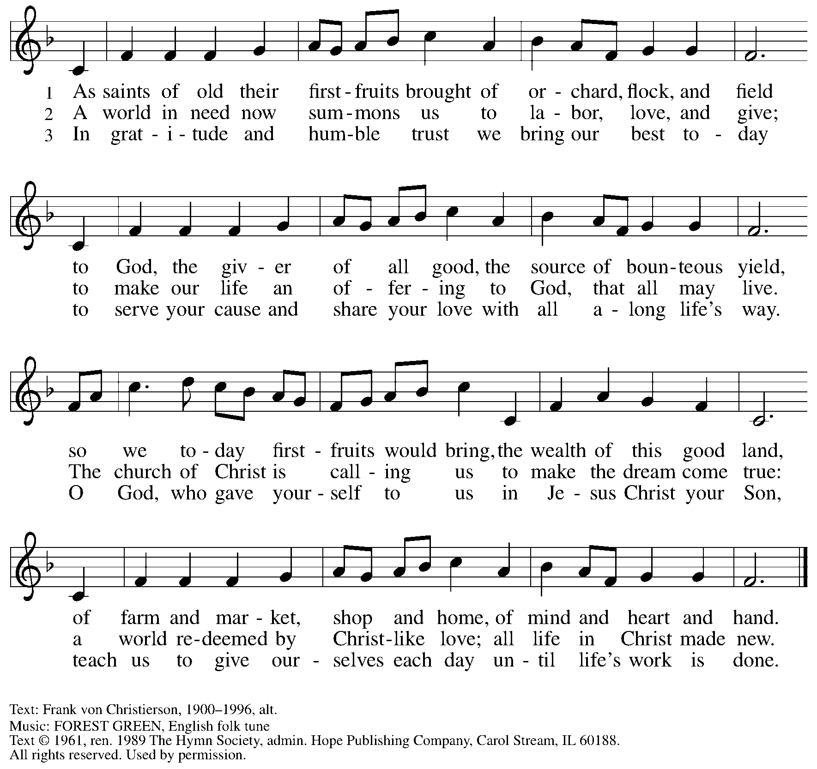
Reprinted under OneLicense.net # A-722139.

Offertory Prayer

A: Let us pray. God of abundance,
C: we bring before you the precious fruits of your creation, and with them our very lives. Teach us patience and hope as we care for all those in need until the coming of your Son, our Savior and Lord. Amen.

Dialogue

P: The Lord be with you.
C: And also with you.

P: Lift up your hearts.
C: We lift them to the Lord.

P: Let us give thanks to the Lord our God.
C: It is right to give our thanks and praise.

Preface

P: It is indeed right, our duty and our joy, …
… we praise your name and join their unending hymn:

Sanctus ELW p. 190

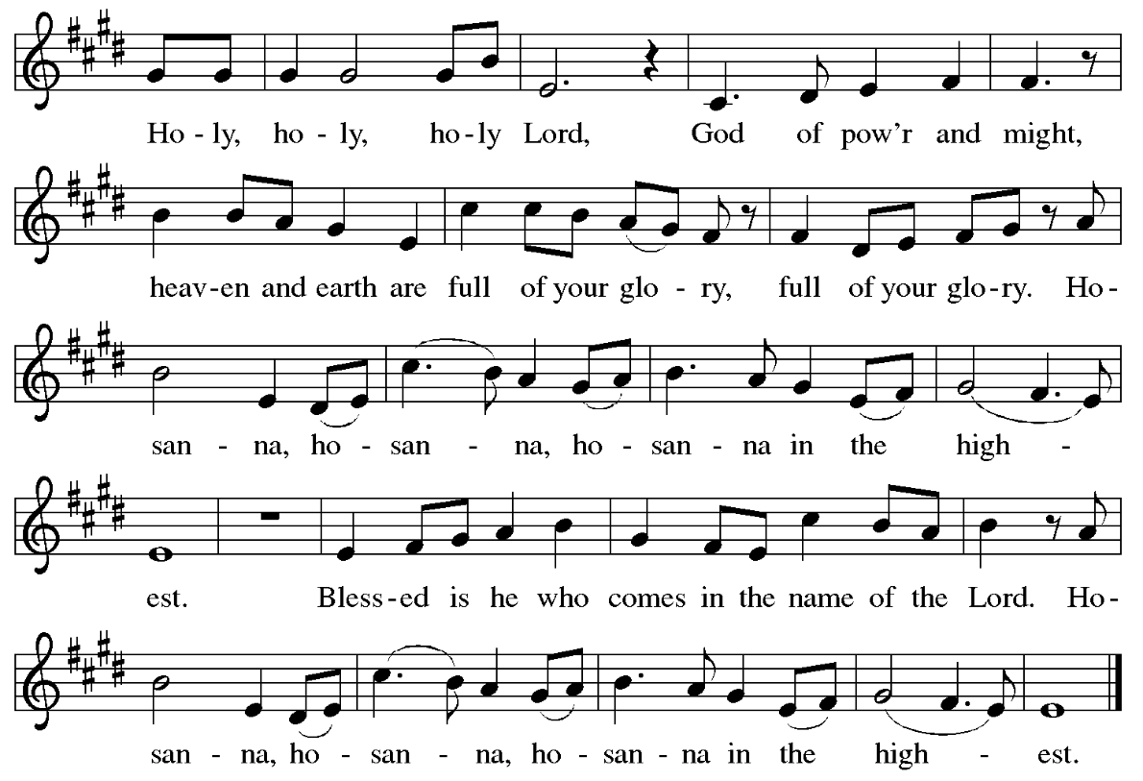

Eucharistic Prayer

P: Holy One, the beginning and the end, the giver of life …
… Do this for the remembrance of me.

P: Let us proclaim the mystery of faith:
C: Christ has died. Christ is risen. Christ will come again.

P: With this bread and cup …
… we look with hope for his coming.
C: Come, Lord Jesus.

P: Holy God, we long for your Spirit …
… Bring the gift of peace on earth.
C: Come, Holy Spirit.

P: All praise and glory are yours,
Holy One of Israel, Word of God incarnate, Power of the Most High,
now and forever.
C: Amen.

Lord’s Prayer

P: Gathered as one by the Holy Spirit, let us pray as Jesus taught us.
C: Our Father in heaven,
hallowed be your name,
your kingdom come,
your will be done,
on earth as in heaven.
Give us today our daily bread.
Forgive us our sins
as we forgive those
who sin against us.
Save us from the time of trial
and deliver us from evil.
For the kingdom, the power,
and the glory are yours,
now and forever. Amen.

Fraction and Invitation

Agnus Dei / Lamb of God ELW p. 191

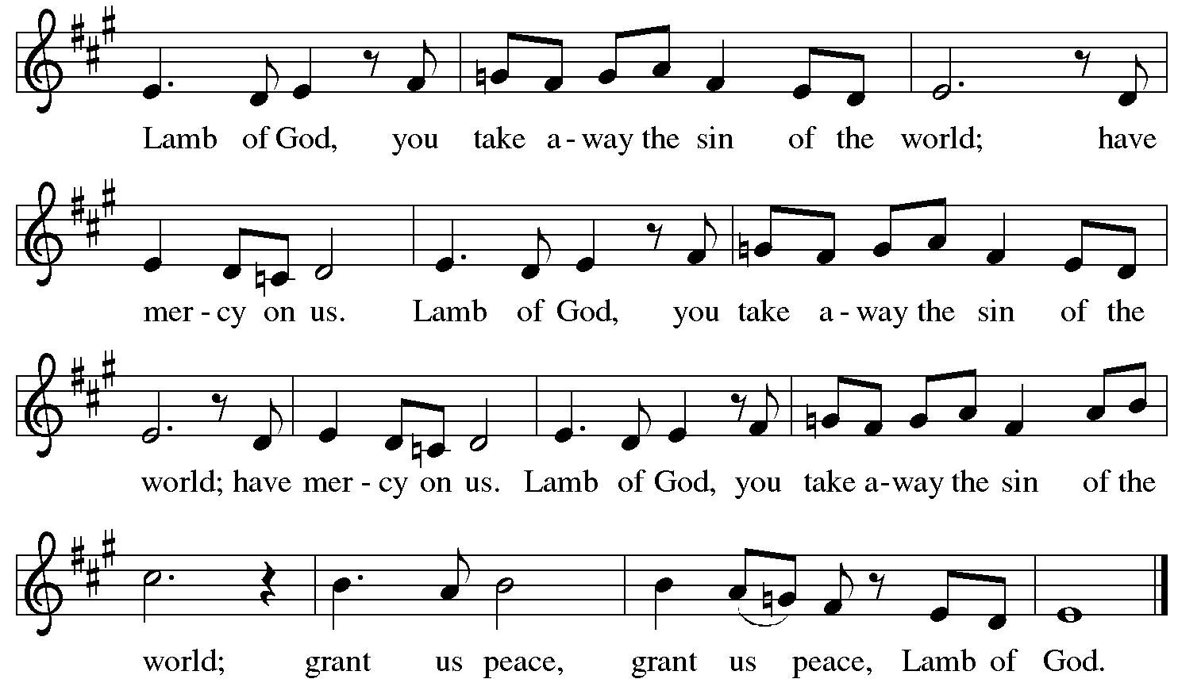

Please be seated.

Holy Communion

- All who seek God and desire a deeper and stronger life in Christ are welcome to receive Holy Communion.
- Worshipers from the pulpit side will proceed forward first, followed by the center section, and then the lectern side.
- Please inform an usher if you would like the ministers to bring Communion to you.
- Holy Communion will be served with bread and wine (amber) or grape juice (purple).
- The presiding minister will first distribute the bread (host) to each communicant. Please indicate if you require a gluten-free host.
- Once you have consumed the bread, please pick up an empty glass from the tray next to the presiding minister. The Communion Assistant will pour wine or grape juice into your glass.
- Please step to the side to consume the wine or grape juice.
- Feel free to kneel at the altar rail for prayer after receiving the sacrament.
- As you return to your pew, glasses may be returned to the empty tray on the side of the center section.
- A blessing will be provided for anyone who does not yet receive the sacrament.
- All are invited to join in singing the hymns during Holy Communion.

Hymns during Holy Communion
As the Dark Awaits the Dawn ELW 261

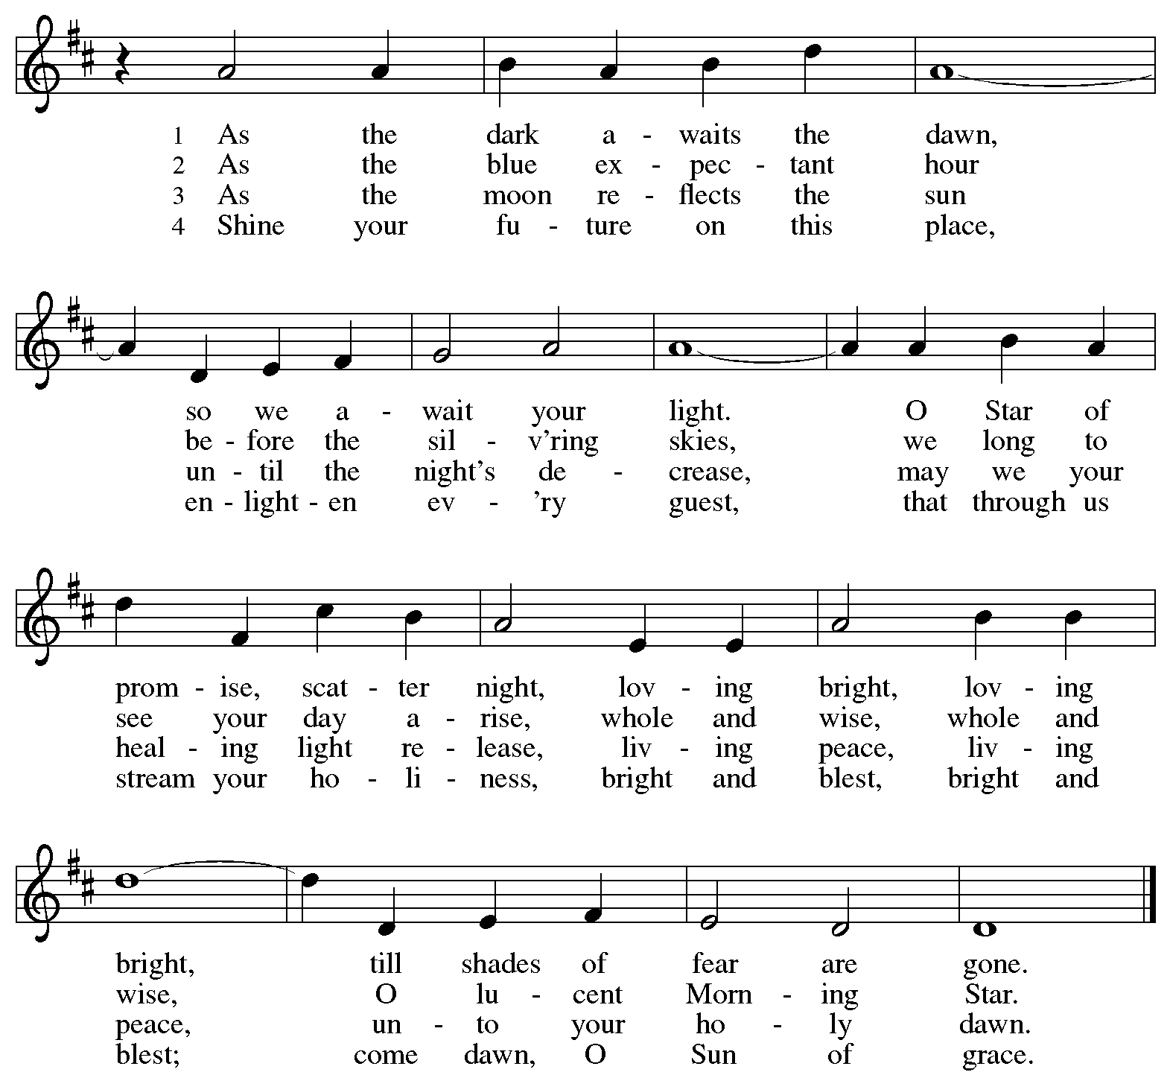


All rights reserved. Reprinted with permission under OneLicense.net # A-722139.

Hymns during Holy Communion
Come Now, O God ACS 902

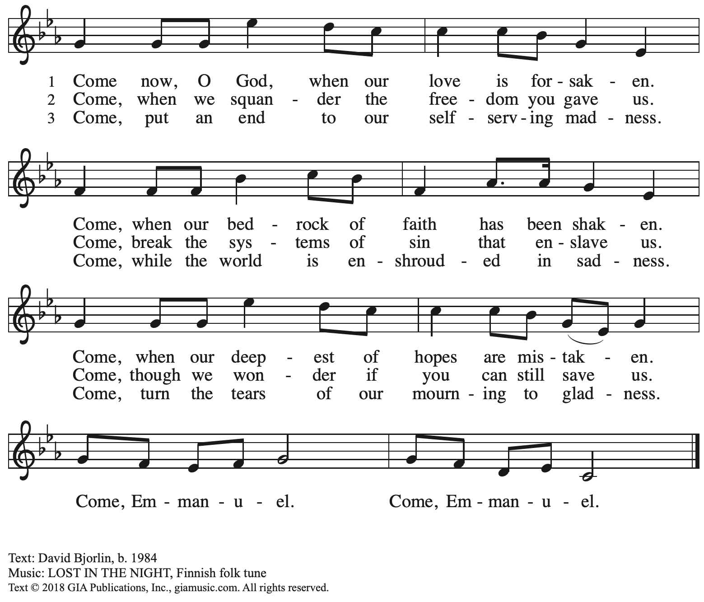
Reprinted with permission under OneLicense.net # A-722139.

Hymns during Holy Communion
Now the Heavens Start to Whisper ACS 901

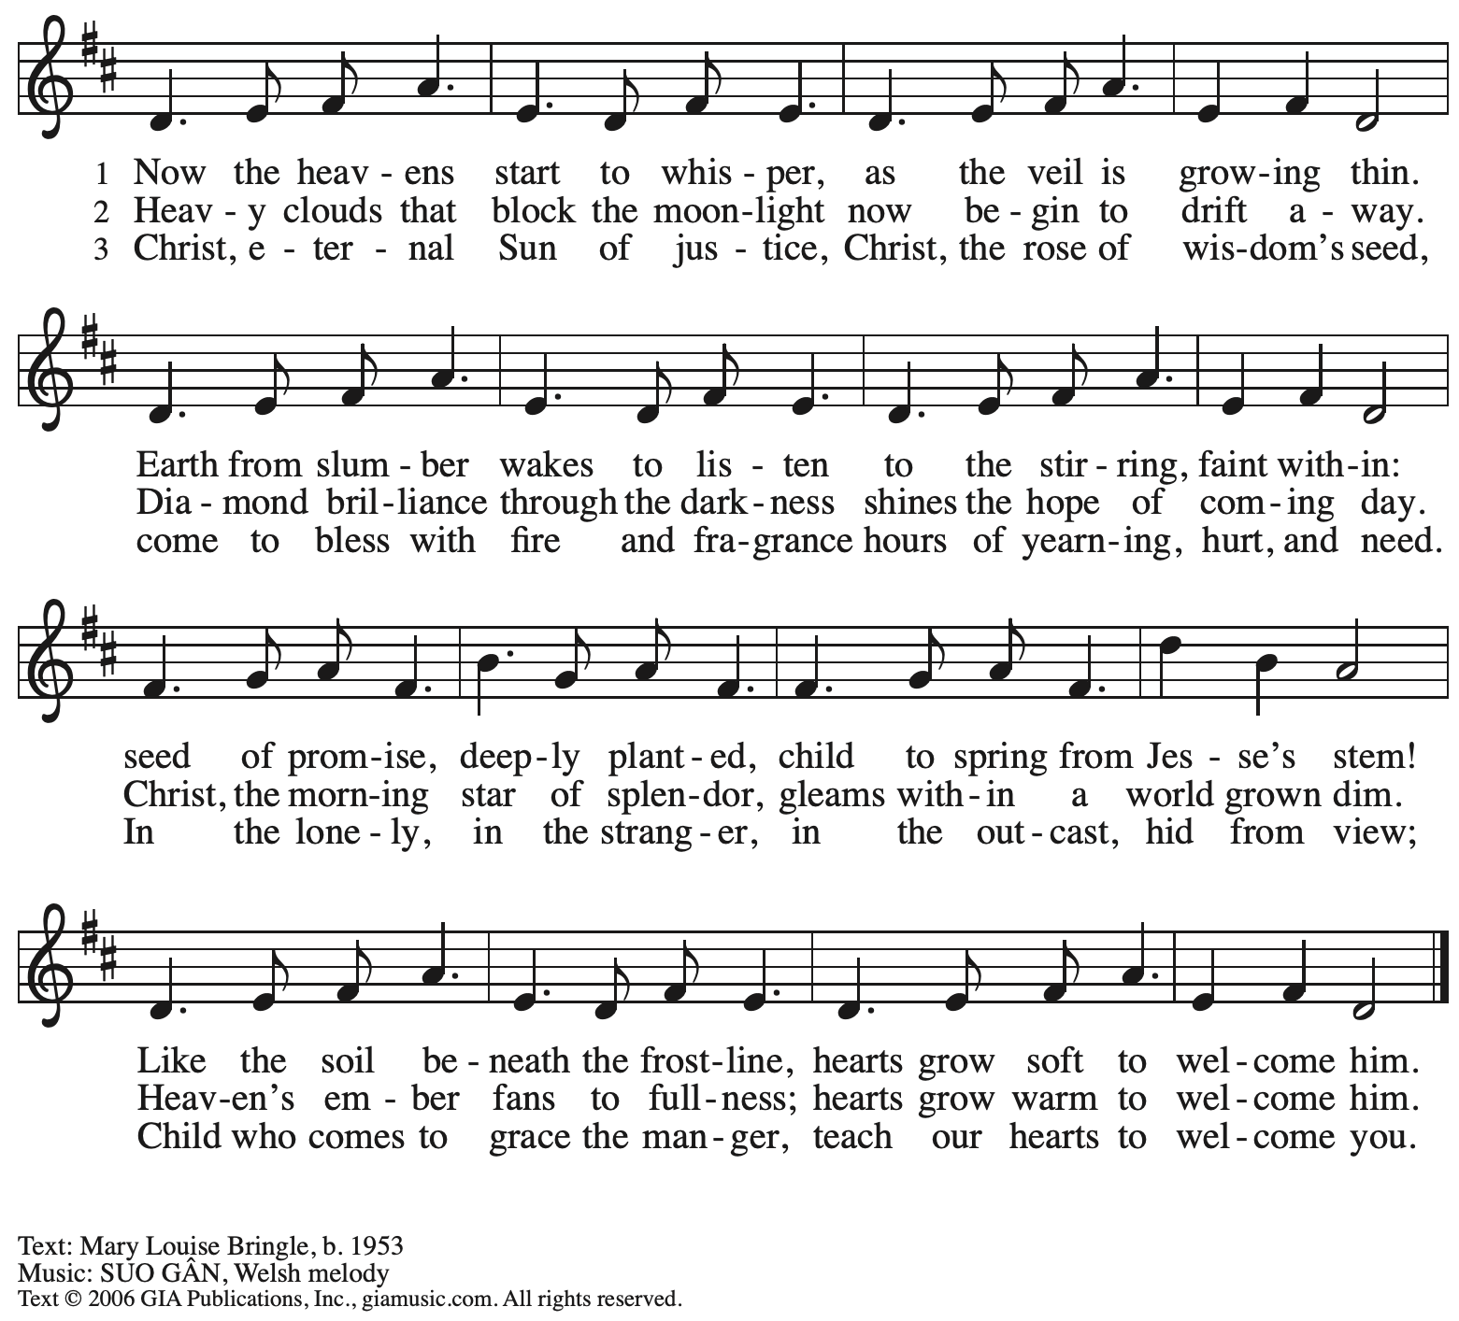
Reprinted with permission under OneLicense.net # A-722139.

When all have returned to their places, please rise as you are able.

Blessing

P: The body and blood of our Lord Jesus Christ strengthen you and keep you in his grace.
C: Amen.

Prayer

A: Let us pray.
God for whom we wait,
in this meal you give us a foretaste of that day when the hungry will be fed with good things. Send us forth to make known your deeds and to proclaim the greatness of your name,
through Jesus Christ, our Savior and Lord.
C: Amen.

Please be seated.

Sending
God blesses us and sends us in mission to the world

Announcements

Please rise as you are able.

Benediction

P: The God of peace bless you,
the love of ☩ Christ sustain you in hope,
and the anointing of the Holy Spirit remain upon you,
now and forever.
C: Amen.

Sending Hymn Following page
Dismissal

A: Go in peace. Keep awake.
C: Thanks be to God!

Postlude

Sending Hymn O Come, O Come, Emmanuel ELW 257
v. 1-
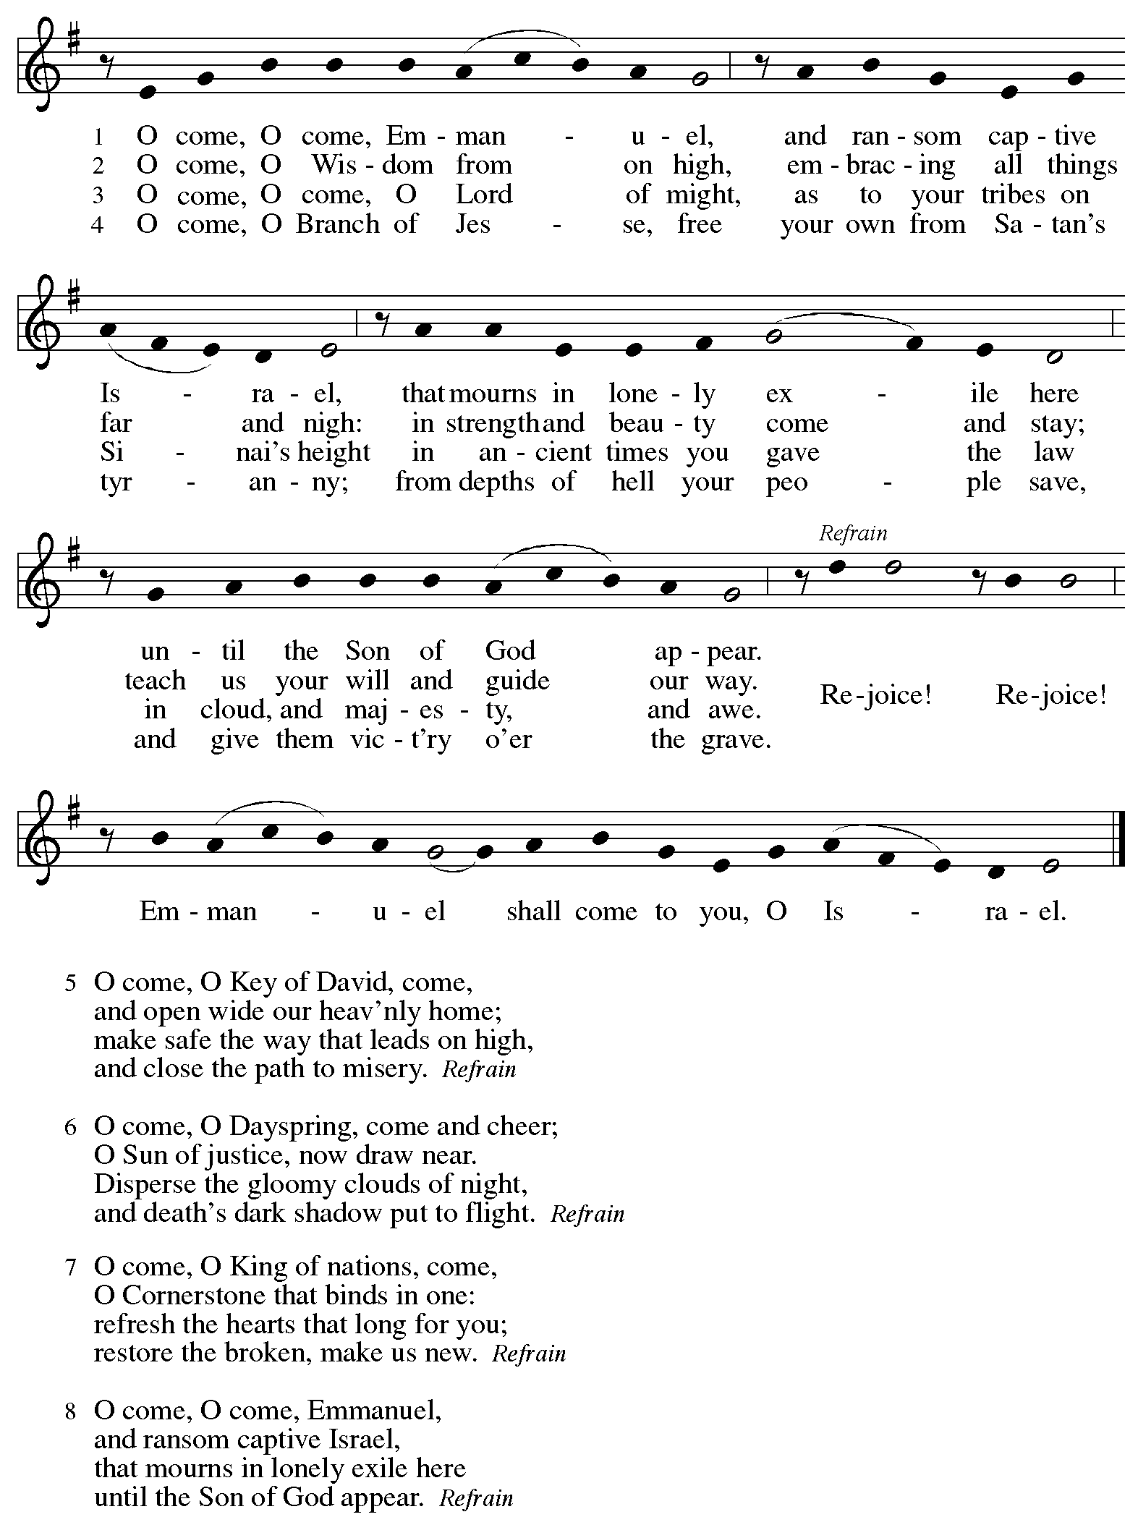
Serving in Worship Today

Altar Care Beverley Chapman
Assisting Minister Jimmi Kocher-Hillmer
Audio-Visual Ministers Jered Stratton
Jason Galyardt
Cantor The Rev. Erin Jones
Lector Michael Chapman
Minister of Music Laura Reynolds
Presiding Minister The Rev. Ross Carmichael

Liturgy and Hymnody Acknowledgements

From SundaysandSeasons.com. Copyright © 2025 Augsburg Fortress. All rights reserved. Reprinted under OneLicense.net # A-722139.
Used by permission of Augsburg Fortress.

The Scripture readings contained herein are from New Revised Standard Version Updated Edition of the Bible © 2021 National Council of Churches of Christ in the United States of America. Used by permission. All rights reserved worldwide.

All Earth Is Hopeful – Toda la tierra Text: Alberto Taulé, b. 1932; tr. Madeleine Forell Marshall, b. 1946. Music: TODA LA TIERRA, Alberto Taulé. Spanish text and tune © 1993 and English text © 1995 Centro de Pastoral Litúrgica, admin. OCP Publications, 5536 NE Hassalo, Portland, OR 97213.

O Come, O Come, Emmanuel – Text: Psalteriolum Cantionum Catholicarum, Köln, 1710, tr. composite. Music: VENI, EMMANUEL, French processional, 15th cent. Text sts. 2, 6, 7 © 1997 Augsburg Fortress. All rights reserved. Reprinted with permission under OneLicense.net # A-722139.

Please use the QR code below to link to St. Andrew’s Announcements online!



St. Andrew Lutheran Church Announcements
December 21st, 2025

- Welcome to Worship at St. Andrew on the Fourth Sunday of Advent – We are thankful you are here, and we offer a special welcome to all visitors and guests who are here for the first time! A nursery is available through the door to the left of the worship space and across the social hall (look for a purple room). Little Church – Big Faith, a Bible lesson and activity for children up to sixth grade, will take place after the prayer of the day. There are also worship “toolkits” to help children engage with worship and “busy bags” for younger children available in the bookcase at the back of the sanctuary. Please feel free to take one to use with/for your children. All are invited to stay for coffee and other drinks, food, and conversation in the Social Hall (through the side door at the left of the worship space) after the service.
- Noisy Offering This Week, Sunday, December 21st, during Worship – On the third Sunday of each month, St. Andrew’s children lead the congregation in a Noisy Offering, in which people are invited to throw their change into buckets that the children carry around the church and bring forward as an additional offering. Each month’s Noisy Offering supports a local, national, or international church-related or otherwise charitable organization. The Noisy Offering recipient for December will be Best of the Batch Foundation's Annual Holiday Drive. Best of the Batch Foundation is a nonprofit organization founded in 1999 by former Pittsburgh Steelers quarterback Charlie Batch. It provides year-round educational programming to more than 4,000 children ages 5 to 18 across nine western Pennsylvania counties. Their goal is "to provide financially challenged communities with the purpose, desire, and resources to give their best efforts in all they do throughout their lives. For more information on this initiative, please visit: https://www.batchfoundation.org/batch-a-toys/.
- Church Decorating for Christmas, Today, December 21st, after Worship – We will be decorating the church after worship today and invite everyone to take part in the fun! Have some coffee and food and gather back in the sanctuary after worship.
- Produce Distribution Supplemental Food of the Month – St. Andrew is collecting supplemental food each month to accompany our produce distribution. For this month, we ask for donations of peanut butter. There are collection boxes at the back of the worship space and social hall.
- Volunteers Requested to help with WPA BOLD Holiday Party on Sunday, January 18th – For several years, the Western PA Blind Outdoor Leisure Development Organization (BOLD), has been holding their holiday parties at St. Andrew, and they will do so again on Sunday, January 18th, from 1:00 - 5:30 p.m. The group has expressed that it would be helpful to have volunteers from the congregation there that day to help set up (this can be done after coffee hour), greet members and help them to find seats, assist with serving buffet food, leading and helping people to get food, and cleanup. If you are willing to help, please speak with Pastor Ross.
- Receive Prayer Team Emails – St. Andrew maintains a list of weekly prayer concerns sent by email to members of the congregation who have opted in. Our prayer team’s email is prayerteam@standrewpittsburgh.org. We will keep names on the list for a maximum of four weeks unless otherwise requested. Thank you for your ministry of prayer!
- Records Update – St. Andrew is updating our records with information from newer attendees, as well as offering current members the opportunity to include current information to be used within the congregation: for emergency contacts, to acknowledge celebrations, milestones, and prayers. Please fill out the form at: https://forms.gle/kKvp19UozuRrhhaV7.
- Coffee Hour Signups – St. Andrew provides hospitality during a coffee hour after worship each Sunday. If you would like to participate and would like information about the duties of setting up, please sign up using the following form: https://www.signupgenius.com/go/5080B4AAFAF2CABF85-47069030-coffee#/.

