

+ First Sunday of Christmas
Service of Lessons and Carols
December 28, 2025



St. Andrew Lutheran Church
304 Morewood Ave.
Pittsburgh, PA 15213
St_andrewELCA@verizon.net
www.standrewpittsburgh.org

+ First Sunday of Christmas
Service of Lessons and Carols
Order for Worship

In recent years, celebrations of the Twelve Days of Christmas have often included a Service of Lessons and Carols, an opportunity to explore the breadth of biblical texts about the incarnation of Jesus and to sing additional, much-beloved hymns of the season. St. Andrew will feature Lessons and Carols in the first part of worship today, then continue with the meal of Holy Communion. In our gathering around word and meal, God continues to redeem us, lift us up, and carry us forward as God’s people as in days of old.

Welcome to St. Andrew!
- St. Andrew welcomes all who are seeking a place of healing, wholeness, and acceptance in a nurturing and faith-forming spiritual home. We are striving toward racial equity worldwide
and we seek to honor the lived experience of all individuals regardless of background. Our community embraces people of all ages, ethnicities, cultures, abilities, sexual orientations,
gender identities and expressions, and family constellations. Come and See!
- Worship Services are live-streamed to multiple online platforms. By attending worship, you agree that your image and voice may be broadcast.
- Everyone is invited to make a name tag at the black bookcase in the back of the worship space if they would like. There are stickers indicating pronouns on the bookcase if you would like to include them on your name tag.
- A nursery is available through the doors at the left side of the sanctuary and across from the doorway to the Social Hall. Look for a purple-colored room.
- Worship “toolkits” to help children engage with the service, along with “busy bags” for younger children, are available in the bookcase at the back of the sanctuary. Please feel free to take one to use with/for your children.
- Holy Communion is served with bread (gluten-free available) and wine or grape juice. The presiding minister will distribute the bread (host). Please consume this and then pick up an empty glass from the tray. The Communion Assistant will pour wine or grape juice into your glass. Please step to the side to consume the wine or grape juice. Feel free to kneel at the altar for prayer and reflection. As you return to your pew, glasses may be returned to the empty trays on the side of the center section.
- A restroom is available on the main level of the church, through the doors to the Social Hall and to the right in the main office.

Abbreviations

P: Pastor/Presiding Minister ELW: Evangelical Lutheran Worship hymnal
A: Assisting Minister
L: Lector
C: Congregation

Musical Offering

Each week, different people from the congregation make an offering of pre-service music, with singing or instrumentation, to help the assembly focus and pray in preparation for worship.

Welcome

Prelude

Gathering
The Holy Spirit calls us together as the people of God

Please rise as you are able. All may make the sign of the cross,
the sign that is marked at Baptism, as the presiding minister begins.

Dialogue

P: Blessed be the holy Trinity, ☩ one God,
Wonderful Counselor, Mighty Savior, Prince of Peace.
C: Amen.

P: Jesus, the bright Morning Star, shines light in the world.
C: By day and night, Christ shines for all to see.

P: Jesus was born in the midst of injustice and poverty
C: that the world may see the justice and richness of God.

P: God so loved the world that God sent Jesus,
C: so that all who believe in him may not perish but have eternal life.

P: Jesus is the light of the world.
C: Jesus is the light of our lives.

P: Sing to God a new song!
C: A song of hope, joy, and peace around the world.

Gathering Hymn Angels We Have Heard on High ELW 289
v. 1-2

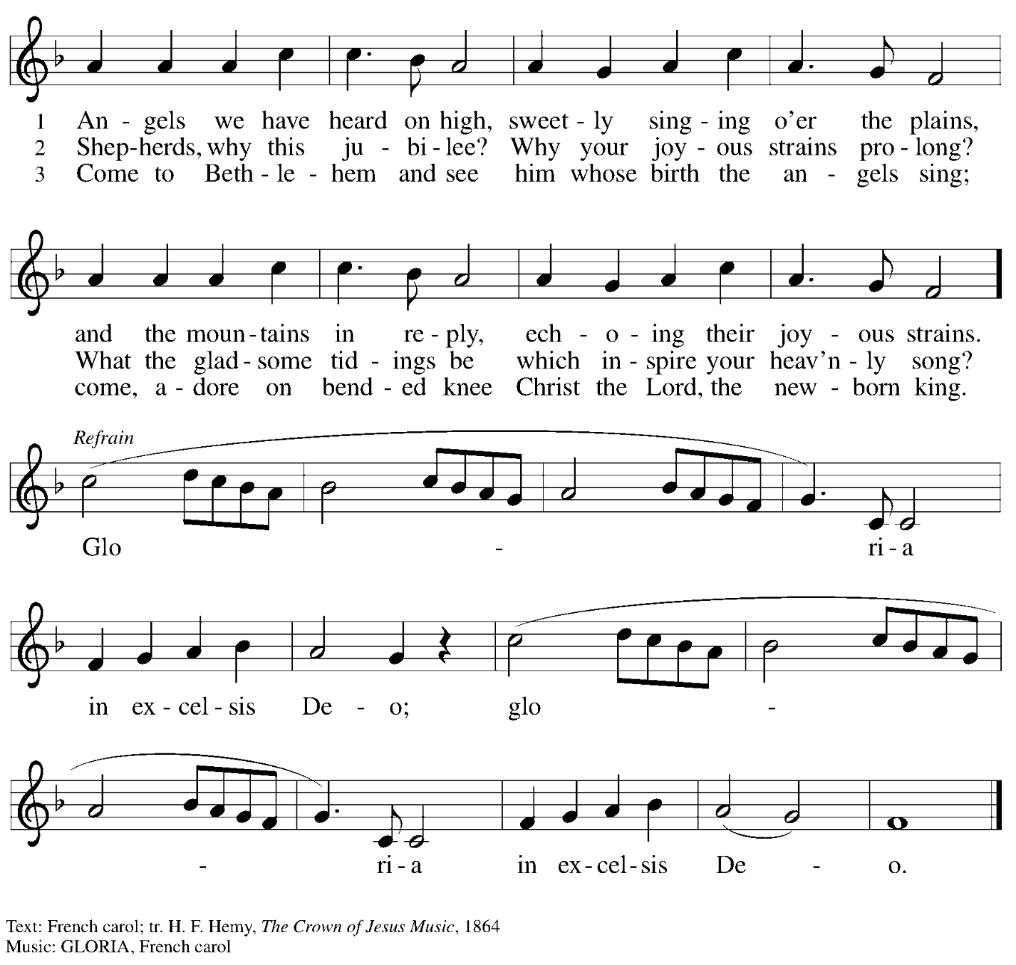

Prayer of the Day

P: The Lord be with you.
C: And also with you.

Let us pray.
Gracious God of heaven and earth,
your gift of hope shines in the coming of Jesus.
Though born in a manger, he is the firstborn of all creation.
Though crucified on a cross, he is the Lord of life.
Fill us with the wonder and joy of his presence in the world
and in our hearts, through Jesus Christ, our Savior and Lord.
C: Amen.

Please be seated.

Word
God speaks to us in Scripture reading, preaching, and song

First Reading – Genesis 1: 1-5, 14-19

Hymn Lo, How a Rose E’er Blooming ELW 272
v. 1-2

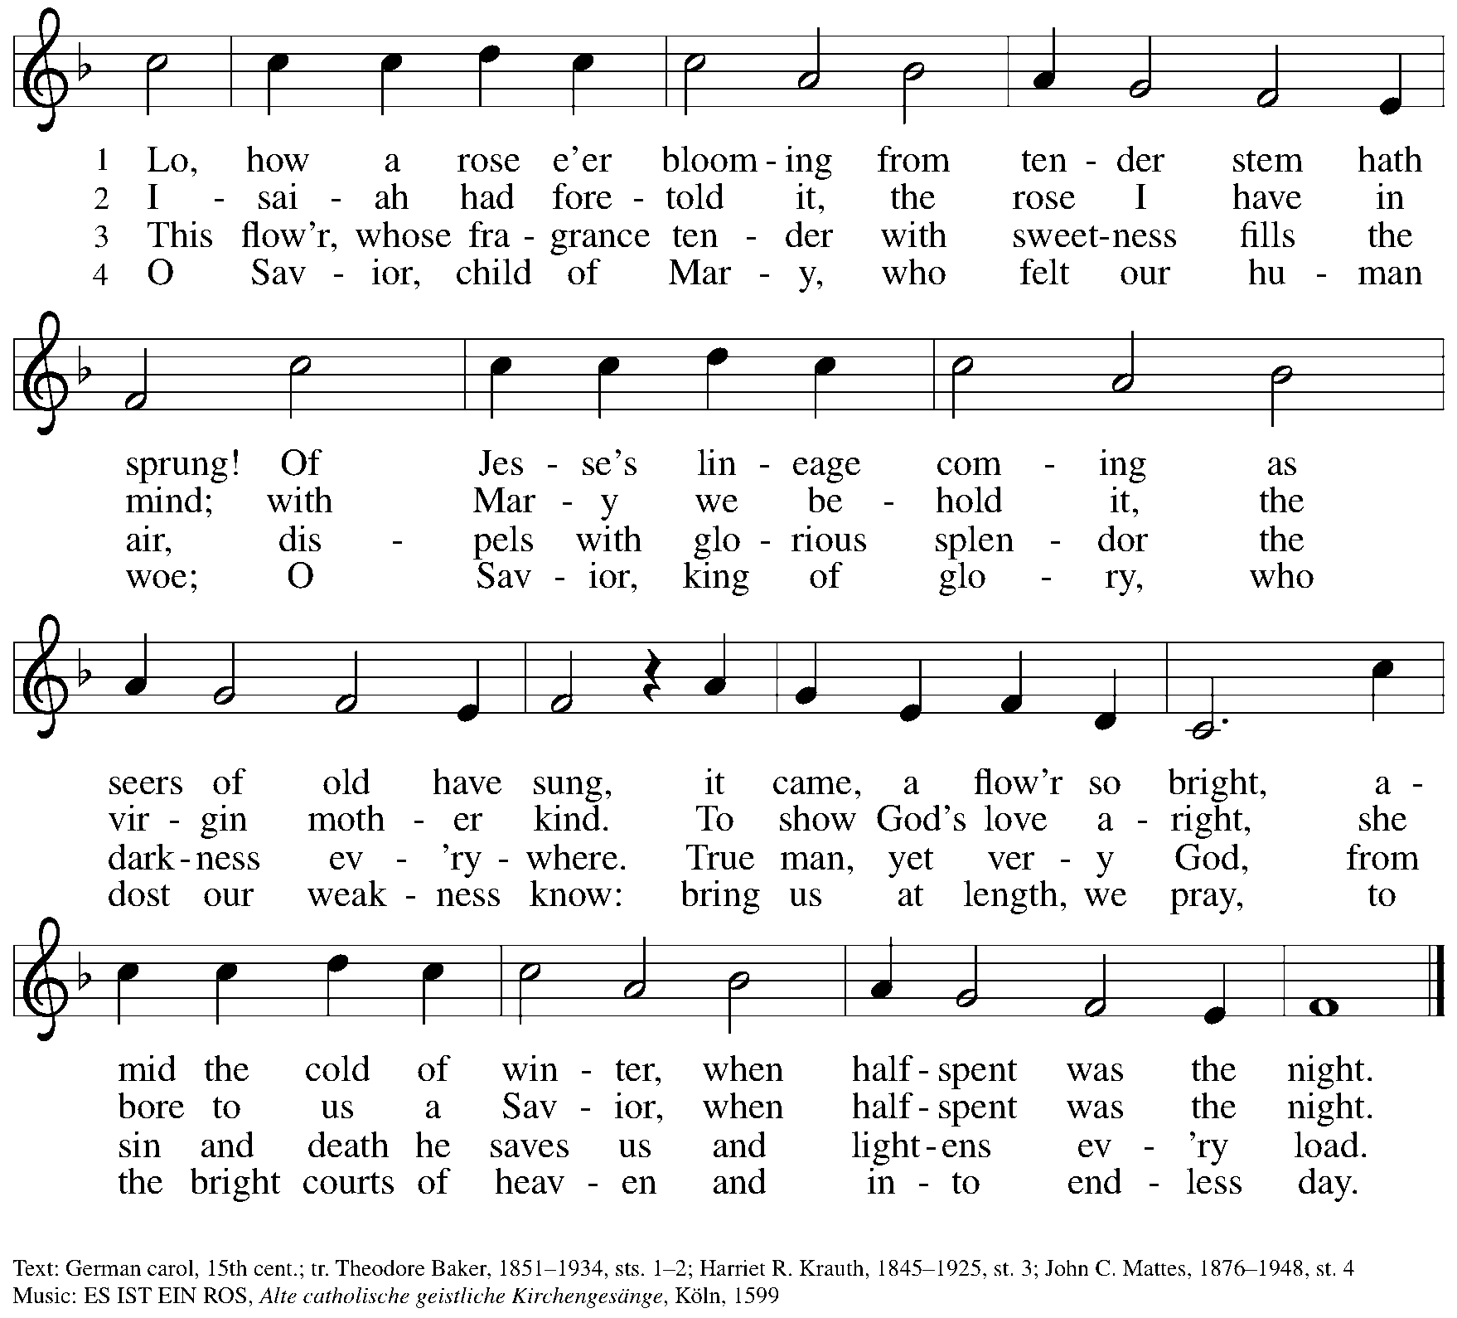

Second Reading – Micah 5: 2-5a

Hymn O Little Town of Bethlehem ELW 279
v. 1-2

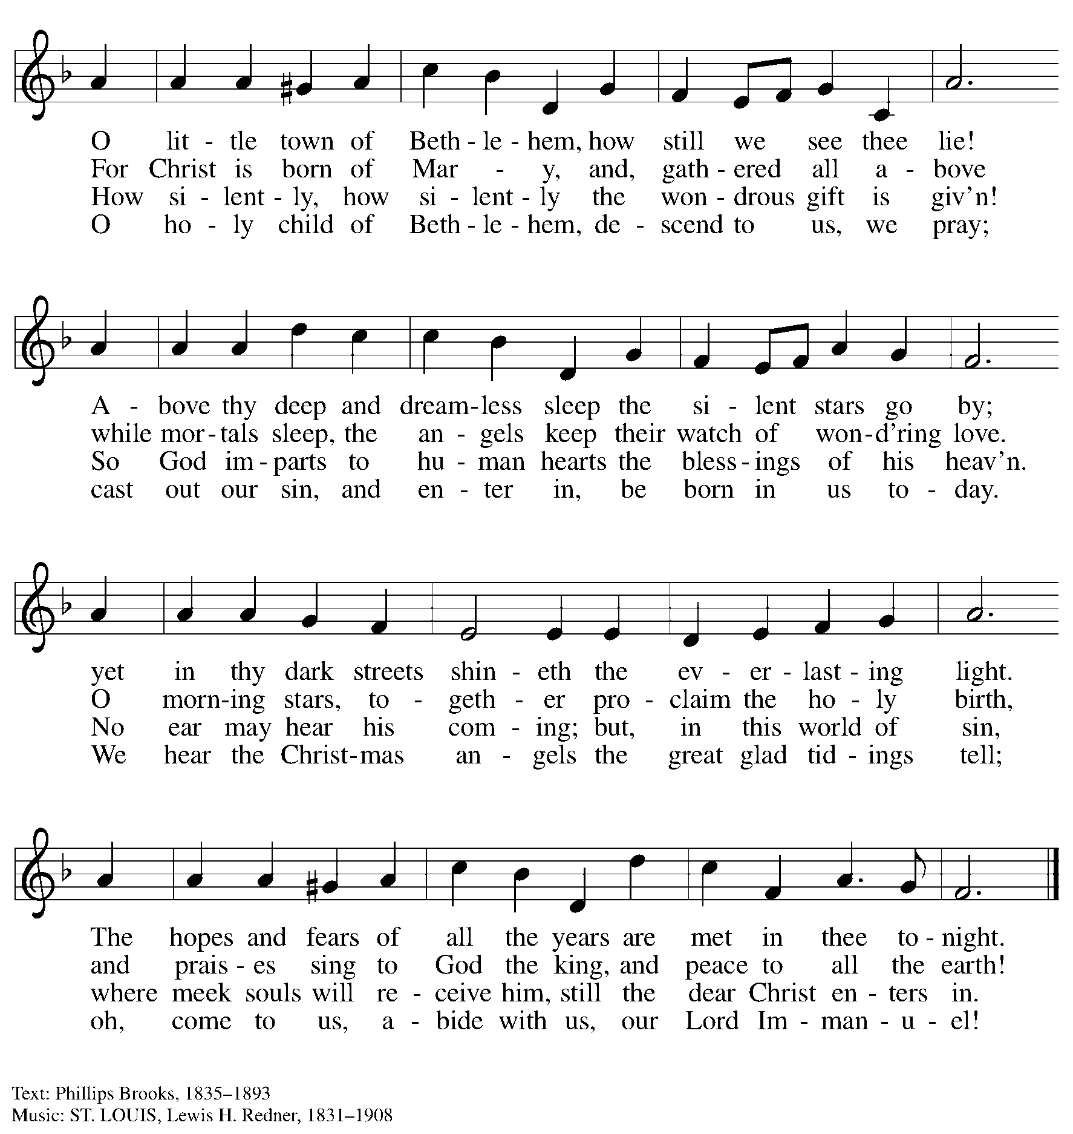

Third Reading – Luke 1: 26-38

Hymn The Angel Gabriel from Heaven Came ELW 265
v. 1-3

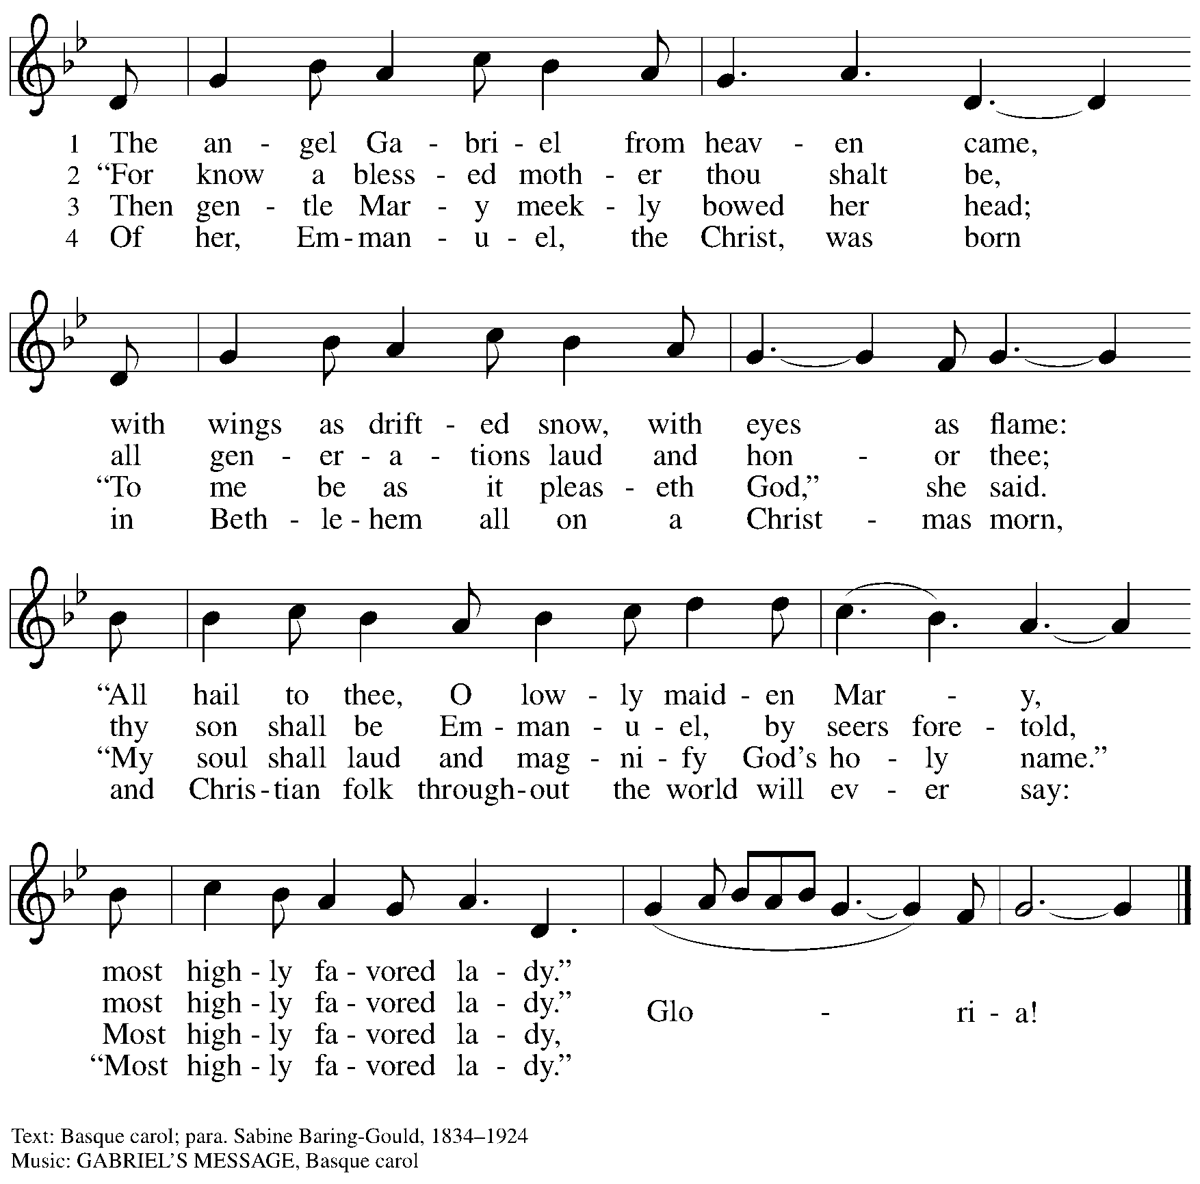

Fourth Reading – Matthew 1: 18-25

Hymn Jesus, What a Wonderful Child ELW 297

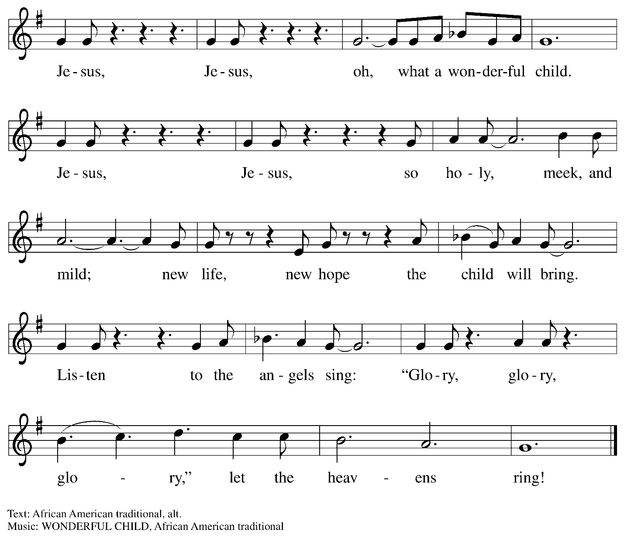

Fifth Reading – Luke 2: 8-20

Hymn Angels from the Realms of Glory ELW 275
v. 1-2

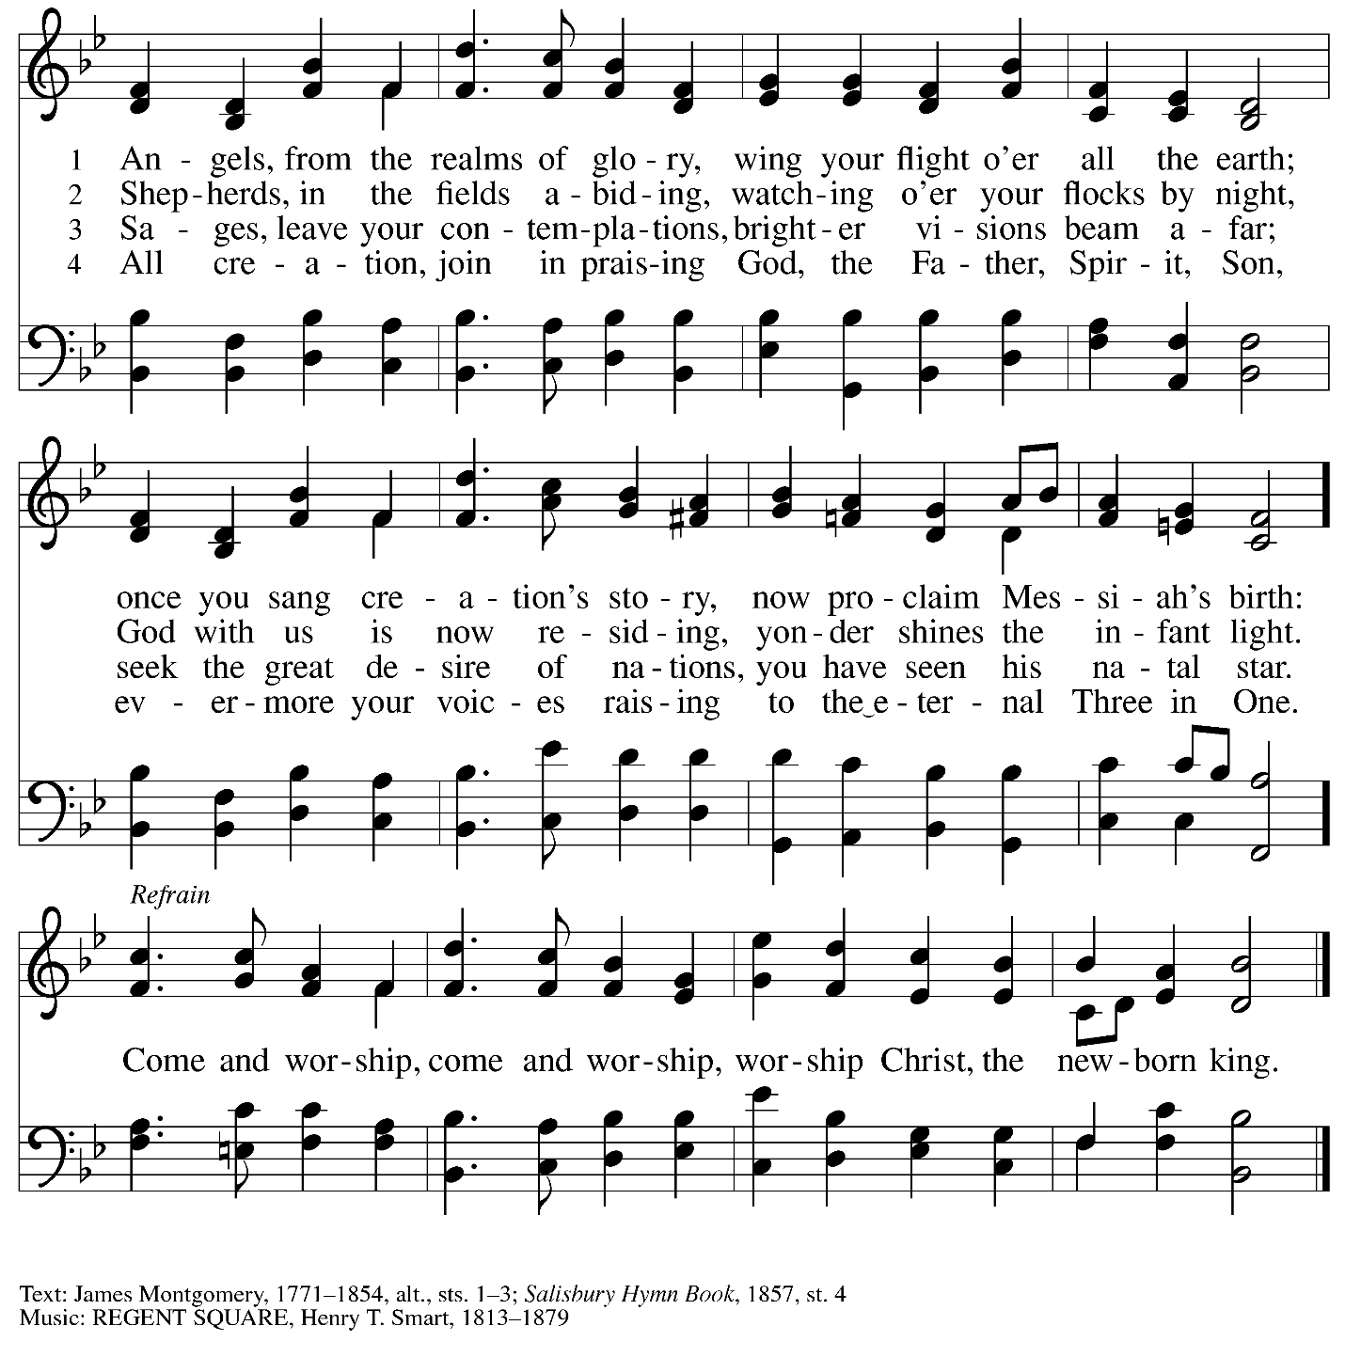

Sixth Reading – Matthew 2: 1-11

Hymn What Child Is This ELW 296
v. 1-3

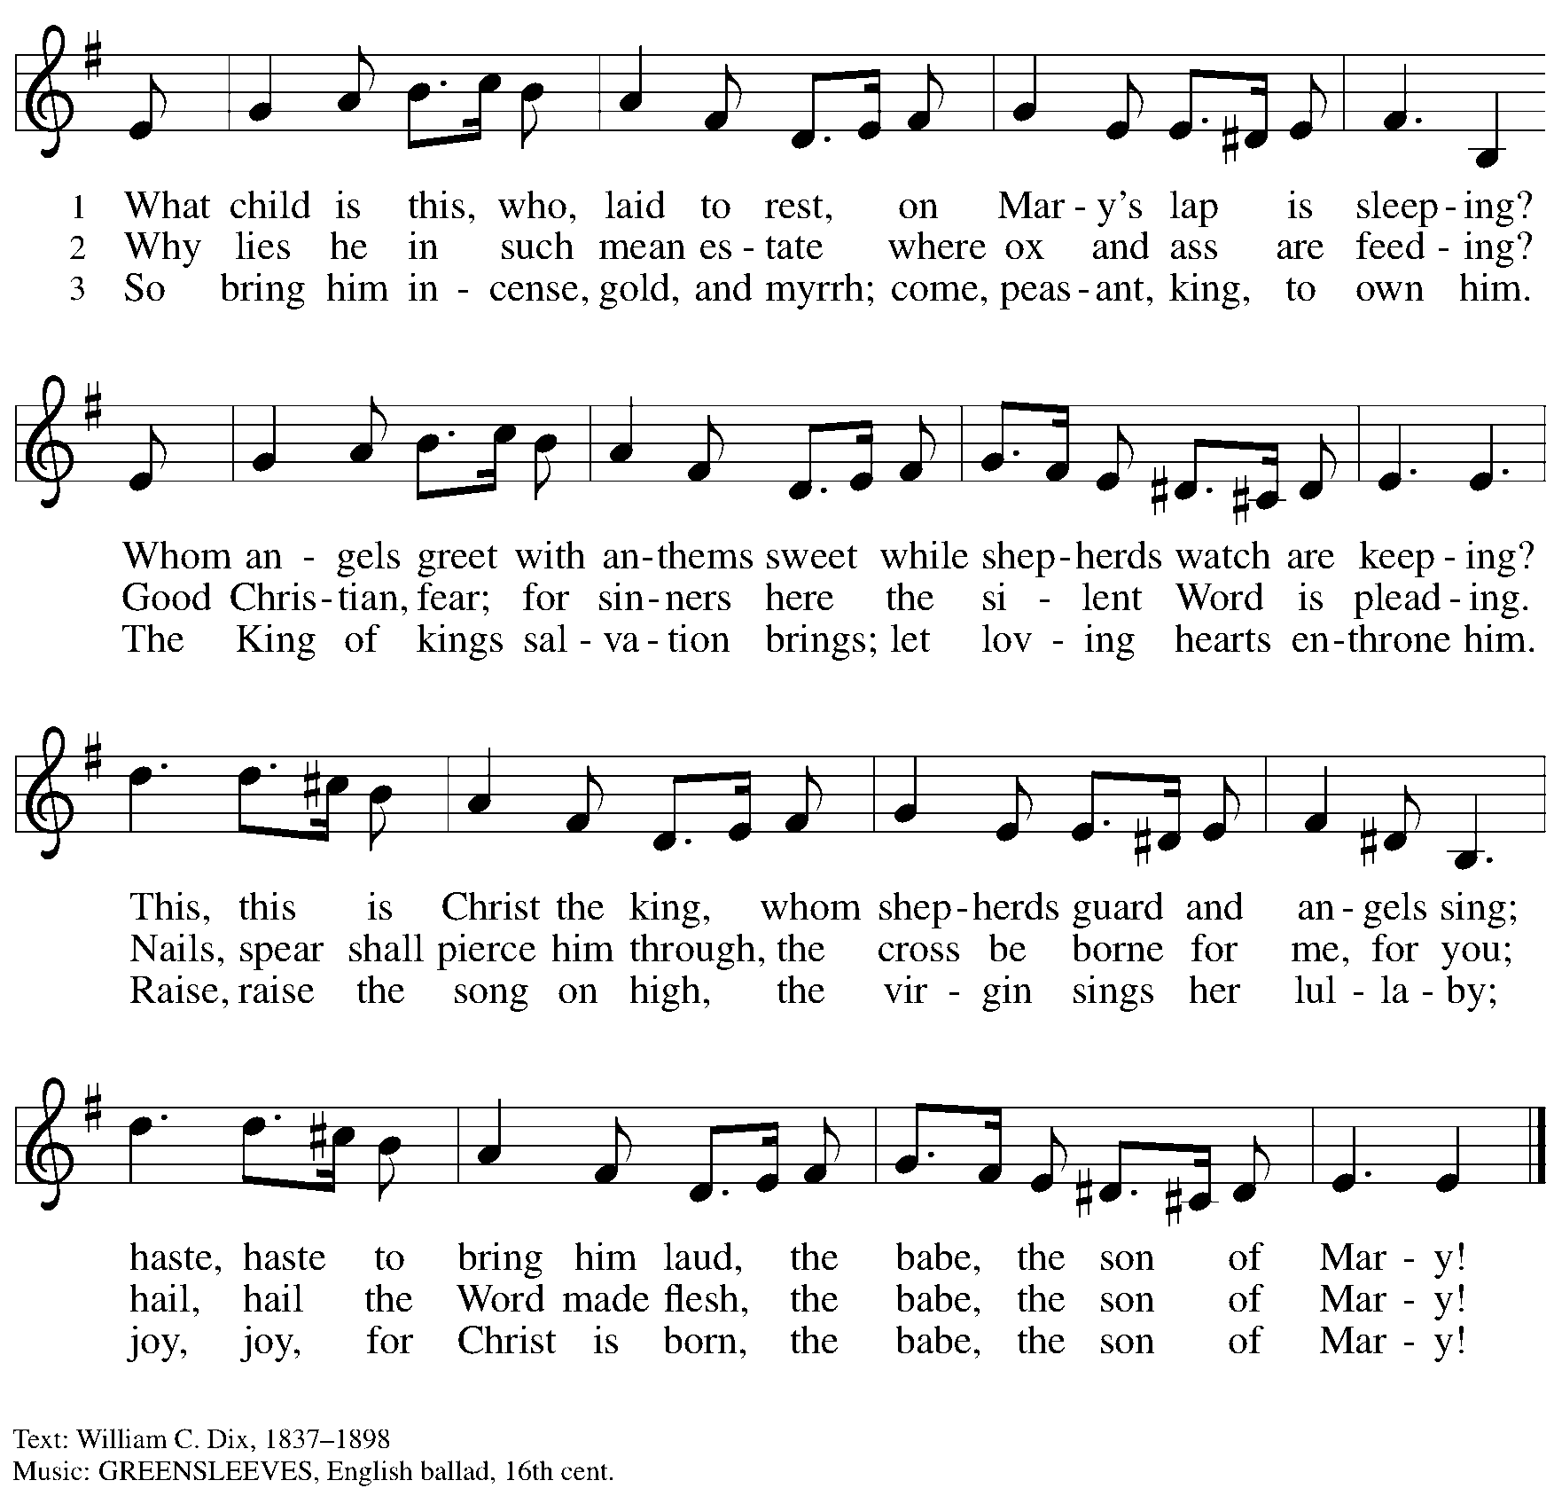

Seventh Reading – John 1: 1-14

Hymn Love Has Come ELW 292
v. 1-2

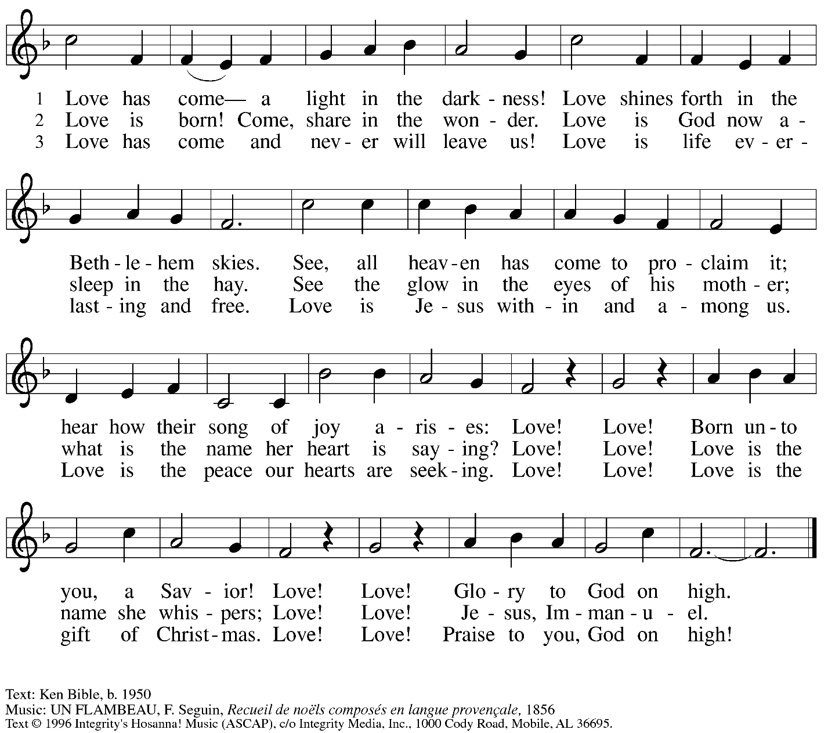
All rights reserved. Reprinted with permission under OneLicense.net # A-722139.

Responsive Prayer

A: It is you, loving God, who lights our path with truth.
C: Your Word, Jesus, is truth.

A: In his light, draw all to the manger
C: to gather in wonder with the shepherds.
A: In his light, draw all to the manger
C: to kneel in reverence with the wise ones.

A: In his light, draw all to the manger
C: to sing for joy with the angels.

A: In the brightness of his life
C: cast away the darkness of injustice, poverty, and hunger in the world.

A: It is you, loving God, who meets us on our way.
C: In the light of Jesus, show the world the way of life.
Amen.

Peace

The presiding minister and the assembly greet one another in the peace of the risen Christ.
P: The peace of Christ be with you always.
C: And also with you.

The people may greet those around them with a sign of Christ’s peace and may say
Peace be with you or similar words. Please be mindful that not everyone will be comfortable with sharing the peace, so please seek consent before shaking hands or hugging. Other possible ways to share the peace include a simple bow with the verbal greeting of peace, or simply a verbal expression of peace.

When the greetings of peace have concluded, please be seated.

Meal
God feeds us with the presence of Jesus Christ

Offering

We offer ourselves, our gifts, and our faithful service to God.
As the offering is gathered for the mission of the church, including the care of those in need,
the table is set for Holy Communion.

There are laminated giving cards in the pew racks that feature a QR code for anyone who would like to give online. Those who give using the QR code, as well as those who give regularly online or through their bank are encouraged to place the laminated card in the plate as an expression of your offering.
Offertory Music

As the gifts are brought forward for presentation, please rise as you are able.
Offertory Song In the Bleak Midwinter ELW 294

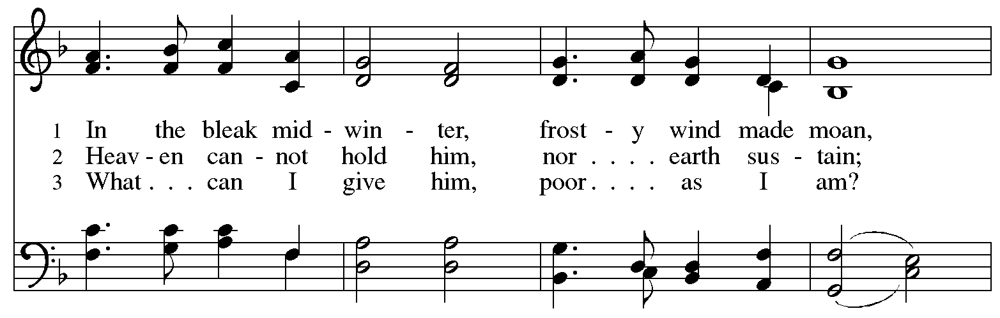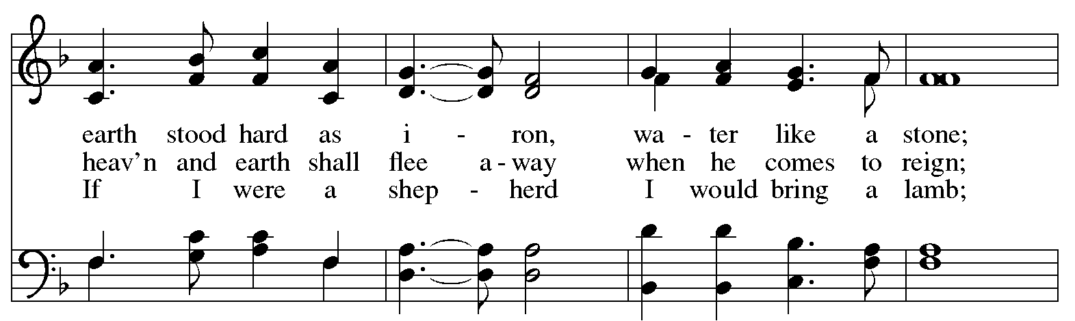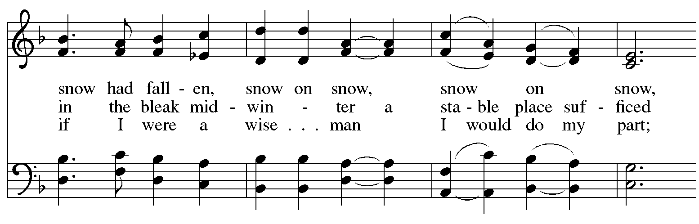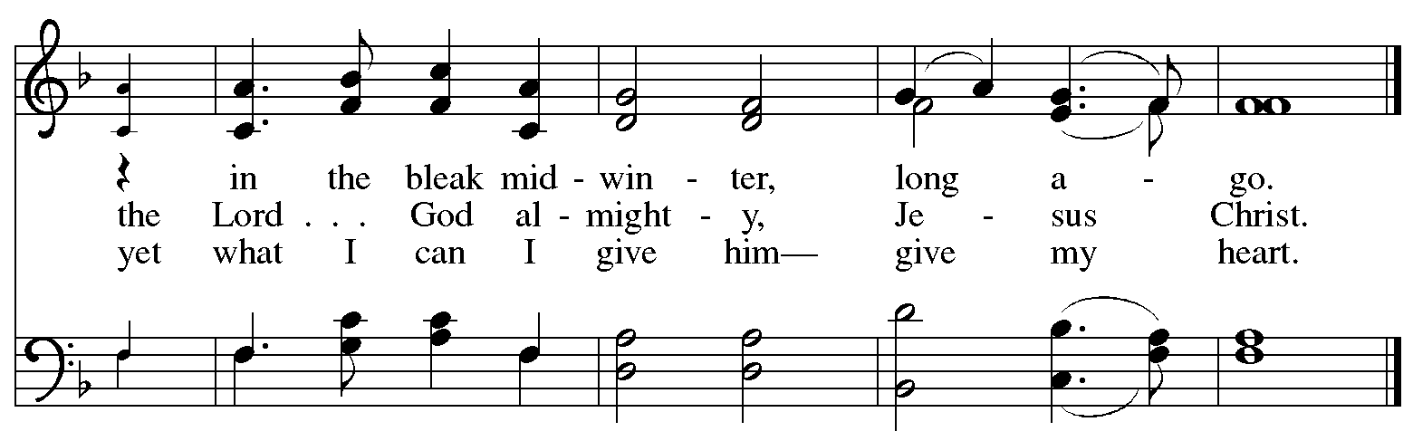
Offertory Prayer

A: Let us pray.
Good and loving God,
C: we rejoice in the birth of Jesus,
who came among the poor to bring the riches of your grace.
As you have blessed us with your gifts, let them be blessing for others.
With the trees of the field, with all earth and heaven,
we shout for joy at the coming of your Son, Jesus Christ our Lord.
Amen.

Dialogue

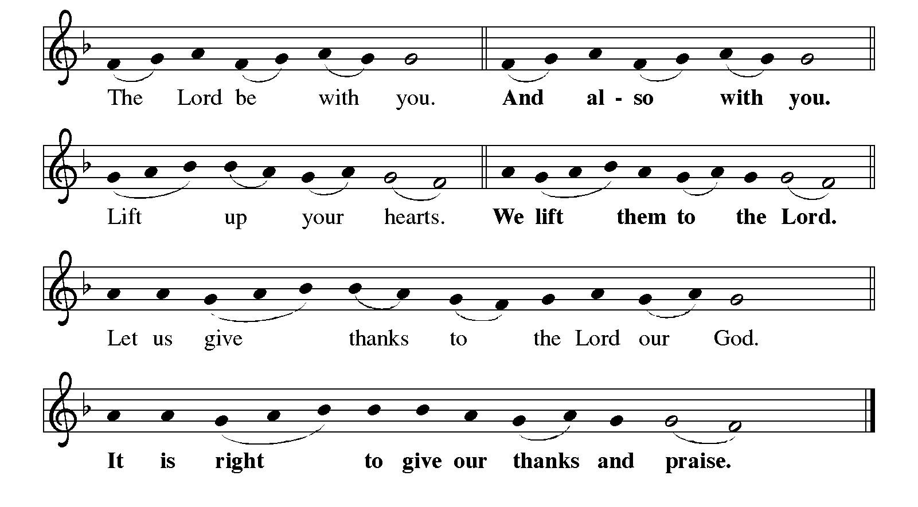
Preface (Sung by the presiding minister)

P: It is indeed right, our duty and our joy,
that we should at all times and in all places
give thanks and praise to you, almighty and merciful God,
through our Savior Jesus Christ.
You comforted your people with the promise of the Redeemer,
through whom you will also make all things new
in the day when he comes to judge the world in righteousness.
And so, with all the choirs of angels,
with the church on earth and the hosts of heaven,
we praise your name and join their unending hymn:
Sanctus ELW p. 144

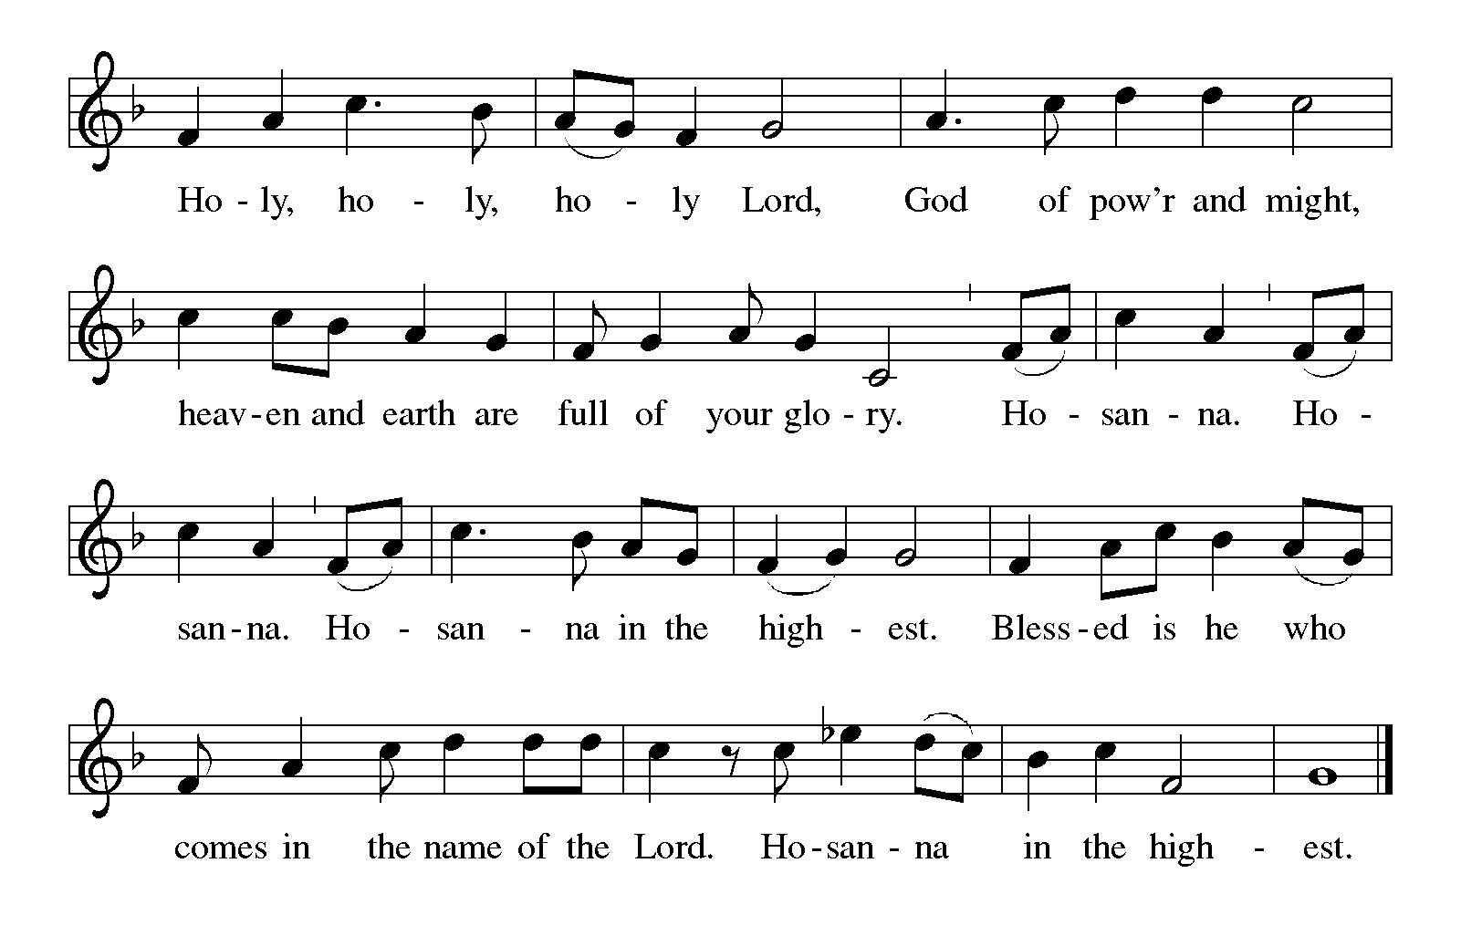
Eucharistic Prayer

P: Holy One, the beginning and the end, the giver of life …
… Do this for the remembrance of me.

P: Let us proclaim the mystery of faith:
C: Christ has died. Christ is risen. Christ will come again.

P: With this bread and cup …
… we look with hope for his coming.
C: Come, Lord Jesus.

P: Holy God, we long for your Spirit …
… Bring the gift of peace on earth.
C: Come, Holy Spirit.

P: All praise and glory are yours,
Holy One of Israel, Word of God incarnate, Power of the Most High,
now and forever.
C: Amen.

Lord’s Prayer

P: Gathered as one by the Holy Spirit, let us pray as Jesus taught us.
C: Our Father in heaven,
hallowed be your name,
your kingdom come,
your will be done,
on earth as in heaven.
Give us today our daily bread.
Forgive us our sins
as we forgive those
who sin against us.
Save us from the time of trial
and deliver us from evil.
For the kingdom, the power,
and the glory are yours,
now and forever. Amen.

Fraction and Invitation



Agnus Dei / Lamb of God ELW p. 146

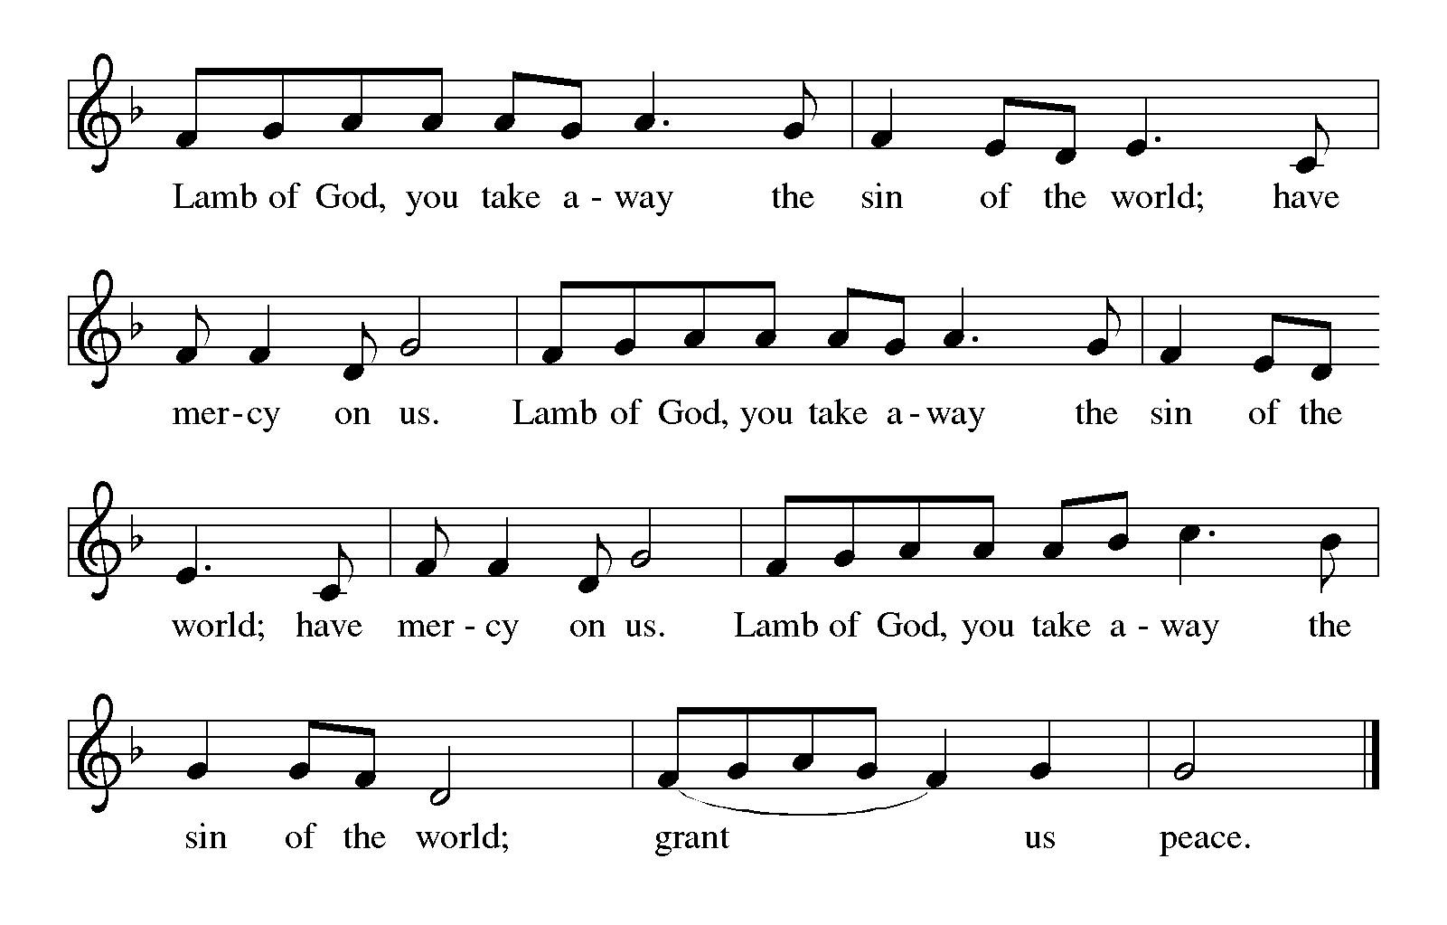

Please be seated.

Holy Communion

- All who seek God and desire a deeper and stronger life in Christ are welcome to receive Holy Communion.
- Worshipers from the pulpit side will proceed forward first, followed by the center section, and then the lectern side.
- Please inform an usher if you would like the ministers to bring Communion to you.
- Holy Communion will be served with bread and wine (amber) or grape juice (purple).
- The presiding minister will first distribute the bread (host) to each communicant. Please indicate if you require a gluten-free host.
- Once you have consumed the bread, please pick up an empty glass from the tray next to the presiding minister. The Communion Assistant will pour wine or grape juice into your glass.
- Please step to the side to consume the wine or grape juice.
- Feel free to kneel at the altar rail for prayer after receiving the sacrament.
- As you return to your pew, glasses may be returned to the empty tray on the side of the center section.
- A blessing will be provided for anyone who does not yet receive the sacrament.
- All are invited to join in singing the hymns during Holy Communion.
Hymns during Holy Communion
Away in a Manger ELW 278

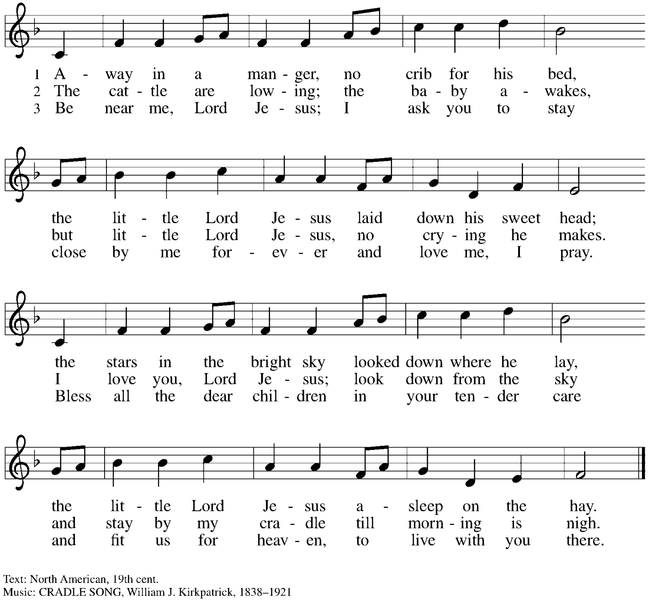

Hymns during Holy Communion
Infant Holy, Infant Lowly ELW 276

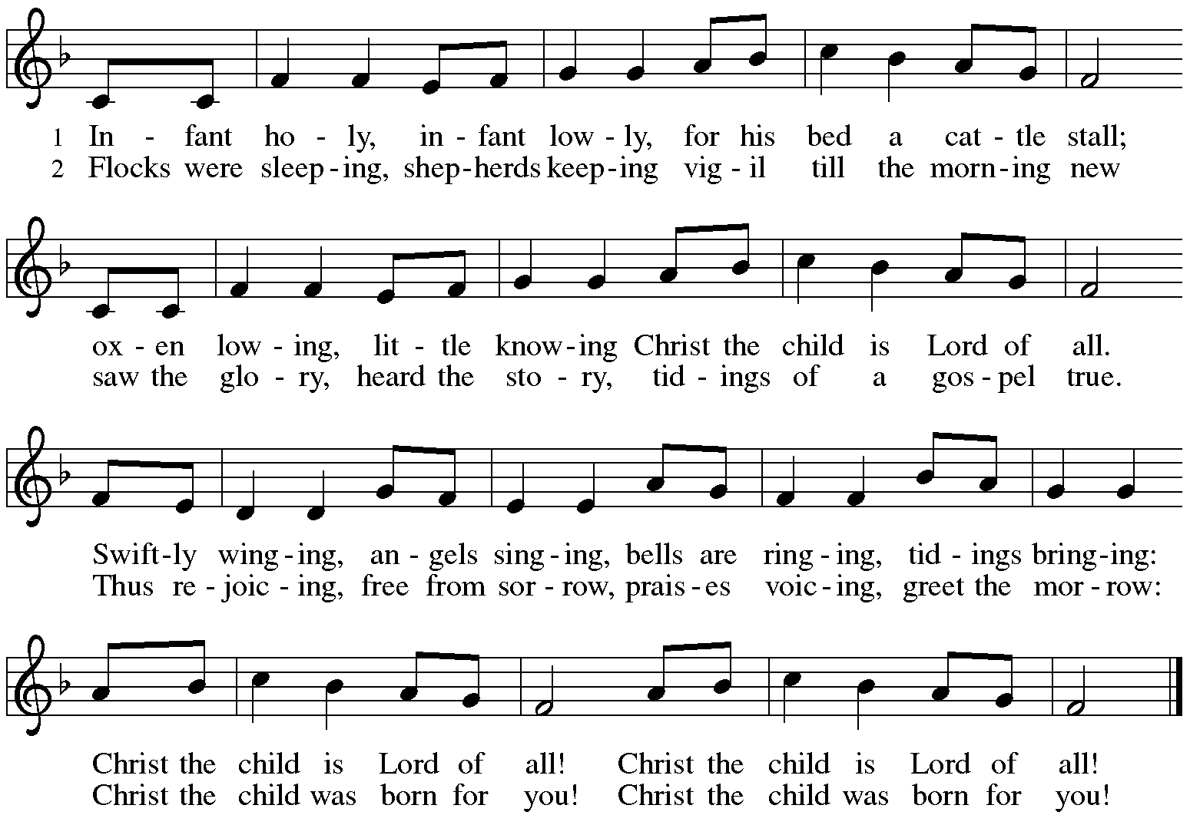


Hymns during Holy Communion
Cold December Flies Away ELW 299

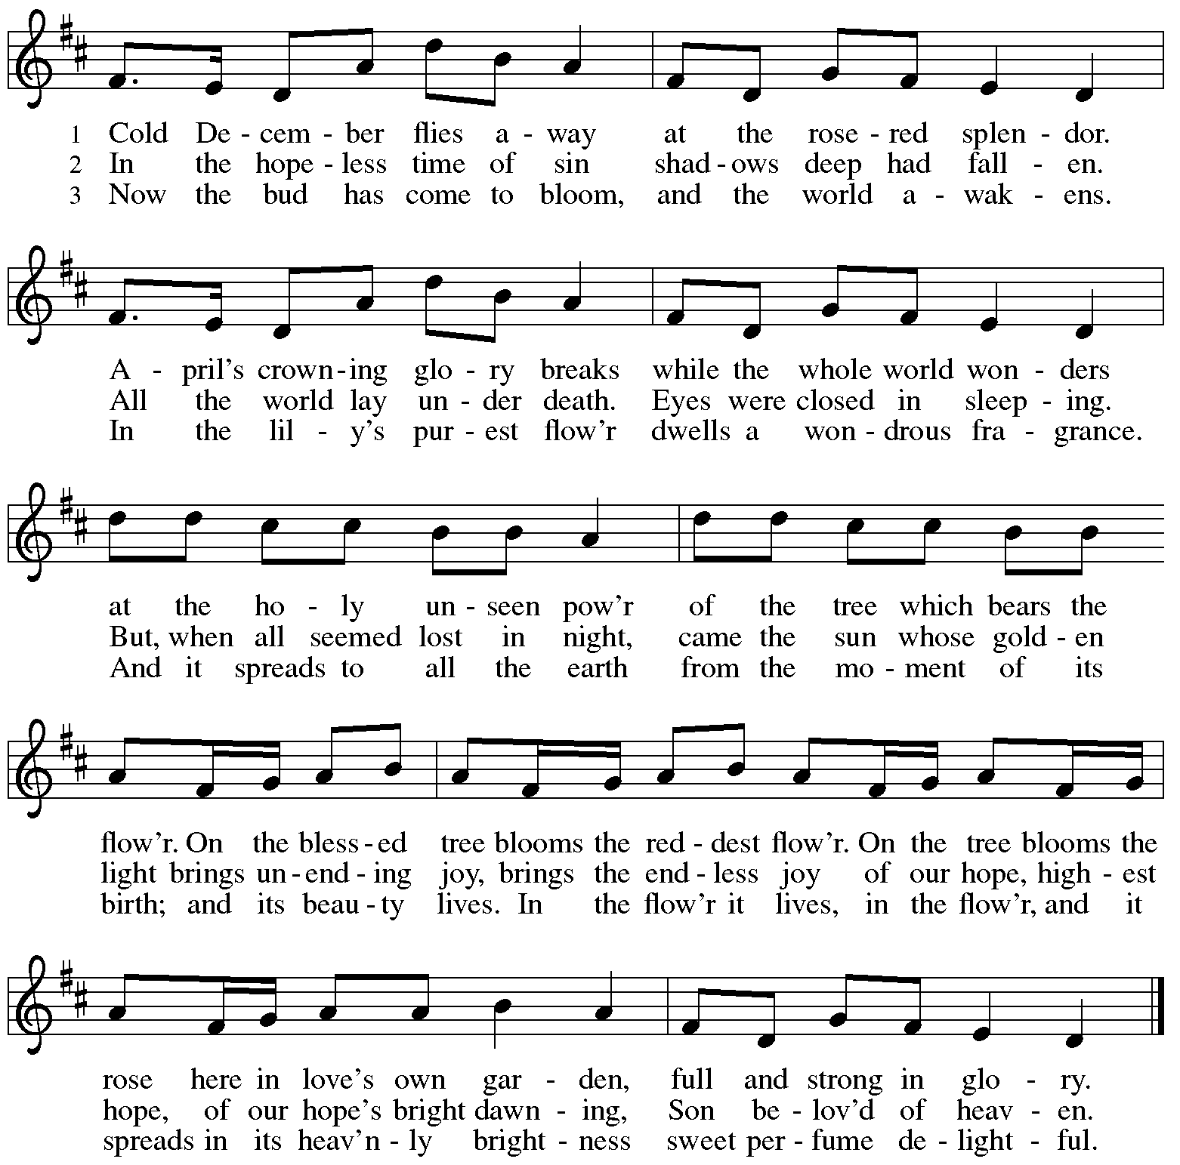

All rights reserved. Reprinted with permission under OneLicense.net #A-722139.

When all have returned to their places, please rise as you are able.

Blessing

P: The body and blood of our Lord Jesus Christ strengthen you and keep you in his grace.
C: Amen.

Prayer

A: Let us pray.
Radiant God, with our eyes we have seen your salvation, and in this meal we have feasted on your grace. May your Word take flesh in us, that we may be your holy people, revealing your glory made known to us in Jesus Christ, our Savior and Lord.
C: Amen.

Please be seated.

Sending
God blesses us and sends us in mission to the world

Announcements

Please rise as you are able.

Benediction

P: Praise God, from whom all blessings flow!
C: Praise God, all creatures here below!

P: You are the shepherds telling the story.
C: We tell it in the streets and across the land.

P: You are the wise ones worshiping with thanksgiving.
C: We worship with gifts of song and service, talents and treasures.

P: You are the angels announcing peace.
C: We live with joy and go now in peace.

P: God bless you and keep you,
☩ Jesus grant you grace and truth,
and the Holy Spirit send peace upon your hearts,
now and forever.
C: Amen.

Sending Hymn Go Tell It on the Mountain ELW 290

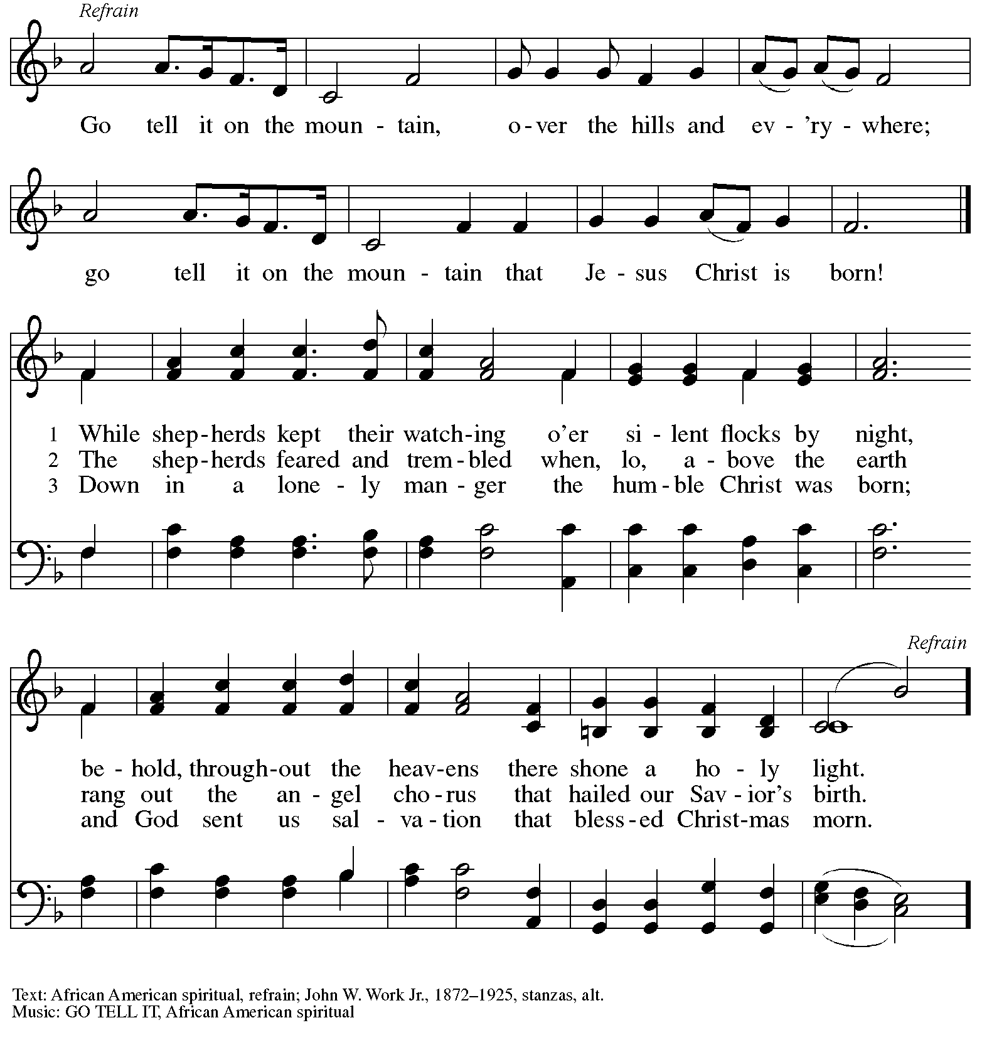

Dismissal

A: Go in peace. Share the good news!
C: Thanks be to God!

Postlude
Serving in Worship Today

Altar Care Christy Ruhe
Assisting Minister Colleen Cooke
Audio-Visual Ministers Sarita
Dave Rollinson
Cantor Joseph Paetz
Lector Pat Taylor
Minister of Music Laura Reynolds
Presiding Minister The Rev. Ross Carmichael

Liturgy and Hymnody Acknowledgements

From SundaysandSeasons.com. Copyright © 2025 Augsburg Fortress. All rights reserved. Reprinted under OneLicense.net # A-722139.
Used by permission of Augsburg Fortress.

The Scripture readings contained herein are from New Revised Standard Version Updated Edition of the Bible © 2021 National Council of Churches of Christ in the United States of America. Used by permission. All rights reserved worldwide.

Please use the QR code below to link to St. Andrew’s Announcements online!



St. Andrew Lutheran Church Announcements
December 28th, 2025

- Welcome to Worship at St. Andrew on the First Sunday of Christmas – We are thankful you are here, and we offer a special welcome to all visitors and guests who are here for the first time! A nursery is available through the door to the left of the worship space and across the social hall (look for a purple room). There are also worship “toolkits” to help children engage with worship and “busy bags” for younger children available in the bookcase at the back of the sanctuary. Please feel free to take one to use with/for your children.
- Monthly Reparations Offering Next Week, Sunday, January 4th, during Worship – In Luke’s Gospel, Jesus tells a story about a compassionate Samaritan, suggesting that God’s people are called to work for healing and restoration for our neighbors, regardless of who or what caused them harm. In light of this, St. Andrew has made a commitment to reparations in regard to African American spiritual songs used in our worship. The text and music of most hymns is attributed to specific authors, with copyrights in place, usage reported, and royalties paid to those whose works are featured in worship. With African American spirituals, this is not possible. In response to many years of such uncredited use, St. Andrew invites the congregation to give a reparations offering. Funds received in worship will be donated to our siblings at Bethel AME Church, whose land and building were taken from them in the 1950s, to fund their development in the Hill District.
- Help Take Down Christmas Decorations Sunday, January 4th – Thank you to everyone who helped decorate the church for the Christmas season this past Sunday, December 21st. Though it is not as fun as decorating for Christmas, we also need help taking down and putting away all the decorations from the season. It is especially helpful to have people who can carry items downstairs to the basement. The Christmas season concludes with the Epiphany of our Lord on January 6th, so we will take down the Christmas decorations on Sunday, January 4th. Thank you!
- Volunteers needed with WPA BOLD Holiday Party, Sunday, January 18th, after Worship – For several years, the Western PA Blind Outdoor Leisure Development Organization (BOLD), has been holding their holiday parties at St. Andrew, and they will do so again on Sunday, January 18th, from 1:00 pm - 5:30 pm. The group has expressed that it would be helpful to have volunteers from the congregation there that day to help set up (this can be done after coffee hour), greet members and help them to find seats, assist with serving buffet food, leading and helping people to get food, and cleanup. If you are willing to help, please speak with Pastor Ross. Thank you very much.
- Produce Distribution Supplemental Food of the Month – St. Andrew is collecting supplemental food each month to accompany our produce distribution. For December, we ask for donations of peanut butter. There are collection boxes at the back of the worship space and social hall. Next month, the supplemental food will be rice.
- “Christ in Our Home” Booklets Available – “Christ in Our Home” is a quarterly devotional resource that encourages readers to live out their faith daily. Each reflective reading is accompanied by a daily scripture reference and prayer for the day. The January-March booklets are available at the entrances. Please feel free to take one home!
- Coffee Hour Signups – St. Andrew provides hospitality during a coffee hour after worship each Sunday. If you would like to participate and would like information about the duties of setting up, please sign up using the following form: https://www.signupgenius.com/go/5080B4AAFAF2CABF85-47069030-coffee#/.
- Prayer Team – St. Andrew maintains a list of weekly prayer concerns. To opt in, or if you have a prayer request, please contact: prayerteam@standrewpittsburgh.org.
- Records Update – St. Andrew is seeking to update our records with information to be used within the congregation for celebrations, milestones, and in prayers of the church. Please fill out the form at: https://forms.gle/kKvp19UozuRrhhaV7.

