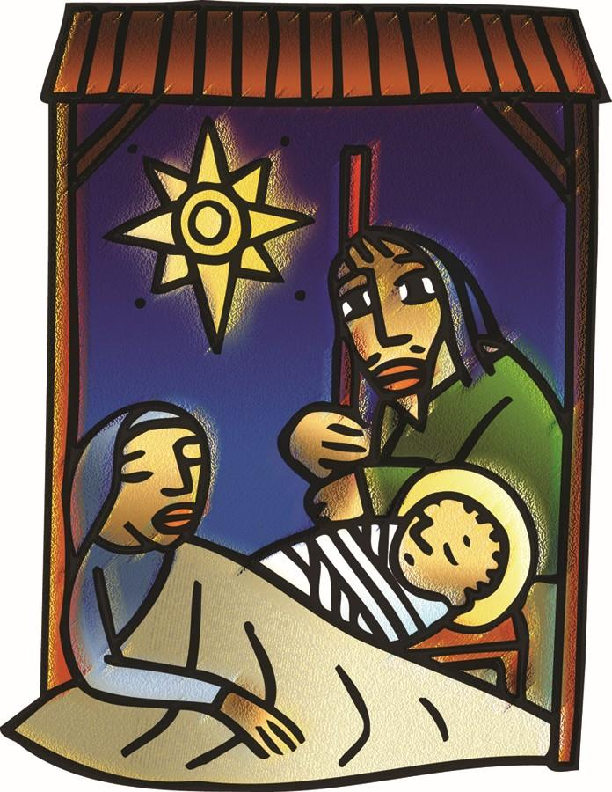

+ The Nativity of our Lord
Christmas Eve
December 24, 2025



St. Andrew Lutheran Church
304 Morewood Ave.
Pittsburgh, PA 15213
St_andrewELCA@verizon.net
www.standrewpittsburgh.org

+ The Nativity of our Lord – Christmas Eve
Order for Worship

In winter’s deepest night, we welcome the light of the Christ child.
Isaiah declares that the light of the long-promised king will illumine the world
and bring endless peace and justice. Paul reminds us that the grace of God through Jesus Christ brings salvation to all people. The angels declare that Jesus’ birth is good and joyful news
for everyone, including lowly shepherds. Filled with the light that shines in our lives,
we go forth to share the light of Christ with the whole world.

Welcome to St. Andrew!
- St. Andrew welcomes all who are seeking a place of healing, wholeness, and acceptance in a nurturing and faith-forming spiritual home. We are striving toward racial equity worldwide
and we seek to honor the lived experience of all individuals regardless of background. Our community embraces people of all ages, ethnicities, cultures, abilities, sexual orientations,
gender identities and expressions, and family constellations. Come and See!
- Worship Services are live-streamed to multiple online platforms. By attending worship, you agree that your image and voice may be broadcast.
- Everyone is invited to make a name tag at the black bookcase in the back of the worship space if they would like. There are stickers indicating pronouns on the bookcase if you would like to include them on your name tag.
- A nursery is available through the doors at the left side of the sanctuary and across from the doorway to the Social Hall. Look for a purple-colored room.
- Children are invited to attend Little Church – Big Faith, a Bible lesson and activity, during worship (after the Prayer of the Day). The group returns to the worship space for the liturgy of Holy Communion.
- Worship “toolkits” to help children engage with the service, along with “busy bags” for younger children, are available in the bookcase at the back of the sanctuary. Please feel free to take one to use with/for your children.
- Holy Communion is served with bread (gluten-free available) and wine or grape juice. The presiding minister will distribute the bread (host). Please consume this and then pick up an empty glass from the tray. The Communion Assistant will pour wine or grape juice into your glass. Please step to the side to consume the wine or grape juice. Feel free to kneel at the altar for prayer and reflection. As you return to your pew, glasses may be returned to the empty trays on either side of the center section.
- A restroom is available on the main level of the church, through the doors to the Social Hall and to the right in the main office.

Abbreviations
P: Pastor/Presiding Minister ELW: Evangelical Lutheran Worship hymnal
A: Assisting Minister
L: Lector
C: Congregation
Pre-Service Music
Coventry Carol Croo and Mawdyke
Joy Givens

Gathering
The Holy Spirit calls us together as the people of God

Worship on The Nativity of our Lord – Christmas Eve begins with the Christmas Proclamation.

Christmas Proclamation

P: Many ages from the time when God created the heavens and the earth
and then formed humanity in God’s own image;
long after the great flood, when God made the rainbow shine forth as a sign of the covenant;
twenty-one centuries from the time the promise was given to Abraham and Sarah;
thirteen centuries after Moses led the people of Israel out of Egypt
and Miriam danced in freedom;
eleven hundred years from the time of Ruth and the judges;
one thousand years from the anointing of David as king,
in fulfillment of the times and years and months and days discerned by the prophets;
in the one hundred and ninety-fourth Olympiad;
the seven hundred and fifty-second year from the foundation of the city of Rome;
the forty-second year of the reign of Octavian Augustus;
while the whole world enjoyed a span of peace,
Jesus Christ, eternal God and Son of the eternal Father,
desiring to sanctify the world by his most merciful coming,
being conceived by the Holy Spirit and nine months of growth in the womb of his mother—
now in our own times is the nativity of our Lord Jesus Christ, God made flesh.

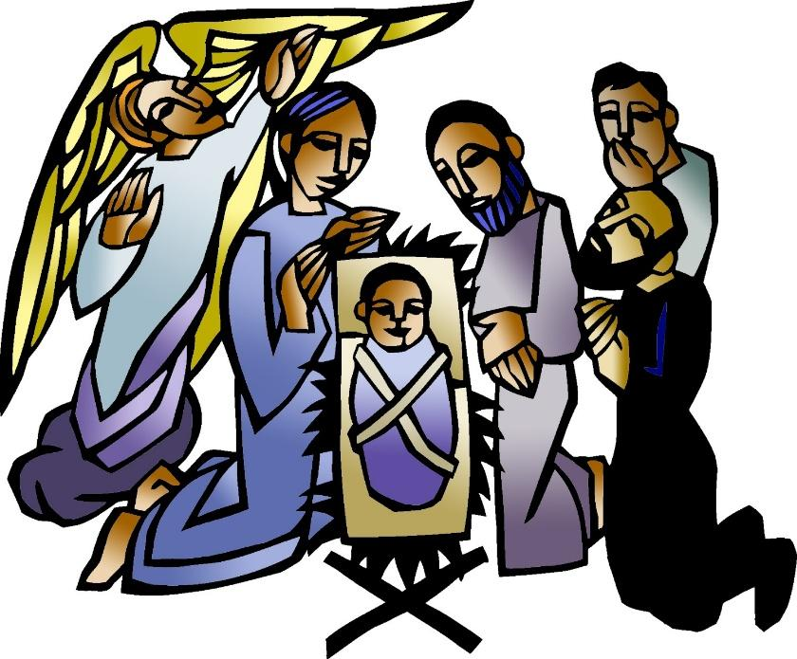

Gathering Hymn O Come, All Ye Faithful ELW 183

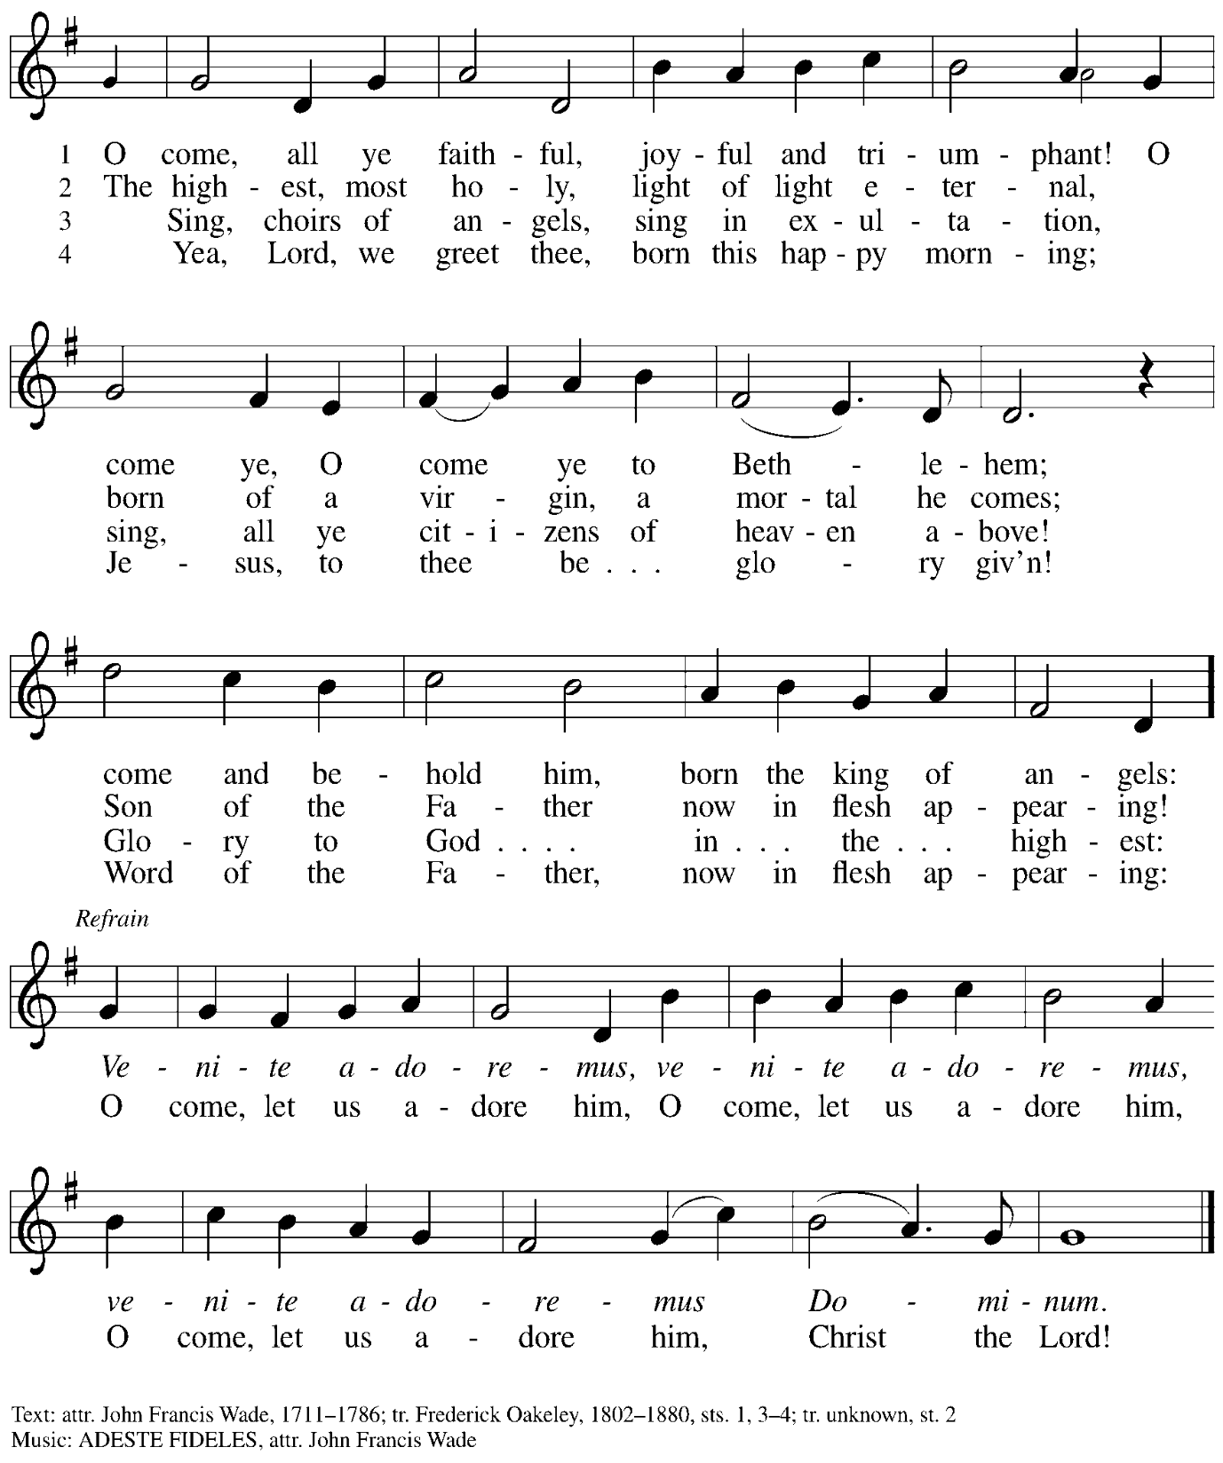

Greeting

P: The grace of our Lord Jesus Christ, the love of God,
and the communion of the Holy Spirit be with you all.
C: And also with you.

Kyrie ELW p. 138

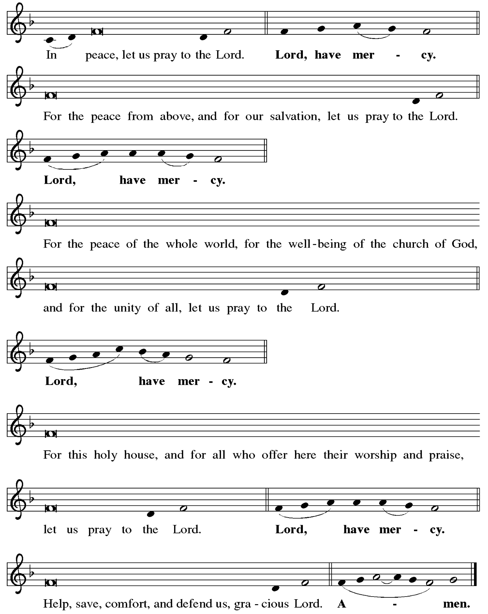

Hymn of Praise Angels We Have Heard on High ELW 289

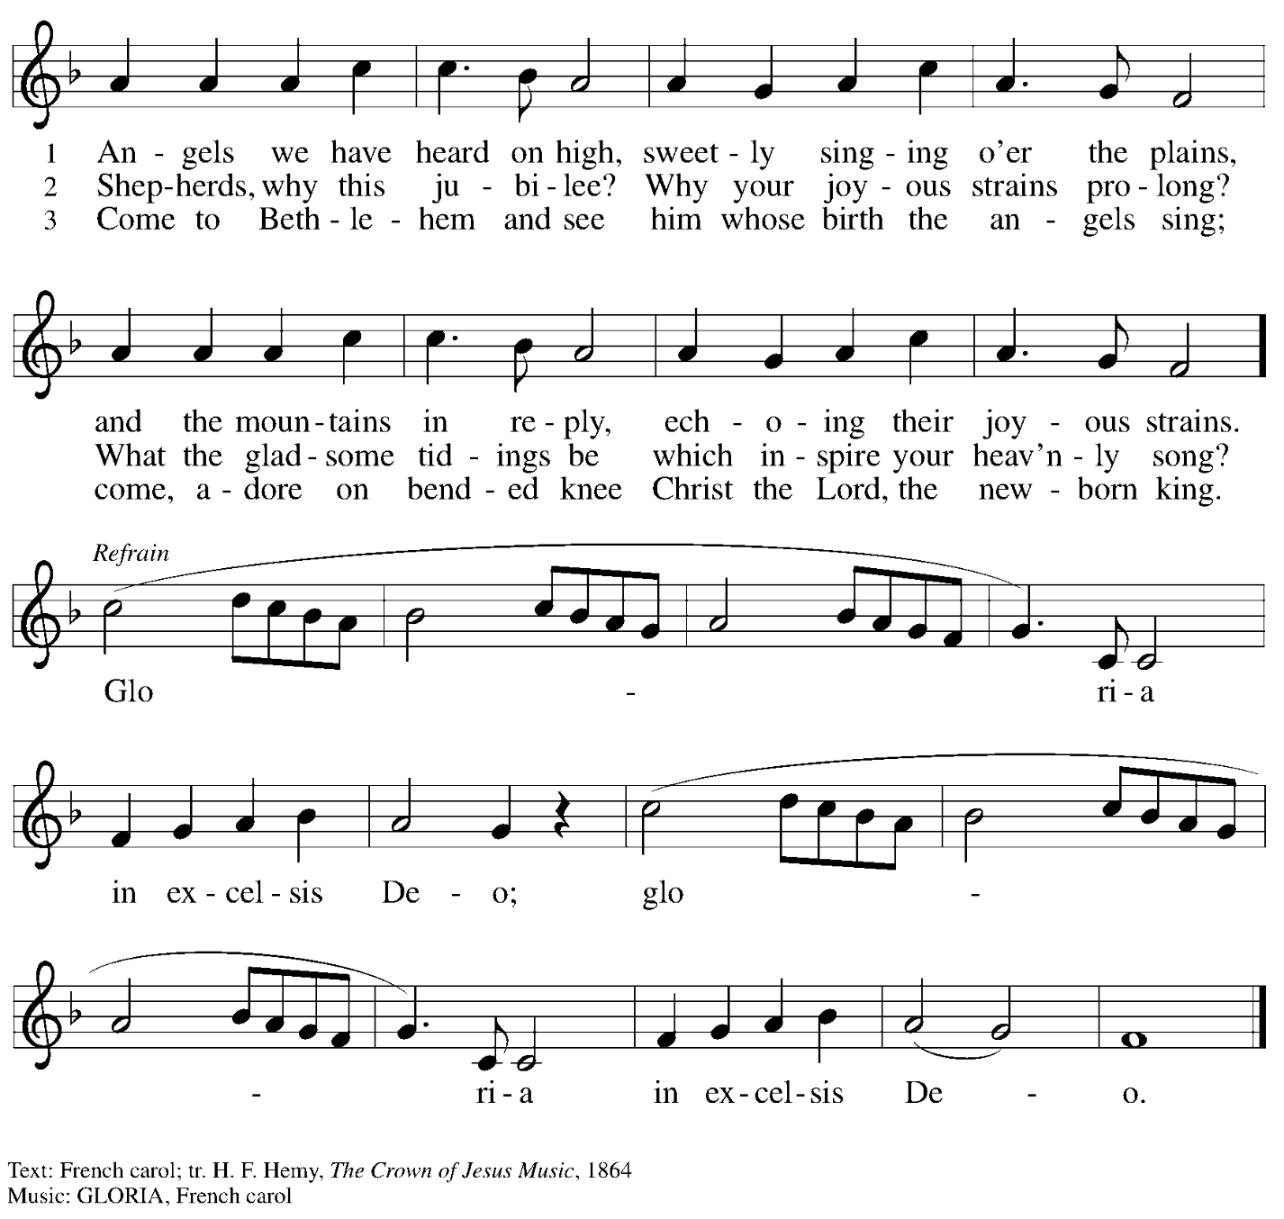

Prayer of the Day

P: The Lord be with you.
C: And also with you.

P: Let us pray.
Almighty God, you made this holy night shine with the brightness of the true Light.
Grant that here on earth we may walk in the light of Jesus’ presence, and in the last day
wake to the brightness of his glory; through your Son, Jesus Christ our Lord,
who lives and reigns with you and the Holy Spirit, one God, now and forever.
C: Amen.
Please be seated.

Word
God speaks to us in Scripture reading, preaching, and song

First Reading – Isaiah 9: 2-7

² The people who walked in darkness
have seen a great light;
those who lived in a land of deep darkness—
on them light has shined.
³ You have multiplied exultation;
you have increased its joy;
they rejoice before you
as with joy at the harvest,
as people exult when dividing plunder.
⁴ For the yoke of their burden
and the bar across their shoulders,
the rod of their oppressor,
you have broken as on the day of Midian.
⁵ For all the boots of the tramping warriors
and all the garments rolled in blood
shall be burned as fuel for the fire.
⁶ For a child has been born for us,
a son given to us;
authority rests upon his shoulders,
and he is named
Wonderful Counselor, Mighty God,
Everlasting Father, Prince of Peace.
⁷ Great will be his authority,
and there shall be endless peace
for the throne of David and his kingdom.
He will establish and uphold it
with justice and with righteousness
from this time onward and forevermore.
The zeal of the Lord of hosts will do this.

L: Word of God, word of life.
C: Thanks be to God.

Psalm 96

The psalm will be sung responsively, led by the cantor, with the congregation singing the verses in bold type and joining in the refrain.

Psalm Tone

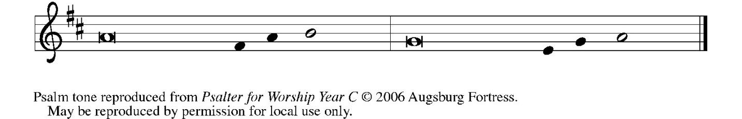

Psalm Refrain

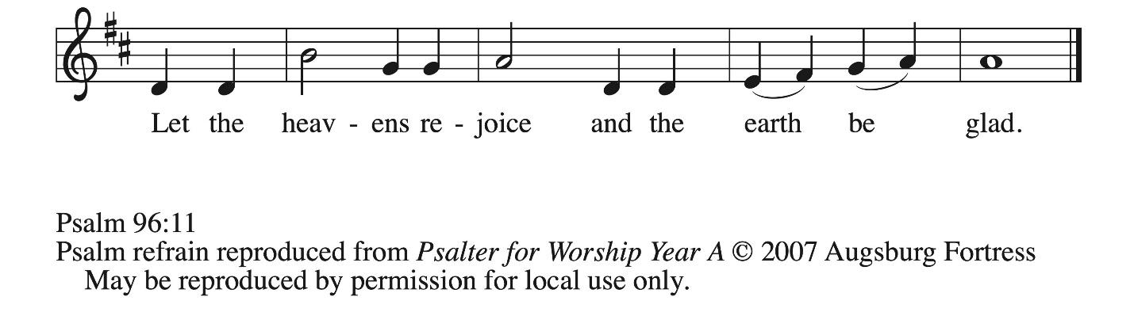

¹ Sing to the Lord | a new song;
sing to the Lord, | all the earth.
² Sing to the Lord, bless the name | of the Lord;
proclaim God’s salvation from | day to day.
³ Declare God’s glory a- | mong the nations
and God’s wonders a- | mong all peoples.
⁴ For great is the Lord and greatly | to be praised,
more to be feared | than all gods. R
⁵ As for all the gods of the nations, they | are but idols;
but you, O Lord, have | made the heavens.
⁶ Majesty and magnificence are | in your presence;
power and splendor are in your | sanctuary.
⁷ Ascribe to the Lord, you families | of the peoples,
ascribe to the Lord hon- | or and power.
⁸ Ascribe to the Lord the honor due the | holy name;
bring offerings and enter the courts | of the Lord. R
⁹ Worship the Lord in the beau- | ty of holiness;
tremble before the Lord, | all the earth.
¹⁰ Tell it out among the nations: “The | Lord is king!
The one who made the world so firm that it cannot be moved will judge the peo- | ples with equity.”
¹¹ Let the heavens rejoice, and let the | earth be glad;
let the sea thunder and all that is in it; let the field be joyful and all that | is therein.
¹² Then shall all the trees of the wood shout for joy at your com- | ing, O Lord,
for you come to | judge the earth.
¹³ You will judge the | world with righteousness
and the peoples | with your truth. R

Second Reading – Titus 2: 11-14

¹¹ The grace of God has appeared, bringing salvation to all, ¹² training us to renounce impiety and worldly passions and in the present age to live lives that are self-controlled, upright, and godly, ¹³ while we wait for the blessed hope and the manifestation of the glory of our great God and Savior, Jesus Christ. ¹⁴ He it is who gave himself for us that he might redeem us from all iniquity and purify for himself a people of his own who are zealous for good deeds.

L: Word of God, word of life.
C: Thanks be to God.

Please rise as you are able.

Gospel Acclamation Silent Night, Holy Night! ELW 281
v. 1-2

1 Silent night, holy night!
All is calm, all is bright
round yon virgin mother and child.
Holy Infant, so tender and mild,
sleep in heavenly peace,
sleep in heavenly peace.

2 Silent night, holy night!
Shepherds quake at the sight;
glories stream from heaven afar,
heav'nly hosts sing, alleluia!
Christ, the Savior, is born!
Christ, the Savior, is born!

Gospel – Luke 2: 1-14 [15-20]

P: The holy Gospel according to St. Luke.
C: Glory to you, O Lord.

¹ In those days a decree went out from Caesar Augustus that all the world should be registered. ² This was the first registration and was taken while Quirinius was governor of Syria. ³ All went to their own towns to be registered. ⁴ Joseph also went from the town of Nazareth in Galilee to Judea, to the city of David called Bethlehem, because he was descended from the house and family of David. ⁵ He went to be registered with Mary, to whom he was engaged and who was expecting a child. ⁶ While they were there, the time came for her to deliver her child. ⁷ And she gave birth to her firstborn son and wrapped him in bands of cloth and laid him in a manger, because there was no place in the guest room.
⁸ Now in that same region there were shepherds living in the fields, keeping watch over their flock by night. ⁹ Then an angel of the Lord stood before them, and the glory of the Lord shone around them, and they were terrified. ¹⁰ But the angel said to them, “Do not be afraid, for see, I am bringing you good news of great joy for all the people: ¹¹ to you is born this day in the city of David a Savior, who is the Messiah, the Lord. ¹² This will be a sign for you: you will find a child wrapped in bands of cloth and lying in a manger.” ¹³ And suddenly there was with the angel a multitude of the heavenly host, praising God and saying,
¹⁴ “Glory to God in the highest heaven,
and on earth peace among those whom God favors!”
¹⁵ When the angels had left them and gone into heaven, the shepherds said to one another, “Let us go now to Bethlehem and see this thing that has taken place, which the Lord has made known to us.” ¹⁶ So they went with haste and found Mary and Joseph and the child lying in the manger. ¹⁷ When they saw this, they made known what had been told them about this child, ¹⁸ and all who heard it were amazed at what the shepherds told them, ¹⁹ and Mary treasured all these words and pondered them in her heart. ²⁰ The shepherds returned, glorifying and praising God for all they had heard and seen, just as it had been told them.

P: The Gospel of the Lord.
C: Praise to you, O Christ.

After the reading of the Gospel, the congregation sings the third verse of Silent Night, Holy Night! Once the hymn has concluded,, please be seated.

Gospel Acclamation Silent Night, Holy Night! ELW 281
v. 3

3 Silent night, holy night!
Son of God, love's pure light
radiant beams from your holy face,
with the dawn of redeeming grace,
Jesus, Lord, at your birth,
Jesus, Lord, at your birth.

Text: Joseph Mohr, 1792-1849; tr. John F. Young, 1820-1885. Music: STILLE NACHT, Franz Gruber, 1787-1863.

Sermon

A time of silence for prayer and reflection follows the sermon.
When the hymn of the day begins, please rise as you are able.

Hymn of the Day Hark! The Herald Angels Sing ELW 270

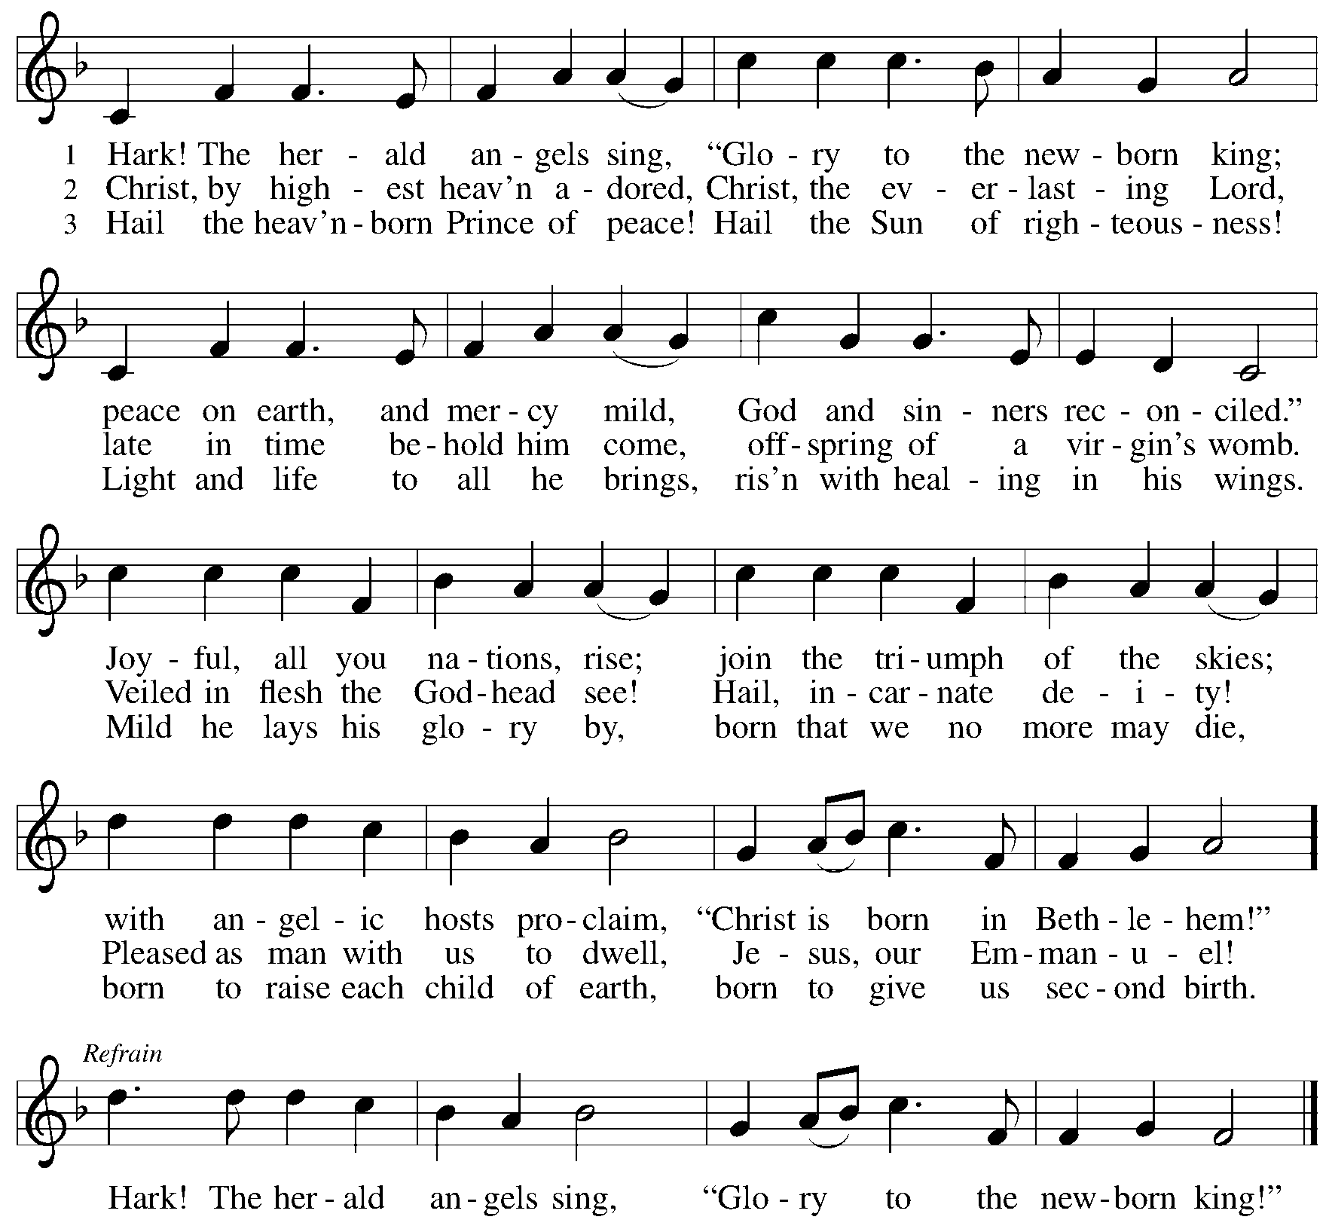

Nicene Creed

C: We believe in one God,
the Father, the Almighty,
maker of heaven and earth,
of all that is, seen and unseen.

We believe in one Lord, Jesus Christ,
the only Son of God,
eternally begotten of the Father,
God from God, Light from Light,
true God from true God,
begotten, not made,
of one Being with the Father;
through him all things were made.
For us and for our salvation
he came down from heaven,
was incarnate of the Holy Spirit and the virgin Mary
and became truly human.
For our sake he was crucified under Pontius Pilate;
he suffered death and was buried.
On the third day he rose again
in accordance with the scriptures;
he ascended into heaven
and is seated at the right hand of the Father.
He will come again in glory to judge the living and the dead,
and his kingdom will have no end.

We believe in the Holy Spirit, the Lord, the giver of life,
who proceeds from the Father and the Son,*
who with the Father and the Son is worshiped and glorified,
who has spoken through the prophets.
We believe in one holy catholic and apostolic church.
We acknowledge one baptism for the forgiveness of sins.
We look for the resurrection of the dead,
and the life of the world to come. Amen.

*Or, “who proceeds from the Father.” The phrase “and the Son” is a later addition to the creed.

Prayers of the People

A: Rejoicing in the good news of Christ’s birth,
let us pray for the church, God’s creation, and all who are in need.

After each petition
A: God of grace,
C: receive our prayer.

P: With joy in our hearts, we commend our prayers to you, O God,
trusting in your boundless mercy and eternal love; through Jesus Christ our Savior.
C: Amen.

Peace

The presiding minister and the assembly greet one another in the peace of the risen Christ.
P: The peace of Christ be with you always.
C: And also with you.

The people may greet those around them with a sign of Christ’s peace and may say
Peace be with you or similar words. Please be mindful that not everyone will be comfortable with sharing the peace, so please seek consent before shaking hands or hugging. Other possible ways to share the peace include a simple bow with the verbal greeting of peace, or simply a verbal expression of peace.

When the greetings of peace have concluded, please be seated.



Meal
God feeds us with the presence of Jesus Christ

Offering

We offer ourselves, our gifts, and our faithful service to God.
As the offering is gathered for the mission of the church, including the care of those in need,
the table is set for Holy Communion.

There are laminated giving cards in the pew racks that feature a QR code for anyone who would like to give online. Those who give using the QR code, as well as those who give regularly online or through their bank are encouraged to place the laminated card in the plate as an expression of your offering.

Offertory Music Cantique de Noël Cappeau and Adam
Joy Givens

As the gifts are brought forward for presentation, please rise as you are able.

Offertory Song In the Bleak Midwinter ELW 294

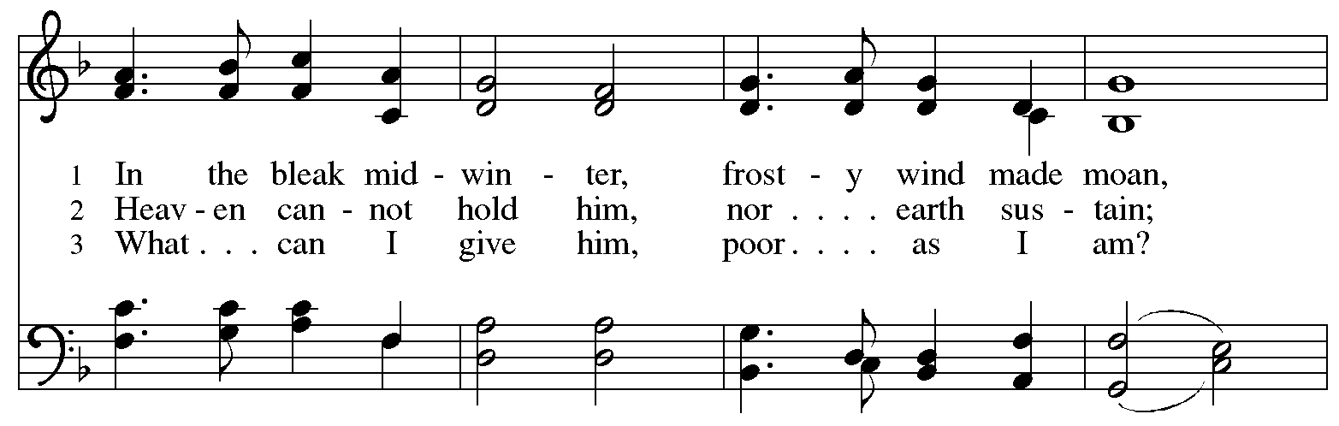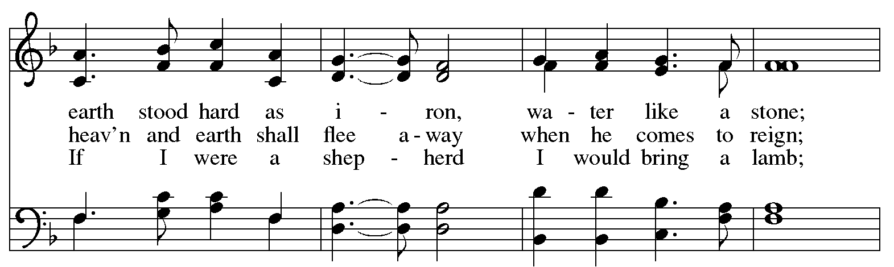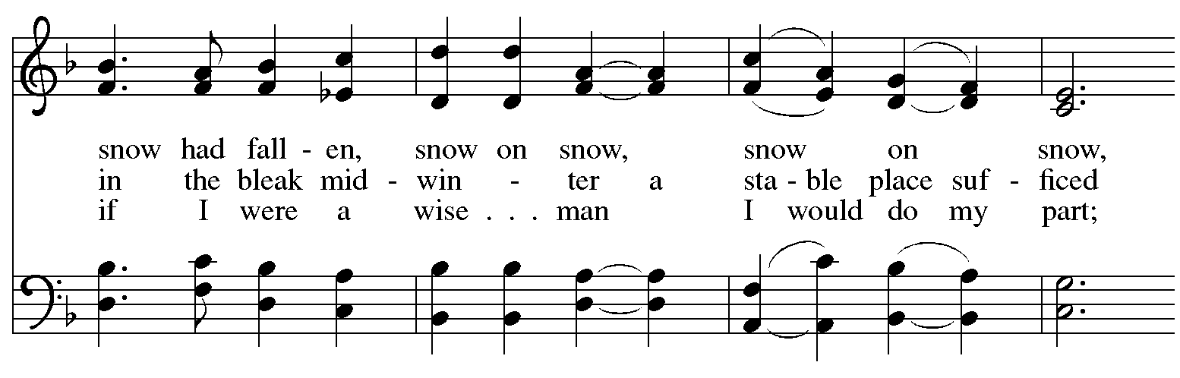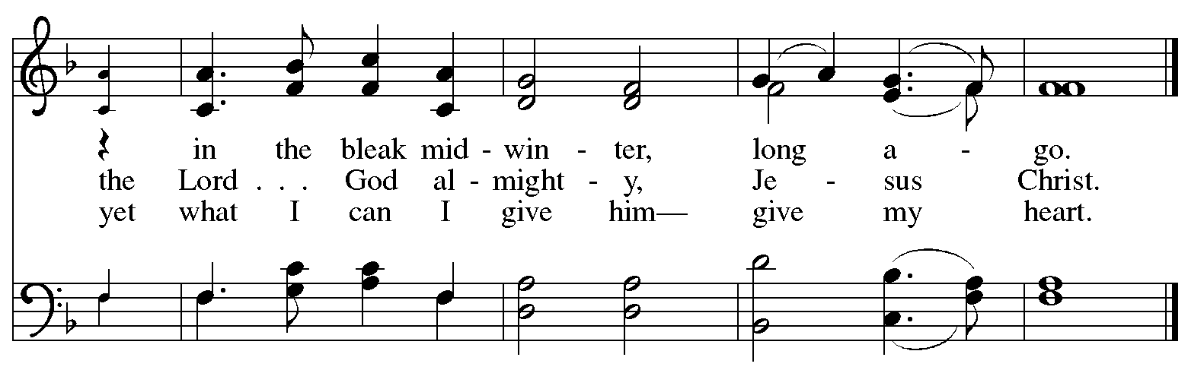
Offertory Prayer

A: Let us pray.
Good and loving God,
C: we rejoice in the birth of Jesus,
who came among the poor to bring the riches of your grace.
As you have blessed us with your gifts, let them be blessing for others.
With the trees of the field, with all earth and heaven,
we shout for joy at the coming of your Son, Jesus Christ our Lord.
Amen.

Dialogue

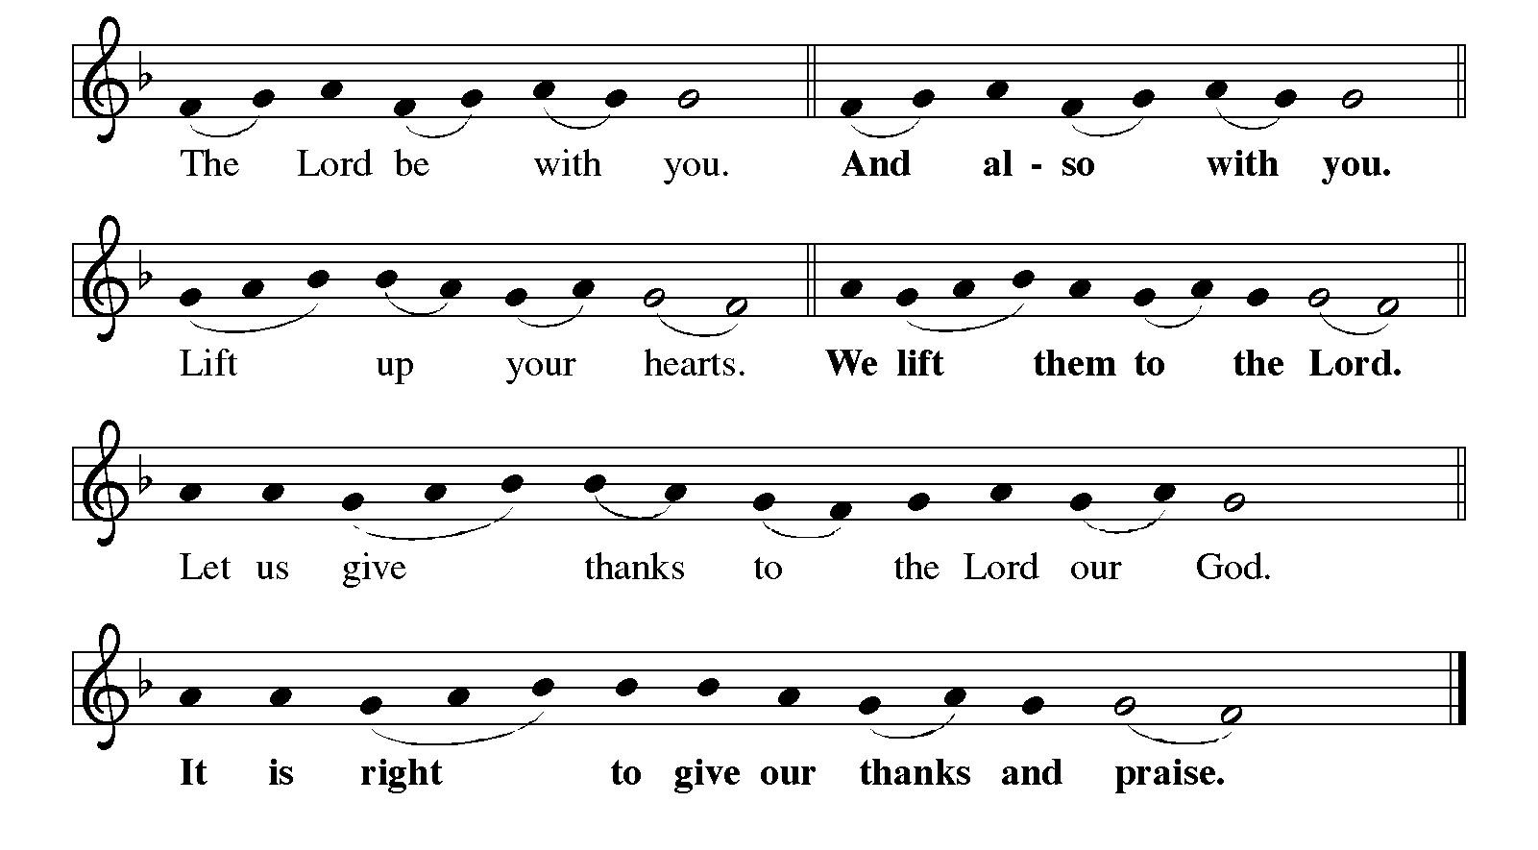

Preface (Sung by the presiding minister)

P: It is indeed right, our duty and our joy,
that we should at all times and in all places
give thanks and praise to you, almighty and merciful God,
through our Savior Jesus Christ.
In the wonder and mystery of the Word made flesh,
you have opened the eyes of faith
to a new and radiant vision of your glory,
that, beholding the God made visible,
we may be drawn to love the God whom we cannot see.
And so, with all the choirs of angels,
with the church on earth and the hosts of heaven,
we praise your name and join their unending hymn:

Sanctus ELW p. 144

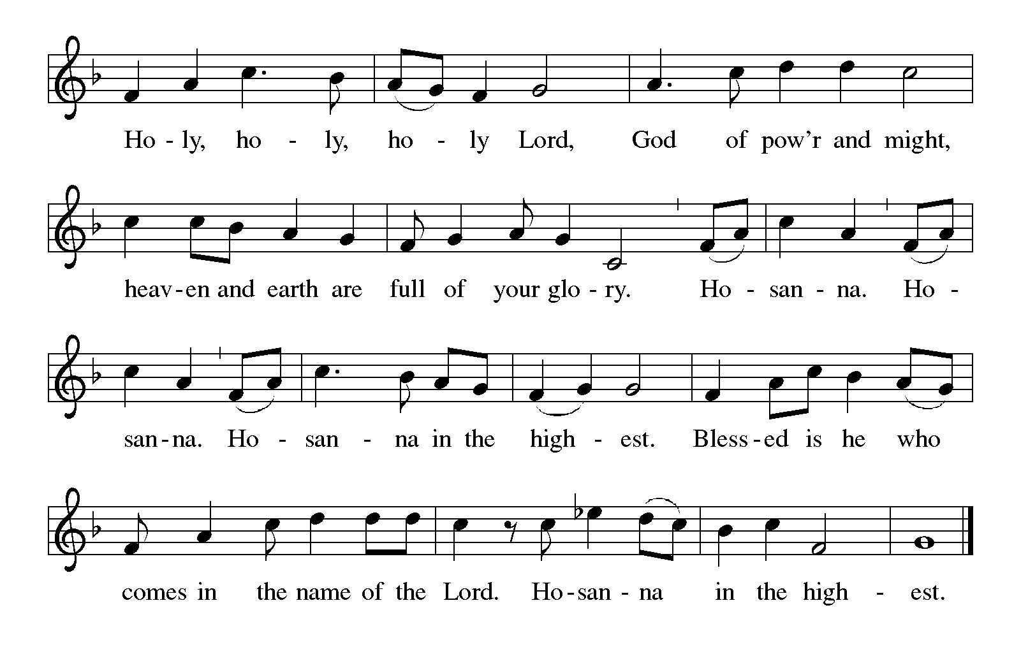
Eucharistic Prayer

P: Holy One, the beginning and the end, the giver of life …
… Do this for the remembrance of me.

P: Let us proclaim the mystery of faith:
C: Christ has died. Christ is risen. Christ will come again.

P: With this bread and cup …
… we look with hope for his coming.
C: Come, Lord Jesus.

P: Holy God, we long for your Spirit …
… Bring the gift of peace on earth.
C: Come, Holy Spirit.

P: All praise and glory are yours,
Holy One of Israel, Word of God incarnate, Power of the Most High,
now and forever.
C: Amen.

Lord’s Prayer

P: Gathered as one by the Holy Spirit, let us pray using the words our Savior taught us.
C: Our Father, who art in heaven,
hallowed be thy name,
thy kingdom come,
thy will be done,
on earth as it is in heaven.
Give us this day our daily bread;
and forgive us our trespasses,
as we forgive those
who trespass against us;
and lead us not into temptation,
but deliver us from evil.
For thine is the kingdom,
and the power, and the glory,
forever and ever. Amen.

Fraction and Invitation



Agnus Dei / Lamb of God ELW p. 146

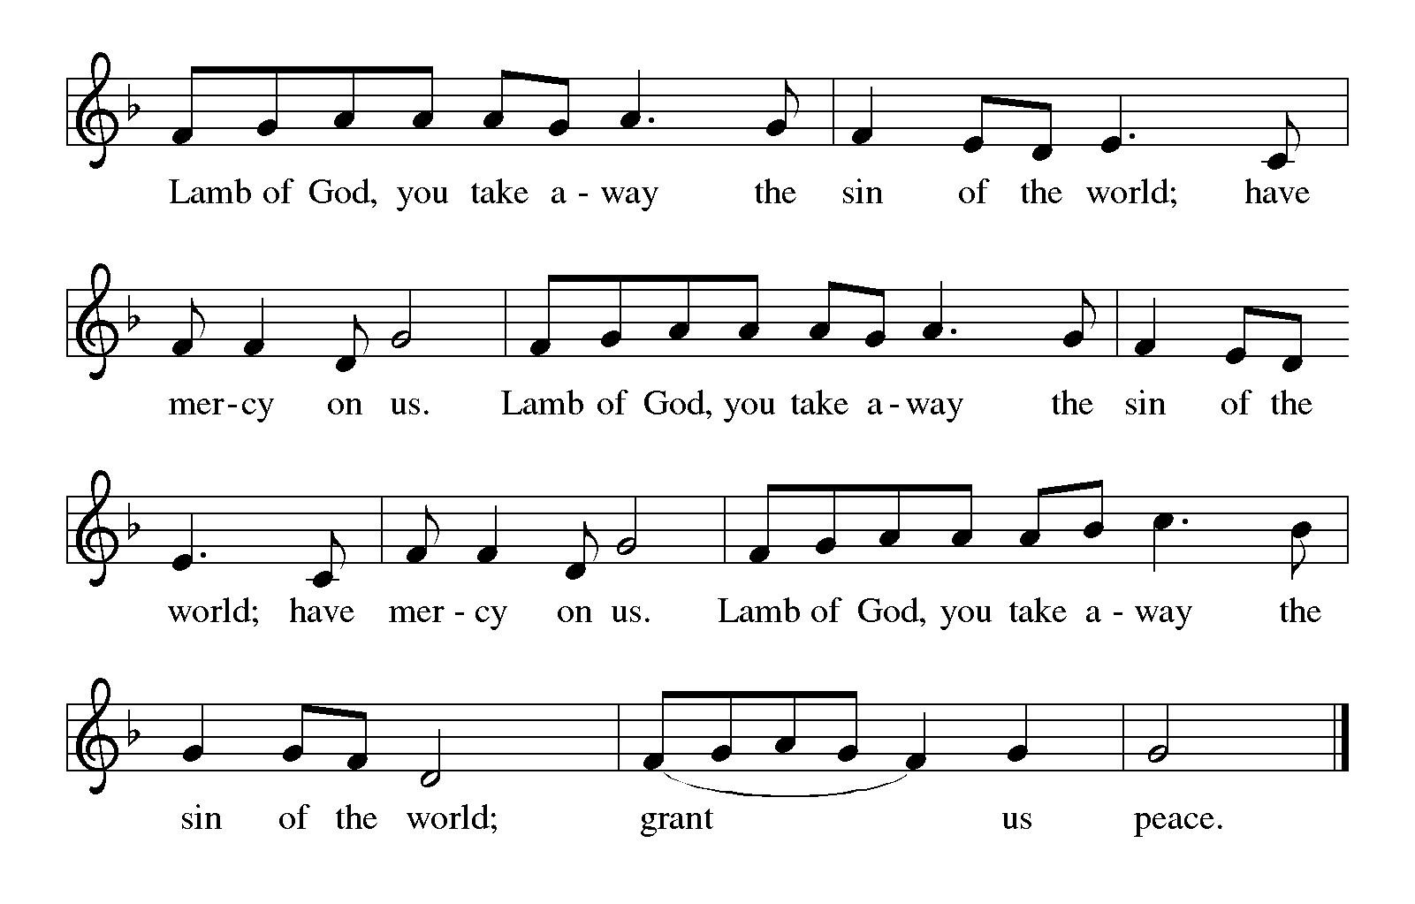

Please be seated.

Holy Communion

- All who seek God and desire a deeper and stronger life in Christ are welcome to receive Holy Communion.
- Worshipers from the pulpit side will proceed forward first, followed by the center section, and then the lectern side.
- Please inform an usher if you would like the ministers to bring Communion to you.
- Holy Communion will be served with bread and wine (amber) or grape juice (purple).
- The presiding minister will first distribute the bread (host) to each communicant. Please indicate if you require a gluten-free host.
- Once you have consumed the bread, please pick up an empty glass from the tray next to the presiding minister. The Communion Assistant will pour wine or grape juice into your glass.
- Please step to the side to consume the wine or grape juice.
- Feel free to kneel at the altar rail for prayer after receiving the sacrament.
- As you return to your pew, glasses may be returned to the empty tray on the side of the center section.
- A blessing will be provided for anyone who does not yet receive the sacrament.
- All are invited to join in singing the hymns during Holy Communion.

Hymns during Holy Communion
Away in a Manger ELW 277

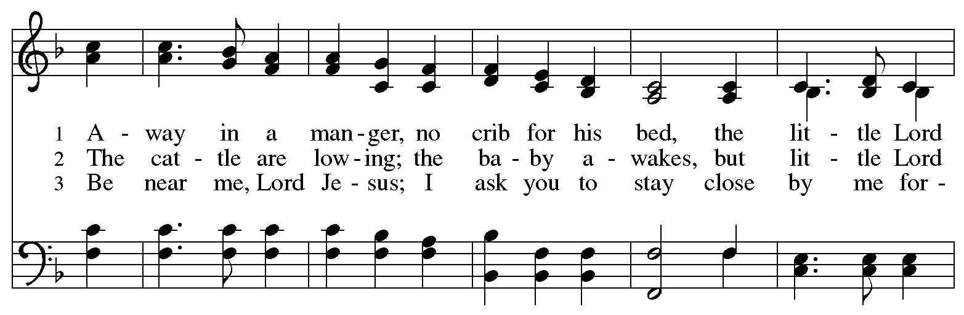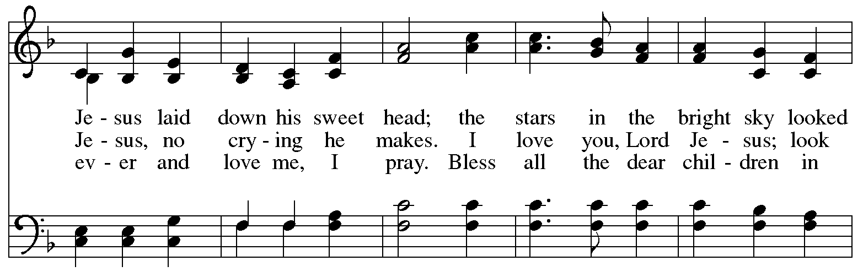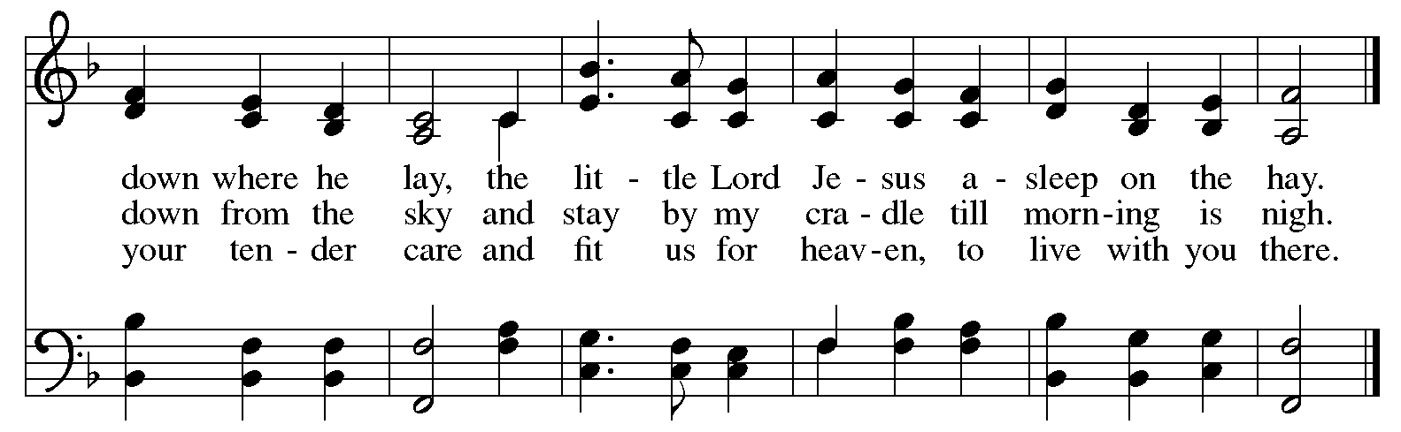

Hymns during Holy Communion
It Came upon the Midnight Clear ELW 282

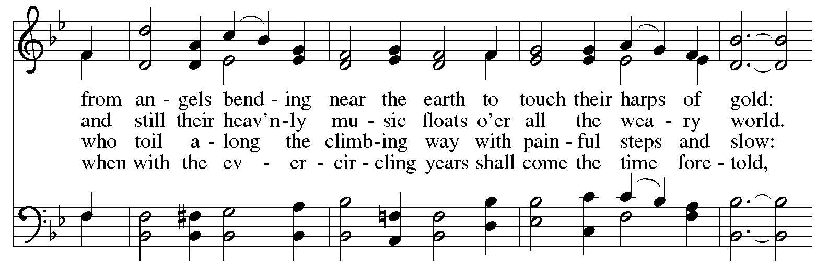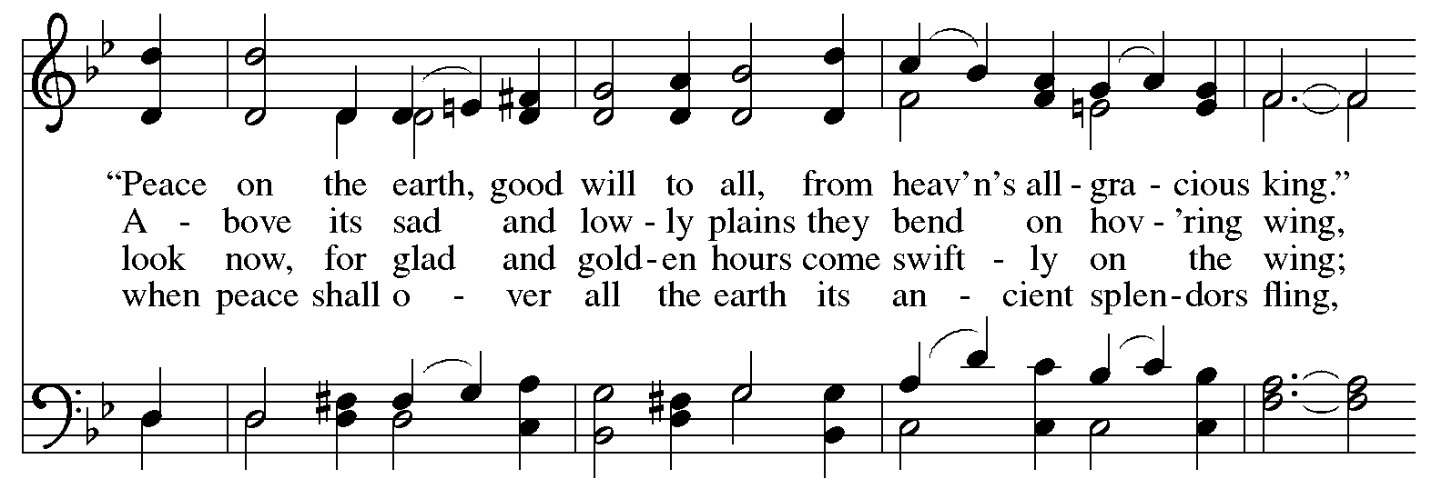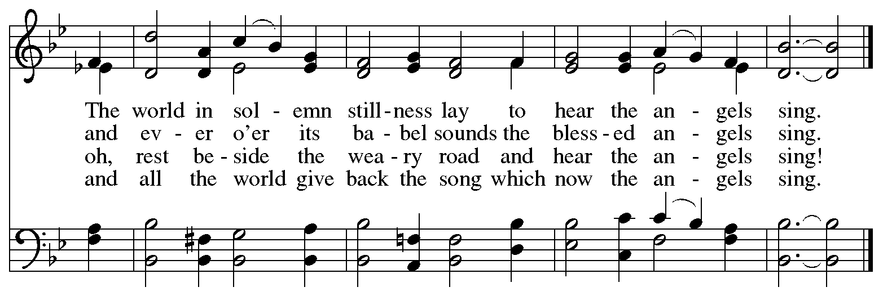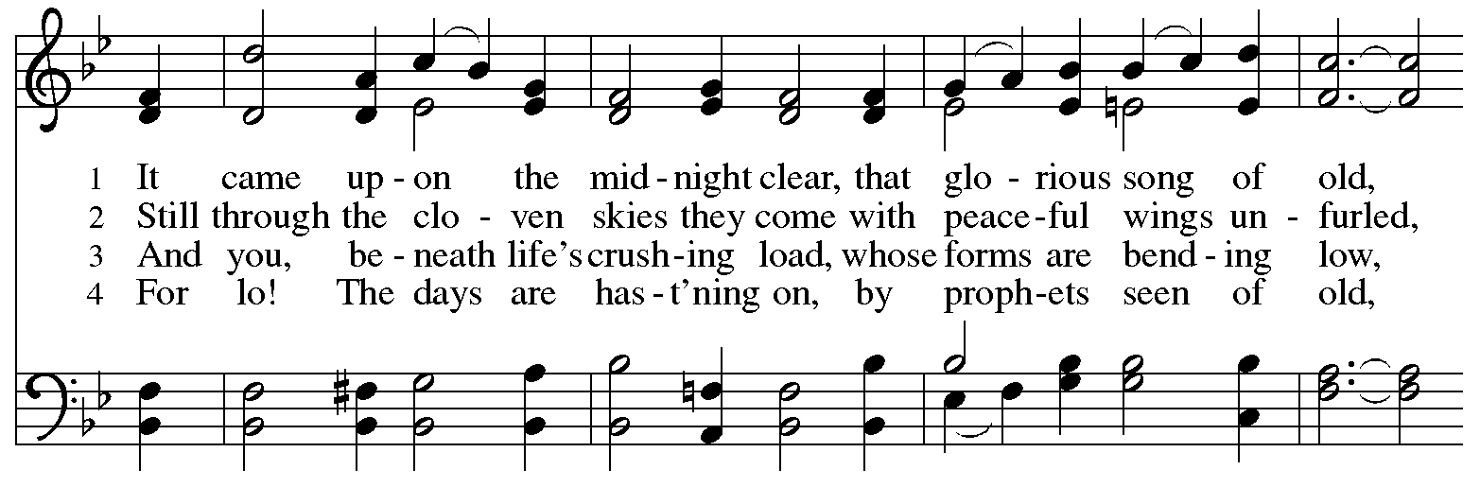

Hymns during Holy Communion
The First Noel ELW 300

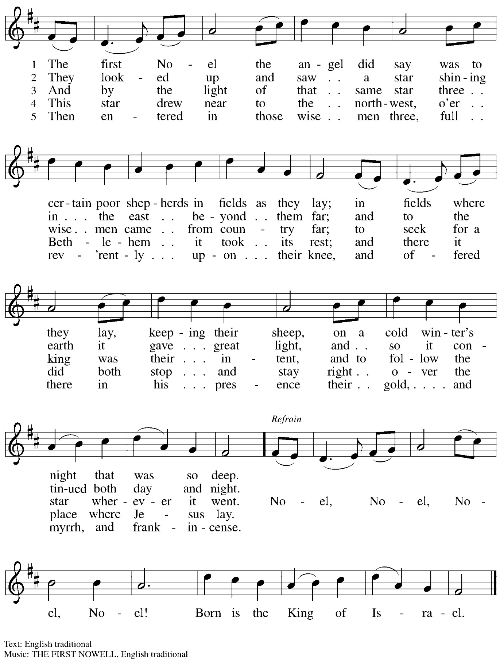
Hymns during Holy Communion
O Little Town of Bethlehem ELW 279

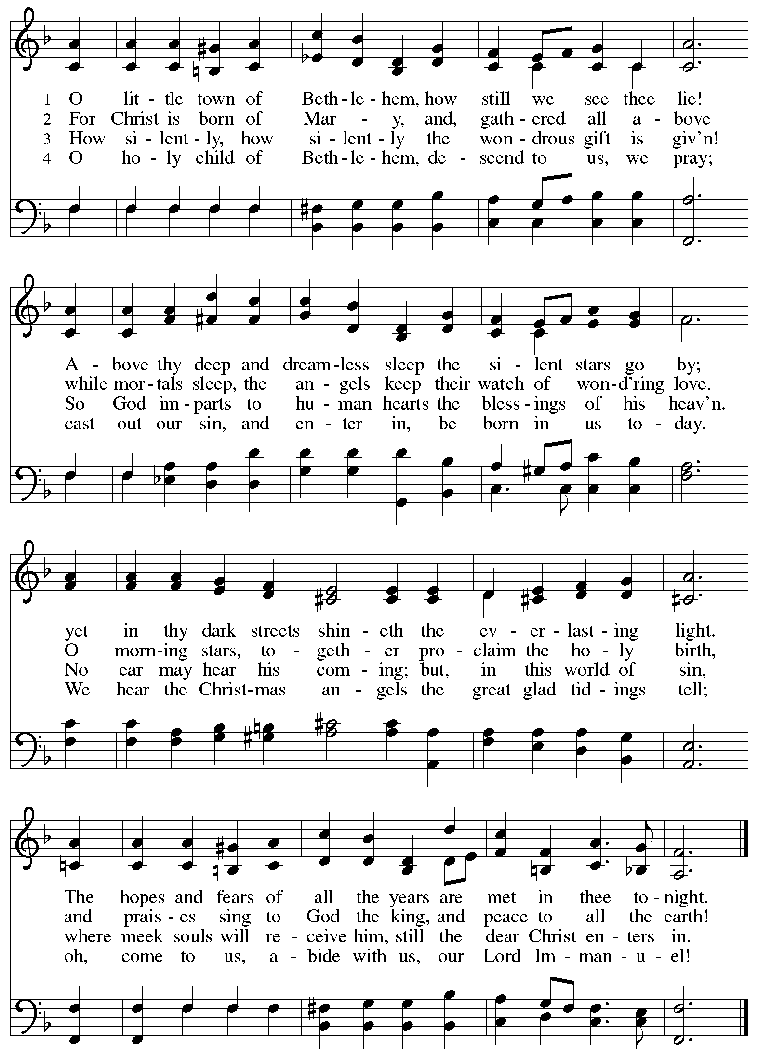
Hymns during Holy Communion
Go Tell It on the Mountain ELW 290

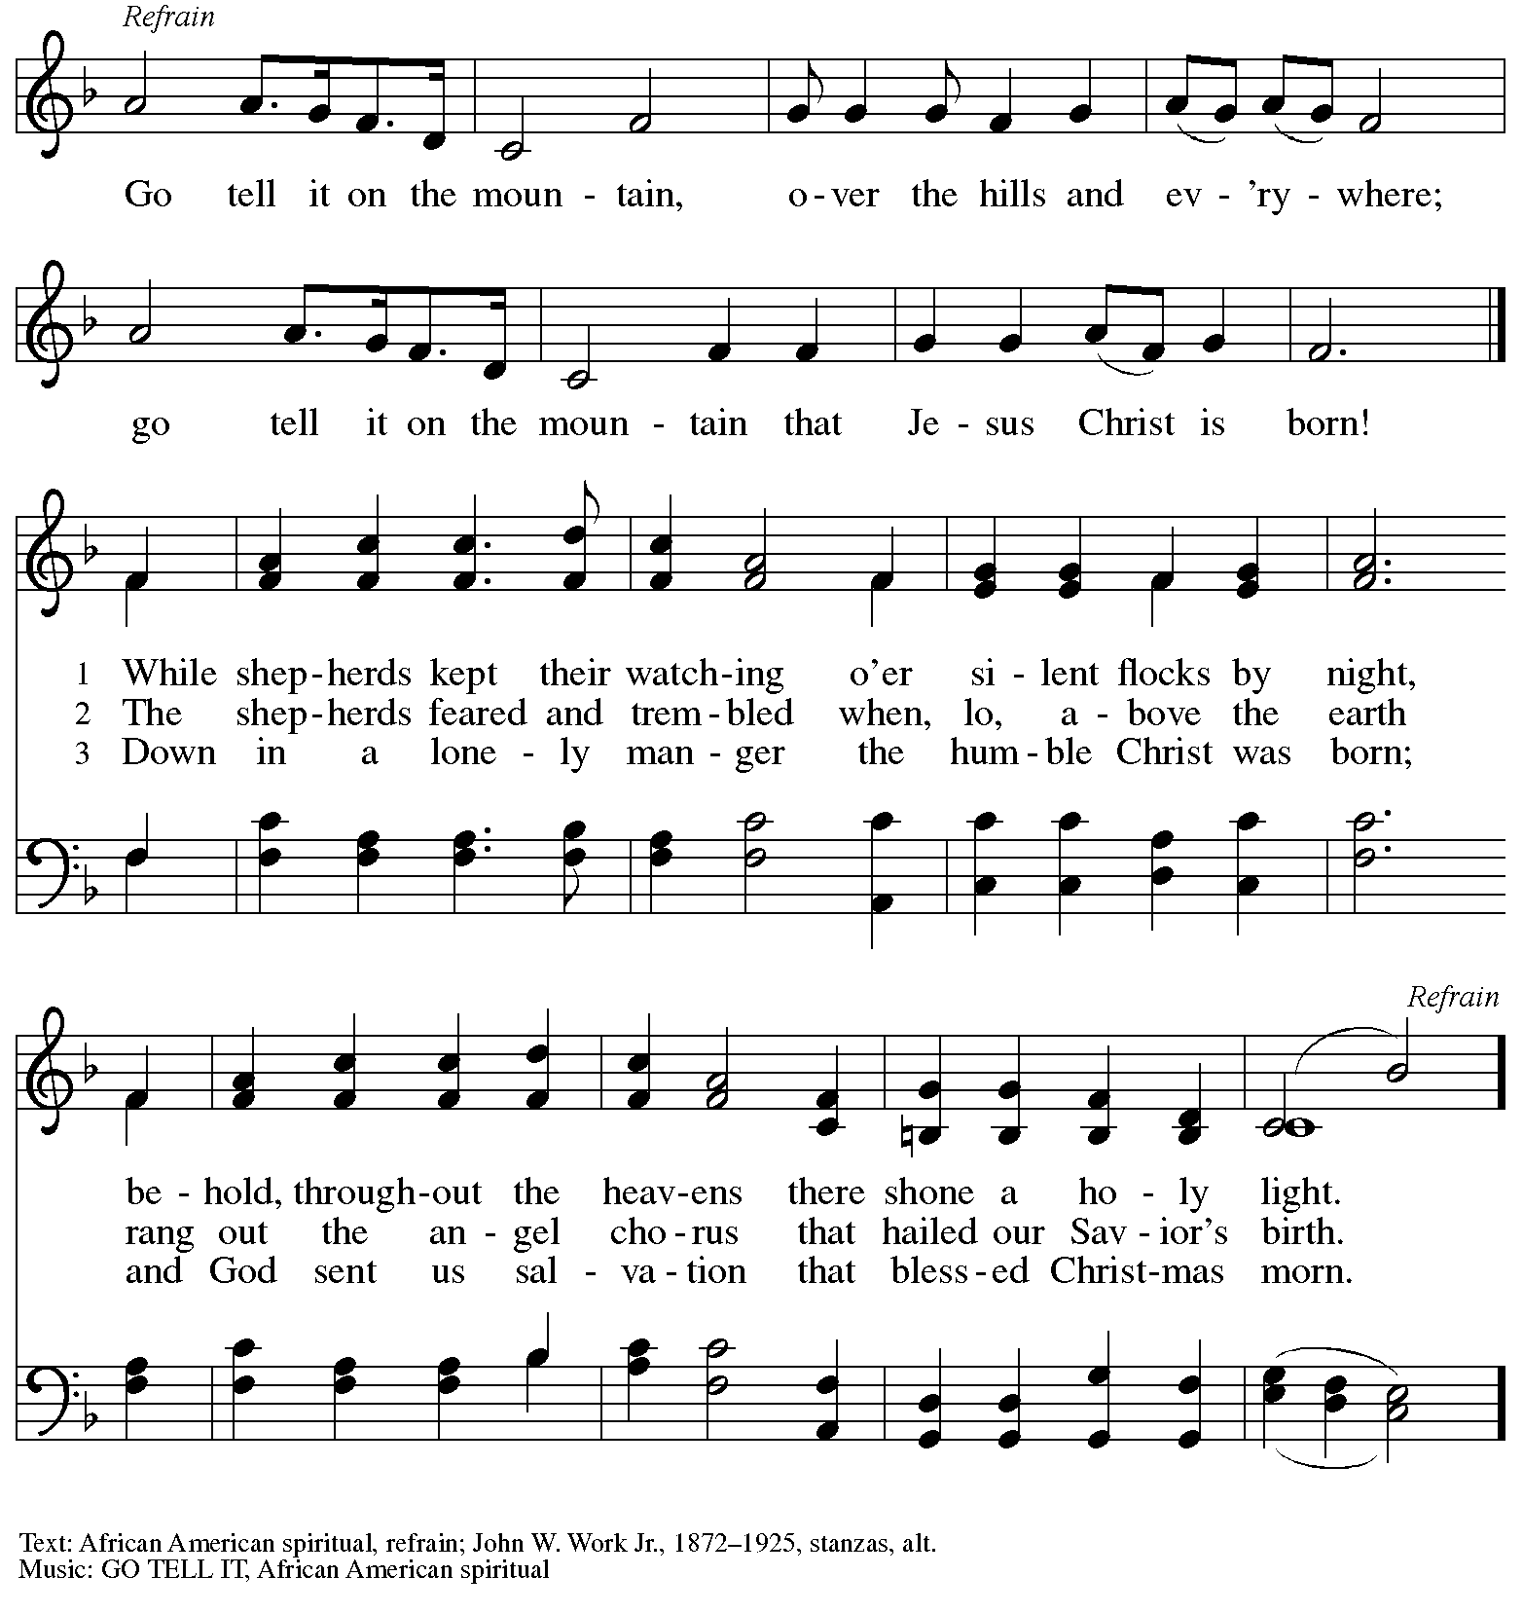

When all have returned to their places, please rise as you are able.

Blessing

P: The body and blood of our Lord Jesus Christ strengthen you and keep you in his grace.
C: Amen.
Nunc Dimittis

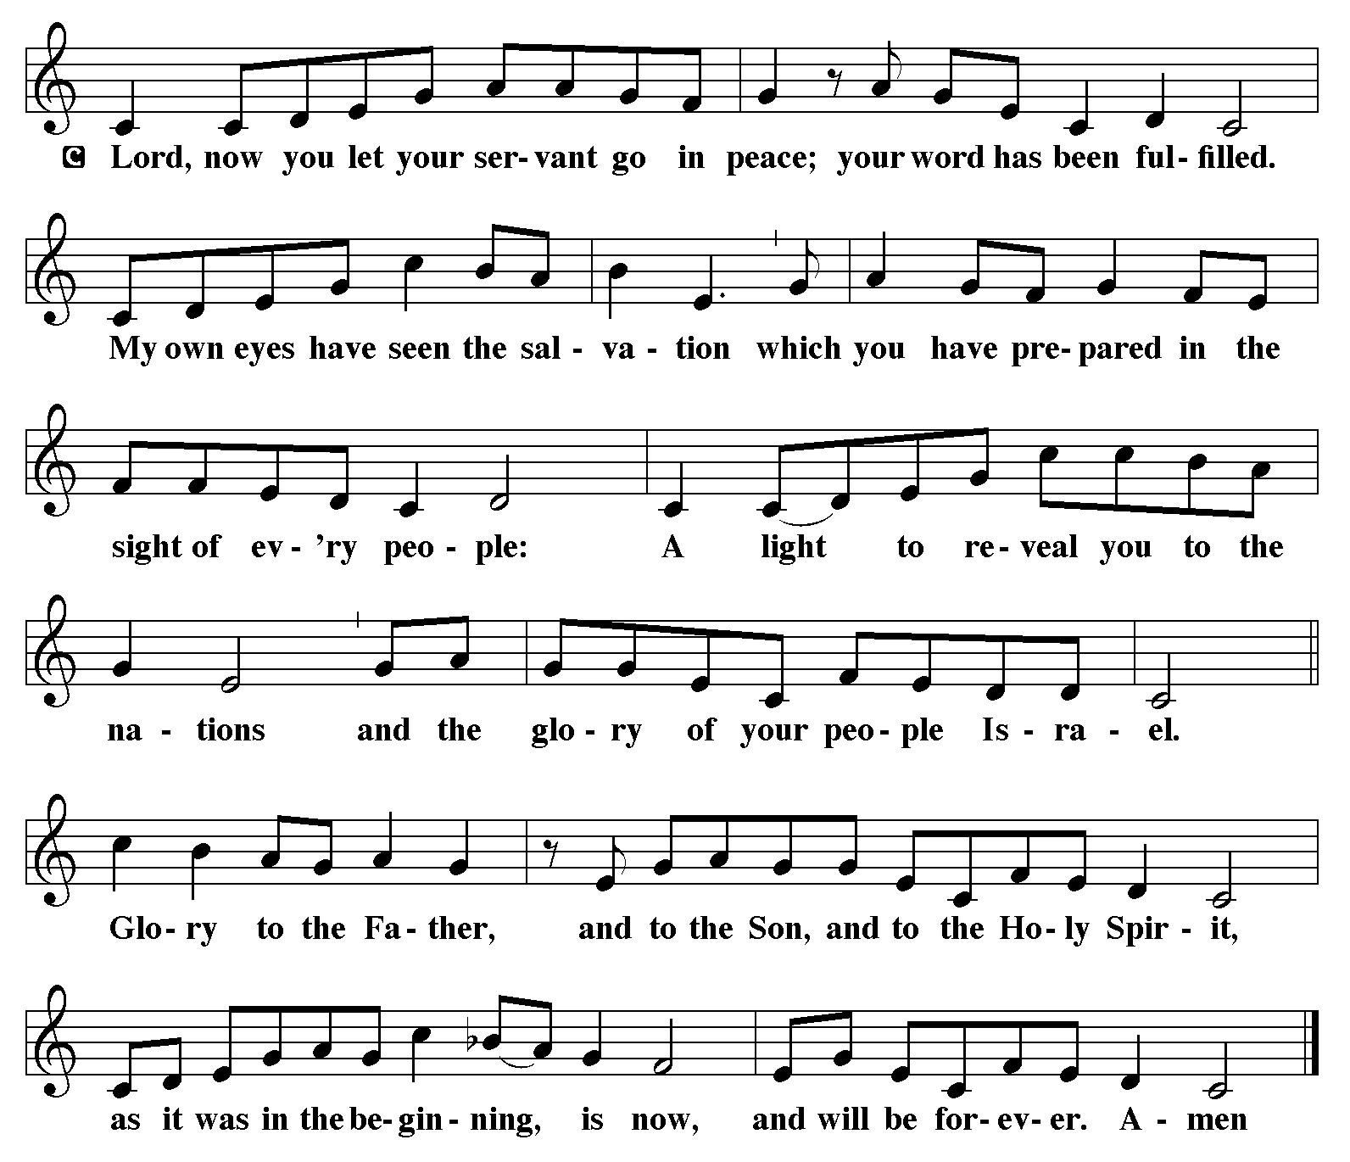

Prayer

A: Let us pray.
Radiant God,
with our eyes we have seen your salvation, and in this meal, we have feasted on your grace.
May your Word take flesh in us, that we may be your holy people,
revealing your glory made known to us in Jesus Christ, our Savior and Lord.
C: Amen.

Sending
God blesses us and sends us in mission to the world

Benediction

P: God bless you and keep you,
☩ Jesus grant you grace and truth,
and the Holy Spirit send peace upon your hearts,
now and forever.
C: Amen.

Sending Hymn Following page

Dismissal

A: Go in peace. Share the good news!
C: Thanks be to God!

Postlude

Sending Hymn Joy to the World ELW 267

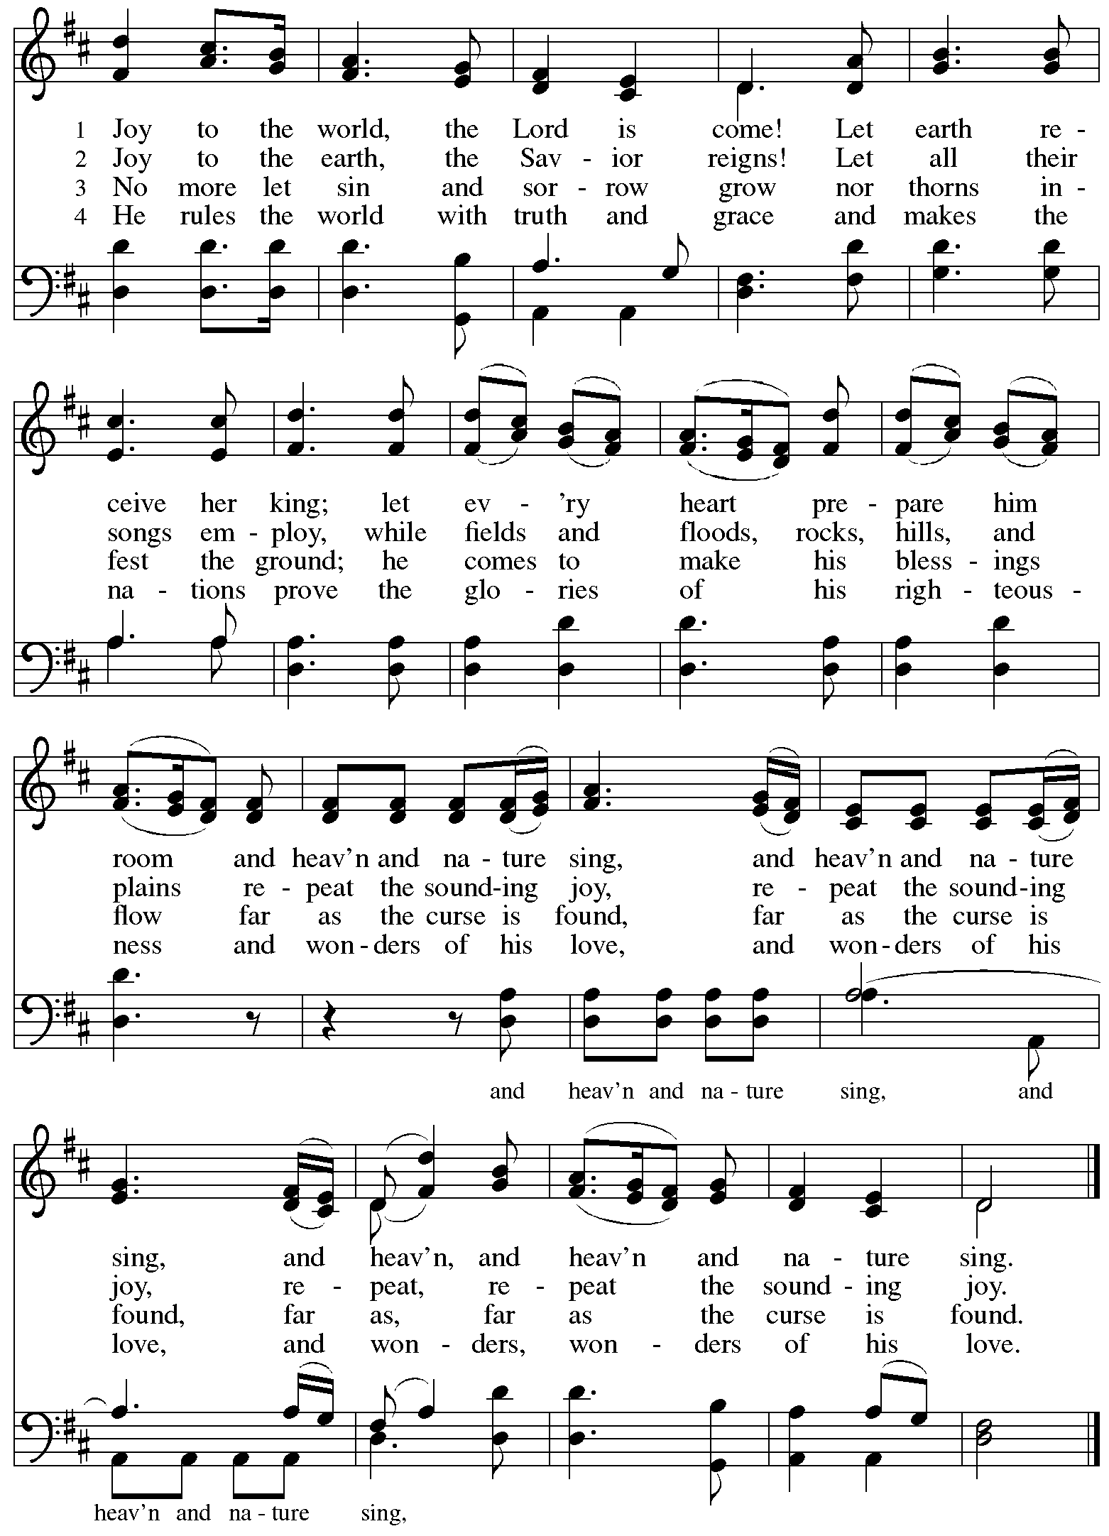
Serving in Worship Today

Altar Care Jodie Minor
Assisting Minister Kathy Hays
Cantor Joy Givens
Lector Lindsay Baxter
Minister of Music Laura Reynolds
Presiding Minister The Rev. Ross Carmichael

Liturgy and Hymnody Acknowledgements

From SundaysandSeasons.com. Copyright © 2025 Augsburg Fortress. All rights reserved. Reprinted under OneLicense.net # A-722139.
Used by permission of Augsburg Fortress.

The Scripture readings contained herein are from New Revised Standard Version Updated Edition of the Bible © 2021 National Council of Churches of Christ in the United States of America. Used by permission. All rights reserved worldwide.

It Came upon the Midnight Clear – Text: Edmund H. Sears, 1810-1876. Music: CAROL, Richard S. Willis, 1819-1900.

O Little Town of Bethlehem – Text: Phillips Brooks, 1835-1893. Music: ST. LOUIS, Lewis H. Redner, 1831-1908.

Joy to the World – Text: Isaac Watts, 1674-1748. Music: ANTIOCH, English melody, 18th cent., arr. Lowell Mason, 1792-1872.

Please use the QR code below to link to St. Andrew’s Announcements online!



St. Andrew Lutheran Church Announcements
December 24th, 2025

- Welcome to Worship at St. Andrew This Christmas Eve! – We are thankful you are here, and we offer a special welcome to all visitors and guests who are here for the first time! A nursery is available through the door to the left of the worship space and across the social hall (look for a purple room). There are also worship “toolkits” to help children engage with worship and “busy bags” for younger children available in the bookcase at the back of the sanctuary. Please feel free to take one to use with/for your children.
- We Invite Everyone to Worship on Sundays at 10:00 a.m.! On most Sundays, September through May St. Andrew offers Little Church – Big Faith, a Bible lesson and activity for children up to sixth grade, during worship. Little Church – Big Faith will resume on Sunday, January 11th.

