

+ Baptism of our Lord
January 11, 2026



St. Andrew Lutheran Church
304 Morewood Ave.
Pittsburgh, PA 15213
St_andrewELCA@verizon.net
www.standrewpittsburgh.org

+ Baptism of our Lord
Order for Worship

In the waters of the Jordan River, Jesus is revealed as the beloved Son of God.
Through this great epiphany, Jesus fulfills all righteousness and becomes the servant of God who will bring forth justice and be a light to the nations. In the waters of Baptism we too are washed by the Word, anointed by the Spirit, and named God’s beloved children. Our baptismal mission is to proclaim good news to all who are oppressed or in need of God’s healing.

Welcome to St. Andrew!
- St. Andrew welcomes all who are seeking a place of healing, wholeness, and acceptance in a nurturing and faith-forming spiritual home. We are striving toward racial equity worldwide
and we seek to honor the lived experience of all individuals regardless of background. Our community embraces people of all ages, ethnicities, cultures, abilities, sexual orientations,
gender identities and expressions, and family constellations. Come and See!
- Worship Services are live-streamed to multiple online platforms. By attending worship, you agree that your image and voice may be broadcast.
- Everyone is invited to make a name tag at the black bookcase in the back of the worship space if they would like. There are stickers indicating pronouns on the bookcase if you would like to include them on your name tag.
- A nursery is available through the doors at the left side of the sanctuary and across from the doorway to the Social Hall. Look for a purple-colored room.
- Children are invited to attend Little Church – Big Faith, a Bible lesson and activity, during worship (after the Prayer of the Day). The group returns to the worship space for the liturgy of Holy Communion.
- Worship “toolkits” to help children engage with the service, along with “busy bags” for younger children, are available in the bookcase at the back of the sanctuary. Please feel free to take one to use with/for your children.
- Holy Communion is served with bread (gluten-free available) and wine or grape juice. The presiding minister will distribute the bread (host). Please consume this and then pick up an empty glass from the tray. The Communion Assistant will pour wine or grape juice into your glass. Please step to the side to consume the wine or grape juice. Feel free to kneel at the altar for prayer and reflection. As you return to your pew, glasses may be returned to the empty trays on either side of the center section.
- A restroom is available on the main level of the church, through the doors to the Social Hall and to the right in the main office.

Abbreviations
P: Pastor/Presiding Minister ELW: Evangelical Lutheran Worship hymnal
A: Assisting Minister ACS: All Creation Sings hymnal
L: Lector
C: Congregation

Musical Offering

Each week, different people from the congregation make an offering of pre-service music, with singing or instrumentation, to help the assembly focus and pray in preparation for worship.

Welcome

Prelude Spirit, Open My Heart arr. Moore

Gathering
The Holy Spirit calls us together as the people of God

Please rise as you are able. All may make the sign of the cross,
the sign that is marked at Baptism, as the presiding minister begins.

Thanksgiving for Baptism

P: Blessed be the holy Trinity, ☩ one God,
the fountain of living water, the rock who gave us birth,
our light and our salvation.
C: Amen.

P: Joined to Christ in the waters of Baptism, we are clothed with God’s mercy and forgiveness.
Let us give thanks for the gift of Baptism.

Water is poured into the font, and the presiding minister begins the thanksgiving.

P: We give you thanks, O God,
for in the beginning you created us in your image and placed us in a well-watered garden.
In the desert, you promised pools of water for the parched, and you gave us water from the rock. When we did not know the way, you sent the Good Shepherd to lead us to still waters.
At the cross, you washed us from Jesus’ wounded side, and on this day,
you shower us again with the water of life.

We praise you for your salvation through water, for the water in this font,
for the waters of the Allegheny, Monongahela, and Ohio rivers,
and for all water everywhere.

Bathe us in your forgiveness, grace, and love.
Satisfy all who thirst, and give us the life only you can give.

To you be given honor and praise through Jesus Christ, our living water,
in the unity of the Holy Spirit, now and forever.
C: Amen.

Gathering Hymn Arise, Your Light Has Come! ELW 314

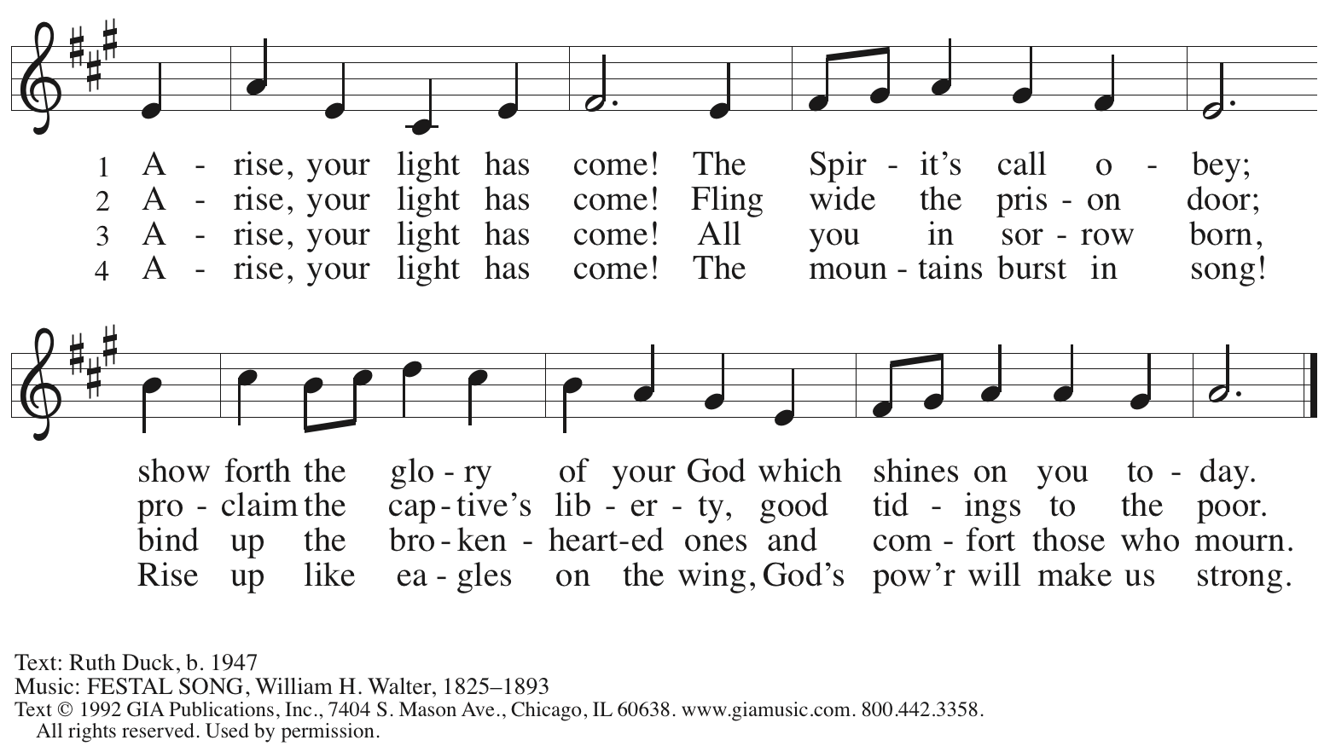
Reprinted under OneLicense.net # A-722139.

Greeting

P: The grace of our Lord Jesus Christ, the love of God,
and the communion of the Holy Spirit be with you all.
C: And also with you.

Kyrie ACS p. 31

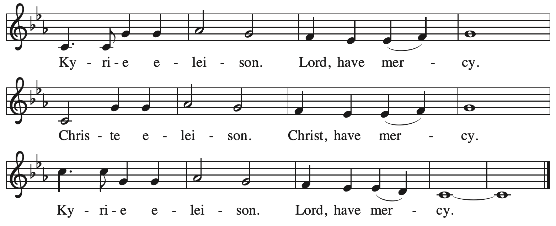
Hymn of Praise ACS p. 31

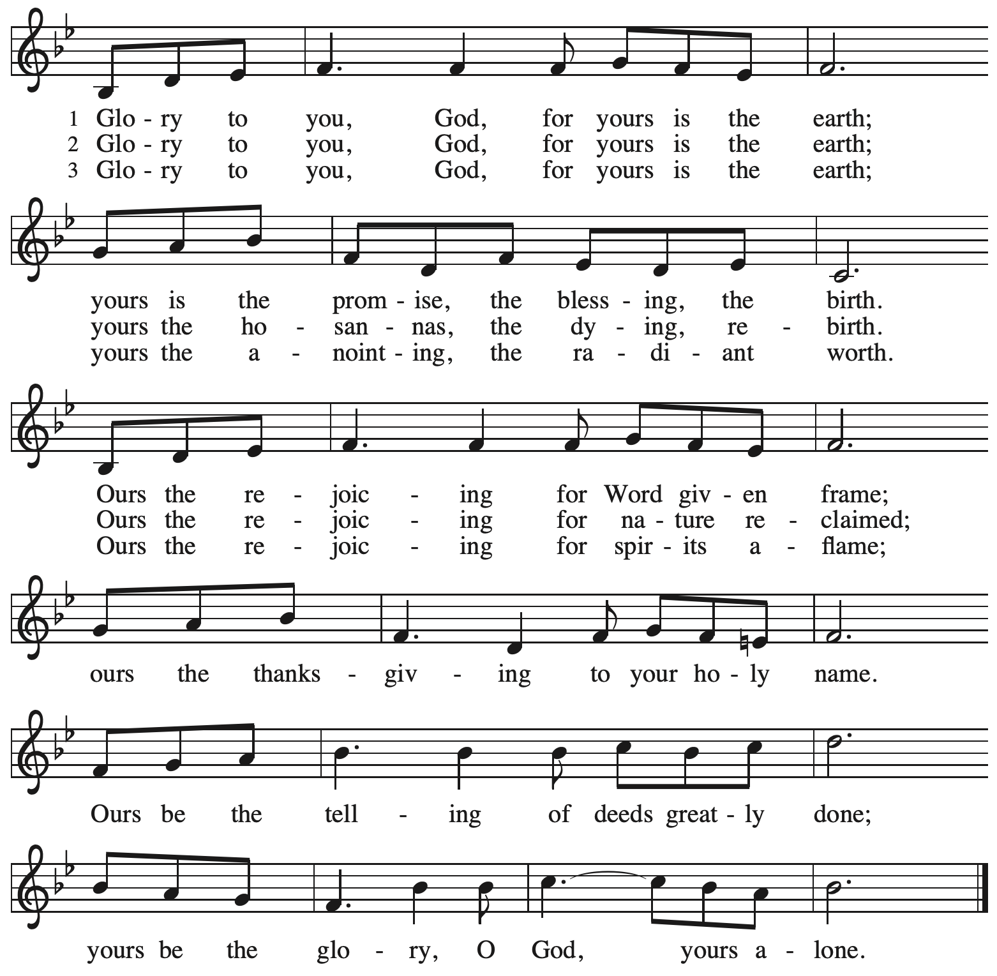

Prayer of the Day

P: The Lord be with you.
C: And also with you.

P: O God our Father, at the baptism of Jesus you proclaimed him your beloved Son and anointed him with the Holy Spirit. Make all who are baptized into Christ faithful to their calling to be your children, and empower us all with your Spirit, through Jesus Christ, our Savior and Lord,
who lives and reigns with you and the Holy Spirit, one God, now and forever.
C: Amen.
Please be seated.

Word
God speaks to us in Scripture reading, preaching, and song

First Reading – Isaiah 42: 1-9

¹ Here is my servant, whom I uphold,
my chosen, in whom my soul delights;
I have put my spirit upon him;
he will bring forth justice to the nations.
² He will not cry out or lift up his voice
or make it heard in the street;
³ a bruised reed he will not break,
and a dimly burning wick he will not quench;
he will faithfully bring forth justice.
⁴ He will not grow faint or be crushed
until he has established justice in the earth,
and the coastlands wait for his teaching.
⁵ Thus says God, the Lord,
who created the heavens and stretched them out,
who spread out the earth and what comes from it,
who gives breath to the people upon it
and spirit to those who walk in it:
⁶ I am the Lord; I have called you in righteousness;
I have taken you by the hand and kept you;
I have given you as a covenant to the people,
a light to the nations,
⁷ to open the eyes that are blind,
to bring out the prisoners from the dungeon,
from the prison those who sit in darkness.
⁸ I am the Lord; that is my name;
my glory I give to no other,
nor my praise to idols.
⁹ See, the former things have come to pass,
and new things I now declare;
before they spring forth,
I tell you of them.

L: Word of God, word of life.
C: Thanks be to God.

Psalm 29

The psalm will be sung responsively, led by the cantor, with the congregation singing the verses in bold type and joining in the refrain.

Psalm Tone


Psalm Refrain

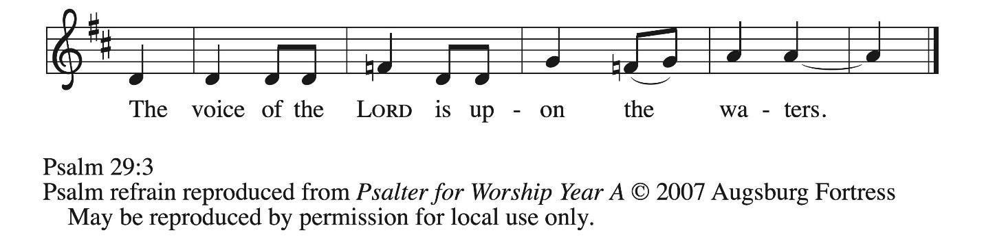

¹ Ascribe to the | Lord, you gods,
ascribe to the Lord glo- | ry and strength.
² Ascribe to the Lord the glory | due God’s name;
worship the Lord in the beau- | ty of holiness.
³ The voice of the Lord is upon the waters; the God of | glory thunders;
the Lord is upon the | mighty waters.
⁴ The voice of the Lord is a pow- | erful voice;
the voice of the Lord is a | voice of splendor. R
⁵ The voice of the Lord breaks the | cedar trees;
the Lord breaks the ce- | dars of Lebanon;
⁶ the Lord makes Lebanon skip | like a calf,
and Mount Hermon like a | young wild ox.
⁷ The voice | of the Lord
bursts forth in | lightning flashes.
⁸ The voice of the Lord | shakes the wilderness;
the Lord shakes the wilder- | ness of Kadesh. R
⁹ The voice of the Lord makes the oak trees writhe and strips the | forests bare.
And in the temple of the Lord all are | crying, “Glory!”
¹⁰ The Lord sits enthroned a- | bove the flood;
the Lord sits enthroned as king for- | evermore.
¹¹ O Lord, give strength | to your people;
give them, O Lord, the bless- | ings of peace. R

Second Reading – Acts 10: 34-43

³⁴ Peter began to speak to [Cornelius and his household]: “I truly understand that God shows no partiality, ³⁵ but in every people anyone who fears God and practices righteousness is acceptable to God. ³⁶ You know the message God sent to the people of Israel, preaching peace by Jesus Christ—he is Lord of all. ³⁷ That message spread throughout Judea, beginning in Galilee after the baptism that John announced: ³⁸ how God anointed Jesus of Nazareth with the Holy Spirit and with power; how he went about doing good and healing all who were oppressed by the devil, for God was with him. ³⁹ We are witnesses to all that he did both in Judea and in Jerusalem. They put him to death by hanging him on a tree, ⁴⁰ but God raised him on the third day and allowed him to appear, ⁴¹ not to all the people but to us who were chosen by God as witnesses and who ate and drank with him after he rose from the dead. ⁴² He commanded us to preach to the people and to testify that he is the one ordained by God as judge of the living and the dead. ⁴³ All the prophets testify about him that everyone who believes in him receives forgiveness of sins through his name.”

L: Word of God, word of life.
C: Thanks be to God.

Please rise as you are able.

Gospel Acclamation ACS p. 33

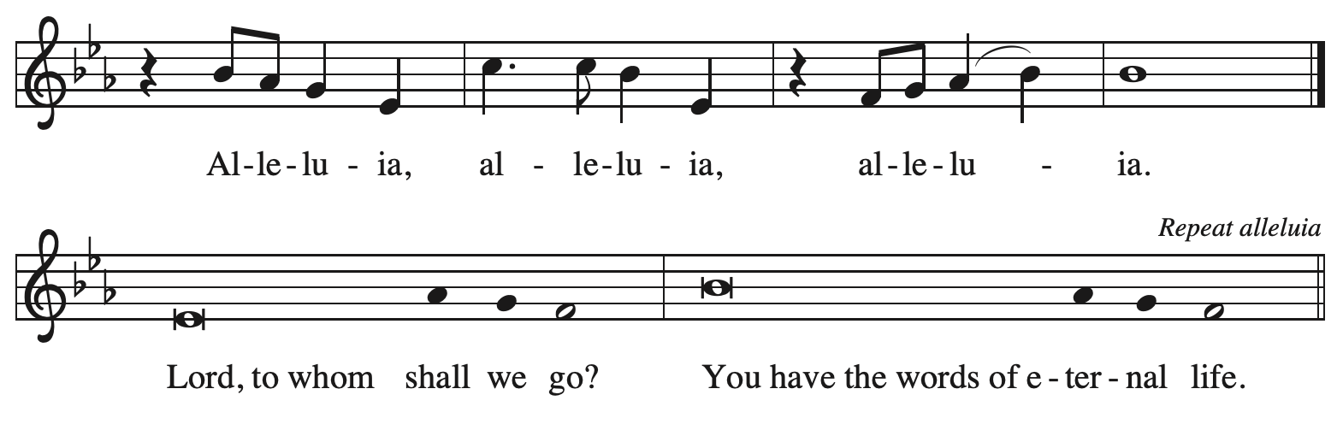

Gospel – Matthew 3: 13-17

P: The holy Gospel according to St. Matthew.
C: Glory to you, O Lord.

¹³ Jesus came from Galilee to John at the Jordan, to be baptized by him. ¹⁴ John would have prevented him, saying, “I need to be baptized by you, and do you come to me?” ¹⁵ But Jesus answered him, “Let it be so now, for it is proper for us in this way to fulfill all righteousness.” Then he consented. ¹⁶ And when Jesus had been baptized, just as he came up from the water, suddenly the heavens were opened to him and he saw God’s Spirit descending like a dove and alighting on him. ¹⁷ And a voice from the heavens said, “This is my Son, the Beloved, with whom I am well pleased.”

P: The Gospel of the Lord.
C: Praise to you, O Christ.

Please be seated.

Sermon

A time of silence for prayer and reflection follows the sermon.
When the hymn of the day begins, please rise as you are able.



Hymn of the Day Down Galilee’s Slow Roadways ACS 916

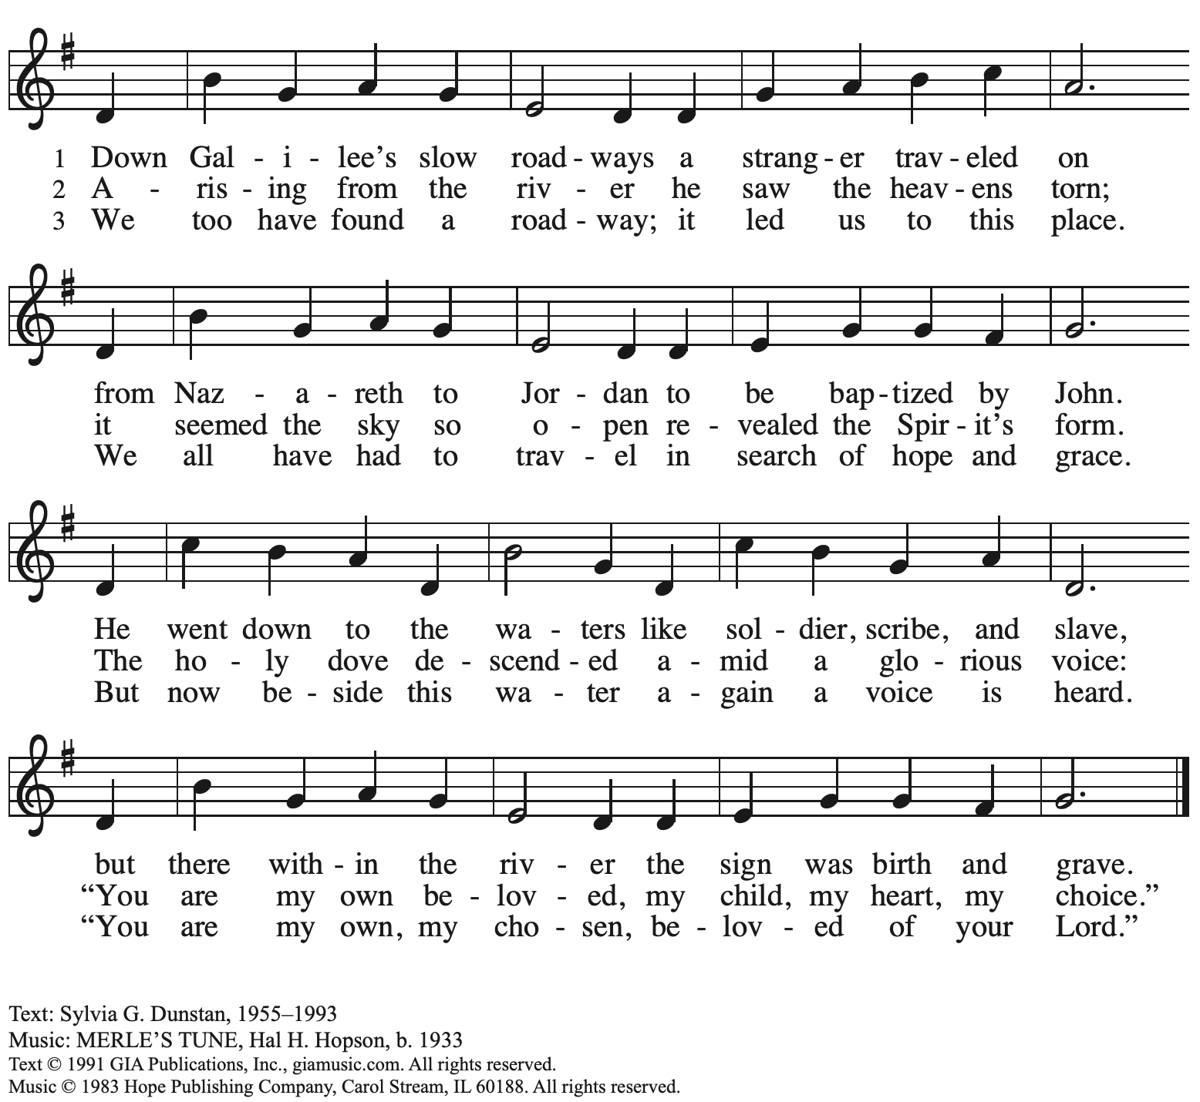
Reprinted with permission under OneLicense.net # A-722139.

Apostles’ Creed

C: I believe in God, the Father almighty,
creator of heaven and earth.

I believe in Jesus Christ, God’s only Son, our Lord,
who was conceived by the Holy Spirit,
born of the virgin Mary,
suffered under Pontius Pilate,
was crucified, died, and was buried;
he descended to the dead.*
On the third day he rose again;
he ascended into heaven,
he is seated at the right hand of the Father,
and he will come to judge the living and the dead.

I believe in the Holy Spirit,
the holy catholic church,
the communion of saints,
the forgiveness of sins,
the resurrection of the body,
and the life everlasting. Amen.

*Or, “he descended into hell,” another translation of this text in widespread use.

Please be seated.

Installation of Congregation Council Leaders

P: The following people have been elected by the congregation to positions of leadership on the congregation council. We give thanks for their willingness to serve and for the gifts they offer in service. In Baptism, we are welcomed into the body of Christ and sent to share in the mission of God’s reign; we rejoice now that these siblings in Christ will lead us in our common life and our mutual mission as a congregation.

The names of those to be installed are read by a representative of the congregation.

P: A reading from First Corinthians: There are varieties of gifts, but the same Spirit; and there are varieties of services, but the same Lord; and there are varieties of activities, but it is the same God who activates all of them in everyone. To each is given the manifestation of the Spirit for the common good. (1 Corinthians 12: 4-7)

P: You have been elected to positions of leadership and trust in this congregation.

You are to see that the words and deeds of this household of faith bear witness to God, who gathers us into one together with the whole church.

You are to seek to involve all members of this congregation in worship, learning, witness, service, and support, so that the mission of Christ is carried out in this congregation, in this community, and in the whole world.

You are to be faithful in your specific area of serving, that the Spirit who empowers you may be glorified.

You are to be examples of faith active in love, fostering peace, harmony, and mutual understanding in this congregation.

On behalf of your siblings in Christ, I ask you:
Will you accept and faithfully carry out the duties of the offices to which you have been elected?
Response: I will, and I ask God to help me.

The assembly stands, as able. Those being installed face the assembly.
The presiding minister addresses the assembly.

P: People of God, I ask you:
Will you support these elected leaders, and will you share in the mutual ministry
that Christ has given to all who are baptized?
C: We will, and we ask God to help us.

Those being installed face the presiding minister, who addresses them.
P: I now declare you installed as council members of this congregation.
Almighty God bless you, and direct your days and your deeds in peace,
that you may be faithful servants of Christ.
C: Amen.

The service continues with the prayers of intercession. Prayers are included for the newly installed leaders. After the greeting of peace, the newly installed leaders return to their places.

Prayers of the People

A: As God’s beloved children united in Christ, let us pray for the church,
the world, and the whole human community.

After each petition
A: Merciful God,
C: receive our prayer.

The presiding minister concludes the prayers.
P: Confident that the Holy Spirit receives our prayers and answers us,
we commend all for whom we pray to your lovingkindness, O God,
revealed to us through Jesus Christ our Savior.
C: Amen.

Peace

The presiding minister and the assembly greet one another in the peace of the risen Christ.
P: The peace of Christ be with you always.
C: And also with you.

The people may greet those around them with a sign of Christ’s peace and may say
Peace be with you or similar words. Please be mindful that not everyone will be comfortable with sharing the peace, so please seek consent before shaking hands or hugging.
Other possible ways to share the peace include a simple bow with the verbal greeting of peace, or simply a verbal expression of peace.

When the greetings of peace have concluded, please be seated.



Meal
God feeds us with the presence of Jesus Christ

Offering

We offer ourselves, our gifts, and our faithful service to God.
As the offering is gathered for the mission of the church, including the care of those in need,
the table is set for Holy Communion.

There are laminated giving cards in the pew racks that feature a QR code for anyone who would like to give online. Those who give using the QR code, as well as those who give regularly online or through their bank are encouraged to place the laminated card in the plate as an expression of your offering.

Offertory Music Come, Thou Fount of Every Blessing arr. Mayo

As the gifts are brought forward for presentation, please rise as you are able.

Offertory Song God of the Fertile Fields ACS 1063
v. 1, 3

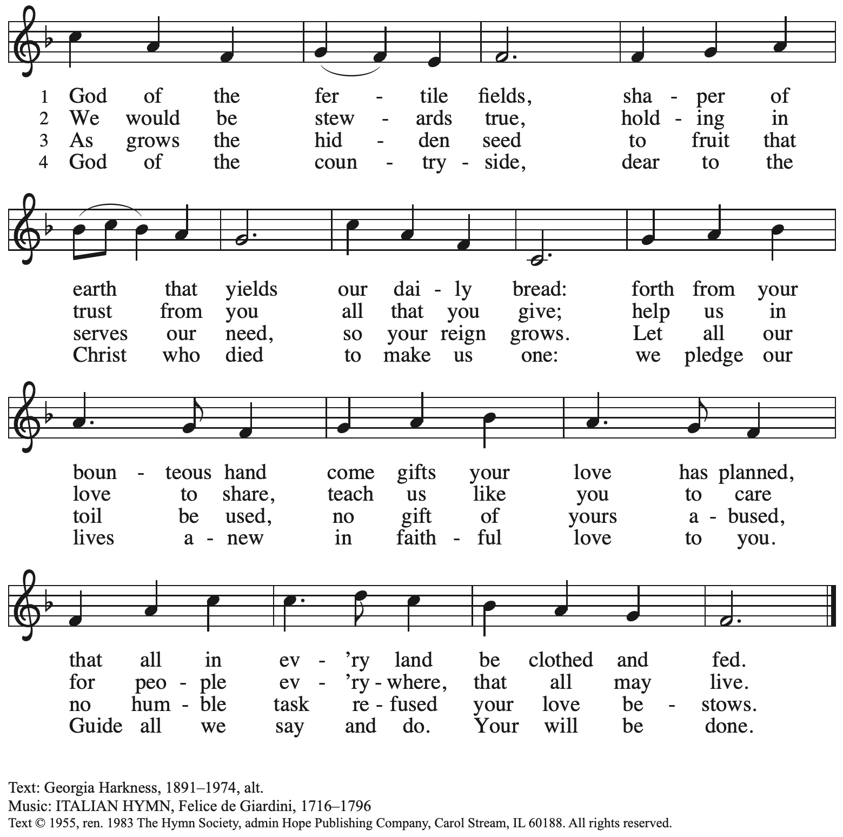
Reprinted with permission under One License.net # A-722139.

Offertory Prayer

A: Let us pray.
God of goodness and growth,
C: all creation is yours, and your faithfulness is sure.
Word and water, wine and bread: these are signs of your abundant grace.

Receive the gifts we bring, and nourish us to proclaim your abiding love
in our communities and in the world,
through Jesus Christ, our strength and our song.
Amen.

Dialogue

P: The Lord be with you.
C: And also with you.

P: Lift up your hearts.
C: We lift them to the Lord.

P: Let us give thanks to the Lord our God.
C: It is right to give our thanks and praise.

Preface (Spoken by the presiding minister)

P: It is indeed right, our duty and our joy,
that we should at all times and in all places
give thanks and praise to you, almighty and merciful God,
through our Savior Jesus Christ.
By the leading of a star he was shown forth to all nations;
in the waters of the Jordan you proclaimed him your beloved Son;
and in the miracle of water turned to wine he revealed your glory.
And so, with all the choirs of angels,
with the church on earth and the hosts of heaven,
we praise your name and join their unending hymn:

Sanctus ACS p. 36

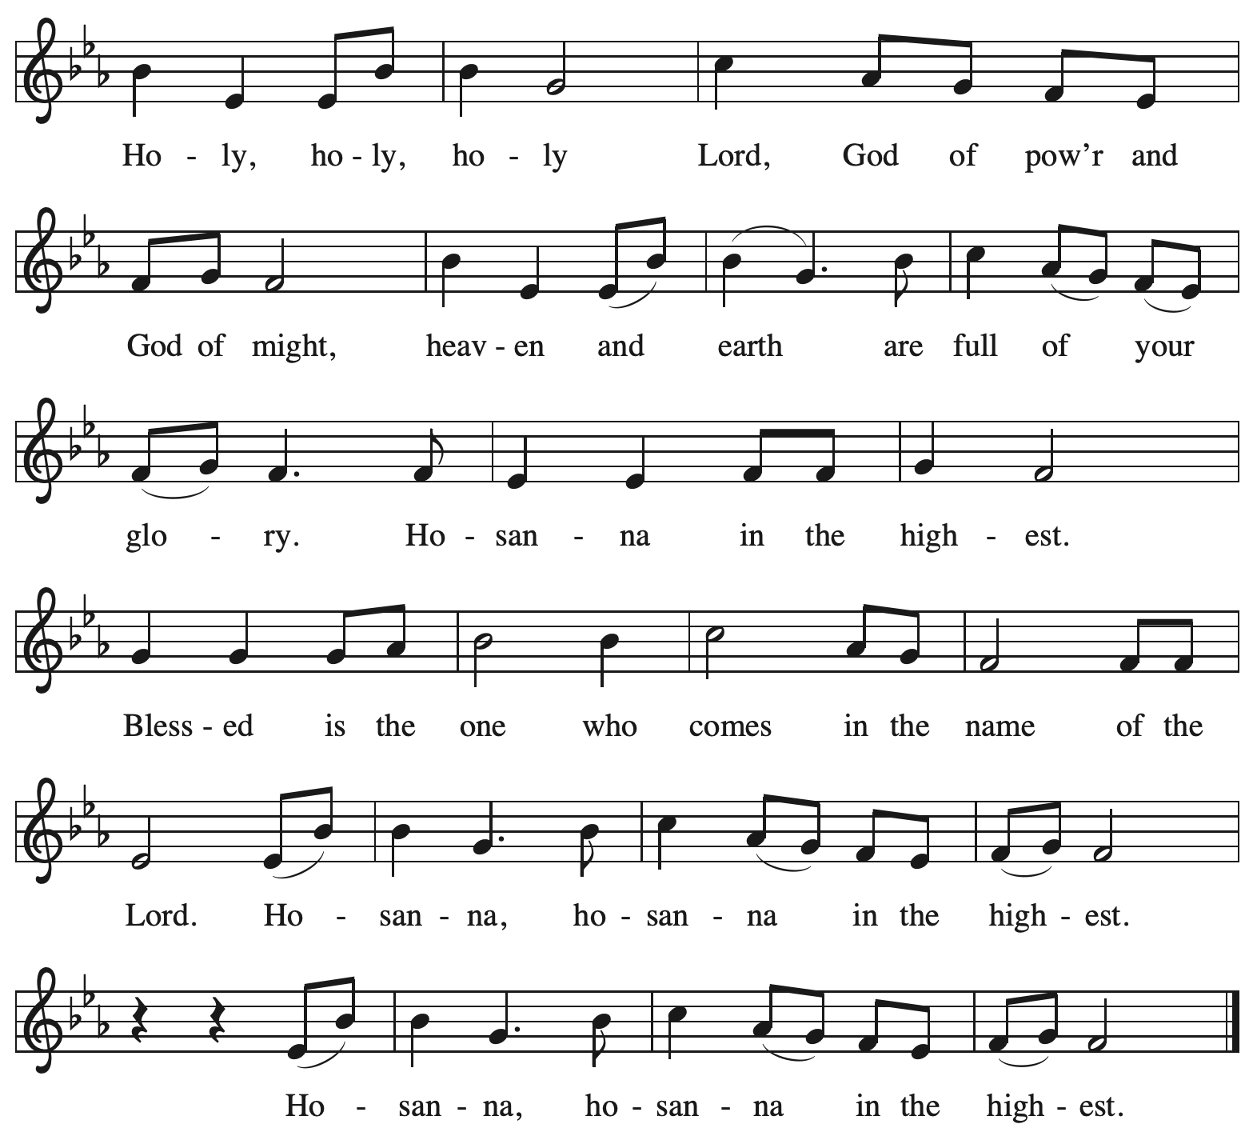

Eucharistic Prayer

P: Holy God, mighty and merciful, your peoples praise you, saying:
Your mercy endures forever.
C: Your mercy endures forever.

P: By your promise …
… the colors of your love and faithfulness.
Your mercy endures forever.
C: Your mercy endures forever.

P: By your promise …
… and calling them to be a light to the nations.

Your mercy endures forever.
C: Your mercy endures forever.

P: By your promise …
… Do this for the remembrance of me.

With this bread and cup
we remember his life laid down and lifted up
as we proclaim the mystery of faith:
C: Christ has died. Christ is risen. Christ will come again.

P: Send your Holy Spirit upon us …
… in your Spirit, now and forever.
C: Amen.

Lord’s Prayer

P: Gathered as one by the Holy Spirit, let us pray as Jesus taught us.
C: Our Father in heaven,
hallowed be your name,
your kingdom come,
your will be done,
on earth as in heaven.
Give us today our daily bread.
Forgive us our sins
as we forgive those
who sin against us.
Save us from the time of trial
and deliver us from evil.
For the kingdom, the power,
and the glory are yours,
now and forever. Amen.

Fraction and Invitation

P: Here is the Lamb of God who takes away the sin of the world.
Come to the table, taste and see.

Agnus Dei / Lamb of God ACS p. 40

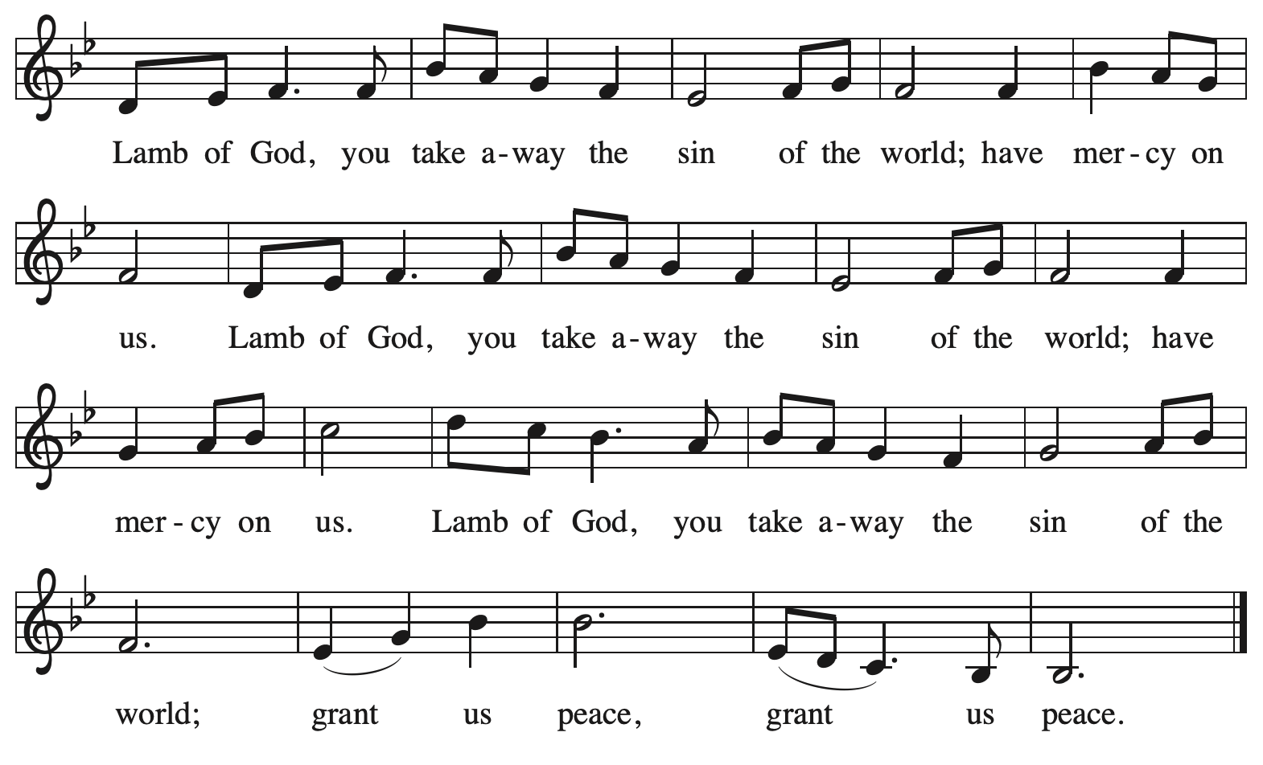

Please be seated.

Holy Communion

- All who seek God and desire a deeper and stronger life in Christ are welcome to receive Holy Communion.
- Worshipers from the pulpit side will proceed forward first, followed by the center section, and then the lectern side.
- Please inform an usher if you would like the ministers to bring Communion to you.
- Holy Communion will be served with bread and wine (amber) or grape juice (purple).
- The presiding minister will first distribute the bread (host) to each communicant. Please indicate if you require a gluten-free host.
- Once you have consumed the bread, please pick up an empty glass from the tray next to the presiding minister. The Communion Assistant will pour wine or grape juice into your glass.
- Please step to the side to consume the wine or grape juice.
- Feel free to kneel at the altar rail for prayer after receiving the sacrament.
- As you return to your pew, glasses may be returned to the empty tray on the side of the center section.
- A blessing will be provided for anyone who does not yet receive the sacrament.
- All are invited to join in singing the hymns during Holy Communion.

Hymns during Holy Communion
Now We Join in Celebration ELW 462

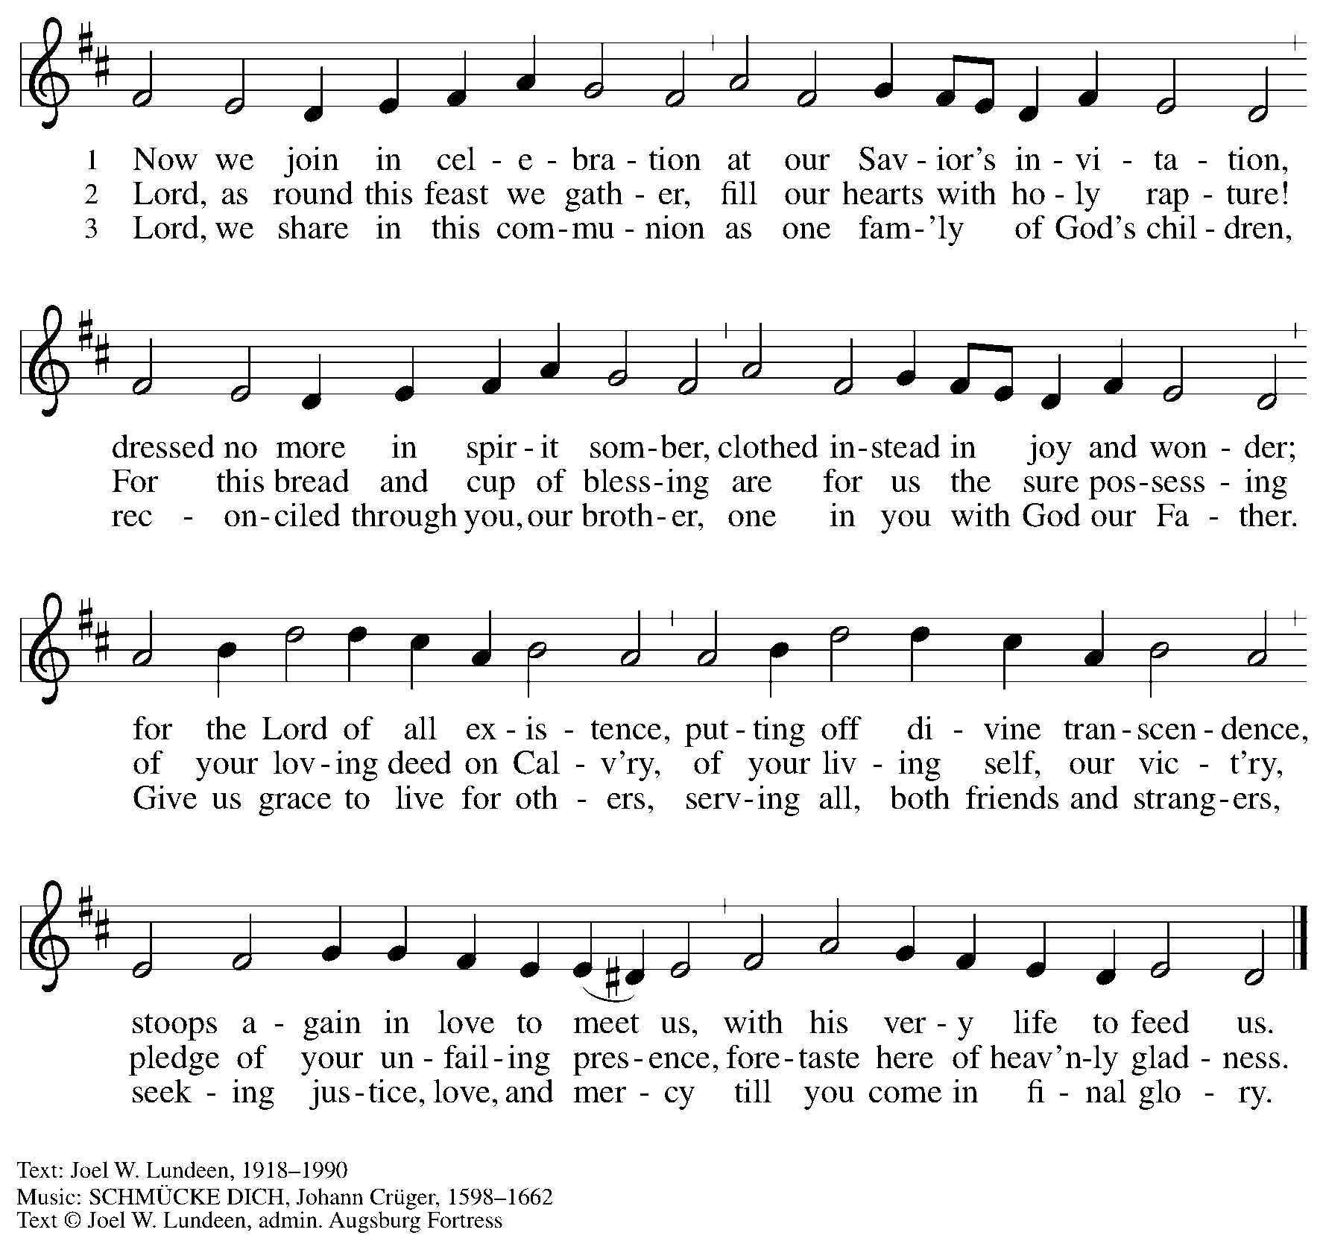
All rights reserved. Reprinted with permission under OneLicense.net # A-722319.

Hymns during Holy Communion
Remember and Rejoice ELW 454

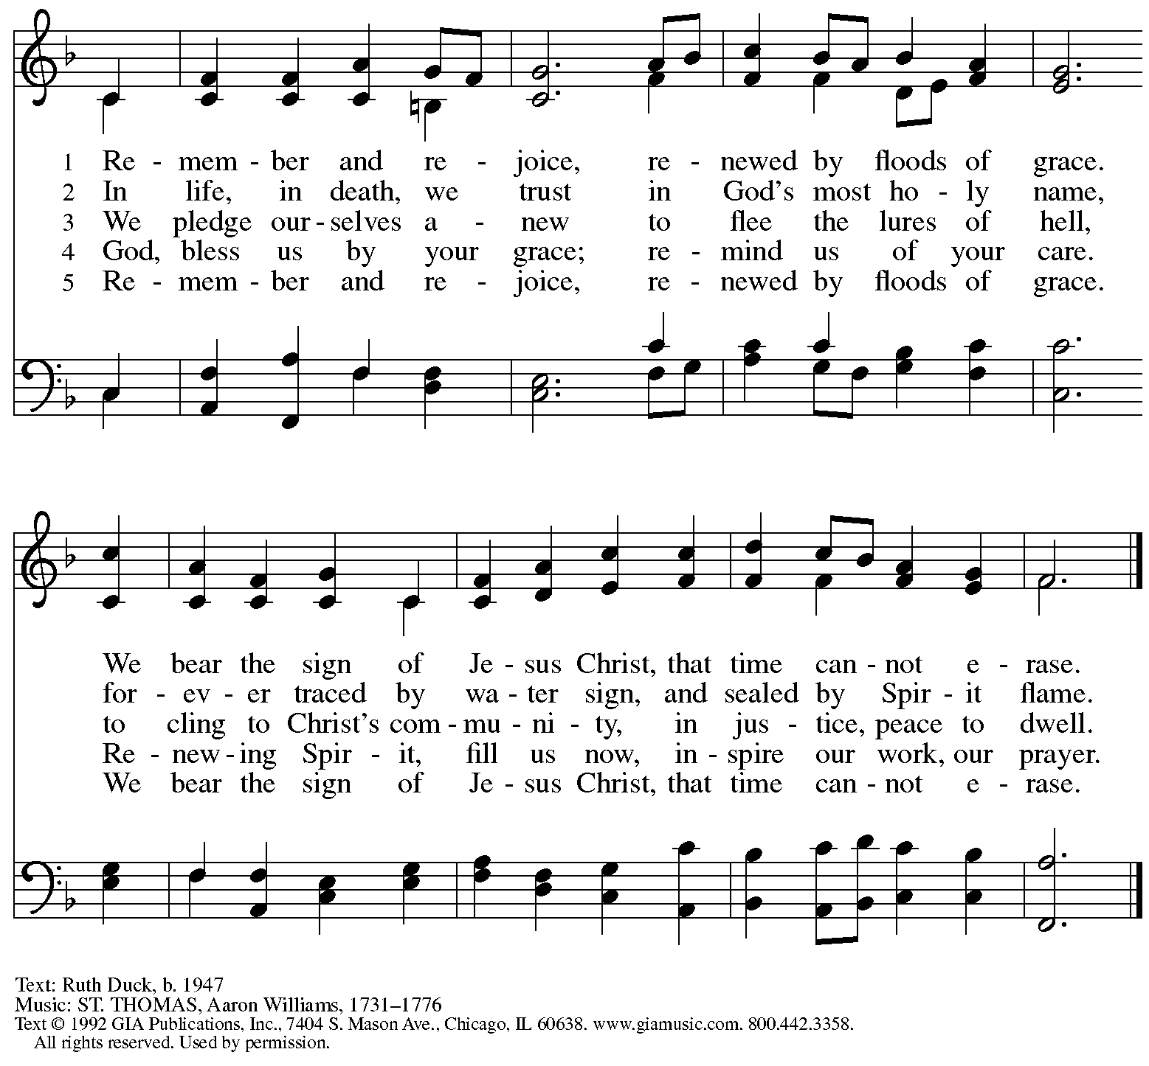
Reprinted under OneLicense.net # A-722139.

Hymns during Holy Communion
Songs of Thankfulness and Praise ELW 310

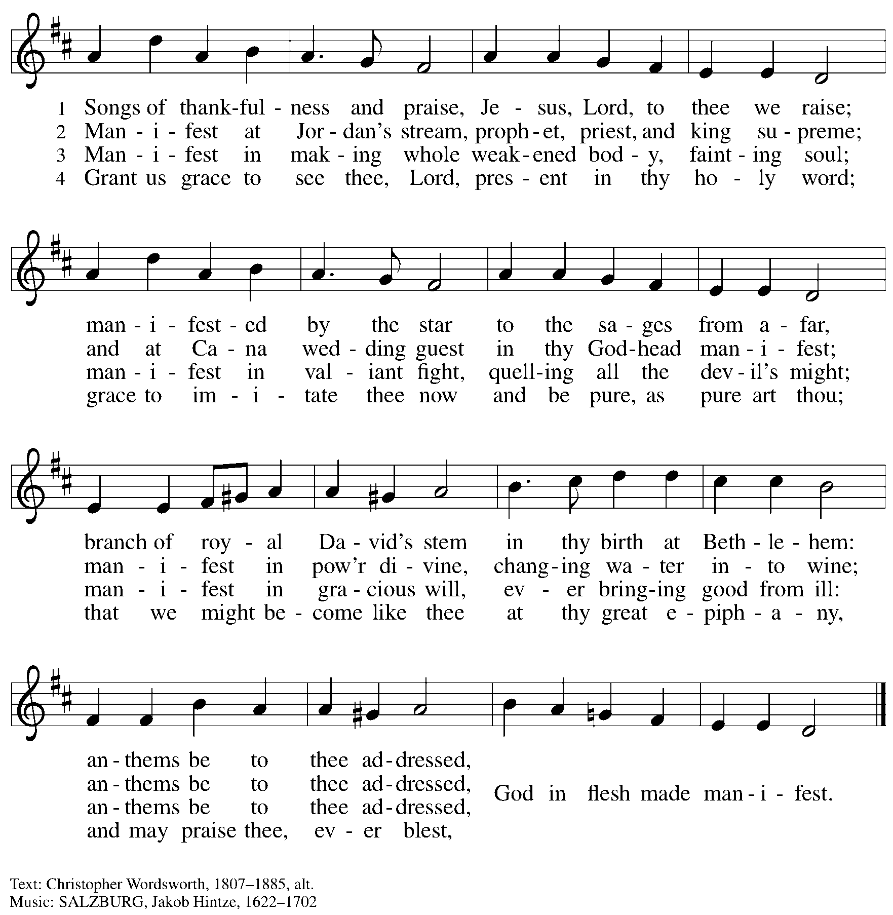

When all have returned to their places, please rise as you are able.

Blessing

P: The body and blood of our Lord Jesus Christ strengthen you and keep you in his grace.
C: Amen.

Prayer

A: Let us pray.
We thank you, O God, that you have strengthened our hearts through this feast of life
and salvation. Shine the light of Christ on our path, that we may do justice, love kindness,
and walk humbly with you, now and forever.
C: Amen.

Please be seated.

Sending
God blesses us and sends us in mission to the world

Announcements

Please rise as you are able.

Benediction

P: The Lord bless you and keep you.
The Lord’s face shine upon you with grace and mercy.
The Lord look upon you with favor and ☩ give you peace.
C: Amen.

Sending Hymn Following page

Dismissal

A: Go in peace. Serve the Lord.
C: Thanks be to God!

Postlude

Sending Hymn Jesus, the Light of the World ACS 914

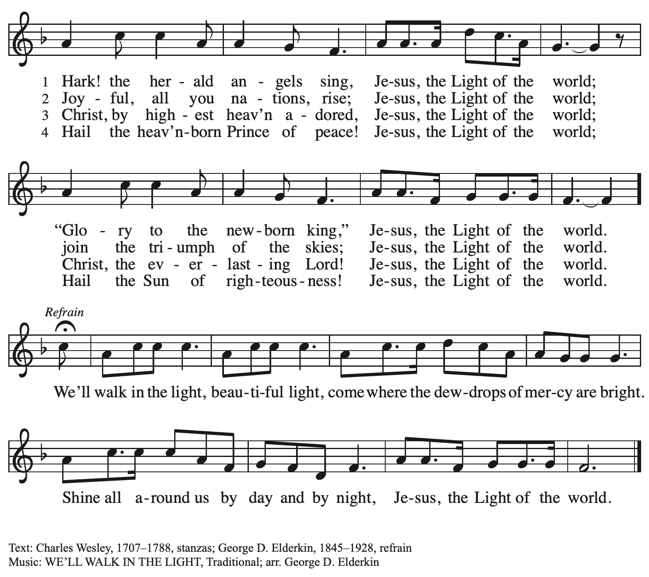

Serving in Worship Today

Altar Care Jodie Minor
Assisting Minister Jeff Denlinger
AV Team Sarita Joseph Paetz
Cantor Miriam Bohlmann Kunz
Lector Michael Chapman
Minister of Music Laura Reynolds
Presiding Minister The Rev. Ross Carmichael

Liturgy and Hymnody Acknowledgements

From SundaysandSeasons.com. Copyright © 2026 Augsburg Fortress. All rights reserved. Reprinted under OneLicense.net # A-722139.
Used by permission of Augsburg Fortress.

The Scripture readings contained herein are from New Revised Standard Version Updated Edition of the Bible © 2021 National Council of Churches of Christ in the United States of America. Used by permission. All rights reserved worldwide.

Please use the QR code below to link to St. Andrew’s Announcements online!



St. Andrew Lutheran Church Announcements
January 11th, 2026

- Welcome to Worship at St. Andrew as we observe + The Baptism of our Lord! – We are thankful you are here, and we offer a special welcome to all visitors and guests who are here for the first time! A nursery is available through the door to the left of the worship space and across the social hall (look for a purple room). Little Church – Big Faith, a Bible lesson and activity for children up to sixth grade, will take place after the prayer of the day. There are also worship “toolkits” to help children engage with worship and “busy bags” for younger children available in the bookcase at the back of the sanctuary. Please feel free to take one to use with/for your children.
- Community Ministry Meeting, January 12th at 7:00 p.m. – St. Andrew’s community ministry committee coordinates our local service ministries such as the outdoor Little Library, the pantry, produce distribution, shelter dinner, and various other activities. New participants are always welcome, and the next meeting is this Monday, January 12th, at 7:00 p.m. on Zoom. Please contact PastorRCarmichael@gmail.com or community@standrewpittsburgh.org if you would like the link.
- Noisy Offering Next week Week, Sunday, January 18th, during Worship – On the third Sunday of each month, St. Andrew’s children lead the congregation in a Noisy Offering, in which people are invited to throw their change into buckets that the children carry around the church and bring forward as an additional offering. Each month’s Noisy Offering supports a local, national, or international church-related or otherwise charitable organization. This month’s offering will benefit Hello Neighbor in their mission to empower refugees and immigrants through community connections, ensuring their journey from arrival to belonging is guided by dignity, cultural sensitivity, and support. You can learn more about their program offerings here: https://www.helloneighbor.io/our-programs.
- Visit from Partners for Sacred Places, Sunday, January 18th – As construction continues on the church roof and towers, we are excited to be making preparations for a capital campaign! As discussed in a previous congregational meeting, St. Andrew is working with consultants from Partners for Sacred Places to help organize and conduct a campaign to raise funds toward our $1 million goal. Tom and Emilio, whom some of you may have met when they visited last year to ask questions and learn from members of the congregation, will be here on Sunday, January 18th to meet with a small group of leaders. Everyone will be hearing more about the campaign in the coming weeks and months. We look forward to this process in hope of all that God will do to help St. Andrew continue and grow as a sustainable place of welcome, inclusion, and refuge for all God's people, shining the light of Christ's love on our neighbors and community here at the corner of Centre and Morewood!
- Volunteers needed with WPA BOLD Holiday Party, Sunday, January 18th, after Worship – For several years, the Western PA Blind Outdoor Leisure Development Organization (BOLD), has been holding their holiday parties at St. Andrew, and they will do so again on Sunday, January 18th, from 1:00 p.m. – 5:30 p.m. The group has asked for volunteers from the congregation there that day to help set up (this can be done after coffee hour), greet members and help them to find seats, assist with serving buffet food, leading and helping people to get food, and cleanup. If you are willing to help, please speak with Pastor Ross. Thank you very much.
- Produce Distribution Supplemental Food of the Month – St. Andrew is collecting supplemental food each month to accompany our produce distribution. For January, we ask for donations of rice. There are collection boxes at the back of the worship space and social hall.
- January Produce Distribution, Third Tuesday Each Month, January 20th from 5:30-6:30 p.m. – St. Andrew partners with Greater Pittsburgh Community Food Bank to serve as a distribution site for fresh produce on the first and third Tuesday of every month. This month’s second distribution will be on Tuesday, January 20th. We invite people of the congregation to help with the distribution from 5:30 p.m. – 6:30 p.m. and/or to help with unloading and setup during the day between 10:00 a.m. and 1:00 p.m.
- Alternatives to Violence Workshop, January 31st, 10:30 a.m. to 12:00 p.m. – Alternatives to Violence (https://avpusa.org/) is hosting a mini-workshop on Saturday, January 31st at St. Andrew Lutheran Church. It is free to attend and all are welcome. If you have any questions, please contact avpPittsburgh@gmail.com. This event was organized by Pastor Martin Rafanan with a grant from the Southwestern Pennsylvania Synod’s Authentic Diversity and Justice working group and its Rev. Dr. Martin Luther King, Jr. Collaborative Grants.
- “Christ in Our Home” Booklets Available – “Christ in Our Home” is a quarterly devotional resource that encourages readers to live out their faith daily. Each reflective reading is accompanied by a daily scripture reference and prayer for the day. The January-March booklets are available at the entrances. Please feel free to take one home!
- Invitation to Prayer Team – St. Andrew maintains a list of weekly prayer concerns sent by email to members of the congregation who have opted in. Our prayer team’s email is prayerteam@standrewpittsburgh.org. We will keep names on the list for a maximum of four weeks unless otherwise requested. Thank you for your ministry of prayer!
- Records Update – St. Andrew is updating our records with information from newer attendees, as well as offering current members the opportunity to include current information to be used within the congregation: to acknowledge celebrations, milestones, and prayers. Please fill out the form at: https://forms.gle/kKvp19UozuRrhhaV7.
- Coffee Hour Signups – If you would like to participate and would like additional information about the duties, please sign up using the following form: https://www.signupgenius.com/go/5080B4AAFAF2CABF85-47069030-coffee#/.

