

+ Second Sunday of Christmas
January 4, 2026



St. Andrew Lutheran Church
304 Morewood Ave.
Pittsburgh, PA 15213
St_andrewELCA@verizon.net
www.standrewpittsburgh.org

+ Second Sunday of Christmas
Order for Worship

Within the gospel reading’s profound words lies the simple message that God is revealed in a human person. Though we may try to understand how the Word existed with God from the beginning of time, the wonder we celebrate at Christmas is that the Word continues to dwell among us. Christ comes among us in the gathered assembly, the scriptures, the waters of new birth, and the bread and the wine. Through these ordinary gifts we receive the fullness of God’s grace and truth.

Welcome to St. Andrew!
- St. Andrew welcomes all who are seeking a place of healing, wholeness, and acceptance in a nurturing and faith-forming spiritual home. We are striving toward racial equity worldwide
and we seek to honor the lived experience of all individuals regardless of background. Our community embraces people of all ages, ethnicities, cultures, abilities, sexual orientations,
gender identities and expressions, and family constellations. Come and See!
- Worship Services are live-streamed to multiple online platforms. By attending worship, you agree that your image and voice may be broadcast.
- Everyone is invited to make a name tag at the black bookcase in the back of the worship space if they would like. There are stickers indicating pronouns on the bookcase if you would like to include them on your name tag.
- A nursery is available through the doors at the left side of the sanctuary and across from the doorway to the Social Hall. Look for a purple-colored room.
- Worship “toolkits” to help children engage with the service, along with “busy bags” for younger children, are available in the bookcase at the back of the sanctuary. Please feel free to take one to use with/for your children.
- Holy Communion is served with bread (gluten-free available) and wine or grape juice. The presiding minister will distribute the bread (host). Please consume this and then pick up an empty glass from the tray. The Communion Assistant will pour wine or grape juice into your glass. Please step to the side to consume the wine or grape juice. Feel free to kneel at the altar for prayer and reflection. As you return to your pew, glasses may be returned to the empty trays on either side of the center section.
- A restroom is available on the main level of the church, through the doors to the Social Hall and to the right in the main office.

Abbreviations

P: Pastor/Presiding Minister ELW: Evangelical Lutheran Worship hymnal
A: Assisting Minister
L: Lector
C: Congregation

Musical Offering

Each week, different people from the congregation make an offering of pre-service music, with singing or instrumentation, to help the assembly focus and pray in preparation for worship.

Welcome

Prelude

Gathering
The Holy Spirit calls us together as the people of God

Please rise as you are able. All may make the sign of the cross,
the sign that is marked at Baptism, as the presiding minister begins.

Confession and Forgiveness

P: Blessed be the holy Trinity, ☩ one God,
Wonderful Counselor, Mighty Savior, Prince of Peace.
C: Amen.

P: Trusting in God’s steadfast love and faithfulness, let us confess our sin.

Silence is kept for reflection

P: Reconciling God,
C: we yearn for your presence to transform our grief, pain, and despair.
We confess that we have not always prepared room in our hearts for your love;
we have not always recognized your presence among us;
we have not always embraced your message of peace.
We cry out, weary with the burden of violence, oppression, and fear.
We confess our failure to make room for those seeking refuge;
our participation in violent systems that harm your innocent ones;
our reluctance to embody your good news.
Be born in us today and teach us to sing the joyful song of your salvation.
Amen.

P: God’s grace upon grace flows over you.
☩ Christ’s presence redeems the whole creation.
Your sins are forgiven. Let the earth rejoice and be glad!
C: Amen.

Gathering Hymn Once in Royal David’s City ELW 269

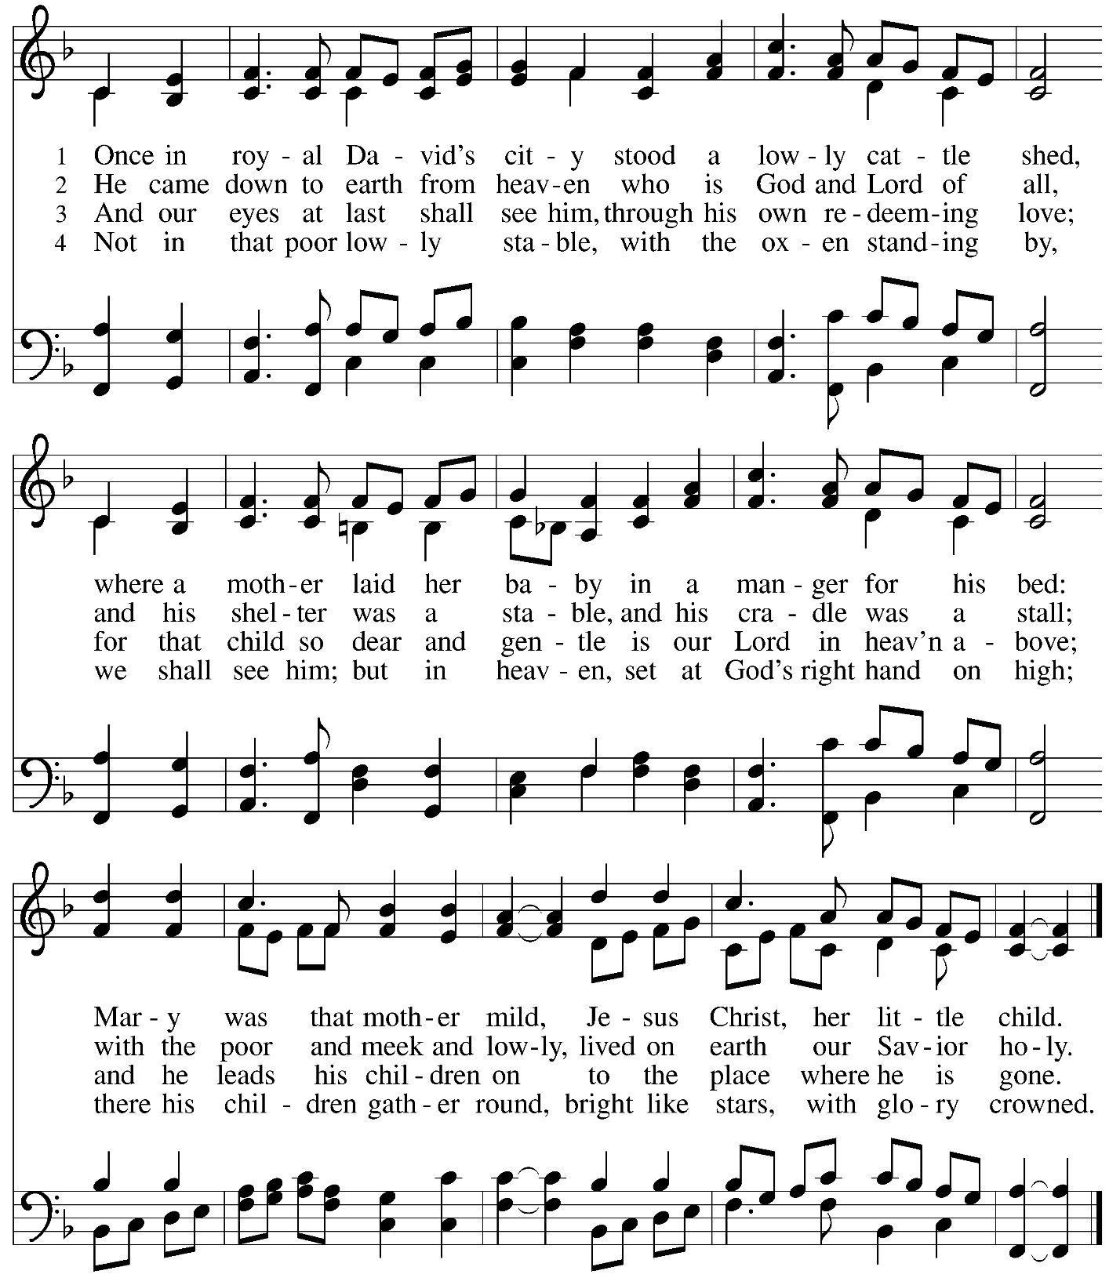

Greeting

P: The grace of our Lord Jesus Christ, the love of God,
and the communion of the Holy Spirit be with you all.
C: And also with you.

Kyrie ELW p. 138

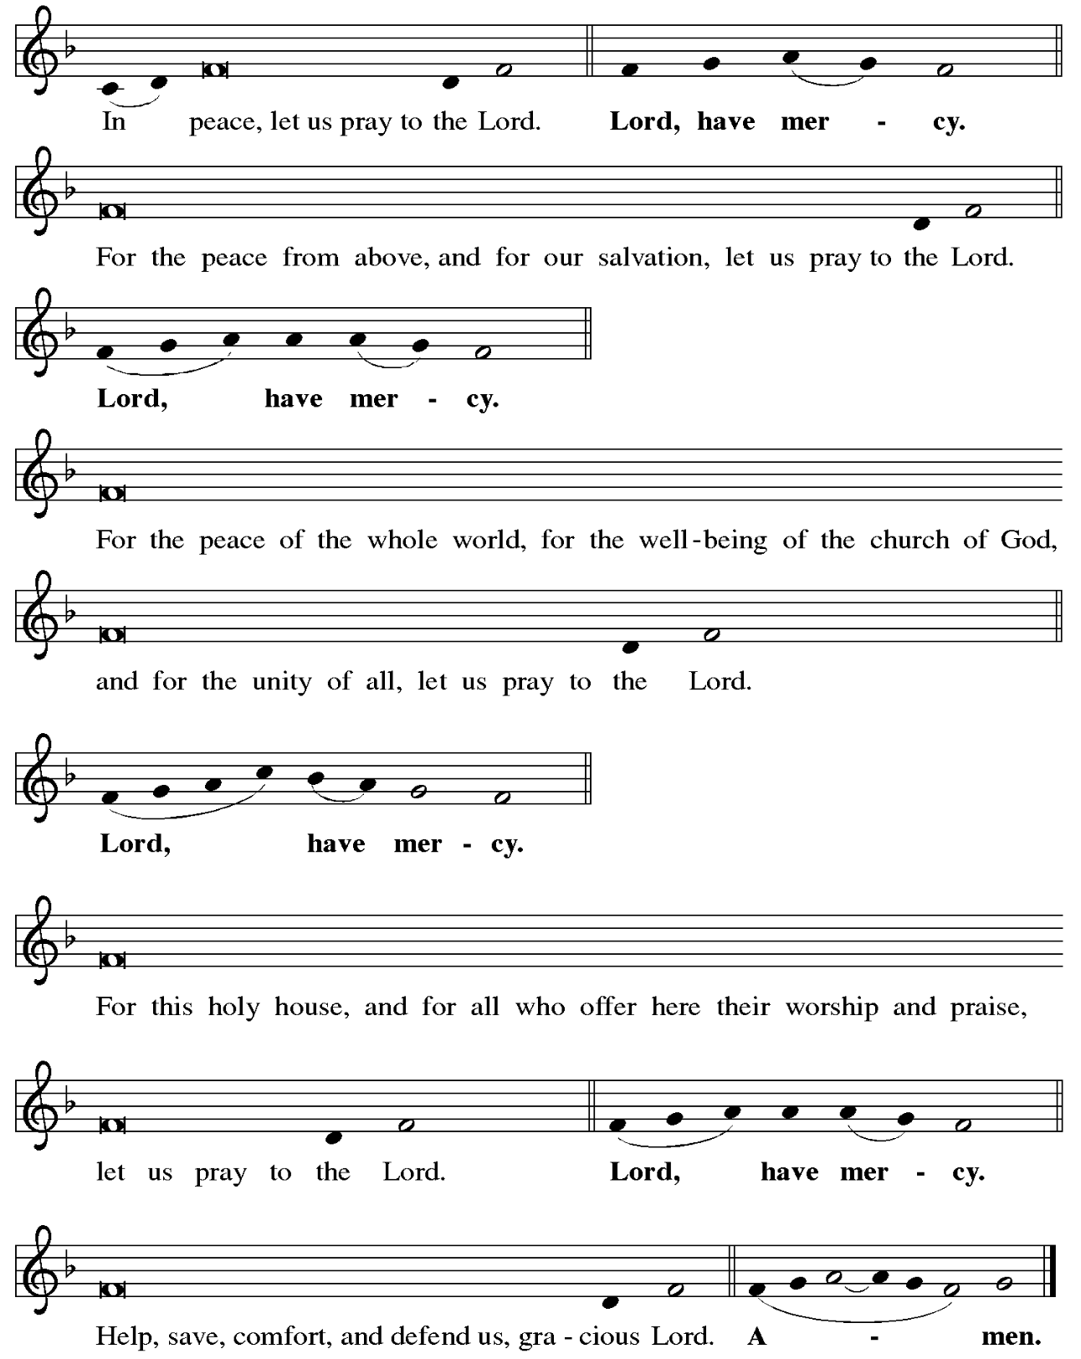

Hymn of Praise Angels We Have Heard on High ELW 289

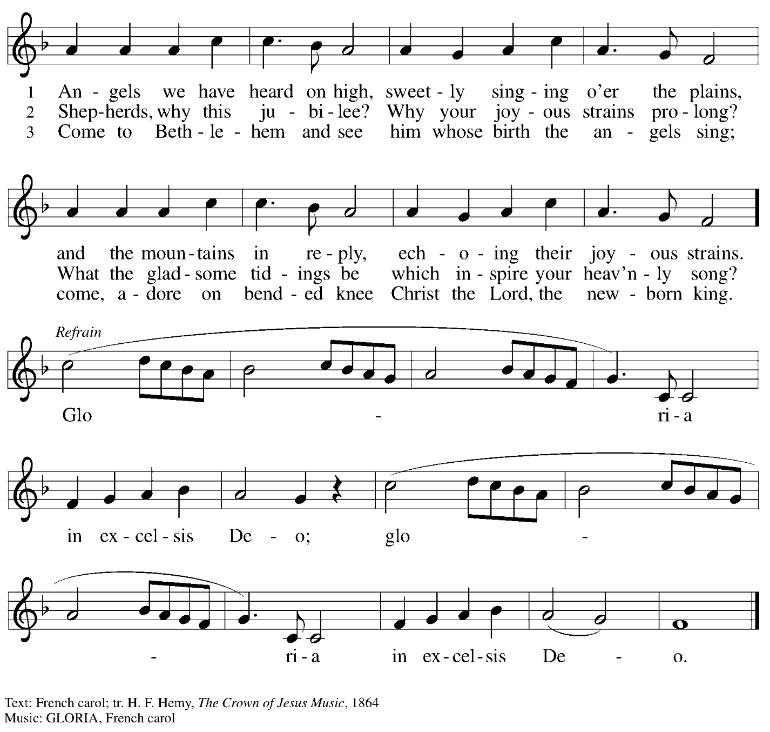

Prayer of the Day

P: The Lord be with you.
C: And also with you.

P: O God our redeemer, you created light that we might live, and you illumine our world with your beloved Son. By your Spirit, comfort us in all darkness, and turn us toward the light of Jesus Christ our Savior, who lives and reigns with you and the Holy Spirit, one God, now and forever.
C: Amen.

Please be seated.

Word
God speaks to us in Scripture reading, preaching, and song

First Reading – Jeremiah 31: 7-14

⁷ Thus says the Lord:
Sing aloud with gladness for Jacob,
and raise shouts for the chief of the nations;
proclaim, give praise, and say,
“Save, O Lord, your people,
the remnant of Israel.”
⁸ See, I am going to bring them from the land of the north
and gather them from the farthest parts of the earth,
among them the blind and the lame,
those with child and those in labor together;
a great company, they shall return here.
⁹ With weeping they shall come,
and with consolations I will lead them back;
I will let them walk by brooks of water,
in a straight path where they shall not stumble,
for I have become a father to Israel,
and Ephraim is my firstborn.
¹⁰ Hear the word of the LORD, O nations,
and declare it in the coastlands far away;
say, “The one who scattered Israel will gather him
and will keep him as a shepherd does a flock.”
¹¹ For the Lord has ransomed Jacob
and has redeemed him from hands too strong for him.
¹² They shall come and sing aloud on the height of Zion,
and they shall be radiant over the goodness of the Lord,
over the grain, the wine, and the oil,
and over the young of the flock and the herd;
their life shall become like a watered garden,
and they shall never languish again.
¹³ Then shall the young women rejoice in the dance,
and the young men and the old shall be merry.
I will turn their mourning into joy;
I will comfort them and give them gladness for sorrow.
¹⁴ I will give the priests their fill of fatness,
and my people shall be satisfied with my bounty,
says the Lord.

L: Word of God, word of life.
C: Thanks be to God.

Psalm 147: 12-20

The psalm will be sung responsively, led by the cantor, with the congregation singing the verses in bold type and joining in the refrain.

Psalm Tone

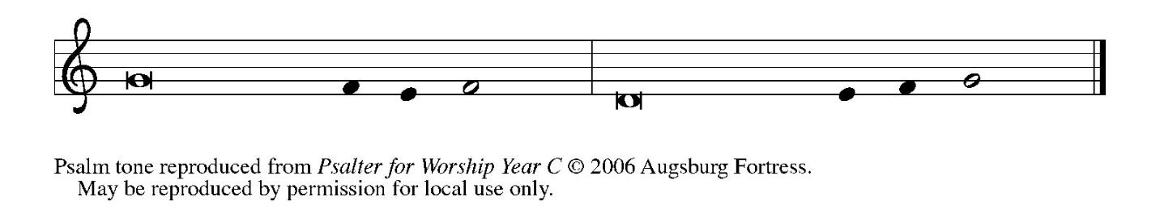

Psalm Refrain

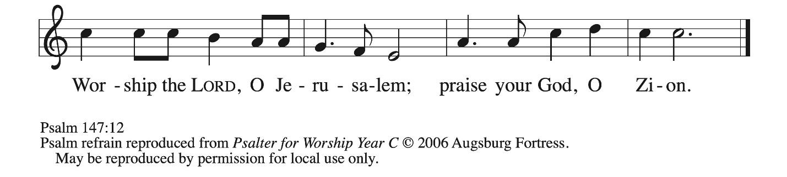

¹² Worship the Lord, | O Jerusalem;
praise your | God, O Zion,
¹³ who has strengthened the bars | of your gates
and has blessed your chil- | dren within you.
¹⁴ God has established peace | on your borders
and satisfies you with the | finest wheat.
¹⁵ God sends out a command | to the earth,
a word that runs | very swiftly. R
¹⁶ God gives | snow like wool,
scattering | frost like ashes.
¹⁷ God scatters | hail like bread crumbs.
Who can stand a- | gainst God’s cold?
¹⁸ The Lord sends forth the | word and melts them;
the wind blows, and the | waters flow.
¹⁹ God declares the | word to Jacob,
statutes and judg- | ments to Israel.
²⁰ The Lord has not done so to any | other nation;
they do not know God’s judgments. | Hallelujah! R

Second Reading – Ephesians 1: 3-14

³ Blessed be the God and Father of our Lord Jesus Christ, who has blessed us in Christ with every spiritual blessing in the heavenly places, ⁴ just as God chose us in Christ before the foundation of the world to be holy and blameless before God in love. ⁵ God destined us for adoption as God’s children through Jesus Christ, according to the good pleasure of God’s will,
⁶ to the praise of God’s glorious grace that God freely bestowed on us in the Beloved. ⁷ In him we have redemption through his blood, the forgiveness of our trespasses, according to the riches of his grace ⁸ that he lavished on us. With all wisdom and insight ⁹ God has made known to us the mystery of God’s will, according to God’s good pleasure that God set forth in Christ, ¹⁰ as a plan for the fullness of time, to gather up all things in him, things in heaven and things on earth. ¹¹ In Christ we have also obtained an inheritance, having been destined according to the purpose of the one who accomplishes all things according to God’s counsel and will, ¹² so that we, who were the first to set our hope on Christ, might live for the praise of his glory. ¹³ In him you also, when you had heard the word of truth, the gospel of your salvation, and had believed in him, were marked with the seal of the promised Holy Spirit; ¹⁴ this is the pledge of our inheritance toward redemption as God’s own people, to the praise of his glory.

L: Word of God, word of life.
C: Thanks be to God.

Please rise as you are able.

Gospel Acclamation ELW p. 142

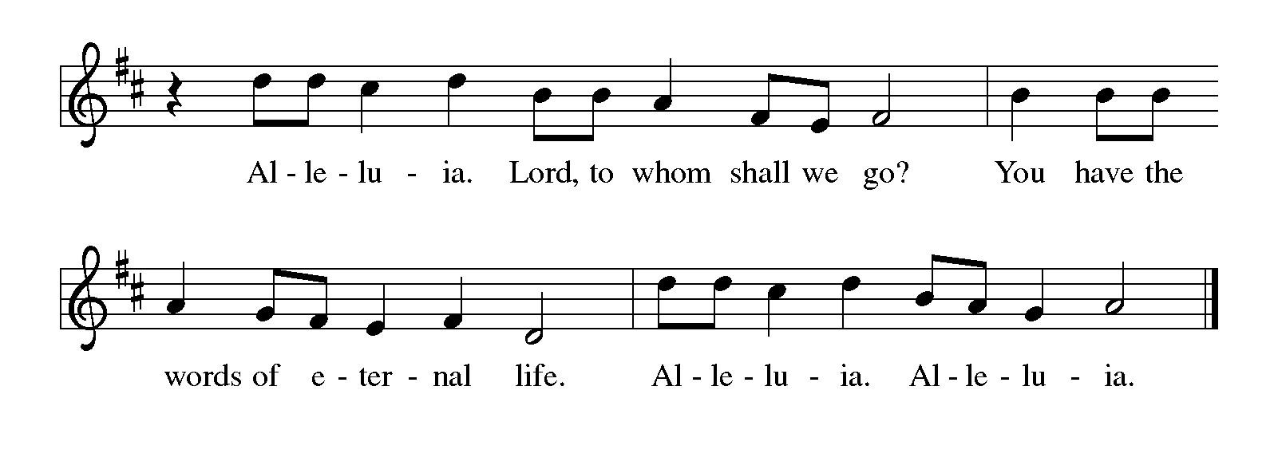
Gospel – John 1: [1-9] 10-18

P: The holy Gospel according to St. John.
C: Glory to you, O Lord.

[¹ In the beginning was the Word, and the Word was with God, and the Word was God. ² The Word was in the beginning with God. ³ All things came into being through him, and without him not one thing came into being. What has come into being ⁴ in him was life, and the life was the light of all people. ⁵ The light shines in the darkness, and the darkness did not overtake it.
⁶ There was a man sent from God whose name was John. ⁷ He came as a witness to testify to the light, so that all might believe through him. ⁸ He himself was not the light, but he came to testify to the light. ⁹ The true light, which enlightens everyone, was coming into the world.]
¹⁰ He was in the world, and the world came into being through him, yet the world did not know him. ¹¹ He came to what was his own, and his own people did not accept him. ¹² But to all who received him, who believed in his name, he gave power to become children of God, ¹³ who were born, not of blood or of the will of the flesh or of the will of humanity, but of God.
¹⁴ And the Word became flesh and lived among us, and we have seen his glory, the glory as of a father’s only son, full of grace and truth. ¹⁵ (John testified to him and cried out, “This was he of whom I said, ‘He who comes after me ranks ahead of me because he was before me.’”) ¹⁶ From his fullness we have all received, grace upon grace. ¹⁷ The law indeed was given through Moses; grace and truth came through Jesus Christ. ¹⁸ No one has ever seen God. It is the only Son, himself God, who is close to the Father’s heart, who has made him known.

P: The Gospel of the Lord.
C: Praise to you, O Christ.

Please be seated.

Sermon

A time of silence for prayer and reflection follows the sermon.
When the hymn of the day begins, please rise as you are able.



Hymn of the Day Word of God, Come Down on Earth ELW 510

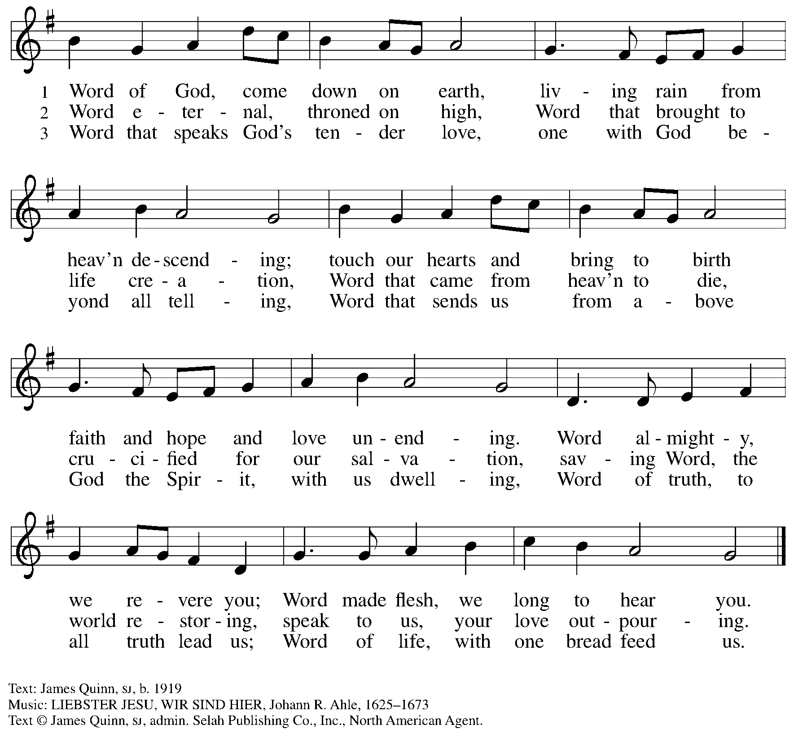
All rights reserved. Reprinted with permission under OneLicense.net # A-722139.

Nicene Creed

C: We believe in one God,
the Father, the Almighty,
maker of heaven and earth,
of all that is, seen and unseen.

We believe in one Lord, Jesus Christ,
the only Son of God,
eternally begotten of the Father,
God from God, Light from Light,
true God from true God,
begotten, not made,
of one Being with the Father;
through him all things were made.
For us and for our salvation
he came down from heaven,
was incarnate of the Holy Spirit and the virgin Mary
and became truly human.
For our sake he was crucified under Pontius Pilate;
he suffered death and was buried.
On the third day he rose again
in accordance with the scriptures;
he ascended into heaven
and is seated at the right hand of the Father.
He will come again in glory to judge the living and the dead,
and his kingdom will have no end.

We believe in the Holy Spirit, the Lord, the giver of life,
who proceeds from the Father and the Son,*
who with the Father and the Son is worshiped and glorified,
who has spoken through the prophets.
We believe in one holy catholic and apostolic church.
We acknowledge one baptism for the forgiveness of sins.
We look for the resurrection of the dead,
and the life of the world to come. Amen.

*Or, “who proceeds from the Father.” The phrase “and the Son” is a later addition to the creed.

Prayers of the People

A: Rejoicing in the good news of Christ’s birth,
let us pray for the church, God’s creation, and all who are in need.

After each petition
A: God of grace,
C: receive our prayer.

P: With joy in our hearts, we commend our prayers to you, O God,
trusting in your boundless mercy and eternal love; through Jesus Christ our Savior.
C: Amen.

Peace

The presiding minister and the assembly greet one another in the peace of the risen Christ.
P: The peace of Christ be with you always.
C: And also with you.

The people may greet those around them with a sign of Christ’s peace and may say
Peace be with you or similar words. Please be mindful that not everyone will be comfortable with sharing the peace, so please seek consent before shaking hands or hugging. Other possible ways to share the peace include a simple bow with the verbal greeting of peace, or simply a verbal expression of peace.

When the greetings of peace have concluded, please be seated.

Meal
God feeds us with the presence of Jesus Christ

Offering

We offer ourselves, our gifts, and our faithful service to God.
As the offering is gathered for the mission of the church, including the care of those in need,
the table is set for Holy Communion.

There are laminated giving cards in the pew racks that feature a QR code for anyone who would like to give online. Those who give using the QR code, as well as those who give regularly online or through their bank are encouraged to place the laminated card in the plate as an expression of your offering.

Reparations Offering

On the first Sunday of each month, St. Andrew invites people of the congregation to give a second offering for a reparations fund in acknowledgment of St. Andrew’s use of African American spiritual songs in our worship services. Please see the note in the announcements for more information.

Offertory Music

As the gifts are brought forward for presentation, please rise as you are able.

Offertory Song In the Bleak Midwinter ELW 294

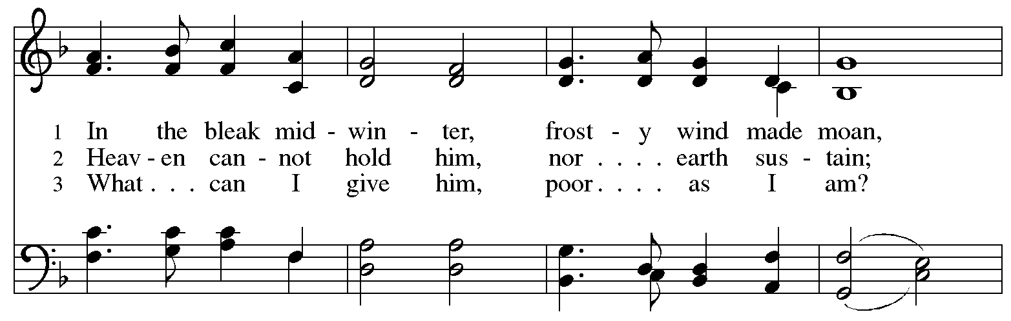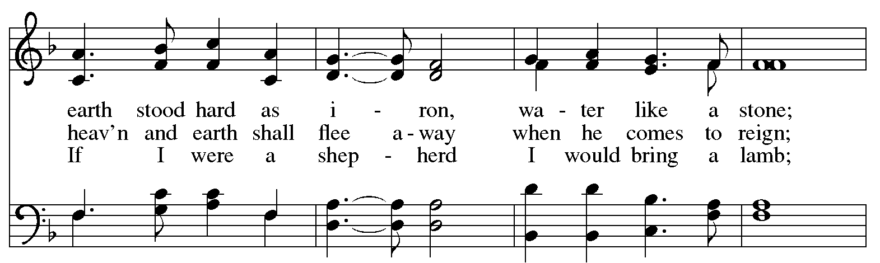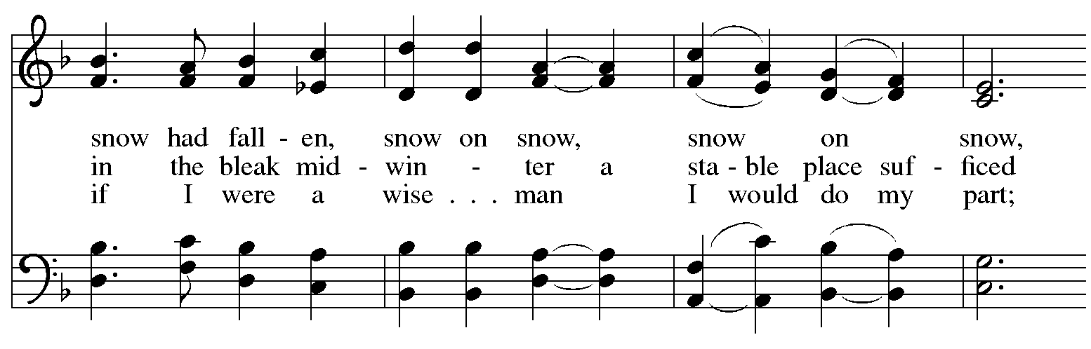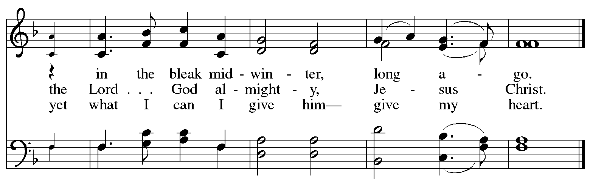

Offertory Prayer

A: Let us pray.
Good and loving God,
C: we rejoice in the birth of Jesus,
who came among the poor to bring the riches of your grace.
As you have blessed us with your gifts, let them be blessing for others.
With the trees of the field, with all earth and heaven,
we shout for joy at the coming of your Son, Jesus Christ our Lord.
Amen.

Dialogue ELW p. 144

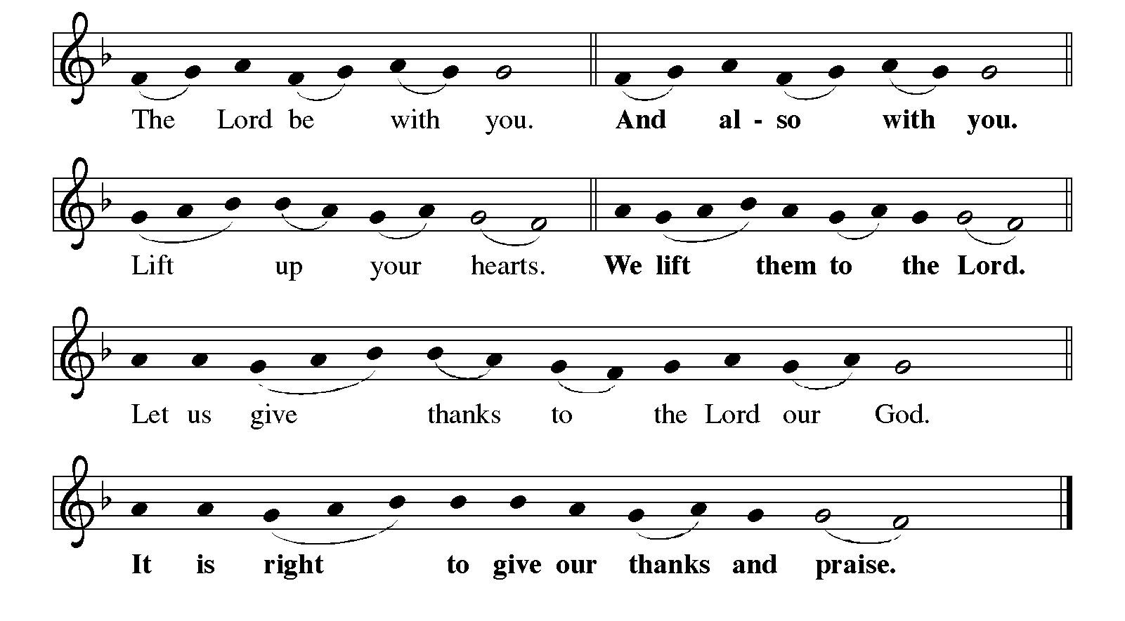

Preface (Sung by the presiding minister)

P: It is indeed right, our duty and our joy,
that we should at all times and in all places
give thanks and praise to you, almighty and merciful God,
through our Savior Jesus Christ.
In the wonder and mystery of the Word made flesh,
you have opened the eyes of faith
to a new and radiant vision of your glory,
that, beholding the God made visible,
we may be drawn to love the God whom we cannot see.
And so, with all the choirs of angels,
with the church on earth and the hosts of heaven,
we praise your name and join their unending hymn:

Sanctus ELW p. 144

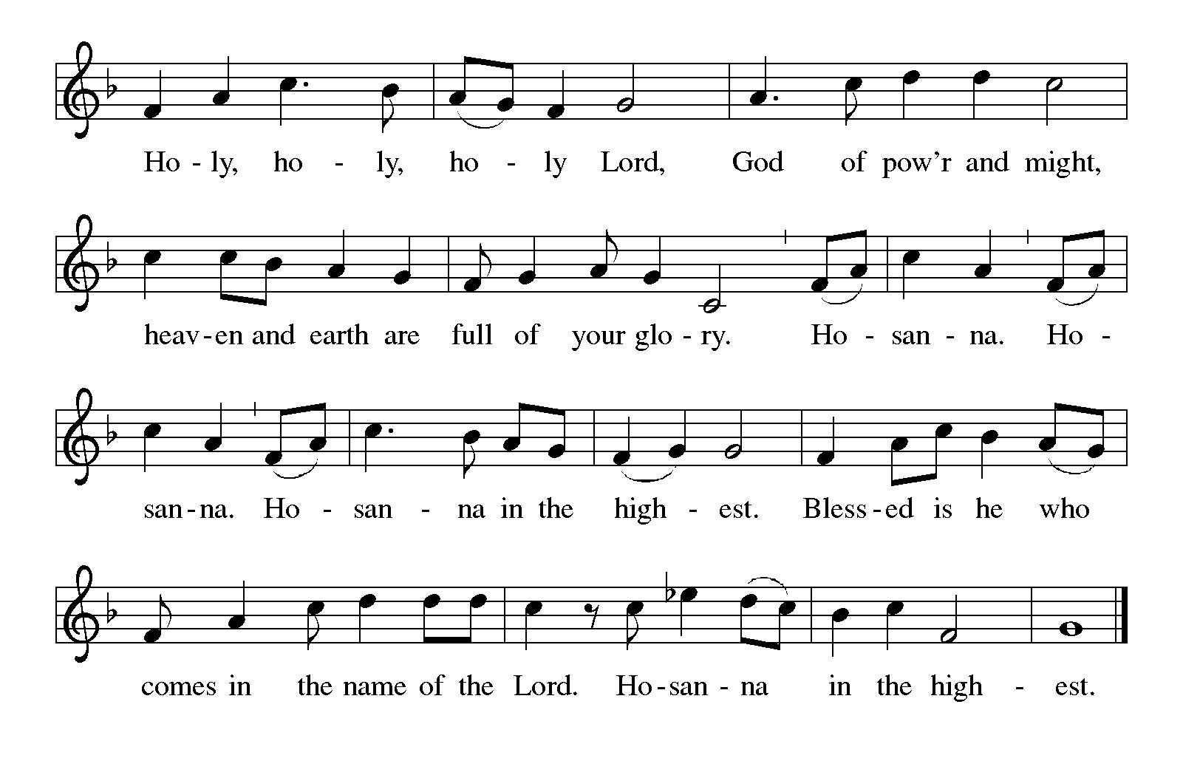
Eucharistic Prayer

P: Holy One, the beginning and the end, the giver of life …
… Do this for the remembrance of me.

P: Let us proclaim the mystery of faith:
C: Christ has died. Christ is risen. Christ will come again.

P: With this bread and cup …
… we look with hope for his coming.
C: Come, Lord Jesus.

P: Holy God, we long for your Spirit …
… Bring the gift of peace on earth.
C: Come, Holy Spirit.

P: All praise and glory are yours,
Holy One of Israel, Word of God incarnate, Power of the Most High,
now and forever.
C: Amen.

Lord’s Prayer

P: Gathered as one by the Holy Spirit, let us pray as Jesus taught us.
C: Our Father in heaven,
hallowed be your name,
your kingdom come,
your will be done,
on earth as in heaven.
Give us today our daily bread.
Forgive us our sins
as we forgive those
who sin against us.
Save us from the time of trial
and deliver us from evil.
For the kingdom, the power,
and the glory are yours,
now and forever. Amen.

Fraction and Invitation


Agnus Dei / Lamb of God ELW p. 146

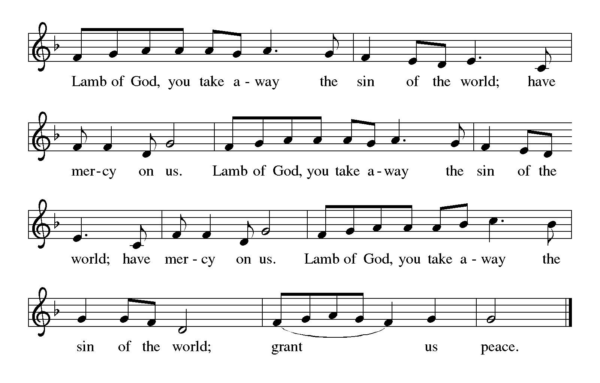

Please be seated.

Holy Communion

- All who seek God and desire a deeper and stronger life in Christ are welcome to receive Holy Communion.
- Worshipers from the pulpit side will proceed forward first, followed by the center section, and then the lectern side.
- Please inform an usher if you would like the ministers to bring Communion to you.
- Holy Communion will be served with bread and wine (amber) or grape juice (purple).
- The presiding minister will first distribute the bread (host) to each communicant. Please indicate if you require a gluten-free host.
- Once you have consumed the bread, please pick up an empty glass from the tray next to the presiding minister. The Communion Assistant will pour wine or grape juice into your glass.
- Please step to the side to consume the wine or grape juice.
- Feel free to kneel at the altar rail for prayer after receiving the sacrament.
- As you return to your pew, glasses may be returned to the empty tray on the side of the center section.
- A blessing will be provided for anyone who does not yet receive the sacrament.
- All are invited to join in singing the hymns during Holy Communion.

Hymns during Holy Communion
Love Has Come ELW 292

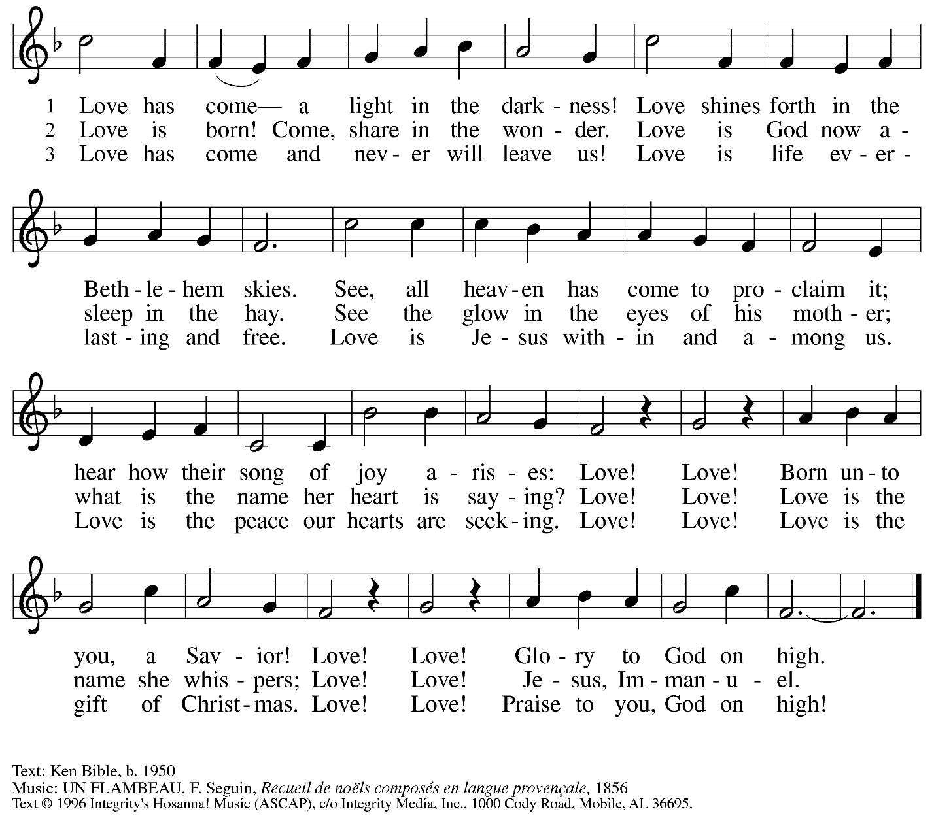
All rights reserved. Reprinted with permission under OneLicense.net # A-722319.

Hymns during Holy Communion
Let All Together Praise Our God ELW 287

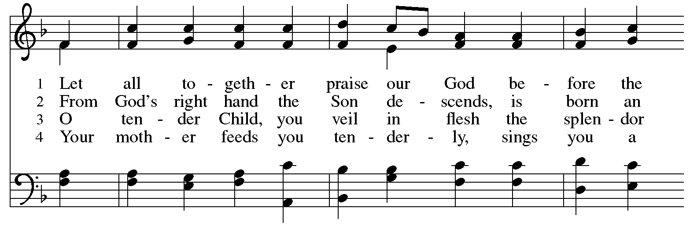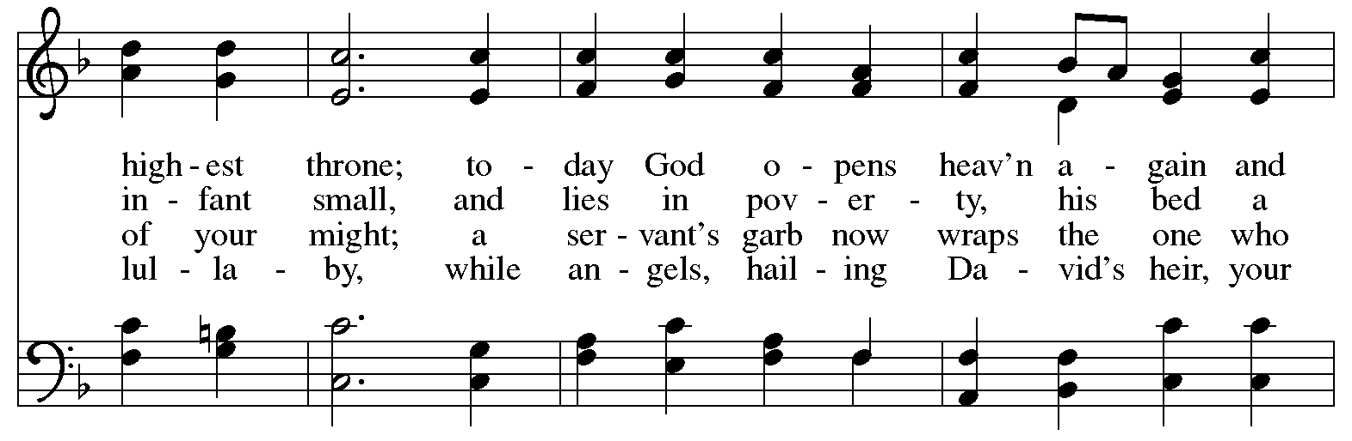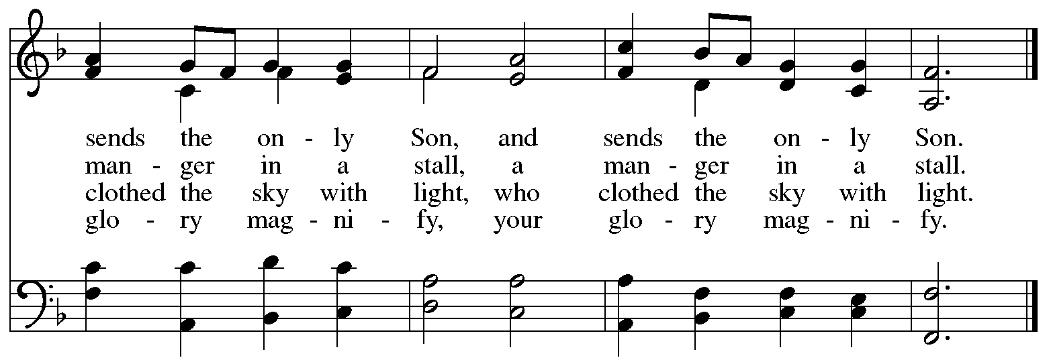

Hymns during Holy Communion
Good Christian Friends, Rejoice ELW 288

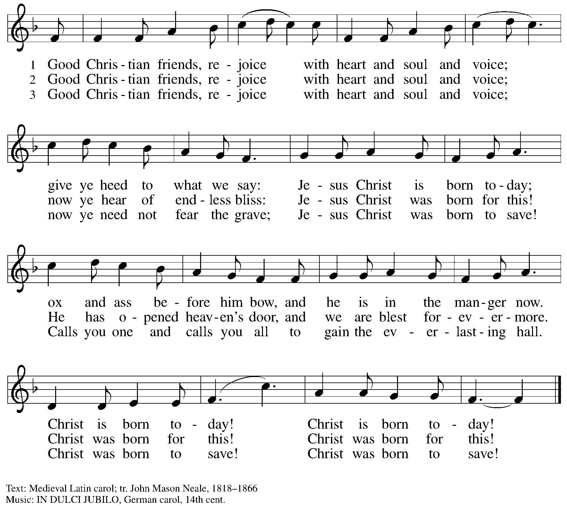

When all have returned to their places, please rise as you are able.

Blessing

P: The body and blood of our Lord Jesus Christ strengthen you and keep you in his grace.
C: Amen.

Nunc Dimittis

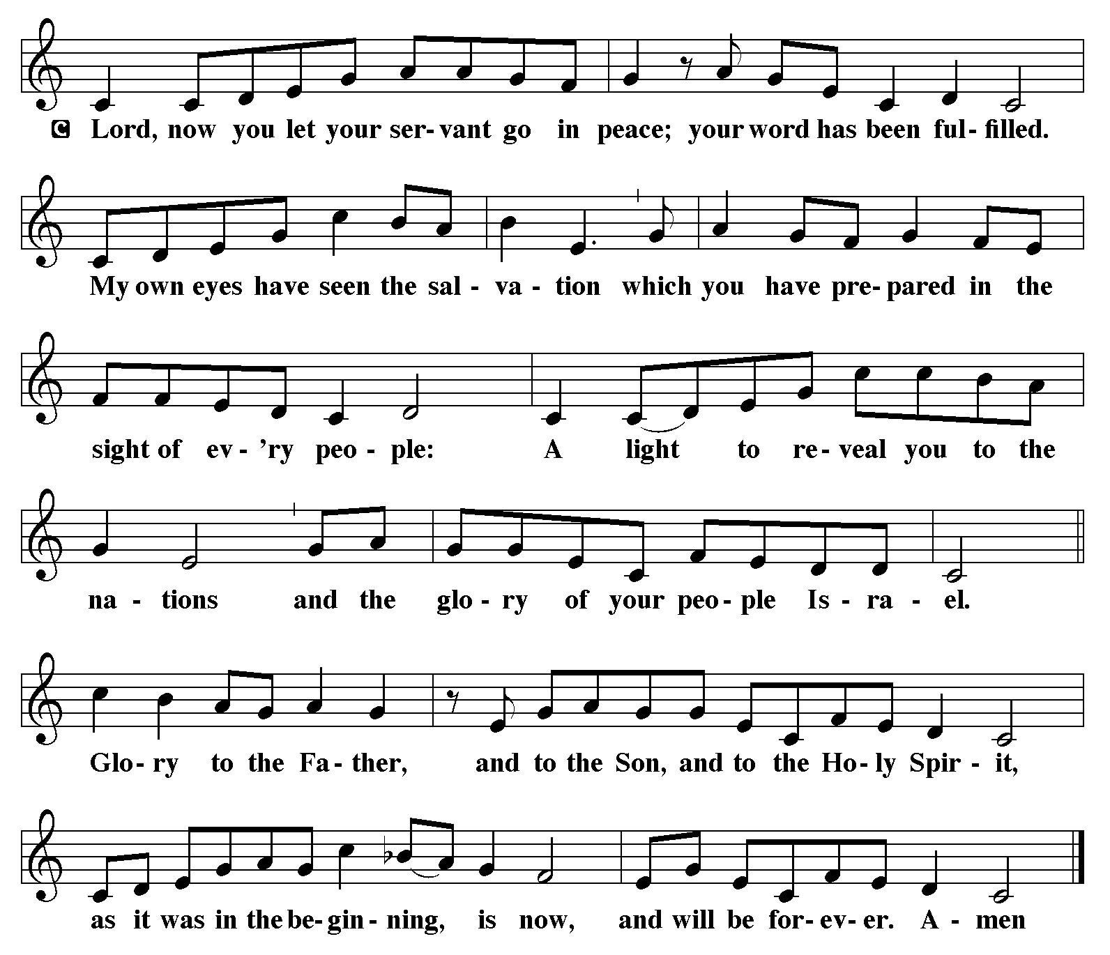

Prayer

A: Let us pray.
Radiant God,
with our eyes we have seen your salvation, and in this meal, we have feasted on your grace.
May your Word take flesh in us, that we may be your holy people,
revealing your glory made known to us in Jesus Christ, our Savior and Lord.
C: Amen.

Please be seated.

Sending
God blesses us and sends us in mission to the world

Announcements

Please rise as you are able.

On January 6th, the Christian Church celebrates the Epiphany of our Lord.
From a word for “manifestation,” Epiphany and the season that follows focus on the light of Christ revealed to people of all nations, as represented by the shining star at Jesus’ birth, and the Magi from the east who followed it to Bethlehem to pay homage to the newborn king.
We move toward Epiphany with the reading of Matthew’s Gospel.

Epiphany Gospel – Matthew 2: 1-12

P: The holy Gospel, according to St. Matthew.
C: Glory to you, O Lord.

¹ In the time of King Herod, after Jesus was born in Bethlehem of Judea, magi from the east came to Jerusalem, ² asking, “Where is the child who has been born king of the Jews? For we observed his star in the east and have come to pay him homage.” ³ When King Herod heard this, he was frightened, and all Jerusalem with him, ⁴ and calling together all the chief priests and scribes of the people, he inquired of them where the Messiah was to be born. ⁵ They told him, “In Bethlehem of Judea, for so it has been written by the prophet:
⁶ ‘And you, Bethlehem, in the land of Judah,
are by no means least among the rulers of Judah,
for from you shall come a ruler
who is to shepherd my people Israel.’ ”
⁷ Then Herod secretly called for the magi and learned from them the exact time when the star had appeared. ⁸ Then he sent them to Bethlehem, saying, “Go and search diligently for the child, and when you have found him, bring me word so that I may also go and pay him homage.”
⁹ When they had heard the king, they set out, and there, ahead of them, went the star that they had seen in the east, until it stopped over the place where the child was. ¹⁰ When they saw that the star had stopped, they were overwhelmed with joy. ¹¹ On entering the house, they saw the child with Mary his mother, and they knelt down and paid him homage. Then, opening their treasure chests, they offered him gifts of gold, frankincense, and myrrh. ¹² And having been warned in a dream not to return to Herod, they left for their own country by another road.

P: The Gospel of the Lord.
C: Praise to you, O Christ.

Benediction

P: God bless you and keep you,
☩ Jesus grant you grace and truth,
and the Holy Spirit send peace upon your hearts,
now and forever.
C: Amen.

Sending Hymn Brightest and Best of the Stars ELW 303
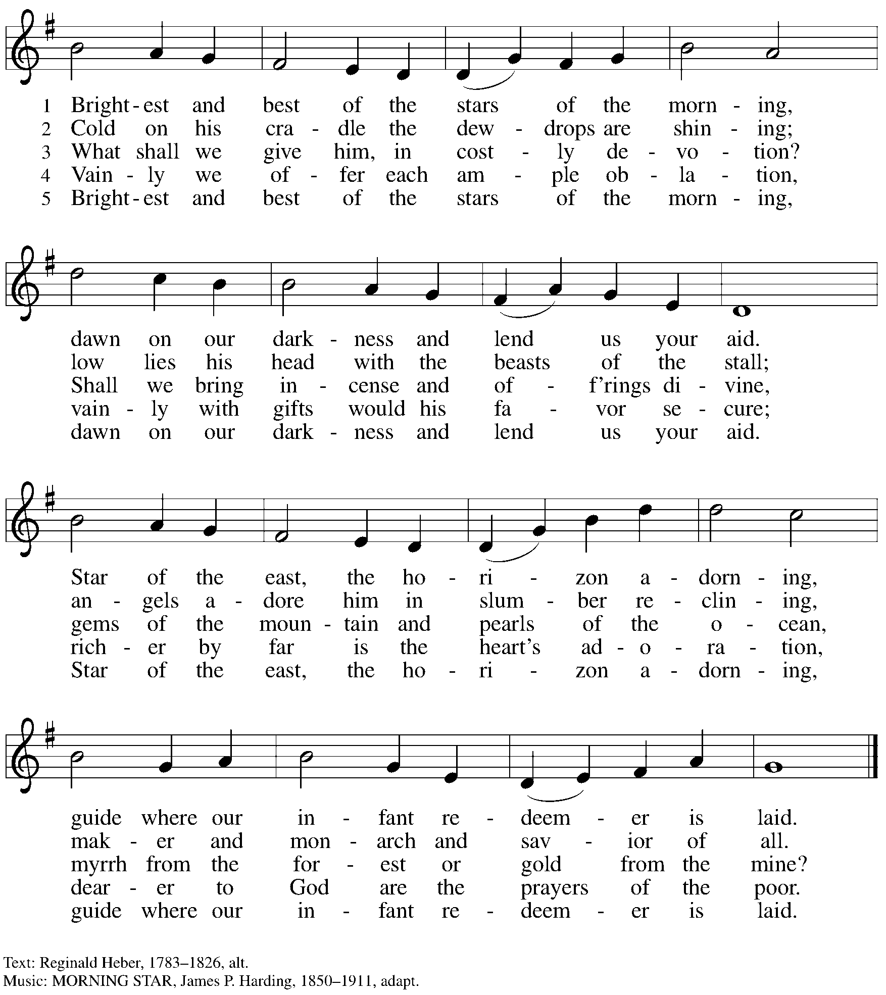

Dismissal

A: Go in peace. Share the good news!
C: Thanks be to God!

Postlude

Serving in Worship Today

Altar Care Jodie Minor
Assisting Minister Jeff Denlinger
AV Team Kristen Asplin
Tyler Rietze
Cantor Timothy Kocher-Hillmer
Lector Kelly Spanninger
Minister of Music Laura Reynolds
Presiding Minister The Rev. Ross Carmichael

Liturgy and Hymnody Acknowledgements

From SundaysandSeasons.com. Copyright © 2026 Augsburg Fortress. All rights reserved. Reprinted under OneLicense.net # A-722139.
Used by permission of Augsburg Fortress.

The Scripture readings contained herein are from New Revised Standard Version Updated Edition of the Bible © 2021 National Council of Churches of Christ in the United States of America. Used by permission. All rights reserved worldwide.

Let All Together Praise Our God – Text: Nikolaus Herman, 1480-1561; tr. hymnal version. Music: LOBT GOTT, IHR CHRISTEN, Nikolaus Herman. Text © 2006 Augsburg Fortress. All rights reserved. Reprinted under OneLicense.net # A-722139.

Please use the QR code below to link to St. Andrew’s Announcements online!


St. Andrew Lutheran Church Announcements
January 4th, 2026

- Welcome to Worship at St. Andrew on the Second Sunday of Christmas! – We are thankful you are here, and we offer a special welcome to all visitors and guests who are here for the first time! A nursery is available through the door to the left of the worship space and across the social hall (look for a purple room). There are also worship “toolkits” to help children engage with worship and “busy bags” for younger children available in the bookcase at the back of the sanctuary. Please feel free to take one to use with/for your children.
- Little Church - Big Faith will resume on January 11th.
- Monthly Reparations Offering Today, January 4th, during Worship – In Luke’s Gospel, Jesus tells a story about a compassionate Samaritan, suggesting that God’s people are called to work for healing and restoration for our neighbors, regardless of who or what caused them harm. In light of this, St. Andrew has made a commitment to reparations in regard to African American spiritual songs used in our worship. The text and music of most hymns is attributed to specific authors, with copyrights in place, usage reported, and royalties paid to those whose works are featured in worship. With African American spirituals, this is not possible. In response to many years of such uncredited use, St. Andrew invites the congregation to give a reparations offering. Funds received in worship will be donated to our siblings at Bethel AME Church, whose land and building were taken from them in the 1950s, to fund their development in the Hill District.
- Help Take Down Christmas Decorations Today, January 4th – Thank you to everyone who helped decorate the church for the Christmas season this past Sunday, December 21st. Though it is not as fun as decorating for Christmas, we also need help taking down and putting away all the decorations from the season. It is especially helpful to have people who can carry items downstairs to the basement. The Christmas season concludes with the Epiphany of our Lord on January 6th, so we will take down the Christmas decorations today. Thank you!
- Volunteers needed with WPA BOLD Holiday Party, Sunday, January 18th, after Worship – For several years, the Western PA Blind Outdoor Leisure Development Organization (BOLD), has been holding their holiday parties at St. Andrew, and they will do so again on Sunday, January 18th, from 1:00 pm - 5:30 pm. The group has asked for volunteers from the congregation there that day to help set up (this can be done after coffee hour), greet members and help them to find seats, assist with serving buffet food, leading and helping people to get food, and cleanup. If you are willing to help, please speak with Pastor Ross. Thank you very much.
- Produce Distribution Supplemental Food of the Month – St. Andrew is collecting supplemental food each month to accompany our produce distribution. For January, we ask for donations of rice. There are collection boxes at the back of the worship space and social hall.
- January Produce Distributions, First and Third Tuesday Each Month, January 6th and 20th at 5:30 p.m. – St. Andrew partners with Greater Pittsburgh Community Food Bank to serve as a distribution site for fresh produce on the first and third Tuesday of every month. Next month’s distributions will be on Tuesday, January 6th and 20th. We invite people of the congregation to help with the distribution from 5:30 p.m. - 6:30 p.m. and/or to help with unloading and setup during the day between 10:00 a.m. and 1:00 p.m.
- “Christ in Our Home” Booklets Available – “Christ in Our Home” is a quarterly devotional resource that encourages readers to live out their faith daily. Each reflective reading is accompanied by a daily scripture reference and prayer for the day. The January-March booklets are available at the entrances. Please feel free to take one home!
- Coffee Hour Signups – St. Andrew provides hospitality during a coffee hour after worship each Sunday. If you would like to participate and would like information about the duties of setting up, please sign up using the following form: https://www.signupgenius.com/go/5080B4AAFAF2CABF85-47069030-coffee#/.
- Prayer Team – St. Andrew maintains a list of weekly prayer concerns. To opt in, or if you have a prayer request, please contact: prayerteam@standrewpittsburgh.org.
- Records Update – St. Andrew is seeking to update our records with information to be used within the congregation for celebrations, milestones, and in prayers of the church. Please fill out the form at: https://forms.gle/kKvp19UozuRrhhaV7.

