

+ Second Sunday after Epiphany
January 18, 2026



St. Andrew Lutheran Church
304 Morewood Ave.
Pittsburgh, PA 15213
St_andrewELCA@verizon.net
www.standrewpittsburgh.org

+ Second Sunday after Epiphany
Order for Worship

Today’s gospel opens with further reflection on Jesus’ baptism. He is the Lamb of God who takes away the sin of the world and the one anointed by the Spirit. In the liturgy we come and see Christ revealed among us in word and meal. We go forth to invite others to come and worship the Holy One and to receive the gifts of grace and peace made known among us.

Welcome to St. Andrew!
- St. Andrew welcomes all who are seeking a place of healing, wholeness, and acceptance in a nurturing and faith-forming spiritual home. We are striving toward racial equity worldwide
and we seek to honor the lived experience of all individuals regardless of background. Our community embraces people of all ages, ethnicities, cultures, abilities, sexual orientations,
gender identities and expressions, and family constellations. Come and See!
- Worship Services are live-streamed to multiple online platforms. By attending worship, you agree that your image and voice may be broadcast.
- Everyone is invited to make a name tag at the black bookcase in the back of the worship space if they would like. There are stickers indicating pronouns on the bookcase if you would like to include them on your name tag.
- A nursery is available through the doors at the left side of the sanctuary and across from the doorway to the Social Hall. Look for a purple-colored room.
- Children are invited to attend Little Church – Big Faith, a Bible lesson and activity, during worship (after the Prayer of the Day). The group returns to the worship space for the liturgy of Holy Communion.
- Worship “toolkits” to help children engage with the service, along with “busy bags” for younger children, are available in the bookcase at the back of the sanctuary. Please feel free to take one to use with/for your children.
- Holy Communion is served with bread (gluten-free available) and wine or grape juice. The presiding minister will distribute the bread (host). Please consume this and then pick up an empty glass from the tray. The Communion Assistant will pour wine or grape juice into your glass. Please step to the side to consume the wine or grape juice. Feel free to kneel at the altar for prayer and reflection. As you return to your pew, glasses may be returned to the empty trays on either side of the center section.
- A restroom is available on the main level of the church, through the doors to the Social Hall and to the right in the main office.

Abbreviations
P: Pastor/Presiding Minister ELW: Evangelical Lutheran Worship hymnal
A: Assisting Minister ACS: All Creation Sings hymnal
L: Lector
C: Congregation

Musical Offering

Each week, different people from the congregation make an offering of pre-service music, with singing or instrumentation, to help the assembly focus and pray in preparation for worship.

Welcome

Prelude When a Star Is Shining arr. Moore

Gathering
The Holy Spirit calls us together as the people of God

Please rise as you are able. All may make the sign of the cross,
the sign that is marked at Baptism, as the presiding minister begins.

Confession and Forgiveness

P: Blessed be the holy Trinity, ☩ one God,
the fountain of living water,
the rock who gave us birth,
our light and our salvation.
C: Amen.

P: Let us confess our sin in the presence of God and of one another.

Silence is kept for reflection.

P: Most merciful God,
C: we confess that we are captive to sin and cannot free ourselves.
We have sinned against you in thought, word, and deed,
by what we have done and by what we have left undone.
We have not loved you with our whole heart;
we have not loved our neighbors as ourselves.
For the sake of your Son, Jesus Christ, have mercy on us.
Forgive us, renew us, and lead us,
so that we may delight in your will and follow in your ways,
to the glory of your holy name. Amen.

P: By water and the Holy Spirit God gives you a new birth,
and through the death and resurrection of ☩ Jesus Christ, God forgives you all your sins.
The God of mercy strengthen you in all goodness and keep you in eternal life.
C: Amen.

Gathering Hymn Light Shone in Darkness ELW 307

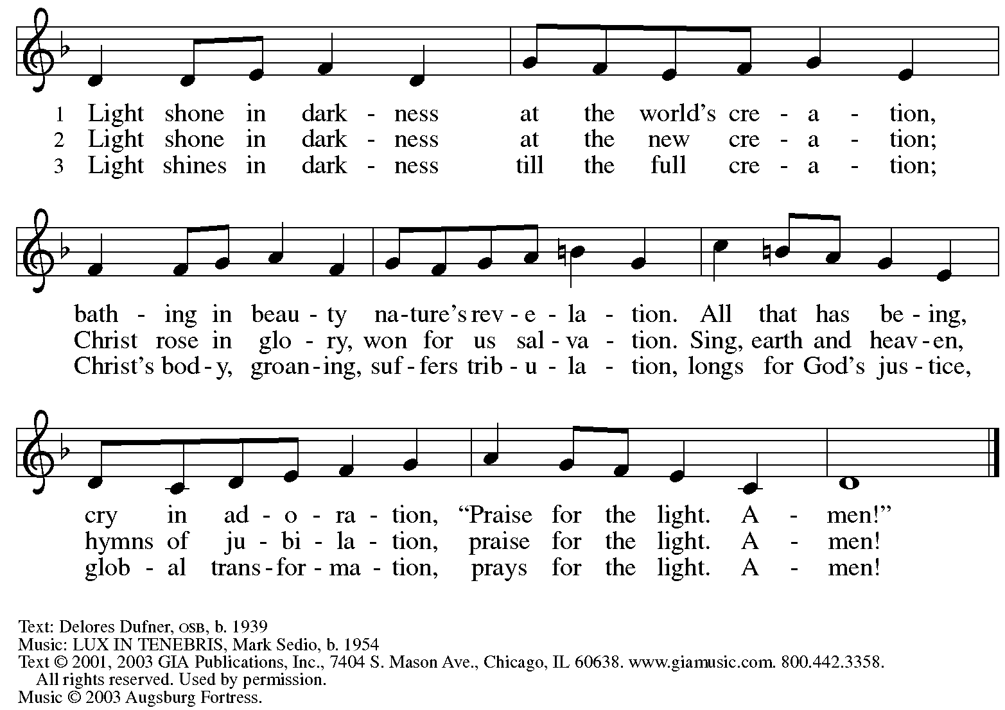
Reprinted under OneLicense.net # A-722139.

Greeting

P: The grace of our Lord Jesus Christ, the love of God,
and the communion of the Holy Spirit be with you all.
C: And also with you.

Hymn of Praise ACS p. 31

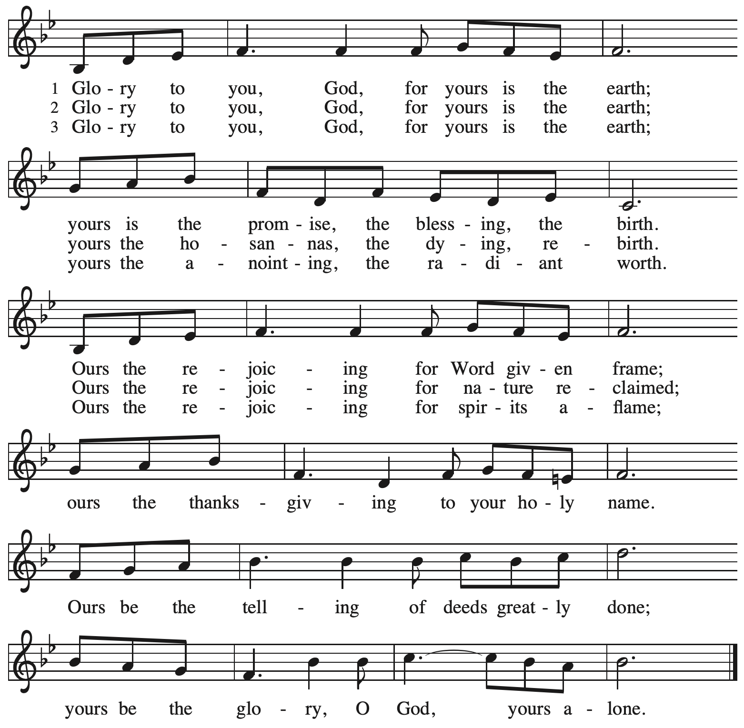

Prayer of the Day

P: The Lord be with you.
C: And also with you.

P: Holy God, our strength and our redeemer, by your Spirit hold us forever,
that through your grace we may worship you and faithfully serve you,
follow you and joyfully find you, through Jesus Christ, our Savior and Lord.
C: Amen.

Please be seated.

Word
God speaks to us in Scripture reading, preaching, and song

First Reading – Isaiah 49: 1-7

¹ Listen to me, O coastlands;
pay attention, you peoples from far away!
The Lord called me before I was born;
while I was in my mother’s womb the Lord named me.
² The Lord made my mouth like a sharp sword;
in the shadow of the Lord’s hand the Lord hid me;
the Lord made me a polished arrow;
in the Lord’s quiver the Lord hid me away.
³ And the Lord said to me, “You are my servant,
Israel, in whom I will be glorified.”
⁴ But I said, “I have labored in vain;
I have spent my strength for nothing and vanity;
yet surely my cause is with the Lord
and my reward with my God.”

⁵ And now the Lord says,
who formed me in the womb to be the Lord’s servant,
to bring Jacob back to the Lord,
and that Israel might be gathered to the Lord,
for I am honored in the sight of the Lord,
and my God has become my strength—
⁶ God says,
“It is too light a thing that you should be my servant
to raise up the tribes of Jacob
and to restore the survivors of Israel;
I will give you as a light to the nations,
that my salvation may reach to the end of the earth.”
⁷ Thus says the Lord,
the Redeemer of Israel and his Holy One,
to one deeply despised, abhorred by the nations,
the slave of rulers,
“Kings shall see and stand up;
princes, and they shall prostrate themselves,
because of the Lord, who is faithful,
the Holy One of Israel, who has chosen you.”

L: Word of God, word of life.
C: Thanks be to God.

Psalm 40: 1-11

The psalm will be sung responsively, led by the cantor, with the congregation singing the verses in bold type and joining in the refrain.

Psalm Tone

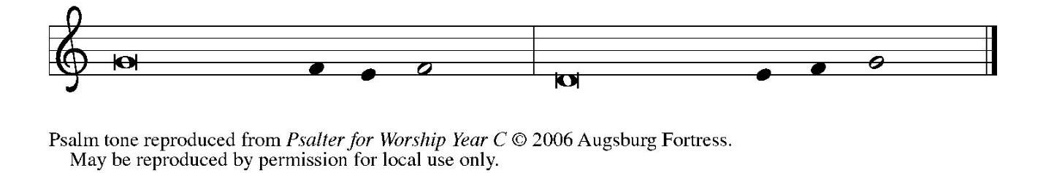

Psalm Refrain

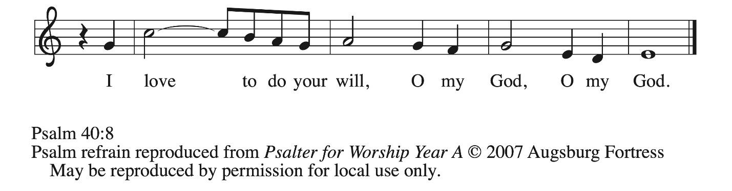

¹ I waited patiently up- | on the Lord,
who stooped to me and | heard my cry.
² The Lord lifted me out of the desolate pit, out of the | miry clay,
and set my feet upon a high cliff, making my | footing sure.
³ The Lord put a new song in my mouth, a song of praise | to our God;
many shall see, and stand in awe, and put their trust | in the Lord.
⁴ Happy are they who trust | in the Lord!
They do not turn to enemies or to those who | follow lies. R
⁵ Great are the wonders you have done, O Lord my God! In your plans for us, none can be com- | pared with you!
Oh, that I could make them known and tell them! But they are more than | I can count.
⁶ Sacrifice and offering you do | not desire;
you have opened my ears: burnt-offering and sin-offering you have | not required. R
⁷ And so I said, “Here I | am; I come.
In the scroll of the book it is writ- | ten of me:
⁸ ‘I love to do your will, | O my God;
your law is | deep within me.’ ”
⁹ I proclaimed righteousness in the | great assembly;
I have not restrained my lips, O | Lord, you know.
¹⁰ I have not hidden your righteousness in my heart; I have spoken of your faithfulness and | your deliverance;
I have not concealed your steadfast love and truth from the | great assembly.
¹¹ You are the Lord; do not withhold your compas- | sion from me;
may your steadfast love and your truth continually | keep me safe. R

Second Reading – 1 Corinthians 1: 1-9

¹ Paul, called to be an apostle of Christ Jesus by the will of God, and our brother Sosthenes,
² To the church of God that is in Corinth, to those who are sanctified in Christ Jesus, called to be saints, together with all those who in every place call on the name of our Lord Jesus Christ, both their Lord and ours:
³ Grace to you and peace from God our Father and the Lord Jesus Christ.
⁴ I give thanks to my God always for you because of the grace of God that has been given you in Christ Jesus, ⁵ for in every way you have been enriched in him, in speech and knowledge of every kind ⁶ just as the testimony of Christ has been strengthened among you ⁷ so that you are not lacking in any gift as you wait for the revealing of our Lord Jesus Christ. ⁸ He will also strengthen you to the end, so that you may be blameless on the day of our Lord Jesus Christ.
⁹ God is faithful, by whom you were called into the partnership of God’s Son, Jesus Christ our Lord.

L: Word of God, word of life.
C: Thanks be to God.

Please rise as you are able.

Gospel Acclamation ACS p. 33

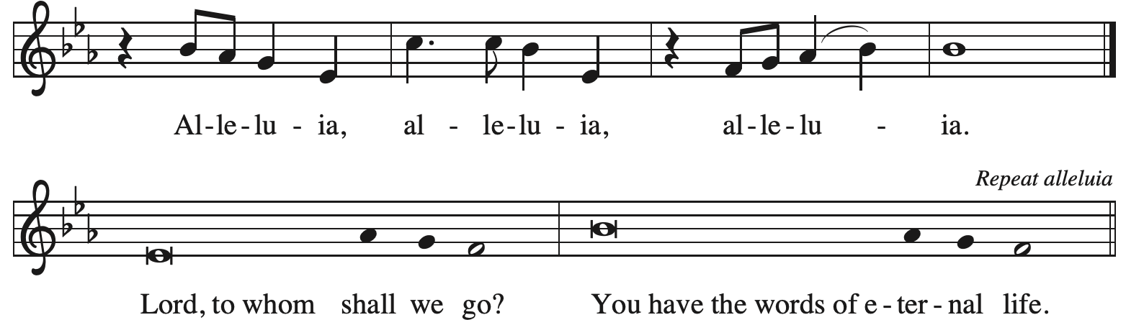

Gospel – John 1: 29-42

P: The holy Gospel according to St. John.
C: Glory to you, O Lord.

²⁹ [John the Baptist] saw Jesus coming toward him and declared, “Here is the Lamb of God who takes away the sin of the world! ³⁰ This is he of whom I said, ‘After me comes a man who ranks ahead of me because he was before me.’ ³¹ I myself did not know him, but I came baptizing with water for this reason, that he might be revealed to Israel.” ³² And John testified, “I saw the Spirit descending from heaven like a dove, and it remained on him. ³³ I myself did not know him, but the one who sent me to baptize with water said to me, ‘He on whom you see the Spirit descend and remain is the one who baptizes with the Holy Spirit.’ ³⁴ And I myself have seen and have testified that this is the Chosen One.”
³⁵ The next day John again was standing with two of his disciples, ³⁶ and as he watched Jesus walk by he exclaimed, “Look, here is the Lamb of God!” ³⁷ The two disciples heard him say this, and they followed Jesus. ³⁸ When Jesus turned and saw them following, he said to them, “What are you looking for?” They said to him, “Rabbi” (which translated means Teacher), “where are you staying?” ³⁹ He said to them, “Come and see.” They came and saw where he was staying, and they remained with him that day. It was about four o’clock in the afternoon. ⁴⁰ One of the two who heard John speak and followed him was Andrew, Simon Peter’s brother. ⁴¹ He first found his brother Simon and said to him, “We have found the Messiah” (which is translated Anointed). ⁴² He brought Simon to Jesus, who looked at him and said, “You are Simon son of John. You are to be called Cephas” (which is translated Peter).

P: The Gospel of the Lord.
C: Praise to you, O Christ.

Please be seated.

Sermon

A time of silence for prayer and reflection follows the sermon.
When the hymn of the day begins, please rise as you are able.



Hymn of the Day Come and See ACS 976

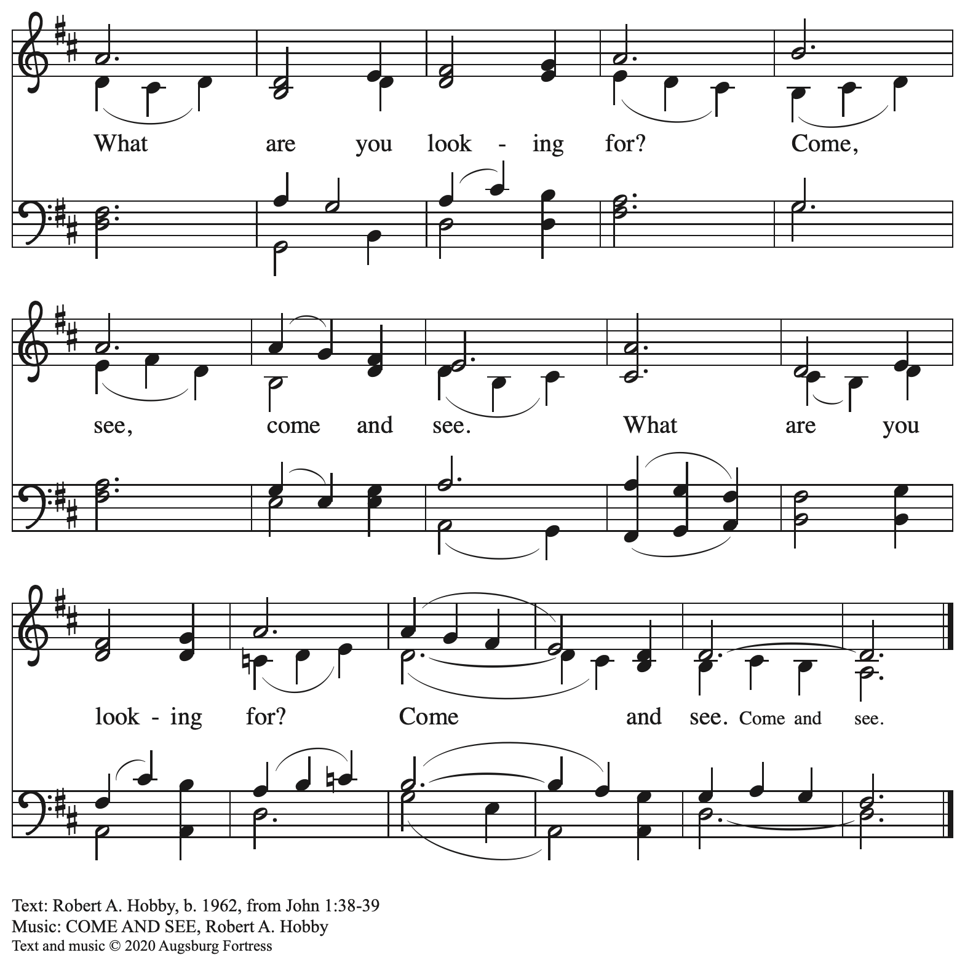
All rights reserved. Reprinted with permission under OneLicense.net # A-722139.

Apostles’ Creed

C: I believe in God, the Father almighty,
creator of heaven and earth.

C: I believe in Jesus Christ, God’s only Son, our Lord,
who was conceived by the Holy Spirit,
born of the virgin Mary,
suffered under Pontius Pilate,
was crucified, died, and was buried;
he descended to the dead.*
On the third day he rose again;
he ascended into heaven,
he is seated at the right hand of the Father,
and he will come to judge the living and the dead.

I believe in the Holy Spirit,
the holy catholic church,
the communion of saints,
the forgiveness of sins,
the resurrection of the body,
and the life everlasting. Amen.

*Or, “he descended into hell,” another translation of this text in widespread use.

Please be seated.

Prayers of the People

A: As God’s beloved children united in Christ, let us pray for the church,
the world, and the whole human community.

After each petition
A: Merciful God,
C: receive our prayer.

The presiding minister concludes the prayers.
P: Confident that the Holy Spirit receives our prayers and answers us,
we commend all for whom we pray to God’s loving-kindness
revealed to us through Jesus Christ our Savior.
C: Amen.

Peace

The presiding minister and the assembly greet one another in the peace of the risen Christ.
P: The peace of Christ be with you always.
C: And also with you.

The people may greet those around them with a sign of Christ’s peace and may say
Peace be with you or similar words. Please be mindful that not everyone will be comfortable with sharing the peace, so please seek consent before shaking hands or hugging.
Other possible ways to share the peace include a simple bow with the verbal greeting of peace, or simply a verbal expression of peace.

When the greetings of peace have concluded, please be seated.



Meal
God feeds us with the presence of Jesus Christ

Offering

We offer ourselves, our gifts, and our faithful service to God.
As the offering is gathered for the mission of the church, including the care of those in need,
the table is set for Holy Communion.

There are laminated giving cards in the pew racks that feature a QR code for anyone who would like to give online. Those who give using the QR code, as well as those who give regularly online or through their bank are encouraged to place the laminated card in the plate as an expression of your offering.

Noisy Offering

St. Andrew’s children lead the congregation in a special offering. As they carry buckets around the sanctuary, people of the congregation are invited to throw in their change as an offering. This month’s offering will support Hello Neighbor, a local organization that “empowers refugees and immigrants through community connections, ensuring their journey from arrival to belonging is guided by dignity, cultural sensitivity, and support.

Offertory Music Blessed Assurance arr. Edstrom

As the gifts are brought forward for presentation, please rise as you are able.
Offertory Song God of the Fertile Fields ACS 1063
v. 1, 3

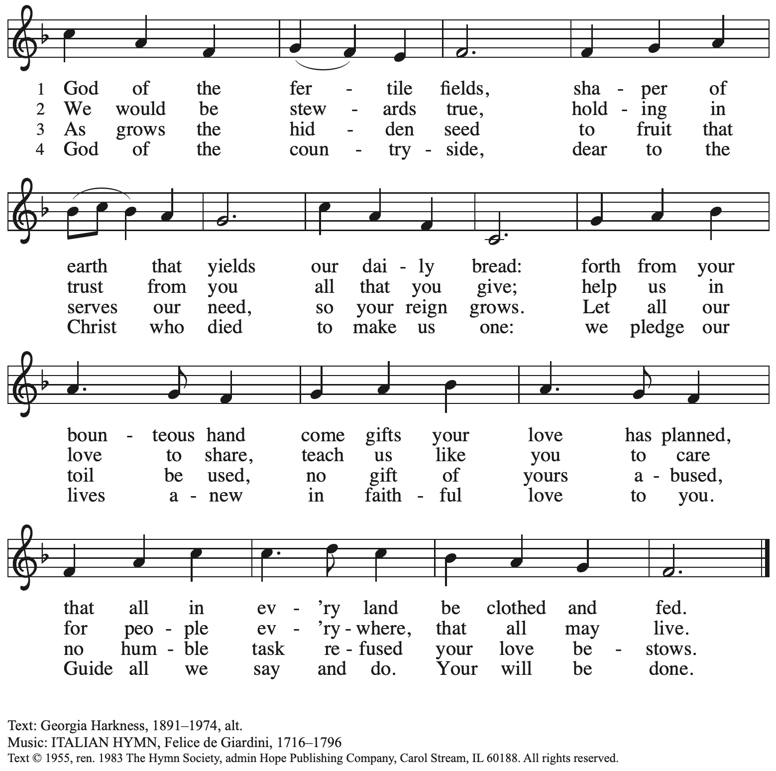
Reprinted with permission under One License.net # A-722139.

Offertory Prayer

A: Let us pray.
God of goodness and growth,
C: all creation is yours, and your faithfulness is sure.
Word and water, wine and bread: these are signs of your abundant grace.

Receive the gifts we bring, and nourish us to proclaim your abiding love
in our communities and in the world,
through Jesus Christ, our strength and our song.
Amen.

Dialogue

P: The Lord be with you.
C: And also with you.

P: Lift up your hearts.
C: We lift them to the Lord.

P: Let us give thanks to the Lord our God.
C: It is right to give our thanks and praise.

Preface (Spoken by the presiding minister)

P: It is indeed right, our duty and our joy,
that we should at all times and in all places
give thanks and praise to you, almighty and merciful God,
through our Savior Jesus Christ;
who on this day overcame death and the grave,
and by his glorious resurrection opened to us the way of everlasting life.
And so, with all the choirs of angels,
with the church on earth and the hosts of heaven,
we praise your name and join their unending hymn:

Sanctus ACS p. 36

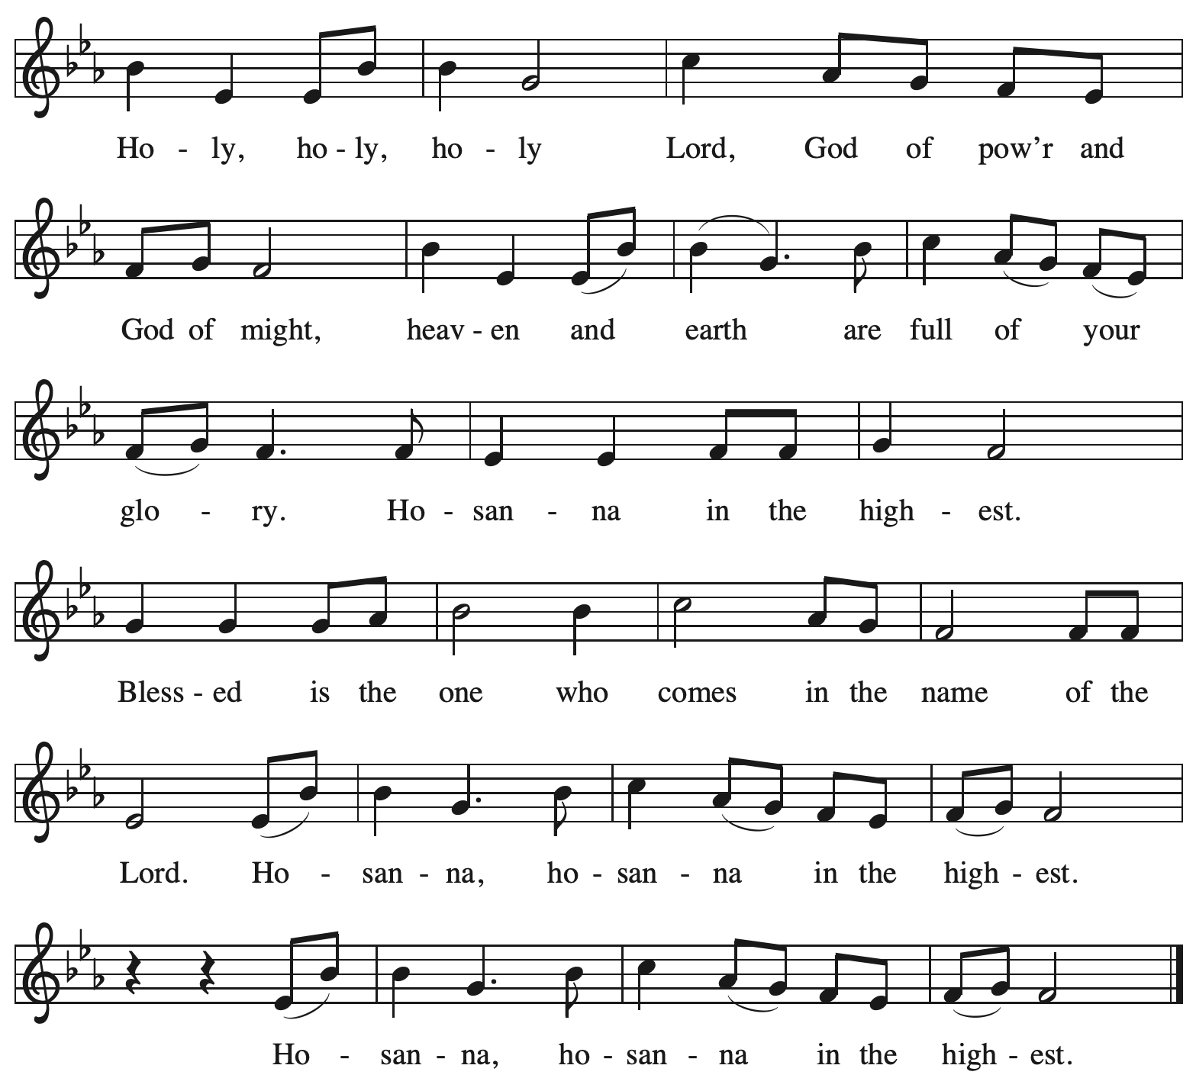

Eucharistic Prayer

P: Holy God, mighty and merciful, your peoples praise you, saying:
Your mercy endures forever.
C: Your mercy endures forever.

P: By your promise …
… the colors of your love and faithfulness.
Your mercy endures forever.
C: Your mercy endures forever.

P: By your promise …
… and calling them to be a light to the nations.
Your mercy endures forever.
C: Your mercy endures forever.

P: By your promise …
… Do this for the remembrance of me.

With this bread and cup
we remember his life laid down and lifted up
as we proclaim the mystery of faith:
C: Christ has died. Christ is risen. Christ will come again.

P: Send your Holy Spirit upon us …
… in your Spirit, now and forever.
C: Amen.

Lord’s Prayer

P: Gathered as one by the Holy Spirit, let us pray as Jesus taught us.
C: Our Father in heaven,
hallowed be your name,
your kingdom come,
your will be done,
on earth as in heaven.
Give us today our daily bread.
Forgive us our sins
as we forgive those
who sin against us.
Save us from the time of trial
and deliver us from evil.
For the kingdom, the power,
and the glory are yours,
now and forever. Amen.

Fraction and Invitation

P: Here is the Lamb of God who takes away the sin of the world.
Come to the table, taste and see.

Agnus Dei / Lamb of God ACS p. 40

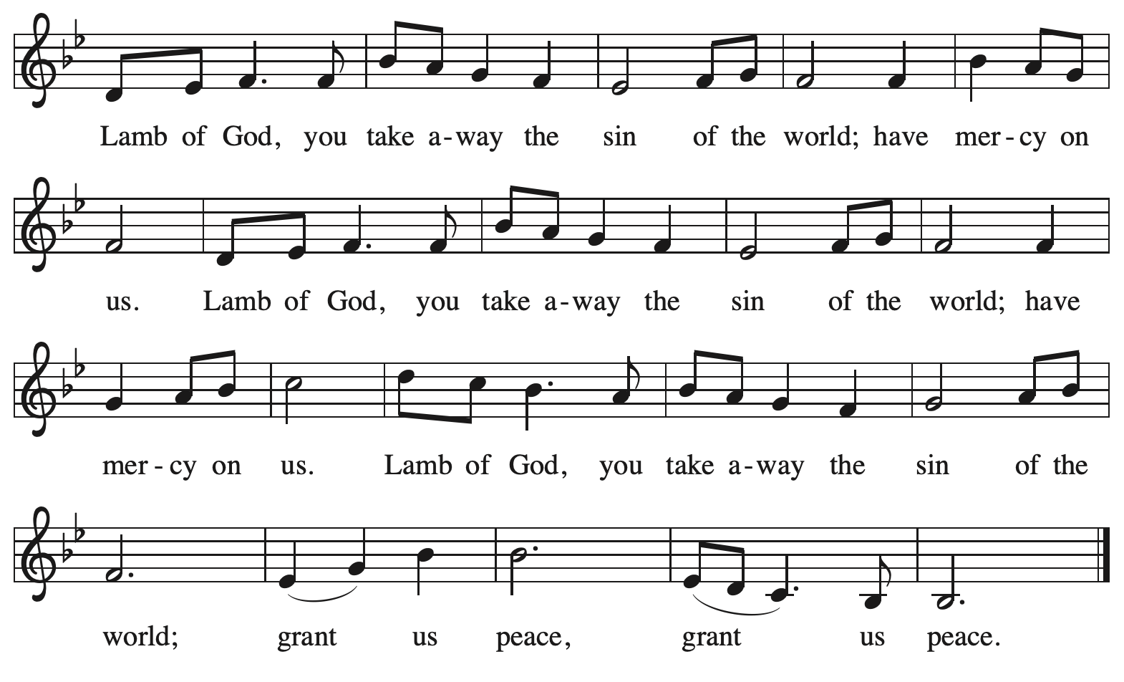

Please be seated.

Holy Communion

- All who seek God and desire a deeper and stronger life in Christ are welcome to receive Holy Communion.
- Worshipers from the pulpit side will proceed forward first, followed by the center section, and then the lectern side.
- Please inform an usher if you would like the ministers to bring Communion to you.
- Holy Communion will be served with bread and wine (amber) or grape juice (purple).
- The presiding minister will first distribute the bread (host) to each communicant. Please indicate if you require a gluten-free host.
- Once you have consumed the bread, please pick up an empty glass from the tray next to the presiding minister. The Communion Assistant will pour wine or grape juice into your glass.
- Please step to the side to consume the wine or grape juice.
- Feel free to kneel at the altar rail for prayer after receiving the sacrament.
- As you return to your pew, glasses may be returned to the empty tray on the side of the center section.
- A blessing will be provided for anyone who does not yet receive the sacrament.
- All are invited to join in singing the hymns during Holy Communion.

Hymns during Holy Communion
By All Your Saints ELW 420

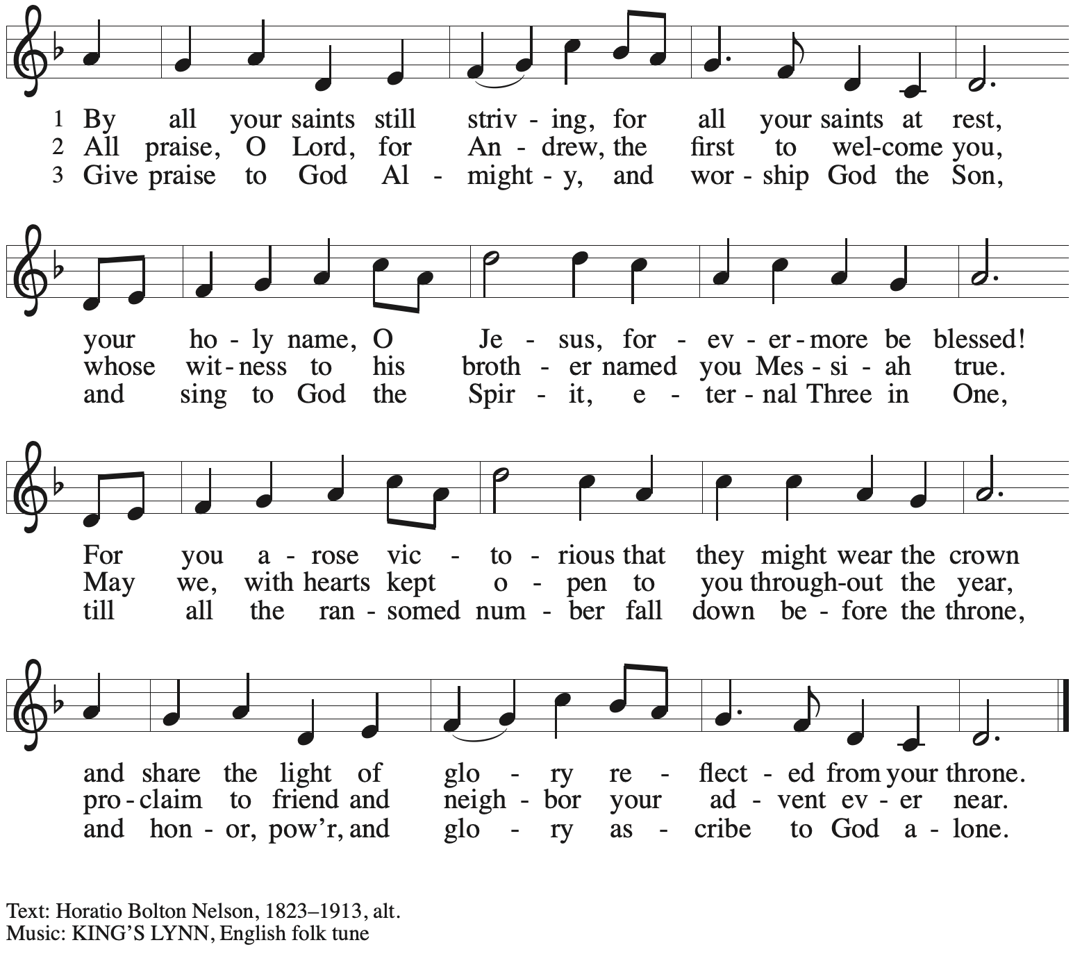

Hymns during Holy Communion
Now Behold the Lamb ELW 341

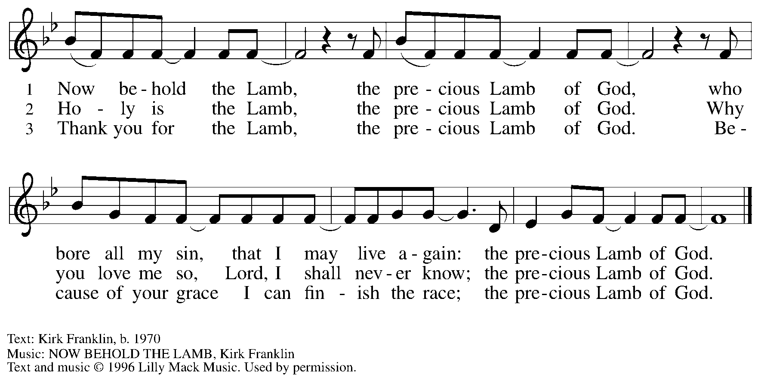
All rights reserved. Reprinted under OneLicense.net # A-722139.

Hymns during Holy Communion
You, Lord, Are Both Lamb and Shepherd ACS 954
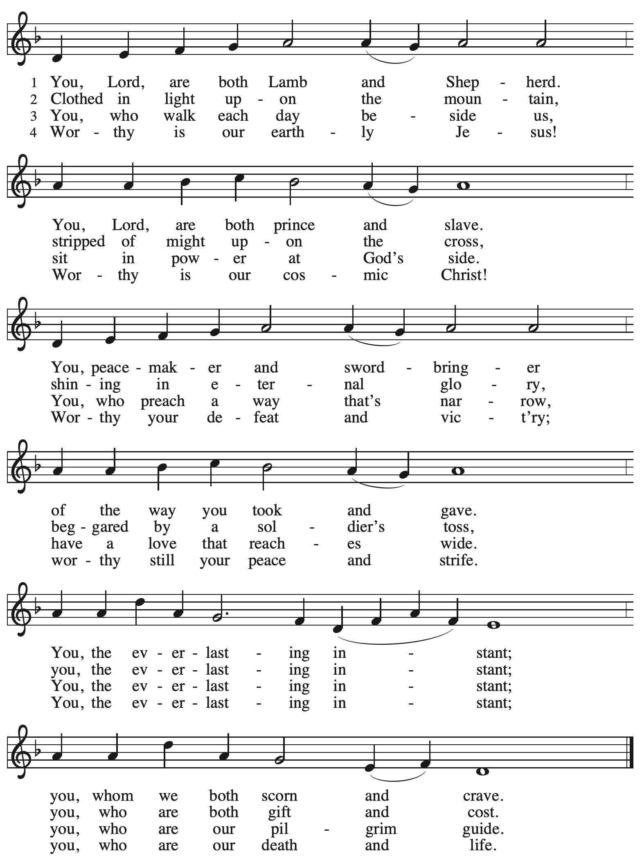

When all have returned to their places, please rise as you are able.

Blessing

P: The body and blood of our Lord Jesus Christ strengthen you and keep you in his grace.
C: Amen.

Prayer

A: Let us pray.
We thank you, O God, that you have strengthened our hearts through this feast of life
and salvation. Shine the light of Christ on our path, that we may do justice, love kindness,
and walk humbly with you, now and forever.
C: Amen.

Please be seated.

Sending
God blesses us and sends us in mission to the world

Announcements

Please rise as you are able.

Benediction

P: The Lord bless you and keep you.
The Lord’s face shine upon you with grace and mercy.
The Lord look upon you with favor and ☩ give you peace.
C: Amen.

Sending Hymn Following page

Dismissal

A: Go in peace. Serve the Lord.
C: Thanks be to God!

Postlude

Sending Hymn The Spirit Sends Us forth to Serve ELW 551

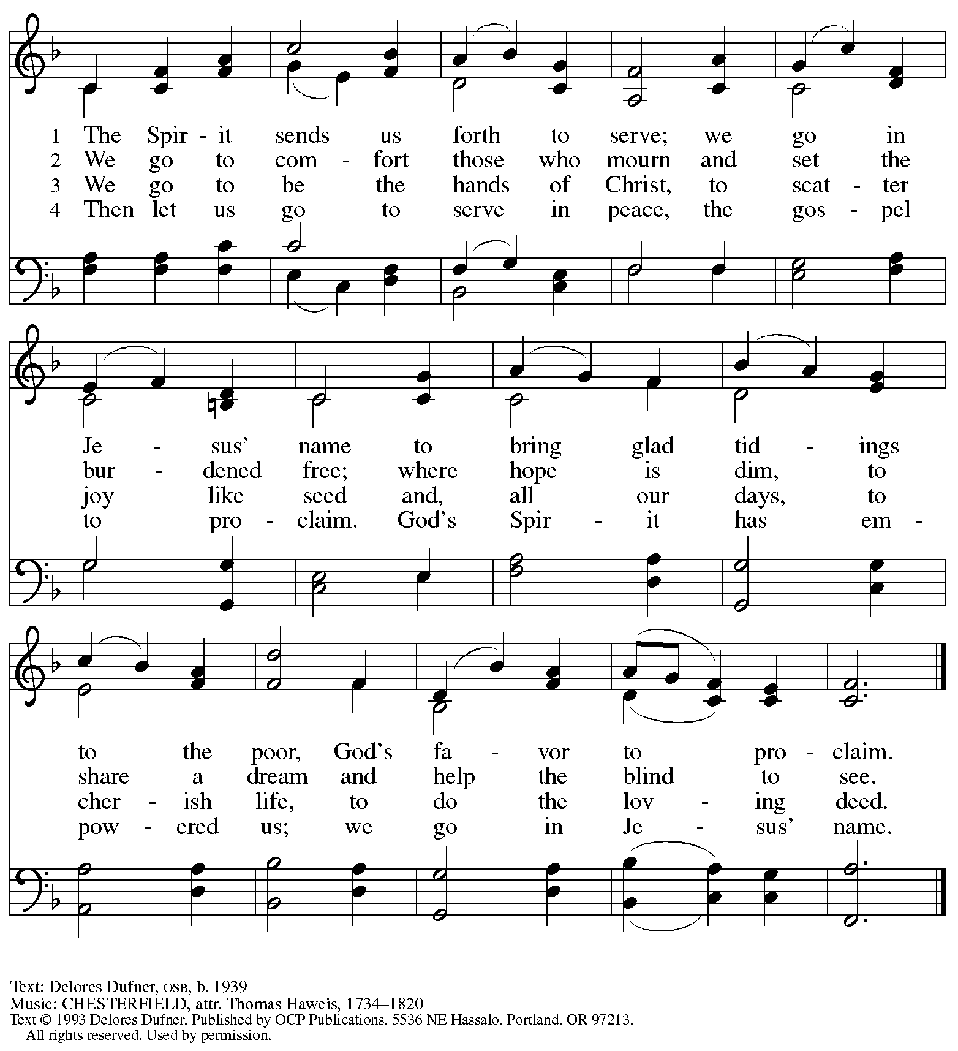
Reprinted with permission under OneLicense.net # A-722139,

Serving in Worship Today

Altar Care Christy Ruhe
Assisting Minister Timothy Kocher-Hillmer
AV Ministers Dave Rollinson
Jered Stratton
Cantor Ian Brown
Lector Lindsay Baxter
Minister of Music Laura Reynolds
Presiding Minister The Rev. Ross Carmichael

Liturgy and Hymnody Acknowledgements

From SundaysandSeasons.com. Copyright © 2026 Augsburg Fortress. All rights reserved. Reprinted under OneLicense.net # A-722139.
Used by permission of Augsburg Fortress.

The Scripture readings contained herein are from New Revised Standard Version Updated Edition of the Bible © 2021 National Council of Churches of Christ in the United States of America. Used by permission. All rights reserved worldwide.

You, Lord, Are Both Lamb and Shepherd – Text: Sylvia G. Dunstan, 1955-1993. Music: PICARDY, French folk tune, 17th cent. Text © 1991 GIA Publications, Inc. www.giamusic.com. All rights reserved. Reprinted with permission under OneLicen.net # A-722139.

Please use the QR code below to link to St. Andrew’s Announcements online!



St. Andrew Lutheran Church Announcements
January 18th, 2026

- Welcome to Worship at St. Andrew on the Second Sunday after Epiphnay! – We are thankful you are here, and we offer a special welcome to all visitors and guests who are here for the first time! A nursery is available through the door to the left of the worship space and across the social hall (look for a purple room). Little Church – Big Faith, a Bible lesson and activity for children up to sixth grade, will take place after the prayer of the day. There are also worship “toolkits” to help children engage with worship and “busy bags” for younger children available in the bookcase at the back of the sanctuary. Please feel free to take one to use with/for your children.
- Noisy Offering Today, Sunday, January 18th, during Worship – On the third Sunday of each month, St. Andrew’s children lead the congregation in a Noisy Offering, in which people are invited to throw their change into buckets that the children carry around the church and bring forward as an additional offering. Each month’s Noisy Offering supports a local, national, or international church-related or otherwise charitable organization. This month’s offering will benefit Hello Neighbor in their mission to empower refugees and immigrants through community connections, ensuring their journey from arrival to belonging is guided by dignity, cultural sensitivity, and support. You can learn more about their program offerings here: https://www.helloneighbor.io/our-programs.
- Visit from Partners for Sacred Places, Today, Sunday, January 18th – As construction continues on the church roof and towers, we are excited to be making preparations for a capital campaign! As discussed in a previous congregational meeting, St. Andrew is working with consultants from Partners for Sacred Places to help organize and conduct a campaign to raise funds toward our $1 million goal. Tom and Emilio, whom some of you may have met when they visited last year to ask questions and learn from members of the congregation, are here today, January 18th to meet with a small group of leaders. Everyone will be hearing more about the campaign in the coming weeks and months. We look forward to this process in hope of all that God will do to help St. Andrew continue and grow as a sustainable place of welcome, inclusion, and refuge for all God's people, shining the light of Christ's love on our neighbors and community here at the corner of Centre and Morewood!
- January Produce Distribution, Third Tuesday Each Month, January 20th from 5:30-6:30 p.m. – St. Andrew partners with Greater Pittsburgh Community Food Bank to serve as a distribution site for fresh produce on the first and third Tuesday of every month. This month’s second distribution will be on Tuesday, January 20th. We invite people of the congregation to help with the distribution from 5:30 p.m. – 6:30 p.m. and/or to help with unloading and setup during the day between 10:00 a.m. and 1:00 p.m.
- Produce Distribution Supplemental Food of the Month – St. Andrew is collecting supplemental food each month to accompany our produce distribution. For January, we ask for donations of rice. There are collection boxes at the back of the worship space and social hall.
- Bible Book Club Returns Wednesday, January 21st at 7:00 p.m. on Zoom – Bible Book Club, which has been on pause since the summer, will resume meeting on Wednesday, January 21st at 7:00 p.m. All are welcome to participate. The group will be reading the Gospel of Mark along with The Gospel of Mark: A Beginner’s Guide to the Good News by Dr. Amy-Jill Levine. Here are the details on the book from one site: (https://www.cokesbury.com/The-Gospel-of-Mark-6?select=862810). We will plan to regroup on the 21st and begin with the introduction to Dr. Levine’s book. The link is https://us02web.zoom.us/j/83196175976?pwd=ejdPOUYrTk4xVFdsdlhHUVJ1L3k2Zz09 - Meeting ID: 831 9617 5976, Passcode: Inspired.
- Alternatives to Violence Workshop, January 31st, 10:30 a.m. to 12:00 p.m. – In a moment marked by deep division, rising fear, and everyday conflicts that touch families, schools, neighborhoods, and public life, the Alternatives to Violence Project (AVP) offers a hopeful and practical invitation: to learn peace not as an abstract ideal, but as a lived practice. On Saturday, January 31st, 2026, from 10:30 a.m. to 12:00 p.m., AVP Pittsburgh will host an interactive mini-workshop, “Acting on Conscience,” at St. Andrew Lutheran Church in Shadyside (Centre & Morewood). Led by Melanie Siaw, AVP facilitator and coordinator of the Pittsburgh Region, this gathering is designed for all ages, with special attention to families. Through a story drawn from the life and witness of Bayard Rustin, participants will explore how conscience, courage, and nonviolence shape everyday choices in times of tension and uncertainty. This event also reflects a long-standing interfaith collaboration for peace in Pittsburgh, bringing together St. Andrew Lutheran Church Shadyside, the Friends Meeting House/Peace Teams, Bethel A.M.E. Church, and AVP Pittsburgh. Together, these partners recognize that peace-making is not optional in a conflicted context—it is essential. The mini-workshop not only stands on its own as a meaningful community experience; it also serves as an introduction to AVP’s 18-hour Basic Workshop, planned for later in Spring 2026. In a world shaped by conflict at every level, this gathering offers a rare and timely opportunity to practice conscience, cultivate hope, and discover—together—paths toward nonviolent living that can sustain individuals, families, and communities for the long haul.
- Growing in Faith Together (GIFT) Group for People New to St. Andrew Begins Meeting after Worship on Sunday, February 1st – While we originally planned for this group to start meeting on Sunday, January 25th , we will now plan to begin one week later, on Sunday, February 1st. We apologize for the delay. This gathering is intended for people who are relatively new to St. Andrew, whether you are preparing to join the congregation by transfer or Affirmation of Baptism, or would just like to meet more people and learn about the congregation. Jeff Denlinger and Kelly Spanninger will serve as facilitators and will be happy to answer any questions.
- “Christ in Our Home” Booklets Available – “Christ in Our Home” is a quarterly devotional resource that encourages readers to live out their faith daily. Each reflective reading is accompanied by a daily scripture reference and prayer for the day. The January-March booklets are available at the entrances. Please feel free to take one home!
- Invitation to Prayer Team – St. Andrew maintains a list of weekly prayer concerns sent by email to members of the congregation who have opted in. Our prayer team’s email is prayerteam@standrewpittsburgh.org. We will keep names on the list for a maximum of four weeks unless otherwise requested. Thank you for your ministry of prayer!
- Records Update – St. Andrew is updating our records with information from newer attendees, as well as offering current members the opportunity to include current information to be used within the congregation: to acknowledge celebrations, milestones, and prayers. Please fill out the form at: https://forms.gle/kKvp19UozuRrhhaV7.
- Coffee Hour Signups – If you would like to participate and would like additional information about the duties, please sign up using the following form: https://www.signupgenius.com/go/5080B4AAFAF2CABF85-47069030-coffee#/.

