

+ Third Sunday after Epiphany
January 25, 2026



St. Andrew Lutheran Church
304 Morewood Ave.
Pittsburgh, PA 15213
St_andrewELCA@verizon.net
www.standrewpittsburgh.org

+ Third Sunday after Epiphany
Order for Worship

Jesus begins his public ministry by calling fishers to leave their nets and follow him.
In Jesus, the reign of God has come near. We who have walked in darkness have seen a great light. We see this light most profoundly in the cross—as God suffers with us and all who are oppressed by sickness, sin, or evil. Light dawns for us as we gather around the word, the font, and the holy table. We are then sent to share the good news that others may be “caught” in the net of God’s grace and mercy.

Welcome to St. Andrew!
- St. Andrew welcomes all who are seeking a place of healing, wholeness, and acceptance in a nurturing and faith-forming spiritual home. We are striving toward racial equity worldwide
and we seek to honor the lived experience of all individuals regardless of background. Our community embraces people of all ages, ethnicities, cultures, abilities, sexual orientations,
gender identities and expressions, and family constellations. Come and See!
- Worship Services are live-streamed to multiple online platforms. By attending worship, you agree that your image and voice may be broadcast.
- Everyone is invited to make a name tag at the black bookcase in the back of the worship space if they would like. There are stickers indicating pronouns on the bookcase if you would like to include them on your name tag.
- A nursery is available through the doors at the left side of the sanctuary and across from the doorway to the Social Hall. Look for a purple-colored room.
- Children are invited to attend Little Church – Big Faith, a Bible lesson and activity, during worship (after the Prayer of the Day). The group returns to the worship space for the liturgy of Holy Communion.
- Worship “toolkits” to help children engage with the service, along with “busy bags” for younger children, are available in the bookcase at the back of the sanctuary. Please feel free to take one to use with/for your children.
- Holy Communion is served with bread (gluten-free available) and wine or grape juice. The presiding minister will distribute the bread (host). Please consume this and then pick up an empty glass from the tray. The Communion Assistant will pour wine or grape juice into your glass. Please step to the side to consume the wine or grape juice. Feel free to kneel at the altar for prayer and reflection. As you return to your pew, glasses may be returned to the empty trays on either side of the center section.
- A restroom is available on the main level of the church, through the doors to the Social Hall and to the right in the main office.

Abbreviations
P: Pastor/Presiding Minister ELW: Evangelical Lutheran Worship hymnal
A: Assisting Minister ACS: All Creation Sings hymnal
L: Lector TFF: This Far By Faith
C: Congregation

Musical Offering

Each week, different people from the congregation make an offering of pre-service music, with singing or instrumentation, to help the assembly focus and pray in preparation for worship.

Welcome

Prelude Be Thou My Vision arr. Keveren

Gathering
The Holy Spirit calls us together as the people of God

Please rise as you are able. All may make the sign of the cross,
the sign that is marked at Baptism, as the presiding minister begins.

Confession and Forgiveness

P: Blessed be the holy Trinity, ☩ one God,
the fountain of living water,
the rock who gave us birth,
our light and our salvation.
C: Amen.

P: Let us confess our sin in the presence of God and of one another.

Silence is kept for reflection.

P: Most merciful God,
C: we confess that we are captive to sin and cannot free ourselves.
We have sinned against you in thought, word, and deed,
by what we have done and by what we have left undone.
We have not loved you with our whole heart;
we have not loved our neighbors as ourselves.
For the sake of your Son, Jesus Christ, have mercy on us.
Forgive us, renew us, and lead us,
so that we may delight in your will and follow in your ways,
to the glory of your holy name. Amen.

P: By water and the Holy Spirit God gives you a new birth,
and through the death and resurrection of ☩ Jesus Christ, God forgives you all your sins.
The God of mercy strengthen you in all goodness and keep you in eternal life.
C: Amen.

Gathering Hymn Come, Beloved of the Maker ELW 306

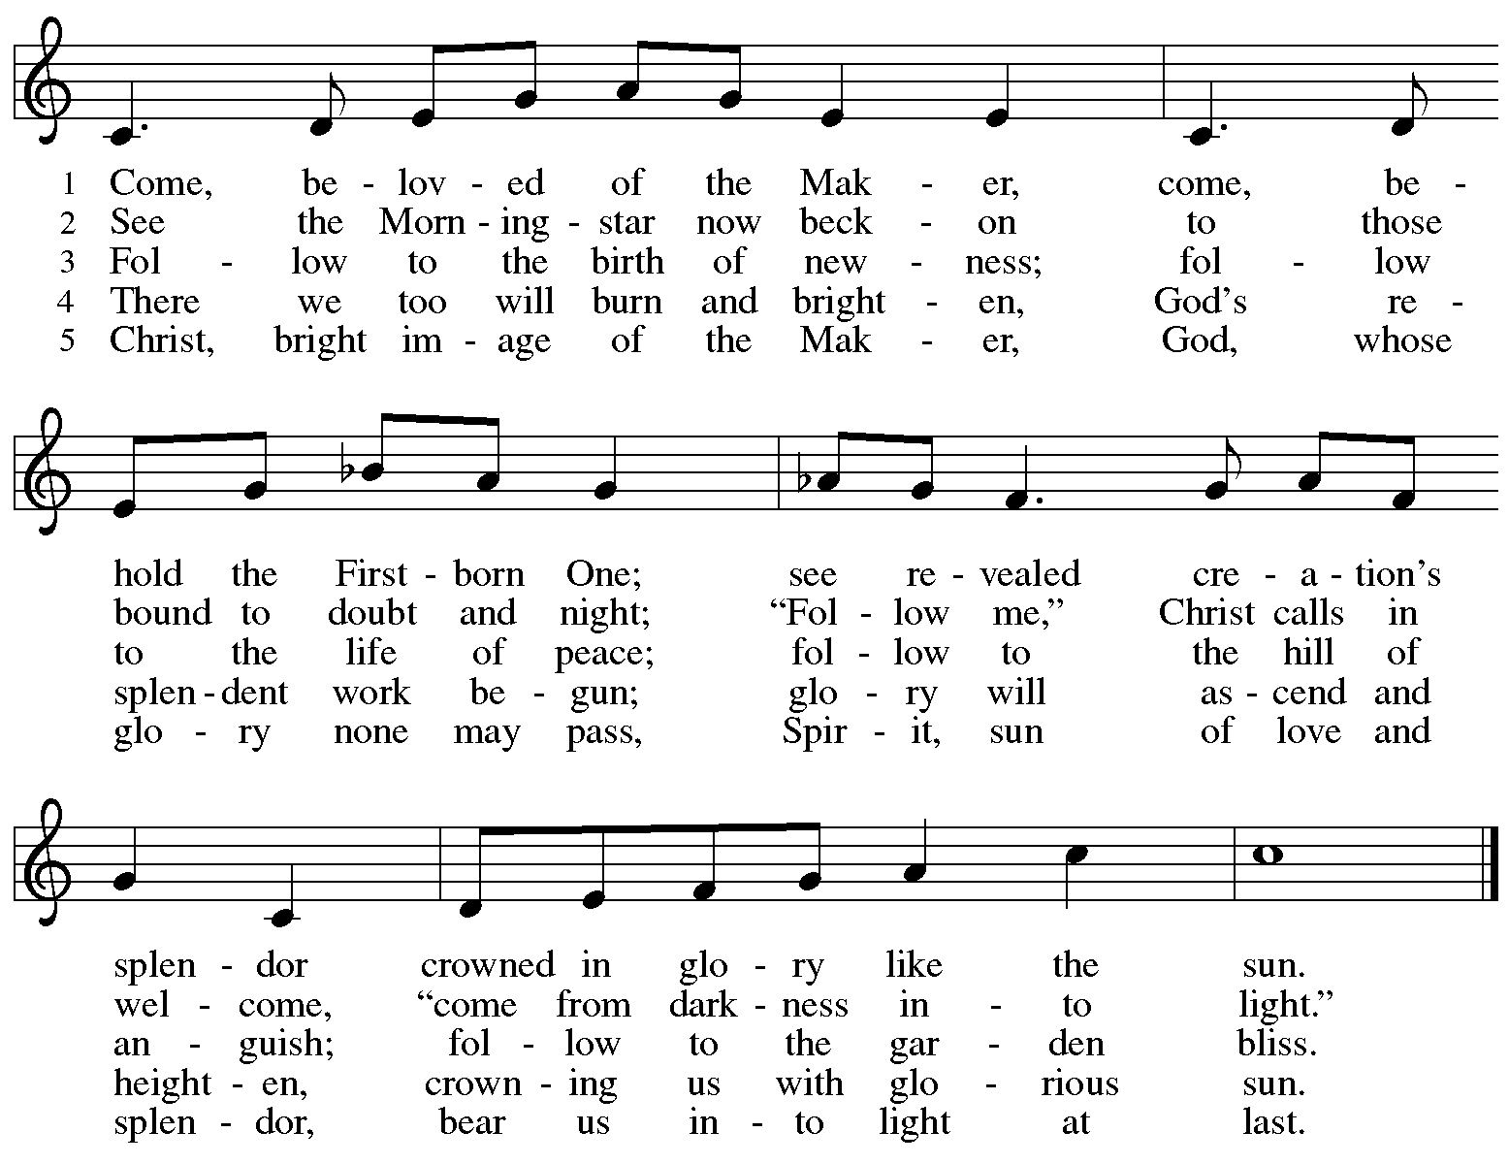

All rights reserved. Reprinted with permission under OneLicense.net # A-722139.

Greeting

P: The grace of our Lord Jesus Christ, the love of God,
and the communion of the Holy Spirit be with you all.
C: And also with you.

Hymn of Praise ACS p. 31

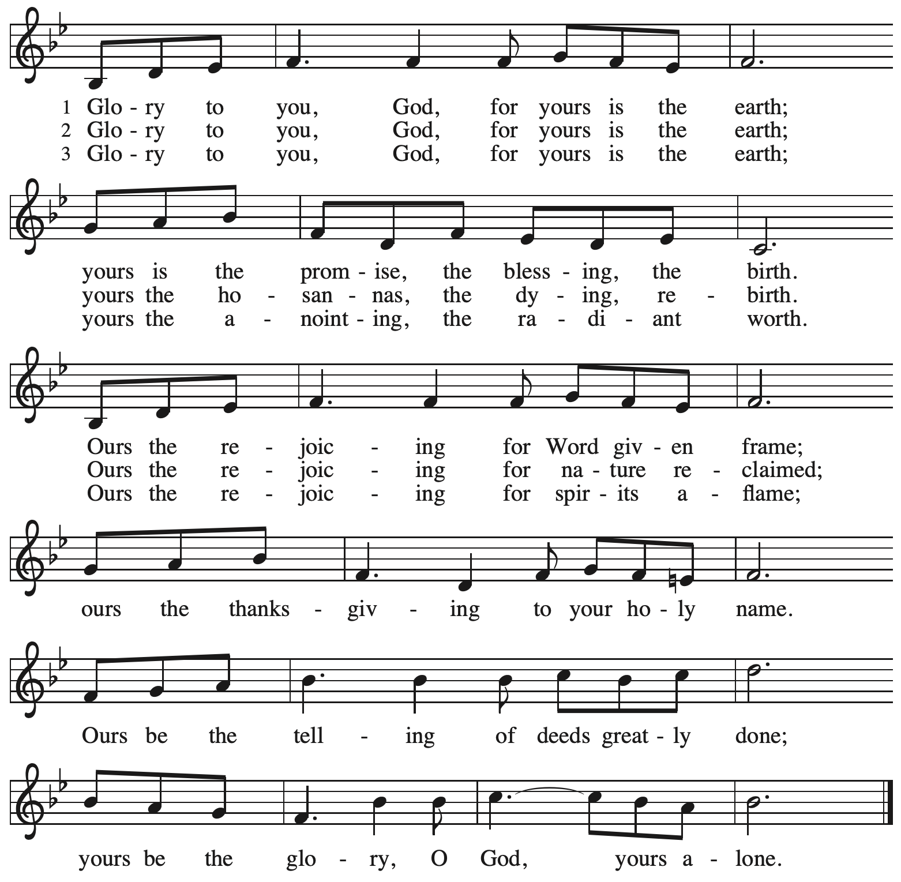

Prayer of the Day

P: The Lord be with you.
C: And also with you.

P: Lord God, your lovingkindness always goes before us and follows after us.
Summon us into your light, and direct our steps in the ways of goodness
that come through the cross of your Son, Jesus Christ, our Savior and Lord.
C: Amen.
Please be seated.
Children are invited to join the adult leader(s) at the side door for Little Church – Big Faith.
We ask that an additional adult from the congregation attend with the children.

Word
God speaks to us in Scripture reading, preaching, and song

First Reading – Isaiah 9: 1-4

¹ There will be no gloom for those who were in anguish. In the former time [the Lord] brought into contempt the land of Zebulun and the land of Naphtali, but in the latter time the Lord will make glorious the way of the sea, the land beyond the Jordan, Galilee of the nations.

² The people who walked in darkness
have seen a great light;
those who lived in a land of deep darkness—
on them light has shined.
³ You have multiplied exultation;
you have increased its joy;
they rejoice before you
as with joy at the harvest,
as people exult when dividing plunder.
⁴ For the yoke of their burden
and the bar across their shoulders,
the rod of their oppressor,
you have broken as on the day of Midian.

L: Word of God, word of life.
C: Thanks be to God.



Psalm 27: 1, 4-9

The psalm will be sung responsively, led by the cantor, with the congregation singing the verses in bold type and joining in the refrain.

Psalm Tone

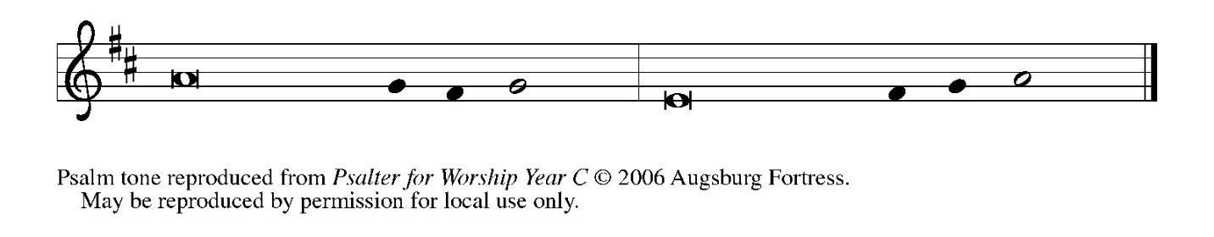

Psalm Refrain

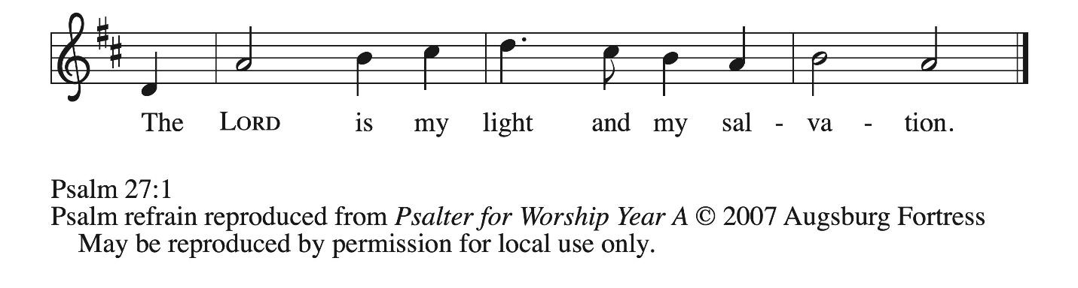

¹ The Lord is my light and my salvation; whom then | shall I fear?
The Lord is the stronghold of my life; of whom shall I | be afraid?
⁴ One thing I ask of the Lord; one | thing I seek;
that I may dwell in the house of the Lord all the days of my life; to gaze upon the beauty of the Lord and to seek God | in the temple.
⁵ For in the day of trouble God will | give me shelter,
hide me in the hidden places of the sanctuary, and raise me high up- | on a rock.
⁶ Even now my head is lifted up above my enemies | who surround me.
Therefore I will offer sacrifice in the sanctuary, sacrifices of rejoicing; I will sing and make music | to the Lord. R
⁷ Hear my voice, O Lord, | when I call;
have mercy on me and | answer me.
⁸ My heart speaks your message— | “Seek my face.”
Your face, O Lord, | I will seek.
⁹ Hide not your face from me, turn not away from your ser- | vant in anger.
Cast me not away—you have been my helper; forsake me not, O God of | my salvation. R

Second Reading – 1 Corinthians 1: 10-18

¹⁰ Now I appeal to you, kindred, by the name of our Lord Jesus Christ, that all of you be in agreement and that there be no divisions among you but that you be knit together in the same mind and the same purpose. ¹¹ For it has been made clear to me by Chloe’s people that there are quarrels among you, my siblings. ¹² What I mean is that each of you says, “I belong to Paul,” or “I belong to Apollos,” or “I belong to Cephas,” or “I belong to Christ.” ¹³ Has Christ been divided? Was Paul crucified for you? Or were you baptized in the name of Paul? ¹⁴ I thank God that I baptized none of you except Crispus and Gaius, ¹⁵ so that no one can say that you were baptized in my name. ¹⁶ I did baptize also the household of Stephanas; beyond that, I do not know whether I baptized anyone else. ¹⁷ For Christ did not send me to baptize but to proclaim the gospel—and not with eloquent wisdom, so that the cross of Christ might not be emptied of its power.

¹⁸ For the message about the cross is foolishness to those who are perishing, but to us who are being saved it is the power of God.

L: Word of God, word of life.
C: Thanks be to God.

Please rise as you are able.

Gospel Acclamation ACS p. 33

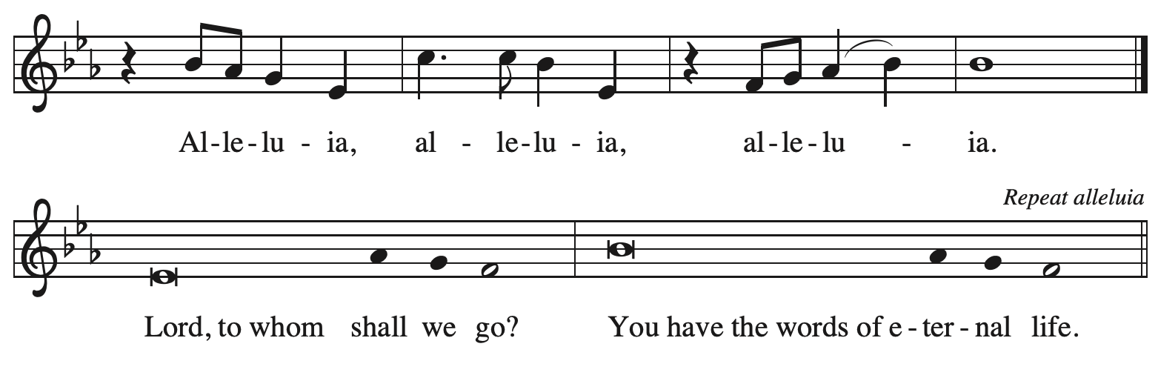

Gospel – Matthew 4: 13-23

P: The holy Gospel according to St. Matthew.
C: Glory to you, O Lord.

¹² Now when Jesus heard that John had been arrested, he withdrew to Galilee. ¹³ He left Nazareth and made his home in Capernaum by the sea, in the territory of Zebulun and Naphtali, ¹⁴ so that what had been spoken through the prophet Isaiah might be fulfilled:
¹⁵ “Land of Zebulun, land of Naphtali,
on the road by the sea, across the Jordan, Galilee of the gentiles—
¹⁶ the people who sat in darkness
have seen a great light,
and for those who sat in the region and shadow of death
light has dawned.”
¹⁷ From that time Jesus began to proclaim, “Repent, for the kingdom of heaven has come near.”
¹⁸ As he walked by the Sea of Galilee, he saw two brothers, Simon, who is called Peter, and Andrew his brother, casting a net into the sea—for they were fishers. ¹⁹ And he said to them, “Follow me, and I will make you fishers of people.” ²⁰ Immediately they left their nets and followed him. ²¹ As he went from there, he saw two other brothers, James son of Zebedee and his brother John, in the boat with their father Zebedee, mending their nets, and he called them. ²² Immediately they left the boat and their father and followed him.

²³ Jesus went throughout all Galilee, teaching in their synagogues and proclaiming the good news of the kingdom and curing every disease and every sickness among the people.

P: The Gospel of the Lord.
C: Praise to you, O Christ.

Please be seated.

Sermon

A time of silence for prayer and reflection follows the sermon.
When the hymn of the day begins, please rise as you are able.

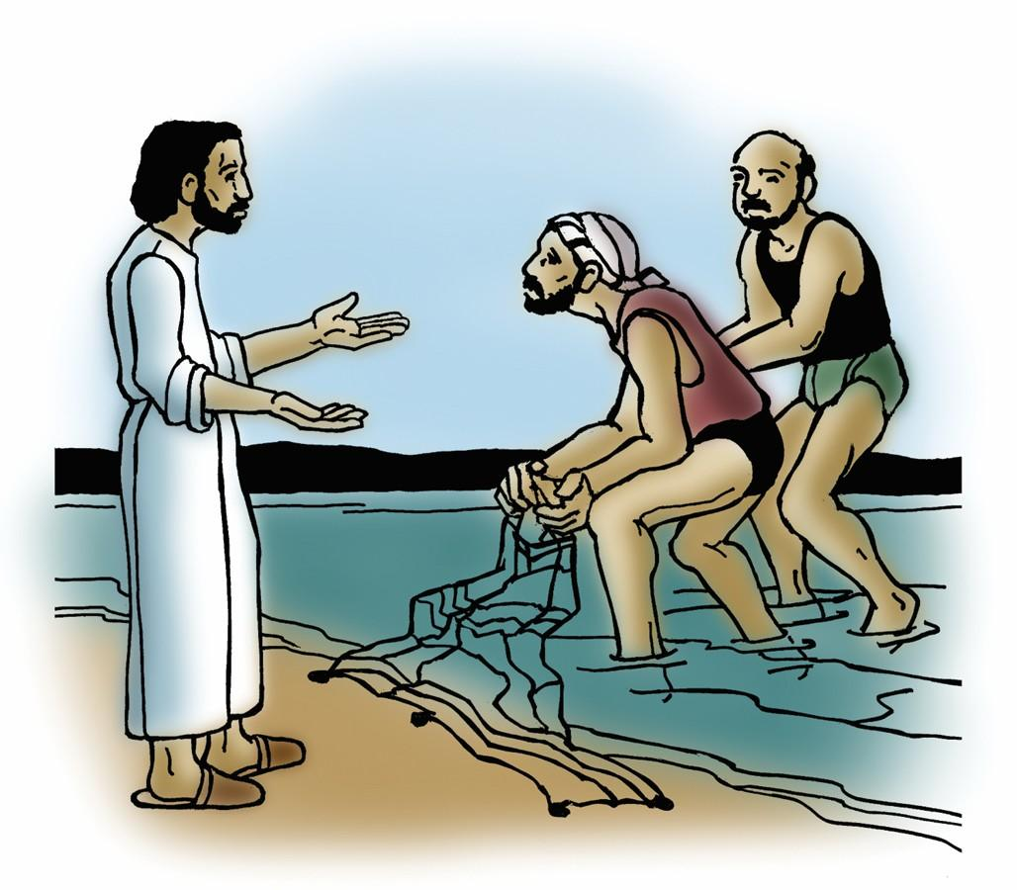

Hymn of the Day Will You Come and Follow Me ELW 798

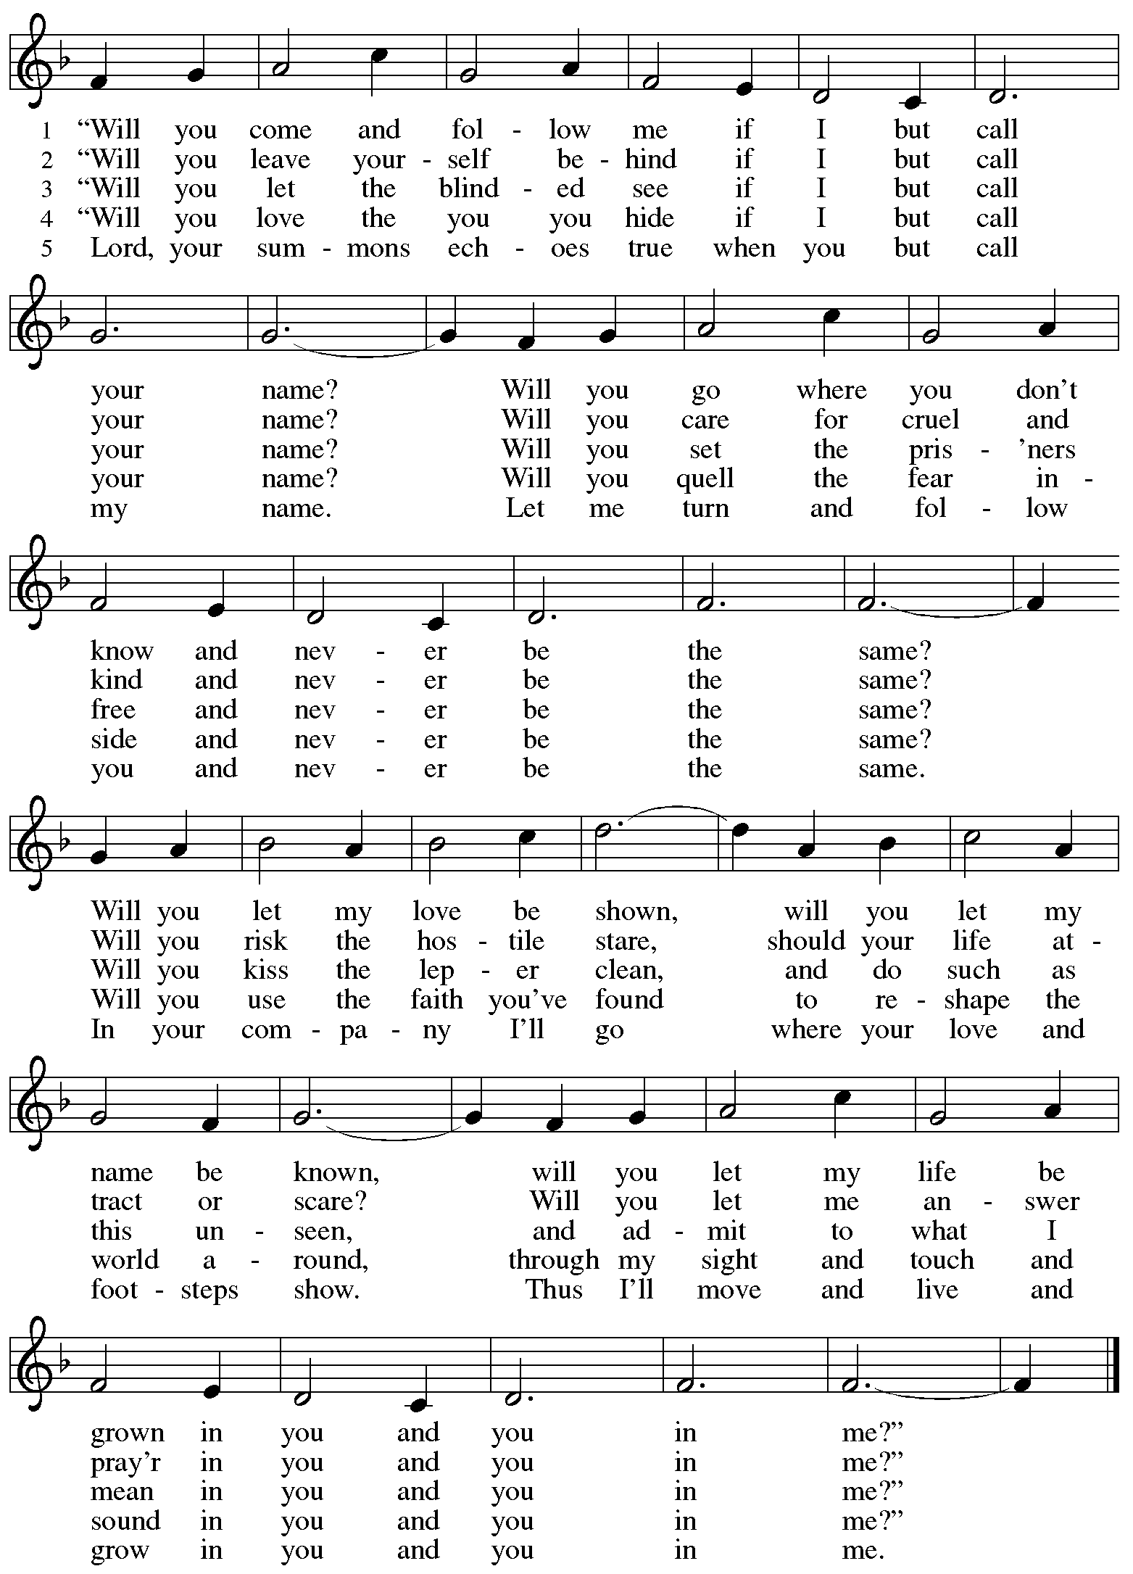
Apostles’ Creed

C: I believe in God, the Father almighty,
creator of heaven and earth.

I believe in Jesus Christ, God’s only Son, our Lord,
who was conceived by the Holy Spirit,
born of the virgin Mary,
suffered under Pontius Pilate,
was crucified, died, and was buried;
he descended to the dead.*
On the third day he rose again;
he ascended into heaven,
he is seated at the right hand of the Father,
and he will come to judge the living and the dead.

I believe in the Holy Spirit,
the holy catholic church,
the communion of saints,
the forgiveness of sins,
the resurrection of the body,
and the life everlasting. Amen.

*Or, “he descended into hell,” another translation of this text in widespread use.

Prayers of the People

A: As God’s beloved children united in Christ, let us pray for the church,
the world, and the whole human community.

After each petition
A: Merciful God,
C: receive our prayer.

The presiding minister concludes the prayers
P: Confident that the Holy Spirit receives our prayers and answers us,
we commend all for whom we pray to your lovingkindness, O God,
revealed to us through Jesus Christ our Savior.
C: Amen.

Peace

The presiding minister and the assembly greet one another in the peace of the risen Christ.
P: The peace of Christ be with you always.
C: And also with you.
The people may greet those around them with a sign of Christ’s peace and may say
Peace be with you or similar words. Please be mindful that not everyone will be comfortable with sharing the peace, so please seek consent before shaking hands or hugging.
Other possible ways to share the peace include a simple bow with the verbal greeting of peace, or simply a verbal expression of peace.

When the greetings of peace have concluded, please be seated.



Meal
God feeds us with the presence of Jesus Christ

Offering

We offer ourselves, our gifts, and our faithful service to God.
As the offering is gathered for the mission of the church, including the care of those in need,
the table is set for Holy Communion.

There are laminated giving cards in the pew racks that feature a QR code for anyone who would like to give online. Those who give using the QR code, as well as those who give regularly online or through their bank are encouraged to place the laminated card in the plate as an expression of your offering.

Offertory Music My Faith Looks Up to Thee arr. Edstrom

As the gifts are brought forward for presentation, please rise as you are able.

Offertory Song God of the Fertile Fields ACS 1063
v. 1, 3

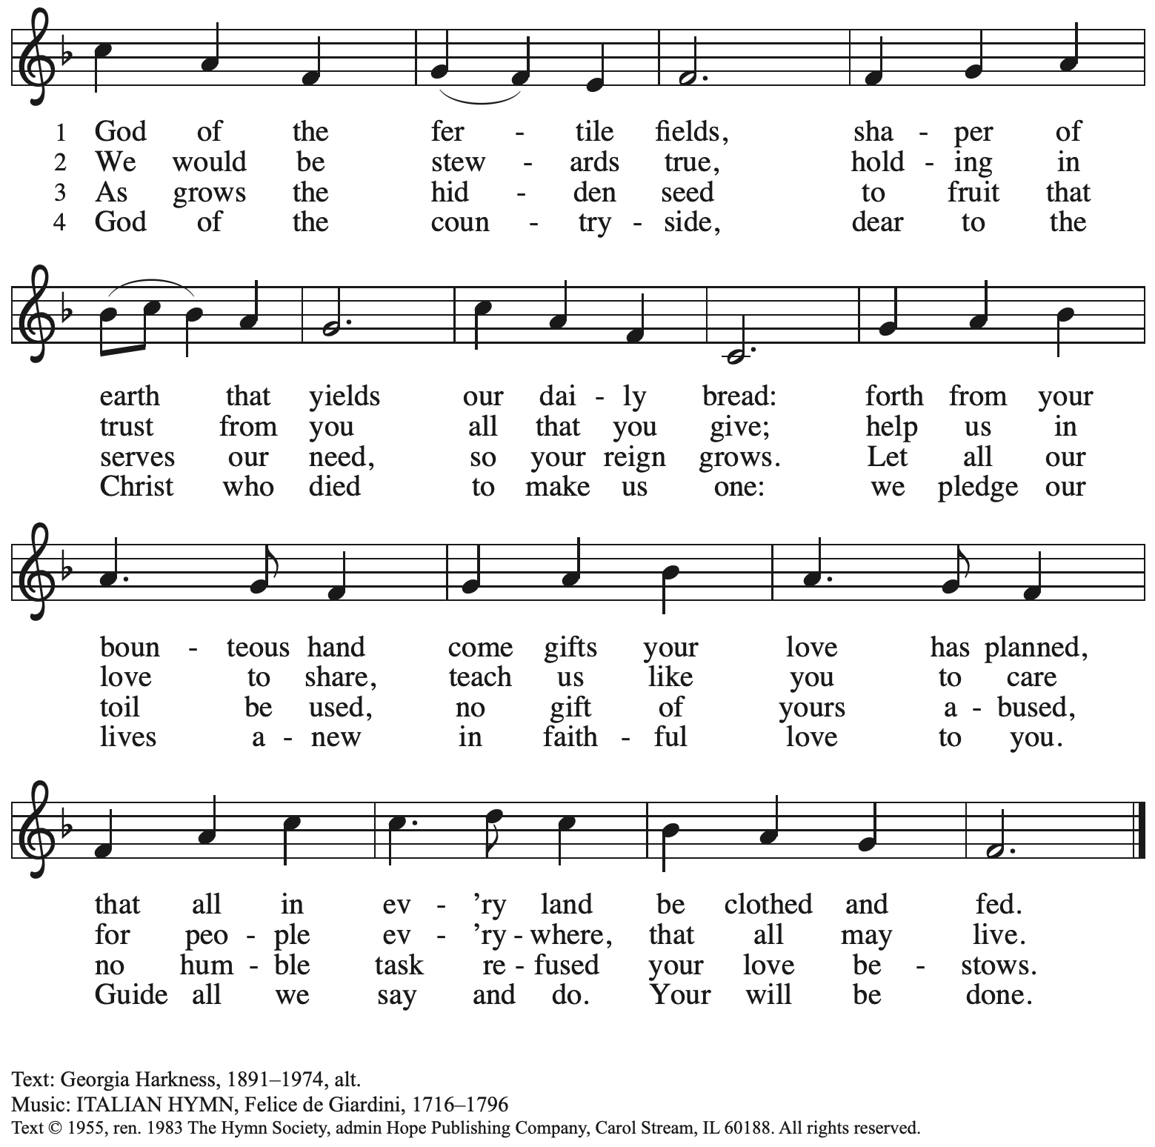
Reprinted with permission under One License.net # A-722139.

Offertory Prayer

A: Let us pray.
God of goodness and growth,
C: all creation is yours, and your faithfulness is sure.
Word and water, wine and bread: these are signs of your abundant grace.
Receive the gifts we bring, and nourish us to proclaim your abiding love
in our communities and in the world,
through Jesus Christ, our strength and our song.
Amen.

Dialogue

P: The Lord be with you.
C: And also with you.

P: Lift up your hearts.
C: We lift them to the Lord.

P: Let us give thanks to the Lord our God.
C: It is right to give our thanks and praise.

Preface (Spoken by the presiding minister)

P: It is indeed right, our duty and our joy,
that we should at all times and in all places
give thanks and praise to you, almighty and merciful God,
through our Savior Jesus Christ;
who on this day overcame death and the grave,
and by his glorious resurrection opened to us the way of everlasting life.
And so, with all the choirs of angels,
with the church on earth and the hosts of heaven,
we praise your name and join their unending hymn:

Sanctus ACS p. 36

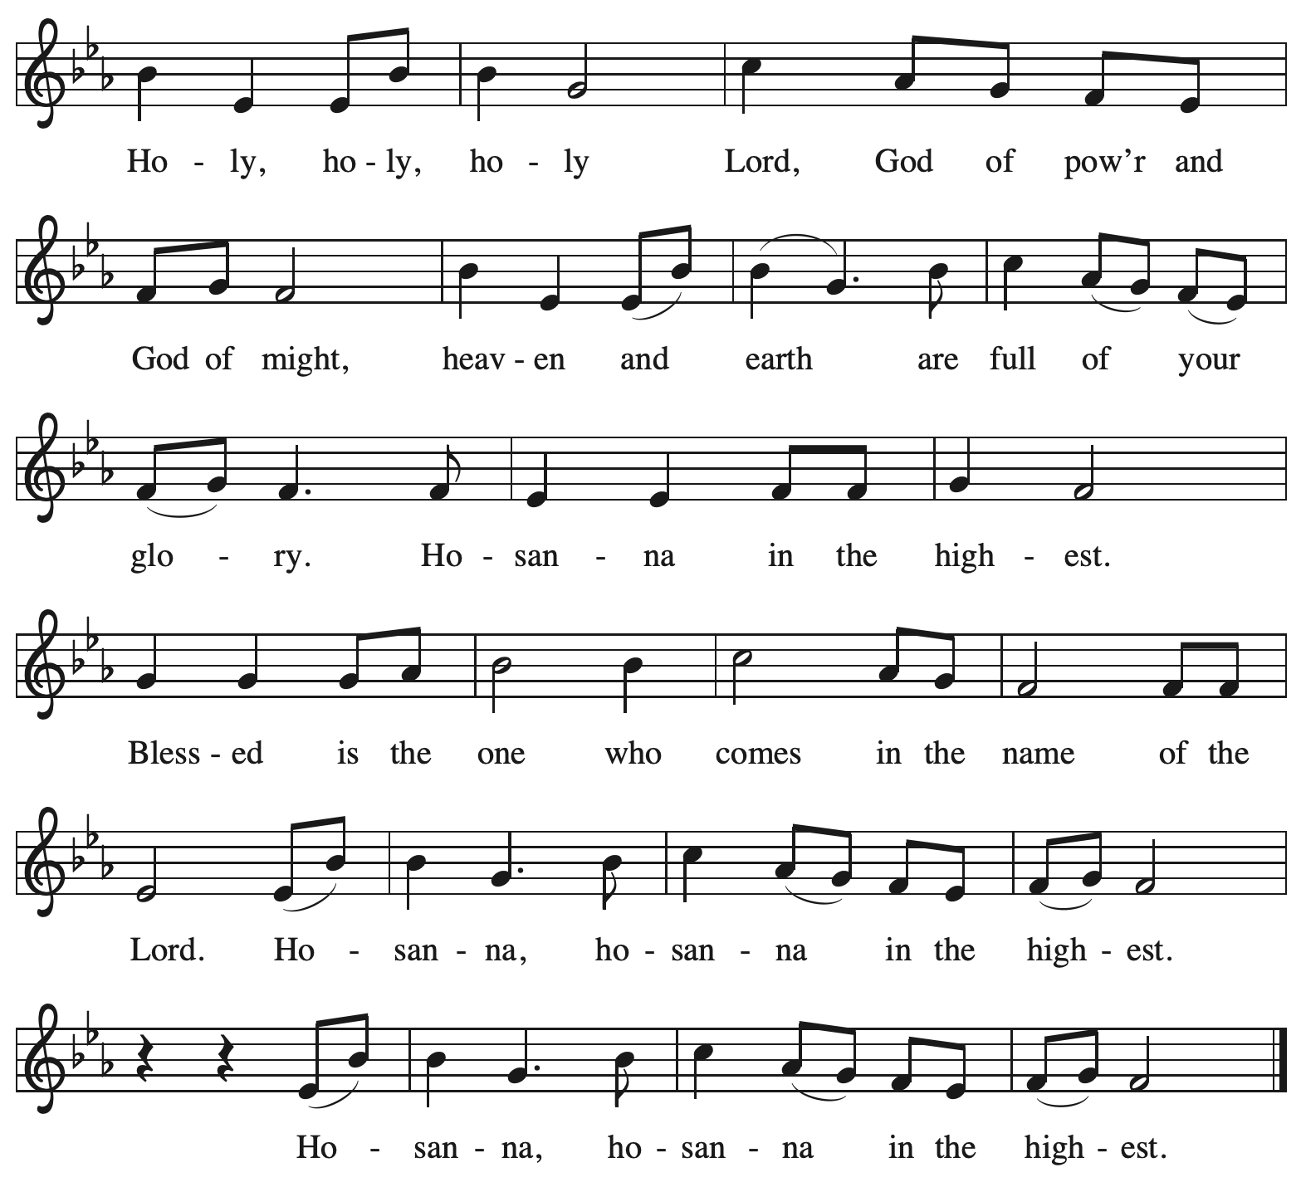

Eucharistic Prayer

P: Holy God, mighty and merciful, your peoples praise you, saying:
Your mercy endures forever.
C: Your mercy endures forever.

P: By your promise …
… the colors of your love and faithfulness.
Your mercy endures forever.
C: Your mercy endures forever.

P: By your promise …
… and calling them to be a light to the nations.
Your mercy endures forever.
C: Your mercy endures forever.

P: By your promise …
… Do this for the remembrance of me.

With this bread and cup
we remember his life laid down and lifted up
as we proclaim the mystery of faith:
C: Christ has died. Christ is risen. Christ will come again.

P: Send your Holy Spirit upon us …
… in your Spirit, now and forever.
C: Amen.

Lord’s Prayer

P: Gathered as one by the Holy Spirit, let us pray as Jesus taught us.
C: Our Father in heaven,
hallowed be your name,
your kingdom come,
your will be done,
on earth as in heaven.
Give us today our daily bread.
Forgive us our sins
as we forgive those
who sin against us.
Save us from the time of trial
and deliver us from evil.
For the kingdom, the power,
and the glory are yours,
now and forever. Amen.

Fraction and Invitation

P: Here is the Lamb of God who takes away the sin of the world.
Come to the table, taste and see.

Agnus Dei / Lamb of God ACS p. 40

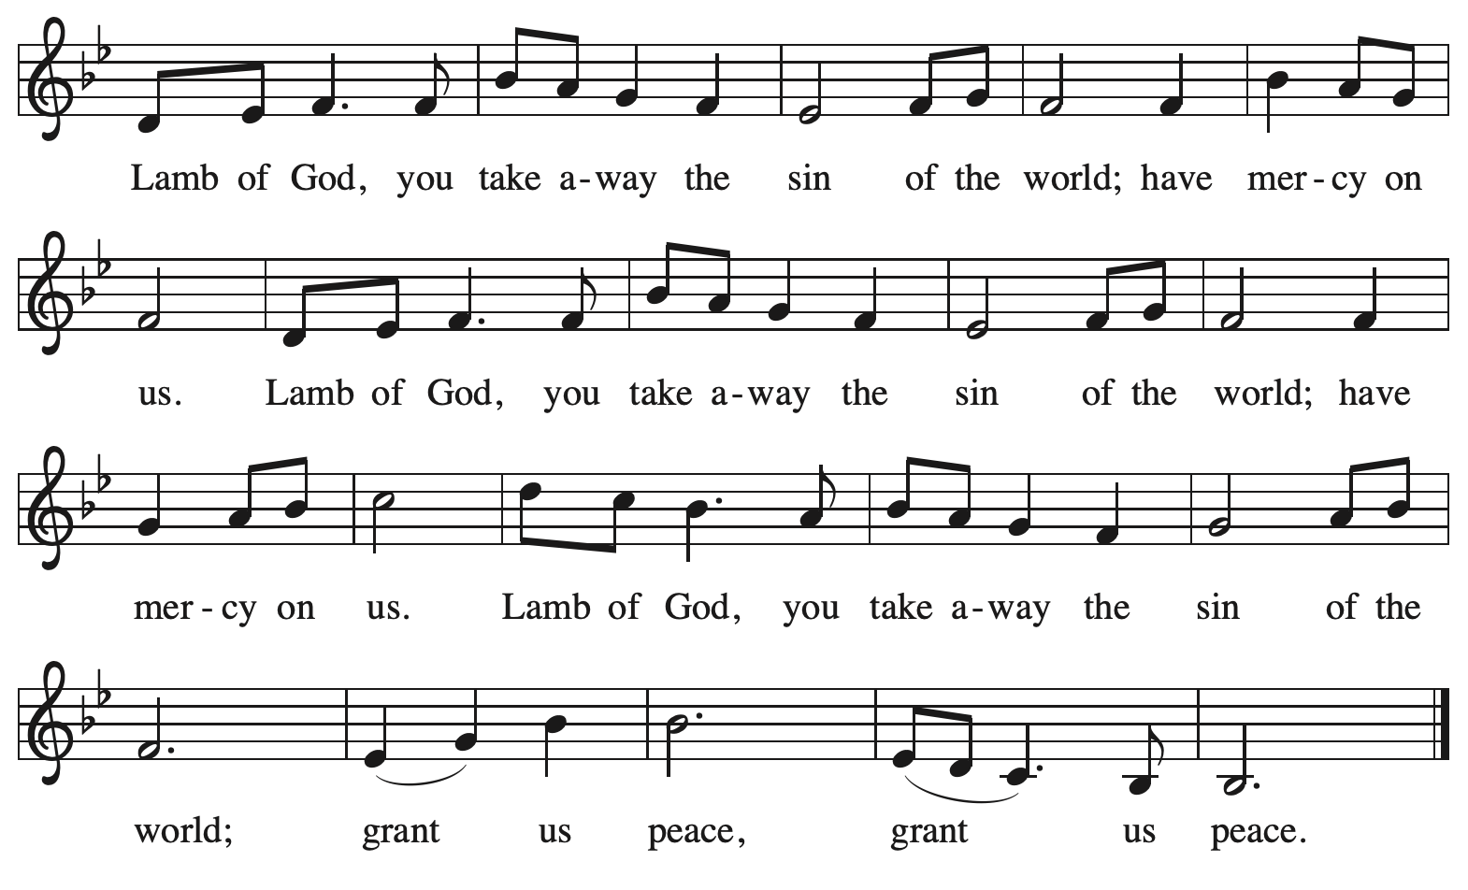

Please be seated.

Holy Communion

- All who seek God and desire a deeper and stronger life in Christ are welcome to receive Holy Communion.
- Worshipers from the pulpit side will proceed forward first, followed by the center section, and then the lectern side.
- Please inform an usher if you would like the ministers to bring Communion to you.
- Holy Communion will be served with bread and wine (amber) or grape juice (purple).
- The presiding minister will first distribute the bread (host) to each communicant. Please indicate if you require a gluten-free host.
- Once you have consumed the bread, please pick up an empty glass from the tray next to the presiding minister. The Communion Assistant will pour wine or grape juice into your glass.
- Please step to the side to consume the wine or grape juice.
- Feel free to kneel at the altar rail for prayer after receiving the sacrament.
- As you return to your pew, glasses may be returned to the empty tray on the side of the center section.
- A blessing will be provided for anyone who does not yet receive the sacrament.
- All are invited to join in singing the hymns during Holy Communion.

Hymns during Holy Communion
I Can Hear My Savior Calling TFF 146

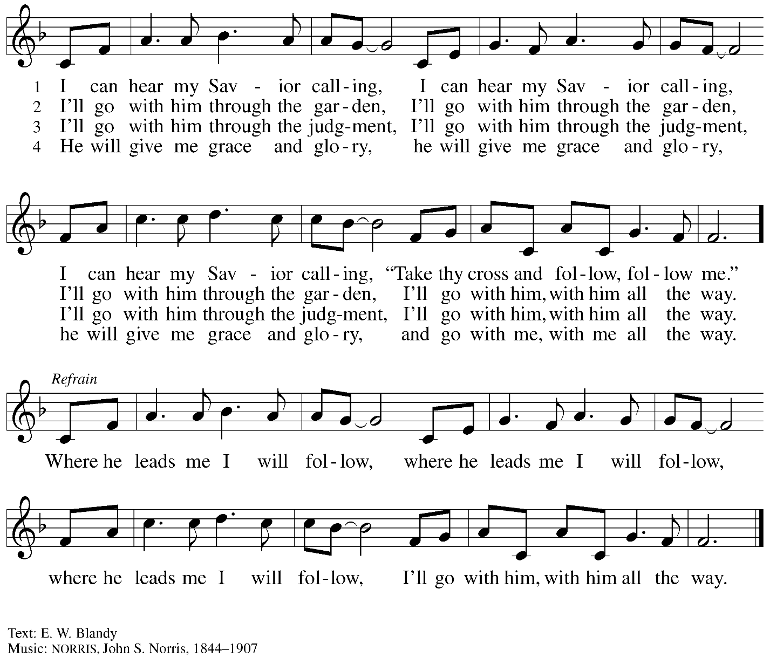

Hymns during Holy Communion
O Word of God Incarnate ELW 514

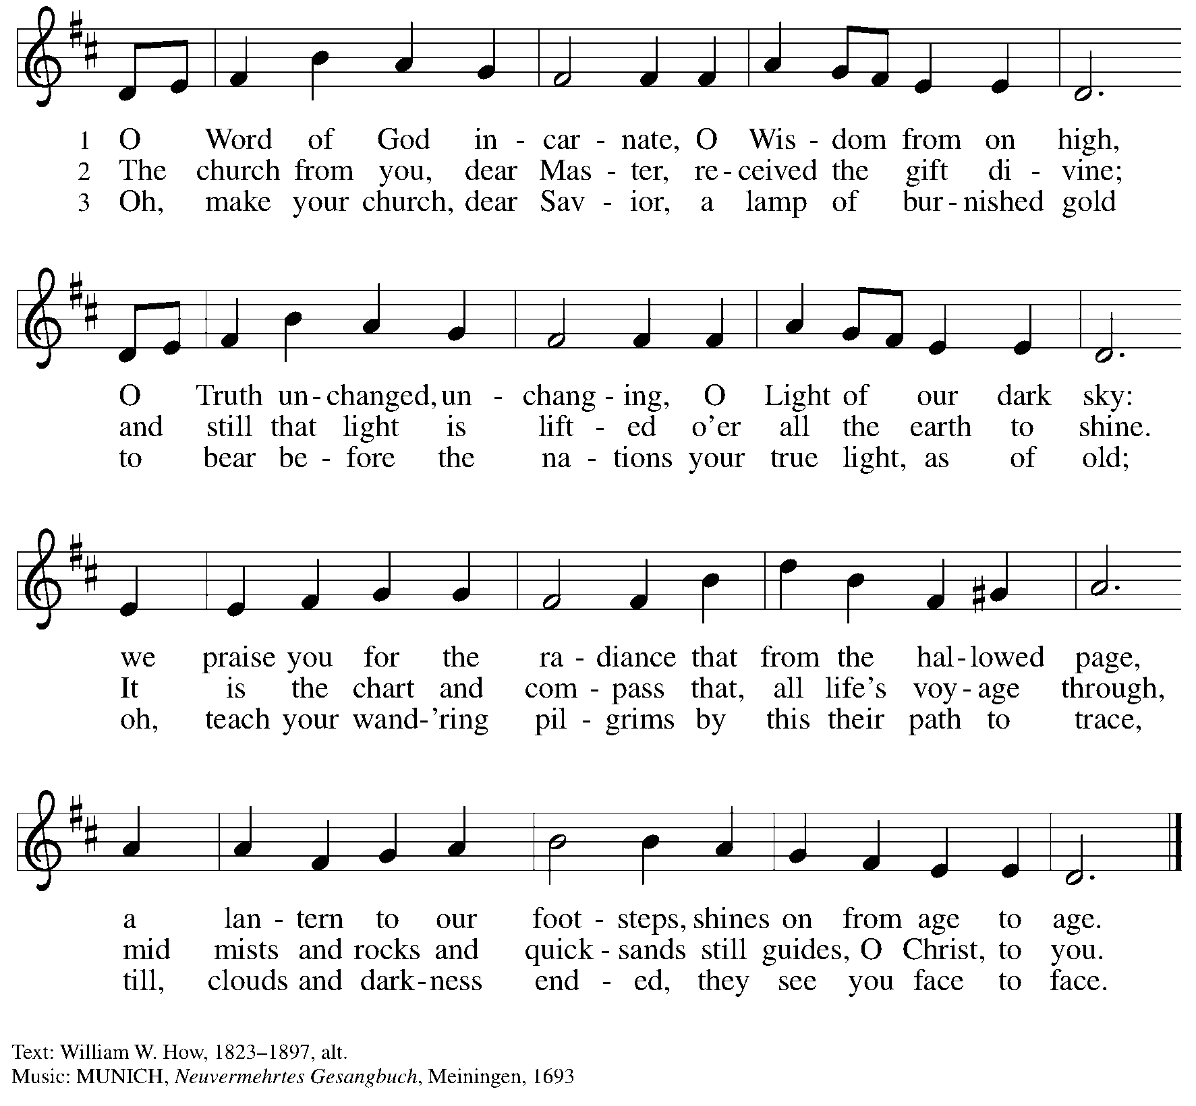

Hymns during Holy Communion
Jesus Calls Us; o’er the Tumult ELW 696

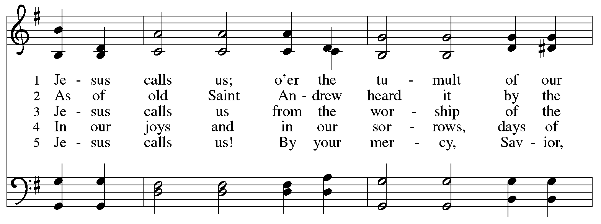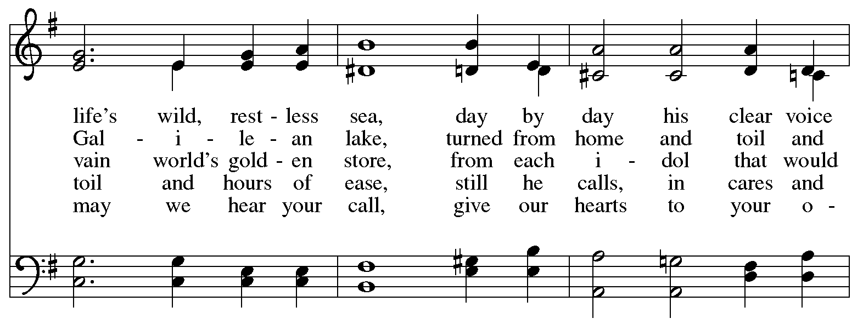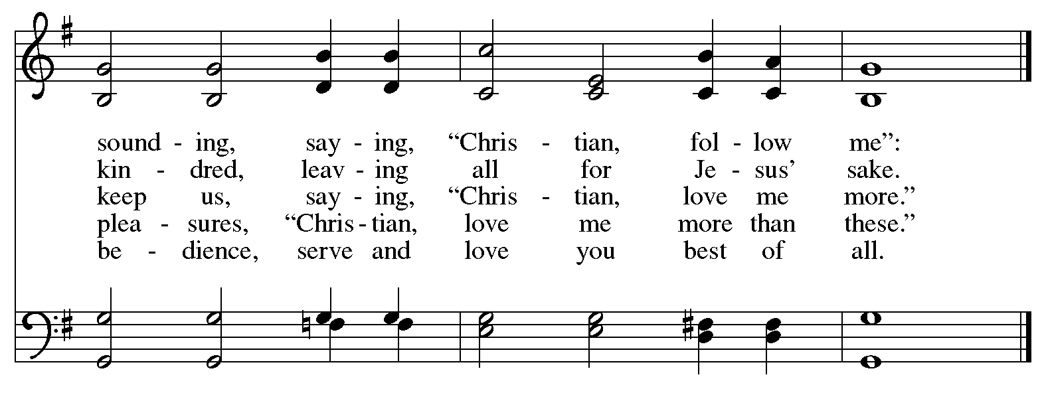

When all have returned to their places, please rise as you are able.

Blessing

P: The body and blood of our Lord Jesus Christ strengthen you and keep you in his grace.
C: Amen.

Prayer

A: Let us pray.
We thank you, O God, that you have strengthened our hearts through this feast of life
and salvation. Shine the light of Christ on our path, that we may do justice, love kindness,
and walk humbly with you, now and forever.
C: Amen.

Please be seated.

Sending
God blesses us and sends us in mission to the world

Announcements

Please rise as you are able.

Benediction

P: The Lord bless you and keep you.
The Lord’s face shine upon you with grace and mercy.
The Lord look upon you with favor and ☩ give you peace.
C: Amen.

Sending Hymn Following page

Dismissal

A: Go in peace. Serve the Lord.
C: Thanks be to God!

Postlude

Sending Hymn Let Us Talents and Tongues Employ ELW 674

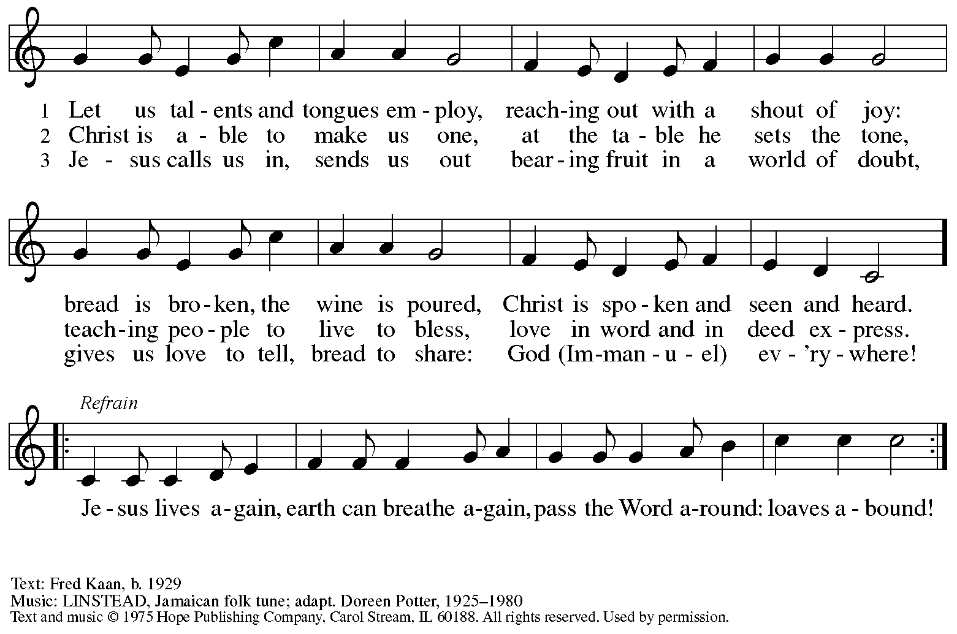
Reprinted under OneLicense.net # A-722139.

Serving in Worship Today

Altar Care Beverley Chapman
Assisting Minister Colleen Cooke
AV Ministers Kristen Asplin
Jason Galyardt
Cantor Maria Mangano
Lector Beverley Chapman
Minister of Music Laura Reynolds
Presiding Minister The Rev. Ross Carmichael

Liturgy and Hymnody Acknowledgements

From SundaysandSeasons.com. Copyright © 2026 Augsburg Fortress. All rights reserved. Reprinted under OneLicense.net # A-722139.
Used by permission of Augsburg Fortress.

The Scripture readings contained herein are from New Revised Standard Version Updated Edition of the Bible © 2021 National Council of Churches of Christ in the United States of America. Used by permission. All rights reserved worldwide.

Will You Come and Follow Me – Text: John L. Bell, b. 1949. Music: KELVINGROVE, Scottish traditional. Text © 1987 Iona Community, GIA Publications, Inc., agent. 7404 S. Mason Ave., Chicago, IL 60638. www.giamusic.com. 800.442.3358. All rights reserved. Reprinted with permission under OneLicense.net # A-722139.

Please use the QR code below to link to St. Andrew’s Announcements online!



St. Andrew Lutheran Church Announcements
January 25th, 2026

- Welcome to Worship at St. Andrew on the Third Sunday after Epiphany! – We are thankful you are here, and we offer a special welcome to all visitors and guests who are here for the first time! A nursery is available through the door to the left of the worship space and across the social hall (look for a purple room). Little Church – Big Faith, a Bible lesson and activity for children up to sixth grade, will take place after the prayer of the day. There are also worship “toolkits” to help children engage with worship and “busy bags” for younger children available in the bookcase at the back of the sanctuary. Please feel free to take one to use with/for your children.
- Bible Book Club Wednesday, January 28th at 7:00 p.m. on Zoom – Bible Book Club will meet on Wednesday at 7:00 p.m. All are welcome to participate. The group will be reading the Gospel of Mark along with The Gospel of Mark: A Beginner’s Guide to the Good News by Dr. Amy-Jill Levine. Here are the details on the book from one site: (https://www.cokesbury.com/The-Gospel-of-Mark-6?select=862810). The link to join the zoom call is https://us02web.zoom.us/j/83196175976?pwd=ejdPOUYrTk4xVFdsdlhHUVJ1L3k2Zz09.
- Alternatives to Violence Workshop, Saturday, January 31st, 10:30 a.m. to 12:00 p.m. – In a moment marked by deep division, rising fear, and everyday conflicts that touch families, schools, neighborhoods, and public life, the Alternatives to Violence Project (AVP) offers a hopeful and practical invitation: to learn peace not as an abstract ideal, but as a lived practice. On Saturday, January 31st, 2026, from 10:30 a.m. to 12:00 p.m., AVP Pittsburgh will host an interactive mini-workshop, “Acting on Conscience,” at St. Andrew Lutheran Church in Shadyside (Centre & Morewood). Led by Melanie Siaw, AVP facilitator and coordinator of the Pittsburgh Region, this gathering is designed for all ages, with special attention to families. Through a story drawn from the life and witness of Bayard Rustin, participants will explore how conscience, courage, and nonviolence shape everyday choices in times of tension and uncertainty. This event also reflects a long-standing interfaith collaboration for peace in Pittsburgh, bringing together St. Andrew Lutheran Church Shadyside, the Friends Meeting House/Peace Teams, Bethel A.M.E. Church, and AVP Pittsburgh. Together, these partners recognize that peace-making is not optional in a conflicted context—it is essential. The mini-workshop not only stands on its own as a meaningful community experience; it also serves as an introduction to AVP’s 18-hour Basic Workshop, planned for later in Spring 2026. In a world shaped by conflict at every level, this gathering offers a rare and timely opportunity to practice conscience, cultivate hope, and discover—together—paths toward nonviolent living that can sustain individuals, families, and communities for the long haul.
- Monthly Reparations Offering February 1st, during Worship – In Luke’s Gospel, Jesus tells a story about a compassionate Samaritan, suggesting that God’s people are called to work for healing and restoration for our neighbors, regardless of who or what caused them harm. In light of this, St. Andrew has made a commitment to reparations in regard to African American spiritual songs used in our worship. The text and music of most hymns is attributed to specific authors, with copyrights in place, usage reported, and royalties paid to those whose works are featured in worship. With African American spirituals, this is not possible. In response to many years of such uncredited use, St. Andrew invites the congregation to give a reparations offering. Funds received in worship will be donated to our siblings at Bethel AME Church, whose land and building were taken from them in the 1950s, to fund their development in the Hill District.
- Growing in Faith Together (GIFT) Group for People New to St. Andrew Begins Meeting after Worship on Sunday, February 1st – This gathering is intended for people who are relatively new to St. Andrew, whether you are preparing to join the congregation by transfer or Affirmation of Baptism, or would just like to meet more people and learn about the congregation. Jeff Denlinger and Kelly Spanninger will serve as facilitators and will be happy to answer any questions.
- Produce Distribution, First and Third Tuesday Each Month, February 3rd and 17th from 5:30-6:30 p.m. – St. Andrew partners with Greater Pittsburgh Community Food Bank to serve as a distribution site for fresh produce on the first and third Tuesday of every month. We invite people of the congregation to help with the distribution from 5:30 p.m. – 6:30 p.m. and/or to help with unloading and setup during the day between 10:00 a.m. and 1:00 p.m.
- Produce Distribution Supplemental Food of the Month – St. Andrew is collecting supplemental food each month to accompany our produce distribution. For January, we ask for donations of rice. There are collection boxes at the back of the worship space and social hall.
- Worship Committee Meeting Sunday, February 8th, after Worship
- Pancake Brunch during Coffee Hour on Sunday, February 15th – Traditionally on Shrove Tuesday, the day before Ash Wednesday, Christians would clear out all the rich and fatty foods from their cupboards in preparation for the season of Lent and its spiritual discipline of fasting. Following this custom, St. Andrew used to hold a pancake dinner on Shrove Tuesday, but we have not done so since before the pandemic. Last year we re-introduced the spirit of Shrove Tuesday after worship on Transfiguration Sunday, and we will do so again this year on February 15th. At the close of worship, we will have a brief outdoor liturgy for the burning of the palms and then proceed to the social hall for a meal together. The hospitality committee will provide pancake mix (with gluten), sausage (non-vegan), gluten-free cupcakes and cookies, butter, syrup, coffee and tea. We ask people of the congregation to bring fruit, breakfast juices, and other gluten-free breakfast items. We hope you will join in these activities as we prepare for the season of Lent, beginning on Ash Wednesday, February 18th.
- Save the Date: Pysanky Ukrainian Egg Lenten Meditation Workshop, Saturday, February 28th, 10:00 a.m. - 3:00 p.m. – Jimmi Kocher-Hillmer is experienced in the practice of Ukrainian Egg Making as a meditational and devotional practice. He has offered to once again lead a workshop this Lent for people of the congregation. Please save February 28th, from 10:00 a.m. to 3:00 p.m. on your calendars for this meaningful and fun opportunity!
- “Christ in Our Home” Booklets Available – “Christ in Our Home” is a quarterly devotional resource that encourages readers to live out their faith daily. Each reflective reading is accompanied by a daily scripture reference and prayer for the day. The January-March booklets are available at the entrances. Please feel free to take one home!
- Invitation to Prayer Team – St. Andrew maintains a list of weekly prayer concerns sent by email to members of the congregation who have opted in. Our prayer team’s email is prayerteam@standrewpittsburgh.org. We will keep names on the list for a maximum of four weeks unless otherwise requested. Thank you for your ministry of prayer!
- Records Update – St. Andrew is updating our records with information from newer attendees, as well as offering current members the opportunity to include information to be used within the congregation to acknowledge celebrations, milestones, and prayers. Please fill out the form at: https://forms.gle/kKvp19UozuRrhhaV7.
- Coffee Hour Signups – If you would like to participate and would like information about the duties, please sign up using the following form: https://www.signupgenius.com/go/5080B4AAFAF2CABF85-47069030-coffee#/.

