

+ Fourth Sunday after Epiphany
February 1, 2026



St. Andrew Lutheran Church
304 Morewood Ave.
Pittsburgh, PA 15213
St_andrewELCA@verizon.net
www.standrewpittsburgh.org

+ Fourth Sunday after Epiphany
Order for Worship

Who are the blessed ones of God? For Micah, they are those who do justice, love kindness,
and walk humbly with God. For Paul, they are the ones who find wisdom in the weakness of the cross. For Jesus, they are the poor, the meek, the merciful, the pure in heart, the peacemakers, those who mourn, and those who hunger for righteousness. In Baptism we find our blessed identity and calling in this countercultural way of living and serving.

Welcome to St. Andrew!
- St. Andrew welcomes all who are seeking a place of healing, wholeness, and acceptance in a nurturing and faith-forming spiritual home. We are striving toward racial equity worldwide
and we seek to honor the lived experience of all individuals regardless of background. Our community embraces people of all ages, ethnicities, cultures, abilities, sexual orientations,
gender identities and expressions, and family constellations. Come and See!
- Worship Services are live-streamed to multiple online platforms. By attending worship, you agree that your image and voice may be broadcast.
- Everyone is invited to make a name tag at the black bookcase in the back of the worship space if they would like. There are stickers indicating pronouns on the bookcase if you would like to include them on your name tag.
- A nursery is available through the doors at the left side of the sanctuary and across from the doorway to the Social Hall. Look for a purple-colored room.
- Children are invited to attend Little Church – Big Faith, a Bible lesson and activity, during worship (after the Prayer of the Day). The group returns to the worship space for the liturgy of Holy Communion.
- Worship “toolkits” to help children engage with the service, along with “busy bags” for younger children, are available in the bookcase at the back of the sanctuary. Please feel free to take one to use with/for your children.
- Holy Communion is served with bread (gluten-free available) and wine or grape juice. The presiding minister will distribute the bread (host). Please consume this and then pick up an empty glass from the tray. The Communion Assistant will pour wine or grape juice into your glass. Please step to the side to consume the wine or grape juice. Feel free to kneel at the altar for prayer and reflection. As you return to your pew, glasses may be returned to the empty trays on either side of the center section.
- A restroom is available on the main level of the church, through the doors to the Social Hall and to the right in the main office.

Abbreviations
P: Pastor/Presiding Minister ELW: Evangelical Lutheran Worship hymnal
A: Assisting Minister ACS: All Creation Sings hymnal
L: Lector
C: Congregation

Musical Offering

Each week, different people from the congregation make an offering of pre-service music, with singing or instrumentation, to help the assembly focus and pray in preparation for worship.

Welcome

Prelude Blessed Are the Poor Tom Leech

Gathering
The Holy Spirit calls us together as the people of God

Please rise as you are able. All may make the sign of the cross,
the sign that is marked at Baptism, as the presiding minister begins.

Confession and Forgiveness

P: Blessed be the holy Trinity, ☩ one God,
the fountain of living water,
the rock who gave us birth,
our light and our salvation.
C: Amen.

P: Let us confess our sin in the presence of God and of one another.

Silence is kept for reflection.

P: Most merciful God,
C: we confess that we are captive to sin and cannot free ourselves.
We have sinned against you in thought, word, and deed,
by what we have done and by what we have left undone.
We have not loved you with our whole heart;
we have not loved our neighbors as ourselves.
For the sake of your Son, Jesus Christ, have mercy on us.
Forgive us, renew us, and lead us,
so that we may delight in your will and follow in your ways,
to the glory of your holy name. Amen.

P: By water and the Holy Spirit God gives you a new birth,
and through the death and resurrection of ☩ Jesus Christ, God forgives you all your sins.
The God of mercy strengthen you in all goodness and keep you in eternal life.
C: Amen.

Gathering Hymn Look Who Gathers at Christ’s Table ACS 977

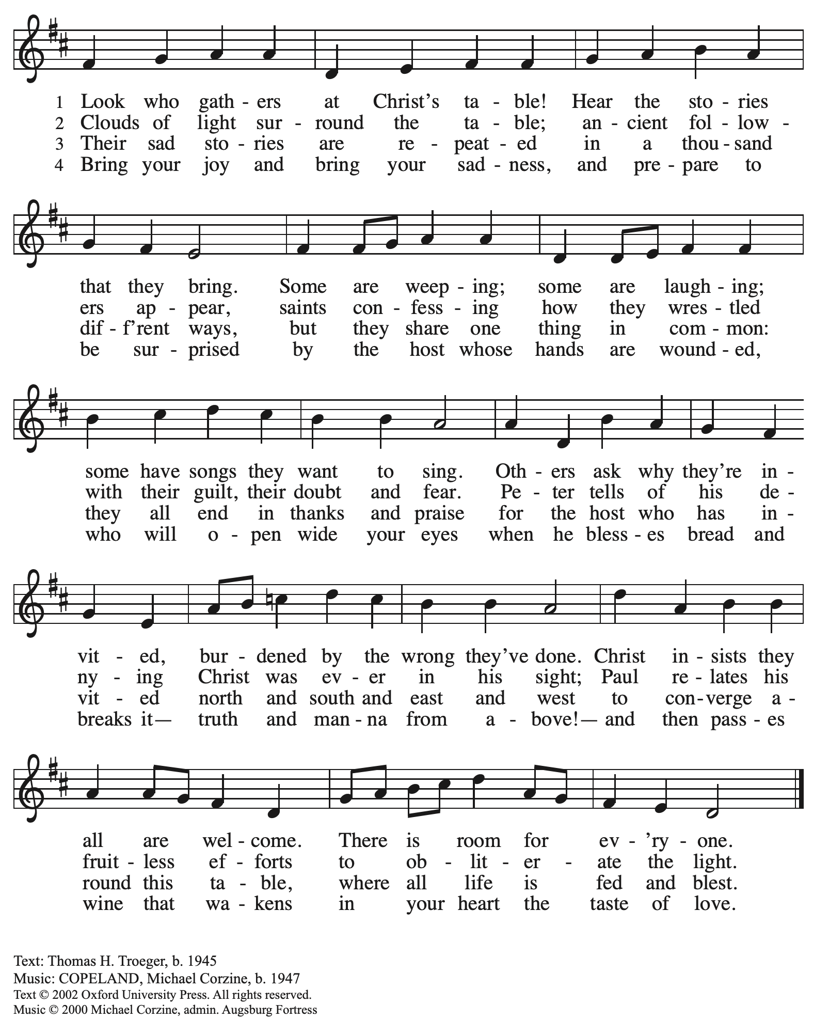
All rights reserved. Reprinted under OneLicense.net # A-722139.
Greeting

P: The grace of our Lord Jesus Christ, the love of God,
and the communion of the Holy Spirit be with you all.
C: And also with you.

Hymn of Praise ACS p. 31

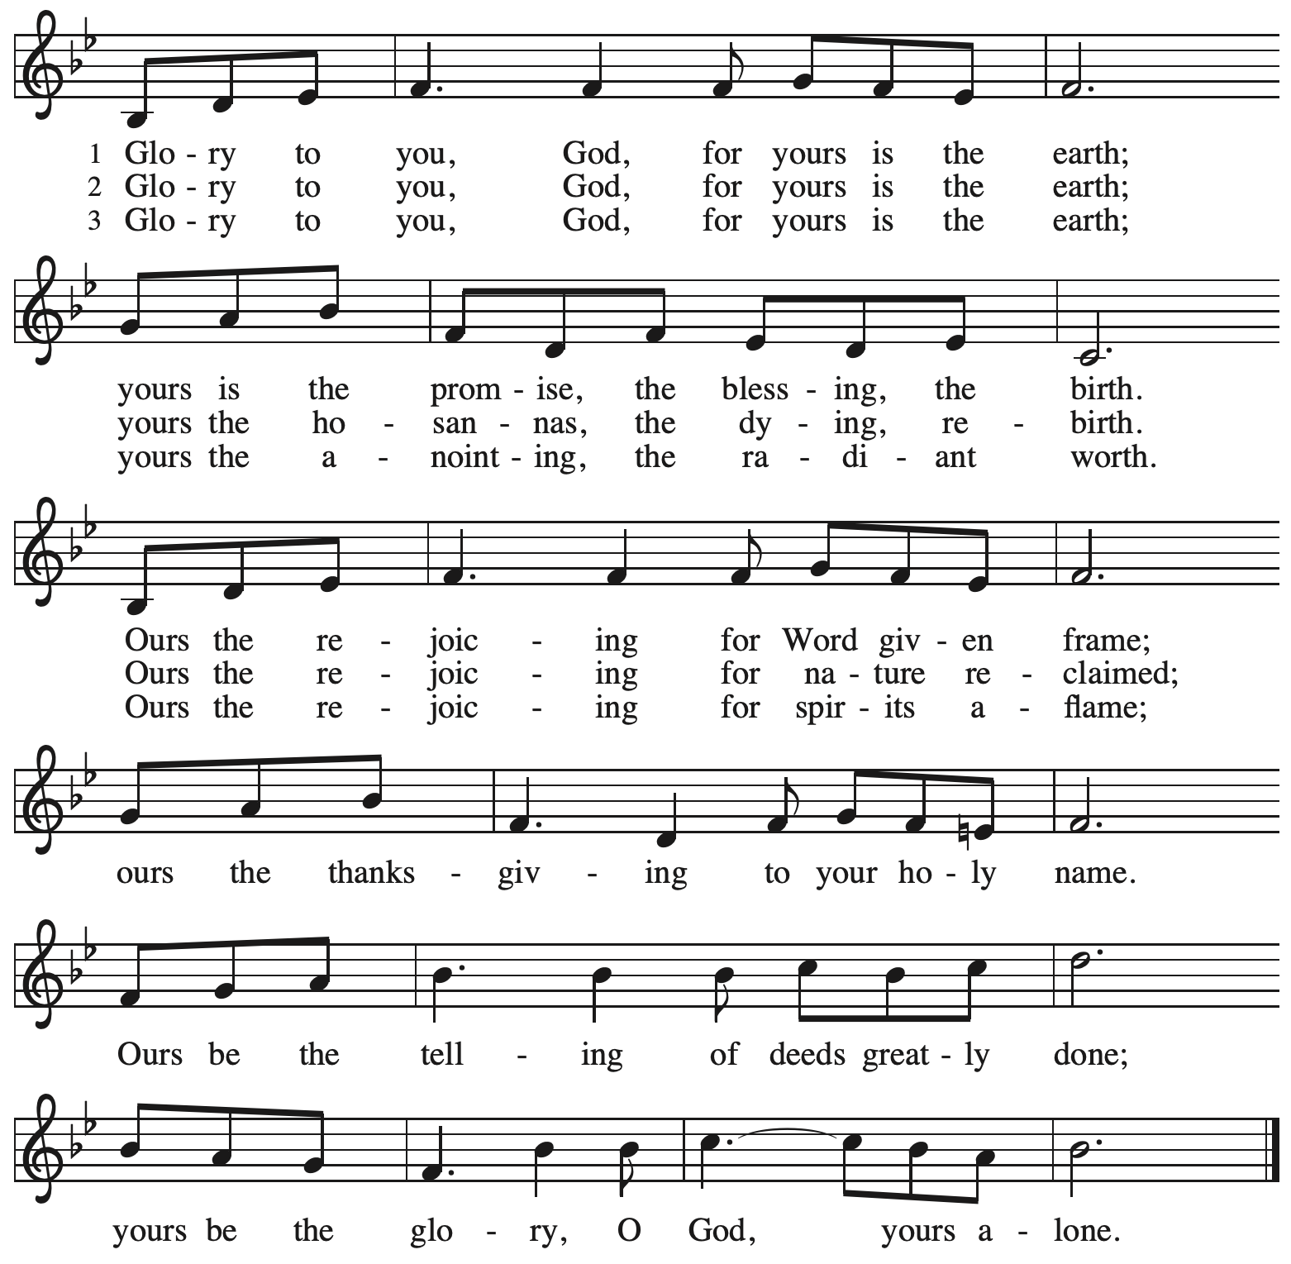

Prayer of the Day

P: The Lord be with you.
C: And also with you.

P: Holy God, you confound the world’s wisdom in giving your kingdom to the lowly and the pure in heart. Give us such a hunger and thirst for justice, and perseverance in striving for peace, that in our words and deeds the world may see the life of your Son, Jesus Christ,
our Savior and Lord.
C: Amen.

Please be seated.
Children are invited to join the adult leader(s) at the side door for Little Church – Big Faith.
We ask that an additional adult from the congregation attend with the children.

Word
God speaks to us in Scripture reading, preaching, and song

First Reading – Micah 6: 1-8

¹ Hear what the Lord says:
Rise, plead your case before the mountains,
and let the hills hear your voice.
² Hear, you mountains, the case of the Lord,
and you enduring foundations of the earth,
for the Lord has a case against God’s people,
and the Lord will contend with Israel.
³ “O my people, what have I done to you?
In what have I wearied you? Answer me!
⁴ For I brought you up from the land of Egypt
and redeemed you from the house of slavery,
and I sent before you Moses,
Aaron, and Miriam.
⁵ O my people, remember now what King Balak of Moab devised,
what Balaam son of Beor answered him,
and what happened from Shittim to Gilgal,
that you may know the saving acts of the Lord.”
⁶ “With what shall I come before the Lord
and bow myself before God on high?
Shall I come before the Lord with burnt offerings,
with calves a year old?
⁷ Will the Lord be pleased with thousands of rams,
with ten thousands of rivers of oil?
Shall I give my firstborn for my transgression,
the fruit of my body for the sin of my soul?”
⁸ The Lord has told you, O mortal, what is good,
and what does the Lord require of you
but to do justice and to love kindness
and to walk humbly with your God?

L: Word of God, word of life.
C: Thanks be to God.

Psalm 15

The psalm will be sung responsively, led by the cantor, with the congregation singing the verses in bold type and joining in the refrain.

Psalm Tone

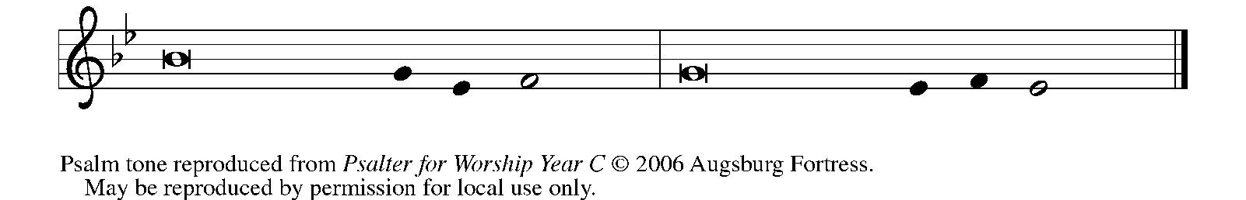
Psalm Refrain

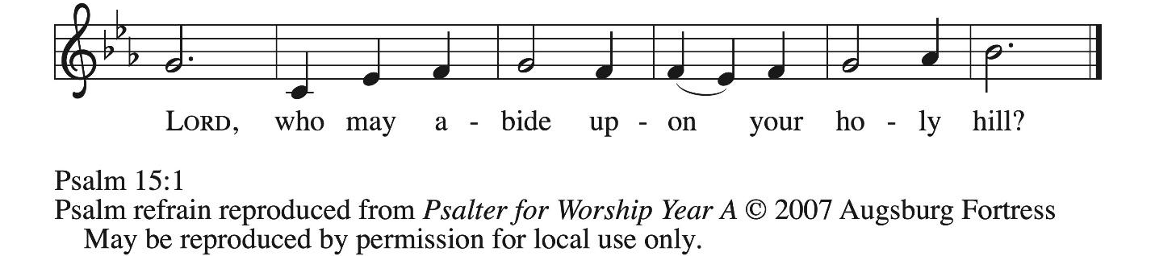

¹ Lord, who may dwell in your | tabernacle?
Who may abide upon your | holy hill?
² Those who lead a blameless life and do | what is right,
who speak the truth | from their heart; R
³ they do not slander with the tongue, they do no evil | to their friends;
they do not cast discredit up- | on a neighbor.
⁴ In their sight the wicked are rejected, but they honor those who | fear the Lord.
They have sworn upon their health and do not take | back their word.
⁵ They do not give their money in hope of gain, nor do they take bribes a- | gainst the innocent.
Those who do these things shall never be | overthrown. R

Second Reading – 1 Corinthians 1: 18-31

¹⁸ The message about the cross is foolishness to those who are perishing, but to us who are being saved it is the power of God. ¹⁹ For it is written,
“I will destroy the wisdom of the wise,
and the discernment of the discerning I will thwart.”
²⁰ Where is the one who is wise? Where is the scholar? Where is the debater of this age? Has not God made foolish the wisdom of the world? ²¹ For since, in the wisdom of God, the world did not know God through wisdom, God decided, through the foolishness of the proclamation, to save those who believe. ²² For Jews ask for signs and Greeks desire wisdom, ²³ but we proclaim Christ crucified, a stumbling block to Jews and foolishness to gentiles, ²⁴ but to those who are the called, both Jews and Greeks, Christ the power of God and the wisdom of God. ²⁵ For God’s foolishness is wiser than human wisdom, and God’s weakness is stronger than human strength.
²⁶ Consider your own call, kindred: not many of you were wise by human standards, not many were powerful, not many were of noble birth. ²⁷ But God chose what is foolish in the world to shame the wise; God chose what is weak in the world to shame the strong; ²⁸ God chose what is low and despised in the world, things that are not, to abolish things that are, ²⁹ so that no one might boast in the presence of God. ³⁰ In contrast, God is why you are in Christ Jesus, who became for us wisdom from God, and righteousness and sanctification and redemption, ³¹ in order that, as it is written, “Let the one who boasts, boast in the Lord.”

L: Word of God, word of life.
C: Thanks be to God.

Please rise as you are able.

Gospel Acclamation ACS p. 33

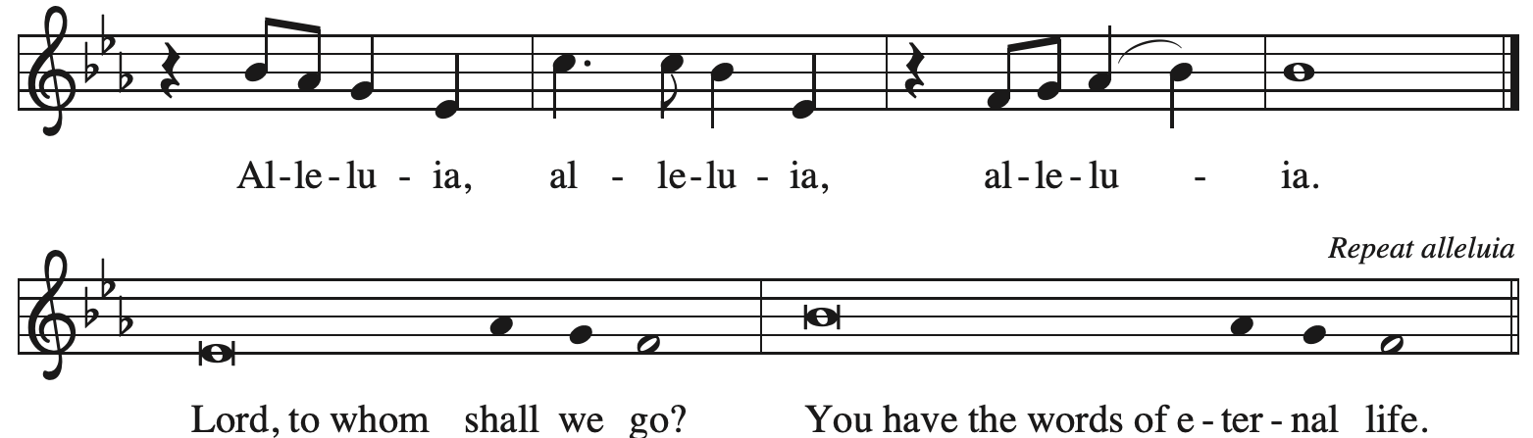

Gospel – Matthew 5: 1-12

P: The holy Gospel according to St. Matthew.
C: Glory to you, O Lord.

¹ When Jesus saw the crowds, he went up the mountain, and after he sat down, his disciples came to him. ² And he began to speak and taught them, saying:
³ “Blessed are the poor in spirit, for theirs is the kingdom of heaven.
⁴ “Blessed are those who mourn, for they will be comforted.
⁵ “Blessed are the meek, for they will inherit the earth.
⁶ “Blessed are those who hunger and thirst for righteousness, for they will be filled.
⁷ “Blessed are the merciful, for they will receive mercy.
⁸ “Blessed are the pure in heart, for they will see God.
⁹ “Blessed are the peacemakers, for they will be called children of God.
¹⁰ “Blessed are those who are persecuted for the sake of righteousness, for theirs is the kingdom of heaven.
¹¹ “Blessed are you when people revile you and persecute you and utter all kinds of evil against you falsely on my account. ¹² Rejoice and be glad, for your reward is great in heaven, for in the same way they persecuted the prophets who were before you.”

P: The Gospel of the Lord.
C: Praise to you, O Christ.

Please be seated.

Sermon

A time of silence for prayer and reflection follows the sermon.
When the hymn of the day begins, please rise as you are able.



Hymn of the Day Cuando el pobre – When the Poor Ones ELW 725

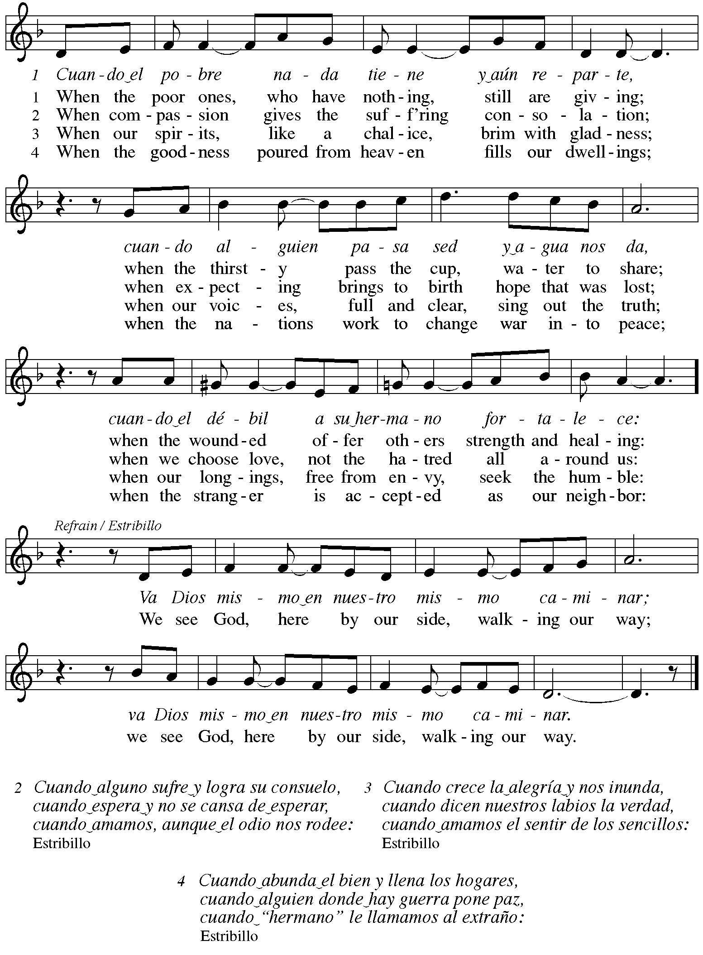
Apostles’ Creed

C: I believe in God, the Father almighty,
creator of heaven and earth.

I believe in Jesus Christ, God’s only Son, our Lord,
who was conceived by the Holy Spirit,
born of the virgin Mary,
suffered under Pontius Pilate,
was crucified, died, and was buried;
he descended to the dead.*
On the third day he rose again;
he ascended into heaven,
he is seated at the right hand of the Father,
and he will come to judge the living and the dead.

I believe in the Holy Spirit,
the holy catholic church,
the communion of saints,
the forgiveness of sins,
the resurrection of the body,
and the life everlasting. Amen.

*Or, “he descended into hell,” another translation of this text in widespread use.

Please be seated.

Prayers of the People

A: As God’s beloved children united in Christ, let us pray for the church,
the world, and the whole human community.

After each petition
A: Merciful God,
C: receive our prayer.

The presiding minister concludes the prayers
P: Confident that the Holy Spirit receives our prayers and answers us,
we commend all for whom we pray to God’s lovingkindness
revealed to us through Jesus Christ our Savior.
C: Amen.

Peace

The presiding minister and the assembly greet one another in the peace of the risen Christ.
P: The peace of Christ be with you always.
C: And also with you.

The people may greet those around them with a sign of Christ’s peace and may say
Peace be with you or similar words. Please be mindful that not everyone will be comfortable with sharing the peace, so please seek consent before shaking hands or hugging.
Other possible ways to share the peace include a simple bow with the verbal greeting of peace, or simply a verbal expression of peace.

When the greetings of peace have concluded, please be seated.

Meal
God feeds us with the presence of Jesus Christ

Offering

We offer ourselves, our gifts, and our faithful service to God.
As the offering is gathered for the mission of the church, including the care of those in need,
the table is set for Holy Communion.

There are laminated giving cards in the pew racks that feature a QR code for anyone who would like to give online. Those who give using the QR code, as well as those who give regularly online or through their bank are encouraged to place the laminated card in the plate as an expression of your offering.

Reparations Offering

On the first Sunday of each month, St. Andrew invites people of the congregation to give a second offering for a reparations fund in acknowledgment of St. Andrew’s use of African American spiritual songs in our worship services. Please see the note in the announcements for more information.

Offertory Music I Love to Tell the Story arr. Keveren

As the gifts are brought forward for presentation, please rise as you are able.

Offertory Song God of the Fertile Fields ACS 1063
v. 1, 3
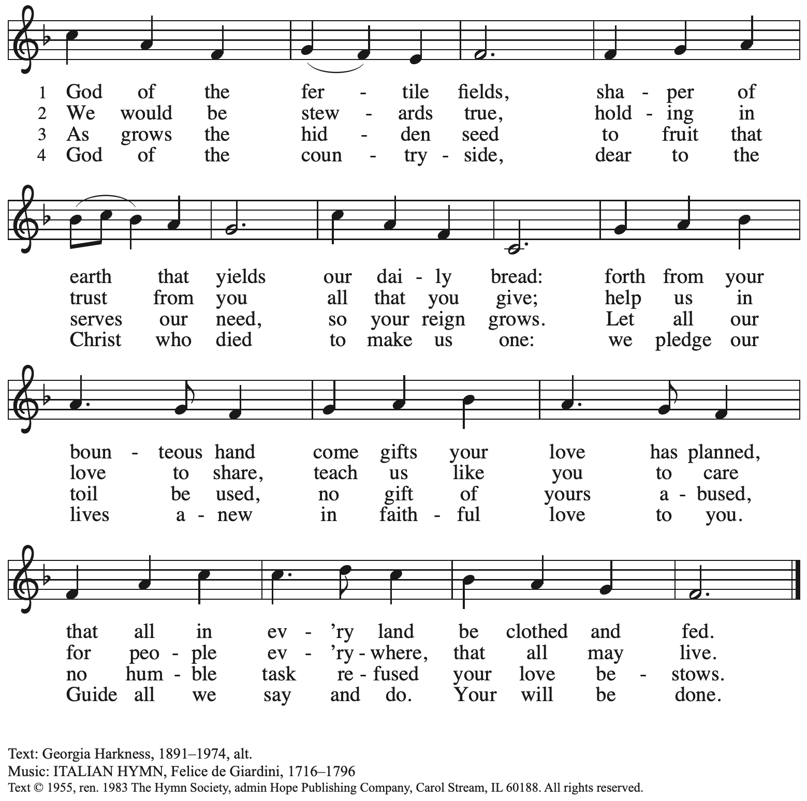
Reprinted with permission under One License.net # A-722139.

Offertory Prayer

A: Let us pray.
God of goodness and growth,
C: all creation is yours, and your faithfulness is sure.
Word and water, wine and bread: these are signs of your abundant grace.
Receive the gifts we bring, and nourish us to proclaim your abiding love
in our communities and in the world,
through Jesus Christ, our strength and our song.
Amen.

Dialogue

P: The Lord be with you.
C: And also with you.

P: Lift up your hearts.
C: We lift them to the Lord.

P: Let us give thanks to the Lord our God.
C: It is right to give our thanks and praise.

Preface (Spoken by the presiding minister)

P: It is indeed right, our duty and our joy,
that we should at all times and in all places
give thanks and praise to you, almighty and merciful God,
through our Savior Jesus Christ;
who on this day overcame death and the grave,
and by his glorious resurrection opened to us the way of everlasting life.
And so, with all the choirs of angels,
with the church on earth and the hosts of heaven,
we praise your name and join their unending hymn:

Sanctus ACS p. 36

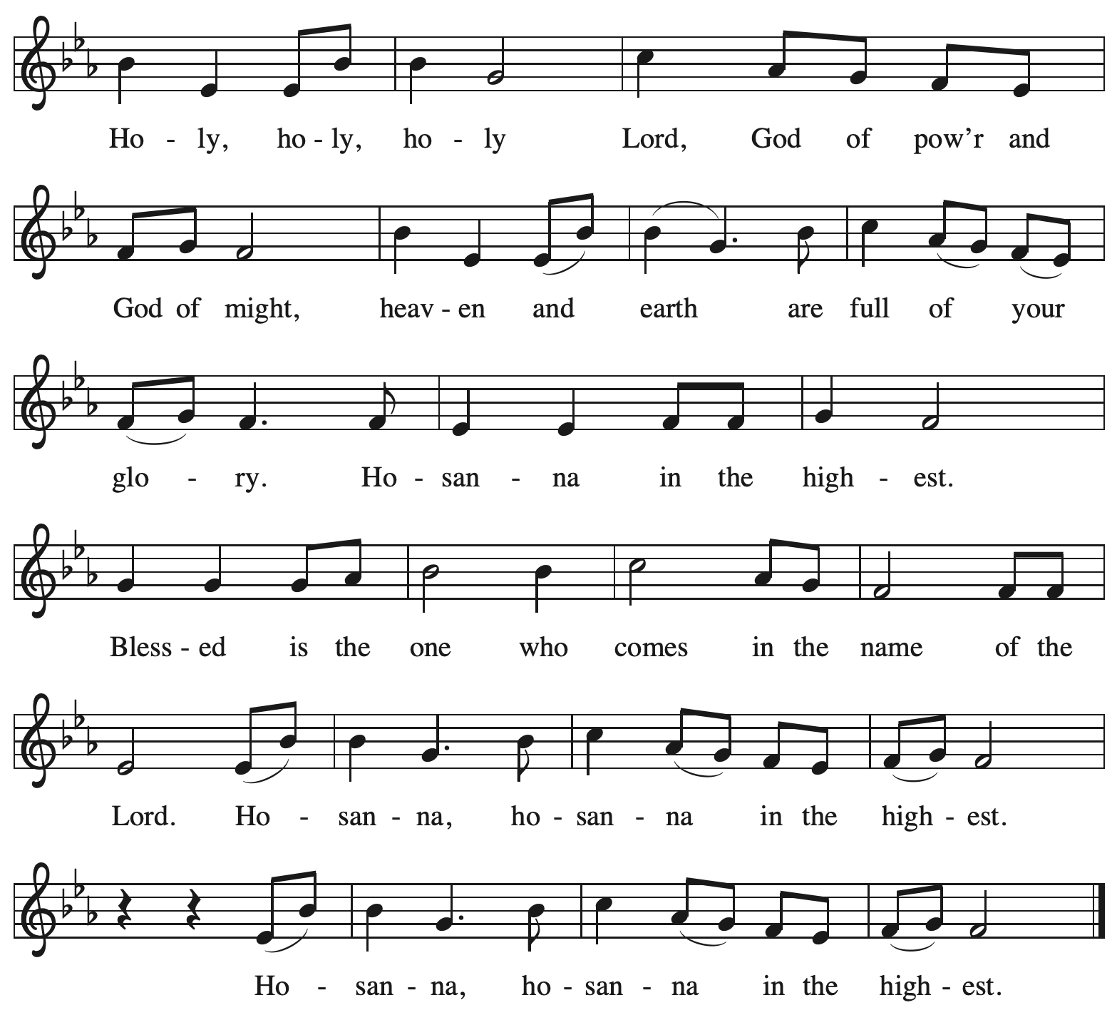

Eucharistic Prayer

P: Holy God, mighty and merciful, your peoples praise you, saying:
Your mercy endures forever.
C: Your mercy endures forever.

P: By your promise …
… the colors of your love and faithfulness.
Your mercy endures forever.
C: Your mercy endures forever.

P: By your promise …
… and calling them to be a light to the nations.
Your mercy endures forever.
C: Your mercy endures forever.

P: By your promise …
… Do this for the remembrance of me.

With this bread and cup
we remember his life laid down and lifted up
as we proclaim the mystery of faith:
C: Christ has died. Christ is risen. Christ will come again.

P: Send your Holy Spirit upon us …
… in your Spirit, now and forever.
C: Amen.

Lord’s Prayer

P: Gathered as one by the Holy Spirit, let us pray using the words our Savior taught us.
C: Our Father, who art in heaven,
hallowed be thy name,
thy kingdom come,
thy will be done,
on earth as it is in heaven.
Give us this day our daily bread;
and forgive us our trespasses,
as we forgive those
who trespass against us;
and lead us not into temptation,
but deliver us from evil.
For thine is the kingdom,
and the power, and the glory,
forever and ever. Amen.

Fraction and Invitation

P: Here is the Lamb of God who takes away the sin of the world.
Come to the table, taste and see.

Agnus Dei / Lamb of God ACS p. 40

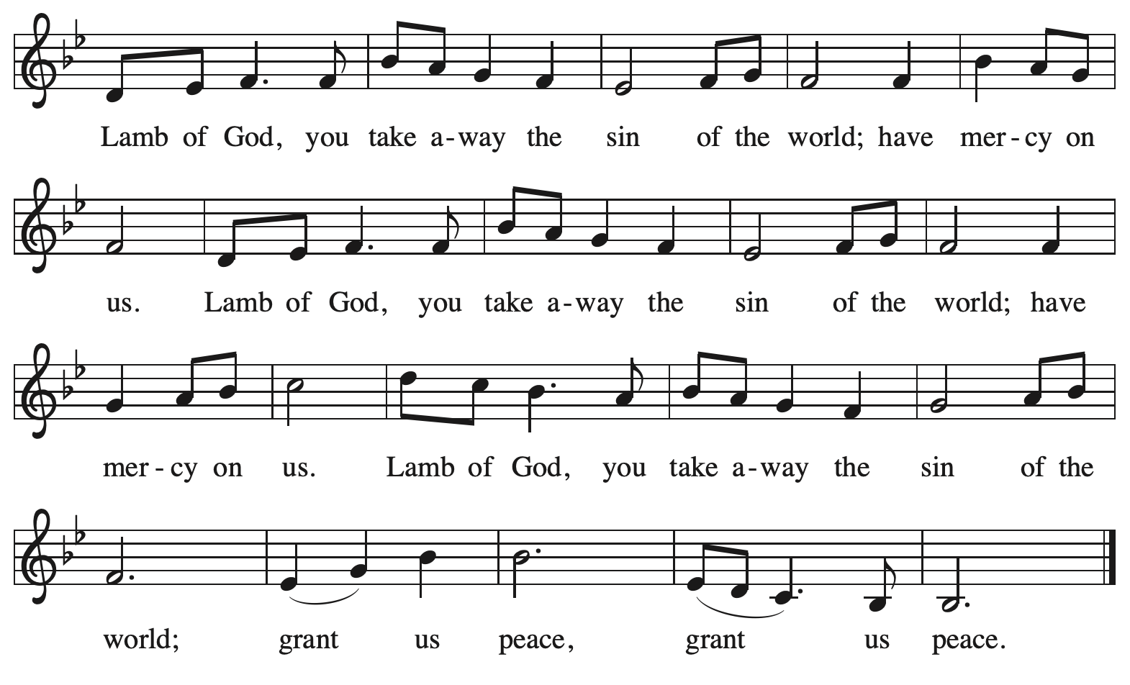

Please be seated.

Holy Communion

- All who seek God and desire a deeper and stronger life in Christ are welcome to receive Holy Communion.
- Worshipers from the pulpit side will proceed forward first, followed by the center section, and then the lectern side.
- Please inform an usher if you would like the ministers to bring Communion to you.
- Holy Communion will be served with bread and wine (amber) or grape juice (purple).
- The presiding minister will first distribute the bread (host) to each communicant. Please indicate if you require a gluten-free host.
- Once you have consumed the bread, please pick up an empty glass from the tray next to the presiding minister. The Communion Assistant will pour wine or grape juice into your glass.
- Please step to the side to consume the wine or grape juice.
- Feel free to kneel at the altar rail for prayer after receiving the sacrament.
- As you return to your pew, glasses may be returned to the empty tray on the side of the center section.
- A blessing will be provided for anyone who does not yet receive the sacrament.
- All are invited to join in singing the hymns during Holy Communion.

Hymns during Holy Communion
By Your Hand You Feed Your People ELW 469

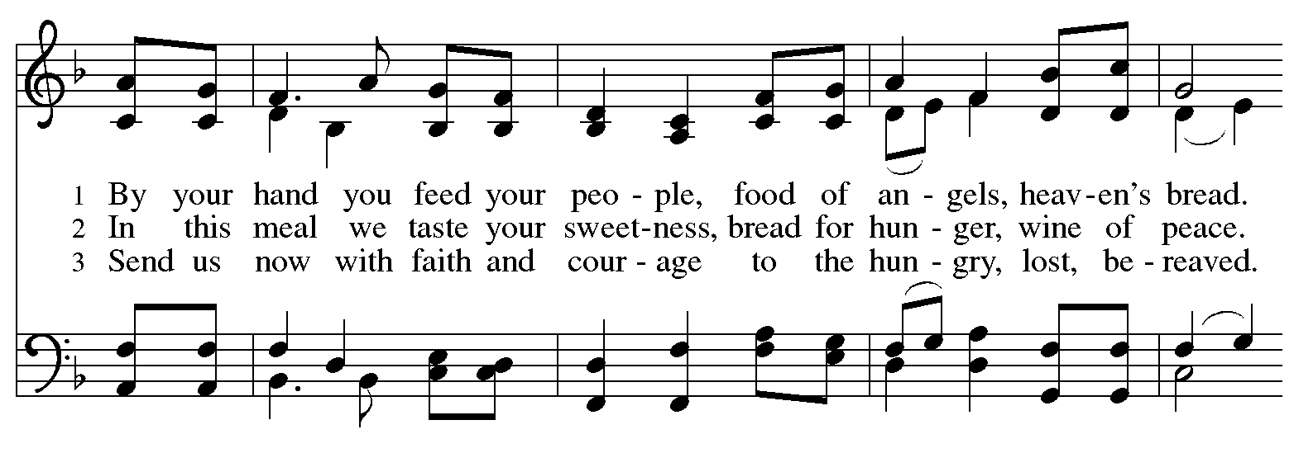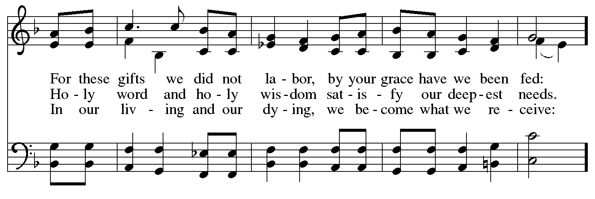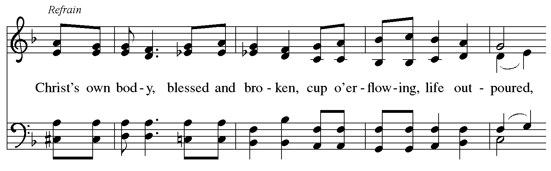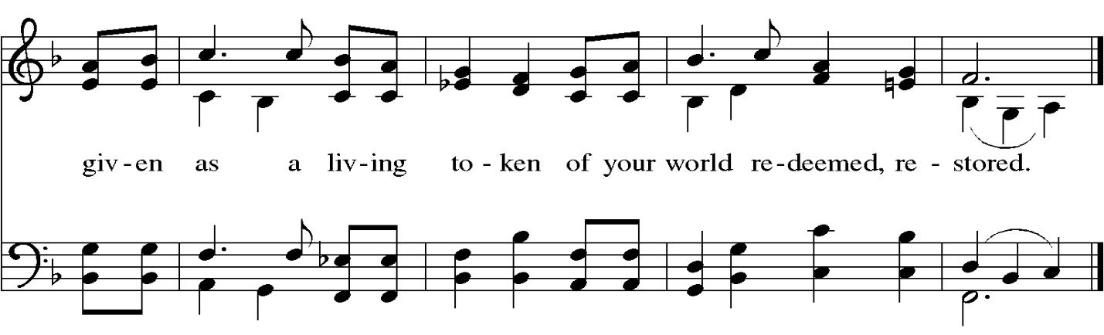
Hymns during Holy Communion
Let Justice Flow Like Streams ELW 717

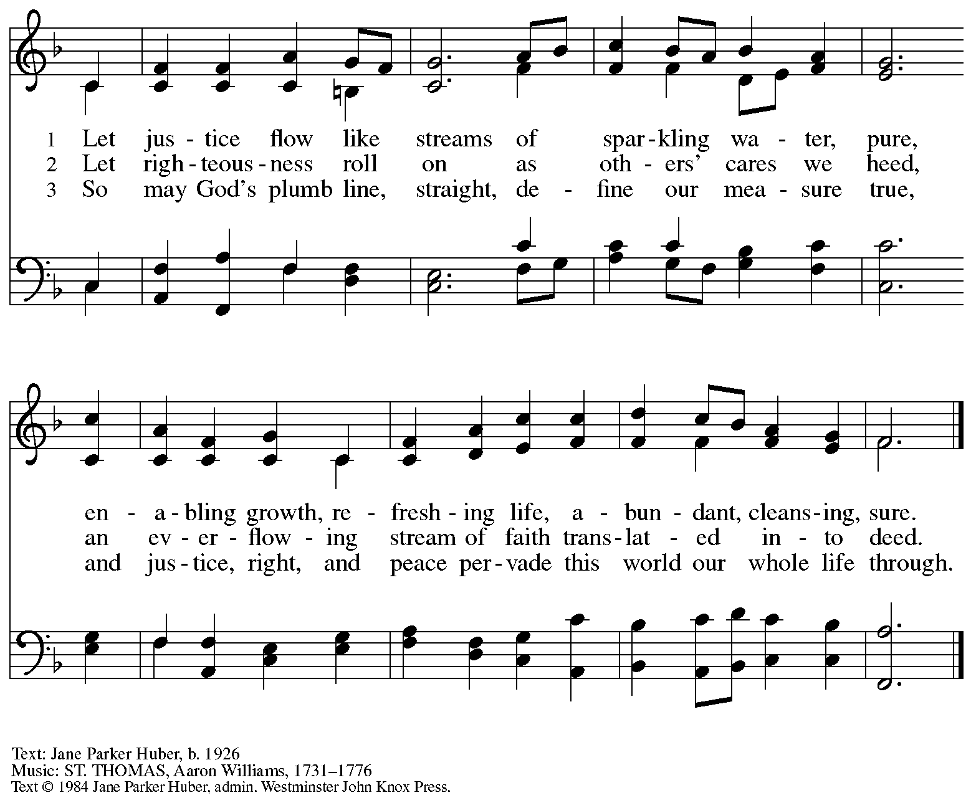
All rights reserved. Reprinted with permission under OneLicense.net # A-722139.

Hymns during Holy Communion
What Does the Lord Require of You? ACS 1057

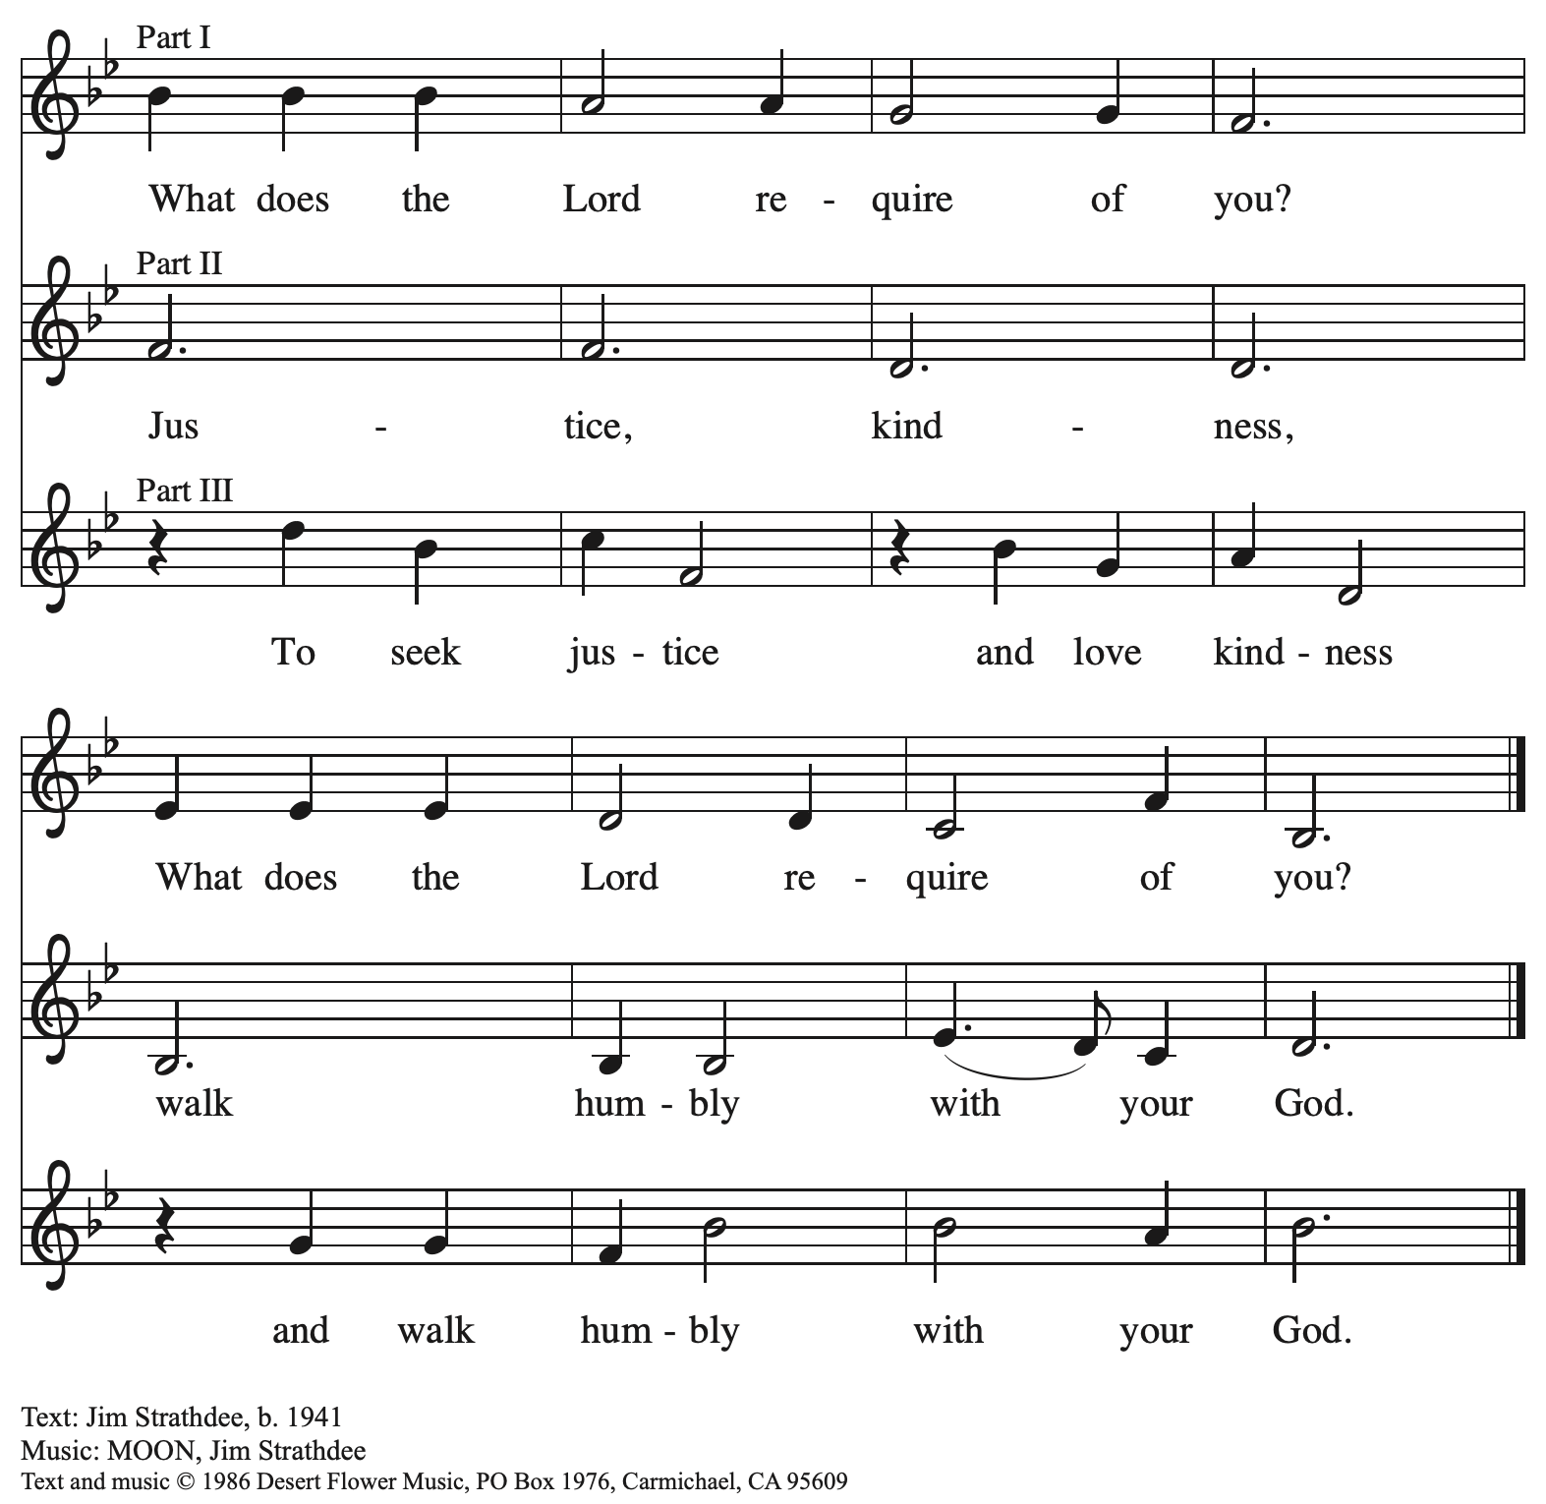
All rights reserved. Reprinted with permission under OneLicense.net # A-722139.

Hymns during Holy Communion
Come and Seek the Ways of Wisdom ACS 971

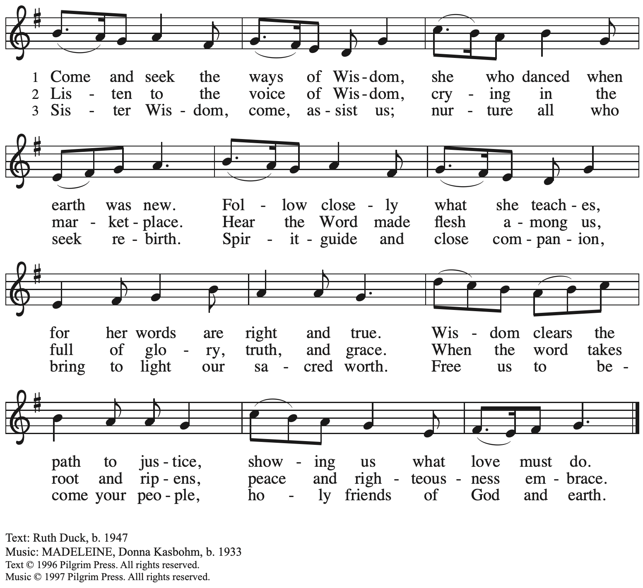
Reprinted with permission under OneLicense.net # A-722139.

When all have returned to their places, please rise as you are able.

Blessing

P: The body and blood of our Lord Jesus Christ strengthen you and keep you in his grace.
C: Amen.

Prayer

A: Let us pray. We thank you, O God, that you have strengthened our hearts through this feast of life and salvation. Shine the light of Christ on our path, that we may do justice, love kindness,
and walk humbly with you, now and forever.
C: Amen.
Please be seated.

Sending
God blesses us and sends us in mission to the world

Announcements

Please rise as you are able.

Benediction

P: The Lord bless you and keep you.
The Lord’s face shine upon you with grace and mercy.
The Lord look upon you with favor and ☩ give you peace.
C: Amen.

Sending Hymn Abide, O Dearest Jesus ELW 539

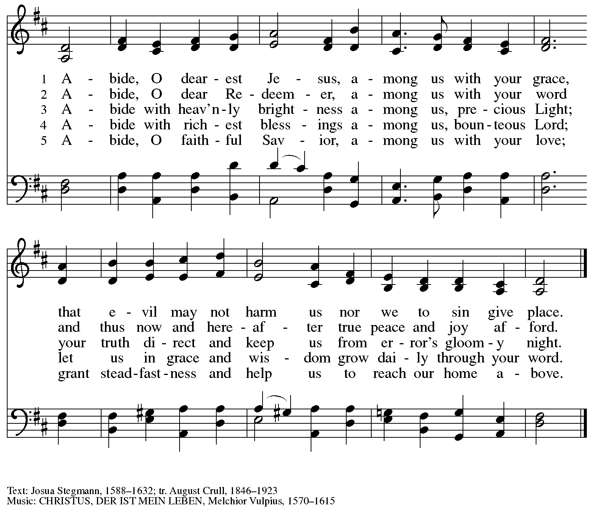

Dismissal

A: Go in peace. Serve the Lord.
C: Thanks be to God!

Postlude

Serving in Worship Today

Altar Care Beverley Chapman
Assisting Minister Jimmi Kocher-Hillmer
Audio Visual Ministers Tyler Rietze
Joseph Paetz
Cantor Marit Bakken
Irish Whistle Tom Leech
Lector Alda Maria Gonzaga
Vocal Soloist Marit Bakken
Minister of Music Laura Reynolds
Presiding Minister The Rev. Ross Carmichael

Liturgy and Hymnody Acknowledgements

From SundaysandSeasons.com. Copyright © 2026 Augsburg Fortress. All rights reserved. Reprinted under OneLicense.net # A-722139.
Used by permission of Augsburg Fortress.

The Scripture readings contained herein are from New Revised Standard Version Updated Edition of the Bible © 2021 National Council of Churches of Christ in the United States of America. Used by permission. All rights reserved worldwide.

Cuando el pobre – When the Poor Ones – Text: José Antonio Olivar, b. 1939; tr. Martin A. Seltz, b. 1951. Music: EL CAMINO, Miguel Manzano, b. 1934. Text and music © 1971, 1998 J.A. Olivar, Miguel Manzano, and San Pablo Internacional—SSP, admin. OCP Publications,
5536 New Hassalo, Portland, OR 97213. All rights reserved. Reprinted with permission under OneLicense.net # A-722139.

By Your Hand You Feed Your People – Text: Susan R. Briehl, b. 1952. Music: CAMROSE, Marty Haugen, b. 1950. Text and music © 2002 GIA Publications, Inc. All rights reserved. Reprinted with permission under OneLiceense.net # A-722139.

Please use the QR code below to link to St. Andrew’s Announcements online!



St. Andrew Lutheran Church Announcements
February 1st, 2026

- Welcome to Worship at St. Andrew on the Fourth Sunday after Epiphany! – We are thankful you are here, and we offer a special welcome to all visitors and guests who are here for the first time! A nursery is available through the door to the left of the worship space and across the social hall (look for a purple room). Little Church – Big Faith, a Bible lesson and activity for children up to sixth grade, will take place after the prayer of the day. There are also worship “toolkits” to help children engage with worship and “busy bags” for younger children available in the bookcase at the back of the sanctuary. Please feel free to take one to use with/for your children.
- Monthly Reparations Offering Today, February 1st, during Worship – In Luke’s Gospel, Jesus tells a story about a compassionate Samaritan, suggesting that God’s people are called to work for healing and restoration for our neighbors, regardless of who or what caused them harm. In light of this, St. Andrew has made a commitment to reparations in regard to African American spiritual songs used in our worship. The text and music of most hymns is attributed to specific authors, with copyrights in place, usage reported, and royalties paid to those whose works are featured in worship. With African American spirituals, this is not possible. In response to many years of such uncredited use, St. Andrew invites the congregation to give a reparations offering. Funds received in worship will be donated to our siblings at Bethel AME Church, whose land and building were taken from them in the 1950s, to fund their development in the Hill District.
- Growing in Faith Together (GIFT) Group for People New to St. Andrew Begins Meeting after Worship Today, February 1st – This gathering is intended for people who are relatively new to St. Andrew, whether you are preparing to join the congregation by transfer or Affirmation of Baptism, or would just like to meet more people and learn about the congregation. Jeff Denlinger and Kelly Spanninger will serve as facilitators and will be happy to answer any questions.
- Produce Distribution, First and Third Tuesday Each Month, February 3rd and 17th from 5:30-6:30 p.m. – St. Andrew partners with Greater Pittsburgh Community Food Bank to serve as a distribution site for fresh produce on the first and third Tuesday of every month. We invite people of the congregation to help with the distribution from 5:30 p.m. – 6:30 p.m. and/or to help with unloading and setup during the day between 10:00 a.m. and 1:00 p.m.
- Produce Distribution Supplemental Food of the Month – St. Andrew is collecting supplemental food each month to accompany our produce distribution. For January, we ask for donations of rice. There are collection boxes at the back of the worship space and social hall.
- Worship Committee Meeting Sunday, February 8th, after Worship
- Pancake Brunch during Coffee Hour on Sunday, February 15th – Traditionally on Shrove Tuesday, the day before Ash Wednesday, Christians would clear out all the rich and fatty foods from their cupboards in preparation for the season of Lent and its spiritual discipline of fasting. Following this custom, St. Andrew used to hold a pancake dinner on Shrove Tuesday, but we have not done so since before the pandemic. Last year we re-introduced the spirit of Shrove Tuesday after worship on Transfiguration Sunday, and we will do so again this year on February 15th. At the close of worship, we will have a brief outdoor liturgy for the burning of the palms and then proceed to the social hall for a meal together. The hospitality committee will provide pancake mix (with gluten), sausage (non-vegan), gluten-free cupcakes and cookies, butter, syrup, coffee and tea. We ask people of the congregation to bring fruit, breakfast juices, and other gluten-free breakfast items. We hope you will join in these activities as we prepare for the season of Lent, beginning on Ash Wednesday, February 18th.
- Save the Date: Pysanky Ukrainian Egg Lenten Meditation Workshop, Saturday, February 28th, 10:00 a.m. - 3:00 p.m. – Jimmi Kocher-Hillmer is experienced in the practice of Ukrainian Egg Making as a meditational and devotional practice. He has offered to once again lead a workshop this Lent for people of the congregation. Please save February 28th from 10:00 a.m. to 3:00 p.m. on your calendars for this meaningful and fun opportunity!
- Invitation to Prayer Team – St. Andrew maintains a list of weekly prayer concerns sent by email to members of the congregation who have opted in. Our prayer team’s email is prayerteam@standrewpittsburgh.org. We will keep names on the list for a maximum of four weeks unless otherwise requested. Thank you for your ministry of prayer!
- Records Update – St. Andrew is updating our records with information from newer attendees, as well as offering current members the opportunity to include information to be used within the congregation to acknowledge celebrations, milestones, and prayers. Please fill out the form at: https://forms.gle/kKvp19UozuRrhhaV7.
- Coffee Hour Signups – If you would like to participate and would like information about the duties, please sign up using the following form: https://www.signupgenius.com/go/5080B4AAFAF2CABF85-47069030-coffee#/.

